Project Name: | Mountain Valley Pipeline | S&S Program: | Mountain Valley Pipeline (SS027)
Inspector: | Marshall Willis | Inspection Date: | Thursday, July 3, 2025
Project Contact: | Cory Chalmers  Brian Clauto | Project Contact Email: | cory.chalmers@eqt.com  brian.clauto@eqt.com
Spread I:  Franklin County | STA 14928+00 – 14981+55  MVP-MLV-AR-33 | Site Conditions: | Dry

ACTIVE STAGE OF CONSTRUCTION: (Check all that apply)
☐ Tree Felling | ☐ Clearing/Grubbing | ☐ Rough Grading | ☐ Trenching | ☐ Stringing/Welding
☐ Lowering/Backfilling | ☐ Final Grading | ☐ Temp. Stabilization | ☒ Perm. Stabilization | ☐ Other

 |  |  |  | Yes | No | N/A
1. |  |  | Are controls installed and implemented in accordance with the approved erosion and sediment control plan and stormwater management plans? | ☒ | ☐ | ☐
2. |  |  | Are all control measures properly maintained in effective operating condition in accordance with good engineering practices and, where applicable, manufacturer specifications? | ☒ | ☐ | ☐
3. |  |  | Areas of offsite sediment deposition observed? | ☐ | ☒ | ☐
Comments: Inspected the following resources: W-B6, S-G15 and S-G13.

Routine Maintenance (72-Hr):
- N/A

Ineffective Controls (24-Hr):
- N/A

Corrective Action: N/A

Deadline: N/A
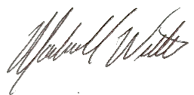
The recommended corrective action deadline date applies to all conditions noted on this report unless otherwise noted. If listed condition(s) currently constitute non-compliance and/or corrective actions are not completed by the deadline, other enforcement actions may be issued to the entity responsible for ensuring compliance on the above project.
Inspector Signature: _________________________
Date: Thursday, July 3, 2025

FielD Inspection Photo LoG
Fig. 1  STA 14980+00: Controls in place and functioning properly.  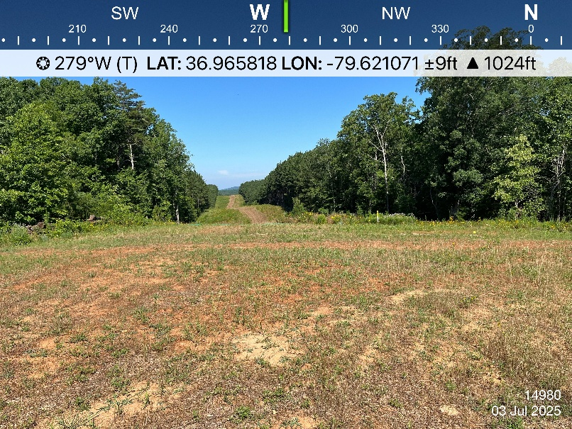 | Fig. 2  STA 14970+00: Controls in place and functioning properly.
Fig. 3  STA 14946+00: Controls in place and functioning properly. | Fig. 4  STA 14940+00: Controls in place and functioning properly.

