Draft

APPLICATION FOR FEDERAL

NO DISCHARGE ZONE

DESIGNATION
Under Clean Water Act Section 312(f)(3)

For Waters of the Northern Neck, Virginia
  - Including waters in Richmond, Lancaster, Northumberland,
  - and Westmoreland Counties

Submitted to the U.S. Environmental Protection Agency, Region III, by the Commonwealth of Virginia

2024

Prepared by the Northern Neck Planning District Commission and the Virginia Department of Environmental Quality

The Northern Neck Planning District Commission  P.O. Box 1600  Warsaw, Virginia 22572  804.333.1900  www.nnpdc.org | Virginia Department of Environmental Quality  P.O. Box 1105  Richmond, VA 23218  804.698.4000  www.deq.virginia.gov
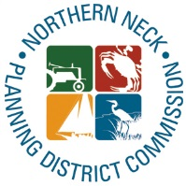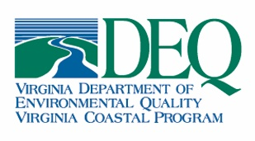

Table of Contents
1.0 Purpose and Background 1
2.0 Geographic Location and Description 2
3.0 Certification of Need 13
3.1 Water quality issues 14
3.2 Shellfish 20
4.0 Pumpout Facility Information 23
4.1 Description of Pumpout Facility Locations and Operations 23
4.2 Pumpout Facility Restrictions and Seasonal Availability 29
4.3 Pumpout Facility Maintenance 31
4.4 Pumpout Facility Waste Management 31
5.0 Wastewater Treatment Facility Information 32
5.1 Description of Wastewater Facility Operations 32
5.2 Estimation of Increased Sewage Volume 37
5.3 Wastewater Facility Compliance 37
6.0 Vessel Populations 38
6.1 Recreational Vessels 39
6.2 Transient Vessels 39
6.3 Commercial Vessels 40
6.4 Tribal Vessels 42
7.0 Adequate Pumpout Facilities 42
8.0 Enforcement, Support, and Outreach Activities 49
8.1 Local Enforcement Capability 50
8.2 Outreach and Education 51
9.0 References 52
Appendix A: Summary of Public Comments 53

Purpose and Background

It is important to Virginia’s economy and to the health of both Virginians and Virginia’s aquatic life to improve and protect our abundant natural resources. A No Discharge Zone (NDZ) is a tool used in Virginia to address impairments in tidal waters or to protect public water supplies. Virginia House Bill 1774 (March 27, 2009) and Virginia House Bill 1943 (March 16, 2011) reenacted and amended section 62.1-44.33 of the Code of Virginia to establish all tidal creeks of the Commonwealth as NDZs and that the designation of NDZs is premised on the improvement of impaired tidal creeks. Furthermore, Initiative #10 in Virginia’s Phase III Chesapeake Bay Watershed Implementation Plan states that “[t]he Commonwealth, in consultation with stakeholders, will consider options available under the Clean Water Act to apply to the Administrator of the E[nvironmental] P[rotection] A[gency] for a No Discharge Zone (NDZ) for all or portions of the Chesapeake Bay mainstem and its tributaries.”
An NDZ is a designated waterbody or portion of a waterbody where discharge of both treated and untreated sewage is prohibited from all vessels. While in an NDZ, vessels must retain all sewage waste onboard for discharge at a vessel sewage pumpout facility.
The designation of NDZs is established by an application process overseen and approved by the U.S. Environmental Protection Agency (EPA). Applications to EPA must include the criteria necessary for EPA approval as listed in EPA’s promulgated guidance: (“Guidance for Vessel Sewage No-Discharge Zone Applications (Clean Water Act Section 312(f))”, May 2023). This application includes data and information in support of those criteria and requests an affirmative determination for the establishment of the proposed NDZs presented in this application under Clean Water Act Section 312(f)(3). Under this section, any State may completely prohibit sewage discharge from all vessels, whether treated or not, into those waters designated as NDZs after EPA has determined that adequate facilities exist and are reasonably available for the safe and sanitary removal and treatment of sewage from all vessels.
An affirmative determination for NDZs in the waters included in this application is requested because of the need to protect aquatic life resources and human health. Specifically, a focus of these proposed NDZs is the protection of Virginia’s culturally and economically important shellfish industry. Therefore, the proposed NDZs are located in shallower waters with sufficient salinity for the survival of shellfish. Additionally, the proposed NDZs will serve to protect the recreational uses of these waters such as swimming, kayaking, boating, water skiing, and fishing.
The waters that are the subject of this application need greater protection than the current federal standards provide. These waters are compromised by excessive bacteria, low dissolved oxygen, and conditions that impair the growth of aquatic plants – factors causing the subject waters to violate state water-quality standards.
Terrestrial pollution is acknowledged to be a significant source of pollution to these waters. Permits issued to business and local, state, and federal facilities, Best Management Practices (BMPs), and Total Maximum Daily Loads (TMDLs) are used to mitigate the impact of land-based pollution. NDZs mitigate the impact of vessel pollution, which is a direct, proximal source of pollution that may have a disproportionate impact on water quality and Virginia’s abundant shellfish resources.
In accordance with the Code of Federal Regulations—40 CFR §140.4(a)—this application requests that the U.S. Environmental Protection Agency grant an affirmative determination that “adequate facilities for the safe and sanitary removal and treatment of sewage from all vessels using such waters are reasonably available.”

Geographic Location and Description

All the subject waters are in rural watersheds in Virginia’s Coastal Plain on the Northern Neck peninsula in the counties of Richmond, Lancaster, Northumberland, and Westmoreland. All waters are tidal and either drain to the Chesapeake Bay via the Rappahannock River or the Potomac River or they drain directly to the Chesapeake Bay. This area is important to Virginia’s thriving shellfish industry and has existing extensive shellfish harvest areas and aquaculture acreage. As illustrated in figures 5-7, VDH has restricted or prohibited shellfish harvesting in portions of these waters due to human health concerns. With a few exceptions, proposed NDZ boundaries have been placed at downstream outlets to the Potomac River, Chesapeake Bay, or Rappahannock River in order to improve water quality conditions in the upstream portions of these waters as well as to protect those shellfish beds located downstream and towards the mouth of these waters. Figure 1 provides an overview of all proposed NDZs on the Northern Neck Peninsula and Figures 2-4 provide greater local detail. These figures also identify vessel sewage pumpout facility locations and are noted with each facility’s unique Map-ID. Facility details are provided in section 4.

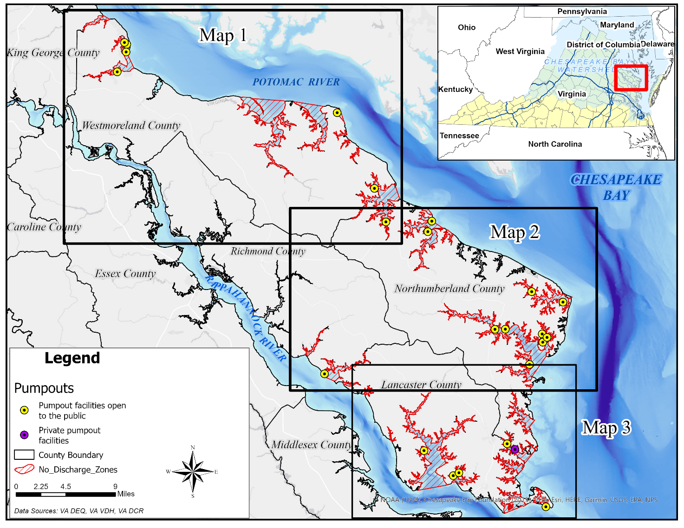Figure 1. Overview of proposed No Discharge Zone waters in the Northern Neck - a peninsula surrounded by the Potomac River, Chesapeake Bay, and the Rappahannock River. Areas identified as Maps 1, 2, and 3 are shown in greater detail in Figures 2-4.
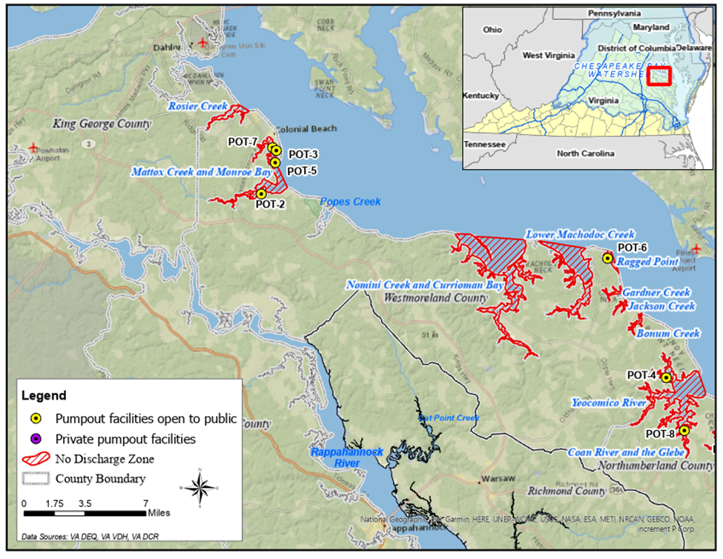
Figure 2. Map 1 displays proposed NDZs in the Northwestern part of the peninsula as well as the locations of existing pumpout facilities which have weekend hours. The waters in this area discharge to the Potomac River.
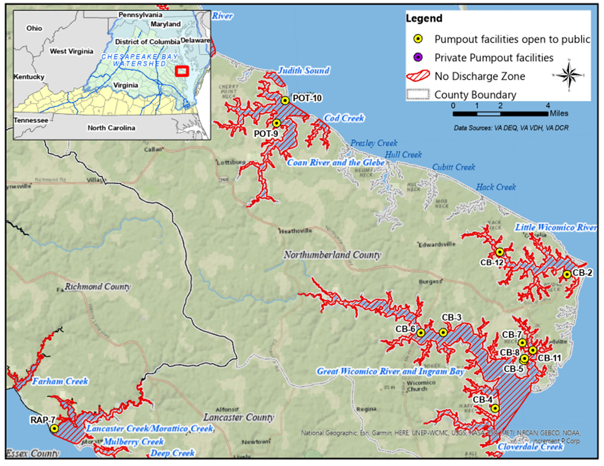
Figure 3. Map 2 displays proposed NDZs in the Northeastern and southwestern parts of the peninsula as well as the locations of existing pumpout facilities which have weekend hours. Proposed NDZs on the north side discharge to the Potomac River and on the east side discharge to the Chesapeake Bay. This map also displays the southwestern-most proposed NDZs (Farnham, Lancaster, Mulberry, and Deep Creeks) which discharge to the Rappahannock River.
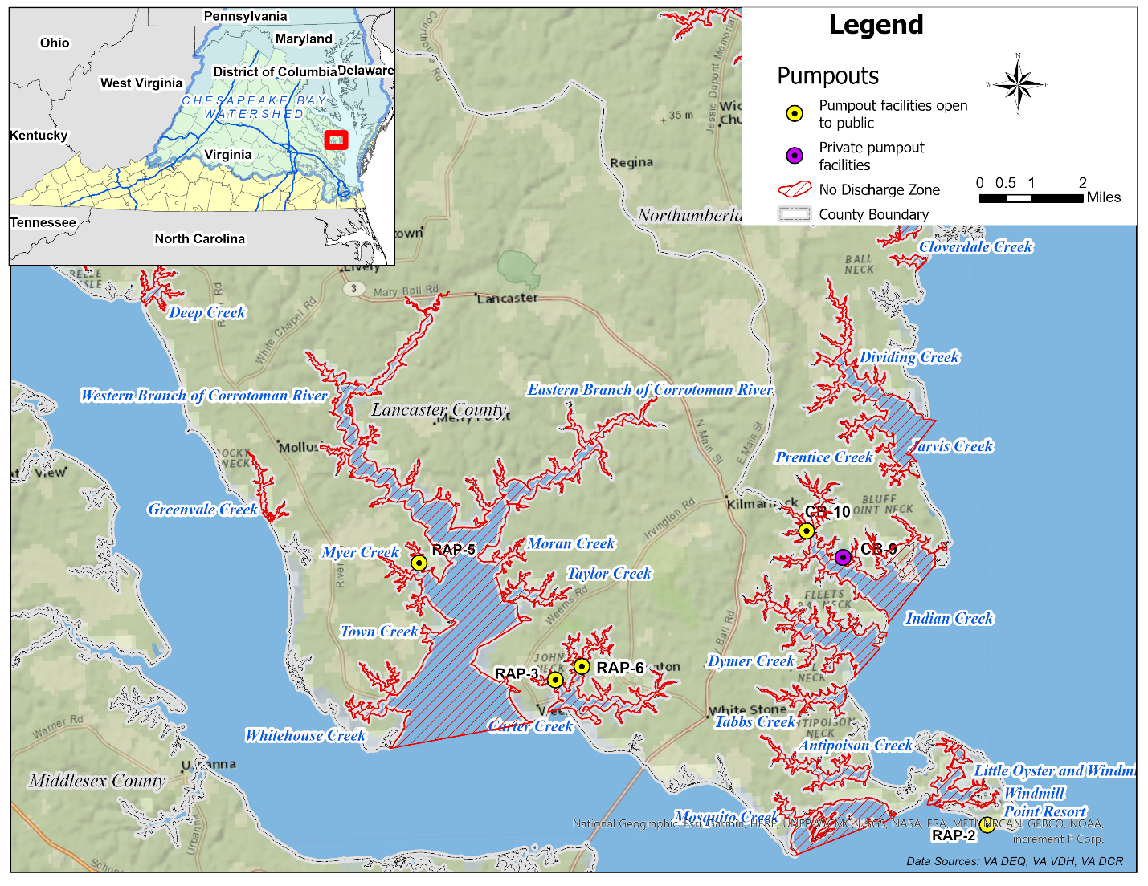
Figure 4. Map 3 displays proposed NDZs in the Southeastern part of the peninsula as well as the locations of existing pumpout facilities which have weekend hours. The proposed NDZs on the east side discharge to the Chesapeake Bay and the proposed NDZs on the south side discharge to the Rappahannock.

A list of waters proposed for NDZ designation is provided in Table 1 along with additional detail regarding shoreline miles and areal extents for each. The waters listed in the table are arranged spatially beginning with the northwestern-most water on the Potomac side of the peninsula and ending with the southwestern-most water on the Rappahannock side of the peninsula.
Table 1. List of proposed NDZs in the Northern Neck.
Waterbody name | Discharges to | Map Number | Shoreline (miles) | Areal extent of proposed NDZ (sq. miles)
Rosier Creek | Potomac River | 1 | 9.05 | 0.63
Mattox Creek and Monroe Bay | Potomac River | 1 | 22.94 | 2.39
Nomini Creek and Currioman Bay | Potomac River | 1 | 70.78 | 8.78
Lower Machodoc Creek | Potomac River | 1 | 36.88 | 3.81
Ragged Point | Potomac River | 1 | 3.67 | 0.29
Gardner Creek | Potomac River | 1 | 6.16 | 0.19
Jackson Creek | Potomac River | 1 | 5.69 | 0.14
Bonum Creek | Potomac River | 1 | 6.63 | 0.2
Yeocomico River | Potomac River | 1 | 57.75 | 5.19
Judith Sound | Potomac River | 2 | 2.52 | 0.24
Coan River and the Glebe | Potomac River | 2 | 46.66 | 3.83
Cod Creek | Potomac River | 2 | 8.78 | 0.36
Little Wicomico River | Chesapeake Bay | 2 | 53.49 | 2.68
Great Wicomico River and Ingram Bay | Chesapeake Bay | 2 | 116.2 | 10.55
Cloverdale Creek | Chesapeake Bay | 2 | 2.22 | 0.07
Dividing Creek | Chesapeake Bay | 3 | 29.15 | 2.00
Indian Creek | Chesapeake Bay | 3 | 36.31 | 1.639
Dymer Creek | Chesapeake Bay | 3 | 22.71 | 1.144
Tabbs Creek | Chesapeake Bay | 3 | 9.92 | 0.289
Antipoison Creek | Chesapeake Bay | 3 | 13.2 | 0.467
Windmill Point Resort | Rappahannock River | 3 | 0.27 | 0.0099
Little Oyster and Windmill Point Creek | Rappahannock River | 3 | 4.43 | 0.453
Mosquito Creek | Rappahannock River | 3 | 3.4 | 1.193
Carter Creek | Rappahannock River | 3 | 27.85 | 0.987
Corrotoman River | Corrotoman River | 3 | 101.1 | 10.00
Greenvale Creek | Rappahannock River | 3 | 4.36 | 0.139
Deep Creek (state park area) | Rappahannock River | 2 | 7.66 | 0.217
Mulberry Creek (state park area) | Rappahannock River | 2 | 7.06 | 0.247
Lancaster Creek (inc. Morattico) | Rappahannock River | 2 | 32.1 | 1.29
Farnham Creek | Rappahannock River | 2 | 5.29 | 0.37

The proposed NDZs are spatially defined in Table 2 with the NDZ extent being all navigable, tidal waters upstream of the line formed between the two points (defined by latitude and longitude) provided in this table. The waters are listed in the same order as described for Table 1.
Table 2. Latitude and longitude of boundary points for each of the proposed NDZs.
Waterbody Name | Boundary Number | Latitude | Longitude
Rosier Creek | 1 | 38.27423 | -76.99004
Rosier Creek | 2 | 38.27963 | -77.00109
Mattox Creek and Monroe Bay | 1 | 38.20925 | -76.95157
Mattox Creek and Monroe Bay | 2 | 38.22965 | -76.96299
Nomini Creek and Currioman Bay | 1 | 38.16002 | -76.70089
Nomini Creek and Currioman Bay | 2 | 38.16642 | -76.77322
Lower Machodoc Creek | 1 | 38.15151 | -76.63835
Lower Machodoc Creek | 2 | 38.15921 | -76.68793
Ragged Point | 1 | 38.12933 | -76.60405
Ragged Point | 2 | 38.14764 | -76.61129
Gardner Creek | 1 | 38.11287 | -76.60394
Gardner Creek | 2 | 38.11343 | -76.60244
Jackson Creek | 1 | 38.10666 | -76.59682
Jackson Creek | 2 | 38.10701 | -76.59705
Bonum Creek | 1 | 38.09569 | -76.58088
Bonum Creek | 2 | 38.09591 | -76.58191
Yeocomico River | 1 | 38.02647 | -76.51607
Yeocomico River | 2 | 38.04299 | -76.52267
Judith Sound | 1 | 38.00501 | -76.46332
Judith Sound | 2 | 38.01331 | -76.47095
Coan River and the Glebe | 1 | 37.98598 | -76.44547
Coan River and the Glebe | 2 | 37.99578 | -76.46318
Cod Creek | 1 | 37.97877 | -76.43125
Cod Creek | 2 | 37.98367 | -76.44064
Little Wicomico River | 1 | 37.88968 | -76.23582
Little Wicomico River | 2 | 37.89021 | -76.23621
Great Wicomico River and Ingram Bay | 1 | 37.78715 | -76.30697
Great Wicomico River and Ingram Bay | 2 | 37.81337 | -76.28235
Cloverdale Creek | 1 | 37.77302 | -76.30958
Cloverdale Creek | 2 | 37.77558 | -76.30586
Dividing Creek | 1 | 37.72099 | -76.31422
Dividing Creek | 2 | 37.730044 | -76.30461
Indian Creek | 1 | 37.67331 | -76.32477
Indian Creek | 2 | 37.68940 | -76.30659
Dymer Creek | 1 | 37.66186 | -76.33574
Dymer Creek | 2 | 37.67154 | -76.32557
Tabbs Creek | 1 | 37.65368 | -76.33947
Tabbs Creek | 2 | 37.65605 | -76.33997
Antipoison Creek | 1 | 37.63031 | -76.33294
Antipoison Creek | 2 | 37.63233 | -76.33258
Windmill Point Resort | 1 | 37.61462 | -76.29060
Windmill Point Resort | 2 | 37.61439 | -76.29018
Little Oyster and Windmill Point | 1 | 37.62423 | -76.31105
Little Oyster and Windmill Point | 2 | 37.62036 | -76.30706
Mosquito Creek | 1 | 37.60892 | -76.35911
Mosquito Creek | 2 | 37.61964 | -76.32341
Carter Creek | 1 | 37.65151 | -76.44559
Carter Creek | 2 | 37.65239 | -76.43984
Corrotoman River | 1 | 37.64870 | -76.45130
Corrotoman River | 2 | 37.64328 | -76.50112
Greenvale Creek | 1 | 37.71024 | -76.54449
Greenvale Creek | 2 | 37.70756 | -76.54179
Deep Creek | 1 | 37.77188 | -76.58611
Deep Creek | 2 | 37.77051 | -76.58414
Mulberry Creek | 1 | 37.78684 | -76.61966
Mulberry Creek | 2 | 37.78408 | -76.61814
Lancaster Creek/Morattico Creek | 1 | 37.79607 | -76.65121
Lancaster Creek/Morattico Creek | 2 | 37.79006 | -76.63477
Farham Creek | 1 | 37.82528 | -76.67962
Farham Creek | 2 | 37.82565 | -76.68040

Certification of Need

The tidal tributaries proposed for NDZ designation need greater protection than the current federal standards provide. These tributaries are important aquaculture areas and, per the Virginia Marine Resources Commission, five of the top 20 aquaculture sites in the state include the Yeocomico River, Coan River, Little Wicomico River, Great Wicomico River, and Lower Machodoc Creek. However, the use of these waters as shellfish-growing areas has been compromised by bacterial impairment, resulting in non-attainment of state water-quality standards. Additionally, these waters are impaired for the aquatic life designated used due to low dissolved oxygen. Some of these waters are also impaired due to a lack of environmentally important submerged aquatic vegetation.
These tributaries are also important to recreational uses such as boating, swimming, and fishing as well as tourism and a safe harbor or repair stop for those vessels transiting the Potomac River, Chesapeake Bay, or Rappahannock River.
All waters proposed for NDZ designation are considered slowly flushing with a few exceptions which are considered to have intermediate flushing rates. Therefore, pollutants discharged to these waters take longer to flush out of the system and may therefore have a greater local impact on water quality.
NDZs offer a compliment to other water quality improvement programs such as BMPs and TMDLs aimed at land-based sources of pollution. While terrestrial pollution may be a significant source of pollution to this estuarine environment, it is typically an indirect source whereas discharges from vessels may be direct and proximate to shellfish grounds and may therefore have a disproportionate impact. Commonly used vessel navigational routes and areas with a higher density of recreational vessels tend to overlap shellfish growing areas.

Water quality issues

Two of the leading causes of water quality impairment in Virginia’s estuarine waters are dissolved oxygen and bacteria (Virginia’s 2022 305(b)/303(d) Water Quality Assessment Integrated Report). Exceedances of fecal coliform criteria is the most common reason for shellfish growing area closures as classified by the Virginia Department of Health following guidance from the National Shellfish Sanitation Program. The national standard for fecal coliform in shellfish waters is a geometric mean of 30 samples not to exceed 14 fecal coliforms per 100 ml. All waters proposed for NDZ currently contain areal extents which have shellfish harvest closures/restrictions (Figures 5-7) or have had closures in the recent past.
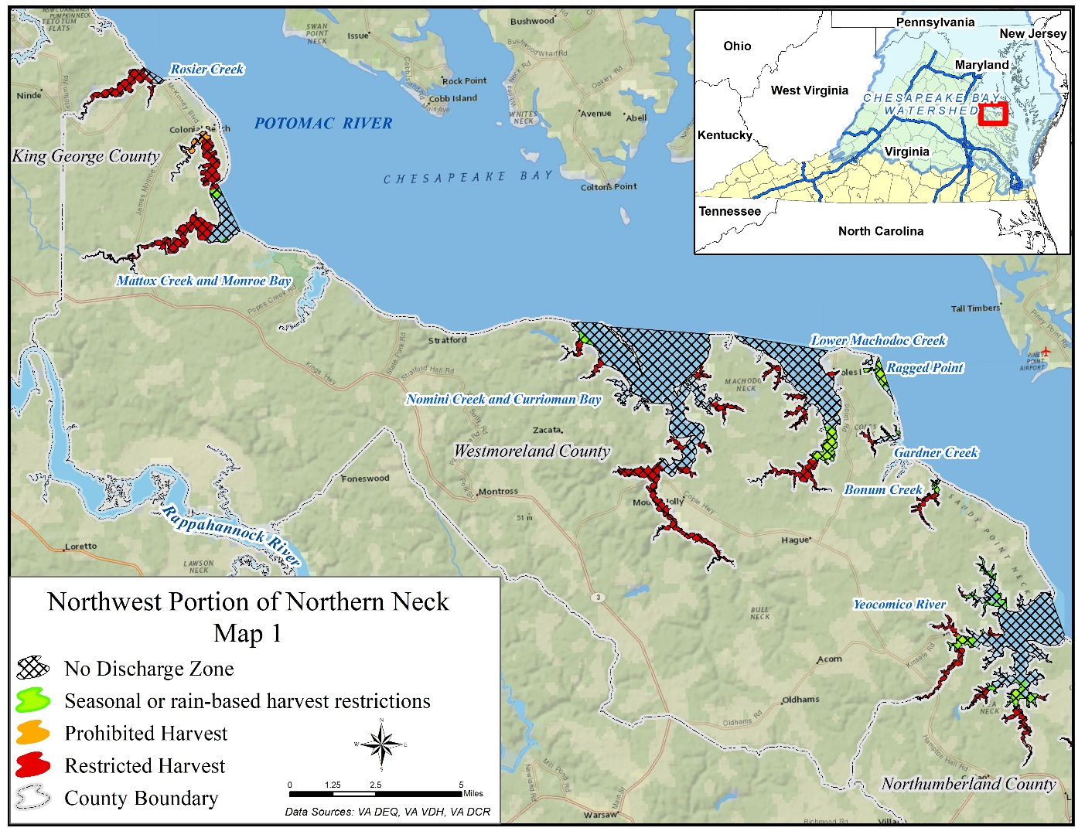
Figures 5. Shellfish closures in the northwest portion of the Northern Neck. VDH shellfish closures displayed include the following categories: seasonal or rain-based restrictions, prohibited closures, and restricted closures. The map also displays proposed NDZs.

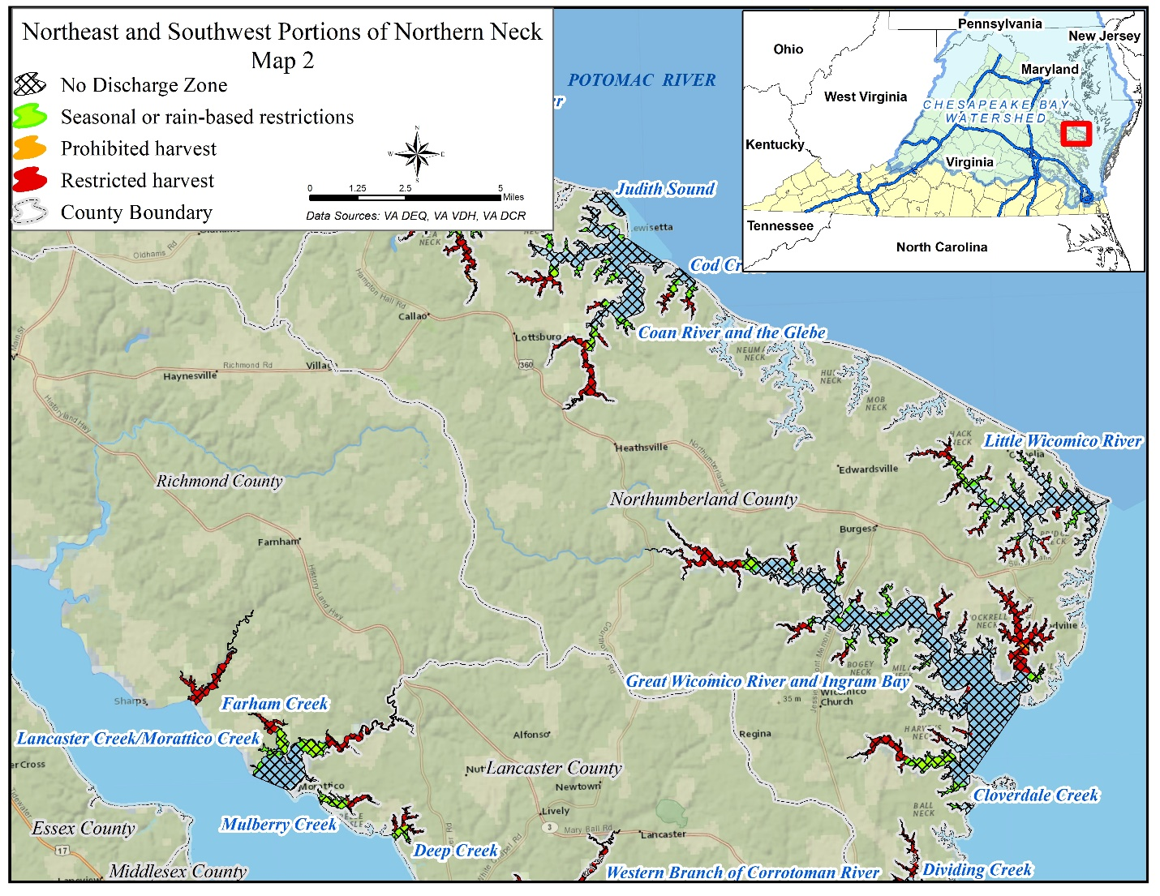
Figures 6. Shellfish closures in the northeast and southwest portions of the Northern Neck. VDH shellfish closures displayed include the following categories: seasonal or rain-based restrictions, prohibited closures, and restricted closures. The map also displays proposed NDZs.

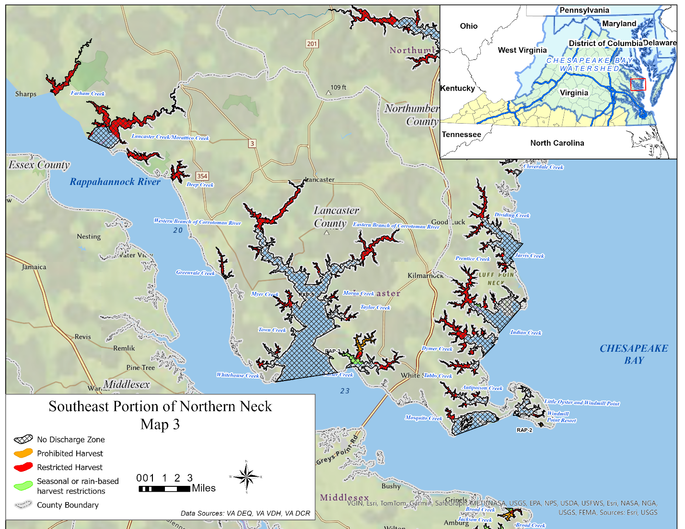
Figure 7. Shellfish closures in the southeast portion of the Northern Neck. VDH shellfish closures displayed include the following categories: seasonal or rain-based restrictions, prohibited closures, and restricted closures. The map also displays proposed NDZs.
Bacteria TMDLs have been developed for all or part of the watersheds draining to each of the waters proposed for NDZ designation with the exception of Town Creek and Moran Creek which are small tributaries to the Corrotoman River. Each of those TMDLs assigns reductions to human sources of bacteria. Additionally, the proposed NDZ waters are included in the Chesapeake Bay TMDL with all waters being listed as impaired on Virginia’s 2022 305(b)/303(d) Water Quality Assessment Integrated Report for dissolved oxygen and many also impaired due to depleted submerged aquatic vegetation.
While there are no regulatory nutrient criteria for Bay waters, total nitrogen (TN) and total phosphorus (TP) thresholds have been developed for annual status reporting (Chesapeake Bay and Watershed Report Card, 2020) by the University of Maryland Center for Environmental Science (UMCE). Those thresholds are specific to the four salinity regimes of the Bay (tidal fresh, oligohaline, mesohaline, polyhaline), and they are frequently exceeded at monitoring stations sampled monthly and bimonthly in the Bay’s tributaries and sub-tributaries (Figure 8). Monitoring results for both TN and TP in the Northern Neck indicate high or very high exceedances of those thresholds.
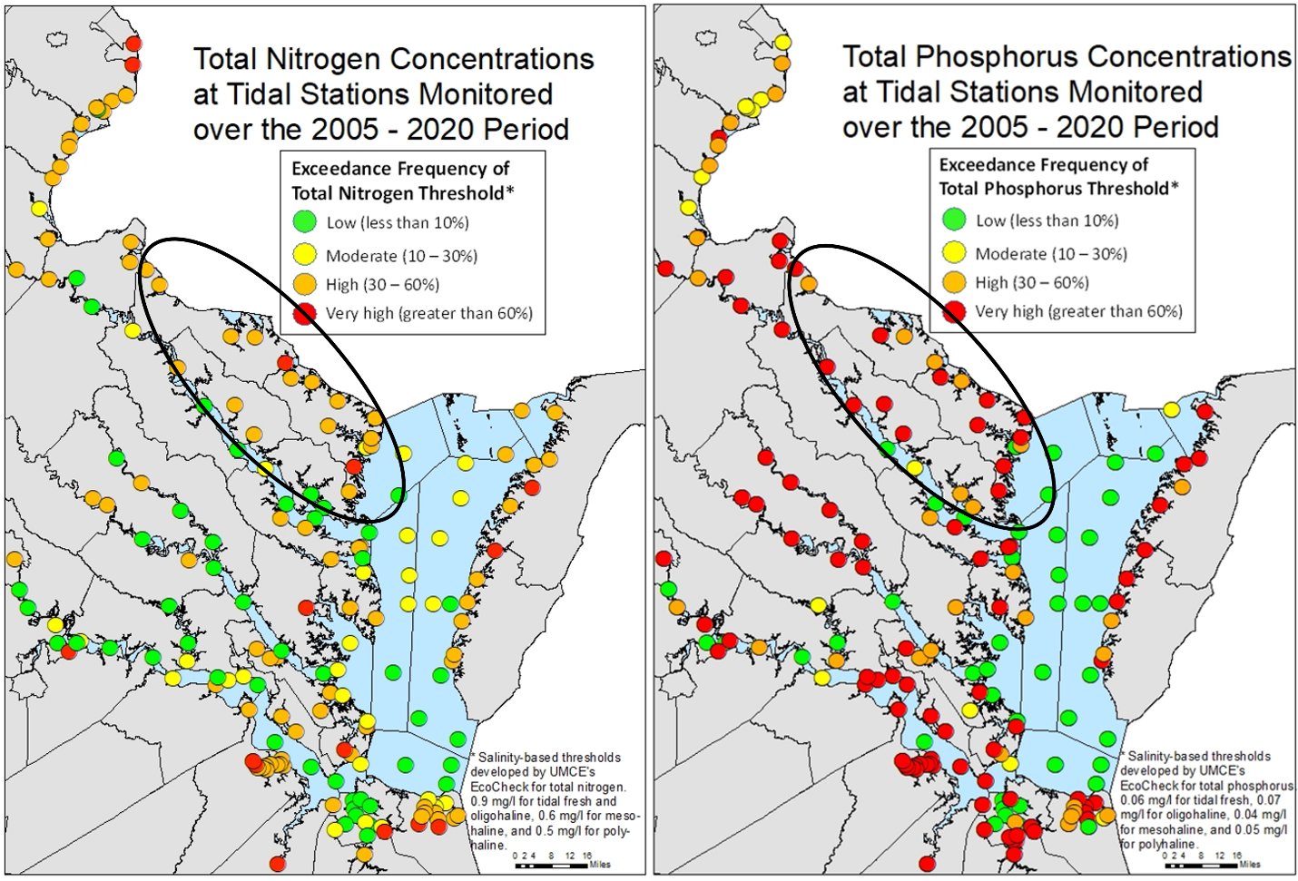
Figure 8. Total Nitrogen (TN) and total phosphorus (TP) concentrations in Virginia’s portion of the Chesapeake Bay and tributaries. The black oval signifies the Northern Neck area. Monitoring results for both TN and TP indicate high or very high exceedances of salinity-based thresholds (0.9 mg/L TN for tidal fresh and oligohaline, 0.6 mg/L TN for mesohaline, and 0.5 mg/L TN for polyhaline; 0.06 mg/L TP for tidal fresh, 0.07 mg/L TP for oligohaline, 0.04 mg/L TP for mesohaline, 0.05 mg/L TP for polyhaline) developed by the University of Maryland Center for Environmental Science.

The proposed NDZs compliment land-based efforts such as TMDLs and BMPs in protecting water quality. BMPs are land-based practices, treatments, and technologies designed to reduce the loading of pollutants such as nitrogen, phosphorus, bacteria, and sediment entering VA’s waters. Figure 9 shows the number of active BMPs in the watersheds of the proposed NDZs. NDZs are a water-based practice designed to reduce pollutant loadings from vessels – a source of pollution which may be direct and proximate to oyster grounds and may have a disproportionate impact on local water quality.

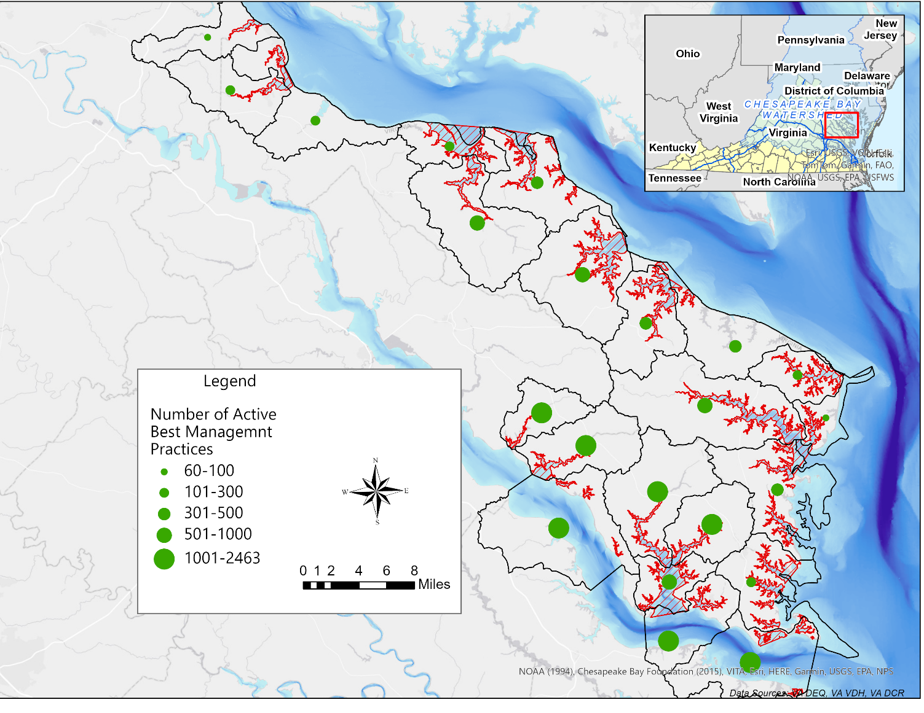
Figure 9. Map of the number of active Best Management Practices by HUC 12 watersheds (black outlines). HUC 12s with higher numbers of BMPs are characterized by larger green circles. Source: DEQ BMP warehouse 2023

Per federal regulations, Marine Sanitation Devices (MSDs) are required on any vessel that has an installed toilet. MSDs are typically categorized as Type I, Type II, or Type III; each with separate requirements (Table 3). Type I and Type II are treat-and-release systems whereas Type III is typically a holding tank in which sewage is stored until it can be discharged at a pumpout facility or when 3 miles offshore. Most recreational vessels with an installed toilet use a Type I or Type III system whereas Type II systems are typically limited to larger commercial vessels.

Table 3. Marine Sanitation Device (MSD) Types and Descriptions.
MSD Type | Description | Installation Requirements | Standards of Performance
Type I | Treat-and-release device typically using maceration and disinfection | May be installed only on vessels less than or equal to 65 feet in length | Must produce effluent with:  - No visible floating solids  - A fecal coliform bacterial count not greater than 1000 per 100 milliliters
Type II | Treat-and-release device that may employ biological treatment and disinfection (some Type IIs may use maceration and disinfection) | May be installed on vessels of any length | Must produce an effluent with:  - A fecal coliform bacterial count not greater than 200 per 100 milliliters  - No more than 150 milligrams of total suspended solids per liter
Type III | Typically a holding tank where sewage is stored until it can be discharged shore-side at a pumpout facility or at sea (beyond 3 miles from shore) | May be installed on vessels of any length | No performance standard; must “be designed to prevent the overboard discharge of treated or untreated sewage or any waste derived from sewage.” 33 CFR 159.53(c)

As described in Table 3, Type I and Type II are required to reduce fecal coliform concentrations prior to release, however, even treated fecal coliform concentrations are significantly higher than fecal coliform concentrations required for attainment of water quality standards. In addition, MSDs provide minimal, if any, treatment for chemical (COD) or biological oxygen demand (BOD), phosphorus, or nitrogen; and the deodorizers and treatment chemicals such as chlorine, formaldehyde and quaternary ammonia used in MSDs can be toxic to marine life. Some of the typical constituents measured in recreational vessel holding tanks is provided in Table 4.

Table 4. Typical constituents measured in recreational vessel holding tanks. Source: Lynnhaven Boat Wastewater Sampling Program. January 7, 2008
Chemical Procedure | Unit | Result | Report Limit
BOD | mg/l | 2,800 | 2
COD | mg/l | 5,000 | 25
TKN | mg/l | 2,290 | .50
Total P | mg/l | 113 | .20
Fecal Coliform | FC/100 ml | 29,000,000 | ND

Shellfish

The current shellfish standard for fecal coliform bacteria allows for a maximum geometric mean of 14 per 100 milliliters (ml) of water and a 90th percentile not to exceed 31 CFU per 100 ml over a 30-month period. Under this standard, the water-quality data from the VDH Division of Shellfish Sanitation (VDH-DSS) monitoring indicates that significant areas of the subject waters in this application failed to meet the National Shellfish Sanitation Standard for fecal coliform bacteria resulting in many shellfish harvest closures (Figures 5-7). The closures are established because of the potential threat to human health resulting from contaminated shellfish consumption. Again, while terrestrial pollution is a threat to these marine natural resources, vessel pollution is direct and proximate to shellfish grounds, and therefore may have a more immediate impact on local water quality.
Virginia’s shellfish aquaculture industry continues to be an important part of Virginia’s seafood economy. According to the Virginia Shellfish Aquaculture Situation and Outlook Report finalized in August 2019 (Karen Hudson, VIMS), Virginia ranks first on the east coast for Eastern oyster production and ranks first in the U.S. for hard clam production. It was estimated that hard clams and oysters grown through aquaculture practices represent over $53 million in dockside value (Virginia Department of Agriculture and Consumer Services). Public shellfish grounds, private shellfish leases, and private oyster gardens occupy a significant portion of the proposed NDZ areas (Figure 10-12). The Yeocomico River, Coan River, Little Wicomico River, Great Wicomico River, and Lower Machodoc Creek are five of the top 20 aquaculture sites in the state according to the Virginia Marine Resources Commission.
The 2014 Chesapeake Bay Watershed Agreement included large-scale oyster restoration goals in Maryland and Virginia to be completed by 2025. One of the rivers included in that goal is the Great Wicomico River (see Figure 11 for location of this river). Many of the planned acres for restoration have already been restored and planning is ongoing for the additional restoration acreage.

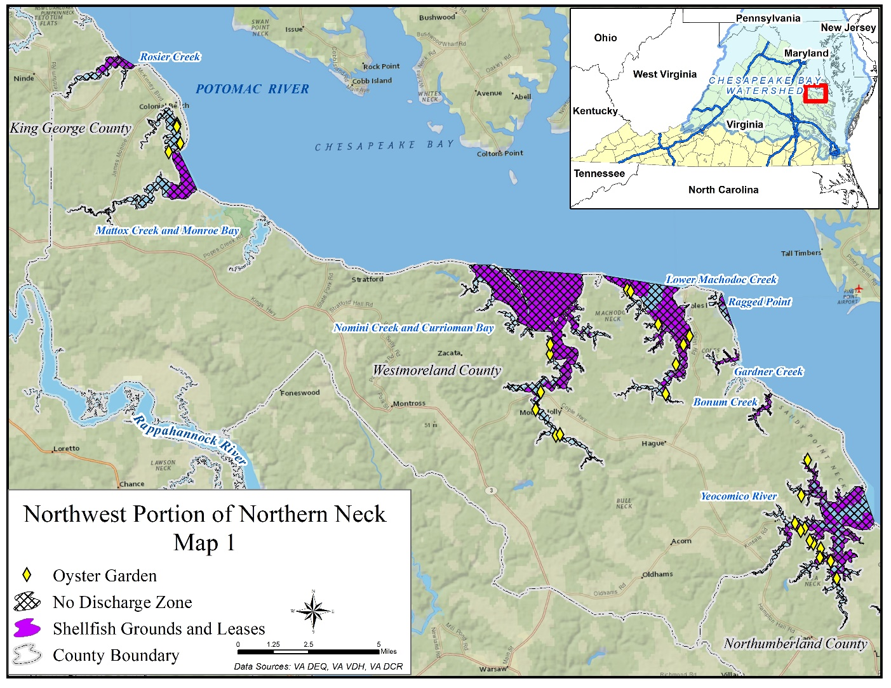
Figure 10. Shellfish public grounds, shellfish private leases, and private oyster gardens within the proposed NDZ boundaries in the northwest portion of the Northern Neck. Shellfish grounds and leases extend beyond the boundaries of the proposed NDZs but are not shown here.
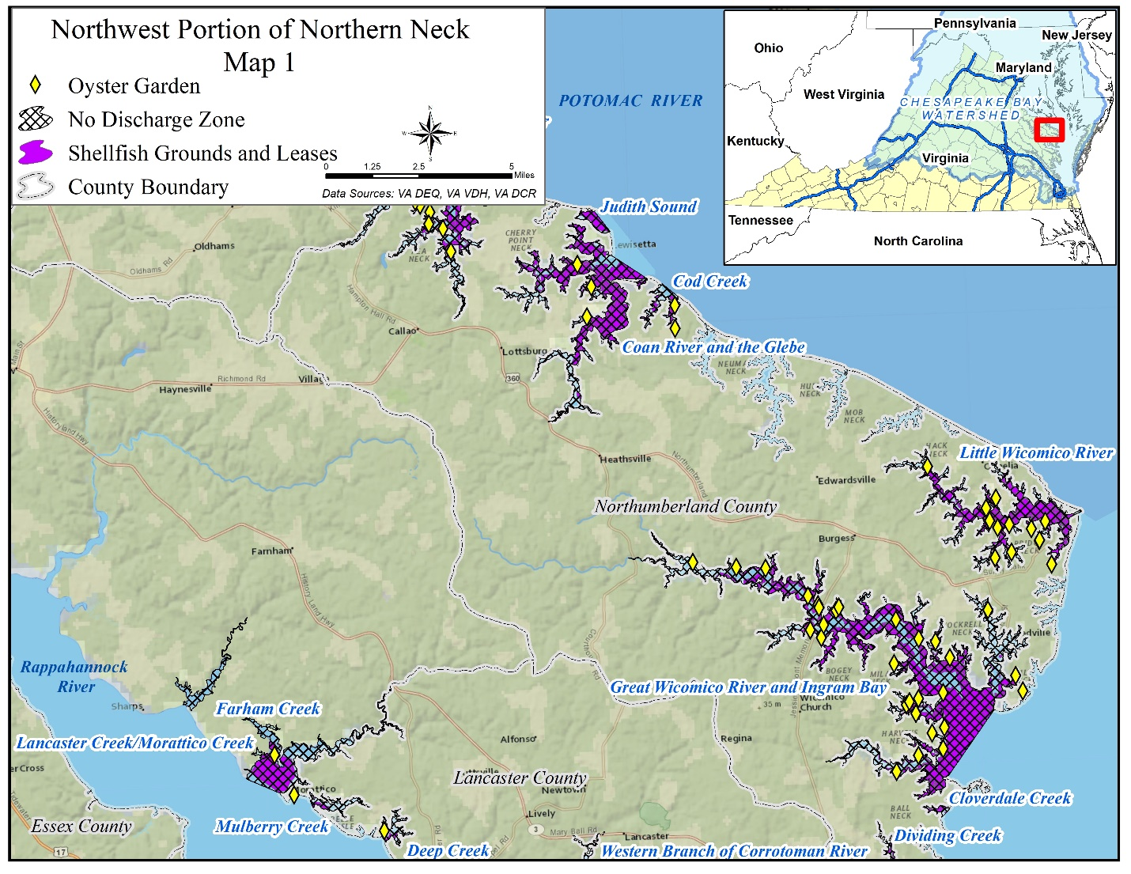
Figure 11. Shellfish public grounds, shellfish private leases, and private oyster gardens in the northeast and southwest portions of the Northern Neck. Shellfish grounds and leases extend beyond the boundaries of the proposed NDZs but are not shown here.

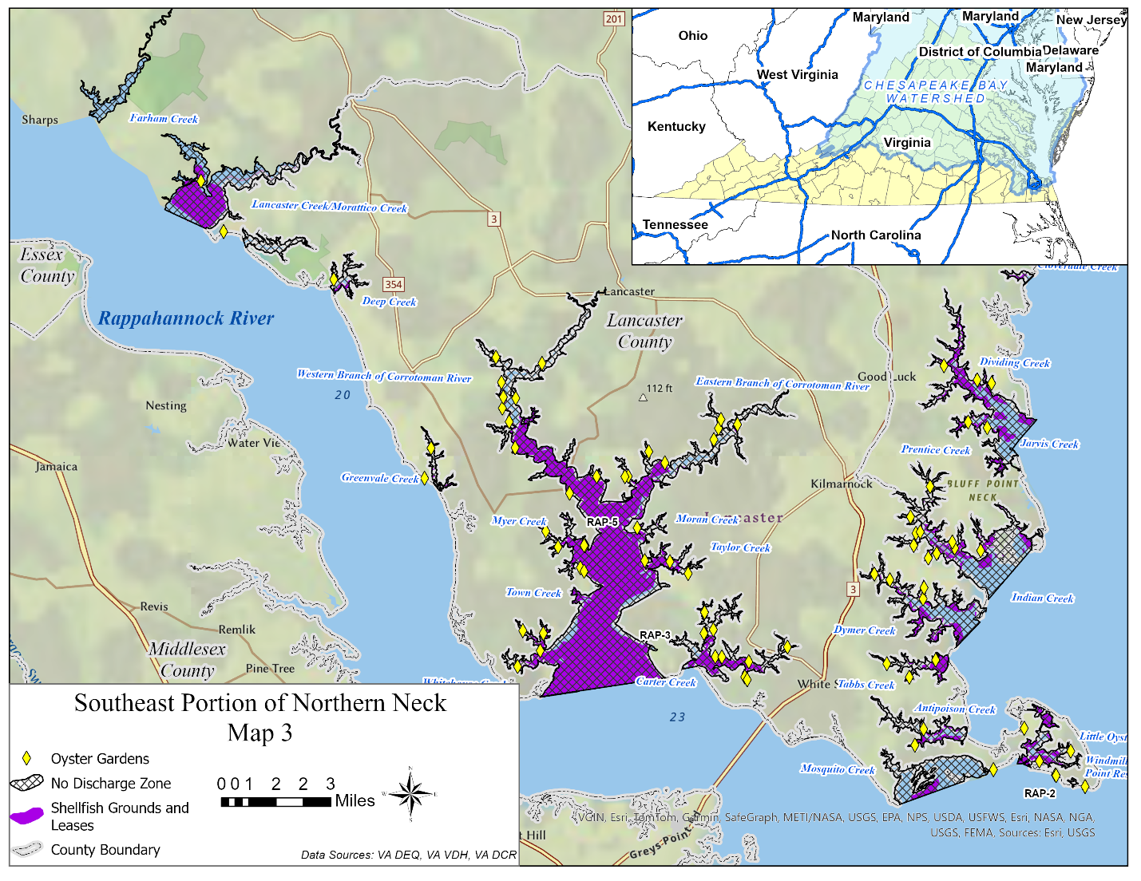
Figure 12. Shellfish public grounds, shellfish private leases, and private oyster gardens in the southeast portion of the Northern Neck. Shellfish grounds and leases extend beyond the boundaries of the proposed NDZs but are not shown here.

Pumpout Facility Information

Description of Pumpout Facility Locations and Operations

The pumpout facilities discussed in this application are limited to those that offer pumpout services during some portion of a peak-use weekend (e.g., July 4th Holiday) and are available to the public. The one exception is Indian Creek Country and Yacht Club which has a pumpout station available every day of the week, but its use is limited to club members and guests - that facility is included for informational purposes only.

Pumpout facilities in the Northern Neck consist of both stationary and portable pumpout stations. There are no mobile pumpouts available in the Northern Neck at this time. Most of the pumpout facilities use a SaniSailor Pump (EMP Industries) with average flow rates of 15-30 gallons per minute (GPM). All pumpout facilities have at least one universal connection and most have several other connection options available for boaters utilizing their pumpout.
A map showing pumpout facility locations is presented in Figure 1 (Section 2) with larger scale maps presented in Figures 2-4 (Section 2). Each facility is identified on the maps by a unique Map ID. The characters within the Map ID (POT, CB, or RAP) indicate whether the facility is on the Potomac, Chesapeake Bay, or Rappahannock side of the Northern Neck peninsula. Details about each facility’s contact information, availability to the public, hours of operation, fees, and mean low water are provided in Table 5.

Table 5. Pumpout facilities available in the Northern Neck. Map IDs can be used to locate the facility in the maps presented in Figures 2-4. The characters within the Map ID (POT, CB, or RAP) indicate whether facility is on the Potomac, Chesapeake Bay, or Rappahannock side of the Northern Neck peninsula. ** Indicates that the pumpout might be winterized weather dependent (typically after the 1st freeze)
Waterfront Facility Name (Code) | Waterfront Facility Information | Hours of Operation | Mean Low Water Depth | Number of Pumpout Facilities by Type | Fee
Blue Compass Marina at Horn Harbor (CB-3) | 836 Horn Harbor Rd. Burgess, VA 22432  804-453-3351 | April-Oct:  M-F: 8am - 9pm  Sat-Sun: 9:30am-4pm  Nov-March:  W-Sun:11am-4pm  24/7 call ahead service | 7 ft | Stationary: 1  Portable Toilet Dump Station: 1 | $0
Buzzard Point Dry Storage & Marina (CB-7) | 468 Buzzard Point Rd, Reedville, VA 22539  804-453-3545 | Late March-Dec**:  M-Sat: 8am-5pm  Sun: 8am-4pm | 8.5 ft | Stationary: 1  Portable Toilet Dump Station: 1 | $5
Carter’s Cove Marina (RAP-3) | 347 Carters Cove Drive, Weems, VA 22576  804-438-5299 | April - Nov:  9am – 5pm daily ** | 5 ft | Stationary: 1  Portable Toilet Dump Station: 1 | Free for slip holders  $5 for non-slip holders
Chesapeake Boat Basin (CB-10) | 1686 Waverly Ave, Kilmarnock, VA 22482  804-436-1234 | M-Sat: 8am-5pm  Sun: 8am-3pm  Closed Sun & Mon in Jan & Feb ** | 13 ft | Stationary: 1  Portable Toilet Dump Station: 1 | $5
Coan River Marina (POT-9) | 3170 Lake Rd. Lottsburg, VA 22511  804-529-6767 | April-Oct:  M-F: 8:30am - 5pm  Sat: 9:30am-2pm  November-March**:  M-F: 9:30am-4pm | 7 ft | Stationary: 1  Portable Toilet Dump Station: 1 | $10 for MSDs  $5 for Portable Toilets
Cockrell’s Marine Railway Inc. (CB-12) | 309 Railway Dr. Heathsville, VA 22473  804-453-3560 | Daily: 6:00am-6:00pm | 5 ft | Stationary: 1  Portable Toilet Dump Station: 1 | Holding tank size dependent: $5-20
Coles Point Marina (POT-6) | 190 Plantation Drive, Hague, VA 22469  804-472-4011 | April-Oct:  M-Th: 9am – 5pm  F&Sat: 8am - 7pm  Sun: 9am-4pm  Nov-March**:  M-Sat: 9am-5pm  Sun: 9am-12pm | 6 ft | Stationary: 1 | $20
Colonial Beach Yacht Center (POT-5) | 1787 Castlewood Drive, Colonial Beach, VA 22443  804-224-7230 | April-Oct:  M- Sun (except T): 10am - 4pm  Nov – March**:  F-Sun:10am-4pm | 5 ft | Stationary: 1 Portable Toilet Dump Station: 1 | $5
Fairport Marina  (CB-8) | 252 Polly Cove Rd., Reedville, VA 22539  804-453-5002 | M,T,Sat,Sun: 9am-5pm  W-F: 9am-10pm | 8 ft | Stationary: 1  Portable Toilet Dump Station: 1 | Holding tank size dependent: $5-10
Indian Creek Country & Yacht Club (CB-9) | 362 Club Drive, Kilmarnock, VA 22482  804-435-1340 | Not open to the public: Members & Invitees Only | 6 ft | Stationary: 1 | Free for members and guests
Ingram Bay Marina (CB-4) | 545 Harveys Neck Rd. Heathsville, VA 22473  804-580-7292 | 9am - 5pm daily | 6 ft | Stationary: 1 Portable Toilet Dump Station: 1 | $5
Jenning's Boatyard Inc. (CB-5) | 169 Boatyard Road Reedville, VA 22539  804-453-7181 | M-F: 8am - 5pm  Sat: 8am - 12pm | 9 ft | Stationary: 1 Portable Toilet Dump Station: 1 | $5
Lewisetta Marina (POT-10) | 369 Church Lane Lottsburg, VA 22511  804-529-7299 | Daily: 7am - 5 pm | 9 ft | Stationary: 1 | $5
Monroe Bay & Winkie Doodle Marinas (POT-7) | 551 Lafayette Street Westmoreland, VA 22443  804-224-7544 | April-Oct:  Daily: 8am - 8pm | 5.5 ft | Stationary: 1 | $0
Olverson's Lodge Creek Marina (POT-8) | 1161 Melrose Rd Lottsburg, VA22511  804-529-5071 | M-Sat: 8am - 5pm  Sun: 8am - 2pm | 10 ft | Stationary: 1  Portable Toilet Dump Station: 1 | $5
Reedville Marina - Crazy Crab Restaurant (CB-11) | 902 Main St Reedville, VA 22539  804-453-6789 | April-Oct:  Daily: 9am – 5pm | 14 ft | Stationary: 1 | $5
Smith Point Marina (CB-2) | 989 Smith Point Rd. Reedville, VA 22539  804-453-4077 | April-Dec:  Daily: 8am - 4pm  Nov – Mar**:  M-F: 8am-4pm | 4.5 ft | Stationary: 1  Portable Toilet Dump Station: 1 | Slip Holders: Free  non-slip holders: $10
Stepp's Harbor View Marina (POT-2) | 277 Harbor View Circle Colonial Beach, VA 22443  804-224-7230 | April-Nov:  Daily: 9am – 5pm | 8 ft | Portable: 1 | $10
The Boat House Marina (POT-3) | 829 Robin Grove Lane, Colonial Beach, VA 22443  804-224-7644 | T-Sat: 8:00-4:00 pm | 6 ft | Portable: 1 | $0
Tides Inn & Lodge (RAP-6) | 480 King Carter Drive, Irvington, VA, 22480  804-438-4418 | Mid-March-Dec:  Daily:8am – 7pm  Jan-Mid March:  Daily: 8am - 4pm | 8 ft | Stationary: 1 | $0
Tiffany Yacht Company (CB-6) | 2355 Jessie Dupont Memorial Highway, Burgess, VA 22432  804-453-3464 | M-F: 7:30am-4:30pm  Sat: 7:30am-12pm | 10 ft | Portable: 1 | Holding tank size dependent: $20+
Whelan's Marina & Campground (RAP-7) | 3993 Hales Point Rd, Farham, VA 22460  804-394-9500 | April-Oct:  M-F: 8am - 5pm  Sat: 8am-1pm  Nov-March:  M-F: 8am-5pm | 3 ft | Portable: 1 | $0
White Point Marina (POT-4) | 175 Marina Drive Kinsale, VA 22488  (804)472-2977 | March 15- Nov 15:  M-F: 7:30am - 4pm  Sat & Sun: 7:30am - 5pm | 8 ft | Stationary: 1 Portable Toilet Dump Station: 1 | $5
Windmill Point Marina (RAP-2) | 40 Windjammer Lane, White Stone, VA 22578  804-436-1818 | Daily: 9am – 5pm  (on call 24/7) | 6.5 ft | Portable: 1 | $20
Yankee Point Marina (RAP-5) | 1303 Oak Hill Rd., Lancaster, VA 22503  804-462-7635 | May 1-Sept 30:  M-TR: 8am - 4:30pm  Sat-Sun: 7am-6pm  Oct 1-April 30:  M-F: 8am-4:30pm  Sat: 9am-4pm | 8.5 ft | Stationary: 1 Portable Toilet Dump Station: 1 | Holding tank size dependent: $10+

Pumpout Facility Restrictions and Seasonal Availability

The information about pumpout facilities was obtained via phone calls and in person visits to the facilities.

Draft restrictions
The mean low water (MLW) depths at the pumpout facilities are similar to that of the creeks thus if vessels cannot access the pumpout it is likely they cannot access the creek as a whole. However, most of the pumpout facilities in this application have MLW depths between 6 and 13 feet (Table 5) which is sufficient to accommodate boats with larger drafts. Most of the facilities with MLWs below 6 ft are located near other facilities with greater MLW to accommodate vessels with greater draft needs. Vessel operators also have the option of timing their use of a pumpout facility during high tide. Whelan’s Marina on Lancaster Creek has an MLW of 3 feet but the creek itself has similar controlling depths so large draft vessels would not be navigating in that creek.

Height restrictions
There are no height restrictions for any of the facilities listed in this application.

Temporal Use of Waters
Recreational traffic in this area is mostly seasonal such that there is very little traffic during the winter season. Traffic begins to decrease significantly in November and begins to pick back up again in April. The little traffic that does occur in the winter is concentrated along the lower portion of the Northern Neck peninsula including the Yeocomico and Coan Rivers, Great Wicomico, Indian Creek, Carter Creek, and Corrotoman River.
Transient traffic is similar to recreational traffic with winter having the lowest traffic and summer having higher traffic. However, transient traffic is also high during spring and fall months when boaters are transporting their boats to different regions. Most pumpout facilities are open with full capacity through during both spring and fall months when transient vessel traffic is high.
Commercial traffic varies by commercial usage type (Table 10). However, in general commercial vessel traffic follows similar patterns of recreational traffic with summer having the highest traffic and winter having the lowest traffic. The largest exception to that pattern would be commercial fishing vessels. October-May is the approved oyster harvesting season in Virginia (VMRC). Oyster harvesting including aquaculture, along with other key fisheries, make commercial fishing a year-round operation. However, most commercial fishing vessels have either an onboard portable toilet or exit the NDZ daily, so these vessels place little, if any, demand on pumpout facilities during any season (Tables 11 and 12). The two largest commercial fishing vessel fleets that operate within the proposed NDZ are Omega Protein and W.E. Kellum Seafood. Omega Protein has its own pumpout facility for their boats at their processing plant in Reedville. W.E. Kellum Seafood’s operating facility is located next to Carter’s Cove Marina which has both a pumpout facility and portable toilet dump station they allow W.E. Kellum Seafood’s vessels to use.

Winter Facility Availability
Pumpout availability varies by waterfront facility with some pumpouts being available year-round, some available depending on the weather, and others that perform entire facility closures during specified months. Table 5 provides information pertaining to seasonal facility closures, pumpout winterization, and hours of operations. The following facilities are open in the winter and have weekend hours:
- Blue Compass Marina (Great Wicomico, CB-3)
- Cockrell’s Marine Railway Inc. (CB-12)
- Fairport Marina (CB-8)
- Ingram Bay Marina (Ingram Bay/Great Wicomico, CB-4)
- Indian Creek Country & Yacht Club (Indian Creek, CB-9)
- Jennings Boatyard (Wicomico, CB-5)
- Lewisetta Marina (Coan River, POT-10)
- Olverson’s Lodge Creek Marina (Yeocomico, POT-8)
- The Boathouse Marina (Monroe Bay, POT-3)
- Tides Inn (Carter Creek, RAP-6)
- Tiffany Yacht Company (Wicomico, CB-6)
- Windmill Point (Windmill Point/Rappahannock, RAP-2)
- Yankee Point Sailboat Marina (Corrotoman, RAP-5)

Dump stations
Some vessels navigating these proposed NDZs may have portable toilets onboard instead of an MSD. It is illegal to empty sewage waste collected in portable toilets into any waters of the United States – the contents must be safely discharged either at an approved dump station or at home. Because it is already illegal to discharge into U.S. waters, dump stations are not considered in this NDZ application. Although, many of the marinas in this application do have dump stations available for boaters with onboard portable toilets (Table 5).

Commercial Vessels
Populations of commercial vessels are discussed in section 5.2. Waterfront facilities have stated that they are willing to accept commercial vessels if they are able to access the pumpout facility based on vessel size restrictions. Such size restrictions are the same as those previously discussed in this section where if larger commercial vessels are able to access the creek, then the MLW depth at the pumpout is similar and sufficient for the vessel. Commercial vessels are charged the same as recreational boaters or dependent upon holding tank size (Table 5).

Percent of Vessels Excluded
Based on the information discussed above a small percentage of vessels (3.7%) potentially using the waterbodies included in this application are greater than or equal to 40 feet in length. The majority of those will be able to access the facilities included in this application. We estimate that less than 1% of vessels may be unable to access some of the facilities included in this application.

Pumpout Facility Maintenance

The Health Department performs annual inspections of marinas to ensure that pumpout facilities are open and functioning properly. Broken pumpout stations can be reported by calling the VDH Marina Program. Specific design and operation requirements are addressed in The Virginia Sanitary Regulations for Marinas and Boat Mooring (12VAC5-570). During marina visits facilities expressed consistent and proper maintenance of their equipment; daily/monthly/yearly inspections, winterization, cleaning, and annual pumpouts of holding/septic tanks.

Pumpout Facility Waste Management

The Commonwealth of Virginia Sanitary Regulations for Marinas and Boat Mooring (12 VAC5-570) address pumping, storing, conveying, and treatment of collected vessel sewage from pumpout stations. Waste collected by the marinas in the proposed NDZs above is either discharged to a public sewer system, pumped and hauled, or treated in an onsite sewage system.
Nine pumpout facilities (Cockrell’s Marine Railway Inc., Ingram Bay Marina, Jenning’s Boatyard Inc., Lewisetta Marina, Olverson’s Lodge Creek Marina, Stepp’s Harbor View Marina, Tiffany Yacht Company, White Point Marina, and Yankee Point Marina) have a ‘pump and haul’ treatment method which conveys waste via pipe to holding tanks. Wastes from these holding tanks are regularly transported by licensed haulers (Lowery, Tom Beasley, Miller, E-Z septic) and then hauled to either municipal waste-treatment facilities or private treatment facilities – all of which are permitted under and must comply with a Virginia Pollutant Elimination Discharge System (VPDES) permit - for their final treatment and disposal. These permits and the regulations at 12 VAC5-570 ensure that each facility is in compliance with local, state, and federal regulations. The permits are reviewed by the Department of Environmental Quality, revised (if necessary), and reissued every five years if the facilities are in compliance with local, state, and federal regulations.
The pumpout system at eight pumpout facilities (Blue Compass Marina at Horn Harbor, Carter’s Cove Marina, Chesapeake Boat Basin, Coan River Marina, Coles Point Marina, Fairport Marina, Indian Creek County and Yacht Club, Smith Point Marina, and Whelan’s Marina and Campground) is connected to on-site septic tanks. Septic systems at these facilities are pumped out annually by local septic companies (Lowery, Tom Beasley, Miller, E-Z septic) which haul the waste to either municipal waste-treatment facilities or private treatment facilities – all of which are permitted under and must comply with a Virginia Pollutant Elimination Discharge System (VPDES) permit - for their final treatment and disposal. Septic systems are regulated by regulations at 12VAC5-610 which were promulgated by the Commonwealth of Virginia State Board of Health. The Virginia Department of Health (VDH) performs one or more inspections per year of the sewerage facilities, sewerage systems, and treatment works to ensure compliance with federal, state, and local regulations. Additionally, the Chesapeake Bay Act requires that onsite sewage septic systems be pumped out every five years.
Two pumpout facilities (Tides Inn and Lodge and Windmill Point Marina) have their own private waste treatment facility onsite; The Tides Utilities LLC North WWTP, The Tides Utilities LLC South WWTP, and Windmill Point Resort and Yacht Harbor. These private wastewater facilities are permitted under and must comply with a Virginia Pollutant Elimination Discharge System (VPDES) permit - for their final treatment and disposal. These permits and the regulations at 12 VAC5-570 ensure that each facility is in compliance with local, state, and federal regulations. The permits are reviewed by the Department of Environmental Quality, revised (if necessary), and reissued every five years if the facilities are in compliance with local, state, and federal regulations.
Four pumpout facilities (Colonial Beach Yacht Center, Monroe Bay & Winkie Doodle Marinas, Reedville Marina, and The Boathouse Marina) are connected to public sewer systems which are regulated under 9VAC25-790 and comply with current federal, state, and local regulations.

Wastewater Treatment Facility Information

Description of Wastewater Facility Operations

Seven wastewater treatment plants (WWTP) are utilized by marinas and local septic companies to dispose vessel waste. Table 6 includes information regarding facility names, average flows for 2023, and design capacity for each wastewater treatment facility.

Table 6. Wastewater facilities utilized by pumpout facilities and septic companies in the Northern Neck.
Wastewater Treatment Facility Name | Average Actual Flows (MGD) | Design Capacity (MGD)
Aquia Wastewater Treatment Plant (VA0060968) | 5.392 | 10
Little Falls Run Wastewater Treatment Facility (VA0076392) | 3.462 | 8.0
Reedville WWTP (VA0060712) | 0.063 | 0.20
The Tides Utilities LLC North WWTP (VA0029343) | 0.006 | 0.0325
The Tides Utilities LLC South WWTP (VA0029351) | 0.012 | 0.0495
Town of Colonial Beach WWTP (VA0026409) | 0.714 | 2.00
Windmill Point Resort and Yacht Harbor (VA0060569) | 0.007 | 0.030

Figures 13-19 provide a longer-term view of each facility’s actual flows compared to their design flow. The figures include actual average flows for each month from January 2019 through August 2024 as well as the actual average flows for each month represented as a percent of design flow. During the 68-month period illustrated in the graphs, the only facility with any actual average monthly flows nearing design capacity was the Town of Colonial Beach WWTP (VA0026409). That facility experienced two months (August 2020 and March 2024) for which the actual average flow neared the design capacity of 2 MGD. The average monthly flow for the entire 68-month period represents an average of 47% of design capacity. During the peak recreational boating season (summer), the average summer flow for that facility is 40% of the design flow.
Figures 13-19 demonstrate capacity in each facility for additional volume. However, based on available information, it is not anticipated that any of the facilities would be at risk of exceeding facility capacity due to an increase in volume from vessel sewage pumpouts after implementation of a no-discharge zone designation.
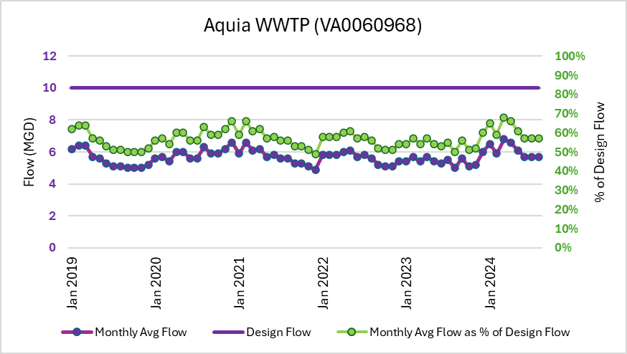
Figure 13. Design flow and flow trends for Aquia Wastewater Treatment Plant (VA0060968) from January 2019 – August 2024. Actual average flow for each month (purple) is compared to design flow (purple). The actual average flow for each month as a percent of the design flow is provided on the secondary vertical axis in green.

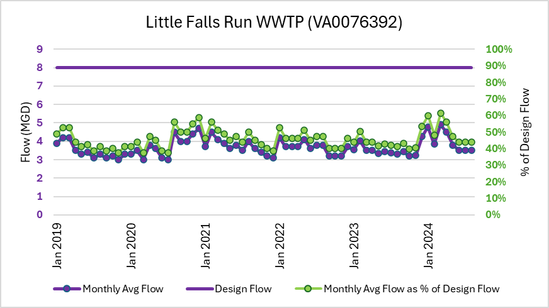
Figure 14. Design flow and flow trends for Little Falls Run WWTP (VA0076392) from January 2019 – August 2024. Actual average flow for each month (purple) is compared to design flow (purple). The actual average flow for each month as a percent of the design flow is provided on the secondary vertical axis in green.
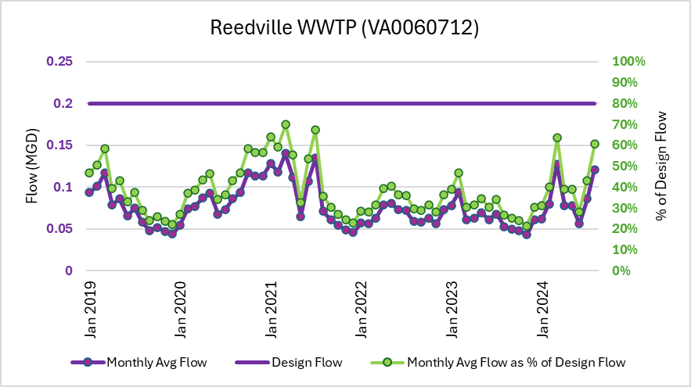
Figure 15. Design flow and flow trends for Reedville WWTP (VA0060712) from January 2019 – August 2024. Actual average flow for each month (purple) is compared to design flow (purple). The actual average flow for each month as a percent of the design flow is provided on the secondary vertical axis in green.

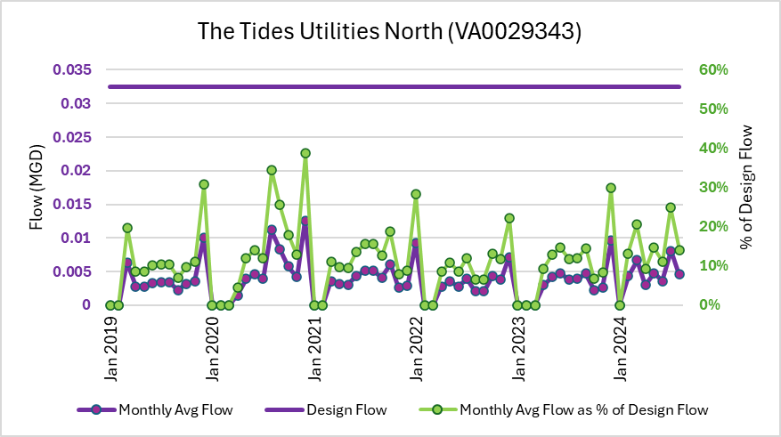
Figure 16. Design flow and flow trends for The Tides Utilities North (VA0029343) from January 2019 – August 2024. Actual average flow for each month (purple) is compared to design flow (purple). The actual average flow for each month as a percent of the design flow is provided on the secondary vertical axis in green.
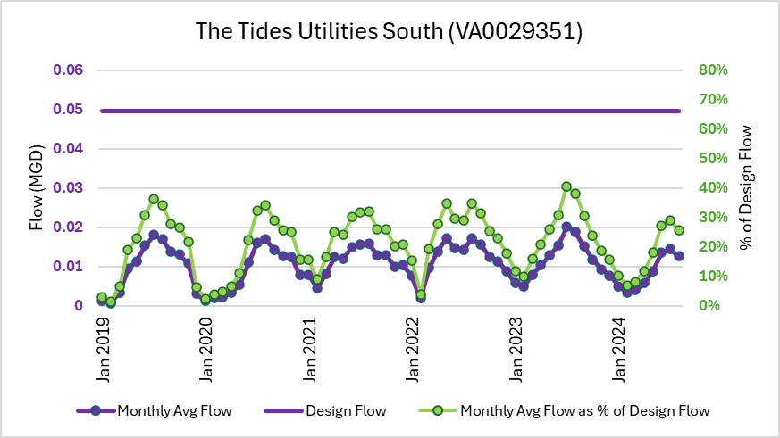
Figure 17. Design flow and flow trends for The Tides Utilities South (VA0029351) from January 2019 – August 2024. Actual average flow for each month (purple) is compared to design flow (purple). The actual average flow for each month as a percent of the design flow is provided on the secondary vertical axis in green.
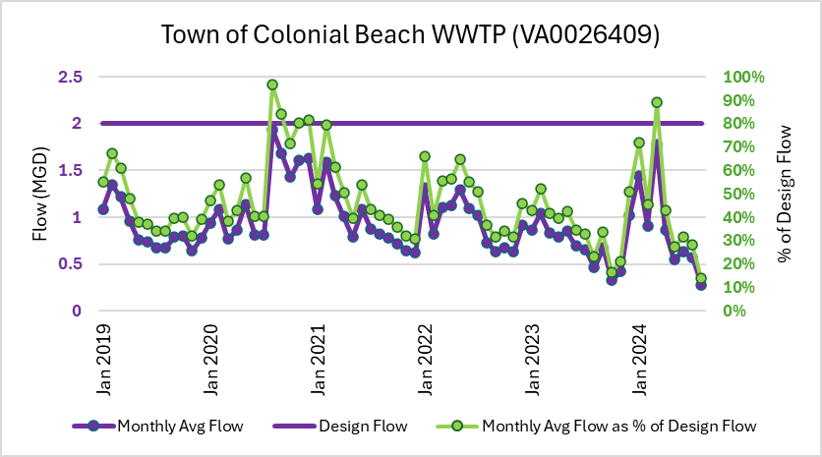
Figure 18. Design flow and flow trends for Town of Colonial Beach WWTP (VA0026409) from January 2019 – August 2024. Actual average flow for each month (purple) is compared to design flow (purple). The actual average flow for each month as a percent of the design flow is provided on the secondary vertical axis in green.
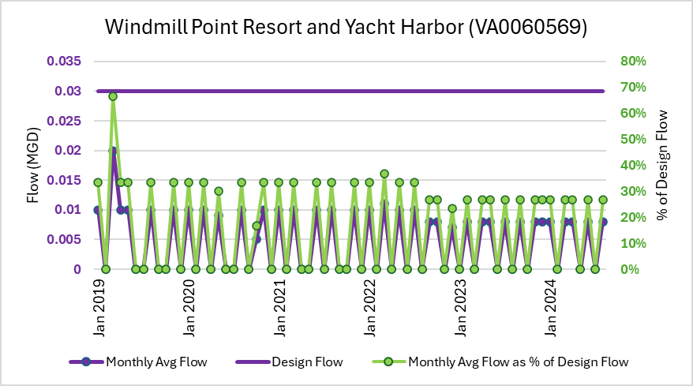
Figure 19. Design flow and flow trends for Windmill Point Resort and Yacht Harbor (VA0060569) from January 2019 – August 2024. Actual average flow for each month (purple) is compared to design flow (purple). The actual average flow for each month as a percent of the design flow is provided on the secondary vertical axis in green.

Estimation of Increased Sewage Volume

The potential increase in volume of vessel sewage due to the implementation of NDZs in the Northern Neck was estimated by using the number of vessels needing to pumpout on a peak weekend (Table 11) and the average number of gallons per pumpout. Using the “Boat Pumpout Expert Panel Report” by the Chesapeake Bay Program (2018) we estimate the average number of gallons per pumpout to be 19 gallons. The number of vessels needing a pumpout on a peak weekend was estimated to be 1262 vessels that would possibly need to pumpout on a peak weekend (Table 12). Multiplying the 19 gallons per pumpout and the total number of vessels on a peak weekend would result in a total of 23,978 gal/peak weekend.

Wastewater Facility Compliance

Of the seven wastewater facilities utilized by pumpout facilities within the Northern Neck two have had recent (5 years) VPDES violations. The Reedville WWTP is currently in compliance with the requirements of a VADEQ consent order. The order requires a civil penalty and plant upgrades. The Town of Colonial Beach WWTP has also had recent VPDES violations and VADEQ’s enforcement program is currently drafting a consent order to establish corrective actions which will bring the facility into compliance.

Vessel Populations

The vessel population potentially visiting the waterbodies included in this application was estimated using Virginia Department of Wildlife Resources (DWR) and the United States Coast Guard (USCG) datasets plus an estimation of transient traffic. The DWR dataset was queried for all vessels used anywhere in the four Northern Neck counties (Richmond, Lancaster, Northumberland, and Westmoreland). The USCG dataset was queried for all vessels with a hailing port located in the same area. Based on the available annual datasets and a desire to avoid timeframes potentially impacted by the COVID pandemic, the year 2019 was selected as the basis for our analysis of vessel traffic. The DWR and USCG datasets were combined so that further analysis included both registered (DWR) and documented (USCG) vessels; doing so likely resulted in a number of vessels being counted twice.
A determination of vessel population requires that those datasets be segregated into size classes based on vessel length because EPA’s NDZ guidance (“Guidance for Vessel Sewage No-Discharge Zone Applications (Clean Water Act Section 312(f))”, May 2023) provides assumptions on vessel sewage management needs based on vessel length. Therefore, the DWR and USCG vessel data was segregated into four size classes as follows:
- Less than 16 feet
- 16 to less than 26 feet
- 26 to less than 40 feet
- Greater than or equal to 40 feet
Table 7 provides a summary of the vessel population in the Northern Neck by vessel length. The following sections and tables within those sections provide further detail of the different vessel populations in the proposed NDZ and how estimations were calculated.

Table 7. Recreational, Transient, and Commercial Vessel population estimates in the Northern Neck.
Vessel Length (ft) | Estimated Number of Recreational Vessels | Estimated Number of Transient Vessels | Estimated Number of Commercial Vessels | Total Number of Vessels
16 to less than 26 | 7510 | 375 | 299 | 8184
26 to less than 40 | 1881 | 393 | 138 | 2412
40+ | 267 | 124 | 57 | 448
Total | 9658 | 892 | 494 | 11044

Recreational Vessels

All recreational vessel owners in Virginia must register their vessels with DWR (with a few minor exceptions). Some recreational vessel owners also choose to document their vessels with the USCG. Table 8 represents the combined estimation of recreational vessels in the Northern Neck

Table 8. Recreational vessel population estimates in the Northern Neck.
Recreational Vessel Length (ft) | Estimated Number of DWR & USCG Vessels
16 to less than 26 | 7510
26 to less than 40 | 1881
40 + | 267
Total | 9658

Transient Vessels

In addition to vessels that are registered with DWR or documented with USCG, transient vessel traffic must be considered in NDZ applications since it is assumed that most waters receive visitors from other parts of the state or from other states. And it is further assumed that a portion of those vessels may require a pumpout. Virginia does not maintain records of transient traffic at each marina therefore, DEQ estimated transient traffic based on the approved NDZ application submitted to EPA by the Maryland Department of Natural Resources (DNR) for Anne Arundel County and the City of Annapolis (“Application for a State Designated, Federally Approved No Discharge Zone for the waters in the City of Annapolis and Anne Arundel County Maryland”; EPA approved 5-11-21; hereafter referred to as AA NDZ). Maryland is VA’s neighboring state and is also located on the Chesapeake Bay so using assumptions from the AA NDZ for transient traffic is reasonable, with the caveat that it is very likely that the Northern Neck waters experience significantly less transient traffic that the much more developed areas of Anne Arundel County and the City of Annapolis (also known as “The Nation’s Sailing Capital”.)
Vessel traffic in the Northern Neck waters was estimated by combining DWR and USCG data with an estimation of transient traffic. A breakdown of DEQ’s method is provided below. Note that the total vessel count does not include vessels in the < 16-foot size class under the assumption that those vessels would not require a pumpout.
- The number of non-transient vessels using the Northern Neck waters was calculated by adding together the DWR registered vessels and the USCG documented vessels for each size class.
- Using the information provided in the AA NDZ application, VA DEQ calculated a ratio of transient vessels in Anne Arundel and Annapolis to non-transient vessels in Anne Arundel and Annapolis for each of the three vessel size classes. Following are the resulting ratios:
  - 16-26 feet (calculated ratio = 0.050)
  - 26-40 feet (calculated ratio = 0.209)
  - Greater than or equal to 40 feet (calculated ratio = 0.466)
- Under an assumption that the Northern Neck experiences a similar ratio of transient vessels to non-transient vessels as experienced in Anne Arundel and Annapolis, DEQ applied the ratios calculated in ‘B’ to the Northern Neck vessel counts estimated in ‘A’ for each size class.
- The total number of vessels was then estimated by adding together the number of non-transient vessels in the Northern Neck (‘A’) with the estimated transient vessels in the Northern Neck (‘C’) for each size class.
The results of those calculations are presented in Table 9
Table 9. Vessel population estimates in the Northern Neck.
Vessel Length (ft) | Estimated Number of Recreational Vessels | Estimated Number of Transient Vessels | Total Number of Vessels
16 to less than 26 | 7510 | 375 | 7885
26 to less than 40 | 1881 | 393 | 2274
40+ | 267 | 124 | 391
Total | 9658 | 892 | 10550

Commercial Vessels

All commercial vessels must be either registered with DWR or documented with USCG. Using this data, we were able to estimate the number of commercial vessels by size (Table 7) and type (Table 10) that may navigate in some of the waters proposed for NDZ designation.
Table 10. Estimated number of commercial vessels in the Northern Neck by Type
Commercial Vessel Type | Estimated Number of Vessels
Fishing | 352
Tug/Barge/Construction | 14
Search and Rescue/Military | 10
Research (University/State Agency) | 6
Passenger Boats (Tours/Ferries/Charters) | 8
Not Specified | 104
Total | 494

Commercial fishing is a significant part of the economy in the Northern Neck. There are primarily two main groups of commercial fishing vessels that can be found in the Northern Neck waters. The first group consists primarily of smaller, shallow-draft vessels that harvest shellfish, crabs, and various types of finfish in the Chesapeake Bay and its tributaries. This group is commonly referred to as “watermen” and “waterwomen”. The watermen and waterwomen typically do not have a marine sanitation device onboard and, instead, either have a bucket onboard which is emptied onshore, or they use onshore restroom facilities. The other group includes the larger fishing vessels that primarily fish offshore and in the Chesapeake Bay. This latter group navigates the Great Wicomico River, Antipoison Creek, and Carter Creek because that is where home ports are located for these larger vessels. Once these vessels leave their docks, they use the subject waters simply to navigate to the larger waterbodies. These vessels typically have holding tanks onboard and either discharge their contents three miles offshore or use their own private pumpout facilities.

Tugboats are defined as those vessels that assist in the maneuvering of other vessels by pushing or pulling them. Tugs are primarily found in Yeocomico River, Indian Creek, and Carter Creek along with a few instances of tug activity in Great Wicomico River. The tugs are primarily owned by one company, Ward Towing, which has a hub in Carter Creek where it docks its vessels while not in use. The tugs currently in use in these waters have MSDs onboard that treat and release however, the company does own tugs with holding tanks so there may be an option to use those tugs in waters designated with an NDZ.

There are three vessels in the Northern Neck area used to ferry passengers across waterways. The Chesapeake Breeze is a large ferry transporting passengers out of Great Wicomico River to Tangier Island located in the Virginia north-central area of Chesapeake Bay. The vessel has a holding tank onboard and uses a pumpout service at Buzzard Point Dry Storage and Marina. The other two ferries are very small ferries both of which can carry a maximum of 6 passengers and 16 tons. Merry Point Ferry crosses the western branch of the Corrotoman River and Sunnybank Ferry crosses Little Wicomico. Due to the short trip length (approximately 10 minutes), the vessels do not have bathroom facilities onboard.

Two large research vessels have occasionally navigated waters proposed for NDZ designation in the Northern Neck. One of the vessels, owned by Old Dominion University, is 55 feet in length and occasionally visits Northern Neck tributaries, primarily Indian Creek and Great Wicomico River. It has a holding tank onboard which they pumpout at their home dock in Little Creek, Virginia (the Virginia Beach area which is at the southern end of the Chesapeake Bay). The other vessel, owned by the Virginia institute of Marine Science and operated out of Gloucester Point, Virginia (outside of the Northern Neck area, near the mouth of the York River), is 92 feet in length and has a treat-and-release type of marine sanitation device onboard. Because it does not have a holding tank onboard, this vessel would be impacted by the designation of NDZs in that it would either need to be retrofitted with a holding tank or operate in those waters without the use of onboard bathroom facilities.

Nearly all commercial vessels operating within the proposed NDZs have either portable toilets which are emptied at dump stations; holding tanks that are already being pumped out; do not require any type of sewage containment or treatment system onboard and use onshore bathroom facilities; or a treat and release type of MSD on board but typical operations are to transit through the proposed NDZ waters as a means of reaching other waters outside of the NDZ. We therefore estimate that, at most, 10% of commercial vessels would require pumpout services though the actual percentage of vessels is likely less; and less than 1% may be unable to access some of the facilities included in this application. These estimations are based on conversations with vessel or fleet operators or their representatives regarding vessel sewage practices and navigational patterns. It is our understanding that very few commercial vessels would require a pump-out while navigating through the proposed NDZ boundaries of the Northern Neck.

Tribal Vessels

Only one federally and/or state recognized tribe, the Rappahannock Tribe, has lands within the four counties of the Northern Neck. DEQ reached out to the Rappahannock Tribe to ensure they were familiar with the concept of an NDZ, obtain information about their vessel usage, and to seek their input on the implementation of NDZs. Based on the information provided by the tribe we determined that they do not have any vessels that would be impacted by the implementation of an NDZ. The tribe expressed that environmental stewardship is very important to them including the implementation of NDZs along with any other measures that may reduce pollutants in the waters of their homelands.

Adequate Pumpout Facilities

To determine the adequacy of the number of existing pumpout facilities to serve the existing vessel population, DEQ relied on EPA’s NDZ guidance (“Guidance for Vessel Sewage No-Discharge Zone Applications (Clean Water Act Section 312(f)”, May 2023) which provides a method for calculating the proportion of a vessel population which may need a pumpout and a method for calculating the number of vessels that existing pumpout facilities can serve. Calculating the number of vessels potentially needing a pumpout must consider the proportion of the vessel population that may require a pumpout. EPA’s guidance provides assumptions about vessel sewage management needs for each size class of vessel as follows:
- < 16 feet: Vessels would not require a pumpout
- 16-26 feet: 20% of vessels would require pumpout
- 26-40 feet: 50% of vessels would require pumpout
- >= 40 feet: 100% of vessels would require pumpout
These percentage assumptions likely exceed the actual percentage of vessels requiring a pumpout within the Northern Neck proposed NDZs. However, these percentages are used to demonstrate that there are adequate pumpout facilities in the proposed NDZ area even with an overestimation of vessels that may require a pumpout. Table 11 provides the step-by-step method for calculating the number of vessels potentially requiring a pumpout in the Northern Neck waters.
Table 11. Steps to calculate the total number of vessels that may require a pumpout.
Step | Step Description for Vessels | Result
1 | Total number of vessels greater than or equal to 16 ft & less than 26 ft | 7885
2 | Percent of vessel of those vessels with MSDs (assume 20% if unknown) | 20%
3 | Number of vessels greater than or equal to 16 ft & less than 26 ft with MSD (multiply results from steps 1 and 2) | 1577
4 | Total number of vessels greater than or equal to 26 ft & less than 40 ft | 2274
5 | Percent of those vessels with MSDs (assume 50% if unknown) | 50%
6 | Number of vessels greater than or equal to 26 ft & less than 40 ft with MSDs (multiply results from steps 4 and 5) | 1137
7 | Total number of vessels greater than or equal to 40 ft | 391
8 | Percent of those vessels with MSD (use 100% if unknown) | 100%
9 | Number of vessels greater than or equal to 40 ft with MSDs (multiply results from steps 7 and 8) | 391
11 | Total number of commercial vessels | 494
12 | Percent of commercial vessels that may need to use a pumpout facility | 10%
13 | Total number of commercial vessels that may need a pumpout | 50
10 | Total number of vessels potentially requiring a pumpout (add results from steps 3, 6, 9, and 13) | 3155

Determining the adequacy of existing pumpout facilities necessitates an estimation of how many of those vessels may be in use simultaneously since not all vessels are in use every day. To be conservative, EPA includes in its guidance an assumption that 40% of vessels will be used on a peak weekend, for example, a July 4th weekend. Table 12 provides this calculation and the resulting number of vessels potentially needing a pumpout. Note that commercial vessels are included in the calculation shown in Table 12. That result will be compared to the number of vessels that existing pumpout facilities can service on a peak weekend in Table 13. As shown in Table 11, the estimated total number of commercial vessels that may need a pumpout is 50 (based on an estimation that 10% of the commercial vessel population may need a pumpout.) Less than 40% of those vessels would require a pumpout on a weekend however, the calculation in Table 12 does not discriminate between commercial and recreational vessels and thus 40% usage on a peak weekend is applied to commercial vessels as well.
Table 12. Calculation of the number of vessels that may require a pumpout on a peak-use summer weekend.
Calculation Description | Result
Total number of vessels with MSD (from Table 11) | 3155
Peak occupancy rate (e.g. peak holiday weekend) (assume 40% if unknown) | 40%
Estimated number of vessels needing pumpout service on a holiday weekend (multiply the first two steps together) | 1262

The next step in the process is to determine how many vessels can be serviced by existing pumpout facilities. This step considers pumpout facilities that are open to the public and available during a “peak use” weekend. So, it will not include Indian Creek Country & Yacht Club, a private facility located on Indian Creek, though it is open 24 hours per day on weekends for its members. This calculation includes the assumption that any one pumpout facility can service four vessels per hour. The number of vessels served by each pumpout facility is then calculated by multiplying the number served per hour by the number of hours the pumpout is open for use on a peak weekend. The number of vessels served by each pumpout facility is combined to estimate the total number of vessels that can be serviced on a peak weekend in the Northern Neck waters (Table 13).

Table 13. Calculation of the number of vessels that may be served by existing pumpout facilities. “Served/Hr” is the number of vessels that can serviced at a pumpout facility per hour. “Hrs. of Operation” is the total number of hours the facility is available for pumpout during a peak-use weekend. “Number of Vessels Served” is calculated by multiplying “Served/Hr” by “Hrs. of Operation”.
Marina | Map ID | Served/Hr. | Hrs. of Operation | Number of Vessels Served
Blue Compass Marina at Horn Harbor | CB-3 | 4 | 13 | 52
Buzzard Point Dry Storage | CB-7 | 4 | 17 | 68
Carter’s Cove Marina | RAP-3 | 4 | 16 | 64
Chesapeake Boat Basin | CB-10 | 4 | 16 | 64
Coan River Marina | POT-9 | 4 | 4.5 | 18
Cockrell’s Marine Railway | CB-12 | 4 | 24 | 96
Coles Point Marina | POT-6 | 4 | 14 | 56
Colonial Beach yacht Center | POT-5 | 4 | 12 | 48
Fairport Marina | CB-8 | 4 | 16 | 64
Ingram Bay Marina | CB-4 | 4 | 16 | 64
Jenning’s Boat Yard | CB-5 | 4 | 4 | 16
Lewisetta Marina | POT-10 | 4 | 20 | 80
Monroe Bay & Winkie Doodle Marinas | POT-7 | 4 | 24 | 96
Olverson’s Lodge Creek Marina | POT-8 | 4 | 15 | 60
Reedville Marina | CB-11 | 4 | 16 | 64
Smith Point Marina | CB-2 | 4 | 16 | 64
Stepp’s Harbor View Marina | POT-2 | 4 | 16 | 64
The Boat House Marina | POT-3 | 4 | 8 | 32
Tides Inn & Lodge | RAP-6 | 4 | 22 | 88
Tiffany Yacht Company | CB-6 | 4 | 4.5 | 18
Whelan’s Marina & Campground | RAP-7 | 4 | 5 | 20
White Point Marina | POT-4 | 4 | 19 | 76
Windmill Point Marina | RAP-2 | 4 | 24 | 96
Yankee Point Marina | RAP-5 | 4 | 22 | 88
Total vessels served |  |  |  | 1456

Finally, the number of vessels potentially needing a pumpout is compared to the number of vessels that may be served by existing pumpout facilities. Results are presented below and indicate that there are an adequate number of existing pumpout facilities to service the vessel population of the Northern Neck.
Number of vessels potentially needing a pumpout: | 1262
Existing pumpout vessel service capacity | 1456

The current pumpout vessel service capacity was calculated to be 1,456 vessels on a peak weekend. The number of vessels potentially needing to pumpout upon NDZ designation was calculated to be 1,262 vessels on a peak weekend. Thus, there are adequate pumpout facilities within the proposed NDZ even when using high vessel count estimates.
A discussion of the adequacy of pumpout facility locations necessitates an understanding of vessel traffic in the waters proposed for NDZ designation. DWR and USCG datasets provide information about the general area (e.g. county) in which a vessel is reported to be used or where a vessel’s home port is located. Those datasets cannot provide a spatial characterization of actual navigational patterns however, the Automated Identification System (AIS) can. AIS is a maritime navigation safety system that most types of commercial vessels are required to install and operate per USCG regulations (Federal Regulations Title 33 Section 164.46). The system tracks information such as vessel identity, position, and heading, among other data with land-based or satellite stations which receive signals automatically and continually sent from vessels housing AIS onboard. Many recreational vessels choose to install AIS for navigational purposes and because of the real-time information and mapping of surrounding vessel traffic that is provided by the system. The systems are most common on recreational vessels of sufficient size to safely navigate from one waterway to another such as, for example, from Carter Creek to the Rappahannock River to the Corrotoman River (see Figures 1-4).) This is relevant because recreational vessels of that size are more likely to have a Marine Sanitation Device (MSD) onboard and therefore, potentially require pumpout services.
The Mid-Atlantic Regional Council on the Ocean’s (MARCO) Mid-Atlantic Ocean Data Portal uses AIS data to analyze vessel traffic. The MARCO Data Portal allows for visualization of navigational patterns thus providing insight into areas most in need of pumpout facilities. The Data Portal represents a summary of all vessel signals collected through AIS for a given year by processing each vessel datapoint into tracks and summarized in 100-meter grid cells. Each cell then represents a summary of vessel transits through that cell during a one-year period. The portal displays that information online using a color scale to depict densities within each cell (Figure 12). To avoid timeframes potentially impacted by the COVID pandemic and to be in sync with the year used to estimate vessel traffic in Section 5, DEQ selected to limit a review of traffic patterns in this portal to 2019.
The data presented in the MARCO Portal should be considered with the caveat that, as noted above, it does not represent all vessels visiting the Northern Neck waters since all vessels do not have AIS installed onboard. However, the data do likely provide a good representation of vessel traffic that is of sufficient size to house an MSD and therefore, potentially require pumpout services.

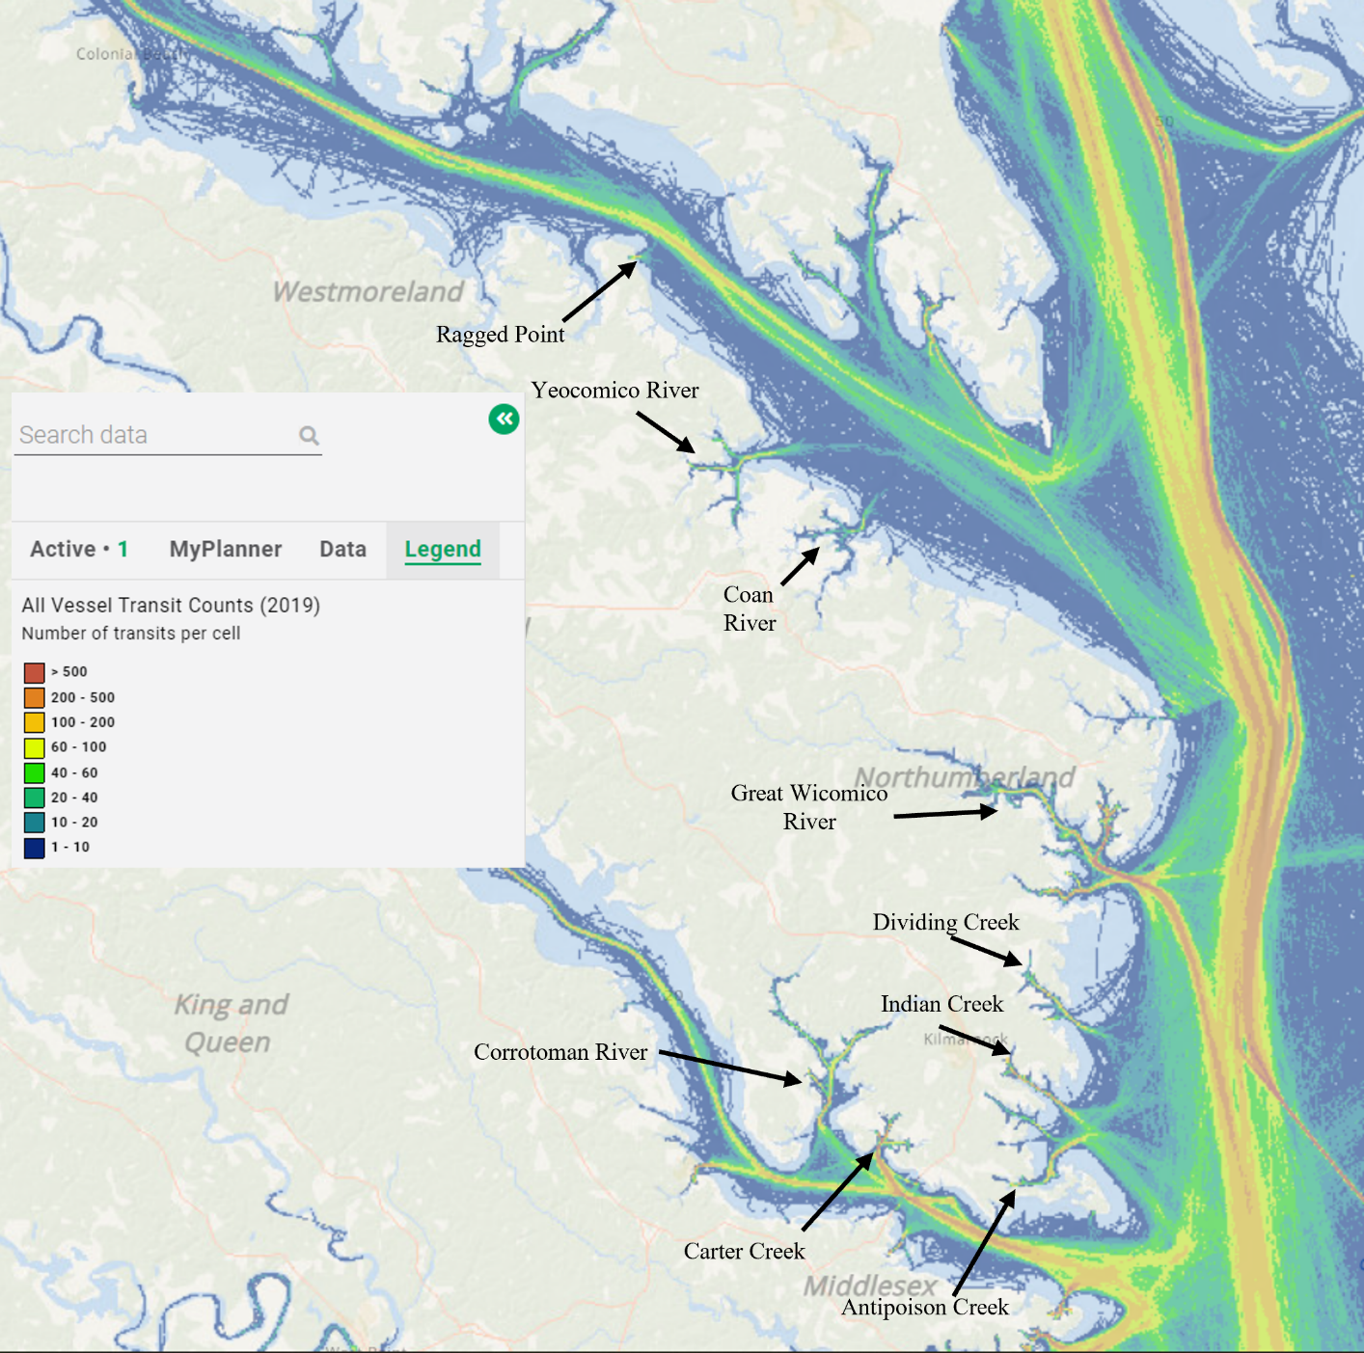
Figure 20. AIS vessel data represented as navigational tracks for the year 2019. Highest densities are noted with yellow, orange, and red.
An examination of vessel densities and navigational patterns according to the color scale provided by the Portal reveals that the waters in the Northern Neck experiencing the majority of traffic are the Great Wicomico River, Indian Creek, Carter Creek, and Corrotoman River, and to a lesser extent, Ragged Point, Yeocomico River, Coan River, Dividing Creek, and an area near the mouth of Antipoison Creek with the remaining waters seeing the least amount of traffic (Figure 12). Pumpout facilities (Figures 1-4) are located in those waters with the majority of traffic with the exception of Dividing Creek and Antipoison Creek. Because the near-shore land-uses in both Dividing and Antipoison Creeks is primarily agriculture and light residential with little other infrastructure which would otherwise promote the congregation of vessels, they are primarily used for transit to and from the Bay.
Pumpout facilities are located throughout the Northern Neck region but some of the waters which experience the least amount of traffic do not have a pumpout facility inside the proposed NDZ boundaries. Vessel operators navigating in those waters must either travel to one of the pumpout facilities located in adjacent waters or use a properly functioning MSD Type I or Type II where permissible (outside an NDZ). Those waters are similar to Dividing and Antipoison Creeks in that the near-shore land-uses consist of agriculture, forest, marsh, and light residential with little to no other infrastructure.
Listed below are proposed NDZs without pumpout facilities inside the waterway itself and for which navigable distance to the closest public pumpout facility is greater than five miles. The distance to the closest public facility and the distance to open water are provided for each of those waters. ‘Open water’ in this context is either the Potomac River, Chesapeake Bay, or the Rappahannock River. Because the open-waters are outside of the proposed NDZs, proper use of well-functioning MSD Type I and MSD Type II (treat and release devices) is permissible. The MARCO Data Portal was used to determine the upstream extent to which most vessels were observed in 2019. Distances were then measured from that upstream point to the closest public pumpout facility in an adjacent water using water depths as a routing guide to ensure the most realistic route was measured. It is important to note that this distance measured is conservative since most vessels navigating the waters listed below would not navigate as far as that upstream extent.
- Rosier Creek: 1 mile to open water; 6.3 miles to Colonial Beach Yacht Center
- Nomini Creek: 3.2 miles to open water; 8.1 miles to Coles Point Plantation Marina
- Machodoc: 2.1 miles to open water; 6 miles to Coles Point
- Cloverdale: 0.5 miles to open water; 6.9 miles to Ingram Bay Marina
- Dividing Creek: 2.6 miles to open water; 7.5 miles to Chesapeake Boat Basin
- Antipoison: 1.8 miles to open water; 6.5 miles to Chesapeake Boat Basin
- Deep Creek: 0.7 miles to open water; 5.5 miles to Whelen’s Marina
- Greenvale Creek: 0.25 miles to open water; 10.9 miles to Yankee Point Marina
The Northern Neck peninsula is a sparsely populated region consisting mostly of forest and agricultural land (Table 14). As a result, it isn’t feasible to establish an economically viable marina in every waterway. In those waterways that lack marinas and other commercial infrastructure (e.g. restaurants, shops), there does not exist a large boating population that lingers for extended periods of time; rather those waterways are used for short-term respite or activities, or for navigation to larger waterbodies. Therefore, “reasonably available” pumpouts in this region may require some boaters to travel to an adjacent waterway should they require pumpout services or to use a well-functioning MSD Type I or Type II in open waters.
Table 14. A summary of land cover in each of the four Northern Neck counties.
County | % Developed | % Open Space/Barren | % Forest/ wetlands | % Agriculture | % Open Water
Westmoreland | 1.1 | 5.2 | 57.4 | 26.7 | 9.6
Northumberland | 0.7 | 5.4 | 55.3 | 25.9 | 12.6
Lancaster | 0.8 | 5.6 | 48.4 | 15.4 | 29.8
Richmond | 0.7 | 3.1 | 61.9 | 22.8 | 11.5

Even though some of the subject waters in this application are not heavily trafficked, NDZs remain an important tool for the improvement and protection of water quality in these waters because of the abundant shellfish grounds, commercial aquaculture leases, oyster restoration areas, and oyster gardens that exist throughout these waters. Common navigational routes in these proposed NDZs are co-located with those important natural resources. Therefore, vessel sewage discharge from even a minor number of vessels (whether sewage is treated with an MSD Type I or II or not) may have a significant impact on water quality in the vicinity of shellfish harvesting areas because that discharge may be direct and proximal to those resources.

Enforcement, Support, and Outreach Activities

The Virginia State Water Control Law (§62.1-44.33) addresses vessel discharges and provides authority for the State Water Control Board to adopt regulations controlling discharges from boats. This section of the law also provides that “Violation of such rules and regulations and violations of the prohibitions created by this section on the discharge of treated and untreated sewage from documented and undocumented boats and vessels shall, upon conviction, be a Class 1 misdemeanor. Every law-enforcement officer of this Commonwealth and its subdivisions shall have the authority to enforce the rules and regulations adopted and promulgated under the provisions of this section and to enforce the prohibitions on the discharge of treated and untreated sewage created by this section.”
The current boating regulation that results from this authority is entitled “Regulations Governing the Discharge of Sewage and Other Wastes from Boats” (9 VAC 25-71). This regulation contains a section that addresses No Discharge Zones:
- All discharge of sewage, whether treated or not, and other wastes from all vessels into designated No Discharge Zones is prohibited. A listing of designated No Discharge Zones within the state appears at 9 VAC 25-71-70.
- Vessels without installed toilets shall dispose of any collected sewage from portable toilets or other containment devices at facilities approved by the Virginia Department of Health for collection of sewage wastes, or otherwise dispose of sewage in a manner that complies with state law.
- Vessels with installed toilets shall have a marine sanitation device to allow sewage holding capacity unless the toilets are rendered inoperable.
- Houseboats having installed toilets shall have a holding tank with the capability of collecting and holding sewage and disposing of collected sewage at a pumpout facility or other facility approved by the Virginia Department of Health for collection of sewage wastes; if a houseboat lacks such capability, the installed toilet shall be removed.
- Y-valves, macerator pump valves, or any other through-hull fitting valves capable of allowing a discharge of sewage from marine sanitation devices shall be secured in the closed position by a device that is not readily removable, including, but not limited to, a numbered container seal, such that through-hull sewage discharge capability is rendered inoperable.
- Every owner or operator of a marina within a designated No Discharge Zone shall notify boat patrons leasing slips of the sewage discharge restriction in the No Discharge Zone. As a minimum, notification shall consist of No Discharge Zone information in the slip rental contract and a sign indicating the area is a designated No Discharge Zone.

8.1 Local Enforcement Capability

Should these waters be designated a No Discharge Zone, in addition to the U.S. Coast Guard, the Virginia Marine Police and the Virginia Department of Wildlife Resources will be the state enforcing authorities however, if needed, any law enforcement officer in Virginia has the authority to enforce an NDZ.
The U.S. Coast Guard Station at St. Inigoes, Maryland (on the St. Marys River), is approximately 8 to 28 nautical miles from the proposed No Discharge Zones waters on the northern half of the Northern Neck area (proposed waters from Rosier Creek to Little Wicomico). The U.S. Coast Guard Station at Milford Haven (on Hills Bay) is approximately 8 to 32 nautical miles from the proposed No Discharge Zone water on the southern half of the Northern Neck (proposed waters Little Wicomico to Farnham Creek.) Both the Virginia Marine Resources Marine Patrol and the Department of Game and Inland Fisheries Game Wardens store boats on land, launching from public facilities in the area to patrol the proposed waters. Additionally, DEQ and VDH-DSS frequent these waters to monitor for pollutants. Both may act as an auxiliary to the state and federal police functions by reporting violations to enforcement authorities.
Upon designation as an NDZ, each marina will be provided with signage to educate the boating public on the importance of pumping out and not discharging sewage waste into the water. House Bill 1943 (which amends and re-enacts 62.1-44.3) states that “…..and (v) every owner or operator of a marina within a designated no discharge zone to notify boat patrons leasing slips of the sewage discharge restriction in the no discharge zone. As a minimum, notification shall consist of no discharge zone information in the slip rental contract and a sign indicating the area is a designated no discharge zone.” DEQ will work with marinas, local stakeholders, and other agencies to ensure that such language is included in leasing agreements and that appropriate signage exists.

8.2 Outreach and Education

DEQ held four public meetings posted in the Virginia Register and Virginia Townhall followed by public comment periods as described below. See Appendix A for summaries of the public comments received from this period.
- Public Meeting held in Richmond County on October 5, 2010; public comment period October 6 to November 8, 2010, and January 18 to February 16, 2011
- Public Meeting held in Lancaster County on February 22, 2011; public comment period from February 23 to April 11, 2011
- Public Meeting held in Northumberland County on May 31, 2011; public comment period from June 1 to June 30, 2011
- Public Meeting held in Westmoreland County on June 14, 2011; public comment period from June 15 to July 15, 2011
Visits to waterfront facilities with pumpout facilities occurred in November and December 2024. During these visits DEQ staff ensured waterfront facilities were familiar with the concept of an NDZ, explained the responsibilities of waterfront facilities and vessel operators within NDZs, obtained updated information about their pumpout facilities and usage, and received feedback from the facilities. Of the 25 facilities visited, 24 provided positive or neutral responses to the implementation of an NDZ.
In addition, DEQ coordinated with EPA, USCG, DWR, VDH, and VMRC and other interested parties during the development of this application. This draft application is a culmination of that coordination as well as modifications to original drafts that were made as a result of public comments received during the public comment periods. No Discharge Zone designations have the support of environmental interests represented by the Friends of the Rappahannock and The Rappahannock Tribe, as well as state agencies of the Commonwealth, including the Virginia Department of Health, the Virginia Marine Resources Commission, and the Virginia Department of Conservation and Recreation.
A public education campaign will be launched after approval and during implementation of the proposed NDZs. The campaign will target boaters, marina owners and operators, and the public in the Northern Neck counties.

9.0 References

2022 305(b)/303(d) Water Quality Assessment Integrated Report 2022 IR.
Chesapeake Bay Program. (2018). Boat Pump-out Expert Panel Report
EMP Industries. SaniSailor Pumpout Systems.
Environmental Protection Agency. Guidance for Vessel Sewage No-Discharge Zone Applications (Clean Water Act Section 312(F)). May 2023.
Maryland Department of Natural Resources. Application for a State Designated, Federally Approved No Discharge Zone for the waters in the City of Annapolis and Anne Arundel County Maryland.
Mid-Atlantic Ocean Data Portal.
United States Coast Guard Documented Vessels Database.
University of Maryland Center for Environmental Science Chesapeake Bay and Watershed Report Card, 2020.
Virginia Department of Health. Shellfish closure dataset.
Virginia Department of Health, Marina Program. Pump-out facilities database.
Virginia Department of Wildlife Resources Boat Registration Database.
Virginia Marine Resources Commission. Shellfish Grounds, Leases, and Gardening Sites dataset.

Appendix A: Summary of Public Comments

DEQ received 60 public comments pertaining to NDZs for the water bodies included in this NDZ application.
Summary of Comments for No Discharge Zone Applications in Lancaster, Northumberland, Richmond, and Westmoreland counties:

Comments Against
The most common comments against the designation of NDZs in these counties included the following:
- Additional regulation, beyond the Clean Water Act prohibition on discharge of untreated sewage, is not needed.
- Better enforcement of the Clean Water Act is all that is needed.
- NDZs cause more pollution, not less. This is due to pumpout system malfunction and illegal dumping by boaters who are unable to find a working pumpout.
- There are an inadequate number of pumpout facilities, especially due to accessibility (e.g. shallow approach depths) and seasonal marina closures (e.g. winter).
- Certain Marine Sanitation Devices (MSDs), such as the Electro Scan, release very clean effluent.
- Based on the Statute, NDZs should be designated in impaired tidal creeks only.

Pertinent DEQ responses include the following:
While it is illegal to discharge raw waste per the Clean Water Act, NDZs elevate the message to the public that dumping is illegal. NDZs are more enforceable because there must be a physical barrier to the y-valve or toilet. This will be visibly apparent to enforcement officers.
The Clean Water Act does not exempt MSDs that perform better than the standard. Because NDZs are only applicable in limited areas, usage of MSD technology is supported by DEQ and may be used in all non-NDZ waters.
EPA guidance is used along with best professional judgment to make the determination on adequate availability of pumpout and dump stations. Certain facilities with shallow approach depths exhibit depths comparable to the surrounding water body. Therefore, larger vessels will not use the waters surrounding these marinas. Larger vessels will be in the mainstem rivers or in deeper water bodies.
DEQ is directed by the Code of Virginia to premise NDZ designations on improvement of impaired tidal creeks. DEQ’s program is primarily premised on addressing tidally influenced areas where water quality is impaired. Federal guidelines also allow States to designate NDZs under the Clean Water if any State determines that the protection and enhancement of the quality of some or all of the waters within such State require greater environmental protection.

Comments in Support
The most common or significant comments supporting the designation of NDZs in these counties included the following:
- MSDs do not sufficiently treat the nutrient load in the waste stream, and they macerate solids to eventually produce a sediment load.
- The problem of incompletely processed sewage by onboard systems is multiplied significantly in the locations where boats are used.
- Boat discharges represent a pollution source that is readily identifiable, undisputable, and solvable at minimal cost relative to other sources.
- The proper management of boat waste is an integral part of protecting these small, shallow tidal coves and the shellfish habitat they provide.
- NDZs must be designated to restore valuable spawning grounds for Perch and Rockfish, as well as shedding grounds for Blue Crabs.
- The proposed boundaries for the Yeocomico River, the Lower Machodoc and the Nomini should be expanded to include existing shellfish beds.
- The proposed boundaries of the NDZs should be to the state line. This will eliminate uncertainty because the state line is a currently-existing boundary.

Pertinent DEQ responses include the following:
While NDZs have historically been used to reduce the bacteria concentrations of shellfish growing waters for protection of human health, DEQ agrees with the rationale that they will also be beneficial by reducing the nutrients and suspended solids which result from MSD Type I/II use.
DEQ agrees that limiting treated vessel sewage can only benefit aquatic life and it is especially important for species consumed by humans.
Due to some comments against NDZ designations in general, DEQ will extend boundaries to the state line only where the extension will specifically extend protection over current or proposed shellfish beds.

