Benthic Stressor Analysis for Horsepen, Little Roanoke, and a UT to Spencer Creek in Charlotte County, Virginia
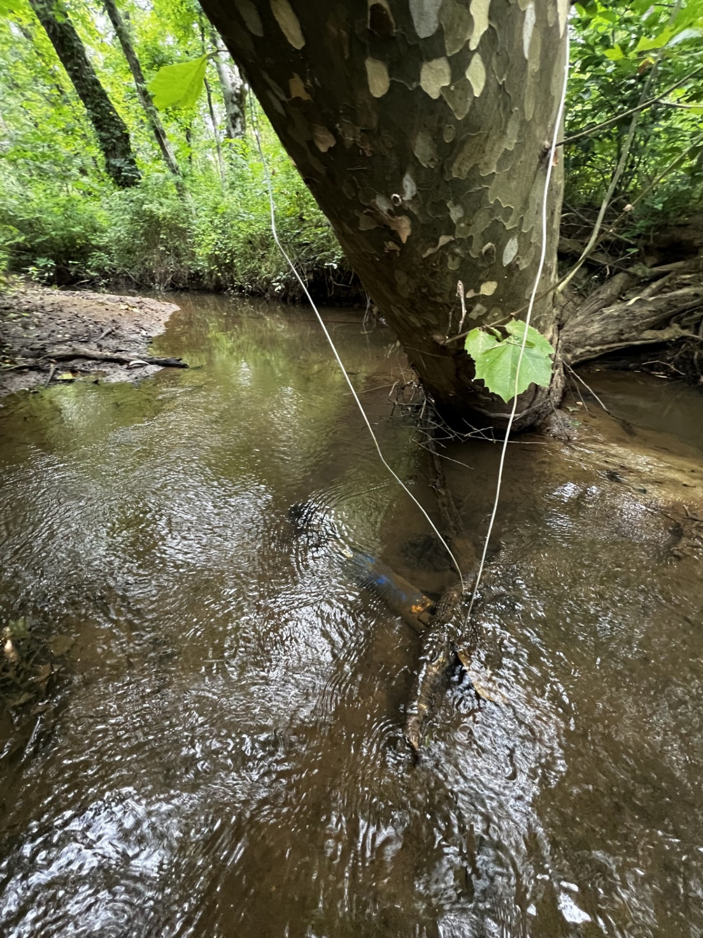
December 2, 2024
Prepared by:
Virginia Department of
Environmental Quality

Table of Contents
Table of Contents 2
List of Tables 4
List of Figures 6
CHAPTER 1: OVERVIEW 9
1.0 Introduction 9
1.1 Applicable Water Quality Standards 9
1.1.2 Impairment Listing 10
1.2 Watershed Characterization 13
1.2.1 Topography 18
1.2.2 Soils 18
1.2.3 Land Use 23
1.2.4 Permitted Facilities 29
1.3 Biological and Water Quality Data 29
1.3.0.1 Published Thresholds for Stressor Effects 30
1.3.1 Biological Monitoring 31
1.3.1.1 Benthic Metrics and Community Composition 35
1.3.1.2 Biological Condition Gradient 36
1.3.1.3 Functional Feeding Groups 38
1.3.2 Habitat Assessment 40
1.3.3 Water Quality Data 48
1.3.3.1 Temperature 49
1.3.3.2 pH 51
1.3.3.3 Dissolved Oxygen 53
1.3.3.4 Conductivity and Dissolved Solids 56
1.3.3.5 Dissolved Ions 58
1.3.3.6 Nutrients 62
1.3.3.7 Metals 66
1.3.3.8 Water Quality Regressions 67
CHAPTER 2: STRESSOR IDENTIFICATION 68
2.0 Causal Analysis 68
2.1 Evidence scoring for spatial co-occurrence 71
2.2 Evidence scoring for temporal co-occurrence 73
2.3 Evidence scoring for causal pathways and mechanistically plausible cause 77
2.4 Evidence scoring for stressor-response relationships from the field and other field studies 83
2.5 Evidence scoring for symptoms 90
2.6 Scoring for consistency of evidence 94
2.7 Summary of the evidence 97
2.7.1 Contributing Factors 98
2.8 TMDL Target Pollutants 99
Works Cited: 100

List of Tables
Table 1. Horsepen Creek, Little Roanoke Creek, and the UT Spencer Creek impaired segments information from DEQ's 2022 303(d)/305(b) Integrated Report (VADEQ, 2022a) and details about the reference stream, Reedy Creek. 11
Table 2. Horsepen Creek, Little Roanoke Creek, and the UT Spencer Creek sampling stations and details about the type and quantity of samples taken. 11
Table 3. Soil Hydrologic Group composition in impaired watersheds. 18
Table 4. The percent of each type of land use in the Horsepen Creek, Little Roanoke Creek, UT to Spencer Creek watersheds (VGIN, 2015). 27
Table 5. The results of a 120-meter buffer created around the streams within the watershed to determine the land use occurring in the riparian area. 28
Table 6. Active permits within the impaired watersheds. 29
Table 7. Average VSCI scores for each impaired station and the reference station, as well as the average VSCI scores for each station within the 2024 assessment window (2017-2022), along with the minimum and maximum recorded scores. 30
Table 8. Metrics used to calculate the Virginia Stream Condition Index (VSCI) (Burton and Gerritsen, 2003). 32
Table 9. VSCI scores for Horsepen Creek, Little Roanoke Creek, UT to Spencer Creek for each season sampled. Orange shaded values indicate the two lowest scores for that station. Red VSCI scores are below the impairment threshold of 60. 34
Table 10. Mid-Atlantic biological condition gradient attributes and stressors evaluated. 37
Table 11. Weighted average biological condition gradient scores by stressor for Horsepen, Little Roanoke, and the UT to Spencer Creeks. 38
Table 12. Biological condition gradient scores by stressor for predominant taxa in Horsepen, Little Roanoke, and the UT to Spencer Creeks. 38
Table 13. Total habitat scores for Horsepen Creek, Little Roanoke Creek, UT to Spencer Creek, and Reedy Creek and the results from a t-test that determined if there is a signifcant difference in each of the impaired stream’s scores compaired to the reference streams score. 41
Table 14. P-Values for each mean habitat parameter score by Horsepen Creek, Little Roanoke Creek, and the UT to Spencer Creek when compared to the reference stream, using t-test with unequal variances. Scores in red indicate a significant difference between the impaired stream and the reference (alpha = 0.05). Habitat parameters denotated with an * indicate components only measured in high gradient streams, the reference stream and the UT to Spencer Creek. 44
Table 15. Stations with a detailed habitat assessment that allows the calculation of LRBS scores, along with LRBS scores, the percent of observed sands and fines substrates, the percent of embeddedness within the streams, and the year the habitat assessment was done. 46
Table 16. Concentrations of metals and hardness sampled from Little Roanoke Creek and the UT to Spencer Creek compared to Virginia Water Quality Criteria for Surface Waters and Aquatic Life (9VAC25-260-140). Calcium, magnesium, barium, beryllium, iron, manganese, thallium, silver, anitmony, and hardness do not have approved criterion for chronic toxicity to aquatic life within the Virginia Administrative Code.. 67
Table 17. Lines of evidence used in the causal analysis approach. 68
Table 18. Scoring criteria for spatial co-occurrence used to evaluate candidate stressors. 71
Table 19. Spatial co-occurrence scores for candidate causes in Horsepen Creek. 72
Table 20. Spatial co-occurrence scores for candidate causes in Little Roanoke Creek. 72
Table 21. Spatial co-occurrence scores for candidate causes in the UT to Spencer Creek. 73
Table 22. Scoring criteria for temporal co-occurrence used to evaluate candidate stressors. 74
Table 23. Temporal co-occurrence scores for candidate causes in Horsepen Creek. 75
Table 24. Temporal co-occurrence scores for candidate causes in Little Roanoke Creek. 76
Table 25. Temporal co-occurrence scores for candidate causes in the UT to Spencer Creek. 77
Table 26. Scoring criteria for causal pathways and mechanistically plausible causation used to evaluate candidate stressors. 78
Table 27. Causal pathway scores for candidate causes in Horsepen Creek. 80
Table 28. Causal pathway scores for candidate causes in Little Roanoke Creek. 81
Table 29. Causal pathway scores for candidate causes in the UT to Spencer Creek. 83
Table 30. Scoring criteria for stressor-response relationships from the field and other field studies used to evaluate candidate stressors. 84
Table 31. Stressor-response relationship scores for each candidate stressor within Horsepen Creek. 86
Table 32. Stressor-response relationship scores for each candidate stressor within Little Roanoke Creek. 88
Table 33. Stressor-response relationship scores for each candidate stressor within the UT to Spencer Creek. 89
Table 34. Scoring criteria for symptoms used to evaluate candidate stressors. 90
Table 35. Stressor symptoms scores for each candidate stressor within Horsepen Creek. 91
Table 36. Stressor symptoms scores for each candidate stressor within Little Roanoke Creek. 93
Table 37. Stressor symptoms scores for each candidate stressor within the UT to Spencer Creek. 94
Table 38. Scoring criteria used to evaluate candidate stressors. 95
Table 39. All scores for each line of evidence and each candidate stressor within Horsepen Creek. 96
Table 40. All scores for each line of evidence and each candidate stressor within Little Roanoke Creek. 96
Table 41. All scores for each line of evidence and each candidate stressor within the UT to Spencer Creek. 97
Table 42. Summary of probable, possible, and non-stressors for Horsepen Creek, Little Roanoke Creek, and the UT to Spencer Creek. 98

List of Figures
Figure 1. Locating map for Horsepen Creek, Little Roanoke Creek, and the UT to Spencer Creek stream segments with aquatic life impairments and VADEQ sampling stations. 11
Figure 2. Map of the Horsepen Creek watershed above the benthic impairment, located in Charlotte County, VA. 14
Figure 3. Map of Little Roanoke Creek watershed above the benthic impairment, located in Charlotte County, VA. 15
Figure 4. Map of the UT Spencer Creek watershed above the benthic impairment, located in Charlotte County, VA. 16
Figure 5. Hydrologic soils groups map of the Horsepen Creek’s watershed, located in Charlotte County, VA. 19
Figure 6. Hydrologic soils groups map of Little Roanoke Creek’s watershed, located in Charlotte County, VA. 20
Figure 7. Hydrologic soils groups map of the UT to Spencer Creek’s watershed, located in Charlotte County, VA. 21
Figure 8. Map of the Horsepen Creek watershed with an overlay of the land uses (VGIN, 2015). 23
Figure 9. Map of the Little Roanoke Creek watershed with an overlay of the land uses (VGIN, 2015). 24
Figure 10. Map of the UT to Spencer Creek watershed with an overlay of the land uses (VGIN, 2015). 25
Figure 11. Functional feeding groups by each impaired stream, Horsepen Creek, Little Roanoke Creek, UT to Spencer Creek, represented by pie charts, compared to pie charts representing the reference stream, Reedy Creek. Each functional feeding group displays the percentage of which it makes up within the observed benthic macroinvertebrate communities. Of the 152 taxa groups collected between all four streams, seven do not have defined feeding groups. Those individuals were left out of this analysis. 38
Figure 12. The average total habitat scores, points, for each impaired stream and the reference stream plotted with the range of observed scores, bars, over the probability ranges for habitat scores indicating habitat being a stressor on the aquatic community. 41
Figure 13. Comparison of total habitat scores with VSCI scores in Horsepen, Little Roanoke, UT to Spencer Creeks, and Reedy Creek. 42
Figure 14. Box and whisker plots comparing individual total habitat score metrics for Horsepen Creek, Little Roanoke Creek, and the UT to Spencer Creek with the reference, Reedy Creek. 44
Figure 15. LRBS scores calculated for each station within the impaired stream segments overlayed with the probability that those scores indicate bed stability is inducing stress to aquatic life. Red indicates a high probability, yellow indicates a medium probability, green indicates a low probability, and blue indicates no probability of calculated relative bed stability causing stress to aquatic life. 46
Figure 16. The linear realtionship between LRBS scores and VSCI scores shown with a scatter plot and regression line. 47
Figure 17. Box-and-whisker plot displaying temperature distributions within Horsepen Creek, Little Roanoke Creek, the UT to Spencer Creek, and Reedy Creek. The red dashed line indicates water quality temperature standard. 49
Figure 18. Continuous monitoring temperature data output from diurnal dissolved oxygen study, Horsepen Creek, Little Roanoke Creek, and the UT to Spencer Creek. Red dashed line indicates water quality temperature standard. 50
Figure 19. Box-and-whisker plot displaying pH distributions within Horsepen Creek, Little Roanoke Creek, the UT to Spencer Creek, and Reedy Creek. This plot overlays color-coded zones of probability, green indicating pH values with a low probability of causing stress to aquatic life, yellow indicating pH values with a medium probability of causing stress to aquatic life. 51
Figure 20. Continuous monitoring pH data output from diurnal dissolved oxygen study, Horsepen Creek, Little Roanoke Creek, and the UT to Spencer Creek. This plot overlays color-coded zones of probability, green indicating pH values with a low probability of causing stress to aquatic life, yellow indicating pH values with a medium probability of causing stress to aquatic life. 52
Figure 21. Box-and-whisker plot displaying dissolved oxygen distributions within Horsepen Creek, Little Roanoke Creek, the UT to Spencer Creek, and Reedy Creek. The red dashed line indicates the water quality dissolved oxygen standard for instantaneous values while the black dashed line indicates the water quality standard for daily average dissolved oxygen. This plot overlays color-coding for ranges of values and their probabilities for causing stress to aquatic life. Red indicates a high probability, yellow indicates a medium probability, green indicates a low probability, and blue indicates no probability of measured dissolved oxygen values causing stress to aquatic life. 53
Figure 22. Continuous moniotring dissolved oxygen data from diurnal dissolved oxygen study, Horsepen Creek, Little Roanoke Creek, and the UT to Spencer Creek. The red dashed line indicates the water quality dissolved oxygen standard for instantaneous values while the black dashed line indicates the water quality standard for daily average dissolved oxygen. This plot overlays color-coding for ranges of values and their probabilities for causing stress to aquatic life. Red indicates a high probability, yellow indicates a medium probability, green indicates a low probability, and blue indicates no probability of measured dissolved oxygen values causing stress to aquatic life. 54
Figure 23. Box-and-whisker plot displaying specific conductivity distributions within Horsepen Creek, Little Roanoke Creek, the UT to Spencer Creek, and the reference stream, Reedy Creek. This plot overlays color-coding for ranges of values and their probabilities for causing stress to aquatic life. Green indicates a low probability and blue indicates no probability of measured specific conductivity values causing stress to aquatic life. 55
Figure 24. Continuous monitoring conductiviy data from diurnal dissolved oxygen study, Horsepen Creek, Little Roanoke Creek, and the UT to Spencer Creek. This plot overlays color-coding for ranges of values and their probabilities for causing stress to aquatic life. Red indicates a high probability, yellow indicates a medium probability, green indicates a low probability, and blue indicates no probability of measured specific conductivity values causing stress to aquatic life. 56
Figure 25. Box-and-whisker plot displaying total dissoleve solids distributions within Horsepen Creek, Little Roanoke Creek, the UT to Spencer Creek, and the reference stream, Reedy Creek. This plot overlays color-coding for ranges of values and their probabilities for causing stress to aquatic life. Green indicates a low probability and blue indicates no probability of measured total dissolved solids values causing stress to aquatic life. 57
Figure 26. Box-and-whisker plot displaying dissolved chloride distributions within Horsepen Creek, Little Roanoke Creek, the UT to Spencer Creek, and the reference stream, Reedy Creek. This plot overlays color-coding for ranges of values and their probabilities for causing stress to aquatic life. Green indicates a low probability and blue indicates no probability of measured dissolved chloride values causing stress to aquatic life. 58
Figure 27. Box-and-whisker plot displaying dissolved potassium distributions within Horsepen Creek, Little Roanoke Creek, the UT to Spencer Creek, and the reference stream, Reedy Creek. This plot overlays color-coding for ranges of values and their probabilities for causing stress to aquatic life. Red indicates a high probability, yellow indicates a medium probability, green indicates a low probability, and blue indicates no probability of measured dissolved potassium values causing stress to aquatic life. 59
Figure 28. Box-and-whisker plot displaying dissolved sodium distributions within Horsepen Creek, Little Roanoke Creek, the UT to Spencer Creek, and the reference stream, Reedy Creek. This plot overlays color-coding for ranges of values and their probabilities for causing stress to aquatic life. Green indicates a low probability and blue indicates no probability of measured dissolved sodium values causing stress to aquatic life. 60
Figure 29. Box-and-whisker plot displaying dissolved sulfate distributions within Horsepen Creek, Little Roanoke Creek, the UT to Spencer Creek, and the reference stream, Reedy Creek. This plot overlays color-coding for ranges of values and their probabilities for causing stress to aquatic life. Blue indicates no probability of measured dissolved sulfate values causing stress to aquatic life. 61
Figure 30. Box-and-whisker plot displaying total nitrogen distributions within Horsepen Creek, Little Roanoke Creek, the UT to Spencer Creek, and the reference stream, Reedy Creek. This plot overlays color-coding for ranges of values and their probabilities for causing stress to aquatic life. Red indicates a high probability, yellow indicates a medium probability, green indicates a low probability, and blue indicates no probability of Total Nitrogen values causing stress to aquatic life. 63
Figure 31. Box-and-whisker plot displaying total phosphorus distributions within Horsepen Creek, Little Roanoke Creek, the UT to Spencer Creek, and the reference stream, Reedy Creek. This plot overlays color-coding for ranges of values and their probabilities for causing stress to aquatic life. Red indicates a high probability, yellow indicates a medium probability, green indicates a low probability, and blue indicates no probability of total phosphorus values causing stress to aquatic life. 64
Figure 32. A conceptual model diagram of the six candidate stressors for the impairments in Horsepen Creek, Little Roanoke Creek, and the UT to Spencer Creek. 69

CHAPTER 1: OVERVIEW

1.0 Introduction
The Clean Water Act requires states to establish water quality standards for all water bodies. These standards consist of a set of designated uses or expectations for a water body and numeric or narrative criteria to ensure that those designated uses can be met. In Virginia, the designated uses are for recreation, swimming & boating, wildlife, aquatic life, fishing, and shellfish. To meet the requirements of the Clean Water Act, Virginia has adopted water quality standards and assesses water quality monitoring data to determine if waterbodies are meeting the adopted standards. Waterbodies not meeting standards, otherwise known as impaired waterbodies, are reported in the Virginia Department of Environmental Quality’s (VADEQ) biennial Integrated Assessment on Virginia’s 303(d) Impaired Waters List or “dirty waters list”.
Horsepen Creek, Little Roanoke Creek, and an unnamed tributary (UT) to Spencer Creek are all located in Charlotte County, Virginia. All three drainages eventually enter Roanoke Creek, which feeds into the Roanoke River. Approximately 5.32 miles of Horsepen Creek is considered impaired for the aquatic life use water quality standard. This impairment comes from various sampling events that have indicated the community of aquatic macroinvertebrates present in that segment of the creek is unhealthy and lacks the diversity and abundance that is to be expected there. Horsepen Creek is impaired from Route 47 to its confluence with Little Horsepen Creek. Approximately 10.16 miles of Little Roanoke Creek and 2.9 miles of the UT to Spencer Creek are considered impaired for the aquatic life use water quality standard as well. Little Roanoke Creek is impaired from its headwaters to its confluence with Dunnavant Creek. The UT to Spencer Creek is impaired from its headwaters to its confluence with Spencer Creek.
The goal of this report is to determine the causes of the aquatic life impairments in Horsepen Creek, Little Roanoke Creek, and the UT to Spencer Creek through a stressor analysis process. Aquatic life impairments are based on assessments of biological indicators of stream heath, the benthic macroinvertebrate community. The cause or causes of an aquatic life impairment are referred to as stressor(s). Biological assessments are effective at determining whether a water body is meeting water quality standards or is impaired; however, they do not provide information on the stressor causing the impairment. The stressor analysis process is a weight-of-evidence approach which uses monitoring data, historical information, and scientific literature to attempt to identify the most likely stressors to the community, and therefore, the cause of the impairment.

1.1 Applicable Water Quality Standards
Virginia’s water quality standards consist of water quality criteria that protect the designated uses of all Virginia waterbodies. According to Virginia’s water quality standards (9 VAC 25-260-10) :
“All state waters, including wetlands, are designated for the following uses:
recreational uses, e.g., swimming and boating; the propagation and growth of a
balanced, indigenous population of aquatic life, including game fish, which might
reasonably be expected to inhabit them; wildlife; and the production of
edible and marketable natural resources, e.g., fish and shellfish.”
Water quality criteria can be numerical or narrative. The General Standard defined in Virginia’s water quality standards (9 VAC 25-260-20) provides general, narrative criteria for the protection of designated uses from substances that may interfere with attainment of such uses. The General Standards states:
“State waters, including wetlands, shall be free from substances attributable
to sewage, industrial waste, or other waste in concentrations, amounts, or
combinations which contravene established standards or interfere directly or
indirectly with designated uses of such water or which are inimical or harmful
to human, animal, plant, or aquatic life.”
A biological impairment of aquatic life in Virginia is based on the biological monitoring and assessment of benthic macroinvertebrate communities. Biomonitoring allows VADEQ to assess the overall ecological condition of streams and rivers by evaluating suitability for support of aquatic communities. In Virginia, benthic macroinvertebrate communities are used as indicators of ecological condition and are one way to determine support for the aquatic life designated use.
A multi-metric macroinvertebrate index, the Virginia Stream Condition Index (VSCI), is used to assess the aquatic life use status for wadable freshwater streams and rivers in non-coastal areas of the state. VSCI scores range from 0 to 100, with higher scores indicating relatively better ecological health. VADEQ has set a score of 60 as the threshold for impairment. Scores below 60 indicate an impaired biological community, while scores above 60 indicate a healthy biological community (VDEQ 2016 Assessment Guidance) .

1.1.2 Impairment Listing
Horsepen Creek drains 21.1 square miles, Little Roanoke Creek drains 35.2 square miles, and the UT to Spencer Creek drains 1.5 square miles of multiuse lands. While these watersheds vary in size, they are similar in that they all drain mostly forested and pastured land in the Piedmont region. All three streams are impaired for the aquatic life use. Horsepen Creek was first listed on Virginia’s 303(d) Report in 2008, based on biomonitoring in 2007. Horsepen Creek is impaired from Route 47 to its confluence with Little Horsepen Creek. Little Roanoke Creek was first listed on Virginia’s 303(d) Report in 2010 based on biomonitoring in 2007. Little Roanoke Creek is impaired from its headwaters to its confluence with Dunnavant Creek. The UT to Spencer Creek was first listed on Virginia’s 303(d) Report in 2014 for an aquatic life use impairment based on biomonitoring in 2012. The UT to Spencer Creek is impaired from its headwaters to its confluence with Spencer Creek. VADEQ has conducted follow-up monitoring at several stations within the impaired reaches in preparation for the stressor identification process.
All three drainages eventually enter Roanoke Creek, which feeds into the Roanoke River. The confluence of Roanoke Creek with the Roanoke River is approximately 65 miles upstream of where the Roanoke River exits Virginia and enters North Carolina, where it will then make its way to the Atlantic Ocean. Table 1 lists the impaired and reference stream segments and Table 2 provides details on the stations where samples were collected. Figure 1 shows the locations of the impaired segments. Both tables also include information for Reedy Creek, in neighboring Halifax County, Virginia. This creek is referenced throughout this report as a reference site of similar circumstance but with a healthier benthic macroinvertebrate community. Reedy Creek is also in the Roanoke River drainage and Piedmont region. It drains 2.08 square miles of forested and agricultural lands.
The same segments of Horsepen Creek, Little Roanoke Creek, and the UT to Spencer Creek are also listed on the 303(d) report for bacteria impairments; however, the Bacteria TMDLs for the Cub Creek, Turnip Creek, Buffalo Creek, Buffalo Creek (UT), and Staunton River Watersheds was completed in 2006 to address this impairment.

Table 1. Horsepen Creek, Little Roanoke Creek, and the UT Spencer Creek impaired segments information from DEQ's 2022 303(d)/305(b) Integrated Report (VADEQ, 2022a) and details about the reference stream, Reedy Creek.
Stream Name | County | VAHUC 6 | Assessment Units | Impairment Cause Group Code | First Listed | Stream Segment Length (miles)
Horsepen Creek | Charlotte Co. | RU85 | VAW-L39R_HEN02A04 | L39R-03-BEN | 2008 | 5.32
Little Roanoke Creek | Charlotte Co. | RU81 | VAW-L39R_LRO02A10 | L39R-07-BEN | 2010 | 10.16
UT Spencer Creek | Charlotte Co. | RU81 | VAW-L39R_XVO01A14 | L39R-09-BEN | 2014 | 2.90
Reedy Creek | Halifax Co. | RU80 | VAW-L38R_RDD01A22 | N/A | N/A | 4.77

Table 2. Horsepen Creek, Little Roanoke Creek, and the UT Spencer Creek sampling stations and details about the type and quantity of samples taken.
Stream Name | Station | Benthic Sampling |  | Water Quality Sampling
 |  | Monitoring Period | Samples Collected | Monitoring Period | Samples Collected
Horsepen Creek | 4AHEN004.27 | 2009-2022 | 15 | 2009-2022 | 32
Little Roanoke Creek | 4ALRO010.18 | 2012-2022 | 13 | 2012-2022 | 44
 | 4ALRO010.68 | 2007 | 2
 | 4ALRO010.88 | 2022 | 2 | 2022 | 3
UT Spencer Creek | 4AXVO000.50 | 2012-2022 | 18 | 2012-2022 | 12
 | 4AXVO000.60 |  |  | 2019-2020 | 17
Reference Watershed Station
Reedy Creek | 4ARDD002.09 | 2020-2021 | 4 | 2020-2021 | 4

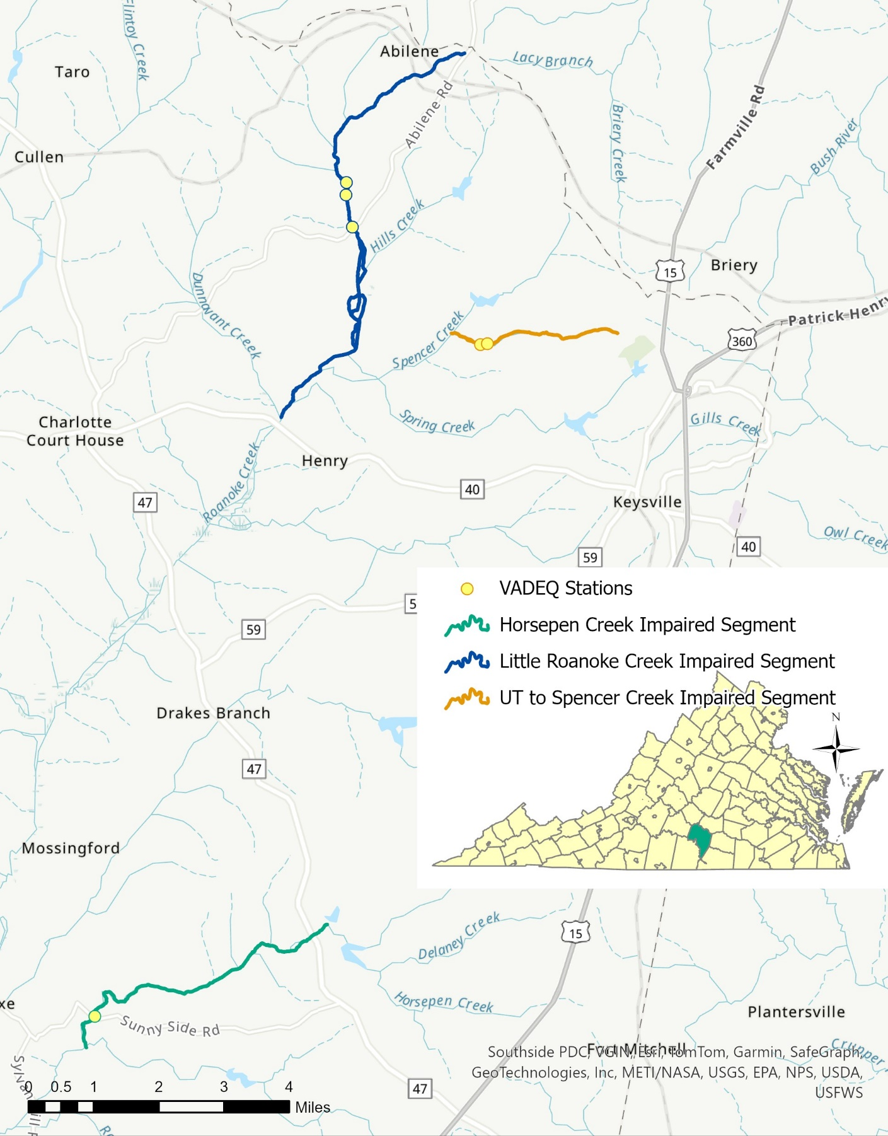

Figure 1. Locating map for Horsepen Creek, Little Roanoke Creek, and the UT to Spencer Creek stream segments with aquatic life impairments and VADEQ sampling stations.

1.2 Watershed Characterization
The physical characteristics of the Horsepen Creek, Little Roanoke Creek, and the UT to Spencer Creek watersheds were calculated using Geographic Information Systems. Land use/cover, soil characteristics, topography, and existing permits within the Horsepen Creek, Little Roanoke Creek, and UT to Spencer Creek watersheds are described below because they help inform the relative processes affecting the watersheds and aquatic life.
These three watersheds are all within Charlotte County, Virginia. Charlottle County has a rich history of agriculture which is still prevalent today. Lying in the center of Virginia’s piedmont region, these watersheds can be characterized by rolling hills of historically productive lands, some of which are still farmed and managed for logging today. While the county is sparsely populated, these three watersheds are neighbored by three towns. These towns are the Town of Charlotte Court House, Town of Drakes Branch, and Town of Keysville. The town of Charlotte Court House is the county seat of Charlotte County.
Horsepen Creek drains 13,500 acres of land, south of the Town of Drakes Branch (Figure 2). From its headwaters to the confluence with Little Horsepen Creek, there are more than 128 miles of stream that make up this watershed. The Horsepen Creek watershed is presently forested but has experienced abundant historical agriculture and logging activities. The entirety of the Horsepen Creek watershed is in the Carolina Slate Belt ecoregion which is often characterized by irregular plains with low rounded ridges and shallow ravines that have been historically used for pasture and timber production.
There are multiple small, private reservoirs within the watershed. Two of these are named, Horseshoe Lake and Roanoke Creek Site 61a Lake. Horseshoe Lake is created by an earthen impoundment on Horsepen Creek and Roanoke Creek Site 61a Lake is also created by an earthen impoundment, but on an unnamed tributary to Horsepen Creek. The surrounding lands are mostly forested, just like most of the watershed.
Little Roanoke Creek drains 22,500 acres of land north of Route 40, between the Towns of Charlotte Court House and Keysville (Figure 3). From its headwaters to the confluence with Dunnavant Creek, Little Roanoke Creek flows for 10.16 miles. There are more than 100 miles of contributing streams to the Little Roanoke Creek watershed before the confluence with Dunnavant Creek. The Little Roanoke Creek watershed is mostly forested but pastured land is also prevalent. The Little Roanoke Creek watershed is in the Northern Outer Piedmont ecoregion which is often characterized by irregular plains and some low rounded hills and ridges. The land was historically used for pasture, timber production, and tobacco production.
There are multiple impounded reservoirs in the Little Roanoke Creek Watershed. These reservoirs are all privately owned and operated. Four of the reservoirs are named, Four Locusts Lake, Keysville Reservoir, Roanoke Creek Site 68 Lake, and Roanoke Creek Site 67 Lake. Four Locusts Lake, adjacent to Briery Country Club, is in the headwaters of Spring Creek, a tributary to Little Roanoke Creek. Downstream, on Spring Creek, is the earthen-impounded Keysville Reservoir. This reservoir historically served as the public water supply for the Town of Keysville. The other two named reservoirs are on the impounded tributaries of Hills Creek and Spencer Creek.
Spencer Creek is a tributary of Little Roanoke Creek and one of the unnamed tributaries of Spencer Creek is the third stream of interest in this report. This tributary drains 962 acres of the eastern portion of the Little Roanoke Creek watershed (Figure 4). The greater characterization of the Little Roanoke Creek watershed is also true for the UT to Spencer Creek’s watershed. The UT drains mostly forested land but with almost a quarter of its surrounding lands being pasture. There are a few small, private ponds in this watershed, however, no major impoundments on the UT or its small tributaries.
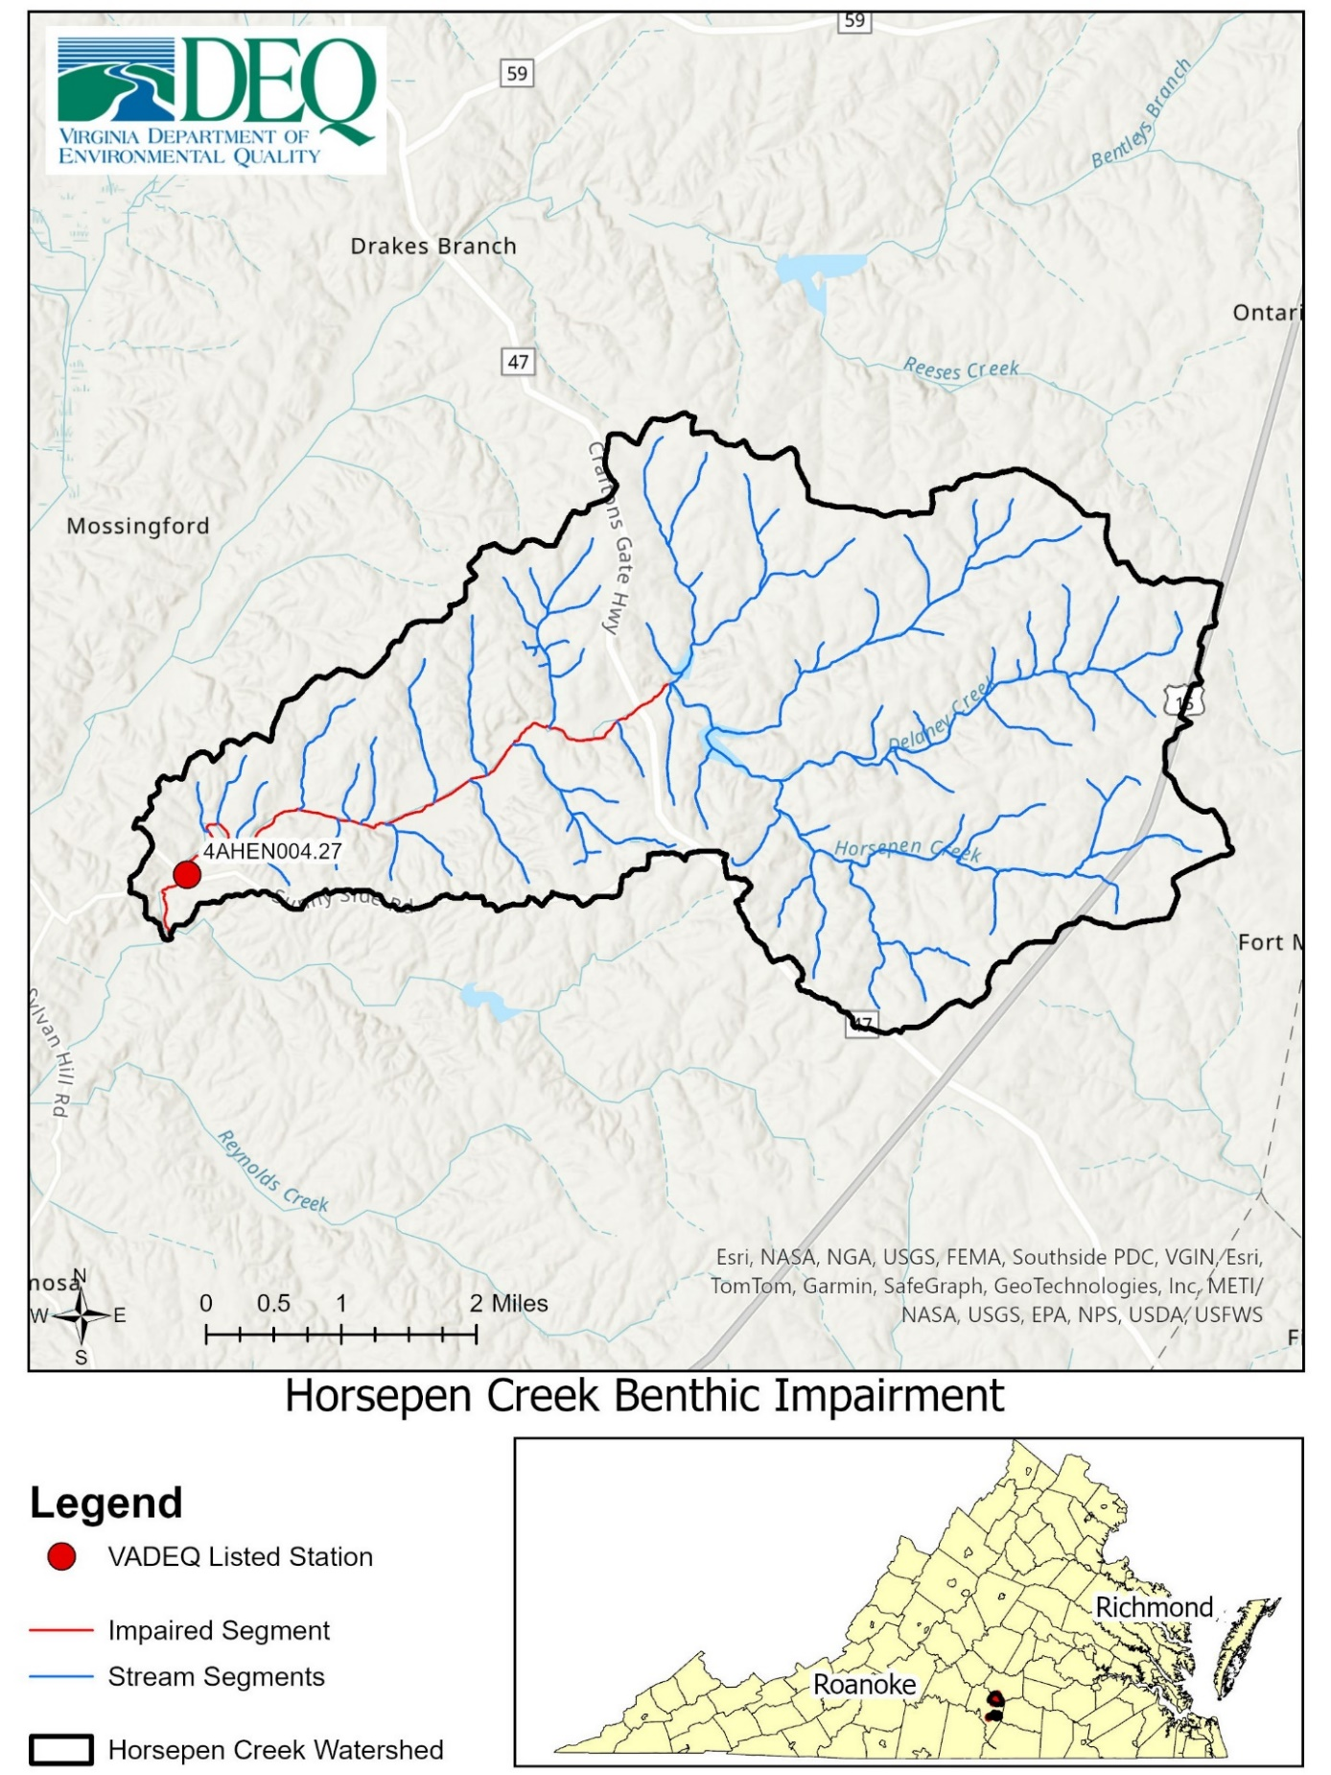

Figure 2. Map of the Horsepen Creek watershed above the benthic impairment, located in Charlotte County, VA.
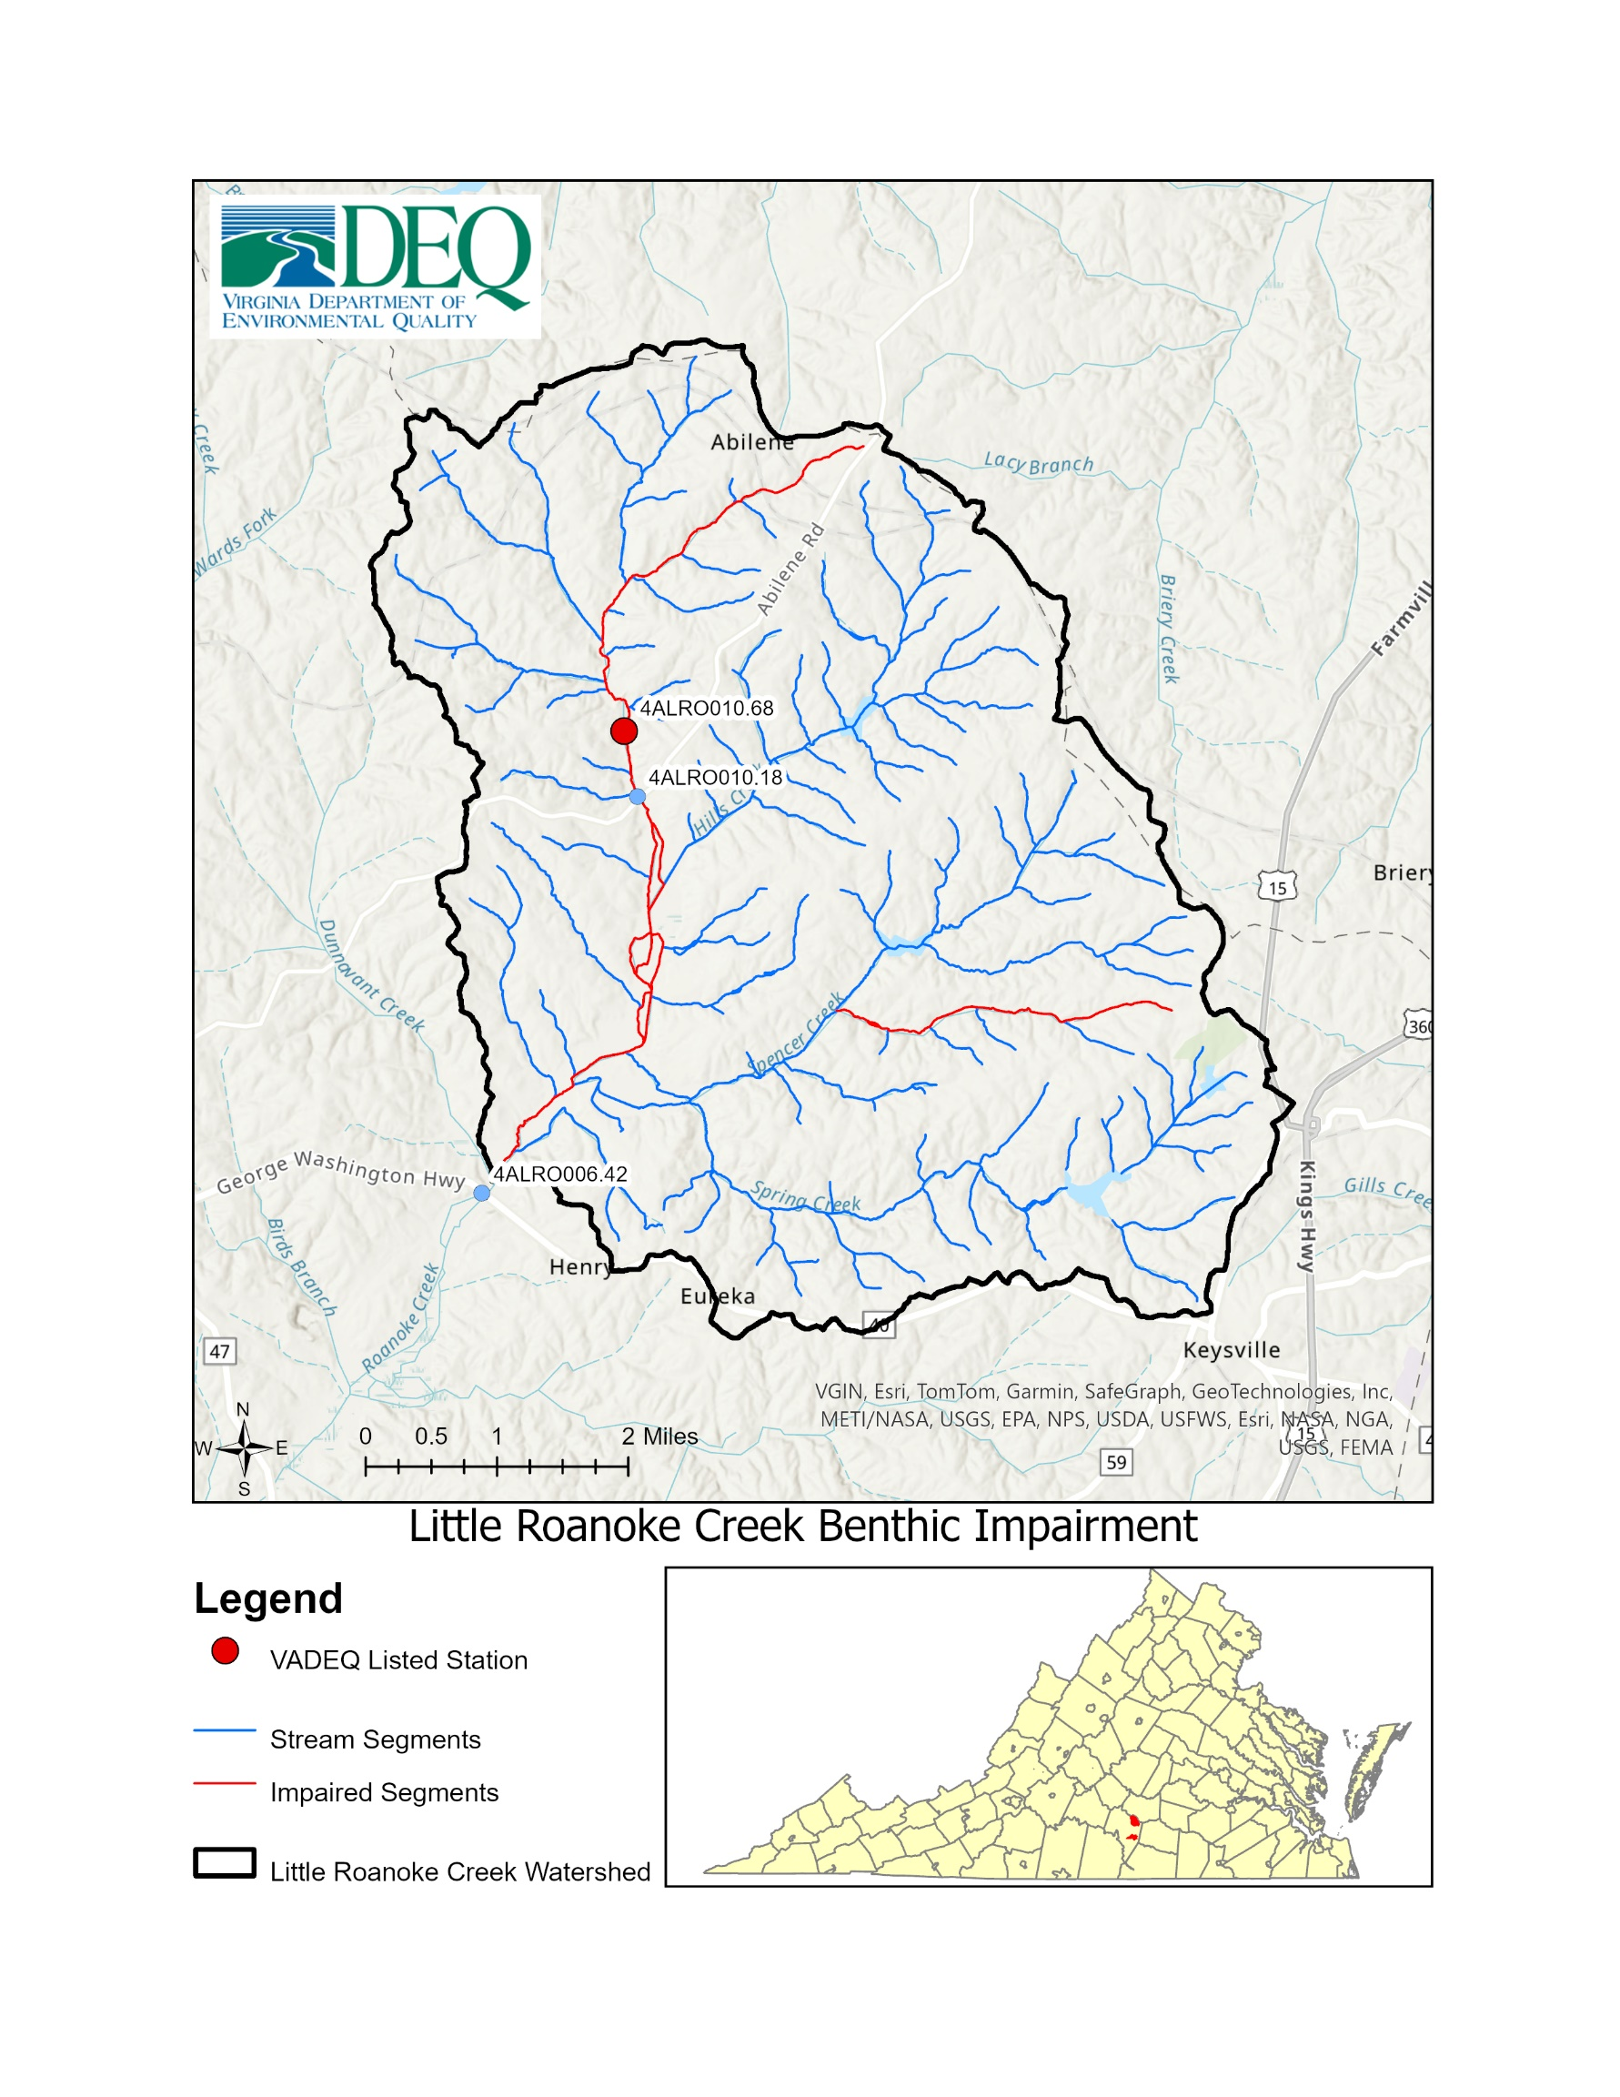
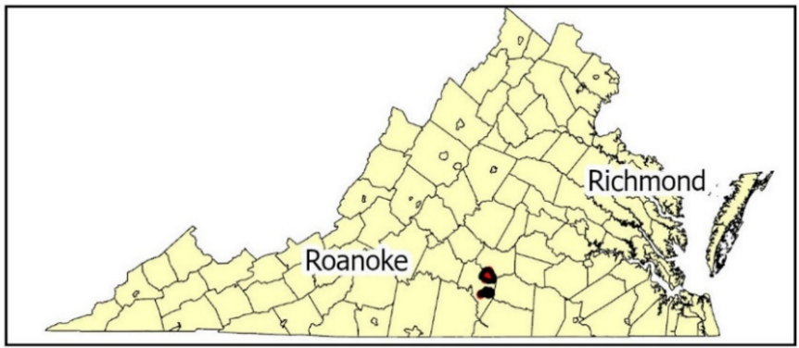

Figure 3. Map of Little Roanoke Creek watershed above the benthic impairment, located in Charlotte County, VA.
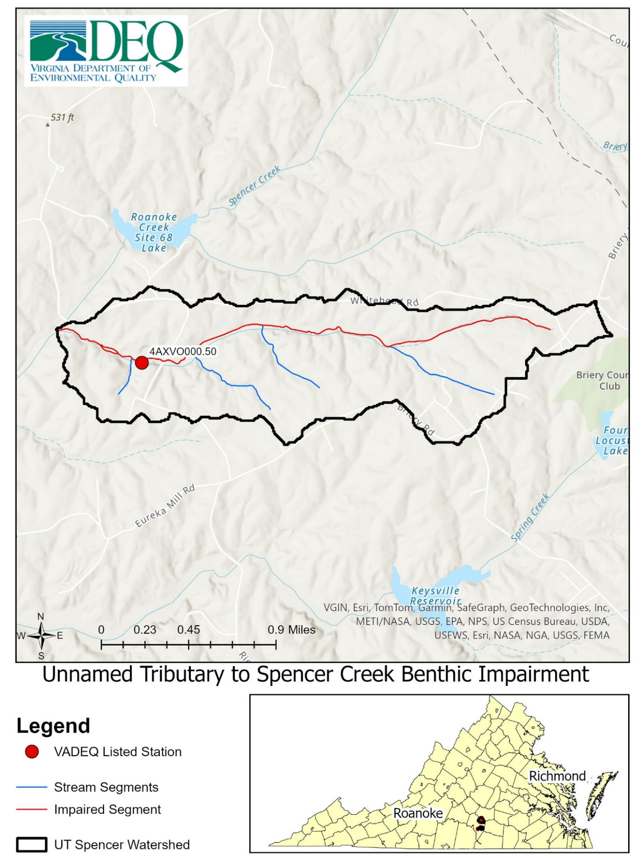

Figure 4. Map of the UT Spencer Creek watershed above the benthic impairment, located in Charlotte County, VA.

1.2.1 Topography
Elevation was calculated in the USGS StreamStats application using the National Elevation Dataset (NED). The Horsepen Creek watershed elevation ranged between 337.8 feet to 621.7 feet above mean sea level, with an elevation average of 489.4 feet. The Little Roanoke Creek watershed elevation ranged between 369.6 to 633.5 feet above mean sea level, with an elevation average of 502.5 feet. The UT to Spencer Creek watershed elevation ranged between 404 to 633.1 feet above mean sea level, with an elevation average of 522 feet. All three watersheds are very similar in topography and elevation. They can be described as areas with rolling hills, shallow valleys, and of low relief.

1.2.2 Soils
Composition of hydrologic soil groups were described in the Horsepen Creek, Little Roanoke Creek, and the UT to Spencer Creek watersheds using the Soil Survey Geographic (SSURGO) database (NCRS, 2015). Hydrologic soil groups represent the infiltration characteristics of soils, where a Hydrologic Group “A” represents soils that have high infiltration rates and Hydrologic Group “D” represents soils that have slow infiltration rates. Soils that have slower infiltration rates are more susceptible to greater erosion rates because rainwater will runoff the land quicker instead of infiltrating. The soil in the Horsepen Creek watershed was comprised of mostly group “B” (77.54%) with “C/D” (8.84%) soils being the next most prevalent (see Figure 5). That indicates that most of the watershed can be described as having moderate infiltration rates and with some areas of slower infiltration rates as well. The soil in the Little Roanoke Creek and UT to Spencer Creek watersheds are also mostly comprised of group “B” (66.13% and 80.47%, respectively) (see Figure 6 and Figure 7). The soil hydrologic groups indicate that soils drain moderately well in the watersheds. None of the three watersheds have more than 2% of the group “A” soils (Table 3). The soils along these creeks are moderately susceptible to erosion which can contribute to streambed sedimentation.

Table 3. Soil Hydrologic Group composition in impaired watersheds.
 |  | Horsepen Creek |  | Little Roanoke Creek |  | UT Spencer Creek
Hydrologic Group | Descriptions | Acreage | Percent of Total | Acreage | Percent of Total | Acreage | Percent of Total
A | High infiltration rates. Soils are deep, well-drained to excessively drained sand and gravels. | 125.55 | 0.93% | 426.45 | 1.9% | 4.4 | 0.46%
B | Moderate infiltration rates. Deep and moderately deep, moderately well and well-drained soils with moderately coarse textures. | 10,470 | 77.54% | 14,871.18 | 66.13% | 774.31 | 80.47%
B/D | The first letter is the hydrologic group if drained, and the second letter represents the natural condition | 939.54 | 6.96% | 1,803.13 | 8.02% | 68.83 | 7.15%
C | Moderate to slow infiltration rates. Soils with layers impeding downward movement of water or soils with moderately fine or fine textures. | 284.95 | 2.11% | 1,299.74 | 5.78% | 19.53 | 2.03%
C/D | The first letter is the hydrologic group if drained, and the second letter represents the natural condition | 1,193.94 | 8.84% | 1,551.35 | 6.9% | 17.66 | 1.84%
D | Very slow infiltration rates. Soils are clayey, have a high-water table, or shallow to impervious cover. | 330.17 | 2.45% | 2,014.78 | 8.96% | 60.28 | 6.26%
Not Rated or not Available |  | 158.12 | 1.17% | 522.74 | 2.32% | 17.21 | 1.79%

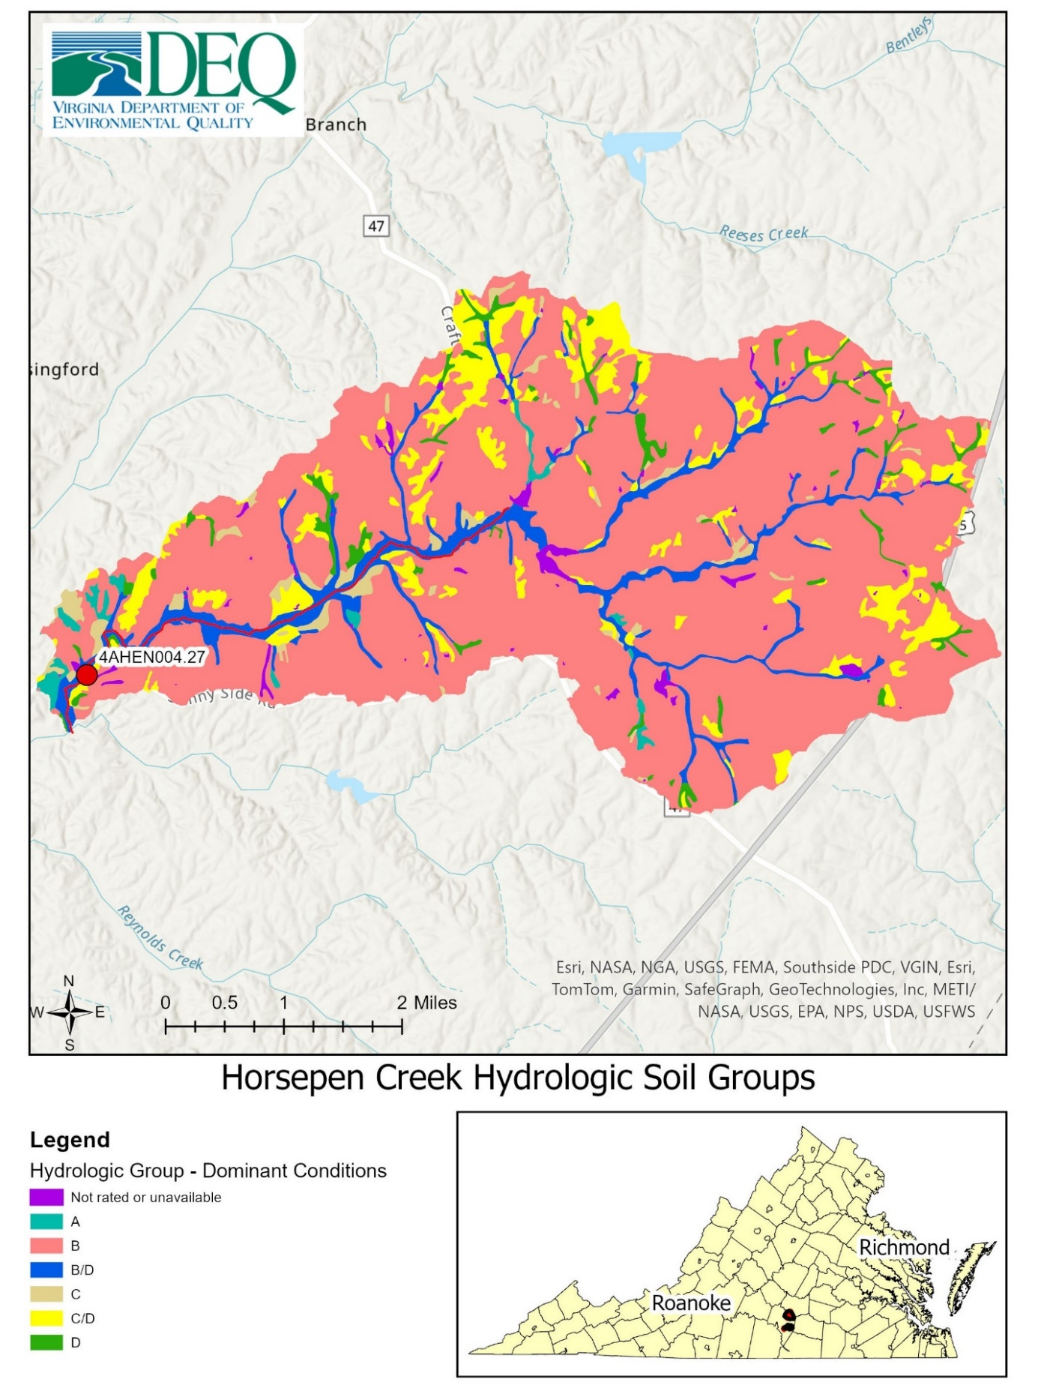

Figure 5. Hydrologic soils groups map of the Horsepen Creek’s watershed, located in Charlotte County, VA.

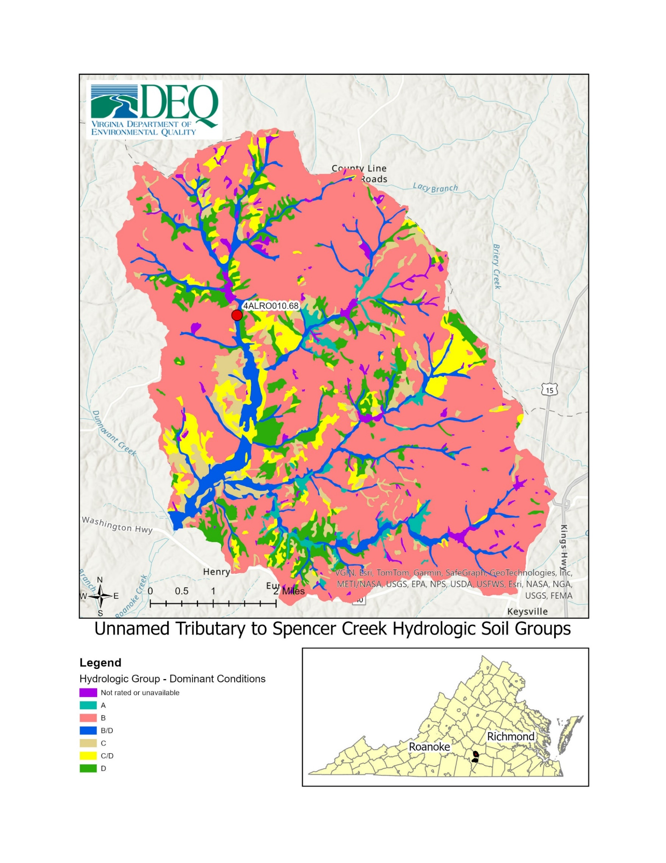

Figure 6. Hydrologic soils groups map of Little Roanoke Creek’s watershed, located in Charlotte County, VA.

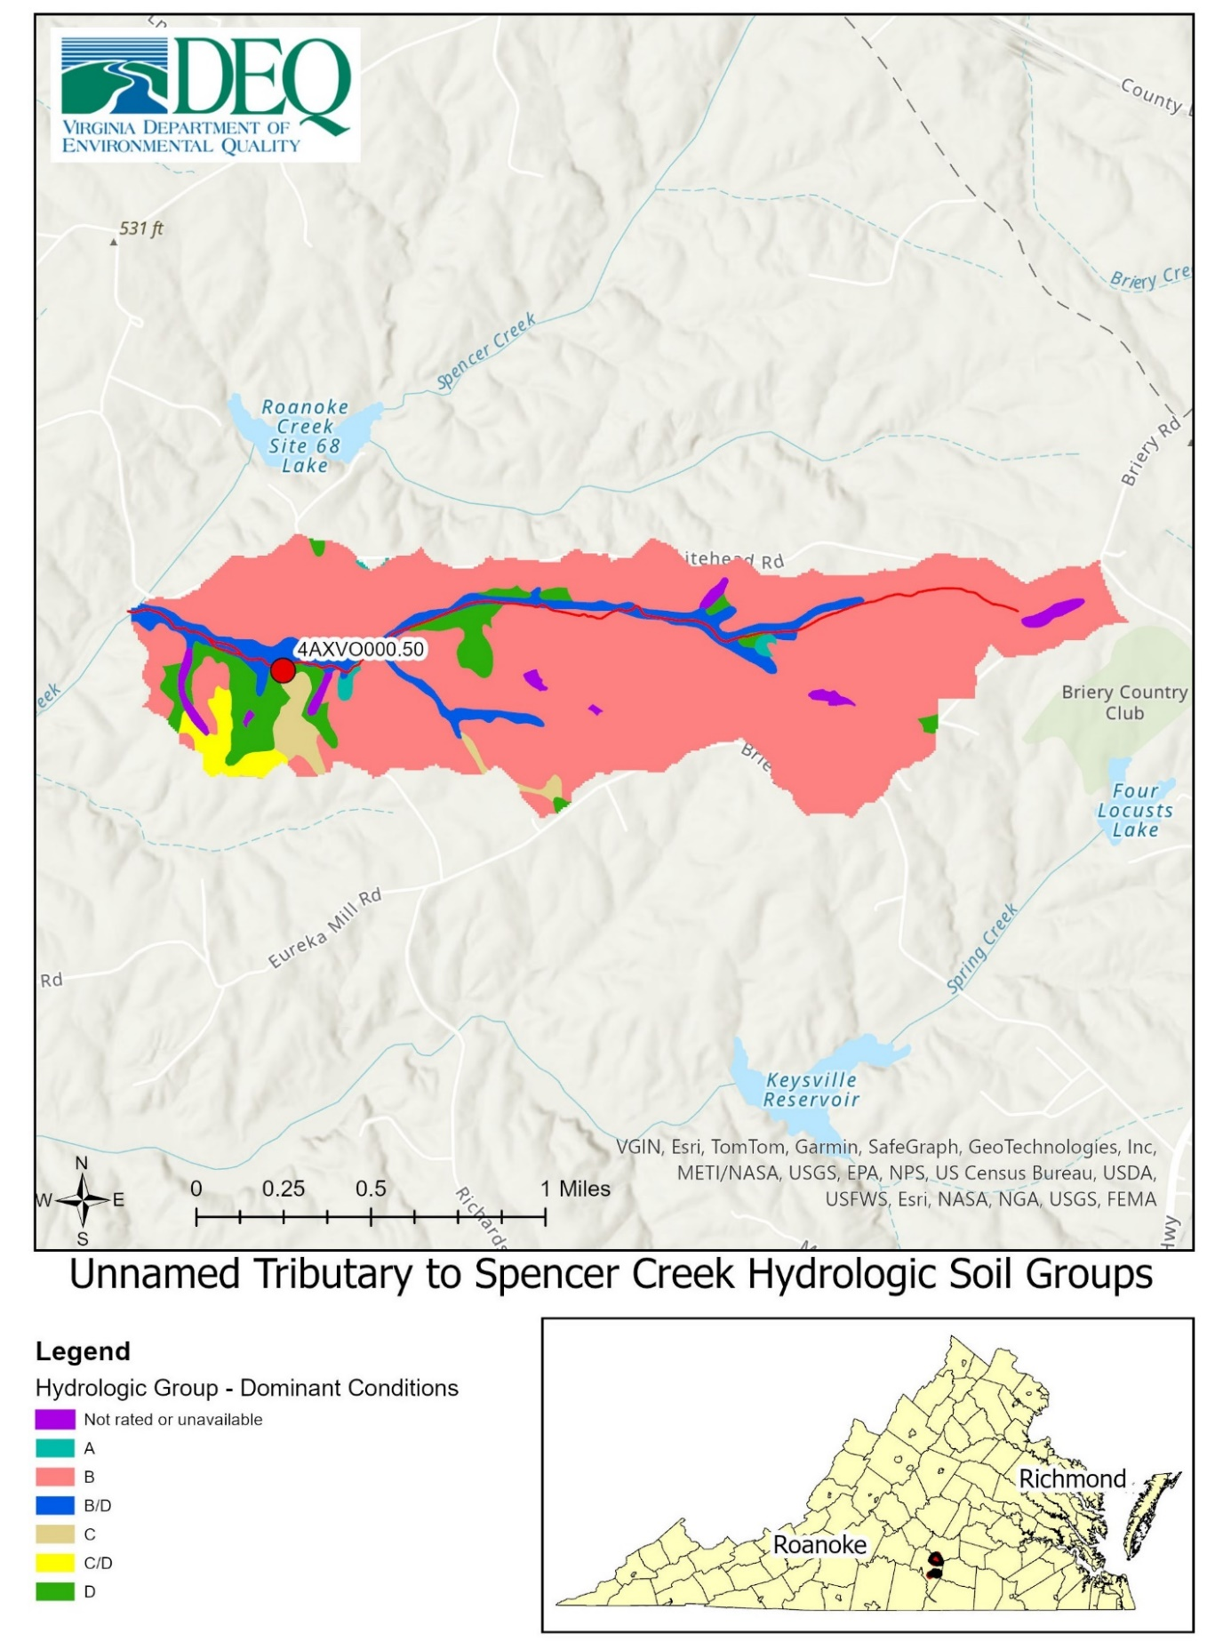

Figure 7. Hydrologic soils groups map of the UT to Spencer Creek’s watershed, located in Charlotte County, VA.

1.2.3 Land Use
The Virginia Geographic Information Network Land Cover Dataset (VGIN, 2015) was used to calculate land use in the three watersheds of interest (Table 4). The Horsepen Creek watershed is approximately 68% forest and 12% pastured (Figure 8). The Little Roanoke Creek watershed is approximately 59% forested, and 14% pastured (Figure 9). The UT to Spencer Creek is approximately 55% forested and 24% pastured (Figure 10). A 120-meter buffer around the streams was applied to look at land use directly adjacent to the streams (Table 5). There was a small change in the land use percentages, but forested and pastured land still dominated the most common land uses. Forest cover increased slightly, and pastured land decreased slightly in the 120-meter buffer compared to the entire watersheds. This is consistent with the historical and current regional industries. This region has long been characterized by logging and livestock production. These areas are sparsely populated and that is reflected by the land uses commonly attributed to urbanization coming in well under 10% for of all the watersheds.

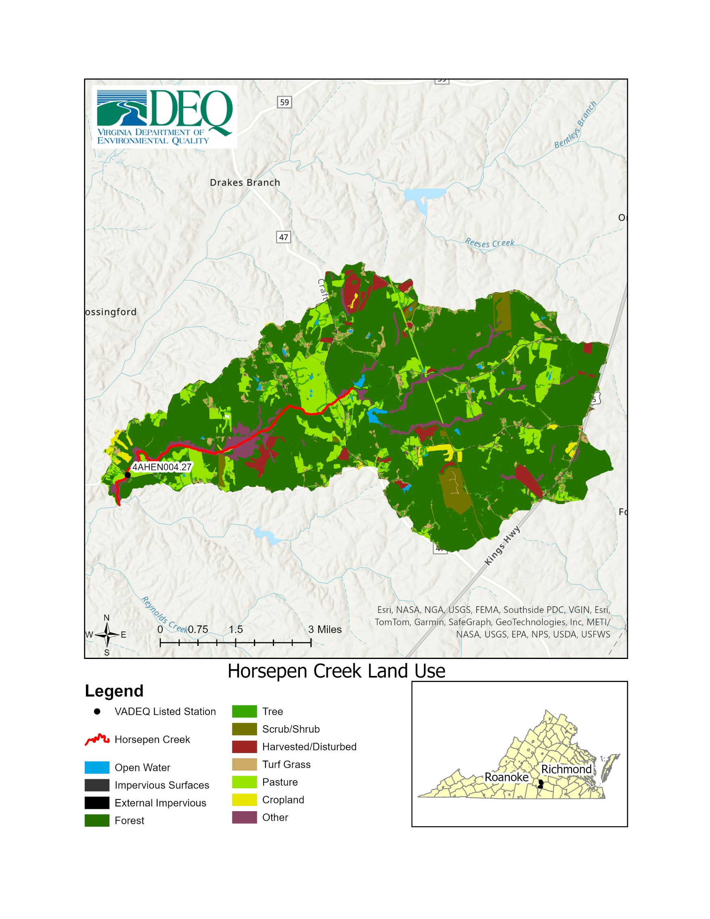

Figure 8. Map of the Horsepen Creek watershed with an overlay of the land uses (VGIN, 2015).
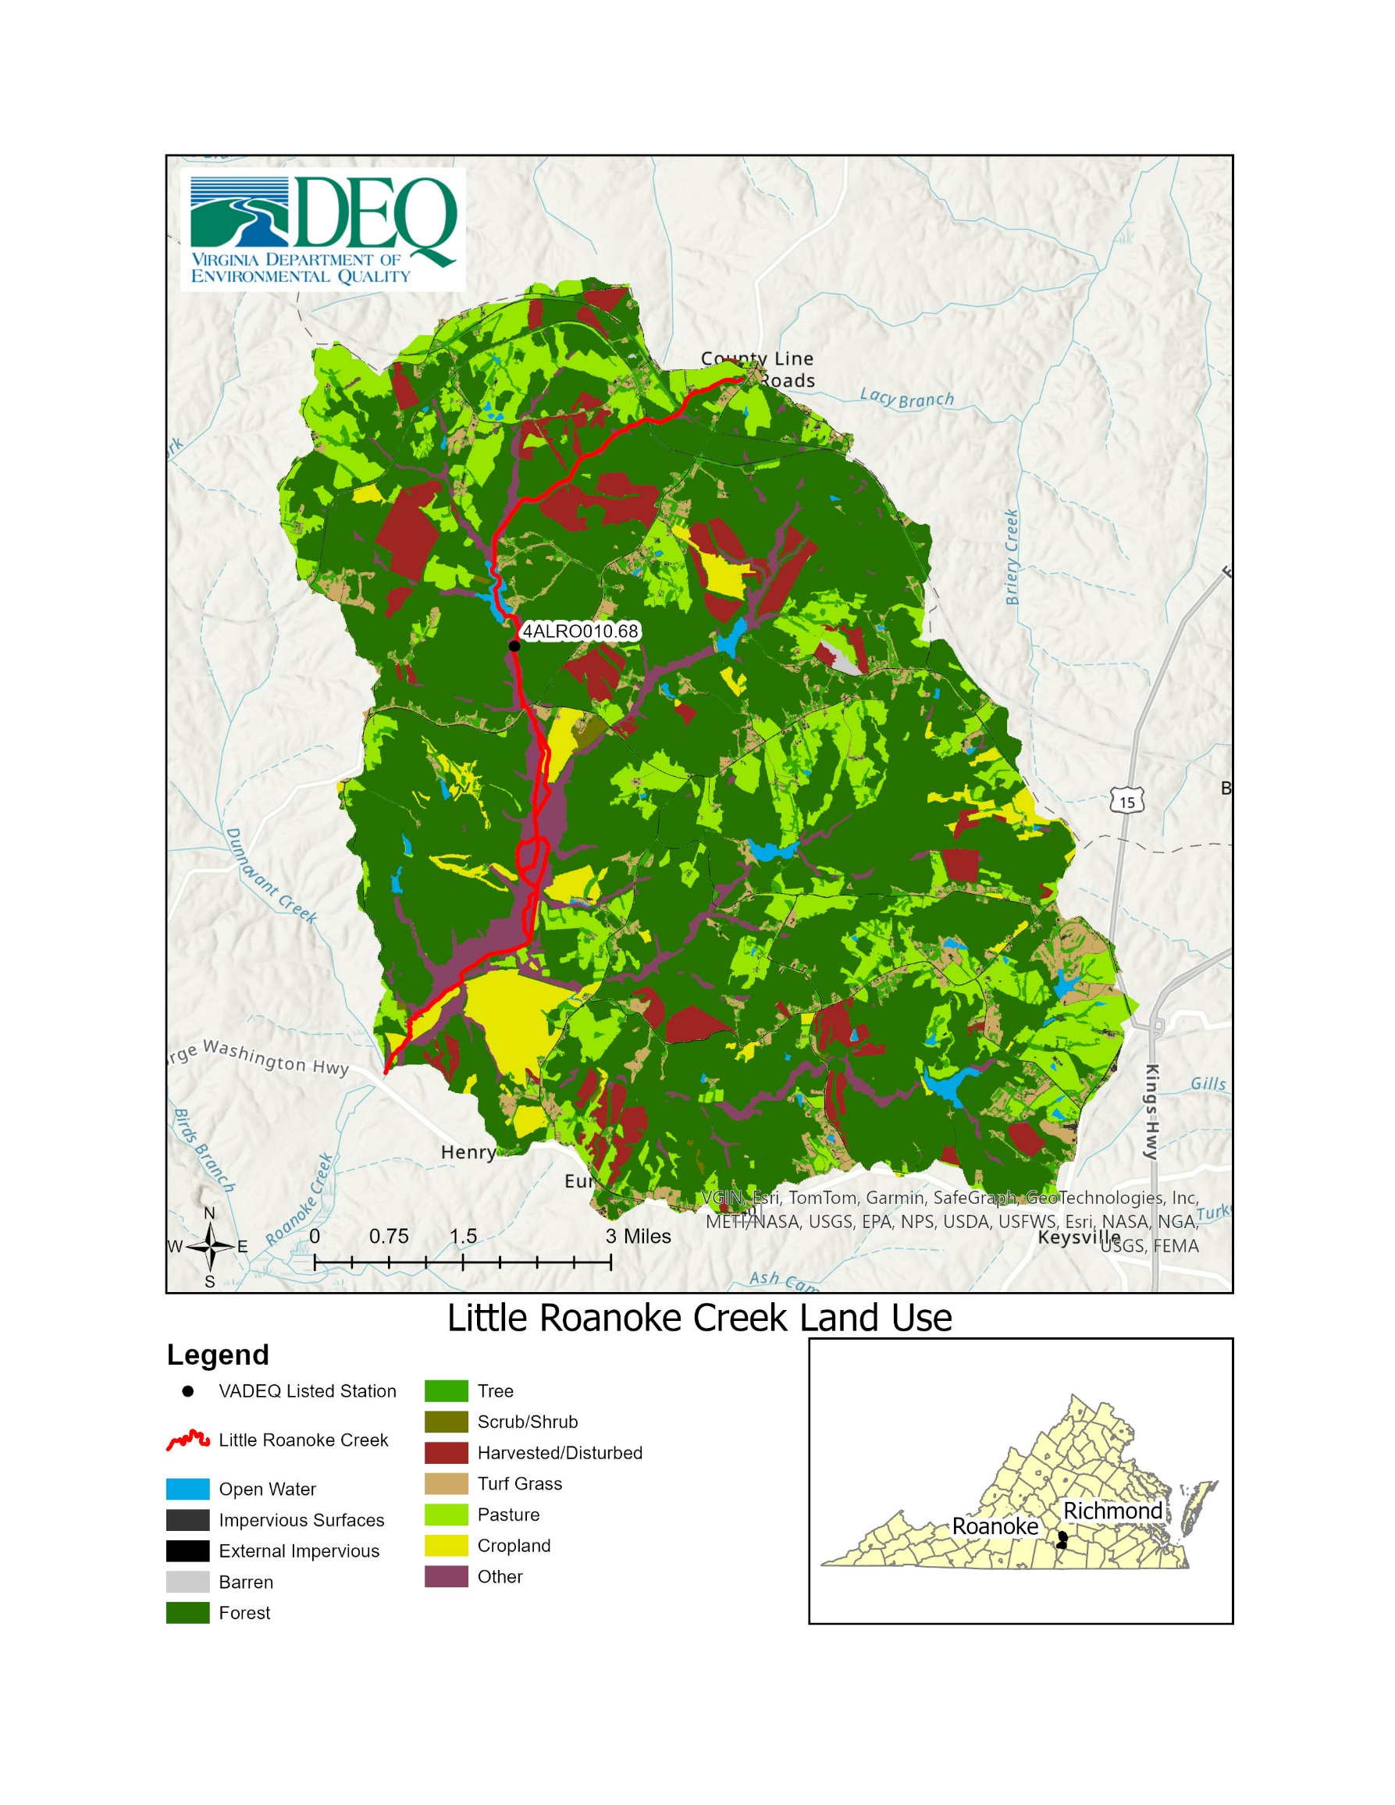

Figure 9. Map of the Little Roanoke Creek watershed with an overlay of the land uses (VGIN, 2015).

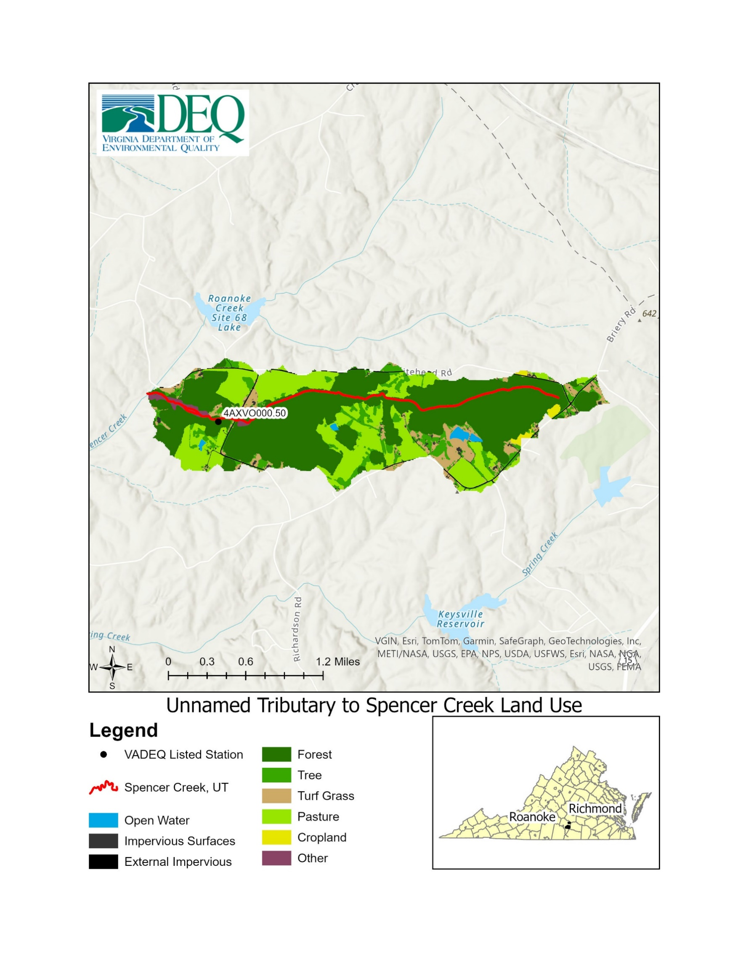

Figure 10. Map of the UT to Spencer Creek watershed with an overlay of the land uses (VGIN, 2015).

Table 4. The percent of each type of land use in the Horsepen Creek, Little Roanoke Creek, UT to Spencer Creek watersheds (VGIN, 2015).
 |  | Horsepen Creek |  | Little Roanoke Creek |  | Spencer Creek, UT
Land use type | Land use description | Area (acres) | Percent land use | Area (acres) | Percent land use | Area (acres) | Percent land use
Water | Drainage networks and basins | 75.93 | 0.56% | 207.41 | 0.92% | 7.85 | 0.82%
Impervious | Extracted and External- high percentage of constructed materials | 185.62 | 1.38% | 373.7 | 1.67% | 24.8 | 2.57%
Barren | Areas with little or no vegetation | 2.71 | 0.02% | 20.49 | 0.09% | 0 | 0
Forest | Areas with tree cover of natural or semi-natural woody vegetation | 9,178.54 | 67.98% | 13,163.93 | 58.53% | 528.71 | 54.95%
Tree | Areas with tree cover of natural or semi-natural woody vegetation that does not encompass an acre | 680.24 | 5.04% | 1,323.13 | 5.88% | 94.29 | 9.8%
Turf Grass | Primarily grasses | 442.05 | 3.27% | 1,017.19 | 4.52% | 61.95 | 6.44%
Harvested/  Disturbed | Areas of forest clear-cut, temporary clearing of vegetation, and other dynamically changing land cover due to land use activities as defined by the EPA | 407.2 | 3.02% | 1,308.38 | 5.82% | 0 | 0
Shrub | Areas of natural or semi-natural woody vegetation with aerial stems generally less than 6 meters | 318.92 | 2.36% | 42.58 | 0.19% | 0 | 0
Pasture | Areas of grasses, legumes, or grass-legumes planted for livestock grazing | 1574.5 | 11.66% | 3,083.03 | 13.71% | 226.5 | 23.54%
Cropland | Areas of herbaceous vegetation that has been planted for production of food | 132.24 | 0.9% | 828.15 | 3.68% | 6.93 | 0.72%
NWI/Other | Soil or substrate periodically covered with water | 504.31 | 3.73% | 1,121.36 | 4.99% | 11.18 | 1.16%

Table 5. The results of a 120-meter buffer created around the streams within the watershed to determine the land use occurring in the riparian area.
 |  | Horsepen Creek |  | Little Roanoke Creek |  | Spencer Creek, UT
Land use type | Land use description | Area (acres) | % land use | Area (acres) | % land use | Area (acres) | % land use
Water | Drainage networks and basins | 68.46 | 1.31 % | 171.25 | 1.9% | 7.85 | 1.84%
Impervious | Extracted and External- high percentage of constructed materials | 21.5 | 0.41% | 61.53 | 0.68% | 3.99 | 0.94%
Barren | Areas with little or no vegetation | 0.47 | 0.01% | 6.49 | 0.07% | 0 | 0%
Forest | Areas with tree cover of natural or semi-natural woody vegetation | 3,573.76 | 68.29% | 5,483.47 | 60.81% | 295.89 | 69.42%
Tree | Areas with tree cover of natural or semi-natural woody vegetation that does not encompass an acre | 178.89 | 3.42% | 339.67 | 3.77% | 24.67 | 5.79%
Turf Grass | Primarily grasses | 75.15 | 1.44% | 239.22 | 2.65% | 18.97 | 4.45%
Harvested/  Disturbed | Areas of forest clear-cut, temporary clearing of vegetation, and other dynamically changing land cover due to land use activities as defined by the EPA | 163.03 | 3.12% | 467.77 | 5.19% | 0 | 0%
Shrub | Areas of natural or semi-natural woody vegetation with aerial stems generally less than 6 meters | 145.24 | 2.78% | 30.08 | 0.33% | 0 | 0%
Pasture | Areas of grasses, legumes, or grass-legumes planted for livestock grazing | 557.48 | 10.65% | 857.73 | 9.51% | 61.85 | 14.51%
Cropland | Areas of herbaceous vegetation that has been planted for production of food | 12.77 | 0.24% | 365.34 | 4.05% | 1.83 | 0.43%
NWI/Other | Soil or substrate periodically covered with water | 436.81 | 8.35% | 994.56 | 11.03% | 11.18 | 2.62%

1.2.4 Permitted Facilities
There is one domestic sewage permit within the Horsepen Creek watershed (Table 6). There are no active permits in the Little Roanoke Creek, and subsequently the UT to Spencer Creek watersheds. The rural nature of the watersheds is reflected by the absence of direct dischargers and potential point sources. This helps to inform the analysis that the benthic stressor is unlikely to be from a discharge source and it is more likely coming from nonpoint source means of deposition.

Table 6. Active permits within the impaired watersheds.
Watershed | Stream | Permit Number | Permit Type | Parameters Sampled
Horsepen creek | Horsepen Creek | VAG404143 | VPDES Domestic Sewage GP | FLOW, pH, BOD5, TSS, DO, CL2 (total contact, inst res max)

1.3 Biological and Water Quality Data
Virginia’s comprehensive surface water quality monitoring strategy integrates sampling at both fixed sites, for the ambient monitoring program, and randomly selected sites, for the probabilistic monitoring program. These varied techniques help to improve understanding of water quality conditions, increase monitoring efficiency, and allow the agency to meet the needs of multiple regulatory and water quality management programs. This sampling data allows VADEQ to assess waterbodies and determine which streams are meeting water quality standards and which streams are impaired. This sampling data is available for Horsepen Creek from 2009-2022, Little Roanoke Creek from 2007-2022, and the UT to Spencer Creek from 2012-2022. Additional continuous monitoring data from 2023 is available for all three streams as well. The benthic macroinvertebrate community was sampled, identified, and then scored according to the VSCI. Habitat assessments were also completed at the time of biological monitoring. Biological samples indicate water and habitat quality within the streams over a long period of time. Water samples were tested for a wide range of substances, including nutrients, solids, bacteria associated with human and animal wastes, and toxic metals. Water samples provide a snapshot of the water quality at the time samples were taken.
From spring 2007 to fall 2022, VADEQ collected 50 benthic macroinvertebrate samples at five stations within the three impaired watersheds. This also gives 50 habitat assessments to analyze. Table 7 displays the average VSCI scores for each station over the 15-year window. In addition, Table 7 also includes averages for the 2024 water quality Assessment window (2017-2022). This assessment window represents the six most recent years of data that VADEQ will use to inform the 2024 Integrated Report, which tracks all impaired waters in Virginia on the 303(d) list. For a stream to be placed on Virginia’s 303(d) list of impaired waters with an aquatic life impairment for its benthic community, there must be at least one benthic sample with a stream condition index score below 60. To remove an aquatic life impairment listing, VSCI scores above 60 must be recorded for the most recent fall and spring samples within a given water quality assessment cycle. Thus, a stream could have average scores above 60 and remain listed as impaired due to either individual fall or spring scores that are below 60. Due to consistency of data and data averages, all available data was used for analysis throughout this report.

Table 7. Average VSCI scores for each impaired station and the reference station, as well as the average VSCI scores for each station within the 2024 assessment window (2017-2022), along with the minimum and maximum recorded scores.
Stream | StationID | Mean VSCI | Mean within 2024 Assessment Window | Minimum VSCI (season, year observed) | Maximum VSCI (season, year observed)
Horsepen Creek | 4AHEN004.27 | 50.4 | 50.6 | 30.1 (spring, 2022) | 64 (fall, 2009)
Little Roanoke Creek | 4ALRO010.18 | 49.3 | 48.7 | 38.9 (fall, 2012) | 71.1 (fall, 2015)
 | 4ALRO010.68 | 43.2 | N/A | 28.4 (spring, 2007) | 57.9 (fall, 2007)
 | 4ALRO010.88 | 34.6 | 34.6 | 33.9 (spring, 2022) | 35.3 (fall, 2022)
UT to Spencer Creek | 4AXVO000.50 | 46.2 | 47.7 | 31.6 (spring, 2021) | 57.9 (spring, 2022)
Reedy Creek | 4ARD002.09 | 67.2 | 67.2 | 58.3 (spring, 2021) | 73.9 (spring, 2020)
Water quality data were collected by VADEQ from 2007 to 2022 in the three impaired watersheds. One-hundred-and-eight (108) instances of water sampling and field parameters (pH, temperature, dissolved oxygen, conductivity) were collected from six ambient monitoring stations in the project area (4AHEN004.27, 4ALRO010.18, 4ALRO010.68, 4ALRO010.88, 4AXVO000.50, 4AXVO000.60). Water quality parameters available for this stressor analysis include: temperature, pH, dissolved oxygen, specific conductivity, total dissolved solids, total nitrogen, total phosphorus, chloride, sulfate, potassium, sodium, and metals. These parameters were analyzed for evidence of stressor effects by comparing measured values to Virginia water quality standards, to reference conditions, and to published thresholds for stressor effects.

1.3.0.1 Published Thresholds for Stressor Effects
Data collected through VADEQ’s Freshwater Probabilistic Monitoring Program was used to develop stressor thresholds or concentration/measured ranges linked to probable stress to aquatic life. The stressor thresholds are not derived from literature values and are not intended to replace water quality criteria or define TMDL endpoints. The probabilistic approach minimizes bias because it is a statistically designed study and sample sites are selected randomly across a geographical area. The probabilistic monitoring dataset allowed VADEQ to determine thresholds ranging from no stress to aquatic life to high probability of stress to aquatic life for the following parameters: dissolved oxygen, pH, total phosphorus, total nitrogen, ionic strength (specific conductivity, TDS, and dissolved sulfate, chloride, sodium, and potassium), dissolved metals cumulative criterion unit, total habitat, and relative bed stability. The stress categories were developed by analyzing benthic macroinvertebrate community responses (represented by VSCI scores) through a variety of peer-reviewed statistical techniques: relative risk, relative extent, conditional probability, and quantile regression. The results were interpreted into stress categories. Specifically, “No Stress to Aquatic Life” means that a parameter range reflects an undisturbed, or background, condition in Virginia. “Low Probability of Stress to Aquatic Life” represents a benthic macroinvertebrate community response that is slightly above background conditions but unlikely to cause a major community shift. The next category is “Medium Probability of Stress to Aquatic Life” and means there is evidence of harm causing a possible shift in benthic communities with changes noticeably above background conditions. The “High Probability of Stress to Aquatic Life” threshold corresponds to values that are among the highest in the Commonwealth and result in degradation of the benthic community (VADEQ, 2017) (Figure 11).
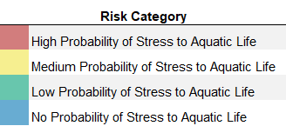

Figure 11. Stressor analysis catergories and the colors associated with each.

1.3.1 Biological Monitoring
Benthic macroinvertebrate communities reflect the water and habitat quality in a stream over a longer period of time compared to ambient water samples that capture water quality at a single point in time. Therefore, the VADEQ evaluates biological communities to assess whether chronic and/or acute stressors are negatively affecting stream resources or habitat that result in biological communities with low diversity and mainly tolerant organisms rather than sensitive organisms. Biological communities are evaluated as impaired or non-impaired using stream condition index (SCI) scores, which account for the number and type of organisms in an aquatic community (Table 8). A VSCI score greater than 60 is considered non-impaired and a score of less than or equal to 60 indicates an impaired stream (VADEQ, 2016).

Table 8. Metrics used to calculate the Virginia Stream Condition Index (VSCI) (Burton and Gerritsen, 2003).
Metrics | Expected Response to Disturbance | Definition of Metric
Taxonomic Richness
Total Taxa | Decrease | Total number of taxa observed
EPT Taxa | Decrease | Total number of pollution sensitive Ephemeroptera, Plecoptera, and Tricoptera (EPT) observed
Taxonomic Composition
% PT-Hydropsychidae | Decrease | % PT taxa in samples excluding pollution-tolerant Hydropsychidae
% Ephemeroptera | Decrease | % Ephemeroptera taxa
% Chironomidae | Increase | % Pollution-tolerant Chironomidae
Evenness
% 2 Dominant Taxa | Increase | % Dominance of the two most abundant taxa
Tolerance
HBI (Family level) | Increase | Hilsenhoff Biotic Index (HBI)
Trophic Group
% Scrapers | Decrease | % of Scraper functional feeding group
In Horsepen Creek, benthic community VSCI scores between 2017 and 2022 averaged 50.6 and ranged from 30.1 (station 4AHEN004.27, 2022) to 63.7 (station 4AHEN004.27, 2021). In Little Roanoke Creek, benthic community VSCI scores between 2017 and 2022 averaged 41.7 and ranged from 33.9 (station 4ALRO010.88, 2022) to 59 (station 4ALRO010.18, 2020). In the UT to Spencer Creek, benthic community VSCI scores between 2017 and 2022 averaged 47.7 and ranged from 31.6 (station 4AXVO000.50, 2021) to 57.9 (station 4AXVO000.50, 2022). The majority of samples were below the impairment threshold (> 80% at all stations). The UT to Spencer Creek has never scored above the impairment threshold in all the years of VADEQ monitoring. The three occasions Horsepen Creek scored above the threshold, were a combination of spring and fall sampling events. The single occasion that Little Roanoke Creek scored above the threshold, was in the fall. Overall, spring benthic scores in Horsepen Creek (averaging 45.7), Little Roanoke Creek (averaging 45.3), and UT to Spencer Creek (averaging 45.9) were lower than fall benthic scores (averaging 55.8, 53.9, and 46.5, respectively); however, this difference was not significant, as determined by a t-test with unequal variances (alpha = 0.05). The average spring benthic VSCI score did trend below average fall scores for all three of the streams (Figure 12). This seasonal trend was the most pronounced in Horsepen and Little Roanoke creeks. This trend indicates that the stressors of these streams may be more prevalent in spring flows. Higher spring flows can lead to increased concentrations of nutrients and/or sediment in runoff to streams. Further exploring temporal trends, VSCI scores were also plotted over the entire sampling window (Figure 13). Seasonal variation is apparent but there have been no consistent temporal changes over time. VSCI scores have not shown a trend of increasing or decreasing during the 15 years of sampling at any of the impaired stations. The only consistency has been the variability of the scores and that they are usually impaired.

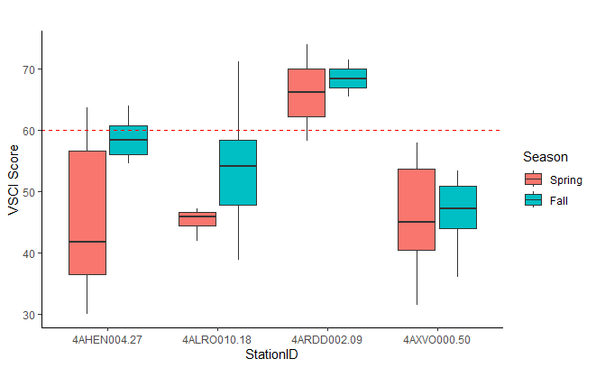

Figure 12. Box and whisker plot displaying the seasonal variations of VSCI scores within Horsepen, Little Roanoke, the UT to Spencer, and Reedy Creeks.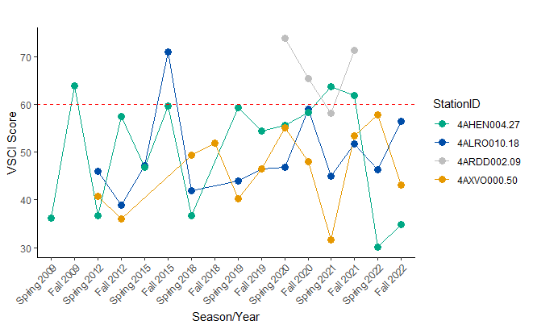

Figure 13. VSCI Scores for Horsepen Creek, Little Roanoke Creek, the UT to Spencer Creek, and Reedy Creek overtime from 2009 through 2022.
All three impaired streams have scored below the VSCI impairment threshold of 60 on average and medially. Horsepen Creek, Little Roanoke Creek, and the UT to Spencer Creek’s median VSCI scores are 55.7, 46.4, and 47.3, respectively. Despite in the fall of 2015, all Little Roanoke Creek VSCI scores have consistently scored below the impairment threshold at all three stations within the impairment. The UT to Spencer Creek has consistently scored below the impairment threshold, with its two lowest scores occurring in the fall of 2012 and the spring of 2021. Horsepen Creek experienced a major increase in VSCI scores in 2021, scoring above the impairment threshold two seasons in a row. That was promptly followed by the two lowest recorded VSCI scores for that creek in both the spring and fall of 2022 (Table 9). This anomaly was explored and is likely influenced by several factors, including but not limited to 2020 being a very wet year within these watersheds, construction of an impoundment on an unnamed tributary to Horsepen Creek, and localized clearcut timber harvesting. While impossible to say what caused the large plummet in VSCI scores, Horsepen Creek is likely very responsive to the land management practices occurring within its watershed and implementation of best management practices could be very effective at improving the water quality quickly.

Table 9. VSCI scores for Horsepen Creek, Little Roanoke Creek, UT to Spencer Creek for each season sampled. Orange shaded values indicate the two lowest scores for that station. Red VSCI scores are below the impairment threshold of 60.
Stream | StationID | Sample Season | VSCI Score
Horsepen Creek | 4AHEN004.27 | Spring 2009 | 36.18
 |  | Fall 2009 | 63.99
 |  | Spring 2012 | 36.71
 |  | Fall 2012 | 57.54
 |  | Spring 2015 | 46.8
 |  | Fall 2015 | 59.63
 |  | Spring 2018 | 36.77
 |  | Spring 2019 | 59.45
 |  | Fall 2019 | 54.54
 |  | Spring 2020 | 55.68
 |  | Fall 2020 | 58.43
 |  | Spring 2021 | 63.72
 |  | Fall 2021 | 61.87
 |  | Spring 2022 | 30.07
 |  | Fall 2022 | 34.81
Little Roanoke Creek | 4ALRO010.18 | Spring 2012 | 45.94
 |  | Fall 2012 | 38.86
 |  | Spring 2015 | 47.26
 |  | Fall 2015 | 71.12
 |  | Spring 2018 | 41.99
 |  | Spring 2019 | 43.94
 |  | Fall 2019 | 46.50
 |  | Spring 2020 | 46.85
 |  | Fall 2020 | 59.02
 |  | Spring 2021 | 44.99
 |  | Fall 2021 | 51.71
 |  | Spring 2022 | 46.41
 |  | Fall 2022 | 56.45
 | 4ALRO010.68 | Spring 2007 | 28.41
 |  | Fall 2007 | 57.92
 | 4ALRO010.88 | Spring 2022 | 35.33
 |  | Fall 2022 | 33.94
UT to Spencer Creek | 4AXVO000.50 | Spring 2012 | 40.82
 |  | Fall 2012 | 36.10
 |  | Spring 2018 | 49.36
 |  | Fall 2018 | 51.92
 |  | Spring 2019 | 40.31
 |  | Fall 2019 | 46.55
 |  | Spring 2020 | 55.20
 |  | Fall 2020 | 47.98
 |  | Spring 2021 | 31.61
 |  | Fall 2021 | 53.41
 |  | Spring 2022 | 57.92
 |  | Fall 2022 | 43.16

1.3.1.1 Benthic Metrics and Community Composition
Individual metrics that comprise the VSCI were evaluated for the impaired stream segments in the Horsepen, Little Roanoke, and UT to Spencer Creek watersheds. These were compared to a reference stream, which is a nearby stream with similar physical attributes but is not impaired. The benthic community from the reference stream used for these comparisons was from Reedy Creek in Halifax County, Virginia. Average metric scores for each station were compared to the reference using a t-test with unequal variances (alpha = 0.05). There were significant differences between all three impaired streams and the reference stream. The percent dominance of the two most abundant taxa was significantly lower in the reference stream and the EPT taxa and total taxa were significantly greater in the reference stream. Ephemeroptera and Diptera were the predominant orders present in all three impaired streams. The percent of Ephemeroptera alone was not different from the reference stream, but the percentage of the benthic community that was made up of Diptera was. The significantly lower abundance of more sensitive macroinvertebrates and lack of diversity in the impaired streams compared to the reference stream, allows for a comparison to determine the most probable stressor to these communities.
Ephemeroptera and Diptera were the predominant orders present in all three impaired streams. The percentage of Ephemeroptera within the benthic communities did not contrast with the reference stream, 16.9% in Horsepen Creek, 19.5% in Little Roanoke Creek, 21.1% in the UT to Spencer Creek, and 20.0% in Reedy Creek. The stark difference was the percentage of the benthic community that was made up by the benthic family, Diptera, 54.2%, 49.3%, 51.1%, and 27.7%, respectively. This increase in the presence of Diptera was mostly seen from the Simulium and Simuliidae genera. These genera are characterized by their filtering head fans, used to capture organic matter. They’re often prevalent in flowing streams, downstream of dams and impoundments that allow for flowing waterbodies to become organic-rich.
In Horsepen Creek, scores for most benthic metrics used to determine the VSCI score were significantly lower (alpha = 0.05) than the those measured in the reference stream. Horsepen Creek is significantly lacking in sensitive taxa and scrapers. Scrapers is the term used to describe the functional feeding group of benthic macroinvertebrates that fill the niche of scraping algae and detritus off rocks and larger woody debris within a stream. While an abundance of scrapers can be indicative of nutrient enrichment in streams, a lack of scrapers can be indicative of excessive sedimentation, burying habitat with interstitial spaces that would allow algae to grow. Sensitive taxa were present in relatively low abundance in Horsepen Creek, resulting in a significantly lower (p = 0.04) Modified Family Biological Index (MFBI) score (74.1) compared to Reedy Creek (83.7). The MFBI measures the ecological tolerance and relative abundance of aquatic macroinvertebrates present in a stream. Lower MFBI scores indicate that water quality or habitat conditions are limiting the presence of sensitive taxa.
In Little Roanoke Creek, scores for most benthic metrics were significantly lower (alpha = 0.05) than the reference condition, with the exception of the percentage scores for scrapers, Ephemeroptera, and Chironomidae, which were not significantly different from Reedy Creek. While not statistically significantly different, the percent of scrapers in Little Roanoke Creek trends lower than that of Reedy Creek. Plecoptera taxa were present in only a low abundance, comprising just 1.5% of the benthic community in Little Roanoke Creek, compared to them representing 9.8% of the community in Reedy Creek. Sensitive taxa were present in relatively low abundance in Little Roanoke Creek, resulting in a significantly lower (p = 0.009) Modified Family Biological Index (MFBI) score (67.7) compared to Reedy Creek (83.7).
Similarly to the previously examined streams, the scores for most benthic metrics were significantly lower (alpha = 0.05) in the UT to Spencer Creek than the reference condition. The lack of scrapers may be indicative of excessive sedimentation, burying habitat necessary for sensitive taxa and scrapers a like. While the representation of more sensitive taxa was better in the UT to Spencer Creek than its impaired counter parts, poor diversity and low species richness were the drivers of lower scores. Sensitive taxa were present in relatively low abundance in the UT to Spencer Creek, resulting in a significantly lower (p = 0.02) Modified Family Biological Index (MFBI) score (71.2) compared to Reedy Creek (83.7). Lower MFBI scores indicate that water quality or habitat conditions are limiting the presence of sensitive taxa.

1.3.1.2 Biological Condition Gradient
In partnership with the United States Environmental Protection Agency (USEPA) and several Mid-Atlantic States (Virginia, West Virginia, and Maryland), Tetra Tech developed a Mid-Atlantic Biological Conditions Gradient (BCG) in 2019 (Tetra Tech, 2019). A BCG is a conceptual framework that may be used to predict biological responses to increased environmental stress. The BCG establishes a framework of measurable characteristics known as “attributes” of biological communities including properties such as richness, abundance, and structure. The model predicts how these attributes shift in response to increasing levels of environmental stress based on observed patterns of biological response to stressors for a given geographic region. The Mid-Atlantic BCG model defines six attributes related to the pollution tolerance among fish and macroinvertebrate taxa present in the region. These attributes were assigned scores for ten specific stressors for a total of 560 macroinvertebrate taxa based on data provided by multiple states through a consensus-based process with input from regional biologists (Table 10).

Table 10. Mid-Atlantic biological condition gradient attributes and stressors evaluated.
Attribute | Explanation | Stressors Evaluated
I | Historically documented, sensitive, long-lived or regionally endemic taxa | Dissolved oxygen  Acidity  Alkalinity  Specific conductivity  Total habitat  % Imperviousness | Chloride  Sulfate  Total Nitrogen  Total Phosphorus  Relative bed stability
II | Highly sensitive taxa
III | Intermediate sensitive taxa
IV | Intermediate tolerant taxa
V | Tolerant taxa
VI | Non-native taxa
Taxa receiving high attribute values for a stressor are typically more tolerant of that particular stressor. Conversely, taxa assigned low attribute values for a stressor are generally intolerant of that stressor. Using attribute data from Virginia’s BCG, scores were assigned to taxa in samples from Horsepen Creek, Little Roanoke Creek, and the UT to Spencer Creek. Weighted average attribute values were calculated for each stressor across all taxa in all three impaired streams (Table 11). Attribute values for stressors were also evaluated for the predominant species to identify potential stressors that may be disproportionately influencing benthic community composition in the impaired streams (Table 12). While there was some variability in the stressors with the highest BCG scores in each impaired creek, total nitrogen, total phosphorus, and relative bed stability were identified in each creek as stressors that may be impacting the benthic macroinvertebrate communities. When looking at the weighted average BCG scores, as well as the scores for the predominant taxa in Horsepen Creek, sulfate, nitrogen, phosphorus, and relative bed stability stand out as the stressors that are most likely impacting the benthic macroinvertebrate community. Looking at the same scores from Little Roanoke Creek, nitrogen, phosphorus, habitat, and relative bed stability stand out as the most likely influences to the stressed benthic macroinvertebrate community. Percent impervious surfaces is indicated by the BCG as a potentially influencing stressor, however, there is very little impervious surface within the watershed. Insects tolerant to impervious surfaces as a stressor are also tolerant to poor habitat and sedimentation, which would explain why that stressor is highlighted within the BCG analysis, despite very little influence from impervious surfaces being present. The UT to Spencer Creek’s scores display the same contradiction. Nitrogen, phosphorus, and relative bed stability are all possibly influencing stressors to the UT to Spencer Creek, as indicated by BCG scores. Relative bed stability as a stressor usually indicates unstable banks, excessive sedimentation, and a lack of diverse habitat available. While nitrogen and phosphorus enrichments can also lead to dissolved oxygen levels that can cause stress to a benthic macroinvertebrate community. Despite the nutrient scores, dissolved oxygen as a stressor does not seem to have a high influence on this community, based on the weighted averages for each creek. Nitrogen and phosphorus enrichment in rural stream systems such as these, are often tied to the same erosion sources that lead to increased sedimentation and lower logarithmic relative bed stability index scores.

Table 11. Weighted average biological condition gradient scores by stressor for Horsepen, Little Roanoke, and the UT to Spencer Creeks.
Stream | Diss. Oxygen | Acidity | Alkalinity | Spec. Cond. | Chloride | Sulfate | TN/TP | Total Habitat | RBS | % Imp.
Horsepen Creek | 3.75 | 3.67 | 3.58 | 3.74 | 3.38 | 4.03 | 4.22 | 3.89 | 4.09 | 3.84
Little Roanoke Creek | 3.97 | 3.72 | 3.78 | 3.89 | 3.53 | 3.77 | 4.35 | 4.05 | 4.09 | 4.26
UT to Spencer Creek | 3.71 | 3.66 | 3.85 | 4.03 | 3.45 | 3.87 | 4.31 | 3.84 | 4.02 | 4.18

Table 12. Biological condition gradient scores by stressor for predominant taxa in Horsepen, Little Roanoke, and the UT to Spencer Creeks.
Stream | Predominant Taxa | General | Diss. Oxygen | Acidity | Alkalinity | Spec. Cond. | Chloride | Sulfate | TN/TP | Total Habitat | RBS | % Imp.
Horsepen Creek | Simulium | 4 | 4 | 4 | 4 | 4 | 3 | 5 | 5 | 4 | 4 | 4
Little Roanoke Creek | Maccaffertium | 4 | 4 | 4 | 4 | 3 | 3 | 3 | 4 | 4 | 4 | 4
UT to Spencer Creek | Maccaffertium | 4 | 4 | 4 | 4 | 3 | 3 | 3 | 4 | 4 | 4 | 4

1.3.1.3 Functional Feeding Groups
The composition of functional feeding groups comprising the benthic community was also analyzed to identify shifts in composition at impaired sites that might provide clues to sources or mechanisms of impairment. Figure 14 shows the composition of functional feeding groups within the impaired streams in comparison to reference conditions in Reedy Creek. Horsepen Creek’s largest functional feeding group was constituted by collectors. Horsepen Creek had more than 20% more collectors than the reference stream, 36.7% and 16.3%, respectively. There were also more filterers and shredders in Horsepen Creek compared to Reedy Creek. Collectors, filterers, and shedders all feed on organic matter within streams. Fine particulate organic matter (FPOM) comes from decomposing detritus, algae, bacteria, and feces deposited within the stream. While collectors acquire FPOM from the stream bottom, filterers collect FPOM from the water column. Shredders consume coarse particulate matter (CPOM), which comes from decomposing leaf litter and wood. Increases in all three functional feeding groups could indicate a buildup of organic matter within Horsepen Creek. Scrappers constituted the largest shift in the compared benthic communities. Scrapers made up 35.2% of the benthic macroinvertebrate community in Reedy Creek, and only 9.6% of the community within Horsepen Creek. Scrapers consume periphyton and biofilms on hard surfaces such as rocks and macrophytes. The large increase in collectors and reduction in scrapers indicates sediment could be covering rocks and suitable substrate, reducing scraper habitat and increasing deposited material and collector habitat.

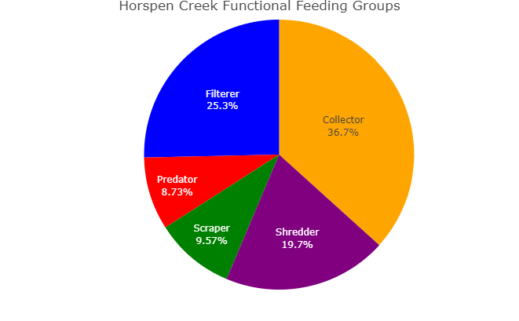 | 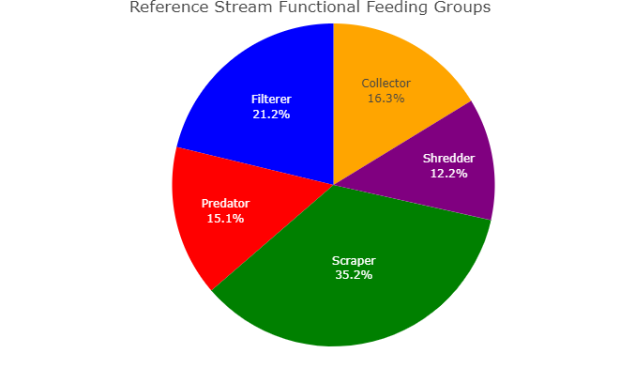
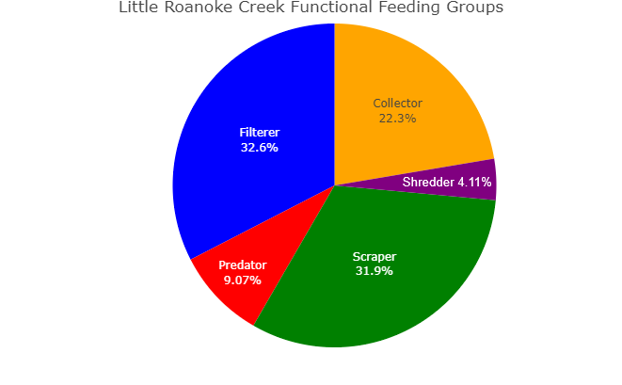
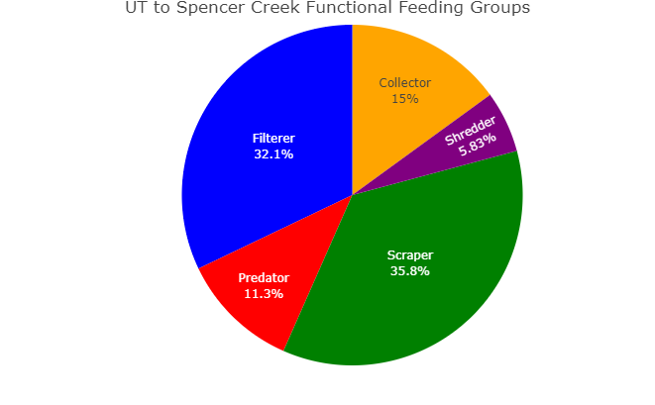

Figure 11. Functional feeding groups by each impaired stream, Horsepen Creek, Little Roanoke Creek, UT to Spencer Creek, represented by pie charts, compared to pie charts representing the reference stream, Reedy Creek. Each functional feeding group displays the percentage of which it makes up within the observed benthic macroinvertebrate communities. Of the 152 taxa groups collected between all four streams, seven do not have defined feeding groups. Those individuals were left out of this analysis.
While Little Roanoke Creek and the UT to Spencer Creek did not see the same reduction in the scrapper functional feeding group from the reference as Horsepen Creek, there was still an increase, greater than 10%, in filterers within both impaired streams. Both impaired streams also saw reductions in the shredder functional feeding group. The loss of riparian buffers, which contribute to CPOM, can lead to reductions in shredders within streams. Alternatively, it could signal an overabundance of FPOM, allowing for a predominance of collectors and filterers in the impaired streams. Little Roanoke Creek also saw a slight increase in collectors compared to Reedy Creek, however, there was little change with that functional feeding group in the UT to Spencer Creek compared to the reference.
While there was an increase in filterers in all three impaired streams compared to the reference stream, none of the streams had a community of filterers comprising greater than 33%. It is common for filter feeders to comprise 40-50% of the macroinvertebrate community in streams with excessive sediment loading because they are well adapted to filter suspended materials. This increase in filterers paired with the increase in collectors does indicate an abundance of FPOM in all the streams.

1.3.2 Habitat Assessment
As part of the Rapid Bioassessment Protocol, a visual habitat assessment is performed at the time of each benthic sample collection. The Rapid Bioassessment scores individual habitat components from 0 to 20. These habitat components include channel alteration, bank stability, bank vegetation, flow, pool substrate, pool variability, riparian vegetation, sediment, and sinuosity in low gradient streams and channel alteration, bank stability, bank vegetation, flow, substrate, velocity, riparian vegetation, sediment, embeddedness, and riffles for high gradient streams. Low gradient and high gradient streams are both scored on channel alteration, bank stability, bank vegetation, riparian vegetation, flow, sediment, and substrate, but differ slightly due to the lack of riffles in low gradient streams. Despite the minute differences, high and low gradient streams in the same ecoregion with similar land use in the watersheds are comparable. Horsepen and Little Roanoke creeks are low gradient streams and the UT to Spencer Creek and Reedy Creek are high gradient streams. The scoring components they all share can be compared to assess similarities in differences that can parse out the potential causes of the impairments. The individual scores for each habitat component are summed to determine a total habitat score. The maximum total habitat score a stream can achieve is 200. Table 13 shows the mean total habitat scores for the impaired streams and compares these scores with the reference stream using a t-tests with unequal variances (alpha = 0.05). Scores for all three impaired creeks were significantly lower than the reference condition. The average total habitat scores for each of the impaired streams, as well as the range of scores achieved over all the years of sampling, are displayed in Figure 15. This chart overlays the probability ranges for inducing stress to aquatic life in relation to total habitat scores. Red indicates a range of scores in which the probability for stress to aquatic life is high. Yellow indicates a range of scores in which the probability for stress to aquatic life is medium. Green indicates a range of scores in which the probability for stress to aquatic life is low, while blue indicates scores with no associated probability for causing stress. This color coding of probability ranges is consistent throughout the report. Horsepen Creek’s mean total habitat score fell in the medium probability range of causing stress to aquatic life. Sampling occurred in Horsepen Creek between 2007 and 2022. During those years of sampling, total habitat scores always fell within the medium to high probability range of inducing stress to aquatic life. The lowest scoring metrics for the total habitat score that are driving low scores are the banks, substrate, vegetation, and sediment. This is consistent with the empirical observations commented along with each sample indicating, bank failures and sedimentation observed. Little Roanoke Creek and the UT to Spencer Creek’s mean total habitat scores were in the low probability range of inducing stress to aquatic life. Both Little Roanoke Creek and the UT to Spencer Creek were sampled various times from 2012 to 2022. Over that time, they had total habitat scores fall within the no probability to medium probability ranges for inducing stress to aquatic life. The habitat metrics in Little Roanoke Creek that are lowering the overall total habitat scores are sediment deposition and bank instability. Empirical observations within the habitat assessments describe incised banks and repeated evidence of beaver impacts. The habitat metrics dragging the total habitat scores down for the UT to Spencer Creek are sediment, banks, and embeddedness. Biologist also commented on these habitat assessments, notating sedimentation and filamentous algae.

Table 13. Total habitat scores for Horsepen Creek, Little Roanoke Creek, UT to Spencer Creek, and Reedy Creek and the results from a t-test that determined if there is a signifcant difference in each of the impaired stream’s scores compaired to the reference streams score.
Stream | Mean Total Habitat Score | Significantly Different from Reference | p value
Horsepen Creek | 108.6 | Yes | 2.78 e⁻⁴
Little Roanoke Creek | 132.82 | Yes | 0.01
UT to Spencer Creek | 134.25 | Yes | 0.02
Reedy Creek | 150.45

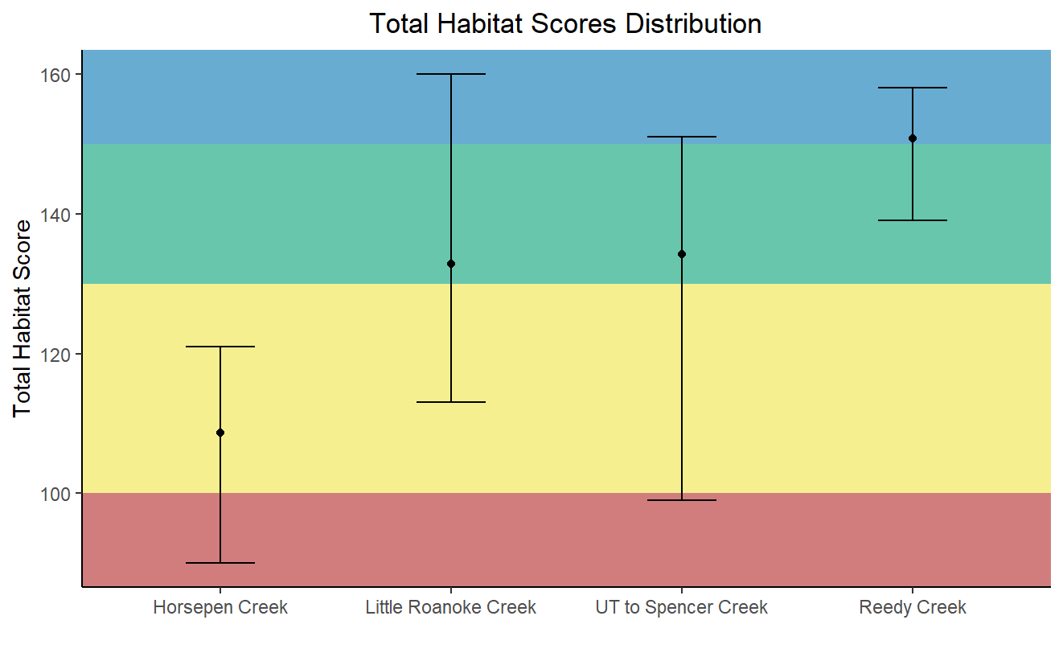

Figure 12. The average total habitat scores, points, for each impaired stream and the reference stream plotted with the range of observed scores, bars, over the probability ranges for habitat scores indicating habitat being a stressor on the aquatic community.
Total habitat scores were statistically compared to VSCI scores through a linear regression analysis (Figure 16). The low R² value (0.01) indicates considerable variability in this relationship and the high p value (0.492) demonstrates that habitat scores are not a good predictor of VSCI scores in these streams. Consequently, while poor habitat does display itself as a possible stressor, this relationship between habitat and VSCI scores does not indicate poor habitat as being the only stressor to the impaired benthic communities.

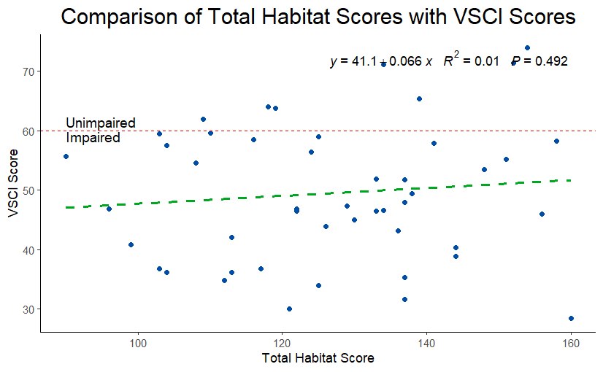

Figure 13. Comparison of total habitat scores with VSCI scores in Horsepen, Little Roanoke, UT to Spencer Creeks, and Reedy Creek.
With so many different metrics making up the total habitat score, the differences between the impaired streams and reference stream are not as obvious while just looking at the total score. For this reason, the individual metrics that make up the total score must be revisited. The mean scores for each observed component in each impaired stream was compared to the same mean component scores in the reference stream with a t-test assuming unequal variances (alpha = 0.5). In Horsepen Creek, mean habitat metric scores for banks, bank vegetation, riparian vegetation, sediment, and substrate were all significantly lower than the reference condition’s scores. The metrics with the greatest significant differences were substrate, riparian vegetation, and bank integrity (Table 14). This indicates that poor substrate, unstable stream banks, poor riparian habitat, and sediment within Horsepen Creek are significantly altering the habitat for aquatic life when compared to the nearby reference stream. Channel alteration and flow did not score significantly different from the reference site.
In Little Roanoke Creek, mean habitat metric scores for banks, bank vegetation, sediment, and substrate were all significantly worse than the reference stream. Bank integrity, substrate, and sediment were the most significantly different from the reference. This is similar to Horsepen Creek, except for the riparian vegetation scoring better and not significantly different from the reference.
Within the UT to Spencer Creek, embeddedness, sediment, banks, and bank vegetation scored significantly worse than the reference stream. Riffles, channel alteration, velocity, substrate, and flow were not significantly different from the reference stream. The biggest observable differences in all three impaired streams compared to the reference are from sedimentation and poor streambank integrity. These differences can be visualized using box and whisker plots, comparing each impaired stream’s individual habitat metrics with Reedy Creek’s metrics (Figure 17).

Table 14. P-Values for each mean habitat parameter score by Horsepen Creek, Little Roanoke Creek, and the UT to Spencer Creek when compared to the reference stream, using t-test with unequal variances. Scores in red indicate a significant difference between the impaired stream and the reference (alpha = 0.05). Habitat parameters denotated with an * indicate components only measured in high gradient streams, the reference stream and the UT to Spencer Creek.
 | Significance of Difference in Mean Habitat Parameter Scores, p-values
Habitat Parameter | Horsepen Creek | Little Roanoke Creek | UT to Spencer Creek
Channel Alteration | 0.488 | 0.287 | 0.120
Bank Integrity | 7.60 e-07 | 7.48 e-04 | 7.46 e-04
Bank Vegetation | 3.16 e-06 | 5.29 e-03 | 0.0123
Embeddedness* | NA | NA | 5.11 e-05
Flow | 0.423 | 0.604 | 0.958
Riffles* | NA | NA | 0.359
Riparian Vegetation | 2.29 e-06 | 0.0836 | 0.633
Sediment | 2.02 e-05 | 4.14 e-04 | 7.34 e-04
Substrate | 1.73 e-09 | 3.01 e-04 | 0.0611
Velocity* | NA | NA | 0.0753
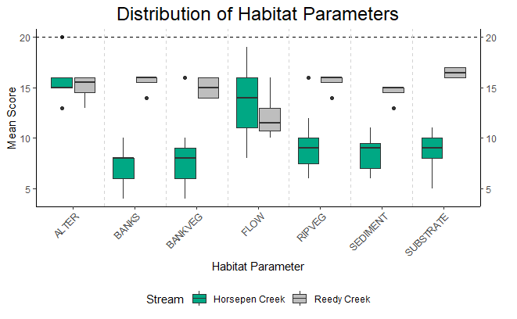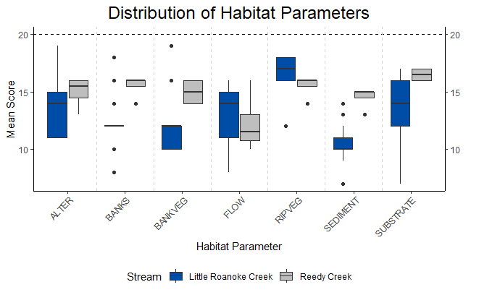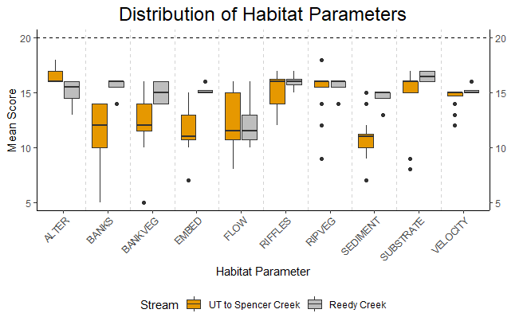

Figure 14. Box and whisker plots comparing individual total habitat score metrics for Horsepen Creek, Little Roanoke Creek, and the UT to Spencer Creek with the reference, Reedy Creek.
As a part of TMDL monitoring, DEQ conducted a more detailed physical habitat assessment of all the impaired streams according to EPA methods for Quantifying Physical Habitat in Wadable Streams (Kaufmann et al., 2007). The assessment required the measurement of channel dimensions and substrate composition at eleven transects within a 150-to-300-meter reach of all three streams. The monitoring stations associated with this assessment are 4AHEN004.27, 4ALRO010.18, 4ALRO010.68, 4ALRO010.88, and 4AXVO000.50 (Table 15). The findings from this assessment allow the calculation of a logarithmic relative bed stability index (LRBS). The LRBS is the ratio between the observed distribution of in-stream sediments and the predicted sediment size distribution based on the bankfull depth. LRBS values near zero indicate that the stream is stable. Large negative values indicate that the stream is unstable and depositing excessive sediment. Large positive numbers, while less common, indicate that the stream is unstable, and sediment starved. In an analysis of streams across the commonwealth, DEQ has determined that LRBS scores between -1.0 and -1.5 have a medium probability of stressing aquatic life, and LRBS scores < -1.5 have a high probability of stressing aquatic life (DEQ, 2017).

Table 15. Stations with a detailed habitat assessment that allows the calculation of LRBS scores, along with LRBS scores, the percent of observed sands and fines substrates, the percent of embeddedness within the streams, and the year the habitat assessment was done.
Stream | Station | Year | %Sand and Fines | %Embedded | Log Relative Bed Stability Index (LRBS)
Horsepen Creek | 4AHEN004.27 | 2020 | 62.9% | 82.7% | -0.38
Little Roanoke Creek | 4ALRO010.18 | 2020 | 75.2% | 77.8% | -0.34
 | 4ALRO010.68 | 2007 | 68.6% | 84.9% | -1.74
 | 4ALRO010.88 | 2022 | 53.3% | 86.7% | -0.91
UT to Spencer Creek | 4AXVO000.50 | 2012 | 58.1% | 91.6% | -1.30
Figure 18 compares LRBS values at each of the stations within the impaired streams to DEQ stressor thresholds. Individual LRBS scores in Little Roanoke Creek ranged from the high probability range for stressor effects to the no probability range for stressor effects at three different stations, all within one mile of each other. The LRBS score in Horsepen Creek, which was only measured at one station, once, was in the no probability range for stressor effects. The LRBS score for the UT to Spencer Creek, also only measured once at one station, was in the medium probability range for stressor effects. Horsepen Creek exhibited characteristics of a stable stream channel with some sediment deposition throughout the streambed and a high degree of embeddedness (Table 15). Sands and fines comprised the greatest proportion of bottom substrates (62.9%) in Horsepen Creek, while cobble and gravel were far less abundant (24.8%). The LRBS value for Horsepen Creek (-0.38) is not indicative of relative bed stability inducing stress to the benthic community (Figure 18). In contrast, LRBS monitoring results for the UT to Spencer Creek indicated less stable conditions present in the stream channel and a medium probability of stress to the benthic community, with an LRBS value of -1.30. In the UT to Spencer Creek, percent embeddedness was higher than all the other impaired streams (91.6%). Sands and fines made up 58.1 % of the substrates while cobble and gravel made up 37.1% of the substrates. The LRBS monitoring results for Little Roanoke Creek are variable from each station where the habitat was assessed. The original listing station, 4ALRO010.68, which was sampled in 2007, had an LRBS score (-1.74) that was in the high probability range for inducing stress to aquatic life. Subsequently, sampling in 2020 and 2022 at two stations up and down stream of the original station, achieved LRBS scores that exhibited characteristics of a more stable stream with no (-0.34) to low (-0.91) probabilities for stress. This could indicate that the stability of the stream has improved. It is also possible that the conditions at these stations, while physically near to another, are unique and different from one another. Changes to stream stability cannot be confirmed since the measurements were taken at different stations along the impaired reach of stream.
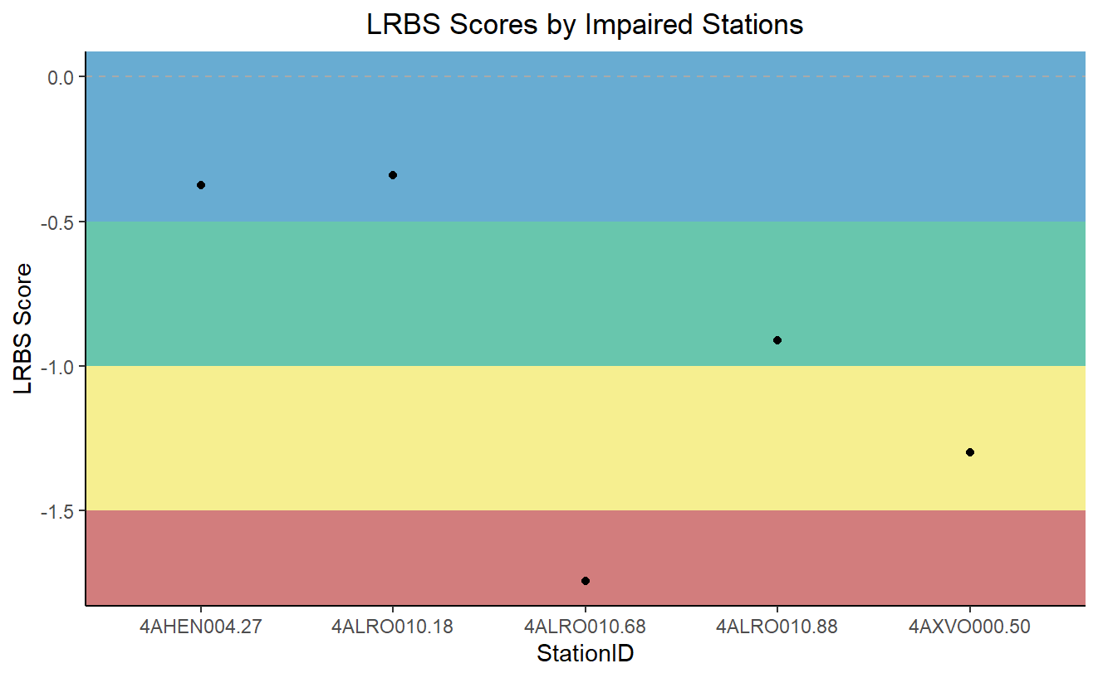

Figure 15. LRBS scores calculated for each station within the impaired stream segments overlayed with the probability that those scores indicate bed stability is inducing stress to aquatic life. Red indicates a high probability, yellow indicates a medium probability, green indicates a low probability, and blue indicates no probability of calculated relative bed stability causing stress to aquatic life.
LRBS scores were statistically compared to VSCI scores through a linear regression analysis (Figure 19). The low R² value (0.01) indicates considerable variability in this relationship and the high p value (0.870) demonstrates that LRBS scores are not a good predictor of VSCI scores in these streams. Consequently, while relative bed stability in the UT to Spencer Creek and Little Roanoke Creek do fall within the range of being potential stressors, this relationship does not indicate that relative bed stability is the only driving stressor to the benthic communities where low VSCI scores have been observed.
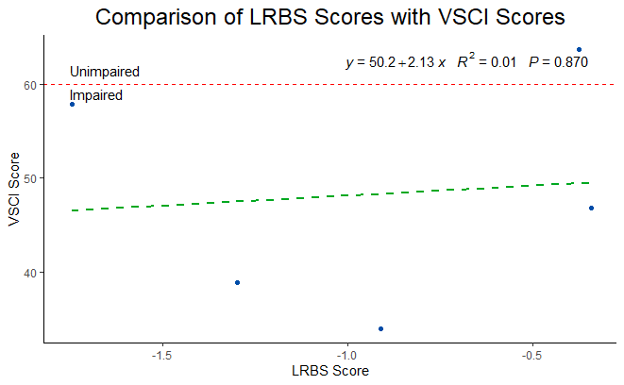

Figure 16. The linear realtionship between LRBS scores and VSCI scores shown with a scatter plot and regression line.

1.3.3 Water Quality Data
To investigate the stressor(s) causing the impairment to the aquatic communities, all available VADEQ bioassessment, ambient water quality and special study data was examined. Biological and probabilistic sampling typically occur during low flow to capture colonized aquatic communities. Ambient water quality monitoring occurs monthly or bimonthly but is most likely during base or low flow given the infrequency and safety associated with storm sampling. Based on VADEQ’s water monitoring program, the observed data may be biased toward low/base flow conditions and may not accurately represent conditions at high flow.
Water quality data has been collected by VADEQ on various occasions between 2007 and 2023 in the Horsepen Creek, Little Roanoke Creek, and the UT to Spencer Creek watersheds. This data was used in this benthic stressor analysis. One-hundred-and-eight (108) samples were collected from five ambient monitoring stations in the project area (4AHEN004.27, 4ALRO010.18, 4ALRO010.88, 4AXVO000.50, 4AXVO000.60). In addition, field parameters, pH, temperature, dissolved oxygen, and conductivity, were measured at all of the ambient monitoring stations, as well as one other biological monitoring station in the Little Roanoke Creek watershed. Water quality parameters analyzed included: temperature, pH, dissolved oxygen, conductivity, total dissolved solids, total nitrogen, total phosphorus, chloride, sulfate, potassium, sodium, and dissolved metals. These parameters were analyzed for evidence of stressor effects by comparing measured values to Virginia water quality standards, to reference conditions, and to published thresholds for stressor effects.
Horsepen Creek station 4AHEN004.27 was first listed as impaired for the General Standard (aquatic life) in 2008. Little Roanoke Creek station 4ALRO010.68 was first listed as impaired for the General Standard (aquatic life) in 2010. The UT to Spencer Creek station 4AXVO000.50 was first listed as impaired for the General Standard (aquatic life) in 2012. All three impairment listings were based on samples taken for the probabilistic monitoring program. Additional ambient and biological monitoring was conducted in preparation for this study.

1.3.3.1 Temperature
Many years of temperature data collected during sampling events as well as temperature data from a special diurnal dissolved oxygen study conducted during the summer of 2023 is available for analysis for all three streams. VADEQ measures field parameters while collecting biological and water quality samples; temperature is one of the field parameters collected. There are four temperature data points taken at the time of spring and fall benthic macroinvertebrate sampling from Reedy Creek to examine. While temperatures vary by season, there is a water quality standard for Class III Piedmont Zone waters of 32 degrees Celsius. All three impaired stream segments are considered Class III Piedmont Zone waters. When water temperatures exceed 32 degrees Celsius, native aquatic life can become stressed and even experience mortality events. Temperature data was analyzed and is displayed in Figure 20 for each of the impaired streams, as well as the reference. This figure allows comparison of temperature variability in the streams and identification of the maximum temperatures recorded in each impaired segment. The box-and-whisker plot provides a visual summary of the year-round recorded temperature distribution for each impaired stream and the limited distribution of recorded spring and fall temperatures in the reference stream. The maximum water temperatures recorded in Horsepen, Little Roanoke, and UT to Spencer Creeks were 25.6°C, 28.01°C, 25.54°C, respectively, which is well below the water quality standard threshold. The interquartile range (25th-75th percentiles) of temperatures for all three streams were very similar and overlapping. None of them are exhibiting concerningly high temperatures that could induce stress to aquatic life.

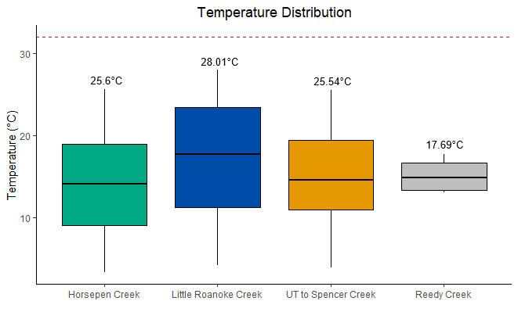

Figure 17. Box-and-whisker plot displaying temperature distributions within Horsepen Creek, Little Roanoke Creek, the UT to Spencer Creek, and Reedy Creek. The red dashed line indicates water quality temperature standard.
The special diurnal dissolved oxygen study, conducted during July and August of 2023, saw the deployment of a sonde, programmed to continuously record field parameters, pH, dissolved oxygen, conductivity, and temperature, at 15-minute intervals over a week-long period. The goal of this deployment is to capture diurnal dissolved oxygen swings that can only be recorded using continuous monitoring. To have the greatest opportunity of capturing stress inducing dissolved oxygen swings, July and August were chosen to be the months of the study. This coincides with the time of year that the greatest opportunity for stress inducing temperatures exist. Temperature data observed in all three impaired streams is displayed in Figure 21. Continuous temperature data exhibited a normal cycle of increasing temperatures during the day and decreasing temperatures during the night. None of the three creeks exhibited temperatures even approaching the water quality standard. This would indicate that temperature is not a likely stressor for any of these streams.
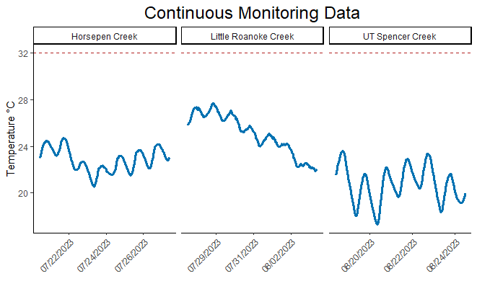

Figure 18. Continuous monitoring temperature data output from diurnal dissolved oxygen study, Horsepen Creek, Little Roanoke Creek, and the UT to Spencer Creek. Red dashed line indicates water quality temperature standard.

1.3.3.2 pH
pH data collected during many sampling events as well as pH data from a special diurnal dissolved oxygen study conducted during the summer of 2023 is available for analysis for all three impaired streams. VADEQ measures field parameters while collecting biological and water quality samples. There are four pH data points taken at the time of spring and fall benthic macroinvertebrate sampling from Reedy Creek to examine. pH is one of the field parameters collected. pH can vary due to natural geology, surrounding land use, and biotic processes within streams. There is a water quality standard for Class III Piedmont Zone waters of 6.0-9.0 pH values. All three impaired stream segments are considered Class III Piedmont Zone waters. When pH values occur outside of the water quality standard range, native aquatic life can become stressed and even experience mortality events. The average pH values from Horsepen (7.4), Little Roanoke (7.3), and the UT to Spencer Creek (7.5) were all near neutral. All the recorded pH values were within the water quality standards criteria (Figure 22). They are all within the range of low probability for producing stressor effects.
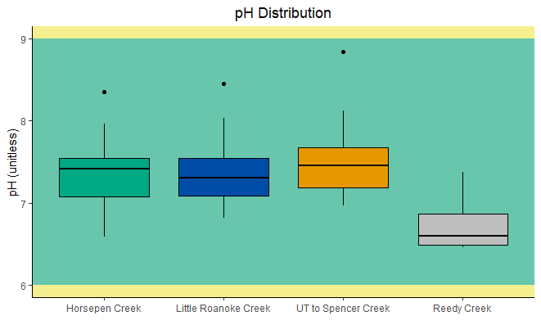

Figure 19. Box-and-whisker plot displaying pH distributions within Horsepen Creek, Little Roanoke Creek, the UT to Spencer Creek, and Reedy Creek. This plot overlays color-coded zones of probability, green indicating pH values with a low probability of causing stress to aquatic life, yellow indicating pH values with a medium probability of causing stress to aquatic life.
The special diurnal dissolved oxygen study, conducted during July and August of 2023, saw the deployment of a sonde, programmed to continuously record field parameters, pH, dissolved oxygen, conductivity, and temperature, at 15-minute intervals over a week-long period. The goal of this deployment is to capture diurnal dissolved oxygen swings that can only be recorded using continuous monitoring. To have the greatest opportunity of capturing stress inducing dissolved oxygen swings, July and August were chosen to be the months of the study. Dissolved oxygen swings often coincide with pH swings due to the diurnal cycles of photosynthesis and respiration that plants and algae undergo. This cycle can raise and lower the pH of a stream drastically. pH values observed in all three impaired streams is displayed in Figure 23. Continuous pH data exhibited an expected cycle of minute increases and decreases with the diurnal cycle. All three impaired creeks exhibited pH values well within the water quality standards. This would indicate that pH is unlikely to be a stressor.
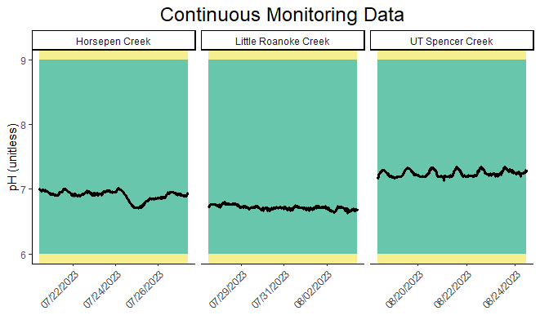

Figure 20. Continuous monitoring pH data output from diurnal dissolved oxygen study, Horsepen Creek, Little Roanoke Creek, and the UT to Spencer Creek. This plot overlays color-coded zones of probability, green indicating pH values with a low probability of causing stress to aquatic life, yellow indicating pH values with a medium probability of causing stress to aquatic life.

1.3.3.3 Dissolved Oxygen
Dissolved oxygen data collected during sampling events as well as data from a special diurnal dissolved oxygen study conducted during the summer of 2023 is available for analysis for all three impaired streams. VADEQ measures field parameters while collecting biological and water quality samples. Dissolved oxygen is one of the field parameters collected. There are four dissolved oxygen data points taken at the time of spring and fall benthic macroinvertebrate sampling from Reedy Creek to examine. The dissolved oxygen water quality standard for Class III Piedmont Zone waters is a minimum of 4.0 mg/L and 5.0 mg/L as a daily average. However, dissolved oxygen values below 7.0 mg/L have a high probability to stressing native aquatic life. The average dissolved oxygen values recorded during ambient and biological monitoring from Horsepen Creek, Little Roanoke Creek, and the UT to Spencer Creek were 8.9 mg/L, 8.5 mg/L, and 9.6 mg/L, respectively. The minimum dissolved oxygen values recorded in Horsepen Creek, Little Roanoke Creek, and UT to Spencer Creek were 3.8 mg/L, 4.2 mg/L, and 6.6 mg/L, respectively (Figure 24). While the averages for all three streams are well above the water quality standards for dissolved oxygen, observations of dissolved oxygen in the high probability zone were also seen for each stream. Horsepen Creek has a recorded dissolved oxygen observation below the water quality standard. The interquartile range (25th-75th percentiles) of dissolved oxygen values recorded in Horsepen Creek falls within the no-to-medium probabilities of inducing stress on aquatic life. The UT to Spencer Creek’s interquartile range of dissolved oxygen values fell within the no-to-low probability range for inducing stress. Little Roanoke Creek’s interquartile range spans the no-to-high probability range for causing stress to benthic macroinvertebrates. This data suggests that while stream conditions, pertaining to dissolved oxygen, may not always be stress inducing, they do get to the point of inducing stress to the biota on occasion within the stream. Water at higher temperatures generally holds less dissolved oxygen, but as was discussed in section 1.3.3.1, none of these streams experienced concerningly high temperatures during the study period. The reduced dissolved oxygen levels are more likely derived from excessive decomposition of organic matter built up, poor stream flow, or eutrophication from nutrient enrichments based on the functional feeding group community compositions and habitat data previously examined.
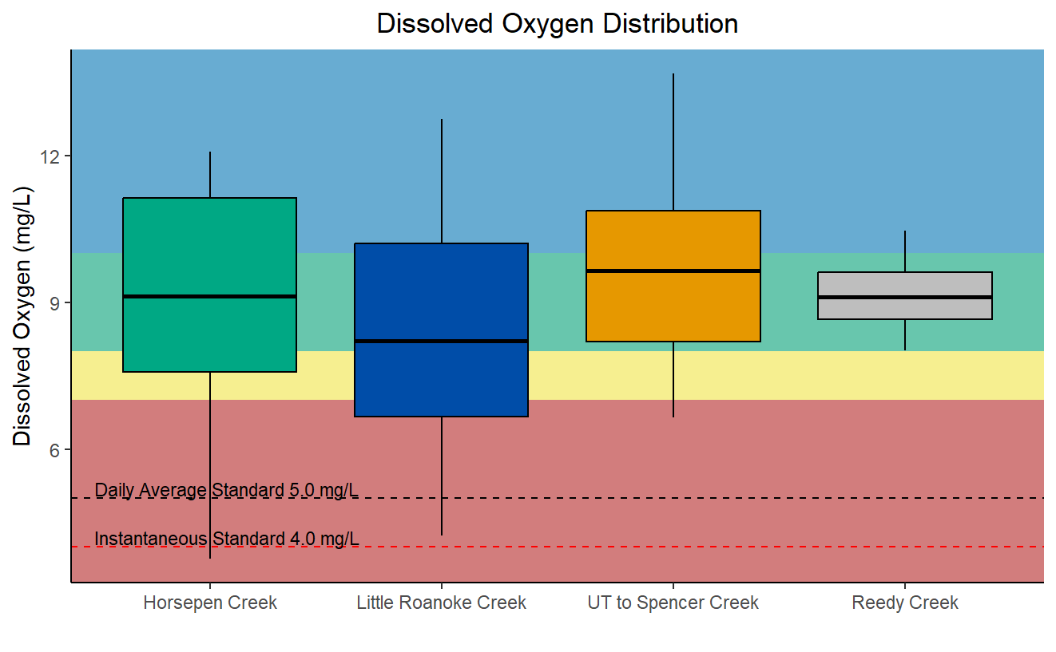

Figure 21. Box-and-whisker plot displaying dissolved oxygen distributions within Horsepen Creek, Little Roanoke Creek, the UT to Spencer Creek, and Reedy Creek. The red dashed line indicates the water quality dissolved oxygen standard for instantaneous values while the black dashed line indicates the water quality standard for daily average dissolved oxygen. This plot overlays color-coding for ranges of values and their probabilities for causing stress to aquatic life. Red indicates a high probability, yellow indicates a medium probability, green indicates a low probability, and blue indicates no probability of measured dissolved oxygen values causing stress to aquatic life.
The special diurnal dissolved oxygen study, conducted during July and August of 2023, saw the deployment of a sonde, programmed to continuously record field parameters, pH, dissolved oxygen, conductivity, and temperature, at 15-minute intervals over a week-long period. The goal of this deployment was to capture diurnal dissolved oxygen swings that can only be recorded using continuous monitoring. Diurnal monitoring of dissolved oxygen is important because critical dissolved oxygen levels are typically encountered just before sunrise. This is due to the combination of oxygen consumption from respiration and the absence of oxygen production from photosynthesis during the night. Diurnal monitoring was conducted in July and August because critical dissolved oxygen levels are more common during the hot and dry summer months, therefore, more readily observable. Dissolved oxygen values observed in all three impaired streams are displayed in Figure 23. Continuous monitoring of the dissolved oxygen concentration exhibited a cycle of expected diurnal swings in Horsepen Creek and the UT to Spencer Creek, however, these swings were not observed in Little Roanoke Creek. Both Horsepen Creek and Little Roanoke Creek exhibited dissolved oxygen values above the overall water quality standard, 4 mg/L, but Little Roanoke Creek’s daily averages fell below the daily water quality standard, 5 mg/L. Little Roanoke Creek’s daily dissolved oxygen levels ranged from 4.32 mg/L to 5.01 mg/L during the sonde deployment, violating the water quality standard seven out of eight days of the deployment. Both Little Roanoke Creek’s and Horsepen Creek’s recorded values remained within the high probability range for inducing stress on the benthic macroinvertebrate communities both day and night throughout the sonde deployment. The UT to Spencer Creek’s observed dissolved oxygen levels swung from the low probability of inducing stress to aquatic life during the daytime to the medium probability range of inducing stress to aquatic life overnight.
In summary, looking at the ambient data and continuous monitoring data together, dissolved oxygen should be considered as a potential stressor within each stream. Dissolved oxygen is most likely not as important of a stressor in the UT to Spencer Creek as it is in the other two larger streams. In Horsepen and Little Roanoke Creeks, dissolved oxygen is most likely causing significant stress to the aquatic life within the stream. Low dissolved oxygen, a stressor in and of itself, is usually an observable side effect of another stressor. The diurnal swings of the dissolved oxygen concentrations in Horsepen Creek are indicative of daily photosynthesis and respiration cycles. The stagnant concentration of dissolved oxygen in Little Roanoke Creek, does not follow the same pattern and is more indicative of a stressor that causes constant conditions for low dissolved oxygen.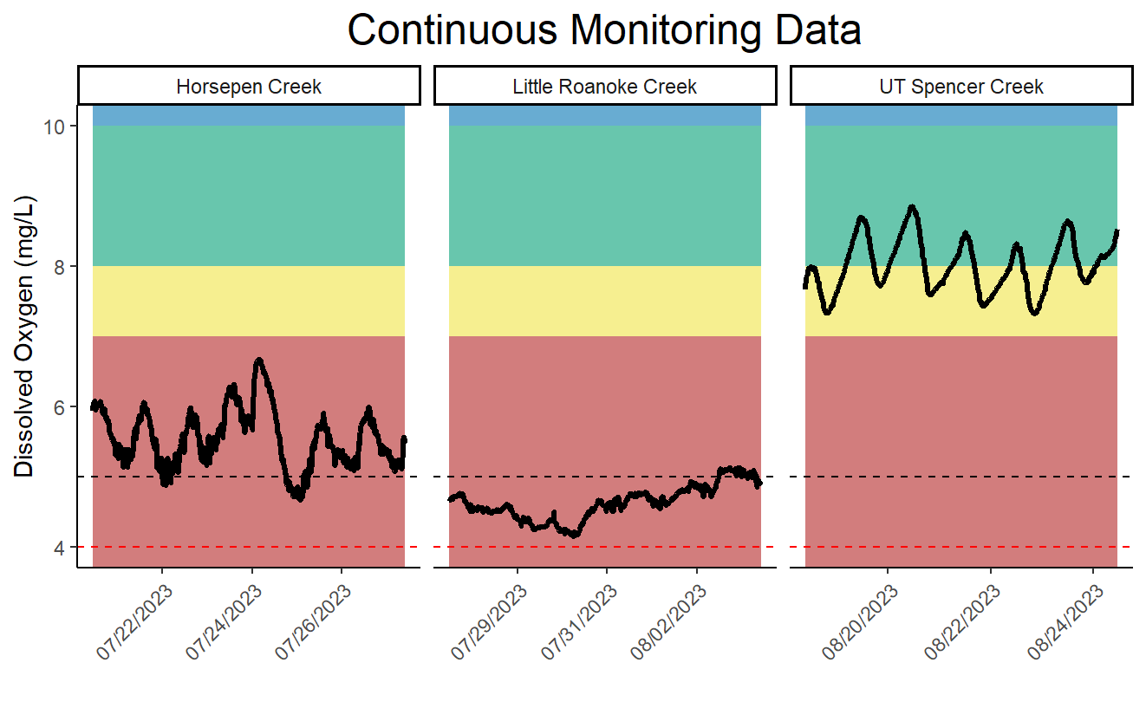

Figure 22. Continuous moniotring dissolved oxygen data from diurnal dissolved oxygen study, Horsepen Creek, Little Roanoke Creek, and the UT to Spencer Creek. The red dashed line indicates the water quality dissolved oxygen standard for instantaneous values while the black dashed line indicates the water quality standard for daily average dissolved oxygen. This plot overlays color-coding for ranges of values and their probabilities for causing stress to aquatic life. Red indicates a high probability, yellow indicates a medium probability, green indicates a low probability, and blue indicates no probability of measured dissolved oxygen values causing stress to aquatic life.

1.3.3.4 Conductivity and Dissolved Solids
Conductivity is a measure of the electrical potential of water based on the ionic charges of dissolved compounds. For this reason, the conductivity of water is closely related to the total dissolved solids present. Conductivity data collected during sampling events as well as from a special diurnal dissolved oxygen study conducted during the summer of 2023 is available for analysis for all three impaired streams. VADEQ measures field parameters while collecting biological and water quality samples. Conductivity is one of the field parameters collected. There are four conductivity data points taken at the time of spring and fall benthic macroinvertebrate sampling from Reedy Creek to examine. Conductivity can vary due to natural geology and human influences on the surrounding landscape. Decreases in sensitive macroinvertebrate taxa, such as Ephemeroptera, have been documented at conductivity levels above 500 uS/cm (Pond, 2004). However, these impacts are more closely associated with concentrations of dissolved metals and salts, which are a covariant of conductivity, and can be toxic to aquatic macroinvertebrates at high concentrations. These constituents are commonly associated with runoff from mined sites and roadways where road salts have been applied. Specific conductance was within the no probability range of inducing stress on aquatic life (Figure 26). The maximum conductivity values recorded in Horsepen Creek, Little Roanoke Creek, and the UT to Spencer Creek were 177 uS/cm, 172 uS/cm, and 155 uS/cm, respectively. These maximum recorded specific conductance values do not indicate that dissolved solids are inducing stress to aquatic life.
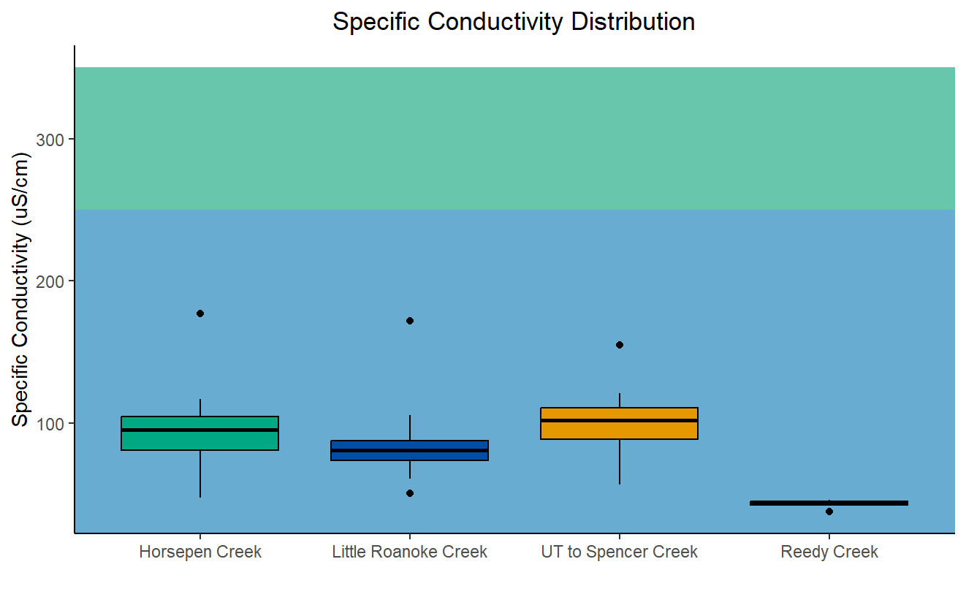

Figure 23. Box-and-whisker plot displaying specific conductivity distributions within Horsepen Creek, Little Roanoke Creek, the UT to Spencer Creek, and the reference stream, Reedy Creek. This plot overlays color-coding for ranges of values and their probabilities for causing stress to aquatic life. Green indicates a low probability and blue indicates no probability of measured specific conductivity values causing stress to aquatic life.
The special diurnal dissolved oxygen study, conducted during July and August of 2023, saw the deployment of a sonde, programmed to continuously record field parameters, pH, dissolved oxygen, conductivity, and temperature, at 15-minute intervals over a week-long period. The goal of this deployment is to capture diurnal dissolved oxygen swings that can only be recorded using continuous monitoring. To have the greatest opportunity of capturing stress inducing dissolved oxygen swings, July and August were chosen to be the months of the study. Specific conductance observed in all three impaired streams is displayed in Figure 27. Continuous conductivity data exhibited no observable cycle of increases or decreases during the deployment. There were also no indications that the conductivity was causing stress.
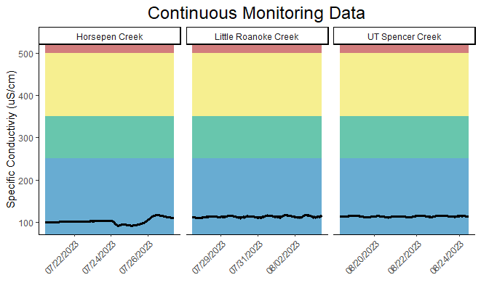

Figure 24. Continuous monitoring conductiviy data from diurnal dissolved oxygen study, Horsepen Creek, Little Roanoke Creek, and the UT to Spencer Creek. This plot overlays color-coding for ranges of values and their probabilities for causing stress to aquatic life. Red indicates a high probability, yellow indicates a medium probability, green indicates a low probability, and blue indicates no probability of measured specific conductivity values causing stress to aquatic life.
Total dissolved solids are closely tied to conductivity since dissolved ions are responsible for transmission of electrical currents in the water. Total dissolved solids were sampled during ambient and biological monitoring events for all three impaired streams between 2019 and 2022. Total dissolved solids were sampled at one biological monitoring event on Reedy Creek in 2021. Like conductivity, total dissolved solids levels were not elevated in the impaired streams and remained within the no-probability range of inducing stress to aquatic life (Figure 28). In the UT to Spencer Creek, some data falling outside of the interquartile range (25th-75th percentiles) falls into the low probability range of inducing stress to aquatic life. The consistency between the probabilities for inducing stress for these total dissolved solids values and the measured specific conductivities indicate that neither of these parameters are of concern in the impaired streams and are unlikely to be stressors.
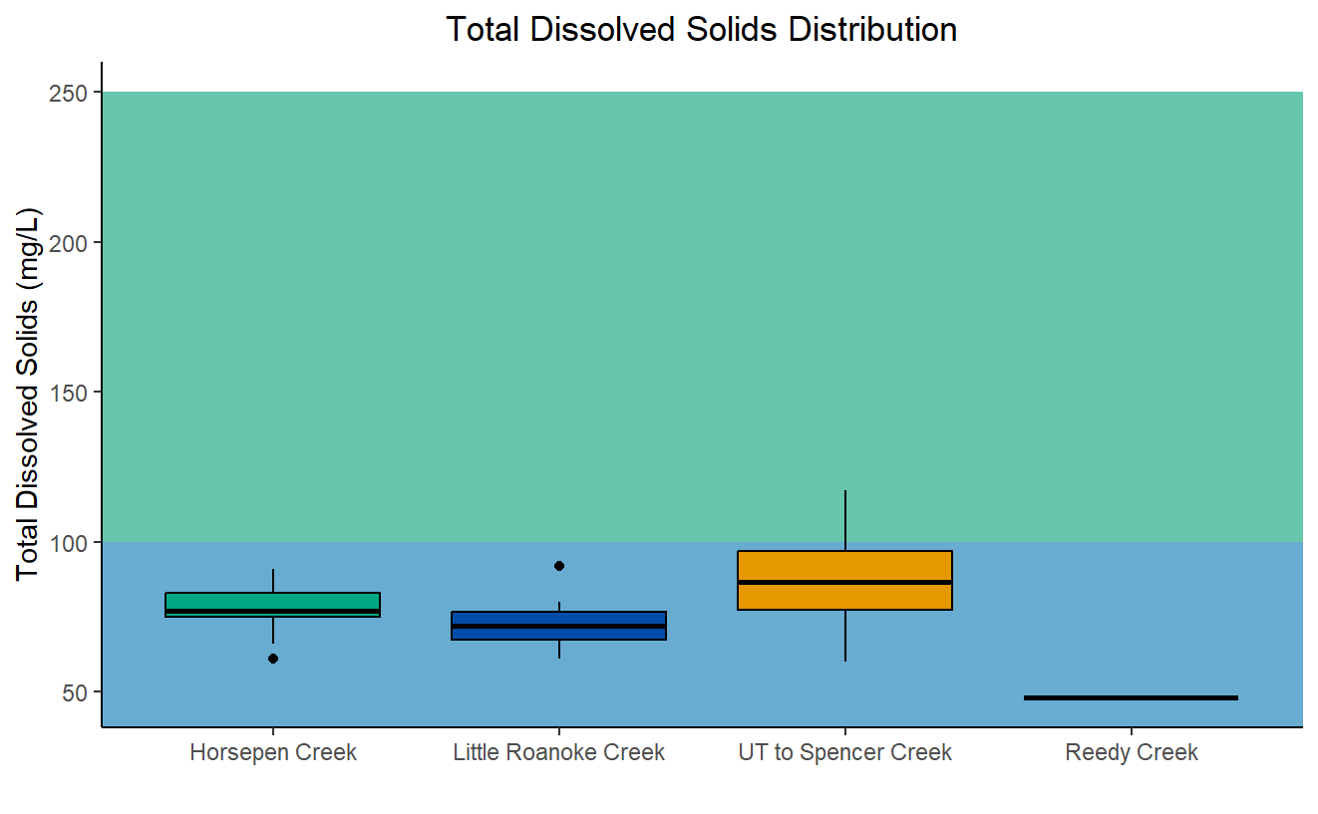

Figure 25. Box-and-whisker plot displaying total dissoleve solids distributions within Horsepen Creek, Little Roanoke Creek, the UT to Spencer Creek, and the reference stream, Reedy Creek. This plot overlays color-coding for ranges of values and their probabilities for causing stress to aquatic life. Green indicates a low probability and blue indicates no probability of measured total dissolved solids values causing stress to aquatic life.

1.3.3.5 Dissolved Ions
Dissolved chloride, potassium, sodium, and sulfate were measured in Horsepen Creek, Little Roanoke Creek, and the UT to Spencer Creek. Dissolved ion concentrations were compared to both DEQ’s stressor thresholds and concentrations in the reference stream, Reedy Creek. Reedy Creek was only sampled for these dissolved ions once, therefore that comparison alone, would not be a strong argument. Some dissolved ions can be naturally occurring in streams that are affected by geologic features, such as karst topography. There is very little karst influence in the piedmont ecoregion, which all these streams occur within. Should there be any elevated ions, it is unlikely that it is from the natural geology of the landscape.
Dissolved chloride concentrations in the three impaired streams all fell within the no-probability range for causing stress to aquatic life (Figure 29). Virginia water quality standards include an acute maximum chloride concentration criterion of 860 mg/l and a chronic maximum concentration criterion of 230 mg/l to protect aquatic life. The acute criterion is for a one-hour average not to be exceeded more than once every three years; the chronic criterion applies to a four-day average, which is also not to be exceeded more than once every three years (9VAC25-260-140). Chloride sampling gave no indication that chloride is a potential stressor to any of the three impaired streams. Dissolved chloride levels were very low, relative to stress inducing probabilities and water quality criteria.
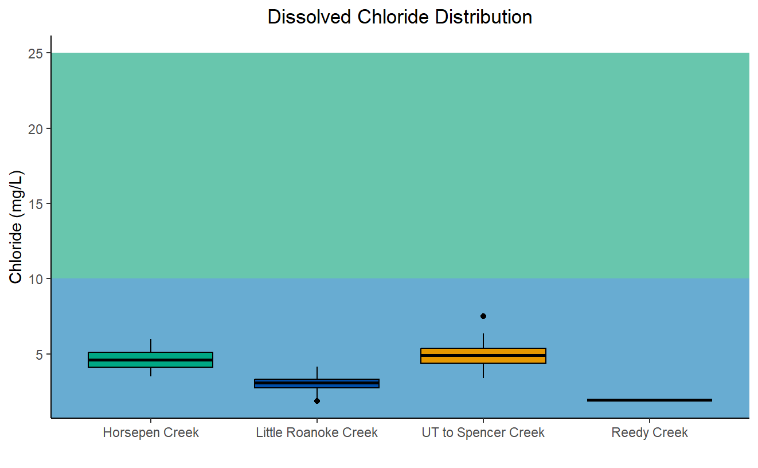

Figure 26. Box-and-whisker plot displaying dissolved chloride distributions within Horsepen Creek, Little Roanoke Creek, the UT to Spencer Creek, and the reference stream, Reedy Creek. This plot overlays color-coding for ranges of values and their probabilities for causing stress to aquatic life. Green indicates a low probability and blue indicates no probability of measured dissolved chloride values causing stress to aquatic life.
Dissolved potassium concentrations in the three impaired streams are a different story from chloride. Median values fell along the boundary of low-to-medium probabilities of stressor effects for Horsepen Creek, Little Roanoke Creek, and the UT to Spencer Creek (Figure 30). The UT to Spencer Creek had a high outlier value that approached the high probability stressor range. This outlier was recorded on October 16, 2019. Along with this high potassium value, chloride and total dissolved solids were higher on this sample date than all other recorded values. Conductivity and other dissolved ions did not display the same spike. After reviewing historical weather data, there was a rainfall event within the 24-hour period prior to that sample being collected. This indicates that stormwater runoff in the UT to Spencer Creek is transporting elevated levels of dissolved potassium and chloride. Dissolved potassium was only measured once in the reference stream. That measured value fell in the low probability stressor range. Due to the 25th to 75th percentiles of values for Little Roanoke Creek and the UT to Spencer Creek falling into the medium probability range for causing stress to aquatic life, dissolved potassium should be considered a potential stressor for both streams.
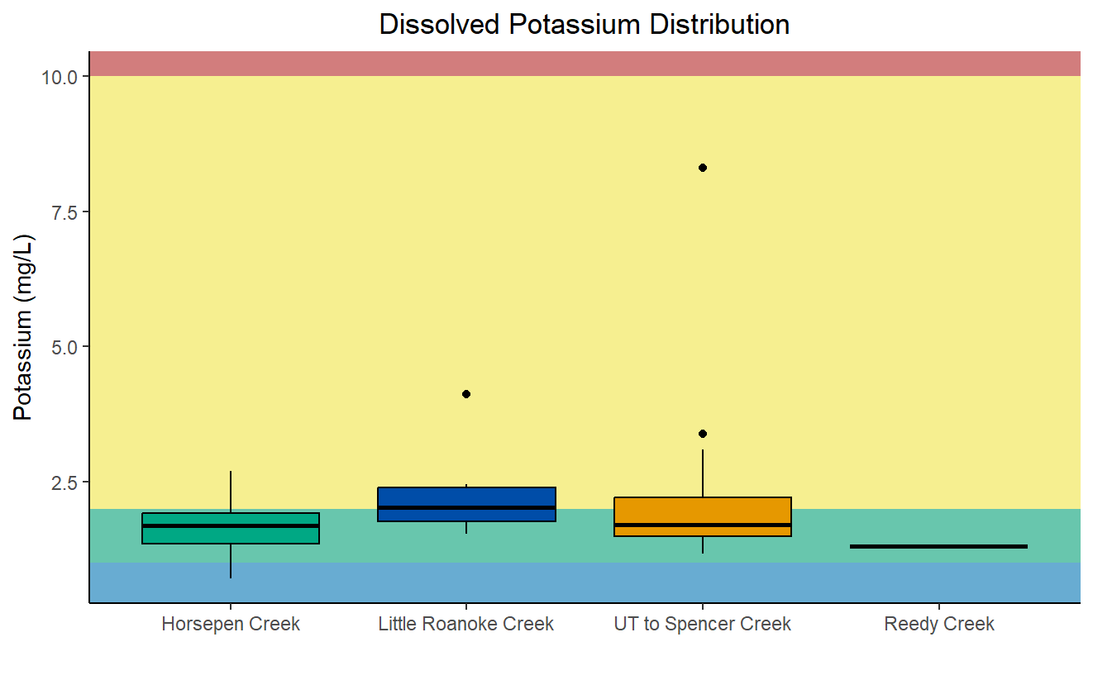

Figure 27. Box-and-whisker plot displaying dissolved potassium distributions within Horsepen Creek, Little Roanoke Creek, the UT to Spencer Creek, and the reference stream, Reedy Creek. This plot overlays color-coding for ranges of values and their probabilities for causing stress to aquatic life. Red indicates a high probability, yellow indicates a medium probability, green indicates a low probability, and blue indicates no probability of measured dissolved potassium values causing stress to aquatic life.
Dissolved sodium levels were respectively low within all three streams. Both the median and average dissolved sodium levels for the impaired streams fell within the no probability range for inducing stress to aquatic life (Figure 31). None of the recorded values raise concern regarding sodium within the impaired streams nor signify that it is a potential stressor.
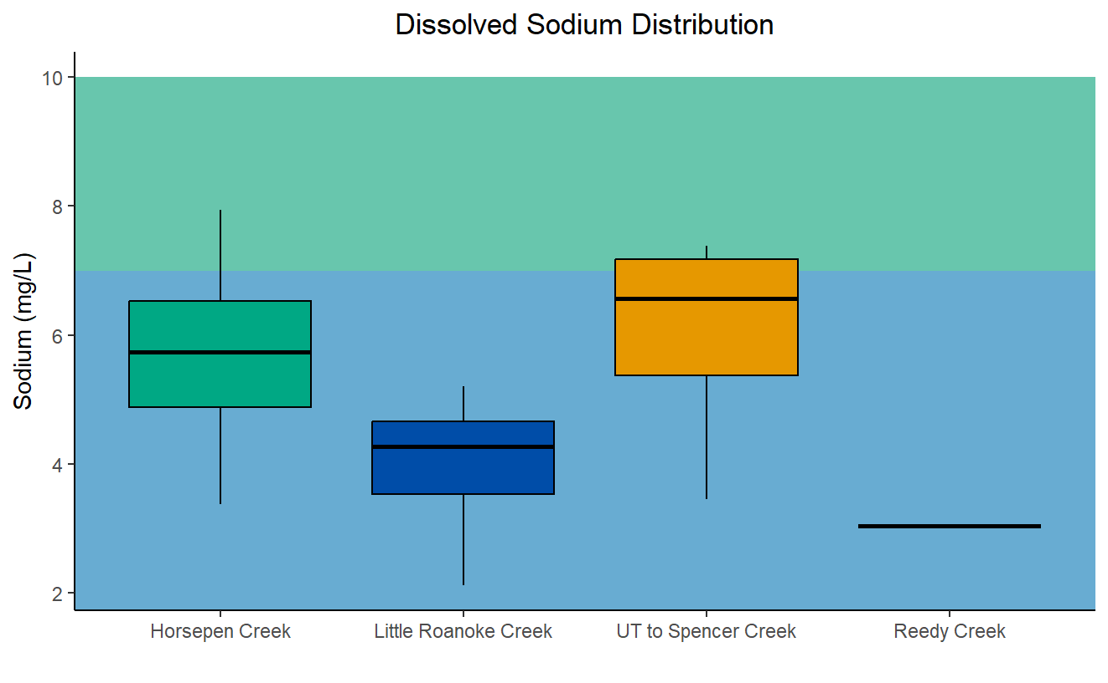

Figure 28. Box-and-whisker plot displaying dissolved sodium distributions within Horsepen Creek, Little Roanoke Creek, the UT to Spencer Creek, and the reference stream, Reedy Creek. This plot overlays color-coding for ranges of values and their probabilities for causing stress to aquatic life. Green indicates a low probability and blue indicates no probability of measured dissolved sodium values causing stress to aquatic life.
Dissolved sulfate concentrations were comparatively low in all three of the impaired streams. The recorded values in Horsepen Creek, Little Roanoke Creek, and the UT to Spencer Creek all fell within the no probability of being a stressor range (Figure 32). In section 1.3.1.2, sulfate was a potential stressor that the BCG indicated the benthic macroinvertebrate community was very tolerant to within Horsepen Creek. These low values dismiss dissolved sulfate from being considered as a potential stressor. Sulfate is unlikely to be a stressor in any of the impaired streams.
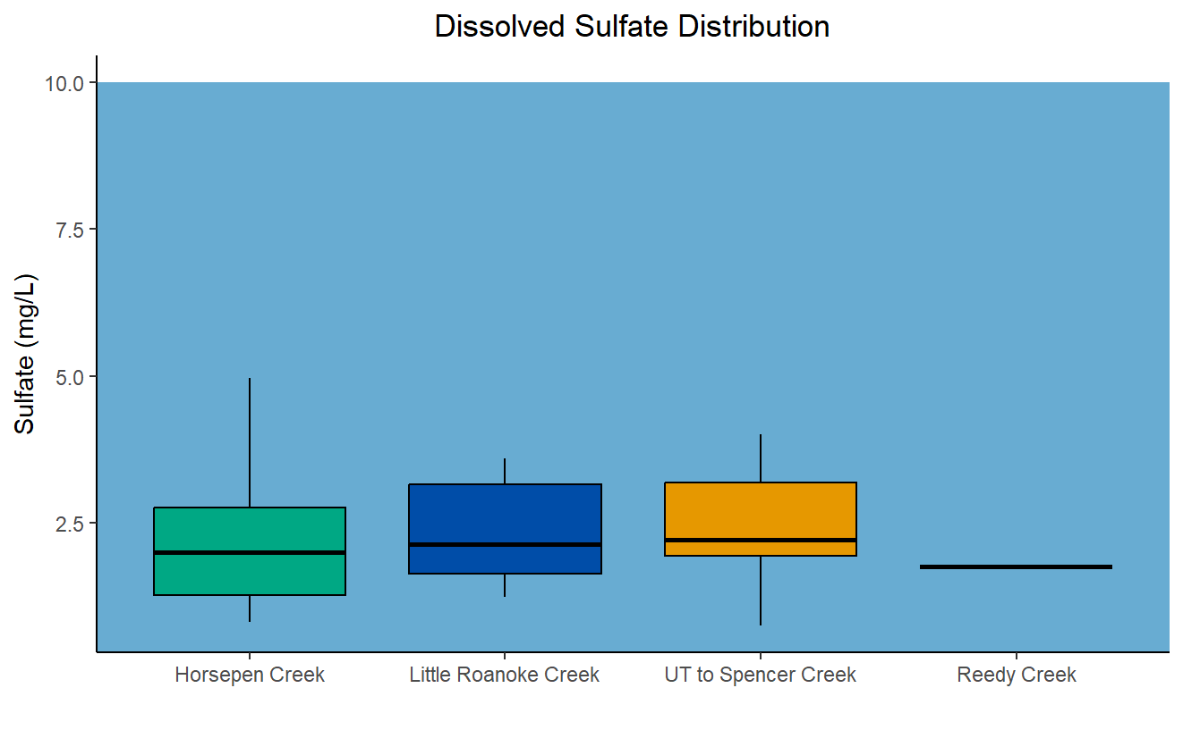

Figure 29. Box-and-whisker plot displaying dissolved sulfate distributions within Horsepen Creek, Little Roanoke Creek, the UT to Spencer Creek, and the reference stream, Reedy Creek. This plot overlays color-coding for ranges of values and their probabilities for causing stress to aquatic life. Blue indicates no probability of measured dissolved sulfate values causing stress to aquatic life.
In summary, conductivity, total dissolved solids, and all the measured ions, excluding potassium, fell into the no-to-low probability ranges for potential stressor affects to aquatic life. The majority (25th-75th percentiles) of dissolved potassium values recorded in Horsepen Creek fell within the low probability range, while the majority of dissolved potassium values in Little Roanoke Creek and the UT to Spencer Creek fell within the low-to-medium probability ranges for potentially inducing stress and should therefore be considered as a possible stressor in those two streams. Potassium is often associated with runoff from lawn and crop fertilizers. Elevated potassium concentrations resulting from fertilizers should be accompanied by elevated nitrogen and phosphorus concentrations as well. While this will be explored more thoroughly in the next section, it was on the same date, October 16, 2019, following a rainfall event, that the highest recorded values of nitrogen and phosphorus was recorded as well. These values all being elevated at once within the UT to Spencer Creek, indicate that agriculturally influenced runoff is impacting that stream. Referring to the land use within the watersheds in section 1.2.3, 4.2% of Horsepen Creek’s watershed consisted of lawn and croplands while 8.2% of Little Roanoke Creek’s watershed and 7.2% of the UT to Spencer Creeks watershed consisted of the two potential sources.

1.3.3.6 Nutrients
Nitrogen and phosphorus are the primary nutrients of concern in freshwater. These nutrients are necessary to support healthy ecosystems, but an excess of nutrients can lead to an excess of algal growth and eutrophication. Excessive algal growth can change the benthic community composition by reducing oxygen levels, leading to further changes in community composition, and eventually hypoxic conditions. Eutrophication is dependent on the availability of nutrients. Needing both nitrogen and phosphorus to produce algae, if one of the nutrients is scarce, that can limit the algal growth, despite excesses of the other nutrient. The nutrient that limits algal growth is commonly referred to as the limiting nutrient. The optimal nitrogen to phosphorus ratio for freshwater is 7.5:1, so ratios above 7.5 indicate that phosphorus is the limiting nutrient, and ratios below 7.5 indicate that nitrogen is the limiting nutrient. In most freshwater streams, no single nutrient is always the limiting nutrient, therefore, both should be controlled if either is causing an impairment. In Horsepen Creek, the average nitrogen to phosphorus ratio was 8.4:1, however, there were five occasions during 19 sampling events where nitrogen concentrations were low enough that when compared to phosphorus, nitrogen was the limiting nutrient. In Little Roanoke Creek, the average nitrogen to phosphorus ratio was 10.7:1. There were only three occasions during 43 sampling events when nitrogen concentrations were low enough that when compared to phosphorus, nitrogen was the limiting nutrient. Finally, in the UT to Spencer Creek, the average nitrogen to phosphorus ratio was 10.9:1. There were three occasions during 20 sampling events when nitrogen concentrations were low enough that when compared to phosphorus, nitrogen was the limiting nutrient. These average ratios indicate that phosphorus is, on average, the limiting nutrient within the three streams. However, within all of three impaired streams, especially Horsepen Creek (> 25% of the time), nitrogen can serve as the limiting nutrient to algal growth from time to time.
VADEQ has measured both total nitrogen and total phosphorus in Horsepen, Little Roanoke, and the UT to Spencer Creeks on many occasions. These nutrients were each only measured once in the reference stream. Total nitrogen and total phosphorus are used in the stressor analysis process to identify the potential for nutrient enrichment within streams. Total nitrogen concentrations in the impaired streams were compared to both DEQ’s stressor thresholds and the reference stream (Figure 33). The majority of values (25th-75th percentiles) recorded in Horsepen Creek and Little Roanoke Creek fell below 1.0 mg/L of total nitrogen, and therefore, were within the no-to-low probability ranges for inducing stress. Most values recorded in the UT to Spencer Creek fell within the low probability range for inducing stress, with a few outlier values falling into the medium probability stressor range. The highest recorded value, 1.81 mg/L, was recorded on October 16, 2019, following a rainfall event. Due to the nature of roadside ambient water quality sampling and the bias against sampling during storm events due to safety, this is an important outlier that points to elevated nutrient concentrations in stormwater runoff that may not always be captured during fair weather conditions.
Both median and average values for all three impaired creeks fell within the low probability range of causing stressor effects due to excess nitrogen. Little Roanoke and the UT to Spencer Creeks did have a few excursions into the medium probability of stressor effects when compared with DEQ’s stressor thresholds (DEQ, 2017). Because nitrogen is not, on average, the limiting nutrient in these streams and most of the recorded values fall within the no-to-low probability ranges for inducing stressor effects, nitrogen is only a possible stressor on its own in these impaired streams.

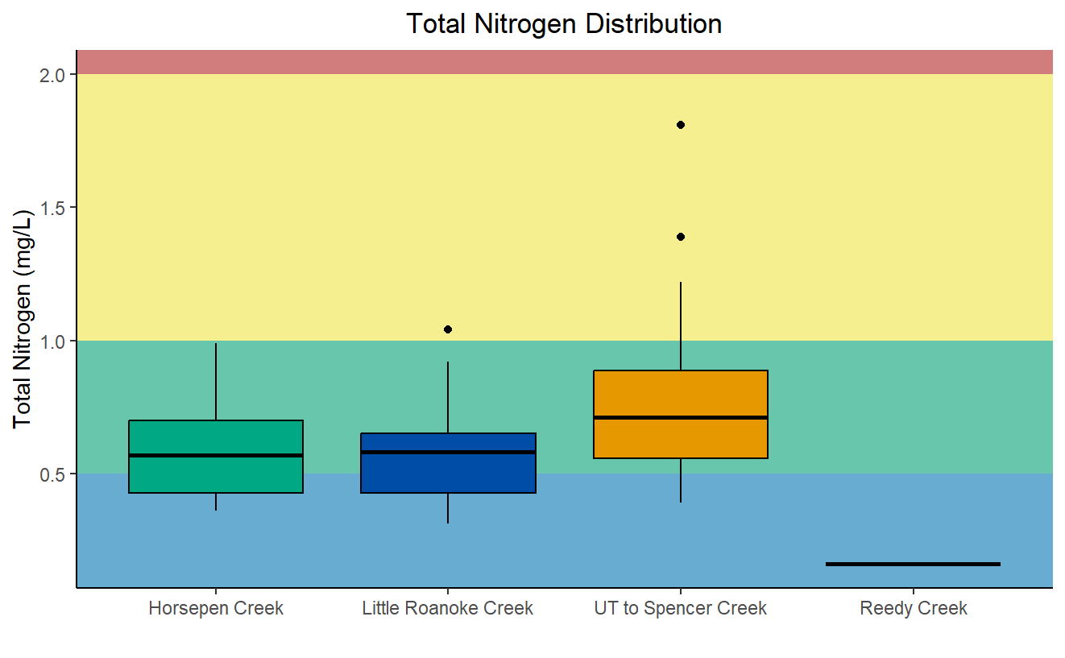

Figure 30. Box-and-whisker plot displaying total nitrogen distributions within Horsepen Creek, Little Roanoke Creek, the UT to Spencer Creek, and the reference stream, Reedy Creek. This plot overlays color-coding for ranges of values and their probabilities for causing stress to aquatic life. Red indicates a high probability, yellow indicates a medium probability, green indicates a low probability, and blue indicates no probability of Total Nitrogen values causing stress to aquatic life.
Total phosphorus was also measured in the impaired streams, and in the reference stream once. Total phosphorus concentrations in the impaired streams were compared to both DEQ’s stressor thresholds and the reference stream (Figure 34). The majority of values (25th-75th percentiles) recorded in Horsepen Creek, Little Roanoke Creek, and the UT to Spencer Creek fell between 0.025 mg/L and 0.1 mg/L of total phosphorus, and therefore, were within the low-to-medium probability ranges for inducing stress. A few values falling into the high probability stressor range, were recorded for all three impaired streams as well.
The UT to Spencer Creek saw some of the highest spikes in total phosphorus values compared to the other streams. The highest recorded total phosphorus value was collected on October 16, 2019, the same date as the elevated nitrogen and potassium concentrations, following a rainfall event. Periodic excursions in phosphorus levels are expected during storm events when sediment is deposited in streams through runoff and streambank erosion. Similar spikes may be observed in healthy streams. Since total phosphorus levels in all three impaired creeks consistently exceeded the threshold of the medium probability range for stressor effects, this data suggests phosphorus is a possible stressor in these streams.
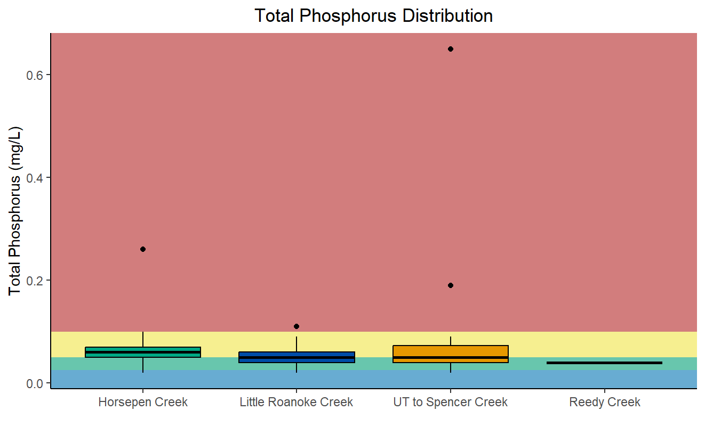

Figure 31. Box-and-whisker plot displaying total phosphorus distributions within Horsepen Creek, Little Roanoke Creek, the UT to Spencer Creek, and the reference stream, Reedy Creek. This plot overlays color-coding for ranges of values and their probabilities for causing stress to aquatic life. Red indicates a high probability, yellow indicates a medium probability, green indicates a low probability, and blue indicates no probability of total phosphorus values causing stress to aquatic life.
Diurnal dissolved oxygen monitoring results must also be considered when determining if phosphorus is a likely stressor in any of these streams. Excess nutrient loads to a stream may accelerate algal growth, resulting in large diurnal swings in dissolved oxygen concentrations during periods of photosynthesis and respiration. Dissolved oxygen levels in Horsepen and Little Roanoke Creeks fell within the high probability range of causing aquatic life stress (below 7 mg/L) during the week-long sonde deployment. In Horsepen Creek, dissolved oxygen concentrations approached, but did not fall below, the water quality standard of 5 mg/L as a daily average. There was an observable diurnal swing in daily dissolved oxygen concentrations. This suggests that prominent cycles of photosynthesis and respiration are affecting dissolved oxygen levels in Horsepen Creek.
In Little Roanoke Creek, diurnal dissolved oxygen levels experienced minimal shifts between the daytime and the evening; however, daily average dissolved oxygen concentrations fell below the water quality standard every full day of the deployment. While elevated phosphorus concentrations may be contributing to algal growth, decaying organic matter, resulting in depleted dissolved oxygen levels, is likely to be affecting this stream more significantly than photosynthesis and respiration cycles. This can be inferred due to the consistency of low dissolved oxygen levels recorded.
In the UT to Spencer Creek, diurnal dissolved oxygen levels experienced daily swings resembling those in Horsepen Creek, though overall higher. Daily average dissolved oxygen concentrations were in the low-to-medium probability range for inducing stressor effects. This suggests that increases in photosynthesis during the day and respiration at night is likely affecting the stream, though not to the extremes seen in Horsepen Creek. The dissolved oxygen levels, which fell into the medium probability range for inducing stress each night of the sonde deployment, are likely associated with elevated phosphorus concentrations.
In summary, monthly ambient monitoring of total nitrogen and total phosphorus indicated that nitrogen and phosphorus were at least possible stressors in Horsepen Creek, Little Roanoke Creek, and the UT to Spencer Creek. However, diurnal monitoring of dissolved oxygen in the impaired streams indicates that the elevated nutrients are having greater effects on Horsepen Creek and UT to Spencer Creek. Little Roanoke Creek, while experiencing very poor levels of dissolved oxygen, seems to be less affected by nutrients directly, and more affected by decomposition of organic matter. Consequently, phosphorus is a possible stressor in Horsepen Creek, Little Roanoke Creek, and the UT to Spencer Creek.

1.3.3.7 Metals
Metals can be present in waterbodies from both natural mineral deposits and from human influence. Different metals can be toxic at different concentrations to aquatic life. Within Little Roanoke Creek and the UT to Spencer Creek, the following metals were sampled: calcium, magnesium, arsenic, barium, beryllium, cadmium, chromium, copper, iron, lead, manganese, thallium, nickel, silver, zinc, antimony, aluminum, selenium. Sampling in Little Roanoke Creek was done at monitoring station 4ALRO010.68 in 2007 and at 4ALRO010.88 in 2022. Sampling in the UT to Spencer Creek was done at monitoring station 4AXVO000.50 in 2012. Of all the metals sampled, none of the concentrations approached VADEQ’s water quality criterion (Table 16). Dissolved metals are not a potential stressor to either of the streams with available data.

Table 16. Concentrations of metals and hardness sampled from Little Roanoke Creek and the UT to Spencer Creek compared to Virginia Water Quality Criteria for Surface Waters and Aquatic Life (9VAC25-260-140). Calcium, magnesium, barium, beryllium, iron, manganese, thallium, silver, anitmony, and hardness do not have approved criterion for chronic toxicity to aquatic life within the Virginia Administrative Code..

* indicates values were calculated based on lowest measured hardness of all three similar samples, 28, most strict

** value calculated based on hardness of 25 mg/L, which is lower than all three measured hardness values
Parameter | Criteria for Chronic Toxicity to Aquatic Life | 4ALRO010.68 | 4ALRO010.88 |  | 4AXVO000.50
Calcium mg/L | NA | 6.50 |  | 6.19 | 7.29
Magnesium mg/L | NA | 3.20 |  | 2.99 | 2.80
Arsenic µg/L | 1.50 e+02 | 0.300 |  | 0.0600 | 0.160
Barium µg/L | NA | 19.8 |  | 26.4 | 18.2
Beryllium µg/L | NA | 0.000 |  | 0.0200 | 0.0400
Cadmium µg/L | 0.280* | 0.000 |  | 0.000 | 0.0300
Chromium µg/L | 26* | 0.800 |  | 0.0800 | 0.410
Copper µg/L | 3.00* | 1.10 |  | 0.610 | 0.590
Iron µg/L | NA | 237 |  | 1.2 e+02 | 276
Lead µg/L | 2.60* | 0.000 |  | 0.0200 | 0.0600
Manganese µg/L | NA | 91.3 |  | 73.6 | 35.6
Thallium µg/L | NA | 0.000 |  | 0.000 | 0.0200
Nickel µg/L | 6.90* | 0.500 |  | 0.250 | 0.440
Silver µg/L | NA | 0.000 |  | 0.000 | 0.0300
Zinc µg/L | 40.0* | 0.000 |  | 0.000 | 0.760
Antimony µg/L | NA | 0.000 |  | 0.0100 | 0.0200
Aluminum µg/L | 5.00 e+02** | 11.9 |  | 3.42 | 16.7
Selenium µg/L | 5.00 | 0.000 |  | 0.070 | 0.300
Hardness mg/L | NA | 29.0 |  | 28.0 | 30.0

1.3.3.8 Water Quality Regressions
To investigate the potential role of various water quality parameters affecting the benthic macroinvertebrate community, SCI scores for Horsepen, Little Roanoke, and the UT to Spencer Creeks were regressed against sampled water quality parameter values. Table 17 shows the results of these regressions. There were no observed significant relationships between SCI scores and any measured water quality parameters within the impaired streams. While dissolved oxygen, total nitrogen, and total phosphorus values indicated potential stressor influences within the streams, additional data is needed to clearly demonstrate the relationship between SCI scores and those water quality parameters. Part of this data challenge stems from benthic data being collected biannually, in the spring and fall, while most water quality parameters are taken monthly or bimonthly year-round.

Table 17. Results from linear regressions of stream condition index scores and water quality parameters recorded in Horsepen Creek, Little Roanoke Creek, and the UT to Spencer Creek.
Parameter | Regression Significant (Y/N) |  |  | R2 |  |  |  | p-value
 | Horsepen Creek | Little Roanoke Creek | UT to Spencer Creek |  | Horsepen Creek | Little Roanoke Creek | UT to Spencer Creek | Horsepen Creek | Little Roanoke Creek | UT to Spencer Creek
Temperature | N | N | N |  | 0.331 | 2.52 e-03 | 0.0355 | 0.0641 | 0.877 | 0.557
pH | N | N | N |  | 0.0915 | 0.259 | 7.53 e-03 | 0.366 | 0.0914 | 0.789
Dissolved Oxygen | N | N | N |  | 4.60 e-03 | 0.0544 | 2.00 e-04 | 0.873 | 0.490 | 0.965
Specific Conductivity | N | N | N |  | 0.0272 | 4.45 e-04 | 4.83 e-06 | 0.0998 | 0.948 | 0.995
Total Dissolved Solids | N | N | N |  | 3.56 e-04 | 0.118 | 0.238 | 0.947 | 0.251 | 0.108
Chloride | N | N | N |  | 0.0190 | 1.23 e-04 | 0.0925 | 0.624 | 0.971 | 0.337
Potassium | N | N | N |  | 1.40 e-05 | 0.0792 | 0.0331 | 0.989 | 0.352 | 0.571
Sodium | N | N | N |  | 8.12 e-03 | 6.71 e-04 | 0.102 | 0.749 | 0.933 | 0.313
Sulfate | N | N | N |  | 0.0529 | 7.25 e-04 | 0.0280 | 0.410 | 0.930 | 0.603
Total Nitrogen | N | N | N |  | 5.14 e-03 | 4.29 e-05 | 7.49 e-05 | 0.800 | 0.983 | 0.979
Total Phosphorus | N | N | N |  | 0.0389 | 0.0101 | 0.0611 | 0.481 | 0.744 | 0.438

CHAPTER 2: STRESSOR IDENTIFICATION

2.0 Causal Analysis
VADEQ conducted the stressor identification according to EPA’s Stressor Identification Guidance Document (USEPA, 2000a) using the Causal Analysis/Diagnosis Decision Information System (CADDIS) (USEPA, 2018). The CADDIS approach provides guidance on evaluating various lines of evidence to determine the cause of biological impairments. In the case of the Horsepen Creek, Little Roanoke Creek, and the UT to Spencer Creek impairments, VADEQ used the available data collected from the sites, published water quality standards and threshold values, and available literature from other cases to investigate the potential causes of impairment. Table 17 shows the lines of evidence suggested by the CADDIS approach, explanations of the concepts, and examples of how each line of evidence was analyzed to identify probable stressors in the impaired streams. Some lines of evidence were not applicable, such as the analysis of biomarkers, field manipulations, or laboratory experiments. Most of the lines of evidence, however, were investigated for each of the three impaired streams. Scoring minutely varies between the different lines of evidence, as not all evidence shares the same significance.

Table 17. Lines of evidence used in the causal analysis approach.
Evidence | The Concept | Examples from Data Analysis
Data from the Case
Spatial Co-occurrence | The biological effect must be observed where the cause is observed and must not be observed where the cause is absent. | Analysis of water quality and habitat data across sites
Temporal Co-occurrence | The biological effect must be observed when the cause is observed and must not be observed when the cause is absent. | Analysis of temporal trends in benthic data
Evidence of Exposure or Biological Mechanism | Measurements of the biota show that relevant exposure to the cause has occurred, or that other biological mechanisms linking the cause to the effect have occurred. | NA
Causal Pathway | Steps in the pathways linking sources to the cause can serve as supplementary or surrogate indicators that the cause and the biological effect are likely to have co-occurred. | Development and analysis of causal pathways for stressors
Stressor-Response Relationships from the Field | As exposure to the cause increases, intensity or frequency of the biological effect increases; as exposure to the cause decreases, intensity or frequency of the biological effect decreases. | Correlation of water quality data with benthic score
Manipulation of Exposure | Field experiments or management actions that increase or decrease exposure to a cause must increase or decrease the biological effect. | NA
Laboratory Tests of Site Media | Controlled exposure in laboratory tests to causes (usually toxic substances) present in site media should induce biological effects consistent with the effects observed in the field. | NA
Temporal Sequence | The cause must precede the biological effect. | NA
Verified Predictions | Knowledge of a cause's mode of action permits prediction and subsequent confirmation of previously unobserved effects. | NA
Symptoms | Biological measurements (often at lower levels of biological organization than the effect) can be characteristic of one or a few specific causes. | Analysis of benthic metrics, community composition, and functional feeding groups
Data from Elsewhere
Stressor-Response Relationships from Other Field Studies | At the impaired sites, the cause must be at levels sufficient to cause similar biological effects in other field studies. | Water quality and Benthic data statistical relationships and stressor probability thresholds
Stressor-Response Relationships from Laboratory Studies | At the impaired sites, the cause must be at levels associated with related biological effects in laboratory studies. | NA
Stressor-Response Relationships from Simulation Models | At the impaired sites, the cause must be at levels associated with effects in mathematical models simulating ecological processes. | Confirmation through use of TMDL model
Mechanistically Plausible Cause | The relationship between the cause and biological effect must be consistent with known principles of biology, chemistry, and physics. | Development and analysis of causal pathways for stressors
Manipulation of Exposure at Other Sites | Field experiments or management actions at other sites that increase or decrease exposure to a cause must increase or decrease the biological effect. | Confirmation through literature
Analogous Stressors | Agents similar to the causal agent at the impaired site should lead to similar effects at other sites. | Confirmation through literature
Multiple Types of Evidence
Consistency of Evidence | Confidence in the argument for or against a cause is increased when many types of evidence consistently support or weaken it. | Weight of evidence approach
Explanation of the Evidence | Confidence in the argument for a candidate cause is increased when a post hoc mechanistic, conceptual, or mathematical model reasonably explains any inconsistent evidence. | Confirmation through use of TMDL model
In Chapter 1 of this report, all candidate stressors and associated data were listed and explored regarding causation for the aquatic life impairment. These preliminary candidate stressors were sedimentation, physical habitat, temperature, pH, dissolved oxygen, conductivity, total dissolved solids, dissolved ions (sodium, potassium, chloride, sulfate), nitrogen, phosphorus, ammonia, and dissolved metals (calcium, magnesium, arsenic, barium, beryllium, cadmium, chromium, copper, iron, lead, manganese, thallium, nickel, silver, zinc, antimony, aluminum, selenium). Some of these candidates have direct negative effects on aquatic life, metal toxicity for example. Other candidates are factors that are byproducts or precursors of another candidate, low dissolved oxygen levels caused by nutrient enrichments leading to eutrophication for example.
During data exploration, it was made clear that temperature, pH, conductivity, total dissolved solids, dissolved sodium, dissolved chloride, dissolved sulfate, ammonia, and dissolved metals were very unlikely to be causing stress to the impaired streams. Candidate stressors that require more in-depth evaluation include sedimentation, physical habitat, dissolved oxygen, dissolved potassium, nitrogen, and phosphorus. These stressors were all deemed possible stressors during data exploration. These stressors will be evaluated through the CADDIS approach for Horsepen Creek, Little Roanoke Creek, and the UT to Spencer Creek.
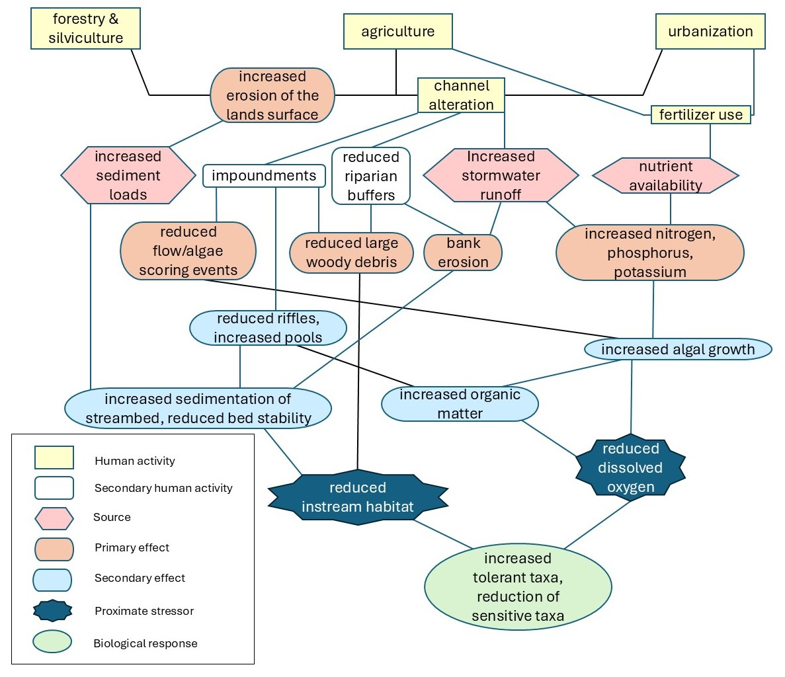
When using the CADDIS approach, strong evidence either supports the relationship between a candidate cause (a proximate stressor) and the biological impairment or refutes the relationship between a candidate cause and the impairment. The relationship, whether direct or indirect, is the pathway in which that candidate causes stress to the benthic macroinvertebrate community. This relationship, or pathway, connects the source with the proximate stressor, if they are not one in the same. To begin the approach with the six candidate stressors, a simple conceptual model diagram was created to display the pathways by which these stressors are most likely interacting with the benthic community (Figure 33). While aspects of the watershed’s hydrology and land use were considered, this diagram is not detailed, nor does it include every avenue by which stressors contact benthic communities. This diagram is meant to provide an understanding of the most influential relationships by which the candidate stressors have to the aquatic environment.

Figure 32. A conceptual model diagram of the six candidate stressors for the impairments in Horsepen Creek, Little Roanoke Creek, and the UT to Spencer Creek.

2.1 Evidence scoring for spatial co-occurrence
The first line of evidence that must be examined in the CADDIS approach is spatial co-occurrence of the candidate stressors with the observed biological impairment. The biological effect must be observed where the candidate cause is observed and must not be observed where the cause is absent. The scoring criteria for this evidence uses a +, 0, ---, and R, coding system where + is awarded for evidence that somewhat supports the case for the candidate cause, 0 indicates the evidence neither supports nor weakens the case for the candidate cause, --- means the evidence convincingly weakens the case for the candidate cause, and R indicates the evidence refutes the case for the candidate cause (Table 18).

Table 18. Scoring criteria for spatial co-occurrence used to evaluate candidate stressors.
Evidence scoring for spatial/temporal co-occurrence
Finding | Interpretation | Score
The effect occurs where the candidate cause occurs OR the effect does not occur where the candidate cause does not occur. | This finding somewhat supports the case for the candidate cause but is not strongly supportive because the association could be coincidental. | +
It is uncertain whether the candidate cause and the effect co-occur. | This finding neither supports nor weakens the case for the candidate cause, because the evidence is ambiguous. | 0
The effect does not occur where the candidate cause occurs OR the effect occurs where the candidate cause does not occur. | This finding convincingly weakens the case for the candidate cause, because causes must co-occur with their effects. | ---
The effect does not occur where the candidate cause occurs OR the effect occurs where the candidate cause does not occur, and the evidence is indisputable. | This finding refutes the case for the candidate cause because causes must co-occur with their effects. | R
Evidence for Horsepen Creek is examined first. Each candidate stressor is evaluated for if the biological effect is observed where the candidate is observed and is not observed when the candidate is absent. Considering the physical stressor candidates first, the data from the rapid habitat assessments is clear, impaired Horsepen Creek has significantly worse scores for the habitat parameter sediment than the unimpaired reference stream. The mean total habitat score overall for Horsepen Creek is significantly lower than the reference. This indicates that both increased sedimentation and poorer physical habitat spatially co-occur with the aquatic life impairment.
Considering the chemical stressor candidates next, both ambient monitoring and continuous monitoring results indicate dissolved oxygen concentrations are often in the elevated, medium to high, probability ranges for inducing stress to aquatic life. A value of 3.8 m/L was recorded at this station during ambient monitoring which breaks the instantaneous water quality standard. Ambient monitoring samples from the listing station, 4AHEN004.27, of dissolved potassium and total nitrogen concentrations fell into the low probably, not no probability, range for inducing stress. Total phosphorus data reflects elevated concentrations of phosphorus that are in the medium probability range for causing stress. In summary, reduced dissolved oxygen levels and elevated concentrations of total phosphorus are both observed with the biological effect, elevated concentrations of potassium and nitrogen were not observed with the biological effect.

Table 19. Spatial co-occurrence scores for candidate causes in Horsepen Creek.
Candidate Cause | Result | Score
Sedimentation | Excessive sedimentation recorded in habitat assessments co-occurs with the impairment | +
Physical Habitat | Statistically significant lower scores than the reference for habitat co-occur with the impairment | +
Dissolved Oxygen | Dissolved oxygen monitoring reveals low concentrations with high probability for benthic stress and breaking water quality standards | +
Dissolved Potassium | Potassium concentrations recorded were all within the no-to-low probability range for benthic stress at monitoring station | ---
Nitrogen | Nitrogen concentrations recorded were all within the no-to-low probability range for benthic stress at monitoring station | ---
Phosphorus | Phosphorus concentrations recorded were mostly in the medium probability range for benthic stress at monitoring station | +
Reviewing Little Roanoke Creek, data from the rapid habitat assessments show significantly lower total habitat scores and individual parameter scores for sediment, substrate, and embeddedness. Dissolved oxygen concentrations from both continuous monitoring and ambient monitoring data display most concentrations in the medium-to-high probability range for inducing stress. Little Roanoke Creek also did not meet the water quality standard for a daily average for dissolved oxygen. Dissolved potassium concentrations elevated into the medium probability range for inducing stress were recorded in a majority of the samples. Total nitrogen concentrations were recorded falling into the no-to-low probability range for inducing stress, while total phosphorus concentrations were recorded in the medium probability range for inducing stress. In summary, all candidate stressors, except for nitrogen, were observed co-occurring with the biological impairment.

Table 20. Spatial co-occurrence scores for candidate causes in Little Roanoke Creek.
Candidate Cause | Result | Score
Sedimentation | Excessive sedimentation recorded in habitat assessments co-occurs with the impairment | +
Physical Habitat | Statistically significant lower scores than the reference for habitat co-occur with the impairment | +
Dissolved Oxygen | Dissolved oxygen monitoring reveals low concentrations with high probability for benthic stress, water quality standards for daily average violated during continuous monitoring | +
Dissolved Potassium | Potassium concentrations recorded were within the medium probability range for benthic stress at monitoring station | +
Nitrogen | Nitrogen concentrations recorded were within the no-to-low probability range for benthic stress at monitoring station | ---
Phosphorus | Many of the phosphorus concentrations recorded were within the in medium probability range for benthic stress at monitoring station | +
Similar to Little Roanoke Creek, the UT to Spencer Creek’s data from the rapid habitat assessments show significantly lower total habitat scores and individual parameter scores for sediment and embeddedness. Different from both Horsepen and Little Roanoke Creeks, dissolved oxygen concentrations from both continuous monitoring and ambient monitoring data display concentrations mostly in the low probability range for inducing stress, only crossing into the medium probably range during diurnal swings. These probability ranges were developed based on ambient data, not continuous monitoring data. With some depression of oxygen values expected at night, this swing into the medium probability range is not indicative of dissolved oxygen causing much stress to aquatic life. Dissolved potassium concentrations were elevated into the medium probability range for inducing stress were recorded in most of the ambient monitoring samples. Total nitrogen concentrations were recorded falling mostly into the low probability range for inducing stress, while total phosphorus concentrations were recorded in the medium probability range for inducing stress. In summary, all candidate stressors, except for nitrogen and dissolved oxygen, were observed co-occurring with the biological impairment. Both dissolved oxygen and total nitrogen concentrations were observed and found to be at levels unlikely to cause benthic stress alongside of the biological impairment.

Table 21. Spatial co-occurrence scores for candidate causes in the UT to Spencer Creek.
Candidate Cause | Result | Score
Sedimentation | Excessive sedimentation recorded in habitat assessments co-occurs with the impairment | +
Physical Habitat | Statistically significant lower scores than the reference for habitat co-occur with the impairment | +
Dissolved Oxygen | Dissolved oxygen monitoring reveals concentrations mostly within the low probability range for benthic stress, no water quality standards ever violated | ---
Dissolved Potassium | Potassium concentrations recorded were within the medium probability range for benthic stress at monitoring station | +
Nitrogen | Nitrogen concentrations recorded were within the low probability range for benthic stress at monitoring station | ---
Phosphorus | Phosphorus concentrations recorded were mostly within the in medium probability ranges for benthic stress at monitoring station | +

2.2 Evidence scoring for temporal co-occurrence
The next line of evidence that must be examined in the CADDIS approach is temporal co-occurrence of the candidate stressors with the observed biological impairment. The biological effect must be observed when the cause is observed and must not be observed when the cause is absent. The scoring criteria for this evidence uses a +, 0, ---, and R, coding system where + is awarded for evidence that somewhat supports the case for the candidate cause, 0 indicates the evidence neither supports or weakens the case for the candidate cause, --- means the evidence convincingly weakens the case for the candidate cause, and R indicates the evidence refutes the case for the candidate cause (Table 22).

Table 22. Scoring criteria for temporal co-occurrence used to evaluate candidate stressors.
Evidence scoring for temporal co-occurrence
Finding | Interpretation | Score
The effect occurs when the candidate cause occurs OR the effect does not occur when the candidate cause does not occur. | This finding somewhat supports the case for the candidate cause but is not strongly supportive because the association could be coincidental. | +
It is uncertain whether the candidate cause and the effect co-occur. | This finding neither supports nor weakens the case for the candidate cause, because the evidence is ambiguous. | 0
The effect does not occur when the candidate cause occurs OR the effect occurs when the candidate cause does not occur. | This finding convincingly weakens the case for the candidate cause, because causes must co-occur with their effects. | ---
The effect does not occur when the candidate cause occurs OR the effect occurs when the candidate cause does not occur, and the evidence is indisputable. | This finding refutes the case for the candidate cause because causes must co-occur with their effects. | R
Evidence for Horsepen Creek is examined first. Each candidate stressor is evaluated for if the biological effect is observed when the candidate is observed and is not observed when the candidate is absent. Considering the physical stressor candidates first, when VSCI scores were plotted with their corresponding total habitat scores, there appeared to be a positive trend. Due to the extreme variability observed in that relationship, it was not found to be statistically significant. This variability is largely due to the complicated make up of the individual scores that produce the total habitat score. Substrate, embeddedness, bank integrity, and sediment all scored significantly lower on average in Horsepen Creek compared to the reference stream. Considering the BCG scores as well, the weighted average BCG score for total habitat and relative bed stability in Horsepen Creek is 3.89 and 4.09 respectively. The benthic community within Horsepen Creek is intermediately tolerant to relative bed stability and approaching intermediate tolerance for poor habitat. This indicates that while habitat is degraded and sedimentation is prolific, the biological impairment is not only present, but likely influenced by these features. This evidence would be stronger if there was a significant correlation between the VSCI and total habitat scores, but still displays a temporal co-occurrence.
Considering the chemical stressor candidates next, both ambient monitoring and continuous monitoring results displayed dissolved oxygen concentrations in the high probability ranges for causing benthic stress. These results co-occur with the benthic impairment. The ambient monitoring samples from the listing station, 4AHEN004.27, of dissolved potassium and total nitrogen concentrations fell into the low probability range for inducing stress. Total phosphorus data reflects elevated concentrations of phosphorus that are in the medium probability range for causing stress. Using the BCG scores once more, dissolved oxygen, and total nitrogen and total phosphorus together, can be evaluated by their probable effects on the benthic community over time. The weighted average BCG scores for dissolved oxygen and total nitrogen/total phosphorus are 3.75 and 4.22, respectively. Conditions within Horsepen Creek have led to a benthic community that is more tolerant to high nutrients than low dissolved oxygen. While both are concurrent, overtime, high nutrients have likely influenced the benthic community to be more tolerant. Since total nitrogen and total phosphorus are scored together using the BCG, it is unclear as to whether only one or both nutrients are influencing the community. In summary, low dissolved oxygen concentrations and elevated concentrations of total phosphorus are both observed co-occurring the biological effect, elevated concentrations of potassium and nitrogen were not observed with the biological effect.

Table 23. Temporal co-occurrence scores for candidate causes in Horsepen Creek.
Candidate Cause | Result | Score
Sedimentation | Excessive sedimentation recorded in habitat assessments co-occurs with the impairment, benthic community tolerant to poor relative bed stability | +
Physical Habitat | Statistically significant lower scores than the reference for habitat co-occur with the impairment, benthic community approaching tolerant to poor habitat | +
Dissolved Oxygen | Dissolved oxygen monitoring reveals low concentrations with high probability for benthic stress co-occurring with impairment | +
Dissolved Potassium | Potassium concentrations recorded were all within the no-to-low probability range for benthic stress at monitoring station | ---
Nitrogen | Nitrogen concentrations recorded were all within the no-to-low probability range for benthic stress at monitoring station | ---
Phosphorus | Phosphorus concentrations recorded were mostly in the medium probability range for benthic stress at monitoring station | +
Reviewing Little Roanoke Creek, data from the rapid habitat assessments show significantly lower total habitat scores and individual parameter scores for sediment, substrate, and embeddedness. The previously analyzed relationship between VSCI scores and total habitat scores is the same for Little Roanoke Creek, as it was for Horsepen Creek. BCG scores for total habitat and relative bed stability for Little Roanoke Creek have weighted averages of 4.05 and 4.09, respectively, indicated intermediate benthic community tolerance for poor habitat and sedimentation. Dissolved oxygen concentrations from both continuous monitoring and ambient monitoring data display most concentrations in the medium-to-high probability range for inducing stress. The weighted average BCG score for dissolved oxygen is 3.97, indicating intermediate tolerance to low dissolved oxygen. Dissolved potassium concentrations were observed in the medium probability range for inducing stress in most of the samples. Total nitrogen concentrations were recorded in the no-to-low probability range for inducing stress, while total phosphorus concentrations were recorded in the medium probability range for inducing stress. The combined total nitrogen/total phosphorus BCG score is the highest of all the scores for all three impaired creeks at 4.35. In summary, all candidate stressors, except for nitrogen, were observed co-occurring with the biological impairment, and BCG scores indicate that nutrients and sedimentation have influenced the biological impairment the most over time.

Table 24. Temporal co-occurrence scores for candidate causes in Little Roanoke Creek.
Candidate Cause | Result | Score
Sedimentation | Excessive sedimentation recorded in habitat assessments co-occurs with the impairment, benthic community tolerant to poor relative bed stability | +
Physical Habitat | Statistically significant lower scores than the reference for habitat co-occur with the impairment, benthic community tolerant to poor habitat | +
Dissolved Oxygen | Dissolved oxygen monitoring reveals low concentrations with high probability for benthic stress co-occurring with impairment | +
Dissolved Potassium | Potassium concentrations recorded were within the medium probability range for benthic stress at monitoring station | +
Nitrogen | Nitrogen concentrations recorded were within the no-to-low probability range for benthic stress at monitoring station | ---
Phosphorus | Many of the phosphorus concentrations recorded were within the in medium probability range for benthic stress at monitoring station, benthic community tolerant to high nutrient loadings | +
Similar to Little Roanoke Creek, the UT to Spencer Creek’s data from the rapid habitat assessments show significantly lower total habitat scores and individual parameter scores for sediment and embeddedness. Different from both Horsepen and Little Roanoke Creeks, dissolved oxygen concentrations from both continuous monitoring and ambient monitoring data display concentrations mostly in the low probability range for inducing stress, only crossing into the medium probably range during diurnal swings. These probability ranges were developed based on ambient data, not continuous monitoring data. With some depression of oxygen values expected at night, this swing into the medium probability range is not indicative of dissolved oxygen causing much stress to aquatic life. Dissolved potassium concentrations were elevated into the medium probability range for inducing stress were recorded in most of the ambient monitoring samples. Total nitrogen concentrations were recorded mostly in the low probability range for inducing stress, while total phosphorus concentrations were recorded in the medium probability range for inducing stress. BCG scores for total habitat, relative bed stability, dissolved oxygen, and total nitrogen/total phosphorus are 3.84, 4.02, 3.71, and 4.31, respectively. These scores indicate stream conditions over time have likely influenced the benthic community to be tolerant to nutrients and sedimentation and lean from somewhat sensitive towards tolerance of poor habitat and lower dissolved oxygen. In summary, all candidate stressors, except for nitrogen and dissolved oxygen, were observed co-occurring with the biological impairment. Both dissolved oxygen and total nitrogen concentrations were observed and found to be at levels unlikely to cause benthic stress alongside of the biological impairment.

Table 25. Temporal co-occurrence scores for candidate causes in the UT to Spencer Creek.
Candidate Cause | Result | Score
Sedimentation | Excessive sedimentation recorded in habitat assessments co-occurs with the impairment, benthic community tolerant to poor relative bed stability | +
Physical Habitat | Statistically significant lower scores than the reference for habitat co-occur with the impairment, benthic community approaching tolerant to poor habitat | +
Dissolved Oxygen | Dissolved oxygen monitoring reveals concentrations mostly within the low probability range for benthic stress, compared to the other stressors, lowest/most intermediately sensitive BCG score | ---
Dissolved Potassium | Potassium concentrations recorded were within the medium probability range for benthic stress at monitoring station | +
Nitrogen | Nitrogen concentrations recorded were within the no-to-low probability range for benthic stress at monitoring station | ---
Phosphorus | Many of the phosphorus concentrations recorded were within the in medium probability range for benthic stress at monitoring station, benthic community tolerant to high nutrient loadings | +

2.3 Evidence scoring for causal pathways and mechanistically plausible cause
The next lines of evidence that must be examined in the CADDIS approach are causal pathways of the candidate stressors. These causal pathways must also be mechanistically plausible, the candidate stressors present and interacting with the biological communities observed in the evidence. Evidence for pathways that lead to sedimentation, poor physical habitat, low dissolved oxygen, elevated dissolved potassium, elevated nitrogen, and elevated phosphorus need to be evaluated. There must be evidence for the candidate stressor to actually be inflicting stress on the biological community and there must be evidence that suggest how the stressor entered the impaired stream. The relationship between the candidate causes and biological effect must be consistent with known principles of biology, chemistry, and physics. The scoring criteria for this evidence uses a ++, +, 0, -, and ---, coding system where ++ is awarded for plausible evidence that strongly supports the candidates case, + is for evidence somewhat supporting the case for the candidate, 0 indicates the evidence neither supports or weakens the case for the candidate cause, - indicates that the findings somewhat weaken the case for the candidate, and --- means the evidence convincingly weakens the case for the candidate cause (Table 26).

Table 26. Scoring criteria for causal pathways and mechanistically plausible causation used to evaluate candidate stressors.
Evidence scoring for causal pathway
Finding | Interpretation | Score
Data show that all steps in at least one causal pathway are present. | This finding strongly supports the case for the candidate cause, because it is improbable that all steps occurred by chance; it is not convincing because these steps may not be sufficient to generate sufficient levels of the cause. | ++
Data show that some steps in at least one causal pathway are present. | This finding somewhat supports the case for the candidate cause. | +
Data show that the presence of all steps in the causal pathway is uncertain. | This finding neither supports nor weakens the case for the candidate cause. | 0
Data show that there is at least one missing step in each causal pathway. | This finding somewhat weakens the case for the candidate cause but is not strongly weakening because it may be due to temporal variability, problems in sampling or analysis, or unidentified alternative pathways. | -
Data show, with a high degree of certainty, that there is at least one missing step in each causal pathway. | This finding convincingly weakens the case for the candidate cause, assuming critical steps in each pathway are known, and are not found at the impaired site after a well-designed, well-performed, and sensitive study. | ---
Evidence for Horsepen Creek is examined first, once again. Each candidate stressor is evaluated for whether evidence supports causal pathways. Considering sedimentation first, sediment is a natural feature to streams and is important in maintaining a balanced substrate. Many human activities can cause large land disturbances, reduce stream bank integrity, and channelize runoff directly into streams without giving natural processes a chance to filter out excessive amounts of sediment. This can bury necessary habitat. There are not many roads intersecting Horsepen Creek, nor much urbanization in the watershed. The land that surrounds Horsepen Creek is largely used for agriculture, residential lawns, and forests, which are managed for silviculture. The pathways for sedimentation from this characterized watershed would include reduced riparian buffers, unstable stream banks, and or channel alterations. From the rapid habitat assessment data, the channel alteration scores for Horsepen Creek are not significantly different from those of the reference stream, however, bank integrity, bank vegetation, embeddedness, riparian vegetation, and sediment all score significantly worse than the reference stream. There is direct evidence for failing banks and reduced riparian vegetation within the impairment alongside an excess of sediment within the impaired stream. Also referring to that habitat data in relation to physical habitat as a candidate stressor, channel alteration, sedimentation, poor riparian buffers, reduced stream variability, and less large woody debris is evidence that would be expected to prove the causal pathway physical habitat impacts the biological community. While sedimentation and poor riparian buffers are recorded, channel alteration and stream variation in Horsepen Creek are not significantly different from the reference stream. There is no woody debris data to compare, however the functional feeding group of benthic macroinvertebrates associated with coarse organic matter, which is largely leafy and woody debris, are elevated in Horsepen Creek when compared to the reference stream. The LRBS score calculated for Horsepen Creek also does not suggest that the streambed in unstable. The causal pathways for physical habitat causing stress which overlap with sedimentation are present, however, those that don’t overlap with sedimentation are missing.
The possible causal pathways for reduced dissolved oxygen would either be sourced from nutrient enrichment, channel modification, or increased decomposing organic matter. For channel modification to be causing low dissolved oxygen concentrations, expected evidence would include recorded channel alteration, reduced large woody debris, or the presence of impoundments. As refuted while discussing physical habitat, there is no evidence of significant channel alteration or reduced large woody debris available. While there are impoundments within the Horsepen Creek watershed, the closest impoundment is more than three miles upstream of the monitoring station. This causal pathway seems unlikely. For nutrients to be causing low dissolved oxygen, evidence would include elevated nutrients, dissolved oxygen measurements corresponding with photosynthetic/respiration diurnal cycles, and increased algal growth. A majority of total phosphorus concentrations measured in Horsepen Creek fell within the medium probability range for inducing stress to aquatic life. Total nitrogen concentrations were also recorded in the low probability stressor range. During the continuous monitoring special study, dissolved oxygen concentrations increased and decreased with the diurnal cycles of plants and algae. In the habitat assessments, biologists notated algal mats present at the monitoring station. All the steps for nutrients causing low dissolve oxygen are present.
The causal pathway for elevated dissolved potassium would have evidence supporting a source (geology, agricultural runoff, industrial discharge) as well as concentrations high enough to cause toxicity to aquatic life. There is evidence of sedimentation and nutrients infiltrating this system as previously discussed, and agricultural land use is the second most popular land use in the watershed. The actual concentrations of dissolved potassium recorded all fell within the no-to-medium range of inducing stress to aquatic life, with most of those data points in the low probability range. The pathway for potassium to enter the system and cause stress is present in the evidence, however the evidence that the dissolved potassium concentrations are high enough to be causing stress is not convincing.
Finally, for nitrogen and phosphorus, the causal pathways for entry into Horsepen Creek are the same as the pathways for potassium. As previously noted, those pathways are present. Evidence that nitrogen or phosphorus are entering the stream and causing stress can be called back from the discussion of the dissolved oxygen candidate stressor. Nutrients are contributing to reduced dissolved oxygen levels. Looking at concentrations of both nutrients measured from sampling, all the total nitrogen concentrations were in the no-to-low probability range for inducing stress, while a majority of the total phosphorus concentrations were in the medium probability range for inducing stress, and there were recorded outliers in the high probability range for inducing stress within Horsepen Creek. It was also calculated that, on average, phosphorus is the limiting nutrient within this system. This leads to a convincing argument that both nitrogen and phosphorus are entering the stream, and phosphorus is present at concentrations that are likely inducing stress to aquatic life, while nitrogen, present and contributing, is not likely the driver of algal growth and depleted dissolved oxygen levels.

Table 27. Causal pathway scores for candidate causes in Horsepen Creek.
Candidate Cause | Result | Score
Sedimentation | Evidence of all steps for one pathway, and some for others, are present | ++
Physical Habitat | Evidence shows that there are multiple missing steps in the causal pathway, while some are present | -
Dissolved Oxygen | Evidence of all steps for one pathway are present | ++
Dissolved Potassium | Evidence shows some steps in one pathway are present | +
Nitrogen | Evidence shows some steps in one pathway are present | +
Phosphorus | Evidence for all steps for one causal pathway are present | ++
Causal pathways for the candidate stressors for Little Roanoke Creek will be the same as those in Horsepen Creek. Land uses within the watershed are also very similar to those outlined in Horsepen Creek, with only small variations in actual percentages. For sedimentation, evidence should again include reduced riparian buffers, unstable stream banks, and or channel alterations. From the rapid habitat assessment data, neither riparian vegetation or channel alteration scores for Little Roanoke Creek were significantly different from those of the reference stream. Bank integrity, bank vegetation, embeddedness, and sediment did all score significantly worse than the reference stream though. There is evidence for failing banks within the impairment contributing to an excess of sediment within the impaired stream. Still referring to the habitat data, physical habitat as a candidate stressor would display evidence of channel alteration, sedimentation, poor riparian buffers, reduced stream variability, and less large woody debris is evidence that would be expected to prove the causal pathway physical habitat impacts the biological community. Sedimentation is recorded but, riparian vegetation, channel alteration, and stream variation in Little Roanoke Creek are not significantly different from the reference stream. There is no woody debris data to compare, however the functional feeding group of benthic macroinvertebrates associated with coarse organic matter, referring to leafy and woody debris, are reduced in Little Roanoke Creek when compared to the reference stream. The LRBS scores calculated for Little Roanoke Creek were all over the place. These scores were calculated for three different stations, within one mile of each other within the impairment. One suggested bed stability had no probability for inducing stress to aquatic life while another suggested it had a high probability for inducing stress to aquatic life. This data is inconclusive. Some steps in the causal pathways for physical habitat to cause stress are present, however, most steps are missing.
The possible causal pathways for reduced dissolved oxygen would either be sourced from nutrient enrichment, channel modification, or increased decomposing organic matter. For channel modification to be causing low dissolved oxygen concentrations, expected evidence would include recorded channel alteration, reduced large woody debris, or the presence of impoundments. There are observations of beaver activity present within this impairment, but the evidence for reduced large woody debris is ambiguous. There are multiple impoundments within the Little Roanoke Creek watershed, however, they are only on tributaries. These impoundments could contribute to increased decomposition as well. For nutrients to be causing low dissolved oxygen, evidence should include elevated nutrients, dissolved oxygen measurements corresponding with photosynthetic/respiration diurnal cycles and increased algal growth. A majority of total phosphorus concentrations measured in Little Roanoke Creek fell within the medium probability range for inducing stress to aquatic life. Total nitrogen concentrations were recorded in the low probability stressor range. However, during the continuous monitoring special study, dissolved oxygen concentrations did not increase and decrease with the diurnal cycles of plants and algae. Dissolved oxygen was very low, below the water quality standard, and stayed low despite diurnal cycles. This evidence refutes nutrients being the driving cause for dissolved oxygen. Also, in the habitat assessments, biologists have never notated algal mats present at the monitoring stations, however, they have notated the presence of beavers for multiple years in a row. The functional feeding group of filterers, most associated with consuming FPOM, is the most abundant group within the stream. This is indicative, although weakly, that decaying organic matter is abundant and may be the driver of low dissolved oxygen. Putting this evidence together with the beaver observations and static dissolved oxygen cycles does somewhat support dissolved oxygen as a probable stressor with a causal pathway of channel alteration from impoundments and beavers.
The causal pathway for elevated dissolved potassium would have evidence supporting a source (geology, agricultural runoff, industrial discharge) as well as concentrations high enough to cause toxicity to aquatic life. There is evidence of sedimentation and nutrients infiltrating this system, as previously discussed, and agricultural land use is the second most popular land use in the watershed. The actual concentrations of dissolved potassium recorded all fell within the low-to-medium range for inducing stress to aquatic life, with a majority of those data points in the medium probability range. The pathway for potassium to enter the system and cause stress is present in the evidence, however, the evidence that the dissolved potassium concentrations are high enough to be toxic, are not convincing.
Finally, for nitrogen and phosphorus, the causal pathways for entry into Little Roanoke Creek are the same as the pathways for potassium. As previously noted, those pathways are present. Evidence that nitrogen or phosphorus are entering the stream and causing stress can be called back from the discussion of the dissolved oxygen candidate stressor. Nutrients could be contributing to reduced dissolved oxygen levels, however, that is inconclusive from the continuous monitoring study results. Looking at concentrations of both nutrients measured from sampling, the majority of total nitrogen concentrations were in the no-to-low probability range for inducing stress, while a majority of the total phosphorus concentrations were in the medium probability range for inducing stress. It was also calculated that, on average, phosphorus is the limiting nutrient within this system. This leads to a convincing argument that both nitrogen and phosphorus are entering the stream, and phosphorus is present at concentrations that have a medium probability for inducing stress to aquatic life, but it is unlikely to be the driver of low dissolved oxygen concentrations.

Table 28. Causal pathway scores for candidate causes in Little Roanoke Creek.
Candidate Cause | Result | Score
Sedimentation | Evidence of all steps for one pathway are present | ++
Physical Habitat | Evidence shows that there are multiple missing steps in the causal pathway, while some are present | -
Dissolved Oxygen | Evidence of all steps for one pathway are present | ++
Dissolved Potassium | Evidence shows some steps in the causal pathway is uncertain | 0
Nitrogen | Evidence of all steps for one causal pathway present for nutrients, uncertain for nitrogen alone | -
Phosphorus | Evidence for most steps for one causal pathway are present | +
Causal pathways for candidate stressors for the UT to Spencer Creek will be the same as the previously examined streams. Land uses in the watershed are also very similar to those outlined in Little Roanoke Creek, as it is within the Little Roanoke Creek Watershed. For sedimentation, evidence should again include reduced riparian buffers, unstable stream banks, and or channel alterations. From the rapid habitat assessment data, neither riparian vegetation or channel alteration scores for the UT to Spencer Creek were significantly different from those of the reference stream. Bank integrity, bank vegetation, embeddedness, and sediment did all still score significantly worse than the reference stream. There is evidence for failing banks within the impairment contributing to an excess of sediment within the impaired stream. Still referring to the habitat data, physical habitat as a candidate stressor would display evidence of channel alteration, sedimentation, poor riparian buffers, reduced stream variability, and less large woody debris is evidence that would be expected to prove the causal pathway physical habitat impacts the biological community. Sedimentation is recorded but, riparian vegetation, channel alteration, and stream variation in the UT to Spencer Creek are not significantly different from the reference stream. There is no woody debris data to compare, the functional feeding group of benthic macroinvertebrates associated with coarse organic matter, which is largely leafy and woody debris, are reduced in the UT to Spencer Creek when compared to the reference stream. The LRBS score calculated for the UT to Spencer Creek did indicate an unstable stream bed with a medium probability for causing stress to aquatic life. This data point is one step in the causal pathway for physical habitat to cause stress are present.
The possible causal pathways for reduced dissolved oxygen would either be sourced from nutrient enrichment, channel modification, or decomposition of organic matter. For channel modification to be causing low dissolved oxygen concentrations, expected evidence would include recorded channel alteration, reduced large woody debris, or the presence of impoundments. As refuted while discussing physical habitat, there is no evidence of significant channel alteration and the evidence for reduced large woody debris is ambiguous. There are no impoundments within the UT to Spencer Creek watershed. This causal pathway seems unlikely. For nutrients to be causing low dissolved oxygen, evidence should include elevated nutrients, dissolved oxygen measurements corresponding with photosynthetic/respiration diurnal cycles and increased algal growth. A majority of total phosphorus concentrations measured in the UT to Spencer Creek fell within the medium probability range for inducing stress to aquatic life. Total nitrogen concentrations were also recorded in the low probability stressor range. During the continuous monitoring special study, dissolved oxygen concentrations increased and decreased with the diurnal cycles of plants and algae. Dissolved oxygen in the UT to Spencer Creek was higher than its impaired counterparts and never really swung low enough to indicate they were irrefutably causing stress to aquatic life. This evidence suggests nutrients may be contributing to dissolved oxygen variations, but dissolved oxygen is not low enough that it is likely a significant stressor.
The causal pathway for elevated dissolved potassium would have evidence supporting a source (geology, agricultural runoff, industrial discharge) as well as concentrations high enough to cause toxicity to aquatic life. There is evidence of sedimentation and nutrients infiltrating this system, as previously discussed, and agricultural land use is the second most popular land use in the watershed. The actual concentrations of dissolved potassium recorded all fell within the low-to-medium range for inducing stress to aquatic life, with most of those data points in the medium probability range. The pathway for potassium to enter the system and cause stress is present in the evidence but the evidence that the dissolved potassium concentrations are high enough to be causing stress is not convincing.
Finally, for nitrogen and phosphorus, the causal pathways for entry into the UT to Spencer Creek are the same as the pathways for potassium. As previously noted, those pathways are present. Evidence that nitrogen or phosphorus are entering the stream and causing stress can be called back from the discussion of the dissolved oxygen candidate stressor. Nutrients are likely contributing to reduced dissolved oxygen levels. Looking at concentrations of both nutrients measured from sampling, the majority of total nitrogen concentrations were in the low probability range for inducing stress, while most of the total phosphorus concentrations were in the medium probability range for inducing stress. It was also calculated that, on average, phosphorus is the limiting nutrient within this system. This leads to a convincing argument that both nitrogen and phosphorus are entering the stream but, the dissolved oxygen concentrations do not reflect that the nutrients are causing negative impacts for the aquatic life. Also, in the habitat assessments, biologists have notated algal mats present at the monitoring station.

Table 29. Causal pathway scores for candidate causes in the UT to Spencer Creek.
Candidate Cause | Result | Score
Sedimentation | Evidence of all steps for one pathway are present | ++
Physical Habitat | Evidence shows that the presence of the steps in the causal pathway are uncertain | 0
Dissolved Oxygen | Evidence shows that the presence of the steps in the causal pathway are uncertain | 0
Dissolved Potassium | Evidence shows that the presence of the steps in the causal pathway are uncertain | 0
Nitrogen | Evidence shows that the presence of the steps in the causal pathway are uncertain | 0
Phosphorus | Evidence shows that the presence of the steps in the causal pathway are uncertain | 0

2.4 Evidence scoring for stressor-response relationships from the field and other field studies
Evidence of stressor-response relationships from the field and from other field studies are now evaluated. Evidence for biological responses to sedimentation, poor physical habitat, low dissolved oxygen, elevated dissolved potassium, elevated nitrogen, and elevated phosphorus need to be evaluated. There should be evidence for the candidate stressor to be eliciting an observable response from the biological communities. When comparing the data collected from the impaired streams to the reference stream, there should be significant differences. The scoring criteria for this evidence uses a ++, +, 0, -, and --, coding system where ++ is awarded for evidence that strongly supports the candidates case, + is for evidence somewhat supporting the case for the candidate, 0 indicates the evidence neither supports or weakens the case for the candidate cause, - indicates that the findings somewhat weaken the case for the candidate, and -- means the evidence strongly weakens the case for the candidate cause (Table 30).

Table 30. Scoring criteria for stressor-response relationships from the field and other field studies used to evaluate candidate stressors.
Evidence scoring for stressor-response relationships from the field
Finding | Interpretation | Score
A strong effect gradient is observed relative to exposure to the candidate cause, at spatially linked sites, and the gradient is in the expected direction. | This finding strongly supports the case for the candidate cause but is not convincing due to potential confounding. | ++
A weak effect gradient is observed relative to exposure to the candidate cause, at spatially linked sites, OR a strong effect gradient is observed relative to exposure to the candidate cause, at non-spatially linked sites, and the gradient is in the expected direction. | This finding somewhat supports the case for the candidate cause but is not strongly supportive due to potential confounding or random error. | +
An uncertain effect gradient is observed relative to exposure to the candidate cause. | This finding neither supports nor weakens the case for the candidate cause, because the evidence is ambiguous. | 0
An inconsistent effect gradient is observed relative to exposure to the candidate cause, at spatially linked sites, OR a strong effect gradient is observed relative to exposure to the candidate cause, at non-spatially linked sites, but the gradient is not in the expected direction. | This finding somewhat weakens the case for the candidate cause, but is not strongly weakening due to potential confounding or random error. | -
A strong effect gradient is observed relative to exposure to the candidate cause, at spatially linked sites, but the relationship is not in the expected direction. | This finding strongly weakens the case for the candidate cause but is not convincing due to potential confounding. | --
Evidence for Horsepen Creek is examined first, once again. Evidence is evaluated for whether it supports that the biological community is having a direct response/relationship to each candidate stressor. This can be seen in the various regression analyses completed, as well as a comparison of values to the with the stressor probability thresholds which were developed from a study that analyzed stressor response relationships within streams across the State of Virginia. The relationships that were inspected to determine if physical habitat is eliciting a stressed response from the biological community were the relationships between total habitat scores and LRBS scores with the VSCI scores for Horsepen Creek. Total habitat scores were compared to corresponding VSCI scores using a linear regression analysis for all three impaired streams. A trendline in the expected direction of the relationship was mapped, however, it was not statistically significant (Figure 14). Looking at the range of total habitat scores from Horsepen Creek, they were always recorded within the medium to high probability range for habitat to be causing stress to aquatic life. The insignificant relationships paired with the poor total habitat scores makes for a weak effect gradient for this candidate cause. A similar analysis was completed for LRBS scores and VSCI scores. LRBS scores were only recorded once within Horsepen Creek and the UT to Spencer Creek and just three times within Little Roanoke Creek, at three different stations. With only five data points to compare, these five data points were compared with the average VSCI scores for their corresponding stations using the same analysis as before. A trendline in the expected direction of the relationship was mapped, however, it was not statistically significant (Figure 17). Also, the recorded LRBS score in Horsepen Creek fell into the no probability range for benthic stress. This evidence is sparse and based on a very small sample size, however, it does not present an obvious effect gradient for sediment as a stressor.
Finally, looking at the water quality candidate stressors, dissolved oxygen, dissolved potassium, nitrogen, and phosphorus, these parameters were regressed against VSCI scores to test for statistically significant relationships (Table 17). None of these sampled parameters displayed a significant relationship, positive or negative, with the VSCI scores recorded within Horsepen Creek. This evidence doesn’t display a gradient that supports or weakens the case for any of these four candidate stressors. Looking that the comparison of the recorded values with the stressor probability thresholds, dissolved oxygen values in the high probability range were observed in both ambient monitoring and continuous monitoring. Dissolved potassium values mostly fell into the low probability stressor range. The lack of both a significant relationship in the regression, as well as most recorded values being unlikely to represent a stream experiencing stress from the ion, does not exemplify any effect gradient for this candidate stressor. The same can be said for nitrogen. Phosphorus, while not showing a significant relationship explicitly with VSCI scores, did have most of it’s recorded values fall into the medium probability stressor range, with an outlier reading in the high probability range. The effects of phosphorus through the lens of stressor-response relationships is not strong enough to convincingly confirm this gradient one way or another.

Table 31. Stressor-response relationship scores for each candidate stressor within Horsepen Creek.
Candidate Cause | Specific Effect | Result | Score
Sedimentation | LRBS score was in the no probability stressor range | Inconsistent effect gradient observed | -
 | Regression did not indicate a significant relationship between LRBS scores and VSCI scores
Physical Habitat | Total habitat scores regularly in the high probability stressor range | Weak effect gradient observed | +
 | Regression did not indicate a significant relationship between LRBS scores and VSCI scores
Dissolved Oxygen | High probability for stress observed in recorded values but no significant relationship between dissolved oxygen and VSCI scores | Weak effect gradient observed | +
Dissolved Potassium | No significant relationship between dissolved potassium and VSCI scores, observed values not consistently high enough to be driving benthic stress | Inconsistent effect gradient observed | -
Nitrogen | No significant relationship between total nitrogen and VSCI scores and scores in the range of no probability stressor values | Inconsistent effect gradient observed | -
Phosphorus | No significant relationship between total phosphorus and VSCI scores but, phosphorus values mostly in medium probability range for stress. | No apparent gradient | 0
Evidence is evaluated for whether it supports that the biological community is having a direct response/relationship to each candidate stressor within Little Roanoke Creek. Total habitat scores were compared to corresponding VSCI scores using a linear regression analysis of all three impaired stream. A trendline in the expected direction of the relationship was mapped, however, it was not statistically significant (Figure 14). A similar analysis was completed for LRBS scores and VSCI scores. LRBS scores were only recorded once within Horsepen Creek and the UT to Spencer Creek and just three times within Little Roanoke Creek, at three different stations. With only five data points to compare, these five data points were compared with the average VSCI scores for their corresponding stations using the same analysis as before. A trendline in the expected direction of the relationship was mapped, however, it was not statistically significant (Figure 17). The total habitat scores in Little Roanoke Creek spanned the range of no-to-medium probabilities for being a stressor with a median in the low probability range. LRBS scores fell into the no, low, and high probability ranges for causing stress. The very low LRBS score was recorded during a 2007 sampling event, while subsequent sampling since 2020 has revealed much better scores. The overall physical habitat data displays inconsistencies in the expected effect gradient for being a stressor. Data relating more to sedimentation specifically, is ambiguous. It displays a history of stream bed instability with potential improvements but does not have a statistically significant relationship with VSCI scores.
Reviewing the water quality candidate stressors, dissolved oxygen, dissolved potassium, nitrogen, and phosphorus, these parameters were regressed against VSCI scores to test for statistically significant relationships (Table 17). None of these sampled parameters displayed a significant relationship, positive or negative, with the VSCI scores recorded within Little Roanoke Creek. Looking that the comparison of the recorded values with the stressor probability thresholds, dissolved oxygen values in the high probability range were observed during both ambient monitoring and continuous monitoring. Dissolved potassium values mostly fell into the low-to-medium probability stressor range. The lack of both a significant relationship in the regression, as well as most recorded values being unlikely to represent a stream experiencing stress from the ion, does not exemplify any effect gradient for this candidate stressor. The same can be said for phosphorus. Nitrogen values largely fell into the no-to low probability range for stress. Only the effects of poor dissolved oxygen through the lens of stressor-response relationships somewhat supports an observable effect gradient.

Table 32. Stressor-response relationship scores for each candidate stressor within Little Roanoke Creek.
Candidate Cause | Specific Effect | Result | Score
Sedimentation | LRBS score recorded in high probability stressor range, recent data indicates improvements | No apparent gradient | 0
 | Regression did not indicate a significant relationship between LRBS scores and VSCI scores
Physical Habitat | Total habitat scores vary, but often score well | Inconsistent effect gradient observed | -
 | Regression did not indicate a significant relationship between LRBS scores and VSCI scores
Dissolved Oxygen | High probability for stress observed in recorded values but no significant relationship between dissolved oxygen and VSCI scores | Weak effect gradient observed | +
Dissolved Potassium | No significant relationship between dissolved potassium and VSCI scores, observed values not consistently high enough to be driving benthic stress | Inconsistent effect gradient observed | -
Nitrogen | No significant relationship between total nitrogen and VSCI scores and scores in the range of no probability stressor values | Inconsistent effect gradient observed | -
Phosphorus | No significant relationship between total phosphorus and VSCI scores, phosphorus values in low-to-medium probability range for stress. | Inconsistent effect gradient observed | -
Examining the same evidence for the UT to Spencer Creek, total habitat scores were compared to corresponding VSCI scores using a linear regression analysis of all three impaired stream. A trendline in the expected direction of the relationship was mapped, however, it was not statistically significant (Figure 14). A similar analysis was completed for LRBS scores and VSCI scores. LRBS scores were only recorded once within Horsepen Creek and the UT to Spencer Creek and just three times within Little Roanoke Creek, at three different stations. With only five data points to compare, these five data points were compared with the average VSCI scores for their corresponding stations using the same analysis as before. A trendline in the expected direction of the relationship was mapped, however, it was not statistically significant (Figure 17). The total habitat scores in the UT to Spencer Creek spanned the range of no-to-high probabilities for being a stressor with a median in the low probability range. The LRBS score fell into the medium probability range for causing stress. The physical habitat data displays great variability but no apparent effect gradient. Data relating more to sedimentation specifically, does indicate potential stream bed instability but does not have a statistically significant relationship with VSCI scores.
Considering the water quality candidate stressors, dissolved oxygen, dissolved potassium, nitrogen, and phosphorus, these parameters were regressed against VSCI scores to test for statistically significant relationships (Table 17). None of these sampled parameters displayed a significant relationship, positive or negative, with the VSCI scores recorded within the UT to Spencer Creek. This evidence doesn’t display a gradient that supports or weakens the case for any of these four candidate stressors. Looking that the comparison of the recorded values with the stressor probability thresholds, dissolved oxygen values were observed in both ambient monitoring and continuous monitoring at concentrations not incompatible with sensitive aquatic life. Dissolved potassium and nitrogen values mostly fell into the low probability stressor range. Phosphorus values fell mostly into the low-to-medium probability ranges for causing stress to aquatic life. None of these water quality parameters display a convincing response relationship with impairment.

Table 33. Stressor-response relationship scores for each candidate stressor within the UT to Spencer Creek.
Candidate Cause | Specific Effect | Result | Score
Sedimentation | LRBS score recorded in medium probability stressor range | Weak effect gradient observed | +
 | Regression did not indicate a significant relationship between LRBS scores and VSCI scores
Physical Habitat | Total habitat scores variable | No apparent gradient | 0
 | Regression did not indicate a significant relationship between LRBS scores and VSCI scores
Dissolved Oxygen | No significant relationship between dissolved oxygen and VSCI scores and recorded values mostly in the range of low probability stressor values | Inconsistent effect gradient observed | -
Dissolved Potassium | No significant relationship between dissolved potassium and VSCI scores, observed values not consistently high enough to be driving benthic stress | Inconsistent effect gradient observed | -
Nitrogen | No significant relationship between total nitrogen and VSCI scores and scores in the range of no probability stressor values | Inconsistent effect gradient observed | -
Phosphorus | No significant relationship between total phosphorus and VSCI scores, phosphorus values in low-to-medium probability range for stress. | Inconsistent effect gradient observed | -

2.5 Evidence scoring for symptoms
Evidence for symptoms of the candidate stressors are now evaluated. Evidence for symptoms of sedimentation, poor physical habitat, low dissolved oxygen, elevated dissolved potassium, elevated nitrogen, and elevated phosphorus need to be evaluated. The data available for symptom analysis is the benthic community data, analyzed using the BCG and functional feeding groups. There should be evidence for the candidate stressors impacting the biological communities based on the symptoms of the biological communities. The scoring criteria for this evidence uses a D, +, 0, ---, and R, coding system where D is awarded for evidence that is sufficient to diagnose the candidate cause, + is for evidence somewhat supporting the case for the candidate, 0 indicates the evidence neither supports or weakens the case for the candidate cause, --- indicates that the findings convincingly weaken the case for the candidate, and R means the evidence refutes the case for the candidate cause (Table 34).

Table 34. Scoring criteria for symptoms used to evaluate candidate stressors.
Evidence scoring for symptoms of candidate stressors
Finding | Interpretation | Score
Symptoms or species occurrences observed at the site are diagnostic of the candidate cause. | This finding is sufficient to diagnose the candidate cause as the cause of the impairment, even without the support of other types of evidence. | D
Symptoms or species occurrences observed at the site include some but not all of a diagnostic set, OR symptoms or species occurrences observed at the site characterize the candidate cause and a few others. | This finding somewhat supports the case for the candidate cause but is not strongly supportive because symptoms or species are indicative of multiple possible causes. | +
Symptoms or species occurrences observed at the site are ambiguous or occur with many causes. | This finding neither supports nor weakens the case for the candidate cause. | 0
Symptoms or species occurrences observed at the site are contrary to the candidate cause. | This finding convincingly weakens the case for the candidate cause. | ---
Symptoms or species occurrences observed at the site are indisputably contrary to the candidate cause. | This finding refutes the case for the candidate cause. | R
Evidence of symptoms is evaluated for whether it supports the diagnosis of the candidate causes. Stressors can have unique effects on benthic macroinvertebrate communities, these effects are the symptoms that help determine the cause for the impairments. In Horsepen Creek, the spring VSCI scores appeared to trend lower than the fall scores, however, there was no statistical difference in spring and fall VSCI scores. Seasonal trends that correspond with stressors having more influence in the spring are usually associated with stressors that increase with winter or spring runoff and increased flows. Increased flows can bring higher concentrations of sediment and fertilizer run off. Physical habitat would not significantly change much from season to season. Dissolved oxygen concentrations should be higher in spring flows due to the colder temperatures and greater flow. Any seasonal trends should be considered while evaluating the symptoms of each candidate stressor.
Using the BCG findings to evaluate the candidate stressors in Horsepen Creek, it is important to remember the significance of BCG scores. Scores of tolerance levels range from I to V, most sensitive to most tolerant, and a score of VI indicates the benthic macroinvertebrate is non-native. A weighted average of the BCG scores for total habitat and relative bed stability resulted in scores of 3.89 and 4.09, respectively (Table 11). These scores indicate that the biological community is made up of taxa that are mostly intermediately tolerant to poor habitat and relatively unstable stream beds. This is often a symptom of poor habitat and sedimentation. Dissolved potassium is not evaluated in the BCG, but dissolved oxygen and nutrients are. Horsepen Creek’s weighted averages for those scores are 3.75 and 4.22, respectively. While the community teeters on the edge of intermediately sensitive to intermediately tolerant taxa to low dissolved oxygen, it has become very tolerant to high inputs of nitrogen and phosphorus. The total nitrogen/total phosphorus stressor is the highest scoring tolerance category of all the stressors when looking at the weighted averages. This indicates that nutrients may be the stressor with the greatest influence on the biological community within Horsepen Creek.
Evaluating the functional feeding groups within Horsepen Creek, collectors and filters make up the largest groups, 36.7% and 25.3% respectively (Figure 12). These functional feedings groups are associated with consuming FPOM. That FPOM can often be accompanied by nutrients and sediments. The large increase in collectors compared to the reference stream is strong evidence for sediment as a candidate stressor. Scrappers only make up 9.57% of the benthic macroinvertebrate samples. These organisms can be sensitive, but also can thrive in streams with abundant algae from nutrient inputs. This data alone does not conclusively support or weaken any of the candidate stressors.
In summary, the symptoms expressed in the biological community reflect a seasonal trend, although insignificant, lower VSCI scores occur mostly in the spring. This does not support the case for physical habitat as a candidate stressor. Stressor effects have produced a community which is most tolerant to high nutrient inputs, both nitrogen and phosphorus, followed by unstable streambeds, poor habitat, and then dissolved oxygen. In a community of tolerant taxa, the functional feeding groups that make up greater than 60% of the community, collectors and filterers, are those dependent on high amounts of FPOM and they thrive in streams with excessive sediment. These symptoms and taxa occurrences support sedimentation, and somewhat supports phosphorus, and nitrogen as potential stressors. This data does somewhat weaken the case for dissolved oxygen as a candidate stressor because the BCG scores and seasonal trends do not support poor dissolved oxygen as the driver of low VSCI scores. This evidence neither supports nor weakens the case for the candidate case of dissolved potassium because it is too ambiguous.

Table 35. Stressor symptoms scores for each candidate stressor within Horsepen Creek.
Candidate Cause | Result | Score
Sedimentation | Evidence somewhat supportive of candidate cause | +
Physical Habitat | Evidence somewhat supportive of candidate cause | 0
Dissolved Oxygen | Evidence somewhat weakens the case for the candidate | ---
Dissolved Potassium | Evidence neither supports nor weakens the case | 0
Nitrogen | Evidence somewhat supportive of candidate cause | +
Phosphorus | Evidence somewhat supportive of candidate cause | +
In Little Roanoke Creek, the spring VSCI scores appeared to trend lower than the fall scores, however, there was no statistical difference in spring and fall VSCI scores. Seasonal trends that correspond with stressors having more influence in the spring are usually associated with stressors that increase with winter or spring runoff and increased flows. Increased flows can bring higher concentrations of sediment and fertilizer run off. Physical habitat would not significantly change much from season to season. Dissolved oxygen concentrations should be higher in spring flows due to the colder temperatures and greater flow. Any seasonal trends should be considered while evaluating the symptoms of each candidate stressor.
Using the BCG findings to evaluate the candidate stressors in Little Roanoke Creek, it is important to remember the significance of BCG scores. Scores of tolerance levels range from I to V, most sensitive to most tolerant, and a score of VI indicates the benthic macroinvertebrate is non-native. A weighted average of the BCG scores for total habitat and relative bed stability resulted in scores of 4.05 and 4.09, respectively (Table 11). These scores indicate that the biological community is made up of taxa that are intermediately tolerant to poor habitat and relatively unstable stream beds. This is often a symptom of poor habitat and sedimentation. Dissolved potassium is not evaluated in the BCG, but dissolved oxygen and nutrients are. Little Roanoke Creek’s weighted averages for those scores are 3.97 and 4.35, respectively. The total nitrogen/total phosphorus stressor is the highest scoring tolerance category when looking at the weighted averages, followed closely by relative bed stability, total habitat, and dissolved oxygen. This indicates that nutrients may be the stressor with the greatest influence on the biological community within Little Roanoke Creek, however, the other stressors score too similarly to discount their influence.
Evaluating the functional feeding groups within Little Roanoke Creek, filters and scrapers make up the largest groups, 32.6% and 31.9% respectively (Figure 12). These functional feedings groups are associated with consuming FPOM and periphyton. That FPOM can often be accompanied by nutrients and sediments. In streams with excessive sediment loading, the percentage of filter feeders would exemplify this same trend. Scrappers can be sensitive taxa, but also can thrive in streams with abundant algae from nutrient inputs. The ratio of scrapers is not much different in Little Roanoke Creek than in Reedy Creek. This consistency in scrappers accompanied by increased filterers and collectors make a good argument for sediment and nutrients as candidate stressors.
In summary, the symptoms expressed in the biological community reflect a trend, although insignificant, of lower VSCI scores in the spring. This does not support the case for physical habitat as a candidate stressor. Stressor effects have produced a community which is most tolerant to high nutrient inputs, both nitrogen and phosphorus, followed by unstable streambeds, poor habitat, and then dissolved oxygen. In a community of intermediately tolerant taxa, the functional feeding groups that make up greater than 60% of the community, filterers and scrappers, are those dependent of FPOM and periphyton growth. These symptoms and taxa occurrences support sedimentation, phosphorus, and nitrogen. This data is ambiguous and does not support nor weaken the cases for dissolved oxygen and dissolved potassium (Table 36).

Table 36. Stressor symptoms scores for each candidate stressor within Little Roanoke Creek.
Candidate Cause | Result | Score
Sedimentation | Evidence somewhat supportive of candidate cause | +
Physical Habitat | Evidence neither supports nor weakens the case | 0
Dissolved Oxygen | Evidence somewhat weakens the case for the candidate | ---
Dissolved Potassium | Evidence neither supports nor weakens the case | 0
Nitrogen | Evidence somewhat supportive of candidate cause | +
Phosphorus | Evidence somewhat supportive of candidate cause | +
In the UT to Spencer Creek, there was no obvious seasonal trend in VSCI scores. Seasonal trends correspond with stressors having more influence in one season than another. VSCI scores that are low in the spring and higher in the fall can usually be explained by increased flows that bring higher concentrations of sediment and fertilizer run off. Physical habitat is a stressor that would not significantly change much from season to season. Dissolved oxygen concentrations should be higher in spring flows due to the colder temperatures and greater flow. The lack of seasonal trends should be considered while evaluating the symptoms of each candidate stressor.
Using the BCG findings to evaluate the candidate stressors in the UT to Spencer Creek, it is important to remember the significance of BCG scores. Scores of tolerance levels range from I to V, most sensitive to most tolerant, and a score of VI indicates the benthic macroinvertebrate is non-native. A weighted average of the BCG scores for total habitat and relative bed stability resulted in scores of 3.84 and 4.02, respectively (Table 11). These scores indicate that the biological community is made up of taxa that are mostly intermediately tolerant to poor habitat and relatively unstable stream beds. This is often a symptom of poorer habitat and sedimentation. Dissolved potassium is not evaluated in the BCG, but dissolved oxygen and nutrients are. the UT to Spencer Creek’s weighted averages for those scores are 3.71 and 4.31, respectively. The total nitrogen/total phosphorus stressor is the highest scoring tolerance category when looking at the weighted averages, followed closely by relative bed stability, and then by total habitat and dissolved oxygen. This indicates that nutrients may be the stressor with the greatest influence on the biological community within the UT to Spencer Creek.
Evaluating the functional feeding groups within the UT to Spencer Creek, scrapers and filterers make up the largest groups, 35.8% and 32.1% respectively (Figure 12). These functional feedings groups are associated with consuming FPOM and periphyton. That FPOM can often be accompanied by nutrients and sediments. This is similar to Little Roanoke Creek. Scrappers can be sensitive taxa, but also can thrive in streams with abundant algae from nutrient inputs. This consistency in scrappers accompanied by increased filterers and collectors make a good argument for sediment and nutrients as candidate stressors.
In summary, the symptoms expressed in the biological community do not reflect a seasonal trend. Stressor effects have produced a community which is most tolerant to high nutrient inputs, both nitrogen and phosphorus, followed by unstable streambeds, poor habitat, and then dissolved oxygen. The dissolved oxygen weighted average BCG score is lower in the UT to Spencer Creek than in either of the other two impaired streams. In a community of intermediately tolerant taxa, the functional feeding groups that make up greater than 60% of the community, filterers and scrappers, are those dependent of FPOM and periphyton growth. These symptoms and taxa occurrences support sedimentation, physical habitat, phosphorus, and nitrogen as potential stressors. This data is ambiguous and does not support nor weaken the case for dissolved potassium. This data someone weakens the case for dissolved oxygen as a candidate stressor.

Table 37. Stressor symptoms scores for each candidate stressor within the UT to Spencer Creek.
Candidate Cause | Result | Score
Sedimentation | Evidence somewhat supportive of candidate cause | +
Physical Habitat | Evidence somewhat supportive of candidate cause | +
Dissolved Oxygen | Evidence somewhat weakens the case for the candidate | ---
Dissolved Potassium | Evidence neither supports nor weakens the case | 0
Nitrogen | Evidence somewhat supportive of candidate cause | +
Phosphorus | Evidence somewhat supportive of candidate cause | +

2.6 Scoring for consistency of evidence
To have confidence in the arguments for or against each candidate cause, the consistency of the evidence must be evaluated for each impaired stream. If all evidence supports a candidate cause, the case for that cause is supported. If evidence weakens a case, the case is weakened, regardless of potentially co-occurring supportive evidence. This is because some stressors illicit similar responses as other stressors or share similar pathways, these stressors will seem somewhat supported if an adjacent stressor is affecting the community. It is also possible that multiple stressors are affecting the biological community at once. Ambiguity neither supports nor weakens the case for the candidate cause. Table 38 displays how the consistency of evidence is scored.

Table 38. Scoring criteria used to evaluate candidate stressors.
Evidence scoring for symptoms of candidate stressors
Finding | Interpretation | Score
All available types of evidence support the case for the candidate cause. | This finding convincingly supports the case for the candidate cause. | +++
All available types of evidence weaken the case for the candidate cause.. | This finding convincingly weakens the candidate cause. | ---
All available types of evidence support the case for the candidate cause, but few types are available. | This finding somewhat supports the case for the candidate cause but is not strongly supportive because coincidence and errors may be responsible. | +
All available types of evidence weaken the case for the candidate cause, but few types are available. | This finding somewhat weakens the case for the candidate cause but is not strongly weakening because coincidence and errors may be responsible. | -
The evidence is ambiguous or inadequate. | This finding neither supports nor weakens the case for the candidate cause. | 0
Some available types of evidence support, and some weaken the case for the candidate cause. | This finding somewhat weakens the case for the candidate cause but is not convincing because a few inconsistencies may be explained. | -
Horsepen Creek experiences failing banks, sedimentation, and the growth of algal mats. To tease out the data and determine the most influential stressor, the consistency of evidence scoring is broken down in Table 39. Lines of evidence that will be evaluated during the TMDL modelling process are excluded from this table and the tables for Little Roanoke and the UT to Spencer Creeks. The lines of evidence that have available data for this stressor analysis are spatial co-occurrence, temporal co-occurrence, causal pathways and mechanistically plausible cause, stressor response relationships from the field, and symptoms. While sediment consistently scored well as a candidate stressor, the case for sediment was weakened by a good LRBS score. Physical habitat also scored well, but lacked support in the symptom line of evidence and was weakened by missing steps for all causal pathways. The evidence was ambiguous for phosphorus as a candidate stressor in the stressor-response relationships from the field line of evidence, however, all unambiguous data supports phosphorus as the most significant stressor within Horsepen Creek. The other candidate stressors, while somewhat supported, were significantly weakened by various lines of evidence. Dissolved oxygen, while weakened in the symptoms line of evidence, had a very strong case considering the water quality standards infraction.

Table 39. All scores for each line of evidence and each candidate stressor within Horsepen Creek.
Types of Evidence | Scores of evidences used in case
 | Sediment | Physical Habitat | Dissolved Oxygen | Dissolved Potassium | Nitrogen | Phosphorus
Spatial Co-occurrence | + | + | + | --- | --- | +
Temporal Co-occurrence | + | + | + | --- | --- | +
Causal Pathway and Mechanistically Plausible Cause | ++ | - | ++ | + | + | ++
Stressor-Response Relationships from the Field | - | + | + | - | - | 0
Symptoms | + | 0 | --- | 0 | + | +
Little Roanoke Creek experiences low dissolved oxygen, sedimentation, and incised banks. To tease out the data and determine the most influential stressor, the consistency of evidence scoring is broken down in Table 40. Sediment was consistently supported during the examination of the evidence, despite one line that was ambiguous, stressor-response relationships from the field. Phosphorus was also supported by much of the evidence but was weakened in the stressor-response relationships from the field line of evidence. Physical habitat, potassium, and nitrogen were all weakened and or to ambiguous to have a supportive case for being the most influential stressors. Dissolved oxygen, while weakened in the symptoms line of evidence, had a very strong case considering the water quality standards infraction..

Table 40. All scores for each line of evidence and each candidate stressor within Little Roanoke Creek.
Types of Evidence | Scores of evidences used in case
 | Sediment | Physical Habitat | Dissolved Oxygen | Dissolved Potassium | Nitrogen | Phosphorus
Spatial Co-occurrence | + | + | + | + | --- | +
Temporal Co-occurrence | + | + | + | + | --- | +
Causal Pathway and Mechanistically Plausible Cause | ++ | - | ++ | 0 | - | +
Stressor-Response Relationships from the Field | 0 | - | + | - | - | -
Symptoms | + | 0 | --- | 0 | + | +
The UT to Spencer Creek experiences algal mats and sedimentation. To tease out the data and determine the most influential stressor, the consistency of evidence scoring is broken down in Table 41. Sediment was consistently supported during the examination of the evidence, without any ambiguity. The evidence was somewhat ambiguous for physical habitat but never weak. All other candidate stressors, while somewhat supported, were weakened by at least one line of evidence. Notably, dissolved oxygen was not supported as a stressor at all.

Table 41. All scores for each line of evidence and each candidate stressor within the UT to Spencer Creek.
Types of Evidence | Scores of evidences used in case
 | Sediment | Physical Habitat | Dissolved Oxygen | Dissolved Potassium | Nitrogen | Phosphorus
Spatial Co-occurrence | + | + | --- | + | --- | +
Temporal Co-occurrence | + | + | --- | + | --- | +
Causal Pathway and Mechanistically Plausible Cause | ++ | 0 | 0 | 0 | 0 | 0
Stressor-Response Relationships from the Field | + | 0 | - | - | - | -
Symptoms | + | + | --- | 0 | + | +

2.7 Summary of the evidence
After reviewing all lines of available evidence, sediment is undoubtably supported as a probable stressor for both Little Roanoke Creek and the UT to Spencer Creek. It is also a possible stressor for Horsepen Creek. While one line of evidence based on one LRBS score in Horsepen Creek weakened the case for that candidate stressor, the other lines of evidence based on benthic community metrics and habitat parameters, relating to sediment and embeddedness, strongly supported the case. Phosphorus, less specifically, nutrients, was supported as the most probable stressor in Horsepen Creek. In rural watersheds like this one, nutrient loading and sediment loading often go hand in hand. Both originate from disturbed and agricultural lands and could be equally addressed by best management practices that protect soils from erosion and the riparian zones along waterways. Phosphorus also was supported as a possible stressor in both Little Roanoke Creek and the UT to Spencer Creek. It is likely that best management practices addressing sediment in both watersheds would also address any nutrient loading that may be occurring.
Dissolved oxygen was well supported as a candidate stressor for Little Roanoke Creek and somewhat for Horsepen Creek. Dissolved oxygen likely suffers as a byproduct from nutrient loading in Horsepen Creek, as shown in the continuous monitoring data. Observations of thick algal matts and the benthic community composition also support low dissolved oxygen as a proximate stressor from nutrient loading. Dissolved oxygen was even poorer in Little Roanoke Creek and did not seem inexplicably connected to nutrients. Low dissolved oxygen appeared to be caused more by decaying organic matter and potentially slow-moving water. With multiple upstream impoundments and beaver activity, it is likely that water is being slowed down by these features. More pools are being created, sediment and nutrients are dropping out of the water column, and dissolved oxygen suffers. These channel modifications are likely exasperating the effects of sediment and nutrients within the stream. Best management practices to address sediment and control erosion would likely provide improvements to the stream faster if stream flow could also be increased. Even though symptoms of dissolved oxygen were difficult to capture and support in that line of evidence, the breaking of the water quality standards during the continuous monitoring deployment paired with the rest of this data makes dissolved oxygen a probable stressor in Little Roanoke Creek.
Physical habitat presented itself as a possible stressor in Horsepen Creek and the UT to Spencer Creek. Addressing sources of excessive sediment and improving riparian buffers will likely address any potential negative impacts habitat is having on the aquatic life in these creeks. Dissolved potassium and nitrogen did have some higher recorded values in all three impaired streams, however, looking at the evidence wholistically, neither candidate stressor had consistent support to be the primary causes of stress. Phosphorus cannot alone increase algae growth within the creeks. Nitrogen is likely supporting phosphorus as a stressor but is not a direct stressor by itself. Addressing nutrients generally will lower nitrogen inputs and lessen its support of phosphorus as a stressor. Physical habitat apart from sedimentation was not a well supported stressor in Little Roanoke Creek. This fits into the likely scenario that reduced stream flow is causing streambed instability and sedimentation more than poor physical habitat. Dissolved oxygen was not a stressor for the UT to Spencer Creek. This supports the conclusion that sediment is the most probable stressor in the UT to Spencer Creek, not nutrients.

Table 42. Summary of probable, possible, and non-stressors for Horsepen Creek, Little Roanoke Creek, and the UT to Spencer Creek.
 | Probable Stressors | Possible Stressors | Non-Stressors
Horsepen Creek | Phosphorus | Sediment, Dissolved Oxygen, Physical Habitat | Dissolved Potassium, Nitrogen
Little Roanoke Creek | Sediment, Dissolved Oxygen | Phosphorus | Physical Habitat, Dissolved Potassium, Nitrogen
UT to Spencer Creek | Sediment | Physical Habitat, Phosphorus | Dissolved Oxygen, Dissolved Potassium, Nitrogen

2.7.1 Contributing Factors
Considering the historic deforestation and intensive agricultural practices in the piedmont ecoregion is important when addressing nutrient and sediment impairments. These practices have produced a legacy of accumulated sediment in valley bottoms that characterize piedmont streams. In a piedmont stream in Georgia, Jackson et al. (2005) it was estimated that the volume of stored sediment in the floodplain from the agricultural era (1820-1930) exceeded current sediment export rates in the watershed by 6,000-10,000 times, meaning that it may take millennia to remove stored sediment from this era. The current geomorphology of piedmont streams is dominated by this process of slowly excavating historically deposited floodplain sediments through channel migration and streambank erosion. The evidence for this process is exemplified by highly incised channels, unstable banks, and streambeds composed of loose and highly mobile sands. This legacy contributes to current sediment loads and stream habitat conditions.
Two relatively large impoundments exist 3+ miles upstream of the impaired segment of Horsepen Creek. Historical imagery shows that the impoundments were present in 1985. The year 1985 is as far back as available imagery goes so they have been there presumably longer than that. The impounded reservoirs do have names, Roanoke Creek Site 61a Lake and Horseshoe Lake. Both reservoirs are privately owned and managed. We have no information about how the reservoirs are managed. The process of damming a stream and creating a lake inherently alters the ecology of the stream by changing flow regimes, temperature regimes, and nutrient and organic matter dynamics. These types of impoundments are found throughout the region as legacies from mills, agriculture practices, and past drinking water supplies.
There are also multiple impounded reservoirs within the Little Roanoke Creek Watershed, on smaller tributaries. These reservoirs are all privately owned and operated. Four of the reservoirs are named, Four Locusts Lake, Keysville Reservoir, Roanoke Creek Site 68 Lake, and Roanoke Creek Site 67 Lake. Four Locusts Lake, adjacent to Briery Country Club, is in the headwaters of Spring Creek, a tributary to Little Roanoke Creek. Downstream, on Spring Creek, is the earthen-impounded Keysville Reservoir. This reservoir historically served as the public water supply for the Town of Keysville. The other two named reservoirs are on the impounded tributaries of Hills Creek and Spencer Creek.

2.8 TMDL Target Pollutants
Based on the guidance from the “Stressor Analysis in Virginia: Data Collection and Stressor Thresholds” document published by VADEQ in 2017 (VADEQ, 2017) and the CADDIS approach, VADEQ has identified that nutrients, more specifically phosphorus, is the most probable stressor to the macroinvertebrate community in Horsepen Creek. Sediment and dissolved oxygen are identified as the most probable stressors to the macroinvertebrate communities in Little Roanoke Creek. Sediment is identified as most probable stressor in the UT to Spencer Creek. Current and past land management practices on soils that only have moderate to low infiltration rates is likely leading to erosion of nutrient enriched soils. These problems seem to be exasperated by low flows in Little Roanoke Creek.
Dissolved oxygen concentrations fluctuated seasonally for all the streams and were within the high probability for aquatic stress category during diurnal dissolved oxygen studies in Horsepen and Little Roanoke Creeks. The low dissolved oxygen concentrations and large fluctuations are most likely caused by nutrient enrichment in Horsepen Creek and by high organic matter content in Little Roanoke Creek. Nutrients and organic matter are likely entering the systems alongside sediment loadings. Total habitat scores indicate that all three impaired streams have an elevated sediment load and suboptimal aquatic habitat. Biologists noted that the stream channels were incised and there were bank failures occurring in all the streams. Algal mats were also notated in Horsepen Creek and the UT to Spencer Creek. The LRBS scores in Little Roanoke Creek and the UT to Spencer Creek indicated potentially unstable stream beds with excessive sedimentation present. Reductions of sediment and nutrients in systems that are largely influenced by non-point source contributions of those pollutants are often achieved by the same best management practices. A TMDL following this analysis should target nutrient and sediment reductions in all three impaired streams to ensure that appropriate best management practices can be installed to improve the water quality of these three streams. Additionally, aeration and or removal of unnecessary impoundments could be considered in the Little Roanoke Creek watershed.

Works Cited:
Barbour, M.T., J. Gerritsen, B. D. Snyder, and J. B. Stribling. 1999. Rapid Bioassessment
Protocols for Use in Streams and Wadeable Rivers: Periphyton, Benthic Macroinvertebrates and Fish, Second Edition. EPA 841-B-99-002. U.S. Environmental Protection Agency; Office of Water, Washington, D.C.
Burton, J. and Gerritsen, J., 2003. A Stream Condition Index for Virginia Non-Coastal Streams. Prepared
for U.S. Environmental Protection Agency and VADEQ.
Frimpong, E. A., Sutton, T. M., Lim, K. J., Hrodey, P. J., Engel, B. A., Simon, T. P., … & Le Master, D. C.
(2005). Determination of optimal riparian forest buffer dimensions for stream biota landscape association models using multimetric and multivariate responses. Canadian Journal of Fisheries and Aquatic Sciences, 62(1), 1-6.
Homer, C.G., Dewitz, J.A., Yang, L., Jin, S., Danielson, P., Xian, G., Coulston, J., Herold, N.D., Wickham,
J.D., and Megown, K. 2015, Completion of the 2011 National Land Cover Database for the conterminous United States-Representing a decade of land cover change information. Photogrammetric Engineering and Remote Sensing, v. 81, no. 5, p. 345-354.
Jackson, C.R., J.K. Martin, D.S. Leigh, and L.T. West. 2005. A southeastern piedmont watershed sediment budget: evidence for a multi-millennial agricultural legacy. Journal of Soil and Water Conservation, 60(6):298-310.
Kaufmann, P.R., Faustin, J.M., Larsen, D.P., and Shirazi, M.A., 2007. A roughness-corrected index of
relative bed stability for regional stream surveys. Geomorphology, v. 99, p. 150-170.
Schindler, D. W. 1977. Evolution of phosphorus limitation in lakes. Science, 195(4275), 260-262.
State Water Control Board (SWCB), 2011. 9 VAC 25-260 Virginia Water Quality Standards.
Tetra Tech. 2019. Biological Condition Gradient (BCG) Attribute Assignments of Macroinvertebrates and Fish in the Mid-Atlantic Region (Virginia, West Virginia, and Maryland).
Pond, G. J., Passmore, M. E., Borsuk, F. A., Reynolds, L., & Rose, C. J. (2008). Downstream effects of
mountaintop coal mining: comparing biological conditions using family-and genus-level macroinvertebrate bioassessment tools. Journal of the North American Benthological Society, 27(3), 717-737.
Pond, G.J. 2004. Effects of Surface Mining and Residential Land Use on Headwater Stream Biotic
Integrity. Kentucky Department of Environmental Protection Division of Water. July, 2004. p.33.
U.S. Environmental Protection Agency. 2000a. Stressor Identification Guidance Document. EPA-822-B-00-025. U.S. EPA Office of Water, Washington D.C.
VA DCR, 2018. Virginia Agricultural Cost-Share (VACS) BMP Manual.
VADEQ, 2022. Virginia 2022 Water Quality Assessment 305(b)/303(d) Integrated Report. Virginia
Department of Environmental Quality.
VADEQ, 2016. Virginia 2016 Water Quality Assessment Guidance Manual. Virginia Department of
Environmental Quality.
VADEQ, 2017. Stressor Analysis in Virginia: Data Collection and Stressor Thresholds. Virginia Department
of Environmental Quality.
Vannote R., Minshall G.W., Cummins K.W., Sedell J., Cushing C.E. Canadian Journal of Fisheries and
Aquatic Sciences, 1980, 37:130-137.
Wenger, S. (1999). A review of the scientific literature on riparian buffer width, extent, and vegetation.

