Virginia Ambient Air Monitoring
2023 Annual Report



Office of Air Quality Monitoring
4949-C Cox Road
Glen Allen, VA 23060

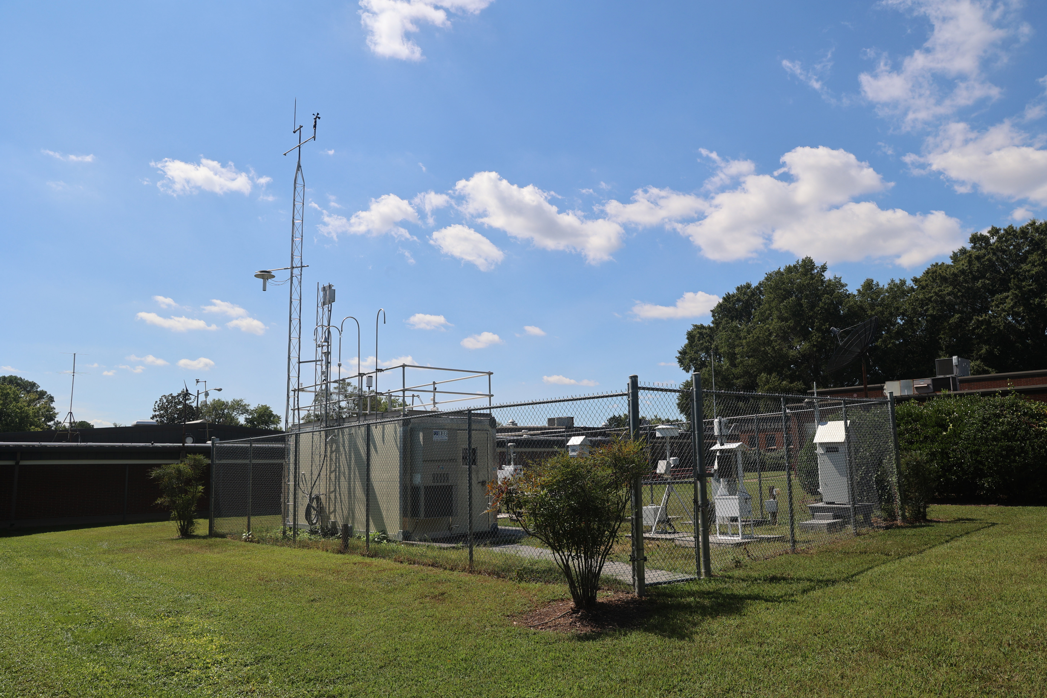
Air monitoring station located in Henrico County

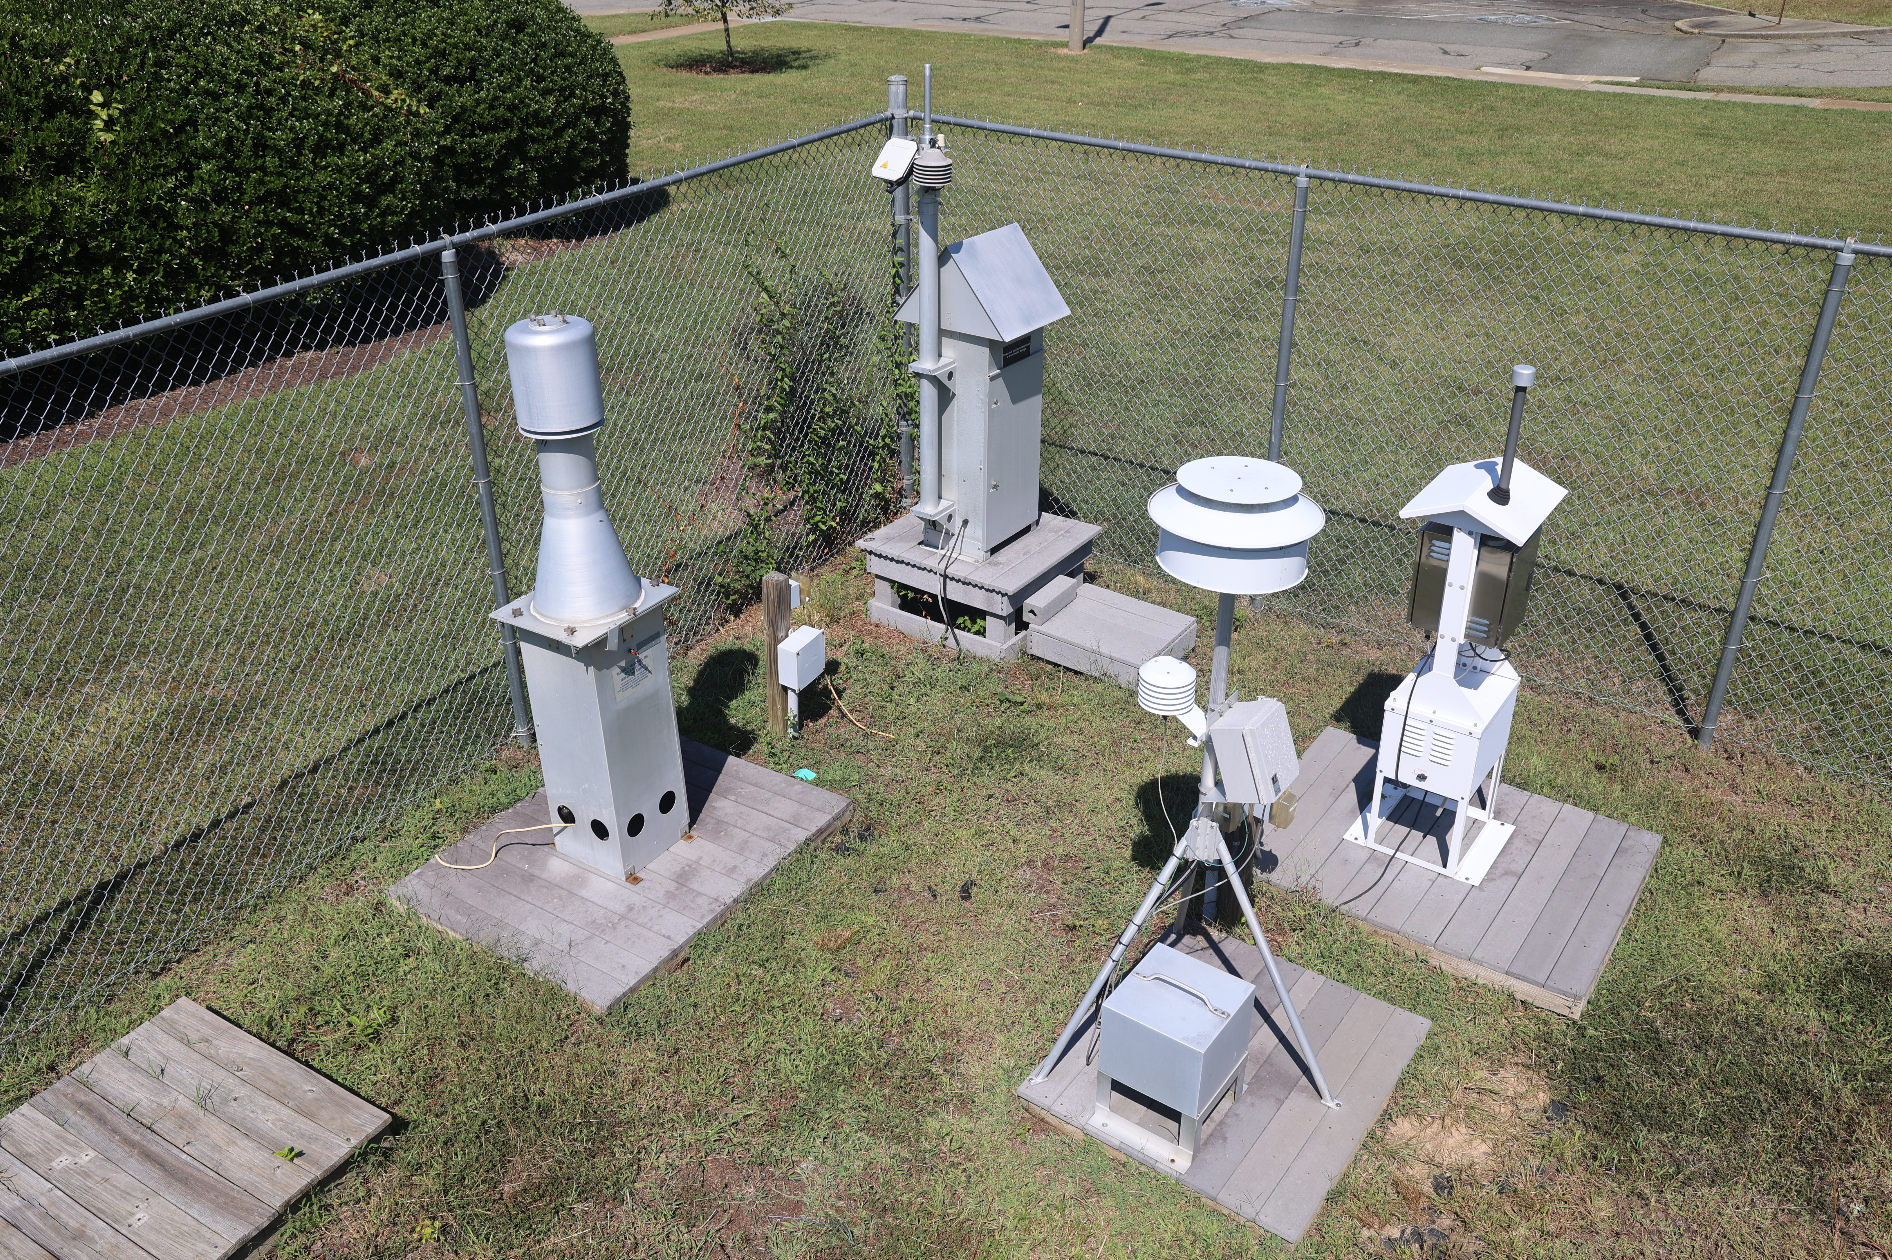
Air Monitoring Equipment at the Henrico County Air Monitoring Station

This Ambient Air Monitoring Data Report includes data gathered during the time period from
Jan. 1, 2023, to Dec. 31, 2023.

Special Thanks to:

Michael Rolband, Director
Virginia Department of Environmental Quality

and to

Michael Dowd
Director, Division of Air Quality

For their support of the publication of this document.

Acknowledgements:

The DEQ Office of Air Quality Monitoring Team would also like to thank Chuck Turner, Dan Salkovitz, Julie Raimondi and the DEQ Communications Office for their assistance in the development of this document.

Published, November 2024
2023 Annual Report prepared by:
DEQ-AQM Data Team
Office of Air Quality Monitoring

TABLE OF CONTENTS

GENERAL INFORMATION:
Introduction 1
Virginia’s Office of Air Quality Monitoring 2
Frequently Asked Questions 3
National Ambient Air Quality Standards (NAAQS) 7

CRITERIA POLLUTANTS:
PM_{2.5} (Particulate Matter equal to or less than 2.5 microns)
Description 9
Graphs 14

PM₁₀ (Particulate Matter equal to or less than 10 microns)
Description 20

CO (Carbon Monoxide)
Description 24
Graphs 27
SO₂ (Sulfur Dioxide)
Description 29
Graphs 32
NO₂ (Nitrogen Dioxide)
Description 35
Graphs 38
O₃ (Ozone)
Description 41
Graphs 46

Pb (Lead)
Description 49

ACID RAIN
Acid Precipitation Monitors 52
AIR TOXICS MONITORING
Air Toxics Monitoring Network 53
Graphs 61
AQI (Air Quality Index) 63
APPENDIX A:
Abbreviation Table 73
Regional Site List and Monitoring Network 74
Data Capture Criteria 80
Number of Criteria Pollutant Monitoring Sites 81

APPENDIX B:
Air Quality Internet Links 83
References 84
INTRODUCTION

The 2023 Virginia Ambient Air Monitoring Data Report is a compilation of air pollutant measurements made by the Virginia Department of Environmental Quality (DEQ), the U.S. Department of Agriculture - Forest Service, the National Park Service, and the Environmental Protection Agency (EPA). Ambient air quality was measured at 34 locations within Virginia during 2023. Included in this total are: (1) one sulfur dioxide monitor that is maintained by an industrial company located in Giles County as required by EPA’s Data Requirements Rule, (2) two CASTNet sites operated by EPA and two IMPROVE sites. All monitoring sites were established in accordance with EPA’s siting criteria contained in 40 CFR Part 58, Appendices D and E. Monitoring network operations conformed to EPA guidance documents and accepted air quality monitoring practices. All data reported for these monitoring sites were quality assured in accordance with requirements contained in 40 CFR Part 58, Appendix A.

Generally, calendar year 2023 was a challenging year in Virginia from the perspective of ozone and PM_{2.5} air quality. In 2023, ambient concentrations of carbon monoxide, nitrogen dioxide, sulfur dioxide, lead and PM₁₀ were within the EPA’s national ambient air quality standards (NAAQS). In 2023 there were several days of forest wildfires which adversely impacted the ozone and PM_{2.5} air quality. Due to the forest fires, in 2023 there were 6 days in Virginia where the ozone 8-hour average exceeded the NAAQS standard of 0.070 ppm in various regions of Virginia. For the three-year averaging period 2021-2023, the ozone design value was meeting the 0.070 ppm NAAQS standard for all ozone sites in Virginia.

There were significant smoke events that affected Virginia in 2023 due to wildfires outside of the commonwealth. For PM_{2.5} air quality, there were exceedances of the 35 ug/m³ 24-hour standard on the following dates: June 6-8, June 28-30, July 17, July 20, November 16-17 in 2023. The impacts of wildfire events are further detailed in the DEQ report linked here: Air Quality and Air Pollution Control Policies of the Commonwealth of Virginia – October 2024. The 2021–2023 design values for all sites in Virginia for both the 24-hour and annual standards for PM_{2.5} were below the NAAQS standard.

Some significant changes that impacted the air quality monitoring network in 2023 were:

- New continuous PM_{2.5} FEM analyzers were installed at the following sites:
  - Tidewater Regional office (AQS No. 51-810-0008)
  - Charles City County (AQS No. 51-036-0002)
  - Rockingham County (AQS No. 51-165-0003)*
  - Loudoun County (AQS No. 51-107-1005)*
  - Chesterfield County (AQS No. 51-041-0004)*
  - Norfolk City (AQS No. 51-710-0024)*

- The Automated Gas Chromatograph at the DEQ Photochemical Assessment Monitoring Site (PAMS) was activated June 1, 2023, and operated throughout the three-month PAMS season with a data capture rate of 72.3%.

*These PM_{2.5} FEM analyzers were installed in 2023, but did not begin reporting data until 1/1/24

OFFICE OF AIR QUALITY MONITORING

The Office of Air Quality Monitoring (AQM) is responsible for ensuring that the Virginia ambient air monitoring network is maintained and operated in accordance with state and federal guidelines. Staff from DEQ regional offices, the City of Alexandria, and the National Park Service conduct the daily operations at these sites. AQM supports these operations by:

- calibrating air monitoring instrumentation and associated support equipment on a set schedule
- auditing instrumentation to ensure that it is operating within standards
- troubleshooting instrumentation problems reported by the regional operators
- supplying field operators with necessary items so they can perform their job properly
- repairing malfunctioning sampling instrumentation and ancillary equipment

AQM’s other functions include:

- responding to regional and locality requests for special sampling such as emergency response or to answer citizen complaints
- coordinating efforts with the regional offices and localities to determine new air monitoring site locations
- conducting AQM-generated special sampling projects to characterize a community's air quality
- furnishing ambient air data to DEQ’s central office and regional offices, localities, EPA, and the EPA database AQS
- answering Freedom of Information Act requests for ambient air monitoring data
- working with regions and localities to meet area monitoring needs and working with EPA to meet necessary state and federal monitoring needs to support SESARM (Southeastern States Air Resource Managers, Inc.) and MARAMA (Mid-Atlantic Regional Air Management Association of the Southeast) on routine and special projects

Criteria Pollutant Monitoring:

A portion of the air monitoring network is made up of instruments that sample for the criteria air pollutants, sulfur dioxide, nitrogen dioxide, carbon monoxide, ozone, lead and particulate matter (PM₁₀ & PM_{2.5}) which can injure health, harm the environment, and cause property damage. Criteria air pollutants are regulated by EPA using health-based criteria (science-based guidelines) as the basis for setting permissible limits. One set of limits (primary standard) protects health; another set of limits (secondary standard) is intended to prevent environmental and property damage.

Special Monitoring:

In addition to overseeing the air sampling network for criteria air pollutants, AQM conducts routine and short-term sampling for VOCs (volatile organic compounds), carbonyls, toxic metals, and NO_{y} (total reactive nitrogen). VOCs sampling measures levels of 58 HAPs (Hazardous Air Pollutants) and 56 Hydrocarbon Ozone Precursors.

FREQUENTLY ASKED QUESTIONS

1. What is the Clean Air Act?

The Clean Air Act is a federal law that provides for the protection of human health and the environment. The original Clean Air Act was passed in 1963, and the 1970 version of the law resulted in the creation of EPA which was charged with setting and enforcing ambient air quality standards. The law was amended in 1977, and most recently in 1990. Most of the activities of DEQ’s Air Division come from mandates of the Clean Air Act and are overseen by EPA.

2. What is a criteria air pollutant?

The Clean Air Act names six air pollutants that are commonly found in the air throughout the United States. They can injure humans by causing respiratory and cardiovascular problems, and they can harm the environment by impairing visibility and causing damage to animals, crops, vegetation, and buildings. EPA has developed health-based criteria for these pollutants through scientific studies and has established regulations setting permissible levels of these pollutants in the air. The criteria pollutants are: carbon monoxide, sulfur dioxide, nitrogen dioxide, ozone, particulate matter, and lead. The limits that have been set for them are the National Ambient Air Quality Standards (NAAQS). The Clean Air Act mandates that EPA review the NAAQS every five years.

3. What is the difference between a primary and secondary National Ambient Air Quality Standard?

The National Ambient Air Quality Standards are divided into two types. The first type, the primary standard, is designed to protect human health, especially those who are most vulnerable such as children and the elderly, and people suffering from asthma, emphysema, chronic bronchitis, and heart ailments. The second type, the secondary standard, is designed to prevent damage to property and the environment. For a list of the primary and secondary National Ambient Air Quality Standards, see the NAAQS table or page 7 of this report.

4. How is the location of an air monitoring station decided?

Generally, the deciding factor in all Virginia air monitoring sampling is to determine where the highest pollutant concentrations will occur and place the sampler as near as possible to that location. A wind rose is a meteorological map showing the frequency and strength of winds from different directions at a specific location. A wind rose is typically used to determine the prevailing wind direction for an area and identify the downwind direction from a probable source.

For typical criteria pollutant monitoring, the federal guidelines contained in Appendices D and E of Part 58 of Title 40 of the Code of Federal Regulations are followed. These guidelines not only encourage siting in areas with free airflow and a minimum number of obstructions, but they also give the height requirements for the sample inlet and the desired separation distances from obstructions such as tree lines, localized sources such as oil furnace flues, and other influences that can skew the data.

FREQUENTLY ASKED QUESTIONS

Other determining factors for placing air monitoring stations include:
- security of the site
- safety of the operator
- availability of electric power and communication service
- accessibility of the site

For more specific information, consult EPA's Quality Assurance Handbook for Air Pollution Measurement Systems, Volume II, Section 6.

5. How large of an area does an air monitoring station represent?

The sampling area of a monitoring site is dependent on the parameters selected for representation, such as:
- type of pollutants being sampled
- rural vs. urban sampling
- source oriented, population oriented, or background oriented
- sampling for pollution transported from outside Virginia

Many sites are also dependent on topography and meteorology of an area, which play an important role. Federal guidelines spell out the general area of representation. Some examples of varied air sampling sites include:
- A background research site in central Virginia may represent an area with a radius of 50 to 100 kilometers.
- An ozone or fine particulate site in the Shenandoah Valley may represent an elongated area with an axis running with the valley and is a 100 kilometers long but only 25 kilometers wide.
- A carbon monoxide sampling site in an urban street canyon setting may represent an area of only a few blocks in radius.
- A source-oriented site in south-central Virginia may represent an area from 0.5 to 4 kilometers in radius.

6. What is a “nonattainment” area?

A nonattainment area is a geographic area that has been determined by EPA as not meeting the air quality standards for one or more pollutants. Typically, an area is declared nonattainment based on data collected at one or more ambient air monitoring sites within the area. However, sometimes the nonattainment designation can be made based on the use of air quality models that use monitoring data from other areas. In Virginia, nonattainment areas are designated for ozone.

7. How can I find out if I live in a nonattainment area?

EPA maintains a list of all nonattainment areas in the country in their Green Book and website.

FREQUENTLY ASKED QUESTIONS

8. What are the impacts of a nonattainment designation?

To demonstrate how they plan to achieve federal air quality standards, states must draft a State Implementation Plan (SIP). This plan lists specific actions that the state will undertake to improve and maintain acceptable air quality, and a time frame for accomplishing these goals. The SIP may require new factories to install the newest and most effective air pollution control technologies. Other actions requiring older factories to retrofit their smokestacks with better pollution control devices, requiring an area to sell only reformulated gasoline during the summer months, requiring vapor recovery systems on gasoline pumps, and requiring vehicle exhaust emission checks. SIP development is a lengthy process and involves negotiation between the state and EPA until it is finalized.

9. What is a maintenance area?

A maintenance area is an area that has formerly been designated nonattainment but is now recognized by EPA as meeting the NAAQS. A maintenance area must have an approved “maintenance plan” to meet and maintain air quality standards.

10. What is a design value?

A design value is a statistic that describes the air quality status of a given area relative to the level of the NAAQS. Design values are typically used to classify nonattainment areas, assess progress towards meeting the NAAQS, and develop control strategies. Design values are expressed as concentrations in the ambient air and are calculated according to regulatory specifications to determine the highest monitored concentration in an attainment or non-attainment area.

- What statistical analysis terms do I need to understand for this report?

- 98th Percentile: The sample value in the summarized sample set where 98% of the values in that set are less than or equal to it
- Annual Weighted Mean: The weighted arithmetic mean for a reported site-parameter-year for the Combined Site Sample Value Listing request.

12. How can I get current or historical air quality data?

Current AQI and air quality forecasts can be obtained from the DEQ public website and EPA's AirNow website. Summary air quality data for PM_{2.5} and ozone, and prior annual monitoring data reports for DEQ, can be found at Air Monitoring Publications. EPA also provides monitoring and emissions data, as well as maps, on the web at their AirData and Air Emissions Inventories webpages. Detailed data for monitoring sites in Virginia can also be obtained by contacting the DEQ Office of Air Quality Monitoring, or from EPA’s Data Mart.

13. What do I do if I have a complaint about air quality in my neighborhood?

Contact the DEQ regional office in your area by phone or make a report online. For a list of regional offices and phone numbers, see Appendix A of this report, or visit DEQ's locations page.

14. Who can I call about an indoor air quality problem, such as mold or radon gas?

Your local health department may be able to assist you with some indoor air quality problems, such as mold or radon gas. See Virginia Department of Health Local Districts for the health department office in your area. Other excellent sources of information on indoor air quality can be found on EPA's Indoor Air Quality website and through the American Lung Association.

15. What is AQI?

Refer to AQI section towards the end of this document.

16. What is FRM and FEM?

An FRM or federal reference method is designed to provide the most fundamentally sound and scientifically defensible concentration measurement. FRMs serve as the basis of comparison upon which to judge other measurement methods. FRM measurement principles for each criteria pollutant are published in 40 Code of Federal Regulations Part 50.

An FEM or federally approved equivalent method is designed to provide a comparable level of compliance decision making quality as provided by FRMs. They typically include newer, innovative technologies that reduce overall operating costs and achieve multiple monitoring objectives.
National Ambient Air Quality Standards

Pollutant |  | Primary/  Secondary | Averaging  Time | Level | Form
Carbon Monoxide |  | Primary | 8-hour | 9 ppm | Not to be exceeded more than once per year
Carbon Monoxide |  | Primary | 1-hour | 35 ppm | Not to be exceeded more than once per year
Lead |  | Primary and Secondary | Rolling 3-month average | 0.15 μg/m³ | Not to be exceeded
Nitrogen Dioxide |  | Primary | 1-hour | 100 ppb | 98th percentile of 1-hour daily maximum concentrations, averaged over 3 years
Nitrogen Dioxide |  | Primary and Secondary | Annual | 53 ppb | Annual Mean
Ozone |  | Primary and Secondary | 8-hour | 0.070 ppm | Annual fourth-highest daily maximum 8-hr concentration, averaged over 3 years
 |  | Primary | Annual | 12.0 μg/m³ | Annual Mean, averaged over 3 years
Particle Pollution | PM_{2.5}¹ | Secondary | Annual | 15.0 μg/m³ | Annual Mean, averaged over 3 years
Particle Pollution | PM_{2.5}¹ | Primary and Secondary | 24-hour | 35 μg/m³ | 98th percentile, averaged over 3 years
Particle Pollution | PM₁₀ | Primary and Secondary | 24-hour | 150 μg/m³ | Not to be exceeded more than once per year on average over 3 years
Sulfur Dioxide |  | Primary | 1-hour | 75 ppb | 99th percentile of 1-hour daily maximum concentrations, averaged over 3 years
Sulfur Dioxide |  | Secondary | 3-hour | 0.5 ppm | Not to be exceeded more than once per year

Please see EPA's NAAQS Table for additional information.

CRITERIA POLLUTANTS

PM_{2.5} Monitoring Network

PM_{2.5} is particulate matter (PM) that is less than or equal to 2.5 micrometers (a micrometer is one millionth of a meter) in aerodynamic diameter. These particles are often called “fine particles” because of their small size. Fine particles originate from a variety of man-made stationary and mobile sources, such as factory smokestacks and diesel engines, as well as from natural sources, such as forest fires and dust storms. These particles may be emitted directly into the air, or they may be formed by chemical reaction in the atmosphere from gaseous emissions of sulfur dioxide (SO₂), nitrogen oxides (NO_{x}), volatile organic compounds (VOCs), and other chemicals.

Scientific research has linked fine particle pollution to human health problems. Such health effects include eye, nose, and throat irritation, coughing, and shortness of breath during episodes of high particulate levels. In addition to health problems, fine particle pollution contributes to haze that causes deterioration of visibility in scenic areas and deposits harmful compounds on the soil and water. For more information regarding health and environmental effects of particulate matter please visit Health and Environmental Effects of Particulate Matter (PM) | US EPA.

PM_{2.5} air quality standards were implemented by EPA in 1997 to protect against the health effects of fine particle pollution.

The DEQ PM_{2.5} monitoring network samples fine particulate in three different ways in Virginia:

PM_{2.5} Manual 24-hour Mass Sampler: This Federal Reference Method (FRM) sampler collects particulate matter on a stretched Teflon filter media. The samplers collect 24-hour samples on a one-in-three-day schedule. Samples collected must be transported to a laboratory for processing.

PM_{2.5} 24-hour Speciation: Speciated PM_{2.5} data are collected at one site in Virginia, the Henrico Police Athletic League in Henrico County, as part of the national Chemical Speciation Network. Samples are collected using a MetOne Super SASS and a URG 3000N carbon sampler. The samplers collect 24-hour samples on a one-in-three-day schedule. Sample are collected on three types of filters which are analyzed in a laboratory for the following:

- Teflon filter: 33 trace elements including aluminum, antimony, arsenic, bromine, calcium, iron, lead, silicon, titanium, vanadium, and zirconium
- Nylon filter: cations (ammonium, potassium, sodium) and anions (nitrate, sulfate chloride)
- Quartz filter: carbons (elemental carbon, organic carbon, total carbon)

PM_{2.5} Monitoring Network

Speciation data, in conjunction with historical data from other speciation sites, including those outside Virginia, gives a representative picture of the constituents of the air samples, which help identify sources of high values and show how the air masses move over a broad area.

PM_{2.5} Continuous: As Manual FRM and speciation monitors are filter-based methods and must be processed in a laboratory, they are not useful for reporting real-time air quality conditions. Continuous FRM and FEM instruments continuously analyze particulate samples, and data can be compiled into hourly and 24-hour averages. Hence, continuous particulate monitors provide real-time data on fine particulate matter. The hourly average data are polled by a central computer and then posted on the DEQ Air Monitoring webpage. The data are also simultaneously sent to EPA’s national air quality website at Airnow. DEQ is in an ongoing effort to implement more continuous PM_{2.5} samplers.

In addition to the PM_{2.5} network operated by DEQ, the National Park Service and the USDA Forest Service operate PM_{2.5} samplers at Big Meadows in Shenandoah
National Park and in Rockbridge County as part of the IMPROVE (Interagency Monitoring of Protected Visual Environments) network. This network employs different sampling
methods than those used by DEQ.

PM_{2.5} analyzers used by VA DEQ:

- Thermo Fisher Scientific Parisitol 2025i and Partisol-Plus 2025 Sequential Air Sampler
- Met One E-SEQ FRM
- Teledyne T640 and T640x
- Thermo Fisher Scientific 1405 TEOM
- URG-3000N Carbon Sampler
- Met One SuperSASS Speciation Sampler
PM_{2.5} Monitoring Network
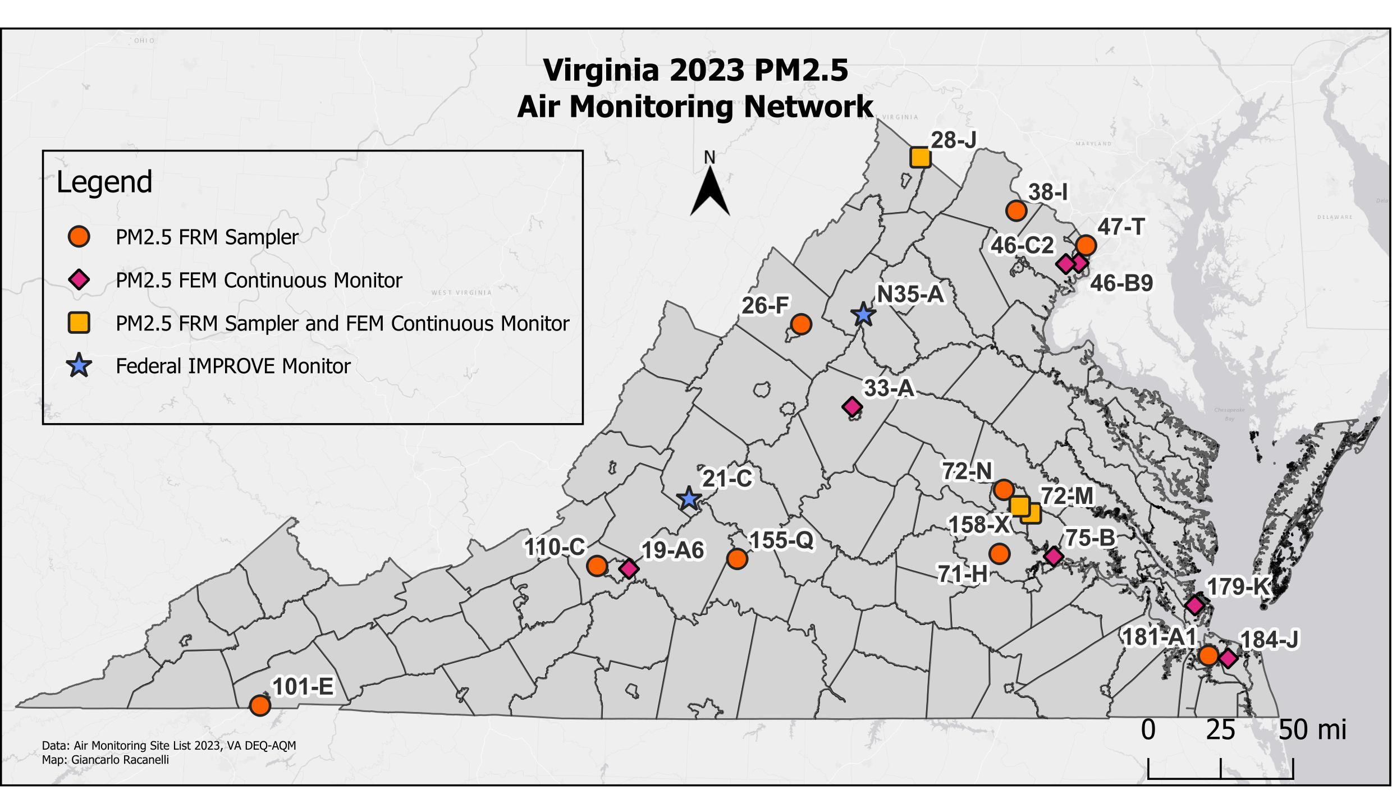
Site ID | AQS ID | County/City | Station Location
19-A6 | 51-161-1004 | Roanoke Co. | Herman L. Horn Elementary School, Ruddell Rd.
21-C | 51-163-0003 | Rockbridge | USDA Forest Service, Natural Bridge Station
26-F | 51-165-0003 | Rockingham | Rockingham VDOT
28-J | 51-069-0010 | Frederick | Woodbine Road, Lester Building Systems
33-A | 51-003-0001 | Albemarle | Albemarle High School
38-I | 51-107-1005 | Loudoun | Broad Run High School, Ashburn
46-B9 | 51-059-0030 | Fairfax | Franconia Park, Telegraph Rd.
46-C2 | 51-059-0031 | Fairfax | Park and Ride, 6831 Backlick Rd.
47-T | 51-013-0020 | Arlington | Aurora Hills Visitors Center. 18th and Hayes St.
71-H | 51-041-0004 | Chesterfield | Beach Road VDOT
72-M | 51-087-0014 | Henrico | Henrico Police Athletic League, 2401 Hartman St.
72-N | 51-087-0015 | Henrico | DEQ Piedmont Office, Glen Allen
75-B | 51-036-0002 | Charles City Co. | Rt. 608, Shirley Plantation
101-E | 51-520-0006 | Bristol | Highland View Elementary School
110-C | 51-775-0011 | Salem | Salem High School
155-Q | 51-680-0015 | Lynchburg | Leesville Hwy. & Greystone Dr., City Water Tower
158-X | 51-760-0025 | Richmond City | Joseph Bryan Park
179-K | 51-650-0008 | Hampton | NASA Langley Research Center
181-A1 | 51-710-0024 | Norfolk | 2nd St. and Woodis Ave.
184-J | 51-810-0008 | Virginia Beach City | DEQ Tidewater Regional Office
N35-A | 51-113-0003 | Madison | Big Meadows, Shenandoah National Park

PM_{2.5} Monitoring Network

NAAQS

Primary Standard for PM_{2.5}
- Annual Arithmetic Mean – the three-year average of the weighted annual mean PM_{2.5} concentration must not exceed 12.0 μg/m³.

Secondary Standard for PM_{2.5}
- Annual Arithmetic Mean – the three-year average of the weighted annual mean PM_{2.5} concentration must not exceed 15.0 μg/m³.

2021-2023 PM_{2.5} Weighted Annual Arithmetic Means (μg/m³, LC)
Site | 2021 | 2022 | 2023 | 3-Year Average
(101-E) Bristol | 7.3 | 6.2 | 8.4 | 7.3
(110-C) Salem | 7.1 | 6.4 | 8.0 | 7.2
(155-Q) Lynchburg | 6.6 | 5.7 | 7.7 | 6.7
(158-X) Richmond | 8.3* | 7.2 | 8.7 | 8.1
(179-K) Hampton | 6.5 | 5.9 | 8.1 | 6.9
(181-A1) Norfolk | 7.2 | 6.3 | 7.8* | 7.1
(184-J) Va. Beach | 7.3* | 6.5 | 8.0 | 7.3
(19-A6) Roanoke Co. | 7.2 | 6.3 | 7.8 | 7.1
(26-F) Rockingham Co. | 7.4 | 6.5 | 8.3 | 7.4
(28-J) Frederick Co. | 7.9 | 7.0 | 8.4 | 7.8
(33-A) Albemarle Co. | 6.6 | 6.6 | 8.2 | 7.1
(38-I) Loudoun Co. | 7.4 | 6.4 | 8.2 | 7.3
(46-B9) Franconia, Fairfax Co. | 7.1 | 6.4 | 9.5 | 7.6
(46-C2) Springfield, Fairfax Co. | 9.1 | 7.3 | 9.1 | 8.5
(47-T) Arlington Co. | 7.9 | 6.7 | 9.1 | 7.9
(71-H) Chesterfield Co. | 7.0 | 5.8 | 7.8 | 6.9
(72-M) Henrico Co. | 7.6 | 6.7 | 8.5 | 7.6
(72-N) Henrico Co. | 7.2 | 6.0 | 8.0 | 7.1
(75-B) Charles City Co. | 7.0 | 5.8 | 7.3 | 6.7

* Annual value did not meet completeness criteria.

PM_{2.5} Monitoring Network

NAAQS

Primary Standard and Secondary for PM_{2.5}

- 24-Hour concentration – the three-year average of the annual 98th percentile of 24-hour concentrations must not exceed 35 μg/m³.

2021-2023 PM_{2.5} 24-hour Averages, 98th Percentile Values (μg/m³, Local Conditions {LC})
Site | 2021 | 2022 | 2023 | 3-Year Average
(101-E) Bristol | 16.2 | 13.0 | 21.3 | 17
(110-C) Salem | 18.8 | 12.6 | 21.7 | 18
(155-Q) Lynchburg | 17.5 | 11.5 | 22.8 | 17
(158-X) Richmond | 17.6 | 15.0 | 26.6 | 20
(179-K) Hampton | 14.6 | 11.8 | 27.5 | 18
(181-A1) Norfolk | 15.4 | 12.8 | 21.4 | 17
(184-J) Va. Beach | 15.1 | 13.6 | 24.6 | 18
(19-A6) Roanoke Co. | 18.6 | 14.0 | 28.1 | 20
(26-F) Rockingham Co. | 18.3 | 13.0 | 38.0 | 23
(28-J) Frederick Co. | 19.3 | 17.4 | 32.4 | 23
(33-A) Albemarle Co. | 16.1 | 13.6 | 33.5 | 21
(38-I) Loudoun Co. | 16.0 | 13.0 | 27.0 | 19
(46-B9) Franconia, Fairfax Co. | 16.7 | 13.2 | 33.0 | 21
(46-C2) Springfield, Fairfax Co. | 19.9 | 15.1 | 30.1 | 22
(47-T) Arlington Co. | 17.1 | 13.5 | 33.1 | 21
(71-H) Chesterfield Co. | 18.9 | 11.9 | 21.2 | 17
(72-M) Henrico Co. | 17.4 | 14.4 | 27.6 | 20
(72-N) Henrico Co. | 17.2 | 11.1 | 20.6 | 16
(75-B) Charles City Co. | 17.0 | 12.9 | 26.1 | 19

* Annual value did not meet completeness criteria

*While 26-F here is above the Primary Standard line of 35.0, the Primary Standard is based off a 3-year average. See PM_{2.5} 98th Percentile Table above for the 2023, 3-year average.

PM₁₀ Monitoring Network

PM₁₀ is particulate matter (PM) comprised of solid particles or liquid droplets with an aerodynamic diameter of less than or equal to 10 micrometers (a micrometer is one millionth of a meter). PM₁₀ particles are larger than PM_{2.5} but are still in a size range that can pose health problems.

PM₁₀ can be inhaled and retained in the human respiratory system, causing breathing difficulties and eye, nose, and throat irritation. In addition to the health effects, these particles can impair visibility, contribute to climate change, and result in acidic dry deposition. Acidic dry deposition occurs when particles containing acidic compounds fall to the ground. The acidic particles can corrode surfaces that they settle on and can increase the acidity of the soil and water.

The NAAQS for particulate matter were revised in January 2012. For more information regarding the history of PM air quality standards, please visit the Timeline of Particulate Matter National Ambient Air Quality Standards.

The Virginia DEQ PM₁₀ monitoring network samples coarse particulates in two different ways:
- PM₁₀ Filter Based High Volume 24-hour Mass Sampler: The traditional filter-based manual method employs a sampler that uses a particle size discrimination inlet on top of a base; a quartz fiber filter is placed in the sampling house before each sampling event. The samplers collect 24-hour samples on a one-in-six day schedule. Samples collected must be transported to AQM for weighing. The PM₁₀ concentration is determined by dividing the change in filter mass from pre- and post-weighing by the volume of sampled air, with the resulting concentration reported as micrograms per cubic meter (mg/m³).
- PM₁₀ Continuous: As manual FRMs are filter-based methods and samples must be processed in a laboratory, they are not useful for reporting real-time air quality conditions. Continuous FRM and FEM instruments analyze coarse particulate samples on a continuous basis, and data can be compiled into hourly and 24-hour averages. DEQ’s network includes continuous particulate monitors that provide real-time data on fine and coarse particulate levels. The hourly average data are polled by a central computer and then posted on the DEQ Air Monitoring webpage. The data are also simultaneously sent to EPA’s national air quality website at AirNow. DEQ is in an ongoing effort to implement more continuous based PM₁₀ samplers.

PM₁₀ Monitoring Network

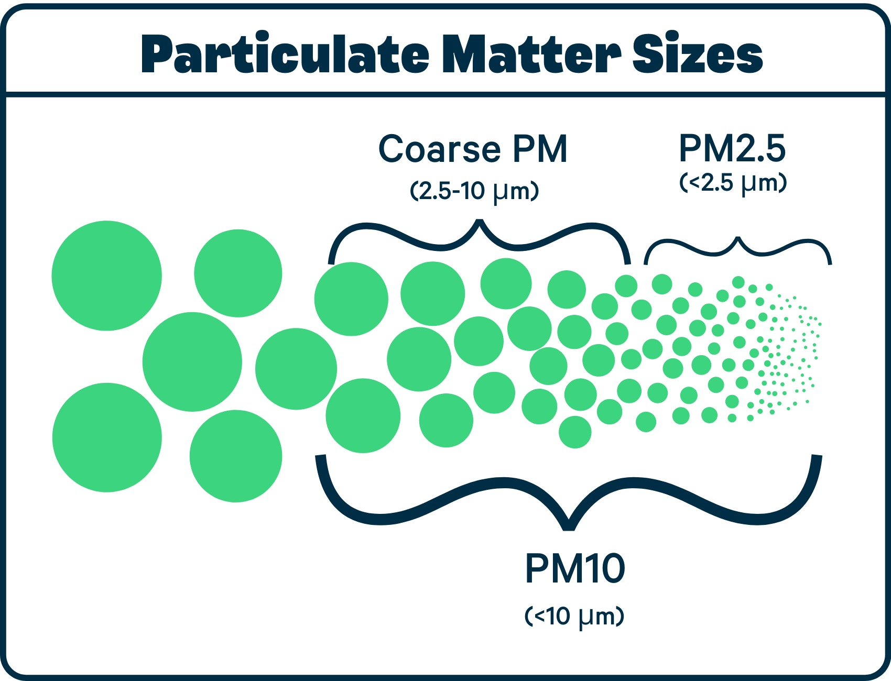
This graphic demonstrates the difference in particle size range among PM_{2.5}, PM_{coarse,} and PM₁₀.

Manufacturer’s information for each PM₁₀ sampler used by VA DEQ:
- Wedding and Associate High-Volume PM₁₀ Samplers
- Teledyne T640 and T640x

PM₁₀ Monitoring Network
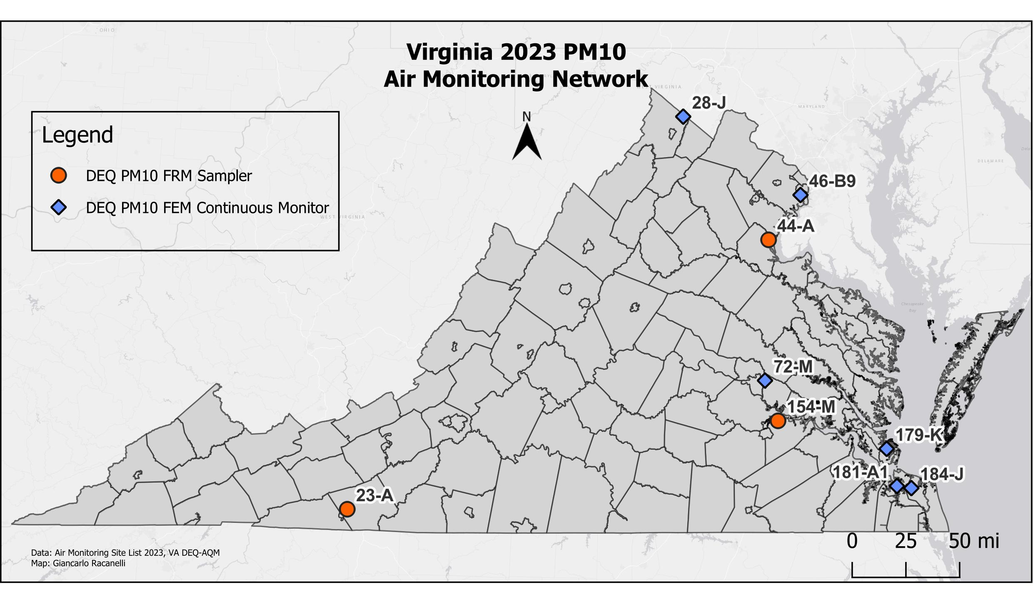
Site ID | AQS ID | County/City | Station Location
23-A | 51-035-0001 | Galax | Gladeville Elementary School
28-J | 51-069-0010 | Frederick Co. | Woodbine Road, Lester Building Systems
44-A | 51-179-0001 | Stafford Co. | Widewater Elementary School
46-B9 | 51-059-0030 | Fairfax Co. | Franconia Park, 6601 Telegraph Rd.
72-M | 51-087-0014 | Henrico Co. | Henrico Police Athletic League, 2401 Hartman St.
154-M | 51-670-0010 | Hopewell | Carter Woodson Middle School
179-K | 51-650-0008 | Hampton | NASA Langley Research Center
181-A1 | 51-710-0024 | Norfolk | 2nd St. and Woodis Ave.
184-J | 51-810-0008 | Virginia Beach | DEQ Tidewater Regional Office

PM₁₀ Monitoring Network

NAAQS

Primary Standard for PM₁₀
- 24-hour concentration not to exceed 150 μg/m³ more than once per year averaged over three years. An exceedance means a 24-hour average value that is above the level of the 24-hour standard after rounding to the nearest 10 μg/m³.

Secondary Standard for PM₁₀
- Same as Primary.

2021-2023 PM₁₀ 24-Hour Average Concentrations (units in μg/m³ STD)
Site | 2021 |  | 2022 |  | 2023 |  | >150 μg/m³
 | 1st Max | 2nd Max | 1st Max | 2nd Max | 1st Max | 2nd Max
(23-A) Galax | 36 | 27 | 25 | 22 | 49 | 44 | 0
(28-J) Frederick Co. * | 51 | 46 | 45 | 42 | 151 | 89 | 0
(44-A) Stafford Co. | 34 | 30 | 18 | 13 | 69 | 34 | 0
(46-B9) Fairfax Co. **@ | 45 | 43 | 30 | 23 | 191 | 131 | 1
(72-M) Henrico Co. | 39 | 40 | 29 | 27 | 91 | 65 | 0
(154-M) Hopewell @ | 34 | 19 | 25 | 16 | 54 | 24 | 0
(179-K) Hampton * | 46 | 44 | 28 | 26 | 115 | 62 | 0
(181-A1) Norfolk ** | 24 | 21 | 22 | 20 | 38 | 24 | 0
(184-J) DEQ TRO** | --- | --- | --- | --- | 95 | 47 | 0

* Continuous monitoring started in 2022
** Continuous monitoring started in 2023
@ Did not meet one quarter of data completeness criteria in either 2022 or 2023

CO Monitoring Network

Carbon monoxide (CO) is a colorless, odorless gas that is produced by incomplete burning of carbon compounds in fossil fuels (gasoline, natural gas, coal, oil, etc.). The greatest sources of CO in ambient outdoor air are cars, trucks and other vehicles or machinery that burn fossil fuels.

CO concentrations are higher in the vicinity of heavily traveled highways and drop rapidly the further the distance from the road. Due to EPA regulations that require near-road CO monitoring in combined statistical areas (CBSAs) with a population of greater than 1 million DEQ operates two near-road air monitoring sites. One is in the Northern Virginia area on Backlick Rd in Fairfax County (adjacent to Interstate 95), and another in Bryan Park in Richmond (adjacent to Interstate 95 and Interstate 64). Please visit the EPA’s webpage on near-road monitoring for more information about near-road monitoring sites.

Ambient levels of carbon monoxide tend to be higher in the colder months due to thermal inversions that trap pollutants close to the ground. A thermal inversion occurs when the temperature of the air next to the ground is colder than air above it. When this happens, the air resists vertical mixing that can help the pollutants to disperse. Without vertical mixing, a layer of smog can form close to the ground.

Carbon monoxide is harmful because it reacts in the bloodstream, reducing the amount of oxygen that is supplied to the heart and brain. CO can be harmful at lower levels to people who suffer from cardiovascular disease, like angina, arteriosclerosis, or congestive heart failure. At high levels, CO can impair brain function, cause vision problems, reduce manual dexterity, and reduce a person’s ability to perform complicated tasks. At very high levels, carbon monoxide can be deadly.

Carbon monoxide in the ambient air is measured continuously with an electronic instrument that uses non-dispersive infrared (NDIR) photometry and is based on the principle that the concentration of CO in a sample of air is related to the amount of infrared (IR) light that is absorbed when a beam of IR light is passed through the sample. Below are the specific analyzers used by the Virginia Office of Air Quality Monitoring.

- Thermo Fisher Scientific Model 48i CO analyzer
- Thermo Fisher Scientific Model 48i TLE CO analyzer (for trace-level concentrations)
- Teledyne Model T300 CO analyzer

CO Monitoring Network

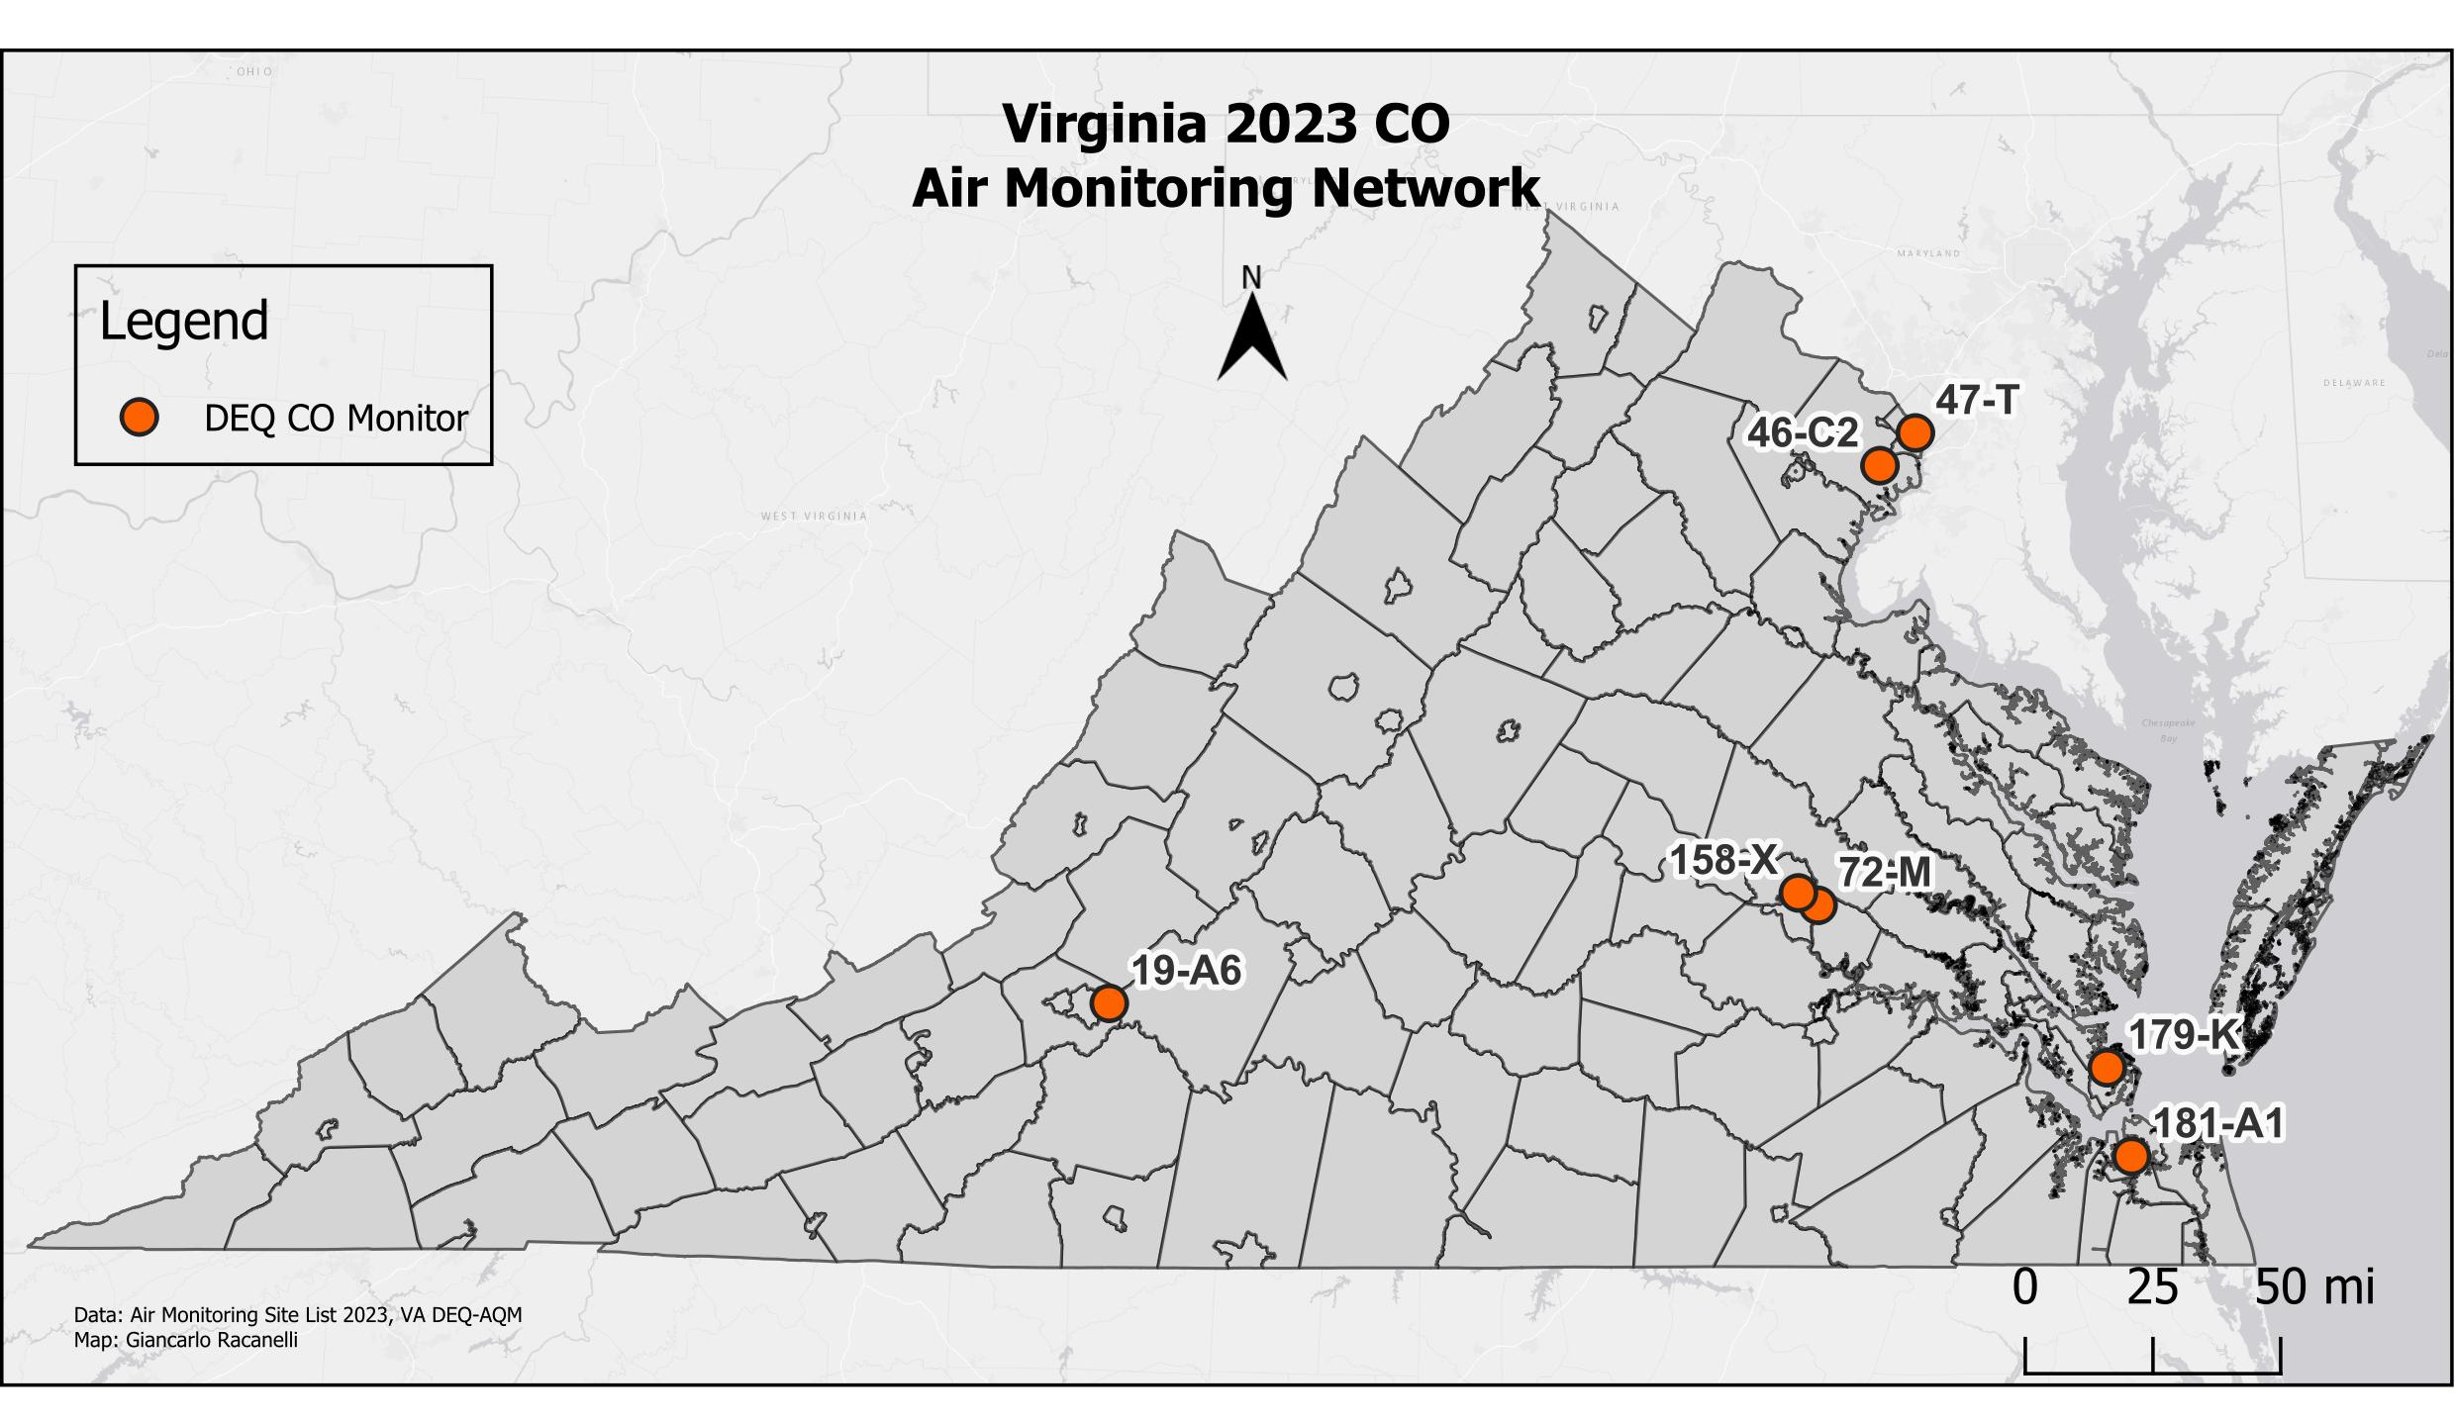
Site ID | AQS ID | County/City | Station Location
19-A6 | 51-161-1004 | Roanoke County | Herman L. Horn Elementary School, Ruddell Rd, Vinton
46-C2 | 51-059-0031 | Fairfax County | Park and Ride, 6831 Backlick Rd.
47-T | 51-013-0020 | Arlington County | Aurora Hills Visitors Center, 18th and Hayes St.
72-M | 51-087-0014 | Henrico County | Henrico Police Athletic League, 2401 Hartman St.
158-X | 51-760-0025 | Richmond City | Joseph Bryan Park
179-K | 51-650-0008 | Hampton | NASA Langley Research Center
181-A1 | 51-710-0024 | Norfolk | 2nd St. and Woodis Ave.

CO Monitoring Network

NAAQS

Primary Standard for CO:
- One-hour average not to exceed 35 ppm more than once per year.
- Eight-hour average not to exceed 9 ppm more than once per year.

There are no Secondary Standards for CO because it does not harm vegetation or buildings.

Site | 2023
 | 1-Hour Avg. (ppm) |  | 8-Hour Avg.* (ppm)
 | 1st Max. | 2nd Max. | 1st Max. | 2nd Max.
(19-A6) Roanoke Co. | 1.5 | 0.9 | 0.9 | 0.8
(46-C2) Fairfax Co. | 1.2 | 1.1 | 1.0 | 0.9
(47-T) Arlington Co. | 1.2 | 1.2 | 0.9 | 0.9
(72-M) Henrico Co.** | 1.53 | 1.47 | 1.3 | 1.1
(158-X) Richmond City | 1.6 | 1.6 | 1.3 | 1.3
(179-K) Hampton | 2.1 | 0.9 | 0.8 | 0.8
(181-A1) Norfolk | 1.6 | 1.1 | 0.8 | 0.8

*: Eight Hour Averages given as Ending-Hour running average
**: The Henrico County site operates a trace-level CO monitor, which reports the 1-hour average to 2 decimal places

Compliance with the national standards for carbon monoxide is measured by comparing the 2nd maximum of all 8-hour averages from that year to the current 8-hour standard, which is currently 9 ppm. Below are historical trends of the 8-hour 2nd maximum across Virginia, which are all well below the 9 ppm.

SO₂ Monitoring Network

Sulfur dioxide (SO₂) is a colorless gas that has a strong odor. It results from burning of fuels containing sulfur (such as coal and oil), petroleum refining, and smelting (extracting metals from ore), and it also occurs naturally from volcanic eruptions. SO₂ can dissolve in water vapor to produce sulfuric acid, and it can also interact with other gases and particles in the air to produce sulfate aerosols that can travel long distances in the atmosphere.

EPA has developed primary and secondary air quality standards for SO₂. The primary standards are designed to protect people from the health effects of sulfur dioxide gas, which include respiratory problems for people with asthma and for those who are active outdoors. Long-term exposure to high concentrations of sulfur dioxide gas can cause respiratory illness and aggravate existing heart conditions. Sulfate particles that are formed from SO₂ gas can be inhaled and are associated with increased respiratory symptoms and disease.

Secondary standards for sulfur dioxide protect against damage to vegetation and buildings, and against decreased visibility. The acids that can form from SO₂ and water vapor contribute to acid deposition (commonly called “acid rain”) which causes damage to the leaves of plants and trees, making them vulnerable to disease, and can increase the acidity of lakes and streams, making them unsuitable for aquatic life. Acid deposition also causes deterioration of materials on buildings, monuments, and sculptures. Finally, small sulfate particles, formed when SO₂ gas reacts with other gases and particles in the air, contribute to haze that causes decreased visibility in many areas of the country.

There is one industrial site SO₂ monitor in Virginia located in Giles County, at the Lhoist North America manufacturing facility. Collected SO₂ data from that site are certified yearly by the DEQ Office of Air Quality Monitoring; however, maintenance of the analyzer and the review and submission of the data are handled by Lhoist.
Sulfur dioxide is monitored continuously with an electronic instrument using ultraviolet fluorescence detection. The instrument pulls outside air into a sample chamber containing a high intensity ultraviolet (UV) light. Any SO₂ molecules in the sample air absorb some of the UV light, become excited, and then fluoresce, releasing light characteristic of SO₂.

Below are the specific analyzers used by the Virginia Office of Air Quality Monitoring:

- Thermo Fisher Scientific Model 43i SO₂ analyzer
- Thermo Fisher Scientific Model 43i-TLE SO₂ analyzer (for trace-level concentrations)

SO₂ Monitoring Network

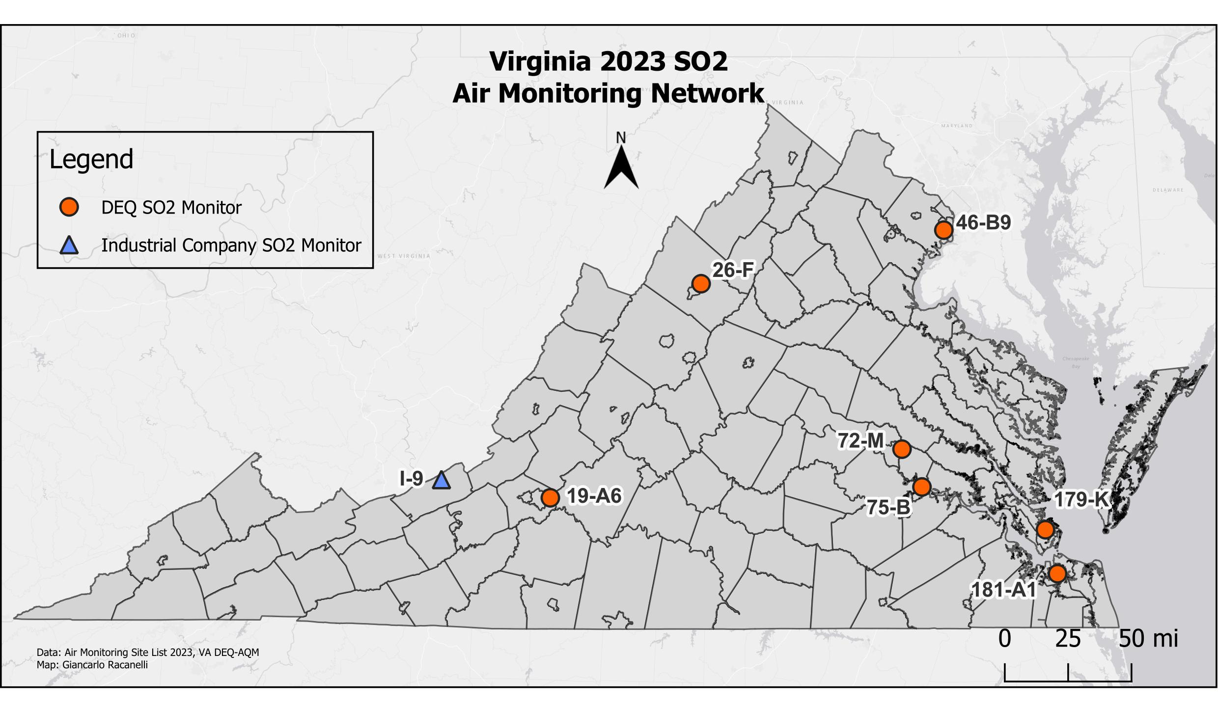
Site ID | AQS ID | County/City | Station Location
19-A6 | 51-161-1004 | Roanoke County | Herman L. Horn Elementary School, Ruddell Rd, Vinton
26-F | 51-165-0003 | Rockingham Co. | Rockingham VDOT
46-B9 | 51-059-0030 | Fairfax County | Franconia Park, 6601 Telegraph Rd.
72-M | 51-087-0014 | Henrico County | Henrico Police Athletic League, 2401 Hartman St.
75-B | 51-036-0002 | Charles City Co. | Rt. 608, Shirley Plantation
179-K | 51-650-0008 | Hampton | NASA Langley Research Center
181-A1 | 51-710-0024 | Norfolk | 2nd St. and Woodis Ave.
I-9* | 51-071-0007 | Giles County | Lhoist, 2093 Big Stony Creek Rd, Ripplemead
* Lhoist is an Industrial SO₂ monitoring site and responsible for managing their site and data submittals to EPA.

SO₂ Monitoring Network

NAAQS

Primary Standard for SO₂

- Three-year average of the annual 99th percentile one-hour daily maximum values not to exceed 75 ppb.

Sulfur Dioxide 99th Percentile 1-Hour Daily Maximum Values (ppb)
Site ID | City/County | 2021 | 2022 | 2023 | 3-Yr Avg Design Value  2021-2023
19-A6 | Roanoke Co. | 3.4 | 2.9* | 3.3 | 3.4
26-F | Rockingham Co. | 1.8 | 1.7 | 1.8 | 1.8
46-B9 | Fairfax Co. | 2.7 | 2.5 | 1.5 | 2.2
72-M | Henrico Co. | 1.5 | 2.8 | 1.5 | 1.9
75-B | Charles City Co. | 2.7 | 3.9 | 2.8 | 3.1
179-K | Hampton | 3.1 | 3.1 | 2.9 | 3.0
181-A1 | Norfolk | 1.9 | 2.4 | 3.3 | 2.5
I-9 | Giles | 98.7 | 61.5 | 39.1 | 66.0

* Did not meet completeness criteria for 2022.

Secondary Standard for SO₂:
- Three-hour concentration not to exceed 0.5 ppm (500 ppb) more than once per year.

Sulfur Dioxide 3-Hour Block Average Maximum Values (ppb)
Site ID | City/County | 2021 | 2022 | 2023 | Number Obs. > 500 ppb
19-A6 | Roanoke Co. | 4.1 | 3.2* | 3.7 | 0
26-F | Rockingham Co. | 1.7 | 1.8 | 1.6 | 0
46-B9 | Fairfax Co. | 3.3 | 2.2 | 1.9 | 0
72-M | Henrico Co. | 3.0 | 3.0 | 1.6 | 0
75-B | Charles City Co. | 4.2 | 3.4 | 2.7 | 0
179-K | Hampton | 3.1 | 2.9 | 2.6 | 0
181-A1 | Norfolk | 2.1 | 2.0 | 2.9 | 0
I-9 | Giles | 157.6 | 64.5 | 51.5 | 0

* Did not meet completeness criteria for 2022.

NO₂ Monitoring Network

Nitrogen dioxide (NO₂) is one in a group of gases referred to as oxides of nitrogen (NO_{X}). NO_{X} gases, including NO₂ which is characterized by a reddish-brown color and pungent odor, results from high temperature burning of fossil fuels in automobiles, power plants, and other industrial, commercial, and residential sources. NO_{X} can also occur naturally from lightning, forest fires, and bacterial processes that take place in soil.

NO_{X} pollution contributes to a wide range of problems in the environment. Ground-level ozone, a major component of “smog”, forms when NO_{X} and volatile organic compounds (VOCs) react in the presence of sunlight. NO_{X} also reacts with other gases and particles in the air to form acids that contribute to acid deposition and to form small particles that can be inhaled into the lungs. NO_{X} contributes to water quality deterioration by depositing nitrogen into water bodies thereby upsetting the nutrient balance and causing oxygen depletion in the water which can harm fish and other aquatic life. Nitrate particles and nitrogen dioxide also contribute to visibility impairment by blocking light transmission.

EPA has established primary and secondary air quality standards for NO₂ because it can cause lung irritation and respiratory problems in humans. Fine particles formed from reaction of NO_{X} gases with other compounds can be inhaled deep into the lungs and cause or worsen respiratory conditions such as emphysema and bronchitis and can aggravate existing heart conditions.

Continuous nitrogen dioxide measurement in the ambient air is traditionally measured with electronic instruments using the gas-phase chemiluminescence method. However, a newer technology is becoming widely used, and DEQ has deployed these new instruments at most of its NO₂ sites. This new technology is called CAPS (cavity-attenuated phase-shift spectroscopy). For more information on the various types of monitors at DEQ, see the manufacturer’s information below:

1. Thermo Fisher Scientific Model 42i NO-NO₂-NO_{x} analyzer
2. Thermo Fisher Scientific Model 42i TL NO_{x} analyzer (trace-level concentrations)
3. Teledyne T500u CAPS NO₂ analyzer
4. Teledyne T200u Trace-level Chemiluminescence NO/NO₂/NO_{y} analyzer
4. Teledyne T200p Photolytic True NO₂/NO/NO_{x} analyzer

NO₂ Monitoring Network

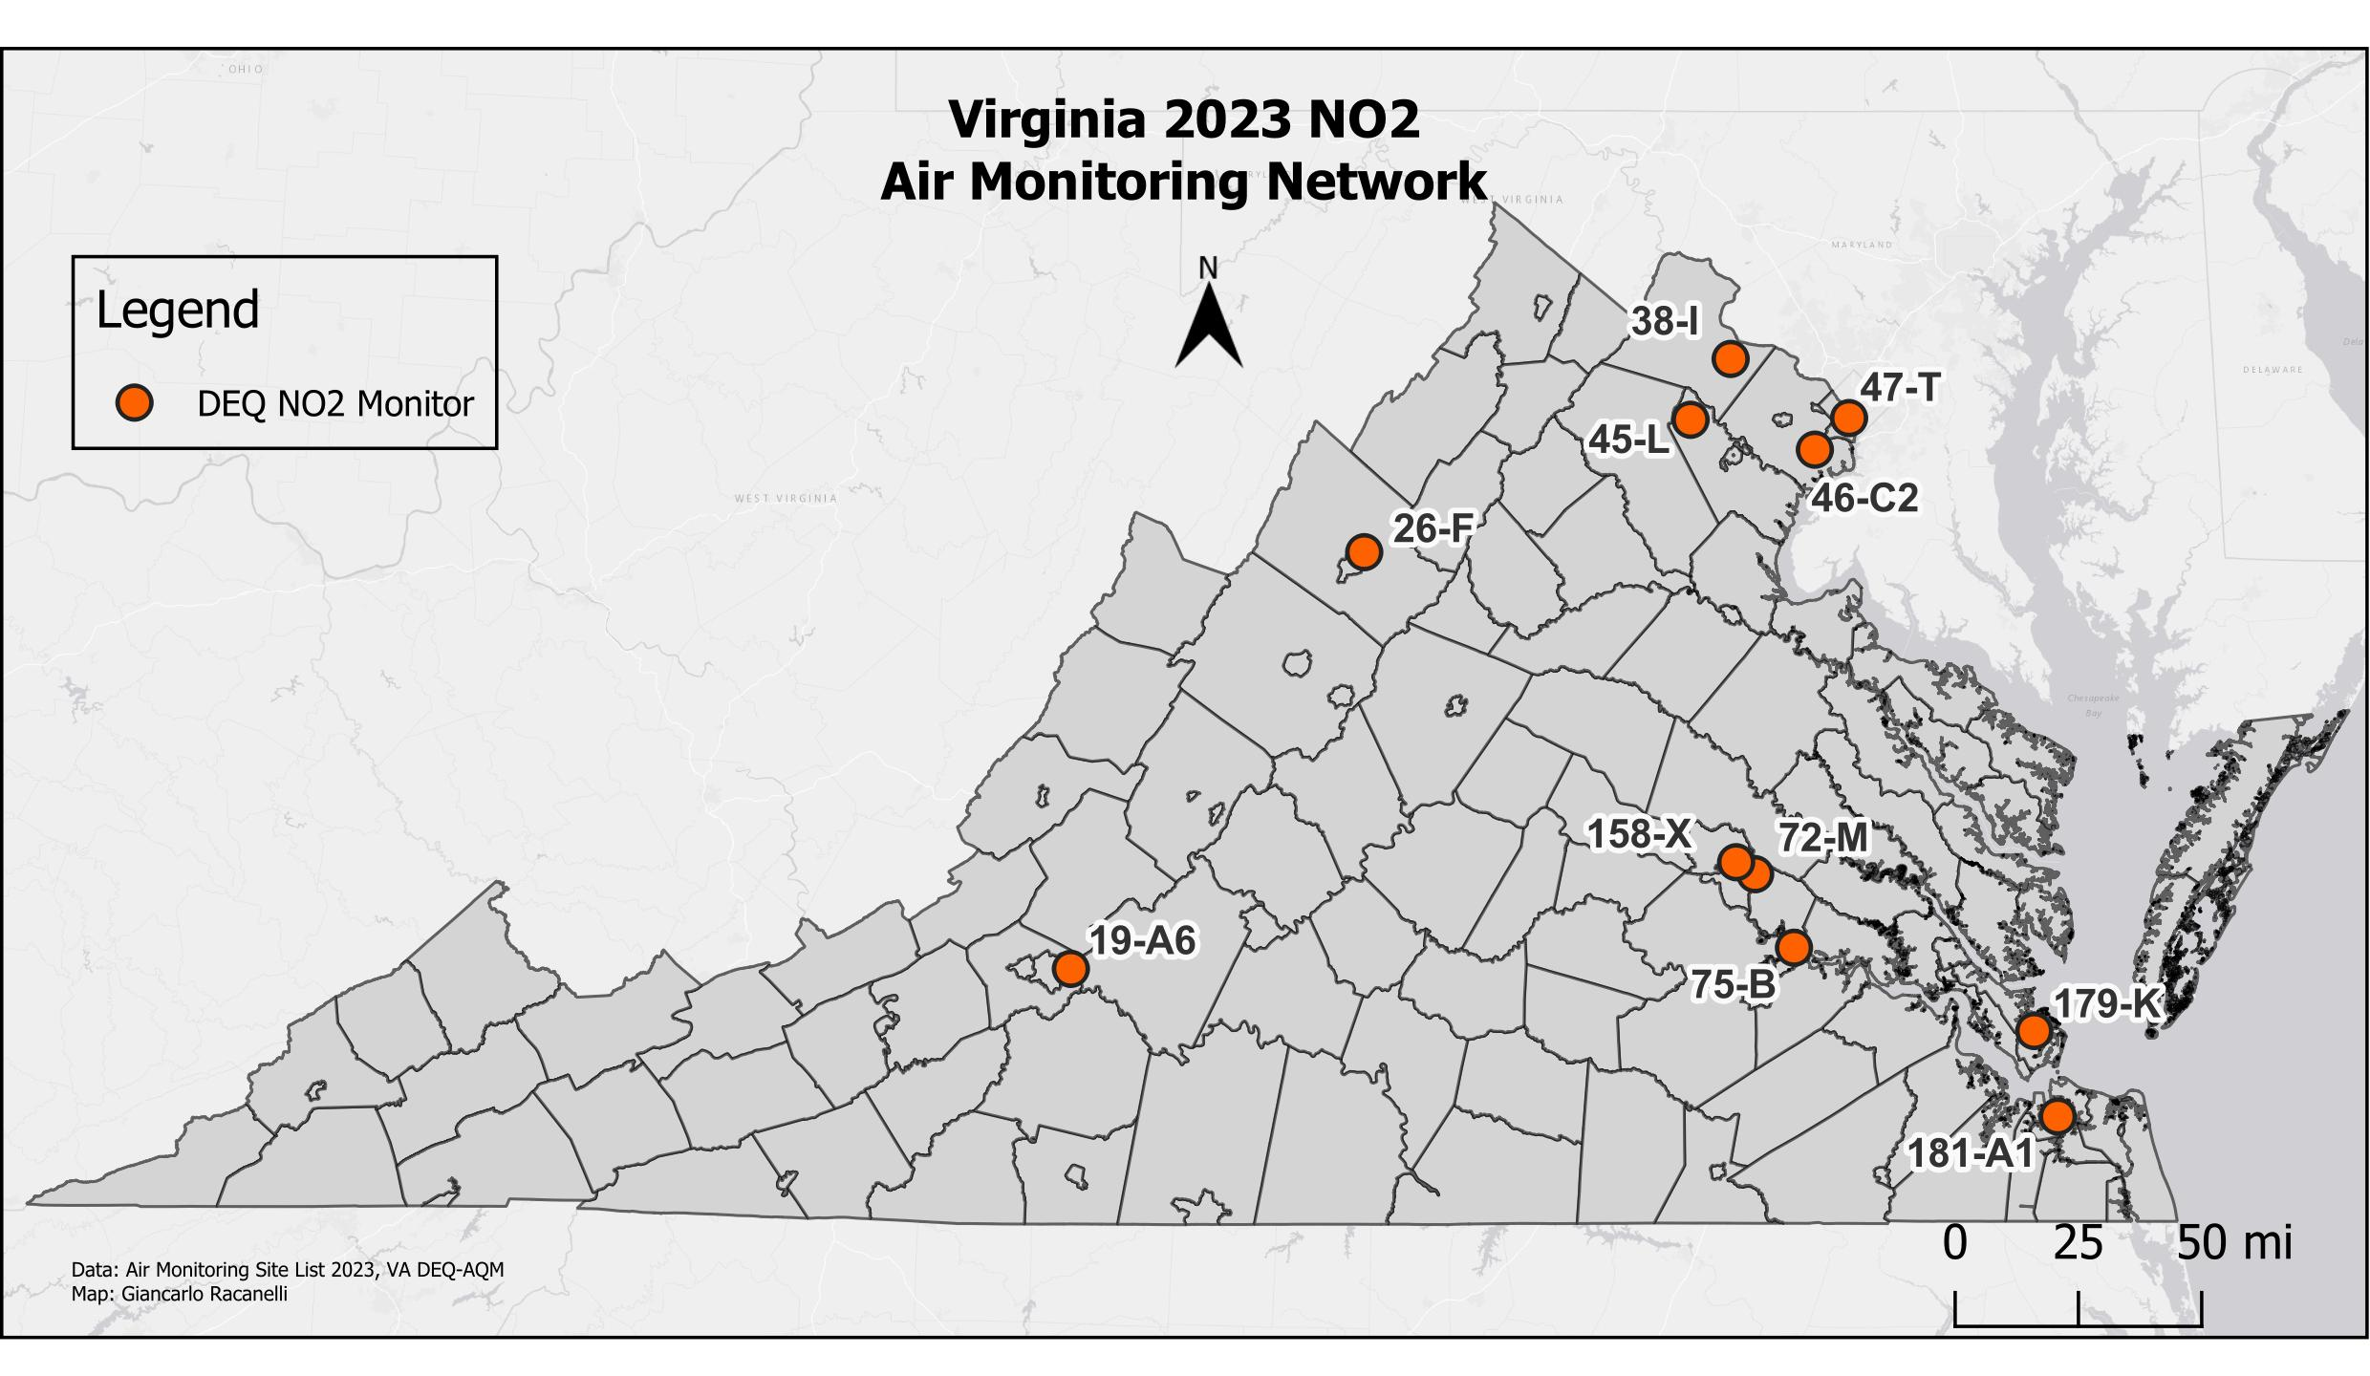

Site ID | County/City | Station Location
19-A6 | Vinton | Herman L. Horn Elementary School, Ruddell Rd.
26-F | Rockingham | Rockingham VDOT
38-I | Loudoun | Broad Run High School, Ashburn
45-L | Prince William | Long Park, Route 15
46-C2 | Fairfax | Park and Ride, 6831 Backlick Rd.
47-T | Arlington | Aurora Hills Visitors Center. 18th and Hayes St.
72-M | Henrico | Henrico Police Athletic League, 2401 Hartman St.
75-B | Charles City Co. | Rt. 608, Shirley Plantation
158-X | Richmond City | Joseph Bryan Park
179-K | Hampton | NASA Langley Research Center
181-A1 | Norfolk | 2nd St. and Woodis Ave.

NO₂ Monitoring Network

NAAQS

Primary Standard for NO₂
- Three-year average of the 98th percentile one-hour daily maximum values not to exceed 100 ppb.
- Annual Arithmetic Mean not to exceed 53 ppb (.053 ppm).

Nitrogen Dioxide 98th Percentile 1-Hour Daily Maximum Values (ppb)
Site  City/County | 2021 | 2022 | 2023 | 3-Yr Avg. Design Value 2021-2023
(19-A6) Roanoke Co. | 33.0 | 32.7 | 30.9 | 32
(26-F) Rockingham Co. | 36.2 | 36.3 | 36.9 | 36
(38-I) Loudoun Co. | 31.3 | 33.7 | 32.1 | 32
(45-L) Prince William Co. | 22.5 | 21.5 | 21.5 | 22
(46-C2) Fairfax Co. | 45.9 | 46.3 | 47.3 | 47
(47-T) Arlington Co. | 40.4 | 41.1 | 39.7 | 40
(72-M) Henrico Co. | 31.2 | 35.4 | 30.3 | 32
(75-B) Charles City Co. | 31.5 | 25.5 | 26.5 | 28
(158-X) Richmond | 47.8 | 48.6 | 46.6 | 48
(179-K) Hampton | 22.4 | 20.4 | 22.3 | 22
(181-A1) Norfolk | 39.6 | 40.9 | 36.6 | 39

Secondary Standard for NO₂
- Annual Arithmetic Mean not to exceed 53 ppb (0.053 ppm).

Site | Annual Arithmetic Mean (ppb)
 | 2021 | 2022 | 2023
(19-A6) Roanoke Co. | 5 | 5 | 5
(26-F) Rockingham Co. | 9 | 8 | 9
(38-I) Loudoun Co. | 5 | 5 | 5
(45-L) Prince William Co. | 4 | 3 | 3
(46-C2) Fairfax Co. | 15 | 15 | 15
(47-T) Arlington Co. | 8 | 9 | 9
(72-M) Henrico Co. | 7 | 7 | 6
(75-B) Charles City Co. | 3 | 4 | 4
(158-X) Richmond | 13 | 14 | 13
(179-K) Hampton | 3 | 3 | 3
(181-A1) Norfolk | 7 | 7 | 8

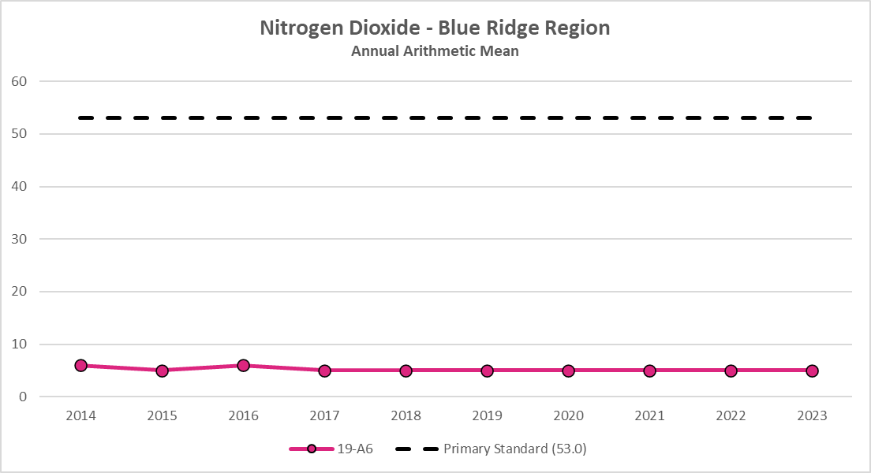
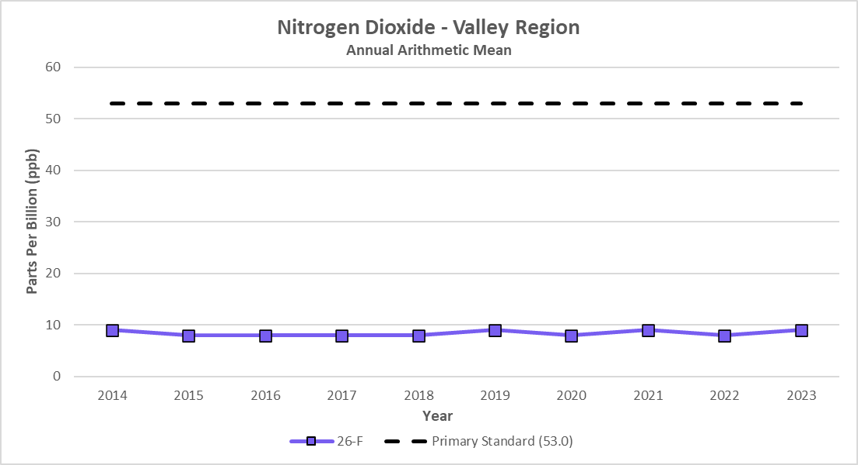
Done

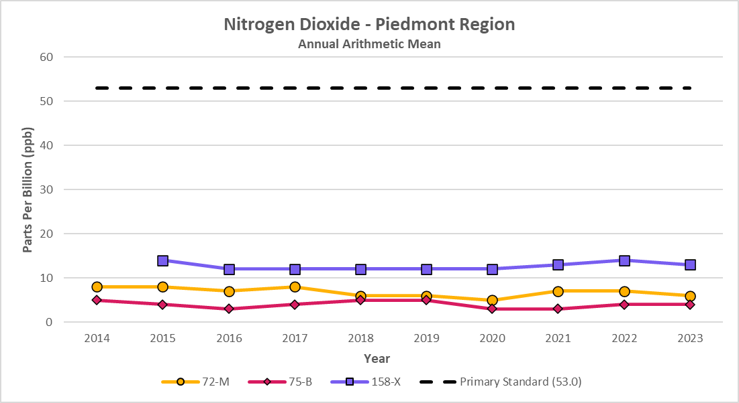
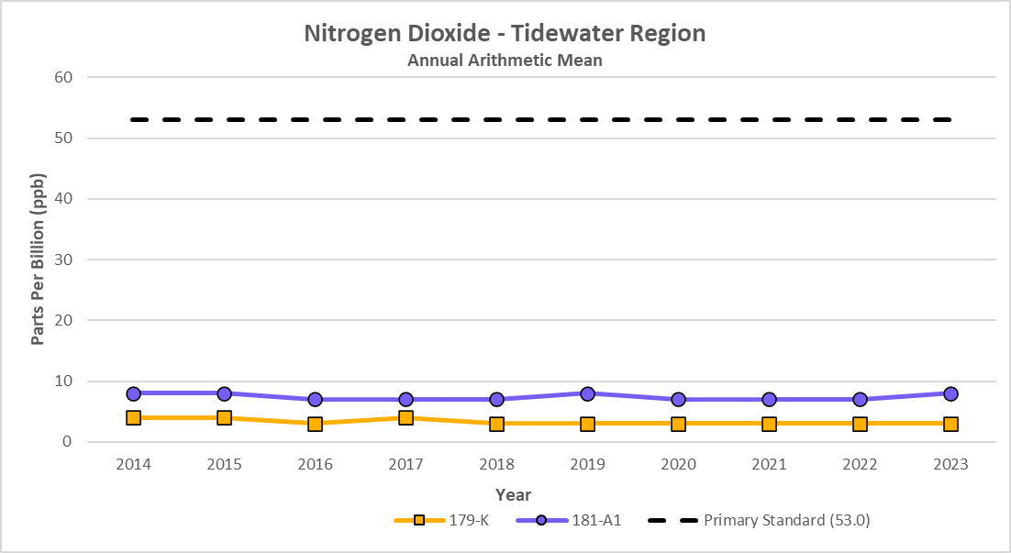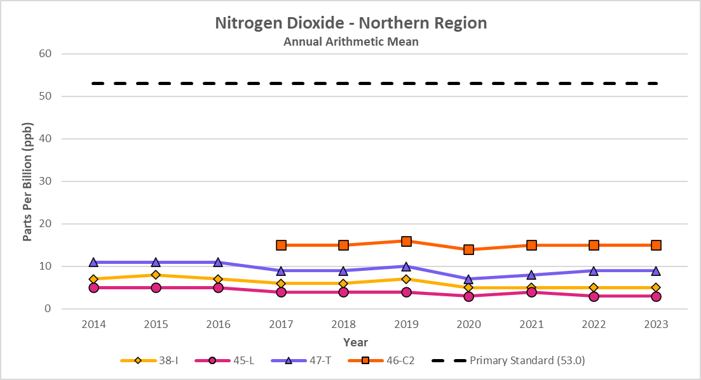

As shown in the charts above, the annual mean NO₂ concentrations throughout Virginia have been consistently below the NAAQS standard of 53 ppb.

Ozone Monitoring Network

Ozone (O₃) is a gas comprised of three oxygen atoms. It is unstable, a strong oxidizing agent, and will react readily with other compounds to decay to the more stable diatomic oxygen (O₂).

Ozone is a gas that occurs both in the Earth's upper atmosphere and at ground level. Ozone can be "good" or "bad" for people's health and for the environment, depending on its location in the atmosphere. “Good” ozone occurs naturally in the stratosphere, about 10-30 miles above the earth’s surface, where it forms a protective layer that filters the sun’s ultraviolet rays before they reach the surface where they can cause harm to people, animals, and plants. “Bad” ozone, or ground-level ozone, occurs when chemicals found in the atmosphere at earth’s surface react in the presence of intense sunlight. Ozone at ground level is harmful because it can cause a variety of health problems, as well as damage to plants and materials. Since ground-level ozone is not emitted directly, it is called a “secondary” pollutant. The pollutants needed to form ozone in the atmosphere are NO_{x} and hydrocarbons (also called VOCs). Atmospheric NOx and VOCs can come from motor vehicle exhaust, power plants, industrial emissions, gasoline vapors, chemical solvents, and natural sources such as lightning, forest fires, and plant decomposition. Ozone, and the chemicals that produce ozone, can travel hundreds of miles from their sources, so that even rural areas with few pollutant emissions can occasionally experience high ozone levels. Efforts to control ground-level ozone involve limiting emissions of NO_{x} and VOCs, or “ozone precursors,” that are necessary for ozone production.

Ground-level ozone is a seasonal pollutant, and the length of the ozone season varies across the country. In some areas, the season may last most of the year, but in Virginia it is usually only a problem during the late spring to summer months when the sunlight is most intense. Virginia is required to operate its ozone monitors from the months of March to October. Ozone sites in northern VA operate throughout the year under the enhanced ozone monitoring plan in the Virginia, Washington DC and Maryland areas. In addition to the seasonal pattern, ozone also has a strong diurnal (daily) pattern at low altitudes, so that it is usually depressed at night, but begins to build during the day after the sun rises.

EPA has created primary and secondary air quality standards for ground-level ozone because of its adverse effects on public health and welfare. In humans, ozone can irritate lung airways, causing sunburn-like inflammation, and can induce symptoms such as wheezing, coughing, and pain when taking a deep breath. Although people with existing respiratory problems, such as asthma and emphysema, are most vulnerable, young children and otherwise healthy people can also suffer respiratory problems from ozone exposure. Scientific studies have shown that even at low levels, ozone can trigger breathing problems for sensitive individuals. In addition to human health problems, ozone can damage the leaves of plants and trees, making them susceptible to disease, insects, and harsh weather. Ozone can also cause rubber to harden and crack, and some painted surfaces to fade more quickly.

Ozone Monitoring Network

Ozone is measured continuously with electronic instruments using UV absorption photometry. The method is based on the principle that ozone strongly absorbs UV light at a wavelength of 254 nanometers (one billionth of a meter). The ozone monitor draws ambient air into a sample cell, passes UV light through the air at one end of the cell, and a detector measures the light intensity in the sample cell at the other end. When more ozone is present in the sample air, less light reaches the detector. The instrument calculates the ozone concentration of the ambient air based on the light intensity measured by the detector, which is output as a voltage and sent via ethernet connection to an external data logger.

Below are the specific analyzers used by the Virginia Office of Air Quality Monitoring:
- Thermo Fisher Scientific Model 49i O₃ analyzer
- Teledyne Model T400 O₃ analyzer
Daily ozone forecasts for selected metropolitan areas and hourly ozone values for all Virginia ozone monitoring sites can be viewed for the months of March to October on the DEQ web page. In addition, animated ozone maps for Virginia and other parts of the United States are available at EPA's AirNow website.

The National Park Service operated one ozone monitor at Big Meadows in Shenandoah National Park in 2023. Daily data from this site is available at the DEQ website, and historical data may be obtained on the internet at NPS Gaseous Pollutant and Meteorological Data or at EPA’s AirData website. EPA also maintains ozone monitoring sites in Giles and Prince Edward counties as part of the CASTNET (Clean Air Status and Trends Network) program. Data from these sites is available for download at the CASTNET website. The certification of the data from these sites is not handled by the Virginia DEQ Office of Air Quality Monitoring.

Ozone Monitoring Network
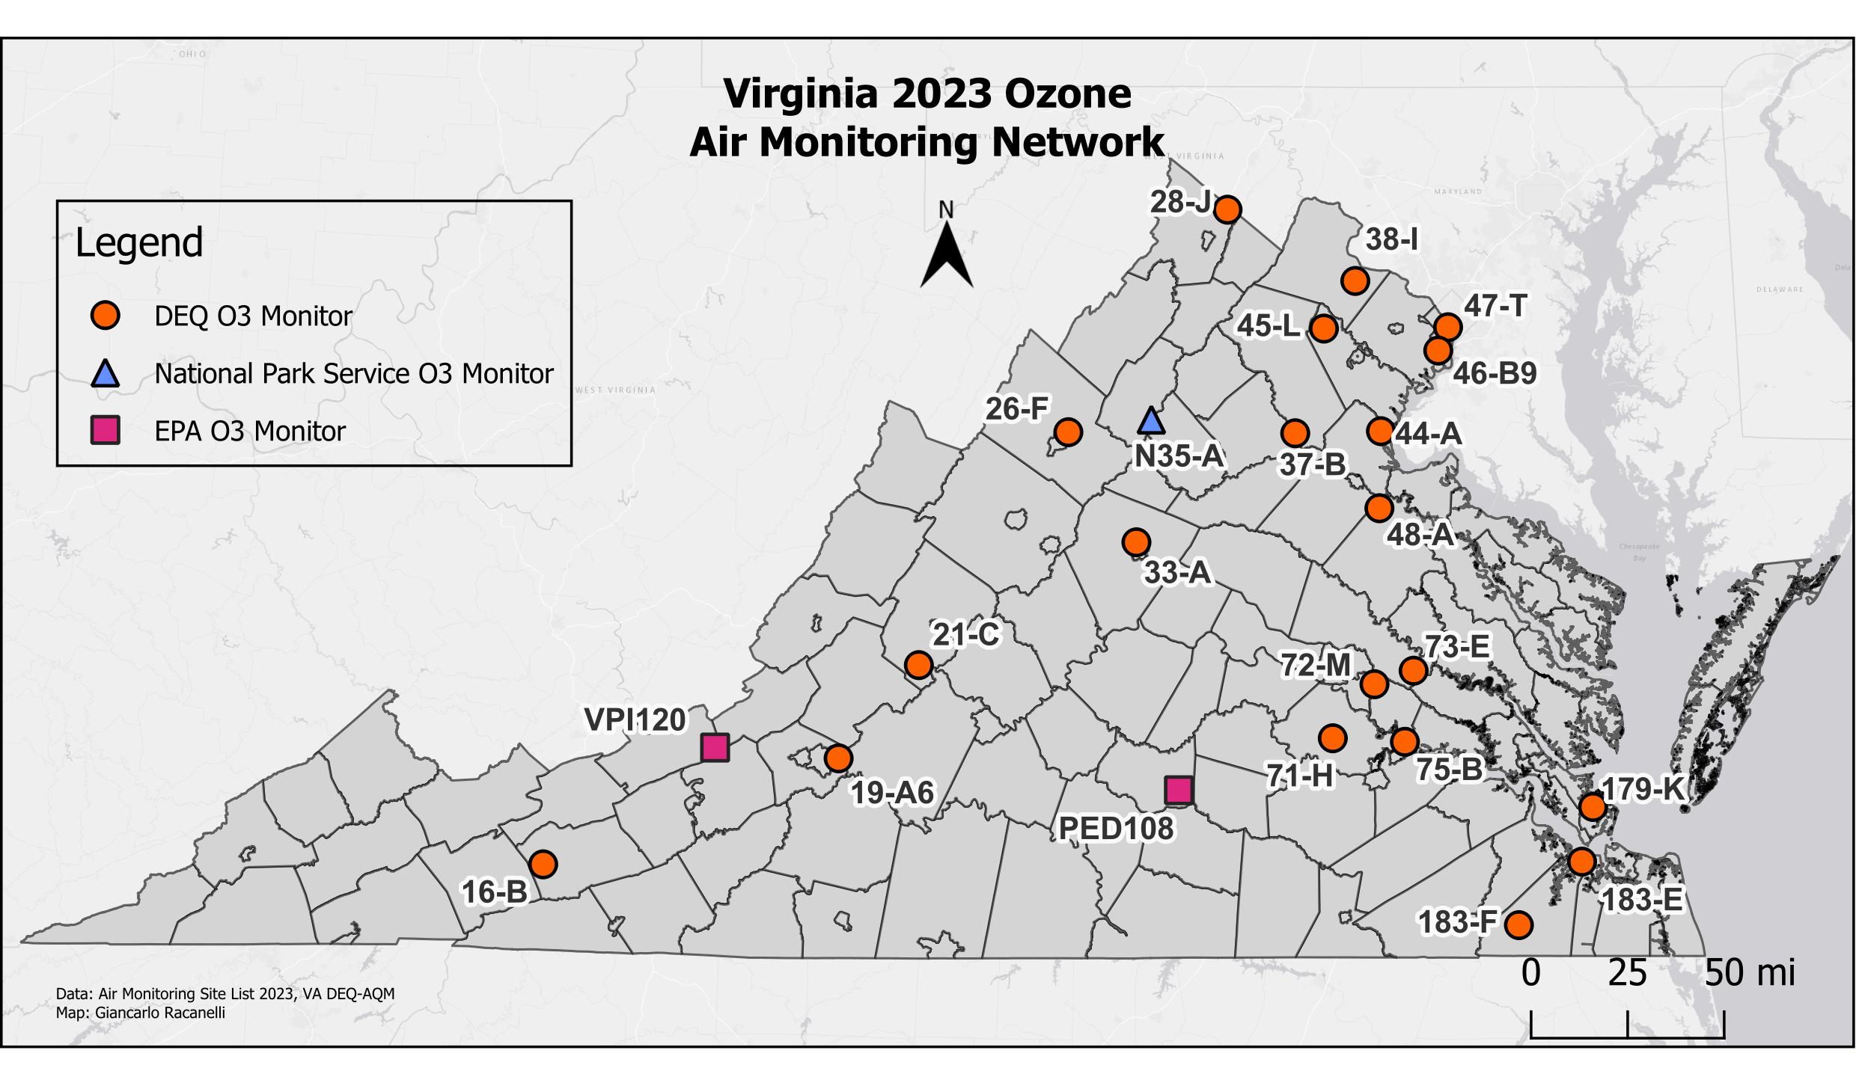
Site ID | AQS ID | County/City | Station Location
16-B | 51-197-0002 | Wythe | Sewage Disposal Plant, Rural Retreat
19-A6 | 51-161-1004 | Roanoke Co. | Herman L. Horn Elementary School, Ruddell Rd.
21-C | 51-163-0003 | Rockbridge | USDA Forest Service, Natural Bridge Station
26-F | 51-165-0003 | Rockingham | Rockingham VDOT
28-J | 51-069-0010 | Frederick | Woodbine Road, Lester Building Systems
33-A | 51-003-0001 | Albemarle | Albemarle High School
37-B | 51-061-0002 | Fauquier | Chester Phelps Wildlife Area, Route 61
38-I | 51-107-1005 | Loudoun | Broad Run High School, Ashburn
44-A | 51-179-0001 | Stafford | Widewater Elementary School, Den Rich Rd.
45-L | 51-153-0009 | Prince William | Long Park, Route 15
46-B9 | 51-059-0030 | Fairfax Co. | Franconia Park, Telegraph Rd.
47-T | 51-013-0020 | Arlington | Aurora Hills Visitors Center. 18th and Hayes St.
48-A | 51-033-0001 | Caroline | U.S.G.S. Geomagnetic Center, Corbin
71-H | 51-041-0004 | Chesterfield | Beach Road VDOT
72-M | 51-087-0014 | Henrico | Henrico Police Athletic League, 2401 Hartman St.
73-E | 51-085-0003 | Hanover | McClellan Rd.
75-B | 51-036-0002 | Charles City Co. | Rt. 608, Shirley Plantation
179-K | 51-650-0008 | Hampton | NASA Langley Research Center
183-E | 51-800-0004 | Suffolk | Tidewater Community College
183-F | 51-800-0005 | Suffolk | Tidewater Research Station, Holland
N35-A* | 51-113-0003 | Madison | Big Meadows, Shenandoah National Park
PED108‡ | 51-147-9991 | Prince Edward | Burkeville
VPI 120‡ | 51-071-9992 | Giles | Blue Grass Trail

*: Federally maintained site operated by the National Park Service
‡: Federally maintained site operated by the EPA CASTNET program

Ozone Monitoring Network

NAAQS

Primary Standard for O₃
- Maximum eight-hour average concentration of 0.070 ppm, effective Oct. 1, 2015, based on three-year average of the annual fourth highest daily maximum eight-hour averages.

Secondary Standard for O₃
- Same as primary.
The standard is attained at a monitoring site when the three-year average of the fourth highest daily maximum eight-hour average for each of the three most recent years is less than or equal to 0.070 ppm.

Site | # Days Exceeded 0.070 ppm | 2023
 |  | Highest Daily Maximum 8-Hour Avg. (ppm)
 |  | 1st Max. | 2nd Max. | 3rd Max. | 4th Max.
(16-B) Wythe Co. | 0 | 0.066 | 0.065 | 0.062 | 0.061
(19-A6) Roanoke Co. | 0 | 0.069 | 0.065 | 0.065 | 0.064
(21-C) Rockbridge Co. | 0 | 0.064 | 0.063 | 0.063 | 0.063
(26-F) Rockingham Co. | 1 | 0.074 | 0.070 | 0.066 | 0.066
(28-J) Frederick Co. | 2 | 0.077 | 0.076 | 0.070 | 0.068
(33-A) Albemarle Co. | 0 | 0.070 | 0.066 | 0.065 | 0.065
(37-B) Fauquier Co. | 2 | 0.075 | 0.074 | 0.066 | 0.064
(38-I) Loudoun Co. | 3 | 0.076 | 0.073 | 0.073 | 0.067
(44-A) Stafford Co. | 2 | 0.093 | 0.071 | 0.068 | 0.066
(45-L) Prince William Co. | 3 | 0.079 | 0.074 | 0.072 | 0.070
(46-B9) Fairfax Co. | 4 | 0.084 | 0.081 | 0.077 | 0.073
(47-T) Arlington Co. | 4 | 0.085 | 0.077 | 0.074 | 0.071
(48-A) Caroline Co. | 0 | 0.069 | 0.066 | 0.065 | 0.065
(71-H) Chesterfield Co. | 0 | 0.068 | 0.066 | 0.064 | 0.062
(72-M) Henrico Co. | 0 | 0.069 | 0.068 | 0.068 | 0.067
(73-E) Hanover Co. | 1 | 0.071 | 0.069 | 0.066 | 0.063
(75-B) Charles City Co. | 0 | 0.061 | 0.061 | 0.060 | 0.060
(179-K) Hampton | 0 | 0.070 | 0.068 | 0.066 | 0.066
(183-E) Suffolk | 1 | 0.075 | 0.065 | 0.062 | 0.061
(183-F) Suffolk | 0 | 0.058 | 0.057 | 0.056 | 0.056

2021-2023 Fourth-Highest Daily Maximum 8-Hour Ozone Averages
(units parts per million)

Areas | Monitor Location  (County/City) | 2021 | 2022 | 2023 | 3-Year Average  (NAAQS = .070 ppm)
Richmond Maintenance Area | Chesterfield Co. | 0.062 | 0.058 | 0.062 | 0.061
 | Henrico Co. | 0.062 | 0.061 | 0.067 | 0.063
 | Hanover Co. | 0.061 | 0.061 | 0.063 | 0.062
 | Charles City Co. | 0.059 | 0.060 | 0.060 | 0.060
Hampton Roads Maintenance Area | Hampton City | 0.061 | 0.060 | 0.066 | 0.062
 | Suffolk City (TCC) | 0.055 | 0.056 | 0.061 | 0.057
 | Suffolk City (Holland) | 0.059 | 0.057 | 0.056 | 0.057
Fredericksburg Maintenance Area | Stafford Co. | 0.062 | 0.058 | 0.066 | 0.062
Northern Virginia Nonattainment Area | Loudoun Co. | 0.066 | 0.061 | 0.067 | 0.065
 | Prince William Co. | 0.062 | 0.058 | 0.070 | 0.063
 | Arlington Co. | 0.070 | 0.061 | 0.071 | 0.067
 | Fairfax Co. (Lee Park) | 0.068 | 0.062 | 0.073 | 0.068
Shenandoah National Park Maintenance Area | Madison Co.  (Big Meadows) | 0.061 | 0.061 | 0.068 | 0.063
LAreas Currently Designated Attainment | Wythe Co. | 0.059 | 0.059 | 0.061 | 0.060
 | Rockbridge Co. | 0.055 | 0.054 | 0.063 | 0.057
 | Rockingham Co. | 0.062 | 0.056 | 0.066 | 0.061
 | Frederick Co. | 0.059 | 0.055 | 0.068 | 0.061
 | Albemarle Co. | 0.061 | 0.055 | 0.065 | 0.060
 | Roanoke Co. | 0.059 | 0.058 | 0.064 | 0.060
 | Fauquier Co. | 0.060 | 0.056 | 0.064 | 0.060
 | Caroline Co. | 0.066 | 0.056 | 0.065 | 0.062

A 3-year average greater than 0.070 ppm exceeds the 8-hour NAAQS for ozone.

Lead Monitoring Network

Lead (Pb) is a metal found naturally in the environment as well as in manufactured products. In the past, emissions from cars and trucks using leaded gasoline were the primary sources of lead in the atmosphere. Efforts by EPA to remove lead from motor vehicle gasoline resulted in dramatic reductions of lead in the ambient air from 1980 to 1999. Now the major sources of lead in the air are ore, metals processing, and piston-engine aircraft operating on leaded aviation gasoline.
Particles containing lead can be inhaled, or lead can be ingested from drinking water or through contaminated food because of deposition of leaded particles onto the ground or in the water. In the body, lead can accumulate in the bones, affect the nervous system, kidney function, immune system, reproductive and developmental systems and the cardiovascular system. Young children are particularly vulnerable to the effects of lead, where it can contribute to behavioral problems and learning deficits. Lead can stay in the environment for a long time, causing adverse effects to plants and animals. For more information regarding health and environmental effects of lead, please visit Learn About Lead | US EPA.
The NAAQS for lead were revised in October 2008. The standard was reviewed in 2016 and retained without revision. At present the primary and secondary standard for lead is 3-month rolling average of 0.15 µg/m³.
The DEQ monitoring network employs a manual TSP sampler that collects lead on a glass microfiber filter. The samplers collect 24-hour samples on a one-in-six day schedule. Samples collected must be transported to a laboratory for analysis using the ICP-MS method. The final concentration is reported as micrograms per cubic meter (mg/m³). DEQ maintains one lead monitoring site in Radford; this site is the source-specific monitoring site for the Radford Army Ammunition Plant.
Manufacturer’s information for lead sampler used by VA DEQ:
- Tisch High-Volume TSP samplers

Lead Monitoring Network

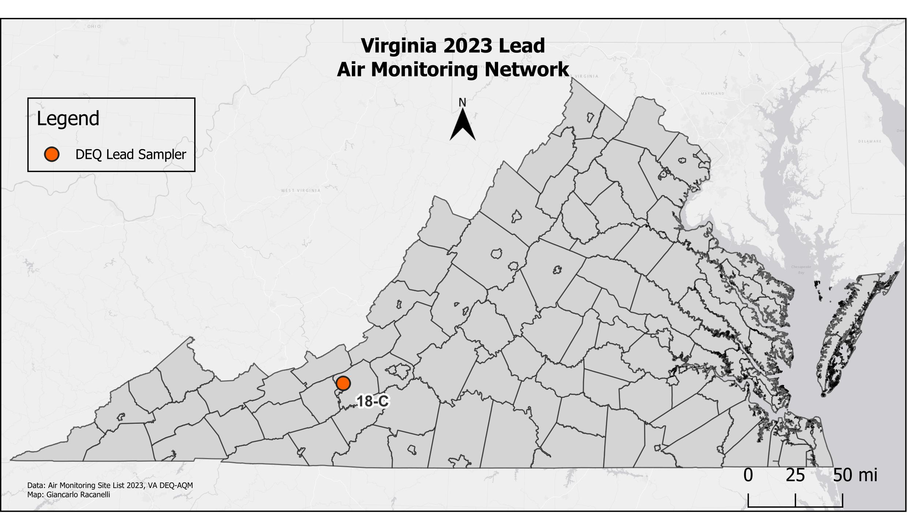
Site ID | AQS  ID | County/City | Station Location
18-C | 51-121-0009 | Montgomery | Stroubles Creek Wastewater Treatment Plant, Radford

NAAQS

Primary Standard for Pb
- 0.15 μg/m³ three-month rolling average

Secondary Standard for Pb
- Same as Primary

2023 Pb 3-Month Averages (units in μg/m³, LC)

Site | No. Samples Collected | 1st Max | 2nd Max | >0.15 μg/m³
(18-C) Montgomery Co. | 60 | 0.027 | 0.018 | 0

Acid Precipitation Network

and

Air Toxics Monitoring Network

Acid Precipitation Network

The National Acid Deposition Program (NADP) had five monitoring sites in Virginia in 2023: Big Meadows (Shenandoah National Park), Blue Grass Trail (Giles County), Charlottesville, Prince Edward County, and Natural Bridge Station (Rockbridge County).

There was one NADP Mercury Deposition Network (MDN) site in Virginia: Big Meadows (Shenandoah National Park). MDN site information and data are available online at Mercury Deposition Network (MDN) site.

There were two NADP Ammonia Monitoring Network (AMoN) sites in Virginia: Prince Edward County and Blue Grass Trail (Giles County). AMoN site information and data are available on-line at Ammonia Monitoring Network.

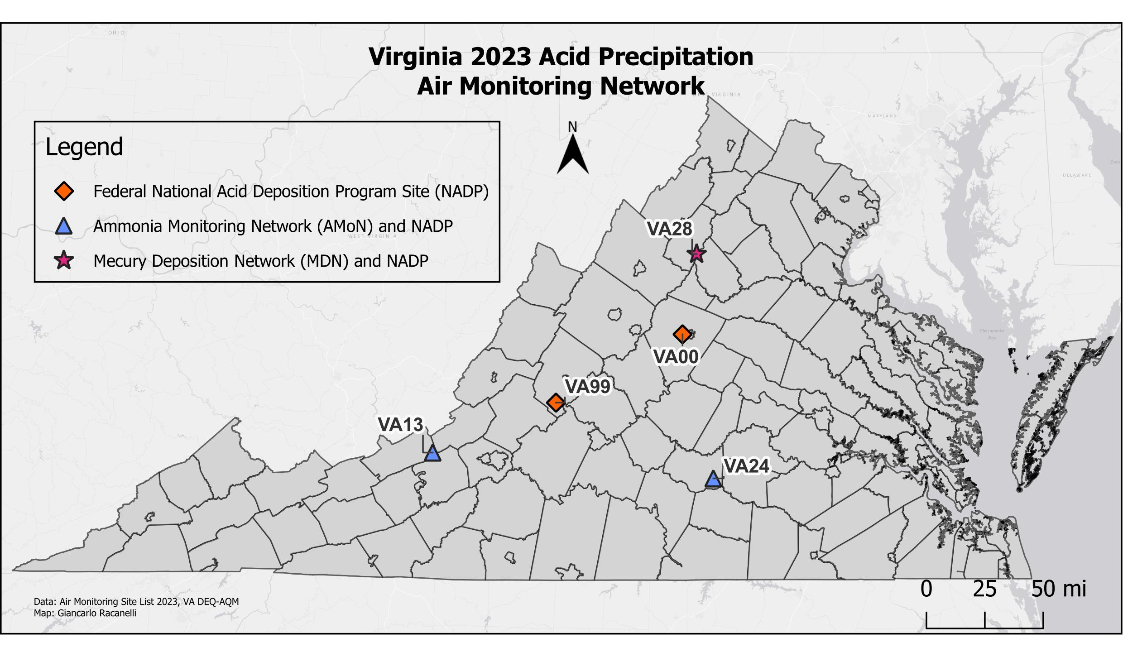
Site ID (NTN) | County/City | Station Location
VA28 | Madison | Big Meadows, Shenandoah National Park
VA00 | Albemarle | Charlottesville
VA99 | Rockbridge | USDA Forest Service, Natural Bridge Station
VA13 | Giles | Blue Grass Trail
VA24 | Prince Edward | Burkeville

Air Toxics Monitoring Network

In 2023, AQM operated an Air Toxics Monitoring Network (ATMN). The ATMN consists of two separate monitoring programs: the Urban Air Toxics Monitoring Program (UATM), and the National Air Toxics Trend Stations Program (NATTS).

The UATM program operated a site located at the Carter G. Woodson Middle School in Hopewell. Sampling at this site consisted of VOCs, Carbonyls, and Total Suspended Particulate (TSP) Metals. Each of the UATM sites had a sampling schedule consisting of 24-hour samples collected every 6th day. Data from these sites are used to characterize air toxics concentrations in the respective urban areas.

AQM used the TO-15 method for collecting ambient air samples for VOC analysis. Air samples were collected using evacuated Silonite^{T}, Silco^{T} or SUMMA^{T} canisters and Xonteck or ATEC air samplers. VOC samples were analyzed using a Gas Chromatograph equipped with a Mass Selective Detector and employed method TO-15. Carbonyls were collected on DNPH (2,4-Dinitrophenylhydrazine) treated sorbent tubes using ATEC 8000 cartridge samplers and analyzed by the Virginia Department of Consolidated Laboratory Services (DCLS), using a Liquid Chromatographic procedure designated as method TO-11A. Metals samples were collected using a high volume Total Suspended Particulate (TSP) sampler and were analyzed by the DCLS. Analysis utilized inductively coupled plasma mass spectrometry (ICP-MS) using method IO-3.1 and IO-3.5.

The NATTS program operated one station located at the Henrico Police Athletic League in Henrico County. The NATTS site had a sampling schedule consisting of 24-hour samples collected every 6th day (in accordance with the EPA Sampling Schedule). Data from this site will be evaluated along with data from all the NATTS sites nationally. Air samples were collected using evacuated Silonite^{T}, Silco^{T} or SUMMA^{T} canisters and ATEC 2200, Xonteck 901, and Xonteck 910 canister air samplers. Each sample was analyzed by using a Gas Chromatograph equipped with a Mass Selective Detector, utilizing method TO-15. Carbonyls were collected on DNPH (2,4-Dinitrophenylhydrazine) treated sorbent tubes using ATEC 8000 cartridge samplers. Carbonyls samples were analyzed by DCLS using a Liquid Chromatographic procedure, and the TO-11a method. The PM₁₀-metals samples were collected using a high volume PM₁₀ sampler and analyzed by the DCLS. Analysis utilized Inductively Coupled Plasma Mass Spectrometry (ICP-MS) using method IO-3.1 and IO-3.5. The Polycyclic Aromatic Hydrocarbons (PAH) samples are collected using polyurethane foam sampling cartridges and analyzed using EPA method TO-13a. The TO-13a analysis is performed by EPA’s contract laboratory ERG.

Air Toxics Monitoring Network

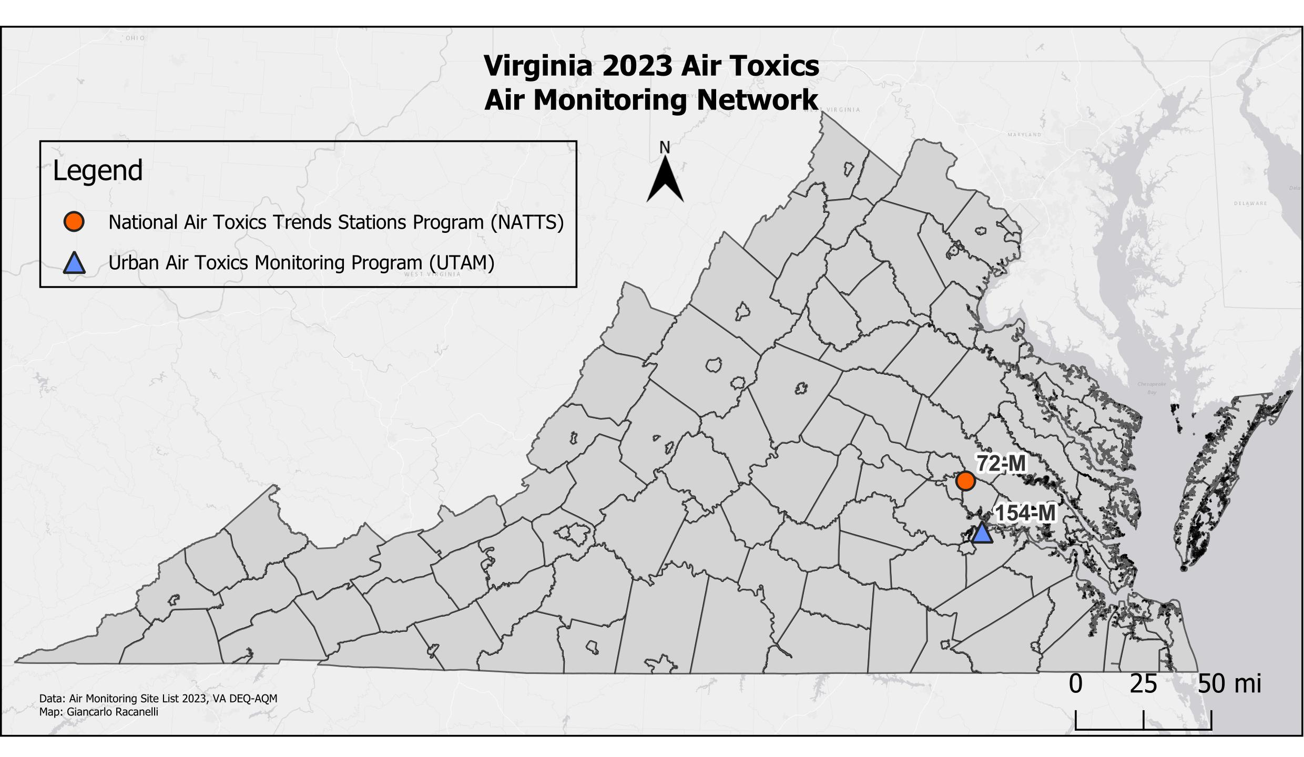

Site ID | AQS  ID | County/City | Station Location
72-M | 51-087-0014 | Henrico | Henrico Police Athletic League, 2401 Hartman St.
154-M | 51-670-0010 | Hopewell | Carter Woodson Middle School

The NATTS site in Richmond collects ambient air samples for air toxics, also called HAPs (Hazardous Air Pollutants), which are regulated under the 1990 amendments of the Clean Air Act. There are 188 HAPs regulated by CAA Section 112; however, 62 have been identified as “Analytes of Principal Interest” for the NATTS program by EPA. These HAPS are typically classified as either VOC (measured with method TO-15), carbonyls (method TO-11a), metals (method IO-3.5) or PAHs (method TO-13a). The analytes are divided into Tier I or Tier II based on their cancer risk and non-cancer hazard quotient, and 18 of these are identified as Tier I analytes by EPA. The table below provides a list of the Tier I analytes of interest with their analytes class and their measurement method.

HAP | Analyte Class | Measurement Method | NATTS Required MDL (ug/m³)
Acrolein | VOC | TO-15 | 0.09
Tetrachloroethylene | VOC | TO-15 | 0.17
Benzene | VOC | TO-15 | 0.13
Carbon tetrachloride | VOC | TO-15 | 0.17
Chloroform | VOC | TO-15 | 0.50
Trichloroethylene | VOC | TO-15 | 0.20
1,3-butadiene | VOC | TO-15 | 0.10
Ethylene Oxide | VOC | TO-15 | 0.054
Vinyl chloride | VOC | TO-15 | 0.11
Formaldehyde | carbonyl | TO-11a | 0.08
Acetaldehyde | carbonyl | TO-11a | 0.45
Naphthalene | PAH | TO-13a | 0.029
Benzo(a)pyrene | PAH | TO-13a | 0.00091
Arsenic | PM₁₀ metal | IO-3.5 | 0.00023
Beryllium | PM₁₀ metal | IO-3.5 | 0.00042
Cadmium | PM₁₀ metal | IO-3.5 | 0.00056
Lead | PM₁₀ metal | IO-3.5 | 0.015
Manganese | PM₁₀ metal | IO-3.5 | 0.0050
Nickel | PM₁₀ metal | IO-3.5 | 0.0021

Detectable VOC in 24-Hour Canister Samples
GC/MSD - Henrico Police Athletic League (NATTS Site), Henrico County
Jan. 1 - Dec. 31, 2023
Concentrations are in ppbV
(Non-detects are counted as zeros for statistical purposes)

Parameter | Parameter Name | Count | Min | Max | Median | Average | Std Dev
43218 | 1,3-butadiene | 58 | 0.00 | 0.074 | 0.011 | 0.015 | 0.016
43372 | MTBE | 58 | 0.00 | 0.310 | 0.000 | 0.005 | 0.040
43441 | Methyl Methacrylate | 58 | 0.00 | 0.040 | 0.000 | 0.002 | 0.006
43505 | Acrolein | 58 | 0.00 | 5.500 | 0.365 | 0.891 | 1.160
43601 | Ethylene Oxide | 36 | 0.046 | 2.930 | 0.121 | 0.322 | 0.586
43702 | Acetonitrile | 58 | 0.00 | 10.300 | 0.535 | 0.931 | 1.882
43704 | Acrylonitrile | 58 | 0.00 | 0.060 | 0.000 | 0.003 | 0.009
43802 | Dichloromethane | 58 | 0.120 | 3.250 | 0.311 | 0.431 | 0.497
43803 | Chloroform | 58 | 0.00 | 0.200 | 0.022 | 0.028 | 0.024
43804 | Carbon Tetrachloride | 58 | 0.00 | 0.087 | 0.077 | 0.069 | 0.017
43806 | Bromoform | 58 | 0.00 | 0.030 | 0.001 | 0.002 | 0.005
43817 | Tetrachloroethylene | 58 | 0.00 | 0.100 | 0.010 | 0.015 | 0.015
43818 | 1,1,2,2-Tetrachloroethane | 58 | 0.00 | 0.110 | 0.000 | 0.003 | 0.015
43820 | 1,1,2-Trichloroethane | 58 | 0.00 | 0.020 | 0.000 | 0.000 | 0.003
43824 | Trichloroethylene | 58 | 0.00 | 0.020 | 0.003 | 0.003 | 0.005
43830 | trans-1,3-Dichlopropene | 58 | 0.00 | 0.080 | 0.000 | 0.002 | 0.011
43831 | cis-1,3-Dichlopropene | 58 | 0.00 | 0.020 | 0.000 | 0.001 | 0.004
43844 | Hexachlorobutadiene | 58 | 0.00 | 0.020 | 0.000 | 0.004 | 0.006
43860 | Vinyl Chloride | 58 | 0.00 | 0.003 | 0.000 | 0.000 | 0.000
45109 | m/p-Xylene | 58 | 0.026 | 0.580 | 0.099 | 0.116 | 0.087
45201 | Benzene | 58 | 0.080 | 0.670 | 0.147 | 0.174 | 0.099
45202 | Toluene | 58 | 0.080 | 0.661 | 0.240 | 0.257 | 0.151
45204 | o-Xylene | 58 | 0.012 | 0.140 | 0.040 | 0.046 | 0.027
45220 | Styrene | 58 | 0.00 | 0.150 | 0.022 | 0.030 | 0.032
45801 | Chlorobenzene | 58 | 0.00 | 0.840 | 0.000 | 0.021 | 0.110
45807 | 1,4-Dichlorobenzene | 58 | 0.00 | 0.220 | 0.009 | 0.024 | 0.041
45810 | 1,2,4-Trichlorobenzene | 58 | 0.00 | 0.390 | 0.001 | 0.022 | 0.065

Detectable VOC in 24-Hour Canister Samples
GC/MSD - Carter G. Woodson Middle School (UATM Site), Hopewell
Jan. 1 - Dec. 31, 2023
Concentrations are in ppbV
(Non-detects are considered zeros for statistical purposes. Results below MDLs and/or Reporting Limits are reported.)

Parameter | Parameter Name | Count | Min | Max | Median | Average | Std Dev
43218 | 1,3-butadiene | 56 | 0 | 0.075 | 0.010 | 0.014 | 0.015
43372 | MTBE | 56 | 0 | 0 | 0 | 0.000 | 0.000
43441 | Methyl Methacrylate | 56 | 0 | 0.08 | 0 | 0.008 | 0.018
43505 | Acrolein | 23 | 0 | 5.40 | 0.330 | 1.070 | 1.377
43601 | Ethylene Oxide | 34 | 0 | 0.548 | 0.130 | 0.126 | 0.052
43702 | Acetonitrile | 56 | 0 | 4.70 | 0.705 | 0.975 | 0.939
43704 | Acrylonitrile | 56 | 0 | 0.08 | 0 | 0.009 | 0.018
43802 | Dichloromethane | 56 | 0 | 0.93 | 0.11 | 0.112 | 0.025
43803 | Chloroform | 54 | 0 | 0.041 | 0.020 | 0.023 | 0.010
43804 | Carbon Tetrachloride | 56 | 0 | 0.084 | 0.060 | 0.054 | 0.021
43806 | Bromoform | 56 | 0 | 0.06 | 0 | 0.005 | 0.012
43817 | Tetrachloroethylene | 56 | 0 | 0.05 | 0.020 | 0.016 | 0.012
43818 | 1,1,2,2-Tetrachloroethane | 56 | 0 | 0.05 | 0 | 0.005 | 0.011
43820 | 1,1,2-Trichloroethane | 56 | 0 | 0.05 | 0 | 0.003 | 0.009
43824 | Trichloroethylene | 56 | 0 | 0.06 | 0 | 0.0060 | 0.011
43830 | trans-1,3-Dichlopropene | 56 | 0 | 0.03 | 0 | 0.001 | 0.004
43831 | cis-1,3-Dichlopropene | 56 | 0 | 0.02 | 0 | 0.001 | 0.004
43844 | Hexachlorobutadiene | 56 | 0 | 0.18 | 0 | 0.010 | 0.026
43860 | Vinyl Chloride | 56 | 0 | 0 | 0 | 0.000 | 0.000
45109 | m/p-Xylene | 56 | 0.02 | 0.46 | 0.100 | 0.123 | 0.087
45201 | Benzene | 56 | 0.05 | 0.68 | 0.140 | 0.158 | 0.101
45202 | Toluene | 56 | 0.05 | 0.92 | 0.197 | 0.229 | 0.173
45204 | o-Xylene | 56 | 0 | 0.18 | 0.044 | 0.053 | 0.035
45220 | Styrene | 56 | 0 | 0.38 | 0.040 | 0.065 | 0.078
45801 | Chlorobenzene | 56 | 0 | 0.21 | 0 | 0.017 | 0.038
45807 | 1,4-Dichlorobenzene | 56 | 0 | 0.57 | 0.021 | 0.069 | 0.115
45810 | 1,2,4-Trichlorobenzene | 56 | 0 | 0.63 | 0.021 | 0.069 | 0.114

UATM 24-Hour Carbonyl Sampling 2023 Summary Statistical Analysis
Concentrations are in ug/m³
(Non-detects are counted as zeros for statistical purposes)

Site | Parameter | Parameter Name | Num | Minimum | Maximum | Median | Average | Std. Dev
Carter G.  Woodson  Middle School | 43502 | Formaldehyde | 59 | 0.81 | 5.04 | 1.82 | 2.126 | 1.060
 | 43503 | Acetaldehyde | 59 | 0.48 | 2.13 | 0.98 | 1.040 | 0.380
 | 43504 | Propionaldehyde | 59 | 0.04 | 0.26 | 0.13 | 0.128 | 0.055
 | 43552 | Methyl Ethyl Ketone | 59 | 0.05 | 0.52 | 0.24 | 0.245 | 0.107
 | 43560 | Methyl Isobutyl Ketone | 59 | 0.00 | 0.06 | 0.02 | 0.016 | 0.017

NATTS 24-hour Carbonyl Sampling 2023 Summary Statistical Analysis
Concentrations are in ug/m³
(Non-detects are counted as zeros for statistical purposes)

Site | Parameter | Parameter Name | Num | Minimum | Maximum | Median | Average | Std. Dev
Henrico Police Athletic League | 43502 | Formaldehyde | 59 | 0.87 | 5.65 | 1.99 | 2.457 | 1.211
 | 43503 | Acetaldehyde | 59 | 0.46 | 1.88 | 1.10 | 1.085 | 0.390
 | 43504 | Propionaldehyde | 59 | 0.05 | 0.34 | 0.17 | 0.164 | 0.066
 | 43551 | Acetone | 59 | 0.51 | 5.90 | 2.12 | 2.326 | 1.134
 | 43552 | Methyl Ethyl Ketone | 55 | 0.05 | 0.60 | 0.27 | 0.279 | 0.115
 | 43560 | Methyl Isobutyl Ketone | 47 | 0.00 | 0.51 | 0.03 | 0.034 | 0.073

NATTS PAH Sampling 2023 Summary Statistical Analysis
Henrico Police Athletic League, Henrico County
Annual mean concentration in ng/m³
(Non-detects are counted as zero for statistical purposes)

Parameter | Parameter Name | 2019 | 2020 | 2021 | 2022 | 2023
17141 | Naphthalene | 56.341 | 38.355 | 44.444 | 46.888 | 47.12
17147 | Acenaphthene | 3.353 | 2.073 | 1.978 | 2.221 | 2.556
17148 | Acenaphthylene | 0.246 | 0.139 | 0.121 | 0.130 | 0.126
17149 | Fluorene | 3.138 | 2.142 | 2.636 | 2.211 | 2.294
17150 | Phenanthrene | 6.137 | 4.528 | 5.581 | 5.118 | 5.085
17151 | Anthracene | 0.090 | 0.085 | 0.089 | 0.090 | 0.071
17201 | Fluoranthene | 1.357 | 0.920 | 1.098 | 1.014 | 0.967
17204 | Pyrene | 0.546 | 0.448 | 0.501 | 0.463 | 0.378
17208 | Chrysene | 0.098 | 0.067 | 0.000 | 0.059 | 0.087
17211 | Coronene | 0.042 | 0.029 | 0.027 | 0.029 | 0.024
17212 | Perylene | 0.004 | 0.001 | 0.009 | 0.000 | 0.009
17215 | Benzo[a]anthracene | 0.036 | 0.025 | 0.044 | 0.030 | 0.052
17220 | Benzo[b]fluoranthene | 0.131 | 0.091 | 0.239 | 0.062 | 0.094
17223 | Benzo[k]fluoranthene | 0.036 | 0.025 | 0.041 | 0.029 | 0.037
17224 | Benzo[e]pyrene | 0.073 | 0.049 | 0.067 | 0.052 | 0.052
17231 | Dibenzo[a,h]anthracene | 0.009 | 0.004 | 0.008 | 0.002 | 0.006
17237 | Benzo[g,h,i]perylene | 0.066 | 0.057 | 0.073 | 0.062 | 0.075
17242 | Benzo[a]pyrene | 0.044 | 0.025 | 0.067 | 0.035 | 0.061
17243 | Indeno[1,2,3-cd]pyrene | 0.075 | 0.046 | 0.074 | 0.042 | 0.057

UATM TSP Metals Sampling 2023 Summary Statistical Analysis
Carter G. Woodson Middle School, Hopewell
Concentrations are in ng/m³
(Non-detects are counted as zeros for statistical purposes)

Metal | No. Samples Collected | Min | Max | Median | Average | Std Dev
Arsenic | 51 | 0.170 | 1.550 | 0.640 | 0.680 | 0.330
Beryllium | 51 | 0.000 | 0.090 | 0.006 | 0.010 | 0.014
Cadmium | 51 | 0.029 | 0.210 | 0.073 | 0.082 | 0.041
Total Chromium* @ | 38 | 0.790 | 2.120 | 1.400 | 1.460 | 0.280
Lead | 51 | 0.490 | 4.190 | 1.560 | 1.720 | 0.810
Manganese | 51 | 1.620 | 21.740 | 5.300 | 6.610 | 4.350
Nickel | 51 | 0.320 | 1.430 | 0.550 | 0.620 | 0.220

@ Did not meet annual data completeness

NATTS PM₁₀ Metals Sampling 2023 Summary Statistical Analysis
Henrico Police Athletic League, Henrico County
Concentrations are in ng/m³
(Non-detects are counted as zeros for statistical purposes)

Metal | No. Samples Collected | Min | Max | Median | Average | Std Dev
Arsenic | 60 | 0.14 | 2.160 | 0.615 | 0.702 | 0.415
Beryllium | 60 | 0.000 | 0.096 | 0.005 | 0.009 | 0.015
Cadmium | 60 | 0.036 | 0.231 | 0.080 | 0.094 | 0.040
Total Chromium* | 60 | 1.240 | 2.400 | 1.575 | 1.611 | 0.228
Lead | 60 | 0.380 | 3.720 | 1.455 | 1.621 | 0.695
Manganese | 60 | 0.530 | 5.340 | 2.160 | 2.140 | 0.963
Nickel | 60 | 0.380 | 1.040 | 0.565 | 0.580 | 0.134

* Note that total chromium is included in the metals data for both the UATM and NATTS site even though it is not a Tier I HAP. Hexavalent chromium was removed from the list of NATTS core HAPs in June 2013 due to its being a local source-driven pollutant (and not ubiquitous) and due to the preponderance of non-detect results on a national scale which provided little useful data. Sites are not required to but may elect to collect and report hexavalent chromium measurement data. DEQ collects and reports total chromium measurement data; total chromium refers to all chromium compounds present regardless of oxidation state.

VOCs Trends NATTS Site

Carbonyls and PAHs Trends NATTS Site

PM₁₀ Metals Trends NATTS Site

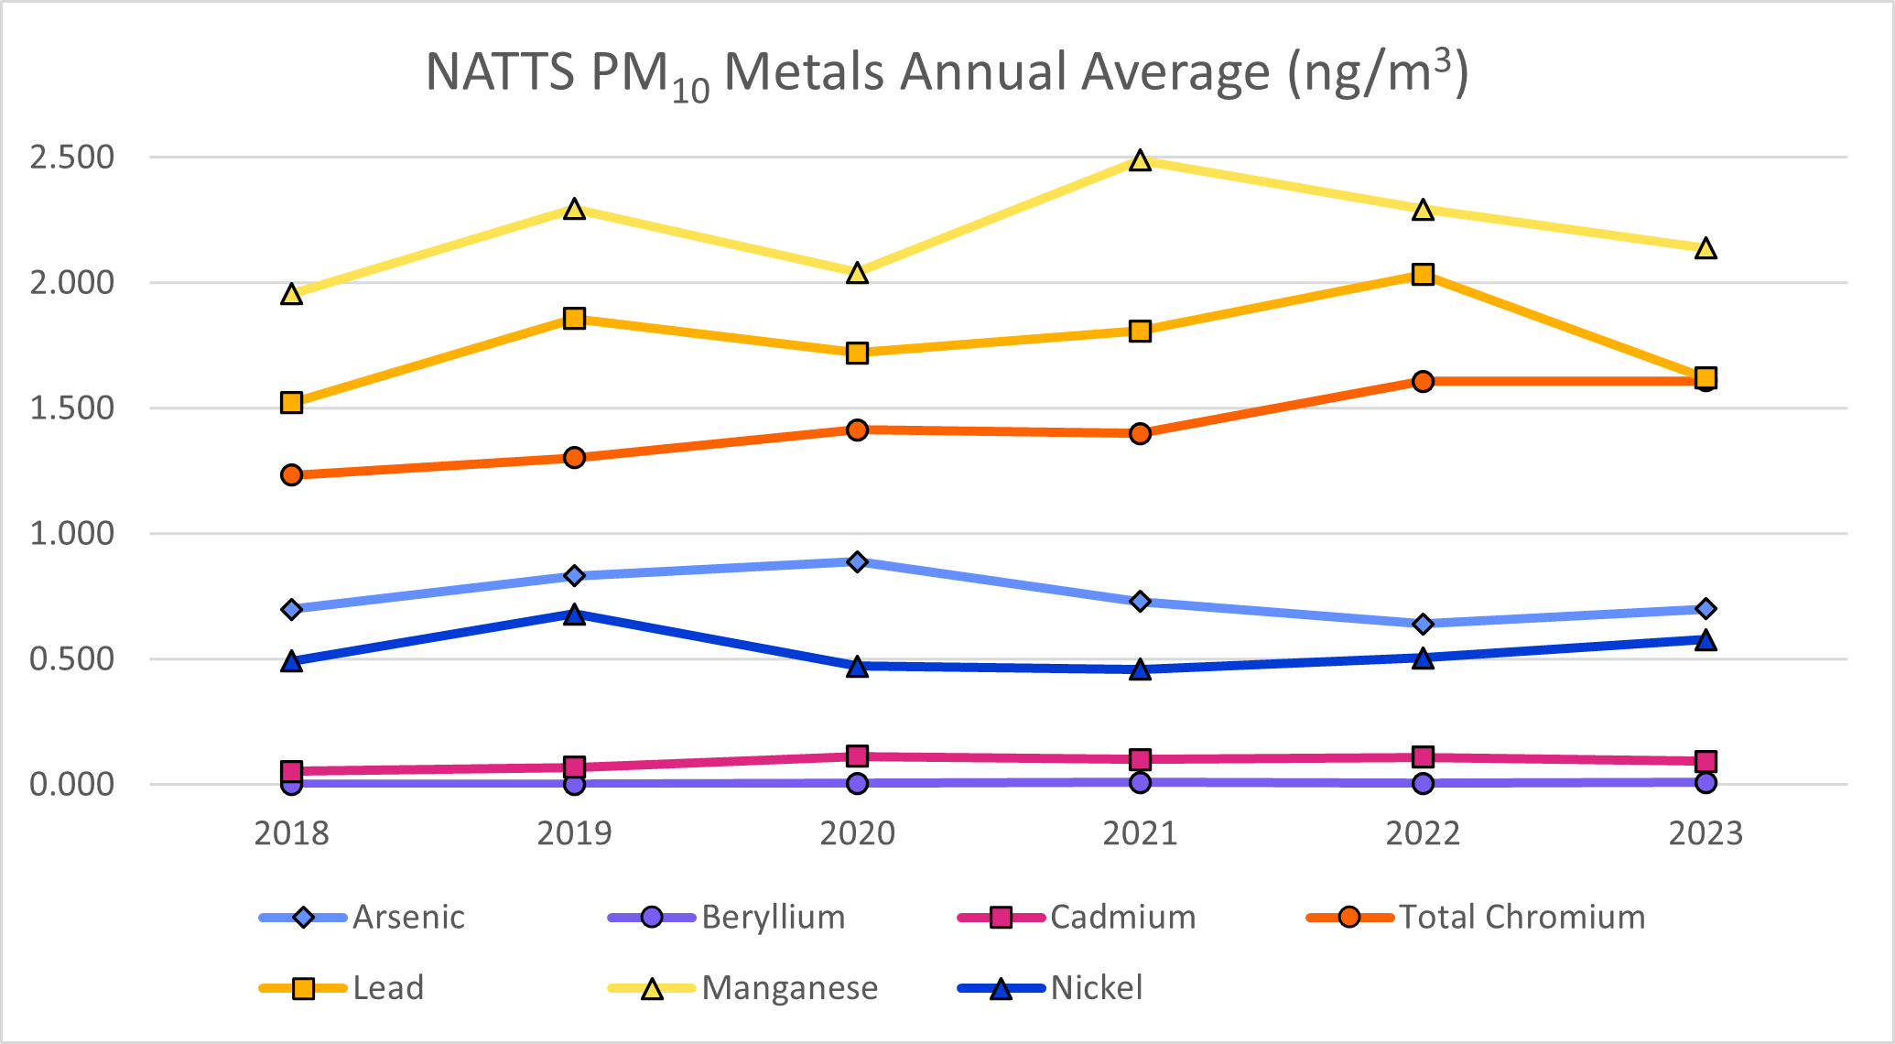

AQI (Air Quality Index)



What is the AQI?

The air quality index (AQI) is a measurement designed to indicate how clean the air is in an area, and it also provides information about health effects associated with air pollution. The index is reported daily, or in some cases continuously, and calculated from measured concentrations of five major pollutants regulated by the Clean Air Act: ground-level ozone, particulate matter, carbon monoxide, sulfur dioxide, and nitrogen dioxide. EPA has established national ambient air quality standards (NAAQS) for each of these pollutants to protect public health, and the index is derived from the NAAQS. State and local agencies are required to report the AQI in areas where the population is 350,000 or more, although it is often reported in additional areas as a public service.

How does the AQI work?

The AQI range is from 0 to 500, with the low numbers representing good air quality and the high numbers indicating unhealthy or even hazardous air quality. The index is divided into six categories with coordinating color codes. In addition, each category has a health-related message associated with it to inform the public of possible health effects that may arise as a result of breathing polluted air.

Generally, an index of 100 corresponds to the national air quality standard for the pollutant, which is the level that EPA has established to protect public health. Levels below 100 are considered satisfactory, while numbers above 100 are considered unhealthy, first for sensitive groups, and then for the general public as the index value increases.

How is the AQI calculated?

The AQI is calculated from air pollution measurements collected at monitoring sites across the country. The reporting agency must calculate an index for each pollutant from the measured concentrations at all monitoring sites in an area using a standard formula developed by EPA. The pollutant with the highest index is reported as the “primary pollutant”, and the highest index is reported as the AQI for the area. If the AQI is above 100, the agency must report which groups may be sensitive to the primary pollutant. If two or more pollutants have indexes above 100, the agency must report all groups that may be affected by those pollutants.

How do I find the AQI for my area?

DEQ reports the air quality index for Roanoke, Winchester, Richmond, Hampton Roads, and Northern Virginia on its Air Quality Index webpage. Air quality forecasts and current air quality data can be obtained at the DEQ site. The DEQ website also contains links to other air quality websites. EPA also reports air quality conditions for the United States at AirNow.

In addition to the internet, current and forecasted AQI levels are broadcast on local television and radio weather reports in many areas. AQI levels are also printed in some newspapers. By reaching out to the public using these different media, individuals can plan their activities to reduce exposure during episodes of poor air quality, and they can also take steps to reduce pollution.

For detailed information about the AQI, and on health effects of the pollutants that are included in the AQI, visit AirNow.

Air Quality Index  (0-500) | Levels of Health Concern | Meaning
(0-50) | Good | Air quality is considered satisfactory, and air pollution poses little or no risk.
(51-100) | Moderate | Air quality is acceptable; however, for some pollutants there may be a moderate health concern for a very small number of people who are unusually sensitive to air pollution.
(101-150) | Unhealthy for  Sensitive Groups | Members of sensitive groups may experience health effects. The general public is not likely to be affected.
(151-200) | Unhealthy | Everyone may begin to experience health effects; members of sensitive groups may experience more serious health effects.
(201-300) | Very Unhealthy | Health warnings of emergency conditions. The entire population is more likely to be affected.
(301-500) | Hazardous | Health alert: everyone may experience more serious health effects.

Note: Values above 500 are considered Beyond the AQI. Follow recommendations for the "Hazardous category." Additional information on reducing exposure to extremely high levels of particle pollution is available “here”.

OZONE
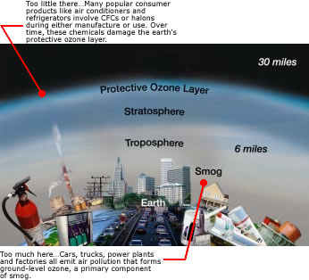

What is ozone?
Ozone is a gas that occurs both in the Earth's upper atmosphere and at ground level. Ozone can be "good" or "bad" for your health and the environment, depending on its location in the atmosphere.

How Can Ozone Be Both Good and Bad?
Ozone occurs in two layers of the atmosphere. The layer closest to the Earth's surface is the troposphere. Here, ground-level or "bad" ozone is an air pollutant that is harmful to breathe and it damages crops, trees and other vegetation. It is a main ingredient of urban smog. The troposphere generally extends to a level about 6 miles up, where it meets the second layer, the stratosphere. The stratosphere or "good" ozone layer extends upward from about 6 to 30 miles and protects life on Earth from the sun's harmful ultraviolet (UV) rays.

What is Happening to the "Good" Ozone Layer?
Ozone is produced naturally in the stratosphere. But this "good" ozone is gradually being destroyed by man-made chemicals referred to as ozone-depleting substances (ODS), including chlorofluorocarbons (CFCs), hydrochlorofluorocarbons (HCFCs), halons, methyl bromide, carbon tetrachloride, and methyl chloroform. These substances were formerly used and sometimes still are used in coolants, foaming agents, fire extinguishers, solvents, pesticides, and aerosol propellants. Once released into the air these ozone-depleting substances degrade very slowly. In fact, they can remain intact for years as they move through the troposphere until they reach the stratosphere. There they are broken down by the intensity of the sun's UV rays and release chlorine and bromine molecules, which destroy the "good" ozone. Scientists estimate that one chlorine atom can destroy 100,000 "good" ozone molecules.
Even though we have reduced or eliminated the use of many ODSs, their use in the past can still affect the protective ozone layer. Research indicates that depletion of the "good" ozone layer is being reduced worldwide. Thinning of the protective ozone layer can be observed using satellite measurements, particularly over the Polar Regions.

How Does the Depletion of "Good" Ozone Affect Human Health and the Environment?
Ozone depletion can cause increased amounts of UV radiation to reach the Earth which can lead to more cases of skin cancer, cataracts, and impaired immune systems. Overexposure to UV is believed to be contributing to the increase in melanoma, the most fatal of all skin cancers. Since 1990, the risk of developing melanoma has more than doubled.
UV can also damage sensitive crops, such as soybeans, and reduce crop yields. Some scientists suggest that marine phytoplankton, which are the base of the ocean food chain, are already under stress from UV radiation. This stress could have adverse consequences for human food supplies from the oceans.

What is Being Done About the Depletion of "Good" Ozone?
The United States, along with over 180 other countries, recognized the threats posed by ozone depletion and in 1987 adopted a treaty called the Montreal Protocol to phase out the production and use of ozone-depleting substances.
EPA has established regulations to phase out ozone-depleting chemicals in the United States. Warning labels must be placed on all products containing CFCs or similar substances and nonessential uses of ozone-depleting products are prohibited. Releases into the air of refrigerants used in car and home air conditioning units and appliances are also prohibited. Some substitutes to ozone-depleting products have been produced and others are being developed. If the United States and other countries stop producing ozone-depleting substances, natural ozone production should return the ozone layer to normal levels by about 2050.

What Causes "Bad" Ozone?
Ground-level or "bad" ozone is not emitted directly into the air but is created by chemical reactions between oxides of nitrogen (NO_{x}) and volatile organic compounds (VOC) in the presence of sunlight. Emissions from industrial facilities and electric utilities, motor vehicle exhaust, gasoline vapors, and chemical solvents are some of the major sources of NO_{x} and VOC.
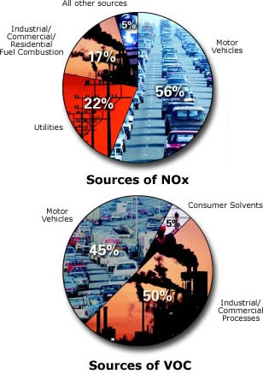
At ground level, ozone is a harmful pollutant. Ozone pollution is a concern during the summer months because strong sunlight and hot weather result in harmful ozone concentrations in the air we breathe. Many urban and suburban areas throughout the United States have high levels of "bad" ozone. But many rural areas of the country are also subject to high ozone levels as winds carry emissions hundreds of miles away from their original sources.

How Does "Bad" Ozone Affect Human Health and the Environment?
Breathing ozone can trigger a variety of health problems including chest pain, coughing, and throat irritation. It can worsen bronchitis, emphysema, and asthma. "Bad" ozone also can reduce lung function and inflame the linings of the lungs. Repeated exposure may permanently scar lung tissue.
Healthy people also experience difficulty breathing when exposed to ozone pollution. Because ozone forms in hot weather, anyone who spends time outdoors in the summer may be affected, particularly children, older people, outdoor workers and people exercising. Millions of Americans live in areas where the national ozone health standards are exceeded.
Ground-level or "bad" ozone also damages vegetation and ecosystems. It leads to reduced agricultural crop and commercial forest yields, reduced growth and survivability of tree seedlings, and increased susceptibility to diseases, pests and other stresses such as harsh weather. In the United States alone, ground-level ozone is responsible for an estimated $500 million in reduced crop production each year. Ground-level ozone also damages the foliage of trees and other plants, affecting the landscape of cities, national parks and forests, and recreation areas.

What Is Being Done About "Bad" Ozone?
Under the Clean Air Act, EPA has set protective health-based standards for ozone in the air we breathe. EPA, state, and cities have instituted a variety of multi-faceted programs to meet these health-based standards. Throughout the country, additional programs are being put into place to cut NO_{x} and VOC emissions from vehicles, industrial facilities, and electric utilities. Programs are also aimed at reducing pollution by reformulating fuels and consumer/commercial products, such as paints and chemical solvents, that contain VOC. Voluntary programs also encourage communities to adopt practices, such as carpooling, to reduce harmful emissions.
High-Altitude "Good" Ozone
- Protect yourself against sunburn. When the UV Index is "high" or "very high": Limit outdoor activities between 10 am and 4 pm, when the sun is most intense. Twenty minutes before going outside, liberally apply a broad-spectrum sunscreen with a Sun Protection Factor (SPF) of at least 15. Reapply every two hours or after swimming or sweating. For UV Index forecasts, check local media reports or visit: sun safety
- Use approved refrigerants in air conditioning and refrigeration equipment. Make sure technicians that work on your car or home air conditioners or refrigerator are certified to recover the refrigerant. Repair leaky air conditioning units before refilling them.

Ground-Level "Bad" Ozone
- Check the air quality forecast in your area. At times when the Air Quality Index (AQI) is forecast to be unhealthy, limit physical exertion outdoors. In many places, ozone peaks in mid-afternoon to early evening. Change the time of day of strenuous outdoor activity to avoid these hours or reduce the intensity of the activity. For AQI forecasts, check your local media reports or visit: http://epa.gov/airnow
- Help your local electric utilities reduce ozone air pollution by conserving energy at home and the office. Consider setting your thermostat a little higher in the summer. Participate in your local utilities' load-sharing and energy conservation programs.
- Reduce air pollution from cars, trucks, gas-powered lawn and garden equipment, boats and other engines by keeping equipment properly tuned and maintained. During the summer, fill your gas tank during the cooler evening hours and be careful not to spill gasoline. Reduce driving, carpool, use public transportation, walk, or bicycle to reduce ozone pollution, especially on hot summer days.
- Use household and garden chemicals wisely. Use low VOC paints and solvents. And be sure to read labels for proper use and disposal.

For more information, please visit these sites:
Airnow
Air Topics



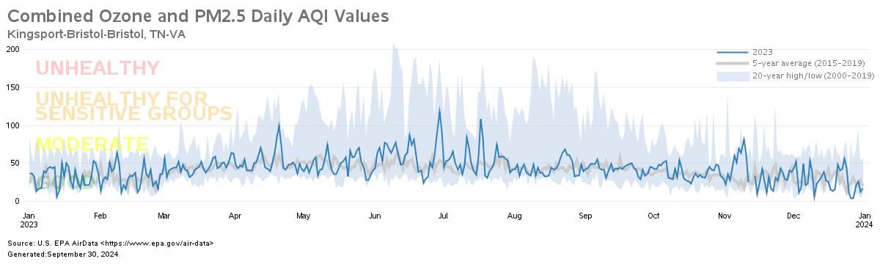

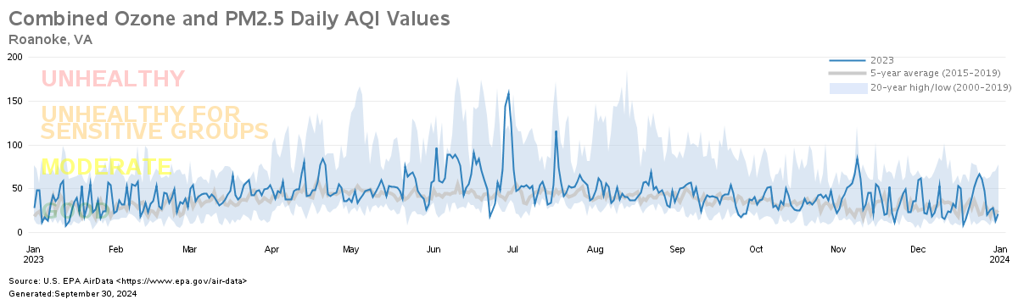

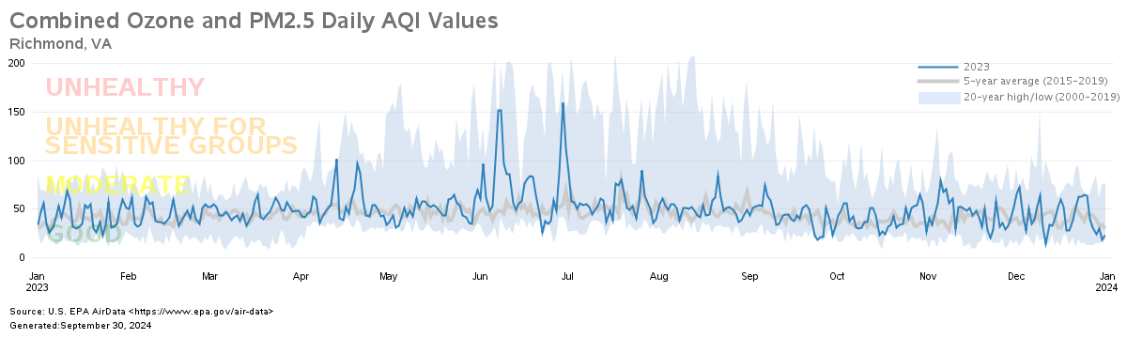

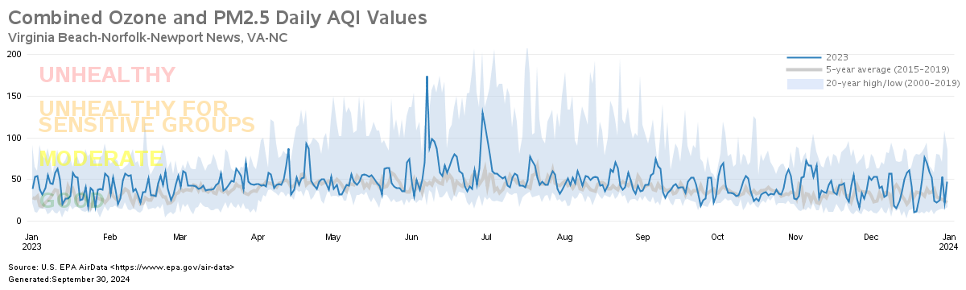

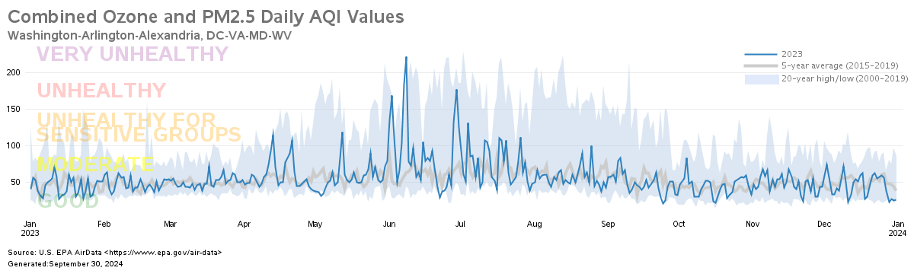

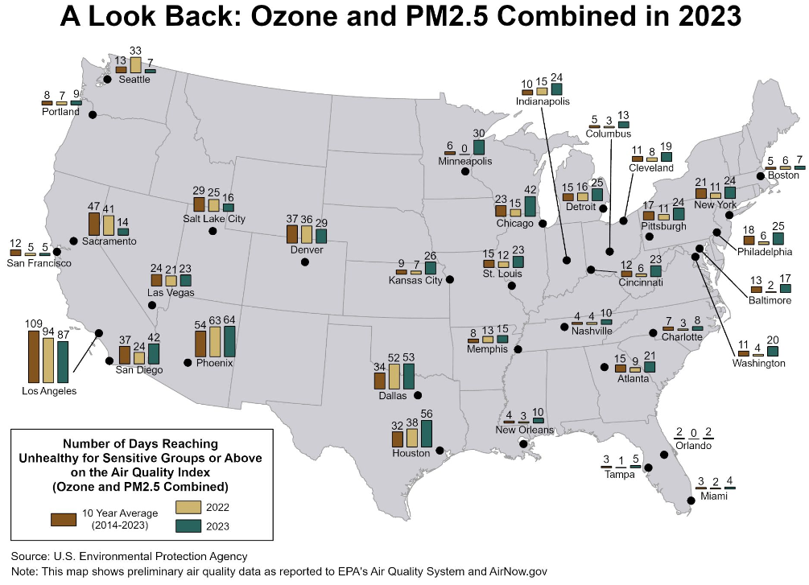
Fine particle pollution can be emitted directly from cars, trucks, buses, power plants and industries, along with wildfires and woodstoves. But it also forms from chemical reactions of other pollutants in the air. Particle pollution can be high at different times of year, depending on where you live. In some areas, for example, colder winters can lead to increased particle pollution emissions from woodstove use, and stagnant weather conditions with calm and light winds can trap PM_{2.5} pollution near emission sources. Federal and state rules are helping reduce fine particle pollution, including clean diesel rules for vehicles and fuels, and rules to reduce pollution from power plants, industries, locomotives, and marine vessels, among others.

A number of factors influence ozone formation, including emissions from cars, trucks, buses, power plants, and industries, along with weather conditions. Weather is especially favorable for ozone formation when it’s hot, dry and sunny, and winds are calm and light. Federal and state regulations, including regulations for power plants, vehicles and fuels, are helping reduce ozone pollution nationwide.
This graphic shows the total number of unhealthy days (nationally) for ozone and fine particle pollution since the year 2000.

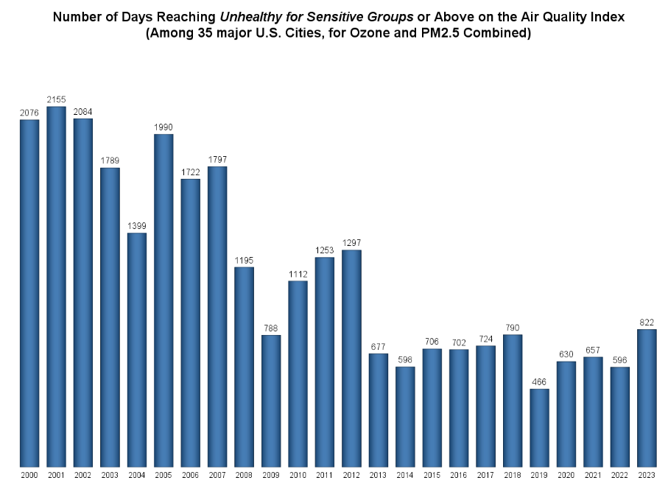

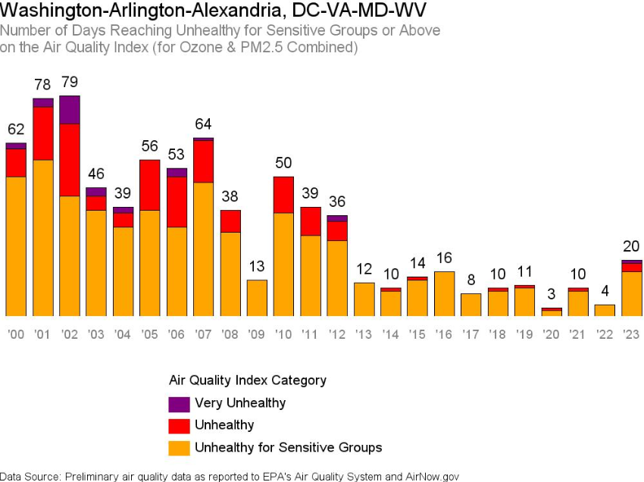

For more information, please visit these EPA sites:

A Look Back in 2023
Our Nations Air – Trends Through 2023
National Air Quality: Status and Trends of Key Air Pollutants

Appendix A

Abbreviation Table

AMoN Ammonia Monitoring Network
AQM Air Quality Monitoring
AQCR Air Quality Control Region
ATMN Air Toxics Monitoring Network
Avg. Average
CAMP Community Air Toxics Assessment Monitoring Program
CASTNET Clean Air Status and Trends Network
CO Carbon Monoxide
DEQ Department of Environmental Quality
FEM Federal Equivalent Method
EPA Environmental Protection Agency
FRM Federal Reference Method
IMPROVE Interagency Monitoring of Protected Visual Environments
LAT Latitude
LC Local Conditions
LONG Longitude
MARAMA Mid-Atlantic Regional Air Management Association
MDL Minimum Detectable Limit
MDN Mercury Deposition Network
MET. Meteorological Instrumentation
MSA Metropolitan Statistical Area
NA Not Available
NADP National Acid Deposition Program
NAMS National Air Monitoring Stations
NATTS National Air Toxics Trend Stations
NMOC Non-Methane Organic Compounds
NO₂ Nitrogen Dioxide
NUM Number of Samples
O₃ Ozone
PAMHC Total PAMS Hydrocarbon
PAMS Photochemical Assessment Monitoring Station
PM₁₀ Particulate Matter with an aerodynamic diameter less than or equal to 10 microns
PM_{2.5} Particulate Matter with an aerodynamic diameter less than or
equal to 2.5 microns
POLLUT. Pollutant
ppbC Part Per Billion of Carbon
ppbv Part Per Billion by volume
ppm Part Per Million
SESARM Southeastern States Air Resource Managers, Inc.
SLAMS State and Local Air Monitoring Station
SO₂ Sulfur Dioxide
STD Standard
STDEV Standard Deviation
TEOM Tapered Element Oscillating Microbalance (a method for
continuously measuring PM_{2.5} in ambient air)
TNMOC Total Nonmethane Organic Compound
UATM Urban Air Toxics Monitoring Program
µg/m³ Micrograms per cubic meter
VOC Volatile Organic Compounds

Southwest Monitoring Network
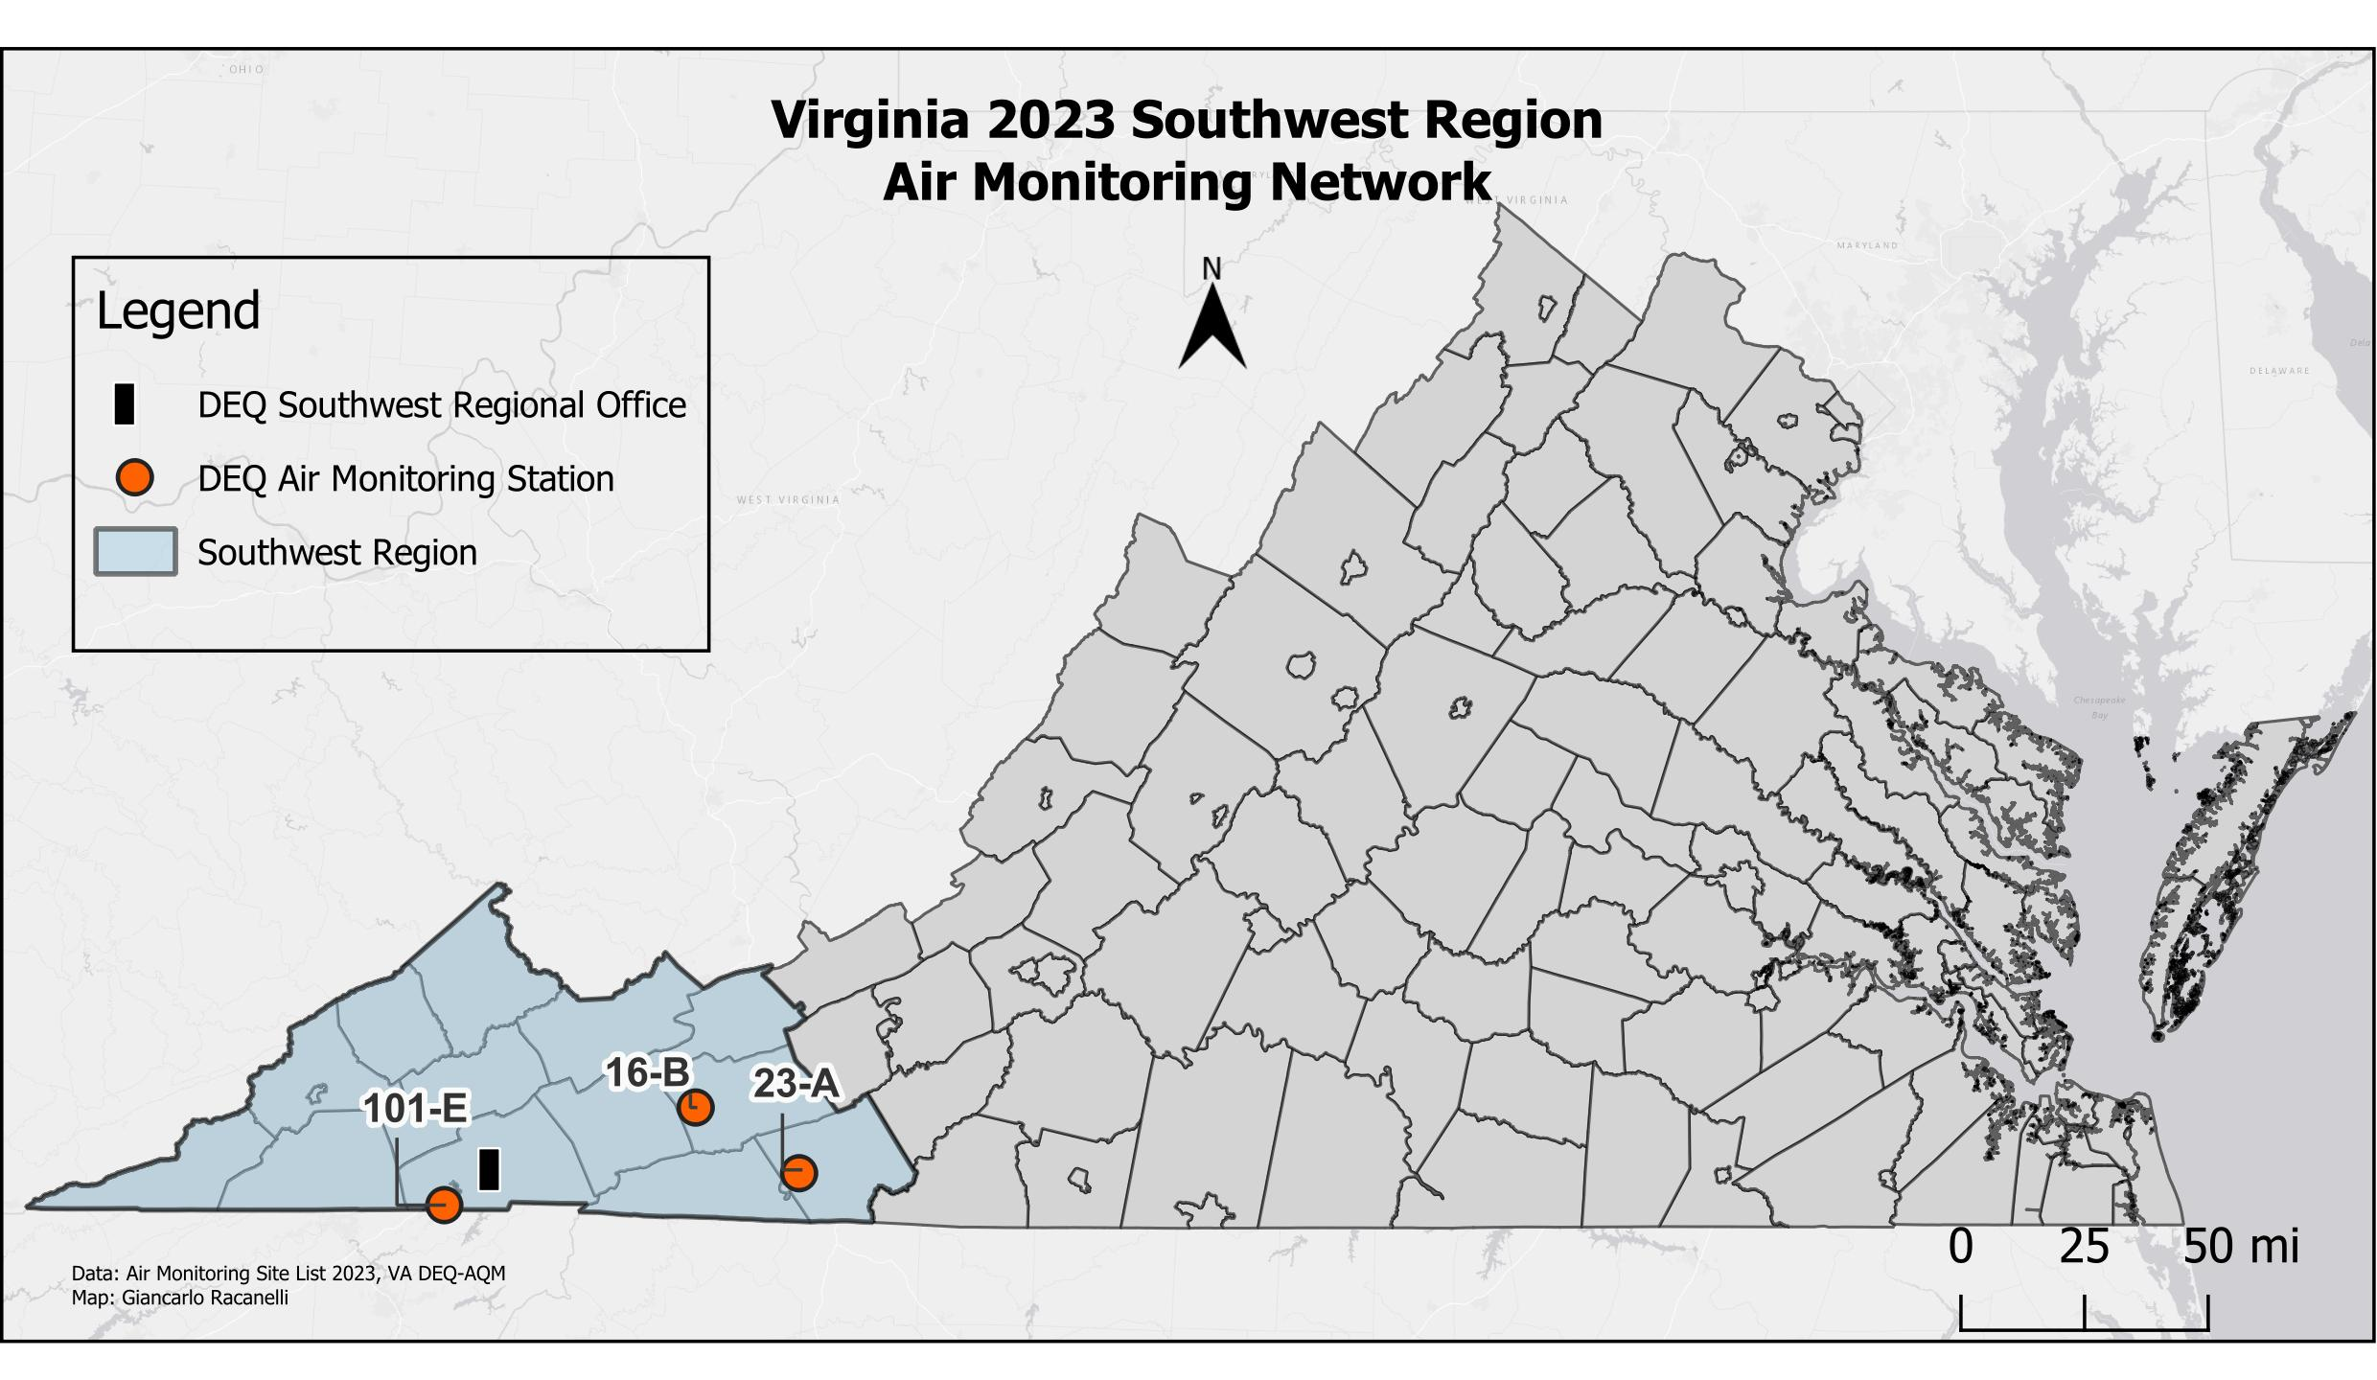

STATION  NUMBER | POLLUT. | LOCATION | EPA ID | CITY/COUNTY | LAT/LONG
16-B | O₃ | Sewage Disposal Plant | 51-197-0002 | Rural Retreat  Wythe Co. | 36.89117  -81.25423
23-A | PM₁₀ | Gladeville Elementary School | 51-035-0001 | Galax  Carroll Co. | 36.70067  -80.87978
101-E | PM_{2.5} | Highland View Elementary School | 51-520-0006 | Bristol | 36.60800  -82.16410

Contact Information for this Region:
Southwest Regional Office
Jeffery Hurst, Director
355-A Deadmore Street
Abingdon, VA 24210
(276) 676-4800

Valley Monitoring Network
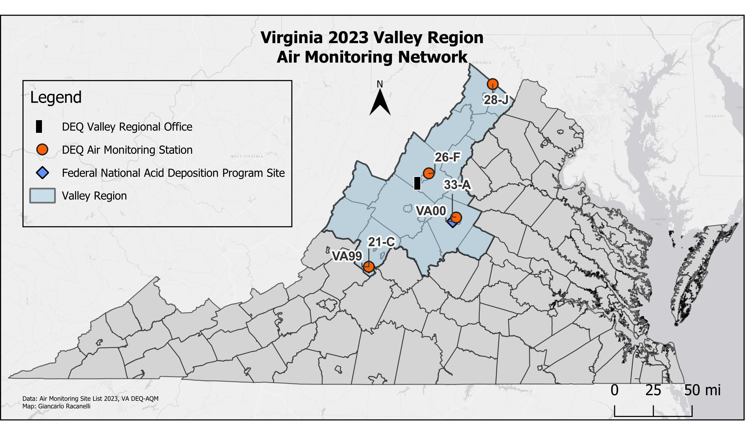
STATION  NUMBER | POLLUT. | LOCATION | EPA ID | CITY/COUNTY | LAT/LONG
21-C | O₃, IMPROVE | Natural Bridge Ranger Station | 51-163-0003 | Rockbridge Co. | 37.62668  -79.51257
26-F | PM_{2.5}, SO₂, NO₂, O₃ | Rockingham VDOT | 51-165-0003 | Harrisonburg  Rockingham Co. | 38.47753  -78.81952
28-J | O₃, PM_{2.5}, PM_{2.5} cont., PM₁₀ cont. | Woodbine Road  Lester Building Systems | 51-069-0010 | Rest  Frederick Co. | 39.28102  -78.08157
33-A | O₃, PM_{2.5}, PM_{2.5} cont. | Albemarle High School | 51-003-0001 | Albemarle Co. | 38.07657  -78.50397

STATION  NUMBER | POLLUT. | LOCATION | EPA ID | CITY/COUNTY | LAT/LONG
VA00 | NADP | Charlottesville | NA | Albemarle | 38.0402  -78.5427
VA99 | NADP | Natural Bridge Ranger Station | 51-163-0003 | Rockbridge Co. | 37.62668  -79.51257

Contact information for this Region:
Valley Regional Office
Brandon Kiracofe, Director
P.O. Box 3000
4411 Early Road
Harrisonburg, VA 22801
(540) 574-7800

Blue Ridge Monitoring Network
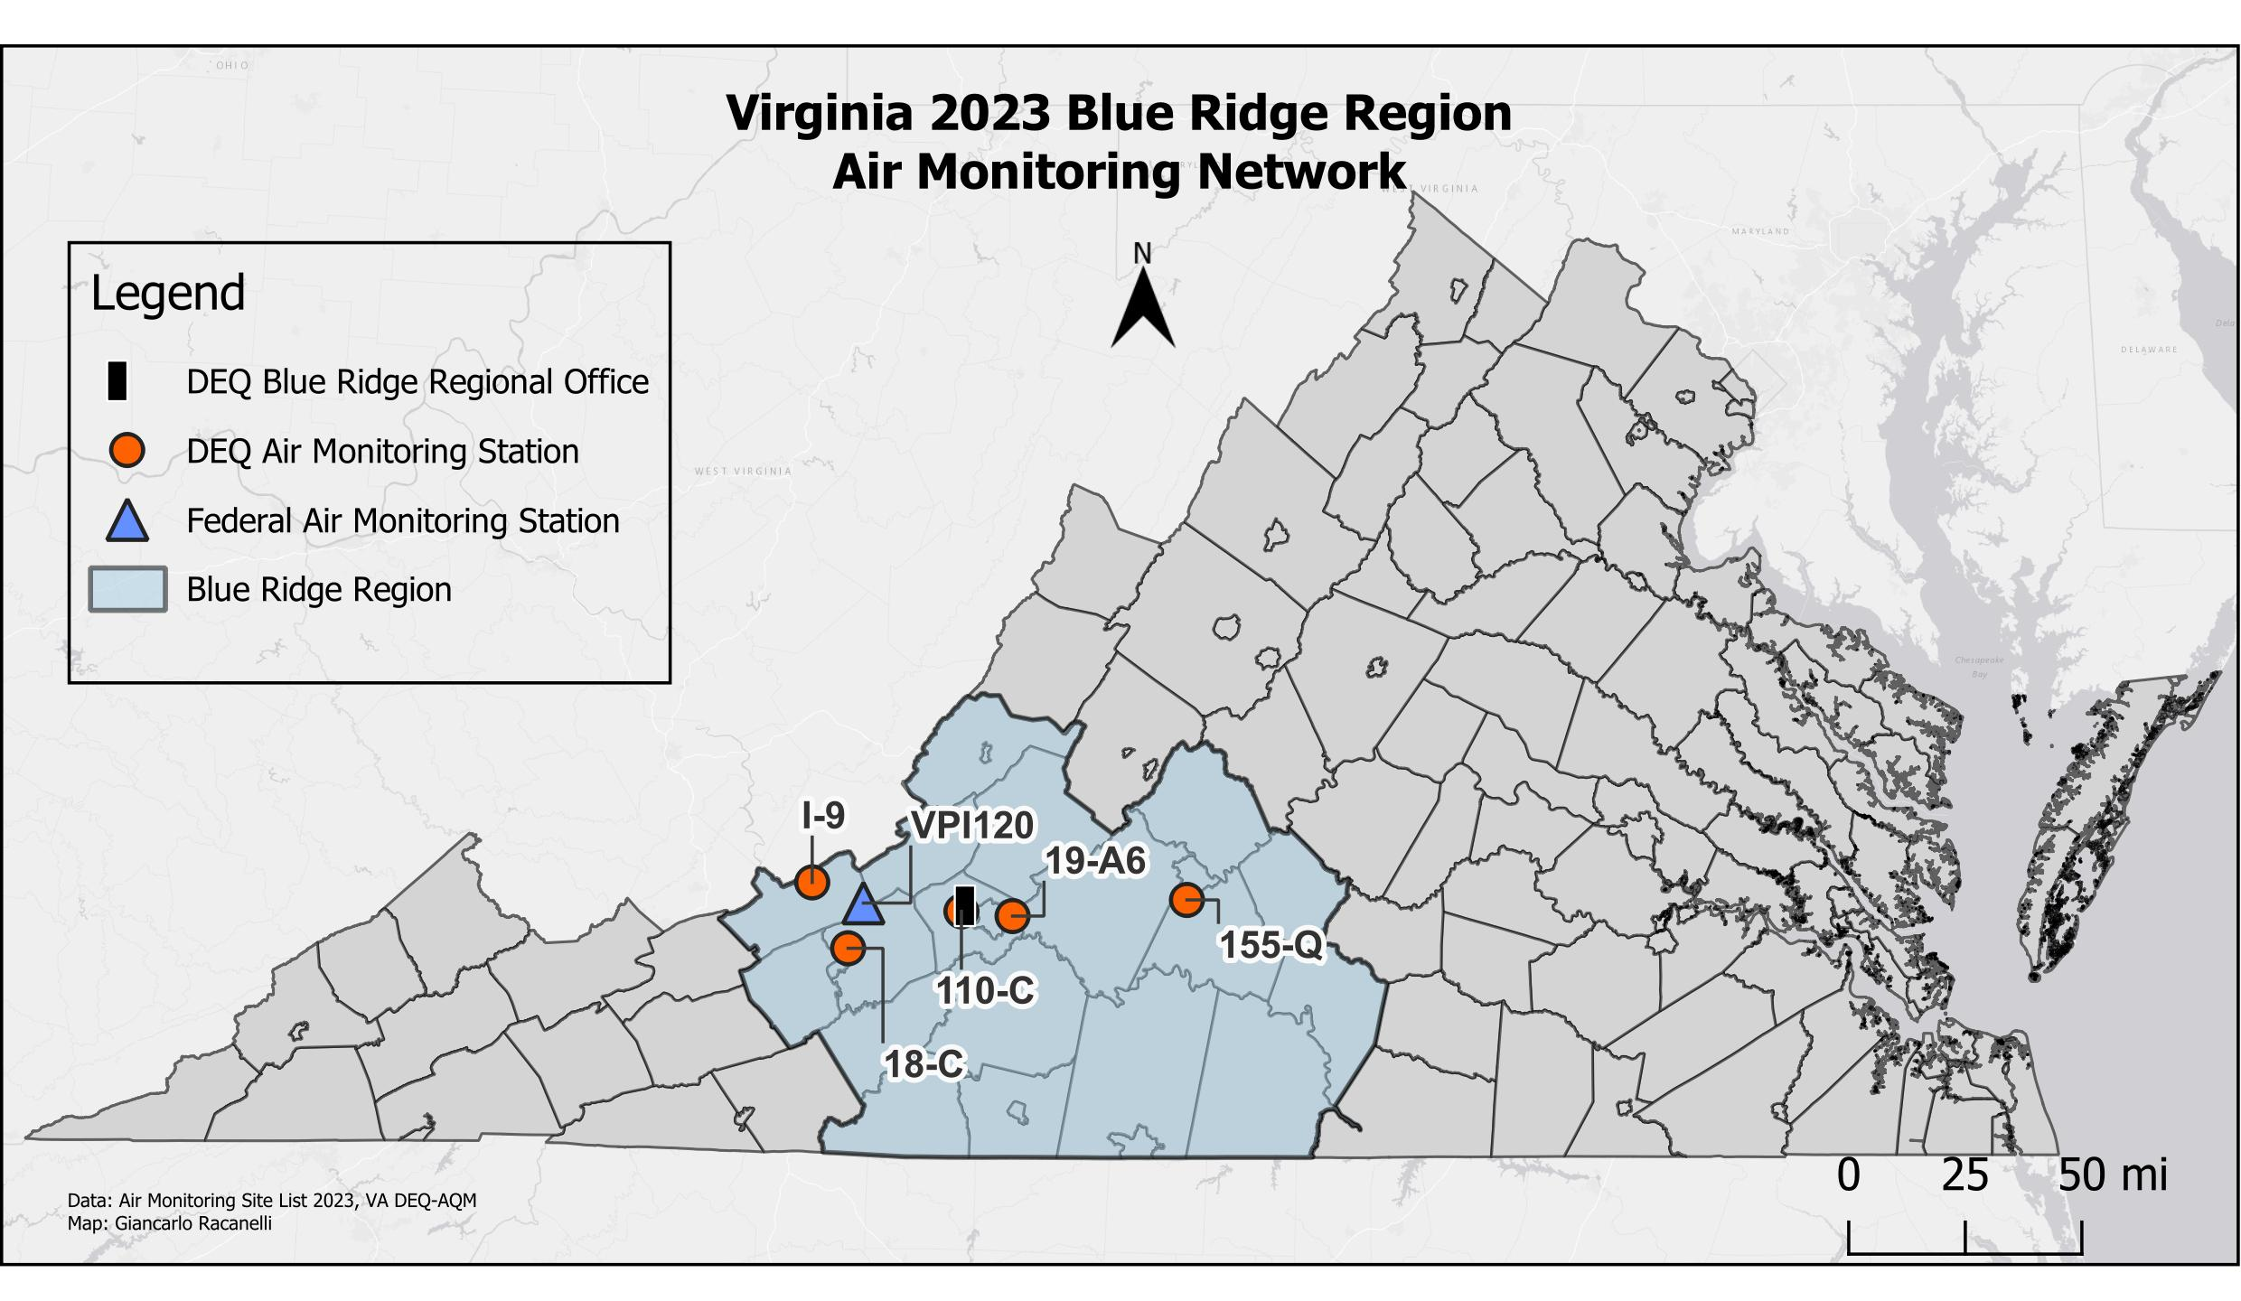

STATION  NUMBER | POLLUT. | LOCATION | EPA ID | CITY/COUNTY | LAT/LONG
18-C | Lead | Stroubles Creek Wastewater Treatment Plant | 51-121-0009 | Montgomery Co. | 37.18494  -80.51606
19-A6 | CO,SO₂, NO₂, O_{3,} PM_{2.5} | East Vinton Elementary School  Ruddell Rd. | 51-161-1004 | Vinton  Roanoke Co. | 37.28342  -79.88452
110-C | PM_{2.5} | Salem High School | 51-775-0011 | Salem | 37.29788  -80.08102
155-Q | PM_{2.5} | Leesville Hwy. & Greystone Dr. | 51-680-0015 | Lynchburg | 37.33175  -79.21478

STATION  NUMBER | POLLUT. | LOCATION | EPA ID | CITY/COUNTY | LAT/LONG
9-I | SO₂ | Giles County | 51-071-0007 | Giles County | 37.3863  -80.6539
VPI120 /  VA13 | O₃, MDN | Blue Grass Trail | 51-071-9992 | Giles County | 37.3232  -80.4572

Contact information for this Region:
Blue Ridge Regional Office
Robert Weld, Director
901 Russell Drive
Salem, VA 24153
(540) 562-6700

Piedmont Monitoring Network
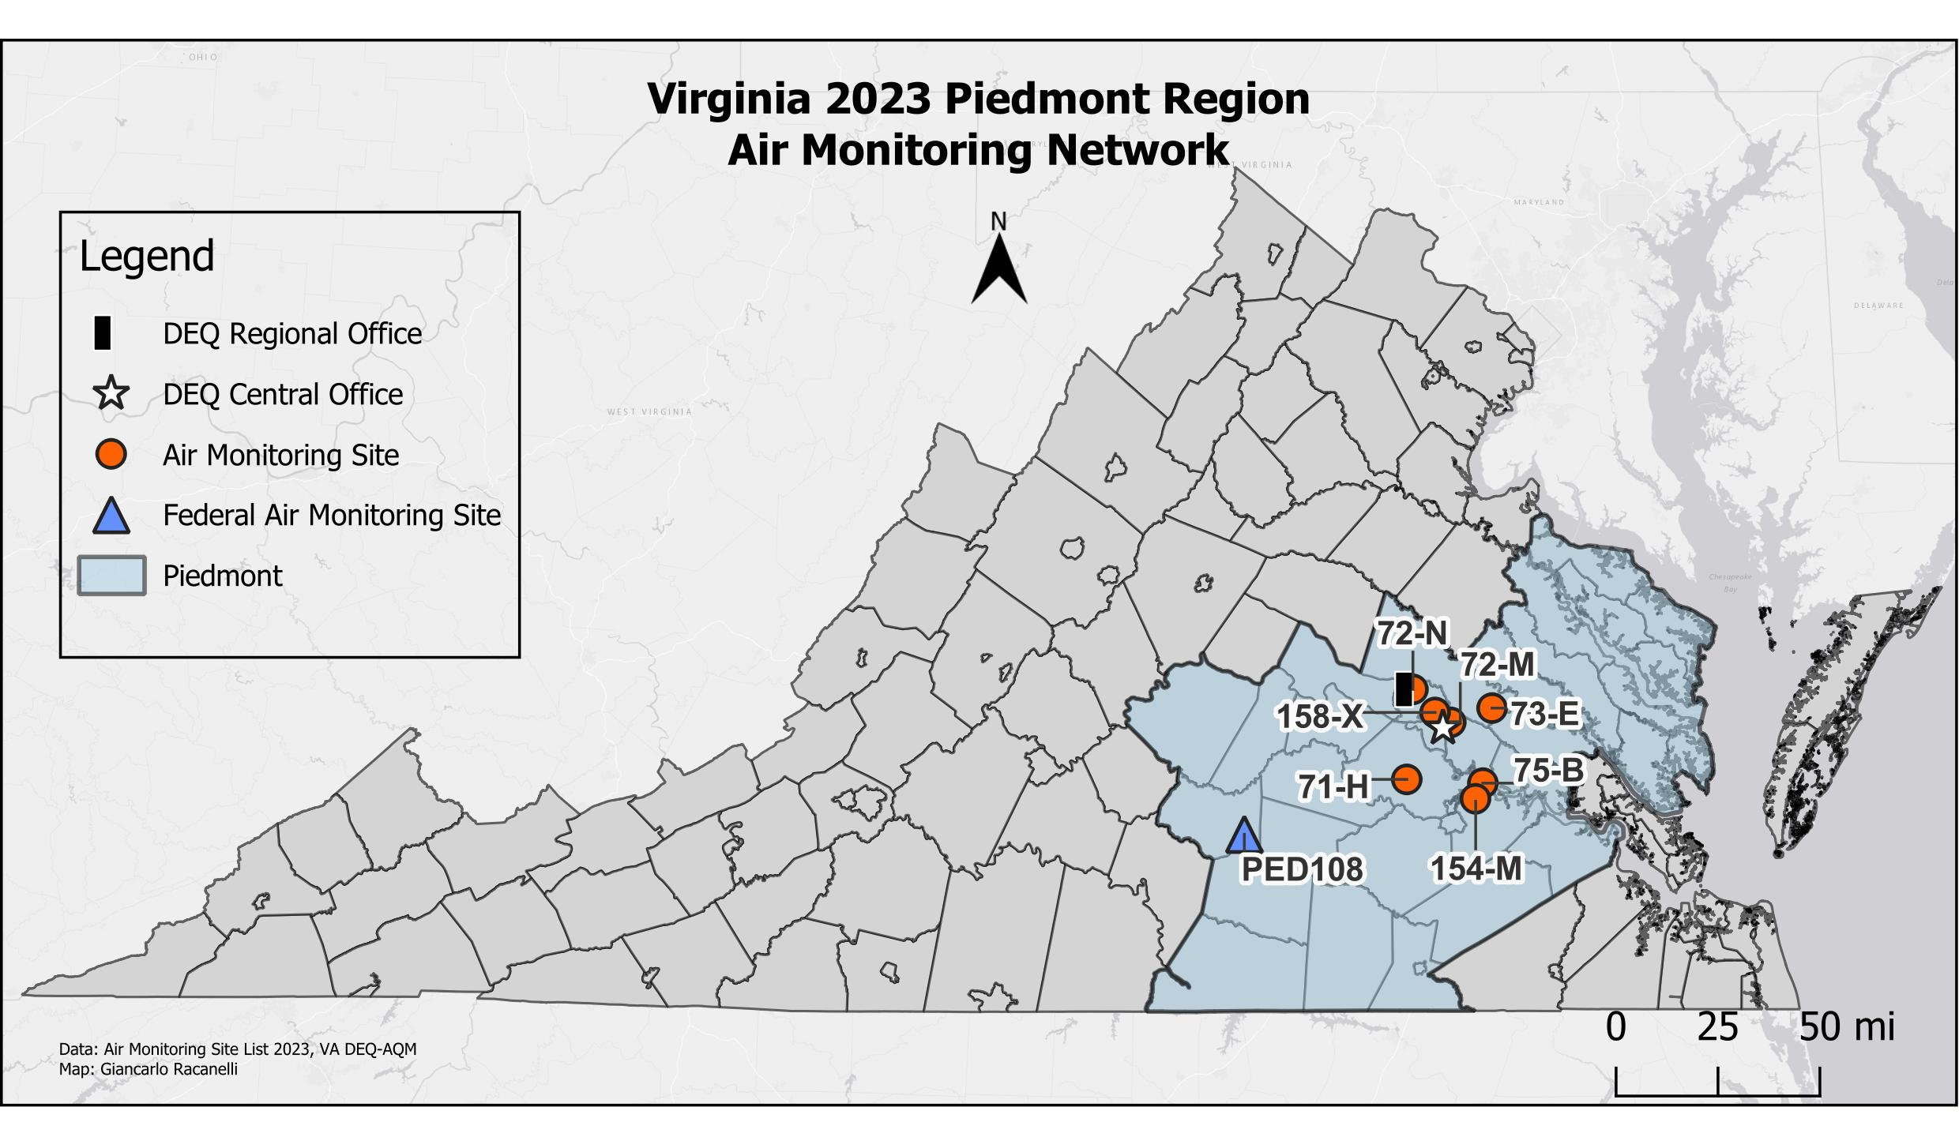

STATION  NUMBER | POLLUT. | LOCATION | EPA ID | CITY/COUNTY | LAT/LONG
71-H | O₃ | Beach Rd.  Highway Shop | 51-041-0004 | Chesterfield Co. | 37.35748  -77.59355
72-M | O₃, VOC, PM_{2.5}, PM₁₀ cont., PM_{2.5} cont., Speciation, Toxics, Met, NCore, NATTS, PAMS | Henrico Police Athletic League  2401 Hartman St. | 51-087-0014 | Henrico Co. | 37.55652  -77.40027
72-N | PM_{2.5} | DEQ-Piedmont Regional Office  4949-A Cox Rd. | 51-087-0015 | Henrico Co. | 37.67132  -77.56640
73-E | O₃ | McClellan Rd. | 51-085-0003 | Hanover Co. | 37.60613  -77.21880
75-B | O₃, NO₂, SO₂, PM_{2.5} | Charles City County  Route 608 | 51-036-0002 | Charles City Co. | 37.34438  -77.25925
154-M | PM₁₀, Toxics | Carter G. Woodson Middle School  1000 Winston Churchill Dr. | 51-670-0010 | Hopewell | 37.28962  -77.29182
158-X | CO, NO2, PM_{2.5} cont. | Joseph Bryan Park | 51-760-0025 | Richmond | 37.59088  -77.46925

STATION  NUMBER | POLLUT. | LOCATION | EPA ID | CITY/COUNTY | LAT/LONG
PED108/ VA24 | O₃, AMoN, NADP | Burkeville | 51-147-9991 | Prince Edward | 37.1655  -78.3069

Contact Information for this Region:
Piedmont Regional Office
Jerome Brooks, Director
4949-A Cox Road
Glen Allen, VA 23060
(804) 527-5020
Tidewater Monitoring Network

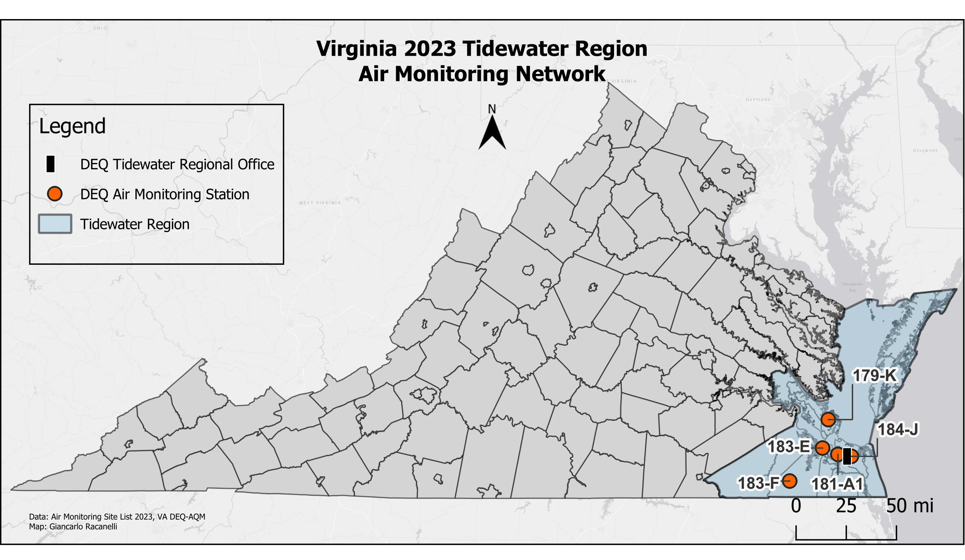
STATION  NUMBER | POLLUT. | LOCATION | EPA ID | CITY/COUNTY | LAT/LONG
179-K | CO, SO₂, NO₂, O₃, PM_{2.5}, PM_{2.5} cont., PM₁₀ cont. | NASA Langley Research Center | 51-650-0008 | Hampton | 37.10373  -76.38702
181-A1 | CO, SO₂, NO₂, PM₁₀, PM_{2.5} | 2nd St. and Woodis Ave. | 51-710-0024 | Norfolk | 36.85555  -76.30135
183-E | O₃ | Tidewater Community College  Frederick Campus | 51-800-0004 | Suffolk | 36.90118  -76.43808
183-F | O₃ | Tidewater Research Station | 51-800-0005 | Suffolk | 36.66525  -76.73078
184-J | PM_{2.5,} PM₁₀ cont. | DEQ – Tidewater Regional Office  5636 Southern Blvd. | 51-810-0008 | Va. Beach | 36.84188  -76.18123

Contact information for this Region:
Craig Nicol, Director
5636 Southern Blvd.
Virginia Beach, VA 23462
(757) 518-2000
Northern Monitoring Network
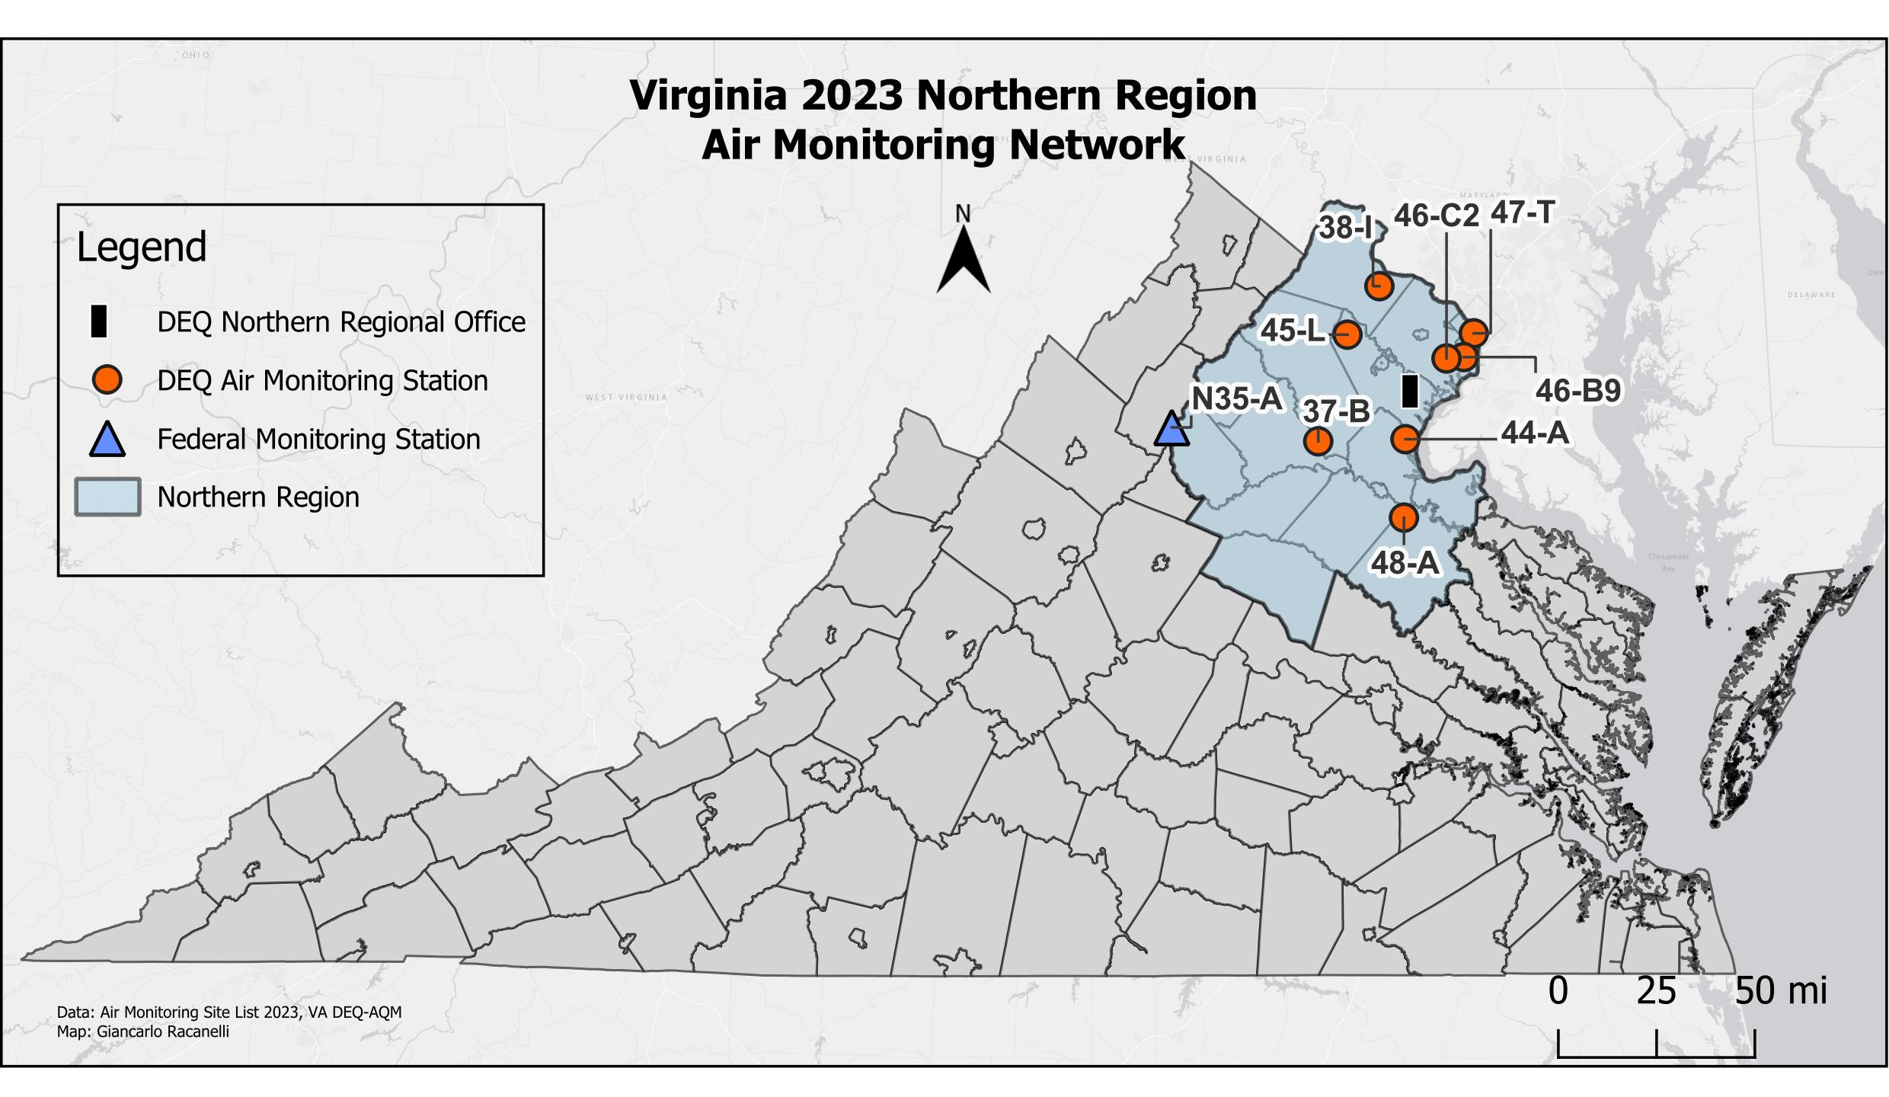
STATION  NUMBER | POLLUT. | LOCATION | EPA ID | CITY/COUNTY | LAT/LONG
37-B | O₃ | Phelps Wildlife Area  Route 651 | 51-061-0002 | Sumerduck  Fauquier Co. | 38.47367  -77.76772
38-I | O₃, NO₂, PM_{2.5} | Broad Run High School  Route 641 | 51-107-1005 | Ashburn  Loudoun Co. | 39.02473  -77.48925
44-A | O_{3,} PM₁₀ | Widewater Elementary School  Den Rich Rd. | 51-179-0001 | Widewater  Stafford Co. | 38.48123  -77.37040
45-L | O₃, NO₂ | Long Park, Route 15 | 51-153-0009 | Prince William Co. | 38.85287  -77.63462
46-B9 | SO₂, O₃, PM_{2.5}, PM₁₀ cont. | Franconia Park  Telegraph Rd. | 51-059-0030 | Franconia  Fairfax Co. | 38.77335  -77.10468
46-C2 | CO, NO₂, PM_{2.5} cont. | 6831 Backlick Rd. | 51-059-0031 | Springfield  Fairfax Co. | 38.76835  -77.18347
47-T | CO, NO₂, O₃, PM_{2.5} | Aurora Hills Visitors Center  18th and Hayes St. | 51-013-0020 | Arlington Co. | 38.85770  -77.05922
48-A | O₃ | U.S.G.S. Geomagnetic Center | 51-033-0001 | Corbin  Caroline Co. | 38.20087  -77.37742

STATION  NUMBER | POLLUT. | LOCATION | EPA ID | CITY/COUNTY | LAT/LONG
N35-A / VA28 | O3,TEOM, IMPROVE, MDN | Big Meadows, National Park Service | 51-113-0003 | Madison Co. | 38.52280  -78.43487

Contact Information for this Region:
Northern Regional Office
Richard Doucette, Director
13901 Crown Court
Woodbridge, VA 22193
(703) 583-3800

Data Capture Criteria

Calculated Value |  | Minimum Number of Observations
3-Hour Average | 3 Consecutive Hourly Observations
8-Hour Average | 6 Hourly Observations
24-Hour Average | 18 Hourly Observations
Quarterly Averages & 3-month Averages | 75% of Scheduled Samples
Yearly Averages | 75% of Total Possible Observations
Annual Weighted Means | Four Complete Quarterly Averages

Number of Criteria Pollutant Monitoring Sites

NCore/SLAMS 2023

REGION | PM_{2.5} | PM₁₀ | Pb | CO | SO₂ | NO₂ | O₃ | TOTAL
Southwest | 1 | 1 | --- | --- | --- | --- | 1 | 3
Valley | 3 | 1 | --- | --- | 1 | 1 | 4 | 10
Blue Ridge | 3 | --- | 1 | 1 | 1 | 1 | 1 | 8
Piedmont | 5 | 2 | --- | 2 | 2 | 3 | 4 | 18
Tidewater | 3 | 3 | --- | 2 | 2 | 2 | 3 | 15
Northern | 4 | 2 | --- | 2 | 1 | 4 | 7 | 20
TOTAL | 19 | 9 | 1 | 7 | 7 | 11 | 20 | 74

Appendix B

Air Quality Internet Links

AirData – Access to national and state air pollution data
Outdoor Air Quality Data

Air Emission Data Sources
Emissions Sources

Air Now – AQI maps
Real Time AQI

American Lung Association:
USA Lung

AQS Data Mart (AQS data for the scientific and technical community):
Data Mart

CASTNET (Clean Air Status and Trends Network)
Castnet

Department of Environmental Quality link:
Virginia DEQ

Environmental Education for teachers and students:
Resources for teachers
DEQ Education webpage

EPA Popular Resources
Environmental Topics

EPA’s Technology Transfer Network (TTN) – Ambient Monitoring Technology Information Center (AMTIC)

IMPROVE
Interagency Monitoring of Protected Visual Environments

MARAMA
Mid-Atlantic Regional Air Management Association

Nonattainment area descriptions:
EPA's Green Book

U.S. EPA:
EPA
EPA Region 3 (Mid-Atlantic)

3-Day Monitoring Schedule for PM_{2.5}, PM₁₀, TSP and VOCs
Sampling Schedule Calendar

National Air Quality: Status and Trends of Key Air Pollutants
Air Trends

References

Air Quality System (AQS)
EPA's AQS

Code of Federal Regulations – 40 CFR 50 & 58
Electronic Code of Federal Regulations

Guide to Understanding Particulate Matter (PM)
Kaiterra

National Ambient Air Quality Standards
EPA NAAQS

Virginia Ambient Air Monitoring Data Reports
DEQ's Air Monitoring Publications

