| DEQ logo |
| --- |
| **Virginia Annual Recycling Summary Report** |
| **Calendar Year 2023** |
| A map of Virginia |
| **October 2024** |

Table of Contents

**Virginia’s State Recycling Summary Report for Calendar Year 2023**

**Executive Summary** 2

**Introduction** 2

**Mandated Recycling Rates** 3

**Solid Waste Management Planning and Recycling Action Plans** 3

**State Recycling Rate Calculation for CY2023** 4

**Calculated Recycling Rates for CY2023** 5

**Solid Waste Planning Units Not Reporting for CY2023** 9

**Recycling Related Report Information** 10

**Virginia State Recycling Summary Report for Calendar Year 2023**

## **Executive Summary**

Virginia’s calendar year 2023 (CY2023) Annual Recycling Rate as reported by Virginia Solid Waste Planning Units (SWPUs) with populations above 100,0001 was calculated at 42.5%. This calculation included credits for solid waste reused, non-municipal solid waste (MSW) recycled, recycling residues, and source reduction programs. This rate was based on the data submitted by the 19 SWPUs required to report for 2023.

Based on information provided by the localities, the CY2023 recycling rate slightly decreased due to continuing recycling challenges, lack of recycling markets in some regions, and SWPUs reporting difficulty in obtaining recycling information from private businesses.

## **Introduction**

The Virginia Department of Environmental Quality (DEQ) completed its review of the recycling rate data reported for calendar year 2023. DEQ reviewed 42 submitted reports. Of the 42 reports, 23 were submitted by SWPUs not required to report during the 2023 reporting cycle.

Virginia’s annual recycling rate for 2023, as shown on the graph below, is based only on data from the reports required to be submitted by the 19 SWPUs with populations above 100,000. This data represents recycling information from 126 Virginia cities, counties, and towns.[1]

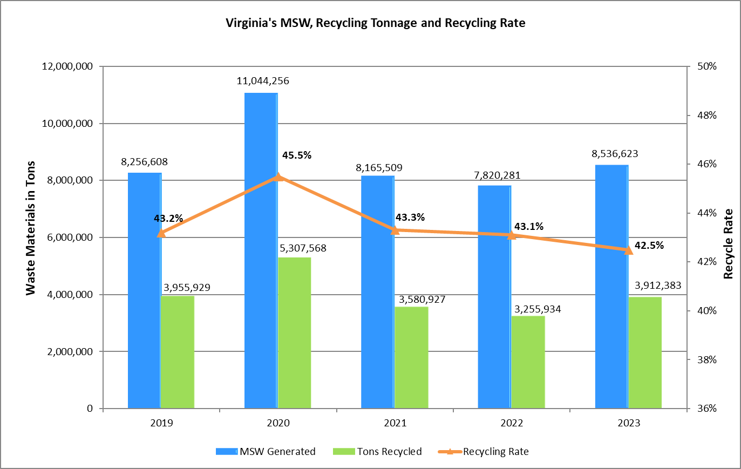

Based on these reports, the calculated state recycling rate is 42.5%, a slight decrease from the CY2022 report. The 19 SWPUs reported recycling 2,772,058 tons of principal recyclable materials (PRMs), 1,140,325 tons of credits (includes recycling residue, reused solid waste, and non-MSW recycled) and disposal of 4,624,240 tons of MSW.

## **Mandated Recycling Rates**

Pursuant to Virginia Code §10.1-1411.D, each SWPU is required to achieve and maintain a minimum 25 percent annual recycling rate *unless*:

* Its population density is less than 100 persons per square mile, *or*
* Its civilian unemployment rate is 50 percent or more above the state unemployment average.

SWPUs that meet the criteria above are required to achieve and maintain a minimum 15 percent recycling rate. All 19 SWPUs required to report, met or exceeded their mandated recycling rate.

## **Solid Waste Management Planning and Recycling Action Plans**

The Virginia Department of Environmental Quality (DEQ) continues to review the required solid waste management plans and any updates submitted by the SWPUs for completeness, including locality or regional recycling program information. All SWPUs are required to maintain or exceed the mandated recycling rate for their jurisdiction(s). If at any time the SWPU reports less than the required 15 or 25 percent recycling rate, DEQ will require that a Recycling Action Plan be developed and submitted as an amendment to the SWPU’s solid waste management plan. Visit [DEQ’s recycling webpage](https://www.deq.virginia.gov/our-programs/land-waste/recycling) for additional information.

## **State Recycling Rate Calculation for CY2023**

19 recycling rate reports, representing 126 Virginia localities, were received pursuant to the requirements of §10.1-1411 of the Code of Virginia. The chart below represents data only from the 19 SWPUs required to report for CY 2023. This represents a return rate of 100 percent of the required reports. Totals for these reports are presented below:

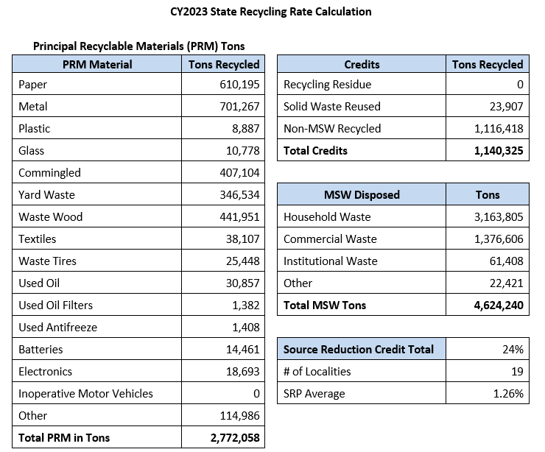

**State Final Recycling Rate Calculation:**

The recycling rate is calculated using the following formula:

$$\left( \frac{\text{PRM} \text{+} \text{Credits}}{\text{PRM} \text{+} \text{Credits} \text{+} \text{MSW Disposed}} \right) \text{x 100 + Source Reduction Credit = Final Recycle Rate}$$

Using the PRMs, credits and MSW disposed tonnage totals above, the state recycling rate is calculated as:

$$\left( \frac{\text{2,772,058 + 1,140,325}}{\text{2,772,058 + 1,140,325 + 4,624,240}} \right) \text{x } \text{100} \text{+} \text{1.26\% = }\text{42.5\%}\text{*}$$

**\***The final state recycling rate has been adjusted so that the aggregate of all credits does not exceed five percentage points of the base recycling rate.

## **Calculated Recycling Rates for CY2023**

|  |  |  |  |
| --- | --- | --- | --- |
| **REPORTING ENTITY  (19 Solid Waste Planning Units required to report annually)** | **2023 Recycling Rate** | **2023 Total Recycled Tons (PRMs + Credits)** | **2023 Total MSW Generation Tons (PRMs + Credits + MSW disposed)** |
| **Alexandria (City) SWPU** (City of Alexandria) | 53.3% | 104,773 | 179,688 |
| **Arlington County SWPU** (Arlington County) | 53.3% | 148,978 | 286,501 |
| **Augusta-Staunton-Waynesboro SWPU** (Augusta County, Cities of Staunton and Waynesboro, Town of Craigsville) | 26.1% | 39,919 | 165,439 |
| **Central Virginia Waste Management Authority SWPU** (Charles City, Chesterfield, Goochland, Hanover, Henrico, New Kent, Powhatan and Prince George Counties; Cities of Richmond, Hopewell, Colonial Heights and Petersburg, Town of Ashland) | 58.1% | 688,026 | 1,223,845 |
| **Fairfax County SWPU** (Fairfax County and Town of Clifton) | 43.9% | 527,913 | 1,166,079 |
| **Greater Rockingham SWPU** (Rockingham County, Towns of Bridgewater, Broadway, Dayton, Elkton, Grottoes, Mount Crawford and Timberville) | 59.1% | 129,193 | 226,347 |
| **Loudoun County SWPU** (Loudoun County, Towns of Hamilton, Hillsboro, Leesburg, Lovettsville, Middleburg, Purcellville and Round Hill) | 33.4% | 155,302 | 450,524 |
| **Montgomery Regional Solid Waste Authority SWPU** (Montgomery County, Towns of Blacksburg and Christiansburg) | 32.6% | 27,800 | 85,213 |
| **Mount Rogers PDC SWPU** (Bland, Smyth, Washington and Wythe Counties, Towns of Abingdon, Chilhowie, Damascus, Glade Spring, Marion, Saltville, Rural Retreat and Wytheville) | 16.4% | 19,186 | 117,028 |
| **Newport News (City) SWPU** (City of Newport News) | 47.6% | 252,721 | 441,893 |
| **Northern Shenandoah Valley Regional Commission SWPU** (Clarke, Frederick, Shenandoah, Warren and Page Counties, City of Winchester, Towns of Berryville, Boyce, Edinburg, Front Royal, Luray, Middletown, Mount Jackson, New Market, Shenandoah, Stanley, Strasburg, Stephens City, Toms Brook and Woodstock) | 52.8% | 157,483 | 310,059 |
| **Prince William County SWPU** (Prince William County, Towns of Dumfries, Haymarket, Occoquan and Quantico) | 42.1% | 230,325 | 541,374 |
| **Rappahannock Regional Solid Waste Management Board SWPU** (Stafford County and City of Fredericksburg) | 32.6% | 68,343 | 223,367 |
| **Region 2000 SWPU** (Nelson, Appomattox and Campbell Counties, City of Lynchburg, Towns of Altavista, Appomattox, Brookneal and Pamplin City) | 40.4%** | 131,844 | 343,107 |
| **Roanoke (City) SWPU** (City of Roanoke) | 27.0% | 12,640 | 46,885 |
| **Southeastern Public Service Authority SWPU**  (Isle of Wight and Southampton Counties, Cities of Chesapeake, Franklin, Norfolk, Portsmouth, Suffolk and Virginia Beach, Towns of Boykins, Branchville, Capron, Courtland, Ivor, Newsoms, Smithfield and Windsor) | 48.4% | 93,556 | 201,800 |
| **Spotsylvania County SWPU** (Spotsylvania County) | 25.8% | 736,319 | 1,812,923 |
| **Thomas Jefferson PDC SWPU** (Albemarle, Fluvanna and Greene Counties, City of Charlottesville, Towns of Columbia, Scottsville and Standardsville) | 36.3% | 51,924 | 143,069 |
| **Virginia Peninsulas Public Service Authority SWPU** (Essex, James City, King and Queen, Mathews, Middlesex and York Counties, Cities of Hampton, Poquoson and Williamsburg, Towns of Tappahannock, Urbanna and West Point) | 41.6% | 336,138 | 571,482 |
| **State Totals (Big 19 Only)\*** | **42.5%** | **3,912,383** | **8,536,623** |

*State calculated recycling rate based on big 19 SWPUs required to report for CY2023

**SWPU may submit a revised recycling rate report for CY2023

|  |  |  |  |
| --- | --- | --- | --- |
| **REPORTING ENTITY  (23 SWPUs with populations 100,000 or less not required to report, but voluntarily reporting)** | **2023 Recycling Rate** | **2023 Total Recycled Tons (PRMs + Credits)** | **2023 Total MSW Generation Tons (PRMs + Credits + MSW disposed)** |
| **Accomack County SWPU**  (Accomack County, Towns of Accomac, Belle Haven, Bloxom, Chincoteague, Hallwood, Keller, Melfa, Onancock, Onley, Painter, Parksley, Saxis, Tangier and Wachapreague) | 23.2% | 8,080 | 38,154 |
| **Amherst County SWPU**  (Amherst County, Towns of Amherst) | 7.3%** | 43,992 | 79,581 |
| **Bedford County SWPU** (Bedford County, Town of Bedford) | 28.4% | 15,322 | 58,091 |
| **Botetourt County SWPU** (Botetourt County, Towns of Buchanan, Fincastle, Troutville) | 17.6% | 4,079 | 23,159 |
| **Caroline County SWPU** (Caroline County, Towns of Bowling Green and Port Royal | 43.8% | 12,665 | 22,409 |
| **Carroll-Grayson-Galax SWPU** (Carroll and Grayson Counties, City of Galax, Towns of Fries, Hillsville, Independence, Troutdale) | 28.9% | 12,889 | 44,525 |
| **Danville (City) SWPU** (City of Danville) | 39.3% | 10,466 | 26,624 |
| **Falls Church (City) SWPU** (City of Falls Church) | 53.0% | 6,983 | 12,069 |
| **Harrisonburg (City) SWPU** (City of Harrisonburg) | 39.6% | 15,019 | 39,967 |
| **Manassas (City) SWPU** (City of Manassas) | 40.0% | 18,708 | 43,805 |
| **Salem (City) SWPU** (City of Salem) | 30.4% | 6,933 | 24,448 |
| **Cumberland Plateau Regional Waste Management Authority SWPU** (Buchanan, Dickenson and Russell Counties, Towns of Grundy, Clincho, Clintwood, Haysi, Cleveland, Honaker and Lebanon) | 27.9% | 18,754 | 67,248 |
| **Fauquier County SWPU** (Fauquier County, Towns of Remington, Plains, Warrenton) | 34.5% | 25,215 | 73,119 |
| **Floyd County SWPU** (Floyd County, Town of Floyd) | 18.9% | 2,949 | 15,601 |
| **Franklin County SWPU** (Franklin County, Towns of Boones Mill and Rocky Mount) | 32.0% | 21,698 | 67,708 |
| **New River Resource Authority SWPU** (Giles and Pulaski Counties, City of Radford, Towns of Dublin, Glen Lyn, Pearisburg, Pembroke, Pulaski, Rich Creek and Narrows) | 30.5% | 24,866 | 81,602 |
| **Orange County SWPU** (Orange County, Towns of Orange and Gordonsville) | 24.9%** | 9,502 | 38,161 |
| **Prince Edward/Cumberland Counties SWPU** (Cumberland County, Prince Edward County and Town of Farmville) | 16.1% | 7,652 | 47,594 |
| **Scott County SWPU** (Scott County, Towns of Clinchport, Duffield, Dungannon, Gate City, Nickelsville and Weber City) | 16.0% | 2,345 | 16,695 |
| **Herndon (Town) SWPU** (Town of Herndon) | 32.3% | 9,087 | 28,127 |
| **Vienna (Town) SWPU** (Town of Vienna) | 34.3% | 3,090 | 9,013 |
| **Vinton (Town) SWPU** (Town of Vinton) | 63.4% | 6,434 | 10,154 |
| **Wise County SWPU** (Wise County, City of Norton, Towns of Appalachia, Big Stone Gap, Coeburn, Pound, St. Paul and Wise) | 22.9% | 11,542 | 50,505 |
| **Voluntary 23 SWPUs Total** | **31.5%** | **298,270** | **918,359** |
| **State Total (Including Voluntary Reports)** | **41.4%** | **4,210,653** | **9,454,982** |

**SWPU may submit a revised recycling rate report for CY2023

All data is based on adjustments by DEQ for consistency with 9VAC-20-130-125, with a 5 percent maximum percentage allowed for credits to the base recycling rate calculated by a solid waste planning unit. A 2 percent source reduction credit has been added to the calculated recycling rates for those planning units with a documented source reduction program in their solid waste management plans.

**Principal Recyclable Materials (PRMs):** Paper, metal, plastic, glass, commingled materials, yard waste, waste wood, textiles, waste tires, used oil, used oil filters, used antifreeze, inoperative automobiles, batteries, electronics and other.

**Credits:** Recycling residues, solid waste reused, non-MSW recycled (includes construction and demolition material, ash and debris) and source reduction initiatives. Source reduction initiatives must be documented as SWPU policy and promoted across the SWPU.

**Municipal Solid Waste (MSW) disposed:** Municipal solid waste delivered to sanitary landfills or incinerators for disposal.

## **Solid Waste Planning Units Not Reporting for CY2023**

29 SWPUs with populations of 100,000 or less and not required to report for CY2023.

1. Alleghany Highlands SWPU
2. Amelia County SWPU
3. Bath County SWPU
4. Brunswick County
5. Buckingham County SWPU
6. City of Bristol SWPU
7. City of Fairfax SWPU
8. City of Manassas Park SWPU
9. Craig County SWPU
10. Culpeper County SWPU
11. Gloucester County SWPU
12. Henry County-City of Martinsville SWPU
13. Highland County SWPU
14. King George County SWPU
15. Lee County SWPU
16. Louisa County SWPU
17. Lunenburg County SWPU
18. Madison County SWPU
19. Northampton County SWPU
20. Northern Neck PDC SWPU
21. Nottoway County SWPU
22. Patrick County SWPU
23. Pittsylvania County SWPU
24. Rappahannock County SWPU
25. Roanoke County SWPU
26. Rockbridge-Buena Vista-Lexington SWPU
27. Southern Crater Region SWPU
28. Southside Regional Public Service Authority SWPU
29. Tazewell County SWPU

## **Recycling Related Report Information**

**Electronics Recycling:**

Although not included in the state recycling rate report, computer manufacturers are required to report to DEQ the amount of electronics recovered through their recycling networks. For calendar year 2023, they reported 850,893 pounds (425 tons) of electronics recovered. For more information about this program, visit [DEQ’s Electronics Recycling](https://www.deq.virginia.gov/our-programs/land-waste/recycling/statewide-recycling-programs/computer-electronics-recycling) webpage.

**Private Sector Reporting:**

Walmart, Sam’s Club, Target, Best Buy, Marshalls, TJ Maxx, Weis Markets and Kohl’s provided 2023 recycling data for their Virginia stores to DEQ. This information was made available to all SWPUs on DEQ’s recycling webpage for inclusion in their recycling reporting. Their reports can be found on the [DEQ Recycling Rate Report webpage](https://www.deq.virginia.gov/our-programs/land-waste/recycling/recycling-data/recycling-rate-report).

1. *Virginia Code §10.1-1411 was amended by legislation introduced during the 2012 Session of the Virginia General Assembly and requires annual recycling rate reporting by each SWPU or locality with a population of greater than 100,000 according to the most recent U.S. Census. Each SWPU or locality with a population of 100,000 or less according to the most recent U.S. Census must submit a recycling survey report once every four years. Planning units in this latter category will next report in 2025 for calendar year 2024.*