PCB Total Maximum Daily Load Development for the James River, Maury River, and Jackson River Watersheds

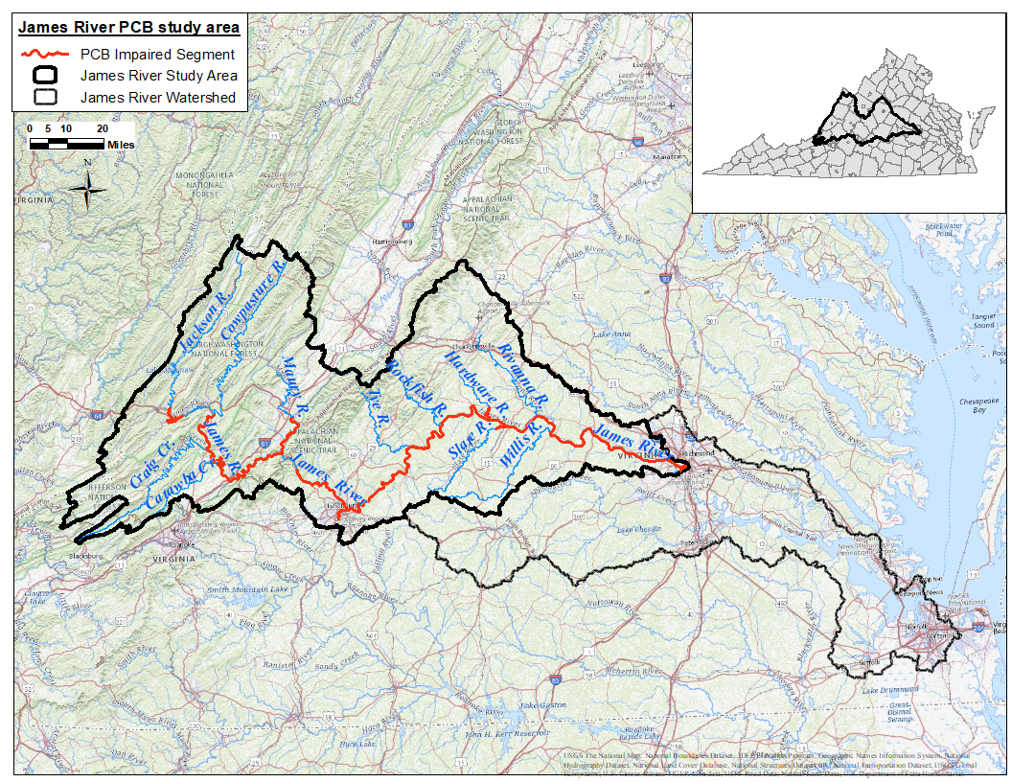

Submitted by:

Virginia Department of Environmental Quality

Prepared by:

Department of Biological Systems Engineering, Virginia Tech &
Virginia Department of Environmental Quality



Draft Report
October 2024

Project Personnel

Virginia Tech, Department of Biological Systems Engineering
Brian Benham, Professor and Extension Specialist: Project Director
Karen Kline, Senior Research Scientist
Emily Smith-McKenna, Research Scientist
Moges Wagena, Senior Research Associate
Sami Towsif Khan, Graduate Research Assistant

Virginia Department of Environmental Quality
Mark Richards, DEQ Central Office
Will Isenberg, DEQ Central Office
Nesha McRae, DEQ Valley Regional Office
Lucy Smith, DEQ Blue Ridge Regional Office
Aerin Doughty, DEQ Blue Ridge Regional Office
Denise Moyer, DEQ Piedmont Regional Office

For additional information, please contact:
Virginia Department of Environmental Quality
Mark Richards, DEQ Central Office, 1111 East Main Street, Suite 1400, P.O. Box 1105 Richmond, 23218. (804) 659-1126 Mark.Richards@DEQ.Virginia.gov

Table of Contents
Table of Contents iii
List of Figures viii
List of Tables xv
Executive Summary I
Background I
Pollutant Sources VII
Modeling VIII
Endpoints VIII
PCB TMDLs IX
Margin of Safety IX
Allocation Scenarios X
Implementation XI
Public Participation XI
Chapter 1: Introduction 1
1.1 Background 1
1.1.1 TMDL Definition and Regulatory Information 1
1.1.2 PCB Impairment Listing 1
1.1.3 Study Area Location and Description 8
1.1.4 Pollutant of Concern 14
1.2 Designated Uses and Applicable Water Quality Standards 15
1.2.1 Designation of Uses (9 VAC 25-260-10 A) 15
1.2.2 Applicable Water Quality Standards 16
1.2.3 Targeted Water Quality Goals 17
Chapter 2: Watershed Characterization 18
2.1 Selection of Subwatersheds 18
2.2 General Watershed Characteristics 20
2.2.1 Water Resources 20
2.2.2 Ecoregions 21
2.2.3 Soils 22
2.2.4 Climate 23
2.2.5 Topography 24
2.2.6 Land Use 25
2.3 Stream Flow Monitoring Data 27
2.4 Suspended Sediment Concentration (SSC) Monitoring Data 28
2.5 Total Organic Carbon (TOC) Data 29
2.6 PCB Concentration Monitoring Data 29
2.6.1 Fish Tissue PCB Concentration Data 29
2.6.2 Sediment-Associated PCB Concentration Data 37
2.6.3 Water Column tPCB Concentration Data 39
Chapter 3: Source Assessment 43
3.1 Permitted Sources 43
3.2 Nonpoint Sources 44
3.2.1 Contaminated Sites 44
3.2.2 Unregulated Surface Sources 44
3.2.3 Atmospheric Deposition 45
3.2.4 Streambed Sediment 45
3.2.5 Biosolids 45
Chapter 4: TMDL Technical Approach 47
4.1 Critical Considerations 47
4.2 Modeling Framework 47
Chapter 5: Model Setup for PCB TMDL Development 49
5.1 Watershed Segmentation 49
5.2 Input Data Requirements 49
5.2.1 Land Use, Soils, and Topography Data 49
5.2.2 Meteorological Data 50
5.2.3 Hydrologic Withdrawals 50
5.3 Representation of Sources 52
5.3.1 Sediment Sources 52
5.3.2 PCB Sources 55
5.4 Model Calibration and Validation 61
5.4.1 Hydrology 61
5.4.2 Sediment 62
5.4.3 PCBs 63
5.5 Existing Conditions 64
Chapter 6: TMDL Allocations 66
6.1 Background 66
6.2 Accounting for Critical Conditions and Seasonal Variations 68
6.2.1 Selection of Representative Modeling Period 68
6.2.2 Seasonal Variability 69
6.3 Margin of Safety (MOS) 70
6.4 Waste Load Allocation (WLA) 71
6.4.1 Future Conditions 71
6.4.2 Permitted Sources 71
6.5 Load Allocation (LA) 77
6.6 Allocation Scenarios 78
6.6.1 PCB Allocation Approach 79
6.6.2 Jackson River 79
6.6.3 Maury River 80
6.6.4 Upper James River 80
6.6.5 Lower James River 81
6.7 Summary of the TMDL Allocation Scenario for PCBs 81
6.7.1 Source Category Breakdown 83
6.7.2 Daily Loads 84
Chapter 7: TMDL Implementation and Reasonable Assurance 87
7.1 Water Quality Management Planning 87
7.2 Staged/Adaptive Implementation 87
7.3 Implementation of Waste Load Allocations 87
7.3.1 Wastewater Treatment Plants 88
7.3.2 Stormwater 88
7.3.3 Insignificant Dischargers 90
7.3.4 TMDL Modifications for New (Previously Unknown Sources) or Expanding Dischargers 90
7.4 Implementation of Load Allocations 91
7.4.1 Implementation Plan Development 91
7.4.2 Staged Implementation Scenarios 92
7.4.3 Link to Ongoing Restoration Efforts 92
7.4.4 Implementation Funding Sources 93
7.4.5 Follow-up Monitoring 93
7.5 Attainability of Designated Use 94
Chapter 8: Public Participation 96
Chapter 9: References 97
Glossary of Terms 100
Appendix A: Setting TMDL Endpoints – Derivation of Water Column PCB Targets for TMDL Development A-1
A.1 Introduction A-1
A.2 BAF Calculation Approach A-2
A.2.1 Total BAF values (TBAFHR) A-4
A.2.2 Baseline BAF values (BLBAFHR) A-5
A.2.3 Fraction of freely-dissolved tPCB (F_{d}) A-5
A.2.4 River Segment Species-Specific Adjusted Total BAFRS Values (ATBAFRS) A-6
A.3 Results A-7
A.4 Conclusion A-8
A.5 BAF Flow Chart A-9
A.6 References A-10
Appendix B: Observed Water Quality Data Inventory B-1
B.1 United States Geological Survey (USGS) Streamflow Gages B-1
B.2 Suspended Sediment Concentration (SSC) Data B-2
B.2.1 Monitoring Stations B-2
B.2.2 Jackson River B-3
B.2.3 Maury River B-3
B.2.4 Upper James River B-4
B.2.5 Lower James River B-5
B.3 Total Organic Carbon (TOC) / Dissolved Organic Carbon (DOC) Data B-7
B.3.1 Monitoring Stations B-7
B.3.2 Jackson River B-7
B.3.3 Maury River B-8
B.3.4 Upper James River B-8
B.3.5 Lower James River B-10
B.4 Fish Tissue PCB Concentration Data B-12
B.4.1 Monitoring Stations B-12
B.4.2 Jackson River B-12
B.4.3 Maury River B-13
B.4.4 Upper James River B-15
B.4.5 Lower James River B-19
B.5 Sediment-Associated PCB Concentration Data B-24
B.5.1 Monitoring Stations B-24
B.5.2 Maury River B-25
B.5.3 Upper James River B-25
B.5.4 Lower James River B-26
B.6 Water Column PCB Concentration Data B-27
B.6.1 Monitoring Stations B-27
B.6.2 Jackson River B-28
B.6.3 Maury River B-28
B.6.4 Upper James River B-29
B.6.5 Lower James River B-30
Appendix C: Source Assessment C-1
C.1 Sources of PCBs C-1
C.1.1 Regulated / Permitted Point Sources C-1
C.1.2 Nonpoint Sources C-9
C.1.3 Atmospheric Deposition C-13
C.1.4 Streambed Sediment C-14
C.2 References C-14
Appendix D: Hydrologic Calibration for the James River PCB TMDL Study Area D-1
D.1 Jackson River Hydrologic Model D-1
D.2 Maury River Hydrologic Model D-9
D.3 Upper James River Hydrologic Model D-15
D.4 Lower James River Hydrologic Model D-23
D.5 References D-31
Appendix E: Sediment Calibration for the James River PCB TMDL Study Area E-1
E.1 Calibration Method E-3
E.1.1 Phase I Calibration Methodology E-3
E.1.2 Phase II Calibration Methodology E-4
E.2 Jackson River E-9
E.2.1 Phase I Calibration E-9
E.2.2 Phase II Calibration E-14
E.3 Maury River E-19
E.3.1 Phase I Calibration E-20
E.3.2 Phase II Calibration E-25
E.4 Upper James River E-30
E.4.1 Phase I Calibration: Upper James River – Cowpasture, Catawba, Craig Creek E-31
E.4.2 Phase II Calibration: Upper James River – Cowpasture, Catawba, Craig Creek E-36
E.4.3 Phase I Calibration: Upper James River – Fishing Creek E-41
E.4.4 Phase II Calibration: Upper James River – Fishing Creek E-46
E.5 Lower James River E-51
E.5.1 Phase I Calibration: Lower James River –Tye and Rockfish River E-52
E.5.2 Phase II Calibration: Lower James River –Tye and Rockfish River E-57
E.5.3 Phase I Calibration: Lower James – Rivanna River E-62
E.5.4 Phase II Calibration: Lower James – Rivanna River E-67
E.5.5 Phase I Calibration: Lower James River – Hardware, Slate, and Willis River E-74
E.5.6 Phase II Calibration: Lower James River – Hardware, Slate, and Willis Rivers E-79
E.5.7 Phase I Calibration: Lower James River – Reedy Creek E-84
E.5.8 Phase II Calibration: Lower James River – Reedy Creek E-89
E.6 References E-95
Appendix F: PCB Calibration for the James River PCB TMDL Study Area F-1
F.1 Calibration Methodology F-1
F.1.1 Calibration Parameters F-1
F.1.2 Calibration Analysis F-7
F.2 Jackson River PCB Calibration Results F-8
F.2.1 PCB Calibration F-9
F.3 Maury River PCB Calibration Results F-14
F.3.1 PCB Calibration F-14
F.4 Upper James River PCB Calibration Results F-20
F.4.1 PCB Calibration: James River – Cowpasture, Catawba, Craig Creek F-20
F.4.2 PCB Calibration: Upper James River – Fishing Creek F-25
F.5 Lower James River PCB Calibration Results F-31
F.5.1 PCB Calibration: Lower James River – Tye and Rockfish River F-32
F.5.2 PCB Calibration: Lower James River – Hardware, Slate, and Willis Rivers F-37
F.5.3 PCB Calibration: Lower James River – Rivanna River F-42
F.5.4 PCB Calibration: Lower James River – Reedy Creek F-47
F.6 References F-53

List of Figures
Figure 1-1. PCB impaired stream segments in the James River watershed. 8
Figure 1-2. TMDL watersheds located within the James River study area. 9
Figure 1-3. PCB impaired segments in the Jackson River watershed. 10
Figure 1-4. PCB impaired segments in the Maury River watershed. 11
Figure 1-5. PCB impaired segments in the Upper James River watershed. 12
Figure 1-6. PCB impaired segments in the Lower James River watershed. 13
Figure 1-7. Chemical structure of polychlorinated biphenyls (PCBs) (Wikimedia, 2006) 14
Figure 2-1. Subwatershed boundaries used in the James River study area. Note, subwatersheds were further refined by major tributary within the Upper and Lower James River TMDL watersheds. 19
Figure 2-2. Reservoirs and dams in the James River study area. 20
Figure 2-3. Level III and IV Ecoregions of the James River study area. 21
Figure 2-4. Distribution of soil types by hydrologic soil group in the James River study area. 22
Figure 2-5. Meteorological stations used for the James River study area. 24
Figure 2-6. Topography of the James River study area. Elevation is in meters. 25
Figure 2-7. Land use distribution in the James River study area. 27
Figure 2-8. USGS flow gage stations within the James River study area. Stream flow monitoring data from these gage stations were used in the hydrology calibration model. 28
Figure 2-9. Suspended sediment concentration (SSC) water quality stations in the James River study area. These stations were used to conduct the sediment model calibration. 30
Figure 2-10. Water quality stations with fish tissue PCB concentration data in the James River study area. These stations were used to calculate the bioaccumulation factor (BAF) and PCB endpoint values. 31
Figure 2-11. Jackson River Watershed fish tissue PCB concentrations (ng PCB/g fish tissue) from DEQ sampling. Observed data are partitioned by station within the TMDL watershed and are graphed moving from upstream to downstream (left to right). The legend indicates the fish species type. 33
Figure 2-12. Maury River Watershed fish tissue PCB concentrations (ng PCB/g fish tissue) from DEQ sampling. Observed data are partitioned by station within the TMDL watershed and are graphed moving from upstream to downstream (left to right). The legend indicates the fish species type. 34
Figure 2-13. Upper James River Watershed fish tissue PCB concentrations (ng PCB/g fish tissue) from DEQ sampling. Observed data are partitioned by station within the TMDL watershed and are graphed moving from upstream to downstream (left to right). The legend indicates the fish species type. 35
Figure 2-14. Lower James River Watershed fish tissue PCB concentrations (ng PCB/g fish tissue) from DEQ sampling. Observed data are partitioned by station within the TMDL watershed and are graphed moving from upstream to downstream (left to right). The legend indicates the fish species type. 36
Figure 2-15. Sediment-associated PCB water quality stations in the James River study area. At these stations, sediment samples were collected and tested for sediment-attached PCB concentrations. The observed data from these stations were used to calculate initial concentrations in the PCB model. 38
Figure 2-16. Sediment-associated PCB concentrations (ng PCBs/g sediment) in DEQ sediment samples. Observed data are partitioned by station and TMDL watershed and are graphed upstream to downstream (left to right). 39
Figure 2-17. Water column tPCB water quality stations in the James River study area. These stations were used to conduct the PCB model calibration. 41
Figure 2-18. Water column tPCB concentrations (pg PCB/L water) from DEQ sampling used in the model. Observed data are partitioned by station and TMDL watershed. Graph lists stations upstream to downstream (left to right), with TMDL endpoints for each TMDL watershed. 42
Figure 5-1. Scouring/resuspension and deposition of sediment in a stream (OzCoasts, 2021). 53
Figure C-1. Flow matrix applicable to the different types of permits. C-1
Figure D-1. Observed and simulated flows and precipitation for the Jackson River during the calibration period. D-2
Figure D-2. Observed and simulated flows and precipitation for the Jackson River during the validation period. D-3
Figure D-3. Observed and simulated flows and precipitation for a representative year (2000) in the calibration period for the Jackson River. D-3
Figure D-4. Observed and simulated flows and precipitation for the Jackson River during a representative year (2009) in the validation period. D-4
Figure D-5. Observed and simulated flows and precipitation for the Jackson River for a representative storm in the calibration period. D-4
Figure D-6. Observed and simulated flows and precipitation for the Jackson River for a representative storm in the validation period. D-5
Figure D-7. Cumulative frequency curves for the calibration period for the Jackson River. D-6
Figure D-8. Cumulative frequency curves for the validation period for the Jackson River. D-6
Figure D-9. Observed and simulated flows and precipitation for the Maury River during the calibration period. D-9
Figure D-10. Observed and simulated flows and precipitation for the Maury River during the validation period. D-10
Figure D-11. Observed and simulated flows and precipitation for a representative year (2009) in the calibration period for the Maury River. D-10
Figure D-12. Observed and simulated flows and precipitation for the Maury River during a representative year (2017) in the validation period. D-11
Figure D-13. Observed and simulated flows and precipitation for the Maury River for a representative storm in the calibration period. D-11
Figure D-14. Observed and simulated flows and precipitation for the Maury River for a representative storm in the validation period. D-12
Figure D-15. Cumulative frequency curves for the calibration period for the Maury River. D-12
Figure D-16. Cumulative frequency curves for the validation period for the Maury River. D-13
Figure D-17. Observed and simulated flows and precipitation for the James River at Bent Creek calibration period. D-17
Figure D-18. Observed and simulated flows and precipitation for the James River at Bent Creek during the validation period. D-17
Figure D-19. Observed and simulated flows and precipitation for a representative year (2011) in the calibration period for the James River at Bent Creek. D-18
Figure D-20. Observed and simulated flows and precipitation for the James River at Bent Creek during a representative year (2007) in the validation period. D-18
Figure D-21. Observed and simulated flows and precipitation for the James River at Bent Creek for a representative storm in the calibration period for May 2014. D-19
Figure D-22. Observed and simulated flows and precipitation for James River at Bent Creek for a representative storm in the validation period for June 2006. D-19
Figure D-23. Cumulative frequency curves for the calibration period for the James River at Bent Creek. D-20
Figure D-24. Cumulative frequency curves for the validation period for the James River at Bent Creek. D-20
Figure D-25. Observed and simulated flows and precipitation for the James River near Richmond, VA calibration period at the outlet. D-24
Figure D-26. Observed and simulated flows and precipitation for the James River near Richmond, VA during the validation period at the outlet. D-25
Figure D-27. Observed and simulated flows and precipitation for a representative year (2012) in the calibration period for the James River near Richmond, VA. D-25
Figure D-28. Observed and simulated flows and precipitation for the James River near Richmond, VA during a representative year (2014) in the validation period. D-26
Figure D-29. Observed and simulated flows and precipitation for the James River near Richmond, VA for a representative storm in the calibration period for March 2012. D-26
Figure D-30. Observed and simulated flows and precipitation for the James River near Richmond, VA for a representative storm in the validation period for May 2014. D-27
Figure D-31. Cumulative frequency curves for the calibration period for the James River near Richmond, VA. D-28
Figure D-32. Cumulative frequency curves for the validation period for the James River near Richmond, VA. D-28
Figure E-1. Model watershed boundaries used for model calibration, within the James River TMDL study area. E-2
Figure E-2. Example shear stress and flow relationship with critical deposition and scour thresholds (Jackson River, reach 1). E-6
Figure E-3. Subwatersheds and monitoring stations used in calibration comparisons for the Jackson River TMDL watershed. E-9
Figure E-4. Forest SOSED, DETS, and observed precipitation for subwatershed 1 in Jackson River watershed. E-10
Figure E-5. Cropland SOSED, DETS, and observed precipitation for subwatershed 1 in Jackson River watershed. E-11
Figure E-6. Pervious Residential SOSED, DETS, and observed precipitation for subwatershed 1 in Jackson River watershed. E-11
Figure E-7. Impervious Residential SOSLD, SLDS, and observed precipitation for subwatershed 1 in Jackson River watershed. E-12
Figure E-8. Sediment concentration-flow plot including daily average simulated SSC vs. daily average simulated flow, observed flow and observed SSC for subwatershed reach 14 in Jackson River watershed. E-15
Figure E-9. Three-day window plot for sediment concentration showing the 3 and 5-day average, maximum minimum, and observed values at station JKS000.38 (Jackson River reach 1). E-16
Figure E-10. Comparison of observed SSC, simulated SSC, and simulated flow for subwatershed reach 1 in the Jackson River watershed. E-17
Figure E-11. Subwatersheds and monitoring stations used in calibration comparisons for the Maury River TMDL watershed. E-20
Figure E-12. Forest SOSED, DETS, and observed precipitation for subwatershed 1 in Maury River watershed. E-21
Figure E-13. Cropland SOSED, DETS, and observed precipitation for subwatershed 1 in Maury River. watershed. E-22
Figure E-14. Pervious Residential SOSED, DETS, and observed precipitation for subwatershed 1 in Maury River watershed. E-22
Figure E-15. Impervious Residential SOSLD, SLDS, and observed precipitation for subwatershed 1 in Maury River watershed E-23
Figure E-16. Sediment concentration-flow plot including daily average simulated SSC vs. daily average simulated flow, observed flow and observed SSC for subwatershed reach 9 in Maury River watershed. E-26
Figure E-17. Three-day window plot for sediment concentration showing the 5-day average, maximum minimum, and observed values at station 2- MRY000.46 (Maury River watershed reach 1). E-27
Figure E-18. Comparison of observed SSC, simulated SSC, and simulated flow for subwatershed reach 1 in the Maury watershed. E-28
Figure E-19. Subwatersheds and monitoring stations used in calibration comparisons for the Upper James River TMDL watershed. E-31
Figure E-20. Forest SOSED, DETS, and observed precipitation for subwatershed 1 in Upper James River—Catawba calibration watershed. E-32
Figure E-21. Cropland SOSED, DETS, and observed precipitation for subwatershed 1 in Upper James River—Catawba calibration watershed. E-33
Figure E-22. Pervious Residential SOSED, DETS, and observed precipitation for subwatershed 1 in Upper James River—Catawba calibration watershed. E-33
Figure E-23. Impervious Residential SOSLD, SLDS, and observed precipitation for subwatershed 1 in Upper James River—Catawba calibration watershed. E-34
Figure E-24. Sediment concentration-flow plot including daily average simulated SSC vs. daily average simulated flow, observed flow and observed SSC for subwatershed reach 3 in Upper James River—Catawba calibration watershed. E-37
Figure E-25. Three-day window plot for sediment concentration showing the 5-day average, maximum minimum, and observed values at station 2-JMS302.85 (Upper James River—Catawba calibration watershed, reach 3). E-38
Figure E-26. Comparison of observed SSC, simulated SSC, and simulated flow for subwatershed reach 3 in the Upper James—Catawba calibration watershed. E-39
Figure E-27. Forest SOSED, DETS, and observed precipitation for subwatershed 1 in Upper James River—Fishing Creek watershed E-42
Figure E-28. Cropland SOSED, DETS, and observed precipitation for subwatershed 1 in Upper James River—Fishing Creek watershed. E-43
Figure E-29. Pervious Residential SOSED, DETS, and observed precipitation for subwatershed 1 in Upper James River—Fishing Creek watershed. E-43
Figure E-30. Impervious Residential SOSLD, SLDS, and observed precipitation for subwatershed 1 in Upper James River—Fishing Creek watershed. E-44
Figure E-31. Sediment concentration-flow plot including daily average simulated SSC vs. daily average simulated flow, observed flow and observed SSC for subwatershed reach 1 in Upper James River—Fishing Creek watershed. E-47
Figure E-32. Three-day window plot for sediment concentration showing the 5-day average, maximum minimum, and observed values at station 2-JMS229.14 (Upper James River—Fishing Creek watershed reach 1). E-48
Figure E-33. Comparison of observed SSC, simulated SSC, and simulated flow for subwatershed reach 1 in the Upper James River—Fishing Creek watershed. E-49
Figure E-34. Subwatersheds and monitoring stations used in calibration comparisons for the Lower James River TMDL watershed. E-52
Figure E-35. Forest SOSED, DETS, and observed precipitation for subwatershed 1 in Lower James River—Tye and Rockfish River watershed E-53
Figure E-36. Cropland SOSED, DETS, and observed precipitation for subwatershed 1 in Lower James River—Tye and Rockfish River watershed. E-54
Figure E-37. Pervious Residential SOSED, DETS, and observed precipitation for subwatershed 1 in Lower James River—Tye and Rockfish River watershed. E-54
Figure E-38. Impervious Residential SOSLD, SLDS, and observed precipitation for subwatershed 1 in Lower James River—Tye and Rockfish River watershed. E-55
Figure E-39. Sediment concentration-flow plot including daily average simulated SSC vs. daily average simulated flow, observed flow and observed SSC for subwatershed reach 2 in Lower James River—Tye and Rockfish River watershed. E-58
Figure E-40. Three-day window plot for sediment concentration showing the 5-day average, maximum minimum, and observed values at station 2-JMS189.31 (Lower James River—Tye and Rockfish River watershed reach 1). E-59
Figure E-41. Comparison of observed SSC, simulated SSC, and simulated flow for subwatershed reach 1 in the Lower James River—Tye and Rockfish watershed. E-60
Figure E-42. Forest SOSED, DETS, and observed precipitation for subwatershed 1 in Lower James – Rivanna River watershed. E-63
Figure E-43. Cropland SOSED, DETS, and observed precipitation for subwatershed 1 in Lower James – Rivanna River watershed. E-64
Figure E-44. Pervious Residential SOSED, DETS, and observed precipitation for subwatershed 1 in Lower James – Rivanna River watershed. E-64
Figure E-45. Impervious Residential SOSLD, SLDS, and observed precipitation for subwatershed 1 in Lower James – Rivanna River watershed. E-65
Figure E-46. Sediment concentration-flow plot including daily average simulated SSC vs. daily average simulated flow, observed flow and observed SSC for subwatershed reach 4 in Lower James – Rivanna River watershed during calibration period (2015 to 2019). E-68
Figure E-47. Sediment concentration-flow plot including daily average simulated SSC vs. daily average simulated flow, observed flow and observed SSC for subwatershed reach 4 in Lower James – Rivanna River watershed during validation period (2011 to 2014). E-69
Figure E-48. Three-day window plot for sediment concentration showing the 3-day average, maximum minimum, and observed values at station RVN001.64 (Lower James – Rivanna River watershed reach 1) during the calibration period (2015 – 2019). E-70
Figure E-49. Comparison of observed SSC, simulated SSC, and simulated flow for subwatershed reach 4 in the Lower James – Rivanna River watershed during the calibration period (2015 – 2019). E-71
Figure E-50. Comparison of observed SSC, simulated SSC, and simulated flow for subwatershed reach 4 in the Lower James – Rivanna River watershed during the validation period (2011 – 2014). E-71
Figure E-51. Forest SOSED, DETS, and observed precipitation for subwatershed 1 downstream Lower James River – Hardware, Slate and Willis Rivers. E-75
Figure E-52. Cropland SOSED, DETS, and observed precipitation for subwatershed 1 in Lower James River – Hardware, Slate, and Willis River watershed. E-76
Figure E-53. Pervious Residential SOSED, DETS, and observed precipitation for subwatershed 1 in Lower James River – Hardware, Slate, and Willis Rivers watershed. E-76
Figure E-54. Impervious Residential SOSLD, SLDS, and observed precipitation for subwatershed 1 in Lower James River – Hardware, Slate, and Willis Rivers watershed E-77
Figure E-55. Sediment concentration-flow plot including daily average simulated SSC vs. daily average simulated flow, observed flow and observed SSC for subwatershed reach 1 in Lower James River – Hardware, Slate, and Willis Rivers watershed. E-80
Figure E-56. Three-day window plot for sediment concentration showing the 5-day average, maximum minimum, and observed values at station 2-JMS157.28 (Lower James River – Hardware, Slate, and Willis Rivers watershed reach 1). E-81
Figure E-57. Comparison of observed SSC, simulated SSC, and simulated flow for subwatershed reach 1 downstream the Lower James River – Hardware, Slate, and Willis Rivers watersheds. E-82
Figure E-58. Forest SOSED, DETS, and observed precipitation for subwatershed 1 in Lower James River – Reedy Creek watershed. E-85
Figure E-59. Cropland SOSED, DETS, and observed precipitation for subwatershed 12 in Lower James River – Reedy Creek watershed. E-86
Figure E-60. Pervious Residential SOSED, DETS, and observed precipitation for subwatershed 1 in Lower James River – Reedy Creek Creek watershed. E-86
Figure E-61. Impervious Residential SOSLD, SLDS, and observed precipitation for subwatershed 1 in Lower James River – Reedy Creek Creek watershed E-87
Figure E-62. Sediment concentration-flow plot including daily average simulated SSC vs. daily average simulated flow, observed flow and observed SSC for subwatershed reach 1 in Lower James River – Reedy Creek watershed. E-90
Figure E-63. Three-day window plot for sediment concentration showing the 5-day average, maximum minimum, and observed values at station 2-JMS111.17 (Lower James River – Reedy Creek watershed reach 1). E-91
Figure E-64. Comparison of observed SSC, simulated SSC, and simulated flow for subwatershed reach 1 in the Lower James River – Reedy Creek watershed. E-92
Figure F-1. Comparison of observed water column PCB concentrations, simulated water column PCB concentrations, and observed rainfall for subwatershed reach 1 in Jackson River. F-10
Figure F-2. Comparison of observed water column PCB concentrations, simulated water column PCB concentrations, and simulated flow for subwatershed reach 1 in Jackson River. F-10
Figure F-3. Five-day window plots for water column PCB concentrations showing the 5-day average, max, and min, and observed values at station 2-JKS000.38 (Jackson River sub-watershed reach 1). F-11
Figure F-4. Comparison of observed water column PCB concentrations, simulated water column PCB concentrations, and observed rainfall for subwatershed reach 1 in Maury River. F-15
Figure F-5. Comparison of observed water column PCB concentrations, simulated water column PCB concentrations, and simulated flow for subwatershed reach 1 in Maury River. F-16
Figure F-6. Five-day window plots for water column PCB concentrations showing the 5-day average, max, and min, and observed values at station 2-MRY000.46 (Maury River subwatershed reach 1). F-17
Figure F-7. Comparison of observed water column PCB concentrations, simulated water column PCB concentrations, and observed rainfall for subwatershed reach 3 in Upper James River. F-21
Figure F-8. Comparison of observed water column PCB concentrations, simulated water column PCB concentrations, and simulated flow for subwatershed reach 3 in Upper James River. F-21
Figure F-9. Five-day window plots for water column PCB concentrations showing the 5-day average, max, and min, and observed values at station 2-JMS302.85 (Upper James River subwatershed reach 3). F-22
Figure F-10. Comparison of observed water column PCB concentrations, simulated water column PCB concentrations, and observed rainfall for subwatershed reach 1 in Upper James River – Fishing Creek. F-26
Figure F-11. Comparison of observed water column PCB concentrations, simulated water column PCB concentrations, and simulated flow for subwatershed reach 1 in Upper James River – Fishing Creek. F-26
Figure F-12. Five-day window plots for water column PCB concentrations showing the 5-day average, max, and min, and observed values at station 2-JMS229.14 (Upper James River – Fishing Creek subwatershed reach 3). F-27
Figure F-13. Comparison of observed water column PCB concentrations, simulated water column PCB concentrations, and observed rainfall for subwatershed reach 2 in Lower James River – Tye and Rockfish River. F-33
Figure F-14. Comparison of observed water column PCB concentrations, simulated water column PCB concentrations, and simulated flow for subwatershed reach 2 in Lower James River – Tye and Rockfish River. F-33
Figure F-15. Five-day window plots for water column PCB concentrations showing the 5-day average, max, and min, and observed values at station 2-JMS189.31 (Lower James River – Tye and Rockfish River subwatershed reach 3). F-34
Figure F-16. Comparison of observed water column PCB concentrations, simulated water column PCB concentrations, and observed rainfall for subwatershed reach 1 in Lower James River – Hardware, Slate, and Willis Rivers. F-38
Figure F-17. Comparison of observed water column PCB concentrations, simulated water column PCB concentrations, and simulated flow for subwatershed reach 1 in Lower James River – Hardware, Slate, and Willis Rivers. F-38
Figure F-18. Five-day window plots for water column PCB concentrations showing the 5-day average, max, and min, and observed values at station 2-JMS157.28(Lower James River – Hardware, Slate, and Willis Rivers subwatershed reach 1). F-39
Figure F-19. Comparison of observed water column PCB concentrations, simulated water column PCB concentrations, and observed rainfall for subwatershed reach 1 in Lower James River – Rivanna River. F-43
Figure F-20. Comparison of observed water column PCB concentrations, simulated water column PCB concentrations, and simulated flow for subwatershed reach 1 in Lower James River – Rivanna River. F-43
Figure F-21. Five-day window plots for water column PCB concentrations showing the 5-day average, max, and min, and observed values at station 2-RVN001.64 (Lower James River – Rivanna River sub-watershed reach 1). F-44
Figure F-22. Comparison of observed water column PCB concentrations, simulated water column PCB concentrations, and observed rainfall for subwatershed reach 1 in Lower James River – Reedy Creek. F-47
Figure F-23. Comparison of observed water column PCB concentrations, simulated water column PCB concentrations, and simulated flow for subwatershed reach 1 in Lower James River – Reedy Creek. F-48
Figure F-24. Five-day window plots for water column PCB concentrations showing the 5-day average, max, and min, and observed values at station 2-JMS111.17(Lower James River – Reedy Creek subwatershed reach 1). F-49

List of Tables
Table 1-1. Impaired segments from the 2022 303(d) list within each TMDL watershed addressed in this TMDL report (DEQ, 2022). 2
Table 1-2. James River water bodies with PCB Fish Consumption Advisories from the VDH 7
Table 1-3. Common PCB concentration and load units used in this report. 15
Table 1-4. Applicable Fish Tissue Thresholds and Water Quality Criterion for PCBs 16
Table 1-5. PCB Water Quality Targets/TMDL Endpoints for each impaired segment 17
Table 2-1. TMDL watershed, number of subwatersheds, and area. 19
Table 2-2. Meteorological stations and the parameter data used from each station. 23
Table 2-3. Land use category aggregation. 26
Table 2-4. Land use areas in the James River study area (acres). 26
Table 2-5. Number of water quality samples exceeding their respective endpoint in each TMDL Watershed and percent exceedance. 40
Table 3-1. James River nonpoint PCB sources. 44
Table 5-1. Withdrawal rates used in modeling the James River study area. 50
Table 5-2. Permitted TSS point sources in James River study area. 53
Table 5-3. Municipal Wastewater Treatment Plant (WWTP) Facilities in the James River study area. 56
Table 5-4. Municipal Combined Sewer Systems (CSS) in the James River study area. 57
Table 5-5. Industrial Stormwater General Permit (ISWGP) Facilities in the James River study area. 57
Table 5-6. Individual Industrial Permitted (IP) facilities in the James River study area. 58
Table 5-7. MS4s in the James River PCB TMDL study area 59
Table 5-8. Areas of railyards/railway spurs, contaminated sites, electric substations, and terminated permits in the James River study area. 60
Table 5-9. Default criteria for hydrologic calibration. 62
Table 5-10. Relative contributions of different PCB sources to the instream PCB concentration for existing conditions in the James River PCB TMDL study area. 65
Table 6-1. Arithmetic mean and median statistics for existing conditions for the James River impaired segments. The median modeled output statistics were used to develop the PCB TMDLs. 68
Table 6-2. TMDL allocation modeling period for each impaired segment. 69
Table 6-3. Baseline PCB Load and Waste Load Allocations of Municipal Wastewater Treatment Plant (WWTP) Facilities in the James River study area. 72
Table 6-4. Baseline tPCB Loads and Waste Load Allocations of Industrial Stormwater General Permit (ISWGP) Facilities in the James River study area. 74
Table 6-5. Baseline PCB Load and Waste Load Allocations of Individual Industrial Permitted (IP) Facilities in the James River study area. 76
Table 6-6. Baseline PCB Load and Waste Load Allocation of MS4 Regions in the James River Study Area. 77
Table 6-7. Estimated annual WLA_{Subtotal} for each of the impaired segments. 77
Table 6-8. PCB source allocation scenario for the Jackson, Maury, Upper and Lower James River impaired segments. 79
Table 6-9. WLA for Future Conditions for the TMDL watersheds in the James River PCB TMDL study area. 83
Table 6-10. Maximum annual PCB loadings (mg/yr) at the outlet of each TMDL watershed in the James River PCB TMDL study area. 83
Table 6-11. Average annual PCB load at the outlet of Jackson, Maury, and Upper and Lower James River watersheds expressed by source category. 83
Table 6-12. Components of Maximum Daily Load Calculations for MS4s and LAs. 86
Table 6-13. Maximum daily PCB loadings (mg/day) at the impaired segment outlets in the James River study area. 86
Table A-1. Homolog-specific partitioning coefficients. A-6
Table B-1. USGS streamflow gages with complete datasets used for the Hydrology Calibration. B-1
Table B-2. DEQ Suspended Sediment Concentration stations used for the sediment calibration. B-2
Table B-3. Observed SSC (mg/L) Data for the Jackson River TMDL Watershed. B-3
Table B-4. Observed SSC (mg/L) Data for the Maury River TMDL Watershed. B-3
Table B-5. Observed SSC (mg/L) Data for the Upper James River TMDL Watershed. B-4
Table B-6. Observed SSC (mg/L) Data for the Lower James River TMDL Watershed. B-5
Table B-7. DEQ Total Organic Carbon and Dissolved Organic Carbon Stations. B-7
Table B-8. Observed TOC (mg/L) and DOC (mg/L) Data for the Jackson River TMDL Watershed. B-7
Table B-9. Observed TOC (mg/L) and DOC (mg/L) Data for the Maury River TMDL Watershed. B-8
Table B-10. Observed TOC (mg/L) and DOC (mg/L) Data for the Upper James River TMDL Watershed. B-8
Table B-11. Observed TOC (mg/L) and DOC (mg/L) Data for the Lower James River TMDL Watershed. B-10
Table B-12. DEQ Fish Tissue PCB concentration stations used for BAF and endpoint calculation. B-12
Table B-13. Fish Tissue PCB Concentration (ng/g or ppb) Data for the Jackson River TMDL Watershed. B-12
Table B-14. Fish Tissue PCB Concentration (ng/g or ppb) Data for the Maury River TMDL Watershed. B-13
Table B-15. Fish Tissue PCB Concentration (ng/g or ppb) Data for the Upper James River TMDL Watershed. B-15
Table B-16. Fish Tissue PCB Concentration (ng/g or ppb) Data for the Lower James River TMDL Watershed. B-19
Table B-17. DEQ sediment-associated PCB concentration stations used for the PCB calibration. B-24
Table B-18. Observed sediment-associated PCB concentration (ng/g) data for the Maury River. B-25
Table B-19. Observed sediment-associated PCB concentration (ng/g) data for the Upper James River. B-25
Table B-20. Observed sediment-associated PCB concentration (ng/g) data for the Lower James River. B-26
Table B-21. DEQ water column tPCB stations used for the PCB calibration. B-27
Table B-22. Observed water column tPCB (pg/L) data for the Jackson River TMDL Watershed. B-28
Table B-23. Observed water column tPCB (pg/L) data for the Maury River TMDL Watershed. B-28
Table B-24. Observed water column tPCB (pg/L) data for the Upper James River TMDL Watershed. B-29
Table B-25. Observed water column tPCB (pg/L) data for the Lower James River TMDL Watershed. B-30
Table C-1. Active Municipal Wastewater Treatment Facilities in the James River study area. C-2
Table C-2. Inactive municipal wastewater treatment facilities in the James River study area. C-3
Table C-3. Municipal Combined Sewer Systems (CSS) in the James River study area. C-3
Table C-4. Active Industrial Stormwater General Permit (ISWGP) facilities in the James River Study area C-4
Table C-5. Inactive Industrial Stormwater General Permit (ISWGP) facilities in the James River Study Area C-5
Table C-6 Active Individual Industrial Permitted (IP) facilities in the James River study area. C-7
Table C-7 Inactive individual industrial permitted (IP) facilities in the James River study area C-9
Table C-8 MS4s in the James River PCB TMDL study area. C-9
Table C-9 James River nonpoint PCB sources C-10
Table C-10 Contaminated sites identified as Railyards, Railway Spurs in the James River study area C-11
Table D-1. Model performance criteria specified by DEQ. D-1
Table D-2. Summary statistics for the calibration period for the Jackson River. D-7
Table D-3. Summary statistics for the validation period for the Jackson River. D-7
Table D-4. Final calibrated parameters for the Jackson River. D-7
Table D-5. Summary statistics for the calibration period for the Maury River. D-13
Table D-6. Summary statistics for the validation period for the Maury River. D-14
Table D-7. Final calibrated parameters for the Maury River. D-14
Table D-8. Summary statistics for the calibration period for the James River at Bent Creek. D-21
Table D-9. Summary statistics for the validation period for the James River at Bent Creek. D-21
Table D-10. Final calibrated parameters for the James River at Bent Creek. D-21
Table D-11. Summary statistics for the calibration period for the James River near Richmond, VA. D-29
Table D-12. Summary statistics for the validation period for the James River near Richmond, VA. D-29
Table D-13. Final calibrated parameters for the James River near Richmond, VA. D-29
Table E-1. Target SOSED and SOSLD ranges for pervious and impervious land uses (USEPA, 2006). E-4
Table E-2. Number of water quality stations with observed SSC data within the James River TMDL watersheds. E-4
Table E-3. Final calibrated parameters for the Jackson River Phase I Calibration. E-13
Table E-4. Three- and five-day window calibration statistics for the Jackson River Phase II Calibration. E-18
Table E-5. Final calibrated parameters for the Jackson River watershed Phase II Calibration. E-18
Table E-6. Final calibrated parameters for the Maury River Phase I Calibration. E-24
Table E-7. Three- and five-day window calibration statistics for the Maury River Phase II Calibration. E-29
Table E-8. Final calibrated parameters for the Maury River watershed Phase II Calibration. E-29
Table E-9. Final calibrated parameters for the Upper James River Phase I Calibration. E-35
Table E-10. Three- and five-day window calibration statistics for the Upper James River Phase II Calibration. E-40
Table E-11. Final calibrated parameters for the Upper James River watershed Phase II Calibration. E-40
Table E-12. Final calibrated parameters for the Upper James River—Fishing Creek Phase I Calibration. E-45
Table E-13. Three- and five-day window calibration statistics for the Upper James River—Fishing Creek Phase II Calibration. E-49
Table E-14. Final calibrated parameters for the Upper James River—Fishing Creek watershed Phase II Calibration. E-50
Table E-15. Final calibrated parameters for the Lower James River—Tye and Rockfish River Phase I Calibration. E-56
Table E-16. Three- and five-day window calibration statistics for the Lower James River—Tye and Rockfish River Phase II Calibration. E-61
Table E-17. Final calibrated parameters for the Lower James River—Tye and Rockfish River watershed Phase II Calibration. E-61
Table E-18. Final calibrated parameters for the Lower James – Rivanna River Phase I Calibration. E-66
Table E-19. Three- and five-day window calibration statistics for the Lower James – Rivanna River Phase II Calibration. E-72
Table E-20. Three- and five-day window validation statistics for the Lower James – Rivanna River Phase II Calibration. E-73
Table E-21. Final calibrated parameters for the Lower James – Rivanna River watershed Phase II Calibration. E-73
Table E-22. Final calibrated parameters for the Lower James River – Hardware, Slate, and Willis Rivers Phase I Calibration. E-78
Table E-23. Three- and five-day window calibration statistics for the Lower James River – Hardware, Slate, and Willis Rivers Phase II Calibration. E-83
Table E-24. Final calibrated parameters for the Lower James River – Hardware, Slate, and Willis Rivers watershed Phase II Calibration. E-83
Table E-25. Final calibrated parameters for the Lower James River – Reedy Creek Phase I Calibration. E-88
Table E-26. Three- and five-day window calibration statistics for the Lower James River – Reedy Creek Phase II Calibration. E-93
Table E-27. Final calibrated parameters for the Lower James River – Reedy Creek watershed Phase II Calibration. E-93
Table F-1. Homolog-specific partitioning coefficients F-5
Table F-2. Number of water column PCB water quality stations and samples used in the calibration. F-7
Table F-3. Simulated water column PCB concentrations (pg/L), 5-day calibration windows, and observed PCB concentrations (pg/L) for Jackson River. F-12
Table F-4. Final calibrated parameters for the Jackson River PCB Calibration. F-13
Table F-5. Estimated existing annual source PCB loads for Jackson River during the allocation period (2010). F-14
Table F-6. Estimated existing relative contributions of different PCB sources to the overall tPCB concentration at the Jackson River TMDL outlet during the allocation period (2010). F-14
Table F-7. Simulated water column PCB concentrations (pg/L), 5-day calibration windows, and observed PCB concentrations (pg/L) for Maury River F-17
Table F-8. Final calibrated parameters for the Maury River PCB Calibration F-18
Table F-9. Estimated existing annual source PCB loads for Maury River during the allocation period (2011). F-19
Table F-10. Estimated existing relative contributions of different PCB sources to the overall tPCB concentration at the Maury River outlet during the allocation period (2011). F-20
Table F-11. Simulated water column PCB concentrations (pg/L), 5-day calibration windows, and observed PCB concentrations (pg/L) for Upper James River. F-23
Table F-12. Final calibrated parameters for the Upper James River PCB Calibration. F-24
Table F-13. Simulated water column PCB concentrations (pg/L), 5-day calibration windows, and observed PCB concentrations (pg/L) for Upper James River – Fishing Creek F-27
Table F-14. Final calibrated parameters for the James River—Fishing Creek PCB Calibration. F-30
Table F-15. Estimated existing annual source PCB loads for Upper James River – Fishing Creek during the allocation period (2010). F-31
Table F-16. Estimated existing relative contributions of different PCB sources to the overall tPCB concentration at the Upper James River – Fishing Creek outlet during the allocation period (2010). F-31
Table F-17. Simulated water column PCB concentrations (pg/L), 5-day calibration windows, and observed PCB concentrations (pg/L) for Lower James River – Tye and Rockfish River F-35
Table F-18. Final calibrated parameters for the Lower James River – Tye and Rockfish River River PCB Calibration F-36
Table F-19. Simulated water column PCB concentrations (pg/L), 5-day calibration windows, and observed PCB concentrations (pg/L) for Lower James River – Hardware, Slate, and Willis Rivers F-40
Table F-20. Final calibrated parameters for the Lower James River – Hardware, Slate, and Willis Rivers PCB Calibration F-41
Table F-21. Simulated water column PCB concentrations (pg/L), 5-day calibration windows, and observed PCB concentrations (pg/L) for Lower James River – Rivanna River F-45
Table F-22. Final calibrated parameters for the Lower James River – Rivanna River PCB Calibration. F-46
Table F-23. Simulated water column PCB concentrations (pg/L), 5-day calibration windows, and observed PCB concentrations (pg/L) for Lower James River – Reedy Creek F-49
Table F-24. Final calibrated parameters for the Lower James River – Reedy Creek PCB Calibration F-51
Table F-25. Estimated existing annual source PCB loads for Lower James River – Reedy Creek during the allocation period (2002). F-52
Table F-26. Estimated existing relative contributions of different PCB sources to the overall tPCB concentration at the Lower James River – Reedy Creek outlet during the allocation period (2002). F-53

Executive Summary

Background
Section 303(d) of the Clean Water Act (CWA) and the United States Environmental Protection Agency’s Water Quality Planning and Management Regulations require states to develop Total Maximum Daily Loads (TMDLs) for waterbodies that exceed applicable water quality standards (WQSs). TMDLs represent the total pollutant loading a waterbody can receive without exceeding applicable WQSs.
Multiple sections of the James River watershed, including Jackson River and Maury River were listed as impaired on Virginia’s 2024 Section 303(d) List due to exceedances of the Virginia Department of Environmental Quality’s (VADEQ) fish tissue screening value for polychlorinated biphenyls (PCBs). PCB Fish consumption advisories were also identified by the Virginia Department of Health (VDH) that include from the head of the James near Iron Gate (at the confluence of Jackson River and Cowpasture River) to Balcony Falls Dam downstream of Glasgow (near the Maury River), the Maury River from Buena Vista at Rt. 60 16 miles to the James River, and James River from Big Island Dam to the I-95 bridge in Richmond (VDH, 2022). Fish consumption advisories mean a TMDL is required. The DEQ impaired segments, descriptions of their extent, and initial listing year are provided in Table ES-1, and the VDH fish consumption advisories are listed in Table ES-2. Figure ES-1 maps the locations of the PCB impaired segments within the James River study area in Virginia. The study area totals 4,342,969 acres (approximately 6,786 mi²), and consists of four TMDL watersheds: Jackson River, Maury River, Upper James River study area (from the head of the James near Iron Gate to Bent Creek confluence), and Lower James River study area (from Bent Creek confluence to I-95 James River Bridge in Richmond).
Table ES-1. Impaired segments from the 2024 303(d) list within each TMDL watershed addressed in this TMDL report (DEQ, 2024).
TMDL Watershed | Impaired Segment | 305b Segment ID | Segment Length (miles) | Initial Listing Year | Description
Jackson River | Jackson River | VAW-I04R_JKS01A00 | 0.48 | 2008 | extending from Westvaco main processing outfall downstream to Dunlap Creek confluence
Jackson River | Jackson River | VAW-I04R_JKS02A00 | 1.28 | 2008 | extending from Covington water intake downstream to Westvaco main processing outfall
Jackson River | Jackson River | VAW-I09R_JKS04A00 | 5.92 | 2008 | extending from Covington STP outfall downstream to just above Lowmoor community
Jackson River | Jackson River | VAW-I09R_JKS04B14 | 0.32 | 2008 | extending from Potts Creek confluence downstream to Covington STP outfall
Jackson River | Jackson River | VAW-I09R_JKS05A00 | 3.01 | 2008 | extending from downstream of Fudge’s Bridge to Potts Creek confluence
Jackson River | Jackson River | VAW-I09R_JKS06A00 | 1.66 | 2008 | extending from Dunlap Creek confluence downstream to just below Lexington Avenue Bridge
Maury River | Maury River | VAV-I37R_MRY01A00 | 5.11 | 2006 | extending from Buffalo Creek confluence downstream to James River
Maury River | Maury River | VAV-I37R_MRY02A00 | 7.25 | 2006 | extending from Indian Gap Run confluence downstream to Buffalo Creek confluence
Maury River | Maury River | VAV-I37R_MRY03A00 | 4.58 | 2004 | extending from South River confluence downstream to Indian Gap Run confluence
Upper James River | James River | VAV-I28R_JMS01A00 | 6.73 | 2022 | extending from Cedar Creek confluence downstream to Maury River confluence
Upper James River | James River | VAW-I18R_JMS01A00 | 7.77 | 2022 | extending from Craig Creek confluence upstream to Stull Run confluence
Upper James River | James River | VAW-I18R_JMS02A00 | 7.63 | 2022 | extending from Stull Run confluence upstream to the confluence of the Jackson and Cowpasture Rivers
Upper James River | James River | VAW-I24R_JMS01A00 | 5.11 | 2022 | extending from Craig Creek confluence downstream to Catawba Creek confluence
Upper James River | James River | VAW-I24R_JMS01A10 | 15.40 | 2022 | extending from Catawba Creek confluence downstream to Looney Creek confluence
Upper James River | James River | VAW-I27R_JMS01A00 | 7.98 | 2020 | extending from Jennings Creek confluence downstream to Big Hollow Branch confluence
Upper James River | James River | VAW-I27R_JMS02A14 | 7.15 | 2022 | extending from Looney Creek confluence downstream to Jennings Creek confluence
Upper James River | James River | VAW-I28R_JMS01A08 | 1.55 | 2020 | extending from Big Hollow Branch confluence downstream to Cedar Creek confluence
Upper James River | James River | VAW-H01R_JMS01A00 | 1.37 | 2006 | extending from Wilderness Creek confluence downstream to Holcomb Rock Dam
Upper James River | James River | VAW-H01R_JMS01A04 | 0.70 | 2006 | extending from upstream ending of the WQS PWS designation downstream to Wilderness Creek confluence
Upper James River | James River | VAW-H01R_JMS02A00 | 3.30 | 2006 | extending from Georgia Pacific outfalls downstream to upstream ending of the WQS PWS designation
Upper James River | James River | VAW-H01R_JMS03A00 | 3.05 | 2006 | extending from Peters Creek confluence downstream to Georgia Pacific outfalls
Upper James River | Blackwater Creek | VAW-H03R_BKW01A00 | 10,54 | 2024 | extending from confluence of Tomahawk and Burton Creeks downstream to confluence on the James River
Upper James River | Fishing Creek | VAW-H03R_FSG01A00 | 6.32 | 2020 | extending from James River upstream to its headwaters
Upper James River | James River | VAW-H03R_JMS01A00 | 3.86 | 2004 | extending from Business 29 bridge downstream to Williams Run confluence
Upper James River | James River | VAW-H03R_JMS04A02 | 4.22 | 2004 | extending from Reusens dam downstream to Business 29 bridge
Upper James River | James River | VAW-H03R_JMS06A02 | 8.26 | 2006 | extending from Holcomb Rock Dam downstream to Reusens Dam
Upper James River | James River | VAW-H05R_JMS01A00 | 6.27 | 2006 | extending from Wreck Island Creek confluence downstream to Bent Creek confluence
Lower James River | James River | VAW-H05R_JMS02A00 | 6.78 | 2006 | extending from Stonewall Creek confluence to Wreck Island Creek confluence
Lower James River | James River | VAW-H05R_JMS02B14 | 3.05 | 2014 | extending from Beck Creek confluence to Stonewall Creek confluence
Lower James River | James River | VAW-H05R_JMS03A00 | 7.71 | 2006 | extending from Archer Creek confluence downstream to Beck Creek confluence
Lower James River | James River | VAW-H05R_JMS04A00 | 2.68 | 2004 | extending from Williams Run confluence downstream to Archer Creek confluence
Lower James River | James River | VAW-H08R_JMS01A00 | 9.68 | 2006 | extending from Bent Creek confluence to Tye River confluence
Lower James River | James River | VAV-H14R_JMS01A18 | 13.49 | 2006 | extending from Bishop Creek confluence downstream to Rockfish River confluence
Lower James River | James River | VAV-H14R_JMS02A18 | 5.09 | 2006 | extending from Tye River confluence downstream to Bishop Creek confluence
Lower James River | James River | VAV-H17R_JMS01A18 | 8.13 | 2006 | extending from Totier Creek confluence downstream to Hardware River confluence
Lower James River | James River | VAV-H17R_JMS02A18 | 4.82 | 2006 | extending from Ballinger Creek confluence downstream to Totier Creek confluence
Lower James River | James River | VAV-H17R_JMS03A18 | 5.74 | 2006 | extending from Rockfish River confluence downstream to Ballinger Creek confluence
Lower James River | Hardware River | VAV-H19R_HRD01A00 | 7.00 | 2008 | extending from Rt. 6 bridge downstream to James River
Lower James River | James River | VAV-H20R_JMS01A02 | 1.98 | 2006 | extending from Hardware River confluence downstream to a point 5 miles above Fork Union Sanitary District raw water intake
Lower James River | James River | VAV-H20R_JMS02A02 | 2.94 | 2006 | extending from a point 5 miles above Fork Union Sanitary District’s raw water intake to Slate River confluence
Lower James River | Slate River | VAP-H22R_SLT03A02 | 1.00 | 2008 | extending from Rt. 676 to a point 5 miles upstream of the Fork Union Sanitary District raw water intake to James River
Lower James River | Slate River | VAP-H22R_SLT03B20 | 2.90 | 2008 | extending from a point 5 miles upstream of the Fork Union Sanitary District raw water intake to James River
Lower James River | James River | VAV-H20R_JMS02B18 | 2.16 | 2006 | extending from Slate River confluence downstream to Fork Union Sanitary District’s raw water intake
Lower James River | James River | VAV-H20R_JMS03A02 | 9.25 | 2006 | extending from Fork Union Sanitary District’s raw water intake downstream to Rivanna River confluence
Lower James River | James River | VAP-H33R_JMS01A98 | 23.09 | 2006 | extending from Rivanna River confluence downstream to Big Linkinghole Creek confluence
Lower James River | James River | VAP-H38R_JMS01A06 | 2.36 | 2006 | extending from Big Linkinghole Creek confluence to start of PWS section
Lower James River | James River | VAP-H38R_JMS02A04 | 3.75 | 2006 | extending from Mohawk Creek confluence to rivermile 137.00
Lower James River | James River | VAP-H38R_JMS03A06 | 6.95 | 2006 | extending from rivermile 137 to rivermile 130.14
Lower James River | James River | VAP-H38R_JMS04A06 | 0.52 | 2006 | extending from start of PWS section downstream to Mohawk Creek confluence
Lower James River | James River | VAP-H39R_JMS01A98 | 7.45 | 2006 | extending from Tuckahoe Creek confluence to William’s Island dam
Lower James River | James River | VAP-H39R_JMS01B00 | 2.04 | 2006 | extending from rivermile 130.14 to rivermile 128.14
Lower James River | James River | VAP-H39R_JMS02A98 | 3.36 | 2006 | extending from William’s Island dam to Boulevard Bridge
Lower James River | James River | VAP-H39R_JMS02B04 | 4.37 | 2006 | extending from rivermile 128.14 to Tuckahoe Creek confluence
Lower James River | Reedy Creek | VAP-H39R_RDD01C10 | 1.09 | 2020 | extending from Roanoke Street to James River
Lower James River | James River | VAP-H39R_JMS03A98 | 2.94 | 2006 | extending from Boulevard Bridge to fall line at approximately railroad trestle above Mayos Bridge
Lower James River | James River – South Channel | VAP-H39R_JMS03B14 | 0.95 | 2006 | extending from Belle Island dam to Brown’s Island dam

Table ES-2. James River water bodies with PCB Fish Consumption Advisories from the Virginia Department of Health (VDH).
Water Body and Affected Boundaries | Affected Localities | Species | Advisories/  Restriction
Maury River from Buena Vista at Rt. 60 16 miles to James River | Rockbridge County and Buena Vista City | Redbreast Sunfish  Rock Bass  Yellow Bullhead Catfish  Carp | No More than Two Meals/Month
Upper James River from the head of the James near Iron Gate (at the confluence of Jackson River and Cowpasture River) to Balcony Falls Dam downstream of Glasgow (near the Maury River) | Botetourt and Rockbridge Counties | Carp | No More than Two Meals/Month
James River from Big Island Dam to I-95 James River Bridge in Richmond | Amherst, Bedford, Campbell, Appomattox, Nelson, Buckingham, Albemarle, Fluvanna, Cumberland, Goochland, Powhatan, Henrico, Chesterfield Counties, Lynchburg and Richmond Cities | Gizzard Shad  Carp  American Eel  Flathead Catfish  Quillback Carpsucker | No More than Two Meals/Month
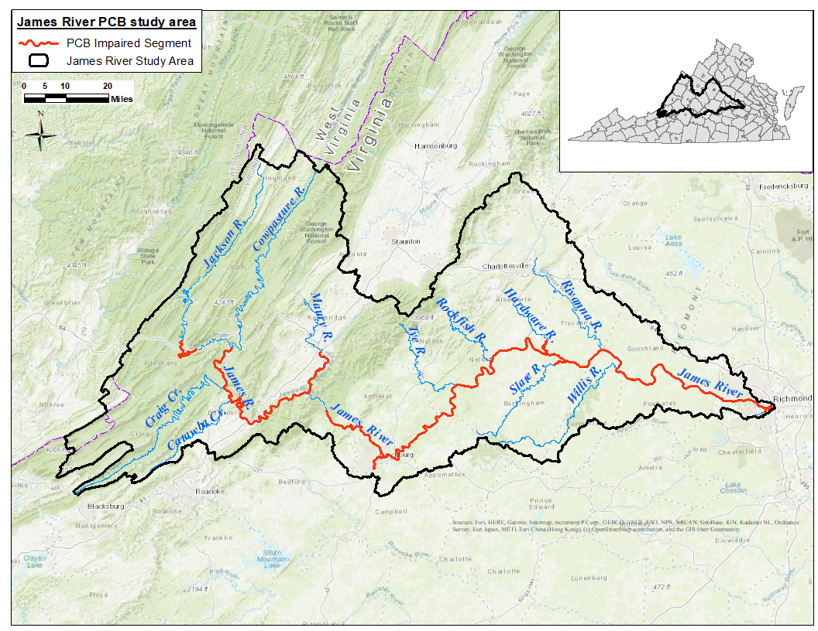
Figure ES-1. PCB impaired stream segments in the James River study area.

Pollutant Sources
PCBs are synthetic compounds that were commonly manufactured in the first half of the 20th century and used for industrial processes. Their chemical structure consists of two bonded phenyl rings and at least one chlorine atom. Although banned in the 1970’s their chemical properties enable PCBs to persist in the environment. Exposure to PCBs leads to chronic ailments such as endocrine disruption, and they are a suspected carcinogen. Sources of PCBs were characterized throughout the James River study area. Point sources include several types of permitted facilities in this watershed. Nonpoint sources include known contaminated sites (e.g., former manufacturing facilities, metal recycling facilities, railyards and railway spurs, spills), non-regulated surface sources (the sum of net atmospheric deposition to land, loads from small tributaries that are not explicitly specified in the model, unregulated stormwater runoff, loads from unidentified contaminated sites, and unspecified point source discharges), atmospheric deposition to water surfaces, and PCB-contaminated stream bed sediment.

Modeling
The Hydrological Simulation Program–FORTRAN (HSPF) (Bicknell et al., 2005) was used to simulate the fate and transport of PCBs in the James River study area. HSPF is a continuous computational model that can represent fate and transport of pollutants on both the land surface and instream. The model simulated hydrology, and sediment and PCB fate and transport. A PCB load equation was developed for four TMDL watersheds: Jackson River, Maury River, Upper and Lower James River. These TMDL watersheds were further sub-divided into subwatersheds based on pollutant sources and various features that impacted the hydrology and pollutant fate and transport modeling. The hydrologic modeling established the foundation for the James River model. Since PCBs are hydrophobic and tend to associate with sediment, a sediment model component was built on the hydrologic model. The final model component simulated PCB fate and transport. The James River model was calibrated at each stage of model development, using a “weight-of-evidence” approach. Multiple analyses were used to ensure the simulated outputs adequately reflect the observed data, particularly during critical flow conditions.

Endpoints
The impaired segments of the James River study area do not support the fish consumption designated use due to exceedances of the Virginia Department of Health’s (VDH) PCB fish tissue threshold and/or the Virginia Department of Environmental Quality’s (VADEQ) total PCB (tPCBs) fish screening value and water quality criterion (WQC). Segment-specific PCB water quality endpoints were calculated using a Bioaccumulation Factor (BAF) approach. This method correlates the localized instream concentrations of PCBs to the concentration of PCBs found within a variety of fish species collected in the same area. As such, the maximum allowable water column tPCB concentration is calculated to ensure the fish tissue thresholds established by either the VDH, 100 ng/g, or the VADEQ, 18 ng/g will be attained. The water column tPCB endpoint for the Jackson River is the PCB WQC of 580 pg/L. Endpoints for the Maury, and Upper and Lower James were calculated using the BAF approach while the PCB WQC was used for the Jackson River segment because the calculated BAF was higher than the WQC (Table ES-3).
Table ES-3. PCB Endpoints for impaired segments of the James River study area
Impaired Segment | PCB Water Quality TMDL Endpoint (pg/L)
Jackson River | 580
Maury River | 400
Upper James River | 120
Lower James River | 52

PCB TMDLs
Various source reduction scenarios were evaluated to identify implementable scenarios that meet the TMDL endpoints for each calibration segment. Load reduction allocation scenarios were generated using meteorological data for the harmonic mean flow year (HMFY) for the James, Maury, and Jackson River segments (and tributaries) included in this TMDL report. The HMFY is the observed flow year whose harmonic mean flow best corresponds to the harmonic mean flow of the entire period of observed flow data at a given gage. The modeled PCB loads correspond to anticipated and permitted future conditions. The TMDL model(s) is used to simulate hourly, instream PCB concentrations for the HMFY. The upper 95% confidence limit of the median of the simulated, daily average instream PCB concentrations, for the applicable HMFY, is compared to the TMDL endpoint to determine if a given PCB pollutant allocation scenario reduces PCB loads sufficiently to meet the TMDL endpoint. Equation ES-1 was used to calculate the loadings shown in Table ES-4. To be consistent with WQS, the annual loads and WLAs are presented using two significant figures.

$TMDL={WLA}_{Total}+LA+MOS$ Eq. ES-1

Where:
WLA_{Total} = waste load allocation (point source contributions, future conditions which account for point source facilities inadvertently excluded from TMDL);
LA = load allocation (nonpoint source contributions); and
MOS = margin of safety.

Margin of Safety
In order to account for the uncertainty of the relationship between the pollutant loads and the quality of the receiving waters, a margin of safety (MOS) was implemented, an explicit MOS of 5% was included. Additional conservative modeling precautions resulted in an implicit additional MO.

Table ES-4. Annual and daily PCB loadings for the TMDLs.
Impaired Segment  (Harmonic Mean Flow Year) | Units | WLA_{Total}¹ | LA² | MOS³ | TMDL⁴
Jackson River | mg/yr | 170,000 | 110,000 | 15,000 | 300,000
(HMFY: 2010) | mg/day | 1,100 | 670 | 89 | 1,900
Maury River | mg/yr | 4,100 | 440,000 | 23,000 | 470,000
(HMFY: 2011) | mg/day | 24 | 2,300 | 120 | 2,400
Upper James River | mg/yr | 190,000 | 340,000 | 28,000 | 560,000
(HMFY: 2010) | mg/day | 1,000 | 1,900 | 160 | 3,100
Lower James River | mg/yr | 160,000 | 270,000 | 22,000 | 450,000
(HMFY: 2002) | mg/day | 1,000 | 1,700 | 140 | 2,800
¹ WLA_{Total} includes future conditions.
² The LA is the remaining loading allowed after the MOS and WLA_{Total} are subtracted from the TMDL as determined for the downstream end/outlet of the impaired segment.
³ Explicit MOS (5%).
⁴ Expressed as two significant figures.

Allocation Scenarios
The proposed TMDL allocation scenarios require load reductions from point and nonpoint sources of PCBs. The difference between the TMDL and the existing annual load represents the necessary level of PCB reduction. The recommended reduction scenarios to meet the segment-specific TMDL endpoints are shown in Table ES-5.
Table ES-5. PCB allocation scenarios showing percent load reduction from existing conditions to meet segment-specific TMDL endpoints.
PCB Load Source Category | Required PCB Load Reductions to Meet the TMDL Endpoint (%)
 | Jackson River | Maury River | Upper  James River | Lower James River
Upstream Sources | – | – | 10 | 8
Known Contaminated Sites | 99 | 99 | 99 | 99
Streambed Sediment | 0 | 0 | 0 | 0
Atmospheric Deposition | 0 | 0 | 0 | 0
Spills | 100 | 100 | 100 | 100
Combined Sewer Systems (CSO) | – | – | 68 | 92
Surface Load, Unregulated | 15 | 0 | 0 | 0
Surface Load, Regulated | – | – | 10 | 10
Permitted | <1% | 99 | 88 | 97

Table ES-6 summarizes the existing loads, WLAs, LAs, and percent reduction by TMDL segment and source category. The LAs and existing loads for the nonpoint sources are the average annual loads based on the source contribution to instream PCB concentration at the outlets of the impaired segments. The WLA is calculated at the outlets of the permitted areas. Existing loads for nonpoint sources are back calculated from the final TMDL. The rows for WLA Future Conditions in Table ES-6 account for point source PCB dischargers that may have been inadvertently excluded from the TMDL and are equal to 0.10% of the TMDL.

Implementation
The goal of the TMDL program is to establish a three-step path that will lead to reasonable assurance that attainment of the applicable WQSs will be achieved. The first step in the process is to develop TMDLs that will meet targeted water quality goals. This report represents the culmination of that effort for the PCB impairments in the James River, Maury River and Jackson River watersheds. The second step is to develop a TMDL implementation plan, which can include the use of available PCB data to “fingerprint” source areas, perform additional investigation of unregulated surface loads which includes uncharacterized nonpoint sources, and to recommend the implementation of best management practices (BMPs) where practical or remediate hot spots. The final step is to initiate recommendations outlined in the TMDL implementation plan, and to monitor stream water quality to determine if fish tissue thresholds and WQSs are being attained. Watershed stakeholders will have opportunities to provide input and to participate in the development of the implementation plan in the future. Implementation plan development will be supported by DEQ’s regional and local offices and other cooperating agencies.

Public Participation
Public participation was elicited at every stage of the TMDL development in order to receive inputs from stakeholders and to apprise the stakeholders of the progress made.
The first PCB Public Meeting was held on Tuesday, January 12, 2021, also held virtually through a webinar platform. The meeting, hosted by DEQ staff, included background information on PCBs and related human health concerns, long term PCB monitoring data from the study area, and an overview of the TMDL process was used in this project. Representatives from Virginia Tech’s Biological Systems Engineering Department discussed the modeling process and tools that were used to predict PCB fate and transport. The comment period for the first public meeting ended February 11, 2021.

Table ES-6. Average annual tPCB loads for James River impaired segments by source category.
Source Category | Existing Load (mg/yr) | WLA  (mg/yr) | LA  (mg/yr) | Reduction  (%)
Jackson River
Upstream Sources
Known Contaminated Sites | 83 |  | 1 | 99
Streambed Sediment | 11,795 |  | 11,795 | 0
Atmospheric Deposition | 11 |  | 11 | 0
Spills | <1 |  | 0 | 100
Combined Sewer Systems (CSO)
Surface Load, Unregulated² | 116,781 |  | 99,264 | 15
Surface Load, Regulated
Permitted | 164,727 | 173,028 |  | -5
WLA Future Conditions¹ |  | 296
TOTAL | 293,397 | 173,324 | 111,071 | 3
Maury River
Upstream Sources
Known Contaminated Sites | 110 |  | 1 | 99
Streambed Sediment | 1 |  | 1 | 0
Atmospheric Deposition | 42 |  | 42 | 0
Spills | <1 |  | 0 | 100
Combined Sewer Systems (CSO)
Surface Load, Unregulated² | 439,139 |  | 439,139 | 0
Surface Load, Regulated
Permitted | 355,762 | 3,645 |  | 99
WLA Future Conditions¹ |  | 467
TOTAL | 795,054 | 4,112 | 439,183 | 44
Upper James River
Upstream Sources | 73,216 | –³ | 65,895 | 10
Known Contaminated Sites | 1,255 |  | 13 | 99
Streambed Sediment | 181 |  | 181 | 0
Atmospheric Deposition | 832 |  | 832 | 0
Spills | <1 |  | 0 | 100
Combined Sewer Systems (CSO) | 3,104 |  | 993 | 68
Surface Load, Unregulated² | 277,574 |  | 277,574 | 0
Surface Load, Regulated | 200,306 | 180,275 |  | 10
Permitted | 83,452 | 9,880 |  | 88
WLA Future Conditions¹ |  | 564
TOTAL | 639,920 | 190,719 | 345,488 | 16
Lower James River
Upstream Sources | 265,825 | –³ | 244,559 | 8
Contaminated Sites | 720 |  | 7 | 99
Streambed Sediment | 1,367 |  | 1,367 | 0
Atmospheric Deposition | 1,562 |  | 1,562 | 0
Spills | <1 |  | 0 | 100
Combined Sewer Systems (CSO) | <1 |  | <1 | 92
Surface Load, Unregulated² | 18,293 |  | 18,293 | 0
Surface Load, Regulated | 169,327 | 152,394 |  | 10
Permitted | 272,789 | 8,995 |  | 97
WLA Future Conditions¹ |  | 448
TOTAL | 729,883 | 161,837 | 265,788 | 42
¹ WLA Future Conditions account for permitted facilities that may come on-line in the future and are equal to 0.10% of the TMDL.
² Unregulated surface sources are the sum of net atmospheric deposition to land surfaces, loads from small tributaries that are not explicitly specified in the model, stormwater runoff, loads from unidentified contaminated sites, and unspecified point source discharges.
³ Upstream Sources are summed in the LA for ease of interpretation, with acknowledgement that some of this load does include a WLA component in the upstream TMDLs (i.e., Jackson River, Maury River, Upper James River).

The first Technical Advisory Committee (TAC) meeting was held on Wednesday, February 24, 2021, and was conducted virtually through an online webinar platform due to the Covid-19 State of Emergency. Presentations included an overview of the James River (Upper and Lower), Maury River, and Jackson River PCB TMDL project including problem identification, PCB monitoring results and prospective sources. The meeting was attended by 54 people (33 TAC members and 21 non-TAC/unnamed participants).
The second and third TAC meetings were held on Tuesday, August 2nd, 2022 (14 people attending) and Wednesday, November 2nd, 2022 (11 people attending), respectively. The primary focus of these meetings was to discuss changes in the WQC and to review draft PCB source allocation scenarios.
The second and final Public Meeting to present the draft PCB TMDL report for the James River study area was held on February 15th, 2024, and more than 30 people attended the meeting. The public comment period for the second public meeting ended March 18th, 2024.

Introduction

Background

TMDL Definition and Regulatory Information
Section 303(d) of the Federal Clean Water Act and the U.S. Environmental Protection Agency’s (EPA) Water Quality Planning and Management Regulations (40 CFR Part 130 and 131) require states to identify water bodies that violate state water quality standards (WQSs) and to develop Total Maximum Daily Loads (TMDLs) that are established at levels necessary to attain narrative and numerical WQSs. A TMDL reflects the total pollutant loading a water body can receive and still attain and maintain the applicable numerical criterion. A TMDL establishes the maximum allowable pollutant loading from both point and nonpoint sources for a water body, allocates the load among the pollutant contributors, and provides a framework for taking actions to restore water quality.

PCB Impairment Listing
Multiple sections of the James River watershed, including the Jackson River and the Maury River were listed as impaired on Virginia’s 2022 Section 303(d) list due to exceedances of the Virginia Department of Environmental Quality’s (DEQ) fish tissue screening value for polychlorinated biphenyls (PCBs). PCB Fish consumption advisories were also identified by the Virginia Department of Health (VDH) that begins at the head of the James near Iron Gate (at the confluence of Jackson River and Cowpasture River) to Balcony Falls Dam downstream of Glasgow (near the Maury River), the Maury River from Buena Vista at Rt. 60 16 miles to the James River, and James River from Big Island Dam to the I-95 bridge in Richmond (VDH, 2022). Fish consumption advisories issued by VDH are also considered impaired by DEQ and require the development of a TMDL. The impaired segments, descriptions of their extent, and initial listing year are provided in Table 1-1 and the fish consumption advisories listed in Table 1-2. Figure 1-1 maps the locations of the PCB impaired segments within the James River study area in Virginia.
Table 1-1. Impaired segments from the 2024 303(d) list within each TMDL watershed addressed in this TMDL report (DEQ, 2024).
TMDL Watershed | Impaired Segment | 305b Segment ID | Segment Length (miles) | Initial Listing Year | Description
Jackson River | Jackson River | VAW-I04R_JKS01A00 | 0.48 | 2008 | extending from Westvaco main processing outfall downstream to Dunlap Creek confluence
Jackson River | Jackson River | VAW-I04R_JKS02A00 | 1.28 | 2008 | extending from Covington water intake downstream to Westvaco main processing outfall
Jackson River | Jackson River | VAW-I09R_JKS04A00 | 5.92 | 2008 | extending from Covington STP outfall downstream to just above Lowmoor community
Jackson River | Jackson River | VAW-I09R_JKS04B14 | 0.32 | 2008 | extending from Potts Creek confluence downstream to Covington STP outfall
Jackson River | Jackson River | VAW-I09R_JKS05A00 | 3.01 | 2008 | extending from downstream of Fudge’s Bridge to Potts Creek confluence
Jackson River | Jackson River | VAW-I09R_JKS06A00 | 1.66 | 2008 | extending from Dunlap Creek confluence downstream to just below Lexington Avenue Bridge
Maury River | Maury River | VAV-I37R_MRY01A00 | 5.11 | 2006 | extending from Buffalo Creek confluence downstream to James River
Maury River | Maury River | VAV-I37R_MRY02A00 | 7.25 | 2006 | extending from Indian Gap Run confluence downstream to Buffalo Creek confluence
Maury River | Maury River | VAV-I37R_MRY03A00 | 4.58 | 2004 | extending from South River confluence downstream to Indian Gap Run confluence
Upper James River | James River | VAV-I28R_JMS01A00 | 6.73 | 2022 | extending from Cedar Creek confluence downstream to Maury River confluence
Upper James River | James River | VAW-I18R_JMS01A00 | 7.77 | 2022 | extending from Craig Creek confluence upstream to Stull Run confluence
Upper James River | James River | VAW-I18R_JMS02A00 | 7.63 | 2022 | extending from Stull Run confluence upstream to the confluence of the Jackson and Cowpasture Rivers
Upper James River | James River | VAW-I24R_JMS01A00 | 5.11 | 2022 | extending from Craig Creek confluence downstream to Catawba Creek confluence
Upper James River | James River | VAW-I24R_JMS01A10 | 15.40 | 2022 | extending from Catawba Creek confluence downstream to Looney Creek confluence
Upper James River | James River | VAW-I27R_JMS01A00 | 7.98 | 2020 | extending from Jennings Creek confluence downstream to Big Hollow Branch confluence
Upper James River | James River | VAW-I27R_JMS02A14 | 7.15 | 2022 | extending from Looney Creek confluence downstream to Jennings Creek confluence
Upper James River | James River | VAW-I28R_JMS01A08 | 1.55 | 2020 | extending from Big Hollow Branch confluence downstream to Cedar Creek confluence
Upper James River | James River | VAW-H01R_JMS01A00 | 1.37 | 2006 | extending from Wilderness Creek confluence downstream to Holcomb Rock Dam
Upper James River | James River | VAW-H01R_JMS01A04 | 0.70 | 2006 | extending from upstream ending of the WQS PWS designation downstream to Wilderness Creek confluence
Upper James River | James River | VAW-H01R_JMS02A00 | 3.30 | 2006 | extending from Georgia Pacific outfalls downstream to upstream ending of the WQS PWS designation
Upper James River | James River | VAW-H01R_JMS03A00 | 3.05 | 2006 | extending from Peters Creek confluence downstream to Georgia Pacific outfalls
Upper James River | Blackwater Creek | VAW-H03R_BKW01A00 | 10.54 | 2024 | extending from confluence of Tomahawk and Burton Creeks downstream to confluence on the James River
Upper James River | Fishing Creek | VAW-H03R_FSG01A00 | 6.32 | 2020 | extending from James River upstream to its headwaters
Upper James River | James River | VAW-H03R_JMS01A00 | 3.86 | 2004 | extending from Business 29 bridge downstream to Williams Run confluence
Upper James River | James River | VAW-H03R_JMS04A02 | 4.22 | 2004 | extending from Reusens dam downstream to Business 29 bridge
Upper James River | James River | VAW-H03R_JMS06A02 | 8.26 | 2006 | extending from Holcomb Rock Dam downstream to Reusens Dam
Upper James River | James River | VAW-H05R_JMS01A00 | 6.27 | 2006 | extending from Wreck Island Creek confluence downstream to Bent Creek confluence
Lower James River | James River | VAW-H05R_JMS02A00 | 6.78 | 2006 | extending from Stonewall Creek confluence to Wreck Island Creek confluence
Lower James River | James River | VAW-H05R_JMS02B14 | 3.05 | 2014 | extending from Beck Creek confluence to Stonewall Creek confluence
Lower James River | James River | VAW-H05R_JMS03A00 | 7.71 | 2006 | extending from Archer Creek confluence downstream to Beck Creek confluence
Lower James River | James River | VAW-H05R_JMS04A00 | 2.68 | 2004 | extending from Williams Run confluence downstream to Archer Creek confluence
Lower James River | James River | VAW-H08R_JMS01A00 | 9.68 | 2006 | extending from Bent Creek confluence to Tye River confluence
Lower James River | James River | VAV-H14R_JMS01A18 | 13.49 | 2006 | extending from Bishop Creek confluence downstream to Rockfish River confluence
Lower James River | James River | VAV-H14R_JMS02A18 | 5.09 | 2006 | extending from Tye River confluence downstream to Bishop Creek confluence
Lower James River | James River | VAV-H17R_JMS01A18 | 8.13 | 2006 | extending from Totier Creek confluence downstream to Hardware River confluence
Lower James River | James River | VAV-H17R_JMS02A18 | 4.82 | 2006 | extending from Ballinger Creek confluence downstream to Totier Creek confluence
Lower James River | James River | VAV-H17R_JMS03A18 | 5.74 | 2006 | extending from Rockfish River confluence downstream to Ballinger Creek confluence
Lower James River | Hardware River | VAV-H19R_HRD01A00 | 7.00 | 2008 | extending from Rt. 6 bridge downstream to James River
Lower James River | James River | VAV-H20R_JMS01A02 | 1.98 | 2006 | extending from Hardware River confluence downstream to a point 5 miles above Fork Union Sanitary District raw water intake
Lower James River | James River | VAV-H20R_JMS02A02 | 2.94 | 2006 | extending from a point 5 miles above Fork Union Sanitary District’s raw water intake to Slate River confluence
Lower James River | Slate River | VAP-H22R_SLT03A02 | 1.00 | 2008 | extending from Rt. 676 to a point 5 miles upstream of the Fork Union Sanitary District raw water intake to James River
Lower James River | Slate River | VAP-H22R_SLT03B20 | 2.90 | 2008 | extending from a point 5 miles upstream of the Fork Union Sanitary District raw water intake to James River
Lower James River | James River | VAV-H20R_JMS02B18 | 2.16 | 2006 | extending from Slate River confluence downstream to Fork Union Sanitary District’s raw water intake
Lower James River | James River | VAV-H20R_JMS03A02 | 9.25 | 2006 | extending from Fork Union Sanitary District’s raw water intake downstream to Rivanna River confluence
Lower James River | James River | VAP-H33R_JMS01A98 | 23.09 | 2006 | extending from Rivanna River confluence downstream to Big Linkinghole Creek confluence
Lower James River | James River | VAP-H38R_JMS01A06 | 2.36 | 2006 | extending from Big Linkinghole Creek confluence to start of PWS section
Lower James River | James River | VAP-H38R_JMS02A04 | 3.75 | 2006 | extending from Mohawk Creek confluence to rivermile 137.00
Lower James River | James River | VAP-H38R_JMS03A06 | 6.95 | 2006 | extending from rivermile 137 to rivermile 130.14
Lower James River | James River | VAP-H38R_JMS04A06 | 0.52 | 2006 | extending from start of PWS section downstream to Mohawk Creek confluence
Lower James River | James River | VAP-H39R_JMS01A98 | 7.45 | 2006 | extending from Tuckahoe Creek confluence to William’s Island dam
Lower James River | James River | VAP-H39R_JMS01B00 | 2.04 | 2006 | extending from rivermile 130.14 to rivermile 128.14
Lower James River | James River | VAP-H39R_JMS02A98 | 3.36 | 2006 | extending from William’s Island dam to Boulevard Bridge
Lower James River | James River | VAP-H39R_JMS02B04 | 4.37 | 2006 | extending from rivermile 128.14 to Tuckahoe Creek confluence
Lower James River | Reedy Creek | VAP-H39R_RDD01C10 | 1.09 | 2020 | extending from Roanoke Street to James River
Lower James River | James River | VAP-H39R_JMS03A98 | 2.94 | 2006 | extending from Boulevard Bridge to fall line at approximately railroad trestle above Mayos Bridge
Lower James River | James River – South Channel | VAP-H39R_JMS03B14 | 0.95 | 2006 | extending from Belle Island dam to Brown’s Island dam

Table 1-2. James River water bodies with PCB Fish Consumption Advisories from the VDH
Water Body and Affected Boundaries | Affected Localities | Species | Advisories/  Restriction
Maury River from Buena Vista at Rt. 60 16 miles to James River | Rockbridge County and Buena Vista City | Redbreast Sunfish  Rock Bass  Yellow Bullhead Catfish  Carp | No More than Two Meals/Month
Upper James River from the head of the James near Iron Gate (at the confluence of Jackson River and Cowpasture River) to Balcony Falls Dam downstream of Glasgow (near the Maury River) | Botetourt and Rockbridge Counties | Carp | No More than Two Meals/Month
James River from Big Island Dam to I-95 James River Bridge in Richmond | Amherst, Bedford, Campbell, Appomattox, Nelson, Buckingham, Albemarle, Fluvanna, Cumberland, Goochland, Powhatan, Henrico, Chesterfield Counties, Lynchburg and Richmond Cities | Gizzard Shad  Carp  American Eel  Flathead Catfish  Quillback Carpsucker | No More than Two Meals/Month

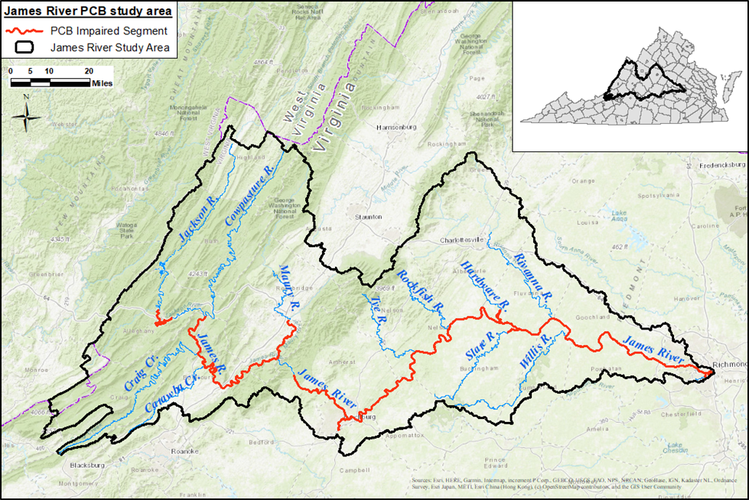
Figure 1-1. PCB impaired stream segments in the James River watershed.

Study Area Location and Description
The James River study area spans 27 counties and includes six city jurisdictions (Figure 1-2). The headwaters start near the West Virginia border, with the confluence of Jackson and Cowpasture Rivers forming the James River. From this point the James River flows eastward roughly 239 miles before it reaches the city of Richmond. The study area totals 4,342,969 acres (approximately 6,786 mi²), and consists of four TMDL watersheds: Jackson River (Figure 1-3), Maury River (Figure 1-4), Upper James River study area (Figure 1-5) and Lower James River study area (Figure 1-6). The James River study area spans steep mountainous slopes in the west, low rolling ridges and hills to the east of the Blue Ridge, and relatively low relief plains in the east. The fall line (roughly parallel to the I-95 corridor) defines the eastern most extent of the freshwater (non-tidal) James River PCB TMDL study area.
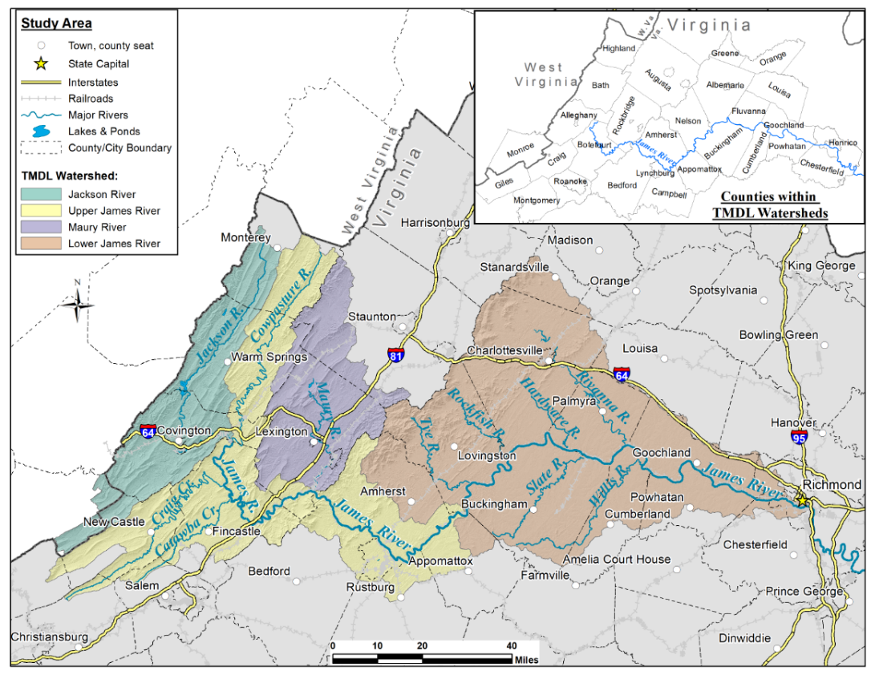
Figure 1-2. TMDL watersheds located within the James River study area.

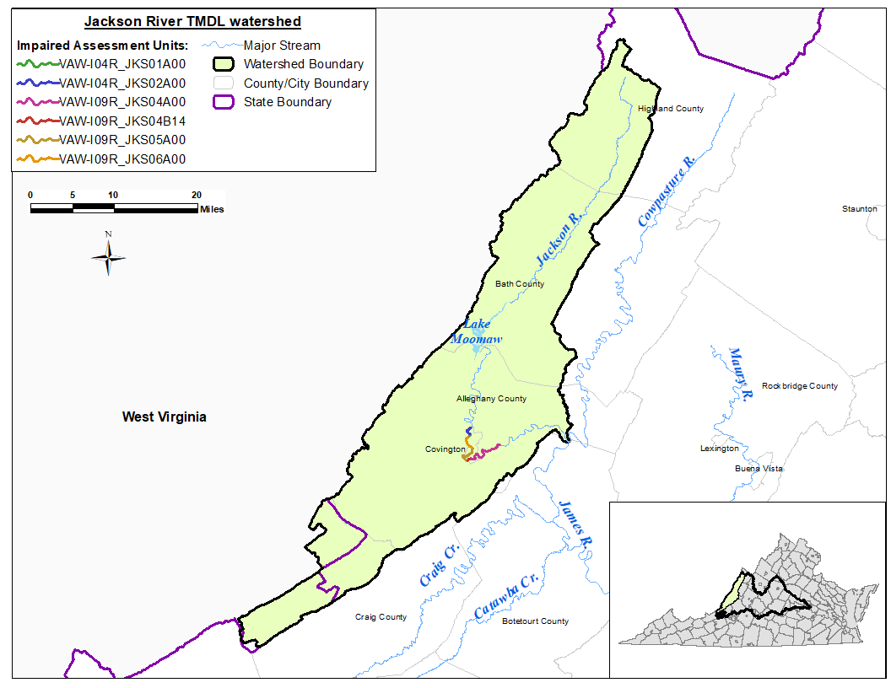
Figure 1-3. PCB impaired segments in the Jackson River watershed.

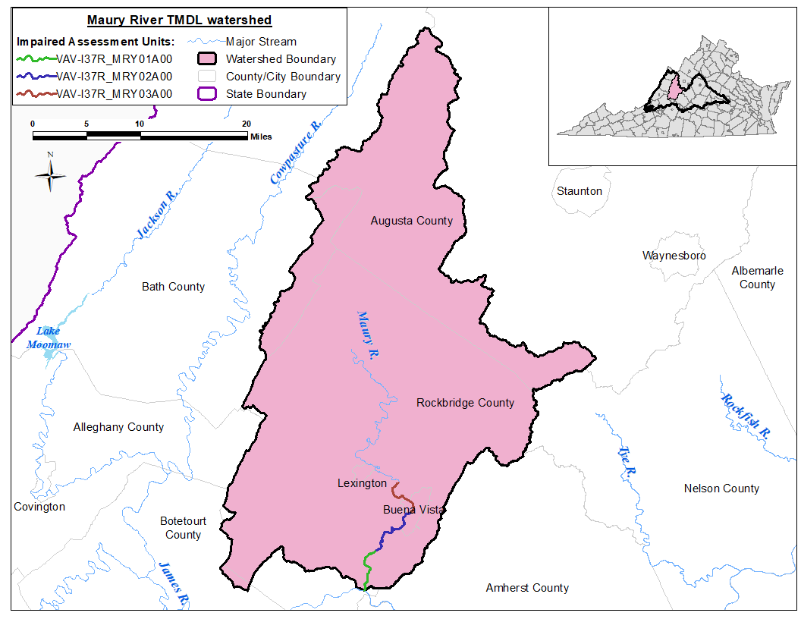
Figure 1-4. PCB impaired segments in the Maury River watershed.

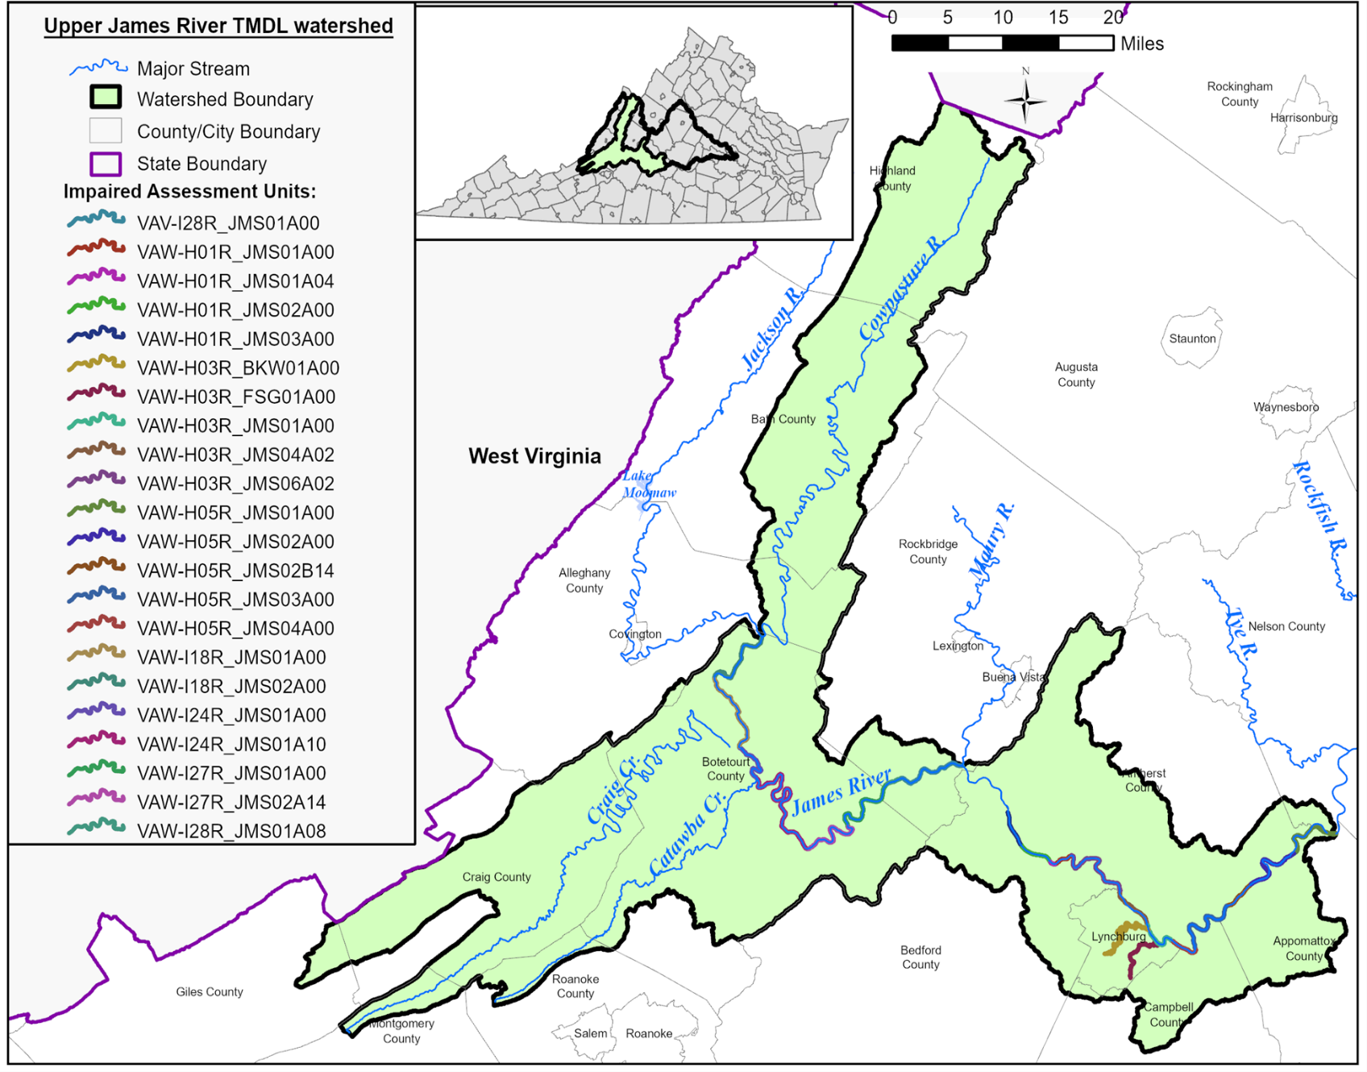
Figure 1-5. PCB impaired segments in the Upper James River watershed.
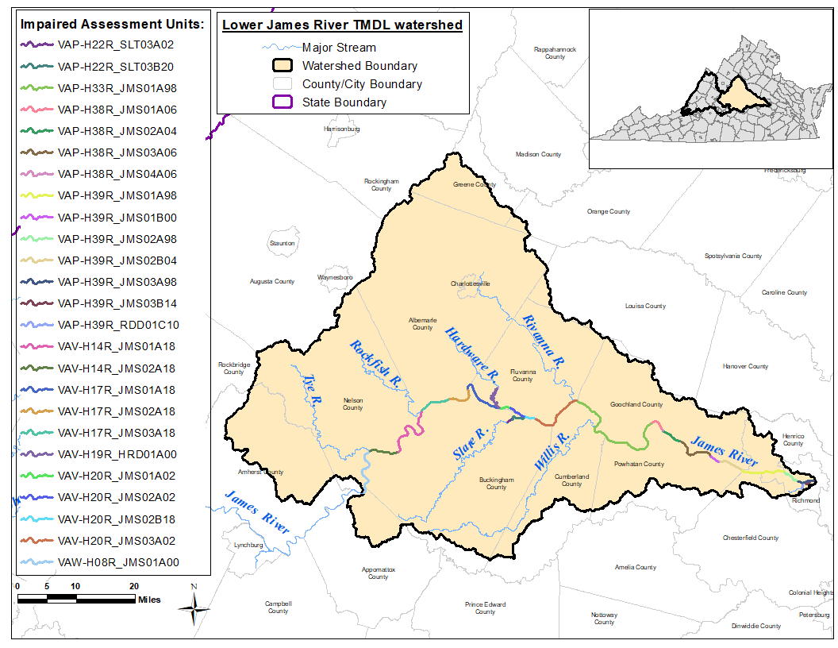
Figure 1-6. PCB impaired segments in the Lower James River watershed.

Pollutant of Concern
The TMDL pollutant of concern is polychlorinated biphenyl (PCB) contamination. PCBs are synthetic compounds that were commonly manufactured in the first half of the 20th century. The chemical structure consists of two bonded phenyl rings with at least one chlorine atom bonded to one of ten positions on the perimeter of the rings (Figure 1-7). There are 209 individual PCB combinations, or congeners, of which chlorine atom(s) are substituted at different positions on the rings. Congeners are grouped by the number of chlorine atoms, irrespective of position, into ten homologs (e.g. monochlorobiphenyl, di-, tri-...deca-). The molecular composition of PCBs enables them to be very resistant to degradation. They are relatively insoluble in water, dielectric, and flame-resistant. As a result, they were commonly used in industrial processes and were often found in oils used in machinery such as transformers. The anti-degradation properties that made them valuable to industrial and manufacturing processes also made them an environmental hazard. When introduced into the environment through volatilization, landfill dumps, or wastewater outflows from municipal or industrial sources, PCBs can persist for many decades.

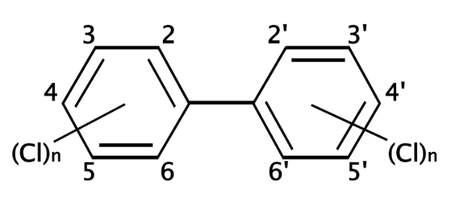
Figure 1-7. Chemical structure of polychlorinated biphenyls (PCBs) (Wikimedia, 2006)

PCB production and usage were banned in the late 1970’s. However, PCBs may still be found in legacy machinery that falls under the exceptions to EPA regulations such as train locomotives. The chemical properties of PCBs mean they are still commonly found in the atmosphere, in the water column and sediment of streams and lakes, and in the soils of contaminated sites. Given their tendency to bioaccumulate in fish at low concentrations and considering their known high toxicity and risk to human health mean that even in small quantities their presence is a concern. The common units used in this report to denote concentrations and loads of PCBs are listed in Table 1-3.

Table 1-3. Common PCB concentration and load units used in this report.
Media | Units | Parts-per
Fish Tissue | nanograms per gram, ng/g | parts-per-billion, ppb
Sediment | nanograms per gram, ng/g | parts-per- billion, ppb
Water Column  (PCB Concentration) | picograms per liter, pg/L | parts-per-quadrillion, ppq
Annual PCB Load | milligrams per year, mg/yr
The primary human health exposure pathway of concern is through consumption of contaminated food. When PCBs enter a water body, they may contaminate fish tissue at very low levels through bioaccumulation. Fish are exposed to PCBs via different pathways such as uptake through the gills and/or skin, exposure can be affected by different feeding strategies, and are known to increase in concentration through trophic transfer within a food chain (i.e., biomagnification). Humans that consume fish contaminated with PCBs may contract a multitude of chronic ailments. PCB exposure can result in endocrine system disruption and weakened immune systems. Acute symptoms include fatigue, headaches, coughs, and rashes. The children of women exposed to PCBs during or before pregnancy have been found with compromised immune systems and intellectual impairment (Jacobson and Jacobson, 1996). PCBs are also a suspected carcinogen in humans. Although food is the major cause of PCB exposure, it can also occur by breathing contaminated air and skin contact.

Designated Uses and Applicable Water Quality Standards

Designation of Uses (9 VAC 25-260-10 A)
“All State waters, including wetlands, are designated for the following uses: recreational uses, e.g., swimming and boating; the propagation and growth of a balanced, indigenous population of aquatic life, including game fish, which might reasonably be expected to inhabit them; wildlife; and the production of edible and marketable natural resources, e.g., fish and shellfish” (SWCB, 2010).
Portions of the Maury and the James River do not support the Fish Consumption use as VDH made the determination for restrictions on fish consumption to protect human health from PCB contamination. In its 1999 Final Rule: Water Quality Standards; Establishment of Numeric Criteria for Priority Toxic Pollutants; States’ Compliance-Revision of Polychlorinated Biphenyls (PCBs) Criteria (USEPA 1999), the EPA determined that the major pathway of human exposure to PCBs is fish consumption.

Applicable Water Quality Standards
The VDH and DEQ have PCB fish tissue thresholds, and DEQ has a water quality criterion (WQC) designed to be protective of the “fishable” use (Table 1-4). VDH provides alerts on unsafe fish consumption when contaminants like PCBs are detected in fish tissue and their quantity in the sampled tissue exceeds the level of concern. In 2012, VDH revised the threshold level from 50 ng/g (ppb) to 100 ng/g (ppb) (VDH, 2012). DEQ’s WQC for total PCBs (tPCB), as listed in 9 VAC-25-260-140, was derived by following EPA’s guidelines to protect human health from toxic effects through drinking water and the consumption of fish. The WQC, adopted by the Virginia State Water Control Board in January 2010, was derived using a risk-based approach whereby 1) a bioconcentration factor (BCF) was used as the denominator of the risk-based equation to translate the value into an acceptable concentration in water (e.g., WQC), and then 2) an acceptable fish tissue threshold concentration was determined by removing the BCF from the equation. DEQ’s criterion-based fish screening threshold was originally 54 ng/g (ppb), but with the application of updated risk-based assumptions, the threshold was decreased to 20 ng/g (ppb) in 2010 (DEQ, 2010), and then again in 2021 to 18 ng/g (ppb) (DEQ, 2021a). The VDH’s revised value and DEQ’s fish tissue value (TV) are different because they serve different purposes. VDH consumption advisories seek to mitigate human health risks once a waterbody has become contaminated. DEQ’s fish screening value is designed to mitigate the risk of excess contamination in all of Virginia’s waters.
Table 1-4. Applicable Fish Tissue Thresholds and Water Quality Criterion for PCBs
Agency | Fish Tissue Threshold  (ng/g, ppb) | Water Quality Criterion (pg/L, ppq)
Virginia Department of Health (VDH) | 100 (Fish Consumption Advisory) | –
Virginia Department of Environmental Quality (DEQ) | 18 (Fish Tissue Value) | 580

Because fish have different exposure pathways to very low levels of PCBs, the use of DEQ’s fish TV and a segment-specific Bioaccumulation Factor (BAF) adds additional assurance to the prospects of restoring the “fishable” use. The benefit to using a segment-specific BAF approach was established during the development of the multi-jurisdictional PCB TMDL for the Potomac River (ICPRB, 2007) the Roanoke River PCB TMDL (DEQ, 2009), and the more recent New River PCB TMDL (DEQ, 2018). By adhering to the guidelines from the aforementioned studies, a PCB water quality target for the Jackson, Maury, and Upper and Lower James Rivers were determined through the derivation of segment-specific endpoints using local fish tissue/river water monitoring data.
A BAF quantifies the ratio between the pollutant concentrations in a stream to the pollutant concentration found within fish. This methodology improves upon the BCF approach as it accounts for multiple pathways of exposure in fish including uptake from water, food, and sediment. For each TMDL watershed, the final BAF value uses DEQ’s fish tissue screening value of 18 ppb to derive the water quality endpoints. Of note, the fish TV is an equivalent concentration to the water based WQC and is consistent with the most up-to-date threshold level as described in the 2024 Water Quality Assessment Guidance Manual (DEQ, 2023).

Targeted Water Quality Goals
After the water quality endpoint was derived from the final BAF, it was compared against the WQC (580 pg/L) for each impaired segment. Appendix A details the process of calculating and selecting the TMDL endpoints. Provided in the appendix is an explanation of the BAF calculation, how the fish tissue thresholds were used, and the conditions for selecting a suitable endpoint. Segment specific water quality endpoints were determined for each TMDL watershed of the James River study area (Table 1-5). Specific endpoints were used for each TMDL watershed to account for differences in the degree of PCB contamination in each watershed and the magnitude of PCB sources. The TMDL endpoints for James, Maury and Jackson Rivers were developed according to a PCB WQS that establishes compliance with the “human health” criteria by relying on the assumption of (an) “average amount of exposure on a long-term basis”.

Table 1-5. PCB Water Quality Targets/TMDL Endpoints for each impaired segment
Impaired Segment | PCB Water Quality TMDL Endpoint (pg/L)
Jackson River | 580
Maury River | 400
Upper James River | 120
Lower James River | 52

Watershed Characterization

Selection of Subwatersheds
The James River study area spans 27 counties, including some or all of: Albemarle, Alleghany, Amherst, Appomattox, Augusta, Bath, Bedford, Botetourt, Buckingham, Campbell, Chesterfield, Craig, Cumberland, Fluvanna, Giles, Goochland, Greene, Henrico, Highland, Louisa, Montgomery, Nelson, Orange, Powhatan, Roanoke, and Rockbridge counties of Virginia, and Monroe County of West Virginia. The study area includes six city jurisdictions: Buena Vista, Charlottesville, Covington, Lexington, Lynchburg, and City of Richmond. The headwaters start near the West Virginia border, with the confluence of Jackson and Cowpasture Rivers forming the James River. From this point the James River flows eastward roughly 239 miles before it reaches the city of Richmond. The study area totals 4,342,969 acres (approximately 6,786 mi²), and consists of four TMDL watersheds: Jackson River, Maury River, Upper and Lower James River (Figure 1-2).
Portions of the James River study area exceed water quality criteria due to PCB contaminants found in fish tissue. The study area was divided into four TMDL watersheds based on major tributary junctions and the location of the PCB impaired segments. The TMDL watersheds were subdivided into a total of 265 subwatersheds (Figure 2-1). Subwatersheds were delineated based on several factors including location of PCB impaired segment, proximity to water quality monitoring stations, stream network continuity, and land use distribution. The length of the PCB impaired stream segments within the study area totals approximately 229 miles. There are approximately 13 miles of PCB impaired stream along the Jackson River, 17 miles on the Maury River, and the Upper James River watershed includes 51 miles of PCB impaired stream. The Lower James River TMDL watershed includes a 7-mile-long impaired segment (on Hardware River), 4 miles (on Slate River), and 121 miles along the James River ending in Richmond. Table 2-1 lists the number of subwatersheds and their total acreage within each TMDL watershed.
The stream network used to help define the subwatersheds was obtained from the National Hydrography Dataset (NHD) (USGS, 2019). It was preferable to have a subwatershed outlet at or near a monitoring station location, so that simulated outputs could be more readily calibrated to observed data (discussed further in Chapter 5). Due to the large size of the James River study area, subwatersheds were further divided among major tributaries within the Upper and Lower James River TMDL watersheds. Major tributaries and segments organized within the Upper James River TMDL watershed include: Cowpasture River, Craig Creek, Catawba Creek, and James River. The Lower James River TMDL watershed includes: Tye River, Rockfish River, Hardware River, Slate River, Rivanna River, Willis River, and James River.

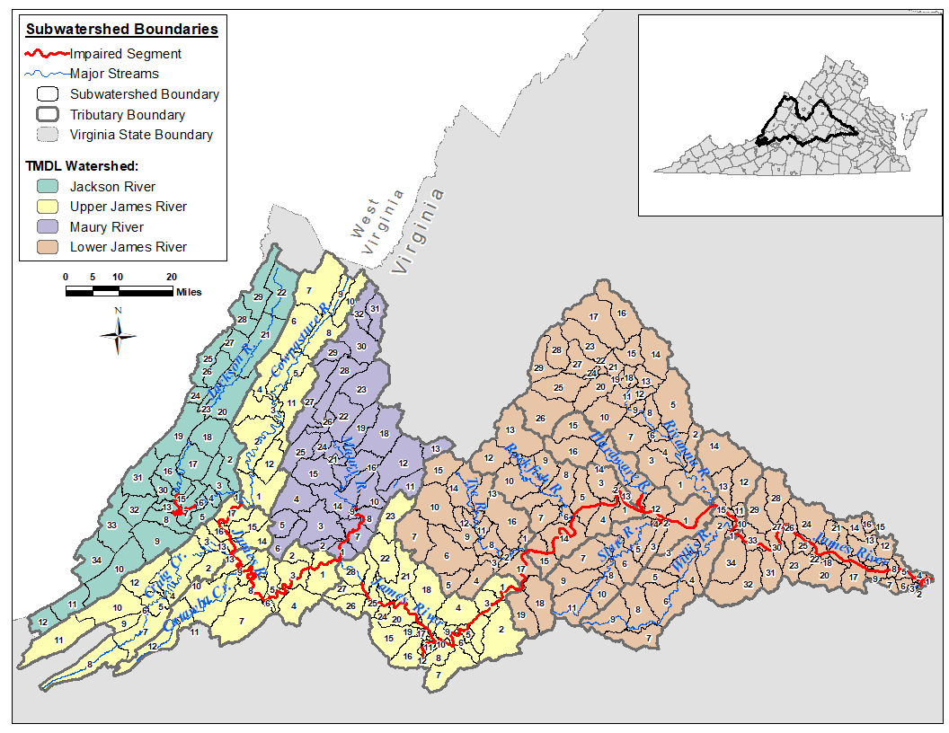
Figure 2-1. Subwatershed boundaries used in the James River study area. Note, subwatersheds were further refined by major tributary within the Upper and Lower James River TMDL watersheds.

Table 2-1. TMDL watershed, number of subwatersheds, and area.
TMDL Watershed | No. Subwatersheds | Total Area (acres)
Jackson River | 34 | 577,798
Maury River | 32 | 536,445
Upper James River | 70 | 1,220,570
Lower James River | 129 | 2,008,156
TOTAL | 265 | 4,342,969

General Watershed Characteristics

Water Resources
The James River study area occupies the entirety of five USGS Hydrologic Unit Code (HUC) basins: Upper James River (HUC 02080201), Maury River (HUC 02080202), Middle James-Buffalo River (HUC 02080203), Rivanna River (HUC 02080204), and Middle James-Willis River (HUC 02080205). Flowing eastward, the James River eventually empties into the Chesapeake Bay.
There is one major reservoir and numerous low-head dams within the study area (Figure 2-2). Gathright Dam creates Lake Moomaw, a 12-mile stretch of the Jackson River. One regulated low-head dam is on the Maury River (Moomaws Dam), and ten regulated low-head dams on the James River.

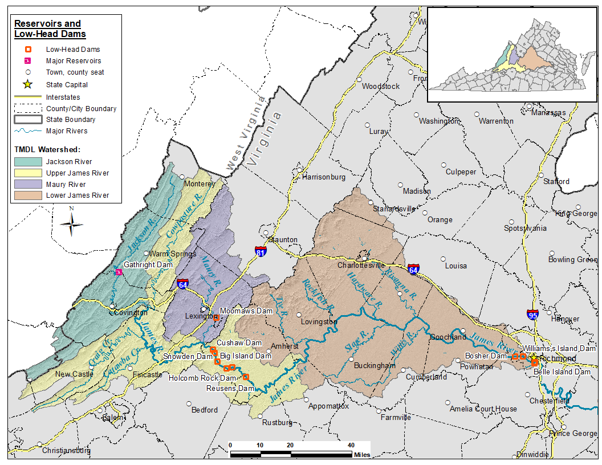
Figure 2-2. Reservoirs and dams in the James River study area.

Ecoregions
The James River study area encompasses six Level III Ecoregions from west to east they are: Central Appalachians (69), Ridge and Valley (67), Blue Ridge (66), Northern Piedmont (64), Piedmont (45), and the Southeastern Plains (65) (Woods et al., 1999). The Level III ecoregions are further subdivided into Level IV ecoregions regions which reflect ecosystems with similar biotic and abiotic characteristics of physiography, geology, soils, climate, vegetation, species distribution, and hydrology. The James River study area spans steep mountainous slopes in the west, low rolling ridges and hills to the east of the Blue Ridge, and relatively low relief plains in the east. These transitions provide a wide spectrum from steep to moderate stream gradients that promote fish habitat and diversity. The fall line (roughly parallel to the I-95 corridor) defines the eastern most extent of the freshwater James River.

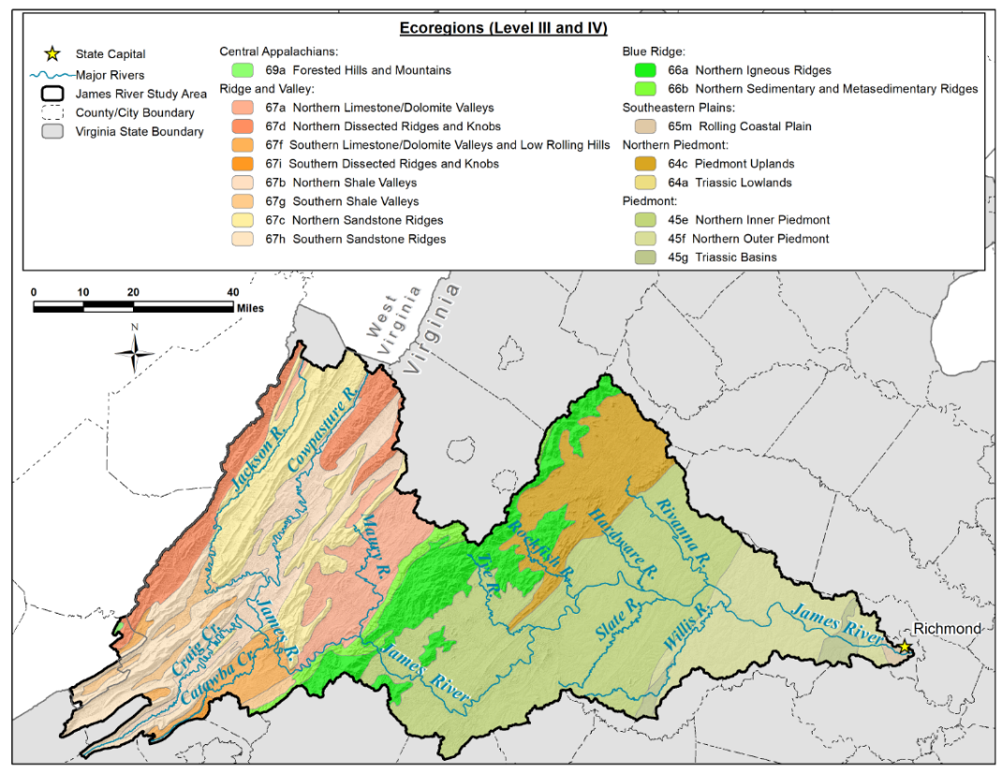
Figure 2-3. Level III and IV Ecoregions of the James River study area.

Soils
The Soil Survey Geographic (SSURGO) dataset was used for the purpose of characterizing the soils and hydrologic modeling of the James River study area. Hydrologic soil groups were the primary soil property used during watershed characterization. Soil groups provide a basis for estimating infiltration rates and surface runoff. For example, soils in hydrologic group “A” pass a larger proportion of rainfall through to groundwater than soils in hydrologic group “B.” Conversely, soils in hydrologic group “D” inhibit infiltration such that a large proportion of rainfall contributes to surface runoff and therefore a more direct path to stream channels. These processes have consequences for the washoff rate of pollutants from the land surface (USDA-NRCS, 2019). Figure 2-4 shows the distribution of the hydrologic soil groups within the James River study area. Hydrologic group “B” soils dominate the watershed with 52% of the entire study area. Hydrologic groups “A”, “D”, and “C” cover 16%, 15%, and 13% of the study area, respectively. A low proportion of the study area contain hydrologic groups “B/D” (2% of the study area), “C/D” (2%), and “A/D” (< 1%).
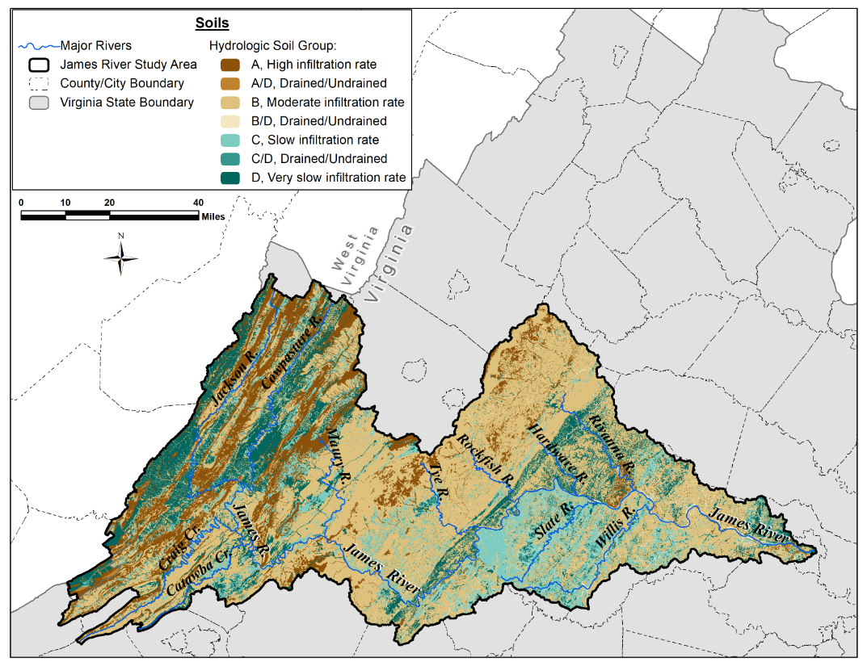
Figure 2-4. Distribution of soil types by hydrologic soil group in the James River study area.

Climate
The climate of the James River study area was characterized using meteorological observations acquired at weather stations from the National Centers for Environmental Information (NCEI) located within or near the watershed (NCEI, 2019; Table 2-2). A map of meteorological station locations is shown in Figure 2-5. These stations were selected based on proximity to the TMDL watersheds, proximity to flow gage stations, orographic influences, and available data with a complete period of record.
Table 2-2 shows the NCEI stations used to collect the main meteorological data for model input: precipitation, minimum and maximum temperature. These nine stations were situated within, and close to, the study area, and together were used to compile a complete dataset for modeling purposes. Most data consisted of daily observations obtained from Global Historical Climatology Network – Daily (GHCN-Daily) meteorological stations.
Below the line break in Table 2-2 is the station used to collect other meteorological data including percent sun, dew point temperature, and average wind speed. These constituents are less commonly recorded, and the nearest station with a complete dataset was the Lynchburg Regional Airport. Past experience from developing TMDLs had revealed that water quality models are not sensitive to these weather inputs. Using best professional judgment, it was determined that a station as distant as Lynchburg is justified.

Table 2-2. Meteorological stations and the parameter data used from each station.
Meteorological Station Locations | Station ID | Meteorological Parameters
Appomattox, VA | USC00440243 | Precipitation  Minimum Daily Temperature  Maximum Daily Temperature
Charlottesville 2 W, VA | USC00441593
Covington Filter Plant, VA | USC00442044
Crozier, VA | USC00442142
Gathright Dam, VA | USC00443310
Glasgow 1 SE, VA | USC00443375
Hot Springs, VA | USC00444128
Lexington, VA | USC00444876
Pedlar Dam, VA | USC00446593
Roanoke Regional Airport | 724110 13741 | Dew Point Temperature  Average Wind Speed
Richmond International Airport | 724010 13740
Lynchburg Regional Airport | 724100 13733 | Percent Sun

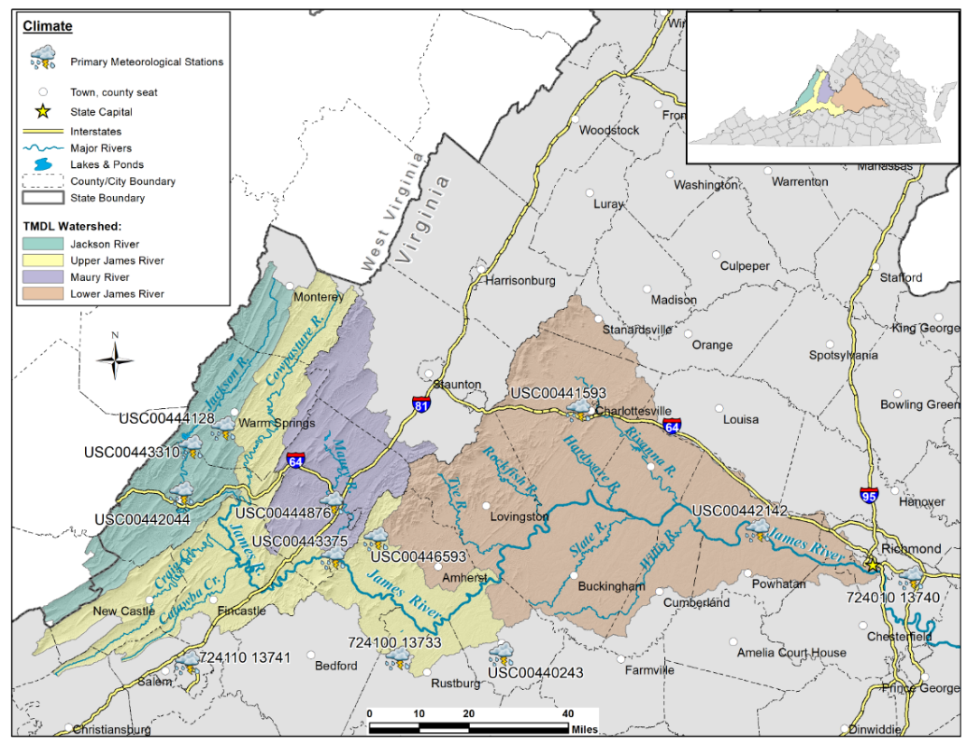
Figure 2-5. Meteorological stations used for the James River study area.

Topography
Topography governs stream gradients and influences weather patterns that drive hydrological behavior. Within the James River study area, elevation data is available as a 10-meter resolution Digital Elevation Model (DEM), which is a detailed topographic dataset derived from the United States Geological Survey (USGS) 3D Elevation Program (USGS, 2019). DEMs were used to delineate subwatersheds and calculate average land surface slopes. Figure 2-6 illustrates the topography in the study area. The James River study area extends from the mountainous slopes along the West Virginia border, where the James River originates and flows eastward through the Blue Ridge Mountains, to the rolling hills of the Piedmont, eventually reaching the fall line that defines the edge of the low-relief Coastal Plain. The changing terrain from west to east is significant, with elevations in the James River study area ranging from 1,382 to 0.4 meters (approximately 4,534 to 1 feet) above mean sea level.

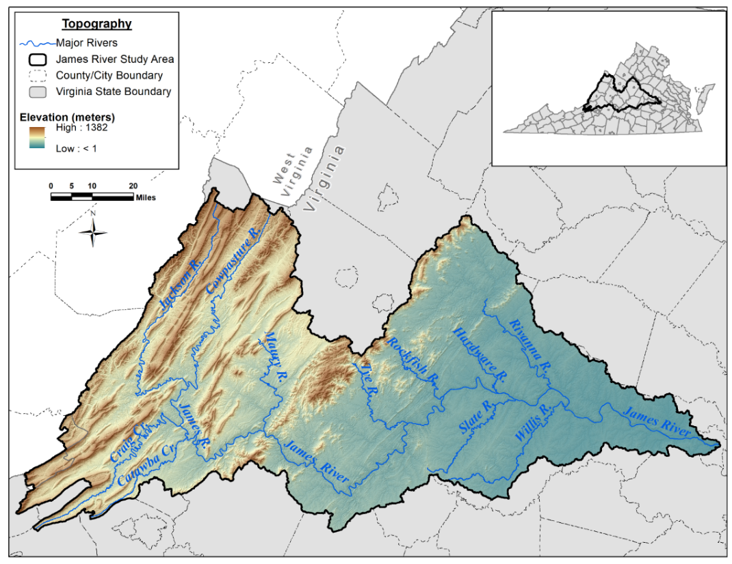
Figure 2-6. Topography of the James River study area. Elevation is in meters.

Land Use
Land use within the James River study area was characterized using two GIS land cover datasets. The Virginia Land Cover Dataset (VLCD), completed in 2016 from the Virginia Geographic Information Network, was used to characterize land use in most of the study area that is located within the state of Virginia (VGIN, 2017). The VLCD consists of 1-meter resolution digital land classes derived from base map aerial imagery. A portion of the study area located within West Virginia (within the Jackson River TMDL watershed), was characterized using the 30-meter resolution 2016 National Land Cover Dataset (NLCD) completed in 2019 (MRLC, 2019).
The VLCD and NLCD land cover classes in the James River study area were grouped into six major land use categories based on similarities in hydrologic features and runoff potential (Table 2-3). Pervious and impervious percentages were assigned to the land use categories for use in the watershed model. VLCD land features classified as ‘Impervious’ tend to represent constructed landscape that includes buildings, paved lots, roads, and railroad corridors (VITA 2016, VGIN 2017). Land cover with VLCD impervious classifications were reclassified as either ‘Residential’ or ‘Commercial’. Areas dominated by high concentrations of impervious features were identified, and these land features were assigned to the ‘Commercial’ category. The modeled land use categories for the James River study area summarized by TMDL watershed in Table 2-4 and are illustrated in Figure 2-7.

Table 2-3. Land use category aggregation.
TMDL Land Use Categories | Pervious/Impervious (Percentage) | VLCD Land Use Classes  (Gridcode) | NLCD¹ Land Use Classes  (Gridcode)
Cropland | Pervious (100%) | Cropland (82) | --
Pasture | Pervious (100%) | Pasture (81) | Pasture/Hay (81)
 | Pervious (100%) | Turfgrass (71) | --
Residential | Pervious (90%); Impervious (10%) | -- | Developed, Open Space (21)
 | Pervious (65%); Impervious (35%) | -- | Developed, Low Intensity (22)
 | Pervious (35%); Impervious (65%) | Impervious-extracted (21) | Developed/Medium Intensity (23)
 |  | Impervious-local datasets (22)
Commercial | Pervious (10%); Impervious (90%) | Impervious-extracted (21) | Developed/High Intensity (24)
 |  | Impervious-local datasets (22)
Forest | Pervious (100%) | Barren (31) | Barren (31)  Deciduous Forest (41)  Evergreen Forest (42)  Mixed Forest (43)  Shrubland (52)  Grassland Herbaceous (71)  Woody Wetlands (90)  Herbaceous Wetlands (95)
 |  | Forest (41)
 |  | Tree (42)
 |  | Scrub/Shrub (51)
 |  | Harvested/Disturbed (61)
 |  | National Wetland Inventory/Other (91)
Water | Pervious (100%) | Hydro (11) | Open Water (11)
¹ NLCD categories only apply to portions of Jackson TMDL subwatersheds 11, 12, and 34.

Table 2-4. Land use areas in the James River study area (acres).
TMDL Watershed | Forest | Cropland | Pasture | Residential | Commercial | Water | Total
Jackson River | 516,365 | 1,955 | 40,190 | 14,300 | 515 | 4,473 | 577,798
Maury River | 414,233 | 6,513 | 89,223 | 24,124 | 387 | 1,965 | 536,445
Upper James River | 1,022,869 | 9,626 | 117,320 | 60,543 | 1,751 | 8,461 | 1,220,570
Lower James River | 1,575,911 | 32,837 | 234,849 | 139,320 | 5,466 | 19,773 | 2,008,156
Total Acres | 3,529,378 | 50,931 | 481,582 | 238,287 | 8,119 | 34,672 | 4,342,969
% of Total | 81% | 1% | 11% | 5% | <1% | 1% | 100%

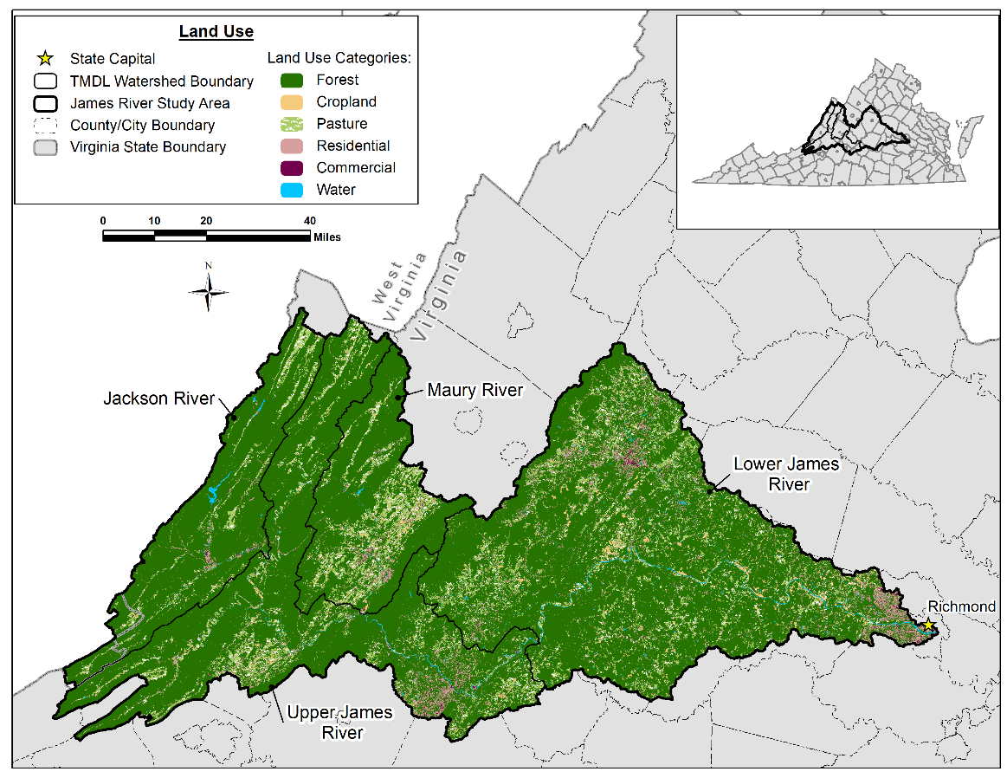
Figure 2-7. Land use distribution in the James River study area.

Stream Flow Monitoring Data
When developing the hydrologic component of a watershed model, observed flow data collected by the United States Geological Survey (USGS) is typically used. The USGS operates numerous flow gages throughout the United States that continuously measure the height of the water level (stage) in the stream. The stream stage is then converted into a discharge volume per unit time using a stage-discharge relationship. The stage-discharge relationship is unique for each gaging station. The USGS reports flow rates as daily averages in units of cubic feet per second (cfs).
Utilizing observed flow data is important for model calibration and verification. Because of the importance of flow data for model calibration, only active gages with complete datasets are used. Stream flow monitoring data from USGS gage stations across the James River study area were used to calibrate and verify the watershed model, Figure 2-8.
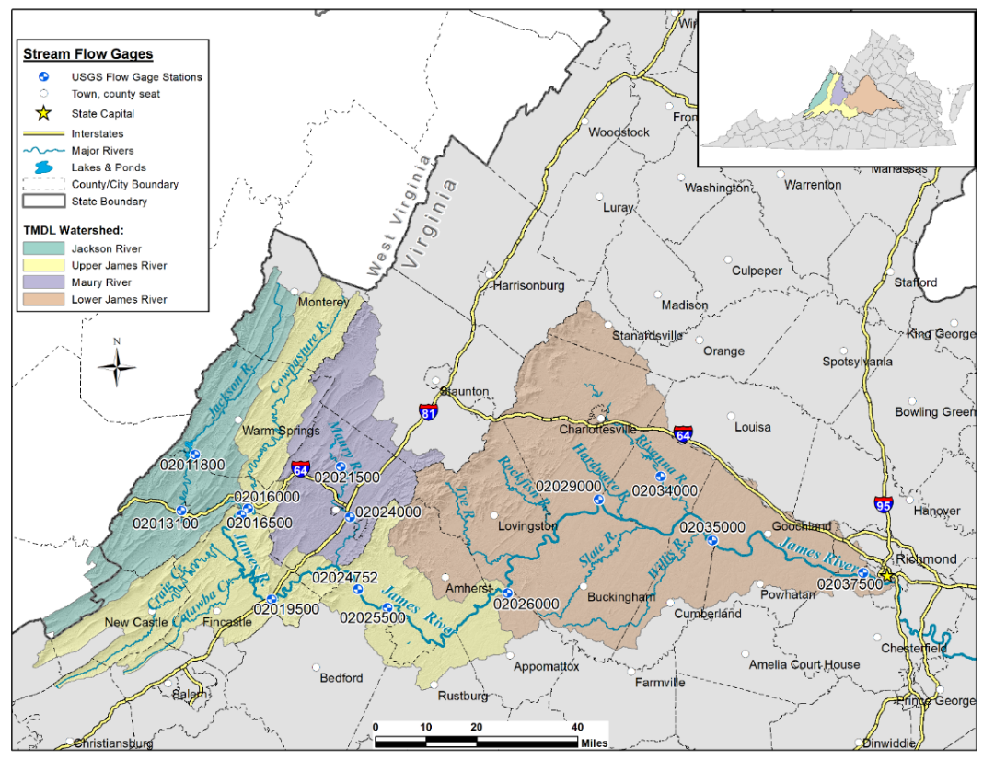
Figure 2-8. USGS flow gage stations within the James River study area. Stream flow monitoring data from these gage stations were used in the hydrology calibration model.

Suspended Sediment Concentration (SSC) Monitoring Data
PCBs are hydrophobic and tend to attach to soil and sediment particles, therefore an integral part of modeling PCBs in the James River study area was understanding the fate and transport of sediment. DEQ collected water column samples in the James River and its tributaries during base and high flow events. The samples were filtered in the laboratory, separating the suspended sediment. The mass of the sediment in each sample was determined. Suspended sediment concentration (SSC) data, provided in units of mg/L, were used to calibrate the sediment component of the watershed model. The locations of the DEQ water quality monitoring stations where SSC samples were collected are shown in Figure 2-9. A.7 includes the SSC data used for model calibration. At some water quality stations, two or fewer samples were collected in a single year. Given the sparse data, sediment calibration relied on a “weight-of-evidence” approach that compared the simulated outputs with the observed data using multiple lines of evidence. The process of calibrating the sediment component of the model is explained in Appendix E.

Total Organic Carbon (TOC) Data
DEQ collected water column samples to determine total organic carbon (TOC). TOC may consist of decaying natural organic matter originating from plant fragments, algal blooms, bacteria, etc., and was reported as a concentration (mg/L). Samples were also analyzed for dissolved organic carbon (DOC) concentration (mg/L), a measure of the quantity of organic carbon dissolved in the water column. TOC, DOC and particulate organic carbon (POC), which is derived by subtracting DOC from TOC, were important water quality constituents used to calculate bioaccumulation factors (BAFs) and TMDL endpoints (Appendix A:). TOC was also used to calculate model parameters that were used to model PCB fate and transport. Details on how TOC data were used during PCB calibration are provided in Appendix F:. A.7 tabulates the TOC data used during the Jackson, Maury, Upper and Lower James River PCB TMDL development.

PCB Concentration Monitoring Data
DEQ collected samples to assess PCB concentration in fish tissue, sediment-attached PCB concentration, and PCB concentration in the water column. The resulting data were used in developing the James River PCB TMDL model.

Fish Tissue PCB Concentration Data
DEQ collected a variety of fish during 1995, 2001, 2003-2005, 2014, and 2017-2019 within the James River and its tributaries and tested their tissue for PCBs. Figure 2-10 shows the locations of the DEQ monitoring stations where fish tissue samples were collected. DEQ collects fish tissue samples to assess PCB contamination. The primary human exposure pathway for PCBs is consuming contaminated fish flesh. Segment-specific fish tissue PCB concentration data measured in units of ng (nanograms, 10⁻⁹ g) of PCBs per gram of fish tissue were used to calculate BAFs and TMDL endpoints. The unit of ng per gram unit is equivalent to parts per billion, ppb. Refer to Appendix A for additional discussion on the selection of the fish tissue record and derivation of TMDL endpoints. DEQ’s fish tissue monitoring data used in this study can be found in Appendix B.

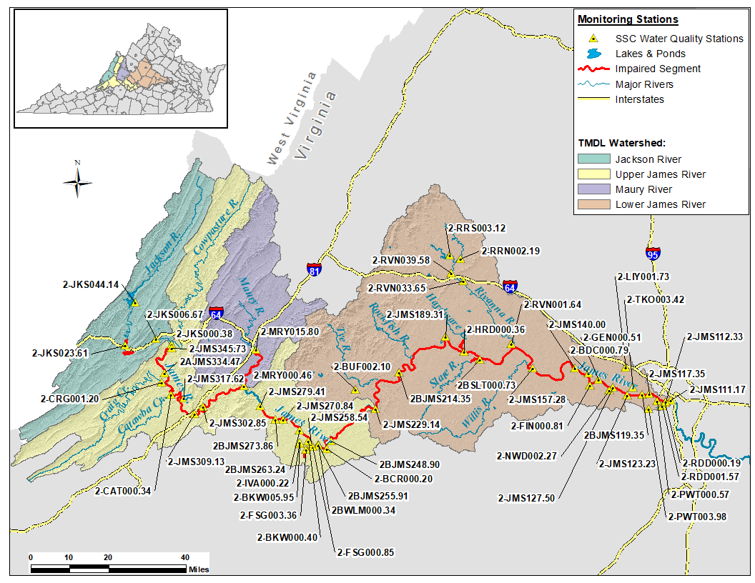
Figure 2-9. Suspended sediment concentration (SSC) water quality stations in the James River study area. These stations were used to conduct the sediment model calibration.
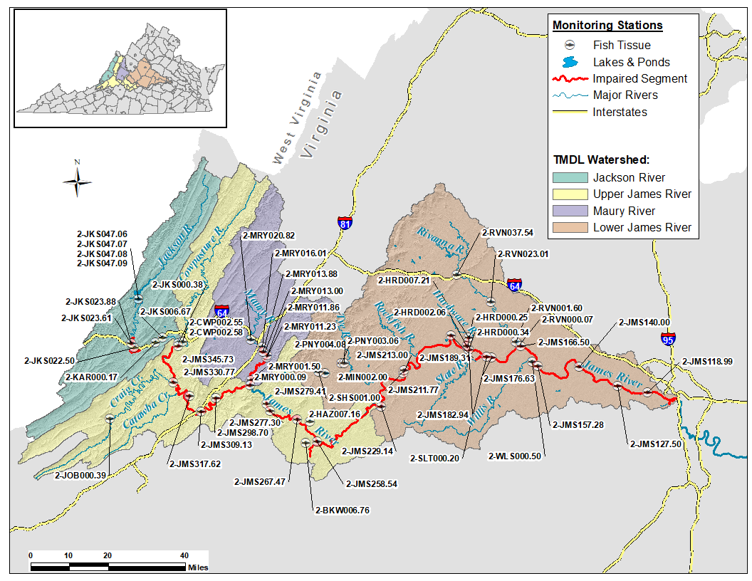
Figure 2-10. Water quality stations with fish tissue PCB concentration data in the James River study area. These stations were used to calculate the bioaccumulation factor (BAF) and PCB endpoint values.

Fish tissue data were plotted to visualize the spatial distribution of PCB concentrations from upstream to downstream within each TMDL watershed (Figure 2-11 to Figure 2-14). The y-axis of the graph is PCB concentration, and the x-axis shows the station ID grouped by TMDL watershed. Stations are sorted left to right from upstream to downstream, and the data are further divided by fish species in each column, by symbol and color. Also plotted are the VDH fish consumption advisory level (100 ng/g) and the DEQ fish tissue screening value (18 ng/g).
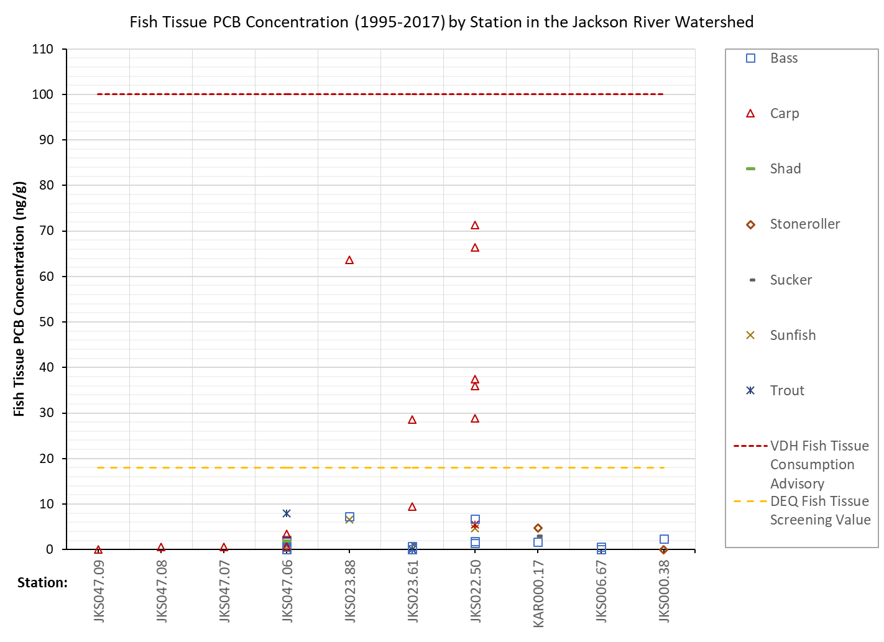
Figure 2-11. Jackson River Watershed fish tissue PCB concentrations (ng PCB/g fish tissue) from DEQ sampling. Observed data are partitioned by station within the TMDL watershed and are graphed moving from upstream to downstream (left to right). The legend indicates the fish species type.
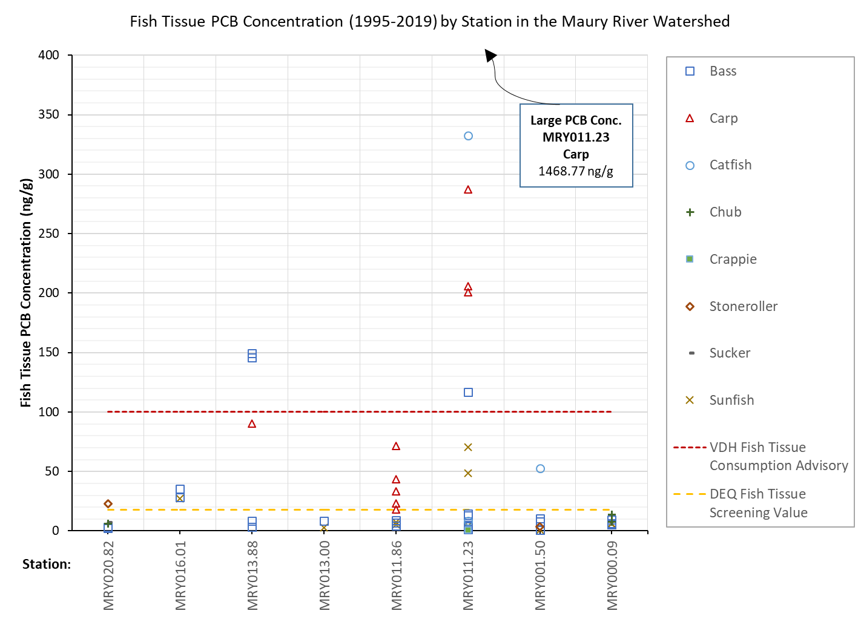
Figure 2-12. Maury River Watershed fish tissue PCB concentrations (ng PCB/g fish tissue) from DEQ sampling. Observed data are partitioned by station within the TMDL watershed and are graphed moving from upstream to downstream (left to right). The legend indicates the fish species type.
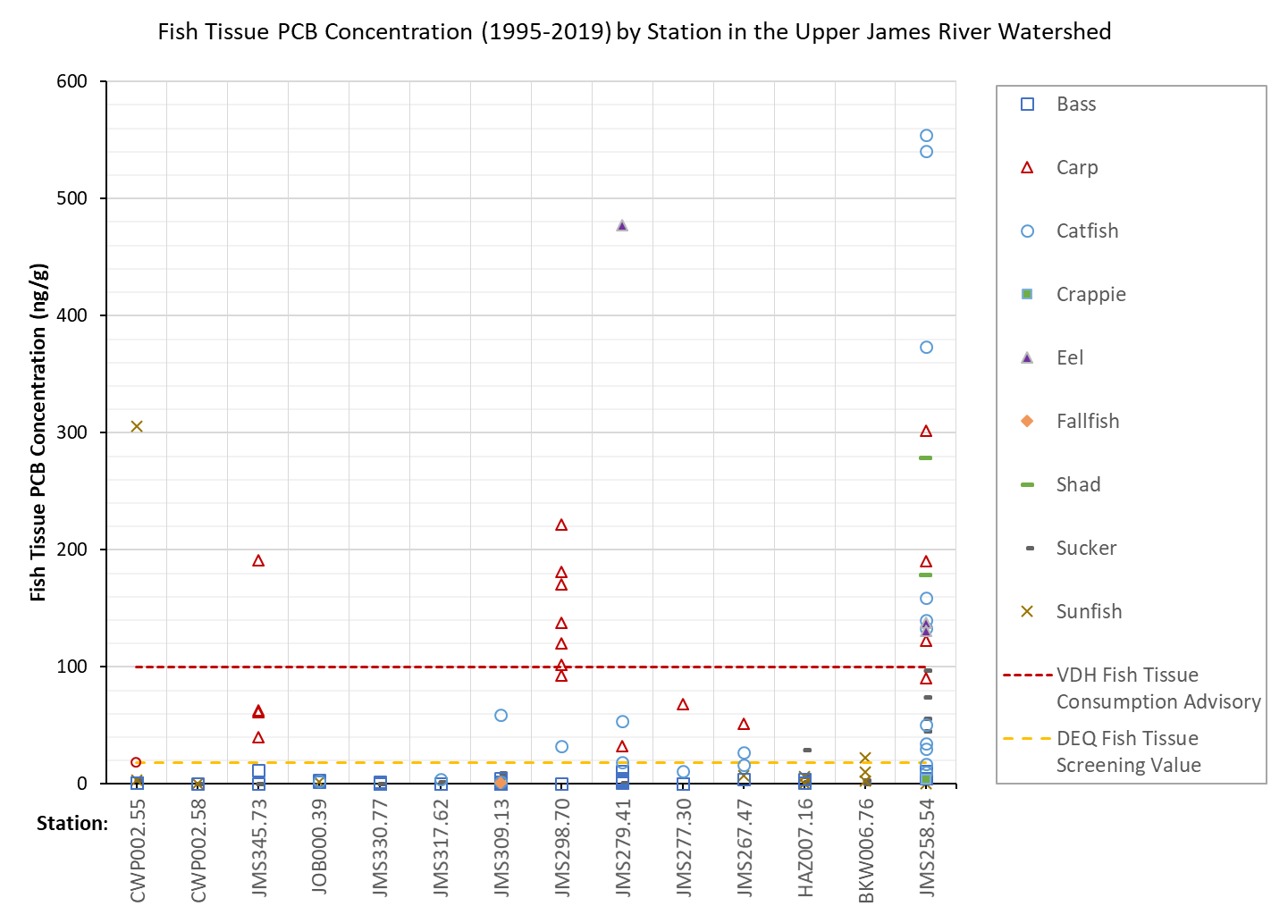
Figure 2-13. Upper James River Watershed fish tissue PCB concentrations (ng PCB/g fish tissue) from DEQ sampling. Observed data are partitioned by station within the TMDL watershed and are graphed moving from upstream to downstream (left to right). The legend indicates the fish species type.
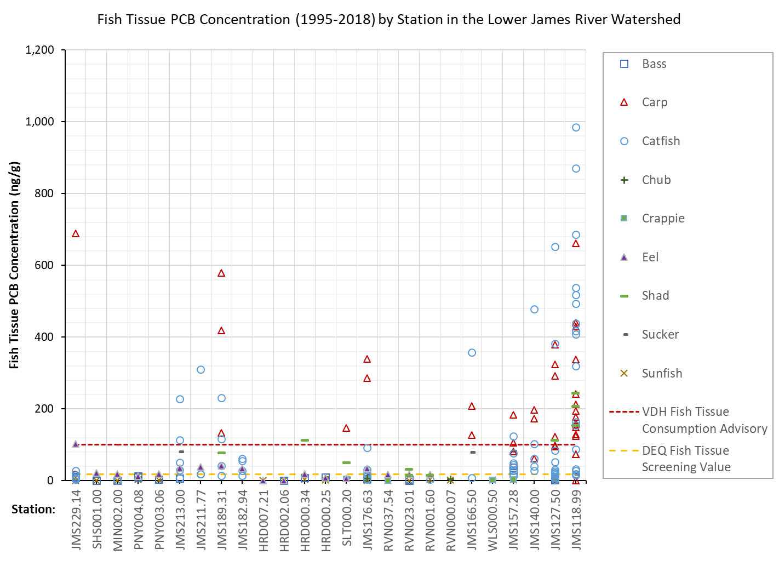
Figure 2-14. Lower James River Watershed fish tissue PCB concentrations (ng PCB/g fish tissue) from DEQ sampling. Observed data are partitioned by station within the TMDL watershed and are graphed moving from upstream to downstream (left to right). The legend indicates the fish species type.

Sediment-Associated PCB Concentration Data
DEQ collected instream sediment samples to measure the quantity of sediment-attached PCBs. Figure 2-15 illustrates the locations of the monitoring stations where samples were collected from 2017 to 2019. Appendix B includes the findings from DEQ’s sediment-associated PCB monitoring. Sediment-bound PCB concentrations are measured in units of ng (nanograms, 10⁻⁹ g) of PCBs per gram of sediment. The observed sample data values were averaged and served as a starting point for initializing simulated sediment PCB concentrations at the beginning of the modeling period. The data were also used to ensure that changes in simulated sediment PCB concentrations corresponded with the observed data over time.
Figure 2-16 presents a graph of observed sediment-associated PCB concentrations measured at DEQ stations, organized by TMDL watershed. The y-axis lists PCB concentration, and the x-axis shows the monitoring stations ordered left to right from upstream to downstream and grouped by TMDL watershed. There were no sediment-associated PCB samples in the Jackson River because of a lack of accessible sediment depositional areas. In general, stations typically capture and show that PCB contamination increases from upstream to downstream. There is no maximum threshold for sediment-associated PCB concentration although sediment screening thresholds identified in DEQ’s PCB strategy (DEQ, 2005a) range from 1.8 ng/g to 49 ng/g and are based on Biota Sediment Accumulation Factors (BSAFs).
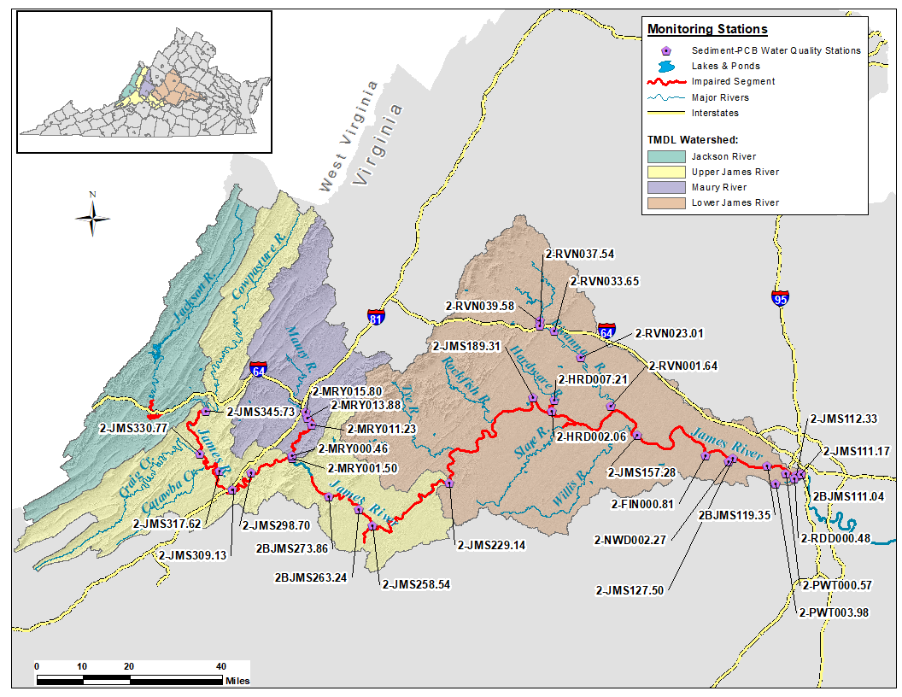
Figure 2-15. Sediment-associated PCB water quality stations in the James River study area. At these stations, sediment samples were collected and tested for sediment-attached PCB concentrations. The observed data from these stations were used to calculate initial concentrations in the PCB model.
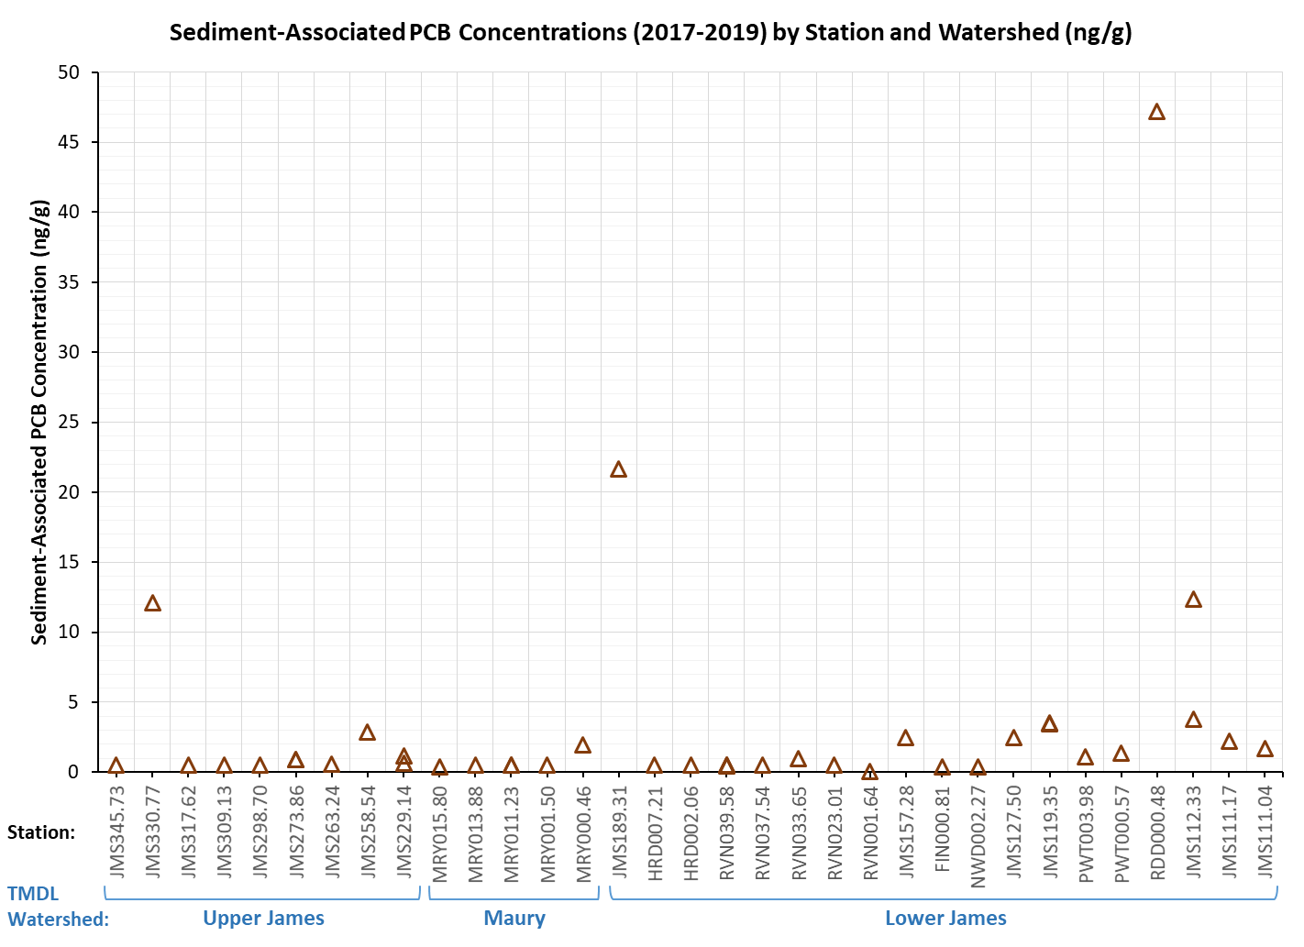
Figure 2-16. Sediment-associated PCB concentrations (ng PCBs/g sediment) in DEQ sediment samples. Observed data are partitioned by station and TMDL watershed and are graphed upstream to downstream (left to right).

Water Column tPCB Concentration Data
DEQ collected water column samples during dry/base flow and wet/elevated flow conditions from the James River and its tributaries to determine PCB concentrations in units of pg (picograms, 10⁻¹² g) per liter of water, which is the equivalent to parts per quadrillion (ppq). This concentration in the water column quantifies PCBs associated with suspended particulate matter as well as “dissolved” PCBs in the ambient water column, i.e., PCBs in the water and are not sediment associated. Figure 2-17 illustrates the station locations where samples were collected. Water column PCB concentration sample results are shown in Appendix B. For each water quality sample, DEQ summed the concentration from all detected PCB congeners to calculate the concentration of total PCBs (tPCB) in addition to the concentration of each PCB homolog group. The tPCB water column concentration was used to calibrate PCB fate and transport in the model. Two or fewer samples were collected in a single year at some water quality stations. Calibrating on the available water column tPCB concentration data used a “weight-of-evidence” approach that compared the simulated outputs using multiple lines of evidence. The PCB weight-of-evidence calibration process is detailed in Appendix F:.
Sediment concentration (SSC) and water column PCB data collected between 2017-2019, were used in the model. SSC and PCB samples were often collected on the same day. Using similar calibration periods for the sediment and PCB components of the model and employing observed sample data that were collected on the same day meant the PCB component of the James River PCB TMDL model could be confidently built on the sediment component.
Table 2-5 shows the number of samples in each TMDL watershed that exceeds its respective endpoint. Figure 2-18 shows the results of the 2017-2019 water column tPCB sampling, illustrating PCB concentrations from upstream to downstream in the study area. The y-axis of the graph is the water column tPCB concentration, and the x-axis shows the station ID sorted left to right from upstream to downstream. Stations are grouped by TMDL watershed, and the graph includes dashed lines for the endpoints of each TMDL watershed with values denoted in the legend. In each of the TMDL watersheds, at least one observed sample exceeded the endpoint concentration.

Table 2-5. Number of water quality samples exceeding their respective endpoint in each TMDL Watershed and percent exceedance.
TMDL Watershed | TMDL Endpoint (pg/L) | No. of Samples Exceeding Endpoint / No. of Samples | Percent Exceedance (%)
Jackson River | 580 | 2 / 13 | 15%
Upper James River | 120 | 41 / 52 | 77%
Maury River | 400 | 2 / 8 | 25%
Lower James River | 52 | 57/ 58 | 98%

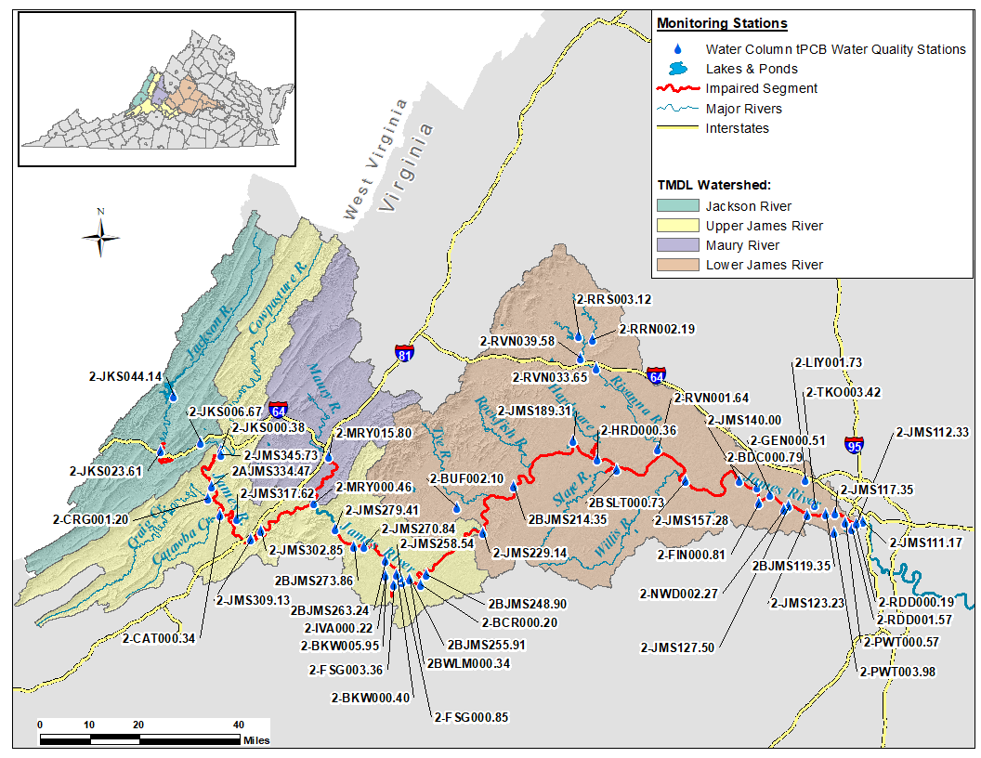
Figure 2-17. Water column tPCB water quality stations in the James River study area. These stations were used to conduct the PCB model calibration.
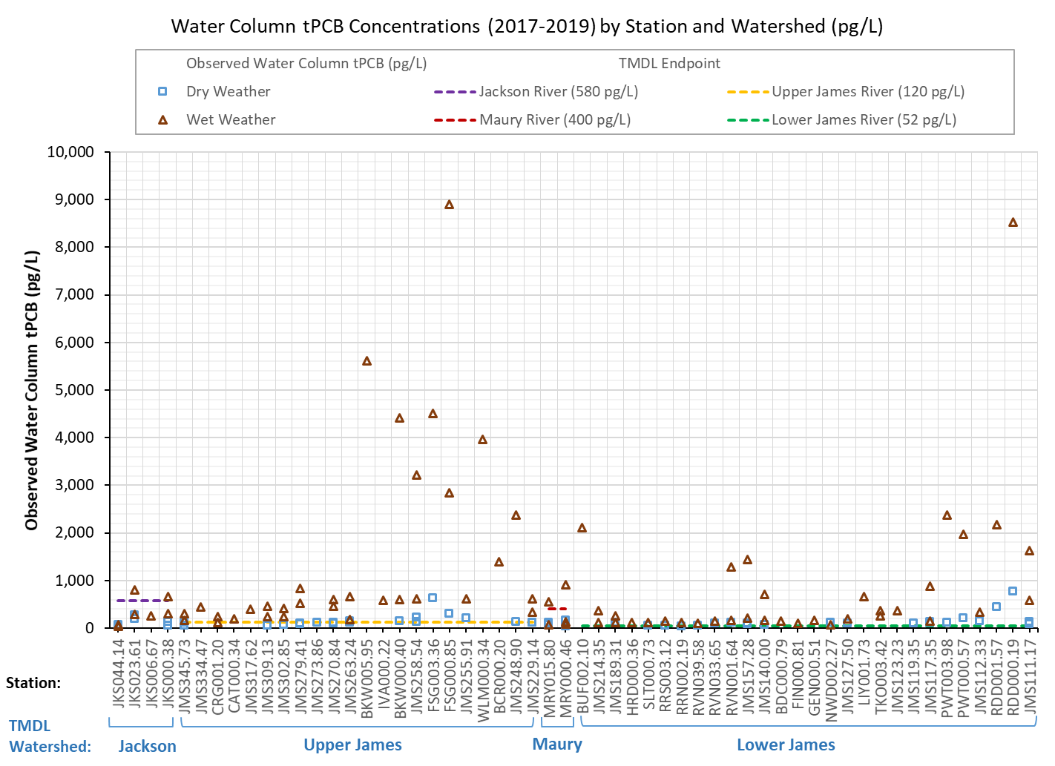
Figure 2-18. Water column tPCB concentrations (pg PCB/L water) from DEQ sampling used in the model. Observed data are partitioned by station and TMDL watershed. Graph lists stations upstream to downstream (left to right), with TMDL endpoints for each TMDL watershed.

Source Assessment
The source assessment chapter describes the currently available data on the sources of PCBs in the James, Maury and Jackson River PCB TMDL study area. Please refer to Appendix C for detailed information. Point- and nonpoint- sources contribute to the PCB loadings found in the impaired segments of the James River watershed. Permitted point sources (e.g., those that are regulated in the Virginia Pollutant Discharge Elimination System (VPDES)), include municipal wastewater treatment plants, and other permitted facilities from industrial or commercial activities that have been identified by DEQ as potentially contributing PCB loadings. Nonpoint sources include: known and suspected runoff (e.g., runoff from contaminated sites, railyards and railway spurs, electrical substations and pollutant spills); less certain sources are categorized as non-regulated surface sources and include uncharacterized sources that contribute background PCBs to the land and water surfaces; atmospheric deposition; and sediment within the channel stream bottom. This chapter describes the types of PCB sources and how they were included in the James River PCB TMDL model. Detailed information regarding the estimation of PCB loads for each of the sources found in James River study area can be found in Appendix C.

Permitted Sources
This section lists the specific permitted facilities that have been identified as possible sources of PCBs. VADEQ originally provided tPCB data from 102 Virginia Pollutant Discharge Elimination System (VPDES) permitted facility dischargers in the study area to use in establishing baseline loads and waste load allocations: 26 municipal wastewater treatment facilities, 2 municipal combined sewer systems (CSS), 58 industrial storm water general permitted facilities (ISWGP), and 16 individual industrial permitted facilities (IP). The tPCB data were either generated by the permittee or default values were utilized when absent. Additionally, VADEQ provided tPCB data from 22 terminated or expired VPDES permitted facility dischargers in the study area to use in establishing baseline loads: 2 municipal wastewater treatment facilities, 14 ISWGPs, and 6 industrial IPs. All three categories of permitted dischargers were modeled as point sources. Appendix C provides permit-specific details.
In addition to the permitted facilities there are eleven municipal separate storm sewer systems (MS4s) in the James River study area. These are municipal regions that convey impervious surface stormwater runoff from within their boundary through a permitted discharge point. MS4s will address the PCB load in their runoff that is discharged through their stormwater conveyance system. Additional details about the PCB loads from the MS4 permits are provided in Appendix C.

Nonpoint Sources
Nonpoint sources included contaminated sites, stormwater runoff from unregulated surface sources (including unregulated stormwater, unidentified contaminated sites, loads from small tributaries, atmospheric deposition to land surfaces, and unspecified point sources), atmospheric deposition to the surface water, and streambed sediment. Table 3-1 lists the nonpoint sources considered in the James River PCB TMDL.
Table 3-1. James River nonpoint PCB sources.
Nonpoint Sources | PCB Load
Contaminated Sites
Volunteer Remediation Program Sites | Varies by site
Railyards and Railway Spurs | 7.02 x 10¹⁰ pg PCB/ton of sediment
Electrical Substation | 1.29 x 10¹² pg/PCB/ton of sediment
Pollution Response Program (PREP) Spills | Varies by Spill
Surface Sources
Unregulated Surface Sources¹ | Varies by land use category
Atmospheric Deposition | 8.90 x 10³ pg/m²/year
Streambed Sediment | Varies by stream segment
¹ Unregulated surface sources represent PCB loads supported by the observed data whose specific location have yet to be identified.

Contaminated Sites
The PCB load for contaminated sites is modeled as a potency factor that estimates the mass of PCBs washed off per ton of sediment runoff from the contaminated site. Contaminated sites with the potential for long-term contamination of the soil, such as former manufacturing facilities with known PCB contamination, terminated permit sites, railyards, and electrical substations, were assigned “contaminated” land use categories that are similar hydrologically, pedologically and geophysically to the existing land use types (e.g., Forest, Cropland, Pasture, Residential, etc.). Since the location of Pollution Response Program (PREP) spills have been recorded in VDEQ’s PREP database, these PCB sources are also identified as loads from contaminated sites. However, because a PREP spill is an isolated incident, PREP PCB spills were modeled as direct inputs into the stream or as deposition onto the land surface as a “one-time” event based on the recorded date of the spill.

Unregulated Surface Sources
Unregulated surface source is a term that collectively describes PCB loadings from uncertain origins that drain to the James, Maury and Jackson Rivers during runoff events. This source category represents PCB load concentrations observed in instream water column samples, but whose specific location have yet to be identified. The term “direct drainage” was used in the Potomac River PCB TMDL to describe unregulated stormwater runoff, unidentified contaminated sites, and unspecified point source discharges (ICPRB, 2007). The Roanoke River PCB TMDL referred to these as “urban background/unidentified sources” (DEQ, 2009) whereas these source types were recognized as “uncharacterized sources” in the New River PCB TMDL (DEQ, 2018). Sources in the James River PCB TMDL study area that are recognized as contributing to the land surface category include loads from unidentified contaminated sites, unregulated stormwater runoff from commercial land use areas, atmospheric deposition to land surfaces, loads from small tributaries that are not explicitly specified in the model, and unspecified point source discharges. Unregulated surface sources were modeled as a load applied to all land area not part of the contaminated sites, railyards, electrical substations, or PREP spills. DEQ will continue to search for these unaccounted sources that contribute to the PCB impairment as part of TMDL implementation and upon identification, will identify mechanisms to target load reductions.

Atmospheric Deposition
Atmospheric deposition is due to aerosolized PCBs that settle out of the atmosphere. This source was applied on all water surfaces in the James, Maury and Jackson River watersheds at a constant rate throughout the year.

Streambed Sediment
The streambed sediment source accounts for legacy PCBs that are present in the aquatic environment and are adsorbed to sediment.

Biosolids
Twenty-six VPDES Municipal WWTPs are considered potential sources of PCBs to the James, Maury, Jackson River watersheds and are allocated a load. Whether legacy or from more recent sources, PCBs can originate from unknown areas within municipality collection systems where conveyance to the treatment plants occurs. After treatment, a small percentage can be released with the effluent. Observations have shown that PCB concentrations entering WWTPs via influents are typically elevated when compared to the concentrations that exit the facilities. Given PCBs extreme hydrophobicity, the tendency is for PCBs to adsorb to available solids. WWTPs, operating properly, can remove 80-99% of solids from the WWTP effluent. Given this, it is reasonable to conclude that most PCBs are settling out of WWTP’s in sewage sludge.
When treated and used for agronomic purposes, sewage sludge is referred to as biosolids, and requires a permit administered under the Virginia Pollution Abatement (VPA) permit program (9VAC25-32-10 et. seq.) or the VPDES permit program (9VAC25-31-10 et seq.). When biosolids are land applied, regulations require treatment to significantly reduce pathogens and vector attraction. Regulations also include pollutant concentration limits for heavy metals and PCBs. Section 9VAC25-32-317 of the VPA permit program requires that PCBs be monitored within sewage sludge and are considered acceptable for application only when the concentration is less than 50 mg/Kg (ppm) of total solids (dry weight basis). Permit regulations also require spreading according to sound agronomic requirements with consideration for topography, hydrology, and the use of appropriate setbacks depending on site-specific conditions.
While it has been the practice to apply biosolids at numerous fields within the study area, application sites are likely insignificant sources of PCBs in the James, Maury and Jackson River watersheds. Samples collected from fields located in other watersheds in Virginia that have received biosolids applications show an arithmetic mean concentration of 0.15 mg/Kg, well below the allowed 50 mg/Kg. Further, with adherence to the agronomic requirements specified in the VPA regulations, prospective loadings derived from stormwater runoff from this source would be considered de minimis.

TMDL Technical Approach
A key component in developing a TMDL is establishing the relationship between pollutant loadings (both point and nonpoint) and instream water quality conditions. Once this relationship is developed, management options for reducing pollutant loadings to streams can be assessed. In developing a TMDL, it is critical to understand the processes that affect the fate and transport of the pollutants that are impairing the waterbody of concern. Pollutant fate and transport was evaluated using a variety of tools, including monitoring, geographic information systems (GIS), and computer simulation models. This chapter discusses the critical considerations and modeling framework.

Critical Considerations
PCBs exist in the environment in many different forms, i.e., as a suspended airborne contaminate, as a freely available (“dissolved”) constituent in the water column, attached to suspended particulates in the water column, attached to sediment deposited on the streambed, and associated with soils on the land surface (e.g., contaminated sites). Understanding the PCB concentrations found in each of these forms requires an understanding of the fate and transport of PCBs within a watershed. Establishing a strong hydrologic representation (or model) of the watershed is an important initial step in assessing the fate and transport of PCBs in the environment. A sufficiently well-calibrated hydrologic model creates a foundation upon which the model’s pollutant fate and transport components can be developed.
A critical assumption when developing the James River PCB TMDL pollutant fate and transport model is that the water quality grab samples collected by DEQ were representative of the stream cross section. For this to be entirely accurate, the section of stream would need to be a continuously well-mixed medium when sampled. In reality, this is likely not the case. However, this is a necessary assumption because continuous sampling across the entire cross section of every stream and tributary is not feasible. To account for this and other uncertainties inherent in pollutant fate and transport modeling, a conservative modeling approach was used to ensure that the model did not underestimate PCB concentration. Additionally, an explicit margin of safety (MOS) of 5% was incorporated into the TMDL.

Modeling Framework
The TMDL development process often relies on the use of a watershed-based model that integrates both point and nonpoint pollutant sources and simulates instream hydrologic and water quality processes. The Hydrological Simulation Program–FORTRAN (HSPF) version 12 (Bicknell et al., 2005) was used to model sediment and PCB transport and fate in the James River study area.
The HSPF model simulates nonpoint source runoff and pollutant loadings, performs flow routing through streams, and simulates instream water quality processes. HSPF estimates runoff from both pervious and impervious parts of the watershed and stream flow in the channel network. The sub-module PWATER (water budget pervious) within the PERLND (pervious land) module simulates runoff from pervious areas (e.g., agricultural land). Runoff from impervious areas is modeled using the IWATER (water budget impervious) sub-module within the IMPLND (impervious land) module. The simulation of flow through the stream network is performed using the HYDR (hydraulic behavior) and ADCALC (advection of fully restrained constituents) sub-modules within the RCHRES (stream reaches and reservoirs) module. While HYDR routes the water through the stream network, ADCALC calculates variables used for simulating convective transport of the pollutant in-stream.
Fate and transport of PCBs on pervious and impervious land segments is simulated using the SEDMNT (sediment production and removal) and PQUAL (quality constituents pervious) sub-modules within the PERLND module and SOLIDS (solids accumulation and removal) and IQUAL (quality constituents impervious) sub-modules within the IMPLND module. Fate and transport of PCBs in stream water is simulated using the sediment transport (SEDTRN) sub-module and general constituent pollutant (GQUAL) sub-module within the RCHRES module. Each component of HSPF contains a series of parameters that control hydrologic and constituent behavior. During calibration, model parameters and pollutant sources are adjusted. The simulated outputs were analyzed against the observed data, and if an adequate calibration was not achieved then the parameters and source loads were further adjusted in an iterative cycle. Model development and calibration are further explained in the next chapter and Appendices D, E, and F.

Model Setup for PCB TMDL Development
Building the James River study area PCB TMDL HSPF model involved two major stages. The first stage involved watershed characterization where relevant meteorological, hydrological and constituent source data were collected, processed, and converted into variables and parameters for the model. The second stage, calibration, entailed comparing the model outputs with observed data and adjusting model parameters and variables until the model adequately simulated the observed data. This chapter provides a summary of model development.

Watershed Segmentation
One of the first steps in the watershed characterization process was delineating the watershed into subwatersheds in order to capture the diversity in hydrology and geomorphology. The study area consists of four TMDL watersheds subdivided based on the location of major tributary junctions and PCB impaired segments. Organizing by major tributaries helped expedite modeling processes due to the large size of the James River study area. Dividing the study area into subwatersheds allowed for more detailed and representative modeling. Rather than assuming the entire watershed is hydrologically homogenous, each subwatershed featured different parameters and proportions of land use types. Subwatersheds were delineated based on the stream network, hydrologic and land use variability, and the locations of PCB sources and DEQ water quality monitoring stations. Where possible, subwatersheds were typically delineated so that a subwatershed outlet coincided with a DEQ water quality monitoring station. This ensured better comparability of simulated and observed data. Table 2-1 includes the number of subwatersheds and respective areas for each TMDL watershed. Figure 2-2 shows the relative position of the subwatersheds within the James River study area.

Input Data Requirements

Land Use, Soils, and Topography Data
Land use, soils, and topographic data were used for estimating various model parameters. Soils data were used to estimate hydrologic parameters that determine surface, interflow, and groundwater patterns, ultimately impacting the water balance. Land use data were used to determine the percentage of pervious and impervious surface area. Stream network data from the high-resolution National Hydrography Dataset (NHDPlusHR) were used to identify perennial streams and the primary stream network (USGS, 2019). Topography was assessed using seamless 10-meter resolution digital elevation models from the USGS 3D Elevation Program (USGS, 2019) and were the basis for subwatershed delineation and calculating terrain slopes. Additional detail about the data discussed here is provided in Chapter 2.

Meteorological Data
Meteorological data (e.g., precipitation, temperature, wind speed, dew point temperature, percent sun) drive mass balance, water quality models like HSPF. The James River PCB TMDL model was developed using meteorology measurements from weather stations that are monitored and quality controlled by the NCEI (NCEI, 2019). The data from these stations (Table 2-2) were accessed to generate time series inputs for meteorological variables which were then used to calculate the water balance. Generally, the data provided by the NCEI were recorded in daily intervals. Since the model simulated at hourly time steps, an HSPF supplemental application called WDMUtil, a utility program to manage Watershed Data Management (WDM) files, was used to disaggregate the daily meteorological data into hourly data.

Hydrologic Withdrawals
Water withdrawals were identified in the James River study area that potentially influence stream flow rate over time (Table 5-1). Monthly withdrawal data were used to estimate average daily withdrawal rates for the facilities. These withdrawals were simulated using time series applied to the specific reach within each subwatershed.

Table 5-1. Withdrawal rates used in modeling the James River study area.
TMDL Watershed | Facility | Major Tributary | Withdrawal Rates (mgd)¹
Jackson | Paint Bank Fish Cultural Sta. | Jackson River | 3.57
 | Covington Plant Westrock | Jackson River | 37.27
 | Jackson River WTP² | Jackson River | 2.53
 | Clifton Forge WTP² | Jackson River | 1.12
 | Homestead Golf Irrigation & Snow Production | Jackson River | 0.03
 | Virginia Hot Springs | Jackson River | 0.85
 | Bath County Regional Water System | Jackson River | 0.03
 | Laurel Hill Trout Farm-South Monterey | Jackson River | 3.12
Maury | Ingleside Dairy Farm, Inc. | Maury River | 0 – 0.02
 | Buena Vista Plant (Modine) | Maury River | 0.02
 | Lexington Golf & Country Club | Maury River | 0.03
 | Maury River WTP² | Maury River | 1.35
 | Goshen Service Area | Maury River | 0.05
 | Laurel Hill Trout Farm - Goshen | Maury River | 0.8
 | Craigsville Service Area | Maury River | 0.18
 | Augusta Springs Service Area | Maury River | 0.07
Upper James | College Hill WTP² | James River - Fishing Cr. | 0.41
 | Tinker Cr-Catawba Cr Diversion | Catawba Cr. | 1.55
 | Boonsboro Country Club | James River - Fishing Cr. | 0.04
 | Eagle Eyrie WTP² | James River - Fishing Cr. | 0.02
 | Amherst County Service Area - Lanum WTP² | James River - Fishing Cr. | 0.35 – 0.7
 | Abert WTP² | James River - Fishing Cr. | 0.3
 | Riverville Mill WTP² | James River - Fishing Cr. | 6.31
 | Georgia-Pacific Big Island WTP² | James River - Fishing Cr. | 14.74
 | New Castle Plant | Craig Cr. | 0.09
 | Gladstone Service Area | James River - Fishing Cr. | 0
 | Pedlar Reservoir Intake | James River - Fishing Cr. | 9.69
 | Cliftondale Country Club | Cowpasture River | 0
 | Millboro Service Area | Cowpasture River | 0.11
 | Coursey Spring Fisheries | Cowpasture River | 13.63
Lower James | Willis Mountain Mining Complex | Willis River | 0.02
 | Windy Hill Sports Complex | James River - Reedy Cr. | 0.01
 | James H. Ritchie | James River - Reedy Cr. | 0
 | Willow Oaks Country Club | James River - Reedy Cr. | 0.05
 | Richmond (City) WTP² | James River - Reedy Cr. | 62.91
 | Henrico County WTP² | James River - Reedy Cr. | 24.55
 | The Country Club of Virginia-Westhampton | James River - Reedy Cr. | 0.05
 | Foundry Golf Club | James River - Reedy Cr. | 0.04
 | Richmond Country Club, Inc | James River - Reedy Cr. | 0.02
 | Amherst (Town) WTP² | Tye River | 0.3
 | Kanawha Club | James River - Reedy Cr. | 0.01
 | James River Corr. Cntr WTP² | James River - Reedy Cr. | 0.57
 | Hermitage Golf Course | James River - Reedy Cr. | 0.09
 | Kelona Farms Inc | James River - Reedy Cr. | 0.01
 | Storage Reservoir (Cvwsc) | Hardware & Slate Rivers | 1.44
 | Royal Stone Plant | James River - Reedy Cr. | 0.22 – 0.77
 | Anderson Creek Quarry | James River - Reedy Cr. | 0.33
 | East Coast Transport, James River Intake | Hardware & Slate Rivers | 6.55
 | Bremo Bluff Power Plant | Hardware & Slate Rivers | 0.02
 | Saunders Brothers, Inc. | Tye River | 0 – 0.2
 | Cobbs Creek Reservoir Temporary Construction Withdrawal | Hardware & Slate Rivers | 0.03
 | Rees Vineyard | Rockfish River | 0
 | Thomas Wheaton | Tye River | 0
 | Lovingston Service Area | Tye River | 0.03
 | Schuyler Service Area | Rockfish River | 0.02
 | Scottsville WTP² | Rockfish River | 0 – 0.05
 | Montebello Fish Station | Tye River | 0.07 – 0.61
 | Lake Monticello Golf Course | Rivanna River | 0.01
 | Lake Monacan-Stoney Creek (Wintergreen) | Rockfish River | 0.32 – 0.52
 | Lake Monticello WTP² | Rivanna River | 0.54
 | Glenmore Country Club | Rivanna River | 0.04
 | Fluvanna Correctional Unit | Rivanna River | 0.2
 | Keswick Hall & Golf Club | Rivanna River | 0.1
 | Observatory Hill WTP² | Rivanna River | 1.38 – 1.51
 | Birdwood Golf Course | Rivanna River | 0.1
 | Meadowcreek Golf Course | Rivanna River | 0.01
 | Old Trail Golf Club | Rivanna River | 0.04
 | Crozet WTP² | Rivanna River | 0.62
 | Farmington Country Club | Rivanna River | 0.1
 | South Rivanna WTP² | Rivanna River | 7.19
 | North Rivanna WTP² | Rivanna River | 0.36
¹million gallons per day
²Water Treatment Plant

Representation of Sources
The James River PCB model simulates the fate and transport of sediment and PCBs through the watershed. This section describes how the loads for both constituents are categorized and input into the model. Loads are input into the model as point sources or rainfall-runoff driven nonpoint sources.

Sediment Sources

Surface Runoff
Instream sediment is part of a healthy ecosystem and serves an important role in the environment. When modeling sediment sources for this TMDL, the goal is not to limit the concentration of sediment instream but to understand the fate of this primary transport vector for PCBs from surface detachment, to runoff, to instream suspended sediment. One significant source of PCBs in the study area is contaminated land areas (both known and unknown). Since PCBs have a high affinity for sediment, the sediment washoff from these land areas can contaminate the stream network with the attached PCBs. Sediment is washed off the land surface through two steps: detachment and removal. Within the model, soil and sediment are detached and “stored” on the land surface through raindrop impact. Sediment is then available for wash off during a surface runoff event. When runoff occurs, the soil and sediment are carried into the stream network. The surface runoff of sediment is a nonpoint source of sediment.

Channel Bed Sediment Scouring
When stream velocity is sufficiently high, the streambed will experience increased shear stress. This shear stress can cause bed sediment to be scoured, suspended into the water column, and carried downstream (Figure 5-1). HSPF is capable of simulating this process. HSPF simulates scour, transport, and deposition. Channel scouring is considered a nonpoint source of sediment because it occurs throughout the stream and is generally a major contributor to observed PCB concentrations after significant precipitation events.
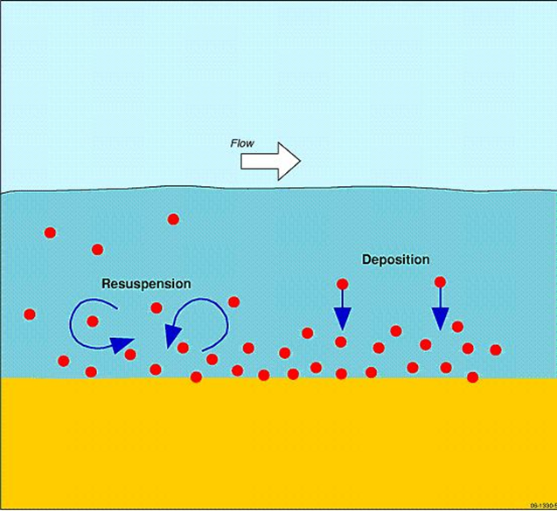
Figure 5-1. Scouring/resuspension and deposition of sediment in a stream (OzCoasts, 2021).

Permitted Sediment Sources
A contributing category of sediment to the study area are permitted point source facilities. The effluent from facilities such as wastewater treatment plants (WWTPs) and industrial plants are monitored and measured for total suspended solids (TSS). The loads from these facilities contribute to the instream suspended sediment concentrations (SSC). They are input into the model with a single point of entry into the stream network. Table 5-2 details the mean monthly flow rate, the mean monthly TSS concentrations for the permitted sources, and the timeframe these mean values encompass.

Table 5-2. Permitted TSS point sources in James River study area.
TMDL Watershed | Facility Name | Permit ID | Mean Monthly Flow  (mgd)ª | Mean TSS (mg/L) | Data Timeframe | Receiving Stream
Jackson River | CSX Transportation Inc - Clifton Forge^{b} | VA0003344 | 0.047 | 0.000 | 1/08-7/16 | Jackson River
 | Rail Over River Industrial Park LLC^{b} | VA0003450 | 0.151 | 4.575 | 1/08-1/15 | Jackson River
 | WestRock Virginia LLC - Covington | VA0003646 | 0.000 | 3.114 | 1/08-1/19 | Jackson River
 | Clifton Forge Town Wastewater Treatment Plant^{b} | VA0022772 | 1.512 | 0.12 | 1/08-9/14 | Jackson River
 | Covington City - Wastewater Treatment Plant | VA0025542 | 1.923 | 0.836 | 1/08-12/19 | Jackson River
 | Alleghany County - Low Moor WWTP | VA0027979 | 0.155 | 2.918 | 1/08-12/19 | Jackson River
 | Dominion Energy - Bath County Power Station | VA0053317 | 4.862 | 1.617 | 1/08-12/19 | Back Creek
 | Hot Springs Regional STP | VA0066303 | 0.316 | 4.089 | 1/08-12/19 | Hot Springs Run
 | Alleghany Co - Lower Jackson River Regional WWTP | VA0090671 | 1.028 | 2.004 | 10/10-12/19 | Jackson River
Maury River | Modine Manufacturing Co - Buena Vista | VA0002771 | 0.050 | 0.060 | 1/08-12/19 | Noels Run
 | Mohawk Industries Inc | VA0004677 | 0.390 | 0.329 | 1/08-12/19 | Maury River
 | Bontex Inc | VA0004791 | 0.268 | 0.725 | 1/08-12/19 | Maury River
 | Buena Vista STP | VA0020991 | 3.528 | 0.330 | 1/08-12/19 | Maury River
 | Lexington-Rockbridge Regional WQCF | VA0088161 | 0.903 | 4.305 | 1/08-12/19 | Maury River
 | DOC - Augusta Correctional Center | VA0091821 | 0.408 | 0.799 | 9/08-12/19 | Smith Creek
Upper James | GP Big Island LLC | VA0003026 | 11.942 | 0.888 | 1/08-12/19 | James River
 | BWXT Nuclear Operations Group Inc | VA0003697 | 1.057 | 5.243 | 1/08-12/19 | James River
 | Framatome Inc - MAR | VA0004774 | 0.003 | 0.126 | 1/08-12/19 | James River
 | VCI Lynchburg Foundry^{b} | VA0006262 | 0.321 | 3.497 | 1/08-10/11 | James River
 | Greif Riverville LLC - Fibre Plant | VA0006408 | 5.914 | 0.949 | 1/08-12/19 | James River
 | Buchanan Town - Sewage Treatment Plant | VA0022225 | 0.064 | 1.038 | 1/08-12/19 | James River
 | Lynchburg Regional Wastewater Treatment Plant | VA0024970 | 11.760 | 0.236 | 1/08-12/19 | James River
 | Amherst Co Service Authority Ivanhoe | VA0063657 | 0.005 | 0.217 | 1/08-12/19 | Fawn Creek, UT
 | Craig New Castle PSA WWTP Outfall 001 | VA0064599 | 0.183 | 3.437 | 1/08-12/19 | Craig Creek
 | Roanoke Cement Co - Botetourt County | VA0072397 | 3.456 | 0.000 | 1/08-12/19 | Catawba Creek
 | Western Virginia Water Authority (WVWA) Eagle Rock WWTP Outfall 001 | VA0076350 | 0.008 | 0.166 | 1/08-12/19 | James River
 | Town of Glasgow WWTP | VA0083712 | 0.268 | 1.631 | 1/08-12/19 | James River
 | Reusens Hydroelectric Plant | VA0087114 | 1.420 | 0.000 | 1/08-12/19 | James River
 | Western Virginia Water Authority (WVWA) Glen Wilton WWTP | VA0089273 | 0.004 | 0.738 | 1/08-12/19 | James River
 | Campbell County Landfill^{b} | VA0091723 | 0.024 | 0.000 | 1/08-3/14 | UT, Tussocky Creek
 | Falwell Industrial Landfill^{b} | VA0092258 | 0.014 | 0.000 | 4/09-1/16 | UT, Little Opossum Creek
Lower James | Dominion - Bremo Power Station | VA0004138 | 2.948 | 0.341 | 1/08-12/19 | James River
 | James River Correction Center | VA0020681 | 0.060 | 5.476 | 1/08-12/19 | James River
 | DOC Powhatan Correctional Center | VA0020699 | 0.240 | 1.535 | 1/08-12/19 | James River, UT
 | VA Correctional Center for Women | VA0020702 | 0.195 | 1.152 | 1/08-12/19 | James River
 | Scottsville WRRF | VA0025470 | 0.066 | 1.647 | 1/08-12/19 | James River
 | Camelot WWTP^{b} | VA0025488 | 0.135 | 5.858 | 1/08-1/13 | Moores Creek
 | Moores Creek Advanced Water Resource Recovery Facility | VA0025518 | 9.691 | 0.758 | 1/08-12/19 | Moores Creek
 | Cooper Industries LLC | VA0027065 | 0.010 | 0.000 | 1/08-12/19 | South Fork Rivanna River, UT
 | Buckingham Co Water System/Dillwyn STP | VA0027294 | 0.054 | 1.382 | 1/08-12/19 | Whispering Creek, UT
 | Rutledge Creek WWTP | VA0031321 | 0.312 | 2.892 | 1/08-12/19 | Rutledge Creek
 | DOC - Buckingham Correctional Center | VA0066460 | 0.244 | 2.405 | 1/08-12/19 | Turpin Creek
 | Glenmore WRRF | VA0086584 | 0.117 | 1.562 | 1/08-12/19 | Rivanna River
 | Amherst County Landfill Permit Number 181 | VA0088684 | 0.022 | 0.000 | 1/08-12/19 | Buffalo River, UT
 | Nelson County Regional STP | VA0089729 | 0.120 | 1.422 | 1/08-12/19 | Black Creek
 | Dutoy Creek WWTP | VA0090727 | 0.060 | 0.867 | 1/08-12/19 | Dutoy Creek, UT
 | Dominion Energy - Bear Garden Generating Station | VA0090891 | 0.673 | 0.000 | 1/11-12/19 | James River
 | Tenaska Virginia Generating Station | VA0090905 | 1.525 | 0.000 | 1/08-12/19 | Rivanna River
ªmillion gallons per day; ^{b}site is no longer active.

PCB Sources

Point Source Dischargers
The James River Study area contains four types of VPDES permits that are modeled as point sources for PCBs: municipal wastewater treatment plants (WWTP), combined sewer systems (CSS), industrial stormwater general permits (ISWGP), and individual industrial permitted facilities (IP). DEQ provided flow and mean concentration information for permitted point sources of PCBs (Tables 5-3 to 5-6), respectively. The mean flows for WWTPs and IPs are calculated from the Discharge Monitoring Reports (DMR) for the period January 2008 to June 2019. Mean flows for ISWGPs were calculated from the facility drainage areas. As noted in the table, the mean tPCB concentration for many of these point sources is based on statewide Standard Industrial Classification (SIC) default values (DEQ, 2016) since they were not screened for PCBs during TMDL development. Refer to Appendix C for greater detail on the approach used to calculate point source loads.

Table 5-3. Municipal Wastewater Treatment Plant (WWTP) Facilities in the James River study area.
TMDL Watershed | Facility Name | Permit ID | Mean Flow (mgd)ª | Mean tPCB Concentration (pg/L)
Jackson River | Covington City - Wastewater Treatment Plant | VA0025542 | 1.9190 | 938.9
 | Alleghany County - Low Moor WWTP | VA0027979 | 0.1543 | 255.6
 | Hot Springs Regional STP | VA0066303 | 0.3159 | 1,707.1^{b}
 | Alleghany Co - Lower Jackson River Regional WWTP | VA0090671 | 0.9646 | 1,707.1^{b}
Maury River | Buena Vista STP | VA0020991 | 1.3128 | 1,707.1^{b}
 | Lexington-Rockbridge Regional WQCF | VA0088161 | 0.9025 | 1,707.1^{b}
 | DOC - Augusta Correctional Center | VA0091821 | 0.3691 | 250.3
Upper James | Buchanan Town - Sewage Treatment Plant | VA0022225 | 0.0641 | 183.3
 | Lynchburg Regional Wastewater Treatment Plant | VA0024970 | 11.8727 | 712.9
 | Amherst Co Service Authority Ivanhoe | VA0063657 | 0.0046 | 1,640.9
 | Craig New Castle PSA WWTP Outfall 001 | VA0064599 | 0.1831 | 142.4
 | Western Virginia Water Authority (WVWA) Eagle Rock WWTP Outfall 001 | VA0076350 | 0.0084 | 577.3
 | Town of Glasgow WWTP | VA0083712 | 0.2673 | 607.7
 | Western Virginia Water Authority (WVWA) Glen Wilton WWTP | VA0089273 | 0.0038 | 780.8
Lower James | James River Correction Center | VA0020681 | 0.0446 | 1,707.1^{b}
 | DOC Powhatan Correctional Center | VA0020699 | 0.2366 | 1,707.1^{b}
 | VA Correctional Center for Women | VA0020702 | 0.1668 | 1,707.1^{b}
 | Moores Creek Advanced Water Resource Recovery Facility | VA0025518 | 9.7148 | 1,707.1^{b}
 | Buckingham Co Water System/Dillwyn STP | VA0027294 | 0.0542 | 1,707.1^{b}
 | Rutledge Creek WWTP | VA0031321 | 0.3156 | 1,707.1^{b}
 | Scottsville WRRF | VA0025470 | 0.0665 | 1,707.1^{b}
 | DOC - Buckingham Correctional Center | VA0066460 | 0.2476 | 1,707.1^{b}
 | Glenmore WRRF | VA0086584 | 0.1173 | 1,707.1^{b}
 | Nelson County Regional STP | VA0089729 | 0.1229 | 1,707.1^{b}
 | ^{c}Oilville Wastewater Treatment Plant | VA0092428 | <0.3000 | 1,707.1^{b}
 | Dutoy Creek WWTP | VA0090727 | 0.0370 | 17.7
ªmillion gallons per day; Municipal Facility mean flows calculated from DMRs from Jan. 2008-Dec. 2019.
^{b}Default tPCB concentration based on a statewide municipal dataset (DEQ, 2016).
^{c}Facility not built.

Table 5-4. Municipal Combined Sewer Systems (CSS) in the James River study area.
TMDL Watershed | Combined Sewer System | Permit ID | Drainage Area (acres) | Mean tPCB Concentration (pg/L)
Upper James | City of Lynchburg | VA0024970 | 1,137.4 | 159,265
Lower James | City of Richmondª | VA0063177 | 11,098.9 | 11,906.68
ª Acreages are based on the outfalls that drain into the Lower James River TMDL watershed. The outfalls that drain into the tidal portion of the James are not included.

Table 5-5. Industrial Stormwater General Permit (ISWGP) Facilities in the James River study area.
TMDL Watershed | Facility Name | Permit ID |  | Mean Flow (mgd)ª | Mean tPCB Concentration (pg/L)
Jackson River | Chemtrade Solutions LLC - Covington | VAR050182 | 0.002 |  | 2,333.0^{b}
 | Material Handlings Solutions | VAR050440 | 0.046 |  | 580
 | Covington City - Peters Mountain Landfill | VAR051392 | 0.004 |  | 1,738.6^{b}
 | WestRock Virginia LLC - Low Moor Converting Plant | VAR052319 | 0.034 |  | 1,496.0^{b}
Maury River | Blue Ridge Resource Authority | VAR051408 | 0.032 |  | 1,738.6
 | Southers Auto Salvage LLC | VAR051827 | 0.007 |  | 1,169.7^{b}
 | Auto Recyclers LLC | VAR051901 | 0.021 |  | 678,247
 | Auto Towing and Repair LLC | VAR052111 | 0.003 |  | 1,169.7^{b}
 | City of Lexington Public Works Facility | VAR052411 | 0.0.1 |  | 17,923.0^{b}
Upper James | Virginia Auto Parts Incorporated | VAR050167 | 0.012 |  | 1,169.7^{b}
 | Candler Oil Company Incorporated | VAR050169 | 0.005 |  | 822.1^{b}
 | Davis-Frost Inc | VAR050172 | 0.008 |  | 36.5
 | Delta Star Incorporated | VAR050173 | 0.041 |  | 1,325.0
 | Crawford Oil Company Incorporated | VAR050181 | 0.006 |  | 822.1^{b}
 | Parker Hannifin Corporation - Powertrain Division | VAR050261 | 0.023 |  | 192.0^{b}
 | Flowserve Lynchburg Operations | VAR050266 | 0.007 |  | 5,103
 | Schwerman Trucking Company | VAR050270 | 0.008 |  | 3,408^{b}
 | Hanwha Azdel | VAR050391 | 0.019 |  | 192^{b}
 | United Parcel Service Inc - Lynchburg | VAR050447 | 0.001 |  | 3,408^{b}
 | WestRock Converting LLC | VAR050524 | 0.017 |  | 3,422
 | Republic Services of Lynchburg | VAR050710 | 0.019 |  | 17,923.0^{b}
 | Botetourt County Landfill | VAR050712 | 0.628 |  | 1,738.6^{b}
 | Cooper Steel of Virginia LLC | VAR050737 | 0.018 |  | 3,469.9^{b}
 | Amherst County Landfill Permit Number 563 | VAR051354 | 0.003 |  | 297.4
 | Rolling Frito-Lay Sales LP - Lynchburg Bin | VAR051551 | 0.001 |  | 3,408^{b}
 | International Paper Company | VAR051585 | 0.023 |  | 1,402.5
 | KDC/One Lynchburg | VAR051906 | 0.003 |  | 2,333.0^{b}
 | Sonoco Recycling LLC - Madison Heights | VAR051959 | 0.018 |  | 51,860.2
 | Region 2000 Regional Landfill - Livestock Rd Fac | VAR051994 | 0.021 |  | 255
 | Watts Petroleum Corporation - Lynchburg | VAR052022 | 0.002 |  | 822.1
 | Banker Steel Company LLC | VAR052109 | 0.006 |  | 3,469.9^{b}
 | Madison Heights Auto Parts | VAR052182 | 0.028 |  | 1,474
 | Griffin Pipe Products Co LLC - Lynchburg | VAR052212 | 0.036 |  | 14,670.6^{b}
 | Porters Properties Lynchburg LLC | VAR052226 | 0.021 |  | 495.7
 | Foss Industrial Recycling LLC - Lynchburg | VAR052309 | 0.015 |  | 150,186.7^{b}
 | Munters - Natural Bridge Station | VAR052383 | 0.003 |  | 3,378.1
 | AOC Metal Works - Lynchburg | VAR052393 | 0.004 |  | 611.0^{b}
 | BRC Investments LLC | VAR052403 | 0.002 |  | 150,186.7^{b}
 | Slocum Adhesives Corporation | VAR052456 | 0.003 |  | 2,333.0^{b}
 | Clear Water Manufacturing | VAR052508 | 0.033 |  | 1,584^{b}
 | Slocum Adhesives Corporation- Carroll Ave | VAR052530 | 0.003 |  | 2,333
Lower James | Glad Manufacturing Company | VAR050222 | 0.040 |  | 44.7
 | Brooks Auto Sales | VAR050630 | 0.007 |  | 1,169.7^{b}
 | UPS Freight- Richmond | VAR050657 | 0.005 |  | 3,408.0^{b}
 | 623 Landfill | VAR050730 | 0.067 |  | 9,874^{b}
 | United Parcel Service - Charlottesville | VAR050780 | 0.001 |  | 3,408.0^{b}
 | BFI Fluvanna Transcyclery | VAR050820 | 0.007 |  | 150,186.7^{b}
 | M and M Service and Salvage Yard Incorporated | VAR050960 | 0.019 |  | 1,169.7^{b}
 | Harry A Wright's Inc | VAR050965 | 0.048 |  | 1,169.7^{b}
 | Ivy Materials Utilization Center | VAR050973 | 0.035 |  | 17,923.0^{b}
 | Republic Services of Charlottesville | VAR050974 | 0.002 |  | 17,923^{b}
 | Chesterfield Auto Parts | VAR051102 | 0.046 |  | 1,169.7^{b}
 | Mullite Plant | VAR051580 | 0.006 |  | 2,333.0^{b}
 | Van Der Linde Recycling | VAR051853 | 0.005 |  | 150,186.7^{b}
 | Buckingham Branch Railroad | VAR051926 | 0.001 |  | 3,054.0
 | County Line Auto Parts | VAR052030 | 0.020 |  | 1,169.7^{b}
 | Morris Industries Incorporated | VAR052269 | 0.002 |  | 1,584.0^{b}
 | Tenaska Virginia Generating Station | VAR052356 | 0.027 |  | 125.4^{b}
 | Panorama Paydirt | VAR052458 | 0.010 |  | 2,333.0^{b}
ªmillion gallons per day
^{b}Default tPCB concentration based on a statewide municipal dataset (DEQ, 2016).

Table 5-6. Individual Industrial Permitted (IP) facilities in the James River study area.
TMDL Watershed | Facility Name | Permit ID | Mean Flow (mgd)ª |  | Mean tPCB Concentration (pg/L)
 |  |  | Process SW
Jackson River | WestRock Virginia LLC - Covington | VA0003646 | 30.2 | 0.113 | 2,631^{b}
 | Dominion Energy - Bath County Power Station | VA0053317 | 69.99 | NA | 190.1^{b}
Maury River | Modine Manufacturing Co - Buena Vista | VA0002771 | 0.032 | NA | 19,234.5^{b}
 | Mohawk Industries Inc | VA0004677 | 0.026 | 0.174 | 560,411.0^{b}
 | Bontex Inc | VA0004791 | 0.108 | NA | 1,532.9^{b}
Upper James | GP Big Island LLC | VA0003026 | 12.08 | 0.12 | 2,636.6
 | BWXT Nuclear Operations Group Inc | VA0003697 | 0.393 | 0.2 | 5,172.8
 | Framatome Inc - MAR | VA0004774 | 0.003 | NA | 220.3
 | Greif Riverville LLC - Fibre Plant | VA0006408 | 5.95 | 0.19 | 1,498.4
 | Roanoke Cement Co - Botetourt County | VA0072397 | 8.16 | 2.45 | 915.0^{b}
 | Reusens Hydroelectric Plant | VA0087114 | 0.104 | 0.003 | 2,432.7
Lower James | Dominion - Bremo Power Station | VA0004138 | 1.80 | 0.27 | 1,663.5
 | Cooper Industries LLC | VA0027065 | 0.010 | NA | 47,347.0^{b}
 | Amherst County Landfill Permit Number 181 | VA0088684 | 101.3 | NA | 1,738.6^{b}
 | Dominion Energy - Bear Garden Generating Station | VA0090891 | 0.325 | 0.039 | 125.4^{b}
 | Tenaska Virginia Generating Station | VA0090905 | 0.494 | NA | 125.4^{b}
ªmillion gallons per day; Process WWTP mean flows were derived from DMRs and SW mean flows were derived adhering to the identical approach used for the ISWGPs.
^{b}Default tPCB concentration based on a statewide municipal dataset (DEQ, 2016).

In addition to the permitted facilities there are eleven municipal separate storm sewer systems (MS4s, Table 5-7) in the study area. These are municipal regions that convey impervious surface stormwater runoff from within their boundary through a permitted discharge point. Appendix C describes in further detail the PCB loads generated from the MS4 permittees.

Table 5-7. MS4s in the James River PCB TMDL study area
TMDL Watershed | MS4 Entity | Permit ID | Service Area (ac)
Upper James | Central Virginia Community College | VAR040118 | 32
 | Lynchburg City | VAR040008 | 7,834
Lower James | Albemarle County | VAR040074 | 14,167
 | Charlottesville City | VAR040051 | 5,733
 | Chesterfield County | VA0088609 | 4,678
 | Department of Juvenile Justice | VAR040128 | 51
 | Henrico County | VA0088617 | 20,835
 | Piedmont Virginia Community College | VAR040108 | 60
 | City of Richmondª | VA0063177 | 9,975
 | University of Virginia | VAR040073 | 1,198
Upper James and Lower James | Virginia Department of Transportation | VA0092975 | 6,426
ª Acreages are based on the outfalls that drain into the Lower James River TMDL watershed. The outfalls that drain into the tidal portion of the James are not included.

Nonpoint Sources
Nonpoint source pollutant load is driven by runoff. Nonpoint sources of PCBs are those that do not have a defined entry point into the stream network. These sources include known PCB contaminated sites as well as sources associated with the unregulated surface load. Known contaminated sites can include former manufacturing facilities, sites associated with terminated permits, railyards and rail spurs, and electrical substations. They may also include PCB spills if the spill occurred on the land surface and was not directly released into the stream. Within the model, nonpoint sources are assigned a washoff potency factor (pg/ton) that defines the quantity of PCBs in pg per ton of sediment that are washed off the land surface. Higher potency factors indicate elevated contamination and more PCB washoff during a storm event. When watershed surface areas are assigned a washoff potency factor, sediment surface runoff becomes a primary contamination pathway. Table 5-8 lists the contaminated sites in the James River PCB TMDL study area. PReP PCB spills were modeled as direct inputs into the stream or as deposition onto the land surface as a “one-time” event based on the recorded date of the spill. Appendix C identifies the occurrences of potential PCB spills reported to DEQ.
Table 5-8. Areas of railyards/railway spurs, contaminated sites, electric substations, and terminated permits in the James River study area.
TMDL Watershed | Site Description | Estimated Area (ac)
Jackson River | Railyards/Railway spurs | 277.3
 | Electric substations | 16.6
 | Terminated Permits | 424.2
Maury River | Railyards/Railway spurs | 11.6
 | Electric substations | 15.0
Upper James River | Railyards/Railway spurs | 404.7
 | Electric substations | 38.5
 | Terminated Permits | 427.5
Lower James River | Buick Property (former) | 2.7
 | 100 Everett Street Site | 267.0
 | Railyards/Railway spurs | 174.6
 | Electric substations | 55.4
 | Terminated Permits | 245.5

When simulated PCB data were compared with water quality samples, the results suggested that there are PCB sources in the James River study area that were not being accounted for in the model. Even with all known sources input into the model, including those from contaminated sites, atmospheric deposition, and streambed sediment, the model underestimated the instream PCB concentration during high flow events beyond an acceptable margin of error. This under prediction is consistent with results from similar PCB TMDL studies recently completed in Virginia (DEQ, 2009; DEQ, 2018) and indicates that additional PCB loading to the James, Maury and Jackson Rivers are occurring. As a result, an unregulated surface source category was added to account for PCB sources in the James River study area that have yet to be identified. Because the location of the contributing surface sources is unknown, the unregulated source category was applied to all land surfaces that are not within a contaminated site. Additional details on how the unregulated surface sources are input into the PCB fate and transport model and how its load was calculated during calibration can be found in Appendix E.

Legacy Sources
Two legacy sources of PCBs are atmospheric deposition and streambed sediment. PCBs that were released into the atmosphere during industrial manufacturing persist. Over time, these PCBs may settle out from the atmosphere and deposit on the ground. Research has shown that PCB atmospheric deposition may be elevated near urban areas, manufacturing facilities, or contaminated sites (Totten et al., 2006). However, because data were not available to quantify varying atmospheric deposition rates within the James River study area, it was assumed that PCB atmospheric deposition was uniform over the study area. PCBs from atmospheric deposition to land were considered as a component of the unregulated surface source category. The ability of PCBs to persist in the environment also means streambed sediment that was contaminated years prior may continue to release PCBs back into the water column if disturbed. PCBs are considered uncontrollable when in the atmosphere or once released to waterbodies and ubiquitously deposited in the streambeds of free-flowing systems. Consequently, PCBs within the streambed sediment were not considered for reduction when allocating PCBs, but in the interest of developing a representative model, they were included as PCB sources.

Model Calibration and Validation
Model calibration is the iterative process of selecting model parameters, producing simulated outputs, comparing the outputs with observed data, adjusting the model parameters, and repeating the process. The goal was to develop a model that provided a reasonably accurate representation of the James River PCB TMDL study area. This section details the procedures used to calibrate the James River PCB TMDL HSPF model.

Hydrology
Hydrologic calibration and validation are critical components of the TMDL development process. Establishing an accurate hydrology component enables better modeling of pollutant fate and transport. HSPF is a rainfall-runoff model whose hydrology is driven by precipitation and evapotranspiration time series and shaped by the various unique subwatershed characteristics. Quality controlled meteorology data from the NCDC weather stations (noted in Section 2.2.4) were used to create those meteorological time series. The observed data used for calibration comparison were from USGS flow gages, which convert stream stage/height values into flow rates based on stage-discharge relationships. The USGS data were also subject to quality control. When modeling stream hydrology, the calibration and validation periods that were used encompassed both high flow/wet years and low flow/dry years. During the five-year calibration period, the model’s hydrologic parameters were adjusted to fit the simulated flow outputs to the observed flow data. The validation period, which was also five years, was used to confirm the accuracy of the simulated model. During validation, model parameters were not adjusted.
Hydrologic calibration and validation entailed qualitative and quantitative weight of evidence analysis. In terms of the qualitative analysis, both the simulated and observed flow rates were plotted on time series graphs to visualize how the simulation fits the observed data. For the quantitative analysis, several statistical criteria specifically selected for hydrologic calibration and outlined in a VADEQ TMDL Guidance Memo were used (DEQ, 2003) (Table 5-9). The focus of the hydrology calibration was to analyze the model’s ability to accurately simulate flow during high flow conditions (storm events) and during low flow conditions (baseflow). The high and low flow periods determined the critical conditions for the water quality model. It is during these periods that pollutant concentrations may increase and violate the water quality standard. Other general model fit statistics analyze the entire modeling period with equal weight. Appendix E contains details for the hydrologic calibration process and the results for the James River PCB TMDL study area.

Table 5-9. Default criteria for hydrologic calibration.
Variable | Percent Error
Total Volume | ±10%
50% Lowest Flows | ±10%
10% Highest Flows | ±15%
Storm Peaks | ±15%
Seasonal Volume Error | ±10%
Storm Volume Error | ±20%

Sediment
Sediment model calibration was conducted in two phases. The first phase simulated the detachment and removal/washoff of sediment from the land surface. The second phase simulated the instream sediment processes such as bed sediment scouring/resuspension, transport, and deposition. In both phases, the calibration involved qualitative, graphical, and quantitative analyses.
In the first phase, sediment runoff data were not available to assist with sediment model calibration. Measuring the sediment runoff load from a land parcel would be costly, time-consuming, and impractical to do on a scale as large as the James River study area. Therefore, sediment model calibration entailed plotting the time series of sediment storage and removal and comparing it to expected trends. In a watershed, sediment storage is expected to increase gradually over time and decrease after precipitation events due to spikes in removal rate. This trend was observed with the simulated outputs. Additionally, the simulated removal rates were compared with known sediment removal ranges for various land use types. The simulated rates were calibrated within expected known ranges.
The second phase of calibration used instream SSC samples collected by DEQ. Figure 2-9 marks the locations of the DEQ water quality monitoring stations in the James River PCB TMDL study area that were used during sediment calibration. SSC and TSS are slightly different water quality measurements. Whereas the methodology for measuring TSS was originally created for analyzing wastewater samples, SSC is more commonly used for natural water samples (Gray et al., 2000). For the purpose of this study, it was appropriate to use SSC and TSS data interchangeably to denote the quantity of suspended sediment instream. The model outputs for the sediment component included flow and SSC values. Under a wide range of flow regimes, the simulated SSC values were compared with the observed instream SSC data. Model parameters were adjusted until simulated outputs were representative of the observed data and could produce the expected sediment concentrations given certain flow conditions. Appendix D details the process of sediment calibration and the results of the calibration for James River.

PCBs
PCBs were simulated as a pollutant that could exist in two states, sediment-associated and “dissolved.” Sediment-associated PCBs were simulated as runoff from the land surface and as suspended instream particulate. “Dissolved” PCBs were only simulated instream. For the purpose of modeling, dissolved was understood as PCBs that are freely suspended in the water column, not attached to sediment, and readily available for uptake. HSPF is capable of modeling pollutants instream as both sediment-associated and dissolved, and the proportion at which they exist in each state is dependent on adsorption/desorption model parameters.
During calibration, PCB sources were designated under two categories, sources with a known load and sources with an uncertain load. Sources with a known load included any sources with a quantifiable load such as atmospheric deposition to water surfaces, known contaminated sites (i.e., spills, railyards and spurs, electrical substations), and streambed sediment where a specific measurement has been completed. Sources with an uncertain load included surface load sources (net atmospheric deposition to land surfaces, unregulated and regulated stormwater runoff, loads from unidentified contaminated sites, and unspecified point source discharges). Appendix E provides additional detail on the model parameters used during calibration and the final results for the James River PCB TMDL model.

Existing Conditions
The existing conditions model run was used to identify which PCB sources were the largest contributors to the instream PCB concentration. The simulated loads from the existing conditions model provided the relative magnitude of loading from various sources and were used as general guidance for prioritizing sources for reduction when developing allocation scenarios. Table 5-10 gives an overview of the contribution from each source type to the instream PCB concentration at the outlet of each TMDL watershed in the James River PCB TMDL study area. Detailed tables with the PCB concentration and load magnitude are presented in Appendix E. Note Table 5-10 measures relative contribution in percent and is not comparable to the source breakdown load tables presented in the Executive Summary nor the tables in Chapter 6. This relative daily contribution table was calculated by sequentially toggling on and off single sources within the model and outputting the mean daily concentration at the TMDL watershed outlet. This information is valuable in understanding the relative impact the different sources have on the instream PCB concentrations once transport factors are considered. The source breakdown load tables are computed from a back calculation of the TMDL.
Table 5-10. Relative contributions of different PCB sources to the instream PCB concentration for existing conditions in the James River PCB TMDL study area.
TMDL Watershed | Streambed Sediment  (%) | Atmospheric Deposition  (%) | Known Contaminated Sites³  (%) | CSO | Permits  (%) | Surface Load  Unregulated  (%) | Surface Load  Regulated  (%) | Boundary Inputs  (%)
Jackson | 14 | <1 | <1 | – | 9 | 77 | – | –
Maury | <1 | <1 | <1 | – | 16 | 84 | – | –
Upper James¹ | <1 | <1 | <1 | <1 | 3 | 55 | 32 | 9¹
Lower James² | <1 | <1 | <1 | <1 | 5 | 5 | 34 | 55²
¹Upstream contributions from the Jackson and Maury Rivers account for 9% of the PCB load in the Upper James River.
²Upstream contributions from the Jackson, Maury, and upper James Rivers account for 55% of the PCB load in the Lower James River.
³ Includes loads from spills, railyards and spurs, electrical substations, and former manufacturing facilities.

TMDL Allocations
The objective of a TMDL is to allocate allowable loads among different pollutant sources so that the appropriate control actions can be taken to achieve WQSs (USEPA, 1991a).

Background
The objective of the PCB TMDL for the James River study area was to determine what reductions in PCB loadings from point and nonpoint sources were required to meet state WQSs. The state water quality standard for PCBs is 580 pg/L unless the PCB fish TV is exceeded. If the PCB fish TV is exceeded, a more protective, segment-specific BAF-calculated water quality endpoint is often necessary to support the fish consumption designated use. The TMDL is the maximum allowable PCB load required for an impaired segment to achieve WQSs (or water quality endpoint) and considers all significant contributing sources. The sources can be separated into nonpoint and point sources, and loads from these sources are defined in the following TMDL equation:

$TMDL = {WLA}_{Total} + LA + MOS$ Eq. 6-1

Where:
WLA_{Total} = waste load allocation (point source contributions, future conditions i.e., growth; accounts for point source facilities inadvertently excluded from TMDL);
LA = load allocation (nonpoint source contributions); and
MOS = margin of safety.

The Virginia Department of Environmental Quality has introduced an updated PCB water quality standard (WQS) that sets the instream PCB water quality criteria (WQC) at 580 pg/L and determines compliance with the “human health” criteria by relying on the assumption of [an] “average amount of exposure on a long-term basis.” As the revised WQC may not always meet the goal of restoring the consumption use when applying a long-term average exposure, a BAF-calculated water column tPCB endpoint which is lower than the WQC was used for three of the four impaired waterbodies within the study area. The procedure for determining the pollutant allocation to meet the instream concentration TMDL endpoint is summarized here, with results from this procedure/analysis for the James River impaired segments presented in Table 6-1. The modeled output for the impaired segments is neither normal nor lognormally distributed, so as directed in a DEQ-issued memorandum (DEQ, 2022), the median of the modeled output was used to develop the PCB TMDLs.
- Using meteorological inputs from the appropriately determined harmonic mean flow year (HMFY), analyze the resulting modeled, 365 daily average instream PCB concentrations to determine which specific statistic of central tendency (i.e., mean or median) of that modeled output should be compared against the TMDL endpoint to determine if the allocation scenario being assessed meets the TMDL endpoint.
- Determine whether the TMDL calibration model output is normal/lognormal or whether the distribution is neither.
  - If the model output is normally distributed, select the arithmetic mean as the measure of central tendency for aggregating model output over the simulation period.
  - If the model output is lognormally distributed, select the geometric mean as the measure of central tendency for aggregating model output over the simulation period.
  - If model output distribution is neither normal nor lognormal, a median of the model output will need to be the measure of central tendency for aggregating model output over the simulation period.

- If the mean of model output is greater than the endpoint specific to the waterbody:
  - Use the upper 95% confidence limit (CL) of the mean as the basis for reductions.
- If the mean of model output is less than the endpoint and the:
  - Upper 95% confidence limit of the mean (arithmetic, Eq. 6-2 or geometric, Eq. 6-3) is greater than the endpoint, use this statistic as the basis for reductions. If the upper 95% CL is less than the endpoint, find the daily value closest to the upper 95% CL that is above the endpoint but is less than the 90th percentile of a normal curve composed from the mean and standard deviation of the model output. Use this value as the basis for reductions.
- If the median of model output is greater than the endpoint:
  - Use the upper 95% CL of the median (Eq. 6-4) as the basis for reductions.
- If the median of model output is less than the endpoint:
  - Upper 95% CL of the median (Eq. 6-4) is greater than the endpoint, use this statistic as the basis for reductions. If the upper 95% CL is less than the endpoint, find the daily value closest to the upper 95% CL that is greater than the endpoint but no greater than the 90th percentile of the model output dataset. Use this value as the basis for reductions.
Upper 95% confidence limit of the arithmetic mean | = | Arithmetic Mean + 1.96 x (standard deviation of daily averages) ÷ sqrt(count of daily averages) | Eq. 6-2
Upper 95% confidence limit of the geometric mean | = | exp(arithmetic mean of log-transformed daily values) + 1.96 x exp(standard deviation of log-transformed daily averages) ÷ sqrt(count of daily averages) | Eq. 6-3
Upper 95% confidence limit of the median¹ | = | 365 * 0.5 + 1.96*sqrt(365* 0.5*(1-.05)) | Eq. 6-4
¹Assumes one has 365 modeled, daily average instream PCB concentration. Round result up to the nearest whole number.

Table 6-1. Arithmetic mean and median statistics for existing conditions for the James River impaired segments. The median modeled output statistics were used to develop the PCB TMDLs.
Arithmetic Mean Modeled Output Statistic | Existing Conditions  PCB concentration (pg/L) |  | Median  Modeled Output Statistic | Existing Conditions  PCB concentration (pg/L)
Jackson River (endpoint 580 pg/L)
Mean | 461 |  | Median | 127
Upper 95% CL | 547 |  | Upper 95% CL | 129
90th percentile | 1,501 |  | 90th percentile | 1,502
Maury River (endpoint 400 pg/L)
Mean | 657 |  | Median | 67
Upper 95% CL | 859 |  | Upper 95% CL | 67
90th percentile | 2,187 |  | 90th percentile | 2,256
Upper James River (endpoint 120 pg/L)
Mean | 290 |  | Median | 40
Upper 95% CL | 363 |  | Upper 95% CL | 47
90th percentile | 777 |  | 90th percentile | 830
Lower James River (endpoint 52 pg/L)
Mean | 157 |  | Median | 40
Upper 95% CL | 187 |  | Upper 95% CL | 52
90th percentile | 489 |  | 90th percentile | 506

Accounting for Critical Conditions and Seasonal Variations
Current EPA regulations [40 CFR 130.7(c)(1)] require TMDLs to consider critical conditions for stream flow, loading, and water quality parameters. Such an approach provides additional assurance that TMDLs, when implemented, will meet the long-term average instream condition of the WQC or TMDL endpoint under a wide variety of flow regimes that affect PCB concentrations.

Selection of Representative Modeling Period
The model calibration period was selected to capture the available PCB monitoring data. For allocation, a harmonic mean flow year (HMFY) was calculated to establish the allocation period. A HMFY is frequently used to account for critical flow conditions when developing TMDLs for contaminants that impact human health on a lifetime exposure scale (USEPA, 1991b). Unlike arithmetic and geometric means, harmonic means tend to be influenced by small values more than large values, and out of the three Pythagorean means, the harmonic mean is the smallest. Choosing the HMFY as the allocation period prioritizes low flow conditions, since low flow conditions typically result in higher instream concentrations of PCBs and greater potential exposure to humans. The modeled PCB loads from nonpoint sources generally do not fluctuate from year to year, and point sources have a larger influence on low flows than high flows. Given two year-long allocation periods, one during an arithmetic mean flow year and one during the HMFY, PCB concentrations will typically be greater in the HMFY allocation period than the arithmetic mean flow year. Using the HMFY as the allocation period ensures that the TMDL addresses critical, low flow conditions.
HMFYs were calculated using the full record of observed flow data from the USGS gage in each impaired segment. The following equation is used to calculate harmonic mean flow:

$H = \frac{n}{\sum{(1/{Q_{i}})}}$ Eq. 6-2

Where:
H = harmonic mean flow, cfs;
n = number of observations (365); and
Q_{i} = daily mean flow for day i.

The harmonic mean flows from each gage were then compared with the annual harmonic mean flows from recent flow data (2001-2020). The year with the harmonic mean flow that best matched the harmonic mean flow from the full flow record was selected as the HMFY for a given segment. Table 6-2 lists the selected HMFY allocation year for each impaired segment.
Table 6-2. TMDL allocation modeling period for each impaired segment.
Impaired Segment | TMDL Allocation Modeling Period (HMFY)
Jackson River | 2010
Maury River | 2011
Upper James | 2010
Lower James | 2002

Seasonal Variability
The HSPF continuous simulation model developed for this project incorporated the seasonal variations of the meteorological and other seasonally varying variables. Seasonal variability was also addressed during the monitoring phase of the project. DEQ collected water column PCB concentration samples, sediment-associated PCB concentration samples, fish tissue samples, and SSC samples in various seasons. The model was calibrated with attention to any seasonal bias.
The HMFY allocation period encompasses an entire calendar year. Using a full continuous calendar year as the allocation period and daily simulated PCB outputs in the TMDL development further ensures that seasonal variability is considered. The TMDL was developed using a PCB endpoint that applies throughout the year. The purpose of this TMDL project is to address water quality impairments due to high levels of PCBs in fish tissue. Since PCBs bioaccumulate, it is also worth noting that seasonal variations may not be as important as long-term annual variations (USEPA, 2011).

Margin of Safety (MOS)
A Margin of Safety (MOS) is factored into a TMDL to account for various sources of uncertainty. The MOS can be either explicit, as an additional load reduction requirement, or implicit, which incorporates conservative assumptions within the development and application of the TMDL model. In accordance with past Virginia PCB TMDLs, an explicit MOS of 5% was used in this study which was subtracted from the TMDL total when calculating the LA (DEQ, 2009). In addition to the explicit MOS, conservative estimations of all appropriate factors affecting PCB loadings in the watershed were used. These estimations provide an additional implicit MO. A sample of conservative assumptions and approaches taken during model development include:
- When conducting model PCB calibration, the unregulated surface source load was created to include sources in the watershed that were not identified. When calibrating the load rate from this source, a more conservative estimate was used to ensure that allocation reductions would sufficiently address the unidentified sources.
- The decay rate of PCBs was not modeled. In a watershed, PCBs decay at an extremely slow rate. Since this was not modeled it provides a more conservative estimate of instream PCB concentrations.
- During allocation, if a scenario output simulated values within 5% of the TMDL endpoint, further PCB load reductions were made.
Creating a TMDL with conservative modeling measures helps to ensure that no water quality standard exceedances will occur if the TMDL pollutant allocation reductions are achieved.

Waste Load Allocation (WLA)

Future Conditions
The production of PCBs was banned in the late 1970’s, although a “newly identified” or contemporary source that can contribute PCB loads includes “inadvertent production” (DEQ, 2016). While it may be a reasonable assumption that any increase in population, human or otherwise, in the James River study area would not lead to a substantial rise in the PCB load, an allocation for a future condition is included to account for facilities that are not currently regulated under a VPDES permit but may require a permit in the years to come. A future conditions load is included in the WLA for each impaired segment. This accounts for PCBs dischargers that may be newly identified in the future and were inadvertently excluded during development of the TMDL, i.e. the future conditions are when more sources have been identified. The WLA for Future Conditions was calculated as 0.1% of the TMDL for each impaired segment a. While this is not considered “future growth”, the inclusion of this allocation is consistent with the future growth concept (DEQ, 2014a). It is possible that future land use changes will lead to different sediment loading scenarios from current conditions, but it was within our professional judgement that such changes will have a negligible impact on PCB loads.

Permitted Sources
The Waste Load Allocation (WLA) specified the maximum allowable PCB load from permitted sources without exceeding the TMDL endpoint. To calculate a WLA for each discharger, the TMDL endpoint concentration from the applicable TMDL study watershed where the facility is located was applied while using the appropriate flow. For municipal facilities, the design flow was used. For stormwater-based outfalls the contributing outfall drainage area was used. For those industrial dischargers that had outfalls with comingled process and stormwater flows, the mean of the daily maximum flows obtained from the DMR were used to calculate each facility’s WLA. For example, if the current mean PCB concentration at a continuously discharging outfall of a permitted source was 3,000 pg/L, and the facility was located in the Jackson River watershed, the baseline PCB load was calculated by multiplying the mean concentration by the average flow rate from the outfall. This load would need to be reduced to the WLA condition by decreasing the mean concentration to the TMDL endpoint for the Jackson River, 580 pg/L, and applying the design flow of the treatment system specific to the discharging outfall.
The existing PCB loads and WLAs for MS4 regions in the James River study area were calculated at the localized outlet of each MS4 region. These loads were derived based on impervious surface acreage within each MS4 region and their intersection with nonregulated surface load sources and contaminated sites, which have defined PCB loading rates. Loads from industrial stormwater permitted facilities located within an MS4 region are assigned to the industrial permitted facility (i.e., excluded from the MS4 load), whereas MS4 permit holders are assigned a WLA that applies to the existing runoff from within their boundary area where attainment of the TMDL endpoint is achieved at the study area outlet. Reductions to nonpoint sources during the allocation phase are reflected in the WLA reductions for MS4s.
Tables 6-2 to 6-5 list the permitted sources in the James River PCB TMDL study area by permit type: Municipal Wastewater Treatment Plant (WWTP) Facilities, Industrial Stormwater General Permit Facilities (ISWGP), Individual Industrial Permit Facilities (IP), and MS4 regions, respectively. Each table identifies the total baseline PCB load from each permit, the WLA presented on an annual and daily basis, and the percent reduction necessary. Of note, the annual loads and WLAs are presented using two significant figures to be consistent with the WQS. The approach used to generate daily loads is presented in Section 6.7.2. A “NA” (i.e., not applicable) in the % reduction column means the permitted facility is currently generating a load that is less than the WLA. A dash (“ – ”) also means the projected load is less than the WLA but the effluent has not yet been screened for PCBs using the low level PCB analytical method. Note that the ISWGP loads in Table 6-4 and IP loads in Table 6-5 are the combined load from all outfalls (i.e., a single load is applied to the entire facility).

Table 6-3. Baseline PCB Load and Waste Load Allocations of Municipal Wastewater Treatment Plant (WWTP) Facilities in the James River study area.
TMDL Watershed | Facility Name | Permit ID | Baseline tPCB Load (mg/yr) | WLA tPCB (mg/yr) | WLA tPCB (mg/d) | % Reduction
Jackson River | Covington City - Wastewater Treatment Plant | VA0025542 | 2,500 | 2,400 | 16.1 | 4
 | Alleghany County - Low Moor WWTP | VA0027979 | 55 | 400 | 2.7 | NA
 | Hot Springs Regional STP | VA0066303 | 750ª | 360 | 2.4 | 52
 | Alleghany Co - Lower Jackson River Regional WWTP | VA0090671 | 2,300ª | 2800 | 18.8 | –
Maury River | Buena Vista STP | VA0020991 | 3,100ª | 1,200 | 8.3 | 68
 | Lexington-Rockbridge Regional WQCF | VA0088161 | 2,100ª | 1,700 | 11.1 | 19
 | DOC - Augusta Correctional Center | VA0091821 | 130 | 240 | 1.6 | NA
Upper James | Buchanan Town - Sewage Treatment Plant | VA0022225 | 16 | 39 | 0.26 | NA
 | Lynchburg Regional Wastewater Treatment Plant | VA0024970 | 12,000 | 4,600 | 31.1 | 62
 | Amherst Co Service Authority Ivanhoe | VA0063657 | 11 | 3 | 0.02 | 77
 | Craig New Castle PSA WWTP Outfall 001 | VA0064599 | 36 | 29 | 0.19 | 19
 | Western Virginia Water Authority (WVWA) Eagle Rock WWTP Outfall 001 | VA0076350 | 7 | 3 | 0.02 | 51
 | Town of Glasgow WWTP | VA0083712 | 220 | 82 | 0.55 | 63
 | Western Virginia Water Authority (WVWA) Glen Wilton WWTP | VA0089273 | 4 | 3 | 0.02 | 20
Lower James | James River Correction Center | VA0020681 | 110ª | 16 | 0.1 | 85
 | DOC Powhatan Correctional Center | VA0020699 | 560ª | 33 | 0.22 | 94
 | VA Correctional Center for Women | VA0020702 | 390ª | 22 | 0.14 | 94
 | Moores Creek Advanced Water Resource Recovery Facility | VA0025518 | 23,000ª | 1,100 | 7.22 | 95
 | Buckingham Co Water System/Dillwyn STP | VA0027294 | 130ª | 14 | 0.10 | 89
 | Rutledge Creek WWTP | VA0031321 | 740ª | 29 | 0.19 | 96
 | Scottsville WRRF | VA0025470 | 160ª | 14 | 0.10 | 91
 | DOC - Buckingham Correctional Center | VA0066460 | 580ª | 22 | 0.14 | 96
 | Glenmore WRRF | VA0086584 | 280ª | 27 | 0.18 | 90
 | Nelson County Regional STP | VA0089729 | 290ª | 16 | 0.11 | 94
 | Oilville Wastewater Treatment Plant | VA0092428 | 0.0^{ab} | 22 | 0.14 | –
 | Dutoy Creek WWTP | VA0090727 | 1.0ª | 18 | 0.12 | –
ª Baseline tPCB load based on a default tPCB concentration taken from a statewide municipal dataset (DEQ, 2016).
^{b} This facility has yet to be constructed.
NA - tPCB load reductions may not apply if the effluent has already been screened and the load is less than the WLA.
“ – “ The projected load is less than the WLA but the effluent has not yet been screened for PCBs using the low level PCB analytical method.

Table 6-4. Baseline tPCB Loads and Waste Load Allocations of Industrial Stormwater General Permit (ISWGP) Facilities in the James River study area.
TMDL Watershed |  | Facility Name | Permit ID | Baseline tPCB Load (mg/yr) | WLA tPCB (mg/yr) | WLA tPCB (mg/d) | % Reduction
Jackson River |  | Chemtrade Solutions LLC - Covington | VAR050182 | 5ª | 1 | 0.01 | 76
 |  | Material Handlings Solutions | VAR050440 | 37 ª | 37 | 0.2 | 0
 |  | Covington City - Peters Mountain Landfill | VAR051392 | 10ª | 3 | 0.02 | 66
 |  | WestRock Virginia LLC - Low Moor Converting Plant | VAR052319 | 70ª | 27 | 0.2 | 61
Maury River |  | Blue Ridge Resource Authority | VAR051408 | 76 | 17 | 0.1 | 78
 |  | Southers Auto Salvage LLC | VAR051827 | 11ª | 4 | 0.02 | 66
 |  | Auto Recyclers LLC | VAR051901 | 19,000 | 11 | 0.1 | 99.9
 |  | Auto Towing and Repair LLC | VAR052111 | 5ª | 2 | 0.01 | 66
 |  | City of Lexington Public Works Facility | VAR052411 | 250ª | 6 | 0.03 | 98
Upper James |  | Virginia Auto Parts Incorporated | VAR050167 | 19ª | 2 | 0.01 | 90
 |  | Candler Oil Company Incorporated | VAR050169 | 6ª | 1 | 0.005 | 85
 |  | Davis-Frost Inc | VAR050172 | 0.4 | 1 | 0.008 | NA
 |  | Delta Star Incorporated | VAR050173 | 74 | 7 | 0.04 | 91
 |  | Crawford Oil Company Incorporated | VAR050181 | 6ª | 1 | 0.005 | 86
 |  | Parker Hannifin Corporation - Powertrain Division | VAR050261 | 6ª | 4 | 0.02 | 38
 |  | Flowserve Lynchburg Operations | VAR050266 | 47 | 1 | .006 | 99
 |  | Schwerman Trucking Company | VAR050270 | 38ª | 1 | 0.007 | 97
 |  | Hanwha Azdel | VAR050391 | 5ª | 3 | 0.02 | 37
 |  | United Parcel Service Inc - Lynchburg | VAR050447 | 3ª | 0.1 | 0.001 | 97
 |  | WestRock Converting LLC | VAR050524 | 79 | 3 | 0.02 | 97
 |  | Republic Services of Lynchburg | VAR050710 | 470ª | 3 | 0.02 | 99
 |  | Botetourt County Landfill | VAR050712 | 1,500ª | 100 | 0.6 | 93
 |  | Cooper Steel of Virginia LLC | VAR050737 | 87ª | 3 | 0.2 | 97
Upper James |  | Amherst County Landfill Permit Number 563 | VAR051354 | 1.4 | 0.6 | 0.003 | 60
 |  | Rolling Frito-Lay Sales LP - Lynchburg Bin | VAR051551 | 5ª | 0.2 | 0.001 | 96
 |  | International Paper Company | VAR051585 | 44 | 4 | 002 | 91
 |  | KDC/One Lynchburg | VAR051906 | 9ª | .5 | .003 | 95
 |  | Sonoco Recycling LLC - Madison Heights | VAR051959 | 1,300 | 3 | 0.02 | 99
 |  | Region 2000 Regional Landfill - Livestock Rd Fac | VAR051994 | 7 | 3 | 0.02 | 53
 |  | Watts Petroleum Corporation - Lynchburg | VAR052022 | 2 | 0.3 | 0.002 | 85
 |  | Banker Steel Company LLC | VAR052109 | 31ª | 1 | 0.01 | 97
 |  | Madison Heights Auto Parts | VAR052182 | 57 | 5 | 0.03 | 92
 |  | Griffin Pipe Products Co LLC - Lynchburg | VAR052212 | 730ª | 6 | 0.04 | 99
 |  | Porters Properties Lynchburg LLC | VAR052226 | 15 | 4 | 0.02 | 77
 |  | Munters - Natural Bridge Station | VAR052383 | 13 | 0.5 | 0.03 | 96
 |  | AOC Metal Works - Lynchburg | VAR052393 | 3ª | 1 | 0.004 | 80
 |  | BRC Investments LLC | VAR052403 | 400ª |  | 0.002 | 99.9
 |  | Slocum Adhesives Corporation | VAR052456 | 10ª | 1 | 0.003 | 95
 |  | Clear Water Manufacturing | VAR052508 | 71ª | 5 | 0.03 | 92
 |  | Slocum Adhesives Corporation- Carroll Ave | VAR052530 | 36 | 2 | 0.01 | 95
 |  | Foss Industrial Recycling – Fariview Lynchburg | VAR052554 | 3,200ª | 3 | 0.02 | 99.9
Lower James |  | Glad Manufacturing Company | VAR050222 | 2 | 3 | 0.02 | NA
 |  | Brooks Auto Sales | VAR050630 | 12ª | 1 | 0.003 | 96
 |  | UPS Freight- Richmond | VAR050657 | 22ª | 0.3 | 0.002 | 99
 |  | 623 Landfill | VAR050730 | 910ª | 5 | 0.03 | 99
 |  | United Parcel Service - Charlottesville | VAR050780 | 3ª | 0.5 | 0.003 | 99
Lower James |  | BFI Fluvanna Transcyclery | VAR050820 | 1,400ª | 0.5 | 0.003 | 99
 |  | M and M Service and Salvage Yard Incorporated | VAR050960 | 30ª | 1 | 0.008 | 96
 |  | Harry A Wright's Inc | VAR050965 | 77ª | 3 | 0.02 | 96
 |  | Ivy Materials Utilization Center | VAR050973 | 860ª | 3 | 0.01 | 99
 |  | Republic Services of Charlottesville | VAR050974 | 57ª | 0.2 | 0.001 | 99
 |  | Chesterfield Auto Parts | VAR051102 | 75ª | 3 | 0.02 | 96
 |  | Mullite Plant | VAR051580 | 21ª | 0.5 | 0.003 | 98
 |  | Van Der Linde Recycling | VAR051853 | 1,100ª | 0.4 | 0.002 | 99
 |  | Buckingham Branch Railroad | VAR051926 | 4 | 0.1 | 0.001 | 98
 |  | County Line Auto Parts | VAR052030 | 33ª | 1 | 0.01 | 96
 |  | Morris Industries Incorporated | VAR052269 | 4ª | 0.1 | 0.001 | 97
 |  | Tenaska Virginia Generating Station | VAR052356 | 5ª | 2 | 0.012 | 60
 |  | Panorama Paydirt | VAR052458 | 34ª | 1 | 0.005 | 98
ª Baseline tPCB load based on a default tPCB concentration taken from a statewide Standard Industrial Classification (SIC) dataset (DEQ, 2016).
NA - tPCB load reductions may not apply if the effluent has already been screened and the load is less than the WLA.

Table 6-5. Baseline PCB Load and Waste Load Allocations of Individual Industrial Permitted (IP) Facilities in the James River study area.
TMDL Watershed |  | Facility Name | Permit ID | Baseline tPCB Load (mg/yr) | WLA tPCB (mg/yr) | WLA tPCB (mg/d) | % Reduction
Jackson River |  | WestRock Virginia LLC - Covingtonª | VA0003646 | 64,000ª | 27,000 | 182.8 | 58
 |  | Dominion Energy - Bath County Power Stationª | VA0053317 | 95,000ª | 140,000 | 914 | –
Maury River |  | Modine Manufacturing Co - Buena Vistaª | VA0002771 | 860ª | 36 | 0.24 | 96
 |  | Mohawk Industries Incª | VA0004677 | 330,000ª | 310 | 3.0 | 99.9
 |  | Bontex Incª | VA0004791 | 230ª | 120 | 0.79 | 48
Upper James |  | GP Big Island LLC | VA0003026 | 38,000 | 1,800 | 11.9 | 95
 |  | BWXT Nuclear Operations Group Inc | VA0003697 | 2,200 | 130 | 0.85 | 94
 |  | Framatome Inc - MAR | VA0004774 | 0.7 | 1.2 | 0.008 | NA
 |  | Greif Riverville LLC - Fibre Plant | VA0006408 | 9,300 | 1,200 | 7.9 | 87
 |  | Roanoke Cement Co - Botetourt Countyª | VA0072397 | 13,000ª | 1,800 | 11.5 | 86
 |  | Reusens Hydroelectric Plant | VA0087114 | 400 | 21 | 0.14 | 95
Lower James |  | Dominion - Bremo Power Station | VA0004138 | 1,100 | 170 | 1.1 | 85
 |  | Cooper Industries LLCª | VA0027065 | 650ª | 1 | 0.005 | 99.9
 |  | Amherst County Landfill Permit Number 181ª | VA0088684 | 240,000ª | 7,300 | 48.8 | 97
 |  | Dominion Energy - Bear Garden Generating Stationª | VA0090891 | 63ª | 37 | 0.24 | 41
 |  | Tenaska Virginia Generating Stationª | VA0090905 | 86ª | 130 | 0.84 | –
ª Baseline tPCB load based on a default tPCB concentration taken from a statewide Standard Industrial Classification (SIC) dataset (DEQ, 2016).
“ – “ The projected load is less than the WLA but the effluent has not yet been screened for PCBs using the low level PCB analytical method.

Table 6-6. Baseline PCB Load and Waste Load Allocation of MS4 Regions in the James River Study Area.
TMDL Watershed | Impervious Area (acres) | Baseline  tPCB Load (mg/yr) | WLA tPCB (mg/yr) | WLA tPCB (mg/d) | % Reduction
Upper James | 9,765 | 200,000 | 180,000 | 1,000 | 10
Lower James | 19,049 | 170,000 | 150,000 | 1,000 | 10

A Total Waste Load Allocation (WLA_{Subtotal}) was calculated for each impaired calibration segment. The WLA_{Subtotal} is the sum of the WLAs for all permitted point source facilities and the WLA for any applicable MS4 permits in the calibration segment. The WLA_{Subtotal} does not include the WLA Future Conditions load which is included further in the chapter when discussing the TMDL. Table 6-7 lists the WLA_{Subtotal} for each impaired segment.

Table 6-7. Estimated annual WLA_{Subtotal} for each of the impaired segments.
Impaired Segment | Total Municipal WLA¹ (mg/yr) | Total ISWGP WLA² (mg/yr) | Total IP WLA³ (mg/yr) | Total MS4 WLA (mg/yr) | WLA_{Subtotal} ⁴ (mg/yr)
Jackson River | 6,000 | 68 | 170,000 | – | 170,000
Maury River | 3,100 | 39 | 470 | – | 3,600
Upper James River | 4,800 | 170 | 5,000 | 180,000 | 190,000
Lower James Rover | 1,300 | 25 | 7,600 | 150,000 | 160,000
¹ Total Waste Load Allocation for Municipal Wastewater Treatment Facilities in given impaired segment.
² Total Waste Load Allocation for Industrial Stormwater General Permit Facilities in given impaired segment.
³ Total Waste Load Allocation for Individual Industrial Permit Facilities in given impaired segment.
⁴ Excludes the Future Condition; Presented as two significant figures.

Load Allocation (LA)
The Load Allocation (LA) determines the maximum allowable PCB load from non-permitted sources (primarily nonpoint sources) without exceeding the TMDL endpoint. For PCBs this load consists of known contaminated sites (e.g., railyards and railway spurs, electrical substations, and spills), unregulated surface sources, atmospheric deposition, and contaminated streambed sediment. For many other pollutants, natural background is included as a source within the LA component of a TMDL. However, since PCBs are man-made, there is no natural background PCB load and it was not included in the PCB LA for the James River study area.
Reductions are typically not assigned to streambed sediments. Realistically, given the difficulty and cost associated with removing contaminated streambed sediment, any reduction called for from this ‘source’ category would be unattainable. Unless there are significantly contaminated streambed sediments in localized depositional areas (e.g., immediately upstream from a dam), it is generally impractical and cost prohibitive to remediate this source of PCBs. For PCB spills, it was assumed that the areas and tributaries affected by PCB spills would be 100% cleaned up. As such, contaminated sites and the unregulated surface sources were the primary targets of the load reductions.

Allocation Scenarios
Using the HSPF model developed to simulate PCB loadings, the recommended reduction scenario that will meet the segment specific TMDL endpoints are shown in Table 6-8. A variety of allocation scenarios were evaluated to meet the PCB endpoints established by DEQ for the four impaired segments in the James River PCB TMDL study area. The scenarios and results are summarized here for Jackson River, Maury River, the Upper James River and the Lower James River. Because these are modeled scenarios, they reflect simulated instream PCB concentrations and include processes such as transport and fate of these pollutants. Each impaired segment is described in its own section to present the results of the PCB allocation scenarios.

Table 6-8. PCB source allocation scenario for the Jackson, Maury, Upper and Lower James River impaired segments.
PCB Load Source Category | Required PCB Load Reductions to Meet the TMDL Endpoint (%)
 | Jackson River | Maury River | Upper  James River | Lower James River
Upstream Sources | – | – | 10 | 8
Known Contaminated Sites | 99 | 99 | 99 | 99
Streambed Sediment | 0 | 0 | 0 | 0
Atmospheric Deposition | 0 | 0 | 0 | 0
Spills | 100 | 100 | 100 | 100
Combined Sewer Systems (CSO) | – | – | 68 | 92
Surface Load, Unregulated | 15 | 0 | 0 | 0
Surface Load, Regulated | – | – | 10 | 10
Permitted | 53 | 99 | 88 | 97

PCB Allocation Approach
PCB allocation scenarios include permitted sources (waste load allocation, WLA) and nonpoint sources (load allocation, LA). The WLA for MS4 permitted areas include PCB loads on the impervious areas within the MS4 Regions. Permitted and nonpoint source loads are subject to reductions needed to achieve the TMDL.
The James River PCB TMDL model generates hourly PCB concentrations at the outlet of each impaired segment. Based on the procedure presented in Section 6.1, the median of model output was used to determine what reductions in PCB loadings from point and nonpoint sources were required to meet state WQSs at the outlet of each impaired segment. An iterative process was used to reduce loads from sources until a successful allocation was achieved.
Using the calibrated model, the process of developing allocation scenarios starts with “Existing Conditions,” that is PCB loadings as calibrated. If there are permitted point source discharges in the watershed, the next model run scenario is called “Baseline Conditions”, where nonpoint sources are not changed, but permitted point sources (VPDES dischargers such as Municipal, Individual Industrial and General Stormwater dischargers) are modeled using their full permitted WLAs. The final scenario is the “TMDL” scenario, in which permitted sources are modeled using the WLAs and reductions are applied to the nonpoint sources to meet the TMDL endpoint.
All of the allocation scenarios assume that any spill of PCBs will be completely cleaned up. Reductions were applied to sources from known contaminated sites first. If a 99% reduction from known contaminated sites did not achieve the TMDL endpoint, then reductions were applied to unregulated and regulated surface load sources from commercial land use.

Jackson River
Observed flow data from USGS gage 01033100 (Dunlap Creek at Covington, VA) was used to assess the HMFY for the Jackson River. Comparing calendar year harmonic mean flows for the most recent 20 years (2001 – 2020), calendar year 2010 was selected as the HMFY allocation period since the annual harmonic mean flow in year 2010 (362 cfs) most closely matches the long-term harmonic mean flow (364 cfs) for the period of record from 10/1/1974 through 12/31/2020.
The TMDL endpoint for Jackson River is 580 pg/L. Under existing conditions, the median and the upper 95% CL of the model output are less than the TMDL endpoint of 580 pg/L. Based on the procedure presented in Section 6.1, the reductions shown in Table 6-8 are based on the value closest to the upper 95% CL that is greater than the endpoint but no greater than the 90th percentile of the model output dataset. As shown in Table 6-8, for the Jackson River TMDL scenario, loads from spills are eliminated (100% reduction), loads from contaminated sources are reduced by 99%, unregulated surface loads are reduced by 15%, and permitted sources below Lake Moomaw are reduced by 53%. The permitted source above Lake Moomaw did not require reductions since the allocated load is greater than the existing load. Overall, under the TMDL, the PCB loads from the Jackson River watershed are reduced by <1%.

Maury River
Observed flow data from USGS gage 02024000 (Maury River near Buena Vista, VA) was used to assess the HMFY for the Maury River. Comparing calendar year harmonic mean flows for the most recent 20 years (2001 – 2020), calendar year 2011 was selected as the HMFY allocation period since the annual harmonic mean flow in year 2011 (247 cfs) most closely matches the long-term harmonic mean flow (242 cfs) for the period of record from 10/1/1938 through the present.
The TMDL endpoint for Maury River is the segment-specific BAF-calculated PCB endpoint of 400 pg/L. Under existing conditions, the median and the upper 95% CL of the model output are less than the TMDL endpoint. Based on the procedure presented in Section 6.1, the reductions shown in Table 6-8 are based on the value closest to the upper 95% CL that is greater than the endpoint but no greater than the 90th percentile of the model output dataset. As shown in Table 6-8, for the Maury River TMDL scenario, loads from spills are eliminated (100% reduction), loads from contaminated sources are reduced by 99%, and permitted sources are reduced by 99%. Overall, under the TMDL, the PCB loads from the Maury River watershed are reduced by 44%.

Upper James River
Observed flow data from USGS gage 02026000 (James River at Bent Creek, VA) was used to assess the HMFY for the Upper James River. Comparing calendar year harmonic mean flows for the most recent 20 years (2001 – 2020), calendar year 2010 was selected as the HMFY allocation period since the annual harmonic mean flow in year 2010 (1,843 cfs) most closely matches the long-term harmonic mean flow (1,872 cfs) for the period of record from 4/1/1925 through 12/31/2020.
The TMDL endpoint for the Upper James River is the segment-specific BAF TMDL endpoint of 120 pg/L. Under existing conditions, the median and the upper 95% CL of the model output are less than the TMDL endpoint. Based on the procedure presented in Section 6.1, the reductions shown in Table 6-8 are based on the value closest to the upper 95% CL that is greater than the endpoint but no greater than the 90th percentile of the model output dataset. As shown in Table 6-8, for the Upper James River TMDL scenario, loads from upstream sources are reduced by 10%. Again, loads from spills are eliminated (100% reduction), loads from contaminated sources are reduced by 99%, loads from combined sewer overflows (CSOs) are reduced by 68%, regulated surface loads are reduced by 10%, and loads from permitted facilities are reduced by 88%. Overall, under the TMDL, the PCB loads from the Upper James River watershed are reduced by 16%.

Lower James River
Observed flow data from USGS gage 02037500 located on James River near Richmond, VA was used to assess the HMFY for the Lower James River. Comparing calendar year harmonic mean flows for the most recent 20 years (2001 – 2020), calendar year 2002 was selected as the HMFY allocation period since the annual harmonic mean flow in year 2002 (1,347 cfs) most closely matches the long-term harmonic mean flow (1,366 cfs) for the period of record from 10/1/1934 through 12/31/2020.
The TMDL endpoint for the Lower James River is the segment-specific BAF TMDL endpoint of 52 pg/L. Based on the procedure presented in Section 6.1, since the median of model output is lower than the endpoint and the upper 95% CL is greater than the endpoint, the reductions shown in Table 6-8 are based on the upper 95% CL of the median. As shown in Table 6-8, for the Lower James River TMDL scenario, loads from upstream sources are reduced by 5%. Again, loads from spills are eliminated (100% reduction), loads from contaminated sources are reduced by 99%, loads from combined sewer overflows (CSOs) are reduced by 92%, regulated surface loads are reduced by 10%, and loads from permitted facilities are reduced by 97%. Overall, under the TMDL, the PCB loads from the Lower James River watershed are reduced by 42%.

Summary of the TMDL Allocation Scenario for PCBs
PCB TMDLs were developed for four impaired segments within the James River PCB TMDL study area. The TMDL addresses the following issues:
- Simulated average daily PCB concentrations in the James, Maury and Jackson Rivers do not exceed upper 95% CL of the modeled median of their respective TMDL endpoints.
- PCBs are a hydrophobic pollutant that tend to associate with soil and sediment. The nonpoint runoff load was modeled by calibrating the SSC component of the model, then simulating PCB runoff as sediment attached. Using this multilayered model that simulated sediment fate and transport and PCB fate and transport ensured that the model adequately represents what is occurring in the study area.
- The TMDL was developed considering all known sources (contaminated sites, permitted, and legacy sources) as well as regulated and nonregulated surface sources.
- An explicit margin of safety (MOS) of 5% was included in the TMDL equations.
- A future conditions load was included to account for facilities that may come on-line in the years to come. The WLA Future Conditions load is proportional to the TMDL. Table 6-9 lists the future conditions load for the TMDL watersheds in the James River PCB TMDL study area. The WLA_{Total} is equal to the WLA_{Subtotal} plus the WLA_{Future Conditions}.
- Critical flow conditions were considered by using the harmonic mean flow year while developing the TMDLs for each impaired segment. Harmonic mean flow is recommended by the USEPA when the human health impact due to a pollutant is considered over a lifetime exposure period (USEPA, 1991b).
- Flows fluctuate seasonally due to changes in precipitation and monthly variable hydrology parameters. Each TMDL accounts for these seasonal effects.
Using Equation 6-1, a summary of each impaired segment’s PCB TMDL allocation scenario is given in Table 6-10. Each TMDL equation was developed using the HMFY allocation period for each impaired segment (Table 6-2).
Table 6-9. WLA for Future Conditions for the TMDL watersheds in the James River PCB TMDL study area.
Impaired Segment | WLA_{Future Conditions} (mg/yr) | Percent of TMDL (%)
Jackson River | 300 | 0.10
Maury River | 470 | 0.10
Upper James River | 560 | 0.10
Lower James River | 450 | 0.10

Table 6-10. Maximum annual PCB loadings (mg/yr) at the outlet of each TMDL watershed in the James River PCB TMDL study area.
Impaired Segment | WLA_{Total} (mg/yr)¹ | LA² (mg/yr) | MOS³ (mg/yr) | TMDL (mg/yr)⁴
 | Equation to Achieve the TMDL Endpoint
Jackson River | 170,000 | 110,000 | 15,000 | 300,000
Maury River | 4,100 | 440,000 | 23,000 | 470,000
Upper James River | 190,000 | 340,000 | 28,000 | 560,000
Lower James River | 160,000 | 270,000 | 22,000 | 450,000
¹ WLA_{Total} includes future conditions.
² The LA is the remaining loading allowed after the MOS and WLA_{Total} were subtracted from the TMDL as determined for the downstream end/outlet of the impaired segment.
³ Explicit MOS (5%).
⁴ Expressed as two significant figures.

Source Category Breakdown
Table 6-11 summarizes the annual existing load, WLA, LA, and percent reduction after allocation by source category for each impaired segment in the James River PCB TMDL study area. The tables include WLA Future Conditions to account for point source PCB dischargers that may be regulated under a VPDES permit in the future and are equal to 0.10% of the TMDL. The LA and existing loads for the nonpoint sources are the average annual loads based on each source’s contribution to the instream PCB concentration at the outlet of each impaired segment. Existing loads for nonpoint sources are back calculated from the final TMDL and are a function of the load allocation percent reduction. The existing loads are not to be used as accurate estimates of the current nonpoint source load. Rather they provide guidance and a visual estimation of how much load needs to be reduced to meet the TMDL.
Table 6-11. Average annual PCB load at the outlet of Jackson, Maury, and Upper and Lower James River watersheds expressed by source category.
Source Category | Existing Load (mg/yr) | WLA  (mg/yr) | LA  (mg/yr) | Reduction  (%)
Jackson River
Upstream Sources
Known Contaminated Sites | 83 |  | 1 | 99
Streambed Sediment | 11,795 |  | 11,795 | 0
Atmospheric Deposition | 11 |  | 11 | 0
Spills | 0 |  | 0 | 100
Combined Sewer Systems (CSO)
Surface Load, Unregulated² | 116,781 |  | 99,264 | 15
Surface Load, Regulated | 0 | 0 |  | 0
Permitted | 164,727 | 173,028 |  | -5
WLA Future Conditions¹ |  | 296
TOTAL | 293,397 | 173,324 | 111,071 | 3
Maury River
Upstream Sources
Known Contaminated Sites | 110 |  | 1 | 99
Streambed Sediment | 1 |  | 1 | 0
Atmospheric Deposition | 42 |  | 42 | 0
Spills | 0 |  | 0 | 100
Combined Sewer Systems (CSO)
Surface Load, Unregulated² | 439,139 |  | 439,139 | 0
Surface Load, Regulated | 0 | 0
Permitted | 355,762 | 3,645 |  | 99
WLA Future Conditions¹ |  | 467
TOTAL | 795,054 | 4,112 | 439,183 | 44
Upper James River
Upstream Sources | 73,216 | –³ | 65,895 | 10
Known Contaminated Sites | 1,255 |  | 13 | 99
Streambed Sediment | 181 |  | 181 | 0
Atmospheric Deposition | 832 |  | 832 | 0
Spills | <1 |  | 0 | 100
Combined Sewer Systems (CSO) | 3,104 |  | 993 | 68
Surface Load, Unregulated² | 277,574 |  | 277,574 | 0
Surface Load, Regulated | 200,306 | 180,275 |  | 10
Permitted | 83,452 | 9,880 |  | 88
WLA Future Conditions¹ |  | 564
TOTAL | 639,920 | 190,719 | 345,488 | 16
Lower James River
Upstream Sources | 265,825 | –³ | 244,559 | 8
Contaminated Sites | 720 |  | 7 | 99
Streambed Sediment | 1,367 |  | 1,367 | 0
Atmospheric Deposition | 1,562 |  | 1,562 | 0
Spills | <1 |  | 0 | 100
Combined Sewer Systems (CSO) | <1 |  | <1 | 92
Surface Load, Unregulated² | 18,293 |  | 18,293 | 0
Surface Load, Regulated | 169,327 | 152,394 |  | 10
Permitted | 272,789 | 8,995 |  | 97
WLA Future Conditions¹ |  | 448
TOTAL | 729,883 | 161,837 | 265,788 | 42
¹ WLA Future Conditions account for permitted facilities that were omitted or may come on-line in the future and are equal to 0.10% of the TMDL.
² Unregulated surface sources are the sum of net atmospheric deposition to land surfaces, loads from small tributaries that are not explicitly specified in the model, stormwater runoff, loads from unidentified contaminated sites, and unspecified point source discharges.
³ Upstream Sources are summed in the LA for ease of interpretation, with acknowledgement that some of this load does include a WLA component in the upstream TMDLs (i.e., Jackson River, Maury River, Upper James River).

Daily Loads
A court ruling by the U.S. Court of Appeals for the District of Columbia Circuit in the case Friends of the Earth, Inc. v. EPA, et al., resulted in requirements for daily maximum load calculations, in addition to the average annual load tabulated in the previous section (Friends of the Earth, Inc. v Environmental Protection Agency, et al., 2006). Setting a maximum daily load will help ensure that the annual loads given in Tables 6-13 to 6-16 are appropriately distributed such that on any given day the PCB water quality standard will be met. The loadings in the annual load tables, being of a longer-term, will more directly assure compliance with the TMDL endpoint.
Daily loads are expressed as Maximum Daily Limit (MDL) and were derived using the approach found in the USEPA Technical Support Document for Water Quality-based Toxics Control (USEPA, 1991b). The following equation was used:

$MDL=LTA×e^{[zσ-0.5σ^{2}]}$ Eq. 6-3

Where:
MDL = maximum daily limit (mg/day);
LTA = long-term average (mg/day);
z = 97th percentile of standard normal probability distribution (z-score);
σ ² = ln(CV²+1); and
CV = Coefficient of variation of daily instream concentration.

The LTA is the annual WLA divided by the number of days in the year (365). The CV is a measure of the instream variability of the initial condition for PCBs and is calculated by dividing the standard deviation by the mean of the distribution of daily PCB concentrations. The 97th percentile was selected as the probability of occurrence, for consistency with limits set in VPDES permits. By using the 97th percentile, the MDL can be expected to be exceeded no more than 3% of the time.
CVs were calculated specifically for each impaired watershed segment to account for the variability in PCB concentrations that are affected by the direct impacts of stormwater on the stream hydrology. Table 6-12 includes the CV, the z score, and the calculated multiplier used to convert the LTA to an MDL.
The LTA-to-MDL multipliers calculated for the impaired segments in the James River PCB TMDL study area presented in Table 6-12, were used to convert the annual WLA to a daily load for stormwater-based permits. The permit types for this approach included MS4s. To simplify the conversion, the average annual WLA for MS4s in the Lower James River, as an example, was multiplied by 0.0063 (i.e., 2.3/365) to yield a daily load expressed as mg/d.
The multipliers included in Table 6-12 were also used to convert the LA and MOS elements of the TMDL equations for each impaired segment in the James River PCB TMDL study area. The resulting daily maximum loadings for each impaired segment are shown in Table 6-13.
Table 6-12. Components of Maximum Daily Load Calculations for MS4s and LAs.
Impaired Segment | CV | z-score  (97th percentile) | LTA-to-MDL multiplier
Jackson River | 220 | 1.88 | 2.20
Maury River | 310 | 1.88 | 1.90
Upper James River | 260 | 1.88 | 2.02
Lower James River | 190 | 1.88 | 2.31

Table 6-13. Maximum daily PCB loadings (mg/day) at the impaired segment outlets in the James River study area.
Impaired Segment | WLA_{Total} (mg/day)¹ | LA² (mg/day) | MOS³ (mg/day) | TMDL (mg/day)⁴
Jackson River | 1,200 | 650 | 89 | 1,900
Maury River | 24 | 2,300 | 120 | 2,400
Upper James River | 1,000 | 1,900 | 160 | 3,100
Lower James River | 1,000 | 1,700 | 140 | 2,800
¹ WLA_{Total} includes future conditions.
² The LA is the remaining loading allowed after the MOS and WLA were subtracted from the TMDL as determined for the downstream end/outlet of the impaired segment.
³ Explicit MOS (5%).
⁴ Expressed as two significant figures

TMDL Implementation and Reasonable Assurance
The PCB TMDL developed for the James River TMDL study area is designed to achieve the selected water quality endpoints. Once this TMDL has been approved by EPA, measures must be taken to reduce pollution levels from both point and nonpoint sources, with an emphasis on those sources with the greatest relative impact on use impairments. The following sections outline the framework used in Virginia to provide reasonable assurance that the required pollutant reductions can be achieved.

Water Quality Management Planning
After DEQ approves the TMDL study staff will present the study to the State Water Control Board (SWCB) and request that the SWCB adopt TMDL WLAs as part of the Water Quality Management Planning Regulation (9 VAC 25-720), in accordance with §2.2-4006A.14 and §2.2-4006B of the Code of Virginia. DEQ's public participation procedures relating to TMDL development can be found in DEQ’s Guidance Memo No. 14-2016 (DEQ, 2014b).

Staged/Adaptive Implementation
In general, Virginia intends for the required control actions, including appropriate best management practices (BMPs), to be implemented in a staged or iterative process that places emphasis on those known sources with the largest impact on water quality. The iterative implementation of pollution control actions in the watershed has several benefits:
- Enables tracking of water quality improvements following implementation through follow-up stream monitoring.
- Provides a measure of quality control, given the uncertainties inherent in computer simulation modeling.
- Provides a mechanism for developing public support through periodic updates on BMP implementation and water quality improvements.
- Helps ensure that the most cost-effective practices are implemented first.
- Allows for the evaluation of the adequacy of the TMDL in achieving WQSs.

Implementation of Waste Load Allocations
Federal regulations require that all new, revised, and reissued National Pollutant Discharge Elimination System (NPDES) permits must be consistent with the assumptions and requirements of any applicable TMDL WLA (40 CFR §122.44 (d)(1)(vii)(B)). Permits should be submitted to EPA for review, as applicable.
To implement the WLA component of the TMDL, DEQ utilizes the VPDES Program under the authority delegated by EPA. Requirements of the permit process should not be duplicated in the TMDL process as, depending on the type and nature of a point source discharge, the WLA component is to be addressed solely through the discharge permit. Federal regulations allow permits to use best management practices (BMPs) in lieu of numeric effluent limitations under certain conditions (40 CFR 122.44(k)). The regulation, in subsections 3 and 4, states that BMP-supported water quality based effluent limits (WQBELs) can be used where “Numeric effluent limitations are infeasible; or [t]he practices are reasonably necessary to achieve effluent limitations and standards or to carry out the purposes and intent of the CWA.” Because BMPs are appropriate and reasonably necessary to achieve water quality standards and to carry out the goals of the Clean Water Act for the James River watershed, DEQ will use “non-numeric” WQBELs to comply with the WLA provisions of the TMDL. BMPs will be implemented through Pollutant Minimization Plans (PMPs) as the primary PCB reduction strategy.
There may be circumstances where a VPDES facility with the potential for discharging PCBs may have been excluded from the development of this TMDL. A small percentage (0.10%) of the PCB TMDL has been set aside as “Future Conditions” to account for these situations. For these occurrences, Permit Special conditions may be incorporated into relevant VPDES facilities that were excluded during TMDL development.

Wastewater Treatment Plants
Effluent from municipal Wastewater Treatment Plants (WWTP) are asked to meet the BMP-based WQBELs for total PCB concentrations at the point of discharge as stipulated in the VPDES permit. The discharge concentration BMP-based WQBELs serve as an effective surrogate to demonstrate that permittees are meeting established PCB waste load allocations. Direct measurement of PCB effluent concentrations compared against TMDL endpoints, or when appropriate Virginia’s WQC, is the expected method for demonstrating that permitted discharges are consistent with the assumptions and requirements of this TMDL.

Stormwater
DEQ regulates stormwater discharges associated with industrial activities through its VPDES program and regulates stormwater discharges from municipal separate storm sewer systems (MS4s) through the Virginia Stormwater Management Program (VSMP). While covered by different regulations, permits allowing the discharge of industrial stormwater and stormwater from MS4s are administered through VPDES permits. All new or revised stormwater permits must be consistent with the assumptions and requirements of any applicable TMDL WLA.

Industrial Stormwater. Discharges from industrial stormwater are derived from precipitation, as opposed to process wastewaters. In the James River study area industrial stormwater discharges are regulated under VPDES general permits. Discharge concentration BMP-based WQBELs serve as an effective surrogate to demonstrate that permittees are meeting established PCB waste load allocations. Direct measurement of PCB effluent concentrations and evaluation against TMDL endpoints, including Virginia’s WQC where applicable, is the expected method for demonstrating permitted discharges are consistent with the assumptions and requirements of this TMDL.

Municipal Separate Storm Sewer Systems – MS4s. For MS4 individual and general permits, DEQ expects the permittee to address the stormwater based TMDL wasteload allocations through their local TMDL Action Plan with the identification and iterative implementation of BMPs in a manner that is consistent with the maximum extent practicable (MEP) standard (CWA § 402(p)(3)(B)(iii). These expectations have been discussed with MS4 permittees in the James River study area (e.g., City of Lynchburg, City of Richmond, VDOT, etc.) throughout the TMDL development process. Permittee implementation of an individual control strategy includes determining BMP effectiveness. If BMPs are showing to not be effective, then the permit must require the MS4 to expand or better tailor its stormwater management program to ensure consistency with the assumptions and requirements of this TMDL and the permittee’s WLA. DEQ will continue to work during permit renewal cycles to ensure reasonable progress is made that will extend into the next permit term as necessary.

MS4s have the flexibility to optimize reductions in stormwater pollutants by implementing BMPs and other requirements of the MS4 permit in an iterative process. Successive permits continually adapt to current conditions, BMP effectiveness and technology, on a location-by-location basis, taking into consideration such factors as condition of receiving waters, specific local concerns, a comprehensive watershed plan, MS4 size, current ability to finance the program, beneficial uses of receiving water, hydrology, geology, and capacity to perform operation and maintenance. Permittees will be strongly encouraged to participate in the development of PCB TMDL Implementation Plans, which are mechanisms used to address non-point sources, as recommendations from stakeholder input may provide a basis for modifications to their stormwater management plan. .

Insignificant Dischargers
Waste load allocations are assigned to permittees considered to be significant dischargers of PCBs. Significant discharges of the PCBs have reasonable potential to cause or contribute to the instream impairment. Conversely, incidental or insignificant discharges of the PCBs may occur but not at levels considered to cause or contribute to the impairment, therefore not necessitating the establishment of waste load allocations for these dischargers. For example, there may be residual PCB loads coming from a small, permitted wastewater treatment sewage discharge or from industrial sites where PCBs have not been used and reflect background conditions. However, discharges of PCBs from these sources are considered to be negligible and are therefore not included in the TMDL and assigned a WLA.

Building Demolition and Associated Construction Stormwater. With the uncertainty of PCB loading from this source, and in considering the transient nature both spatially and temporally of demolition projects for buildings that are at least 10,000 square feet of floor space and built or renovated before January 1, 1980, WLAs have not been developed and assigned under this TMDL. However, to mitigate the possible stormwater conveyance of PCBs from demolition debris, the Construction General Permit No. VAR10 requires the operator to develop, implement, and maintain a Stormwater Pollution Prevention Plan (SWPPP) for demolition activities of old buildings that contribute stormwater discharges to PCB impaired waters such as those described in this TMDL. Moreover, a SWPPP would be applicable where these demolition activities may occur within MS4 areas assigned a WLA.

TMDL Modifications for New (Previously Unknown Sources) or Expanding Dischargers
Permits issued for facilities with WLAs developed as part of a TMDL must be consistent with the assumptions and requirements of these WLAs, per EPA regulations. In cases where a new permit from a previously unknown source of PCBs or proposed permit modification occurs in a TMDL watershed and is therefore affected by a TMDL WLA, permit and TMDL staff will coordinate to ensure that new or expanding discharges meet this requirement. In 2014, DEQ issued Guidance Memorandum No. 14-2015 describing the available options and the process that should be followed under those circumstances, including public participation, State Water Control Board actions, EPA approval, and coordination between permit and TMDL staff (DEQ, 2014a).

Implementation of Load Allocations
The TMDL program does not impart new implementation authorities. Therefore, DEQ intends to use existing programs to the fullest extent in order to attain its water quality goals. The measures for unregulated nonpoint source reductions are implemented in an iterative process using a wide array of BMPs.

Implementation Plan Development
A TMDL implementation plan must address, at a minimum, the requirements specified in the Code of Virginia, Section 62.1-44.19.7. State law directs the State Water Control Board to “develop and implement a plan to achieve fully supporting status for impaired waters. The implementation plan “shall include the date of expected achievement of water quality objectives, measurable goals, corrective actions necessary and the associated costs, benefits and environmental impacts of addressing the impairments.” EPA outlines the minimum elements of an approvable implementation plan in its 1999 “Guidance for Water Quality-Based Decisions: The TMDL Process.” The listed elements include implementation actions/management measures, timelines, legal or regulatory controls, time required to attain WQSs, monitoring plans, and milestones for attaining WQSs.
In order to qualify for other funding sources, such as EPA’s Section 319 grants, additional plan requirements may need to be met. The detailed process for developing an implementation plan has been described in the “TMDL Implementation Plan Guidance Manual,” available at:
https://www.deq.virginia.gov/home/showpublisheddocument/6849/637511609521170000.
Watershed stakeholders will have opportunities to provide input and to participate in the development of a TMDL implementation plan. Regional and local offices of DEQ, DCR, and other cooperating agencies are technical resources that can assist in this endeavor.
With successful completion of implementation plans, local stakeholders will have a blueprint to restore impaired waters and enhance the value of their land and water resources. Additionally, development of an approved implementation plan may enhance opportunities for obtaining financial and technical assistance during implementation.

Staged Implementation Scenarios
The purpose of the staged implementation scenarios is to identify one or more combinations of implementation actions that will result in the reduction of controllable sources to the maximum extent practicable using cost-effective, reasonable BMPs for nonpoint source control.
DEQ expects that implementation of this PCB TMDL to occur in stages, and that full implementation of the TMDL is a long-term goal with the overall timeline to be defined by key stakeholders including property owners of contaminated sites. An example of an initial implementation step may include further evaluation of PCB data results as each analytical sample result is comprised of 209 PCB congeners which can be used to provide insight on prospective sources. Depending on the source of the PCBs to the instream contamination, each PCB result can have a unique “fingerprint”. Follow-up use of available statistical tools may identify possible source areas that match these “fingerprints”. Watershed areas that contain railyards, for instance, can be further evaluated to determine if they contribute greater PCB loads than indicated by this study. Specific goals for subsequent phases of implementation will be determined based on the results of the source identification process. If previously unknown PCB sources are discovered, subsequent implementation phases can include the installation of BMPs used to control sediment (i.e., contaminated) from entering the waterbody. Methods to reduce PCBs can be part of the implementation plan development.

Link to Ongoing Restoration Efforts
Nonpoint source reductions are assigned to sources including known contaminated sites, railyards, historic spills or nonregulated surface sources (the sum of net atmospheric deposition to land surfaces, loads from small tributaries that are not explicitly specified in the model, unregulated stormwater runoff, loads from unidentified contaminated sites, and unspecified point source discharges). Contaminated streambed sediments can also be considered within this category but are not expressed within this TMDL as controllable sources.
Implementation of this TMDL will contribute to on-going water quality improvement efforts in the James River watershed and efforts aimed at restoring water quality. Under the adaptive implementation approach, the Commonwealth intends to use existing programs in order to attain water quality goals. Available programmatic options include a combination of regulatory authorities, such as the Toxics Substances Control Act (TSCA), as well as state programs including the Voluntary Remediation Program (VRP), Toxics Contamination Source Assessment Policy, and the Virginia Environmental Emergency Response Fund (VEERF). The PCB Strategy for the Commonwealth of Virginia, published in October 2004, establishes the general strategy and outlines the regulatory framework and state initiatives that Virginia could use to address PCB impaired waterbodies (DEQ, 2005b).
Atmospheric deposition sources of PCBs can be numerous and difficult to quantify. PCBs enter the air through a variety of pathways, and the deposition of PCBs from the atmosphere to the land surface and the volatilization of PCBs from the land to the atmosphere are not well understood. Atmospheric deposition studies may help identify these pathways, and efforts to remediate contaminated sites can help reduce possible atmospheric contributions.
PCBs in streambed sediments are contributing to the system through the dynamic relationship between the sediment and water processes. This occurs through sediment resuspension and/or partitioning from sediment through desorption. To address contaminated bed sediments where localized hot spots exist (e.g., depositional area behind a dam), mechanical or vacuum dredging could be explored as an option to permanently remove PCBs from the system.

Implementation Funding Sources
Cooperating agencies, organizations and stakeholders must identify potential funding sources available for implementation during the development of the implementation plan in accordance with the “Virginia Guidance Manual for Total Maximum Daily Load Implementation Plans”. Potential sources for implementation may include Virginia Environmental Emergency Response Fund (VEERF), EPA Section 319 funds (applicable to BMPs used to reduce upland soil erosion), the Virginia State Revolving Loan Program, the Virginia Water Quality Improvement Fund, and landowner contributions. The TMDL Implementation Plan Guidance Manual contains additional information on funding sources, as well as government agencies that might support implementation efforts and suggestions for integrating TMDL implementation with other watershed planning efforts.

Follow-up Monitoring
Following the development of the TMDL, DEQ will continue to monitor the PCB impaired waterbodies for 1) the possible detection of uncharacterized sources within the unregulated surface load, and 2) to measure progress in reducing PCBs to the impaired waters as established by fish tissue meeting the restoration goal. As funding is available, and as identified by the “fingerprinting” source identification approach, it is recommended that monitoring of streambed sediments, soil, and water column be continued by DEQ through special studies. A follow-up study to determine progress made to restore the fish consumption use will also be performed in accordance with the Statewide Fish Tissue and Sediment Monitoring Program. The purpose, location, parameters, frequency, and duration of the special studies monitoring will be determined by the DEQ staff, in cooperation with stakeholders. The follow-up fish tissue monitoring station(s) will be in similar locations as the listing stations and should be representative of the original impaired segments. The details of the follow-up monitoring will be outlined in the annual Fish Tissue and Sediment Monitoring Plan prepared by DEQ’s Water Monitoring and Assessment Program.

Attainability of Designated Use
The goal of a TMDL is to restore impaired waters so that numeric and narrative WQSs are attained. WQSs consist of statements that describe water quality requirements and include three components: 1) designated uses, 2) water quality criteria to protect designated uses, and 3) an antidegradation policy. In the case of this PCB TMDL, pollutant load reductions were developed to lower the instream concentrations in order to protect the fish tissue levels for safe consumption by humans. Implementing cost-effective and reasonable best management practices to reduce PCB loads to the maximum extent practicable will ultimately result in attaining the TMDL. However, in some streams for which TMDLs have been developed, factors may prevent the stream from attaining its designated use. In order for a stream to be assigned a new designated use, a subcategory of a use, or a tiered use, the current designated use must be removed. To remove a designated use, the state must demonstrate that the use is not an existing use, and that downstream uses are protected. Such uses will be attained by implementing effluent limits required under §301b and §306 of Clean Water Act and by implementing cost-effective and reasonable best management practices for nonpoint source control (9 VAC 25-260-10 paragraph I).
The state must also demonstrate that attaining the designated use is not feasible because of one or more of the following reasons:

- Naturally occurring pollutant concentration prevents the attainment of the use.
- Natural, ephemeral, intermittent, or low flow conditions prevent the attainment of the use unless these conditions are compensated by the discharge of sufficient volume of pollutant discharges without violating state water conservation.
- Human-caused conditions or sources of pollution prevent the attainment of the use and cannot be remedied or would cause more environmental damage to correct than to leave in place.
- Dams, diversions, or other types of hydrologic modifications preclude the attainment of the use, and it is not feasible to restore the waterbody to its original condition or to operate the modification in such a way that would result in the attainment of the use.
- Physical conditions related to natural features of the waterbody, such as the lack of proper substrate, cover, flow, depth, pools, riffles, and the like, unrelated to water quality, preclude attainment of aquatic life use protection.
- Controls more stringent than those required by §301b and §306 of the Clean Water Act would result in substantial and widespread economic and social impact.

This and other information is collected through a special study called a Use Attainability Analysis (UAA). All site-specific criteria or designated use changes must be adopted by the SWCB as amendments to the WQSs regulations. During the regulatory process, watershed stakeholders and other interested citizens, as well as the EPA, are able to provide comment.
The process to address potentially unattainable reductions based on the above is as follows:
As a first step, measures targeted at the controllable, anthropogenic sources of all pollutants and non-pollutants causing or contributing to the biological impairment will be implemented. In addition, measures should be taken to ensure that discharge permits are fully implementing provisions required in the TMDL. The expectation would be for the reductions of all controllable sources to be to the maximum extent practicable. DEQ will continue to monitor water quality in the impaired river segments during and subsequent to the implementation of these measures to determine if WQSs are being attained. This effort will also help to evaluate if the modeling assumptions used in the TMDL were correct. In the best-case scenario, water quality goals will be met and the river’s uses fully restored using pollution controls and BMPs. If, however, WQSs are not being met, and no additional pollution controls and BMPs can be identified, a UAA would then be initiated with the goal of re-designating the waterways for a more appropriate use, subcategory of a use, or tiered use.
A 2006 amendment to the Code of Virginia under 62.1-44.19:7E provides an opportunity for aggrieved parties to present to the State Water Control Board reasonable grounds indicating that the attainment of the designated use for a water is not feasible. The Board may then allow the aggrieved party to conduct a use attainability analysis according to the criteria listed above and a schedule established by the Board. The amendment further states that “If applicable, the schedule shall also address whether TMDL development or implementation for the water shall be delayed.

Public Participation

Public participation was elicited at every stage of the TMDL development in order to receive inputs from stakeholders and to apprise the stakeholders of the progress made.
The first PCB Public Meeting was held on Tuesday, January 12 2021, also held virtually through a webinar platform. The meeting, hosted by DEQ staff, included background information on PCBs and related human health concerns, long term PCB monitoring data from the study area, and an overview of the TMDL process was used in this project. Representatives from Virginia Tech’s Biological Systems Engineering Department discussed the modeling process and tools that were used to predict PCB fate and transport. The comment period for the first public meeting ended February 11, 2021.
The first Technical Advisory Committee (TAC) meeting was held on Wednesday, February 24, 2021, and was conducted virtually through an online webinar platform due to the Covid-19 State of Emergency. Presentations included an overview of the James River (Upper and Lower), Maury River, and Jackson River PCB TMDL project including problem identification, PCB monitoring results and prospective sources. The meeting was attended by 54 people (33 TAC members and 21 non-TAC/unnamed participants).
The second and third TAC meetings were held on Tuesday, August 2nd, 2022 (14 people attending) and Wednesday, November 2nd, 2022 (11 people attending), respectively. The primary focus of these meetings was to discuss changes in the WQC and to review draft PCB source allocation scenarios.
The second and final Public Meeting to present the draft PCB TMDL report for the James River study area was held on February 15, 2024, and more than 30 people attended the meeting. The public comment period for the second public meeting ended March 18th, 2024.

References
Bicknell, B.R., J.C. Imhoff, J.L. Kittle, Jr., T.H. Jobes, A.S. Donigian, Jr. 2005. HSPF Version 12.2 User's Manual. Mountain View, CA: AQUA TERRA Consultants. In Cooperation with the U.S. Geological Survey and U.S. Environmental Protection Agency. 845 pp. Available at: http://water.epa.gov/scitech/datait/models/basins/bsnsdocs.cfm. Accessed 24 July 2019.

CBP (Chesapeake Bay Program). 1999. Chesapeake Bay Basin Toxics Loading and Release Inventory. EPA 903-R99-006. U.S. EPA Chesapeake Bay Program, Annapolis, MD.

DEQ. 2005a. Appendix G – Development of Screening Levels and Cleanup Levels for Polychlorinated Biphenyls (PCBs), PCB Strategy for the Commonwealth of Virginia. January 2005.

DEQ. 2005b. PCB Strategy for the Commonwealth of Virginia. Available at: http://www.deq.virginia.gov/Portals/0/DEQ/Water/WaterQualityMonitoring/FishSedimentMonitoring/PCB-Statewide-Strategy-2005.pdf. Accessed 1 August 2019.

DEQ. 2009. Roanoke River PCB TMDL Development (Virginia). Prepared for United States Environmental Protection Agency, Region 3. December 2009.

DEQ. 2014a. Guidance Memo 14-2015. TMDL Waste Load Allocation Modifications in Response to New, Expanding or Relinquished Discharges. September 2014.

DEQ. 2014b. Guidance Memo 14-2016. Public Participation Procedures for Water Quality Management Planning. October 2014.

DEQ. 2016. The Relationship between Polychlorinated Biphenyls (PCBs), VPDES Wastewater/Stormwater Facilities, Stormwater Industrial General Permitted Facilities (ISWGPs), and the Standard Industrial Classification System (SIC). Virginia Department of Environmental Quality. February 2016.

DEQ. 2018. PCB Total Maximum Daily Load Development for Reed Creek, the Upper New River, Peak Creek, Walker Creek, Stony Creek, and the Lower New River. Prepared by Virginia Tech Biological Systems Engineering Department. July 2018.

DEQ. 2022. Memo dated 6/21/2022 to Mark Richards, from Tish Robertson (Virginia DEQ -Water Quality Standards), Subject: A suggestion for a PCB TMDL decision process for determining the basis for reductions, given the incorporation of “long term average” language for human health criteria into the WQS.

DEQ. 2023. Guidance Memo No. GM23-2002. 2024 Water Quality Assessment Guidance Manual. Prepared by Virginia Department of Environmental Quality, Division of Water Planning, May 2023.

DEQ. 2024. Draft 2024 305(b)/303(d) Water Quality Assessment Integrated Report. Richmond, VA: DEQ. Available at: https://www.deq.virginia.gov/our-programs/water/water-quality/assessments/integrated-report. Accessed 1 October 2024.

Friends of the Earth, Inc. v Environmental Protection Agency, et al. 2006. United States Court of Appeals for the District of Columbia. No. 05-5015.

Gray, J.R., G.D. Glysson, L.M. Turcios, G.E. Schwarz. 2000. Comparability of suspended-sediment concentration and total suspended solids data. U.S. Geological Survey: Reston, VA. WRI Report 00-4191. Available at: https://water.usgs.gov/osw/pubs/WRIR00-4191.pdf. Accessed 24 July 2019.

ICPRB (Interstate Commission on the Potomac River Basin). 2007. Total Maximum Daily Loads of Polychlorinated Biphenyls (PCBs) for Tidal Portions of the Potomac and Anacostia Rivers in the District of Columbia, Maryland, and Virginia. Prepared for District of Columbia Department of the Environment, Maryland Department of the Environment, and Virginia Department of Environmental Quality. September 28, 2007.

Jacobson, J.L., S.W. Jacobson. 1996. Intellectual impairment in children exposed to polychlorinated biphenyls in utero. N. Engl. J. Med. 335(11):783-789.

NCEI. 2019. National Oceanic and Atmospheric Administration: National Centers for Environmental Information. Available at: https://www.ncei.noaa.gov/. Accessed 23 July 2019.

OzCoasts. 2021. Geoscience Australia: Australian Government. Available at: Resuspension - OzCoasts. Accessed 26 May 2021.

SWCB (State Water Control Board). 2010. 9 VAC 25-260 Virginia Water Quality Standards. Available at: https://law.lis.virginia.gov/admincode/title9/agency25/chapter260/section10/. Accessed 11 June 2021.

Totten, L.A., M. Panangadan, S.J. Eisenreich, G.J. Cavallo, T.J. Fikslin. 2006. Direct and indirect atmospheric deposition of PCBs to the Delaware River watershed. Environmental Science and Technology 40(7) 2171-2176.

USDA-NRCS. 2019. U.S. Department of Agriculture, Natural Resources Conservation Service. Web Soil Survey. https://websoilsurvey.sc.egov.usda.gov/App/HomePage.htm. Accessed 1 August 2019.

USEPA (U.S. Environmental Protection Agency). 1991a. Guidance for Water Quality-based Decisions: The TMDL Process. EPA 440/4-91-001. Washington, D.C.: Office of Water, USEPA.

USEPA (U.S. Environmental Protection Agency). 1991b. Technical Support Document for Water Quality-based Toxics Control. EPA 505/2-90-001. Washington, D.C.: Office of Water, USEPA.

USEPA. 1999. Water Quality Standards; Establishment of Numeric Criteria for Priority Toxic Pollutants; States’ Compliance – Revision of Polychlorinated Biphenyls (PCBs) Criteria.

USEPA. 2011. PCB TMDL Handbook, EPA 841-R-11-006.

USGS. 2019. The National Map. U.S. Department of the Interior. Available at: https://nationalmap.gov/. Accessed 1 August 2019.

VDH. 2012. Virginia Department of Health Guidelines for Issuance of Fish Consumption Advisories Due to Contamination of Fish with Polychlorinated Biphenyls (PCBs). Revised 2012.

VDH (Virginia Department of Health). 2022. Virginia Department of Health PCB Fish Consumption Advisories. Prepared by Virginia Department of Health Office of Environmental Epidemiology, Division of Public Health Toxicology, Richmond, VA. Available at: https://www.vdh.virginia.gov/environmental-health/public-health-toxicology/fish-consumption-advisory/. Accessed 4 November 2022

VGIN (Virginia Geographic Information Network). 2017. Virginia GIS Clearinghouse. 2016 Virginia Land Cover Dataset. Available at https://vgin.maps.arcgis.com. Accessed 1 August 2019.

VITA (Virginia Information Technologies Agency). 2016. Technical Plan of Operations Virginia Statewide Land Cover Data Development, version 7, 65pp. Prepared by WorldView Solutions Inc., Richmond, VA.

Wikimedia. 2006. https://commons.wikimedia.org/wiki/File:Polychlorinated_biphenyl_structure.svg

Woods, A.J., J.M. Omernik, and D.D. Brown. 1999. Level III and IV Ecoregions of Delaware, Maryland, Pennsylvania, Virginia, and West Virginia. USEPA: Corvallis, Oregon. Available at: https://gaftp.epa.gov/EPADataCommons/ORD/Ecoregions/reg3/reg3_eco_desc.doc. Accessed 1 August 2019.

Glossary of Terms
Atmospheric Deposition
In which a constituent currently suspended in the atmosphere deposits onto the land and water surface either via precipitation (wet deposition) or a gradual settling process not driven by precipitation (dry deposition).

Allocation
That portion of a receiving water’s loading capacity that is attributed to one of its existing or future pollution sources (nonpoint or point) or to natural background sources.

Allocation Scenario
A proposed series of point and nonpoint source allocations (loadings from different sources), which are being considered to meet a water quality planning goal.

Background levels
Levels representing the chemical, physical, and biological conditions that would result from natural geomorphological processes such as weathering and dissolution.

Baseline PCB load
The initial or reference PCB load analytically measured from effluent that is discharged through permitted outfalls. Typically this tPCB effluent screening measurement occurs during TMDL development, or shortly after. Over time, dischargers take new measurements to establish existing PCB loads, which they then compare to the baseline PCB load. A PMP is required when the baseline load exceeds the assigned WLA.

BASINS (Better Assessment Science Integrating Point and Nonpoint Sources)
A computer-run tool that contains an assessment and planning component that allows users to organize and display geographic information for selected watersheds. It also contains a modeling component to examine impacts of pollutant loadings from point and nonpoint sources and to characterize the overall condition of specific watersheds.

Best Management Practices (BMP)
Methods, measures, or practices that are determined to be reasonable and cost- effective means for a land owner to meet certain, generally nonpoint source, pollution control needs. BMPs include structural and nonstructural controls and operation and maintenance procedures.

Bioaccumulation
The accumulation of a chemical in an organism through all source pathways including water, diet, and contaminated sediment.

Calibration
The process of adjusting model parameters within physically defensible ranges until the resulting predictions give a best possible good fit to observed data.

Calibration Segment
A defined subdivision of the James River study area. Calibration segments were used to allow for easier modeling and to isolate sources and hydrologic features. Fifty-six calibration segments were used for calibration. The calibration segments are interconnected meaning the model outputs from some segments were inputs for other segments.

Direct nonpoint sources
Sources of pollution that are defined statutorily (by law) as nonpoint sources that are represented in the model as point source loadings due to limitations of the model. Examples include: PCB oil spills and atmospheric deposition.

Endpoint
The final goal of the TMDL. Calculated from bioaccumulation factors and VDH and DEQ fish tissue screening thresholds, this value establishes the water column PCB concentration that has to be attained in order to restore the fish consumption use. Endpoints are specific to each calibration segment.

HSPF (Hydrological Simulation Program-Fortran)
A computer-based model that calculates runoff, sediment yield, and fate and transport of various pollutants to the stream. The model was developed under the direction of the U.S. Environmental Protection Agency (EPA).

Hydrology
The study of the distribution, properties, and effects of water on the earth’s surface, in the soil and underlying rocks, and in the atmosphere.

Load allocation (LA)
The portion of a receiving water’s loading capacity that is attributed either to one of its existing or future nonpoint sources of pollution or to natural background.

Margin of Safety (MOS)
A required component of the TMDL that accounts for the uncertainty about the relationship between the pollutant loads and the quality of the receiving waterbody. The MOS is normally incorporated into the conservative assumptions used to develop TMDLs (generally within the calculations or models).

Maximum Extent Practicable (MEP)
MEP is an iterative standard, which evolves over time as urban runoff management knowledge increases. As such, the operator's MS4 program must continually be assessed and modified to incorporate improved programs, control measures, BMPs, etc., to attain compliance with water quality standards (From 9 VAC 25-870-10).

Model
Mathematical representation of hydrologic and water quality processes. Effects of land use, slope, soil characteristics, and management practices are included.

Nonpoint source
Pollution that is not released through pipes but rather originates from multiple sources over a relatively large area. Nonpoint sources include contaminated sites, PCB fluid spills, and railyards and railway spurs. Another nonpoint source includes non-regulated surface loads, i.e. atmospheric deposition to land surface in the watershed and potential contaminated areas located throughout the watershed that have not yet been identified.

Outfall
The discharge point of a point source into a stream, river, or lake.

Polychlorinated Biphenyls (PCB)
An organic compound chemically defined as two bonded benzene rings with 1 to 10 chlorine atoms substituted around the perimeter of the rings. PCBs are man-made chemicals and were manufactured during the early 20th century for use in heavy machinery. The chemical structure of PCBs allows them to be very stable. As a result, they persist in the environment and are found in soils, streams, and the atmosphere. PCBs also bioaccumulate in fatty tissue. PCBs are an endocrine disruptor which mean they interfere the hormonal system in mammals. They are also a suspected carcinogen. Although, PCB production in the United States was banned by Congress in 1979, their toxicity and longevity mean they continue to be a concern for public health.

Point source
Pollutant loads discharged at a specific location from pipes, outfalls, and conveyance channels from either municipal wastewater treatment plants or industrial waste treatment facilities. Point sources can also include pollutant loads contributed by tributaries to the main receiving water stream or river.

Pollution
Generally, the presence of matter or energy whose nature, location, or quantity produces undesired environmental effects. Under the Clean Water Act for example, the term is defined as the man-made or man-induced alteration of the physical, biological, chemical, and radiological integrity of water.

Reach
Segment of a stream or river.

Runoff
That part of rainfall or snowmelt that runs off the land into streams or other surface water. It can carry pollutants from the air and land into receiving waters.

Sediment-Associated Pollutant
A pollutant with a high affinity for attaching to soil or sediment. If a pollutant is sediment-associated, modeling the fate and transport of sediment through the watershed is a key component of the model development process and provides a more accurate representation of pollutant contamination pathways.

Simulation
The use of mathematical models to approximate the observed behavior of a natural water system in response to a specific known set of input and forcing conditions. Models that have been validated, or verified, are then used to predict the response of a natural water system to changes in the input or forcing conditions.

Subwatershed
A subdivision of the calibration segments. Subwatersheds were delineated based on a number of factors: continuity of the stream network, similarity of land use distribution, and monitoring station locations.

Total Maximum Daily Load (TMDL)
The sum of the individual wasteload allocations (WLA’s) for point sources, load allocations (LA’s) for nonpoint sources and natural background, plus a margin of safety (MOS). TMDLs can be expressed in terms of mass per time, toxicity, or other appropriate measures that relate to a state’s water quality standard.

Total Organic Carbon (TOC)
A water quality measurement of the total amount of organic carbon in a sample. Carbon in water may be in the form of decaying natural organic matter such as plant fibers.

Urban Runoff
Surface runoff originating from an urban drainage area including streets, parking lots, and rooftops.

Validation (of a model)
Process of determining how well the mathematical model’s computer representation describes the actual behavior of the physical process under investigation. This follows the calibration of the model and ensures that the calibrated values adequately represent the watershed.

Wasteload allocation (WLA)
The portion of a receiving water’s loading capacity that is allocated to one of its existing or future point sources of pollution. WLAs constitute a type of water quality-based effluent limitation.

Water quality standard
Law or regulation that consists of the beneficial designated use or uses of a water body, the numeric and narrative water quality criteria that are necessary to protect the use or uses of that particular water body, and an anti-degradation statement.

Watershed
A drainage area or basin in which all land and water areas drain or flow toward a central collector such as a stream, river, or lake at a lower elevation.

Setting TMDL Endpoints – Derivation of Water Column PCB Targets for TMDL Development

Introduction
This Appendix details the procedures and equations used to calculate the TMDL endpoints for the James River impaired segments. The endpoints were calculated using bioaccumulation factors (BAF) which relate the concentration of a pollutant in a stream to the concentration of pollutant found within each fish species. Fish tissue samples were used to calculate the total PCB (tPCB) TMDL endpoint since ingestion of PCB-contaminated foods is a common exposure pathway for PCB related illness. Figure 2-9 in the main document shows the extent of the impaired stream segments in the James River study area and the water quality stations where fish tissue samples were collected. Using the procedure explained here, consideration was given to: 1) fish tissue data set robustness, and 2) the importance of the fish species from a recreational or consumption value. DEQ’s fish species selection rationale included:
- When possible, a mean PCB concentration was calculated using fish sample size ≥ 8 and water concentration (WQ) target ≤ 580 pg/L; if these criteria were not met, then the WQ target was not considered for that species as an individual TMDL endpoint.
- A WQ target >580 pg/L was not used to avoid skewing results to a level greater than the criterion.
In the absence of a site-specific endpoint that is more protective of water quality, the DEQ WQC (580 pg/L or ppq) is considered the default PCB TMDL endpoint and is equivalent to DEQ’s 18 ppb fish tissue value (TV) included in the Water Quality Assessment Guidance (DEQ, 2021a). Eq. A-1 and Eq. A-2 describe the calculations of Virginia’s PCB WQC and PCB fish TV, respectively.
 | $$Water Quality Criterion=\frac{RL x BW}{CSF x CR x BCF}$$ | Eqn. A-1
 | $$Fish Tissue Value (TV) =\frac{RL x BW}{CSF x CR}$$ | Eqn. A-2
Where:
RL = human health criteria at risk level 0.00001 (1 in 100,000 population)
BW = average adult body weight of 80 kg (176.4 lbs.)
CSF = cancer potency factor of 2 (USEPA-IRIS, 1997)
CR = fish consumption rate of 0.022 kg/day
BCF = USEPA recommended bioconcentration factor of 31,200 (USEPA, 1980)

The equation used to derive the Virginia PCB WQC differs from that used to calculate the fish tissue threshold value by using a Bioconcentration Factor (BCF), which was empirically derived in the 1980’s using experimental data that compared the chemical concentrations in the water to fish tissue. When calculating the WQC, the mathematical derivation using the BCF value only considers a single fish exposure pathway to PCBs (i.e., water passing over the gills). The newer BAF approach, recommended by the U.S. Environmental Protection Agency (USEPA) for persistent pollutants like PCBs, considers food and sediment (ingestion/contact) as fish exposure pathways (USEPA 2000; 2003). The James River site-specific PCB TMDL endpoints were calculated using site-specific BAFs and the fish tissue threshold. Calculated endpoints that are more protective than the WQC (i.e., less than 580 pg/l or ppq) are preferred as long as the data set meets the basic requirements for sample size and the species is of recreational interest (or it serves as a surrogate for recreationally important species). When the calculated BAF endpoint is greater than (i.e., less protective) than the WQC, the WQC becomes the default endpoint.

BAF Calculation Approach
The BAF calculation approach described here includes the consideration of multiple fish tissue samples collected from1995 through 2019 and the use of available Total Organic Carbon (TOC) and Particulate Organic Carbon (POC) data to estimate Dissolved Organic Carbon (DOC). The entire computational approach is included within this Appendix to provide context.
The Virginia Department of Health (VDH) used an allowable fish tissue total PCB (tPCB) concentration screening threshold of 54 ng/g (ppb) until 2012, when the VDH fish tissue screening value was revised to 100 ppb. Until recently, DEQ used a fish TV of 20 ppb but as described in the 2022 Water Quality Guidance Manual (DEQ, 2021a) lowered it to 18 ppb. The 100 ppb fish tissue screening value from VDH and 18 ppb fish TV from DEQ were considered when calculating site-specific James River PCB TMDL endpoints.
The site-specific allowable tPCB instream concentration, expressed in pg/L (or parts-per-quadrillion, ppq) for a given fish species may be calculated by dividing the allowable screening threshold concentration considered by a species-specific adjusted total BAF, which has units of litres per kg (L/kg). The instream PCB concentration TMDL endpoint for a given river segment is often based on the PCB concentration associated with the fish species that poses the greatest risk to humans when the fish is consumed.
Total BAF (TBAF) values represent the ratio of the tPCB concentration in a fish’s wet tissue to the tPCB concentration in water. Baseline BAF (BLBAF) values are TBAF values normalized by the fraction of freely dissolved tPCBs in the water column and fish tissue lipid content. BLBAF values are used to identify those species that are most susceptible to accumulating and storing PCBs. BLBAF values are used to calculate adjusted total BAF values which are normalized for comparison among the species within a river segment. The adjusted total BAF value in a given river segment (ATBAF_{RS}) is the ratio of tPCB concentration in fish tissue to the tPCB concentration in water normalized across the fish samples within a river segment. The ATBAF_{RS} is calculated using a series of equations, as described in this appendix.
USEPA provides four methods for developing BAF values (USEPA, 2003). Method 1, which uses monitoring data to calculate the BAF values, was applied in this analysis. To provide an accurate TMDL endpoint, a temporal window for recent water quality, sediment, and fish tissue data has been established from the available DEQ data. Water quality data are available from 2017-2019. Depending on the impaired area, fish tissue samples were collected beginning in 1995, 2002-2005, 2014, and 2017-2019. Using data from the different time periods is supported by the temporal consistency of observed fish tissue PCB concentrations. Moreover, the perceived impact on the overall BAF result for each impairment by using fish tissue from 1995 is negligible as 1) the samples sizes (n) from 1995 were small (see Appendix B) and 2) the tissue concentrations are in-line with recent fish data, and 3) the endpoints were derived using the arithmetic mean derived from the BAF values of all the recreational species collected over the full sampling period. The flow chart included at the end of this appendix (A.6) provides a visual representation of the process used in the example calculation to reach a potential instream TMDL endpoint.

Total BAF values (TBAFHR)
DEQ collects fish tissue samples at specific locations. Fish tissue sample data may be associated with water quality data collected at a given water quality monitoring station that falls within the home range of a given fish species. Home range, defined as the normal distance that a given fish species travels, can range from 1, 2, or 5 miles upstream and downstream of the fish tissue collection site depending on the species. Multiple fish species and multiple fish of the same species may be sampled at a given fish sampling location on a given date. An individual fish tissue sample consists of one to ten fish of the same species. This sample type is known as a composite.
The median tPCB concentration in the water column is calculated for each water quality station using all or some subset of the data collected at that station (note that data from some stations may not be applicable to all species depending on the location of the fish sampling site relative to the water quality monitoring station) (ICPRB, 2007). A species-specific home range total BAF (TBAF_{HR}) is calculated using the results from an individual fish tissue sample (note an individual sample result can contain a composite of up to 10 individual fish, and the average of the median tPCB values of the water column samples that fall within the home range of that species, Eq. A 3 (USEPA 2000; 2003):

〖TBAF〗__{HR}=(t〖PCB〗__{tissue})/〖tPCB〗__{water} Eqn. A 3
Where:
TBAF_{HR} = the tPCB concentration in a given species’ fish tissue divided by the average median tPCB concentration in the water column within that species’ home range (L/kg)
tPCB_{tissue} = concentration of tPCB in wet fish tissue (ng/g)
tPCB_{water} = average median concentration of tPCB in water (μg/L)

The median TBAF_{HR} values for each species in a river segment was used to determine the median total BAF value for a given river segment (TBAF_{RS}) for each species (ICPRB, 2007). The home range of a given species applied to a specific sample represents the area within a stream reach to which that fish (or multiple fish) is exposed and may accumulate PCBs based on the observed water quality. Median TBAF_{RS} values may be used for comparison purposes; however, TBAF_{HR} values, and not the median TBAF_{RS} values, are used to calculate BLBAF and ATBAF_{RS} values. Trophic-level BAF values are determined by pooling the species samples by trophic level and calculating the geometric means (USEPA, 2003).

Baseline BAF values (BLBAFHR)
Baseline BAFHR (BLBAF_{HR}) values are used to normalize the TBAF_{HR} values using the fraction of freely dissolved tPCBs in the water (F_{d}) and the fish tissue lipid content. For each species, the tPCB concentration in an individual fish tissue sample is normalized by that fish tissue’s measured lipid fraction, and then divided by the average fraction of freely-dissolved tPCBs within the species home range (F_{d-HR}), Eq. A 4 (USEPA, 2003):

〖BLBAF〗__{HR}=[〖TBAF〗__{HR}/F_(_{d-HR}) -1]*1/lipid Eqn. A 4
Where:
BLBAF_{HR} = tPCB concentration in an individual fish tissue sample divided by the average concentration of freely-dissolved tPCB in the species home range, and normalized by that species lipid fraction (L/kg).
Fd-HR = fraction of the species’ home range tPCB concentration in water that is freely-dissolved (unitless)
Lipid = fraction of tissue that is lipid (unitless)

Fraction of freely-dissolved tPCB (F_{d})
The freely-dissolved tPCB fraction in the water column is a function of dissolved and particulate organic carbon concentrations in the water column. The freely-dissolved fraction (Fd-H) of tPCB in the water column for a single homolog is calculated using Eq. A 5 (USEPA, 2000; 2003),

F_(_{d-H})=1/(1+POC*K_(_{OW_H})+0.08*DOC*K_(_{OW_H}) ) Eqn. A 5
Where:
F_{d-H} = dissolved fraction of tPCB in water (unitless) for a single homolog
POC = particulate organic carbon concentration (mg/L)
DOC = dissolved organic carbon concentration (mg/L)
K_{OW_H} = partitioning coefficient for tPCB (L/mg)

There are 209 unique chemical congeners that comprise the tPCB parameter. Octanol-water partitioning coefficients (K_{ow_H}) for specific PCB congeners range over four orders of magnitude. These 209 congeners are uniquely grouped by the total number of chlorine atoms and the position of each chlorine atom on the biphenyl chemical structure into 10 distinct groupings, or homologs. Each homolog has a distinct number of chlorine atoms; however, the location of the chlorine atoms is not considered when grouping PCBs by homolog. The octanol-water partitioning coefficient (K_{ow_H}) for each homolog is listed in Table A 1 (ICPRB, 2007). The partitioning coefficient is usually expressed as logK_{ow}, the base 10 logarithm of the water partition coefficient. For example, the partitioning coefficient K_{ow_tri} is expressed as logK_{ow}_H= 5.425, or 10^{5.425} L/kg, in the last column of Table A 1. Homolog-specific partitioning coefficients. To calculate an F_{d-HR} representative of tPCBs in the home range of a given fish species, F_{d-H} must be calculated for each water column sample PCB homolog using Eq. A 5.
Table A-1. Homolog-specific partitioning coefficients.
Homolog | log K_{ow_H} | K_{ow_H} (L/kg)
K_{ow_mono+di} | 4.675 | 47,315
K_{ow_tri} | 5.425 | 266,073
K_{ow_tetra} | 6.005 | 1,011,579
K_{ow_penta} | 6.525 | 3,349,654
K_{ow_hexa} | 6.73 | 5,370,318
K_{ow_hepta} | 7.235 | 17,179,084
K_{ow_octa} | 7.6 | 39,810,717
K_{ow_nona} | 7.915 | 82,224,265
K_{ow_deca} | 8.18 | 151,356,125
Source: ICPRB, 2007

The fraction of freely-dissolved PCBs in the water column (F_{d-WC}) is calculated as the product of individual homolog F_{d-H} values and observed water column tPCB homolog concentrations, summed over all homologs and divided by the water column tPCB concentration (the sum of all PCB homolog concentrations). This homolog-weighted freely dissolved fraction (F_{d-WC}) is calculated for each water column sample within each fish species home range. The homolog-weighted freely dissolved fraction for each water quality station (F_{d-WQ}) is calculated as the median F_{d-WC}. A species-specific BLBAF_{HR} is calculated using the average of the F_{d-WQ} values within a species home range (F_{d-HR}) through Eq. A 4. The species-specific baseline BAF for each river segment (BLBAF_{RS}) is the median of the species-specific BLBAF_{HR} values in a given river segment.

River Segment Species-Specific Adjusted Total BAFRS Values (ATBAFRS)
The species-specific ATBAF_{RS} is calculated using Eq. A 6:

A〖TBAF〗__{RS}=[(BL〖BAF〗__{RS}*medianlipid)+1]*F_(_{d-RS}) Eqn. A 6
Where:
ATBAF_{RS} = BLBAF_{RS} normalized by median lipid content and the fraction of freely dissolved tPCBs in the river segment (L/kg)
medianlipid = median lipid content of a given species for a given river segment (unitless)
F_{d-RS} = fraction of freely dissolved tPCBs in water for a given river segment (unitless)

For a given species in a given river segment, the median lipid content and F_{d-RS} are calculated to determine the species-specific ATBAF_{RS}. The median of all species-specific lipid content across fish tissue stations within a river segment is determined and used in Eq. A 6. The fraction of freely dissolved tPCBs in water for a given river segment (F_{d-RS}) is calculated as the median of all F_{d-HR} values within a single river segment for a given species.
To determine the instream tPCB TMDL endpoints considered for each fish species in a stream reach, each of the fish tissue tPCB screening thresholds cited (18 ppb and 100 ppb) were divided by the ATBAF_{RS}.

Results
Site-specific PCB TMDL endpoints were calculated for each fish species collected from the four impaired segments within the James River TMDL study area. When applying DEQ’s 18 ppb TV, a site-specific PCB value was derived for the individual fish species within each impaired area. The BAF results for all fish within each TMDL watershed were then evaluated using the three following scenarios to determine PCB endpoints: 1) scenario one was based on using all species of recreational interest with a sample size > 8; 2) the second scenario was based on using the Advisory species regardless of the sample size; and 3) the final scenario was based on on Advisory species with a sample size > 8. Except for the Jackson River, the selected endpoints were based on a central tendency value (i.e., arithmetic mean) of the BAF results from scenario 3. Each endpoint served as a threshold when running model allocation scenarios and was used concurrently with the application a process to account for long-term average exposure. Note that all endpoint values have been set to two significant figures to be consistent with the application of DEQ’s WQS.
All site-specific endpoints for the Maury River, Upper James River, and Lower James River are more protective than the state WQC of 580 pg/L, as indicated in Table A 2. The site-specific endpoint for the Jackson River was greater than the WQC, therefore the WQC was selected as the TMDL endpoint for the Jackson River. The resulting TMDL endpoints from all fish species collected in the stream ranged in concentration from 52 pg/L to 580 pg/L.

Conclusion
The water column tPCB endpoint for the Jackson River is the PCB WQC of 580 pg/L. Endpoints for the Maury, and Upper and Lower James were calculated using the BAF approach (Table A-2).

Table A-2. PCB Endpoints for impaired segments of the James River study area
Impaired Segment | PCB Water Quality TMDL Endpoint (pg/L)
Jackson River | 580
Maury River | 400
Upper James River | 120
Lower James River | 52

BAF Flow Chart
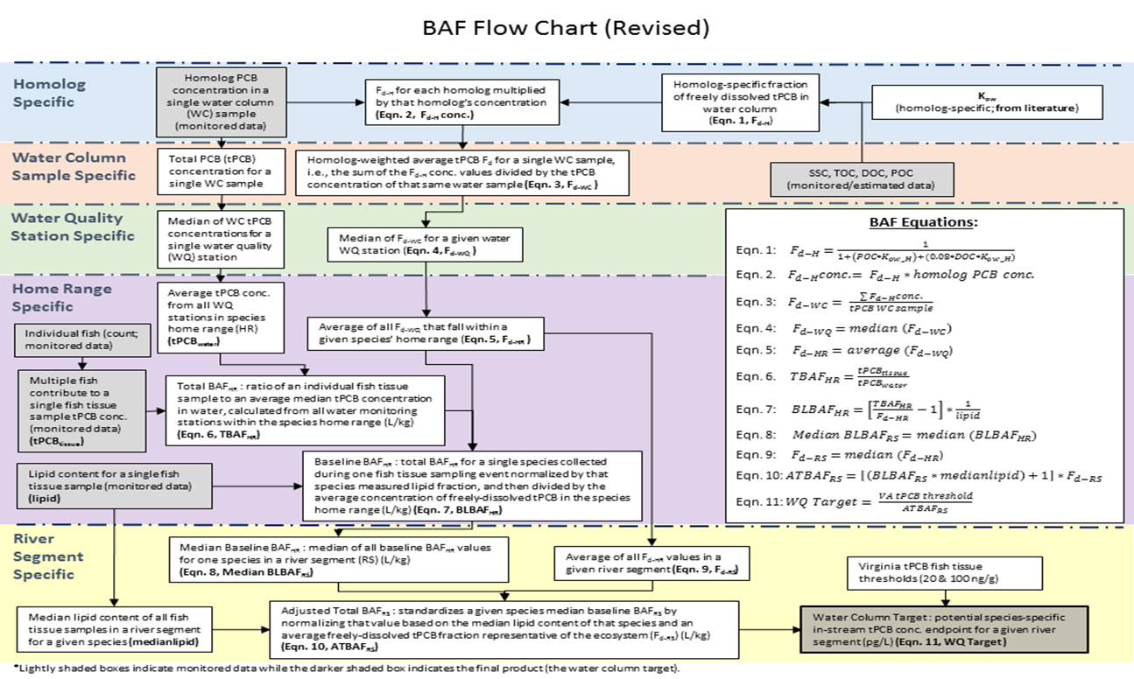

References
DEQ. 2021a. Guidance Memo No. GM21-2002. 2022 Water Quality Assessment Guidance Manual. Prepared by Virginia Department of Environmental Quality, Division of Water Planning, April 2021.

ICPRB (Interstate Commission on the Potomac River Basin). 2007. Total Maximum Daily Loads of Polychlorinated Biphenyls (PCBs) for Tidal Portions of the Potomac and Anacostia Rivers in the District of Columbia, Maryland, and Virginia. Prepared by The Interstate Commission on the Potomac River Basin (ICPRB). October 2007.

USEPA (U. S. Environmental Protection Agency). 1980. Ambient Water Quality Criteria for Polychlorinated Biphenyls. EPA 440/5-80-068. Office of Water, Washington, DC. October 1980.

USEPA (U. S. Environmental Protection Agency). 2000. Further Site Characterization and Analysis, Volume 2D – Revised Baseline Modeling Report, Books 1 and 2. Hudson River PCBs Reassessment RI/FS. Prepared for USEPA by TAMS Consultants, Inc., Limno-Tech, Inc., Menzie-Cura &Associates, Inc., and Tetra-Tech, Inc., January 2000.

USEPA (U. S. Environmental Protection Agency). 2003. Methodology for deriving ambient water quality criteria for the protection of human health (2000). EPA-822-R-03-030. Technical support document volume 2: development of national bioaccumulation factors. Office of Water, Washington, DC. December 2003.

USEPA-IRIS (U.S. Environmental Protection Agency Integrated Risk Information System). 1997. Polychlorinated biphenyls (PCBs). CASRN 1336-36-3. Office of Water, Washington, DC. June 1997.

Observed Water Quality Data Inventory

United States Geological Survey (USGS) Streamflow Gages
Table B-1. USGS streamflow gages with complete datasets used for the Hydrology Calibration.
TMDL Watershed | USGS Stream Gage Station
Jackson River | USGS 02011800 | USGS 02013100
Upper James River | USGS 02016000  USGS 02016500  USGS 02019500 | USGS 02024752  USGS 02025500
Maury River | USGS 02021500 | USGS 02024000
Lower James River | USGS 02026000  USGS 02029000  USGS 02034000 | USGS 02035000  USGS 02037500

Suspended Sediment Concentration (SSC) Data

Monitoring Stations
Table B-2. DEQ Suspended Sediment Concentration stations used for the sediment calibration.
TMDL Watershed | DEQ Water Quality SSC Stations
Jackson River | 2-JKS000.38 2-JKS006.67 2-JKS023.61 2-JKS044.14
Upper James River | 2-JMS302.85 2-JMS317.62 2BWLM000.34 2-BKW000.40 2BJMS273.86  2-JMS345.73 2AJMS334.47 2BJMS255.91 2-BKW005.95 2-JMS279.41  2-JMS309.13 2-JMS229.14 2-FSG000.85 2-IVA000.22  2-CAT000.34 2BJMS248.90 2-FSG003.36 2BJMS263.24  2-CRG001.20 2-BCR000.20 2-JMS258.54 2-JMS270.84
Maury River | 2-MRY000.46 2-MRY015.80
Lower James River | 2-JMS189.31 2-RVN001.64 2-JMS127.50 2-TKO003.42 2-NWD002.27  2BJMS214.35 2-RRN002.19 2-JMS111.17 2-JMS140.00 2-JMS112.33  2-BUF002.10 2-RRS003.12 2-JMS117.35 2-RDD000.19 2-GEN000.51  2-JMS157.28 2-RVN033.65 2-FIN000.81 2-RDD001.57 2-BDC000.79  2BSLT000.73 2-RVN039.58 2-JMS123.23 2-PWT000.57  2-HRD000.36 2BJMS119.35 2-LIY001.73 2-PWT003.98

Jackson River
Table B-3. Observed SSC (mg/L) Data for the Jackson River TMDL Watershed.
Subwatershed* | Date | Station | Observed SSC (mg/L)
JKS-01 | 7/19/2017 | 2-JKS000.38 | 2.54
JKS-01 | 2/8/2018 | 2-JKS000.38 | 58.10
JKS-01 | 9/17/2018 | 2-JKS000.38 | 99.40
JKS-01 | 12/7/2018 | 2-JKS000.38 | 3.21
JKS-03 | 2/8/2018 | 2-JKS006.67 | 62.50
JKS-14 | 7/19/2017 | 2-JKS023.61 | 1.74
JKS-14 | 2/8/2018 | 2-JKS023.61 | 15.50
JKS-14 | 9/17/2018 | 2-JKS023.61 | 15.40
JKS-14 | 12/7/2018 | 2-JKS023.61 | 7.16
JKS-17 | 7/19/2017 | 2-JKS044.14 | 2.14
JKS-17 | 2/8/2018 | 2-JKS044.14 | 1.69
JKS-17 | 9/17/2018 | 2-JKS044.14 | 1.48
JKS-17 | 12/7/2018 | 2-JKS044.14 | 1.64
*Subwatershed designation for the Jackson River (JKS).

Maury River
Table B-4. Observed SSC (mg/L) Data for the Maury River TMDL Watershed.
Subwatershed* | Date | Station | Observed SSC (mg/L)
MRY-01 | 7/20/2017 | 2-MRY000.46 | 2.02
MRY-01 | 2/8/2018 | 2-MRY000.46 | 123.00
MRY-01 | 6/4/2018 | 2-MRY000.46 | 7.51
MRY-01 | 4/3/2019 | 2-MRY000.46 | 1.07
MRY-09 | 7/20/2017 | 2-MRY015.80 | 1.44
MRY-09 | 2/8/2018 | 2-MRY015.80 | 62.10
MRY-09 | 6/4/2018 | 2-MRY015.80 | 6.86
MRY-09 | 4/3/2019 | 2-MRY015.80 | 0.46
*Subwatershed designation for the Maury River (MRY).

Upper James River
Table B-5. Observed SSC (mg/L) Data for the Upper James River TMDL Watershed.
Subwatershed* | Date | Station | Observed SSC (mg/L)
CRG-13 | 9/17/2018 | 2AJMS334.47 | 134.00
MJF-07 | 9/17/2018 | 2-BCR000.20 | 815.00
MJF-06 | 9/17/2018 | 2BJMS248.90 | 144.00
MJF-06 | 2/7/2019 | 2BJMS248.90 | 1.66
MJF-10 | 9/17/2018 | 2BJMS255.91 | 160.00
MJF-10 | 2/7/2019 | 2BJMS255.91 | 1.70
MJF-20 | 7/19/2017 | 2BJMS263.24 | 2.11
MJF-20 | 2/8/2018 | 2BJMS263.24 | 33.30
MJF-20 | 9/17/2018 | 2BJMS263.24 | 172.00
MJF-20 | 2/7/2019 | 2BJMS263.24 | 2.04
MJF-25 | 2/7/2019 | 2BJMS273.86 | 1.46
MJF-14 | 2/8/2018 | 2-BKW000.40 | 27.80
MJF-14 | 9/17/2018 | 2-BKW000.40 | 281.00
MJF-14 | 2/7/2019 | 2-BKW000.40 | 3.37
MJF-16 | 9/17/2018 | 2-BKW005.95 | 340.00
MJF-09 | 9/17/2018 | 2BWLM000.34 | 124.00
CAT-10 | 2/8/2018 | 2-CAT000.34 | 122.00
CRG-01 | 2/8/2018 | 2-CRG001.20 | 145.00
CRG-01 | 9/17/2018 | 2-CRG001.20 | 35.50
MJF-11 | 2/8/2018 | 2-FSG000.85 | 8.69
MJF-11 | 9/17/2018 | 2-FSG000.85 | 358.00
MJF-11 | 2/7/2019 | 2-FSG000.85 | 1.63
MJF-12 | 9/17/2018 | 2-FSG003.36 | 266.00
MJF-12 | 2/7/2019 | 2-FSG003.36 | 8.50
MJF-15 | 9/17/2018 | 2-IVA000.22 | 184.00
MJF-01 | 7/19/2017 | 2-JMS229.14 | 2.40
MJF-01 | 2/8/2018 | 2-JMS229.14 | 35.90
MJF-01 | 9/17/2018 | 2-JMS229.14 | 438.00
MJF-01 | 2/7/2019 | 2-JMS229.14 | 7.14
MJF-13 | 7/19/2017 | 2-JMS258.54 | 6.41
MJF-13 | 2/8/2018 | 2-JMS258.54 | 34.30
MJF-13 | 9/17/2018 | 2-JMS258.54 | 206.00
MJF-13 | 2/7/2019 | 2-JMS258.54 | 15.80
MJF-20 | 7/19/2017 | 2-JMS270.84 | 2.16
MJF-20 | 2/8/2018 | 2-JMS270.84 | 88.20
MJF-20 | 9/17/2018 | 2-JMS270.84 | 128.00
MJF-20 | 2/7/2019 | 2-JMS270.84 | 2.92
MJF-27 | 7/19/2017 | 2-JMS279.41 | 1.49
MJF-27 | 2/8/2018 | 2-JMS279.41 | 150.00
MJF-27 | 9/17/2018 | 2-JMS279.41 | 153.00
MJF-27 | 2/7/2019 | 2-JMS279.41 | 2.10
CAT-03 | 7/19/2017 | 2-JMS302.85 | 1.81
CAT-03 | 2/8/2018 | 2-JMS302.85 | 160.00
CAT-03 | 9/17/2018 | 2-JMS302.85 | 106.00
CAT-05 | 2/8/2018 | 2-JMS309.13 | 185.00
CAT-05 | 9/17/2018 | 2-JMS309.13 | 107.00
CAT-05 | 12/7/2018 | 2-JMS309.13 | 0.94
CAT-08 | 9/17/2018 | 2-JMS317.62 | 210.00
CRG-17 | 7/19/2017 | 2-JMS345.73 | 1.03
CRG-17 | 2/8/2018 | 2-JMS345.73 | 77.80
CRG-17 | 9/17/2018 | 2-JMS345.73 | 106.00
CRG-17 | 12/7/2018 | 2-JMS345.73 | 0.83
*Subwatershed designations for major tributaries: Catawba Creek (CAT), Craig Creek (CRG), James River/Fishing Creek junction (MJF).

Lower James River
Table B-6. Observed SSC (mg/L) Data for the Lower James River TMDL Watershed.
Subwatershed* | Date | Station | Observed SSC (mg/L)
MJR-24 | 11/15/2018 | 2-BDC000.79 | 264.00
MJR-08 | 7/12/2017 | 2BJMS119.35 | 3.54
RKF-14 | 2/8/2018 | 2BJMS214.35 | 114.00
RKF-14 | 8/23/2018 | 2BJMS214.35 | 8.05
HSR-02 | 7/19/2017 | 2BSLT000.73 | 1.45
HSR-02 | 2/8/2018 | 2BSLT000.73 | 20.40
TYE-03 | 9/17/2018 | 2-BUF002.10 | 2790.00
MJR-23 | 10/11/2017 | 2-FIN000.81 | 34.60
MJR-21 | 11/15/2018 | 2-GEN000.51 | 212.00
HSR-13 | 10/30/2017 | 2-HRD000.36 | 50.90
MJR-01 | 7/13/2017 | 2-JMS111.17 | 4.35
MJR-01 | 2/12/2018 | 2-JMS111.17 | 683.00
MJR-01 | 8/29/2018 | 2-JMS111.17 | 3.56
MJR-01 | 11/6/2018 | 2-JMS111.17 | 162.00
MJR-04 | 8/29/2018 | 2-JMS112.33 | 4.64
MJR-04 | 11/6/2018 | 2-JMS112.33 | 196.00
MJR-05 | 8/28/2017 | 2-JMS117.35 | 4.26
MJR-05 | 2/12/2018 | 2-JMS117.35 | 393.00
MJR-05 | 8/30/2018 | 2-JMS117.35 | 4.20
MJR-05 | 11/6/2018 | 2-JMS117.35 | 116.00
MJR-09 | 2/12/2018 | 2-JMS123.23 | 88.60
MJR-18 | 7/12/2017 | 2-JMS127.50 | 2.78
MJR-18 | 10/23/2018 | 2-JMS127.50 | 5.26
MJR-18 | 11/6/2018 | 2-JMS127.50 | 130.00
MJR-25 | 2/12/2018 | 2-JMS140.00 | 284.00
MJR-25 | 7/19/2018 | 2-JMS140.00 | 1.48
MJR-25 | 11/6/2018 | 2-JMS140.00 | 23.40
MJR-35 | 8/28/2017 | 2-JMS157.28 | 1.28
MJR-35 | 2/12/2018 | 2-JMS157.28 | 161.00
MJR-35 | 7/19/2018 | 2-JMS157.28 | 1.83
MJR-35 | 11/6/2018 | 2-JMS157.28 | 112.00
RKF-02 | 7/19/2017 | 2-JMS189.31 | 2.12
RKF-02 | 2/8/2018 | 2-JMS189.31 | 36.40
RKF-02 | 8/23/2018 | 2-JMS189.31 | 6.16
RKF-02 | 4/3/2019 | 2-JMS189.31 | 1.76
MJR-16 | 2/12/2018 | 2-LIY001.73 | 76.40
MJR-20 | 6/26/2018 | 2-NWD002.27 | 4.36
MJR-20 | 11/15/2018 | 2-NWD002.27 | 174.00
MJR-06 | 6/26/2018 | 2-PWT000.57 | 8.03
MJR-06 | 11/15/2018 | 2-PWT000.57 | 404.00
MJR-07 | 6/26/2018 | 2-PWT003.98 | 2.24
MJR-07 | 11/15/2018 | 2-PWT003.98 | 60.00
MJR-02 | 6/26/2018 | 2-RDD000.19 | 4.47
MJR-02 | 11/15/2018 | 2-RDD000.19 | 39.90
MJR-03 | 6/26/2018 | 2-RDD001.57 | 1.78
MJR-03 | 11/15/2018 | 2-RDD001.57 | 20.30
RVN-13 | 6/12/2018 | 2-RRN002.19 | 86.50
RVN-13 | 6/27/2019 | 2-RRN002.19 | 5.68
RVN-18 | 6/12/2018 | 2-RRS003.12 | 34.60
RVN-18 | 6/27/2019 | 2-RRS003.12 | 4.16
RVN-01 | 10/30/2017 | 2-RVN001.64 | 252.00
RVN-01 | 6/12/2018 | 2-RVN001.64 | 64.45
RVN-01 | 6/27/2019 | 2-RVN001.64 | 6.06
RVN-08 | 6/12/2018 | 2-RVN033.65 | 45.40
RVN-08 | 6/27/2019 | 2-RVN033.65 | 2.84
RVN-11 | 6/12/2018 | 2-RVN039.58 | 32.90
RVN-11 | 6/27/2019 | 2-RVN039.58 | 4.34
MJR-11 | 2/12/2018 | 2-TKO003.42 | 12.50
MJR-11 | 11/15/2018 | 2-TKO003.42 | 7.24
*Subwatershed designations for major tributaries: Hardware and Slate Rivers (HSR), Rockfish River (RKF), Rivanna River (RVN), Tye River (TYE), James River/Reedy Creek junction (MJR).

Total Organic Carbon (TOC) / Dissolved Organic Carbon (DOC) Data

Monitoring Stations
Table B-7. DEQ Total Organic Carbon and Dissolved Organic Carbon Stations.
TMDL Watershed | DEQ Water Quality TOC and DOC Stations
Jackson River | 2-JKS000.38 2-JKS006.67 2-JKS023.61 2-JKS044.14
Upper James River | 2AJMS334.47 2-BKW000.40 2-FSG003.36 2-JMS302.85  2-BCR000.20 2-BKW005.95 2-IVA000.22 2-JMS309.13  2BJMS248.90 2BWLM000.34 2-JMS229.14 2-JMS317.62  2BJMS255.91 2-CAT000.34 2-JMS258.54 2-JMS345.73  2BJMS263.24 2-CRG001.20 2-JMS270.84  2BJMS273.86 2-FSG000.85 2-JMS279.41
Maury River | 2-MRY000.46 2-MRY015.80
Lower James River | 2-BDC000.79 2-GEN000.57 2-JMS157.28 2-RRN002.19  2BJMS119.35 2-HRD000.36 2-JMS189.31 2-RRS003.12  2BJMS214.35 2-JMS111.17 2-LIY001.73 2-RVN001.64  2BSLT000.73 2-JMS112.33 2-NWD002.27 2-RVN033.65  2-BUF002.10 2-JMS117.35 2-PWT000.57 2-RVN039.58  2-DPR001.00 2-JMS123.23 2-PWT003.98 2-TKO003.42  2-FIN000.81 2-JMS127.50 2-RDD000.19  2-GEN000.51 2-JMS140.00 2-RDD001.57

Jackson River
Table B-8. Observed TOC (mg/L) and DOC (mg/L) Data for the Jackson River TMDL Watershed.
Subwatershed* | Date | Station | Observed TOC (mg/L) | Observed DOC (mg/L)
JKS-01 | 7/19/2017 | 2-JKS000.38 | 7.60 | 7.38
JKS-01 | 2/8/2018 | 2-JKS000.38 | 4.67 | 5.33
JKS-01 | 9/17/2018 | 2-JKS000.38 | 6.53 | 5.54
JKS-01 | 12/7/2018 | 2-JKS000.38 | 4.16 | 3.71
JKS-03 | 2/8/2018 | 2-JKS006.67 | 5.13 | 6.54
JKS-14 | 7/19/2017 | 2-JKS023.61 | 16.00 | 14.10
JKS-14 | 2/8/2018 | 2-JKS023.61 | 9.09 | 9.85
JKS-14 | 9/17/2018 | 2-JKS023.61 | 13.20 | 9.64
JKS-14 | 12/7/2018 | 2-JKS023.61 | 9.07 | 7.26
JKS-17 | 7/19/2017 | 2-JKS044.14 | 1.68 | 1.87
JKS-17 | 2/8/2018 | 2-JKS044.14 | 1.58 | 2.34
JKS-17 | 9/17/2018 | 2-JKS044.14 | 1.86 | 1.81
JKS-17 | 12/7/2018 | 2-JKS044.14 | 1.54 | 1.47
*Subwatershed designation for the Jackson River (JKS).

Maury River
Table B-9. Observed TOC (mg/L) and DOC (mg/L) Data for the Maury River TMDL Watershed.
Subwatershed | Date | Station | Observed TOC (mg/L) | Observed DOC (mg/L)
MRY-01 | 7/20/2017 | 2-MRY000.46 | 1.64 | 1.67
MRY-01 | 2/8/2018 | 2-MRY000.46 | 4.37 | 4.70
MRY-01 | 6/4/2018 | 2-MRY000.46 | 2.08 | 1.81
MRY-01 | 4/3/2019 | 2-MRY000.46 | 1.42 | 1.07
MRY-09 | 7/20/2017 | 2-MRY015.80 | 1.79 | 1.51
MRY-09 | 2/8/2018 | 2-MRY015.80 | 3.13 | 3.13
MRY-09 | 6/4/2018 | 2-MRY015.80 | 2.05 | 1.76
MRY-09 | 4/3/2019 | 2-MRY015.80 | 1.15 | 1.25
*Subwatershed designation for the Maury River (MRY).

Upper James River
Table B-10. Observed TOC (mg/L) and DOC (mg/L) Data for the Upper James River TMDL Watershed.
Subwatershed* | Date | Station | Observed TOC (mg/L) | Observed DOC (mg/L)
MJF-01 | 7/19/2017 | 2-JMS229.14 | 3.84 | 3.66
MJF-01 | 2/8/2018 | 2-JMS229.14 | 3.65 | 3.98
MJF-01 | 9/17/2018 | 2-JMS229.14 | 11.30 | 7.71
MJF-01 | 2/7/2019 | 2-JMS229.14 | 2.08 | 1.85
MJF-06 | 9/17/2018 | 2BJMS248.90 | 6.64 | 4.47
MJF-06 | 2/7/2019 | 2BJMS248.90 | 1.91 | 1.74
MJF-07 | 9/17/2018 | 2-BCR000.20 | 9.98 | 8.21
MJF-09 | 9/17/2018 | 2BWLM000.34 | 10.70 | 8.74
MJF-10 | 9/17/2018 | 2BJMS255.91 | 6.28 | 3.91
MJF-10 | 2/7/2019 | 2BJMS255.91 | 1.78 | 1.65
MJF-11 | 2/8/2018 | 2-FSG000.85 | 6.25 | 6.18
MJF-11 | 9/17/2018 | 2-FSG000.85 | 6.65 | 4.56
MJF-11 | 2/7/2019 | 2-FSG000.85 | 1.92 | 1.60
MJF-12 | 9/17/2018 | 2-FSG003.36 | 4.99 | 3.90
MJF-12 | 2/7/2019 | 2-FSG003.36 | 2.56 | 1.93
MJF-13 | 7/19/2017 | 2-JMS258.54 | 3.51 | 3.44
MJF-13 | 2/8/2018 | 2-JMS258.54 | 3.56 | 3.66
MJF-13 | 9/17/2018 | 2-JMS258.54 | 4.91 | 3.69
MJF-13 | 2/7/2019 | 2-JMS258.54 | 1.79 | 1.88
MJF-14 | 2/8/2018 | 2-BKW000.40 | 3.26 | 4.65
MJF-14 | 9/17/2018 | 2-BKW000.40 | 5.78 | 3.96
MJF-14 | 2/7/2019 | 2-BKW000.40 | 1.46 | 1.47
MJF-15 | 9/17/2018 | 2-IVA000.22 | 5.98 | 5.28
MJF-16 | 9/17/2018 | 2-BKW005.95 | 4.83 | 3.98
MJF-20 | 7/19/2017 | 2BJMS263.24 | 3.90 | 3.67
MJF-20 | 2/8/2018 | 2BJMS263.24 | 3.44 | 4.04
MJF-20 | 9/17/2018 | 2BJMS263.24 | 3.84 | 3.25
MJF-20 | 2/7/2019 | 2BJMS263.24 | 2.36 | 2.00
MJF-20 | 7/19/2017 | 2-JMS270.84 | 4.19 | 4.20
MJF-20 | 2/8/2018 | 2-JMS270.84 | 3.76 | 3.87
MJF-20 | 9/17/2018 | 2-JMS270.84 | 5.41 | 3.92
MJF-20 | 2/7/2019 | 2-JMS270.84 | 2.29 | 1.94
MJF-25 | 2/7/2019 | 2BJMS273.86 | 1.99 | 1.65
MJF-27 | 7/19/2017 | 2-JMS279.41 | 4.07 | 3.91
MJF-27 | 2/8/2018 | 2-JMS279.41 | 6.61 | 5.16
MJF-27 | 9/17/2018 | 2-JMS279.41 | 6.73 | 4.03
MJF-27 | 2/7/2019 | 2-JMS279.41 | 2.17 | 2.14
CAT-03 | 7/19/2017 | 2-JMS302.85 | 5.23 | 5.08
CAT-03 | 2/8/2018 | 2-JMS302.85 | 5.49 | 5.67
CAT-03 | 9/17/2018 | 2-JMS302.85 | 4.43 | 3.40
CAT-05 | 2/8/2018 | 2-JMS309.13 | 6.02 | 5.89
CAT-05 | 9/17/2018 | 2-JMS309.13 | 5.11 | 4.25
CAT-05 | 12/7/2018 | 2-JMS309.13 | 2.11 | 1.94
CAT-08 | 9/17/2018 | 2-JMS317.62 | 7.82 | 5.36
CAT-10 | 2/8/2018 | 2-CAT000.34 | 7.41 | 5.34
CRG-01 | 2/8/2018 | 2-CRG001.20 | 6.67 | 5.22
CRG-01 | 9/17/2018 | 2-CRG001.20 | 7.61 | 6.37
CRG-13 | 9/17/2018 | 2AJMS334.47 | 6.86 | 5.57
CRG-17 | 7/19/2017 | 2-JMS345.73 | 5.48 | 5.14
CRG-17 | 2/8/2018 | 2-JMS345.73 | 4.85 | 5.76
CRG-17 | 9/17/2018 | 2-JMS345.73 | 10.90 | 5.96
CRG-17 | 12/7/2018 | 2-JMS345.73 | 2.91 | 2.31
*Subwatershed designations for major tributaries: Catawba Creek (CAT), Craig Creek (CRG), James River/Fishing Creek junction (MJF).

Lower James River
Table B-11. Observed TOC (mg/L) and DOC (mg/L) Data for the Lower James River TMDL Watershed.
Subwatershed* | Date | Station | Observed TOC (mg/L) | Observed DOC (mg/L)
MJR-01 | 7/13/2017 | 2-JMS111.17 | 3.04 | 3.47
MJR-01 | 2/12/2018 | 2-JMS111.17 | 12.30 | 8.39
MJR-01 | 8/29/2018 | 2-JMS111.17 | 3.03 | 2.72
MJR-01 | 11/6/2018 | 2-JMS111.17 | 7.90 | 5.47
MJR-02 | 6/26/2018 | 2-RDD000.19 | 13.30 | 11.60
MJR-02 | 11/15/2018 | 2-RDD000.19 | 9.10 | 5.70
MJR-03 | 6/26/2018 | 2-RDD001.57 | 14.80 | 13.80
MJR-03 | 11/15/2018 | 2-RDD001.57 | 10.90 | 8.52
MJR-04 | 8/29/2018 | 2-JMS112.33 | 2.975 | 2.68
MJR-04 | 11/6/2018 | 2-JMS112.33 | 8.82 | 6.37
MJR-06 | 6/26/2018 | 2-PWT000.57 | 6.22 | 5.66
MJR-06 | 11/15/2018 | 2-PWT000.57 | 6.97 | 5.39
MJR-07 | 6/26/2018 | 2-PWT003.98 | 5.25 | 4.92
MJR-07 | 11/15/2018 | 2-PWT003.98 | 5.86 | 5.18
MJR-05 | 8/28/2017 | 2-JMS117.35 | 3.90 | 3.95
MJR-05 | 2/12/2018 | 2-JMS117.35 | 12.30 | 9.06
MJR-05 | 8/30/2018 | 2-JMS117.35 | 2.67 | 2.41
MJR-05 | 11/6/2018 | 2-JMS117.35 | 6.76 | 5.64
MJR-08 | 7/12/2017 | 2BJMS119.35 | 2.90 | 2.86
MJR-09 | 2/12/2018 | 2-JMS123.23 | 12.60 | 17.60
MJR-11 | 2/12/2018 | 2-TKO003.42 | 11.80 | 9.58
MJR-11 | 11/15/2018 | 2-TKO003.42 | 7.90 | 6.98
MJR-12 | 11/15/2018 | 2-DPR001.00 | 6.82 | 5.99
MJR-16 | 2/12/2018 | 2-LIY001.73 | 13.90 | 12.00
MJR-18 | 7/12/2017 | 2-JMS127.50 | 3.08 | 2.94
MJR-18 | 11/6/2018 | 2-JMS127.50 | 8.81 | 6.64
MJR-20 | 6/26/2018 | 2-NWD002.27 | 4.14 | 4.10
MJR-20 | 11/15/2018 | 2-NWD002.27 | 7.50 | 6.44
MJR-21 | 11/15/2018 | 2-GEN000.51 | 11.00 | 6.27
MJR-21 | 11/15/2018 | 2-GEN000.57 | 10.60 | 6.18
MJR-23 | 10/11/2017 | 2-FIN000.81 | 11.20 | 9.00
MJR-24 | 11/15/2018 | 2-BDC000.79 | 9.43 | 6.83
MJR-25 | 2/12/2018 | 2-JMS140.00 | 14.50 | 16.20
MJR-25 | 7/19/2018 | 2-JMS140.00 | 2.84 | 2.59
MJR-25 | 11/6/2018 | 2-JMS140.00 | 9.53 | 6.91
MJR-35 | 8/28/2017 | 2-JMS157.28 | 4.09 | 3.92
MJR-35 | 2/12/2018 | 2-JMS157.28 | 14.60 | 14.00
MJR-35 | 7/19/2018 | 2-JMS157.28 | 3.08 | 2.83
MJR-35 | 11/6/2018 | 2-JMS157.28 | 8.27 | 6.60
RVN-01 | 10/30/2017 | 2-RVN001.64 | 8.40 | 5.40
RVN-01 | 6/12/2018 | 2-RVN001.64 | 4.04 | 3.77
RVN-01 | 6/27/2019 | 2-RVN001.64 | 2.48 | 2.12
RVN-08 | 6/12/2018 | 2-RVN033.65 | 3.40 | 3.14
RVN-08 | 6/27/2019 | 2-RVN033.65 | 2.55 | 2.19
RVN-11 | 6/12/2018 | 2-RVN039.58 | 3.39 | 3.28
RVN-11 | 6/27/2019 | 2-RVN039.58 | 2.32 | 1.96
RVN-13 | 6/12/2018 | 2-RRN002.19 | 3.90 | 3.90
RVN-13 | 6/27/2019 | 2-RRN002.19 | 2.39 | 2.33
RVN-18 | 6/12/2018 | 2-RRS003.12 | 4.44 | 3.25
RVN-18 | 6/27/2019 | 2-RRS003.12 | 2.23 | 2.01
HSR-02 | 7/19/2017 | 2BSLT000.73 | 3.33 | 3.10
HSR-02 | 2/8/2018 | 2BSLT000.73 | 6.09 | 5.47
HSR-13 | 10/30/2017 | 2-HRD000.36 | 6.38 | 5.41
RKF-02 | 7/19/2017 | 2-JMS189.31 | 3.47 | 3.30
RKF-02 | 2/8/2018 | 2-JMS189.31 | 3.28 | 4.12
RKF-02 | 8/23/2018 | 2-JMS189.31 | 3.13 | 2.78
RKF-02 | 4/3/2019 | 2-JMS189.31 | 1.45 | 1.32
RKF-14 | 2/8/2018 | 2BJMS214.35 | 4.54 | 5.73
RKF-14 | 8/23/2018 | 2BJMS214.35 | 3.14 | 2.80
TYE-03 | 9/17/2018 | 2-BUF002.10 | 12.90 | 8.40
*Subwatershed designations for major tributaries: Hardware and Slate Rivers (HSR), Rockfish River (RKF), Rivanna River (RVN), Tye River (TYE), James River/Reedy Creek junction (MJR).

Fish Tissue PCB Concentration Data

Monitoring Stations
Table B-12. DEQ Fish Tissue PCB concentration stations used for BAF and endpoint calculation.
TMDL Watershed | DEQ Fish Tissue Sampling Stations
Jackson River | 2-JKS000.38 2-JKS006.67 2-JKS022.50 2-JKS023.61 2-JKS023.88  2-JKS047.06 2-JKS047.07 2-JKS047.08 2-JKS047.09 2-KAR000.17
Upper James River | 2-JMS258.54 2-JOB000.39 2-JMS279.41 2-JMS298.70 2-JMS330.77  2-HAZ007.16 2-JMS267.47 2-BKW006.76 2-CWP002.58 2-JMS345.73  2-CWP002.55 2-JMS309.13 2-JMS277.30 2-JMS317.62
Maury River | 2-MRY013.00 2-MRY016.01 2-MRY001.50 2-MRY011.23  2-MRY000.09 2-MRY011.86 2-MRY020.82 2-MRY013.88
Lower James River | 2-JMS176.63 2-JMS157.28 2-JMS118.99 2-SHS001.00 2-JMS182.94  2-HRD000.25 2-PNY004.08 2-JMS127.50 2-JMS140.00 2-HRD007.21  2-RVN000.07 2-RVN001.60 2-JMS213.00 2-JMS166.50 2-HRD002.06  2-WLS000.50 2-HRD000.34 2-PNY003.06 2-JMS189.31 2-RVN023.01  2-JMS229.14 2-SLT000.20 2-MIN002.00 2-JMS211.77 2-RVN037.54

Jackson River
Table B-13. Fish Tissue PCB Concentration (ng/g or ppb) Data for the Jackson River TMDL Watershed.
Subwatershed* | Date | Station | Species Common Name | No. of Fish Analyzed | Lipid Content (%) | Average Fish Tissue tPCB (ng/g)
JKS-01 | 7/25/2005 | 2-JKS000.38 | Rock Bass | 6 | 5.97 | 2.34
JKS-03 | 8/24/2017 | 2-JKS006.67 | Smallmouth Bass | 6 | 3.42 | 0.00
JKS-03 | 8/24/2017 | 2-JKS006.67 | Rock Bass | 7 | 6.26 | 0.53
JKS-05 | 9/19/2001 | 2-KAR000.17 | Stoneroller | 5 | 8.72 | 4.78
JKS-05 | 9/19/2001 | 2-KAR000.17 | White Sucker | 7 | 6.64 | 3.01
JKS-05 | 9/19/2001 | 2-KAR000.17 | Rock Bass | 2 | 2.69 | 1.70
JKS-13 | 7/29/2005 | 2-JKS022.50 | Carp | 1 | 32.06 | 66.43
JKS-13 | 7/29/2005 | 2-JKS022.50 | Carp | 1 | 24.99 | 28.81
JKS-13 | 7/29/2005 | 2-JKS022.50 | Carp | 1 | 8.93 | 35.96
JKS-13 | 7/29/2005 | 2-JKS022.50 | Carp | 1 | 7.05 | 71.31
JKS-13 | 7/29/2005 | 2-JKS022.50 | Rainbow Trout | 2 | 7.04 | 5.36
JKS-13 | 7/29/2005 | 2-JKS022.50 | Carp | 3 | 14.82 | 37.48
JKS-13 | 7/29/2005 | 2-JKS022.50 | Rock Bass | 7 | 2.95 | 1.86
JKS-13 | 7/29/2005 | 2-JKS022.50 | Rock Bass | 7 | 3.27 | 6.67
JKS-13 | 7/29/2005 | 2-JKS022.50 | Smallmouth Bass | 4 | 4.86 | 1.35
JKS-13 | 7/29/2005 | 2-JKS022.50 | Redbreast Sunfish | 4 | 4.49 | 4.60
JKS-14 | 8/23/2017 | 2-JKS023.61 | Carp | 2 | 15.52 | 9.48
JKS-14 | 8/23/2017 | 2-JKS023.61 | Carp | 3 | 18.04 | 28.55
JKS-14 | 8/23/2017 | 2-JKS023.61 | White Sucker | 6 | 8.70 | 1.27
JKS-14 | 8/23/2017 | 2-JKS023.61 | Largemouth Bass | 3 | 3.32 | 0.65
JKS-14 | 8/23/2017 | 2-JKS023.61 | Rainbow Trout | 2 | 13.22 | 0.00
JKS-14 | 8/23/2017 | 2-JKS023.61 | Rock Bass | 8 | 3.64 | 0.00
JKS-14 | 8/14/1995 | 2-JKS023.88 | Rock Bass | 10 | 0.73 | 7.25
JKS-14 | 8/14/1995 | 2-JKS023.88 | Carp | 5 | 7.50 | 63.71
JKS-14 | 8/14/1995 | 2-JKS023.88 | Redbreast Sunfish | 10 | 0.76 | 6.55
JKS-19 | 9/20/2001 | 2-JKS047.06 | Rainbow Trout | 3 | 6.60 | 7.94
JKS-19 | 9/20/2001 | 2-JKS047.06 | Rock Bass | 10 | 3.94 | 0.61
JKS-19 | 9/20/2001 | 2-JKS047.06 | Gizzard Shad | 6 | 9.20 | 1.86
JKS-19 | 9/20/2001 | 2-JKS047.06 | Largemouth Bass | 3 | 3.19 | 2.08
JKS-19 | 9/20/2001 | 2-JKS047.06 | Carp | 2 | 13.25 | 3.44
JKS-19 | 7/26/2005 | 2-JKS047.06 | Rock Bass | 5 | 4.15 | 0.00
JKS-19 | 7/26/2005 | 2-JKS047.06 | Carp | 1 | 20.92 | 0.66
JKS-19 | 7/26/2005 | 2-JKS047.06 | Largemouth Bass | 3 | 4.97 | 1.66
JKS-19 | 7/26/2005 | 2-JKS047.06 | Bluegill Sunfish | 9 | 3.53 | 0.19
JKS-19 | 7/26/2005 | 2-JKS047.07 | Carp | 1 | 17.26 | 0.60
JKS-19 | 7/26/2005 | 2-JKS047.08 | Carp | 1 | 16.63 | 0.50
JKS-19 | 7/26/2005 | 2-JKS047.09 | Carp | 1 | 14.81 | 0.00
*Subwatershed designation for the Jackson River (JKS).

Maury River
Table B-14. Fish Tissue PCB Concentration (ng/g or ppb) Data for the Maury River TMDL Watershed.
Subwatershed* | Date | Station | Species Common Name | No. of Fish Analyzed | Lipid Content (%) | Fish Tissue tPCB (ng/g)
MRY-01 | 10/6/2004 | 2-MRY000.09 | Smallmouth Bass | 1 | 4.46 | 9.60
MRY-01 | 10/6/2004 | 2-MRY000.09 | Smallmouth Bass | 2 | 5.36 | 5.25
MRY-01 | 10/6/2004 | 2-MRY000.09 | Smallmouth Bass | 3 | 4.38 | 5.59
MRY-01 | 10/6/2004 | 2-MRY000.09 | Smallmouth Bass | 3 | 5.68 | 6.61
MRY-01 | 10/6/2004 | 2-MRY000.09 | Bull Chub | 3 | 11.62 | 7.60
MRY-01 | 10/6/2004 | 2-MRY000.09 | Bull Chub | 3 | 15.54 | 13.92
MRY-01 | 10/6/2004 | 2-MRY000.09 | Bull Chub | 4 | 11.93 | 13.64
MRY-01 | 10/6/2004 | 2-MRY000.09 | Redbreast Sunfish | 3 | 6.13 | 6.59
MRY-01 | 10/6/2004 | 2-MRY000.09 | Redbreast Sunfish | 4 | 6.83 | 5.89
MRY-01 | 7/10/2001 | 2-MRY001.50 | Rock Bass | 15 | 2.85 | 8.02
MRY-01 | 7/10/2001 | 2-MRY001.50 | Northern Hogsucker | 2 | 4.29 | 8.00
MRY-01 | 7/10/2001 | 2-MRY001.50 | Smallmouth Bass | 3 | 2.69 | 10.43
MRY-01 | 7/10/2001 | 2-MRY001.50 | Stoneroller | 11 | 7.09 | 3.62
MRY-01 | 8/23/2017 | 2-MRY001.50 | Redbreast Sunfish | 3 | 6.68 | 0.84
MRY-01 | 8/23/2017 | 2-MRY001.50 | Rock Bass | 14 | 3.64 | 0.72
MRY-01 | 8/23/2017 | 2-MRY001.50 | Rock Bass | 15 | 4.00 | 0.61
MRY-01 | 8/23/2017 | 2-MRY001.50 | Flathead Catfish | 1 | 6.12 | 52.58
MRY-08 | 7/10/2001 | 2-MRY011.23 | Yellow Bullhead Catfish | 4 | 4.47 | 332.69
MRY-08 | 7/10/2001 | 2-MRY011.23 | Smallmouth Bass | 3 | 2.63 | --
MRY-08 | 7/10/2001 | 2-MRY011.23 | Rock Bass | 15 | 2.66 | 116.77
MRY-08 | 7/10/2001 | 2-MRY011.23 | Redbreast Sunfish | 15 | 4.04 | 70.55
MRY-08 | 7/27/2005 | 2-MRY011.23 | Rock Bass | 11 | 5.44 | 14.56
MRY-08 | 7/27/2005 | 2-MRY011.23 | Rock Bass | 11 | 5.45 | 4.98
MRY-08 | 7/27/2005 | 2-MRY011.23 | White Sucker | 2 | 15.16 | 59.46
MRY-08 | 7/27/2005 | 2-MRY011.23 | Carp | 1 | 12.67 | 287.16
MRY-08 | 7/27/2005 | 2-MRY011.23 | Carp | 1 | 11.19 | 200.51
MRY-08 | 7/27/2005 | 2-MRY011.23 | Carp | 1 | 17.08 | 1468.77
MRY-08 | 7/27/2005 | 2-MRY011.23 | Carp | 1 | 18.46 | 205.63
MRY-08 | 7/27/2005 | 2-MRY011.23 | Redbreast Sunfish | 5 | 12.60 | 48.56
MRY-08 | 7/27/2005 | 2-MRY011.23 | Green Sunfish | 7 | 4.75 | 3.39
MRY-08 | 7/27/2005 | 2-MRY011.23 | Black Crappie | 6 | 3.19 | 0.99
MRY-08 | 8/22/2017 | 2-MRY011.23 | Redbreast Sunfish | 10 | 3.14 | 4.15
MRY-08 | 8/22/2017 | 2-MRY011.23 | Rock Bass | 12 | 3.58 | 3.99
MRY-08 | 8/22/2017 | 2-MRY011.23 | Rock Bass | 15 | 3.10 | 1.38
MRY-08 | 8/22/2017 | 2-MRY011.23 | Yellow Bullhead Catfish | 4 | 4.68 | 8.31
MRY-08 | 8/28/2017 | 2-MRY011.23 | Smallmouth Bass | 5 | 4.66 | 12.75
MRY-08 | 10/6/2004 | 2-MRY011.86 | Smallmouth Bass | 3 | 4.79 | 6.74
MRY-08 | 10/6/2004 | 2-MRY011.86 | Smallmouth Bass | 3 | 5.57 | 8.89
MRY-08 | 10/6/2004 | 2-MRY011.86 | Smallmouth Bass | 4 | 5.25 | 4.37
MRY-08 | 10/6/2004 | 2-MRY011.86 | Carp | 1 | 8.24 | 33.23
MRY-08 | 10/6/2004 | 2-MRY011.86 | Carp | 1 | 16.18 | 71.53
MRY-08 | 10/6/2004 | 2-MRY011.86 | Carp | 1 | 9.52 | 22.99
MRY-08 | 10/6/2004 | 2-MRY011.86 | Carp | 1 | 14.02 | 43.73
MRY-08 | 10/6/2004 | 2-MRY011.86 | Carp | 1 | 7.84 | 18.22
MRY-08 | 10/6/2004 | 2-MRY011.86 | Redbreast Sunfish | 5 | 5.09 | 7.25
MRY-08 | 10/6/2004 | 2-MRY011.86 | Redbreast Sunfish | 5 | 4.35 | 5.21
MRY-08 | 8/15/1995 | 2-MRY013.00 | Smallmouth Bass | 10 | 0.69 | 8.29
MRY-08 | 8/15/1995 | 2-MRY013.00 | Redbreast Sunfish | 10 | 0.56 | 2.96
MRY-08 | 8/15/1995 | 2-MRY013.00 | White Sucker | 6 | 3.23 | 15.88
MRY-08 | 8/15/1995 | 2-MRY013.00 | White Sucker | 6 | 3.27 | 13.04
MRY-08 | 8/21/2017 | 2-MRY013.88 | Largemouth Bass | 6 | 6.52 | 145.57
MRY-08 | 8/21/2017 | 2-MRY013.88 | Largemouth Bass | 6 | 6.46 | 149.56
MRY-08 | 8/21/2017 | 2-MRY013.88 | White Sucker | 6 | 13.92 | 6.90
MRY-08 | 8/21/2017 | 2-MRY013.88 | Rock Bass | 7 | 2.66 | 3.15
MRY-08 | 8/21/2017 | 2-MRY013.88 | Carp | 3 | 17.62 | 90.38
MRY-08 | 6/28/2019 | 2-MRY013.88 | Smallmouth Bass | 2 | 5.56 | 8.18
MRY-08 | 6/28/2019 | 2-MRY013.88 | Smallmouth Bass | 5 | 3.68 | 3.55
MRY-14 | 7/9/2001 | 2-MRY016.01 | Rock Bass | 15 | 3.11 | 28.22
MRY-14 | 7/9/2001 | 2-MRY016.01 | Smallmouth Bass | 2 | 2.77 | 35.37
MRY-14 | 7/9/2001 | 2-MRY016.01 | River Chub | 2 | 2.77 | –
MRY-14 | 7/9/2001 | 2-MRY016.01 | Redbreast Sunfish | 8 | 4.34 | 27.15
MRY-14 | 7/27/2005 | 2-MRY020.82 | Rock Bass | 10 | 5.52 | 3.45
MRY-14 | 7/27/2005 | 2-MRY020.82 | Rock Bass | 10 | 6.67 | 2.81
MRY-14 | 7/27/2005 | 2-MRY020.82 | River Chub | 5 | 6.61 | 6.13
MRY-14 | 7/27/2005 | 2-MRY020.82 | Central Stoneroller | 12 | 35.10 | 22.77
MRY-14 | 7/27/2005 | 2-MRY020.82 | Smallmouth Bass | 4 | 6.68 | 2.15
*Subwatershed designation for the Maury River (MRY). Lost samples are denoted by “–”.

Upper James River
Table B-15. Fish Tissue PCB Concentration (ng/g or ppb) Data for the Upper James River TMDL Watershed.
Subwatershed* | Date | Station | Species Common Name | No. of Fish Analyzed | Lipid Content (%) | Average Fish Tissue tPCB (ng/g)
CAT-03 | 8/9/2017 | 2-JMS298.70 | Smallmouth Bass | 6 | 4.74 | 0.00
CAT-03 | 8/9/2017 | 2-JMS298.70 | Flathead Catfish | 1 | 6.56 | 32.70
CAT-03 | 8/9/2017 | 2-JMS298.70 | Carp | 3 | 31.68 | 101.80
CAT-03 | 8/9/2017 | 2-JMS298.70 | Carp | 3 | 26.98 | 170.36
CAT-03 | 10/8/2019 | 2-JMS298.70 | Carp | 3 | 36.78 | 221.44
CAT-03 | 10/8/2019 | 2-JMS298.70 | Carp | 3 | 25.42 | 120.53
CAT-03 | 10/8/2019 | 2-JMS298.70 | Carp | 2 | 30.12 | 92.69
CAT-03 | 10/8/2019 | 2-JMS298.70 | Carp | 3 | 30.34 | 137.58
CAT-03 | 10/8/2019 | 2-JMS298.70 | Carp | 3 | 24.60 | 180.89
CAT-05 | 7/26/2005 | 2-JMS309.13 | Fallfish | 4 | 10.38 | 1.26
CAT-05 | 7/26/2005 | 2-JMS309.13 | Rock Bass | 10 | 6.99 | 2.00
CAT-05 | 7/26/2005 | 2-JMS309.13 | Flathead Catfish | 1 | 4.31 | 1.59
CAT-05 | 7/26/2005 | 2-JMS309.13 | Smallmouth Bass | 3 | 5.77 | 4.58
CAT-05 | 7/26/2005 | 2-JMS309.13 | Redbreast Sunfish | 5 | 6.01 | 1.86
CAT-05 | 9/10/2014 | 2-JMS309.13 | Channel Catfish | 3 | 30.12 | 59.50
CAT-05 | 9/10/2014 | 2-JMS309.13 | Quillback Carpsucker | 2 | 6.72 | 8.93
CAT-05 | 8/11/2017 | 2-JMS309.13 | Smallmouth Bass | 6 | 3.30 | 0.71
CAT-05 | 8/11/2017 | 2-JMS309.13 | Smallmouth Bass | 6 | 3.00 | 0.58
CAT-05 | 8/11/2017 | 2-JMS309.13 | Rock Bass | 10 | 2.72 | 0.00
CAT-05 | 8/11/2017 | 2-JMS309.13 | Rock Bass | 10 | 3.04 | 0.00
CAT-05 | 8/11/2017 | 2-JMS309.13 | Northern Hogsucker | 6 | 5.08 | 0.00
CAT-05 | 8/11/2017 | 2-JMS309.13 | Redbreast Sunfish | 8 | 5.16 | 0.00
CAT-08 | 9/25/2017 | 2-JMS317.62 | Smallmouth Bass | 10 | 3.22 | 0.00
CAT-08 | 9/25/2017 | 2-JMS317.62 | Rock Bass | 10 | 3.34 | 0.00
CAT-08 | 9/25/2017 | 2-JMS317.62 | Northern Hogsucker | 5 | 5.08 | 0.00
CAT-08 | 9/25/2017 | 2-JMS317.62 | Flathead Catfish | 3 | 8.64 | 4.44
CAT-13 | 9/25/2017 | 2-JMS330.77 | Smallmouth Bass | 6 | 4.60 | 1.81
CAT-13 | 9/25/2017 | 2-JMS330.77 | Rock Bass | 10 | 5.08 | 0.53
CAT-13 | 9/25/2017 | 2-JMS330.77 | Rock Bass | 11 | 3.34 | 0.00
CAT-13 | 9/25/2017 | 2-JMS330.77 | Northern Hogsucker | 6 | 3.68 | 1.37
CRG-10 | 9/19/2001 | 2-JOB000.39 | Brown Bullhead Catfish | 2 | 3.70 | 2.52
CRG-10 | 9/19/2001 | 2-JOB000.39 | Redbreast Sunfish | 9 | 3.34 | 2.07
CRG-10 | 9/19/2001 | 2-JOB000.39 | Rock Bass | 10 | 2.81 | 1.53
CRG-10 | 9/19/2001 | 2-JOB000.39 | Smallmouth Bass | 2 | 3.71 | 3.24
CRG-17 | 9/28/2017 | 2-JMS345.73 | Smallmouth Bass | 3 | 4.12 | 11.89
CRG-17 | 9/28/2017 | 2-JMS345.73 | Rock Bass | 11 | 4.32 | 0.59
CRG-17 | 9/28/2017 | 2-JMS345.73 | Northern Hogsucker | 10 | 5.00 | 0.00
CRG-17 | 9/30/2019 | 2-JMS345.73 | Carp | 3 | 16.46 | 39.75
CRG-17 | 9/30/2019 | 2-JMS345.73 | Carp | 3 | 10.26 | 61.60
CRG-17 | 9/30/2019 | 2-JMS345.73 | Carp | 3 | 41.20 | 191.10
CRG-17 | 9/30/2019 | 2-JMS345.73 | Carp | 3 | 15.78 | 62.80
CWP-01 | 7/12/2001 | 2-CWP002.55 | Redbreast Sunfish | 9 | 5.49 | 305.89
CWP-01 | 7/12/2001 | 2-CWP002.55 | Black Jumprock Sucker | 6 | 4.19 | 3.17
CWP-01 | 7/12/2001 | 2-CWP002.55 | Rock Bass | 15 | 2.45 | 1.33
CWP-01 | 7/25/2005 | 2-CWP002.55 | Rock Bass | 10 | 6.61 | 0.87
CWP-01 | 7/25/2005 | 2-CWP002.55 | Rock Bass | 10 | 4.66 | 1.11
CWP-01 | 7/25/2005 | 2-CWP002.55 | Redbreast Sunfish | 3 | 5.86 | 3.54
CWP-01 | 9/5/2017 | 2-CWP002.58 | Rock Bass | 11 | 3.04 | 0.00
CWP-01 | 9/5/2017 | 2-CWP002.58 | Redbreast Sunfish | 10 | 2.66 | 0.00
CWP-01 | 9/5/2017 | 2-CWP002.58 | Black Jumprock Sucker | 6 | 5.30 | 0.00
MJF-10 | 9/7/1995 | 2-JMS258.54 | Smallmouth Bass | 10 | 0.89 | 5.14
MJF-10 | 9/7/1995 | 2-JMS258.54 | Redbreast Sunfish | 9 | 1.20 | 4.44
MJF-10 | 9/7/1995 | 2-JMS258.54 | White Sucker | 9 | 8.75 | 45.20
MJF-10 | 7/11/2001 | 2-JMS258.54 | American Eel | 4 | 22.80 | 138.07
MJF-10 | 7/11/2001 | 2-JMS258.54 | Carp | 4 | 5.44 | 301.54
MJF-10 | 7/11/2001 | 2-JMS258.54 | Carp | 4 | 18.22 | 190.69
MJF-10 | 9/6/2001 | 2-JMS258.54 | Bluegill Sunfish | 7 | 4.42 | re-extract
MJF-10 | 9/6/2001 | 2-JMS258.54 | Bluegill Sunfish | 7 | 4.45 | 4.69
MJF-10 | 9/6/2001 | 2-JMS258.54 | Flathead Catfish | 3 | 14.34 | 373.33
MJF-10 | 9/6/2001 | 2-JMS258.54 | Gizzard Shad | 10 | 19.57 | 178.38
MJF-10 | 9/6/2001 | 2-JMS258.54 | Smallmouth Bass | 8 | 3.31 | 11.42
MJF-10 | 7/26/2005 | 2-JMS258.54 | Redhorse Sucker | 4 | 38.50 | 55.35
MJF-10 | 7/26/2005 | 2-JMS258.54 | Flathead Catfish | 1 | 7.85 | 158.84
MJF-10 | 7/26/2005 | 2-JMS258.54 | Flathead Catfish | 1 | 27.76 | 554.07
MJF-10 | 7/26/2005 | 2-JMS258.54 | Flathead Catfish | 1 | 3.45 | 29.78
MJF-10 | 7/26/2005 | 2-JMS258.54 | Flathead Catfish | 2 | 13.12 | 17.39
MJF-10 | 7/26/2005 | 2-JMS258.54 | Gizzard Shad | 5 | 33.64 | 278.20
MJF-10 | 7/26/2005 | 2-JMS258.54 | Black Crappie | 3 | 2.86 | 4.48
MJF-10 | 7/26/2005 | 2-JMS258.54 | Channel Catfish | 3 | 12.11 | 51.01
MJF-10 | 7/26/2005 | 2-JMS258.54 | Channel Catfish | 4 | 9.91 | 9.93
MJF-10 | 8/27/2014 | 2-JMS258.54 | American Eel | 3 | 46.86 | 130.62
MJF-10 | 8/27/2014 | 2-JMS258.54 | Channel Catfish | 5 | 11.86 | 34.67
MJF-10 | 8/27/2014 | 2-JMS258.54 | Flathead Catfish | 1 | 16.00 | 540.68
MJF-10 | 8/27/2014 | 2-JMS258.54 | Flathead Catfish | 1 | 5.98 | 133.28
MJF-10 | 8/27/2014 | 2-JMS258.54 | Flathead Catfish | 2 | 4.04 | 140.15
MJF-10 | 8/27/2014 | 2-JMS258.54 | Quillback Carpsucker | 3 | 12.90 | 97.01
MJF-10 | 8/27/2014 | 2-JMS258.54 | Quillback Carpsucker | 2 | 11.86 | 73.71
MJF-10 | 8/27/2014 | 2-JMS258.54 | Quillback Carpsucker | 2 | 8.54 | 51.78
MJF-10 | 8/27/2014 | 2-JMS258.54 | Carp | 2 | 12.28 | 90.28
MJF-10 | 8/27/2014 | 2-JMS258.54 | Carp | 3 | 14.64 | 122.39
MJF-16 | 10/27/2005 | 2-BKW006.76 | Redbreast Sunfish | 5 | 5.63 | 22.33
MJF-16 | 10/27/2005 | 2-BKW006.76 | Redbreast Sunfish | 5 | 5.90 | 10.02
MJF-16 | 10/27/2005 | 2-BKW006.76 | Redear Sunfish | 3 | 5.72 | 2.70
MJF-16 | 10/27/2005 | 2-BKW006.76 | Northern Hogsucker | 3 | 5.16 | 3.11
MJF-16 | 10/27/2005 | 2-BKW006.76 | Northern Hogsucker | 2 | 4.93 | 1.44
MJF-18 | 7/11/2001 | 2-HAZ007.16 | Smallmouth Bass | 3 | 3.14 | 3.99
MJF-18 | 7/11/2001 | 2-HAZ007.16 | White Sucker | 7 | 5.21 | 7.45
MJF-18 | 7/11/2001 | 2-HAZ007.16 | Redbreast Sunfish | 14 | 2.46 | 6.37
MJF-18 | 7/11/2001 | 2-HAZ007.16 | Redhorse Sucker | 5 | 8.60 | 6.13
MJF-18 | 7/28/2005 | 2-HAZ007.16 | Smallmouth Bass | 3 | 4.59 | 1.43
MJF-18 | 7/28/2005 | 2-HAZ007.16 | Northern Hogsucker | 2 | 4.20 | 1.85
MJF-18 | 7/28/2005 | 2-HAZ007.16 | White Sucker | 6 | 3.82 | 0.22
MJF-18 | 7/28/2005 | 2-HAZ007.16 | Redbreast Sunfish | 10 | 3.34 | 0.00
MJF-20 | 9/25/2001 | 2-JMS267.47 | Bluegill Sunfish | 10 | 3.02 | 7.06
MJF-20 | 9/25/2001 | 2-JMS267.47 | Spotted Bass | 7 | 3.69 | 4.12
MJF-20 | 9/25/2001 | 2-JMS267.47 | Carp | 5 | 8.65 | 51.84
MJF-20 | 9/25/2001 | 2-JMS267.47 | Channel Catfish | 3 | 2.80 | 27.07
MJF-20 | 9/25/2001 | 2-JMS267.47 | Channel Catfish | 3 | 2.82 | 16.19
MJF-27 | 8/8/2017 | 2-JMS277.30 | Smallmouth Bass | 7 | 3.56 | 0.73
MJF-27 | 8/8/2017 | 2-JMS277.30 | Rock Bass | 4 | 5.08 | 0.60
MJF-27 | 8/8/2017 | 2-JMS277.30 | Channel Catfish | 3 | 17.26 | 11.13
MJF-27 | 8/8/2017 | 2-JMS277.30 | Carp | 3 | 18.96 | 68.03
MJF-27 | 10/26/2005 | 2-JMS279.41 | Largemouth Bass | 2 | 3.91 | 10.75
MJF-27 | 10/26/2005 | 2-JMS279.41 | Largemouth Bass | 2 | 3.52 | 1.18
MJF-27 | 10/26/2005 | 2-JMS279.41 | Smallmouth Bass | 2 | 4.53 | 4.10
MJF-27 | 10/26/2005 | 2-JMS279.41 | Smallmouth Bass | 2 | 4.06 | 4.66
MJF-27 | 10/26/2005 | 2-JMS279.41 | Redhorse Sucker | 3 | 8.32 | 0.99
MJF-27 | 10/26/2005 | 2-JMS279.41 | Redhorse Sucker | 2 | 17.74 | 6.99
MJF-27 | 10/26/2005 | 2-JMS279.41 | Rock Bass | 5 | 5.58 | 3.25
MJF-27 | 10/26/2005 | 2-JMS279.41 | Rock Bass | 5 | 5.48 | 2.27
MJF-27 | 9/9/2014 | 2-JMS279.41 | American Eel | 1 | 68.46 | 477.11
MJF-27 | 9/9/2014 | 2-JMS279.41 | Channel Catfish | 5 | 15.42 | 18.56
MJF-27 | 9/9/2014 | 2-JMS279.41 | Flathead Catfish | 1 | 2.20 | 54.15
MJF-27 | 9/9/2014 | 2-JMS279.41 | Quillback Carpsucker | 1 | 7.22 | 28.92
MJF-27 | 9/9/2014 | 2-JMS279.41 | Carp | 3 | 8.24 | 32.18
*Subwatershed designations for major tributaries: Catawba Creek (CAT), Craig Creek (CRG), James River/Fishing Creek junction (MJF).

Lower James River
Table B-16. Fish Tissue PCB Concentration (ng/g or ppb) Data for the Lower James River TMDL Watershed.
Subwatershed* | Date | Station | Species Common Name | No. of Fish Analyzed | Lipid Content (%) | Fish Tissue tPCB (ng/g)
HSR-13 | 8/4/1995 | 2-HRD000.25 | Largemouth Bass | 5 | 0.97 | 10.04
HSR-13 | 8/4/1995 | 2-HRD000.25 | Sunfish | 10 | 0.57 | 1.58
HSR-13 | 8/4/1995 | 2-HRD000.25 | Redhorse Sucker | 10 | 2.93 | 9.23
HSR-13 | 8/6/2001 | 2-HRD000.34 | Gizzard Shad | 10 | 13.32 | 113.07
HSR-13 | 8/6/2001 | 2-HRD000.34 | Redbreast Sunfish | 8 | 2.27 | 4.19
HSR-13 | 8/6/2001 | 2-HRD000.34 | Smallmouth Bass | 5 | 3.01 | 7.97
HSR-13 | 8/6/2001 | 2-HRD000.34 | White Sucker | 7 | 8.10 | 15.93
HSR-13 | 8/10/2017 | 2-HRD002.06 | Rock Bass | 12 | 3.38 | 0.00
HSR-13 | 8/10/2017 | 2-HRD002.06 | Green Sunfish | 9 | 3.42 | 0.00
HSR-13 | 8/10/2017 | 2-HRD002.06 | Redbreast Sunfish | 5 | 72.32 | 0.00
HSR-13 | 8/10/2017 | 2-HRD002.06 | American Eel | 2 | 36.58 | 1.35
HSR-13 | 8/7/2017 | 2-HRD007.21 | Bluegill Sunfish | 6 | 3.82 | 0.00
HSR-13 | 8/7/2017 | 2-HRD007.21 | Green Sunfish | 5 | 3.74 | 0.00
HSR-13 | 8/7/2017 | 2-HRD007.21 | American Eel | 4 | 18.64 | 0.91
MJR-08 | 3/18/2003 | 2-JMS118.99 | Quillback Carpsucker | 5 | 5.50 | 156.62
MJR-08 | 3/18/2003 | 2-JMS118.99 | Redhorse Sucker | 1 | 13.80 | 17.97
MJR-08 | 3/18/2003 | 2-JMS118.99 | Gizzard Shad | 2 | 20.35 | 207.59
MJR-08 | 3/18/2003 | 2-JMS118.99 | Channel Catfish | 4 | 22.25 | 28.34
MJR-08 | 3/18/2003 | 2-JMS118.99 | Channel Catfish | 3 | 15.01 | 18.50
MJR-08 | 3/18/2003 | 2-JMS118.99 | Channel Catfish | 4 | 15.42 | 16.45
MJR-08 | 3/18/2003 | 2-JMS118.99 | Channel Catfish | 5 | 6.16 | 18.31
MJR-08 | 3/18/2003 | 2-JMS118.99 | Carp | 1 | 30.01 | 177.68
MJR-08 | 3/18/2003 | 2-JMS118.99 | Carp | 1 | 42.59 | 661.11
MJR-08 | 3/18/2003 | 2-JMS118.99 | Carp | 1 | 15.50 | 194.47
MJR-08 | 3/18/2003 | 2-JMS118.99 | Carp | 1 | 8.49 | 74.72
MJR-08 | 3/18/2003 | 2-JMS118.99 | Carp | 1 | 19.62 | 124.33
MJR-08 | 3/18/2003 | 2-JMS118.99 | Carp | 1 | 26.80 | 429.37
MJR-08 | 3/18/2003 | 2-JMS118.99 | Carp | 1 | 20.60 | 129.35
MJR-08 | 4/25/2005 | 2-JMS118.99 | Carp | 1 | 17.00 | –
MJR-08 | 4/25/2005 | 2-JMS118.99 | Carp | 1 | 18.88 | 155.91
MJR-08 | 4/25/2005 | 2-JMS118.99 | Carp | 1 | 41.48 | 338.31
MJR-08 | 4/25/2005 | 2-JMS118.99 | Flathead Catfish | 2 | 3.32 | 32.75
MJR-08 | 4/25/2005 | 2-JMS118.99 | Blue Catfish | 1 | 8.78 | 88.36
MJR-08 | 5/2/2005 | 2-JMS118.99 | Carp | 1 | 12.16 | 148.35
MJR-08 | 5/2/2005 | 2-JMS118.99 | Carp | 1 | 16.34 | 212.78
MJR-08 | 5/2/2005 | 2-JMS118.99 | Carp | 1 | 9.82 | 74.72
MJR-08 | 5/2/2005 | 2-JMS118.99 | Carp | 1 | 37.47 | 440.73
MJR-08 | 5/2/2005 | 2-JMS118.99 | Flathead Catfish | 1 | 16.67 | 870.96
MJR-08 | 5/2/2005 | 2-JMS118.99 | Flathead Catfish | 1 | 19.15 | 319.36
MJR-08 | 5/9/2005 | 2-JMS118.99 | Gizzard Shad | 10 | 35.73 | 244.84
MJR-08 | 5/9/2005 | 2-JMS118.99 | Flathead Catfish | 1 | 10.49 | 517.85
MJR-08 | 5/9/2005 | 2-JMS118.99 | Flathead Catfish | 1 | 5.82 | 493.85
MJR-08 | 5/8/2014 | 2-JMS118.99 | Blue Catfish | 1 | 31.72 | 408.22
MJR-08 | 5/8/2014 | 2-JMS118.99 | Blue Catfish | 2 | 5.50 | 155.24
MJR-08 | 5/8/2014 | 2-JMS118.99 | Blue Catfish | 2 | 6.50 | 164.60
MJR-08 | 5/8/2014 | 2-JMS118.99 | Flathead Catfish | 1 | 14.78 | 417.43
MJR-08 | 5/8/2014 | 2-JMS118.99 | Flathead Catfish | 1 | 31.52 | 985.42
MJR-08 | 5/8/2014 | 2-JMS118.99 | Flathead Catfish | 1 | 16.00 | 685.96
MJR-08 | 5/8/2014 | 2-JMS118.99 | Flathead Catfish | 1 | 15.50 | 538.05
MJR-08 | 5/8/2014 | 2-JMS118.99 | Flathead Catfish | 1 | 9.78 | 438.48
MJR-08 | 5/8/2014 | 2-JMS118.99 | Carp | 3 | 21.20 | 161.27
MJR-08 | 5/8/2014 | 2-JMS118.99 | Carp | 3 | 17.22 | 241.71
MJR-08 | 5/8/2014 | 2-JMS118.99 | Gizzard Shad | 10 | 24.98 | 154.61
MJR-18 | 7/17/2003 | 2-JMS127.50 | Smallmouth Bass | 4 | 3.57 | 2.43
MJR-18 | 7/17/2003 | 2-JMS127.50 | Redbreast Sunfish | 5 | 3.64 | 0.81
MJR-18 | 7/17/2003 | 2-JMS127.50 | Quillback Carpsucker | 4 | 9.12 | 4.36
MJR-18 | 7/17/2003 | 2-JMS127.50 | Carp | 3 | 14.54 | 95.57
MJR-18 | 7/17/2003 | 2-JMS127.50 | Flathead Catfish | 2 | 10.78 | 8.16
MJR-18 | 7/17/2003 | 2-JMS127.50 | Channel Catfish | 3 | 16.06 | 16.18
MJR-18 | 7/17/2003 | 2-JMS127.50 | Carp | 1 | 29.75 | 123.55
MJR-18 | 7/17/2003 | 2-JMS127.50 | Carp | 1 | 26.19 | 98.28
MJR-18 | 7/17/2003 | 2-JMS127.50 | Carp | 1 | 26.60 | 324.94
MJR-18 | 7/17/2003 | 2-JMS127.50 | Carp | 1 | 19.02 | 379.86
MJR-18 | 7/17/2003 | 2-JMS127.50 | Carp | 1 | 15.20 | 291.97
MJR-18 | 6/2/2005 | 2-JMS127.50 | Bluegill Sunfish | 10 | 5.84 | 2.51
MJR-18 | 6/2/2005 | 2-JMS127.50 | Channel Catfish | 3 | 8.84 | 18.93
MJR-18 | 6/2/2005 | 2-JMS127.50 | Flathead Catfish | 1 | 3.74 | 21.72
MJR-18 | 6/2/2005 | 2-JMS127.50 | Flathead Catfish | 1 | 10.68 | 382.69
MJR-18 | 6/2/2005 | 2-JMS127.50 | Flathead Catfish | 3 | 2.67 | 4.13
MJR-18 | 6/9/2014 | 2-JMS127.50 | American Eel | 5 | 39.34 | 16.80
MJR-18 | 6/9/2014 | 2-JMS127.50 | Blue Catfish | 1 | 17.12 | 653.01
MJR-18 | 6/9/2014 | 2-JMS127.50 | Blue Catfish | 2 | 19.70 | 52.58
MJR-18 | 6/9/2014 | 2-JMS127.50 | Blue Catfish | 3 | 13.58 | 84.12
MJR-18 | 6/9/2014 | 2-JMS127.50 | Flathead Catfish | 1 | 12.00 | 31.40
MJR-18 | 6/9/2014 | 2-JMS127.50 | Flathead Catfish | 2 | 6.66 | 21.65
MJR-18 | 6/9/2014 | 2-JMS127.50 | Flathead Catfish | 2 | 6.26 | 11.42
MJR-18 | 6/9/2014 | 2-JMS127.50 | Flathead Catfish | 2 | 3.00 | 26.62
MJR-18 | 6/9/2014 | 2-JMS127.50 | Quillback Carpsucker | 1 | 2.80 | 13.69
MJR-18 | 6/9/2014 | 2-JMS127.50 | Quillback Carpsucker | 1 | 2.66 | 13.26
MJR-18 | 6/9/2014 | 2-JMS127.50 | Gizzard Shad | 6 | 19.16 | 113.28
MJR-25 | 6/4/2014 | 2-JMS140.00 | Channel Catfish | 5 | 21.02 | 27.56
MJR-25 | 6/4/2014 | 2-JMS140.00 | Blue Catfish | 1 | 40.94 | 102.35
MJR-25 | 6/4/2014 | 2-JMS140.00 | Blue Catfish | 1 | 25.22 | 478.07
MJR-25 | 6/4/2014 | 2-JMS140.00 | Blue Catfish | 1 | 26.18 | 61.27
MJR-25 | 6/4/2014 | 2-JMS140.00 | Blue Catfish | 2 | 16.14 | 40.34
MJR-25 | 6/4/2014 | 2-JMS140.00 | Carp | 4 | 28.80 | 61.55
MJR-25 | 6/4/2014 | 2-JMS140.00 | Carp | 4 | 22.08 | 173.04
MJR-25 | 6/4/2014 | 2-JMS140.00 | Carp | 3 | 20.72 | 197.29
MJR-35 | 5/22/2001 | 2-JMS157.28 | Smallmouth Bass | 4 | 4.25 | 37.11
MJR-35 | 5/22/2001 | 2-JMS157.28 | Redhorse Sucker | 7 | 7.15 | 7.36
MJR-35 | 5/22/2001 | 2-JMS157.28 | Channel Catfish | 4 | 13.14 | 28.39
MJR-35 | 5/22/2001 | 2-JMS157.28 | Carp | 5 | 13.46 | 183.60
MJR-35 | 5/22/2001 | 2-JMS157.28 | Redbreast Sunfish | 12 | 3.93 | 4.45
MJR-35 | 6/9/2005 | 2-JMS157.28 | Black Crappie | 4 | 2.74 | 3.09
MJR-35 | 6/9/2005 | 2-JMS157.28 | Smallmouth Bass | 3 | 2.29 | 21.51
MJR-35 | 6/9/2005 | 2-JMS157.28 | Channel Catfish | 5 | 14.02 | 13.65
MJR-35 | 6/9/2005 | 2-JMS157.28 | Channel Catfish | 1 | 11.91 | 44.71
MJR-35 | 6/9/2005 | 2-JMS157.28 | Flathead Catfish | 3 | 4.13 | 14.56
MJR-35 | 6/9/2005 | 2-JMS157.28 | Flathead Catfish | 1 | 4.75 | 77.31
MJR-35 | 6/10/2014 | 2-JMS157.28 | American Eel | 5 | 35.86 | 17.14
MJR-35 | 6/10/2014 | 2-JMS157.28 | Channel Catfish | 5 | 11.40 | 50.00
MJR-35 | 6/10/2014 | 2-JMS157.28 | Flathead Catfish | 1 | 16.58 | 124.59
MJR-35 | 6/10/2014 | 2-JMS157.28 | Quillback Carpsucker | 5 | 9.96 | 83.05
MJR-35 | 6/10/2014 | 2-JMS157.28 | Carp | 4 | 26.12 | 105.39
MJR-35 | 6/10/2014 | 2-JMS157.28 | Carp | 3 | 26.30 | 81.57
WIL-15 | 6/12/2014 | 2-JMS166.50 | American Eel | 4 | 34.42 | 17.27
WIL-15 | 6/12/2014 | 2-JMS166.50 | Channel Catfish | 2 | 12.14 | 7.86
WIL-15 | 6/12/2014 | 2-JMS166.50 | Flathead Catfish | 1 | 9.46 | 358.22
WIL-15 | 6/12/2014 | 2-JMS166.50 | Quillback Carpsucker | 1 | 26.72 | 79.86
WIL-15 | 6/12/2014 | 2-JMS166.50 | Carp | 3 | 22.82 | 127.21
WIL-15 | 6/12/2014 | 2-JMS166.50 | Carp | 2 | 27.96 | 208.02
HSR-01 | 6/1/1995 | 2-JMS176.63 | Smallmouth Bass | 11 | 0.60 | 5.17
HSR-01 | 6/1/1995 | 2-JMS176.63 | River Chub | 10 | 0.93 | 6.59
HSR-01 | 6/1/1995 | 2-JMS176.63 | Sunfish | 10 | 0.79 | 3.75
HSR-01 | 6/16/2005 | 2-JMS176.63 | Redbreast Sunfish | 4 | 5.89 | 0.60
HSR-01 | 6/16/2005 | 2-JMS176.63 | Flathead Catfish | 1 | 5.22 | 12.55
HSR-01 | 6/16/2005 | 2-JMS176.63 | Flathead Catfish | 1 | 5.54 | 19.96
HSR-01 | 6/16/2005 | 2-JMS176.63 | Channel Catfish | 4 | 20.34 | 31.19
HSR-01 | 6/16/2005 | 2-JMS176.63 | Channel Catfish | 1 | 18.52 | 92.29
HSR-01 | 6/16/2005 | 2-JMS176.63 | Carp | 1 | 25.94 | 339.35
HSR-01 | 6/26/2014 | 2-JMS176.63 | American Eel | 4 | 46.74 | 19.55
HSR-01 | 6/26/2014 | 2-JMS176.63 | Channel Catfish | 5 | 8.48 | 4.51
HSR-01 | 6/26/2014 | 2-JMS176.63 | Channel Catfish | 5 | 9.58 | 4.95
HSR-01 | 6/26/2014 | 2-JMS176.63 | Quillback Carpsucker | 1 | 3.24 | 15.99
HSR-01 | 6/26/2014 | 2-JMS176.63 | Carp | 2 | 25.94 | 286.79
RKF-01 | 8/14/2014 | 2-JMS182.94 | American Eel | 5 | 35.36 | 41.92
RKF-01 | 8/14/2014 | 2-JMS182.94 | American Eel | 12 | 50.34 | 34.98
RKF-01 | 8/14/2014 | 2-JMS182.94 | Channel Catfish | 5 | 17.20 | 28.68
RKF-01 | 8/14/2014 | 2-JMS182.94 | Flathead Catfish | 1 | 6.44 | 55.54
RKF-01 | 8/14/2014 | 2-JMS182.94 | Flathead Catfish | 1 | 7.34 | 61.18
RKF-01 | 8/14/2014 | 2-JMS182.94 | Flathead Catfish | 5 | 3.64 | 14.77
RKF-02 | 6/24/2014 | 2-JMS189.31 | American Eel | 8 | 35.98 | 35.73
RKF-02 | 6/24/2014 | 2-JMS189.31 | American Eel | 10 | 39.64 | 38.79
RKF-02 | 6/24/2014 | 2-JMS189.31 | Channel Catfish | 5 | 21.18 | 14.39
RKF-02 | 6/24/2014 | 2-JMS189.31 | Flathead Catfish | 1 | 5.88 | 116.44
RKF-02 | 6/24/2014 | 2-JMS189.31 | Flathead Catfish | 2 | 11.48 | 230.66
RKF-02 | 6/24/2014 | 2-JMS189.31 | Flathead Catfish | 1 | 3.28 | 41.52
RKF-02 | 6/24/2014 | 2-JMS189.31 | Gizzard Shad | 5 | 24.24 | 77.40
RKF-02 | 6/24/2014 | 2-JMS189.31 | Carp | 3 | 30.18 | 133.62
RKF-02 | 6/24/2014 | 2-JMS189.31 | Carp | 3 | 32.00 | 579.34
RKF-02 | 6/24/2014 | 2-JMS189.31 | Carp | 4 | 19.42 | 419.28
RKF-14 | 7/9/2014 | 2-JMS211.77 | American Eel | 6 | 45.12 | 19.63
RKF-14 | 7/9/2014 | 2-JMS211.77 | Channel Catfish | 5 | 13.04 | 18.85
RKF-14 | 7/9/2014 | 2-JMS211.77 | Channel Catfish | 5 | 29.50 | 19.35
RKF-14 | 7/9/2014 | 2-JMS211.77 | Flathead Catfish | 1 | 12.38 | 310.60
RKF-14 | 6/15/2005 | 2-JMS213.00 | Flathead Catfish | 1 | 9.25 | 228.28
RKF-14 | 6/15/2005 | 2-JMS213.00 | Flathead Catfish | 1 | 3.43 | 51.66
RKF-14 | 6/15/2005 | 2-JMS213.00 | Flathead Catfish | 1 | 5.69 | 29.15
RKF-14 | 6/15/2005 | 2-JMS213.00 | Smallmouth Bass | 2 | 3.51 | 7.19
RKF-14 | 6/15/2005 | 2-JMS213.00 | Redhorse Sucker | 5 | 34.76 | 81.11
RKF-14 | 6/15/2005 | 2-JMS213.00 | Channel Catfish | 4 | 23.28 | 8.07
RKF-14 | 6/15/2005 | 2-JMS213.00 | Channel Catfish | 1 | 15.73 | 113.99
TYE-17 | 8/22/1995 | 2-JMS229.14 | Carp | 5 | 7.25 | 688.33
TYE-17 | 8/22/1995 | 2-JMS229.14 | Channel Catfish | 10 | 4.89 | 28.18
TYE-17 | 8/22/1995 | 2-JMS229.14 | Redbreast Sunfish | 9 | 1.44 | 9.91
TYE-17 | 10/17/2001 | 2-JMS229.14 | Channel Catfish | 1 | 16.97 | 15.53
TYE-17 | 10/17/2001 | 2-JMS229.14 | Smallmouth Bass | 3 | 3.88 | 11.61
TYE-17 | 10/17/2001 | 2-JMS229.14 | Smallmouth Bass | 5 | 5.61 | 8.33
TYE-17 | 10/17/2001 | 2-JMS229.14 | Redbreast Sunfish | 4 | 5.55 | 1.37
TYE-17 | 10/17/2001 | 2-JMS229.14 | American Eel | 4 | 26.46 | 102.63
TYE-17 | 8/13/2014 | 2-JMS229.14 | American Eel | 8 | 49.26 | 22.16
TYE-17 | 8/13/2014 | 2-JMS229.14 | American Eel | 8 | 48.48 | 18.92
TYE-17 | 8/13/2014 | 2-JMS229.14 | Channel Catfish | 5 | 19.38 | 6.23
TYE-17 | 8/13/2014 | 2-JMS229.14 | Channel Catfish | 5 | 9.50 | 3.51
TYE-06 | 7/20/2005 | 2-MIN002.00 | Black Crappie | 10 | 3.25 | 0.15
TYE-06 | 7/20/2005 | 2-MIN002.00 | Redear Sunfish | 5 | 3.15 | 0.15
TYE-06 | 7/20/2005 | 2-MIN002.00 | Largemouth Bass | 10 | 2.62 | 0.37
TYE-06 | 7/20/2005 | 2-MIN002.00 | Bluegill Sunfish | 6 | 3.41 | 0.44
TYE-06 | 7/20/2005 | 2-MIN002.00 | Channel Catfish | 2 | 29.33 | 0.00
TYE-06 | 7/20/2005 | 2-MIN002.00 | Channel Catfish | 5 | 14.78 | 0.00
TYE-09 | 6/29/2005 | 2-PNY003.06 | Redbreast Sunfish | 7 | 6.44 | 2.32
TYE-09 | 6/29/2005 | 2-PNY003.06 | Rock Bass | 7 | 4.13 | 4.02
TYE-09 | 6/29/2005 | 2-PNY003.06 | White Sucker | 2 | 8.66 | 1.03
TYE-09 | 6/29/2005 | 2-PNY003.06 | American Eel | 6 | 27.60 | 12.57
TYE-09 | 6/19/2001 | 2-PNY004.08 | Bluehead Chub | 9 | 2.94 | 9.29
TYE-09 | 6/19/2001 | 2-PNY004.08 | Northern Hogsucker | 2 | 4.31 | 5.70
TYE-09 | 6/19/2001 | 2-PNY004.08 | Rock Bass | 7 | 2.74 | 9.77
TYE-09 | 6/19/2001 | 2-PNY004.08 | Smallmouth Bass | 3 | 3.15 | 13.25
TYE-09 | 6/19/2001 | 2-PNY004.08 | Redbreast Sunfish | 8 | 3.55 | 3.89
RVN-01 | 8/4/1995 | 2-RVN000.07 | River Chub | 10 | 1.00 | 4.10
RVN-01 | 8/4/1995 | 2-RVN000.07 | Redbreast Sunfish | 11 | 0.53 | 1.62
RVN-01 | 7/5/2001 | 2-RVN001.60 | Gizzard Shad | 2 | 7.19 | 16.00
RVN-01 | 7/5/2001 | 2-RVN001.60 | Yellow Bullhead Catfish | 3 | 3.39 | 4.11
RVN-01 | 7/5/2001 | 2-RVN001.60 | Redbreast Sunfish | 13 | 2.62 | 4.55
RVN-01 | 7/5/2001 | 2-RVN001.60 | American Eel | 12 | 32.25 | 33.87
RVN-04 | 10/24/2018 | 2-RVN023.01 | Smallmouth Bass | 2 | 4.58 | 3.41
RVN-04 | 10/24/2018 | 2-RVN023.01 | Largemouth Bass | 1 | 2.90 | 0.00
RVN-04 | 10/24/2018 | 2-RVN023.01 | Largemouth Bass | 1 | 4.08 | 0.00
RVN-04 | 10/24/2018 | 2-RVN023.01 | Gizzard Shad | 7 | 10.58 | 15.33
RVN-04 | 10/24/2018 | 2-RVN023.01 | Gizzard Shad | 7 | 9.82 | 31.50
RVN-04 | 10/24/2018 | 2-RVN023.01 | Redbreast Sunfish | 3 | 3.66 | 0.00
RVN-11 | 10/25/2018 | 2-RVN037.54 | American Eel | 3 | 51.50 | 8.94
RVN-11 | 10/25/2018 | 2-RVN037.54 | American Eel | 3 | 40.48 | 6.81
RVN-11 | 10/25/2018 | 2-RVN037.54 | Redbreast Sunfish | 10 | 3.10 | 0.00
RVN-11 | 10/25/2018 | 2-RVN037.54 | Black Crappie | 2 | 2.72 | 0.72
TYE-06 | 7/20/2005 | 2-SHS001.00 | Bluegill Sunfish | 6 | 3.04 | 0.00
TYE-06 | 7/20/2005 | 2-SHS001.00 | Black Crappie | 10 | 3.93 | 0.00
TYE-06 | 7/20/2005 | 2-SHS001.00 | Redear Sunfish | 5 | 2.96 | 0.00
TYE-06 | 7/20/2005 | 2-SHS001.00 | Largemouth Bass | 5 | 2.92 | 0.08
HSR-02 | 8/6/2001 | 2-SLT000.20 | White Sucker | 6 | 5.87 | 9.78
HSR-02 | 8/6/2001 | 2-SLT000.20 | Gizzard Shad | 7 | 7.15 | 49.75
HSR-02 | 8/6/2001 | 2-SLT000.20 | Carp | 4 | 21.53 | 147.44
HSR-02 | 8/6/2001 | 2-SLT000.20 | Black Crappie | 5 | 2.93 | 4.76
WIL-02 | 8/8/1995 | 2-WLS000.50 | White Crappie | 10 | 0.57 | 1.97
WIL-02 | 8/8/1995 | 2-WLS000.50 | Redbreast Sunfish | 10 | 0.69 | 2.18
WIL-02 | 8/8/1995 | 2-WLS000.50 | White Sucker | 10 | 2.12 | 5.02
*Subwatershed designations for major tributaries: Hardware and Slate Rivers (HSR), Rockfish River (RKF), Rivanna River (RVN), James River/Reedy Creek junction (MJR), Tye River (TYE), Willis River (WIL). Lost samples are denoted by “–”.

Sediment-Associated PCB Concentration Data

Monitoring Stations
Table B-17. DEQ sediment-associated PCB concentration stations used for the PCB calibration.
TMDL Watershed | DEQ Water Quality Sediment-Associated PCB Stations
Jackson River | none
Upper James River | 2BJMS263.24 2-JMS309.13  2BJMS273.86 2-JMS317.62  2-JMS229.14 2-JMS330.77  2-JMS258.54 2-JMS345.73  2-JMS298.70
Maury River | 2-MRY015.80 2-MRY011.23 2-MRY000.46  2-MRY013.88 2-MRY001.50
Lower James River | 2-JMS189.31 2-JMS111.17 2-RVN039.58 2-NWD002.27  2-JMS157.28 2BJMS111.04 2-RVN037.54 2-PWT000.57  2BJMS119.35 2-HRD007.21 2-RVN001.64 2-PWT003.98  2-JMS127.50 2-HRD002.06 2-RVN033.65 2-RDD000.48  2-JMS112.33 2-RVN023.01 2-FIN000.81 2-NWD002.27

Maury River
Table B-18. Observed sediment-associated PCB concentration (ng/g) data for the Maury River.
Subwatershed* | Date | Station | Observed Sediment-Associated tPCB (ng/g)
MRY-01 | 8/23/2017 | 2-MRY001.50 | 0.50
MRY-01 | 4/3/2019 | 2-MRY000.46 | 1.95
MRY-07 | 8/22/2017 | 2-MRY011.23 | 0.50
MRY-07 | 8/22/2017 | 2-MRY011.23 | 0.50
MRY-08 | 8/21/2017 | 2-MRY013.88 | 0.50
MRY-09 | 7/20/2017 | 2-MRY015.80 | 0.38
*Subwatershed designation for the Maury River (MRY).

Upper James River
Table B-19. Observed sediment-associated PCB concentration (ng/g) data for the Upper James River.
Subwatershed* | Date | Station | Observed Sediment-Associated tPCB (ng/g)
CAT-03 | 8/9/2017 | 2-JMS298.70 | 0.50
CAT-06 | 8/11/2017 | 2-JMS309.13 | 0.50
CAT-08 | 9/25/2017 | 2-JMS317.62 | 0.50
CAT-13 | 9/25/2017 | 2-JMS330.77 | 12.12
CRG-17 | 9/28/2017 | 2-JMS345.73 | 0.50
MJF-01 | 7/19/2017 | 2-JMS229.14 | 0.63
MJF-01 | 7/19/2017 | 2-JMS229.14 | 1.19
MJF-13 | 2/7/2019 | 2-JMS258.54 | 2.84
MJF-20 | 7/19/2017 | 2BJMS263.24 | 0.59
*Subwatershed designations for major tributaries: Catawba Creek (CAT), Craig Creek (CRG), James River/Fishing Creek junction (MJF).

Lower James River
Table B-20. Observed sediment-associated PCB concentration (ng/g) data for the Lower James River.
Subwatershed* | Date | Station | Observed Sediment-Associated tPCB (ng/g)
HSR-13 | 8/10/2017 | 2-HRD002.06 | 0.50
HSR-13 | 8/7/2017 | 2-HRD007.21 | 0.50
MJR-01 | 12/3/2018 | 2BJMS111.04 | 1.71
MJR-01 | 8/29/2018 | 2-JMS111.17 | 2.19
MJR-02 | 8/30/2018 | 2-RDD000.48 | 47.20
MJR-04 | 8/29/2018 | 2-JMS112.33 | 12.39
MJR-04 | 8/29/2018 | 2-JMS112.33 | 3.79
MJR-06 | 6/26/2018 | 2-PWT000.57 | 1.37
MJR-07 | 6/26/2018 | 2-PWT003.98 | 1.09
MJR-08 | 7/12/2017 | 2BJMS119.35 | 3.47
MJR-08 | 7/12/2017 | 2BJMS119.35 | 3.53
MJR-18 | 7/12/2017 | 2-JMS127.50 | 2.47
MJR-20 | 6/26/2018 | 2-NWD002.27 | 0.37
MJR-23 | 8/22/2017 | 2-FIN000.81 | 0.37
MJR-35 | 7/19/2018 | 2-JMS157.28 | 2.51
RKF-02 | 7/19/2017 | 2-JMS189.31 | 21.66
RVN-01 | 8/14/2017 | 2-RVN001.64 | 0.05
RVN-04 | 10/24/2018 | 2-RVN023.01 | 0.50
RVN-08 | 6/27/2019 | 2-RVN033.65 | 0.94
RVN-11 | 10/25/2018 | 2-RVN037.54 | 0.50
RVN-11 | 10/25/2018 | 2-RVN039.58 | 0.50
RVN-11 | 10/25/2018 | 2-RVN039.58 | 0.50
RVN-11 | 6/27/2019 | 2-RVN039.58 | 0.43
*Subwatershed designations for major tributaries: Hardware and Slate Rivers (HSR), Rockfish River (RKF), Rivanna River (RVN), James River/Reedy Creek junction (MJR).

Water Column PCB Concentration Data

Monitoring Stations
Table B-21. DEQ water column tPCB stations used for the PCB calibration.
TMDL Watershed | DEQ Water Quality Water Column tPCB Stations
Jackson River | 2-JKS000.38 2-JKS006.67 2-JKS023.61 2-JKS044.14
Upper James River | 2-JMS302.85 2-JMS317.62 2BWLM000.34 2-BKW000.40 2BJMS273.86  2-JMS345.73 2AJMS334.47 2BJMS255.91 2-BKW005.95 2-JMS279.41  2-JMS309.13 2-JMS229.14 2-FSG000.85 2-IVA000.22  2-CAT000.34 2BJMS248.90 2-FSG003.36 2BJMS263.24  2-CRG001.20 2-BCR000.20 2-JMS258.54 2-JMS270.84
Maury River | 2-MRY000.46 2-MRY015.80
Lower James River | 2-JMS189.31 2-RVN001.64 2-JMS127.50 2-TKO003.42 2-NWD002.27  2BJMS214.35 2-RRN002.19 2-JMS111.17 2-JMS140.00 2-JMS112.33  2-BUF002.10 2-RRS003.12 2-JMS117.35 2-RDD000.19 2-GEN000.51  2-JMS157.28 2-RVN033.65 2-FIN000.81 2-RDD001.57 2-BDC000.79  2BSLT000.73 2-RVN039.58 2-JMS123.23 2-PWT000.57  2-HRD000.36 2BJMS119.35 2-LIY001.73 2-PWT003.98

Jackson River
Table B-22. Observed water column tPCB (pg/L) data for the Jackson River TMDL Watershed.
Subwatershed* | Date | Station | Observed Water Column tPCB (pg/L)
JKS-01 | 7/19/2017 | 2-JKS000.38 | 133.95
JKS-01 | 2/8/2018 | 2-JKS000.38 | 312.26
JKS-01 | 9/17/2018 | 2-JKS000.38 | 668.52
JKS-01 | 12/7/2018 | 2-JKS000.38 | 55.26
JKS-03 | 2/8/2018 | 2-JKS006.67 | 262.91
JKS-14 | 7/19/2017 | 2-JKS023.61 | 275.02
JKS-14 | 2/8/2018 | 2-JKS023.61 | 296.36
JKS-14 | 9/17/2018 | 2-JKS023.61 | 806.40
JKS-14 | 12/7/2018 | 2-JKS023.61 | 195.58
JKS-17 | 7/19/2017 | 2-JKS044.14 | 43.35
JKS-17 | 2/8/2018 | 2-JKS044.14 | 76.77
JKS-17 | 9/17/2018 | 2-JKS044.14 | 46.58
JKS-17 | 12/7/2018 | 2-JKS044.14 | 67.17
*Subwatershed designation for the Jackson River (JKS).

Maury River
Table B-23. Observed water column tPCB (pg/L) data for the Maury River TMDL Watershed.
Subwatershed* | Date | Station | Observed Water Column tPCB (pg/L)
MRY-01 | 7/20/2017 | 2-MRY000.46 | 157.83
MRY-01 | 2/8/2018 | 2-MRY000.46 | 917.44
MRY-01 | 6/4/2018 | 2-MRY000.46 | 80.54
MRY-01 | 6/4/2018 | 2-MRY000.46 | 139.22
MRY-09 | 4/3/2019 | 2-MRY000.46 | 43.09
MRY-09 | 4/3/2019 | 2-MRY000.46 | 58.25
MRY-09 | 7/20/2017 | 2-MRY015.80 | 119.58
MRY-09 | 2/8/2018 | 2-MRY015.80 | 547.35
MRY-09 | 6/4/2018 | 2-MRY015.80 | 75.93
MRY-09 | 4/3/2019 | 2-MRY015.80 | 75.06
*Subwatershed designation for the Maury River (MRY).

Upper James River
Table B-24. Observed water column tPCB (pg/L) data for the Upper James River TMDL Watershed.
Subwatershed* | Date | Station | Observed Water Column tPCB (pg/L)
CRG-13 | 9/17/2018 | 2AJMS334.47 | 446.91
MJF-07 | 9/17/2018 | 2-BCR000.20 | 1,398.01
MJF-06 | 9/17/2018 | 2BJMS248.90 | 2,371.58
MJF-06 | 2/7/2019 | 2BJMS248.90 | 131.74
MJF-10 | 9/17/2018 | 2BJMS255.91 | 608.90
MJF-10 | 2/7/2019 | 2BJMS255.91 | 213.40
MJF-20 | 7/19/2017 | 2BJMS263.24 | 151.61
MJF-20 | 2/8/2018 | 2BJMS263.24 | 183.70
MJF-20 | 9/17/2018 | 2BJMS263.24 | 660.12
MJF-20 | 2/7/2019 | 2BJMS263.24 | 115.79
MJF-25 | 2/7/2019 | 2BJMS273.86 | 122.72
MJF-14 | 2/8/2018 | 2-BKW000.40 | 595.31
MJF-14 | 9/17/2018 | 2-BKW000.40 | 4,414.24
MJF-14 | 2/7/2019 | 2-BKW000.40 | 147.17
MJF-16 | 9/17/2018 | 2-BKW005.95 | 5,616.64
MJF-09 | 9/17/2018 | 2BWLM000.34 | 3,965.67
CAT-10 | 2/8/2018 | 2-CAT000.34 | 189.90
CRG-01 | 2/8/2018 | 2-CRG001.20 | 246.89
CRG-01 | 9/17/2018 | 2-CRG001.20 | 125.47
MJF-11 | 2/8/2018 | 2-FSG000.85 | 2,845.14
MJF-11 | 9/17/2018 | 2-FSG000.85 | 8,907.23
MJF-11 | 2/7/2019 | 2-FSG000.85 | 305.23
MJF-12 | 9/17/2018 | 2-FSG003.36 | 4,511.99
MJF-12 | 2/7/2019 | 2-FSG003.36 | 630.03
MJF-15 | 9/17/2018 | 2-IVA000.22 | 592.01
MJF-01 | 7/19/2017 | 2-JMS229.14 | 112.07
MJF-01 | 2/8/2018 | 2-JMS229.14 | 337.03
MJF-01 | 9/17/2018 | 2-JMS229.14 | 618.39
MJF-01 | 2/7/2019 | 2-JMS229.14 | 118.06
MJF-13 | 7/19/2017 | 2-JMS258.54 | 222.03
MJF-13 | 2/8/2018 | 2-JMS258.54 | 614.76
MJF-13 | 9/17/2018 | 2-JMS258.54 | 3,215.95
MJF-13 | 2/7/2019 | 2-JMS258.54 | 128.36
MJF-20 | 7/19/2017 | 2-JMS270.84 | 106.34
MJF-20 | 2/8/2018 | 2-JMS270.84 | 457.17
MJF-20 | 9/17/2018 | 2-JMS270.84 | 600.84
MJF-20 | 2/7/2019 | 2-JMS270.84 | 111.16
MJF-27 | 7/19/2017 | 2-JMS279.41 | 86.26
MJF-27 | 2/8/2018 | 2-JMS279.41 | 520.03
MJF-27 | 9/17/2018 | 2-JMS279.41 | 829.88
MJF-27 | 2/7/2019 | 2-JMS279.41 | 100.06
CAT-03 | 7/19/2017 | 2-JMS302.85 | 66.50
CAT-03 | 2/8/2018 | 2-JMS302.85 | 419.85
CAT-03 | 9/17/2018 | 2-JMS302.85 | 240.20
CAT-05 | 2/8/2018 | 2-JMS309.13 | 455.24
CAT-05 | 9/17/2018 | 2-JMS309.13 | 238.60
CAT-05 | 12/7/2018 | 2-JMS309.13 | 56.93
CAT-08 | 9/17/2018 | 2-JMS317.62 | 396.63
CRG-17 | 7/19/2017 | 2-JMS345.73 | 121.13
CRG-17 | 2/8/2018 | 2-JMS345.73 | 167.18
CRG-17 | 9/17/2018 | 2-JMS345.73 | 310.93
CRG-17 | 12/7/2018 | 2-JMS345.73 | 63.38
*Subwatershed designations for major tributaries: Catawba Creek (CAT), Craig Creek (CRG), James River/Fishing Creek junction (MJF).

Lower James River
Table B-25. Observed water column tPCB (pg/L) data for the Lower James River TMDL Watershed.
Subwatershed* | Date | Station | Observed Water Column tPCB (pg/L)
MJR-24 | 11/15/2018 | 2-BDC000.79 | 147.27
MJR-08 | 7/12/2017 | 2BJMS119.35 | 109.14
RKF-14 | 2/8/2018 | 2BJMS214.35 | 361.68
RKF-14 | 8/23/2018 | 2BJMS214.35 | 112.66
HSR-02 | 7/19/2017 | 2BSLT000.73 | 53.55
HSR-02 | 2/8/2018 | 2BSLT000.73 | 121.95
TYE-03 | 9/17/2018 | 2-BUF002.10 | 2,104.40
MJR-23 | 10/11/2017 | 2-FIN000.81 | 96.82
MJR-21 | 11/15/2018 | 2-GEN000.51 | 164.21
HSR-13 | 10/30/2017 | 2-HRD000.36 | 111.34
MJR-01 | 7/13/2017 | 2-JMS111.17 | 131.72
MJR-01 | 2/12/2018 | 2-JMS111.17 | 1,628.83
MJR-01 | 8/29/2018 | 2-JMS111.17 | 89.13
MJR-01 | 11/6/2018 | 2-JMS111.17 | 584.89
MJR-04 | 8/29/2018 | 2-JMS112.33 | 145.83
MJR-04 | 11/6/2018 | 2-JMS112.33 | 336.12
MJR-05 | 8/28/2017 | 2-JMS117.35 | 112.26
MJR-05 | 2/12/2018 | 2-JMS117.35 | 880.93
MJR-05 | 8/30/2018 | 2-JMS117.35 | 138.49
MJR-05 | 11/6/2018 | 2-JMS117.35 | 154.58
MJR-09 | 2/12/2018 | 2-JMS123.23 | 372.83
MJR-18 | 7/12/2017 | 2-JMS127.50 | 105.83
MJR-18 | 11/6/2018 | 2-JMS127.50 | 189.57
MJR-25 | 2/12/2018 | 2-JMS140.00 | 712.67
MJR-25 | 7/19/2018 | 2-JMS140.00 | 68.51
MJR-25 | 11/6/2018 | 2-JMS140.00 | 158.21
MJR-35 | 8/28/2017 | 2-JMS157.28 | 109.03
MJR-35 | 2/12/2018 | 2-JMS157.28 | 1,441.74
MJR-35 | 7/19/2018 | 2-JMS157.28 | 90.21
MJR-35 | 11/6/2018 | 2-JMS157.28 | 205.47
RKF-02 | 7/19/2017 | 2-JMS189.31 | 123.57
RKF-02 | 2/8/2018 | 2-JMS189.31 | 252.40
RKF-02 | 8/23/2018 | 2-JMS189.31 | 111.39
RKF-02 | 4/3/2019 | 2-JMS189.31 | 99.63
MJR-16 | 2/12/2018 | 2-LIY001.73 | 669.37
MJR-20 | 6/26/2018 | 2-NWD002.27 | 118.97
MJR-20 | 11/15/2018 | 2-NWD002.27 | 74.49
MJR-06 | 6/26/2018 | 2-PWT000.57 | 218.52
MJR-06 | 11/15/2018 | 2-PWT000.57 | 1,963.97
MJR-07 | 6/26/2018 | 2-PWT003.98 | 117.00
MJR-07 | 11/15/2018 | 2-PWT003.98 | 2,378.95
MJR-02 | 6/26/2018 | 2-RDD000.19 | 769.56
MJR-02 | 11/15/2018 | 2-RDD000.19 | 8,529.66
MJR-03 | 6/26/2018 | 2-RDD001.57 | 443.73
MJR-03 | 11/15/2018 | 2-RDD001.57 | 2,171.32
RVN-13 | 6/12/2018 | 2-RRN002.19 | 120.78
RVN-13 | 6/27/2019 | 2-RRN002.19 | 40.33
RVN-18 | 6/12/2018 | 2-RRS003.12 | 151.82
RVN-18 | 6/27/2019 | 2-RRS003.12 | 59.41
RVN-01 | 10/30/2017 | 2-RVN001.64 | 1,286.08
RVN-01 | 6/12/2018 | 2-RVN001.64 | 163.39
RVN-01 | 6/27/2019 | 2-RVN001.64 | 111.36
RVN-08 | 6/12/2018 | 2-RVN033.65 | 144.76
RVN-08 | 6/27/2019 | 2-RVN033.65 | 107.33
RVN-11 | 6/12/2018 | 2-RVN039.58 | 100.61
RVN-11 | 6/27/2019 | 2-RVN039.58 | 61.47
MJR-11 | 2/12/2018 | 2-TKO003.42 | 360.15
MJR-11 | 11/15/2018 | 2-TKO003.42 | 250.70
*Subwatershed designations for major tributaries: Hardware and Slate Rivers (HSR), Rockfish River (RKF), Rivanna River (RVN), Tye River (TYE), James River/Reedy Creek junction (MJR).

Source Assessment

Sources of PCBs
PCB sources are divided into several major categories: regulated (permitted) point sources, non-point sources that include contaminated sites, atmospheric deposition, and streambed sediments. Regulated point sources and contaminated sites are further subdivided.

Regulated / Permitted Point Sources
DEQ administers the Virginia Pollutant Discharge Elimination System (VPDES) Program that includes all point sources. Specific categories of point sources typically included in PCB TMDL Source Assessment studies involve municipal wastewater treatment plants (WWTP), industrial storm water general permitted facilities (ISWGP), individual industrial permitted facilities (IP), and Municipal separate storm sewer systems (MS4s) permits. Figure C-1 includes a listing of permit type and a flow matrix that is applied as specified in the calculation of baseline PCB loads and waste load allocations (WLAs).
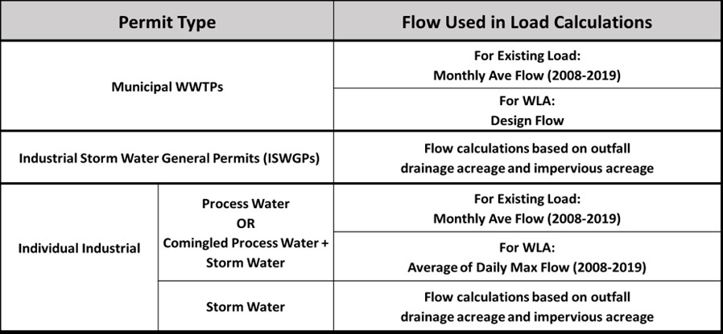
Figure C-1. Flow matrix applicable to the different types of permits.

Municipal Wastewater Treatment Facilities
Table C-1 lists the active municipal wastewater treatment facilities in the James River study area, with the mean PCB concentration and TMDL endpoints used to calculate baseline PCB loads and WLAs, respectively. Equations 1 and 2 are used to derive the PCB loadings from continuously discharging outfalls such as municipal WWTPs or industrial WWTPs.
Eq. 1 $Existing Load (mg/yr)=Monthly Ave Flow \left(MGD\right) x Ave. tPCB Conc. (pg/L)$x Conversion Factor
Eq. 2 $WLA (mg/yr)=Design Flow \left(MGD\right) x TMDL Endpoint (pg/L) x Conversion Factor$
Where: Monthly Average Flow = Calibration period for TMDL Model
MGD = Million Gallons per Day
Conversion Factor (mg/yr) = 1.38

Table C-2 lists the municipal wastewater treatment plants that are no longer active in the James River study area. For active WWTPs where PCBs were not collected in advance of the TMDL development, default tPCB concentrations were used from a statewide dataset that are applicable to municipal outfalls (DEQ, 2016).
Table C-1. Active Municipal Wastewater Treatment Facilities in the James River study area.
TMDL Watershed | Facility Name | Permit ID | Mean tPCB Concentration  (pg/L) | TMDL Endpoint (pg/L)
Jackson River | Covington City - Wastewater Treatment Plant | VA0025542 | 938.9 | 580
 | Alleghany County - Low Moor WWTP | VA0027979 | 255.6 | 580
 | Hot Springs Regional STP | VA0066303 | 1,707.1ª | 580
 | Alleghany Co - Lower Jackson River Regional WWTP | VA0090671 | 1,707.1ª | 580
Maury River | Buena Vista STP | VA0020991 | 1,707.1ª | 400
 | Lexington-Rockbridge Regional WQCF | VA0088161 | 1,707.1ª | 400
 | DOC - Augusta Correctional Center | VA0091821 | 250.3 | 400
Upper James River | Buchanan Town - Sewage Treatment Plant | VA0022225 | 183.3 | 120
 | Lynchburg Regional Wastewater Treatment Plant | VA0024970 | 712.9 | 120
 | Amherst Co Service Authority Ivanhoe | VA0063657 | 1,640.9 | 120
 | Craig New Castle PSA WWTP Outfall 001 | VA0064599 | 142.4 | 120
 | Western Virginia Water Authority (WVWA) Eagle Rock WWTP Outfall 001 | VA0076350 | 577.3 | 120
 | Town of Glasgow WWTP | VA0083712 | 607.7 | 120
 | Western Virginia Water Authority (WVWA) Glen Wilton WWTP | VA0089273 | 780.8 | 120
Lower James River | James River Correction Center | VA0020681 | 1,707.1ª | 52
 | DOC Powhatan Correctional Center | VA0020699 | 1,707.1ª | 52
 | VA Correctional Center for Women | VA0020702 | 1,707.1ª | 52
 | Scottsville WRRF | VA0025470 | 1,707.1ª | 52
 | Moores Creek Advanced Water Resource Recovery Facility | VA0025518 | 1,707.1ª | 52
 | Buckingham Co Water System/Dillwyn STP | VA0027294 | 1,707.1ª | 52
 | Rutledge Creek WWTP | VA0031321 | 1,707.1ª | 52
 | DOC - Buckingham Correctional Center | VA0066460 | 1,707.1ª | 52
 | Glenmore WRRF | VA0086584 | 1,707.1ª | 52
 | Nelson County Regional STP | VA0089729 | 1,707.1ª | 52
 | Dutoy Creek WWTP | VA0090727 | 17.7 | 52
 | Oilville Wastewater Treatment Plant | VA0092428 | 1,707.1ª | 52
ª Default tPCB concentration based on a statewide municipal dataset (DEQ, 2016).
Table C-2. Inactive municipal wastewater treatment facilities in the James River study area.
TMDL Watershed | Facility Name | Permit ID | Mean tPCB Concentration  (pg/L)
Jackson River | Clifton Forge Town Wastewater Treatment Plant | VA0022772 | 1,707.1ª
Lower James River | Camelot WWTP | VA0025488 | 1,707.1ª
ª Default tPCB concentration based on a statewide municipal dataset (DEQ, 2016).

Two municipalities in the James River study area operate Combined Sewer Systems (CSSs), the City of Lynchburg and the City of Richmond. In older cities like these, the system for handling stormwater is often combined with the system for handling sewage. On most days, the sewage and stormwater are conveyed to the wastewater facility where it is treated before being discharged. However, because wastewater facilities have a maximum volume of water that can be treated over a given amount of time, during periods of heavy precipitation, the maximum volume of water that can be treated may be exceeded. When that volume is exceeded it leads to combined sewer overflows (CSOs) of untreated mixed sewage and stormwater are discharged. Both cities have entered into long-term control plans (LTCPs) that lay out the course for controlling these CSOs. Some of the LTCP activities include separating certain CSS outfalls to only discharge stormwater, adding storage capacity, and increasing treatment capacity at the wastewater facility. Given the evolving nature of these CSSs, the monthly CSO volumes for each CSS outfall over January 2008-December 2019 were used in the calculation of the baseline CSS PCB load. These flows were multiplied by a PCB concentration averaged from monitoring data at CSO outfalls during discharge events to derive the PCB load. The same concentration was multiplied by the LTCP goal overflow volume to calculate waste load allocations. The LTCP goal overflow volumes were derived independently for both the City of Lynchburg and the City of Richmond based on the models used to develop each City’s LTCP. Table C-3 lists the CSSs in the James River Study Area, the area drained by each CSS, and the average annual overflow volume during the modeling period.
Table C-3. Municipal Combined Sewer Systems (CSS) in the James River study area.
TMDL Watersheds | Combined Sewer System | Permit ID | Drainage Area (acres) | Average Annual Overflow (MG) | Mean tPCB Concentration (pg/L)
Upper James River | City of Lynchburg | VA0024970 | 1,137.4 | 55.2 | 159,265
Lower James River | City of Richmondª | VA0063177 | 11,098.9 | 2,240.2 | 11,906.68
ª Acreages and overflow values are based on the outfalls that drain into the Lower James River watershed. The outfalls that drain into the tidal portion of the James are not included.

Industrial Stormwater General Permitted Facilities (ISWGP)
Industrial Stormwater General Permitted Facilities that are receiving PCB WLAs were selected by DEQ for this TMDL based on their SIC codes. The facilities regulated as an ISWGP generally have a smaller industrial footprint whereby the PCB loads are a direct function of stormwater runoff. The VPDES General Permit Regulation for Discharges of Stormwater Associated with Industrial Activity (9VAC25-151-70) formed the basis for the load derivation from these facilities. In determining the PCB concentration, an acreage based weighted mean concentration was calculated when multiple SW outfalls existed and if available, included both actual PCB data and/or default PCB concentrations in the calculation. The PCB loads were derived by calculating the annual runoff from the facility (gal/yr), which is an attribute of the drainage areas (acres) associated with the industrial activity and impervious acreages and multiplying it by the PCB concentration at the outfall. The calculated ISWGP loads serve as a constant point source load to the model since the runoff/flow rate is an annual average, whereas the PCB load from the WWTP varies by month (DEQ, 2016). Table C-4 lists the active ISWGPs in the James River study area and the TMDL endpoint used to calculate the waste load allocation. Table C-5 lists the inactive ISWGP permits in the James River study area. As these former industrial sites are no longer permitted, residual PCBs can remain on site and be transported to the local impaired waterway. Therefore, the PCB loads originating from these sites were reallocated to the Contaminated site source category.

Table C-4. Active Industrial Stormwater General Permit (ISWGP) facilities in the James River Study area
TMDL Watershed | Facility Name | Permit ID |  | No. of Outfalls | TMDL Endpoint (pg/L)
Jackson River | Chemtrade Solutions LLC - Covington | VAR050182 | 1 |  | 580
 | Material Handlings Solutions | VAR050440 | 6 |  | 580
 | Covington City - Peters Mountain Landfill | VAR051392 | 4 |  | 580
 | WestRock Virginia LLC - Low Moor Converting Plant | VAR052319 | 3 |  | 580
Maury River | Blue Ridge Resource Authority | VAR051408 | 1 |  | 400
 | Southers Auto Salvage LLC | VAR051827 | 4 |  | 400
 | Auto Recyclers LLC | VAR051901 | 1 |  | 400
 | Auto Towing and Repair LLC | VAR052111 | 1 |  | 400
 | City of Lexington Public Works Facility | VAR052411 | 2 |  | 400
Upper James River | Virginia Auto Parts Incorporated | VAR050167 | 2 |  | 120
 | Candler Oil Company Incorporated | VAR050169 | 4 |  | 120
 | Davis-Frost Inc | VAR050172 | 1 |  | 120
 | Delta Star Incorporated | VAR050173 | 3 |  | 120
 | Crawford Oil Company Incorporated | VAR050181 | 1 |  | 120
 | Parker Hannifin Corporation - Powertrain Division | VAR050261 | 1 |  | 120
 | Flowserve Lynchburg Operations | VAR050266 | 4 |  | 120
 | Schwerman Trucking Company | VAR050270 | 1 |  | 120
 | Hanwha Azdel | VAR050391 | 3 |  | 120
 | United Parcel Service Inc - Lynchburg | VAR050447 | 2 |  | 120
 | WestRock Converting LLC | VAR050524 | 7 |  | 120
 | Republic Services of Lynchburg | VAR050710 | 2 |  | 120
 | Botetourt County Landfill | VAR050712 | 3 |  | 120
 | Cooper Steel of Virginia LLC | VAR050737 | 4 |  | 120
 | Amherst County Landfill Permit Number 563 | VAR051354 | 1 |  | 120
 | Rolling Frito-Lay Sales LP - Lynchburg Bin | VAR051551 | 1 |  | 120
 | International Paper Company | VAR051585 | 3 |  | 120
 | KDC/One Lynchburg | VAR051906 | 5 |  | 120
 | Sonoco Recycling LLC - Madison Heights | VAR051959 | 1 |  | 120
 | Region 2000 Regional Landfill - Livestock Rd Fac | VAR051994 | 2 |  | 120
 | Watts Petroleum Corporation - Lynchburg | VAR052022 | 1 |  | 120
 | Banker Steel Company LLC | VAR052109 | 3 |  | 120
 | Madison Heights Auto Parts | VAR052182 | 6 |  | 120
 | Griffin Pipe Products Co LLC - Lynchburg | VAR052212 | 4 |  | 120
 | Porters Properties Lynchburg LLC | VAR052226 | 1 |  | 120
 | Foss Industrial Recycling LLC - Lynchburg | VAR052309 | 4 |  | 120
 | Munters - Natural Bridge Station | VAR052383 | 2 |  | 120
 | AOC Metal Works - Lynchburg | VAR052393 | 2 |  | 120
 | BRC Investments LLC | VAR052403 | 2 |  | 120
 | Slocum Adhesives Corporation | VAR052456 | 2 |  | 120
 | Clear Water Manufacturing | VAR052508 | 1 |  | 120
 | Slocum Adhesives Corporation- Carroll Ave | VAR052530 | 3 |  | 120
Lower James River | Glad Manufacturing Company | VAR050222 | 2 |  | 52
 | Brooks Auto Sales | VAR050630 | 1 |  | 52
 | UPS Freight- Richmond | VAR050657 | 1 |  | 52
 | 623 Landfill | VAR050730 | 7 |  | 52
 | United Parcel Service - Charlottesville | VAR050780 | 2 |  | 52
 | BFI Fluvanna Transcyclery | VAR050820 | 3 |  | 52
 | M and M Service and Salvage Yard Incorporated | VAR050960 | 1 |  | 52
 | Harry A Wright's Inc | VAR050965 | 1 |  | 52
 | Ivy Materials Utilization Center | VAR050973 | 6 |  | 52
 | Republic Services of Charlottesville | VAR050974 | 1 |  | 52
 | Chesterfield Auto Parts | VAR051102 | 2 |  | 52
 | Mullite Plant | VAR051580 | 1 |  | 52
 | Van Der Linde Recycling | VAR051853 | 2 |  | 52
 | Buckingham Branch Railroad | VAR051926 | 1 |  | 52
 | County Line Auto Parts | VAR052030 | 2 |  | 52
 | Morris Industries Incorporated | VAR052269 | 1 |  | 52
 | Tenaska Virginia Generating Station | VAR052356 | 2 |  | 52
 | Panorama Paydirt | VAR052458 | 8 |  | 52

Table C-5. Inactive Industrial Stormwater General Permit (ISWGP) facilities in the James River Study Area.
TMDL Watershed | Facility Name | Permit ID | No. of Outfalls
Jackson River | Bath Co Solid Waste Transfer Stn Closed Landfill | VAR051406 | 3
 | Gerdau - Covington | VAR051976 | 1
Upper James River | CR Hudgins Plating Incorporated | VAR050262 | 2
 | LSC Communications Inc - Lynchburg | VAR050527 | 3
 | Region 2000 Services Authority - Concord Turnpike | VAR051355 | 2
 | DeGe Incorporated Miscellaneous Metal Fabricators | VAR051586 | 1
 | CD Auto Recycling | VAR051763 | 1
 | Harold Beasley Inc | VAR051902 | 1
 | F Wayne Graves Oil Company Inc | VAR052021 | 2
 | Former CA Recycling and National Battery Co | VAR052385 | 1
Lower James River | Cosner Brothers Auto Parts Inc | VAR050825 | 6
 | Greene County Transfer Station | VAR051618 | 3
 | CARR Service Center | VAR051730 | 6
 | M & M Service & Salvage Yard Inc - East | VAR052274 | 1

Individual Industrial Permitted Facilities (IP)
The loads from IPs are calculated using a combination of the two previous methods. These facilities often feature multiple outfalls that may be one of two types, process/comingled (P/C) or stormwater (SW), where P/C includes process water outfalls and process water outfalls that are comingled with stormwater. For active IPs, the load from P/C outfalls were calculated similarly to municipal wastewater treatment facilities (see Equations 1 and 2 above) in which the DMR monthly average flows were multiplied by the PCB concentration at the outfall. Like the active permits, PCB load from P/C outfalls at IPs that are no longer active were calculated using the PCB concentration and the average monthly flow rate-included in the DMR for the period of permit activity between January 2008 and December 2019. The loads from SW outfalls were calculated similarly to the ISWGPs in which they were calculated as a function of facility area, runoff, and PCB concentration. Once calculated, PCB loadings at facilities where outfalls were limited to the P/C type were summed to reflect the baseline and WLA load for the combined outfalls. For those facilities that included both P/C outfalls and SW outfalls, the calculated loads were summed to yield a single baseline load and WLA. For both active and historically active SW IP outfalls, the loads were only modeled for the period of permit activity. The load from each outfall was input into the model as a point source. For both active and historically active permits, if PCB concentration data was not collected in advance of the TMDL development, default tPCB concentrations were used from a statewide dataset based on the appropriate Standard Industrial Classification (DEQ, 2016). In determining the PCB concentration for SW outfalls, an acreage based weighted mean concentration was calculated when multiple SW outfalls existed and if available, included both actual PCB data and/or default PCB concentrations in the calculation. Table C-6 lists the active IPs in the James River study area with the TMDL endpoints used to calculate waste load allocations. Outfall number, mean tPCB concentration, and whether the outfall was process/comingled, or stormwater are also listed. Table C-7 lists the IPs that are no longer active in the James River study area with the outfall number and the mean PCB concentration used to calculate historical PCB load. Similar to the ISWGPs, the PCB loads originating from these sites were reallocated to the Contaminated site source category as residual PCBs can remain on site and continue to be transported to the local impaired waterway.
Table C-6. Active Individual Industrial Permitted (IP) facilities in the James River study area.
TMDL Watershed | Facility Name | Permit ID | Outfall # | Type of Outfall | Mean tPCB Concentration (pg/L) | TMDL Endpoint (pg/L)
Jackson River | WestRock Virginia LLC - Covington | VA0003646 | 003 | P/C | 1,532.9 | 580
 |  |  | 004 | SW | 429 | 580
 |  |  | 009 | SW | 429 | 580
 |  |  | 010 | SW | 429 | 580
 |  |  | 012 | SW | 429 | 580
 |  |  | 013 | SW | 429 | 580
 |  |  | 015 | SW | 429 | 580
 | Dominion Energy - Bath County Power Station | VA0053317 | 001 | P/C | 1,030.8 | 580
 |  |  | 006 | P/C | 125.4ª | 580
 |  |  | 007 | P/C | 125.4ª | 580
 |  |  | 008 | P/C | 125.4ª | 580
 |  |  | 009 | P/C | 125.4ª | 580
 |  |  | 014 | P/C | 125.4ª | 580
 |  |  | 015 | P/C | 125.4ª | 580
 |  |  | 030 | P/C | 125.4ª | 580
 |  |  | 039 | P/C | 125.4ª | 580
 |  |  | 040 | P/C | 125.4ª | 580
 |  |  | 041 | P/C | 125.4ª | 580
 |  |  | 043 | P/C | 125.4ª | 580
 |  |  | 045 | P/C | 125.4ª | 580
 |  |  | 046 | P/C | 125.4ª | 580
Maury River | Modine Manufacturing Co - Buena Vista | VA0002771 | 001 | P/C | 19,234.5 | 400
 | Mohawk Industries Inc | VA0004677 | 001 | P/C | 560,411.0ª | 400
 |  |  | 002 | SW | 560,411.0ª | 400
 |  |  | 003 | SW | 560,411.0ª | 400
 |  |  | 005 | SW | 560,411.0ª | 400
 |  |  | 006 | SW | 560,411.0ª | 400
 |  |  | 007 | SW | 560,411.0ª | 400
 |  |  | 008 | SW | 560,411.0ª | 400
 |  |  | 009 | SW | 560,411.0ª | 400
 | Bontex Inc | VA0004791 | 001 | P/C | 1,532.9ª | 400
Upper James River | GP Big Island LLC | VA0003026 | 002 | P/C | 1,532.9ª | 120
 |  |  | 003 | P/C | 3,261.1 | 120
 |  |  | 005 | SW | 2,677.3ª | 120
 |  |  | 012 | SW | 2,677.3ª | 120
 |  |  | 014 | SW | 2,677.3ª | 120
 |  |  | 015 | SW | 2,677.3ª | 120
 |  |  | 017 | SW | 2,677.3ª | 120
 |  |  | 018 | SW | 2,677.3ª | 120
 |  |  | 021 | SW | 2,677.3ª | 120
 |  |  | 022 | SW | 2,677.3ª | 120
 |  |  | 023 | SW | 2,677.3ª | 120
 |  |  | 025 | SW | 2,677.3ª | 120
 |  |  | 028 | SW | 2,677.3ª | 120
 |  |  | 555^{b} | SW | 2,677.3ª | 120
 | BWXT Nuclear Operations Group Inc | VA0003697 | 001 | P/C | 1,597.1 | 120
 |  |  | 002 | SW | 4,846 | 120
 |  |  | 003 | SW | 4,846 | 120
 |  |  | 004 | SW | 4,846ª | 120
 |  |  | 005 | SW | 4,846ª | 120
 |  |  | 006 | SW | 4,846ª | 120
 |  |  | 007 | SW | 4,846ª | 120
 |  |  | 008 | SW | 4,846ª | 120
 |  |  | 009 | SW | 4,846ª | 120
 |  |  | 010 | SW | 4,846ª | 120
 |  |  | 011 | SW | 4,846ª | 120
 | Framatome Inc - MAR | VA0004774 | 001 | P/C | 438 | 120
 |  |  | 004 | P/C | 2.5 | 120
 | Greif Riverville LLC - Fibre Plant | VA0006408 | 001 | P/C | 1,084.8 | 120
 |  |  | 002 | SW | 1,532.9ª | 120
 |  |  | 003 | SW | 1,532.9ª | 120
 |  |  | 004 | SW | 1,532.9ª | 120
 |  |  | 005 | SW | 1,532.9ª | 120
 |  |  | 006 | SW | 1,532.9ª | 120
 |  |  | 007 | SW | 1,532.9ª | 120
 |  |  | 008 | SW | 1,532.9ª | 120
 |  |  | 009 | SW | 1,532.9ª | 120
 |  |  | 010 | SW | 1,532.9ª | 120
 |  |  | 011 | SW | 1,532.9ª | 120
 |  |  | 012 | SW | 1,532.9ª | 120
 | Roanoke Cement Co - Botetourt County | VA0072397 | 001 | P/C | 915ª | 120
 |  |  | 002 | P/C | 915ª | 120
 |  |  | 003 | P/C | 915ª | 120
 |  |  | 004 | P/C | 915ª | 120
 |  |  | 005 | P/C | 915ª | 120
 |  |  | 007 | P/C | 915ª | 120
 |  |  | 008 | SW | 915ª | 120
 |  |  | 009 | SW | 915ª | 120
 |  |  | 010 | SW | 915ª | 120
 |  |  | 011 | SW | 915ª | 120
 | Reusens Hydroelectric Plant | VA0087114 | 001 | P/C | 2,461.4ª | 120
 |  |  | 002 | P/C | 2,461.4ª | 120
 |  |  | 003 | P/C | 2,461.4ª | 120
 |  |  | 004 | P/C | 2,461.4ª | 120
 |  |  | 005 | P/C | 2,461.4ª | 120
 |  |  | 006 | P/C | 1,036.9 | 120
 |  |  | 007 | SW | 3,684.9 | 120
Lower James River | Dominion - Bremo Power Station | VA0004138^{c} | 002 | P/C | 67.6 | 52
 |  |  | 006 | SW | 2,461.4ª | 52
 |  |  | 008 | SW | 2,461.4ª | 52
 | Cooper Industries LLC | VA0027065 | 001 | P/C | 47,347.0ª | 52
 | Amherst County Landfill Permit Number 181 | VA0088684 | 001 | P/C | 1,738.6ª | 52
 |  |  | 003 | P/C | 1,738.6ª | 52
 | Dominion Energy - Bear Garden Generating Station | VA0090891 | 001 | P/C | 125.4ª | 52
 |  |  | 002 | SW | 125.4ª | 52
 | Tenaska Virginia Generating Station | VA0090905 | 004 | P/C | 125.4ª | 52
ª Default tPCB concentration based on a statewide Standard Industrial Classification (SIC) dataset (DEQ, 2016).
^{b} Outfall 555 accounts for four total outfalls. These include 007, 009, 010, 013.
^{c} Baseline loads include six total outfalls. There were seven outfalls removed in 2020. Three of those had historical discharges and were counted in the baseline loads.
Table C7. Inactive individual industrial permitted (IP) facilities in the James River study area.
TMDL Watershed | Facility Name | Permit ID | Outfall # | Type of Outfall | Mean tPCB Concentration (pg/L)
Jackson River | CSX Transportation Inc - Clifton Forge | VA0003344 | 001 | P/C | 3,063.5ª
 | Rail Over River Industrial Park LLC | VA0003450 | 001 | P/C | 34.3ª
 |  |  | 002 | P/C | 34.3ª
Upper James River | VCI Lynchburg Foundry | VA0006262 | 001 | P/C | 14,670.6ª
 |  |  | 002 | P/C | 14,670.6ª
 |  |  | 003 | SW | 14,670.6ª
 |  |  | 004 | SW | 14,670.6ª
 |  |  | 005 | SW | 14,670.6ª
 | Campbell County Landfill | VA0091723 | 001 | P/C | 1,738.6ª
 |  |  | 002 | P/C | 1,738.6ª
 | Falwell Industrial Landfill | VA0092258 | 001 | P/C | 44.7
Lower James River | Orange Madison Cooperative Farm Service | VA0087351 | 001 | P/C | 822.1ª
ª Default tPCB concentration based on a statewide Standard Industrial Classification (SIC) dataset (DEQ, 2016).

In addition to the permitted facilities listed in the preceding tables, there are eleven municipal separate storm sewer systems (MS4s, Table C-8) in the study area. These are municipal regions that convey impervious surface stormwater runoff from within their boundary through a permitted discharge point. MS4s are responsible for the PCB load in their runoff that is discharged through their stormwater conveyance system.
Table C-8. MS4s in the James River PCB TMDL study area.
MS4 Entity | Permit Number | Service Area (acres)ª
Albemarle County | VAR040074 | 14,167
Central Virginia Community College | VAR040118 | 32
Charlottesville City | VAR040051 | 5,733
Chesterfield County | VA0088609 | 4,678
Department of Juvenile Justice | VAR040128 | 51
Henrico County | VA0088617 | 20,835
Lynchburg City | VAR040008 | 7,834
Piedmont Virginia Community College | VAR040108 | 60
Richmond City | VA0063177 | 9,975
University of Virginia | VAR040073 | 1,198
Virginia Department of Transportation | VA0092975 | 6,426
ª in some areas, MS4 drainage areas may overlap.

Nonpoint Sources
The nonpoint PCB sources considered when developing a PCB TMDL include several subcategories of contaminated sites, atmospheric deposition and streambed sediment. Properties that are often associated with PCB contamination can include Comprehensive Environmental Restoration, Compensation, and Liability Act (CERCLA) known as Superfund sites, Resource Conservation Recovery Act (RCRA) Corrective Action (CA) facilities, Brownfield sites, and sites enrolled in DEQ’s Voluntary Remediation Program (VRP). Additional subcategories include sites remediated for PCBs with EPA oversight under the Toxics Substances Control Act (TSCA), railyards/railway spurs, electrical substations, and sites with possible PCB spills.
Contaminated sites and railyards were assigned a specific “contaminated” land use type that is similar hydrologically, pedologically (soil classification) and geophysically to the existing land use types (e.g., Commercial, Industrial). The sediment runoff from the “contaminated” land uses included an associated PCB load because PCBs adsorb to sediment. The contributing areas associated with the unregulated surface runoff load were not assigned specific land use types, but their sediment runoff still included a PCB load. PCB spills were modeled as direct inputs into the stream or as deposition onto the land surface. Table C-9 lists the nonpoint sources considered in the James River PCB TMDL.
Table C-9. James River nonpoint PCB sources.
Nonpoint Sources | PCB Load
Contaminated Sites
Volunteer Remediation Program Sites | Varies by site
Railyards and Railway Spurs | 7.02 x 10¹⁰ pg PCB/ton of sediment
Electrical Substation | 1.29 x 10¹² pg/PCB/ton of sediment
Pollution Response Program (PREP) Spills | Varies by Spill
Surface Sources
Unregulated Surface Sources¹ | Varies by land use category
Atmospheric Deposition | 8.90 x 10³ pg/m²/year
Streambed Sediment | Varies by stream segment
¹ Unregulated surface sources represent PCB loads supported by the observed data whose specific location have yet to be identified.

Contaminated Sites
For purposes of this study, those properties and sites where PCBs have been identified as a contaminant of concern or potential concern were included. No CERCLA, RCRA Corrective Action, Brownfield or VRP sites (except the former 2.7 acre Buick Property which was fully remediated) were identified in the study as contributing PCBs and included as contaminated sites. Other categories of contaminated sites are described in the following sections.

Railyards and Railway Spurs
Railyards and railway spurs are included as PCB sources because the EPA allows continued operation of older train engine transformers that still use PCB fluids. When trains containing PCBs are idled for extended periods on unused rail lines, PCBs may leak onto the ground and contaminate the soil. A review of other PCB TMDLs developed in Virginia indicated that railyards were previously included as potential sources. The Roanoke River PCB TMDL (DEQ, 2009) included two sites as source areas: Shaffers Crossing (VPDES-permitted railyard) and Norfolk Southern 12. Shaffers Crossing was modeled as a point source, but the Norfolk Southern yard was treated as a nonpoint source. Permitted PCB point source data for the James River did not include any railyards, but analysis of satellite imagery revealed several railyards and railway spurs throughout the James River study area (Table C-10). Railyards and railway spurs were modeled as nonpoint sources and were assigned specific PCB contaminated land uses and loads. Since soil tests were not conducted at most railyards and railway spurs, PCB load rates were adopted from the Roanoke River PCB TMDL.
Table C-10. Contaminated sites identified as Railyards, Railway Spurs in the James River study area.
TMDL Watershed | Site Description | Receiving Body | Estimated Area  (ac)
Jackson River | Railway spur 19 | Jackson River | 10.9
 | Railway spur 20 | Jackson River | 196.2
 | Railway spur 21 | Jackson River | 34.4
 | Railway spur 22 | Dunlap Creek, Jackson River | 18.8
 | Railway spur 23 | Dry Run, Jackson River | 10.9
 | Railway spur 25 | Jackson River | 6.1
Maury River | Railway spur 18 | Unnamed Trib to Maury River | 4.7
 | Railway spur 19 | Maury River | 5.2
 | Railway spur 26 | Brattons Run, Unnamed Trib to Calfpasture River | 1.7
Upper James River | Railway spur 8 | Unnamed Tribs (3x) to James River | 19.8
 | Railway spur 9 | James River | 1.5
 | Railway spur 10 | Unnamed Trib to James River, James River, Fishing Creek | 37.3
 | Railway spur 11 | James River | 30.5
 | Railway spur 12^{b} | Fishing Creek, Unnamed Trib to Fishing Creek, | 191.0
 | Railway spur 13 | Unnamed Trib to Tomahawk Creek | 3.4
 | Railway spur 14 | Unnamed Trib to Blackwater Creek | 1.4
 | Railway spur 15 | James River | 85.0
 | Railway spur 16 | Unnamed Trib to Harris Creek | 2.4
 | Railway spur 24 | Unnamed Trib to Catawba Creek | 16.7
 | Rail Station 2 | Unnamed Trib to Blackwater Creek | 2.3
Lower James River | Norfolk Southern and Railway Spur 10 | James River | 40.7
 | Norfolk Southern Railyard | James River, Kanawah Canal | 0.9
 | Railway spur 1 | Unnamed Trib to James River | 6.5
 | Railway spur 2 | James River | 3.4
 | Railway spur 4 | Unnamed Trib to James River | 12.7
 | Railway spur 5 | Joshua Creek | 2.76
 | Railway spur 6 | Unnamed Trib to Gold Mine Branch | 1.1
 | Railway spur 7 | Unnamed Trib to Whispering Creek | 3.2
 | Railway spur 8 | James River | 24.4
 | Railway spur 17 | Unnamed Trib to Rivanna River | 7.6
 | Railway station 1 | Unnamed Trib to Moores Creek | 2.3

Railyards and railway spurs in the James River PCB TMDL study area were identified using Google Earth historical satellite imagery. Railroad lines were visually traced until a railyard or possible railway spur was identified. Key indicators of a railway spur were rail lines that diverted off the main track before ending abruptly and/or the presence of secondary and tertiary tracks. These extra rail lines were potentially used for maintenance purposes. The satellite imagery of these sites typically showed rail tie storage, indicating the possibility of railway machinery being present. If these sites were used for storage, PCBs may have leached into the soil. Locations with a large confluence of rail lines and noticeable railway activity were designated as railyards.
Several manufacturing and industrial facilities were also identified as railway spurs if it was determined from satellite imagery that rail lines and parcels of land adjacent to these rail lines were storing train cars and cargo for extended periods. The assumption is that when left stationary, trains and/or their cargo leach PCBs into the soil.
Spills and leaks by locomotives occasionally occurred when they were outside of the railyard and railway spur boundaries. Records of these incidents were recorded in DEQ’s Pollution Response Program (PREP) database. These incidents were used to generate one-time loads of PCBs. Further information on PREP incidents is provided in its respective section below.

Electrical Substations
Electrical substations are part of an electrical generation, transmission, and distribution system that are used to convert voltage from high to low (or the reverse) through the use of electrical transformers. The equipment associated with this function historically contained dielectric fluids that contained high levels of PCBs. One hundred eighteen electrical substations totaling 125.53 acres were identified in the James River study area. The average area of a substation was 1.06 acres with a range from 0.02 to 9.69 acres. The applied loading rate was based on data provided by Dominion Energy and Appalachian Power for previous PCB TMDL studies (ICPRB, 2007; DEQ, 2018) and was estimated at 1.29 x 10¹² (pg/ton).

Former Industrial Sites/Inactive permits
Former industrial sites that are no longer permitted under the ISWGP or IP VPDES categories, have been included in the contaminated site category as residual PCBs can remain on site long after the industrial activities have ceased. During periods of rainfall remaining PCBs can be transported off-site to the local impaired waterway and for this reason PCB loads originating from these sites were reallocated to the Contaminated site source category.

Pollution Response Program (PREP) PCB Spills
The Pollution Response Program (PREP) database is managed by DEQ and tracks pollution incidents that result in potential human health or environmental impact. Agencies, businesses, or individuals report the incidents to DEQ who dispatch personnel to investigate the report. Entries in the database may include improper liquid or solid waste disposal, leakages, sewer overflows, legal or illegal burnings, or unidentified contaminants visible in a stream. DEQ reviewed the database entries for incidents in the James River study area that occurred during the modeling period. The database was pared down to oil spills since PCBs are commonly found in oils. Database entries that noted the oil was non-PCB was ignored in the report.
In the model, PREP incidents were simulated as one-time localized events. If a duration was not provided in the PREP database, it was estimated using best professional judgement. The PREP spills were often listed as a volume. Given the fact that many of the spills were in the form of oil, it was assumed that the density of the liquid spills was 0.9 kg/L (less than the density of water). The assumed concentration of PCBs in the oil was 0.05%, which is conservative for spills from an unknown origin (DEQ, 2018). Locations of the spill incidents, in addition to the details for the estimated quantities of PCBs (mg) released from each spill incident, were included in the model. For incidents with spills of unknown quantity, the modeled PCB load was based on an estimated spill volume of one gallon.

Unregulated Surface Runoff
Unregulated surface runoff is a term that collectively accounts for PCB loadings from an uncertain origin found within regulated and non-regulated areas that drain to the James River watershed. Unregulated surface drainage includes areas adjacent to the James, Jackson and Maury Rivers and their associated tributaries that are recognized as contributing PCB loads. These areas contribute background PCBs associated with atmospheric deposition to the land surfaces as well as unknown or uncharacterized PCB contaminated sites (including past spill sites), unregulated stormwater runoff from commercial land use areas, loads from small tributaries that are not explicitly specified in the model, and unspecified point source discharges. Sources represented by this category include PCB loads supported by the observed instream data whose specific location have yet to be identified.

Atmospheric Deposition
Due to their molecular stability, PCBs persist in the atmosphere after volatilization and may contaminate waterbodies through direct deposition onto the water surface or by runoff after deposition onto the land surface. Atmospheric deposition was applied on all water surfaces in the James River study area at a constant rate. Atmospheric deposition on the water surface immediately enters the water column as a freely available pollutant constituent. Since there are no available data to characterize the atmospheric deposition of tPCBs to the surface waters, Virginia Tech Biological Systems Engineering (BSE) elected to use a PCB atmospheric deposition rate of 3.0 x 10⁶ pg/ac/month applied across the James River study area. This rate corresponds with results in the Roanoke River and New River PCB TMDLs. When PCBs are deposited onto the land surface they adsorb to soil particles but do not enter into the stream network until a precipitation event induces a runoff event that carries soils with the adsorbed PCB contamination into a stream. Atmospheric deposition to the land surface was modeled as part of the non-regulated watershed runoff.

Streambed Sediment
The historical discharges of PCBs into the water combined with the ability of PCBs to persist in the environment and their tendency to adsorb to sediment particles make sediment within stream channels a major source of PCBs. Due to their hydrophobic properties, PCBs adsorb to sediment particles. PCBs have a higher tendency to associate at elevated concentrations with finer sediment particles, which have more surface area and higher carbon content, such as clay and silt rather than coarser particles like sand. PCB contaminated sediment may settle to the streambed, but when disturbed the sediment may re-suspend into the water column and the soil-attached PCBs may desorb into the water. Streambed sediment sampling by DEQ has shown measurable concentrations of PCBs in James River. The sediment PCB concentrations in these observed samples were used in the James River PCB model to provide initial concentrations of PCBs associated with sediment.

References
DEQ. 2009. Roanoke River PCB TMDL Development (Virginia). Prepared for United States Environmental Protection Agency, Region 3. December 2009.
DEQ. 2016. The Relationship between Polychlorinated Biphenyls (PCBs), VPDES Wastewater/Stormwater Facilities, Stormwater Industrial General Permitted Facilities (ISWGPs), and the Standard Industrial Classification System (SIC). Virginia Department of Environmental Quality. February 2016.
DEQ. 2018. PCB Total Maximum Daily Load Development for Reed Creek, the Upper New River, Peak Creek, Walker Creek, Stony Creek, and the Lower New River. Prepared by Department of Biological Systems Engineering, Virginia, Tech. July 2018.
ICPRB (Interstate Commission on the Potomac River Basin). 2007. Total Maximum Daily Loads of Polychlorinated Biphenyls (PCBs) for Tidal Portions of the Potomac and Anacostia Rivers in the District of Columbia, Maryland, and Virginia. Prepared by The Interstate Commission on the Potomac River Basin (ICPRB). October 2007.

Hydrologic Calibration for the James River PCB TMDL Study Area
Model calibration is the process of selecting model parameters that provide an accurate representation of the watershed. In this section, we discuss the procedures followed to calibrate and validate the hydrology component of the Hydrological Simulation Program-FORTRAN (HSPF) model. Hydrologic calibrations and validations were performed for the Jackson and Maury River TMDL watersheds, while calibrations and validations were performed for multiple segments in the Upper and Lower James River TMDL watersheds. Within Appendix D each calibration segment is presented in its own section. Locations of the James River study area and flow gages are shown in Figure 2-8.
The Enhanced Expert System for calibration of HSPF (HSPEXP+) was used to aid in model calibration. HSPEXP+ uses the EXS file (“*.exs”) to obtain information about the calibration site, observed flow time-series dataset, simulated time-series datasets, analysis period, drainage area, storm periods, and model performance criteria. For this project, VADEQ guidance specifies the performance criteria listed in Table D-1 be used when assessing model performance during the calibration and validation periods.
Table D-1. Model performance criteria specified by DEQ.
Variable | Percent Error
Total Volume | ±10%
50% Lowest Flows | ±10%
10% Highest Flows | ±15%
Storm Peaks | ±15%
Seasonal Volume Error | ±10%
Storm Volume Error | ±20%

Jackson River Hydrologic Model
Observed daily flow data for the Jackson River were available from USGS monitoring station 01033100 (Dunlap Creek at Covington, VA). Daily flow data were used in the hydrologic calibration/validation. Meteorological data was obtained primarily from the Hot Springs, VA observation station (USC00444128) from National Centers for Environmental Information (NCEI).
The hydrologic calibration and validation periods were from January 1, 2000 to December 31, 2004, and January 1, 2009 to December 31, 2013, respectively. The model was calibrated and validated using daily average flow in cubic feet per second (cfs). The HSPF model was run until the simulated and observed flow met the criteria presented in Table D-1. The final calibration parameters were within the recommended ranges found in EPA’s BASINS Technical Note 6 (USEPA, 2000).
Figure D-1 and Figure D-2 show that the simulated flow for both the calibration and validation matched the observed flow well, although the model over predicted some of the peaks during both the calibration and validation periods. The agreement between the model simulated and observed flows is further illustrated in Figure D-3 and Figure D-4 for a representative year, and Figure D-5 and Figure D-6 for a representative storm. The model was able to capture representative storms, and annual flows during the calibration and validation periods.
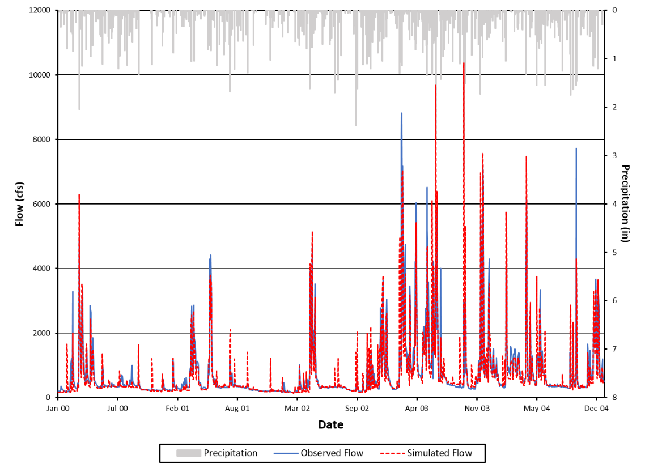
Figure D-1. Observed and simulated flows and precipitation for the Jackson River during the calibration period.

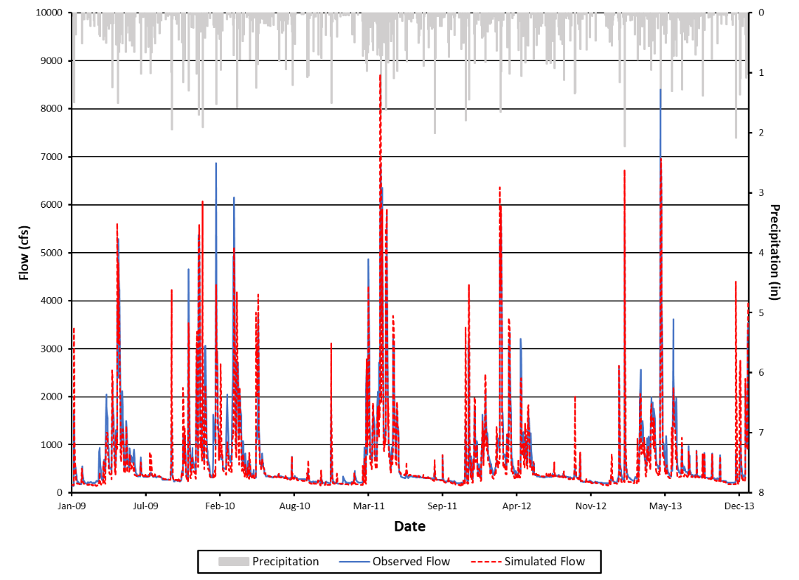
Figure D-2. Observed and simulated flows and precipitation for the Jackson River during the validation period.

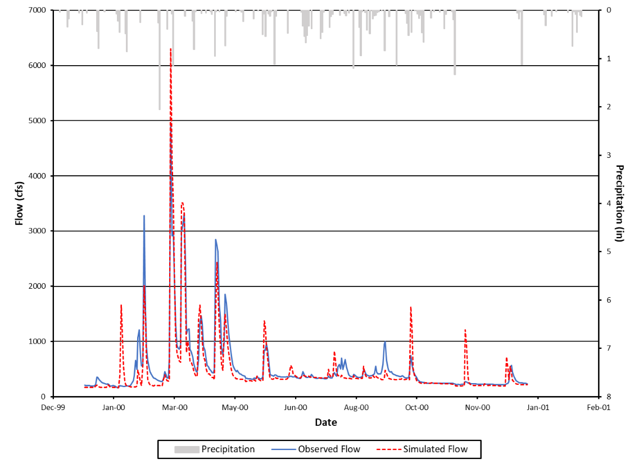
Figure D-3. Observed and simulated flows and precipitation for a representative year (2000) in the calibration period for the Jackson River.

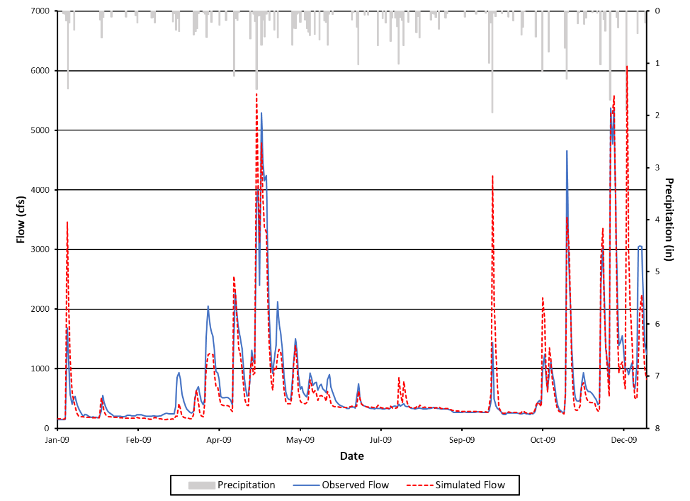
Figure D-4. Observed and simulated flows and precipitation for the Jackson River during a representative year (2009) in the validation period.

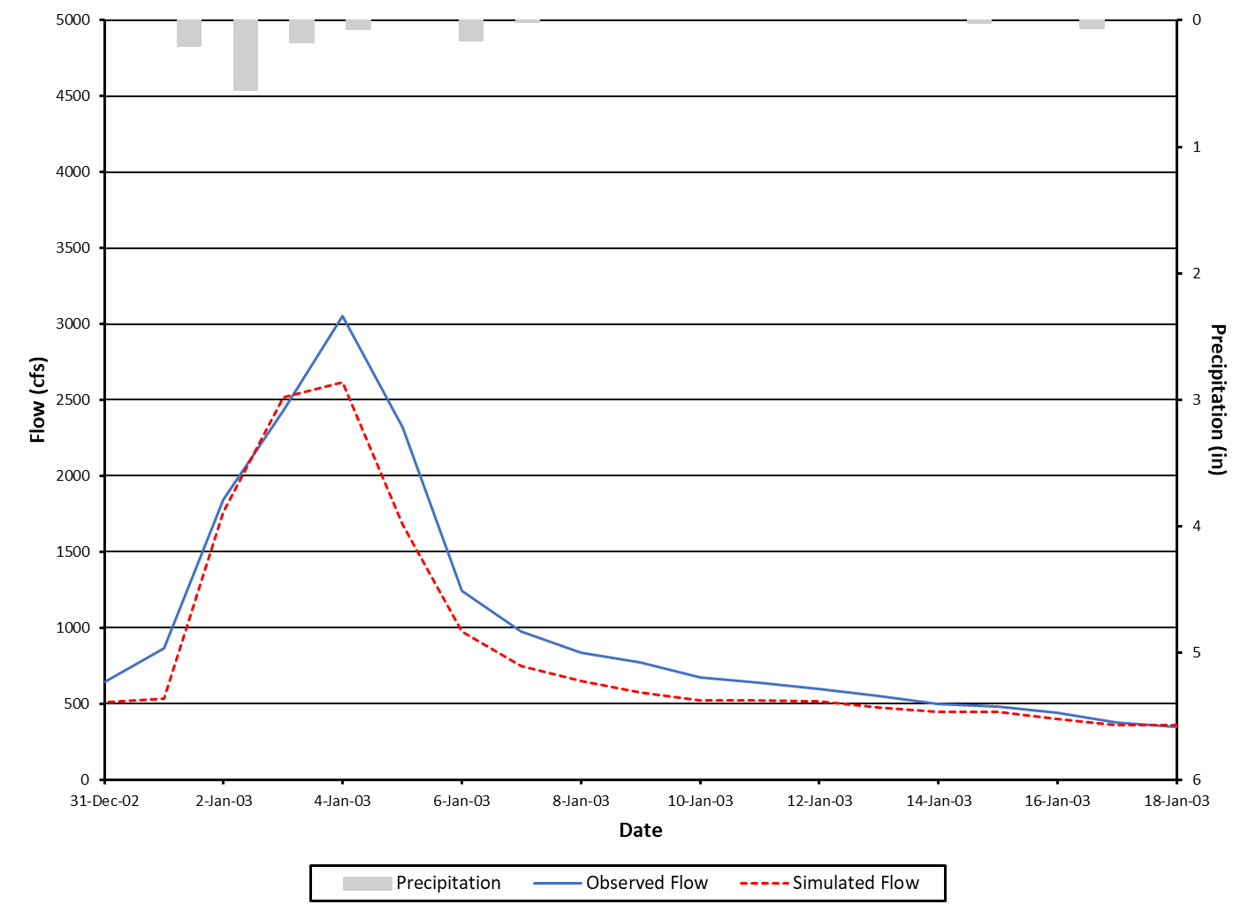
Figure D-5. Observed and simulated flows and precipitation for the Jackson River for a representative storm in the calibration period.

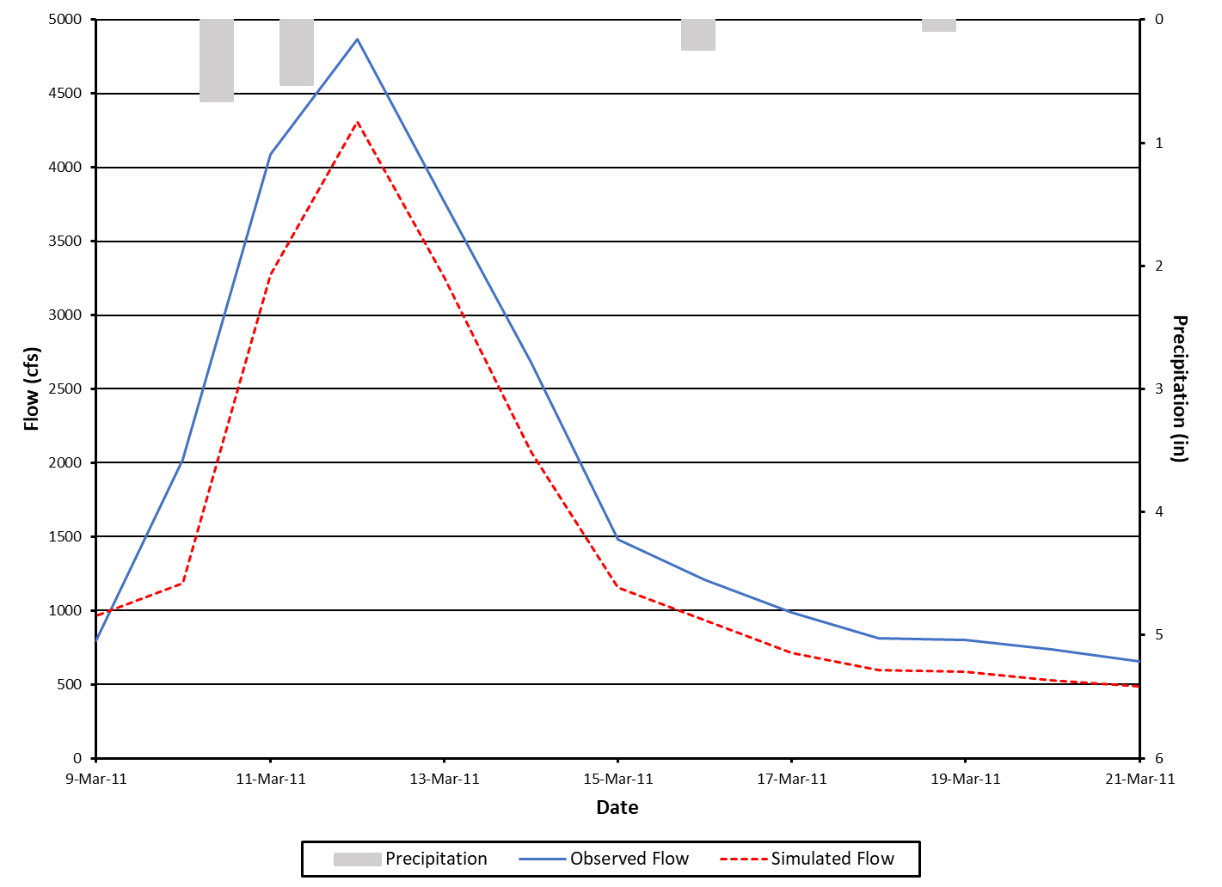
Figure D-6. Observed and simulated flows and precipitation for the Jackson River for a representative storm in the validation period.

Figure D-7 and Figure D-8 illustrate model agreement with observed data using cumulative frequency curves. The model adequately captured cumulative frequency for both calibration and validation periods.
Selected diagnostic outputs from the HSPEXP+ program is listed in Table D-2 and Table D-3. Percent errors for all the diagnostic outputs were within the allowable error criterion limits for both the calibration and validation periods.
When the observed flow data were evaluated using the Baseflow Filter program (Arnold et al., 1995), the range of baseflow indices was 0.40 to 0.62. The simulated baseflow indices are within the range of baseflow indices for the observed flow data, and the simulated indices are comparable to the observed median index. The final calibrated hydrologic parameters can be found in Table D-4.
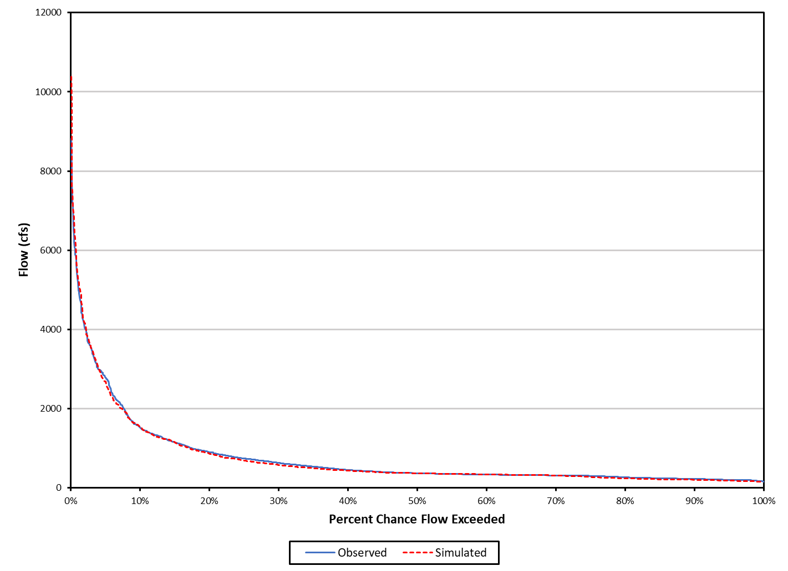
Figure D-7. Cumulative frequency curves for the calibration period for the Jackson River.

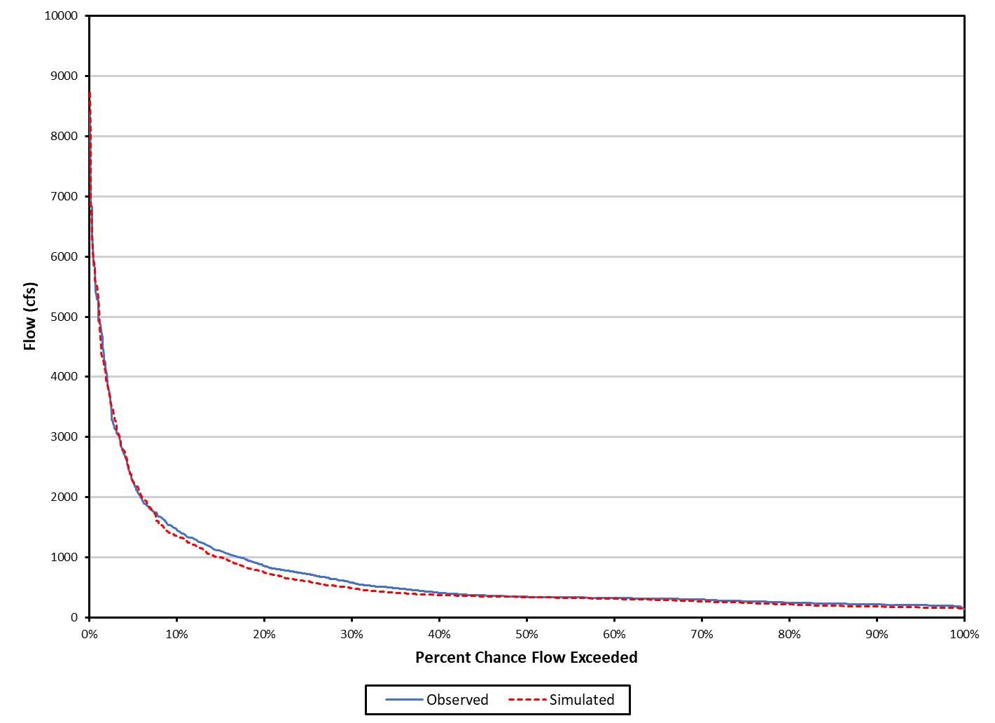
Figure D-8. Cumulative frequency curves for the validation period for the Jackson River.

Table D-2. Summary statistics for the calibration period for the Jackson River.
Total Runoff (in) | Simulated |  | Observed | Error (%) |  | Criterion
 | 79.616 |  | 81.287 | -2.1 |  | ±10%
Average Annual Total Runoff (in) | 15.923 |  | 16.257 | -2.1 |  | ±10%
Total of Highest 10% of flows (in) | 34.120 |  | 34.506 | 0.8 |  | ±15%
Total of Lowest 50% of flows (in) | 14.853 |  | 15.369 | -4.0 |  | ±10%
Total Winter Runoff (in) | 18.642 |  | 19.527 | -4.5 |  | n/a
Total Summer Runoff (in) | 15.981 |  | 14.769 | 8.2 |  | n/a
Total Seasonal Volume Error | – |  | – | 12.7 |  | ±20%
Storm Peaks (cfs) | 1,799.3 |  | 2,104.7 | -14.5 |  | ±15%
Total Storm Volume (selected storms) (in) | 15.387 |  | 17.371 | -11.4 |  | ±20%
Coefficient of Determination, r² |  | 0.92

Table D-3. Summary statistics for the validation period for the Jackson River.
Total Runoff (in) | Simulated |  | Observed | Error (%) |  | Criterion
 | 71.143 |  | 76.096 | -6.5 |  | ±10%
Average Annual Total Runoff (in) | 14.229 |  | 15.219 | -6.5 |  | ±10%
Total of Highest 10% of flows (in) | 30.782 |  | 31.466 | -0.2 |  | ±15%
Total of Lowest 50% of flows (in) | 13.566 |  | 14.865 | -9.2 |  | ±10%
Total Winter Runoff (in) | 17.646 |  | 18.273 | -3.4 |  | n/a
Total Summer Runoff (in) | 11.029 |  | 11.585 | -4.8 |  | n/a
Total Seasonal Volume Error | – |  | – | -1.4 |  | ±20%
Storm Peaks (cfs) | 1,332.9 |  | 1,511.1 | -11.8 |  | ±15%
Total Storm Volume (selected storms) (in) | 11.027 |  | 12.847 | -14.2 |  | ±20%
Coefficient of Determination, r² |  | 0.95

Table D-4. Final calibrated parameters for the Jackson River.
Parameter | Definition | Units | FINAL CALIBRATION | Possible  Range of  Values‡ | Function of …‡ | Comment
PERLND (Pervious Land module)
PWAT-PARM2 (Pervious Water Budget Hydrology Parameter Group 2)
FOREST | Fraction forest cover | none | 1.0 forest, 0.0 other | 0.0 - 1.0 | Forest cover | –
LZSN | Lower zone nominal soil moisture storage | inches | 6.0 - 6.5 | 2.0 - 15.0 | Soils, climate | Calibration
INFILT | Index to infiltration capacity | in/hr | 0.008 - 0.191ª | 0.001 - 0.500 | Soils, land use | Calibration
LSUR | Length of overland flow | feet | 23- 486ª | 10 - 700 | Topography | Estimated using GIS
SLSUR | Slope of overland flow plane | none | 0.02935 - 0.45484ª | 0.001 - 0.400 | Topography | Estimated using GIS
KVARY | Groundwater recession variable | 1/in | 0.0 | 0.0 - 5.0 | Baseflow recession variation | Calibration
AGWRC | Base groundwater recession | none | 0.99 | 0.850 - 0.999 | Baseflow recession | Calibration
PWAT-PARM3 (Pervious Water Budget Hydrology Parameter Group 3)
PETMAX | Temp below which ET is reduced | deg. F | 45 - 47 | 32 - 48 | Climate, vegetation | –
PETMIN | Temp below which ET is set to zero | deg. F | 35 | 30 - 40 | Climate, vegetation | –
INFEXP | Exponent in infiltration equation | none | 2 | 1 - 3 | Soils variability | Default to 2.0
INFILD | Ratio of max/mean  infiltration capacities | none | 2 | 1 - 3 | Soils variability | Default to 2.0
DEEPFR | Fraction of GW inflow to deep recharge | none | 0.00 - 0.05 | 0.00 - 0.50 | Geology, groundwater recharge | Calibration
BASETP | Fraction of remaining ET from baseflow | none | 0.008- 0.024ª | 0.0 - 0.2 | Riparian vegetation | Calibration
AGWETP | Fraction of remaining ET from active GW | none | 0.000 - 0.016ª | 0.0 - 0.2 | Marsh/wetlands extent | Calibration
PWAT-PARM4 (Pervious Water Budget Hydrology Parameter Group 4)
CEPSC | Interception storage capacity | inches | 0.05 – 0.30^{b} | 0.01 - 0.40 | Vegetation, type/density, land use | Calibration
UZSN | Upper zone nominal soil moisture storage | inches | 0.08 – 0.45^{b} | 0.05 - 2.00 | Surface soil conditions, land use | Calibration
NSUR | Manning’s n  (roughness) | none | 0.40 forest; 0.20 cropland,  0.24 pasture/hay, 0.15 res.; 0.15 comm.; and 0.10 water | 0.05 - 0.50 | Surface conditions,  residue | Calibration
INTFW | Interflow/surface runoff partition parameter | none | 1.38 – 1.78 | 1.0 - 10.0 | Soils, topography, land use | Calibration
IRC | Interflow recession parameter | none | 0.3 – 0.4 | 0.30 - 0.85 | Soils, topography, land use | Calibration
LZETP | Lower zone ET parameter | none | 0.1 – 0.58^{b} | 0.1 - 0.9 | Vegetation, type/density, root depth | Calibration
IMPLND (Imervious Land module)
IWAT-PARM2 (Impervious Water Budget Hydrology Parameter Group 2)
LSUR | Length of overland flow | feet | 53.5 | 50 - 250 | Topography, drainage system | Estimated using GIS
SLSUR | Slope of overland flow plane | none | 0.15 | 0.001 - 0.150 | Topography, drainage | Estimated using GIS
NSUR | Manning’s n  (roughness) | none | 0.08 | 0.01 - 0.15 | Impervious surface conditions | Default to  0.075
RETSC | Retention/interception storage capacity | inches | 0.10 | 0.01 - 0.30 | Impervious surface conditions | Default to 0.1
IWAT-PARM3 (Impervious Water Budget Hydrology Parameter Group 3)
PETMAX | Temp below which ET is reduced | deg. F | 46 | 32 - 48 | Climate, vegetation | –
PETMIN | Temp below which ET is set to zero | deg. F | 35 | 30 - 40 | Climate, vegetation | –
RCHRES (Reach/reservoir module)
HYDR-PARM2 (Reach/Reservoir Hydrology Parameter Group 2)
KS | Weighting factor for hydraulic routing | – | 0.0 | 0.00 - 0.99 | Channel slope, flow obstructions | Use KS = 0.5
‡ From the EPA BASINS Technical Note 6 (USEPA. 2000).
- Varies with land use.
- Varies by month and with land use.

Maury River Hydrologic Model
Observed daily flow data for the Maury River were available from USGS monitoring station 02023000 near Buena Vista, VA. Daily flow data were used in the hydrologic calibration/validation. Meteorological data was obtained primarily from the Buena Vista, VA observation station (USC00441159) from National Centers for Environmental Information (NCEI).
The hydrologic calibration and validation periods were from January 1, 2009 to December 31, 2013, and January 1, 2014 to December 31, 2017, respectively. The model was calibrated and validated using daily average flow in cubic feet per second (cfs). The HSPF model was run until the simulated and observed flow met the criteria presented in Table D-1. The final calibration parameters were within the recommended ranges found in EPA’s BASINS Technical Note 6 (USEPA, 2000).
Figure D-9 and Figure D-10 show that the simulated flow for both the calibration and validation matched the observed flow well, although the model over predicted some of the peaks during both the calibration and validation periods. The agreement between the model simulated and observed flows is further illustrated in Figure D-11 and Figure D-12 for a representative year, and Figure D-13 and Figure D-14 for a representative storm. The model was able to capture representative storms, and annual flows during the calibration and validation periods.
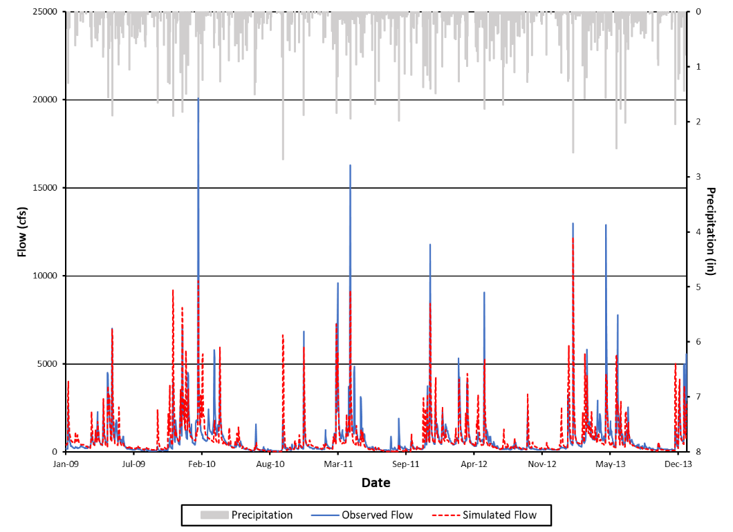
Figure D-9. Observed and simulated flows and precipitation for the Maury River during the calibration period.

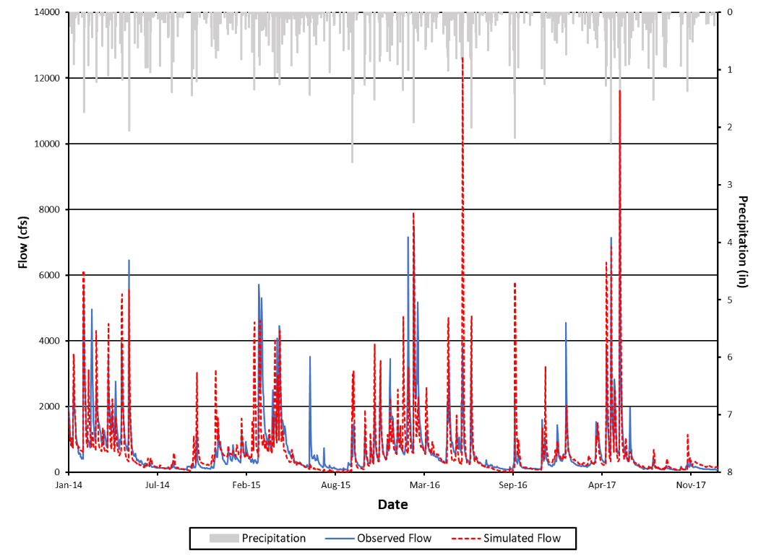
Figure D-10. Observed and simulated flows and precipitation for the Maury River during the validation period.

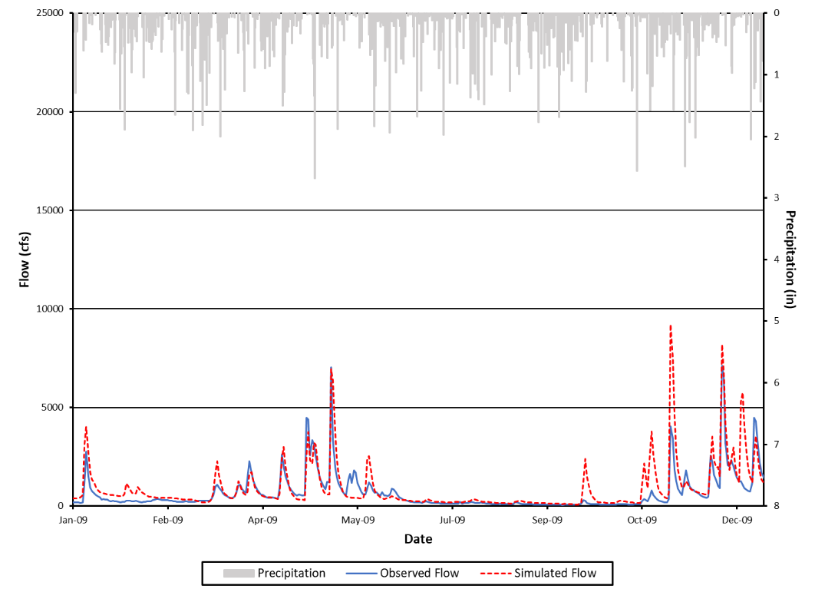
Figure D-11. Observed and simulated flows and precipitation for a representative year (2009) in the calibration period for the Maury River.

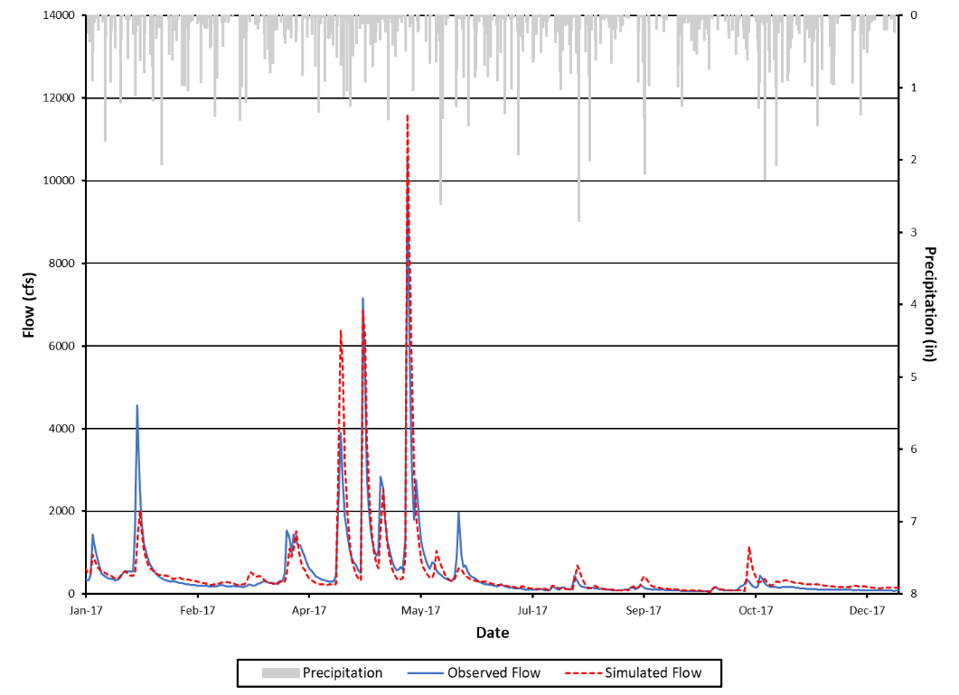
Figure D-12. Observed and simulated flows and precipitation for the Maury River during a representative year (2017) in the validation period.

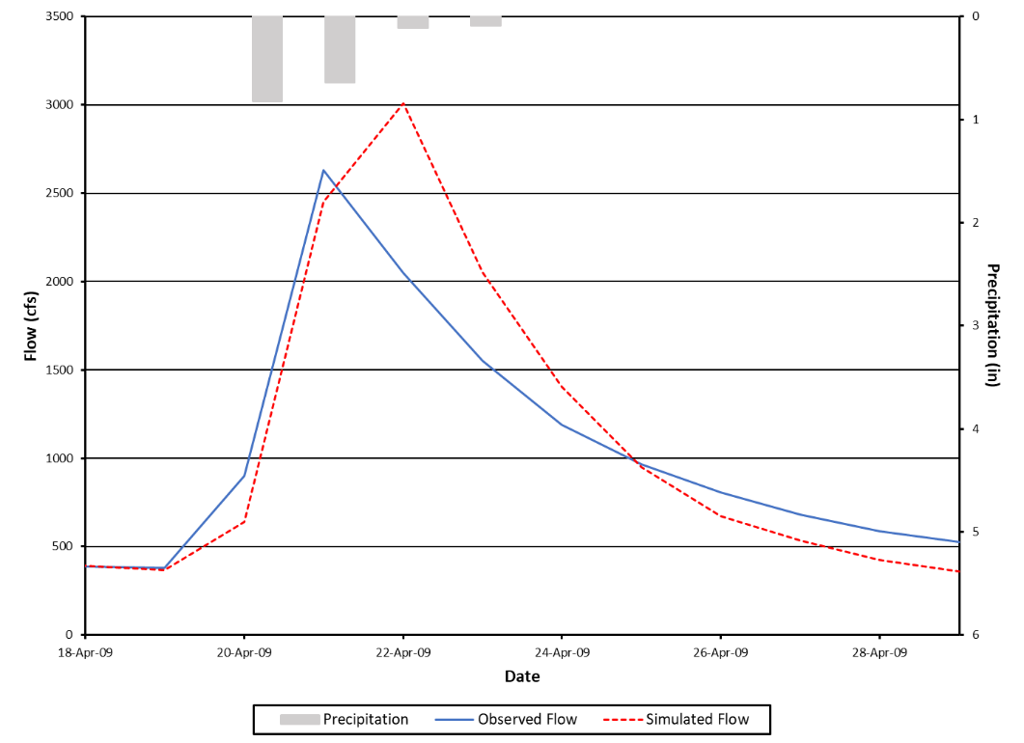
Figure D-13. Observed and simulated flows and precipitation for the Maury River for a representative storm in the calibration period.

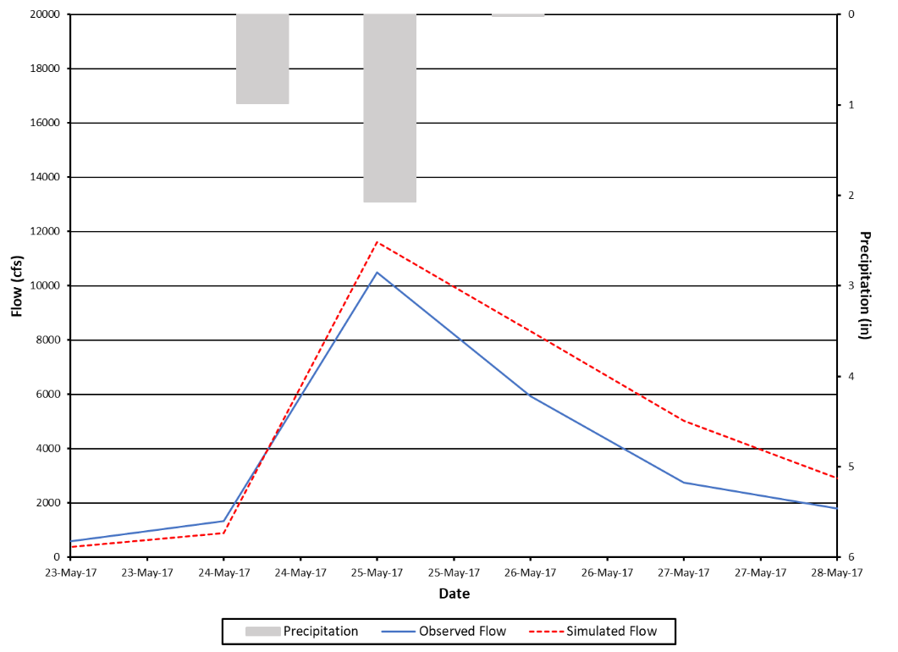
Figure D-14. Observed and simulated flows and precipitation for the Maury River for a representative storm in the validation period.

Figure D-15 and Figure D-16 illustrate model agreement with observed data using cumulative frequency curves. The model adequately captured cumulative frequency for both calibration and validation periods.
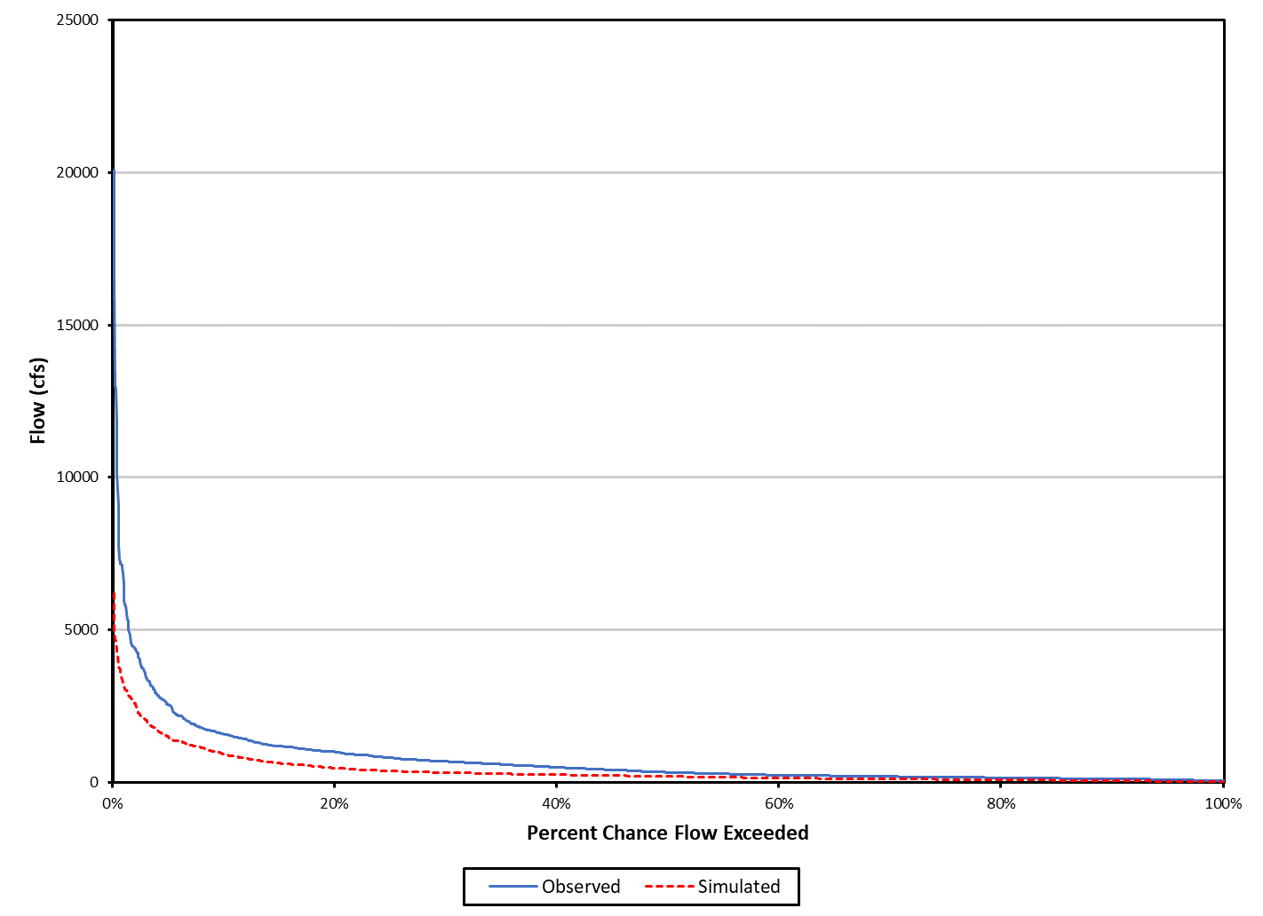
Figure D-15. Cumulative frequency curves for the calibration period for the Maury River.

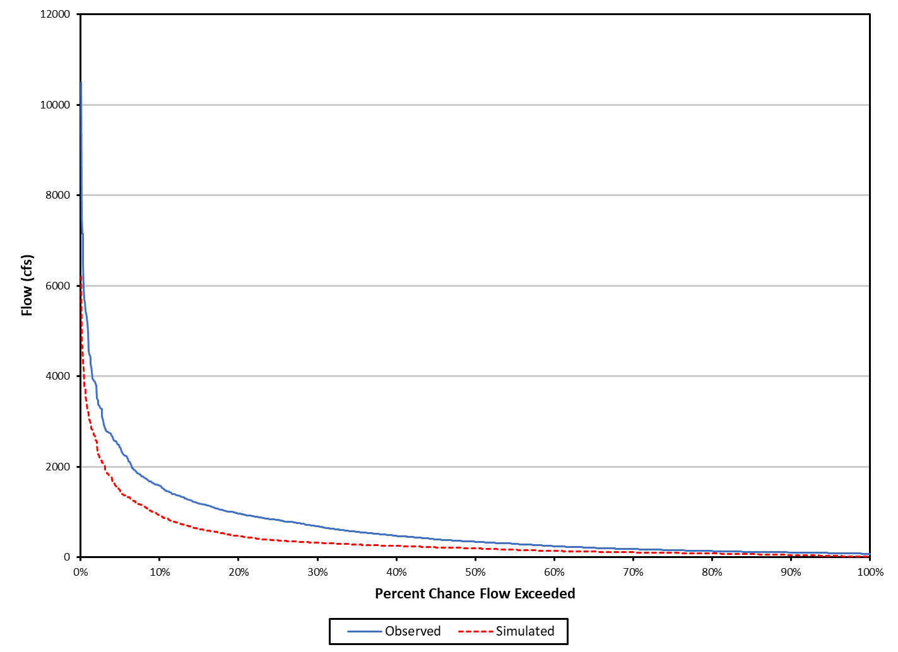
Figure D-16. Cumulative frequency curves for the validation period for the Maury River.

Selected diagnostic outputs from the HSPEXP+ program is listed in Table D-6 and Table D-7. Percent errors for all the diagnostic outputs were within the allowable error criterion limits for both the calibration and validation periods.
When the observed flow data were evaluated using the Baseflow Filter program (Arnold et al., 1995), the range of baseflow indices was 0.41 to 0.64. The simulated baseflow indices are within the range of baseflow indices for the observed flow data, and the simulated indices are comparable to the observed median index. The final calibrated hydrologic parameters can be found in Table D-8.
Table D-5. Summary statistics for the calibration period for the Maury River.
Total Runoff (in) | Simulated | Observed | Error (%) | Criterion
 | 78.751 | 76.061 | 3.5 | ±10%
Average Annual Total Runoff (in) | 15.750 | 15.212 | 3.5 | ±10%
Total of Highest 10% of flows (in) | 37.251 | 35.464 | 5.0 | ±15%
Total of Lowest 50% of flows (in) | 9.649 | 8.996 | 7.3 | ±10%
Total Winter Runoff (in) | 29.412 | 25.303 | 16.2 | n/a
Total Summer Runoff (in) | 8.800 | 9.079 | -3.1 | n/a
Total Seasonal Volume Error | – | – | -19.3 | ±20%
Storm Peaks (cfs) | 3,708.1 | 4,260.4 | -13.0 | ±15%
Total Storm Volume (selected storms) (in) | 24.732 | 22.576 | 9.6 | ±20%
Coefficient of Determination, r² |  | 0.75

Table D-6. Summary statistics for the validation period for the Maury River.
Total Runoff (in) | Simulated | Observed | Error (%) | Criterion
 | 57.161 | 56.074 | 1.9 | ±10%
Average Annual Total Runoff (in) | 14.019 | 14.290 | 1.9 | ±10%
Total of Highest 10% of flows (in) | 26.566 | 23.788 | 11.7 | ±15%
Total of Lowest 50% of flows (in) | 7.050 | 7.194 | -2.0 | ±10%
Total Winter Runoff (in) | 19.516 | 18.918 | 3.2 | n/a
Total Summer Runoff (in) | 6.908 | 6.741 | 2.5 | n/a
Total Seasonal Volume Error | – | – | -0.7 | ±20%
Storm Peaks (cfs) | 2,816.8 | 2,821.0 | -0.2 | ±15%
Total Storm Volume (selected storms) (in) | 14.721 | 13.990 | 5.2 | ±20%
Coefficient of Determination, r² |  | 0.80

Table D-7. Final calibrated parameters for the Maury River.
Parameter | Definition | Units | FINAL CALIBRATION | Possible  Range of  Values‡ | Function of …‡ | Comment
PERLND (Pervious Land module)
PWAT-PARM2 (Pervious Water Budget Hydrology Parameter Group 2)
FOREST | Fraction forest cover | none | 1.0 forest, 0.0 other | 0.0 - 1.0 | Forest cover | –
LZSN | Lower zone nominal soil moisture storage | inches | 3.2 – 4.7 | 2.0 - 15.0 | Soils, climate | Calibration
INFILT | Index to infiltration capacity | in/hr | 0.00588 – 0.24730ª | 0.001 - 0.500 | Soils, land use | Calibration
LSUR | Length of overland flow | feet | 24.2 –686.4ª | 10 - 700 | Topography | Estimated using GIS
SLSUR | Slope of overland flow plane | none | 0.02781 – 0.39704ª | 0.001 - 0.400 | Topography | Estimated using GIS
KVARY | Groundwater recession variable | 1/in | 0.0 | 0.0 - 5.0 | Baseflow recession variation | Calibration
AGWRC | Base groundwater recession | none | 0.969 - 0.993ª | 0.850 - 0.999 | Baseflow recession | Calibration
PWAT-PARM3 (Pervious Water Budget Hydrology Parameter Group 3)
PETMAX | Temp below which ET is reduced | deg. F | 45 - 47 | 32 - 48 | Climate, vegetation | –
PETMIN | Temp below which ET is set to zero | deg. F | 35 | 30 - 40 | Climate, vegetation | –
INFEXP | Exponent in infiltration equation | none | 2 | 1 - 3 | Soils variability | Default to 2.0
INFILD | Ratio of max/mean  infiltration capacities | none | 2 | 1 - 3 | Soils variability | Default to 2.0
DEEPFR | Fraction of GW inflow to deep recharge | none | 0.00 - 0.075 | 0.00 - 0.50 | Geology, groundwater recharge | Calibration
BASETP | Fraction of remaining ET from baseflow | none | 0.008 - 0.124ª | 0.0 - 0.2 | Riparian vegetation | Calibration
AGWETP | Fraction of remaining ET from active GW | none | 0.008 – 0.195ª | 0.0 - 0.2 | Marsh/wetlands extent | Calibration
PWAT-PARM4 (Pervious Water Budget Hydrology Parameter Group 4)
CEPSC | Interception storage capacity | inches | 0.04 – 0.40^{b} | 0.01 - 0.40 | Vegetation, type/density, land use | Calibration
UZSN | Upper zone nominal soil moisture storage | inches | 0.03 – 0.91^{b} | 0.05 - 2.00 | Surface soil conditions, land use | Calibration
NSUR | Manning’s n  (roughness) | none | 0.40 forest; 0.24 pasture/hay, 0.20 cropland, 0.15 res.; 0.15 comm.; and 0.10 water | 0.05 - 0.50 | Surface conditions,  residue | Calibration
INTFW | Interflow/surface runoff partition parameter | none | 1.0 - 1.5ª | 1.0 - 10.0 | Soils, topography, land use | Calibration
IRC | Interflow recession parameter | none | 0.3 – 0.4 | 0.30 - 0.85 | Soils, topography, land use | Calibration
LZETP | Lower zone ET parameter | none | 0.1 – 0.9^{b} | 0.1 - 0.9 | Vegetation, type/density, root depth | Calibration
IMPLND (Impervious Land module)
IWAT-PARM2 (Impervious Water Budget Hydrology Parameter Group 2)
LSUR | Length of overland flow | feet | 54.5 | 50 - 250 | Topography, drainage system | Estimated using GIS
SLSUR | Slope of overland flow plane | none | 0.10 | 0.001 - 0.150 | Topography, drainage | Estimated using GIS
NSUR | Manning’s n  (roughness) | none | 0.08 | 0.01 - 0.15 | Impervious surface conditions | Default to  0.075
RETSC | Retention/interception storage capacity | inches | 0.10 | 0.01 - 0.30 | Impervious surface conditions | Default to 0.1
IWAT-PARM3 (Impervious Water Budget Hydrology Parameter Group 3)
PETMAX | Temp below which ET is reduced | deg. F | 46 | 32 - 48 | Climate, vegetation | –
PETMIN | Temp below which ET is set to zero | deg. F | 35 | 30 - 40 | Climate, vegetation | –
RCHRES (Reach/reservoir module)
HYDR-PARM2 (Reach/Reservoir Hydrology Parameter Group 2)
KS | Weighting factor for hydraulic routing | – | 0.0 | 0.00 - 0.99 | Channel slope, flow obstructions | Use KS = 0.5
‡ from the EPA BASINS Technical Note 6 (USEPA. 2000).
ªVaries with land use.
^{b}Varies by month and with land use.

Upper James River Hydrologic Model
This section presents the HSPF hydrologic calibration/validation results for the Upper James River TMDL Watershed that includes: Cowpasture River, Craig Creek, Catawba Creek, portions of the James River, and Fishing Creek. Figure E-18 illustrates the location of TMDL watershed, major tributary boundaries, and reaches used in model calibration. Observed daily flow data were obtained from three USGS monitoring stations to use in the hydrologic calibration/validation for the Upper James River TMDL, USGS monitoring station 02016000 located on Cowpasture River near Clifton Forge, VA, USGS monitoring station 02019500 located on James River at Buchanan, VA, and USGS monitoring station 02026000 located on James River at Bent Creek, VA. Meteorological data were obtained primarily from the Hot Springs (USC00444128), Glasgow (USC00443375), Covington (USC00442044), Roanoke (724110 13741), and Appomattox/Lynchburg (USC00440243), VA observation stations from National Centers for Environmental Information (NCEI).
Due to the large size of the resulting hydrology calibration and validation tables and figures, only the results for the calibration/validation to the USGS monitoring station 02026000 located on James River at Bent Creek, VA are included in this Appendix. Including calibration/validation results for all USGS monitoring stations would have made the report unmanageably long. These results can be made available upon request by referring to the contact information on page ii.
The hydrologic calibration and validation periods were from January 1, 2010 to December 31, 2014, and January 1, 2004 to December 31, 2007, respectively. The model was calibrated and validated using daily average flow in cubic feet per second (cfs). The HSPF model was run until the simulated and observed flow met criteria presented in Table D-1. The final calibration parameters were within the range of recommended EPA’s BASINS Technical Note 6 (USEPA, 2000).
Figure D-17 and Figure D-18 show that the simulated flow for both the calibration and validation matched the observed flow well, although the model under predicted some of the peaks during calibration period and over predicted during the validation period. The agreement with observed flows is further illustrated in Figure D-19 and Figure D-20 for a representative year, although some peaks during validation period and Figure D-21 and Figure D-22 for a representative storm. The model captured both representative storms and year flow during calibration and validation periods.
Figure D-23 and Figure D-24 illustrate model agreement with observed data using cumulative frequency curves. The model adequately captured cumulative frequency for both calibration and validation periods.
Selected diagnostic outputs from the HSPEXP+ program is listed in Table D-8 and Table D-9. Percent errors for all the diagnostic outputs were within the allowable error criterion limits for both the calibration and validation periods.
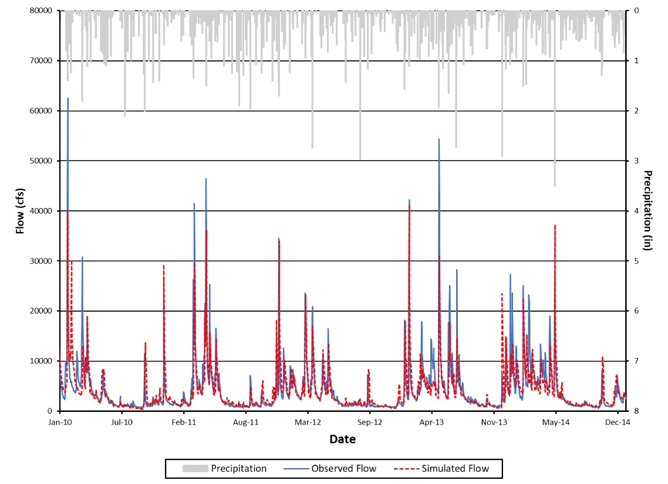
Figure D-17. Observed and simulated flows and precipitation for the James River at Bent Creek calibration period.

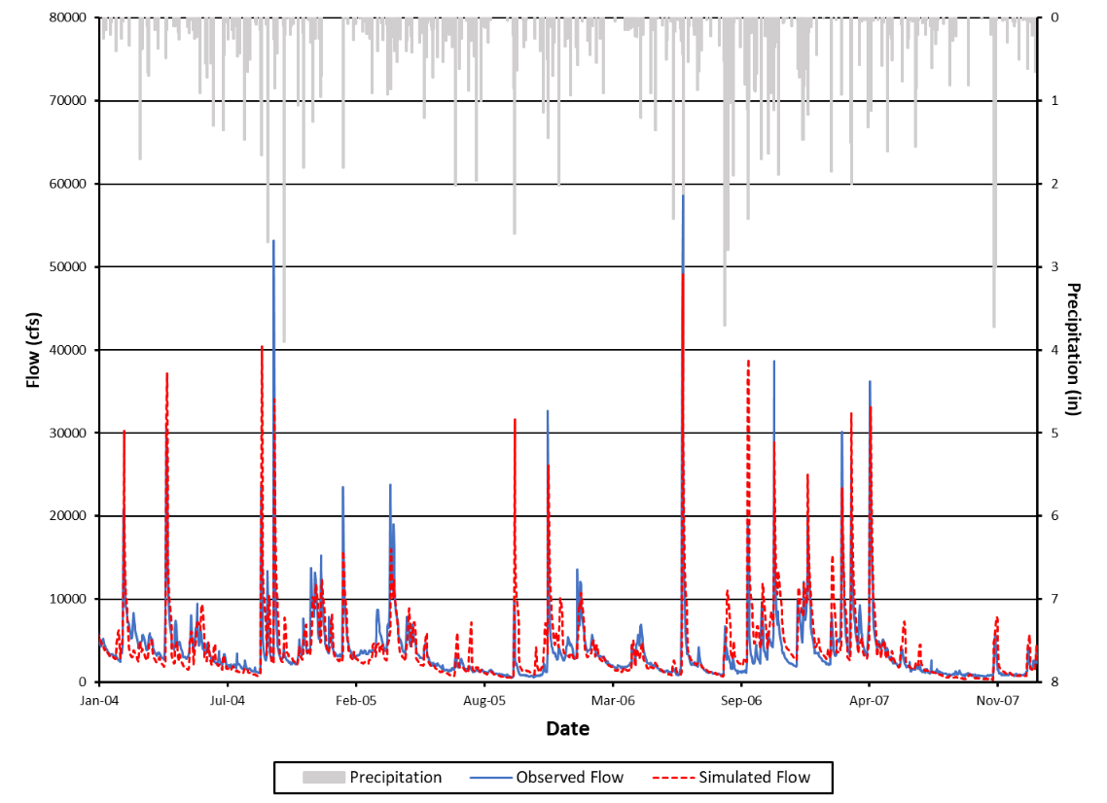
Figure D-18. Observed and simulated flows and precipitation for the James River at Bent Creek during the validation period.

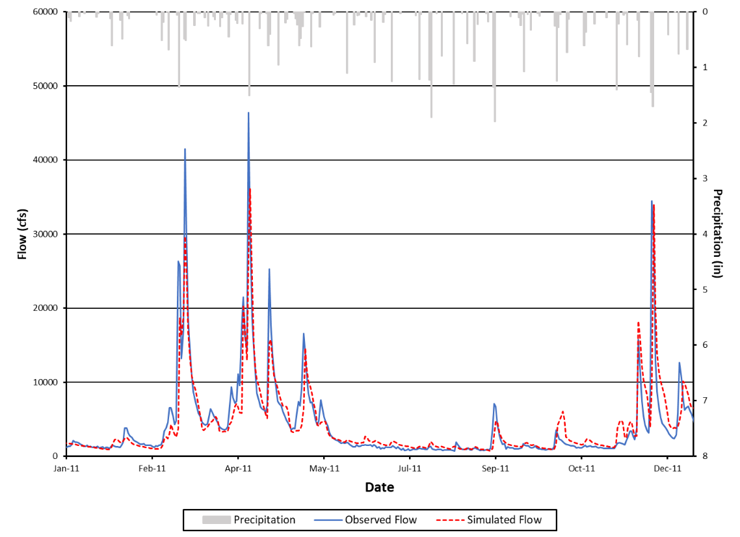
Figure D-19. Observed and simulated flows and precipitation for a representative year (2011) in the calibration period for the James River at Bent Creek.

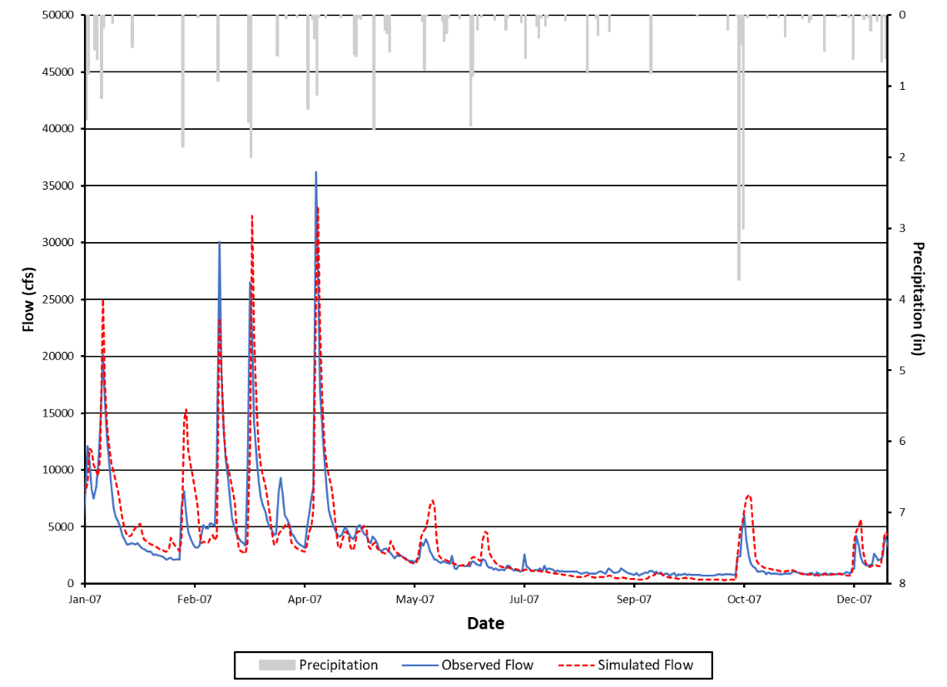
Figure D-20. Observed and simulated flows and precipitation for the James River at Bent Creek during a representative year (2007) in the validation period.

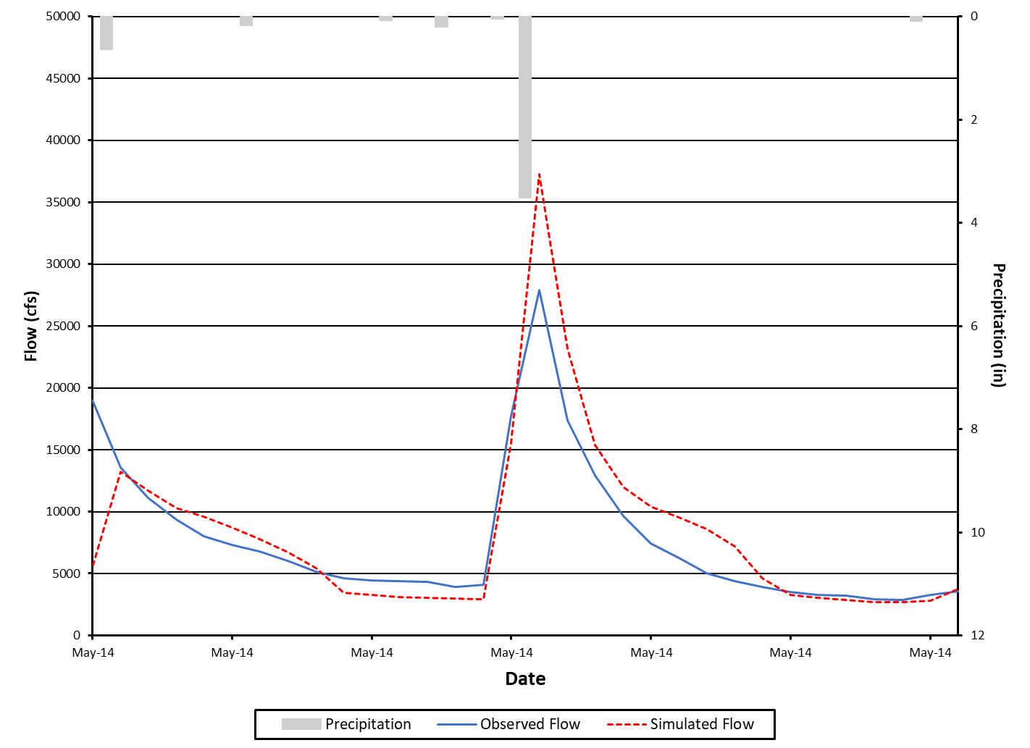
Figure D-21. Observed and simulated flows and precipitation for the James River at Bent Creek for a representative storm in the calibration period for May 2014.

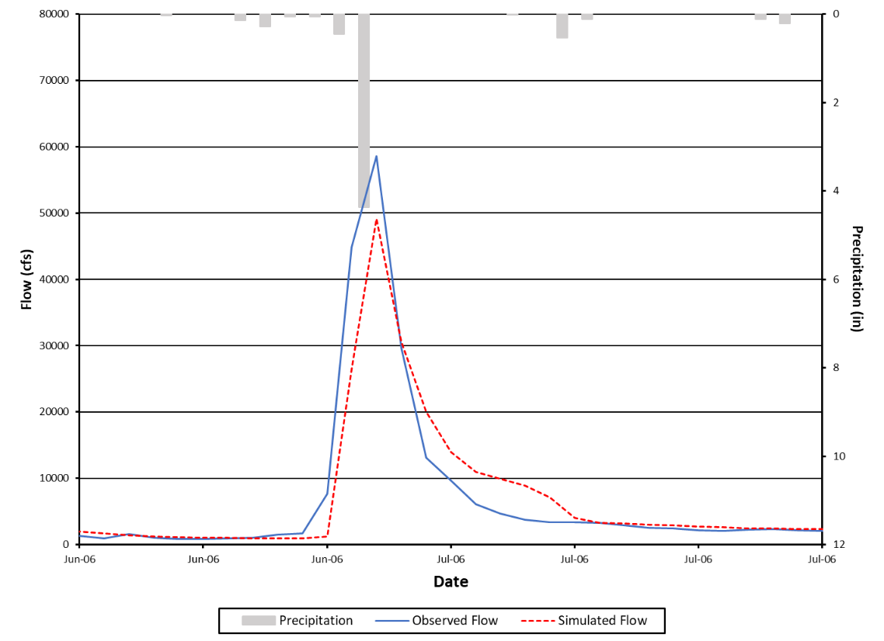
Figure D-22. Observed and simulated flows and precipitation for James River at Bent Creek for a representative storm in the validation period for June 2006.

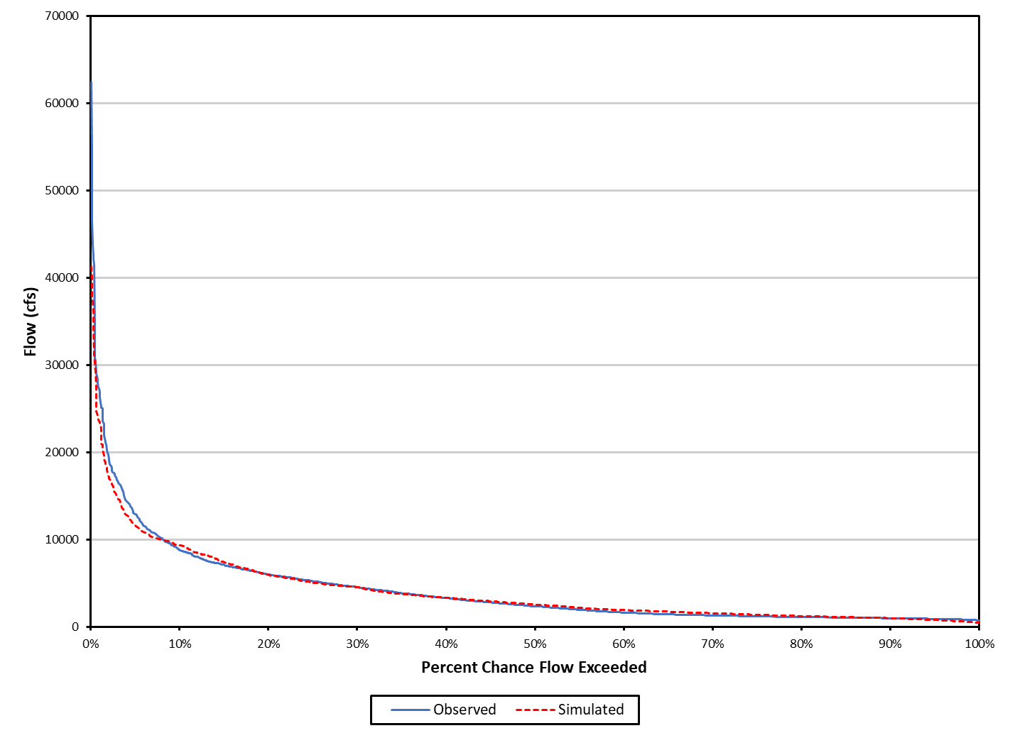
Figure D-23. Cumulative frequency curves for the calibration period for the James River at Bent Creek.

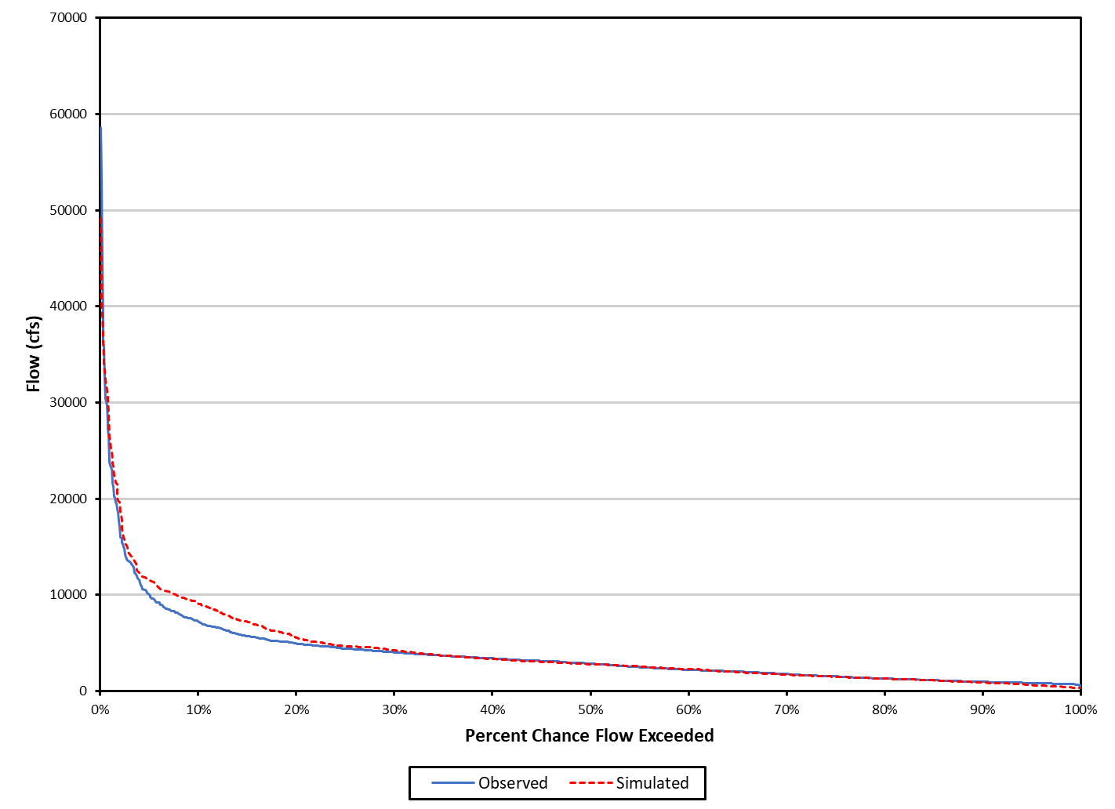
Figure D-24. Cumulative frequency curves for the validation period for the James River at Bent Creek.

Table D-8. Summary statistics for the calibration period for the James River at Bent Creek.
 | Simulated | Observed | Error (%) | Criterion
Total Runoff (in) | 75.796 | 77.043 | -1.6 | ±10%
Average Annual Total Runoff (in) | 15.159 | 15.411 | -1.6 | ±10%
Total of Highest 10% of flows (in) | 26.071 | 29.032 | -10.2 | ±15%
Total of Lowest 50% of flows (in) | 13.305 | 12.12 | 9.8 | ±10%
Total Winter Runoff (in) | 25.808 | 23.889 | 8.0 | ±15%
Total Summer Runoff (in) | 10.275 | 10.670 | -3.7 | ±20%
Total Seasonal Volume Error | – | – | -11.7 | ±20%
Storm Peaks (cfs) | 13,124 | 15,296 | -14.2 | ±15%
Total Storm Volume (selected storms) (in) | 20.045 | 20.925 | -4.2 | ±20%
Coefficient of Determination, r² |  | 0.89

Table D-9. Summary statistics for the validation period for the James River at Bent Creek.
 | Simulated | Observed | Error (%) | Criterion
Total Runoff (in) | 61,292 | 57,152 | 7.2 | ±10%
Average Annual Total Runoff (in) | 15,323 | 14.883 | 7.2 | ±10%
Total of Highest 10% of flows (in) | 21.456 | 19.530 | 9.9 | ±15%
Total of Lowest 50% of flows (in) | 11.499 | 11.867 | -3.1 | ±10%
Total Winter Runoff (in) | 18.869 | 17.562 | 7.4 | ±15%
Total Summer Runoff (in) | 8.921 | 8.733 | 2.2 | ±20%
Total Seasonal Volume Error | – | – | -5.3 | ±20%
Storm Peaks (cfs) | 12,716 | 11,667 | 9.0 | ±15%
Total Storm Volume (selected storms) (in) | 13.554 | 11.418 | 18.7 | ±20%
Coefficient of Determination, r² |  | 0.77

When the observed flow data were evaluated using the Baseflow Filter program (Arnold et al., 1995) for James River at Bent Creek, the range of baseflow indices was 0.35 to 0.62. This baseflow indices result does not include the upstream flows from Jackson and Maury Rivers which is expected to change the baseflow separation result. Therefore, the comparison between the baseflow indices for the simulated data and observed flow were not presented for the calibration and validation periods. The final calibrated hydrologic parameters can be found in Table D-10.
Table D-10. Final calibrated parameters for the James River at Bent Creek.
Parameter | Definition | Units | FINAL CALIBRATION |  |  | Possible  Range of  Values‡ |  | Function of …‡ | Comment
PERLND (Pervious Land module)
PWAT-PARM2 (Pervious Water Budget Hydrology Parameter Group 2)
FOREST | Fraction forest cover | none | 1.0 forest, 0.0 other |  |  | 0.0 - 1.0 |  | Forest cover | –
LZSN | Lower zone nominal soil moisture storage | inches | 4.5 – 5.5 |  |  | 2.0 - 15.0 |  | Soils, climate | Calibration
INFILT | Index to infiltration capacity | in/hr | 0.0507 - 0.500ª |  |  | 0.001 - 0.500 |  | Soils, land use | Calibration
LSUR | Length of overland flow | feet | 19.47- 1270.77ª |  |  | 10 - 700 |  | Topography | Estimated using GIS
SLSUR | Slope of overland flow plane | none | 0.0064 - 0.3843ª |  |  | 0.001 - 0.400 |  | Topography | Estimated using GIS
KVARY | Groundwater recession variable | 1/in | 0.0 |  |  | 0.0 - 5.0 |  | Baseflow recession variation | Calibration
AGWRC | Base groundwater recession | none | 0.955 - 0.965ª |  |  | 0.850 - 0.999 |  | Baseflow recession | Calibration
PWAT-PARM3 (Pervious Water Budget Hydrology Parameter Group 3)
PETMAX | Temp below which ET is reduced | deg. F | 45 - 47 |  |  | 32 - 48 |  | Climate, vegetation | –
PETMIN | Temp below which ET is set to zero | deg. F | 35 |  |  | 30 - 40 |  | Climate, vegetation | –
INFEXP | Exponent in infiltration equation | none | 2 |  |  | 1 - 3 |  | Soils variability | Default to 2.0
INFILD | Ratio of max/mean  infiltration capacities | none | 2 |  |  | 1 - 3 |  | Soils variability | Default to 2.0
DEEPFR | Fraction of GW inflow to deep recharge | none | 0.00 - 0.20 |  |  | 0.00 - 0.50 |  | Geology, groundwater recharge | Calibration
BASETP | Fraction of remaining ET from baseflow | none | 0.006- 0.050ª |  |  | 0.0 - 0.2 |  | Riparian vegetation | Calibration
AGWETP | Fraction of remaining ET from active GW | none | 0.00 – 0.04 |  |  | 0.0 - 0.2 |  | Marsh/wetlands extent | Calibration
PWAT-PARM4 (Pervious Water Budget Hydrology Parameter Group 4)
CEPSC | Interception storage capacity | inches | 0.05 - 0.40^{b} |  |  | 0.01 - 0.40 |  | Vegetation, type/density, land use | Calibration
UZSN | Upper zone nominal soil moisture storage | inches | 0.20 – 0.80 |  |  | 0.05 - 2.00 |  | Surface soil conditions, land use | Calibration
NSUR | Manning’s n  (roughness) | none | 0.40 forest; 0.20 cropland, 0.24  pasture/hay; 0.15  res. and comm.; and 0.10 water |  |  | 0.05 - 0.50 |  | Surface conditions,  residue | Calibration
INTFW | Interflow/surface runoff partition parameter | none | 1.5 – 2.0 |  |  | 1.0 - 10.0 |  | Soils, topography, land use | Calibration
IRC | Interflow recession parameter | none | 0.30 - 0.40 |  |  | 0.30 - 0.85 |  | Soils, topography, land use | Calibration
LZETP | Lower zone ET parameter | none | 0.01 – 0.85^{b} |  |  | 0.1 - 0.9 |  | Vegetation, type/density, root depth | Calibration
IMPLND (Imervious Land module)
IWAT-PARM2 (Impervious Water Budget Hydrology Parameter Group 2)
LSUR | Length of overland flow | feet | 53.9 |  |  | 50 - 250 |  | Topography, drainage system | Estimated using GIS
SLSUR | Slope of overland flow plane | none | 0.11 |  |  | 0.001 - 0.150 |  | Topography, drainage | Estimated using GIS
NSUR | Manning’s n  (roughness) | none | 0.08 |  |  | 0.01 - 0.15 |  | Impervious surface conditions | Default to  0.075
RETSC | Retention/interception storage capacity | inches | 0.1 |  |  | 0.01 - 0.30 |  | Impervious surface conditions | Default to 0.1
IWAT-PARM3 (Impervious Water Budget Hydrology Parameter Group 3)
PETMAX | Temp below which ET is reduced | deg. F | 46 |  |  | 32 - 48 |  | Climate, vegetation | –
PETMIN | Temp below which ET is set to zero | deg. F | 35 |  |  | 30 - 40 |  | Climate, vegetation | –
RCHRES (Reach/reservoir module)
HYDR-PARM2 (Reach/Reservoir Hydrology Parameter Group 2)
KS | Weighting factor for hydraulic routing |  | 0.0 |  |  | 0.00 - 0.99 |  | Channel slope, flow obstructions | Use KS = 0.5
‡ from the EPA BASINS Technical Note 6 (USEPA. 2000).
- Varies with land use.
- Varies by month and with land use.

Lower James River Hydrologic Model
This section presents the HSPF hydrologic calibration/validation results for the Lower James River TMDL Watershed that include major tributary watersheds: Tye and Rockfish Rivers; Hardware, Slate, and Willis Rivers; Rivanna River, portions of the James River, and Reedy Creek. Chapter 2 provides maps illustrating the location of the Lower James River watersheds and flow gages used for hydrology calibration. Model watersheds in the Lower James River TMDL watershed are shown in Figure E-33, illustrating the location of TMDL watershed, major tributary boundaries, reaches used during model calibration. Observed daily flow data were obtained from four USGS monitoring stations to use in the hydrologic calibration/validation for the Lower James River TMDL: USGS monitoring station 02029000 located on the James River at Scottsville, VA, USGS monitoring station 02034000 located on the Rivanna River at Palmyra, VA, USGS monitoring station USGS 02035000 located on the James River at Cartersville, VA, and USGS monitoring station 02037500 located on the James River near Richmond, VA. Meteorological data were obtained primarily from the Charlottesville (USC00441593) and Crozier (USC00442142), VA observation stations from National Centers for Environmental Information (NCEI).
Due to the large size of the resulting hydrology calibration and validation tables and figures, only the results for the calibration/validation to the USGS monitoring station 02037500 located on James River near Richmond, VA are included in this Appendix. Including calibration/validation results for all USGS monitoring stations would have made the report unmanageably long. These results can be made available upon request by referring to the contact information on page ii.
The hydrologic calibration and validation periods were from January 1, 2009 to December 31, 2013, and January 1, 2014 to December 31, 2017, respectively. The model was calibrated and validated using daily average flow in cubic feet per second (cfs). The HSPF model was run until the simulated and observed flow met criteria presented in Table D-1. The final calibration parameters were within the range of recommended EPA’s BASINS Technical Note 6 (USEPA, 2000).
Figure D-25 and Figure D-26 show that the simulated flow for both the calibration and validation matched the observed flow well, although the model over predicted some of the peaks during calibration period and under predicted during the validation period. The agreement with observed flows is further illustrated in Figure D-27 and Figure D-28 for a representative year, although under predicted baseflow during validation period and Figure D-29 and Figure D-30 for a representative storm. The model captured both representative storms and year flow during calibration and
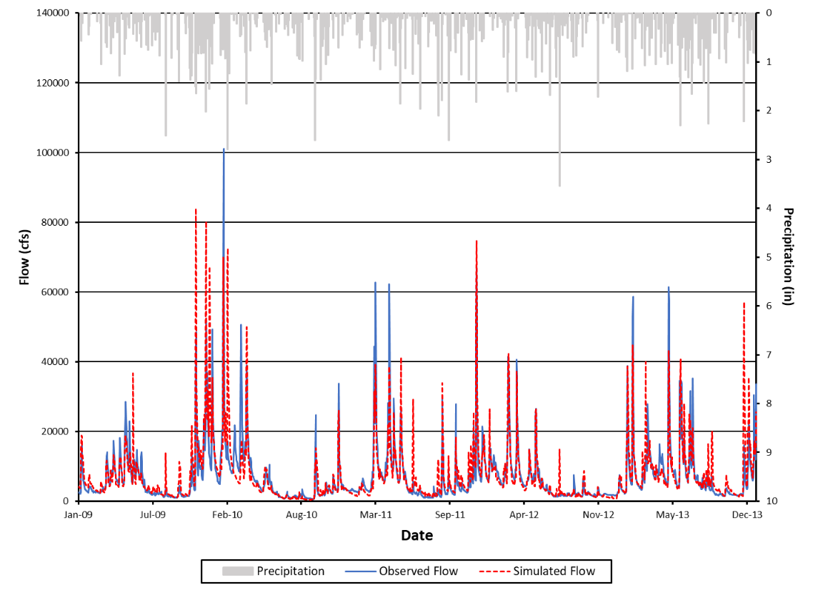
Figure D-25. Observed and simulated flows and precipitation for the James River near Richmond, VA calibration period at the outlet.

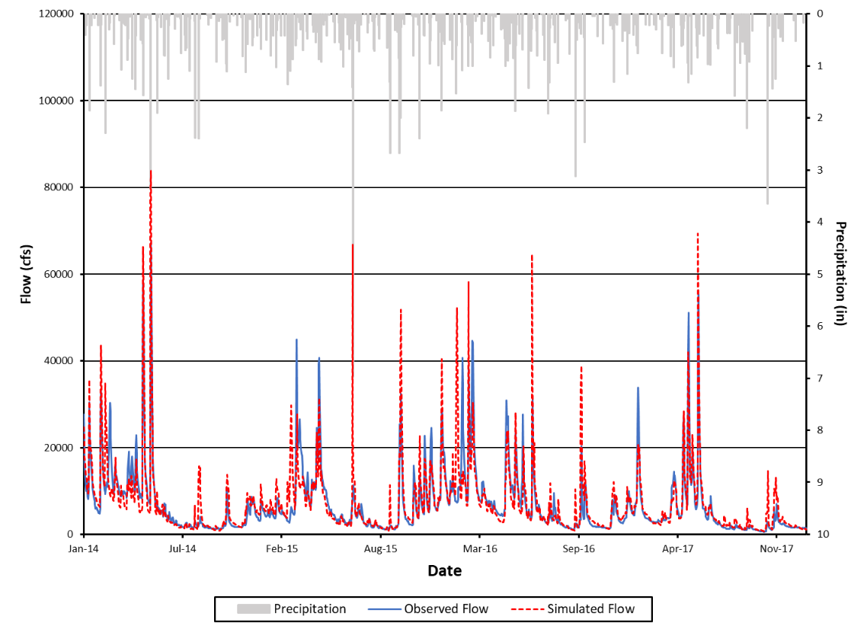
Figure D-26. Observed and simulated flows and precipitation for the James River near Richmond, VA during the validation period at the outlet.

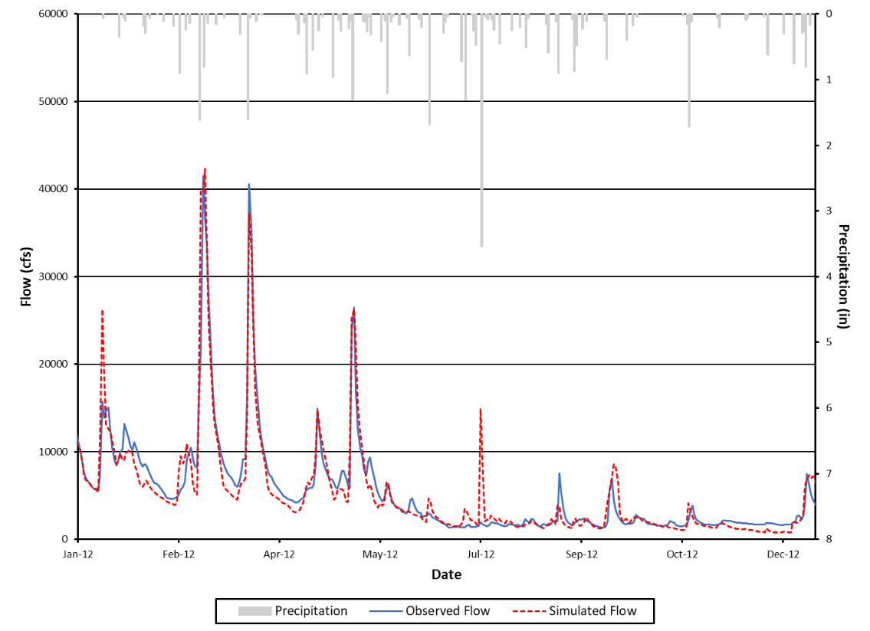
Figure D-27. Observed and simulated flows and precipitation for a representative year (2012) in the calibration period for the James River near Richmond, VA.

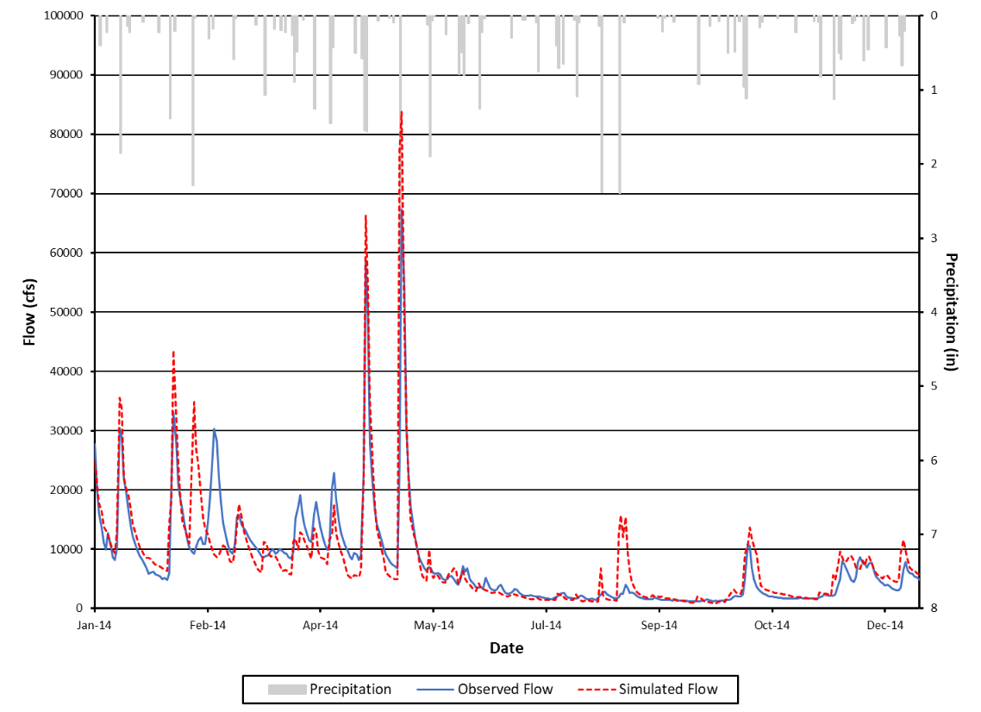
Figure D-28. Observed and simulated flows and precipitation for the James River near Richmond, VA during a representative year (2014) in the validation period.

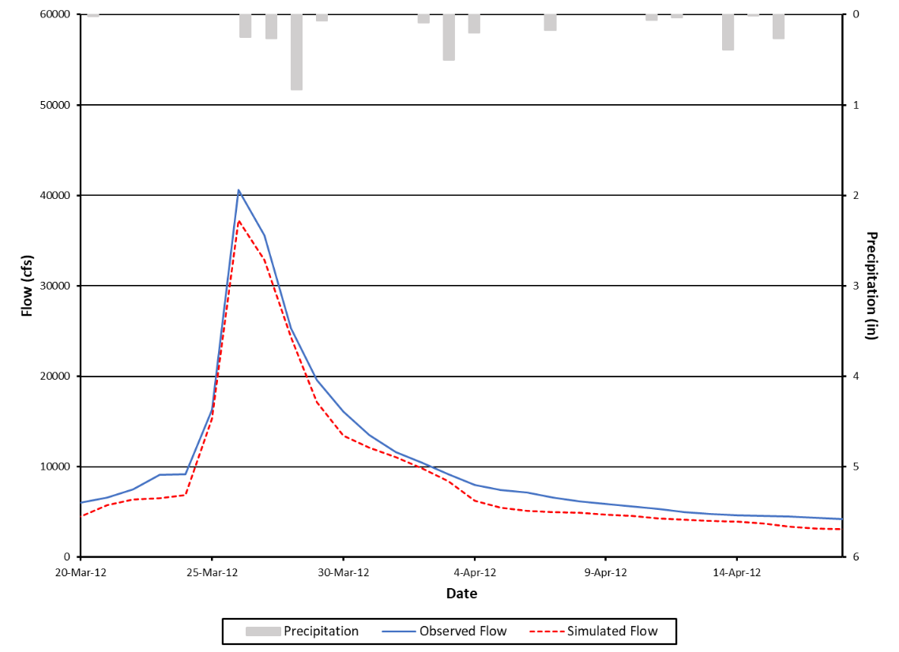
Figure D-29. Observed and simulated flows and precipitation for the James River near Richmond, VA for a representative storm in the calibration period for March 2012.

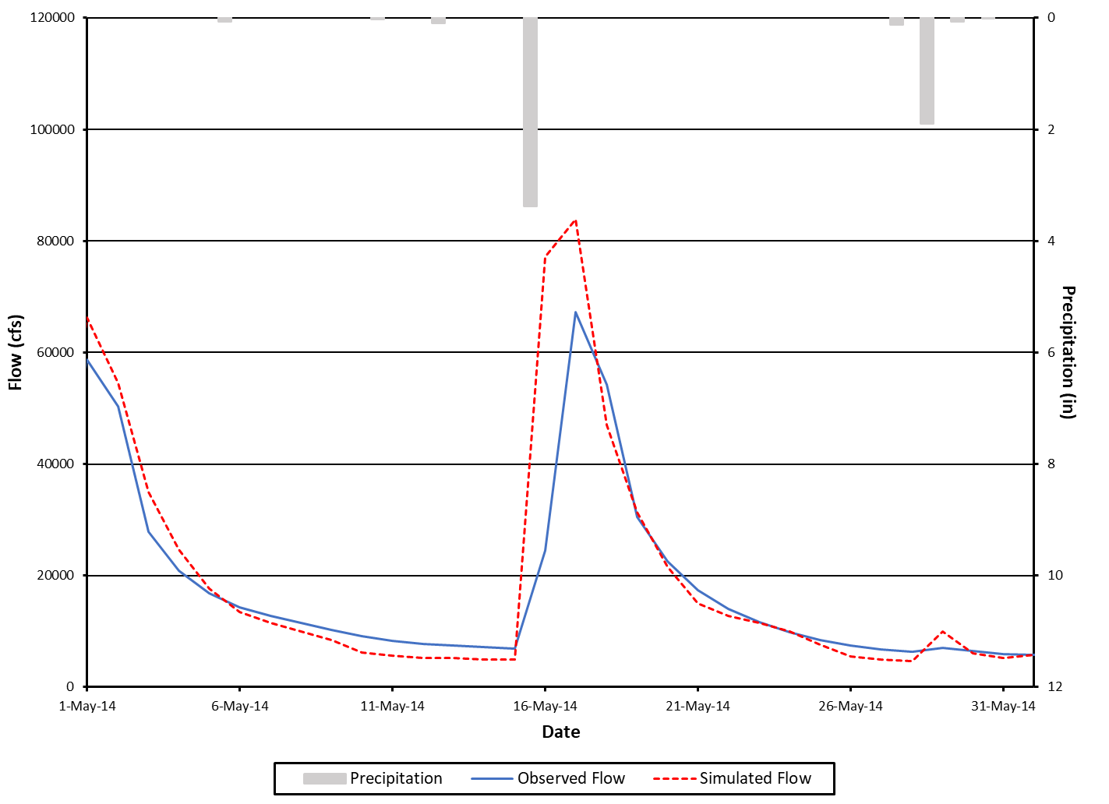
Figure D-30. Observed and simulated flows and precipitation for the James River near Richmond, VA for a representative storm in the validation period for May 2014.

Figure D-31 and Figure D-32 illustrate model agreement with observed data using cumulative frequency curves. The model adequately captured cumulative frequency for both calibration and validation periods.
Selected diagnostic outputs from the HSPEXP+ program is listed in Table D-11 and Table D-12. Percent errors for all the diagnostic outputs were within the allowable error criterion limits for both the calibration and validation periods.
When the observed flow data were evaluated using the Baseflow Filter program (Arnold et al., 1995) for the James River near Richmond, the range of baseflow indices was 0.29 to 0.58. This baseflow indices result does not include the upstream flows from James River upstream of Bent Creek, which is expected to change the baseflow separation result. Therefore, the comparison between the baseflow indices for the simulated data and observed flow were not presented for the calibration and validation periods. The final calibrated hydrologic parameters can be found in Table D-13.
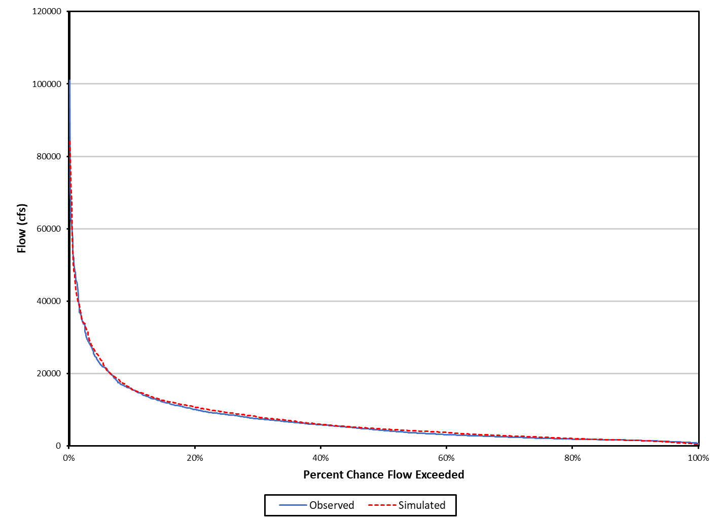
Figure D-31. Cumulative frequency curves for the calibration period for the James River near Richmond, VA.

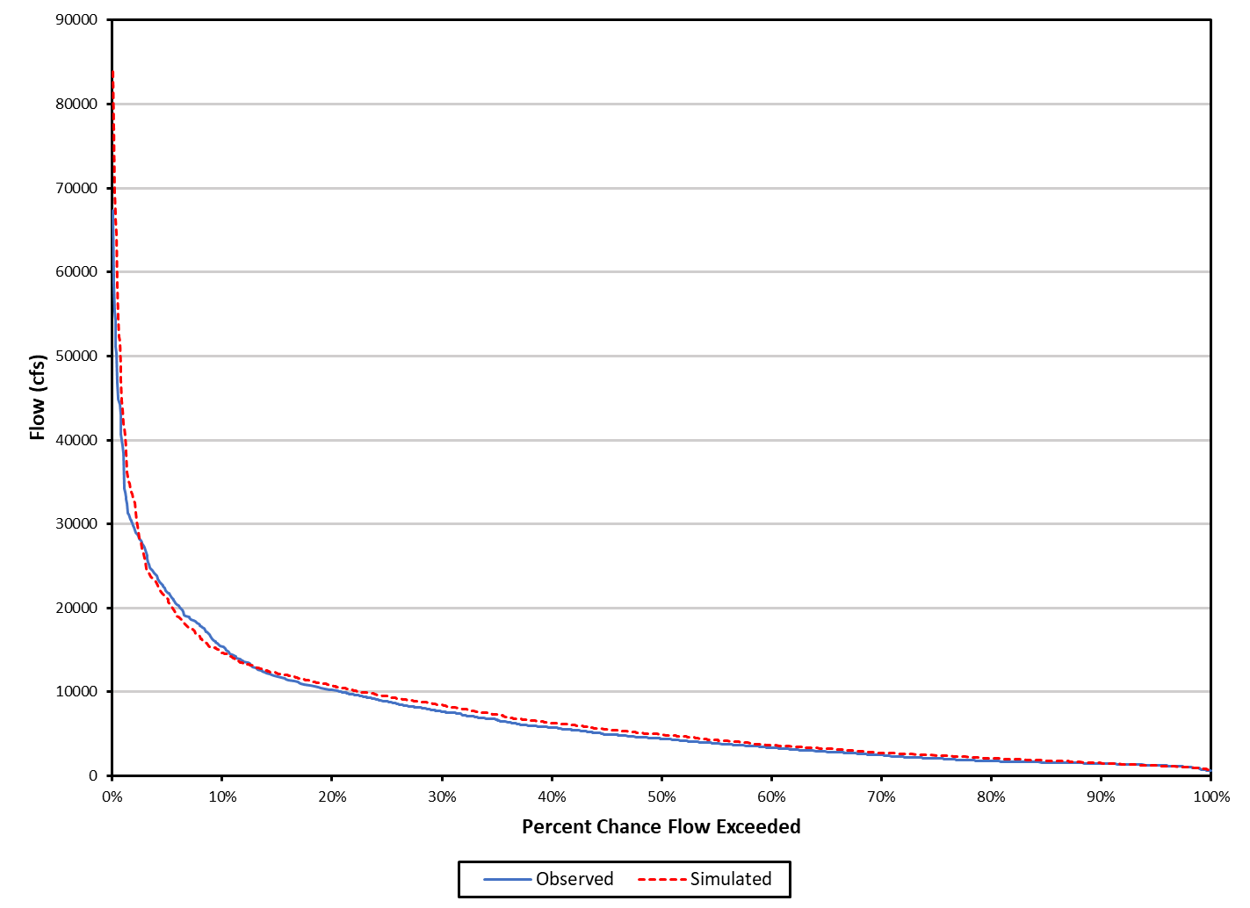
Figure D-32. Cumulative frequency curves for the validation period for the James River near Richmond, VA.

Table D-11. Summary statistics for the calibration period for the James River near Richmond, VA.
Total Runoff (in) | Simulated | Observed | Error (%) | Criterion
 | 74.688 | 71.486 | 4.5 | ±10%
Average Annual Total Runoff (in) | 14.938 | 14.297 | 4.5 | ±10%
Total of Highest 10% of flows (in) | 27.404 | 26.892 | 1.9 | ±15%
Total of Lowest 50% of flows (in) | 12.550 | 11.399 | 10.0 | ±10%
Total Winter Runoff (in) | 26.037 | 23.402 | 11.3 | ±15%
Total Summer Runoff (in) | 11.327 | 10.200 | 11.1 | ±20%
Total Seasonal Volume Error | – | – | -0.2 | ±20%
Storm Peaks (cfs) | 25,191 | 27,353 | -7.9 | ±15%
Total Storm Volume (selected storms) (in) | 22.042 | 22.396 | -1.6 | ±20%
Coefficient of Determination, r² |  | 0.85

Table D-12. Summary statistics for the validation period for the James River near Richmond, VA.
Total Runoff (in) | Simulated | Observed | Error (%) | Criterion
 | 58.895 | 55.636 | 5.9 | ±10%
Average Annual Total Runoff (in) | 14.724 | 13.909 | 5.9 | ±10%
Total of Highest 10% of flows (in) | 20.021 | 19.410 | 2.8 | ±15%
Total of Lowest 50% of flows (in) | 10.522 | 9.452 | 11.3 | ±10%
Total Winter Runoff (in) | 19.817 | 17.805 | 11.3 | ±15%
Total Summer Runoff (in) | 8.951 | 7.636 | 17.2 | ±20%
Total Seasonal Volume Error | – | – | 5.9 | ±20%
Storm Peaks (cfs) | 20,646 | 19,781 | 4.4 | ±15%
Total Storm Volume (selected storms) (in) | 15.694 | 15.053 | 4.3 | ±20%
Coefficient of Determination, r² |  | 0.88

Table D-13. Final calibrated parameters for the James River near Richmond, VA.
Parameter | Definition | Units |  |  | FINAL CALIBRATION |  |  | Possible  Range of  Values‡ |  | Function of …‡ |  | Comment
PERLND (Pervious Land module)
PWAT-PARM2 (Pervious Water Budget Hydrology Parameter Group 2)
FOREST | Fraction forest cover |  | none |  | 1.0 forest, 0.0 other |  |  | 0.0 - 1.0 |  | Forest cover |  | –
LZSN | Lower zone nominal soil moisture storage |  | inches |  | 7.5 |  |  | 2.0 - 15.0 |  | Soils, climate |  | Calibration
INFILT | Index to infiltration capacity |  | in/hr |  | 0.005 - 0.186ª |  |  | 0.001 - 0.500 |  | Soils, land use |  | Calibration
LSUR | Length of overland flow |  | feet |  | 43.749 - 503.226ª |  |  | 10 - 700 |  | Topography |  | Estimated using GIS
SLSUR | Slope of overland flow plane |  | none |  | 0.0073 - 0.193ª |  |  | 0.001 - 0.400 |  | Topography |  | Estimated using GIS
KVARY | Groundwater recession variable |  | 1/in |  | 0.0 |  |  | 0.0 - 5.0 |  | Baseflow recession variation |  | Calibration
AGWRC | Base groundwater recession |  | none |  | 0.850 - 0.960ª |  |  | 0.850 - 0.999 |  | Baseflow recession |  | Calibration
PWAT-PARM3 (Pervious Water Budget Hydrology Parameter Group 3)
PETMAX | Temp below which ET is reduced | deg. F |  |  | 45 - 47 |  |  | 32 - 48 |  | Climate, vegetation |  | –
PETMIN | Temp below which ET is set to zero | deg. F |  |  | 35 |  |  | 30 - 40 |  | Climate, vegetation |  | –
INFEXP | Exponent in infiltration equation | none |  |  | 2 |  |  | 1 - 3 |  | Soils variability |  | Default to 2.0
INFILD | Ratio of max/mean  infiltration capacities | none |  |  | 2 |  |  | 1 - 3 |  | Soils variability |  | Default to 2.0
DEEPFR | Fraction of GW inflow to deep recharge | none |  |  | 0.00 - 0.25ª |  |  | 0.00 - 0.50 |  | Geology, groundwater recharge |  | Calibration
BASETP | Fraction of remaining ET from baseflow | none |  |  | 0.0- 0.03ª |  |  | 0.0 - 0.2 |  | Riparian vegetation |  | Calibration
AGWETP | Fraction of remaining ET from active GW | none |  |  | 0.00 – 0.02ª |  |  | 0.0 - 0.2 |  | Marsh/wetlands extent |  | Calibration
PWAT-PARM4 (Pervious Water Budget Hydrology Parameter Group 4)
CEPSC | Interception storage capacity | inches |  |  | 0.05 – 0.40^{b} |  |  | 0.01 - 0.40 |  | Vegetation, type/density, land use |  | Calibration
UZSN | Upper zone nominal soil moisture storage | inches |  |  | 0.05 – 0.80^{b} |  |  | 0.05 - 2.00 |  | Surface soil conditions, land use |  | Calibration
NSUR | Manning’s n  (roughness) | none |  |  | 0.40 forest; 0.20 cropland, 0.24  pasture/hay; 0.15  res. and comm.; and 0.10 water |  |  | 0.05 - 0.50 |  | Surface conditions,  residue |  | Calibration
INTFW | Interflow/surface runoff partition parameter | none |  |  | 1.0 |  |  | 1.0 - 10.0 |  | Soils, topography, land use |  | Calibration
IRC | Interflow recession parameter | none |  |  | 0.30 |  |  | 0.30 - 0.85 |  | Soils, topography, land use |  | Calibration
LZETP | Lower zone ET parameter | none |  |  | 0.10 – 0.85^{b} |  |  | 0.1 - 0.9 |  | Vegetation, type/density, root depth |  | Calibration
IMPLND (Impervious Land module)
IWAT-PARM2 (Impervious Water Budget Hydrology Parameter Group 2)
LSUR | Length of overland flow | feet |  |  | 53.9 |  |  | 50 - 250 |  | Topography, drainage system |  | Estimated using GIS
SLSUR | Slope of overland flow plane | none |  |  | 0.05 |  |  | 0.001 - 0.150 |  | Topography, drainage |  | Estimated using GIS
NSUR | Manning’s n  (roughness) | none |  |  | 0.08 |  |  | 0.01 - 0.15 |  | Impervious surface conditions |  | Default to  0.075
RETSC | Retention/interception storage capacity | inches |  |  | 0.1 |  |  | 0.01 - 0.30 |  | Impervious surface conditions |  | Default to 0.1
IWAT-PARM3 (Impervious Water Budget Hydrology Parameter Group 3)
PETMAX | Temp below which ET is reduced | deg. F |  |  | 46 |  |  | 32 - 48 |  | Climate, vegetation |  | –
PETMIN | Temp below which ET is set to zero | deg. F |  |  | 35 |  |  | 30 - 40 |  | Climate, vegetation |  | –
RCHRES (Reach/reservoir module)
HYDR-PARM2 (Reach/Reservoir Hydrology Parameter Group 2)
KS | Weighting factor for hydraulic routing |  |  |  | 0.0 |  |  | 0.00 - 0.99 |  | Channel slope, flow obstructions |  | Use KS = 0.5
‡ from the EPA BASINS Technical Note 6 (USEPA. 2000).
ªVaries with land use.
^{b}Varies by month and with land use.

References
Arnold, J.G, P.M. Allen, R. Muttiah, and G. Bernhardt. 1995. Automated Base Flow Separation and Recession Analysis Techniques. Ground Water (33) 6: 1010-1018.

USEPA. 2000. BASINS Technical Note 6: Estimating Hydrology and Hydraulic Parameters for HSPF. EPA-823-R00-012. Washington, D.C.: Office of Water, USEPA. Available at: https://nepis.epa.gov/Exe/ZyPDF.cgi/P1004XDT.PDF?Dockey=P1004XDT.PDF. Accessed November 1, 2021.

Sediment Calibration for the James River PCB TMDL Study Area
Sediment acts as a transport mechanism for PCBs. As part of the James River PCB TMDL development, model calibrations were performed for the coupled hydrology/water quality simulation model Hydrological Simulation Program-FORTRAN (HSPF) to predict sediment loads through the James River and its tributaries. The calibration within the James River study area includes the following TMDL watersheds: the Jackson River, Maury River, Upper and Lower James Rivers. TMDL watershed locations are illustrated in Chapter 2, and Figure 2-8 illustrates the locations of suspended sediment monitoring stations in the James River TMDL watersheds.
Due to the large size of the James River study area, sediment calibration modeling was organized and further subdivided among major tributaries within the Upper and Lower James River TMDL watersheds (Figure E-1). Major tributaries and segments within the Upper James River TMDL watershed include: Cowpasture River, Craig Creek, Catawba Creek, and James River – Fishing Creek (in the Lynchburg area). The Lower James River TMDL watershed includes: Tye River, Rockfish River, Hardware River, Slate River, Rivanna River, Willis River, and James River– Reedy Creek (in the Richmond area). The calibration results are reported for each James River TMDL watershed and calibration segment separately section by section.
The sediment calibration process was divided into two phases. Phase I addressed sediment detachment from land surfaces and loading into subwatershed stream/river reaches (water course) by comparing model-calculated loadings with published calibration targets. Phase II addressed instream total suspended sediment (SSC) concentrations within each reach. Phase II accounted for land surface loadings from Phase I and sediment deposition/scouring along stream/river beds. The outline of both calibration phases is described below, with the results for each TMDL watershed described in their respective section. During each model run, HSPF was executed using an hourly time-step interval and results are reported as daily averages.
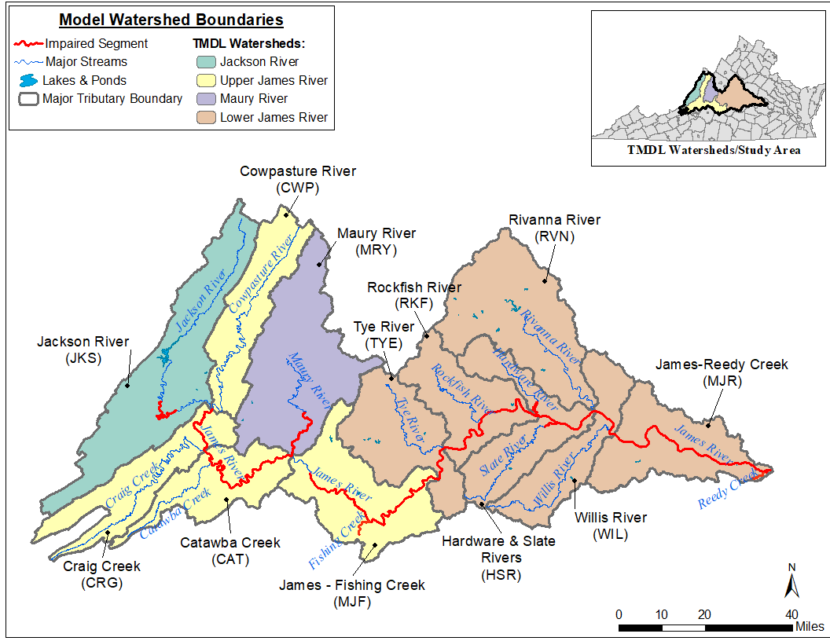
Figure E-1. Model watershed boundaries used for model calibration, within the James River TMDL study area.

Calibration Method

Phase I Calibration Methodology
Phase I sediment modeling used the sediment detachment and transport functionality in HSPF. The final model output for pervious land uses (e.g., cropland) was split into two sets of data: 1) the rate of sediment detachment and removal from the land surface (SOSED, tons/ac-yr), and 2) the storage of detached sediment on the land surface (DETS, tons/acre). Impervious land uses (e.g., residential) included two additional model outputs: wash-off of solids from impervious land surface (SOSLD, tons/ac-yr) and storage of solids on impervious land surface (SLDS, tons/acre).
Unlike typical water quality calibrations, there were no sediment storage or sediment removal observed data for model calibration. Measuring the quantity and removal rate of sediment on a land surface would be a laborious and expensive task, and include a high degree of uncertainty. Therefore, instead of comparing model performance against monitoring data, a “weight-of-evidence” approach was used to assess calibration sufficiency. That approach entailed calibrating the model output SOSED and SOSLD values using target ranges listed in EPA BASINS Technical Note 8, Table E-1 (USEPA, 2006). As part of the “weight-of-evidence” approach, model outputs were graphed to visualize the fluctuations in sediment storage on the land surface. The goal was to calibrate the wash off and removal rates such that sediment storage (DETS and SLDS) increased and decreased in conjunction with precipitation patterns, i.e. sediment storage totals should increase steadily before decreasing as a result of storm events. Further, DETS and SLDS totals should not continually increase or decrease over time, and significant storage reductions should be more frequent on impervious surfaces. These are sediment removal characteristics that could be reasonably expected in a watershed.
Analysis of the SOSED, SOSLD, DETS, and SLDS for each land use was performed qualitatively using time series plots to determine if the simulated sediment storage and removal values trended as expected. In the interest of consistency, and because no observed data were used, the same calibration period (January 1, 2011 to December 31, 2019) was used for the Phase I sediment calibration for all the subwatersheds. In a typical water quality calibration for a specific constituent, calibration periods would be specific to each subwatershed and monitoring station according to when observed samples were acquired. However, since no observed data were available, a uniform, multi-year calibration period that included a range of annual precipitation magnitudes was used.

Table E-1. Target SOSED and SOSLD ranges for pervious and impervious land uses (USEPA, 2006).
Pervious Land Use | Target SOSED Range (tons/ac-yr)
Forest | 0.05-0.4
Pasture/Hay | 0.3-1.8
Cropland | 0.5-5.0
Residential | 0.2-1.0
Commercial | 0.2-1.0
Water | 0.001-0.010
Impervious Land use | Target SOSLD Range (tons/ac-yr)
Residential | 0.2-1.0
Commercial | 0.2-1.0

Phase II Calibration Methodology
Phase II sediment modeling built upon Phase I calibration. In Phase II, HSPF was configured to output sediment bed depth (ft), sediment inflow (tons), sediment outflow (tons), deposition/scouring along the sediment bed (tons), sediment storage (tons), flow rate (cfs), shear stress (lb/ft²), and total suspended sediment concentrations (SSC, mg/L) for each calibrated reach. Once the model was run, annual averages of these outputs were examined to ensure the model did not produce unusually large or small values for sediment inflows, outflows and deposition/scouring, that bed depth remained relatively stable for the duration of the simulation, and to confirm that model output was consistent with the simulated hydrology. The Phase II calibration process entailed comparing simulated instream SSC values against observed SSC data (mg/L) provided by the Virginia Department of Environmental Quality (VADEQ). Observed total SSC is the sum of both fine SSC (suspended sediment concentration less than 62 µm, MG/L) and coarse SSC (suspended sediment concentration greater than 62 µm, MG/L). Table E-2 lists the number of VADEQ water quality stations with observed SSC data in each TMDL watershed and the number of observed samples available.

Table E-2. Number of water quality stations with observed SSC data within the James River TMDL watersheds.
TMDL Watershed | No. Water Quality Stations w/ Observed SSC Data | Total No. Observed SSC Data Samples
Jackson River | 4 | 13
Maury River | 2 | 8
Upper James River | 22 | 52
Lower James River | 28 | 59
Total | 56 | 132

Model performance was again assessed using a “weight-of-evidence” approach, as discussed in EPA BASINS Technical Note 8 (USEPA, 2006). The Phase II calibration process focused on subwatershed reaches within each TMDL watershed where observed data were available, and the model was evaluated based on knowledge of the study area and expected behavior. BASINS Technical Note 8 recommends a graphical analysis to compare model simulated and observed data. Additionally, in other TMDL studies where observed data were sparse, 3- and 5-day calibration windows have been used both qualitatively (graphical/visual) and quantitatively to evaluate model calibration sufficiency. Calibration windows are centered (in time) on observed data (Kim et al., 2007; Russo et al., 2011; Liao et al., 2015). Calibration windows were used here as part a “weight-of-evidence” approach to assess model sediment model calibration sufficiency.
The first Phase II model run for every calibration segment was used to generate estimates of the critical bed shear stress parameters (TAUCD and TAUCS) for each subwatershed reach. These critical shear stress values determined the shear stress threshold at which clay or silt was deposited (TAUCD) or scoured (TAUCS) from the reach bed. Since these thresholds were dependent on flow, specifically the 5%, 10%, 85% and 90% flows in a reach, it was difficult to determine their values a priori. Instead, the first model run was used to provide initial parameter estimates. At the end of this run, simulated shear stress and simulated flow were output as daily averages. Then, they were ranked in order of lowest flow/shear stress to highest flow/shear stress. The shear stress value corresponding to the 5% lowest flow in each reach was the deposition critical bed shear stress (TAUCD) for clay. The shear stress value corresponding to the 10% lowest flows in each reach was the deposition critical bed shear stress (TAUCD) for silt. Flows below these levels caused sediment to settle out and be deposited on the reach bed. The shear stress values corresponding to the 85% and 90% highest flows in each reach were the scour critical bed shear stress (TAUCS) for clay and silt, respectively. Flows above these levels caused sediment to scour from the reach bed. When the flow rate was between the upper and lower thresholds, no deposition or scouring occurred (i.e., sediment was transported downstream through the reach). Figure E-2 illustrates the parallel relationship between flow and shear stress with critical shear stress values denoted as horizontal lines for an example (Jackson River, reach 1).
Figure E-2. Example shear stress and flow relationship with critical deposition and scour thresholds (Jackson River, reach 1).

Although TAUCD and TAUCS are calibration parameters that were subject to change during the calibration, it was necessary to calculate initial estimates in the first model run to expedite the calibration process. In the second run, the “placeholder” TAUCD and TAUCS values were replaced with the estimates. Then the calibration continued with all calibration parameters subject to change to achieve a sufficiently calibrated model. A table of Phase II calibration parameters and final values is included at the end of each calibration segment’s section.

Graphical Model Performance Assessment (Qualitative)
After each successful HSPF model run, the sediment outputs were plotted and analyzed to qualitatively assess model calibration sufficiency. The graphical analysis included three types of plots. A similar qualitative graphical calibration assessment approach was used in the Roanoke River PCB TMDL (DEQ, 2009) and New River PCB TMDL (DEQ, 2018).
The first type of graph used illustrates sediment concentration vs flow. In this graph, daily average simulated SSC was plotted against daily average simulated flow. Observed VADEQ SSC data were also plotted when available. A plot where most of the observed data points are encompassed by the “cloud” of simulated concentration versus flow plot data would indicate the model is sufficiently well-calibrated. VADEQ and BSE believe that the concentration-flow plots illustrate that the model is sufficiently well calibrated.
A second type plot was used to qualitatively assess how the model performed on a given sampling date when compared to observed data. A two-part calibration graph was produced to address this need. First, observed sediment concentration data were plotted by date on the x-axis. The simulated average daily SSC for a 3-day window centered on the observed sampling date was also plotted. The maximum and minimum simulated daily SSC concentrations during the 3-day window were plotted as well. In a sufficiently well-calibrated model, a majority of the observed data points should fall within the 3-day window maximum-minimum range. When the observed data is not captured within a given 3-day window range, the model should under- and over-estimate roughly equally. Using the 3-day window to qualitatively assess model performance can aid in illustrating temporal fluctuations in the model that may cause the sediment concentrations to have a delayed or early response.
A final plot that was used to qualitatively assess model calibration was a time series plot of daily average simulated and observed SSC with daily average simulated flow plotted on a secondary axis. These plots were generated for all subwatershed reaches where observed SSC data was available. The objective of this analysis was to show that simulated SSC responded to fluctuations in simulated flow, and that simulated SSC could adequately predict observed SSC.

Three- and Five-day Window Model Performance Assessment (Quantitative)
In addition to the 3-day window qualitative, graphical assessment, 3- and 5-day calibration windows were used to quantitatively assess model performance. Again, 3-day and 5-day calibration windows were centered (in time) on observed data. Each window included an equal number of simulated data points before and after the sample date. The minimum and maximum daily simulated SSC values within the windows were determined. If the observed SSC value was between the minimum and maximum values, then that data point was considered to be “within” the window. If the observed SSC value was less than the minimum value, then it was considered to be “below” the calibration window. If the observed SSC value was greater than the maximum, then it was considered to be “above” the calibration window. It should be emphasized that 3- and 5-day windows were only generated around observed SSC sample data.
Kim et al. (2007) justified the use of 5-day windows for developing bacterial TMDLs in watersheds with limited observed data. Kim et al. (2007) stated that the goal of the calibration was to achieve at least 70% observed data points within the 5-day window. Additionally, in order to avoid model bias, the percentage of data points above and below the window (if any) should be roughly equal.
The 3-day calibration window is ‘stricter’ in terms of analyzing model performance since it narrows the calibration window. Both Russo et al. (2011) and Liao et al. (2015) used 3-day calibration windows to assess bacteria model performance. Unlike the 5-day calibration window, calibration criteria for a 3-day window are not clearly defined in the literature. However, since the 3-day window is narrower, BSE believes achieving a majority of data points (i.e. ≥50%) within the 3-day calibration window demonstrates adequate evidence of model fit. Again, in order to avoid model bias, the percentage of data points above and below the 3-day calibration window maximum and minimum values should be roughly equal.
The 3- and 5-day calibration window “within”, “below”, and “above” statistics were calculated once per model run and included all observed SSC data available from VADEQ. During calibration, the 3-day and 5-day windows metrics were examined after each run as a primary indicator to determine if additional calibration was necessary. BSE believes it is reasonable to use both the 3- and 5-day calibration windows to quantitatively assessing sediment model performance.

Jackson River
This section presents the HSPF sediment calibration results for the Jackson River. The calibration results are summarized by Phase I and Phase II. Chapter 2 provides maps showing the location of the Jackson River subwatersheds that will be discussed as well as all observed SSC water quality stations and USGS flow gage. Figure E-3 illustrates the location of TMDL watershed, major tributary boundaries, reaches, and select monitoring stations used for comparing simulated and observed values during model calibration.

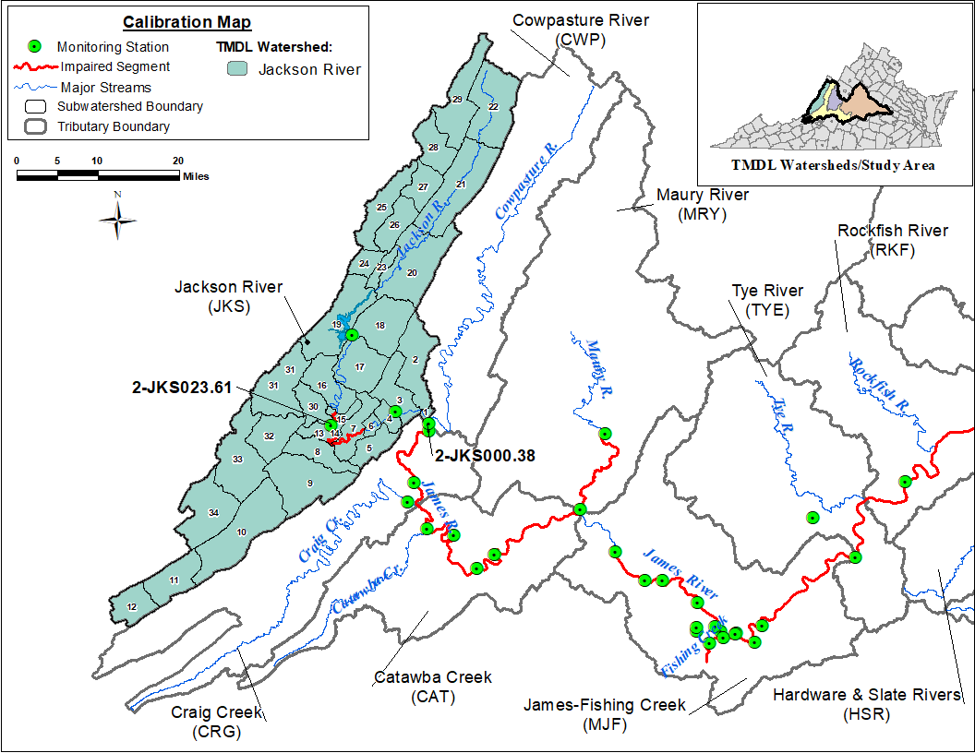
Figure E-3. Subwatersheds and monitoring stations used in calibration comparisons for the Jackson River TMDL watershed.

Phase I Calibration
Average annual SOSED and SOSLD (sediment and solids wash-off rate) values for Jackson River were calibrated to within the load target ranges (Table E-1) for each Jackson River subwatershed and land use. Due to the large size of the resulting SOSED and SOSLD calibration tables, they are not included in this Appendix; including tables would have increased report length significantly. These tables can be made available upon request by referring to the contact information on page ii.

Pervious Land Use Calibration
Figure E-4, Figure E-5, and Figure E-6 show observed precipitation (upper axis) and simulated SOSED, DETS values for Forest, Cropland and pervious Residential land uses for the calibration period (2011-2019), respectively for subwatershed 1 in the Jackson River watershed. Other pervious land uses and subwatersheds produced similar SOSED and DETS plots. As expected, the DETS in each subwatershed for each pervious land use increased over time before decreasing during instances of sediment removal caused by storm events. The magnitude of DETS was smallest for the Forest land use and largest in Cropland land use, which was expected since forested lands have a greater percentage of vegetative cover and cropland is periodically fallowed.

Figure E-4. Forest SOSED, DETS, and observed precipitation for subwatershed 1 in Jackson River watershed.
Figure E-5. Cropland SOSED, DETS, and observed precipitation for subwatershed 1 in Jackson River watershed.

Figure E-6. Pervious Residential SOSED, DETS, and observed precipitation for subwatershed 1 in Jackson River watershed.

Impervious Land Use Calibration
Figure E-7 shows the observed precipitation (upper axis) and SOSLD and SLDS values for the impervious fraction of the Residential land use for subwatershed 1 from January 1, 2011 to December 31, 2019. Impervious land cover was subject to greater sediment loss during smaller magnitude precipitation events than pervious land cover. Compared to pervious land uses, significant storage reductions were more frequent on impervious lands.

Figure E-7. Impervious Residential SOSLD, SLDS, and observed precipitation for subwatershed 1 in Jackson River watershed.

SOSED, SOSLD, DETS, and SLDS Summary
The simulated SOSED, SOSLD, DETS, and SLDS values on the pervious and impervious land uses followed expected patterns and sediment removal characteristics. On pervious land uses, the DETS (sediment storage) increased steadily before decreasing sharply due to spikes in SOSED (sediment removal) which were a result of major storm events. This periodic rise and fall of sediment storage are characteristic of a well-calibrated model. On impervious land use, the SLDS (solids storage) fluctuations (increases and decreases) were more frequent when compared to the DETS for the pervious land uses. Impervious land uses were more sensitive to smaller storms and subject to more frequent wash off. Pervious and impervious Residential land use were included in the analysis to provide a comparison of the difference between pervious and impervious land cover. The calibrated Phase I model provided a reasonable approximation of the behavior of sediment detachment and removal in the Jackson River calibration. Due to the large number of subwatersheds and land uses in Jackson River, Phase I graphs for the other subwatersheds are not included in this report due to lengthiness, but they can be made available upon request by referring to the contact information on page ii. The final calibrated sediment parameters for the Phase I calibration are presented in Table E-3.

Table E-3. Final calibrated parameters for the Jackson River Phase I Calibration.
Parameter | Definition | FUNCTION OF… | Units | FINAL CALIBRATION | POSSIBLE RANGE OF VALUES^{ǂ} | CALCULATION METHOD^{ǂ}
PERLNDª
SED-PARM2 (Sediment Parameter Group 2)
SMPF | Management Practice (P) factor from USLE | Land use, agricultural practices | none | 0.0-1.0 | 0.0 - 1.0 | Constant at 1.0, Assumed no Management Practices
KRER | Coefficient in the soil detachment equation | Soils | complex | 0.050 - 0.352^{b} | 0.05 - 0.75 | Estimated in GIS, Calibrated in HSPF
JRER | Exponent in the soil detachment equation | Soils, climate | none | 3.0 for water and 2 for others | 1.0 - 3.0 | Based on Technical Note Recommended Values
AFFIX | Daily reduction in detached sediment | Soils, compaction, agricultural operations | per day | 0.001 - 0.5^{b} | 0.01 - 0.50 | Estimated from Recommended Values, Calibrated in HSPF
COVER | Fraction land surface protected from rainfall | Vegetal cover, land use | none | 0.0-0.980 | 0.0 - 0.98 | Estimated from Recommended Values, Calibrated in HSPF
NVSI | Atmospheric additions to sediment storage | Deposition, activities, etc. | lb/ac-day | 0.0 – 6.0^{b} | 0.0 - 20.0 | Based on Tech. Note Recommended Values
SED-PARM3 (Sediment Parameter Group 3)
KSER | Coefficient in the sediment washoff equation | Soils, surface conditions | complex | 0.010 - 4.90^{b} | 0.001 - 10.0 | Estimated from Recommended Values, Calibrated in HSPF
JSER | Exponent in the sediment washoff equation | Soils, surface conditions | none | 1.0 – 1.6 | 1.0 - 3.0 | “ ”
KGER | Coefficient in the soil matrix scour equation | Soils, evidence of gullies | complex | 0.0 – 0.5 | 0.0 - 10.0 | “ ”
JGER | Exponent in the soil matrix scour equation | Soils, evidence of gullies | none | 1.5 - 2.5 | 1.0 - 5.0 | “ ”
IMPLND^{c}
SLD-PARM2 (Solids Parameter Group 2)
KEIM | Coefficient in the solids washoff equation | Surface conditions, solids characteristics | complex | 1.0 | 0.1 - 10.0 | Based on Tech. Note Recommended Values
JEIM | Exponent in the solids washoff equation | Surface conditions, solids characteristics | none | 1.8 | 1.0 - 3.0 | “ ”
ACCSDP | Solids accumulation rate on the land surface | Land use, traffic, human activities | lb/ac-day | 0.0028 | 0.0 - 30.0 | “ ”
REMSDP | Fraction of the solids removed per day | Street sweeping, wind, traffic | per day | 0.05 | 0.01 - 1.0 | “ ”
^{ǂ} Acquired from EPA BASINS Technical Note 8 (2006)
ª Pervious land segment
^{b} Varies with land use (data available upon request by referring to the contact information on page ii).
^{c} Impervious land segment.

Phase II Calibration
As mentioned in the introductory calibration methodology section, the first run of the Phase II calibration was used to generate initial estimates of critical shear stress values. TAU represents the critical bed shear stress. TAUCD is the parameter used to calculate critical shear stress for deposition, and TAUCS is the parameter used to calculate critical shear stress for scour. Once the initial run was complete, the calibration continued by substituting the placeholder TAUCD and TAUCS values with updated estimates. In subsequent calibration runs, all sediment calibration parameters including TAUCD and TAUCS were subject to adjustment. Phase II calibration sufficiency metrics were analyzed after each run to determine if model calibration would continue. Although not explicitly part of the calibration evaluation process, another check that was performed after each calibration run examined the change in sediment bed depth. Bed depth was output as an annual average for each subwatershed reach. Large swings in bed depth trends were indications that the model could be encountering calculation errors and misrepresenting the subwatershed.

Graphical Model Performance Assessment (Qualitative)
The Phase II graphical calibration focused on model fit at the stations and subwatersheds where observed SSC data were available. Figure E-8 provides an initial visual analysis of model fit. In this graph, observed and simulated sediment concentrations were plotted against flow. Simulated data from January 1, 2017 to December 31, 2018 for reach 14, the channel corresponding to subwatershed 14 in the Jackson River, were included in the graph as daily averages (open circles); the simulated daily average SSC (mg/L) on a given date was plotted against its corresponding simulated daily average flow rate (cfs). Observed data were plotted similarly using the observed SSC (mg/L) at VADEQ water quality monitoring station JKS023.61 and the observed flow at the corresponding USGS flow gage on Jackson River (green triangles). The USGS flow gage closest to VADEQ station JKS023.61 with a complete flow record is USGS02013100.
Figure E-8 shows that the model is capable of simulating the appropriate sediment concentration magnitude given a particular flow rate. The simulated data “cloud” encompasses the observed data points. This graph shows for a certain observed flow rate and SSC combination, the model is capable of generating sediment-flow condition. Additionally, as observed flow increases, observed SSC also increases. A similar sediment concentration-flow correlation was illustrated with the simulated data.
Figure E-8. Sediment concentration-flow plot including daily average simulated SSC vs. daily average simulated flow, observed flow and observed SSC for subwatershed reach 14 in Jackson River watershed.

Figure E-9 further illustrates the model performance, with simulated and observed sediment concentrations plotted on each day that observed SSC data were collected at DEQ station JKS000.38. The performance of the 3-day window surrounding the date of the observed SSC were different for each reach in the Jackson River based on the number of SSC observed data points in each reach. The average daily simulated, and observed SSC for a 3-day window surrounding the date of the observed sampling was also included in the plot. In addition, the maximum and minimum simulated daily SSC concentrations during that 3-day window are shown. All the observed SSC data points were captured within the 3-day sediment windows by the model for reach 1 of the Jackson River watersheds.

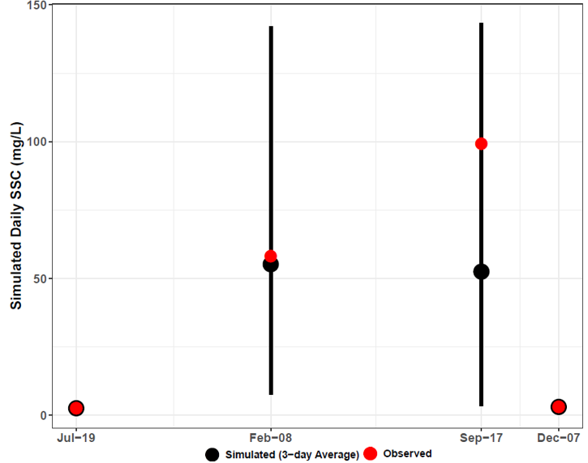
Figure E-9. Three-day window plot for sediment concentration showing the 3 and 5-day average, maximum minimum, and observed values at station JKS000.38 (Jackson River reach 1).

Figure E-10 illustrates another comparison of daily average simulated SSC and observed SSC. Both were plotted on the same graph with the daily average simulated flow for subwatershed reach 1 on a secondary axis. The flow and SSC time series have been scaled along the y-axis to emphasize the magnitude of simulated SSC fluctuations and to better illustrate observed and simulated SSC. This time series plot is representative of the results from other Jackson River subwatershed reaches and water quality stations. This graph shows that increases in simulated flow resulted in increases in simulated sediment concentration. It also shows that simulated sediment concentration increased as observed SSC increased, and the model capture all observed SSC data points. This plot clearly shows high intensity rainfall condition is the main source of high sediment concentration in the watershed.
Figure E-10. Comparison of observed SSC, simulated SSC, and simulated flow for subwatershed reach 1 in the Jackson River watershed.

Three- and Five-day Window Model Performance Assessment (Quantitative)
Table E-4 includes the results of the quantitative 3- and 5-day window calibration sufficiency analysis which was calculated for all observed SSC data in the Jackson River watershed. Three- and 5-day windows were only calculated around the days on which observed data is available. The 77% of observed data within the 5-day window is greater than the published 70% criteria that has been used for sparse data bacteria model calibration applications (Kim et al., 2007), and the 62% of the observed data within the 3-day window is greater than the desired 50% discussed earlier. And while the model did exhibit a slight under-prediction bias as indicated by the slightly larger percentage ‘below’ values for both the 3- and 5-day windows, overall the model performed well. Despite the sparsity of the observed data, the results of the calibration window analysis indicate that the model is sufficiently well-calibrated. The final calibrated sediment parameters for the Phase II calibration can be found in Table E-5.

Table E-4. Three- and five-day window calibration statistics for the Jackson River Phase II Calibration.
Statistics | Value
Number of Observed Data Points | 13
Percentage within 3-day window | 62%
Percentage above 3-day maximum | 15%
Percentage below 3-day minimum | 23%
Percentage within 5-day window | 77%
Percentage above 5-day maximum | 8%
Percentage below 5-day minimum | 15%

Calibration Summary
Using a “weight-of-evidence” approach presented here, the conclusion is that the Jackson River watershed HSPF sediment model is sufficiently well calibrated to adequately simulate sediment loads. SSC-flow time series plots for all Jackson River watershed SSC stations can be provided upon request by referring to the contact information on page ii.

Table E-5. Final calibrated parameters for the Jackson River watershed Phase II Calibration.
Parameter | Definition | FUNCTION OF… | Units | FINAL CALIBRATION | POSSIBLE RANGE OF VALUES^{ǂ} | CALCULATION METHOD^{ǂ}
RCHRESª
SANDFG (Sand Parameter Flags)
SNDFG | Indicates method used for Sandload Simulation | Type of stream; user experience | none | 3 | 1 - 3 | Constant, Power Function Method
SED-GENPARM (General Parameters)
BEDWID | Width of cross-section over which HSPF will assume bed sediment is deposited | Reach \ Waterbody morphology | ft | 120 | 5 - 1000 | Estimated from ArcGIS 3D Analyst
BEDWRN | Bed depth which, if exceeded (i.e., through deposition) will cause a warning message to be printed | Reach \ Waterbody morphology, User needs | ft | 7.5 | 0.5 - 20 | Estimated from ArcGIS 3D Analyst
POR | Porosity of the bed (volume voids/total volume) | Reach \ Sediment Bed Characteristics | none | 0.5 | 0.25 - 0.9 | Based on Technical Note Recommended Values
SAND-PM (Sand Parameters)
D | Effective diameter of the transported sand particles | Sediment properties | in | 0.005 | 0.0005 - 0.2 | Based on Tech. Note Recommended Values
W | Fall velocity of transported sand particles in still water | Particle diameter and density | in/sec | 0.4 | 0.1 - 10 | “ ”
RHO | Density of sand particles | Sediment properties | g/cm³ | 2.6 | 1.5 - 3.0 | “ ”
KSAND | Coefficient in sandload power function formula | Sand properties and hydraulics | complex | 0.001 | 0.001 - 10 | Estimated from Recommended Values, Calibrated in HSPF
EXPSND | Exponent in sandload power function formula | Sand properties and hydraulics | complex | 2.0^{b} | 1.0 - 6.0 | Estimated from Recommended Values, Calibrated in HSPF
SILT-CLAY-PM (Silt Parameters)
D | Effective diameter of silt particles | Sediment properties | in | 0.0006 | 0.0001 - 0.004 | Based on Tech. Note Recommended Values
W | Fall velocity of transported silt particles in still water | Particle diameter and density | in/sec | 0.0005 | 0.0 - 0.1 | “ ”
RHO | Density of silt particles | Sediment properties | g/cm³ | 2.3 | 1.5 - 3.0 | “ ”
TAUCD | Critical bed shear stress for deposition | Silt properties and hydraulics | lb/ft² | 0.0156 – 0.5544^{b} | 0.001 - 1.0 | Estimated from Initial Run, Calibrated in HSPF
TAUCS | Critical bed shear stress for scour | Silt properties and hydraulics | lb/ft² | 0.1486 – 1.0820^{b} | 0.01 - 3.0 | Estimated from Initial Run, Calibrated in HSPF
M | Erodibility coefficient | Silt properties and hydraulics | lb/ft²-d | 0.001-05^{b} | 0.001 - 5.0 | Estimated from Recommended Values, Calibrated in HSPF
SILT-CLAY-PM (Clay Parameters)
D | Effective diameter of clay particles | Sediment properties | in | 0.0001 | 0.000005 - 0.00025 | Based on Tech. Note Recommended Values
W | Fall velocity of transported clay particles in still water | Particle diameter and density | in/sec | 0.00005 | 0.0 - 0.1 | “ ”
RHO | Density of clay particles | Sediment properties | g/cm³ | 2.0 | 1.5 - 3.0 | “ ”
TAUCD | Critical bed shear stress for deposition | Clay properties and hydraulics | lb/ft² | 0.0130- 0.54040^{b} | 0.001 - 1.0 | Estimated from Initial Run, Calibrated in HSPF
TAUCS | Critical bed shear stress for scour | Clay properties and hydraulics | lb/ft² | 0.1450 – 0.91410^{b} | 0.01 - 3.0 | Estimated from Initial Run, Calibrated in HSPF
M | Erodibility coefficient | Clay properties and hydraulics | lb/ft²-d | 0.001-0.05^{b} | 0.001 - 5.0 | Estimated from Recommended Values, Calibrated in HSPF
SSED-INIT | Initial concentrations of suspended sediment | Reach | mg/L | 5 sand; 12 silt; 12 clay | n/a | Estimated
BED-INIT | Initial content of bed sediment | Sediment Bed Characteristics | pct. | 30% sand; 40% silt; 30% clay | n/a | Estimated
^{ǂ} Acquired from EPA BASINS Technical Note 8 (2006).
ª Main stem of stream in each subwatershed.
^{b} Varies with subwatershed reach (data available upon request by referring to the contact information on page ii).

Maury River
This section presents the HSPF sediment calibration results for the Maury River. The calibration results are summarized by Phase I and Phase II. Chapter 2 provides maps showing the location of the Maury River subwatersheds that will be discussed as well as the observed SSC water quality stations and USGS flow gage. Figure E-11 illustrates the location of TMDL watershed, major tributary boundaries, reaches, and select monitoring stations used for comparing simulated and observed values during model calibration.
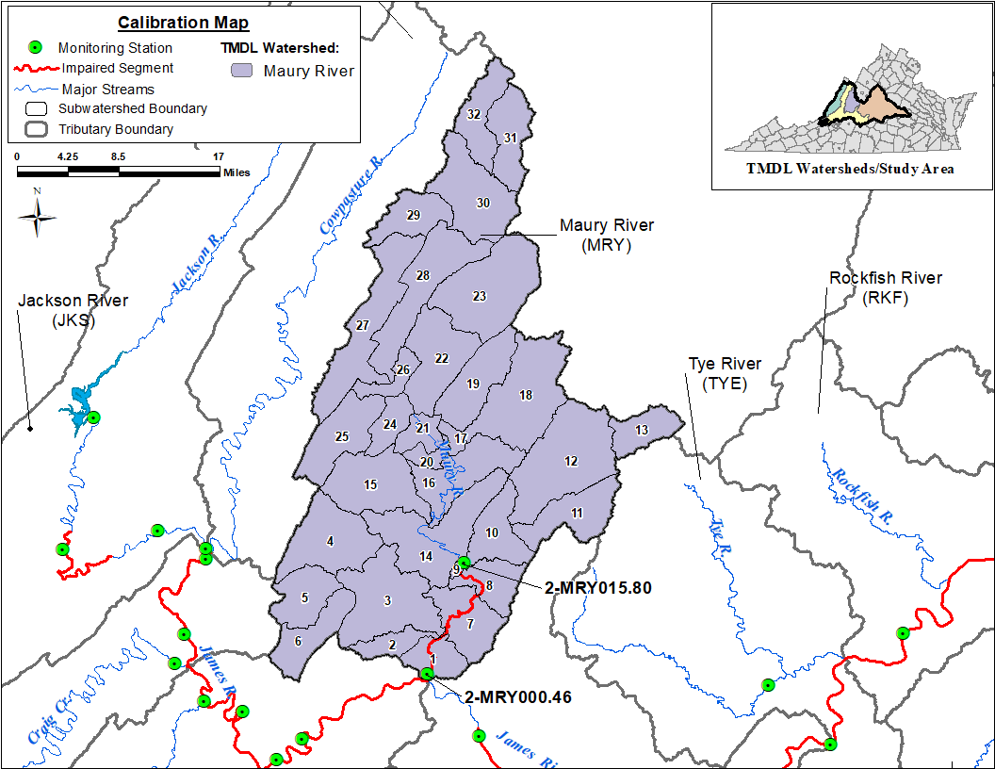
Figure E-11. Subwatersheds and monitoring stations used in calibration comparisons for the Maury River TMDL watershed.

Phase I Calibration
Average annual SOSED and SOSLD (sediment and solids wash-off rate) values for Maury River were calibrated to within the load target ranges (Table E-1) for each Maury River subwatershed and land use. Due to the large size of the resulting SOSED and SOSLD calibration tables for the 32 subwatersheds, they are not included in this Appendix; including tables would have made the report unmanageably long. These tables can be made available upon request by referring to the contact information on page ii.

Pervious Land Use Calibration
Figure E-12, Figure E-13, and Figure E-14 show observed precipitation (upper axis) and simulated SOSED, DETS values for Forest, Cropland and pervious Residential land uses for the calibration period (2011-2019), respectively for subwatershed 1 in the Maury River watershed. Other pervious land uses, and subwatersheds produced similar SOSED and DETS plots. As expected, the DETS in each subwatershed for each pervious land use increased over time before decreasing during instances of sediment removal caused by major storm events. The magnitude of DETS was smallest for the Forest land use and largest in Cropland land use, which was expected since forested lands have a greater percentage of vegetative cover and cropland is periodically fallowed.
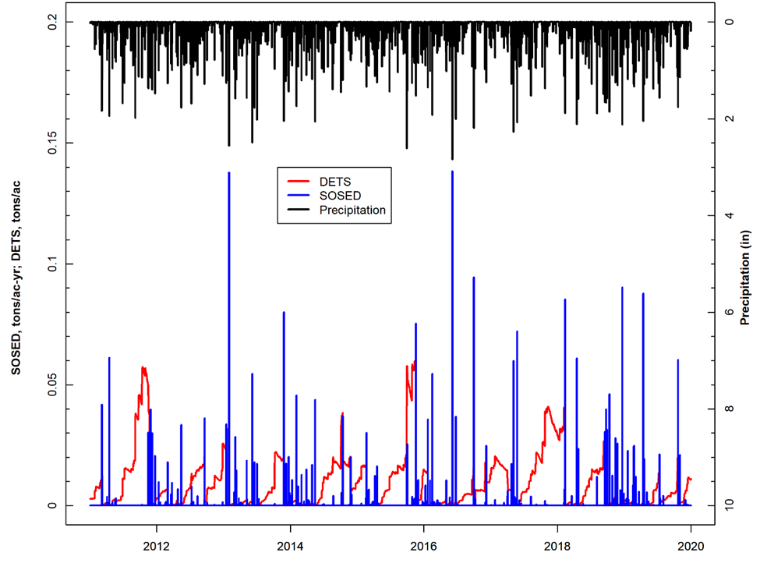
Figure E-12. Forest SOSED, DETS, and observed precipitation for subwatershed 1 in Maury River watershed.

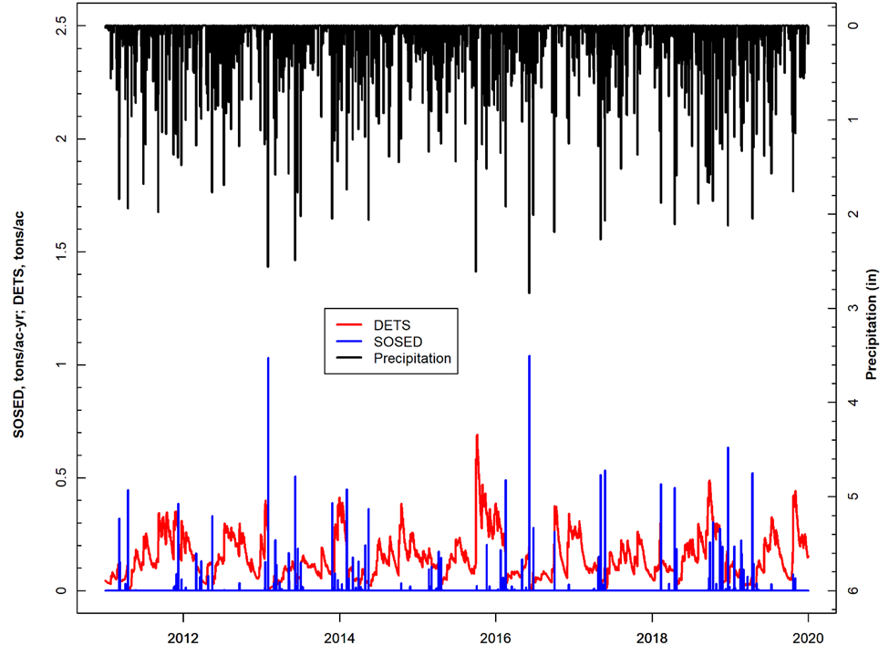
Figure E-13. Cropland SOSED, DETS, and observed precipitation for subwatershed 1 in Maury River. watershed.
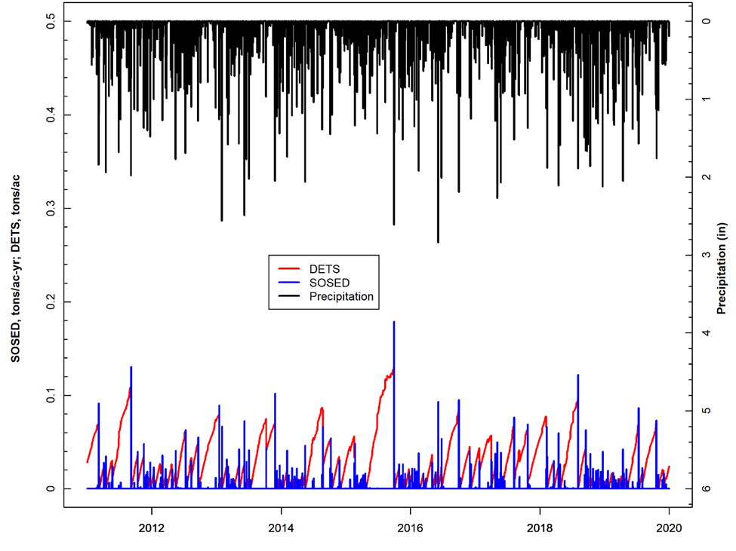
Figure E-14. Pervious Residential SOSED, DETS, and observed precipitation for subwatershed 1 in Maury River watershed.

Impervious Land Use Calibration
Figure E-15 shows the observed precipitation (upper axis) and SOSLD and SLDS values for the impervious fraction of the Residential land use for subwatershed 1 from January 1, 2011 to December 31, 2019. Impervious land cover was subject to greater sediment loss during smaller magnitude precipitation events than pervious land cover. Compared to pervious land uses, significant storage reductions were more frequent on impervious lands.

Figure E-15. Impervious Residential SOSLD, SLDS, and observed precipitation for subwatershed 1 in Maury River watershed

SOSED, SOSLD, DETS, and SLDS Summary
The simulated SOSED, SOSLD, DETS, and SLDS values on the pervious and impervious land uses followed expected patterns and sediment removal characteristics. On pervious land uses, the DETS (sediment storage) increased steadily before decreasing sharply due to spikes in SOSED (sediment removal) which were a result of major storm events. This periodic rise and fall of sediment storage are characteristic of a well-calibrated model. On impervious land use, the SLDS (solids storage) fluctuations (increases and decreases) were more frequent when compared to the DETS for the pervious land uses. Impervious land uses were more sensitive to smaller storms and subject to more frequent wash off. Pervious and impervious Residential land use were included in the analysis to provide a comparison of the difference between pervious and impervious land cover. The calibrated Phase I model provided a reasonable approximation of the behavior of sediment detachment and removal in the Maury River overland sediment transport calibration. Due to the large number of subwatersheds and land uses in Maury River, Phase I graphs for the other subwatersheds are not included in this report due to lengthiness, but they can be made available upon request by referring to the contact information on page ii. The final calibrated sediment parameters for the Phase I calibration are presented in Table E-6.

Table E-6. Final calibrated parameters for the Maury River Phase I Calibration.
Parameter | Definition | FUNCTION OF… | Units | FINAL CALIBRATION | POSSIBLE RANGE OF VALUES^{ǂ} | CALCULATION METHOD^{ǂ}
PERLNDª
SED-PARM2 (Sediment Parameter Group 2)
SMPF | Management Practice (P) factor from USLE | Land use, agricultural practices | none | 1 | 0.0 - 1.0 | Constant at 1.0, Assumed no Management Practices
KRER | Coefficient in the soil detachment equation | Soils | complex | 0.050 - 0.750^{b} | 0.05 - 0.75 | Based on Technical Note Recommended Values, Calibrated in HSPF
JRER | Exponent in the soil detachment equation | Soils, climate | none | 3.0 for water bodies and 2 for others | 1.0 - 3.0 | Based on Technical Note Recommended Values
AFFIX | Daily reduction in detached sediment | Soils, compaction, agricultural operations | per day | 0.001 - 0.05^{b} | 0.01 - 0.50 | Estimated from Recommended Values, Calibrated in HSPF
COVER | Fraction land surface protected from rainfall | Vegetal cover, land use | none | 0.0-0.97 | 0.0 - 0.98 | Estimated from Recommended Values, Calibrated in HSPF
NVSI | Atmospheric additions to sediment storage | Deposition, activities, etc. | lb/ac-day | 0.0 – 2.0^{b} | 0.0 - 20.0 | Based on Tech. Note Recommended Values
SED-PARM3 (Sediment Parameter Group 3)
KSER | Coefficient in the sediment washoff equation | Soils, surface conditions | complex | 0.1 - 9.00^{b} | 0.001 - 10.0 | Estimated from Recommended Values, Calibrated in HSPF
JSER | Exponent in the sediment washoff equation | Soils, surface conditions | none | 1.10 – 1.20 | 1.0 - 3.0 | “ ”
KGER | Coefficient in the soil matrix scour equation | Soils, evidence of gullies | complex | 0.0 – 0.21 | 0.0 - 10.0 | “ ”
JGER | Exponent in the soil matrix scour equation | Soils, evidence of gullies | none | 1.5-2.5 | 1.0 - 5.0 | “ ”
IMPLND^{c}
SLD-PARM2 (Solids Parameter Group 2)
KEIM | Coefficient in the solids washoff equation | Surface conditions, solids characteristics | complex | 2.0 | 0.1 - 10.0 | Based on Tech. Note Recommended Values
JEIM | Exponent in the solids washoff equation | Surface conditions, solids characteristics | none | 1.8 | 1.0 - 3.0 | “ ”
ACCSDP | Solids accumulation rate on the land surface | Land use, traffic, human activities | lb/ac-day | 0.0022 | 0.0 - 30.0 | “ ”
REMSDP | Fraction of the solids removed per day | Street sweeping, wind, traffic | per day | 0.04 | 0.01 - 1.0 | “ ”
^{ǂ} Acquired from EPA BASINS Technical Note 8 (2006)
ª Pervious land segments
^{b} Varies with land use (data available upon request by referring to the contact information on page ii)
^{c} Impervious land segment

Phase II Calibration
As mentioned in the introductory calibration methodology section, the first run of the Phase II calibration was used to generate initial estimates of critical shear stress values. TAU represents the critical bed shear stress. TAUCD is the parameter used to calculate critical shear stress for deposition, and TAUCS is the parameter used to calculate critical shear stress for scour. Once the initial run was complete, the calibration continued by substituting the placeholder TAUCD and TAUCS values with updated estimates. In subsequent calibration runs, all sediment calibration parameters including TAUCD and TAUCS were subject to adjustment. Phase II calibration efficiency metrics were analyzed after each run to determine if it’s necessary to continue the model calibration procedure further.

Graphical Model Performance Assessment (Qualitative)
The Phase II graphical calibration focused on model fit at the stations and subwatersheds where observed SSC data were available. Figure E-16 provides an initial visual analysis of model fit. In this graph, observed and simulated sediment concentrations were plotted against flow. Simulated data from January 1, 2017 to December 31, 2019 for reach 09, the reach corresponding to subwatershed 09 in the Maury River, were included in the graph as daily averages (open circles); the simulated daily average SSC (mg/L) on a given date was plotted against its corresponding simulated daily average flow rate (cfs). Observed data were plotted similarly using the observed SSC (mg/L) at VADEQ water quality monitoring station 2-MRY015.80 and the observed flow at the corresponding USGS flow gage on Maury River (Red triangles). The USGS flow gage closest to VADEQ station 2-MRY015.80 with a complete flow record is USGS02024000 (Maury River near Buena Vista).
Figure E-16 shows that the model is capable of simulating the appropriate sediment concentration magnitude given a particular flow rate. The simulated data “cloud” encompasses the observed data points. This graph shows for a certain observed flow rate and SSC combination, the model is capable of generating sediment-flow condition. Additionally, as observed flow increases, observed SSC also increases except for one date. On that particular date the observed SSC was very low despite the high observed flow of the river at two of the reaches. A similar sediment concentration-flow correlation was illustrated with the simulated data.
Figure E-16. Sediment concentration-flow plot including daily average simulated SSC vs. daily average simulated flow, observed flow and observed SSC for subwatershed reach 9 in Maury River watershed.

Figure E-17 further illustrates the model performance, with simulated and observed sediment concentrations plotted on each day at which observed SSC data were collected at VADEQ station 2-MRY000.46. The average daily simulated and observed SSC for a 5-day window surrounding the date of the observed sampling was also included in the plot. In addition, the maximum and minimum simulated daily SSC concentrations during that 5-day window are shown. All the observed SSC data points were captured within the 5-day sediment windows by the model for reach 1 of the Maury River watersheds.
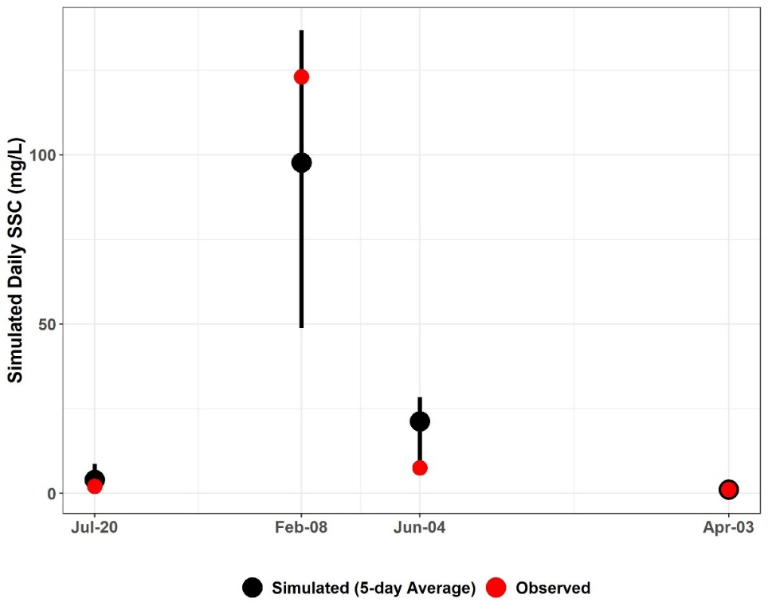
Figure E-17. Three-day window plot for sediment concentration showing the 5-day average, maximum minimum, and observed values at station 2- MRY000.46 (Maury River watershed reach 1).

Figure E-18 illustrates another comparison of daily average simulated SSC and observed SSC. Both were plotted on the same graph with the daily average simulated flow for the river section within the subwatershed 1 on a secondary axis. The flow and SSC time series have been scaled along the y-axis to emphasize the magnitude of simulated SSC fluctuations and to better illustrate observed and simulated SSC. This graph shows that increases in simulated flow resulted in increases in simulated sediment concentration. It also shows that simulated sediment concentration increased as observed SSC increased, and the model capture all observed SSC data points. This plot clearly shows high intensity rainfall condition is the main source of high sediment concentration in the watershed.

Figure E-18. Comparison of observed SSC, simulated SSC, and simulated flow for subwatershed reach 1 in the Maury watershed.

Three- and Five-day Window Model Performance Assessment (Quantitative)
Table E-7 includes the results of the quantitative 3- and 5-day window calibration sufficiency analysis which was calculated for all observed SSC data in the Maury River watershed. 3- and 5-day windows were only calculated around the days on which observed data were available. The 75% of observed data within the 5-day window is greater than the published 70% criteria that has been used for sparse data bacteria model calibration applications (Kim et al., 2007), and the 50% of the observed data within the 3-day window is equal to the desired 50% discussed earlier. It is worth mentioning that for the river section within subwatershed 1 all of the four observed data points were within the 5-day window and 75% of them were within the 3-day window. And while the model over-predicted some of the SSC data as indicated by the slightly larger percentage ‘below’ values for the 3-day windows, overall the model performed well. Despite the sparsity of the observed data, the results of the calibration window analysis indicate that the model is sufficiently well-calibrated. The final calibrated sediment parameters for the Phase II calibration can be found in Table E-8.

Table E-7. Three- and five-day window calibration statistics for the Maury River Phase II Calibration.
Statistics | Value
Number of Observed Data Points | 8
Percentage within 3-day window | 75%
Percentage above 3-day maximum | 0%
Percentage below 3-day minimum | 25%
Percentage within 5-day window | 87.5%
Percentage above 5-day maximum | 0%
Percentage below 5-day minimum | 12.5%

Calibration Summary
Using a “weight-of-evidence” approach presented here, the conclusion is that the Maury River watershed HSPF sediment model is sufficiently well calibrated to adequately simulate sediment loads. SSC-flow time series plots for all Maury River watershed SSC stations can be provided upon request by referring to the contact information on page ii.

Table E-8. Final calibrated parameters for the Maury River watershed Phase II Calibration.
Parameter | Definition | FUNCTION OF… | Units | FINAL CALIBRATION | POSSIBLE RANGE OF VALUES^{ǂ} | CALCULATION METHOD^{ǂ}
RCHRESª
SANDFG (Sand Parameter Flags)
SNDFG | Indicates method used for Sandload Simulation | Type of stream; user experience | none | 3 | 1 - 3 | Constant, Power Function Method
SED-GENPARM (General Parameters)
BEDWID | Width of cross-section over which HSPF will assume bed sediment is deposited | Reach \ Waterbody morphology | ft | 16 | 5 - 1000 | Based on Technical Note Recommended Values
BEDWRN | Bed depth which, if exceeded (i.e., through deposition) will cause a warning message to be printed | Reach \ Waterbody morphology, User needs | ft | 10 | 0.5 - 20 | Based on Technical Note Recommended Values
POR | Porosity of the bed (volume voids/total volume) | Reach \ Sediment Bed Characteristics | none | 0.5 | 0.25 - 0.9 | Based on Technical Note Recommended Values
SAND-PM (Sand Parameters)
D | Effective diameter of the transported sand particles | Sediment properties | in | 0.005 | 0.0005 - 0.2 | Based on Tech. Note Recommended Values
W | Fall velocity of transported sand particles in still water | Particle diameter and density | in/sec | 0.1 | 0.1 - 10 | “ ”
RHO | Density of sand particles | Sediment properties | g/cm³ | 4 | 1.5 - 3.0 | “ ”
KSAND | Coefficient in sandload power function formula | Sand properties and hydraulics | complex | 0.05-0.125 | 0.001 - 10 | Estimated from Recommended Values, Calibrated in HSPF
EXPSND | Exponent in sandload power function formula | Sand properties and hydraulics | complex | 2.0^{b} | 1.0 - 6.0 | Estimated from Recommended Values, Calibrated in HSPF
SILT-CLAY-PM (Silt Parameters)
D | Effective diameter of silt particles | Sediment properties | in | 0.0005 | 0.0001 - 0.004 | Based on Tech. Note Recommended Values
W | Fall velocity of transported silt particles in still water | Particle diameter and density | in/sec | 0.0004 | 0.0 - 0.1 | “ ”
RHO | Density of silt particles | Sediment properties | g/cm³ | 3 | 1.5 - 3.0 | “ ”
TAUCD | Critical bed shear stress for deposition | Silt properties and hydraulics | lb/ft² | 0.01 – 0.22^{b} | 0.001 - 1.0 | Estimated from Initial Run, Calibrated in HSPF
TAUCS | Critical bed shear stress for scour | Silt properties and hydraulics | lb/ft² | 0.07 – 2.77^{b} | 0.01 - 3.0 | Estimated from Initial Run, Calibrated in HSPF
M | Erodibility coefficient | Silt properties and hydraulics | lb/ft²-d | 0.1-0.2^{b} | 0.001 - 5.0 | Estimated from Recommended Values, Calibrated in HSPF
SILT-CLAY-PM (Clay Parameters)
D | Effective diameter of clay particles | Sediment properties | in | 0.001 | 0.000005 - 0.00025 | Based on Tech. Note Recommended Values
W | Fall velocity of transported clay particles in still water | Particle diameter and density | in/sec | 0.005 | 0.0 - 0.1 | “ ”
RHO | Density of clay particles | Sediment properties | g/cm³ | 2.9 | 1.5 - 3.0 | “ ”
TAUCD | Critical bed shear stress for deposition | Clay properties and hydraulics | lb/ft² | 0.01- 0.220^{b} | 0.001 - 1.0 | Estimated from Initial Run, Calibrated in HSPF
TAUCS | Critical bed shear stress for scour | Clay properties and hydraulics | lb/ft² | 0.05 – 2.44^{b} | 0.01 - 3.0 | Estimated from Initial Run, Calibrated in HSPF
M | Erodibility coefficient | Clay properties and hydraulics | lb/ft²-d | 0.1-0.2^{b} | 0.001 - 5.0 | Estimated from Recommended Values, Calibrated in HSPF
SSED-INIT | Initial concentrations of suspended sediment | Reach | mg/L | 10 sand; 20 silt; 20 clay | n/a | Based on Tech. Note Recommended Values
BED-INIT | Initial content of bed sediment | Sediment Bed Characteristics | pct. | 60% sand; 20% silt; 20% clay | n/a
^{ǂ} Acquired from EPA BASINS Technical Note 8 (2006)
ª Main stem of stream in each subwatershed
^{b} Varies with subwatershed reach (data available upon request by referring to the contact information on page ii)

Upper James River
This section presents the HSPF sediment calibration results for the Upper James River TMDL Watershed that includes: Cowpasture River, Craig Creek, Catawba Creek, portions of the James River, and Fishing Creek. The calibration results are summarized by Phase I and Phase II. Chapter 2 provides maps showing the location of the Upper James River subwatersheds that will be discussed as well as all observed SSC water quality stations and USGS flow gage. Figure E-19 illustrates the location of TMDL watershed, major tributary boundaries, reaches, and select monitoring stations used for comparing simulated and observed values during model calibration.

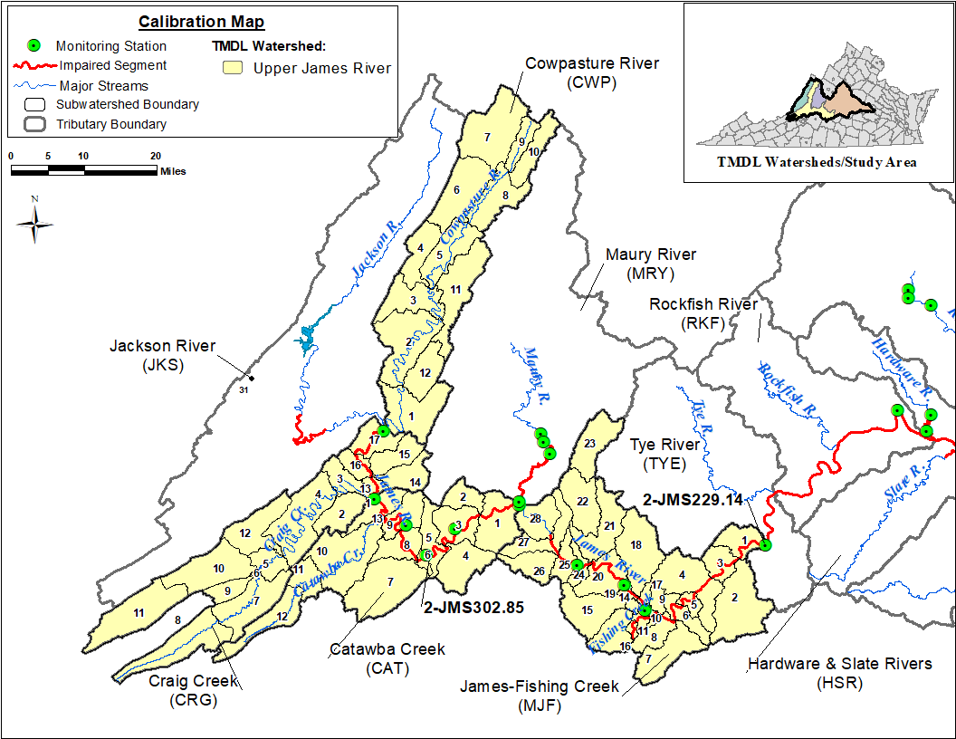
Figure E-19. Subwatersheds and monitoring stations used in calibration comparisons for the Upper James River TMDL watershed.

Phase I Calibration: Upper James River – Cowpasture, Catawba, Craig Creek
This section of calibration results for James River—Cowpasture, Catawba, and Craig Creeks are collectively referred to as “Upper James River”. Comparison analyses of model results for the outlet located in the James River—Catawba calibration watershed portion are discussed in the following sections. Average annual SOSED and SOSLD (sediment and solids wash-off rate) values for Upper James River were calibrated to within the load target ranges (Table E-1) for each Upper James River subwatershed and land use. Due to the large size of the resulting SOSED and SOSLD calibration tables for the 30 subwatersheds, they are not included in this Appendix; including tables would have made the report unmanageably long. These tables can be made available upon request by referring to the contact information on page ii.

Pervious Land Use Calibration
Figure E-20, Figure E-21, and Figure E-22 show observed precipitation (upper axis) and simulated SOSED, DETS values for Forest, Cropland and pervious Residential land uses for the calibration period (2011-2019), respectively for subwatershed 1 in the Upper James River watershed. Other pervious land uses, and subwatersheds produced similar SOSED and DETS plots. As expected, the DETS in each subwatershed for each pervious land use increased over time before decreasing during instances of sediment removal caused by major storm events. The magnitude of DETS was smallest for the Forest land use and largest in Cropland land use, which was expected since forested lands have a greater percentage of vegetative cover and cropland is periodically fallowed.
Figure E-20. Forest SOSED, DETS, and observed precipitation for subwatershed 1 in Upper James River—Catawba calibration watershed.

Figure E-21. Cropland SOSED, DETS, and observed precipitation for subwatershed 1 in Upper James River—Catawba calibration watershed.
Figure E-22. Pervious Residential SOSED, DETS, and observed precipitation for subwatershed 1 in Upper James River—Catawba calibration watershed.

Impervious Land Use Calibration
Figure E-23 shows the observed precipitation (upper axis) and SOSLD and SLDS values for the impervious fraction of the Residential land use for subwatershed 1 from January 1, 2011 to December 31, 2019. Impervious land cover was subject to greater sediment loss during smaller magnitude precipitation events than pervious land cover. Compared to pervious land uses, significant storage reductions were more frequent on impervious lands.

Figure E-23. Impervious Residential SOSLD, SLDS, and observed precipitation for subwatershed 1 in Upper James River—Catawba calibration watershed.

SOSED, SOSLD, DETS, and SLDS Summary
The simulated SOSED, SOSLD, DETS, and SLDS values on the pervious and impervious land uses followed expected patterns and sediment removal characteristics. On pervious land uses, the DETS (sediment storage) increased steadily before decreasing sharply due to spikes in SOSED (sediment removal) which were a result of major storm events. This periodic rise and fall of sediment storage are characteristic of a well-calibrated model. On impervious land use, the SLDS (solids storage) fluctuations (increases and decreases) were more frequent when compared to the DETS for the pervious land uses. Impervious land uses were more sensitive to smaller storms and subject to more frequent wash off. Pervious and impervious Residential land use were included in the analysis to provide a comparison of the difference between pervious and impervious land cover. The calibrated Phase I model provided a reasonable approximation of the behavior of sediment detachment and removal in the Upper James River overland sediment transport calibration. Due to the large number of subwatersheds and land uses in Upper James River, Phase I graphs for the other subwatersheds are not included in this report due to lengthiness, but they can be made available upon request by referring to the contact information on page ii. The final calibrated sediment parameters for the Phase I calibration are presented in Table E-9.

Table E-9. Final calibrated parameters for the Upper James River Phase I Calibration.
Parameter | Definition | FUNCTION OF… | Units | FINAL CALIBRATION | POSSIBLE RANGE OF VALUES^{ǂ} | CALCULATION METHOD^{ǂ}
PERLNDª
SED-PARM2 (Sediment Parameter Group 2)
SMPF | Management Practice (P) factor from USLE | Land use, agricultural practices | none | 1 | 0.0 - 1.0 | Constant at 1.0, Assumed no Management Practices
KRER | Coefficient in the soil detachment equation | Soils | complex | 0.200 - 0.352^{b} | 0.05 - 0.75 | Based on Technical Note Recommended Values, Calibrated in HSPF
JRER | Exponent in the soil detachment equation | Soils, climate | none | 2.0 – 3.05 ^{b} | 1.0 - 3.0 | Based on Technical Note Recommended Values
AFFIX | Daily reduction in detached sediment | Soils, compaction, agricultural operations | per day | 0.01 - 0.50^{b} | 0.01 - 0.50 | Estimated from Recommended Values, Calibrated in HSPF
COVER | Fraction land surface protected from rainfall | Vegetal cover, land use | none | 0.20 - 0.97 | 0.0 - 0.98 | Estimated from Recommended Values, Calibrated in HSPF
NVSI | Atmospheric additions to sediment storage | Deposition, activities, etc. | lb/ac-day | 0.0 – 10.0^{b} | 0.0 - 20.0 | Based on Tech. Note Recommended Values
SED-PARM3 (Sediment Parameter Group 3)
KSER | Coefficient in the sediment washoff equation | Soils, surface conditions | complex | 0. 1 – 4.5^{b} | 0.001 - 10.0 | Estimated from Recommended Values, Calibrated in HSPF
JSER | Exponent in the sediment washoff equation | Soils, surface conditions | none | 1.0 – 2.5 | 1.0 - 3.0 | “ ”
KGER | Coefficient in the soil matrix scour equation | Soils, evidence of gullies | complex | 0.0 | 0.0 - 10.0 | “ ”
JGER | Exponent in the soil matrix scour equation | Soils, evidence of gullies | none | 2.0 | 1.0 - 5.0 | “ ”
IMPLND^{c}
SLD-PARM2 (Solids Parameter Group 2)
KEIM | Coefficient in the solids washoff equation | Surface conditions, solids characteristics | complex | 1.0 | 0.1 - 10.0 | Based on Tech. Note Recommended Values  Calibrated in HSPF
JEIM | Exponent in the solids washoff equation | Surface conditions, solids characteristics | none | 1.8 | 1.0 - 3.0 | “ ”
ACCSDP | Solids accumulation rate on the land surface | Land use, traffic, human activities | lb/ac-day | 0.0032 | 0.0 - 30.0 | “ ”
REMSDP | Fraction of the solids removed per day | Street sweeping, wind, traffic | per day | 0.05 | 0.01 - 1.0 | “ ”
^{ǂ} Acquired from EPA BASINS Technical Note 8 (2006)
ª Pervious land segments
^{b} Varies with land use (data available upon request by referring to the contact information on page ii)
^{c} Impervious land segment

Phase II Calibration: Upper James River – Cowpasture, Catawba, Craig Creek
As mentioned in the introductory calibration methodology section, the first run of the Phase II calibration was used to generate initial estimates of critical shear stress values. TAU represents the critical bed shear stress. TAUCD is the parameter used to calculate critical shear stress for deposition, and TAUCS is the parameter used to calculate critical shear stress for scour. Once the initial run was complete, the calibration continued by substituting the placeholder TAUCD and TAUCS values with updated estimates. In subsequent calibration runs, all sediment calibration parameters including TAUCD and TAUCS were subject to adjustment. Phase II calibration efficiency metrics were analyzed after each run to determine if it’s necessary to continue the model calibration procedure further.

Graphical Model Performance Assessment (Qualitative)
The Phase II graphical calibration focused on model fit at the stations and sub-watersheds where observed SSC data were available. Figure E-24 provides an initial visual analysis of model fit. In this graph, observed and simulated sediment concentrations were plotted against flow. Simulated data from January 1, 2013 to December 31, 2019 for reach 03, the reach corresponding to subwatershed 03 in the Upper James River—Catawba calibration watershed, were included in the graph as daily averages (open circles); the simulated daily average SSC (mg/L) on a given date was plotted against its corresponding simulated daily average flow rate (cfs). Observed data were plotted similarly using the observed SSC (mg/L) at VADEQ water quality monitoring station 2-JMS302.85 and the observed flow at the corresponding USGS flow gage on Upper James River (Red triangles). The USGS flow gage closest to VADEQ station 2-JMS302.85 with a complete flow record is USGS02019500 (James River at Buchanan, VA).
Figure E-24 shows that the model is capable of simulating the appropriate sediment concentration magnitude given a particular flow rate. The simulated data “cloud” encompasses the observed data points. This graph shows for a certain observed flow rate and SSC combination, the model is capable of generating sediment-flow condition. Additionally, as observed flow increases, observed SSC also increases except for one date. On that particular date the observed SSC was very low despite the high observed flow of the river at two of the reaches. A similar sediment concentration-flow correlation was illustrated with the simulated data.
Figure E-24. Sediment concentration-flow plot including daily average simulated SSC vs. daily average simulated flow, observed flow and observed SSC for subwatershed reach 3 in Upper James River—Catawba calibration watershed.

Figure E-25 further illustrates the model performance. In Figure E-25 simulated and observed sediment concentrations were plotted on each day at which observed SSC data were collected at VADEQ station 2-JMS302.85. The average daily simulated and observed SSC for a 5-day window surrounding the date of the observed sampling was also included in the plot. In addition, the maximum and minimum simulated daily SSC concentrations during that 5-day window are shown. The Figure E-25 shows all the observed SSC data points were captured within the 5-day sediment windows by the model for reach 3 of the Upper James River watersheds.
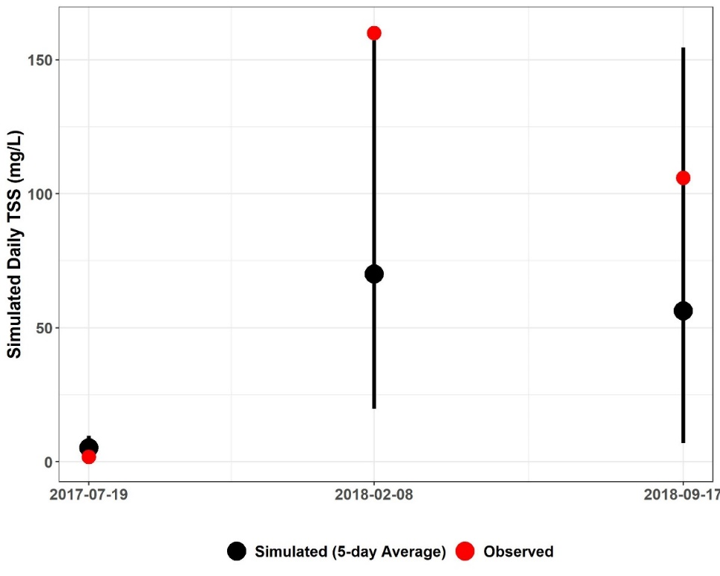
Figure E-25. Three-day window plot for sediment concentration showing the 5-day average, maximum minimum, and observed values at station 2-JMS302.85 (Upper James River—Catawba calibration watershed, reach 3).

Figure E-26 illustrates another comparison of daily average simulated SSC and observed SSC. Both were plotted on the same graph with the daily average simulated flow for the river section within the subwatershed 3 on a secondary axis. The flow and SSC time series have been scaled along the y-axis to emphasize the magnitude of simulated SSC fluctuations and to better illustrate observed and simulated SSC. This graph shows that increases in simulated flow resulted in increases in simulated sediment concentration. It also shows that simulated sediment concentration increased as observed SSC increased, and the model capture all observed SSC data points. This plot clearly shows high intensity rainfall condition is the main source of high sediment concentration in the watershed.
Figure E-26. Comparison of observed SSC, simulated SSC, and simulated flow for subwatershed reach 3 in the Upper James—Catawba calibration watershed.

Three- and Five-day Window Model Performance Assessment (Quantitative)
Table E-10 includes the results of the quantitative 3- and 5-day window calibration sufficiency analysis which was calculated for all observed SSC data in the Upper James River watershed. 3- and 5-day windows were only calculated around the days on which observed data were available. The 80% of observed data within the 5-day window is greater than the published 70% criteria that has been used for sparse data bacteria model calibration applications (Kim et al., 2007), and the 60% of the observed data within the 3-day window is greater than the desired 50% discussed earlier. It is worth mentioning that for the river section within subwatershed 3 all of the three observed data points were within the 5-day window. And while the model under-predicted some of the SSC data as indicated by the slightly larger percentage ‘above’ values for the 3 and 5-day windows, overall the model performed well. Despite the sparsity of the observed data, the results of the calibration window analysis indicate that the model is sufficiently well-calibrated. The final calibrated sediment parameters for the Phase II calibration can be found in Table E-11.

Table E-10. Three- and five-day window calibration statistics for the Upper James River Phase II Calibration.
Statistics | Value
Number of Observed Data Points | 15
Percentage within 3-day window | 60%
Percentage above 3-day maximum | 26%
Percentage below 3-day minimum | 14%
Percentage within 5-day window | 80%
Percentage above 5-day maximum | 20%
Percentage below 5-day minimum | 0%

Calibration Summary: Upper James River –Cowpasture, Catawba, Craig Creek
Using a “weight-of-evidence” approach presented here, the conclusion is that the Upper James River watershed HSPF sediment model is sufficiently well calibrated to adequately simulate sediment loads. SSC-flow time series plots for all Upper James River watershed SSC stations can be provided upon request by referring to the contact information on page ii.

Table E-11. Final calibrated parameters for the Upper James River watershed Phase II Calibration.
Parameter | Definition | FUNCTION OF… | Units | FINAL CALIBRATION | POSSIBLE RANGE OF VALUES^{ǂ} | CALCULATION METHOD^{ǂ}
RCHRESª
SANDFG (Sand Parameter Flags)
SNDFG | Indicates method used for Sandload Simulation | Type of stream; user experience | none | 3 | 1 - 3 | Constant, Power Function Method
SED-GENPARM (General Parameters)
BEDWID | Width of cross-section over which HSPF will assume bed sediment is deposited | Reach \ Waterbody morphology | ft | 13 | 5 - 1000 | Based on Technical Note Recommended Values
BEDWRN | Bed depth which, if exceeded (i.e., through deposition) will cause a warning message to be printed | Reach \ Waterbody morphology, User needs | ft | 6.5-20^{b} | 0.5 - 20 | Based on Technical Note Recommended Values
POR | Porosity of the bed (volume voids/total volume) | Reach \ Sediment Bed Characteristics | none | 0.5 | 0.25 - 0.9 | Based on Technical Note Recommended Values
SAND-PM (Sand Parameters)
D | Effective diameter of the transported sand particles | Sediment properties | in | 0.005 | 0.0005 - 0.2 | Based on Tech. Note Recommended Values
W | Fall velocity of transported sand particles in still water | Particle diameter and density | in/sec | 0.1-1.9^{b} | 0.1 - 10 | “ ”
RHO | Density of sand particles | Sediment properties | g/cm³ | 2.5-3.0^{b} | 1.5 - 3.0 | “ ”
KSAND | Coefficient in sandload power function formula | Sand properties and hydraulics | complex | 0.001-0.05^{b} | 0.001 - 10 | Estimated from Recommended Values, Calibrated in HSPF
EXPSND | Exponent in sandload power function formula | Sand properties and hydraulics | complex | 1.5-2.0^{b} | 1.0 - 6.0 | Estimated from Recommended Values, Calibrated in HSPF
SILT-CLAY-PM (Silt Parameters)
D | Effective diameter of silt particles | Sediment properties | in | 0.0006 | 0.0001 - 0.004 | Based on Tech. Note Recommended Values
W | Fall velocity of transported silt particles in still water | Particle diameter and density | in/sec | 0.0005-0.0295^{b} | 0.0 - 0.1 | “ ”
RHO | Density of silt particles | Sediment properties | g/cm³ | 2.3 | 1.5 - 3.0 | “ ”
TAUCD | Critical bed shear stress for deposition | Silt properties and hydraulics | lb/ft² | 0.002 – 0.08^{b} | 0.001 - 1.0 | Estimated from Initial Run, Calibrated in HSPF
TAUCS | Critical bed shear stress for scour | Silt properties and hydraulics | lb/ft² | 0.2 – 1.00^{b} | 0.01 - 3.0 | Estimated from Initial Run, Calibrated in HSPF
M | Erodibility coefficient | Silt properties and hydraulics | lb/ft²-d | 0.001-4.5^{b} | 0.001 - 5.0 | Estimated from Recommended Values, Calibrated in HSPF
SILT-CLAY-PM (Clay Parameters)
D | Effective diameter of clay particles | Sediment properties | in | 0.001 | 0.000005 - 0.00025 | Based on Tech. Note Recommended Values
W | Fall velocity of transported clay particles in still water | Particle diameter and density | in/sec | 0.0005-0.0295^{b} | 0.0 - 0.1 | “ ”
RHO | Density of clay particles | Sediment properties | g/cm³ | 2.0 | 1.5 - 3.0 | “ ”
TAUCD | Critical bed shear stress for deposition | Clay properties and hydraulics | lb/ft² | 0.001- 0.80^{b} | 0.001 - 1.0 | Estimated from Initial Run, Calibrated in HSPF
TAUCS | Critical bed shear stress for scour | Clay properties and hydraulics | lb/ft² | 0.01 – 1.9^{b} | 0.01 - 3.0 | Estimated from Initial Run, Calibrated in HSPF
M | Erodibility coefficient | Clay properties and hydraulics | lb/ft²-d | 0.001-4.5^{b} | 0.001 - 5.0 | Estimated from Recommended Values, Calibrated in HSPF
SSED-INIT | Initial concentrations of suspended sediment | Reach | mg/L | 2 sand; 2 silt; 20 clay | n/a | Based on Tech. Note Recommended Values
BED-INIT | Initial content of bed sediment | Sediment Bed Characteristics | pct. | 15% sand; 65% silt; 20% clay | n/a
^{ǂ} Acquired from EPA BASINS Technical Note 8 (2006)
ª Main stem of stream in each subwatershed
^{b} Varies with subwatershed reach (data available upon request by referring to the contact information on page ii)

Phase I Calibration: Upper James River – Fishing Creek
This section presents the HSPF sediment calibration results for the James River—Fishing Creek calibration segment. This is the furthest downstream modeled watershed within the Upper James River TMDL watershed (Figure E-19). The calibration results are summarized by Phase I and Phase II. Chapter 2 provides maps showing the location of the Upper James River – Fishing Creek subwatersheds that will be discussed as well as the observed SSC water quality stations and USGS flow gage.
Average annual SOSED and SOSLD (sediment and solids wash-off rate) values for Upper James River – Fishing Creek were calibrated to within the load target ranges (Table E-1) for each Upper James River – Fishing Creek subwatershed and land use. Due to the large size of the resulting SOSED and SOSLD calibration tables for the 30 subwatersheds, they are not included in this Appendix; including tables would have made the report unmanageably long. These tables can be made available upon request by referring to the contact information on page ii.

Pervious Land Use Calibration
Figure E-27, Figure E-28, and Figure E-29 show observed precipitation (upper axis) and simulated SOSED, DETS values for Forest, Cropland and pervious Residential land uses for the calibration period (2011-2019), respectively for subwatershed 1 in the Upper James River – Fishing Creek watershed. Other pervious land uses, and subwatersheds produced similar SOSED and DETS plots. As expected, the DETS in each subwatershed for each pervious land use increased over time before decreasing during instances of sediment removal caused by major storm events. The magnitude of DETS was smallest for the Forest land use and largest in Cropland land use, which was expected since forested lands have a greater percentage of vegetative cover and cropland is periodically fallowed.
Figure E-27. Forest SOSED, DETS, and observed precipitation for subwatershed 1 in Upper James River—Fishing Creek watershed

Figure E-28. Cropland SOSED, DETS, and observed precipitation for subwatershed 1 in Upper James River—Fishing Creek watershed.

Figure E-29. Pervious Residential SOSED, DETS, and observed precipitation for subwatershed 1 in Upper James River—Fishing Creek watershed.

Impervious Land Use Calibration
Figure E-30 shows the observed precipitation (upper axis) and SOSLD and SLDS values for the impervious fraction of the Residential land use for subwatershed 1 from January 1, 2011 to December 31, 2019. Impervious land cover was subject to greater sediment loss during smaller magnitude precipitation events than pervious land cover. Compared to pervious land uses, significant storage reductions were more frequent on impervious lands.

Figure E-30. Impervious Residential SOSLD, SLDS, and observed precipitation for subwatershed 1 in Upper James River—Fishing Creek watershed.

SOSED, SOSLD, DETS, and SLDS Summary
The simulated SOSED, SOSLD, DETS, and SLDS values on the pervious and impervious land uses followed expected patterns and sediment removal characteristics. On pervious land uses, the DETS (sediment storage) increased steadily before decreasing sharply due to spikes in SOSED (sediment removal) which were a result of major storm events. This periodic rise and fall of sediment storage are characteristic of a well-calibrated model. On impervious land use, the SLDS (solids storage) fluctuations (increases and decreases) were more frequent when compared to the DETS for the pervious land uses. Impervious land uses were more sensitive to smaller storms and subject to more frequent wash off. Pervious and impervious Residential land use were included in the analysis to provide a comparison of the difference between pervious and impervious land cover. The calibrated Phase I model provided a reasonable approximation of the behavior of sediment detachment and removal in the James River—Fishing Creek overland sediment transport calibration. Due to the large number of subwatersheds and land uses in Upper James River – Fishing Creek, Phase I graphs for the other subwatersheds are not included in this report due to lengthiness, but they can be made available upon request by referring to the contact information on page ii. The final calibrated sediment parameters for the Phase I calibration are presented in Table E-12.

Table E-12. Final calibrated parameters for the Upper James River—Fishing Creek Phase I Calibration.
Parameter | Definition | FUNCTION OF… | Units | FINAL CALIBRATION | POSSIBLE RANGE OF VALUES^{ǂ} | CALCULATION METHOD^{ǂ}
PERLNDª
SED-PARM2 (Sediment Parameter Group 2)
SMPF | Management Practice (P) factor from USLE | Land use, agricultural practices | none | 1 | 0.0 - 1.0 | Constant at 1.0, Assumed no Management Practices
KRER | Coefficient in the soil detachment equation | Soils | complex | 0.050 - 0.352^{b} | 0.05 - 0.75 | Based on Technical Note Recommended Values, Calibrated in HSPF
JRER | Exponent in the soil detachment equation | Soils, climate | none | 2.0 – 3.0 ^{b} | 1.0 - 3.0 | Based on Technical Note Recommended Values
AFFIX | Daily reduction in detached sediment | Soils, compaction, agricultural operations | per day | 0.01 - 0.50^{b} | 0.01 - 0.50 | Estimated from Recommended Values, Calibrated in HSPF
COVER | Fraction land surface protected from rainfall | Vegetal cover, land use | none | 0.20-0.97 | 0.0 - 0.98 | Estimated from Recommended Values, Calibrated in HSPF
NVSI | Atmospheric additions to sediment storage | Deposition, activities, etc. | lb/ac-day | 0.0 – 10.0^{b} | 0.0 - 20.0 | Based on Tech. Note Recommended Values
SED-PARM3 (Sediment Parameter Group 3)
KSER | Coefficient in the sediment washoff equation | Soils, surface conditions | complex | 0.10 – 9.50^{b} | 0.001 - 10.0 | Estimated from Recommended Values, Calibrated in HSPF
JSER | Exponent in the sediment washoff equation | Soils, surface conditions | none | 1.00 – 2.50 | 1.0 - 3.0 | “ ”
KGER | Coefficient in the soil matrix scour equation | Soils, evidence of gullies | complex | 0.0 | 0.0 - 10.0 | “ ”
JGER | Exponent in the soil matrix scour equation | Soils, evidence of gullies | none | 2.0 | 1.0 - 5.0 | “ ”
IMPLND^{c}
SLD-PARM2 (Solids Parameter Group 2)
KEIM | Coefficient in the solids washoff equation | Surface conditions, solids characteristics | complex | 0.28 | 0.1 - 10.0 | Based on Tech. Note Recommended Values  Calibrated in HSPF
JEIM | Exponent in the solids washoff equation | Surface conditions, solids characteristics | none | 2.5 | 1.0 - 3.0 | “ ”
ACCSDP | Solids accumulation rate on the land surface | Land use, traffic, human activities | lb/ac-day | 0.0114 | 0.0 - 30.0 | “ ”
REMSDP | Fraction of the solids removed per day | Street sweeping, wind, traffic | per day | 0.05 | 0.01 - 1.0 | “ ”
^{ǂ} Acquired from EPA BASINS Technical Note 8 (2006)
ª Pervious land segments
^{b} Varies with land use (data available upon request by referring to the contact information on page ii)
^{c} Impervious land segment

Phase II Calibration: Upper James River – Fishing Creek
As mentioned in the introductory calibration methodology section, the first run of the Phase II calibration was used to generate initial estimates of critical shear stress values. TAU represents the critical bed shear stress. TAUCD is the parameter used to calculate critical shear stress for deposition, and TAUCS is the parameter used to calculate critical shear stress for scour. Once the initial run was complete, the calibration continued by substituting the placeholder TAUCD and TAUCS values with updated estimates. In subsequent calibration runs, all sediment calibration parameters including TAUCD and TAUCS were subject to adjustment. Phase II calibration efficiency metrics were analyzed after each run to determine if it’s necessary to continue the model calibration procedure further.

Graphical Model Performance Assessment (Qualitative)
The Phase II graphical calibration focused on model fit at the stations and subwatersheds where observed SSC data were available. Figure E-31 provides an initial visual analysis of model fit. In this graph, observed and simulated sediment concentrations were plotted against flow. Simulated data from January 1, 2013 to December 31, 2019 for reach 01, the reach corresponding to subwatershed 01 in the Upper James River – Fishing Creek, were included in the graph as daily averages (open circles); the simulated daily average SSC (mg/L) on a given date was plotted against its corresponding simulated daily average flow rate (cfs). Observed data were plotted similarly using the observed SSC (mg/L) at VADEQ water quality monitoring station 2-JMS229.14 and the observed flow at the corresponding USGS flow gage on James River—Fishing Creek (Red triangles). The USGS flow gage closest to VADEQ station 2-JMS229.14 with a complete flow record is USGS 02026000 (James River at Bent Creek, VA).
Figure E-31 shows that the model is capable of simulating the appropriate sediment concentration magnitude given a particular flow rate. The simulated data “cloud” encompasses the observed data points. This graph shows for a certain observed flow rate and SSC combination, the model is capable of generating sediment-flow condition. Additionally, as observed flow increases, observed SSC also increases except for one date. On that particular date the observed SSC was very low despite the high observed flow of the river at two of the reaches. A similar sediment concentration-flow correlation was illustrated with the simulated data.
Figure E-31. Sediment concentration-flow plot including daily average simulated SSC vs. daily average simulated flow, observed flow and observed SSC for subwatershed reach 1 in Upper James River—Fishing Creek watershed.

Figure E-32 further illustrates the model performance showing simulated and observed sediment concentrations plotted on each day at which observed SSC data were collected at DEQ station 2-JMS229.14. The average daily simulated and observed SSC for a 5-day window surrounding the date of the observed sampling was also included in the plot. In addition, the maximum and minimum simulated daily SSC concentrations during that 5-day window are shown. The figure shows three out of four observed SSC data points were captured within the 5-day sediment windows by the model for reach 1 of the James River—Fishing Creek watersheds.

Figure E-33 illustrates another comparison of daily average simulated SSC and observed SSC. Both were plotted on the same graph with the daily average simulated flow for the river section within the subwatershed 1 on a secondary axis. The flow and SSC time series have been scaled along the y-axis to emphasize the magnitude of simulated SSC fluctuations and to better illustrate observed and simulated SSC. This graph shows that increases in simulated flow resulted in increases in simulated sediment concentration. It also shows that simulated sediment concentration increased as observed SSC increased, and the model capture all observed SSC data points. This plot clearly shows high intensity rainfall condition is the main source of high sediment concentration in the watershed.

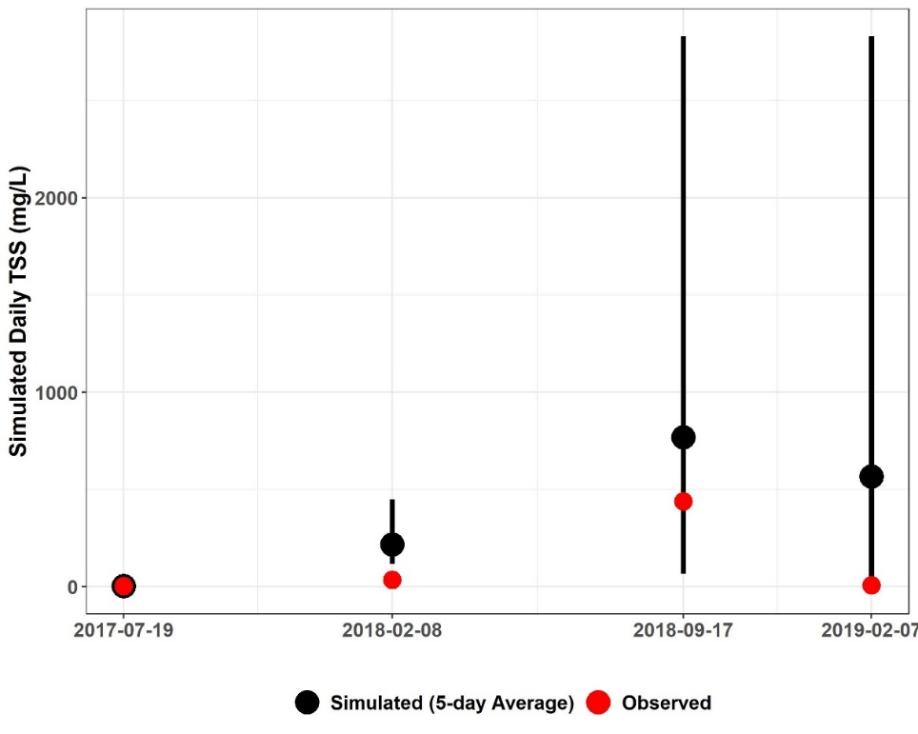
Figure E-32. Three-day window plot for sediment concentration showing the 5-day average, maximum minimum, and observed values at station 2-JMS229.14 (Upper James River—Fishing Creek watershed reach 1).

Figure E-33. Comparison of observed SSC, simulated SSC, and simulated flow for subwatershed reach 1 in the Upper James River—Fishing Creek watershed.

Three- and Five-day Window Model Performance Assessment (Quantitative)
Table E-13 includes the results of the quantitative 3- and 5-day window calibration sufficiency analysis which was calculated for all observed SSC data in the Upper James River – Fishing Creek watershed. 3- and 5-day windows were only calculated around the days on which observed data were available. The 76% of observed data within the 5-day window is greater than the published 70% criteria that has been used for sparse data bacteria model calibration applications (Kim et al., 2007), and the 70% of the observed data within the 3-day window is greater than the desired 50% discussed earlier. It is worth mentioning that for the river section within subwatershed 1 three out of four observed data points were within the 5-day window. And while the model under-predicted some of the SSC data as indicated by the slightly larger percentage ‘above’ values for the 3 and 5-day windows, overall the model performed well. Despite the sparsity of the observed data, the results of the calibration window analysis indicate that the model is sufficiently well-calibrated. The final calibrated sediment parameters for the Phase II calibration can be found in Table E-14.

Table E-13. Three- and five-day window calibration statistics for the Upper James River—Fishing Creek Phase II Calibration.
Statistics | Value
Number of Observed Data Points | 38
Percentage within 3-day window | 70%
Percentage above 3-day maximum | 13%
Percentage below 3-day minimum | 17%
Percentage within 5-day window | 76%
Percentage above 5-day maximum | 10%
Percentage below 5-day minimum | 14%

Calibration Summary: Upper James River – Fishing Creek
Using a “weight-of-evidence” approach presented here, the conclusion is that the James River—Fishing Creek watershed HSPF sediment model is sufficiently well calibrated to adequately simulate sediment loads. SSC-flow time series plots for all James River—Fishing Creek watershed SSC stations can be provided upon request by referring to the contact information on page ii.

Table E-14. Final calibrated parameters for the Upper James River—Fishing Creek watershed Phase II Calibration.
Parameter | Definition | FUNCTION OF… | Units | FINAL CALIBRATION | POSSIBLE RANGE OF VALUES^{ǂ} | CALCULATION METHOD^{ǂ}
RCHRESª
SANDFG (Sand Parameter Flags)
SNDFG | Indicates method used for Sandload Simulation | Type of stream; user experience | none | 3 | 1 - 3 | Constant, Power Function Method
SED-GENPARM (General Parameters)
BEDWID | Width of cross-section over which HSPF will assume bed sediment is deposited | Reach \ Waterbody morphology | ft | 13 | 5 - 1000 | Based on Technical Note Recommended Values
BEDWRN | Bed depth which, if exceeded (i.e., through deposition) will cause a warning message to be printed | Reach \ Waterbody morphology, User needs | ft | 20 | 0.5 - 20 | Based on Technical Note Recommended Values
POR | Porosity of the bed (volume voids/total volume) | Reach \ Sediment Bed Characteristics | none | 0.5 | 0.25 - 0.9 | Based on Technical Note Recommended Values
SAND-PM (Sand Parameters)
D | Effective diameter of the transported sand particles | Sediment properties | in | 0.005 | 0.0005 - 0.2 | Based on Tech. Note Recommended Values
W | Fall velocity of transported sand particles in still water | Particle diameter and density | in/sec | 0.1-1.9^{b} | 0.1 - 10 | “ ”
RHO | Density of sand particles | Sediment properties | g/cm³ | 2.5-3.0^{b} | 1.5 - 3.0 | “ ”
KSAND | Coefficient in sandload power function formula | Sand properties and hydraulics | complex | 0.001-0.05^{b} | 0.001 - 10 | Estimated from Recommended Values, Calibrated in HSPF
EXPSND | Exponent in sandload power function formula | Sand properties and hydraulics | complex | 1.5-2.0^{b} | 1.0 - 6.0 | Estimated from Recommended Values, Calibrated in HSPF
SILT-CLAY-PM (Silt Parameters)
D | Effective diameter of silt particles | Sediment properties | in | 0.0006 | 0.0001 - 0.004 | Based on Tech. Note Recommended Values
W | Fall velocity of transported silt particles in still water | Particle diameter and density | in/sec | 0.0005-0.0295^{b} | 0.0 - 0.1 | “ ”
RHO | Density of silt particles | Sediment properties | g/cm³ | 2.3 | 1.5 - 3.0 | “ ”
TAUCD | Critical bed shear stress for deposition | Silt properties and hydraulics | lb/ft² | 0.002 – 0.08^{b} | 0.001 - 1.0 | Estimated from Initial Run, Calibrated in HSPF
TAUCS | Critical bed shear stress for scour | Silt properties and hydraulics | lb/ft² | 0.2 – 1.00^{b} | 0.01 - 3.0 | Estimated from Initial Run, Calibrated in HSPF
M | Erodibility coefficient | Silt properties and hydraulics | lb/ft²-d | 0.001-4.5^{b} | 0.001 - 5.0 | Estimated from Recommended Values, Calibrated in HSPF
SILT-CLAY-PM (Clay Parameters)
D | Effective diameter of clay particles | Sediment properties | in | 0.001 | 0.000005 - 0.00025 | Based on Tech. Note Recommended Values
W | Fall velocity of transported clay particles in still water | Particle diameter and density | in/sec | 0.0005-0.0295^{b} | 0.0 - 0.1 | “ ”
RHO | Density of clay particles | Sediment properties | g/cm³ | 2.0 | 1.5 - 3.0 | “ ”
TAUCD | Critical bed shear stress for deposition | Clay properties and hydraulics | lb/ft² | 0.001- 0.80^{b} | 0.001 - 1.0 | Estimated from Initial Run, Calibrated in HSPF
TAUCS | Critical bed shear stress for scour | Clay properties and hydraulics | lb/ft² | 0.01 – 1.9^{b} | 0.01 - 3.0 | Estimated from Initial Run, Calibrated in HSPF
M | Erodibility coefficient | Clay properties and hydraulics | lb/ft²-d | 0.001-4.5^{b} | 0.001 - 5.0 | Estimated from Recommended Values, Calibrated in HSPF
SSED-INIT | Initial concentrations of suspended sediment | Reach | mg/L | 2 sand; 2 silt; 20 clay | n/a | Based on Tech. Note Recommended Values
BED-INIT | Initial content of bed sediment | Sediment Bed Characteristics | pct. | 15% sand; 65% silt; 20% clay | n/a
^{ǂ} Acquired from EPA BASINS Technical Note 8 (2006)
ª Main stem of stream in each subwatershed
^{b} Varies with subwatershed reach (data available upon request by referring to the contact information on page ii)

Lower James River
This section presents the HSPF sediment calibration results for the Lower James River TMDL Watershed that include major tributary watersheds: Tye and Rockfish Rivers; Hardware, Slate, and Willis Rivers; Rivanna River, portions of the James River, and Reedy Creek. The calibration results are summarized by Phase I and Phase II. Chapter 2 provides maps illustrating the location of the Lower James River subwatersheds that will be discussed as well as all the observed SSC water quality stations and USGS flow gages. Figure E-34 illustrates the location of TMDL watershed, major tributary boundaries, reaches, and select monitoring stations used for comparing simulated and observed values during model calibration.

Phase I Calibration: Lower James River –Tye and Rockfish River
Comparison analyses of model results for the outlet located downstream of the Lower James River –Tye and Rockfish River calibration portion are discussed in the following sections. Average annual SOSED and SOSLD (sediment and solids wash-off rate) values for Lower James River –Tye and Rockfish River were calibrated to within the load target ranges (Table E-1) for each Lower James River –Tye and Rockfish River subwatershed and land use. Due to the large size of the resulting SOSED and SOSLD calibration tables for the 34 subwatersheds, they are not included in this Appendix; including tables would have made the report unmanageably long. These tables can be made available upon request by referring to the contact information on page ii.
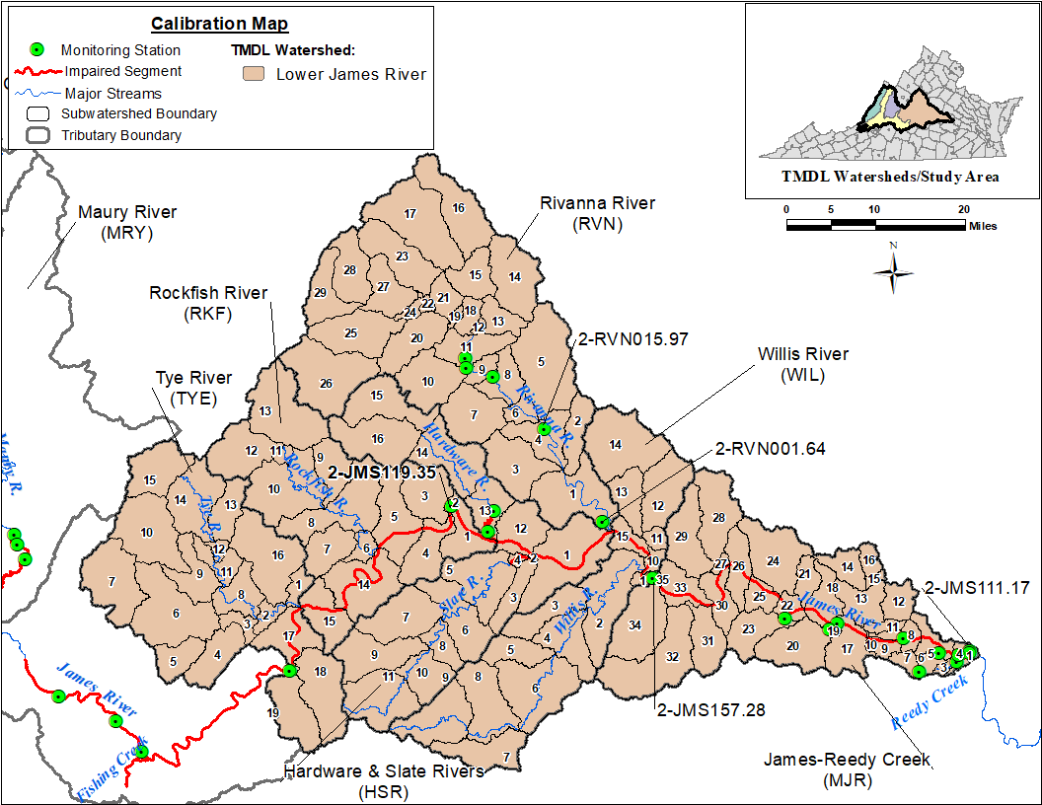
Figure E-34. Subwatersheds and monitoring stations used in calibration comparisons for the Lower James River TMDL watershed.

Pervious Land Use Calibration
Figure E-35, Figure E-36, and Figure E-37 show observed precipitation (upper axis) and simulated SOSED, DETS values for Forest, Cropland and pervious Residential land uses for the calibration period (2011-2019), respectively for subwatershed 1 in the Lower James River –Tye and Rockfish River watershed. Other pervious land uses, and subwatersheds produced similar SOSED and DETS plots. As expected, the DETS in each subwatershed for each pervious land use increased over time before decreasing during instances of sediment removal caused by major storm events. The magnitude of DETS was smallest for the Forest land use and largest in Cropland land use, which was expected since forested lands have a greater percentage of vegetative cover and cropland is periodically fallowed.
Figure E-35. Forest SOSED, DETS, and observed precipitation for subwatershed 1 in Lower James River—Tye and Rockfish River watershed

Figure E-36. Cropland SOSED, DETS, and observed precipitation for subwatershed 1 in Lower James River—Tye and Rockfish River watershed.

Figure E-37. Pervious Residential SOSED, DETS, and observed precipitation for subwatershed 1 in Lower James River—Tye and Rockfish River watershed.

Impervious Land Use Calibration
Figure E-38 shows the observed precipitation (upper axis) and SOSLD and SLDS values for the impervious fraction of the Residential land use for subwatershed 1 from January 1, 2011 to December 31, 2019. Impervious land cover was subject to greater sediment loss during smaller magnitude precipitation events than pervious land cover. Compared to pervious land uses, significant storage reductions were more frequent on impervious lands.

Figure E-38. Impervious Residential SOSLD, SLDS, and observed precipitation for subwatershed 1 in Lower James River—Tye and Rockfish River watershed.

SOSED, SOSLD, DETS, and SLDS Summary
The simulated SOSED, SOSLD, DETS, and SLDS values on the pervious and impervious land uses followed expected patterns and sediment removal characteristics. On pervious land uses, the DETS (sediment storage) increased steadily before decreasing sharply due to spikes in SOSED (sediment removal) which were a result of major storm events. This periodic rise and fall of sediment storage are characteristic of a well-calibrated model. On impervious land use, the SLDS (solids storage) fluctuations (increases and decreases) were more frequent when compared to the DETS for the pervious land uses. Impervious land uses were more sensitive to smaller storms and subject to more frequent wash off. Pervious and impervious Residential land use were included in the analysis to provide a comparison of the difference between pervious and impervious land cover. The calibrated Phase I model provided a reasonable approximation of the behavior of sediment detachment and removal in the James River—Tye and Rockfish River overland sediment transport calibration. Due to the large number of subwatersheds and land uses in Lower James River –Tye and Rockfish River, Phase I graphs for the other subwatersheds are not included in this report due to lengthiness, but they can be made available upon request by referring to the contact information on page ii. The final calibrated sediment parameters for the Phase I calibration are presented in Table E-15.

Table E-15. Final calibrated parameters for the Lower James River—Tye and Rockfish River Phase I Calibration.
Parameter | Definition | FUNCTION OF… | Units | FINAL CALIBRATION | POSSIBLE RANGE OF VALUES^{ǂ} | CALCULATION METHOD^{ǂ}
PERLNDª
SED-PARM2 (Sediment Parameter Group 2)
SMPF | Management Practice (P) factor from USLE | Land use, agricultural practices | none | 1 | 0.0 - 1.0 | Constant at 1.0, Assumed no Management Practices
KRER | Coefficient in the soil detachment equation | Soils | complex | 0.050 - 0.352^{b} | 0.05 - 0.75 | Based on Technical Note Recommended Values, Calibrated in HSPF
JRER | Exponent in the soil detachment equation | Soils, climate | none | 2.0 – 3.0 ^{b} | 1.0 - 3.0 | Based on Technical Note Recommended Values
AFFIX | Daily reduction in detached sediment | Soils, compaction, agricultural operations | per day | 0.01 - 0.50^{b} | 0.01 - 0.50 | Estimated from Recommended Values, Calibrated in HSPF
COVER | Fraction land surface protected from rainfall | Vegetal cover, land use | none | 0.20 - 0.97 | 0.0 - 0.98 | Estimated from Recommended Values, Calibrated in HSPF
NVSI | Atmospheric additions to sediment storage | Deposition, activities, etc. | lb/ac-day | 0.0 – 10.0^{b} | 0.0 - 20.0 | Based on Tech. Note Recommended Values
SED-PARM3 (Sediment Parameter Group 3)
KSER | Coefficient in the sediment washoff equation | Soils, surface conditions | complex | 0.10 – 9.50^{b} | 0.001 - 10.0 | Estimated from Recommended Values, Calibrated in HSPF
JSER | Exponent in the sediment washoff equation | Soils, surface conditions | none | 1.10 – 2.50 | 1.0 - 3.0 | “ ”
KGER | Coefficient in the soil matrix scour equation | Soils, evidence of gullies | complex | 0.0 | 0.0 - 10.0 | “ ”
JGER | Exponent in the soil matrix scour equation | Soils, evidence of gullies | none | 2.0 | 1.0 - 5.0 | “ ”
IMPLND^{c}
SLD-PARM2 (Solids Parameter Group 2)
KEIM | Coefficient in the solids washoff equation | Surface conditions, solids characteristics | complex | 0.28 | 0.1 - 10.0 | Based on Tech. Note Recommended Values  Calibrated in HSPF
JEIM | Exponent in the solids washoff equation | Surface conditions, solids characteristics | none | 2.5 | 1.0 - 3.0 | “ ”
ACCSDP | Solids accumulation rate on the land surface | Land use, traffic, human activities | lb/ac-day | 0.0086 | 0.0 - 30.0 | “ ”
REMSDP | Fraction of the solids removed per day | Street sweeping, wind, traffic | per day | 0.05 | 0.01 - 1.0 | “ ”
^{ǂ} Acquired from EPA BASINS Technical Note 8 (2006)
ª Pervious land segments
^{b} Varies with land use (data available upon request by referring to the contact information on page ii)
^{c} Impervious land segment

Phase II Calibration: Lower James River –Tye and Rockfish River
As mentioned in the introductory calibration methodology section, the first run of the Phase II calibration was used to generate initial estimates of critical shear stress values. TAU represents the critical bed shear stress. TAUCD is the parameter used to calculate critical shear stress for deposition, and TAUCS is the parameter used to calculate critical shear stress for scour. Once the initial run was complete, the calibration continued by substituting the placeholder TAUCD and TAUCS values with updated estimates. In subsequent calibration runs, all sediment calibration parameters including TAUCD and TAUCS were subject to adjustment. Phase II calibration efficiency metrics were analyzed after each run to determine if it’s necessary to continue the model calibration procedure further.

Graphical Model Performance Assessment (Qualitative)
The Phase II graphical calibration focused on model fit at the stations and subwatersheds where observed SSC data were available. Figure E-39 provides an initial visual analysis of model fit. In this graph, observed and simulated sediment concentrations were plotted against flow. Simulated data from January 1, 2013 to December 31, 2019 for reach 01, the reach corresponding to subwatershed 01 in the Lower James River –Tye and Rockfish River, were included in the graph as daily averages (open circles); the simulated daily average SSC (mg/L) on a given date was plotted against its corresponding simulated daily average flow rate (cfs). Observed data were plotted similarly using the observed SSC (mg/L) at VADEQ water quality monitoring station 2-JMS189.31 and the observed flow at the corresponding USGS flow gage on Lower James River –Tye and Rockfish River (Red triangles). The USGS flow gage closest to VADEQ station 2-JMS189.31 with a complete flow record is USGS 02029000 (James River at Scottsville, VA).
Figure E-39 shows that the model is capable of simulating the appropriate sediment concentration magnitude given a particular flow rate. The simulated data “cloud” encompasses the observed data points. This graph shows for a certain observed flow rate and SSC combination, the model is capable of generating sediment-flow condition. Additionally, as observed flow increases, observed SSC also increases except for one date. On that particular date the observed SSC was very low despite the high observed flow of the river at two of the reaches. A similar sediment concentration-flow correlation was illustrated with the simulated data.
Figure E-39. Sediment concentration-flow plot including daily average simulated SSC vs. daily average simulated flow, observed flow and observed SSC for subwatershed reach 2 in Lower James River—Tye and Rockfish River watershed.

Figure E-40 further illustrates the model performance showing simulated and observed sediment concentrations plotted on each day at which observed SSC data were collected at VADEQ station 2-JMS189.31. The average daily simulated and observed SSC for a 5-day window surrounding the date of the observed sampling was also included in the plot. In addition, the maximum and minimum simulated daily SSC concentrations during that 5-day window are shown. The figure shows three out of four observed SSC data points were captured within the 5-day sediment windows by the model for reach 2 of the Lower James River –Tye and Rockfish River watersheds.
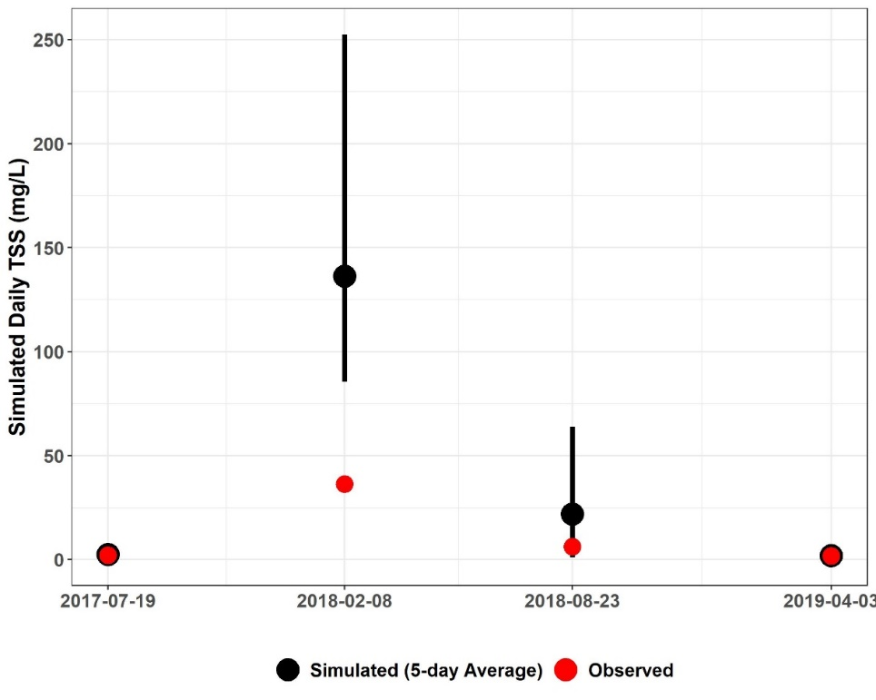
Figure E-40. Three-day window plot for sediment concentration showing the 5-day average, maximum minimum, and observed values at station 2-JMS189.31 (Lower James River—Tye and Rockfish River watershed reach 1).

Figure E-41 illustrates another comparison of daily average simulated SSC and observed SSC. Both were plotted on the same graph with the daily average simulated flow for the river section within the subwatershed 1 on a secondary axis. The flow and SSC time series have been scaled along the y-axis to emphasize the magnitude of simulated SSC fluctuations and to better illustrate observed and simulated SSC. This graph shows that increases in simulated flow resulted in increases in simulated sediment concentration. It also shows that simulated sediment concentration increased as observed SSC increased, and the model capture all observed SSC data points. This plot clearly shows high intensity rainfall condition is the main source of high sediment concentration in the watershed.
Figure E-41. Comparison of observed SSC, simulated SSC, and simulated flow for subwatershed reach 1 in the Lower James River—Tye and Rockfish watershed.

Three- and Five-day Window Model Performance Assessment (Quantitative)
Table E-16 includes the results of the quantitative 3- and 5-day window calibration sufficiency analysis which was calculated for all observed SSC data in the Lower James River –Tye and Rockfish River watershed. 3- and 5-day windows were only calculated around the days on which observed data were available. The 72% of observed data within the 5-day window is greater than the published 70% criteria that has been used for sparse data bacteria model calibration applications (Kim et al., 2007), and the 70% of the observed data within the 3-day window is greater than the desired 50% discussed earlier. It is worth mentioning that for the river section within subwatershed 2, three out of four observed data points were within the 5-day window. And while the model over-predicted some of the SSC data as indicated by the slightly larger percentage ‘above’ values for the 3 and 5-day windows, overall the model performed well. Despite the sparsity of the observed data, the results of the calibration window analysis indicate that the model is sufficiently well-calibrated. The final calibrated sediment parameters for the Phase II calibration can be found in Table E-17.

Table E-16. Three- and five-day window calibration statistics for the Lower James River—Tye and Rockfish River Phase II Calibration.
Statistics | Value
Number of Observed Data Points | 7
Percentage within 3-day window | 72%
Percentage above 3-day maximum | 14%
Percentage below 3-day minimum | 14%
Percentage within 5-day window | 72%
Percentage above 5-day maximum | 14%
Percentage below 5-day minimum | 14%

Calibration Summary: Lower James River –Tye and Rockfish River
Using a “weight-of-evidence” approach presented here, the conclusion is that the Lower James River –Tye and Rockfish River watershed HSPF sediment model is sufficiently well calibrated to adequately simulate sediment loads. SSC-flow time series plots for all Lower James River –Tye and Rockfish River watershed SSC stations can be provided upon request by referring to the contact information on page ii.

Table E-17. Final calibrated parameters for the Lower James River—Tye and Rockfish River watershed Phase II Calibration.
Parameter | Definition | FUNCTION OF… | Units | FINAL CALIBRATION | POSSIBLE RANGE OF VALUES^{ǂ} | CALCULATION METHOD^{ǂ}
RCHRESª
SANDFG (Sand Parameter Flags)
SNDFG | Indicates method used for Sandload Simulation | Type of stream; user experience | none | 3 | 1 - 3 | Constant, Power Function Method
SED-GENPARM (General Parameters)
BEDWID | Width of cross-section over which HSPF will assume bed sediment is deposited | Reach \ Waterbody morphology | ft | 13 | 5 - 1000 | Based on Technical Note Recommended Values
BEDWRN | Bed depth which, if exceeded (i.e., through deposition) will cause a warning message to be printed | Reach \ Waterbody morphology, User needs | ft | 20 | 0.5 - 20 | Based on Technical Note Recommended Values
POR | Porosity of the bed (volume voids/total volume) | Reach \ Sediment Bed Characteristics | none | 0.5 | 0.25 - 0.9 | Based on Technical Note Recommended Values
SAND-PM (Sand Parameters)
D | Effective diameter of the transported sand particles | Sediment properties | in | 0.005 | 0.0005 - 0.2 | Based on Tech. Note Recommended Values
W | Fall velocity of transported sand particles in still water | Particle diameter and density | in/sec | 0.1-1.9^{b} | 0.1 - 10 | “ ”
RHO | Density of sand particles | Sediment properties | g/cm³ | 2.5-3.0^{b} | 1.5 - 3.0 | “ ”
KSAND | Coefficient in sandload power function formula | Sand properties and hydraulics | complex | 0.001-0.05^{b} | 0.001 - 10 | Estimated from Recommended Values, Calibrated in HSPF
EXPSND | Exponent in sandload power function formula | Sand properties and hydraulics | complex | 1.5-2.0^{b} | 1.0 - 6.0 | Estimated from Recommended Values, Calibrated in HSPF
SILT-CLAY-PM (Silt Parameters)
D | Effective diameter of silt particles | Sediment properties | in | 0.0006 | 0.0001 - 0.004 | Based on Tech. Note Recommended Values
W | Fall velocity of transported silt particles in still water | Particle diameter and density | in/sec | 0.0005-0.0295^{b} | 0.0 - 0.1 | “ ”
RHO | Density of silt particles | Sediment properties | g/cm³ | 2.3 | 1.5 - 3.0 | “ ”
TAUCD | Critical bed shear stress for deposition | Silt properties and hydraulics | lb/ft² | 0.002 – 0.08^{b} | 0.001 - 1.0 | Estimated from Initial Run, Calibrated in HSPF
TAUCS | Critical bed shear stress for scour | Silt properties and hydraulics | lb/ft² | 0.2 – 1.00^{b} | 0.01 - 3.0 | Estimated from Initial Run, Calibrated in HSPF
M | Erodibility coefficient | Silt properties and hydraulics | lb/ft²-d | 0.001-4.5^{b} | 0.001 - 5.0 | Estimated from Recommended Values, Calibrated in HSPF
SILT-CLAY-PM (Clay Parameters)
D | Effective diameter of clay particles | Sediment properties | in | 0.001 | 0.000005 - 0.00025 | Based on Tech. Note Recommended Values
W | Fall velocity of transported clay particles in still water | Particle diameter and density | in/sec | 0.0005-0.0295^{b} | 0.0 - 0.1 | “ ”
RHO | Density of clay particles | Sediment properties | g/cm³ | 2.0 | 1.5 - 3.0 | “ ”
TAUCD | Critical bed shear stress for deposition | Clay properties and hydraulics | lb/ft² | 0.001- 0.80^{b} | 0.001 - 1.0 | Estimated from Initial Run, Calibrated in HSPF
TAUCS | Critical bed shear stress for scour | Clay properties and hydraulics | lb/ft² | 0.01 – 1.9^{b} | 0.01 - 3.0 | Estimated from Initial Run, Calibrated in HSPF
M | Erodibility coefficient | Clay properties and hydraulics | lb/ft²-d | 0.001-4.5^{b} | 0.001 - 5.0 | Estimated from Recommended Values, Calibrated in HSPF
SSED-INIT | Initial concentrations of suspended sediment | Reach | mg/L | 2 sand; 2 silt; 20 clay | n/a | Based on Tech. Note Recommended Values
BED-INIT | Initial content of bed sediment | Sediment Bed Characteristics | pct. | 15% sand; 65% silt; 20% clay | n/a
^{ǂ} Acquired from EPA BASINS Technical Note 8 (2006)
ª Main stem of stream in each subwatershed
^{b} Varies with subwatershed reach (data available upon request by referring to the contact information on page ii)

Phase I Calibration: Lower James – Rivanna River
Comparison analyses of model results for the outlet of the Lower James – Rivanna River model watershed are discussed in the following sections. Average annual SOSED and SOSLD (sediment and solids wash-off rate) values for Lower James – Rivanna River were calibrated to within the load target ranges (Table E-1) for each subwatershed and land use. Due to the large size of the resulting SOSED and SOSLD calibration tables, they are not included in this Appendix; including tables would have increased report length significantly. These tables can be made available upon request by referring to the contact information on page ii.

Pervious Land Use Calibration
Figure E-42, Figure E-43, and Figure E-44 show observed precipitation (upper axis) and simulated SOSED, DETS values for Forest, Cropland and pervious Residential land uses for the calibration period (2011-2019), respectively for subwatershed 1 in the Lower James – Rivanna River watershed. Other pervious land uses and subwatersheds produced similar SOSED and DETS plots. As expected, the DETS in each subwatershed for each pervious land use increased over time before decreasing during instances of sediment removal caused by storm events. The magnitude of DETS was smallest for the Forest land use and largest in Cropland land use, which was expected since forested lands have a greater percentage of vegetative cover and cropland is periodically fallowed.

Figure E-42. Forest SOSED, DETS, and observed precipitation for subwatershed 1 in Lower James – Rivanna River watershed.
Figure E-43. Cropland SOSED, DETS, and observed precipitation for subwatershed 1 in Lower James – Rivanna River watershed.

Figure E-44. Pervious Residential SOSED, DETS, and observed precipitation for subwatershed 1 in Lower James – Rivanna River watershed.

Impervious Land Use Calibration
Figure E-45 shows the observed precipitation (upper axis) and SOSLD and SLDS values for the impervious fraction of the Residential land use for subwatershed 1 from January 1, 2011 to December 31, 2019. Impervious land cover was subject to greater sediment loss during smaller magnitude precipitation events than pervious land cover. Compared to pervious land uses, significant storage reductions were more frequent on impervious lands.

Figure E-45. Impervious Residential SOSLD, SLDS, and observed precipitation for subwatershed 1 in Lower James – Rivanna River watershed.

SOSED, SOSLD, DETS, and SLDS Summary
The simulated SOSED, SOSLD, DETS, and SLDS values on the pervious and impervious land uses followed expected patterns and sediment removal characteristics. On pervious land uses, the DETS (sediment storage) increased steadily before decreasing sharply due to spikes in SOSED (sediment removal) which were a result of major storm events. This periodic rise and fall of sediment storage are characteristic of a well-calibrated model. On impervious land use, the SLDS (solids storage) fluctuations (increases and decreases) were more frequent when compared to the DETS for the pervious land uses. Impervious land uses were more sensitive to smaller storms and subject to more frequent wash off. Pervious and impervious Residential land use were included in the analysis to provide a comparison of the difference between pervious and impervious land cover. The calibrated Phase I model provided a reasonable approximation of the behavior of sediment detachment and removal in the Lower James – Rivanna River calibration. Due to the large number of subwatersheds and land uses in Lower James – Rivanna River, Phase I graphs for the other subwatersheds are not included in this report due to lengthiness, but they can be made available upon request by referring to the contact information on page ii. The final calibrated sediment parameters for the Phase I calibration are presented in Table E-18.

Table E-18. Final calibrated parameters for the Lower James – Rivanna River Phase I Calibration.
Parameter | Definition | FUNCTION OF… | Units | FINAL CALIBRATION | POSSIBLE RANGE OF VALUES^{ǂ} | CALCULATION METHOD^{ǂ}
PERLNDª
SED-PARM2 (Sediment Parameter Group 2)
SMPF | Management Practice (P) factor from USLE | Land use, agricultural practices | none | 0.0-1.0 | 0.0 - 1.0 | Constant at 1.0, Assumed no Management Practices
KRER | Coefficient in the soil detachment equation | Soils | complex | 0.050 - 0.752^{b} | 0.05 - 0.75 | Estimated in GIS, Calibrated in HSPF
JRER | Exponent in the soil detachment equation | Soils, climate | none | 2.0 for water and forest and 2.5 for others | 1.0 - 3.0 | Based on Technical Note Recommended Values
AFFIX | Daily reduction in detached sediment | Soils, compaction, agricultural operations | per day | 0.001 - 0.065^{b} | 0.01 - 0.50 | Estimated from Recommended Values, Calibrated in HSPF
COVER | Fraction land surface protected from rainfall | Vegetal cover, land use | none | 0.0-0.225 | 0.0 - 0.98 | Estimated from Recommended Values, Calibrated in HSPF
NVSI | Atmospheric additions to sediment storage | Deposition, activities, etc. | lb/ac-day | 0.0 – 6.0^{b} | 0.0 - 20.0 | Based on Tech. Note Recommended Values
SED-PARM3 (Sediment Parameter Group 3)
KSER | Coefficient in the sediment washoff equation | Soils, surface conditions | complex | 0.010 - 5.90^{b} | 0.001 - 10.0 | Estimated from Recommended Values, Calibrated in HSPF
JSER | Exponent in the sediment washoff equation | Soils, surface conditions | none | 1.0 – 1.6 | 1.0 - 3.0 | “ ”
KGER | Coefficient in the soil matrix scour equation | Soils, evidence of gullies | complex | 0.0 – 0.5 | 0.0 - 10.0 | “ ”
JGER | Exponent in the soil matrix scour equation | Soils, evidence of gullies | none | 1.0 - 2.0 | 1.0 - 5.0 | “ ”
IMPLND^{c}
SLD-PARM2 (Solids Parameter Group 2)
KEIM | Coefficient in the solids washoff equation | Surface conditions, solids characteristics | complex | 1.0 | 0.1 - 10.0 | Based on Tech. Note Recommended Values
JEIM | Exponent in the solids washoff equation | Surface conditions, solids characteristics | none | 1.8 | 1.0 - 3.0 | “ ”
ACCSDP | Solids accumulation rate on the land surface | Land use, traffic, human activities | lb/ac-day | 0.0028 | 0.0 - 30.0 | “ ”
REMSDP | Fraction of the solids removed per day | Street sweeping, wind, traffic | per day | 0.05 | 0.01 - 1.0 | “ ”
^{ǂ} Acquired from EPA BASINS Technical Note 8 (2006)
ª Pervious land segment
^{b} Varies with land use (data available upon request by referring to the contact information on page ii)
^{c} Impervious land segment

Phase II Calibration: Lower James – Rivanna River
As mentioned in the introductory calibration methodology section, the first run of the Phase II calibration was used to generate initial estimates of critical shear stress values. TAU represents the critical bed shear stress. TAUCD is the parameter used to calculate critical shear stress for deposition, and TAUCS is the parameter used to calculate critical shear stress for scour. Once the initial run was complete, the calibration continued by substituting the placeholder TAUCD and TAUCS values with updated estimates. In subsequent calibration runs, all sediment calibration parameters including TAUCD and TAUCS were subject to adjustment. Phase II calibration sufficiency metrics were analyzed after each run to determine if model calibration would continue. Although not explicitly part of the calibration evaluation process, another check that was performed after each calibration run examined the change in sediment bed depth. Bed depth was output as an annual average for each subwatershed reach. Large swings in bed depth trends were indications that the model could be encountering calculation errors and misrepresenting the subwatershed.

Graphical Model Performance Assessment (Qualitative)
The Phase II graphical calibration focused on model fit at the stations and subwatersheds where observed SSC data were available. Figure E-46 and Figure E-47 provide an initial visual analysis of model fit during calibration and validation periods respectively. In these graphs, observed and simulated sediment concentrations were plotted against flow. Simulated data from January 1, 2015 to December 31, 2019 and January 1, 2011 to December 31, 2014 during calibration and validation periods respectively for reach 4, the channel corresponding to subwatershed 4 in the Lower James – Rivanna River, were included in the graph as daily averages (open circles); the simulated daily average SSC (mg/L) on a given date was plotted against its corresponding simulated daily average flow rate (cfs). For both periods, observed data were plotted similarly using the observed SSC (mg/L) at VADEQ water quality monitoring station RVN015.97 and the observed flow at the corresponding USGS flow gage on Lower James – Rivanna River (red triangles). The USGS flow gage closest to VADEQ station RVN015.97 with a complete flow record is USGS02034000 Rivanna River at Palmyra, VA.
Figure E-46 and Figure E-47 show that the model is capable of simulating the appropriate sediment concentration magnitude given a particular flow rate during both calibration and validation periods. The simulated data “cloud” encompasses the observed data points during both periods, although the model missed some high TSS during both periods. These graphs show for a certain observed flow rate and SSC combination, the model is capable of generating sediment-flow condition during both periods. Additionally, as observed flow increases, observed SSC also increases. A similar sediment concentration-flow correlation was illustrated with the simulated data.

Figure E-46. Sediment concentration-flow plot including daily average simulated SSC vs. daily average simulated flow, observed flow and observed SSC for subwatershed reach 4 in Lower James – Rivanna River watershed during calibration period (2015 to 2019).

Figure E-47. Sediment concentration-flow plot including daily average simulated SSC vs. daily average simulated flow, observed flow and observed SSC for subwatershed reach 4 in Lower James – Rivanna River watershed during validation period (2011 to 2014).

Figure E-48 further illustrates the model performance during the calibration period for reach 1, with simulated and observed sediment concentrations plotted on each day that observed SSC data were collected at DEQ station RVN001.64 at the outlet of the watershed. The performance of the 3-day window surrounding the date of the observed SSC were different for each reach in the Lower James – Rivanna River based on the number of SSC observed data points in each reach. The average daily simulated, and observed SSC for a 3-day window surrounding the date of the observed sampling was also included in the plot. In addition, the maximum and minimum simulated daily SSC concentrations during that 3-day window are shown. Figure E-48 shows among three data points two of the observed SSC data points were captured within the 3-day sediment windows by the model for reach 1 of the Lower James – Rivanna River watersheds during the calibration period.

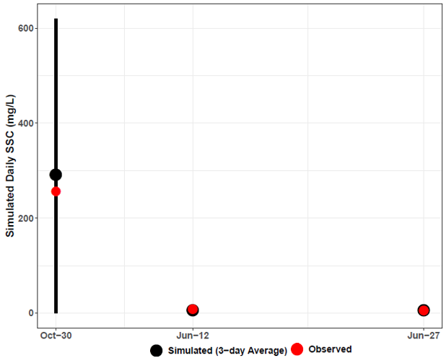
Figure E-48. Three-day window plot for sediment concentration showing the 3-day average, maximum minimum, and observed values at station RVN001.64 (Lower James – Rivanna River watershed reach 1) during the calibration period (2015 – 2019).

Figure E-49 and Figure E-50 illustrate another comparison of daily average simulated SSC and observed SSC during both calibration and validation periods. Both were plotted on the same graph with the daily average simulated flow for subwatershed reach 4 on a secondary axis during both periods. The flow and SSC time series have been scaled along the y-axis to emphasize the magnitude of simulated SSC fluctuations and to better illustrate observed and simulated SSC. This time series plot is representative of the results from other Lower James – Rivanna River subwatershed reaches and water quality stations. These graphs show that increases in simulated flow resulted in increases in simulated sediment concentration during both periods. It also shows that simulated sediment concentration increased as observed SSC increased, and the model capture all observed SSC data points except missed some TSS peaks during both periods. These plots clearly show high intensity rainfall condition is the main source of high sediment concentration in the watershed.
Figure E-49. Comparison of observed SSC, simulated SSC, and simulated flow for subwatershed reach 4 in the Lower James – Rivanna River watershed during the calibration period (2015 – 2019).

Figure E-50. Comparison of observed SSC, simulated SSC, and simulated flow for subwatershed reach 4 in the Lower James – Rivanna River watershed during the validation period (2011 – 2014).

Three- and Five-day Window Model Performance Assessment (Quantitative)
Table E-19 and Table E-20 include the results of the quantitative 3- and 5-day window calibration sufficiency analysis which was calculated for all observed SSC data in the Lower James – Rivanna River watershed. Since Lower James – Rivanna River has large number of data points of TSS,115 data points were used during calibration and 65 data points all from reach 4 were used during validation period. Three- and 5-day windows were only calculated around the days on which observed data is available for both periods. The 70.4 and 73.8% of observed data within the 5-day window during calibration and validation periods respectively is greater than the published 70% criteria that has been used for sparse data bacteria model calibration applications (Kim et al., 2007), and the 50.8% of the observed data within the 3-day window during validation periods is greater than the desired 50% discussed earlier, but 49% of the observed data within the 3-day window during calibration period is a little less than the desired 50%, but still acceptable since more TSS data points were used during calibration period than validation period where slightly harder to achieve the 3- day window criteria normally used to spare data points. And while the model did exhibit under-prediction bias as indicated by the larger percentage ‘below’ values for both the 3- and 5-day windows, overall the model performed well. Despite the 3-day window result during the calibration period, other results of the calibration window analysis indicate that the model is sufficiently well-calibrated. The final calibrated sediment parameters for the Phase II calibration can be found in Table E-21.

Table E-19. Three- and five-day window calibration statistics for the Lower James – Rivanna River Phase II Calibration.
Statistics | Value
Number of Observed Data Points | 115
Percentage within 3-day window | 49%
Percentage above 3-day maximum | 42%
Percentage below 3-day minimum | 9%
Percentage within 5-day window | 70%
Percentage above 5-day maximum | 29%
Percentage below 5-day minimum | 1%

Table E-20. Three- and five-day window validation statistics for the Lower James – Rivanna River Phase II Calibration.
Statistics | Value
Number of Observed Data Points | 65
Percentage within 3-day window | 51%
Percentage above 3-day maximum | 34%
Percentage below 3-day minimum | 15%
Percentage within 5-day window | 74%
Percentage above 5-day maximum | 23%
Percentage below 5-day minimum | 3%

Calibration Summary: Lower James – Rivanna River
Using a “weight-of-evidence” approach presented here, the conclusion is that the Rivanna River watershed HSPF sediment model is sufficiently well calibrated to adequately simulate sediment loads. SSC-flow time series plots for all Lower James – Rivanna River watershed SSC stations can be provided upon request by referring to the contact information on page ii.

Table E-21. Final calibrated parameters for the Lower James – Rivanna River watershed Phase II Calibration.
Parameter | Definition | FUNCTION OF… | Units | FINAL CALIBRATION | POSSIBLE RANGE OF VALUES^{ǂ} | CALCULATION METHOD^{ǂ}
RCHRESª
SANDFG (Sand Parameter Flags)
SNDFG | Indicates method used for Sandload Simulation | Type of stream; user experience | none | 3 | 1 - 3 | Constant, Power Function Method
SED-GENPARM (General Parameters)
BEDWID | Width of cross-section over which HSPF will assume bed sediment is deposited | Reach \ Waterbody morphology | ft | 10-13 | 5 - 1000 | Estimated from ArcGIS 3D Analyst
BEDWRN | Bed depth which, if exceeded (i.e., through deposition) will cause a warning message to be printed | Reach \ Waterbody morphology, User needs | ft | 5.5-20 | 0.5 - 20 | Estimated from ArcGIS 3D Analyst
POR | Porosity of the bed (volume voids/total volume) | Reach \ Sediment Bed Characteristics | none | 0.5 | 0.25 - 0.9 | Based on Technical Note Recommended Values
SAND-PM (Sand Parameters)
D | Effective diameter of the transported sand particles | Sediment properties | in | 0.005 | 0.0005 - 0.2 | Based on Tech. Note Recommended Values
W | Fall velocity of transported sand particles in still water | Particle diameter and density | in/sec | 0.4 | 0.1 - 10 | “ ”
RHO | Density of sand particles | Sediment properties | g/cm³ | 2.6 | 1.5 - 3.0 | “ ”
KSAND | Coefficient in sandload power function formula | Sand properties and hydraulics | complex | 0.005 – 0.02 | 0.001 - 10 | Estimated from Recommended Values, Calibrated in HSPF
EXPSND | Exponent in sandload power function formula | Sand properties and hydraulics | complex | 1.0 - 2.0^{b} | 1.0 - 6.0 | Estimated from Recommended Values, Calibrated in HSPF
SILT-CLAY-PM (Silt Parameters)
D | Effective diameter of silt particles | Sediment properties | in | 0.0006 | 0.0001 - 0.004 | Based on Tech. Note Recommended Values
W | Fall velocity of transported silt particles in still water | Particle diameter and density | in/sec | 0.0001 – 0.001 | 0.0 - 0.1 | “ ”
RHO | Density of silt particles | Sediment properties | g/cm³ | 2.3 | 1.5 - 3.0 | “ ”
TAUCD | Critical bed shear stress for deposition | Silt properties and hydraulics | lb/ft² | 0.003 – 0.885^{b} | 0.001 - 1.0 | Estimated from Initial Run, Calibrated in HSPF
TAUCS | Critical bed shear stress for scour | Silt properties and hydraulics | lb/ft² | 0.009– 2.287^{b} | 0.01 - 3.0 | Estimated from Initial Run, Calibrated in HSPF
M | Erodibility coefficient | Silt properties and hydraulics | lb/ft²-d | 0.001-1.5^{b} | 0.001 - 5.0 | Estimated from Recommended Values, Calibrated in HSPF
SILT-CLAY-PM (Clay Parameters)
D | Effective diameter of clay particles | Sediment properties | in | 0.0001-0.005 | 0.000005 - 0.00025 | Based on Tech. Note Recommended Values
W | Fall velocity of transported clay particles in still water | Particle diameter and density | in/sec | 0.00001-0.001 | 0.0 - 0.1 | “ ”
RHO | Density of clay particles | Sediment properties | g/cm³ | 2.0 | 1.5 - 3.0 | “ ”
TAUCD | Critical bed shear stress for deposition | Clay properties and hydraulics | lb/ft² | 0.003- 0.796^{b} | 0.001 - 1.0 | Estimated from Initial Run, Calibrated in HSPF
TAUCS | Critical bed shear stress for scour | Clay properties and hydraulics | lb/ft² | 0.009 – 2.160^{b} | 0.01 - 3.0 | Estimated from Initial Run, Calibrated in HSPF
M | Erodibility coefficient | Clay properties and hydraulics | lb/ft²-d | 0.001-1.5^{b} | 0.001 - 5.0 | Estimated from Recommended Values, Calibrated in HSPF
SSED-INIT | Initial concentrations of suspended sediment | Reach | mg/L | 2-50 sand; 2-50 silt; 2-50clay | n/a | Estimated
BED-INIT | Initial content of bed sediment | Sediment Bed Characteristics | pct. | 25% sand; 45% silt; 30% clay | n/a | Estimated
^{ǂ} Acquired from EPA BASINS Technical Note 8 (2006)
ª Main stem of stream in each subwatershed
^{b} Varies with subwatershed reach (data available upon request by referring to the contact information on page ii)

Phase I Calibration: Lower James River – Hardware, Slate, and Willis River
Comparison analyses of model results for the outlet located downstream of the collective Lower James River – Hardware, Slate, and Willis River calibration portion are discussed in the following sections. Average annual SOSED and SOSLD (sediment and solids wash-off rate) values were calibrated to within the load target ranges (Table E-1) for each subwatershed and land use. Due to the large size of the resulting SOSED and SOSLD calibration tables for the 30 subwatersheds, they are not included in this Appendix; including tables would have made the report unmanageably long. These tables can be made available upon request by referring to the contact information on page ii.

Pervious Land Use Calibration
Figure E-51, Figure E-52, and Figure E-53 show observed precipitation (upper axis) and simulated SOSED, DETS values for Forest, Cropland and pervious Residential land uses for the calibration period (2011-2019), respectively for subwatershed 1 in the Lower James River – Hardware, Slate, and Willis River watershed. Other pervious land uses, and subwatersheds produced similar SOSED and DETS plots. As expected, the DETS in each subwatershed for each pervious land use increased over time before decreasing during instances of sediment removal caused by major storm events. The magnitude of DETS was smallest for the Forest land use and largest in Cropland land use, which was expected since forested lands have a greater percentage of vegetative cover and cropland is periodically fallowed.

Figure E-51. Forest SOSED, DETS, and observed precipitation for subwatershed 1 downstream Lower James River – Hardware, Slate and Willis Rivers.

Figure E-52. Cropland SOSED, DETS, and observed precipitation for subwatershed 1 in Lower James River – Hardware, Slate, and Willis River watershed.
Figure E-53. Pervious Residential SOSED, DETS, and observed precipitation for subwatershed 1 in Lower James River – Hardware, Slate, and Willis Rivers watershed.

Impervious Land Use Calibration
Figure E-54 shows the observed precipitation (upper axis) and SOSLD and SLDS values for the impervious fraction of the Residential land use for subwatershed 1 from January 1, 2011 to December 31, 2019. Impervious land cover was subject to greater sediment loss during smaller magnitude precipitation events than pervious land cover. Compared to pervious land uses, significant storage reductions were more frequent on impervious lands.

Figure E-54. Impervious Residential SOSLD, SLDS, and observed precipitation for subwatershed 1 in Lower James River – Hardware, Slate, and Willis Rivers watershed

SOSED, SOSLD, DETS, and SLDS Summary
The simulated SOSED, SOSLD, DETS, and SLDS values on the pervious and impervious land uses followed expected patterns and sediment removal characteristics. On pervious land uses, the DETS (sediment storage) increased steadily before decreasing sharply due to spikes in SOSED (sediment removal) which were a result of major storm events. This periodic rise and fall of sediment storage are characteristic of a well-calibrated model. On impervious land use, the SLDS (solids storage) fluctuations (increases and decreases) were more frequent when compared to the DETS for the pervious land uses. Impervious land uses were more sensitive to smaller storms and subject to more frequent wash off. Pervious and impervious Residential land use were included in the analysis to provide a comparison of the difference between pervious and impervious land cover. The calibrated Phase I model provided a reasonable approximation of the behavior of sediment detachment and removal in the Lower James River – Hardware, Slate, and Willis Rivers overland sediment transport calibration. Due to the large number of subwatersheds and land uses in Lower James River – Hardware, Slate, and Willis Rivers, Phase I graphs for the other subwatersheds are not included in this report due to lengthiness, but they can be made available upon request by referring to the contact information on page ii. The final calibrated sediment parameters for the Phase I calibration are presented in Table E-22.

Table E-22. Final calibrated parameters for the Lower James River – Hardware, Slate, and Willis Rivers Phase I Calibration.
Parameter | Definition | FUNCTION OF… | Units | FINAL CALIBRATION | POSSIBLE RANGE OF VALUES^{ǂ} | CALCULATION METHOD^{ǂ}
PERLNDª
SED-PARM2 (Sediment Parameter Group 2)
SMPF | Management Practice (P) factor from USLE | Land use, agricultural practices | none | 1 | 0.0 - 1.0 | Constant at 1.0, Assumed no Management Practices
KRER | Coefficient in the soil detachment equation | Soils | complex | 0.050 - 0.352^{b} | 0.05 - 0.75 | Based on Technical Note Recommended Values,  Calibrated in HSPF
JRER | Exponent in the soil detachment equation | Soils, climate | none | 2.0 – 3.0^{b} | 1.0 - 3.0 | Based on Technical Note Recommended Values
AFFIX | Daily reduction in detached sediment | Soils, compaction, agricultural operations | per day | 0.01 - 0.50^{b} | 0.01 - 0.50 | Estimated from Recommended Values, Calibrated in HSPF
COVER | Fraction land surface protected from rainfall | Vegetal cover, land use | none | 0.24 - 0.97 | 0.0 - 0.98 | Estimated from Recommended Values, Calibrated in HSPF
NVSI | Atmospheric additions to sediment storage | Deposition, activities, etc. | lb/ac-day | 0.0 – 10.0^{b} | 0.0 - 20.0 | Based on Tech. Note Recommended Values
SED-PARM3 (Sediment Parameter Group 3)
KSER | Coefficient in the sediment washoff equation | Soils, surface conditions | complex | 0. 1 – 9.5^{b} | 0.001 - 10.0 | Estimated from Recommended Values, Calibrated in HSPF
JSER | Exponent in the sediment washoff equation | Soils, surface conditions | none | 1.00 – 2.50 | 1.0 - 3.0 | “ ”
KGER | Coefficient in the soil matrix scour equation | Soils, evidence of gullies | complex | 0.0 | 0.0 - 10.0 | “ ”
JGER | Exponent in the soil matrix scour equation | Soils, evidence of gullies | none | 2.0 | 1.0 - 5.0 | “ ”
IMPLND^{c}
SLD-PARM2 (Solids Parameter Group 2)
KEIM | Coefficient in the solids washoff equation | Surface conditions, solids characteristics | complex | 0.28 | 0.1 - 10.0 | Based on Tech. Note Recommended Values  Calibrated in HSPF
JEIM | Exponent in the solids washoff equation | Surface conditions, solids characteristics | none | 2.5 | 1.0 - 3.0 | “ ”
ACCSDP | Solids accumulation rate on the land surface | Land use, traffic, human activities | lb/ac-day | 0.0086 | 0.0 - 30.0 | “ ”
REMSDP | Fraction of the solids removed per day | Street sweeping, wind, traffic | per day | 0.05 | 0.01 - 1.0 | “ ”
^{ǂ} Acquired from EPA BASINS Technical Note 8 (2006)
ª Pervious land segments
^{b} Varies with land use (data available upon request by referring to the contact information on page ii)
^{c} Impervious land segment

Phase II Calibration: Lower James River – Hardware, Slate, and Willis Rivers
As mentioned in the introductory calibration methodology section, the first run of the Phase II calibration was used to generate initial estimates of critical shear stress values. TAU represents the critical bed shear stress. TAUCD is the parameter used to calculate critical shear stress for deposition, and TAUCS is the parameter used to calculate critical shear stress for scour. Once the initial run was complete, the calibration continued by substituting the placeholder TAUCD and TAUCS values with updated estimates. In subsequent calibration runs, all sediment calibration parameters including TAUCD and TAUCS were subject to adjustment. Phase II calibration efficiency metrics were analyzed after each run to determine if it’s necessary to continue the model calibration procedure further.

Graphical Model Performance Assessment (Qualitative)
The Phase II graphical calibration focused on model fit at the stations and subwatersheds where observed SSC data were available. Figure E-55 provides an initial visual analysis of model fit. In this graph, observed and simulated sediment concentrations were plotted against flow. Simulated data from January 1, 2013 to December 31, 2019 for reach 01, the reach corresponding to subwatershed 01 in the James River---Hardware, Slate and Willis River, were included in the graph as daily averages (open circles); the simulated daily average SSC (mg/L) on a given date was plotted against its corresponding simulated daily average flow rate (cfs). Observed data were plotted similarly using the observed SSC (mg/L) at VADEQ water quality monitoring station 2-JMS157.28 and the observed flow at the corresponding USGS flow gage on James River---Hardware, Slate and Willis (Red triangles). The USGS flow gage closest to VADEQ station 2-JMS157.28 with a complete flow record is USGS 02035000 (James River at Cartersville, VA).
Figure E-55 shows that the model is capable of simulating the appropriate sediment concentration magnitude given a particular flow rate. The simulated data “cloud” encompasses the observed data points. This graph shows for a certain observed flow rate and SSC combination, the model is capable of generating sediment-flow condition. Additionally, as observed flow increases, observed SSC also increases except for one date. On that particular date the observed SSC was very low despite the high observed flow of the river at two of the reaches. A similar sediment concentration-flow correlation was illustrated with the simulated data.
Figure E-55. Sediment concentration-flow plot including daily average simulated SSC vs. daily average simulated flow, observed flow and observed SSC for subwatershed reach 1 in Lower James River – Hardware, Slate, and Willis Rivers watershed.

Figure E-56 further illustrates the model performance showing simulated and observed sediment concentrations plotted on each day at which observed SSC data were collected at VADEQ station 2-JMS157.28. The average daily simulated and observed SSC for a 5-day window surrounding the date of the observed sampling was also included in the plot. In addition, the maximum and minimum simulated daily SSC concentrations during that 5-day window are shown. The figure shows three out of four observed SSC data points were captured within the 5-day sediment windows by the model for reach 1 of the Lower James River – Hardware, Slate, and Willis Rivers watersheds.
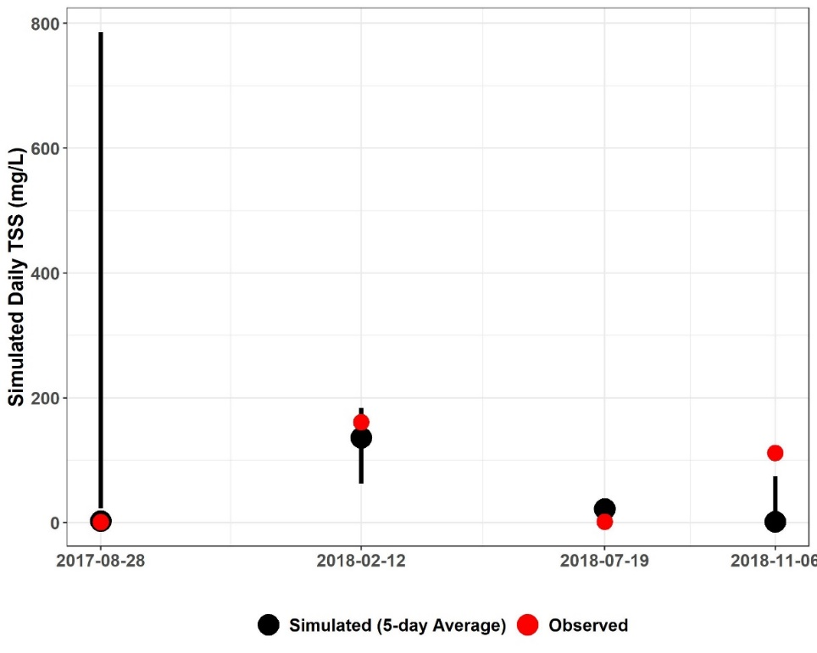
Figure E-56. Three-day window plot for sediment concentration showing the 5-day average, maximum minimum, and observed values at station 2-JMS157.28 (Lower James River – Hardware, Slate, and Willis Rivers watershed reach 1).

Figure E-57 illustrates another comparison of daily average simulated SSC and observed SSC. Both were plotted on the same graph with the daily average simulated flow for the river section within the subwatershed 1 on a secondary axis. The flow and SSC time series have been scaled along the y-axis to emphasize the magnitude of simulated SSC fluctuations and to better illustrate observed and simulated SSC. This graph shows that increases in simulated flow resulted in increases in simulated sediment concentration. It also shows that simulated sediment concentration increased as observed SSC increased, and the model capture all observed SSC data points. This plot clearly shows high intensity rainfall condition is the main source of high sediment concentration in the watershed.
Figure E-57. Comparison of observed SSC, simulated SSC, and simulated flow for subwatershed reach 1 downstream the Lower James River – Hardware, Slate, and Willis Rivers watersheds.

Three- and Five-day Window Model Performance Assessment (Quantitative)
Table E-23 includes the results of the quantitative 3- and 5-day window calibration sufficiency analysis which was calculated for all observed SSC data in the Lower James River – Hardware, Slate, and Willis Rivers watershed. 3- and 5-day windows were only calculated around the days on which observed data were available. The 72% of observed data within the 5-day window is greater than the published 70% criteria that has been used for sparse data bacteria model calibration applications (Kim et al., 2007), and the 57% of the observed data within the 3-day window is greater than the desired 50% discussed earlier. It is worth mentioning that for the river section within subwatershed 1 three out of four observed data points were within the 5-day window. And while the model over-predicted some of the SSC data as indicated by the slightly larger percentage ‘below’ values for the 3 window, overall the model performed well. Despite the sparsity of the observed data, the results of the calibration window analysis indicate that the model is sufficiently well-calibrated. The final calibrated sediment parameters for the Phase II calibration can be found in Table E-24.

Table E-23. Three- and five-day window calibration statistics for the Lower James River – Hardware, Slate, and Willis Rivers Phase II Calibration.
Statistics | Value
Number of Observed Data Points | 7
Percentage within 3-day window | 57%
Percentage above 3-day maximum | 15%
Percentage below 3-day minimum | 28%
Percentage within 5-day window | 72%
Percentage above 5-day maximum | 14%
Percentage below 5-day minimum | 14%

Calibration Summary: James River—Hardware, Slate, and Willis River
Using a “weight-of-evidence” approach presented here, the conclusion is that the Lower James River – Hardware, Slate, and Willis Rivers watershed HSPF sediment model is sufficiently well calibrated to adequately simulate sediment loads. SSC-flow time series plots for all Lower James River – Hardware, Slate, and Willis Rivers watershed SSC stations can be provided upon request by referring to the contact information on page ii.

Table E-24. Final calibrated parameters for the Lower James River – Hardware, Slate, and Willis Rivers watershed Phase II Calibration.
Parameter | Definition | FUNCTION OF… | Units | FINAL CALIBRATION | POSSIBLE RANGE OF VALUES^{ǂ} | CALCULATION METHOD^{ǂ}
RCHRESª
SANDFG (Sand Parameter Flags)
SNDFG | Indicates method used for Sandload Simulation | Type of stream; user experience | none | 3 | 1 - 3 | Constant, Power Function Method
SED-GENPARM (General Parameters)
BEDWID | Width of cross-section over which HSPF will assume bed sediment is deposited | Reach \ Waterbody morphology | ft | 13 | 5 - 1000 | Based on Technical Note Recommended Values
BEDWRN | Bed depth which, if exceeded (i.e., through deposition) will cause a warning message to be printed | Reach \ Waterbody morphology, User needs | ft | 20 | 0.5 - 20 | Based on Technical Note Recommended Values
POR | Porosity of the bed (volume voids/total volume) | Reach \ Sediment Bed Characteristics | none | 0.5 | 0.25 - 0.9 | Based on Technical Note Recommended Values
SAND-PM (Sand Parameters)
D | Effective diameter of the transported sand particles | Sediment properties | in | 0.005 | 0.0005 - 0.2 | Based on Tech. Note Recommended Values
W | Fall velocity of transported sand particles in still water | Particle diameter and density | in/sec | 0.1-1.9^{b} | 0.1 - 10 | “ ”
RHO | Density of sand particles | Sediment properties | g/cm³ | 2.5-3.0^{b} | 1.5 - 3.0 | “ ”
KSAND | Coefficient in sandload power function formula | Sand properties and hydraulics | complex | 0.001-0.05^{b} | 0.001 - 10 | Estimated from Recommended Values, Calibrated in HSPF
EXPSND | Exponent in sandload power function formula | Sand properties and hydraulics | complex | 1.5-2.0^{b} | 1.0 - 6.0 | Estimated from Recommended Values, Calibrated in HSPF
SILT-CLAY-PM (Silt Parameters)
D | Effective diameter of silt particles | Sediment properties | in | 0.0006 | 0.0001 - 0.004 | Based on Tech. Note Recommended Values
W | Fall velocity of transported silt particles in still water | Particle diameter and density | in/sec | 0.0005-0.0295^{b} | 0.0 - 0.1 | “ ”
RHO | Density of silt particles | Sediment properties | g/cm³ | 2.3 | 1.5 - 3.0 | “ ”
TAUCD | Critical bed shear stress for deposition | Silt properties and hydraulics | lb/ft² | 0.002 – 0.08^{b} | 0.001 - 1.0 | Estimated from Initial Run, Calibrated in HSPF
TAUCS | Critical bed shear stress for scour | Silt properties and hydraulics | lb/ft² | 0.2 – 1.00^{b} | 0.01 - 3.0 | Estimated from Initial Run, Calibrated in HSPF
M | Erodibility coefficient | Silt properties and hydraulics | lb/ft²-d | 0.001-4.5^{b} | 0.001 - 5.0 | Estimated from Recommended Values, Calibrated in HSPF
SILT-CLAY-PM (Clay Parameters)
D | Effective diameter of clay particles | Sediment properties | in | 0.001 | 0.000005 - 0.00025 | Based on Tech. Note Recommended Values
W | Fall velocity of transported clay particles in still water | Particle diameter and density | in/sec | 0.0005-0.0295^{b} | 0.0 - 0.1 | “ ”
RHO | Density of clay particles | Sediment properties | g/cm³ | 2.0 | 1.5 - 3.0 | “ ”
TAUCD | Critical bed shear stress for deposition | Clay properties and hydraulics | lb/ft² | 0.001- 0.80^{b} | 0.001 - 1.0 | Estimated from Initial Run, Calibrated in HSPF
TAUCS | Critical bed shear stress for scour | Clay properties and hydraulics | lb/ft² | 0.01 – 1.9^{b} | 0.01 - 3.0 | Estimated from Initial Run, Calibrated in HSPF
M | Erodibility coefficient | Clay properties and hydraulics | lb/ft²-d | 0.001-4.5^{b} | 0.001 - 5.0 | Estimated from Recommended Values, Calibrated in HSPF
SSED-INIT | Initial concentrations of suspended sediment | Reach | mg/L | 2 sand; 2 silt; 20 clay | n/a | Based on Tech. Note Recommended Values
BED-INIT | Initial content of bed sediment | Sediment Bed Characteristics | pct. | 15% sand; 65% silt; 20% clay | n/a
^{ǂ} Acquired from EPA BASINS Technical Note 8 (2006)
ª Main stem of stream in each subwatershed
^{b} Varies with subwatershed reach (data available upon request by referring to the contact information on page ii)

Phase I Calibration: Lower James River – Reedy Creek
Comparison analyses of model results for the outlet located downstream of the Lower James River – Reedy Creek calibration portion (the outlet of the James River study area) are discussed in the following sections. Average annual SOSED and SOSLD (sediment and solids wash-off rate) values for Lower James River – Reedy Creek were calibrated to within the load target ranges (Table E-1) for each Lower James River – Reedy Creek subwatershed and land use. Due to the large size of the resulting SOSED and SOSLD calibration tables for the 30 subwatersheds, they are not included in this Appendix; including tables would have made the report unmanageably long. These tables can be made available upon request by referring to the contact information on page ii.

Pervious Land Use Calibration
Figure E-58, Figure E-59, and Figure E-60 show observed precipitation (upper axis) and simulated SOSED, DETS values for Forest, Cropland and pervious Residential land uses for the calibration period (2011-2019), respectively for subwatershed 1 in the Lower James River – Reedy Creek watershed. Other pervious land uses, and subwatersheds produced similar SOSED and DETS plots. As expected, the DETS in each subwatershed for each pervious land use increased over time before decreasing during instances of sediment removal caused by major storm events. The magnitude of DETS was smallest for the Forest land use and largest in Cropland land use, which was expected since forested lands have a greater percentage of vegetative cover and cropland is periodically fallowed.
Figure E-58. Forest SOSED, DETS, and observed precipitation for subwatershed 1 in Lower James River – Reedy Creek watershed.

Figure E-59. Cropland SOSED, DETS, and observed precipitation for subwatershed 12 in Lower James River – Reedy Creek watershed.

Figure E-60. Pervious Residential SOSED, DETS, and observed precipitation for subwatershed 1 in Lower James River – Reedy Creek Creek watershed.

Impervious Land Use Calibration
Figure E-61 shows the observed precipitation (upper axis) and SOSLD and SLDS values for the impervious fraction of the Residential land use for subwatershed 1 from January 1, 2011 to December 31, 2019. Impervious land cover was subject to greater sediment loss during smaller magnitude precipitation events than pervious land cover. Compared to pervious land uses, significant storage reductions were more frequent on impervious lands.

Figure E-61. Impervious Residential SOSLD, SLDS, and observed precipitation for subwatershed 1 in Lower James River – Reedy Creek Creek watershed

SOSED, SOSLD, DETS, and SLDS Summary
The simulated SOSED, SOSLD, DETS, and SLDS values on the pervious and impervious land uses followed expected patterns and sediment removal characteristics. On pervious land uses, the DETS (sediment storage) increased steadily before decreasing sharply due to spikes in SOSED (sediment removal) which were a result of major storm events. This periodic rise and fall of sediment storage are characteristic of a well-calibrated model. On impervious land use, the SLDS (solids storage) fluctuations (increases and decreases) were more frequent when compared to the DETS for the pervious land uses. Impervious land uses were more sensitive to smaller storms and subject to more frequent wash off. Pervious and impervious Residential land use were included in the analysis to provide a comparison of the difference between pervious and impervious land cover. The calibrated Phase I model provided a reasonable approximation of the behavior of sediment detachment and removal in the Lower James River – Reedy Creek overland sediment transport calibration. Due to the large number of subwatersheds and land uses in Lower James River – Reedy Creek, Phase I graphs for the other subwatersheds are not included in this report due to lengthiness, but they can be made available upon request by referring to the contact information on page ii. The final calibrated sediment parameters for the Phase I calibration are presented in Table E-25.

Table E-25. Final calibrated parameters for the Lower James River – Reedy Creek Phase I Calibration.
Parameter | Definition | FUNCTION OF… | Units | FINAL CALIBRATION | POSSIBLE RANGE OF VALUES^{ǂ} | CALCULATION METHOD^{ǂ}
PERLNDª
SED-PARM2 (Sediment Parameter Group 2)
SMPF | Management Practice (P) factor from USLE | Land use, agricultural practices | none | 1 | 0.0 - 1.0 | Constant at 1.0, Assumed no Management Practices
KRER | Coefficient in the soil detachment equation | Soils | complex | 0.05 - 0. 50^{b} | 0.05 - 0.75 | Based on Technical Note Recommended Values, Calibrated in HSPF
JRER | Exponent in the soil detachment equation | Soils, climate | none | 1.81 | 1.0 - 3.0 | Based on Technical Note Recommended Values
AFFIX | Daily reduction in detached sediment | Soils, compaction, agricultural operations | per day | 0.08 | 0.01 - 0.50 | Estimated from Recommended Values, Calibrated in HSPF
COVER | Fraction land surface protected from rainfall | Vegetal cover, land use | none | 0.30-0.95 | 0.0 - 0.98 | Estimated from Recommended Values, Calibrated in HSPF
NVSI | Atmospheric additions to sediment storage | Deposition, activities, etc. | lb/ac-day | 0.0 | 0.0 - 20.0 | Based on Tech. Note Recommended Values
SED-PARM3 (Sediment Parameter Group 3)
KSER | Coefficient in the sediment washoff equation | Soils, surface conditions | complex | 0.01 – 4.35^{b} | 0.001 - 10.0 | Estimated from Recommended Values, Calibrated in HSPF
JSER | Exponent in the sediment washoff equation | Soils, surface conditions | none | 1.67 | 1.0 - 3.0 | “ ”
KGER | Coefficient in the soil matrix scour equation | Soils, evidence of gullies | complex | 0.0 | 0.0 - 10.0 | “ ”
JGER | Exponent in the soil matrix scour equation | Soils, evidence of gullies | none | 2.5 | 1.0 - 5.0 | “ ”
IMPLND^{c}
SLD-PARM2 (Solids Parameter Group 2)
KEIM | Coefficient in the solids washoff equation | Surface conditions, solids characteristics | complex | 1.6 | 0.1 - 10.0 | Based on Tech. Note Recommended Values  Calibrated in HSPF
JEIM | Exponent in the solids washoff equation | Surface conditions, solids characteristics | none | 1.5 | 1.0 - 3.0 | “ ”
ACCSDP | Solids accumulation rate on the land surface | Land use, traffic, human activities | lb/ac-day | 0.004 | 0.0 - 30.0 | “ ”
REMSDP | Fraction of the solids removed per day | Street sweeping, wind, traffic | per day | 0.05 | 0.01 - 1.0 | “ ”
^{ǂ} Acquired from EPA BASINS Technical Note 8 (2006)
ª Pervious land segments
^{b} Varies with land use (data available upon request by referring to the contact information on page ii)
^{c} Impervious land segment

Phase II Calibration: Lower James River – Reedy Creek
As mentioned in the introductory calibration methodology section, the first run of the Phase II calibration was used to generate initial estimates of critical shear stress values. TAU represents the critical bed shear stress. TAUCD is the parameter used to calculate critical shear stress for deposition, and TAUCS is the parameter used to calculate critical shear stress for scour. Once the initial run was complete, the calibration continued by substituting the placeholder TAUCD and TAUCS values with updated estimates. In subsequent calibration runs, all sediment calibration parameters including TAUCD and TAUCS were subject to adjustment. Phase II calibration efficiency metrics were analyzed after each run to determine if it’s necessary to continue the model calibration procedure further.

Graphical Model Performance Assessment (Qualitative)
The Phase II graphical calibration focused on model fit at the stations and subwatersheds where observed SSC data were available. Figure E-62 provides an initial visual analysis of model fit. In this graph, observed and simulated sediment concentrations were plotted against flow. Simulated data from January 1, 2013 to December 31, 2019 for reach 01, the reach corresponding to subwatershed 01 in the Lower James River – Reedy Creek, were included in the graph as daily averages (open circles); the simulated daily average SSC (mg/L) on a given date was plotted against its corresponding simulated daily average flow rate (cfs). Observed data were plotted similarly using the observed SSC (mg/L) at VADEQ water quality monitoring station 2-JMS111.17 and the observed flow at the corresponding USGS flow gage on Lower James River – Reedy Creek (Red triangles). The USGS flow gage closest to VADEQ station 2-JMS111.17 with a complete flow record is USGS 02037500 (James River near Richmond, VA).
Figure E-62 shows that the model is capable of simulating the appropriate sediment concentration magnitude given a particular flow rate. The simulated data “cloud” encompasses the observed data points. This graph shows for a certain observed flow rate and SSC combination, the model is capable of generating sediment-flow condition. Additionally, as observed flow increases, observed SSC also increases except for one date. On that particular date the observed SSC was very low despite the high observed flow of the river at two of the reaches. A similar sediment concentration-flow correlation was illustrated with the simulated data.
Figure E-62. Sediment concentration-flow plot including daily average simulated SSC vs. daily average simulated flow, observed flow and observed SSC for subwatershed reach 1 in Lower James River – Reedy Creek watershed.

Figure E-63 further illustrates the model performance showing simulated and observed sediment concentrations plotted on each day at which observed SSC data were collected at DEQ station 2-JMS111.17. The average daily simulated and observed SSC for a 5-day window surrounding the date of the observed sampling was also included in the plot. In addition, the maximum and minimum simulated daily SSC concentrations during that 5-day window are shown. The figure shows three out of four observed SSC data points were captured within the 5-day sediment windows by the model for reach 1 of the Lower James River – Reedy Creek watersheds.
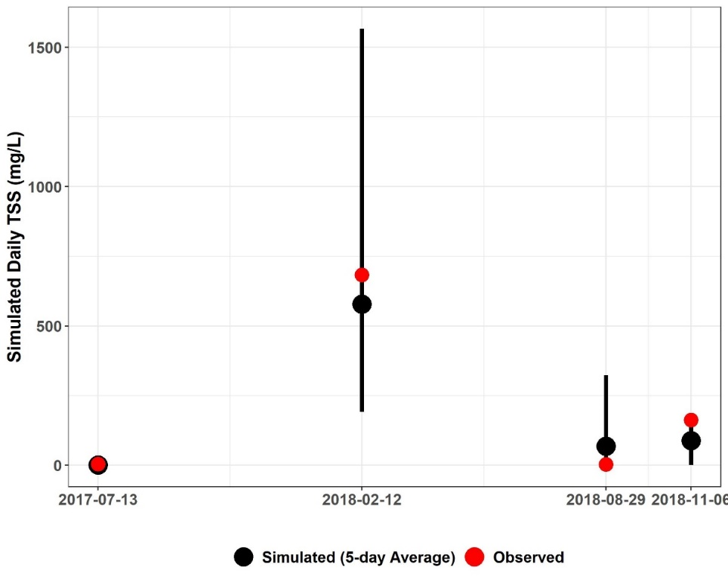
Figure E-63. Three-day window plot for sediment concentration showing the 5-day average, maximum minimum, and observed values at station 2-JMS111.17 (Lower James River – Reedy Creek watershed reach 1).

Figure E-64 illustrates another comparison of daily average simulated SSC and observed SSC. Both were plotted on the same graph with the daily average simulated flow for the river section within the subwatershed 1 on a secondary axis. The flow and SSC time series have been scaled along the y-axis to emphasize the magnitude of simulated SSC fluctuations and to better illustrate observed and simulated SSC. This graph shows that increases in simulated flow resulted in increases in simulated sediment concentration. It also shows that simulated sediment concentration increased as observed SSC increased, and the model capture all observed SSC data points. This plot clearly shows high intensity rainfall condition is the main source of high sediment concentration in the watershed.
Figure E-64. Comparison of observed SSC, simulated SSC, and simulated flow for subwatershed reach 1 in the Lower James River – Reedy Creek watershed.

Three- and Five-day Window Model Performance Assessment (Quantitative)
Table E-26 includes the results of the quantitative 3- and 5-day window calibration sufficiency analysis which was calculated for all observed SSC data in the Lower James River – Reedy Creek watershed. 3- and 5-day windows were only calculated around the days on which observed data were available. The 80% of observed data within the 5-day window is greater than the published 70% criteria that has been used for sparse data bacteria model calibration applications (Kim et al., 2007), and the 62% of the observed data within the 3-day window is greater than the desired 50% discussed earlier. It is worth mentioning that for the river section within subwatershed 1, three out of four observed data points were within the 5-day window. And while the model under-predicted some of the SSC data as indicated by the slightly larger percentage ‘above’ values for the 3-day window, overall the model performed well. Despite the sparsity of the observed data, the results of the calibration window analysis indicate that the model is sufficiently well-calibrated. The final calibrated sediment parameters for the Phase II calibration can be found in Table E-27.

Table E-26. Three- and five-day window calibration statistics for the Lower James River – Reedy Creek Phase II Calibration.
Statistics | Value
Number of Observed Data Points | 34
Percentage within 3-day window | 62%
Percentage above 3-day maximum | 26%
Percentage below 3-day minimum | 12%
Percentage within 5-day window | 80%
Percentage above 5-day maximum | 17%
Percentage below 5-day minimum | 3%

Calibration Summary: Lower James River – Reedy Creek
Using a “weight-of-evidence” approach presented here, the conclusion is that the James River—Reedy Creek watershed HSPF sediment model is sufficiently well calibrated to adequately simulate sediment loads. SSC-flow time series plots for all James River—Reedy Creek watershed SSC stations can be provided upon request by referring to the contact information on page ii.

Table E-27. Final calibrated parameters for the Lower James River – Reedy Creek watershed Phase II Calibration.
Parameter | Definition | FUNCTION OF… | Units | FINAL CALIBRATION | POSSIBLE RANGE OF VALUES^{ǂ} | CALCULATION METHOD^{ǂ}
RCHRESª
SANDFG (Sand Parameter Flags)
SNDFG | Indicates method used for Sandload Simulation | Type of stream; user experience | none | 3 | 1 - 3 | Constant, Power Function Method
SED-GENPARM (General Parameters)
BEDWID | Width of cross-section over which HSPF will assume bed sediment is deposited | Reach \ Waterbody morphology | ft | 13 | 5 - 1000 | Based on Technical Note Recommended Values
BEDWRN | Bed depth which, if exceeded (i.e., through deposition) will cause a warning message to be printed | Reach \ Waterbody morphology, User needs | ft | 20 | 0.5 - 20 | Based on Technical Note Recommended Values
POR | Porosity of the bed (volume voids/total volume) | Reach \ Sediment Bed Characteristics | none | 0.5 | 0.25 - 0.9 | Based on Technical Note Recommended Values
SAND-PM (Sand Parameters)
D | Effective diameter of the transported sand particles | Sediment properties | in | 0.005 | 0.0005 - 0.2 | Based on Tech. Note Recommended Values
W | Fall velocity of transported sand particles in still water | Particle diameter and density | in/sec | 0.1-1.9^{b} | 0.1 - 10 | “ ”
RHO | Density of sand particles | Sediment properties | g/cm³ | 2.5-3.0^{b} | 1.5 - 3.0 | “ ”
KSAND | Coefficient in sandload power function formula | Sand properties and hydraulics | complex | 0.001-0.05^{b} | 0.001 - 10 | Estimated from Recommended Values, Calibrated in HSPF
EXPSND | Exponent in sandload power function formula | Sand properties and hydraulics | complex | 1.5-2.0^{b} | 1.0 - 6.0 | Estimated from Recommended Values, Calibrated in HSPF
SILT-CLAY-PM (Silt Parameters)
D | Effective diameter of silt particles | Sediment properties | in | 0.0006 | 0.0001 - 0.004 | Based on Tech. Note Recommended Values
W | Fall velocity of transported silt particles in still water | Particle diameter and density | in/sec | 0.0005-0.0295^{b} | 0.0 - 0.1 | “ ”
RHO | Density of silt particles | Sediment properties | g/cm³ | 2.3 | 1.5 - 3.0 | “ ”
TAUCD | Critical bed shear stress for deposition | Silt properties and hydraulics | lb/ft² | 0.002 – 0.08^{b} | 0.001 - 1.0 | Estimated from Initial Run, Calibrated in HSPF
TAUCS | Critical bed shear stress for scour | Silt properties and hydraulics | lb/ft² | 0.2 – 1.00^{b} | 0.01 - 3.0 | Estimated from Initial Run, Calibrated in HSPF
M | Erodibility coefficient | Silt properties and hydraulics | lb/ft²-d | 0.001-4.5^{b} | 0.001 - 5.0 | Estimated from Recommended Values, Calibrated in HSPF
SILT-CLAY-PM (Clay Parameters)
D | Effective diameter of clay particles | Sediment properties | in | 0.001 | 0.000005 - 0.00025 | Based on Tech. Note Recommended Values
W | Fall velocity of transported clay particles in still water | Particle diameter and density | in/sec | 0.0005-0.0295^{b} | 0.0 - 0.1 | “ ”
RHO | Density of clay particles | Sediment properties | g/cm³ | 2.0 | 1.5 - 3.0 | “ ”
TAUCD | Critical bed shear stress for deposition | Clay properties and hydraulics | lb/ft² | 0.001- 0.80^{b} | 0.001 - 1.0 | Estimated from Initial Run, Calibrated in HSPF
TAUCS | Critical bed shear stress for scour | Clay properties and hydraulics | lb/ft² | 0.01 – 1.9^{b} | 0.01 - 3.0 | Estimated from Initial Run, Calibrated in HSPF
M | Erodibility coefficient | Clay properties and hydraulics | lb/ft²-d | 0.001-4.5^{b} | 0.001 - 5.0 | Estimated from Recommended Values, Calibrated in HSPF
SSED-INIT | Initial concentrations of suspended sediment | Reach | mg/L | 2 sand; 2 silt; 20 clay | n/a | Based on Tech. Note Recommended Values
BED-INIT | Initial content of bed sediment | Sediment Bed Characteristics | pct. | 15% sand; 65% silt; 20% clay | n/a
^{ǂ} Acquired from EPA BASINS Technical Note 8 (2006)
ª Main stem of stream in each subwatershed
^{b} Varies with subwatershed reach (data available upon request by referring to the contact information on page ii)

References
DEQ. 2009. Roanoke River PCB TMDL Development (Virginia). Prepared for United States Environmental Protection Agency, Region 3. December 2009.

DEQ. 2018. PCB Total Maximum Daily Load Development for Reed Creek, the Upper New River, Peak Creek, Walker Creek, Stony Creek, and the Lower New River.
Prepared by Virginia Tech Biological Systems Engineering Department. July
2018.

Kim, S.M., B.L. Benham, K.M. Brannan, R.W. Zeckoski, G.R. Yagow, 2007. Water Quality Calibration Criteria for Bacteria TMDL Development. 2007 American Society of Agricultural and Biological Engineers ISSN 0883-8542 23(2) 171-176.

Liao, H., LH. Krometis, K. Kline, W.C. Hession, 2015. Long-Term Impacts of Bacteria-Sediment Interactions in Watershed-Scale Microbial Fate and Transport Modeling. Journal of Environmental Quality ISSN 0047-2425 44(5) 1483-1490.

Russo, S.A., J. Hunn, G.W. Characklis, 2011. Considering Bacteria-Sediment Associations in Microbial Fate and Transport Modeling. Journal of Environmental Engineering ISSN 0733-9372 137(8) 697-706.

USEPA. 2006. BASINS Technical Note 8: Sediment Parameter and Calibration for HSPF. Washington, D.C.: Office of Water, USEPA. Available at: https://www.epa.gov/sites/production/files/2015-08/documents/2006_02_02_basins_tecnote8.pdf. Accessed 24 July 2019.

PCB Calibration for the James River PCB TMDL Study Area
The final phase of the James River PCB TMDL model calibration focused on modeling the fate and transport of polychlorinated biphenyls (PCBs) throughout the study area. PCBs in the James River study area were simulated as water quality constituents that existed in “dissolved” and sediment-associated states. The PCB calibration includes the TMDL watersheds: Jackson River, Maury River, Upper and Lower James Rivers. Chapter 2 provides maps illustrating the subwatersheds, impaired segments and the PCB water quality stations within the four James River TMDL watersheds.

Calibration Methodology
The James River study area was organized into four TMDL watersheds and were further subdivided and modeled as individual subwatersheds. The PCB model calibration process was organized by major tributaries similar to the sediment model calibration (Figure E-1). The simulated, dissolved PCB concentrations were calibrated against observed water column PCB samples. PCB sources in each subwatershed included wash-off loading from known contaminated sites (i.e., spills), direct drainage sources (i.e., the net atmospheric PCB deposition on land and water surfaces, loads from small tributaries not explicitly specified in the model, regulated and unregulated stormwater runoff, loads from unidentified contaminated sites, and unspecified point source discharges), legacy instream sediment-associated PCBs (i.e., streambed sediment), railyards and railways. The PCB model calibration was an iterative process in which calibration parameters were adjusted, the model was executed, and the outputs were assessed using graphical and quantitative analyses. This series of steps was repeated until an acceptable model calibration was achieved. The calibration results are reported for each James River TMDL watershed and calibration segment separately section by section.

Calibration Parameters
The HSPF parameters and inputs that were used in the PCB calibration are described below. Calibration parameters included selected PCB loading rates and PCB-sediment association variables. Initial estimates for parameters were calculated from the best available observed data. Calibration decisions for each parameter are specified in the following parameter descriptions.

Atmospheric Deposition
For the James River PCB TMDL, atmospheric deposition was applied or “input” into the model differently on water and land surfaces, and was included as a portion of the direct drainage load. Within HSPF, atmospheric deposition is modeled as a dissolved pollutant. Thus, atmospheric deposition of a given pollutant, as defined by the model, cannot be sediment-associated. While modeling PCB atmospheric deposition applied to water surfaces as a “dissolved” constituent has been done previously, BSE believes that it is more reasonable and defensible to treat PCB atmospheric deposition on the land surface as a sediment-associated pollutant. As a result, PCB atmospheric deposition was quantified using two different model parameters. The first parameter, MONTH-DATA, applied a PCB atmospheric deposition rate to only the water surface and is discussed further in the next subsection. The second parameter, washoff potency factor (POTFW), quantified the washoff of PCBs from the land surface per ton of simulated sediment loss.
The MONTH-DATA parameter was used to apply a constant rate of dissolved PCBs to the surface of all stream/river reaches and reservoirs. The deposition rate of pg/acre/month was subdivided by HSPF into the user-selected time step units (hours). This method is similar to that used in previous Virginia PCB TMDLs. In the New River (DEQ, 2018), Roanoke River (DEQ, 2009) and Levisa River (DEQ, 2011) PCB TMDLs, monthly atmospheric deposition was applied only to reaches and reservoirs.
During calibration of the James River PCB model an initial PCB atmospheric deposition rate of 5.4 x 10⁸ pg/ac/month was used. However, this value resulted in simulated instream PCB concentrations at low flows that were greater than the available, observed data. The modelers of the Roanoke River (DEQ, 2009) and New River (DEQ, 2018) PCB TMDLs found similar issues when using the PCB atmospheric deposition rate reported by the USEPA Chesapeake Bay Program (CBP) in 1999 (CBP, 1999).
Based on the James River PCB study area modeling results and the results reported in the Roanoke River (DEQ, 2009) and New River (DEQ, 2018) PCB TMDLs, BSE elected to use atmospheric deposition as a calibration parameter. BSE reduced the atmospheric deposition rate until the simulated instream PCB concentrations at low flow compared reasonably well with the observed data. The final calibrated PCB atmospheric deposition rate was 3.0 x 10⁶ pg/ac/month.
Research has shown that PCB atmospheric deposition is a function of near-field land use such as urban development, manufacturing facilities, or contaminated sites (Totten et al., 2006). However, the data needed to discretely apply varying atmospheric deposition rates within the James River study area were not available. The James River PCB TMDL model applies the PCB atmospheric deposition to the water surface at a constant rate that does not fluctuate during the year.

Washoff Potency Factor, POTFW (pg/ton)
The washoff potency factor (POTFW) parameter determines the PCB loading from the land surface during precipitation events. It is used when the water quality constituent of interest, such as PCBs, is sediment-associated. The POTFW value determines the mass of PCBs (pg) that are washed from the land surface per ton of simulated sediment loss. Higher POTFW values simulate greater PCB loads entering a stream as sediment is detached from the land surface.
The magnitude of the POTFW varied depending on whether or not the land surface was part of a known, contaminated site. Known contaminated sites include active and inactive manufacturing facilities and were modeled as discrete land parcels. Known contaminated sites retained the same hydrological properties as the subwatershed where they were located, but they were assigned different water quality parameters. For known contaminated sites, data collected at the sites by VADEQ were used to calculate POTFW values. For one specific type of known contaminated site, railyards, the POTFW estimate from the New River (DEQ, 2018) and Roanoke River (DEQ, 2009) PCB TMDLs (7.02 x 10¹⁰ pg/ton) was used because of the proximity and similar history of rail activity within those watersheds and the James River study area. The same railyard POTFW value was used for the James River PCB TMDL.
For land surfaces that were not part of a known contaminated site, an initial POTFW value of 3.0 x 10¹¹ pg/ton was used to account for direct drainage within the study area. In order to maintain consistency, the same POTFW for direct drainage loads from land surfaces was used on both pervious land and impervious land despite the possibility of different commercial or industrial activities occurring on pervious and impervious surfaces. In the absence of observed data, the rationale for this decision was to avoid incorrectly assigning a larger PCB load to one land surface type, which could cause issues during the TMDL allocation process. Because the quantity of sediment that washes off varies by land use, the PCB loading is also a function of land use. Because of the inherent uncertainty of the direct drainage POTFW parameter, it was used as a primary calibration parameter. The POTFW values used in the James River model implicitly include atmospheric deposition of PCBs on the land surface.

PCB Adsorption Coefficient, KD (L/mg)
The adsorption coefficient (KD) is a measure of the tendency for PCBs to adsorb to sediment. HSPF splits KD values into six categories for each reach corresponding to the type of sediment-associated PCBs: 1) sand, 2) silt, and 3) clay in the water column; and 4) sand, 5) silt, and 6) clay on the streambed. KD values were calculated in two stages. In the first stage, an initial KD value was calculated based on a formula that accounts for the proportion of each PCB homolog and associated organic carbon content. In the second stage, the initial KD values were multiplied by a sediment adjustment factor. This factor adjusted the KD value for each sediment size fraction (sand, silt, and clay) according to the corresponding organic carbon content.
All observed water column samples and some observed sediment PCB samples provided PCB homolog composition data. From this information, initial KD values were calculated using Equation E-1.

$KD=1×{10}^{-6}×f_{oc}×K_{ow}$ Eq. E-1

Where:
KD = the (initial) adsorption coefficient between the dissolved and sediment-associated states (L/mg)
f_{oc} = weight fraction of the total carbon in the solid matter (gC/g)
K_{ow} = octanol-water partition coefficient (L/kg)

In Equation E-1, f_{oc} was derived from observed total organic carbon (TOC) data, and K_{ow} is a coefficient that varies by PCB homolog type as listed in Table F-1 (ICPRB, 2007). For a given observed PCB water quality sample with a distinct distribution of homolog concentrations, a weighted K_{ow} value was calculated by multiplying each homolog concentration by its respective K_{ow_H}, summing, and dividing by the total PCB concentration. The initial estimate for KD was calculated using the weighted K_{ow} and the derived f_{oc}.
Table F-1. Homolog-specific partitioning coefficients
Homolog | log K_{ow_H} | K_{ow_H} (L/kg)
K_{ow_mono+di} | 4.675 | 47,315
K_{ow_tri} | 5.425 | 266,073
K_{ow_tetra} | 6.005 | 1,011,579
K_{ow_penta} | 6.525 | 3,349,654
K_{ow_hexa} | 6.73 | 5,370,318
K_{ow_hepta} | 7.235 | 17,179,084
K_{ow_octa} | 7.6 | 39,810,717
K_{ow_nona} | 7.915 | 82,224,265
K_{ow_deca} | 8.18 | 151,356,125
Source: ICPRB, 2007.

The second stage of the KD calculation multiplied the initial KD by a sediment adjustment factor since organic carbon content varies by sediment size fraction (Li and Ping, 2014). The results of Li and Ping (2014) showed that organic carbon content attached to clay is 70% greater than on silt, and the quantity of organic carbon content attached to sand is 94.1% less than on silt. As a result, silt was established as the baseline. A sediment adjustment factor of 1 was used for silt KD values. The silt KD values were effectively equal to the initial KD values from the first stage. Sand and clay KD values were then calculated by multiplying by their respective sediment adjustment factors, 1.7 and 0.059 (1 - 0.941).
Suspended sediment KD values were calculated with observed water column samples. Bed sediment KD values were calculated using observed sediment PCB data when available. Since every subwatershed reach in the James River study area did not have its own water quality monitoring station with observed PCB data, KD values were assigned from similar reaches that did have observed data. KD values were calculated from observed data and were not adjusted during the calibration.

Adsorption/Desorption Rate, ADRATE (1/day)
The adsorption/desorption rate (ADRATE) quantifies how quickly PCBs attach and detach from sediment and enter the water column. In HSPF, ADRATE is split into six categories corresponding to the size fraction of sediment-associated PCBs: suspended sand, silt, and clay; and bed sand, silt, and clay. In the Roanoke River PCB TMDL (DEQ, 2009) and New River PCB TMDL (DEQ, 2018), the ADRATE was calculated by first identifying the median representative homolog from the observed water column PCB data. This entailed summing the concentrations of each homolog of all observed water column samples, reordering the homologs from mono to deca, and then determining which homolog was at the median point in the list. The adsorption/desorption rate corresponding to that median homolog was calculated from the rates provided in Schneider (2005).
A similar methodology was used for the James River PCB model in that the median representative homolog was determined for each reach. The adsorption/desorption rate corresponding to that median homolog was calculated from the rates provided in Schneider (2005). A consistent ADRATE value was used in all reaches within the James River study area. Also adhering to the modeling methodology used in the Roanoke River and New River PCB TMDLs, an ADRATE value was only applied to the suspended sediment (sand, silt, and clay). The bed sediment ADRATE value was set to the minimum allowable in HSPF. It was assumed that the adsorption/desorption on the bed sediment is negligible. Similar to KD, the ADRATE value was derived from observed data. As such, once the initial value was calculated, it was not adjusted during calibration. The ADRATE value for suspended sediment in the James River study area varies from 0.79 to 6.32 because the median representative homologs for the water column PCB samples in the calibration segments were pentachlorobiphenyl and tetrachlorobiphenyl homologs.

Initial Concentration of PCBs on Sediment, SEDCONC (pg/mg)
The initial concentration of PCBs bound to sediment (SEDCONC) is a measure of the mass of sediment-associated PCBs (pg) per unit mass of sediment (mg). Similar to KD and ADRATE, SEDCONC is also split into six categories for each reach corresponding to sediment size fraction: suspended sand, silt, and clay; and bed sand, silt, and clay. Compared to water column PCB observed data, there were few, recent sediment-associated PCB concentration observations. The available observed data were used as the initial estimates of SEDCONC. During calibration, it was found that low concentrations of SEDCONC (<10 pg/mg) had a small impact on the dissolved PCB concentrations. However, when increased into the range of >40 pg/mg, SEDCONC increased the PCB concentrations during low flow conditions.
Adhering to the modeling methodology used in the Roanoke River and New River PCB TMDLs, SEDCONC values were only applied on the bed sediment silt and clay. It was assumed that the initial concentration of sediment-associated PCBs on suspended sediment and bed sand was negligible. The bed sediment SEDCONC values were adjusted during the calibration process and range from 0.1 – 134 pg/mg depending on the stream segment.

Calibration Analysis
The analysis of each calibration run involved a series of assessments both graphical and quantitative. The simulated dissolved PCB concentrations output at the end of each model run were compared against the observed water column PCB samples. The number of water quality stations used for calibration, and the number of total observed water column PCB samples are shown in Table F-2. A total of 155 observed water column PCB samples were available in the James River PCB TMDL study area. All of these data were reviewed/considered when developing/calibrating the James River PCB model.

Table F-2. Number of water column PCB water quality stations and samples used in the calibration.
TMDL Watershed | No. Calibration Water Quality Stations w/ Observed PCB Data | Total No. of Observed PCB Data Samples
Jackson River | 4 | 13
Maury River | 2 | 10
Upper James River | 22 | 52
Lower James River | 28 | 58
Total | 56 | 133

Model performance was assessed using a “weight-of-evidence” approach. The calibration process focused on subwatershed reaches where observed data were available, and the model was evaluated based on knowledge of the study area. Similar to the sediment model calibration, a graphical analysis was used to compare the simulated and observed data. Additionally, a quantitative analysis was used to assess how well the model output compared with the observed data.

PCB Concentration Time Series Graphs
Two PCB concentration time series graphs were generated for each subwatershed reach with observed PCB water quality data. Both graphs include simulated average daily and observed PCB concentrations on the primary y-axis, and date on the x-axis. One graph shows observed daily rainfall on a secondary inverted y-axis, while the other plots simulated average flow rate on a secondary inverted y-axis. The time series graphs are used to show how simulated PCB concentrations respond to fluctuations in observed rainfall and simulated flow, and demonstrate the ability of the model to simulate PCB concentrations comparable to observed data.

Five-Day Calibration Window Assessments
Five-day calibration window metrics were used to quantitatively analyze model performance. Each 5-day window consists of the date of each observed PCB sample, two days before the sample was collected and two days after. The simulated daily PCB concentration outputs during those 5 days are used to identify the hourly maximum and minimum PCB concentrations within the 5-day window. If the observed PCB value falls between the minimum and maximum simulated values, then that observed PCB value was “within” the window. If the observed PCB value was less than the minimum value, then it was considered to be “below” the calibration window. If the data point was greater than the maximum, then it was considered to be “above” the calibration window. It should be emphasized that 5-day windows were only generated around the date and time when each observed PCB sample was collected.
Kim et al. (2007) justified the use of a 5-day window to assess model performance for developing bacterial TMDLs in watersheds with limited observed data. They stated that the goal of the calibration was to achieve at least 70% of the observed data points within the 5-day window. Additionally, in order to avoid model bias, the fraction of data above and below the window (if any) should be roughly equal. BSE believes the use of a 5-day calibration window, with a slight modification, is effective for assessing PCB model performance. Kim et al. (2007) recommended a “70% within” threshold for the 5-day window for bacteria modeling. PCB modeling is more complex than bacteria modeling (i.e., PCB modeling is also dependent on modeling sediment), as a result, a threshold of “50% within” the window is considered to be reasonable for assessing PCB model performance.
The 5-day calibration window “within”, “below”, and “above” statistics were calculated once per model run using the observed PCB data from all calibration water quality stations within a given calibration segment. The 5-day statistics were examined after each run as an indicator of model calibration sufficiency. Each subwatershed PCB model calibration 5-day window analysis summary includes a box-and-whisker plot and table. Together, the visual flow-PCB concentration comparison, time series graphs, and the quantitative 5-day window analysis constituted the “weight-of-evidence” approach used to evaluate PCB calibration sufficiency for the HSPF James River PCB TMDL model.

Jackson River PCB Calibration Results
This section presents the HSPF PCB calibration for the Jackson River TMDL watershed. The calibration results are summarized in tabular format for the entire watershed and graphed for a representative subwatershed reach. Figure E-2 illustrates the location of TMDL watershed, major tributary boundaries, reaches, and select monitoring stations used for comparing simulated and observed values during model calibration.

PCB Calibration
PCB model calibration was an iterative process in which adjustments were made to the calibration parameters. After executing the model, the results were analyzed, and the parameters were adjusted again. The results of the model were analyzed using the “weight-of-evidence” metrics discussed previously.

PCB Concentration Time Series Graphs
Figure F-1 and Figure F-2 illustrate the comparison of daily average simulated PCB concentrations and observed water column PCB concentrations for reach number one (outlet) of Jackson River. These graphs show that the simulated PCB concentration responded to fluctuations in rainfall and simulated flow. The model adequately simulated instream PCB concentrations in response to extreme rainfall and peak flow events. The model also captured reported PCB spills, i.e., the peak PCB concentrations seen in the figures are the result of reported PCB spills. These plots illustrate that the simulated PCB concentrations followed a pattern of increasing and decreasing similar to the observed data. Further, the model adequately reflects the baseflow PCB concentrations and peak observed concentrations. Time series graphs for the other Jackson River water quality calibration stations and their corresponding reaches can be provided by BSE upon request by referring to the contact information on page ii.

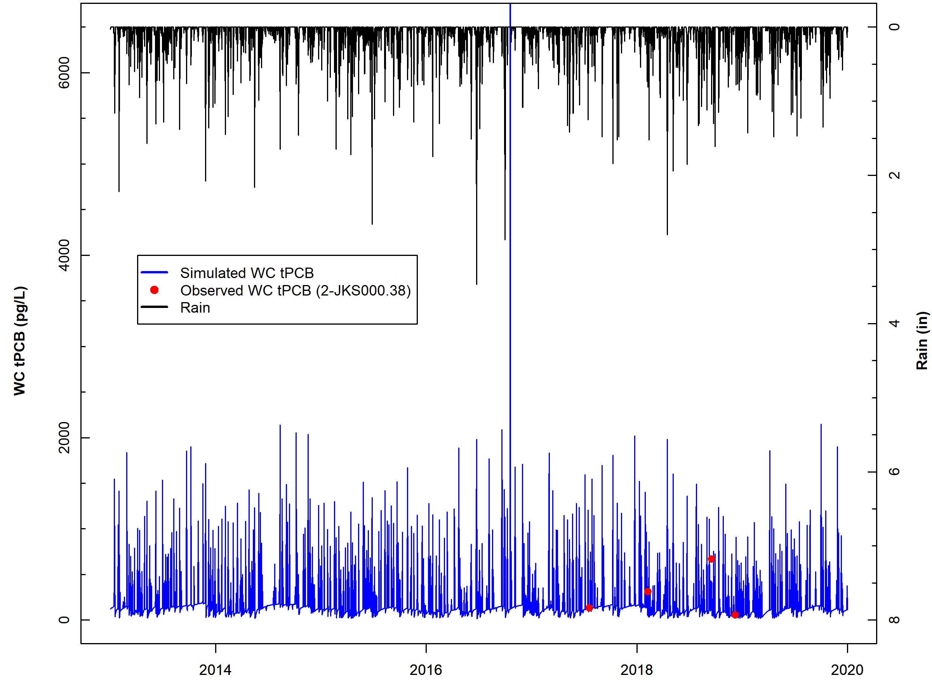
Figure F-1. Comparison of observed water column PCB concentrations, simulated water column PCB concentrations, and observed rainfall for subwatershed reach 1 in Jackson River.

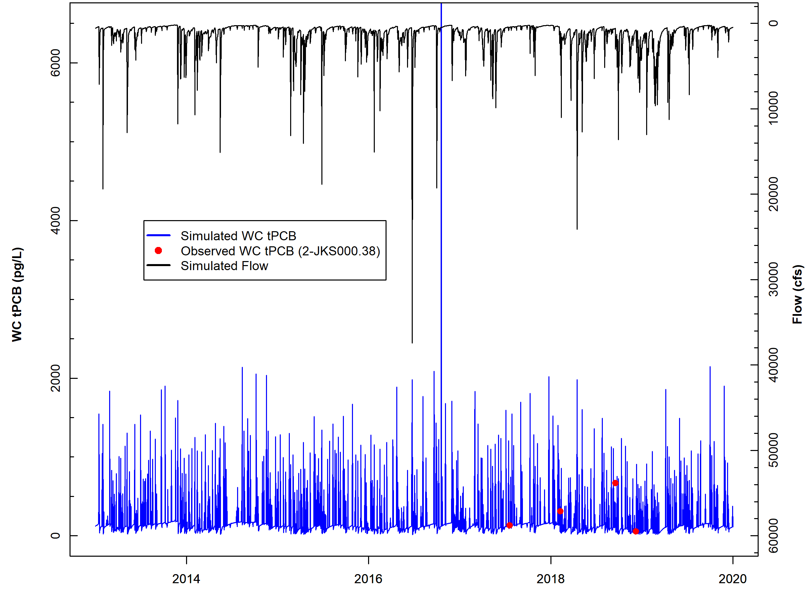
Figure F-2. Comparison of observed water column PCB concentrations, simulated water column PCB concentrations, and simulated flow for subwatershed reach 1 in Jackson River.

Five-day Window Performance Assessment
Figure F-3 shows the 5-day windows and observed data for Jackson River reach number one (outlet). All observed data points for reach one were within the 5-day windows indicating a good fit between the simulated and observed data. The 5-day window plots for the other Jackson River water quality calibration stations can be provided upon request by referring to the contact information on page ii. Table F-3 includes the results of the 5-day window calibration analysis for all Jackson River calibration reaches. Results show that across all stations, 85% of the observed data were within a 5-day window, exceeding the 50% calibration threshold goal, and also 8% of the data were above and below the 5-day windows respectively, indicating that the model is not exhibiting bias.
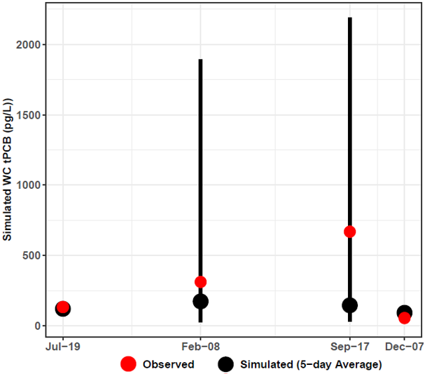
Figure F-3. Five-day window plots for water column PCB concentrations showing the 5-day average, max, and min, and observed values at station 2-JKS000.38 (Jackson River sub-watershed reach 1).

Table F-3. Simulated water column PCB concentrations (pg/L), 5-day calibration windows, and observed PCB concentrations (pg/L) for Jackson River.
Subwatershed | Station | Date | Observed Water Column PCB | Simulated | 5-Day Max. | 5-Day Min.
 |  |  |  | 5-Day Average
1 | 2-JKS000.38 | 7/19/2017 | 133.95 | 131.42 | 145.17 | 116.06
1 | 2-JKS000.38 | 2/8/2018 | 312.26 | 990.13 | 34065.29 | 7.28
1 | 2-JKS000.38 | 9/17/2018 | 668.52 | 242.74 | 7417.36 | 8.53
1 | 2-JKS000.38 | 12/7/2018 | 55.26 | 104.91 | 109.44 | 102.25
4 | 2-JKS006.67 | 2/8/2018 | 262.91 | 589.69 | 23657.81 | 3.40
14 | 2-JKS023.61 | 7/19/2017 | 275.02 | 273.19 | 306.88 | 229.65
14 | 2-JKS023.61 | 2/8/2018 | 296.36 | 872.53 | 37390.98 | 4.15
14 | 2-JKS023.61 | 9/17/2018 | 806.40 | 299.67 | 8172.61 | 3.63
14 | 2-JKS023.61 | 12/7/2018 | 195.58 | 195.25 | 199.28 | 191.91
17 | 2-JKS044.14 | 7/19/2017 | 43.35 | 43.19 | 44.16 | 41.56
17 | 2-JKS044.14 | 2/8/2018 | 76.77 | 58.92 | 499.97 | 9.43
17 | 2-JKS044.14 | 9/17/2018 | 46.58 | 32.97 | 198.85 | 8.35
17 | 2-JKS044.14 | 12/7/2018 | 67.17 | 36.92 | 37.26 | 36.77
 |  |  | Within 5-Day Range | Above 5-Day Range | Below 5-Day Range
 |  | PERCENT | 85% | 8% | 8%

Calibration Summary
The “weight-of-evidence” approach used for the Jackson River HSPF PCB model calibration sufficiency assessment included a qualitative, visual examination of the PCB concentration time series graphs and the 5-day calibration window assessment. Based on these analyses of instream PCB concentration response to precipitation and flow conditions, BSE concludes that the Jackson River HSPF PCB TMDL model was sufficiently well calibrated to adequately simulate in-stream PCB concentrations. The PCB calibration parameters are shown in Table F-4.
Table F-5 provides an estimate of the contributions from the different source categories to the annual PCB loading (mg/yr) in the stream. These contributions include loadings to unregulated land surface (atmospheric deposition, unregulated stormwater runoff, loads from unidentified contaminated sites, unspecified point source discharges), contaminated sites (including railyards and electric substations), direct loading to the stream (atmospheric deposition to water surfaces and permitted sources), instream contaminated streambed sediment, and spill sites. The “percent of total load” column shows the portion of the PCB load (mg) that originates from a particular PCB source; it does not describe the fate of the PCBs once they enter the stream/river reach.
Table F-4. Final calibrated parameters for the Jackson River PCB Calibration.
Parameter | Definition | Units | FINAL  CALIBRATION VALUE | POSSIBLE RANGE OF VALUES^{ǂ} | CALCULATION METHOD^{ǂ}
PERLND/IMPLNDª
QUAL-INPUT (Nonseasonal Sediment-Associated Quality Constituent Parameters)
POTFW^{b} | Washoff potency factor (unregulated surface sources¹) | pg/ton | 2.39E+09 – 2.00E+13 | 0.0 - Inf. | Calibrated
POTFW^{b} | Washoff potency factor (contaminated sites) | pg/ton | 7.02E+10 – 1.29E+12 | 0.0 - Inf. | Approximated from previous PCB TMDLs^{c}  Estimated from observed sampling data
RCHRES^{e}
GQ-KD (Adsorption Coefficients of PCB Quality Constituent)
ADPM1-ADPM3 | Adsorption coefficients for suspended sediment | L/mg | Sand: 0.044 – 0.88^{f};  Silt: 0.747 – 1.494^{f};  Clay: 1.270 – 2.540^{f} | 1.0E-10 - Inf. | Derived from observed water column samples with PCB homolog and TOC data,  Calibrated
ADPM4-ADPM6 | Adsorption coefficients for bed sediment | L/mg | Sand: 0.001 -0.008,  Silt: 0.022 – 0.133;  Clay: 0.037– 0.266 | 1.0E-10 - Inf. | Derived from observed sediment samples with PCB homolog and TOC data,  Calibrated
GQ-ADRATE (Adsorption/Desorption Rate Parameters)
ADPM1-ADPM3 | Adsorption/desorption rates for suspended sediment | 1/day | 0.79 – 1.61 | 1.0E-05 - Inf. | Derived from observed water column samples with PCB homolog data, Applied to entire calibration segment
ADPM4-ADPM6 | Adsorption/desorption rates for bed sediment | 1/day | 1.0E-05 | 1.0E-05 - Inf. | Assumed approx. zero as in previous PCB TMDLs^{c}
GQ-SEDCONC (Initial PCB Concentrations on Sediment)
SQAL1-SQAL4 | Initial PCB concentrations on suspended sediment | pg/mg | 0.0 | 0.0 - Inf. | Assumed zero as in previous PCB TMDLs^{c}
SQAL5-SQAL6 | Initial PCB concentrations on bed sediment | pg/mg | 0.01 – 133.75^{f} | 0.0 - Inf. | Estimated in observed sediment sample data, Calibrated
MONTH-DATA | PCB atmospheric deposition rate on water surface | pg/ac/mo-nth | 3.0E+06 | N/A | Initial value based on Chesapeake Bay Toxics Report^{g}, Calibrated
^{ǂ} Acquired from HSPF Version 12.2 User’s Manual
¹ Unregulated surface sources represent the sum of net atmospheric deposition to land surfaces, loads from small tributaries that are not specified in the model, unregulated stormwater runoff, loads from unidentified contaminated sites, and unspecified point source discharges from land uses
² Direct drainage sources represent the sum of net atmospheric deposition to land and water surfaces, loads from small tributaries that are not specified in the model, regulated and unregulated stormwater runoff, loads from unidentified contaminated sites, and unspecified point source discharges from commercial land use
ª Pervious and Impervious land segment
^{b} Includes the atmospheric deposition on the land surface
^{c} DEQ, 2009. Roanoke River PCB TMDL., 2018 New River PCB TMDL
^{d} Varies between contaminated sites
^{e} Main stem of stream in each subwatershed
^{f} Varies by calibration segment reach
^{g} CBP, 1999. Chesapeake Bay Basin Toxics Loading and Release Inventory.

Table F-5. Estimated existing annual source PCB loads for Jackson River during the allocation period (2010).
Source | Estimated Load  (mg/yr) | Percent of total load (%)
Streambed Sediment | 38,185 | 11
Atmospheric Deposition | 27 | <1
Spills | <1 | <1
Contaminated Sites | 200 | <1
Permitted | 23,354 | 7
Surface Load - Unregulated¹ | 280,804 | 82
Total | 342,570 | –
¹ Unregulated surface sources represent the sum of net atmospheric deposition to land surfaces, loads from small tributaries that are not specified in the model, unregulated stormwater runoff, loads from unidentified contaminated sites, and unspecified point source discharges.

Table F-6 shows the contribution (as a %) of the various PCB sources to the in-stream PCB concentration at the outlet (pg/L). The largest source of PCBs are unregulated surface loads followed by legacy sources (i.e., PCBs associated with bed sediments).

Table F-6. Estimated existing relative contributions of different PCB sources to the overall tPCB concentration at the Jackson River TMDL outlet during the allocation period (2010).
Source | Mean Daily Water Column tPCB Concentrations by Source (pg/L) | Relative Contribution by Source (%)
All Sources | 461 | –
Surface Load - Unregulated¹ | 356 | 77
Streambed Sediment | 63 | 14
Atmospheric Deposition | <1 | <1
Spills | <1 | <1
Contaminated Sites | <1 | <1
Permitted | 41 | 9
¹ Unregulated surface sources represent the sum of net atmospheric deposition to land surfaces, loads from small tributaries that are not specified in the model, unregulated stormwater runoff, loads from unidentified contaminated sites, and unspecified point source discharges.

Maury River PCB Calibration Results
This section presents the HSPF PCB calibration for the Maury River TMDL watershed. The calibration results are summarized in tabular format for the entire watershed and graphed for a representative subwatershed reach. Figure E-10 illustrates the location of the subwatersheds that will be discussed as well as the observed PCB water quality stations.

PCB Calibration
PCB model calibration was an iterative process in which adjustments were made to the calibration parameters. After executing the model, the results were analyzed, and the parameters were adjusted again. The results of the model were analyzed using the “weight-of-evidence” metrics discussed previously.

PCB Concentration Time Series Graphs

Figure F-4 and Figure F-5 illustrate the comparison of daily average simulated PCB concentrations and observed water column PCB concentrations for reach number one (outlet) of Maury River. These graphs show that the simulated PCB concentration responded to fluctuations in rainfall and simulated flow. The model adequately simulated instream PCB concentrations in response to extreme rainfall and peak flow events. These plots illustrate that the simulated PCB concentrations followed a pattern of increasing and decreasing similar to the observed data. Further, the model adequately reflects the baseflow PCB concentrations and peak observed concentrations. Time series graphs for the other Maury River water quality calibration stations and their corresponding reaches can be provided by BSE upon request.
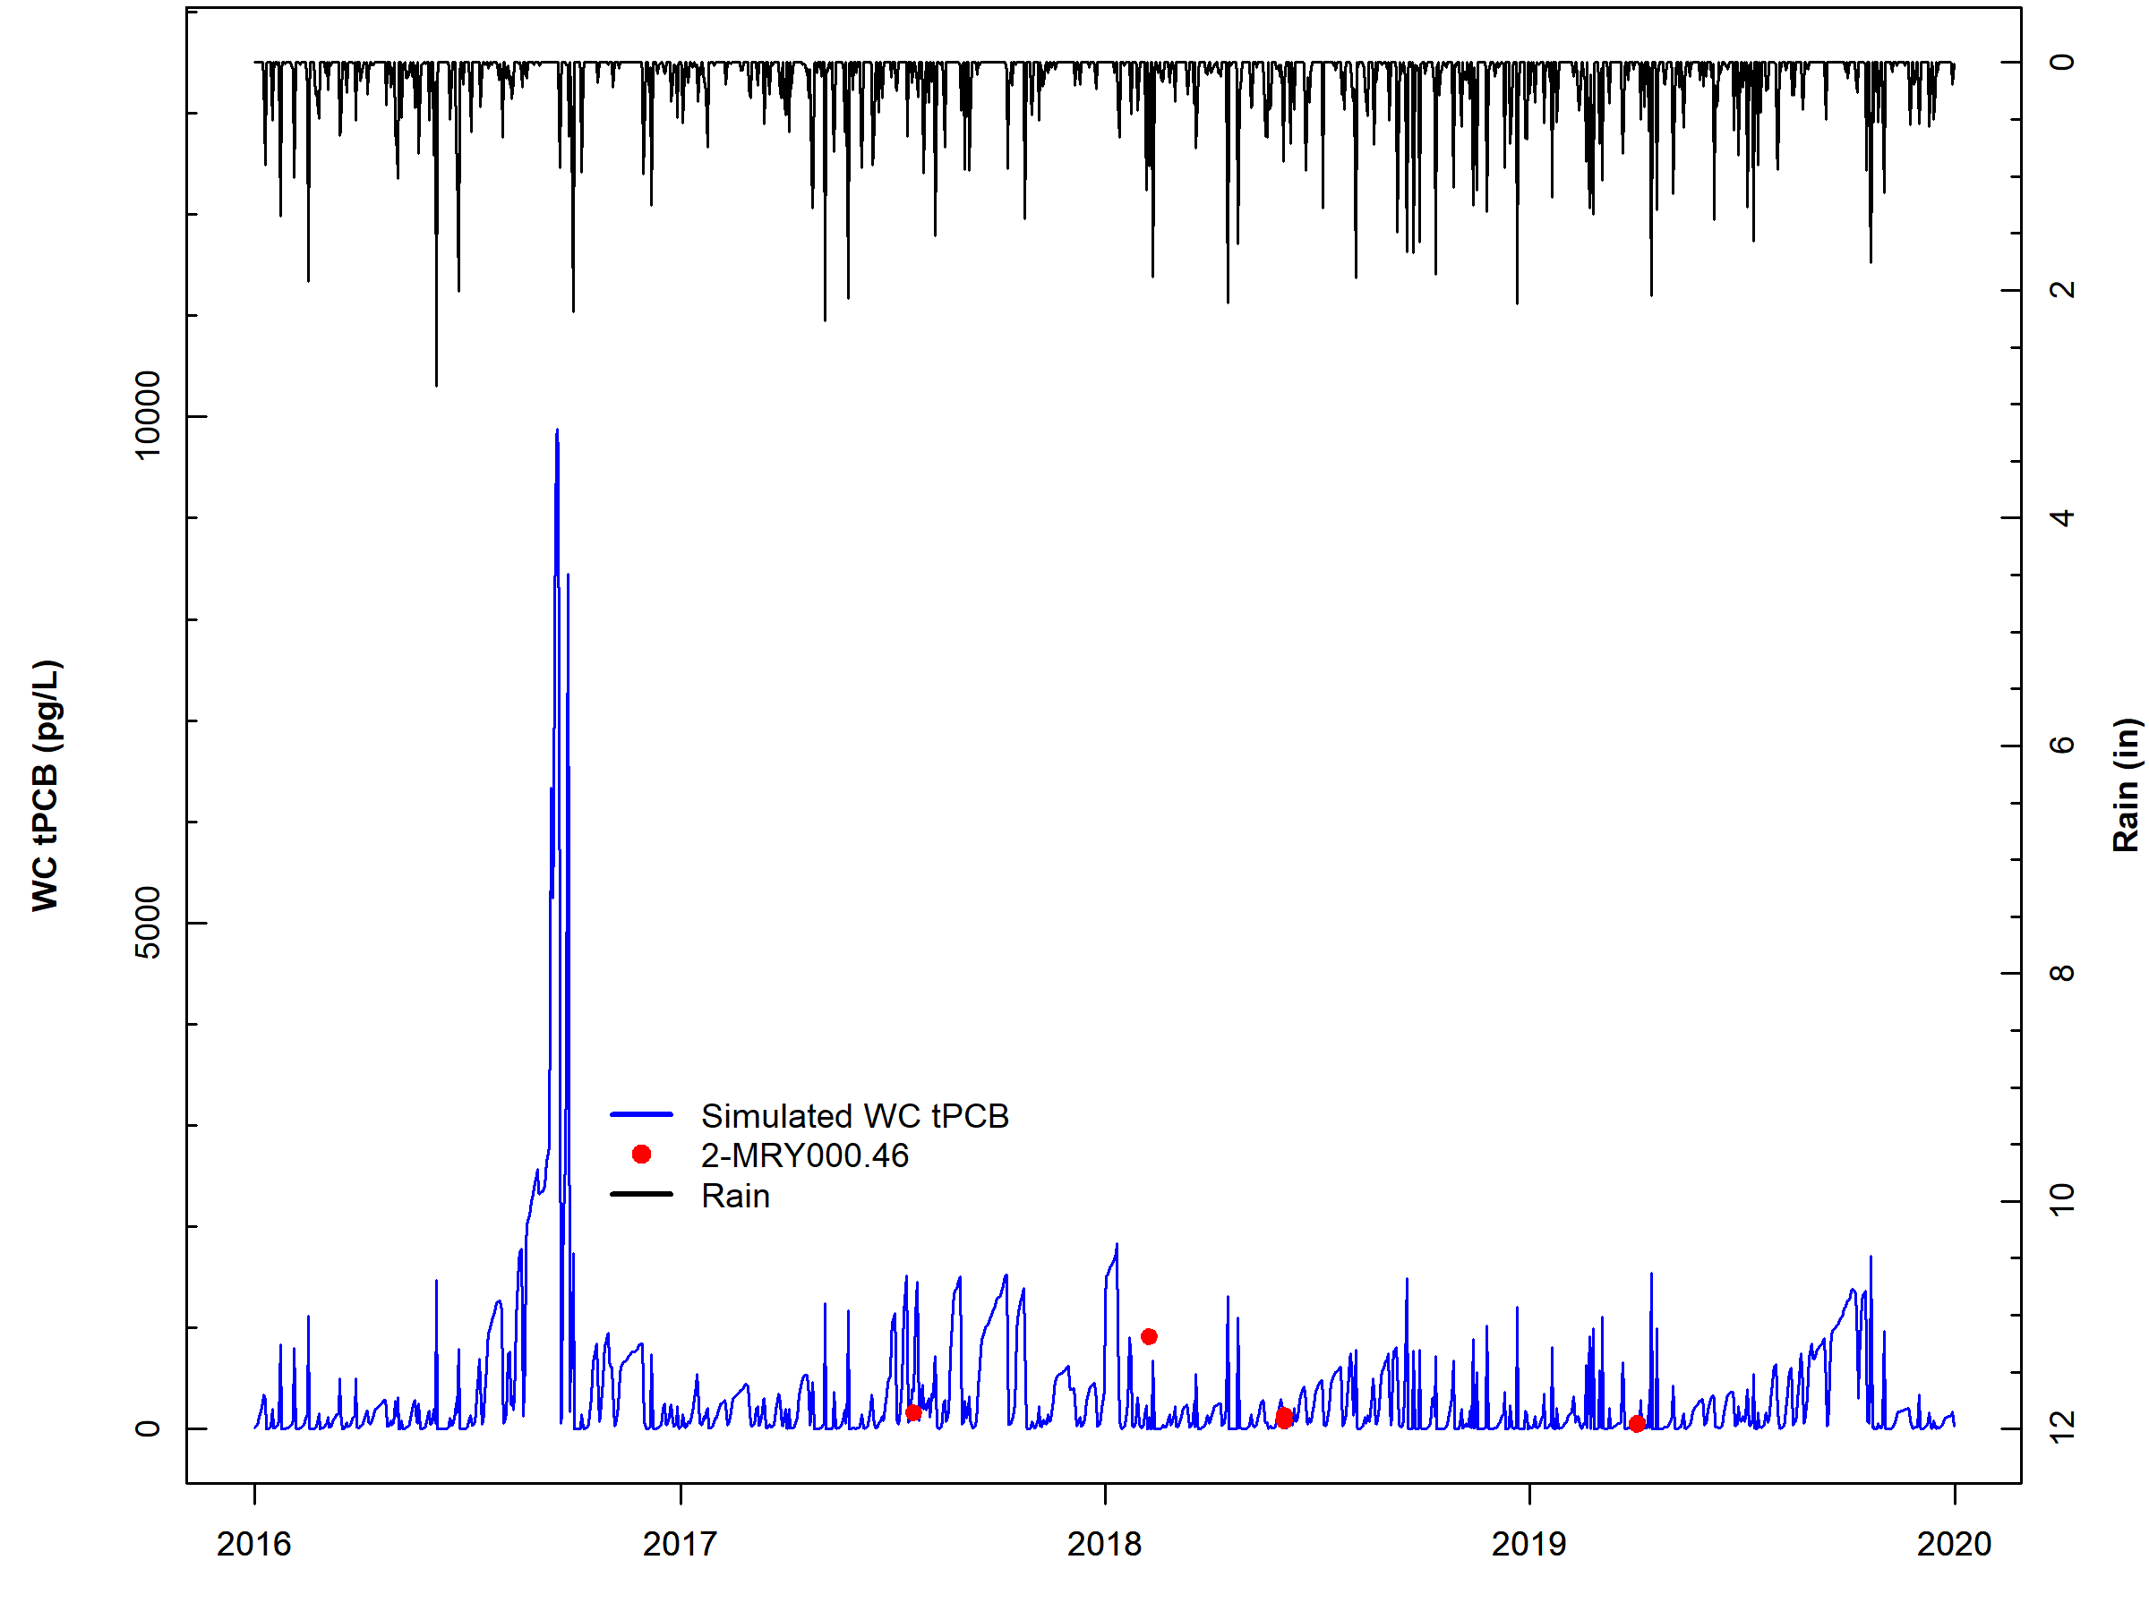
Figure F-4. Comparison of observed water column PCB concentrations, simulated water column PCB concentrations, and observed rainfall for subwatershed reach 1 in Maury River.

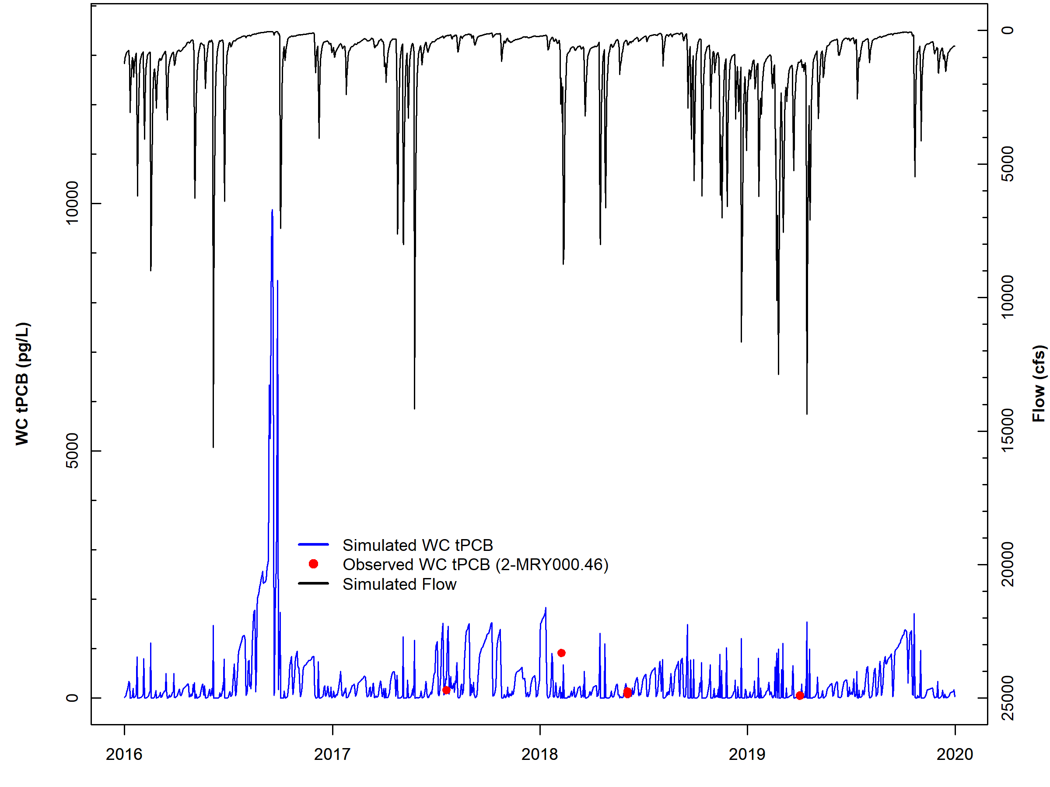
Figure F-5. Comparison of observed water column PCB concentrations, simulated water column PCB concentrations, and simulated flow for subwatershed reach 1 in Maury River.

Five-day Window Performance Assessment
Figure F-6 shows the 5-day windows and observed data for Maury River reach number one (outlet). All observed data points for reach one were within the 5-day windows. The 5-day window plots for the other Maury River water quality calibration stations can be provided upon request by referring to the contact information on page ii. Table F-7 includes the results of the 5-day window calibration analysis for all Maury River calibration reaches. Results show that across all stations, 87.5% of the observed data were within a 5-day window, exceeding the 50% calibration threshold goal, and also 12.5% of the data were above the 5-day windows respectively, indicating that the model is not exhibiting bias.

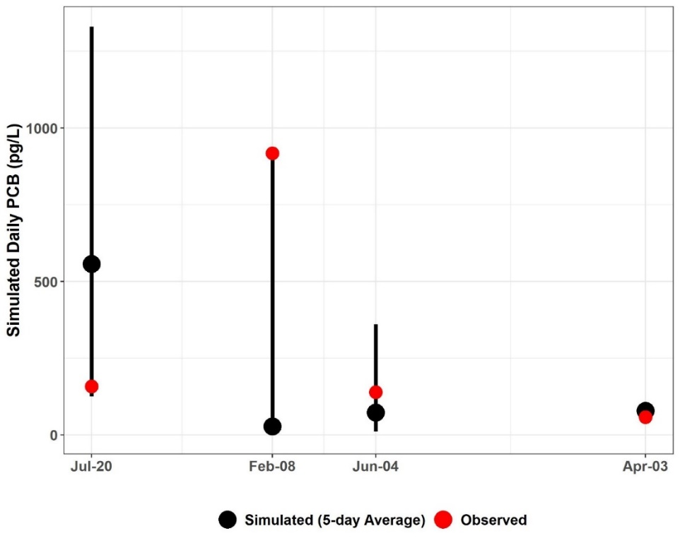
Figure F-6. Five-day window plots for water column PCB concentrations showing the 5-day average, max, and min, and observed values at station 2-MRY000.46 (Maury River subwatershed reach 1).

Table F-7. Simulated water column PCB concentrations (pg/L), 5-day calibration windows, and observed PCB concentrations (pg/L) for Maury River
Subwatershed | Station ID | Date | Observed Water Column PCB | Simulated | 5-Day Max. | 5-Day Min.
 |  |  |  | 5-Day Average
1 | 2-MRY000.46 | 7/20/2017 | 157.83 | 314.18 | 9671.73 | 115.39
1 | 2-MRY000.46 | 2/8/2018 | 917.44 | 355.37 | 6099.03 | 74.92
1 | 2-MRY000.46 | 6/4/2018 | 139.22 | 923.97 | 43493.54 | 53.52
1 | 2-MRY000.46 | 4/3/2019 | 58.25 | 59.28 | 109.14 | 55.54
9 | 2-MRY015.80 | 7/20/2017 | 119.57 | 56.92 | 1991.41 | 10.92
9 | 2-MRY015.80 | 2/8/2018 | 547.35 | 142.28 | 3446.74 | 11.90
9 | 2-MRY015.80 | 6/4/2018 | 75.93 | 256.26 | 10536.16 | 11.59
9 | 2-MRY015.80 | 4/3/2019 | 75.05 | 11.23 | 11.54 | 11.10
 |  |  |  | Within 5-Day Range | Above 5-Day Range | Below 5-Day Range
 |  |  | PERCENT | 87.5% | 12.5% | 0%

Calibration Summary
The “weight-of-evidence” approach used for the Maury River HSPF PCB model calibration sufficiency assessment included a qualitative, visual examination of the PCB concentration time series graphs and the 5-day calibration window assessment. Based on these analyses of instream PCB concentration response to precipitation and flow conditions, BSE concludes that the Maury River HSPF PCB TMDL model was sufficiently well calibrated to adequately simulate in-stream PCB concentrations. The PCB calibration parameters are shown in Table F-8.

Table F-8. Final calibrated parameters for the Maury River PCB Calibration
Parameter | Definition | Units | FINAL  CALIBRATION VALUE | POSSIBLE RANGE OF VALUES^{ǂ} | CALCULATION METHOD^{ǂ}
PERLND/IMPLNDª
QUAL-INPUT (Nonseasonal Sediment-Associated Quality Constituent Parameters)
POTFW^{b} | Washoff potency factor (unregulated surface sources¹) | pg/ton | 2.39E+09 – 3.14E+14 | 0.0 - Inf. | Calibrated
POTFW^{b} | Washoff potency factor (contaminated sites) | pg/ton | 7.02E+10 – 1.29E+12 | 0.0 - Inf. | Approximated from previous PCB TMDLs^{c}  Estimated from observed sampling data
RCHRES^{e}
GQ-KD (Adsorption Coefficients of PCB Quality Constituent)
ADPM1-ADPM3 | Adsorption coefficients for suspended sediment | L/mg | Sand: 0.002 – 0.008^{f};  Silt: 0.039 – 0.145^{f};  Clay: 0.066 – 0.246^{f} | 1.0E-10 - Inf. | Derived from observed water column samples with PCB homolog and TOC data,  Calibrated
ADPM4-ADPM6 | Adsorption coefficients for bed sediment | L/mg | Sand: 1.0 – 5.6^{f},  Silt: 17.8 – 95.3^{f};  Clay: 30.2– 162.0^{f} | 1.0E-10 - Inf. | Derived from observed sediment samples with PCB homolog and TOC data,  Calibrated
GQ-ADRATE (Adsorption/Desorption Rate Parameters)
ADPM1-ADPM3 | Adsorption/desorption rates for suspended sediment | 1/day | 0.7896 | 1.0E-05 - Inf. | Derived from observed water column samples with PCB homolog data, Applied to entire calibration segment
ADPM4-ADPM6 | Adsorption/desorption rates for bed sediment | 1/day | 1.0E-05 | 1.0E-05 - Inf. | Assumed approx. zero as in previous PCB TMDLs^{c}
GQ-SEDCONC (Initial PCB Concentrations on Sediment)
SQAL1-SQAL4 | Initial PCB concentrations on suspended sediment | pg/mg | 0 | 0.0 - Inf. | Assumed zero as in previous PCB TMDLs^{c}
SQAL5-SQAL6 | Initial PCB concentrations on bed sediment | pg/mg | 0.01 | 0.0 - Inf. | Estimated in observed sediment sample data, Calibrated
MONTH-DATA | PCB atmospheric deposition rate on water surface | pg/ac/mo-nth | 3.0E+06 | N/A | Initial value based on Chesapeake Bay Toxics Report^{g}, Calibrated
^{ǂ} Acquired from HSPF Version 12.2 User’s Manual
¹ Unregulated surface sources represent the sum of net atmospheric deposition to land surfaces, loads from small tributaries that are not specified in the model, unregulated stormwater runoff, loads from unidentified contaminated sites, and unspecified point source discharges
ª Pervious and Impervious land segment
^{b} Includes the atmospheric deposition on the land surface
^{c} DEQ, 2009. Roanoke River PCB TMDL., DEQ, 2018 New River PCB TMDL
^{d} Varies between contaminated sites
^{e} Main stem of stream in each subwatershed
^{f} Varies by calibration segment reach
^{g} CBP, 1999. Chesapeake Bay Basin Toxics Loading and Release Inventory.

Table F-9 provides an estimate of the contributions from the different source categories to the annual PCB loading (mg/yr) in the stream. These contributions include loadings to unregulated land surface (atmospheric deposition, unregulated stormwater runoff, loads from unidentified contaminated sites, unspecified point source discharges), contaminated sites (including railyards and electric substations), direct loading to the stream (atmospheric deposition to water surfaces and permitted sources), instream contaminated streambed sediment, and spill sites. The “percent of total load” column shows the portion of the PCB load (mg) that originates from a particular PCB source; it does not describe the fate of the PCBs once they enter the stream/river reach.

Table F-9. Estimated existing annual source PCB loads for Maury River during the allocation period (2011).
Source | Estimated Load  (mg/yr) | Percent of total load (%)
Streambed Sediment | 1 | <1
Spills | <1 | <1
Contaminated Sites | 118 | <1
Permitted | 34,593 | 7
Atmospheric Deposition | 44 | <1
Surface Load - Unregulated¹ | 467,552 | 93
Total | 502,308 | –
¹ Unregulated surface sources represent the sum of net atmospheric deposition to land surfaces, loads from small tributaries that are not specified in the model, unregulated stormwater runoff, loads from unidentified contaminated sites, and unspecified point source discharges

Table F-10 shows the contribution (in percent) of the various PCB sources to the in-stream PCB concentration at the outlet (pg/L). The largest source of PCBs is unregulated surface sources, followed by permitted sources followed by.

Table F-10. Estimated existing relative contributions of different PCB sources to the overall tPCB concentration at the Maury River outlet during the allocation period (2011).
Source | Mean Daily Water Column tPCB Concentrations by Source (pg/L) | Relative Contribution by Source (%)
All Sources | 657 | –
Surface Load - Unregulated¹ | 555 | 84
Streambed Sediment | <1 | <1
Atmospheric Deposition | <1 | <1
Spills | <1 | <1
Contaminated Sites | <1 | <1
Permitted | 102 | 16
¹Unregulated surface sources represent the sum of net atmospheric deposition to land surfaces, loads from small tributaries that are not specified in the model, unregulated stormwater runoff, loads from unidentified contaminated sites, and unspecified point source discharges.

Upper James River PCB Calibration Results
This section presents the HSPF PCB calibration for the Upper James River TMDL watershed that includes: Cowpasture River, Craig Creek, Catawba Creek, portions of the James River, and Fishing Creek. The calibration results are summarized in tabular format for the entire watershed and graphed for a representative subwatershed reach. Figure E-18 illustrates the location of the subwatersheds that will be discussed as well as the observed PCB water quality stations.

PCB Calibration: James River – Cowpasture, Catawba, Craig Creek
This section of calibration results for James River – Cowpasture, Catawba, Craig Creeks are collectively referred to as “Upper James River”. PCB model calibration was an iterative process in which adjustments were made to the calibration parameters. After executing the model, the results were analyzed, and the parameters were adjusted again. The results of the model were analyzed using the “weight-of-evidence” metrics discussed previously.

PCB Concentration Time Series Graphs
Figure F-7 and Figure F-8 illustrate the comparison of daily average simulated PCB concentrations and observed water column PCB concentrations for reach number three which is close to the outlet of Upper James River. These graphs show that the simulated PCB concentration responded to fluctuations in rainfall and simulated flow. The model adequately simulated instream PCB concentrations in response to extreme rainfall and peak flow event. These plots illustrate that the simulated PCB concentrations followed a pattern of increasing and decreasing similar to the observed data. Further, the model adequately reflects the baseflow PCB concentrations and peak observed concentrations. Time series graphs for the other Upper James River water quality calibration stations and their corresponding reaches can be provided by BSE upon request by referring to the contact information on page ii.
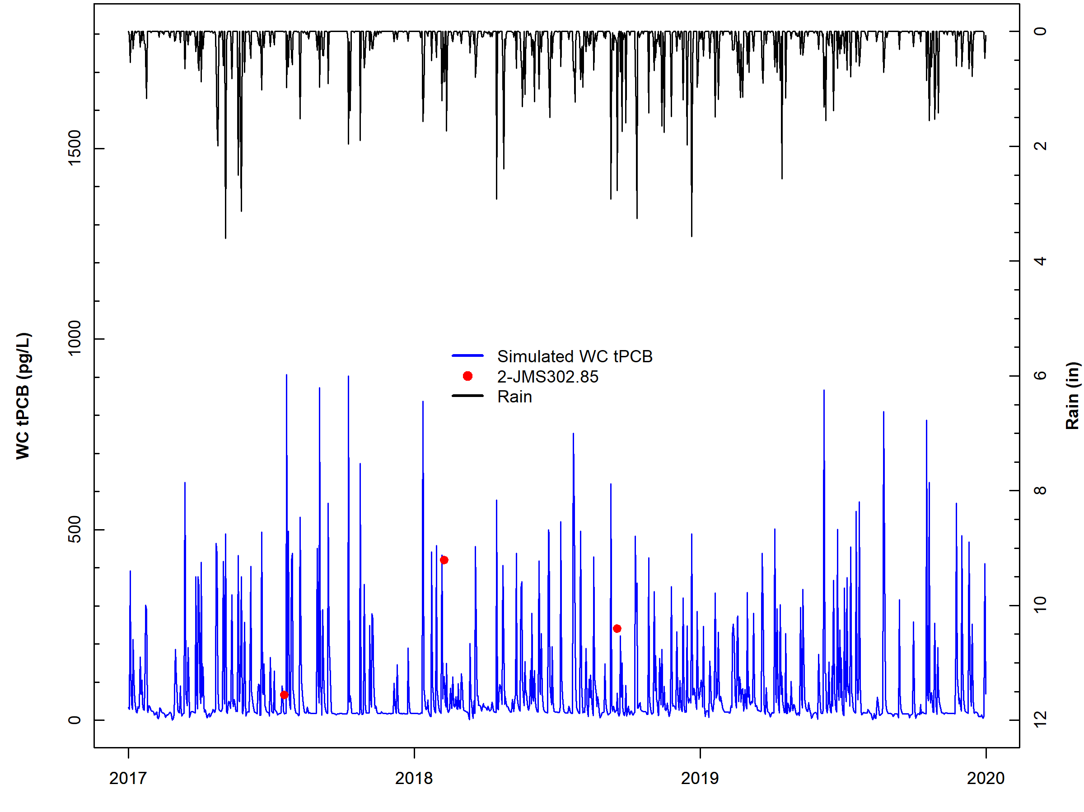
Figure F-7. Comparison of observed water column PCB concentrations, simulated water column PCB concentrations, and observed rainfall for subwatershed reach 3 in Upper James River.

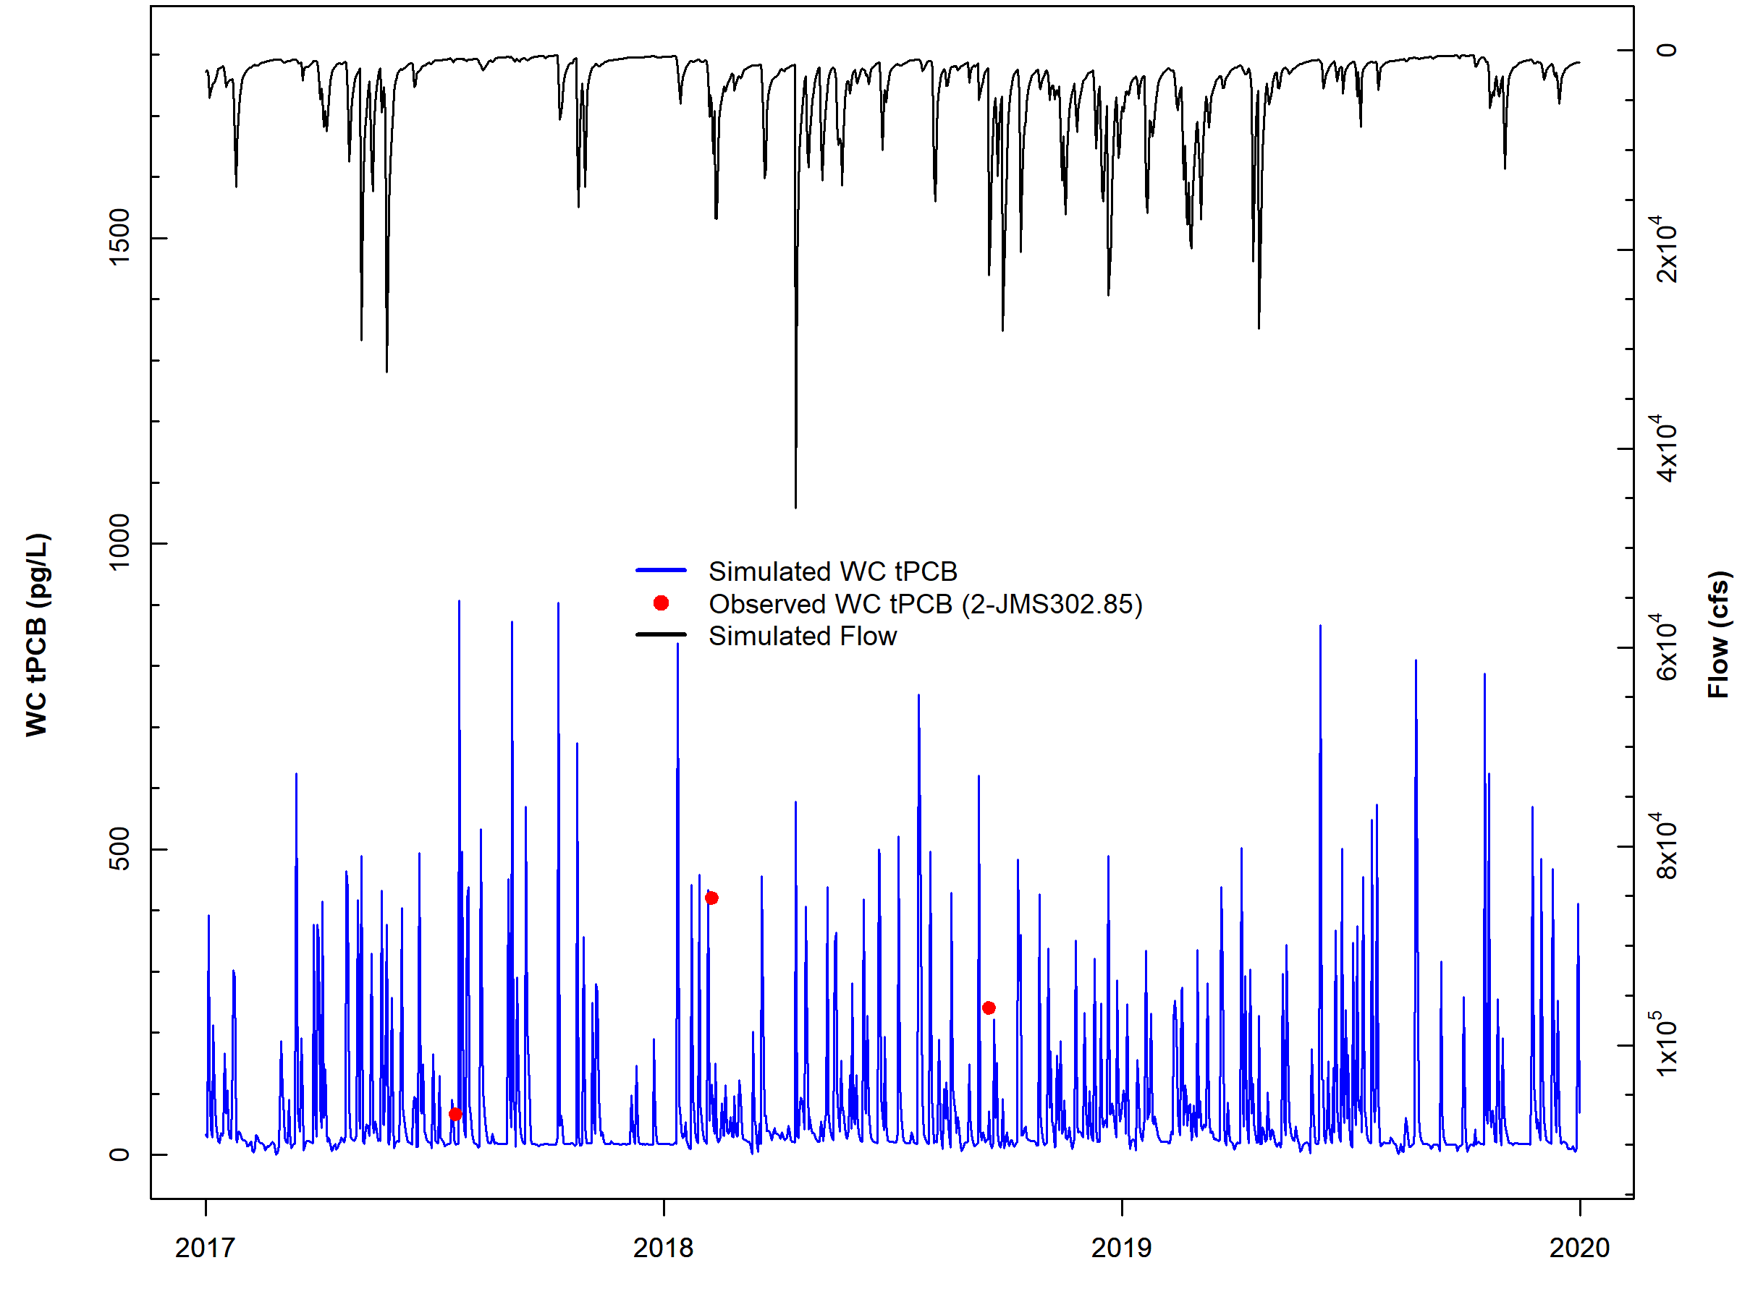
Figure F-8. Comparison of observed water column PCB concentrations, simulated water column PCB concentrations, and simulated flow for subwatershed reach 3 in Upper James River.

Five-day Window Performance Assessment
Figure F-9 shows the 5-day windows and observed data for Upper James River reach number one (outlet). Two of the three observed data points for reach three were within the 5-day windows. The 5-day window plots for the other Upper James River water quality calibration stations can be provided upon request by referring to the contact information on page ii. Table F-11 includes the results of the 5-day window calibration analysis for all Upper James River calibration reaches. Results show that across all stations, 93.3% of the observed data were within a 5-day window, exceeding the 50% calibration threshold goal, and also only 6.7% of the data were above the 5-day windows respectively, indicating that the model is not exhibiting bias.

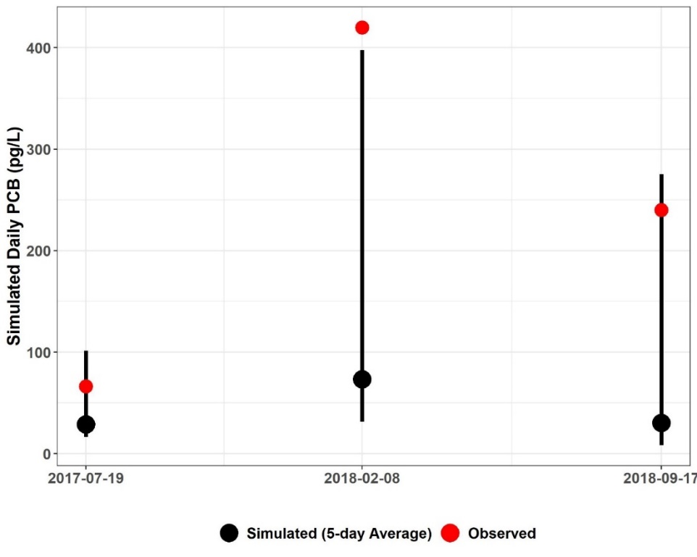
Figure F-9. Five-day window plots for water column PCB concentrations showing the 5-day average, max, and min, and observed values at station 2-JMS302.85 (Upper James River subwatershed reach 3).

Table F-11. Simulated water column PCB concentrations (pg/L), 5-day calibration windows, and observed PCB concentrations (pg/L) for Upper James River.
Subwatershed | Station ID | Date | Observed Water Column PCB | Simulated | 5-Day Max. | 5-Day Min.
 |  |  |  | 5-Day Average
3 | 2-JMS302.85 | 7/19/2017 | 66.50 | 457.77 | 4249.22 | 20.35
3 | 2-JMS302.85 | 2/8/2018 | 419.85 | 637.25 | 2519.88 | 102.85
3 | 2-JMS302.85 | 9/17/2018 | 240.20 | 518.66 | 1971.77 | 36.68
5 | 2-JMS309.13 | 2/8/2018 | 510.73 | 521.30 | 2694.65 | 63.00
5 | 2-JMS309.13 | 9/17/2018 | 238.60 | 614.80 | 7348.93 | 58.20
5 | 2-JMS309.13 | 12/7/2018 | 56.93 | 56.27 | 127.44 | 45.06
8 | 2-JMS317.62 | 9/17/2018 | 396.63 | 367.72 | 1343.68 | 48.87
10 | 2-CAT000.34 | 2/8/2018 | 189.90 | 74.88 | 680.33 | 5.11
21 | 2-CRG001.20 | 2/8/2018 | 246.89 | 189.43 | 477.10 | 29.03
21 | 2-CRG001.20 | 9/17/2018 | 125.47 | 363.01 | 2157.09 | 3.02
33 | 2AJMS334.47 | 9/17/2018 | 446.91 | 133.07 | 1326.95 | 6.07
37 | 2-JMS345.73 | 7/19/2017 | 121.13 | 72.83 | 73.69 | 71.94
37 | 2-JMS345.73 | 2/8/2018 | 167.18 | 169.73 | 3029.89 | 12.98
37 | 2-JMS345.73 | 9/17/2018 | 310.93 | 63.02 | 382.22 | 8.96
37 | 2-JMS345.73 | 12/7/2018 | 63.38 | 63.33 | 64.31 | 62.52
 |  |  |  | Within 5-Day Range | Above 5-Day Range | Below 5-Day Range
 |  |  | PERCENT | 93.9% | 6.7% | 0%

Calibration Summary: James River – Cowpasture River, Catawba, Craig Creeks
The “weight-of-evidence” approach used for the Upper James River HSPF PCB model calibration sufficiency assessment included a qualitative, visual examination of the PCB concentration time series graphs and the 5-day calibration window assessment. Based on these analyses of instream PCB concentration response to precipitation and flow conditions, BSE concludes that the Upper James River HSPF PCB TMDL model was sufficiently well calibrated to adequately simulate in-stream PCB concentrations. The PCB calibration parameters are shown in Table F-12.

Table F-12. Final calibrated parameters for the Upper James River PCB Calibration.
Parameter | Definition | Units | FINAL  CALIBRATION VALUE | POSSIBLE RANGE OF VALUES^{ǂ} | CALCULATION METHOD^{ǂ}
PERLND/IMPLNDª
QUAL-INPUT (Nonseasonal Sediment-Associated Quality Constituent Parameters)
POTFW^{b} | Washoff potency factor (unregulated surface sources¹) | pg/ton | 2.39E+09 – 1.00E+13 | 0.0 - Inf. | Calibrated
POTFW^{b} | Washoff potency factor (contaminated sites) | pg/ton | 7.02E+10 – 1.29E+12 | 0.0 - Inf. | Approximated from previous PCB TMDLs^{c}  Estimated from observed sampling data
RCHRES^{e}
GQ-KD (Adsorption Coefficients of PCB Quality Constituent)
ADPM1-ADPM3 | Adsorption coefficients for suspended sediment | L/mg | Sand: 0.01 – 0.06^{f};  Silt: 0.01 – 1.0^{f};  Clay: 0.4 – 1.7^{f} | 1.0E-10 - Inf. | Derived from observed water column samples with PCB homolog and TOC data,  Calibrated
ADPM4-ADPM6 | Adsorption coefficients for bed sediment | L/mg | Sand: 0.003 – 0.095,  Silt: 0.025 – 1.611,  Clay: 0.043 – 2.74 | 1.0E-10 - Inf. | Derived from observed sediment samples with PCB homolog and TOC data,  Calibrated
GQ-ADRATE (Adsorption/Desorption Rate Parameters)
ADPM1-ADPM3 | Adsorption/desorption rates for suspended sediment | 1/day | 0.0987 – 3.158^{f} | 1.0E-05 - Inf. | Derived from observed water column samples with PCB homolog data, Applied to entire calibration segment
ADPM4-ADPM6 | Adsorption/desorption rates for bed sediment | 1/day | 1.0E-05 | 1.0E-05 - Inf. | Assumed approx. zero as in previous PCB TMDLs^{c}
GQ-SEDCONC (Initial PCB Concentrations on Sediment)
SQAL1-SQAL4 | Initial PCB concentrations on suspended sediment | pg/mg | 0.0 | 0.0 - Inf. | Assumed zero as in previous PCB TMDLs^{c}
SQAL5-SQAL6 | Initial PCB concentrations on bed sediment | pg/mg | 0.01 – 10.00 | 0.0 - Inf. | Estimated in observed sediment sample data, Calibrated
MONTH-DATA | PCB atmospheric deposition rate on water surface | pg/ac/mo-nth | 3.0E+06 | N/A | Initial value based on Chesapeake Bay Toxics Report^{g},  Calibrated
^{ǂ} Acquired from HSPF Version 12.2 User’s Manual
¹ Unregulated surface sources represent the sum of net atmospheric deposition to land surfaces, loads from small tributaries that are not specified in the model, unregulated stormwater runoff, loads from unidentified contaminated sites, and unspecified point source discharges
ª Pervious and Impervious land segment
^{b} Includes the atmospheric deposition on the land surface
^{c} DEQ, 2009. Roanoke River PCB TMDL., 2018 New River PCB TMDL
^{d} Varies between contaminated sites
^{e} Main stem of stream in each subwatershed
^{f} Varies by calibration segment reach
^{g} CBP, 1999. Chesapeake Bay Basin Toxics Loading and Release Inventory.

PCB Calibration: Upper James River – Fishing Creek
This section presents the HSPF PCB calibration for the Upper James River – Fishing Creek watershed. This is the furthest downstream modeled watershed within the Upper James River TMDL watershed. The calibration results are summarized in tabular format for the entire watershed and graphed for a representative subwatershed reach. Figure E-19 illustrates the location of the subwatersheds that will be discussed as well as the observed PCB water quality stations.
PCB model calibration was an iterative process in which adjustments were made to the calibration parameters. After executing the model, the results were analyzed, and the parameters were adjusted again. The results of the model were analyzed using the “weight-of-evidence” metrics discussed previously.

PCB Concentration Time Series Graphs
Figure F-10 and Figure F-11 illustrate the comparison of daily average simulated PCB concentrations and observed water column PCB concentrations for reach number three which is close to the outlet of the Upper James River – Fishing Creek watershed. These graphs show that the simulated PCB concentration responded to fluctuations in rainfall and simulated flow. The model adequately simulated instream PCB concentrations in response to extreme rainfall and peak flow events. These plots illustrate that the simulated PCB concentrations followed a pattern of increasing and decreasing similar to the observed data. Further, the model adequately reflects the baseflow PCB concentrations and peak observed concentrations. Time series graphs for the other Upper James River – Fishing Creek water quality calibration stations and their corresponding reaches can be provided by BSE upon request by referring to the contact information on page ii.
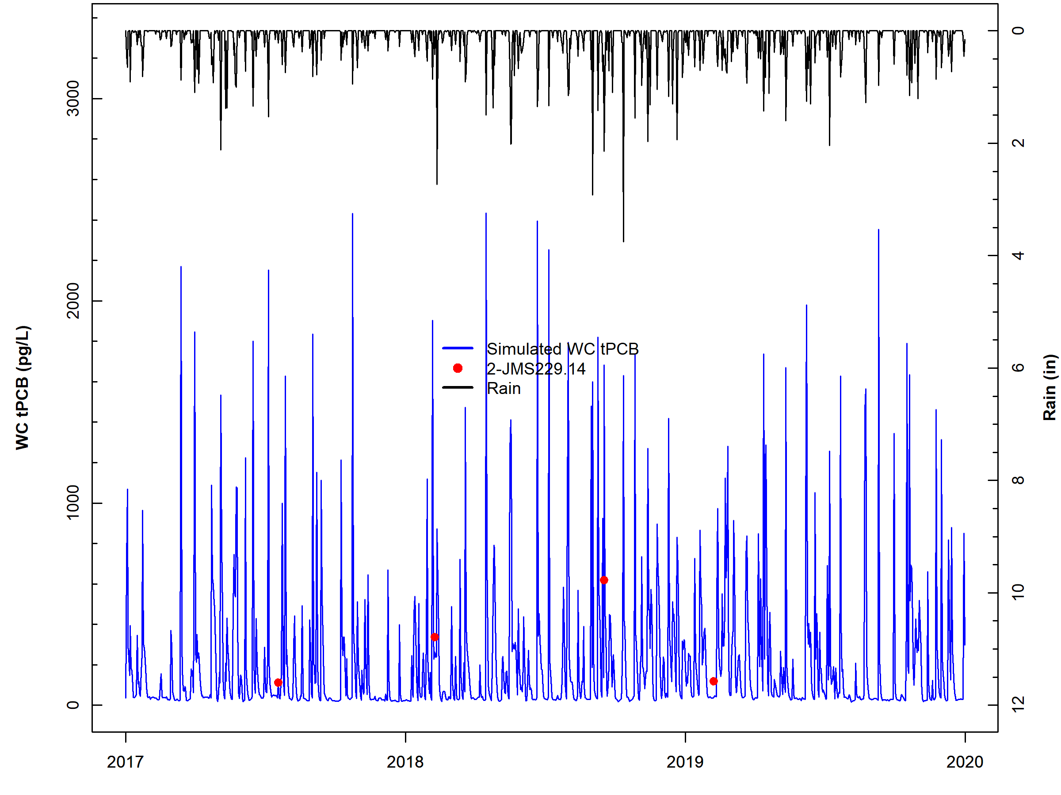
Figure F-10. Comparison of observed water column PCB concentrations, simulated water column PCB concentrations, and observed rainfall for subwatershed reach 1 in Upper James River – Fishing Creek.

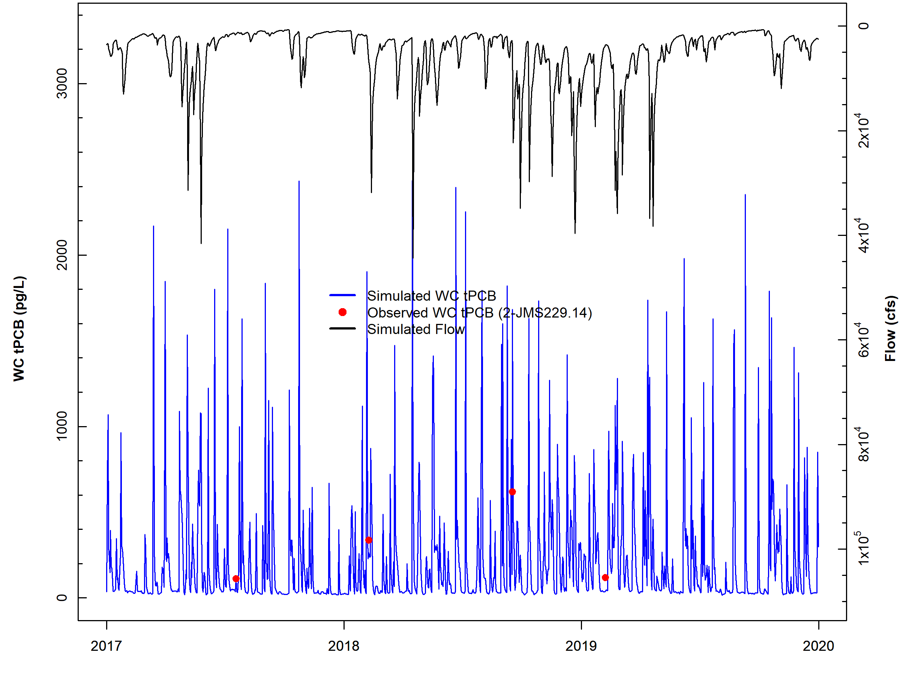
Figure F-11. Comparison of observed water column PCB concentrations, simulated water column PCB concentrations, and simulated flow for subwatershed reach 1 in Upper James River – Fishing Creek.

Five-day Window Performance Assessment
Figure F-12 shows the 5-day windows and observed data for Upper James River –Fishing Creek watershed reach number one (outlet). Two of the three observed data points for reach three were within the 5-day windows. The 5-day window plots for the other Upper James River – Fishing Creek water quality calibration stations can be provided upon request by referring to the contact information on page ii. Table F-15 includes the results of the 5-day window calibration analysis for all Upper James River – Fishing Creek calibration reaches. Results show that across all stations, 81% of the observed data were within a 5-day window, exceeding the 50% calibration threshold goal and while the model under-predicted some of the PCB data as indicated by the high percentage of ‘above’ values for the 5-day windows, overall the model performed well. Despite the sparsity of the observed data, the results of the calibration window analysis indicate that the model is sufficiently well-calibrated.

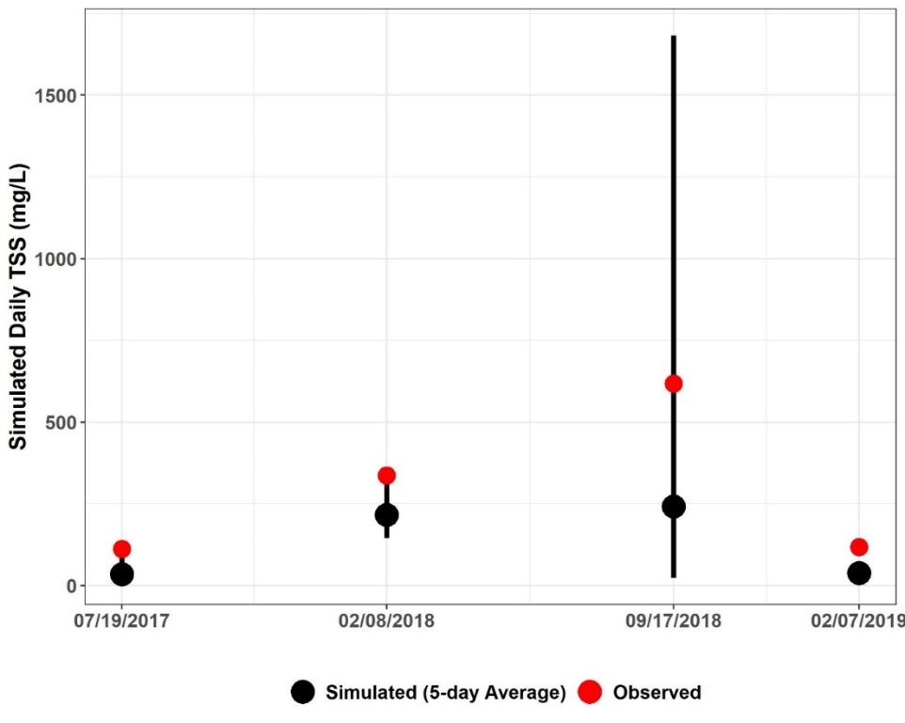
Figure F-12. Five-day window plots for water column PCB concentrations showing the 5-day average, max, and min, and observed values at station 2-JMS229.14 (Upper James River – Fishing Creek subwatershed reach 3).

Table F-13. Simulated water column PCB concentrations (pg/L), 5-day calibration windows, and observed PCB concentrations (pg/L) for Upper James River – Fishing Creek
Subwatershed | Station ID | Date | Observed Water Column PCB | Simulated | 5-Day Max. | 5-Day Min.
 |  |  |  | 5-Day Average
1 | 2-JMS229.14 | 7/19/2017 | 112.07 | 48.47 | 98.75 | 37.40
1 | 2-JMS229.14 | 2/8/2018 | 337.03 | 227.57 | 374.10 | 154.77
1 | 2-JMS229.14 | 9/17/2018 | 618.39 | 226.71 | 821.74 | 28.08
1 | 2-JMS229.14 | 2/7/2019 | 118.06 | 51.93 | 75.27 | 40.68
6 | 2BJMS248.90 | 9/17/2018 | 228.28 | 54.87 | 289.39 | 9.03
6 | 2BJMS248.90 | 2/7/2019 | 67.62 | 171.41 | 269.56 | 30.77
7 | 2-BCR000.20 | 9/17/2018 | 1398.01 | 125.49 | 3164.00 | 2.86
9 | 2BWLM000.34 | 9/17/2018 | 3965.67 | 6019.39 | 201201.00 | 1.03
10 | 2BJMS255.91 | 9/17/2018 | 608.90 | 38.93 | 1354.93 | 1.23
10 | 2BJMS255.91 | 2/7/2019 | 213.40 | 177.45 | 306.90 | 8.40
11 | 2-FSG000.85 | 2/8/2018 | 2845.14 | 10766.06 | 197591.40 | 1744.72
11 | 2-FSG000.85 | 9/17/2018 | 8907.23 | 5648.65 | 207493.10 | 0.56
11 | 2-FSG000.85 | 2/7/2019 | 305.23 | 54.83 | 73.37 | 47.16
12 | 2-FSG003.36 | 9/17/2018 | 4511.99 | 5015.80 | 240761.00 | 3.87
12 | 2-FSG003.36 | 2/7/2019 | 630.03 | 61.56 | 106.55 | 48.10
13 | 2-JMS258.54 | 7/19/2017 | 222.03 | 45.11 | 389.89 | 20.45
13 | 2-JMS258.54 | 2/8/2018 | 614.76 | 95.85 | 970.34 | 29.99
13 | 2-JMS258.54 | 9/17/2018 | 3215.95 | 938.00 | 43850.30 | 9.75
13 | 2-JMS258.54 | 2/7/2019 | 128.36 | 172.94 | 283.09 | 25.61
14 | 2-BKW000.40 | 2/8/2018 | 595.31 | 27.14 | 665.67 | 10.98
14 | 2-BKW000.40 | 9/17/2018 | 4414.24 | 35.25 | 1543.43 | 2.38
14 | 2-BKW000.40 | 2/7/2019 | 147.17 | 3.02 | 3.17 | 2.87
15 | 2-IVA000.22 | 9/17/2018 | 592.01 | 72.72 | 1784.92 | 10.23
16 | 2-BKW005.95 | 9/17/2018 | 5616.64 | 138.34 | 6164.00 | 3.25
20 | 2BJMS263.24 | 7/19/2017 | 151.61 | 62.99 | 333.90 | 23.02
20 | 2BJMS263.24 | 2/8/2018 | 183.7 | 55.83 | 190.39 | 24.49
20 | 2BJMS263.24 | 9/17/2018 | 660.12 | 69.38 | 1031.64 | 7.01
20 | 2BJMS263.24 | 2/7/2019 | 115.79 | 232.84 | 404.33 | 28.77
21 | 2-JMS270.84 | 7/19/2017 | 106.34 | 12.31 | 366.88 | 4.89
21 | 2-JMS270.84 | 2/8/2018 | 457.17 | 37.11 | 676.68 | 6.58
21 | 2-JMS270.84 | 9/17/2018 | 600.84 | 23.28 | 665.86 | 2.97
21 | 2-JMS270.84 | 2/7/2019 | 111.16 | 4.66 | 4.70 | 4.61
25 | 2BJMS273.86 | 2/7/2019 | 122.72 | 226.68 | 448.63 | 3.42
28 | 2-JMS279.41 | 7/19/2017 | 86.26 | 216.93 | 958.17 | 10.14
28 | 2-JMS279.41 | 2/8/2018 | 520.03 | 21.59 | 557.82 | 2.21
28 | 2-JMS279.41 | 9/17/2018 | 829.88 | 141.73 | 2301.66 | 0.56
28 | 2-JMS279.41 | 2/7/2019 | 100.06 | 472.46 | 1459.64 | 55.61
 |  |  |  | Within 5-Day Range | Above 5-Day Range | Below 5-Day Range
 |  |  | PERCENT | 81% | 19% | 0%

Calibration Summary: Upper James River – Fishing Creek
The “weight-of-evidence” approach used for the Upper James River – Fishing Creek HSPF PCB model calibration sufficiency assessment included a qualitative, visual examination of the PCB concentration time series graphs and the 5-day calibration window assessment. Based on these analyses of instream PCB concentration response to precipitation and flow conditions, BSE concludes that the Upper James River – Fishing Creek HSPF PCB TMDL model was sufficiently well calibrated to adequately simulate in-stream PCB concentrations. The PCB calibration parameters are shown in Table F-16.
Table F-17 provides an estimate of the contributions from the different source categories to the annual PCB loading (mg/yr) in the stream. These contributions include loadings to regulated land surface (MS4 service areas), unregulated land surface (atmospheric deposition, unregulated stormwater runoff, loads from unidentified contaminated sites, unspecified point source discharges), contaminated sites (including railyards and electric substations), direct loading to the stream (atmospheric deposition to water surfaces and permitted sources), instream contaminated streambed sediment, and spill sites. The “percent of total load” column shows the portion of the PCB load (mg) that originates from a particular PCB source; it does not describe the fate of the PCBs once they enter the stream/river reach.
Table F-18 shows the contribution (in percent) of the various PCB sources to the in-stream PCB concentration at the outlet (pg/L). The largest source of PCBs is unregulated and regulated surface sources, followed by permitted sources.

Table F-14. Final calibrated parameters for the James River—Fishing Creek PCB Calibration.
Parameter | Definition | Units | FINAL  CALIBRATION VALUE | POSSIBLE RANGE OF VALUES^{ǂ} | CALCULATION METHOD^{ǂ}
PERLND/IMPLNDª
QUAL-INPUT (Nonseasonal Sediment-Associated Quality Constituent Parameters)
POTFW^{b} | Washoff potency factor (surface sources – regulated and unregulated¹) | pg/ton | 2.39E+09 – 5.28E+13 | 0.0 - Inf. | Calibrated
POTFW^{b} | Washoff potency factor (contaminated sites) | pg/ton | 7.02E+10 – 1.29E+12 | 0.0 - Inf. | Approximated from previous PCB TMDLs^{c}  Estimated from observed sampling data
RCHRES^{e}
GQ-KD (Adsorption Coefficients of PCB Quality Constituent)
ADPM1-ADPM3 | Adsorption coefficients for suspended sediment | L/mg | Sand: 0.001 – 0. 301^{f};  Silt: 0.014 – 5.103^{f};  Clay: 0.024 – 8.676 | 1.0E-10 - Inf. | Derived from observed water column samples with PCB homolog and TOC data,  Calibrated
ADPM4-ADPM6 | Adsorption coefficients for bed sediment | L/mg | Sand: 0.006 – 0.783,  Silt: 0.101 – 13.280,  Clay: 0.176 – 22.576 | 1.0E-10 - Inf. | Derived from observed sediment samples with PCB homolog and TOC data,  Calibrated
GQ-ADRATE (Adsorption/Desorption Rate Parameters)
ADPM1-ADPM3 | Adsorption/desorption rates for suspended sediment | 1/day | 3.0564 | 1.0E-05 - Inf. | Derived from observed water column samples with PCB homolog data, Applied to entire calibration segment
ADPM4-ADPM6 | Adsorption/desorption rates for bed sediment | 1/day | 1.0E-05 | 1.0E-05 - Inf. | Assumed approx. zero as in previous PCB TMDLs^{c}
GQ-SEDCONC (Initial PCB Concentrations on Sediment)
SQAL1-SQAL4 | Initial PCB concentrations on suspended sediment | pg/mg | 0.0 | 0.0 - Inf. | Assumed zero as in previous PCB TMDLs^{c}
SQAL5-SQAL6 | Initial PCB concentrations on bed sediment | pg/mg | 0.01 | 0.0 - Inf. | Derived from observed sediment samples
MONTH-DATA | PCB atmospheric deposition rate on water surface | pg/ac/mo-nth | 3.0E+06 | N/A | Initial value based on Chesapeake Bay Toxics Report^{g}, Calibrated
^{ǂ} Acquired from HSPF Version 12.2 User’s Manual
¹ Surface sources represent the sum of net atmospheric deposition to land surfaces, loads from small tributaries that are not specified in the model, regulated and unregulated stormwater runoff, loads from unidentified contaminated sites, and unspecified point source discharges
ª Pervious and Impervious land segment
^{b} Includes the atmospheric deposition on the land surface
^{c} DEQ, 2009. Roanoke River PCB TMDL., 2018 New River PCB TMDL
^{d} Varies between contaminated sites
^{e} Main stem of stream in each subwatershed
^{f} Varies by calibration segment reach
^{g} CBP, 1999. Chesapeake Bay Basin Toxics Loading and Release Inventory.

Table F-15. Estimated existing annual source PCB loads for Upper James River – Fishing Creek during the allocation period (2010).
Source | Estimated Load  (mg/yr) | Percent of total load (%)
Upstream Sources | 81,796 | 13
Streambed Sediment | 203 | <1
Surface Load – Unregulated¹ | 310,099 | 50
Surface Load – Regulated¹ | 200,306 | 33
Atmospheric Deposition | 930 | <1
CSOs | 3,468 | <1
Spills | <1 | <1
Contaminated Sites | 1,403 | <1
Permitted | 15,754 | 3
Total | 310,099 | –
¹ Surface load sources represent the sum of net atmospheric deposition to land surfaces, loads from small tributaries that are not specified in the model, regulated and unregulated stormwater runoff, loads from unidentified contaminated sites, and unspecified point source discharges

Table F-16. Estimated existing relative contributions of different PCB sources to the overall tPCB concentration at the Upper James River – Fishing Creek outlet during the allocation period (2010).
Source | Mean Daily Water Column tPCB Concentrations by Source (pg/L) | Relative Contribution by Source (%)
All Sources | 290 | –
Upstream Sources | 27 | 9
Surface Load – Unregulated¹ | 158 | 54
Surface Load – Regulated¹ | 92 | 32
Atmospheric Deposition | <1 | <1
Streambed Sediment | <1 | <1
Spills | <1 | <1
Contaminated Sites | 1 | <1
Permitted | 9 | 3
CSOs | 2 | 1
¹Surface load sources represent the sum of net atmospheric deposition to land surfaces, loads from small tributaries that are not specified in the model, regulated and unregulated stormwater runoff, loads from unidentified contaminated sites, and unspecified point source discharges.

Lower James River PCB Calibration Results
This section presents the HSPF sediment calibration results for the Lower James River TMDL Watershed that include major tributary watersheds: Tye and Rockfish Rivers; Hardware, Slate, and Willis Rivers; Rivanna River, portions of the James River, and Reedy Creek. The calibration results are summarized in tabular format for the entire watershed and graphed for a representative subwatershed reach. Figure E-33 illustrates the location of the subwatersheds that will be discussed as well as the observed PCB water quality stations.

PCB Calibration: Lower James River – Tye and Rockfish River
This section presents the HSPF PCB calibration for the outlet located downstream of the Lower James River – Tye and Rockfish River watersheds. PCB model calibration was an iterative process in which adjustments were made to the calibration parameters. After executing the model, the results were analyzed, and the parameters were adjusted again. The results of the model were analyzed using the “weight-of-evidence” metrics discussed previously.

PCB Concentration Time Series Graphs
Figure F-13 and Figure F-14 illustrate the comparison of daily average simulated PCB concentrations and observed water column PCB concentrations for reach number two which is close to the outlet of Lower James River – Tye and Rockfish River. These graphs show that the simulated PCB concentration responded to fluctuations in rainfall and simulated flow. The model adequately simulated instream PCB concentrations in response to extreme rainfall and peak flow events. These plots illustrate that the simulated PCB concentrations followed a pattern of increasing and decreasing similar to the observed data. Further, the model adequately reflects the baseflow PCB concentrations and peak observed concentrations. Time series graphs for the other Lower James River – Tye and Rockfish River water quality calibration stations and their corresponding reaches can be provided by BSE upon request by referring to the contact information on page ii.
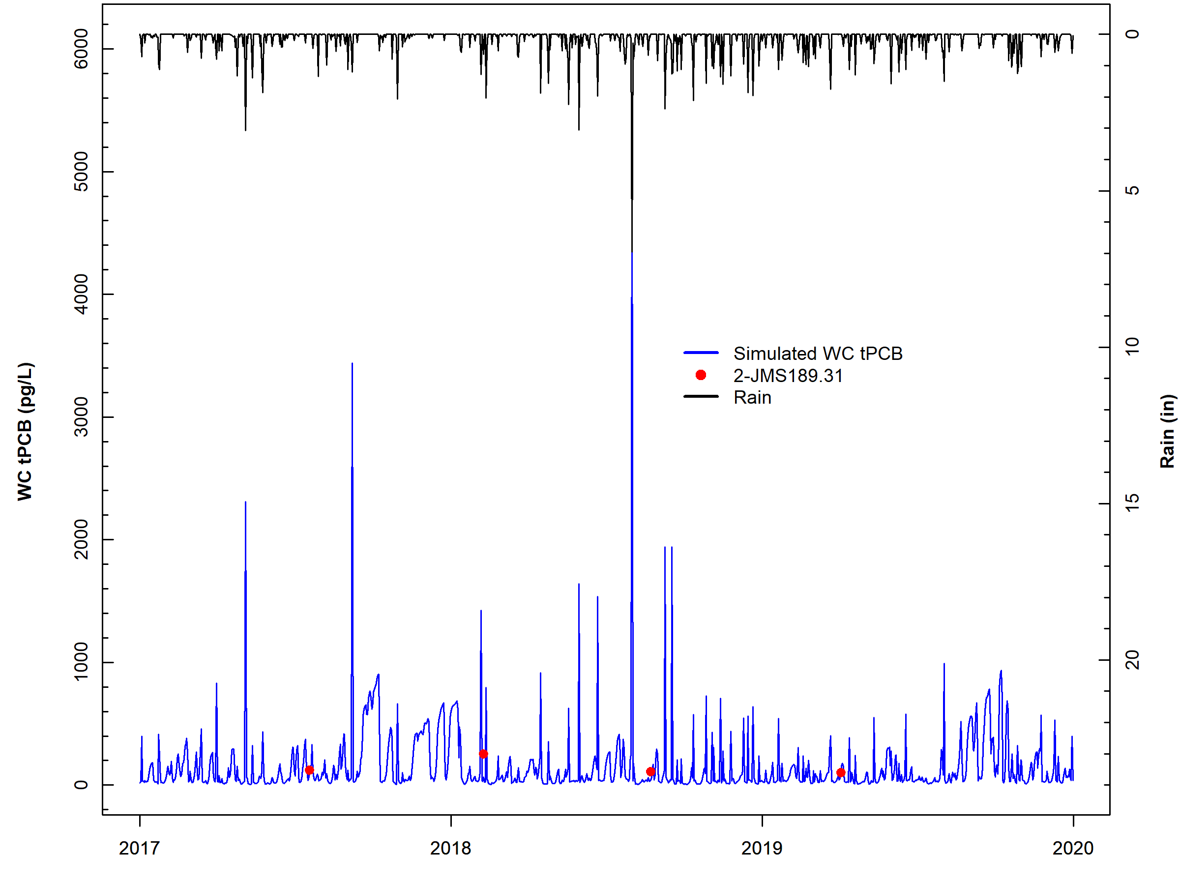
Figure F-13. Comparison of observed water column PCB concentrations, simulated water column PCB concentrations, and observed rainfall for subwatershed reach 2 in Lower James River – Tye and Rockfish River.

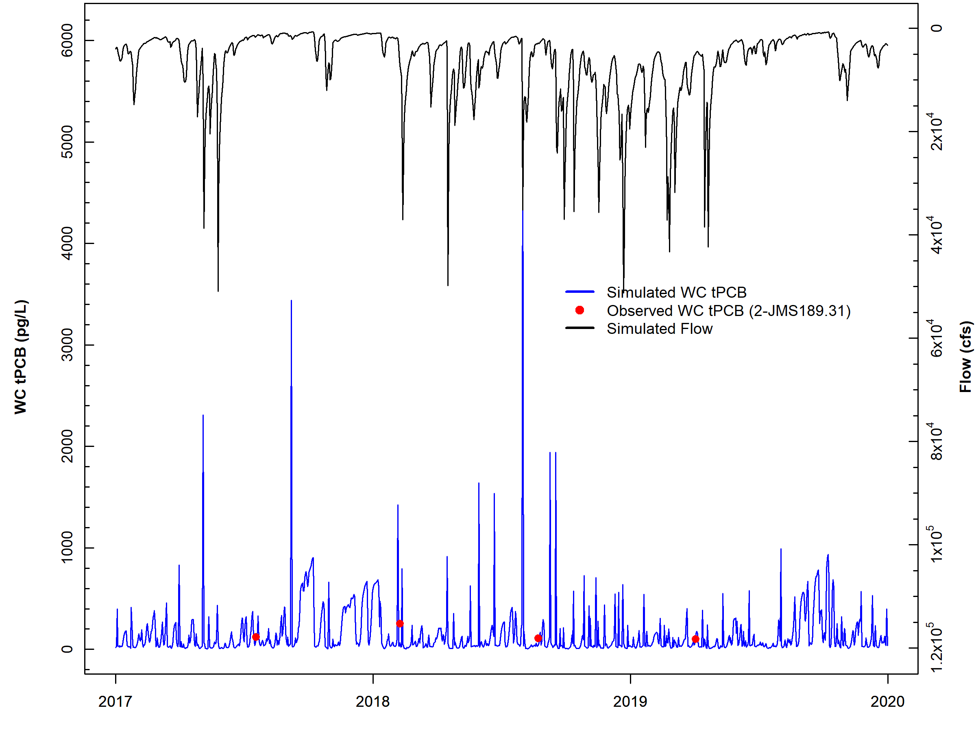
Figure F-14. Comparison of observed water column PCB concentrations, simulated water column PCB concentrations, and simulated flow for subwatershed reach 2 in Lower James River – Tye and Rockfish River.

Five-day Window Performance Assessment
Figure F-15 shows the 5-day windows and observed data for Lower James River – Tye and Rockfish River reach number one (outlet). All of the observed data points for reach four were within the 5-day windows. The 5-day window plots for the other Lower James River – Tye and Rockfish River water quality calibration stations can be provided upon request by referring to the contact information on page ii. Table F-19 includes the results of the 5-day window calibration analysis for all Lower James River – Tye and Rockfish River calibration reaches. Results show that across all stations, 85% of the observed data were within a 5-day window, exceeding the 50% calibration threshold goal and while the model over-predicted some of the PCB data as indicated by the high percentage of ‘below’ values for the 5-day windows, overall the model performed well. Despite the sparsity of the observed data, the results of the calibration window analysis indicate that the model is sufficiently well-calibrated.

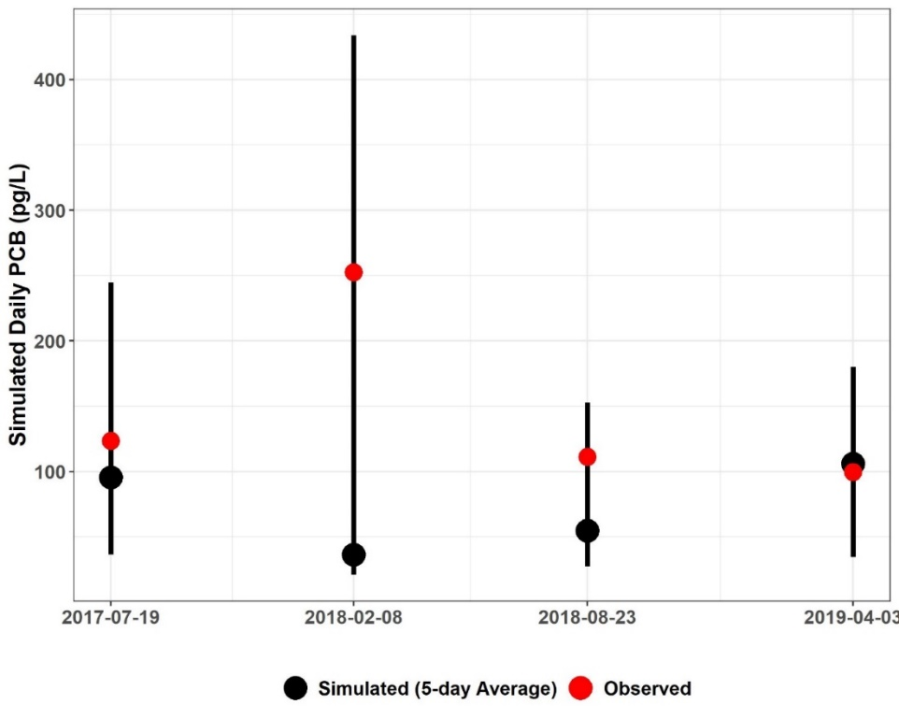
Figure F-15. Five-day window plots for water column PCB concentrations showing the 5-day average, max, and min, and observed values at station 2-JMS189.31 (Lower James River – Tye and Rockfish River subwatershed reach 3).

Table F-17. Simulated water column PCB concentrations (pg/L), 5-day calibration windows, and observed PCB concentrations (pg/L) for Lower James River – Tye and Rockfish River
Subwatershed | Station ID | Date | Observed Water Column PCB | Simulated | 5-Day Max. | 5-Day Min.
 |  |  |  | 5-Day Average
2 | 2-JMS189.31 | 7/19/2017 | 123.57 | 95.68 | 244.58 | 36.47
2 | 2-JMS189.31 | 2/8/2018 | 252.40 | 36.51 | 433.66 | 21.10
2 | 2-JMS189.31 | 8/23/2018 | 111.39 | 54.68 | 152.55 | 27.26
2 | 2-JMS189.31 | 4/3/2019 | 99.63 | 105.92 | 180.02 | 34.52
15 | 2BJMS214.35 | 2/8/2018 | 361.68 | 346.38 | 615.46 | 147.64
15 | 2BJMS214.35 | 8/23/2018 | 112.66 | 418.05 | 1626.36 | 217.58
24 | 2-BUF002.10 | 9/17/2018 | 2104.4 | 403.31 | 2146.93 | 8.42
 |  |  |  | Within 5-Day Range | Above 5-Day Range | Below 5-Day Range
 |  |  | PERCENT | 85% | 0% | 15%

Calibration Summary: Lower James River – Tye and Rockfish River
The “weight-of-evidence” approach used for the James River—Tye and Rockfish River HSPF PCB model calibration sufficiency assessment included a qualitative, visual examination of the PCB concentration time series graphs and the 5-day calibration window assessment. Based on these analyses of instream PCB concentration response to precipitation and flow conditions, BSE concludes that the James River—Tye and Rockfish River HSPF PCB TMDL model was sufficiently well calibrated to adequately simulate in-stream PCB concentrations. The PCB calibration parameters are shown in Table F-20.

Table F-18. Final calibrated parameters for the Lower James River – Tye and Rockfish River River PCB Calibration
Parameter | Definition | Units | FINAL  CALIBRATION VALUE | POSSIBLE RANGE OF VALUES^{ǂ} | CALCULATION METHOD^{ǂ}
PERLND/IMPLNDª
QUAL-INPUT (Nonseasonal Sediment-Associated Quality Constituent Parameters)
POTFW^{b} | Washoff potency factor (unregulated surface sources¹) | pg/ton | 2.39E+09 – 8.15E+12 | 0.0 - Inf. | Calibrated
POTFW^{b} | Washoff potency factor (contaminated sites) | pg/ton | 7.02E+10 – 1.29E+12 | 0.0 - Inf. | Approximated from previous PCB TMDLs^{c}  Estimated from observed sampling data
RCHRES^{e}
GQ-KD (Adsorption Coefficients of PCB Quality Constituent)
ADPM1-ADPM3 | Adsorption coefficients for suspended sediment | L/mg | Sand: 0.004 – 0.072^{f};  Silt: 0.073 – 1.227^{f};  Clay: 0.124 – 2.086^{f} | 1.0E-10 - Inf. | Derived from observed water column samples with PCB homolog and TOC data,  Calibrated
ADPM4-ADPM6 | Adsorption coefficients for bed sediment | L/mg | Sand: 0.07,  Silt: 1.25,  Clay: 2.12 | 1.0E-10 - Inf. | Derived from observed sediment samples with PCB homolog and TOC data,  Calibrated
GQ-ADRATE (Adsorption/Desorption Rate Parameters)
ADPM1-ADPM3 | Adsorption/desorption rates for suspended sediment | 1/day | 0.0595 | 1.0E-05 - Inf. | Derived from observed water column samples with PCB homolog data, Applied to entire calibration segment
ADPM4-ADPM6 | Adsorption/desorption rates for bed sediment | 1/day | 1.0E-05 | 1.0E-05 - Inf. | Assumed approx. zero as in previous PCB TMDLs^{c}
GQ-SEDCONC (Initial PCB Concentrations on Sediment)
SQAL1-SQAL4 | Initial PCB concentrations on suspended sediment | pg/mg | 0.0 | 0.0 - Inf. | Assumed zero as in previous PCB TMDLs^{c}
SQAL5-SQAL6 | Initial PCB concentrations on bed sediment | pg/mg | 21.66 | 0.0 - Inf. | Derived from observed sediment samples
MONTH-DATA | PCB atmospheric deposition rate on water surface | pg/ac/mo-nth | 3.0E+06 | N/A | Initial value based on Chesapeake Bay Toxics Report^{g},  Calibrated
^{ǂ} Acquired from HSPF Version 12.2 User’s Manual
¹Surface load sources represent the sum of net atmospheric deposition to land surfaces, loads from small tributaries that are not specified in the model, regulated and unregulated stormwater runoff, loads from unidentified contaminated sites, and unspecified point source discharges.
ª Pervious and Impervious land segment
^{b} Includes the atmospheric deposition on the land surface
^{c} DEQ, 2009. Roanoke River PCB TMDL., 2018 New River PCB TMDL
^{d} Varies between contaminated sites
^{e} Main stem of stream in each subwatershed
^{f} Varies by calibration segment reach
^{g} CBP, 1999. Chesapeake Bay Basin Toxics Loading and Release Inventory.

PCB Calibration: Lower James River – Hardware, Slate, and Willis Rivers
This section presents the HSPF PCB calibration for the outlet located downstream of the collective Lower James River –Hardware, Slate, and Willis Rivers watersheds. PCB model calibration was an iterative process in which adjustments were made to the calibration parameters. After executing the model, the results were analyzed, and the parameters were adjusted again. The results of the model were analyzed using the “weight-of-evidence” metrics discussed previously.

PCB Concentration Time Series Graphs
Figure F-16 and Figure F-17 illustrate the comparison of daily average simulated PCB concentrations and observed water column PCB concentrations for reach number one which is close to the outlet of Lower James River – Hardware, Slate, and Willis Rivers. These graphs show that the simulated PCB concentration responded to fluctuations in rainfall and simulated flow. The model adequately simulated instream PCB concentrations in response to extreme rainfall and peak flow events. These plots illustrate that the simulated PCB concentrations followed a pattern of increasing and decreasing similar to the observed data. Further, the model adequately reflects the baseflow PCB concentrations and peak observed concentrations. Time series graphs for the other Lower James River – Hardware, Slate, and Willis Rivers water quality calibration stations and their corresponding reaches can be provided by BSE upon request by referring to the contact information on page ii.
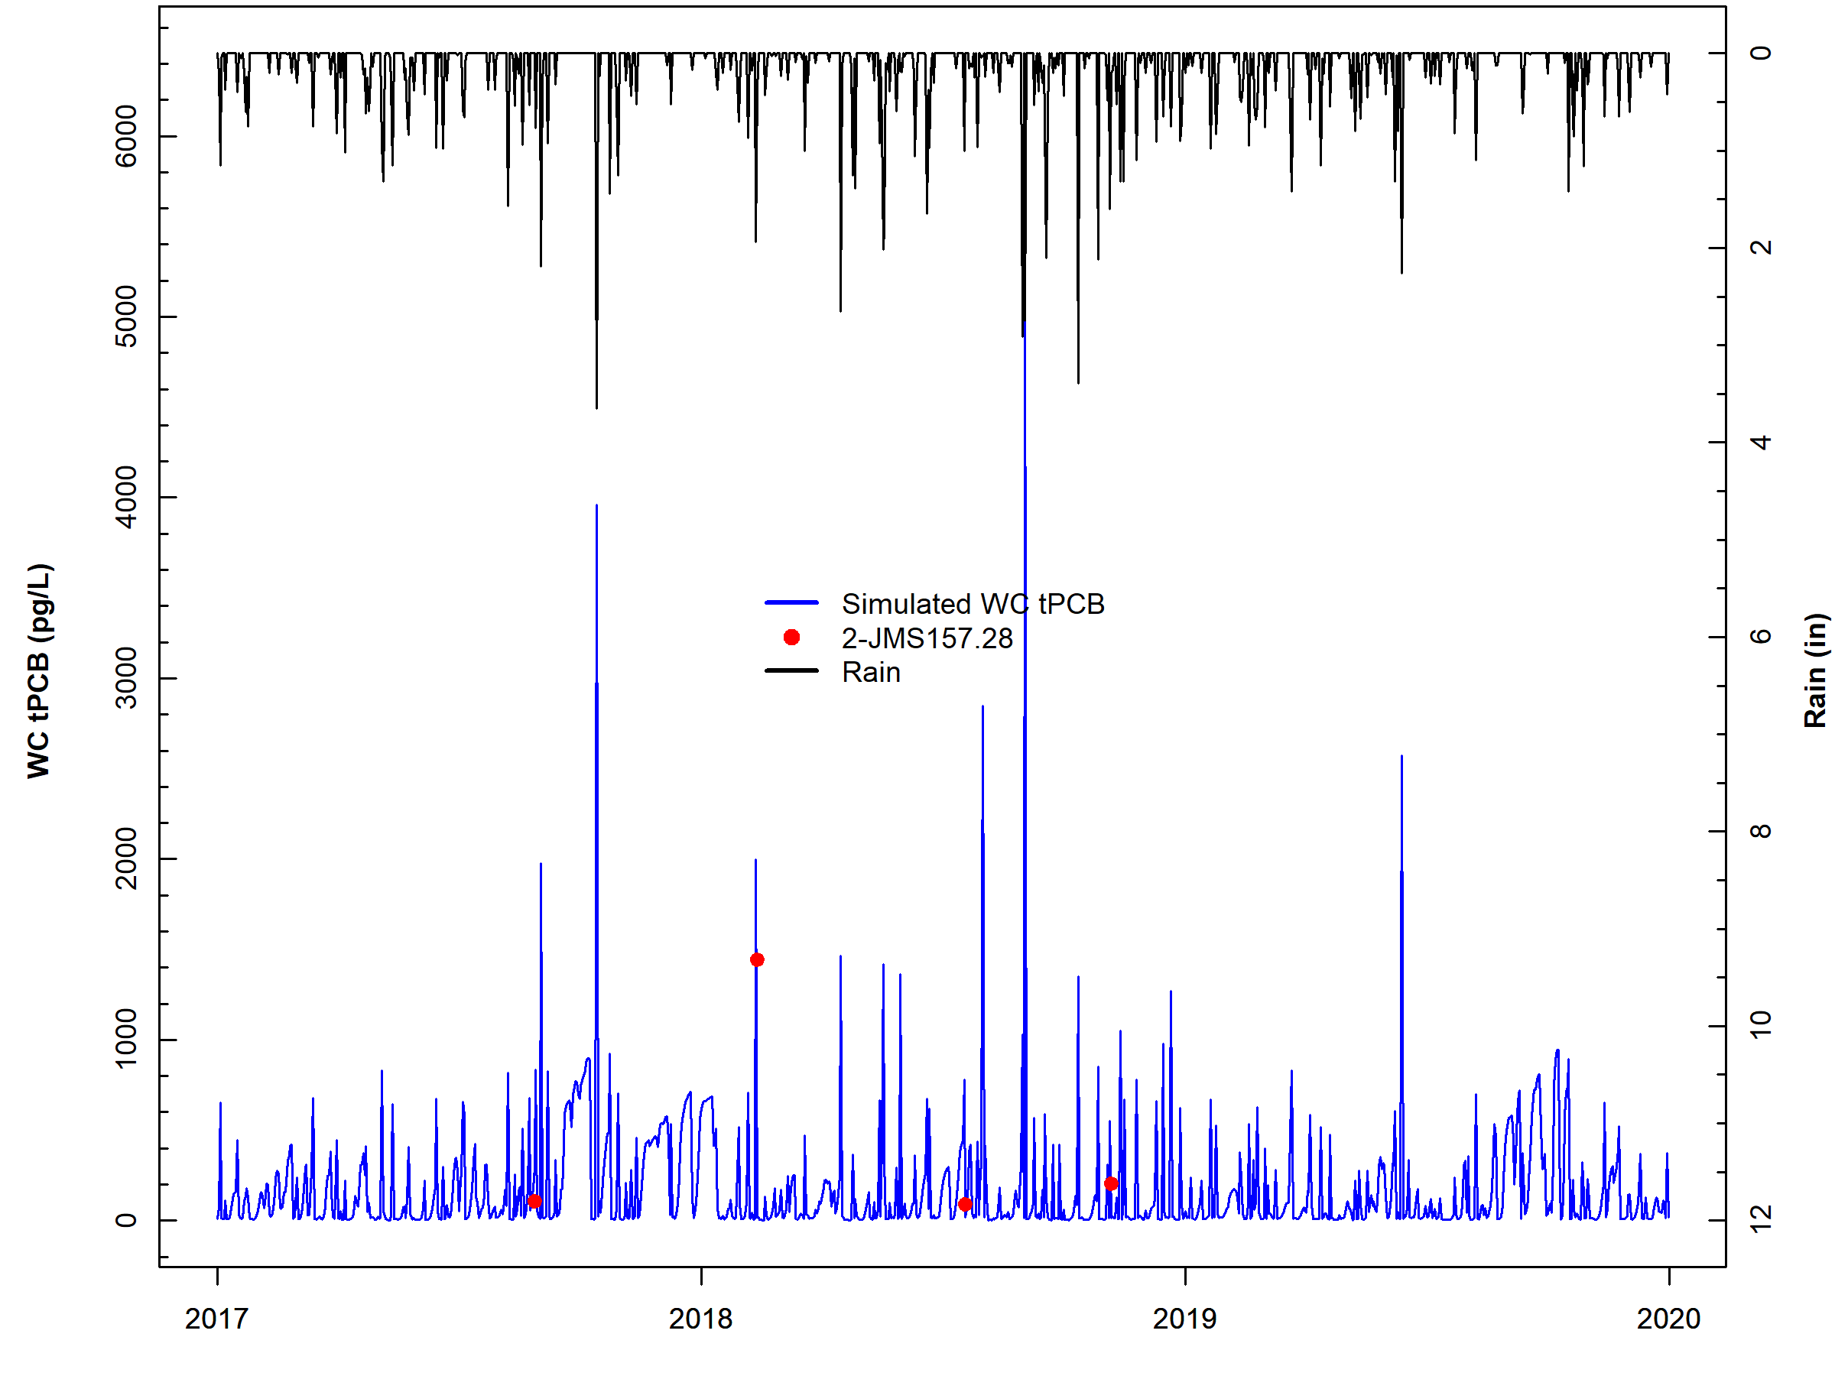
Figure F-16. Comparison of observed water column PCB concentrations, simulated water column PCB concentrations, and observed rainfall for subwatershed reach 1 in Lower James River – Hardware, Slate, and Willis Rivers.

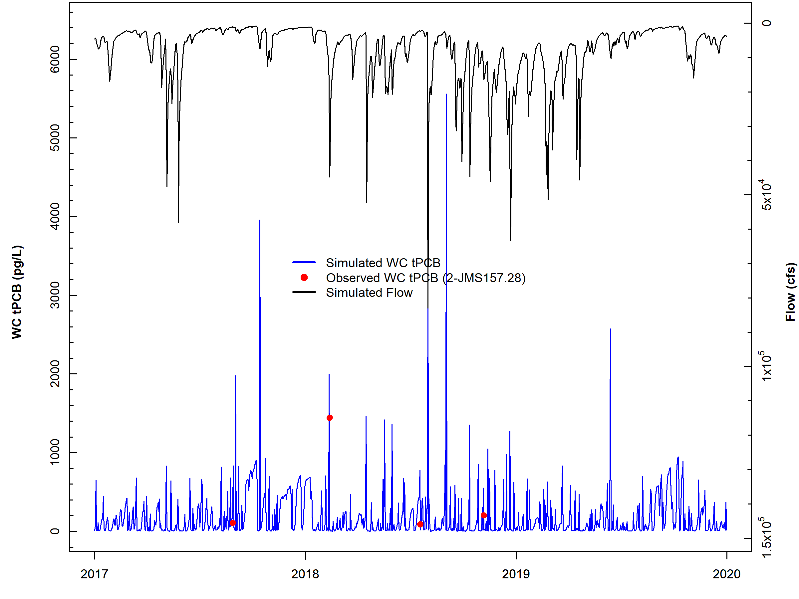
Figure F-17. Comparison of observed water column PCB concentrations, simulated water column PCB concentrations, and simulated flow for subwatershed reach 1 in Lower James River – Hardware, Slate, and Willis Rivers.

Five-day Window Performance Assessment
Figure F-18 shows the 5-day windows and observed data for James River---Hardware, Slate and Willis reach number one (outlet). All of the observed data points for reach four were within the 5-day windows. The 5-day window plots for the other James River---Hardware, Slate and Willis water quality calibration stations can be provided upon request by referring to the contact information on page ii. Table F-23 includes the results of the 5-day window calibration analysis for all James River---Hardware, Slate and Willis calibration reaches. Results show that across all stations, 85% of the observed data were within a 5-day window, exceeding the 50% calibration threshold goal and while the model over-predicted some of the PCB data as indicated by the high percentage of ‘below’ values for the 5-day windows, overall the model performed well. Despite the sparsity of the observed data, the results of the calibration window analysis indicate that the model is sufficiently well-calibrated.

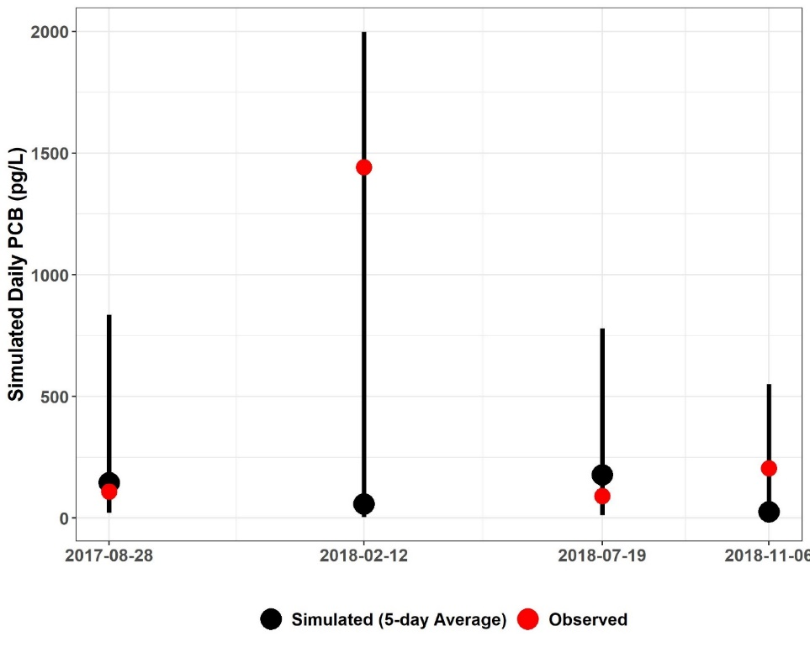
Figure F-18. Five-day window plots for water column PCB concentrations showing the 5-day average, max, and min, and observed values at station 2-JMS157.28(Lower James River – Hardware, Slate, and Willis Rivers subwatershed reach 1).

Table F-19. Simulated water column PCB concentrations (pg/L), 5-day calibration windows, and observed PCB concentrations (pg/L) for Lower James River – Hardware, Slate, and Willis Rivers
Subwatershed | Station ID | Date | Observed Water Column PCB | Simulated | 5-Day Max. | 5-Day Min.
 |  |  |  | 5-Day Average
1 | 2-JMS157.28 | 8/28/2017 | 109.03 | 146.19 | 835.85 | 21.21
1 | 2-JMS157.28 | 2/12/2018 | 1441.74 | 58.44 | 1997.98 | 4.09
1 | 2-JMS157.28 | 7/19/2018 | 90.21 | 178.33 | 778.88 | 11.70
1 | 2-JMS157.28 | 11/6/2018 | 205.47 | 25.79 | 549.84 | 7.53
22 | 2BSLT000.73 | 7/19/2017 | 53.55 | 276.72 | 367.33 | 196.44
22 | 2BSLT000.73 | 2/8/2018 | 121.95 | 109.77 | 952.00 | 35.49
33 | 2-HRD000.36 | 10/30/2017 | 111.34 | 33.09 | 189.42 | 4.72
 |  |  |  | Within 5-Day Range | Above 5-Day Range | Below 5-Day Range
 |  |  | PERCENT | 85% | 0% | 15%

Calibration Summary: Lower James River – Hardware, Slate, and Willis Rivers
The “weight-of-evidence” approach used for the Lower James River – Hardware, Slate, and Willis Rivers HSPF PCB model calibration sufficiency assessment included a qualitative, visual examination of the PCB concentration time series graphs and the 5-day calibration window assessment. Based on these analyses of instream PCB concentration response to precipitation and flow conditions, BSE concludes that the Lower James River – Hardware, Slate, and Willis Rivers HSPF PCB TMDL model was sufficiently well calibrated to adequately simulate in-stream PCB concentrations. The PCB calibration parameters are shown in Table F-24.

Table F-20. Final calibrated parameters for the Lower James River – Hardware, Slate, and Willis Rivers PCB Calibration
Parameter | Definition | Units | FINAL  CALIBRATION VALUE | POSSIBLE RANGE OF VALUES^{ǂ} | CALCULATION METHOD^{ǂ}
PERLND/IMPLNDª
QUAL-INPUT (Nonseasonal Sediment-Associated Quality Constituent Parameters)
POTFW^{b} | Washoff potency factor (unregulated surface sources¹) | pg/ton | 2.39E+09 – 3.90E+11 | 0.0 - Inf. | Calibrated
POTFW^{b} | Washoff potency factor (contaminated sites) | pg/ton | 7.02E+10 – 1.29E+12 | 0.0 - Inf. | Approximated from previous PCB TMDLs^{c}  Estimated from observed sampling data
RCHRES^{e}
GQ-KD (Adsorption Coefficients of PCB Quality Constituent)
ADPM1-ADPM3 | Adsorption coefficients for suspended sediment | L/mg | Sand: 0.002 – 0.003^{f};  Silt: 0.026 – 0.048^{f};  Clay: 0.044 – 0.082^{f} | 1.0E-10 - Inf. | Derived from observed water column samples with PCB homolog and TOC data,  Calibrated
ADPM4-ADPM6 | Adsorption coefficients for bed sediment | L/mg | Sand: 0.01 – 0.16^{f},  Silt: 0.16 – 2.62^{f},  Clay: 0.28 – 4.46^{f} | 1.0E-10 - Inf. | Derived from observed sediment samples with PCB homolog and TOC data,  Calibrated
GQ-ADRATE (Adsorption/Desorption Rate Parameters)
ADPM1-ADPM3 | Adsorption/desorption rates for suspended sediment | 1/day | 0.9614 | 1.0E-05 - Inf. | Derived from observed water column samples with PCB homolog data, Applied to entire calibration segment
ADPM4-ADPM6 | Adsorption/desorption rates for bed sediment | 1/day | 1.0E-05 | 1.0E-05 - Inf. | Assumed approx. zero as in previous PCB TMDLs^{c}
GQ-SEDCONC (Initial PCB Concentrations on Sediment)
SQAL1-SQAL4 | Initial PCB concentrations on suspended sediment | pg/mg | 0.0 | 0.0 - Inf. | Assumed zero as in previous PCB TMDLs^{c}
SQAL5-SQAL6 | Initial PCB concentrations on bed sediment | pg/mg | 0.01 | 0.0 - Inf. | Derived from observed sediment samples
MONTH-DATA | PCB atmospheric deposition rate on water surface | pg/ac/mo-nth | 3.0E+06 | N/A | Initial value based on Chesapeake Bay Toxics Report^{g}, Calibrated
^{ǂ} Acquired from HSPF Version 12.2 User’s Manual
¹ Surface load sources represent the sum of net atmospheric deposition to land surfaces, loads from small tributaries that are not specified in the model, regulated and unregulated stormwater runoff, loads from unidentified contaminated sites, and unspecified point source discharges.
ª Pervious and Impervious land segment
^{b} Includes the atmospheric deposition on the land surface
^{c} DEQ, 2009. Roanoke River PCB TMDL., 2018 New River PCB TMDL
^{d} Varies between contaminated sites
^{e} Main stem of stream in each subwatershed
^{f} Varies by calibration segment reach
^{g} CBP, 1999. Chesapeake Bay Basin Toxics Loading and Release Inventory.

PCB Calibration: Lower James River – Rivanna River
This section presents the HSPF PCB calibration for the downstream outlet of the Lower James River – Rivanna River watershed. The calibration results are summarized in tabular format for the entire watershed and graphed for a representative subwatershed reach. PCB model calibration was an iterative process in which adjustments were made to the calibration parameters. After executing the model, the results were analyzed, and the parameters were adjusted again. The results of the model were analyzed using the “weight-of-evidence” metrics discussed previously.

PCB Concentration Time Series Graphs
Figure F-19 and Figure F-20 illustrate the comparison of daily average simulated PCB concentrations and observed water column PCB concentrations for reach number one (outlet) of Lower James River – Rivanna River. These graphs show that the simulated PCB concentration responded to fluctuations in rainfall and simulated flow. The model adequately simulated instream PCB concentrations in response to extreme rainfall and peak flow events. These plots illustrate that the simulated PCB concentrations followed a pattern of increasing and decreasing similar to the observed data. Further, the model adequately reflects the baseflow PCB concentrations and peak observed concentrations. Time series graphs for the other Lower James River – Rivanna River water quality calibration stations and their corresponding reaches can be provided by BSE upon request by referring to the contact information on page ii.

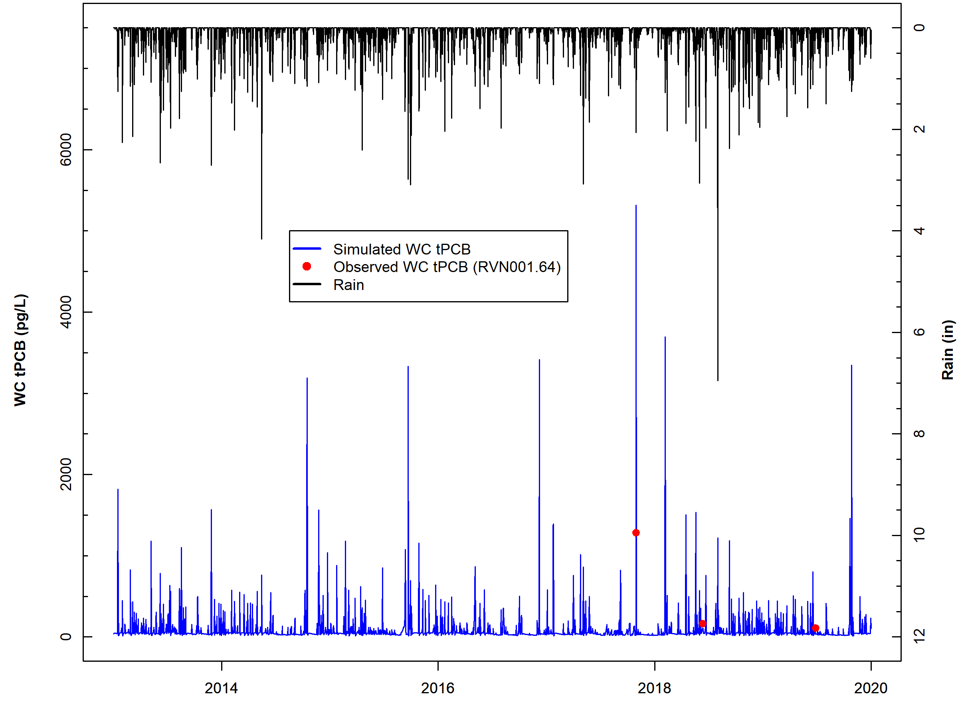
Figure F-19. Comparison of observed water column PCB concentrations, simulated water column PCB concentrations, and observed rainfall for subwatershed reach 1 in Lower James River – Rivanna River.

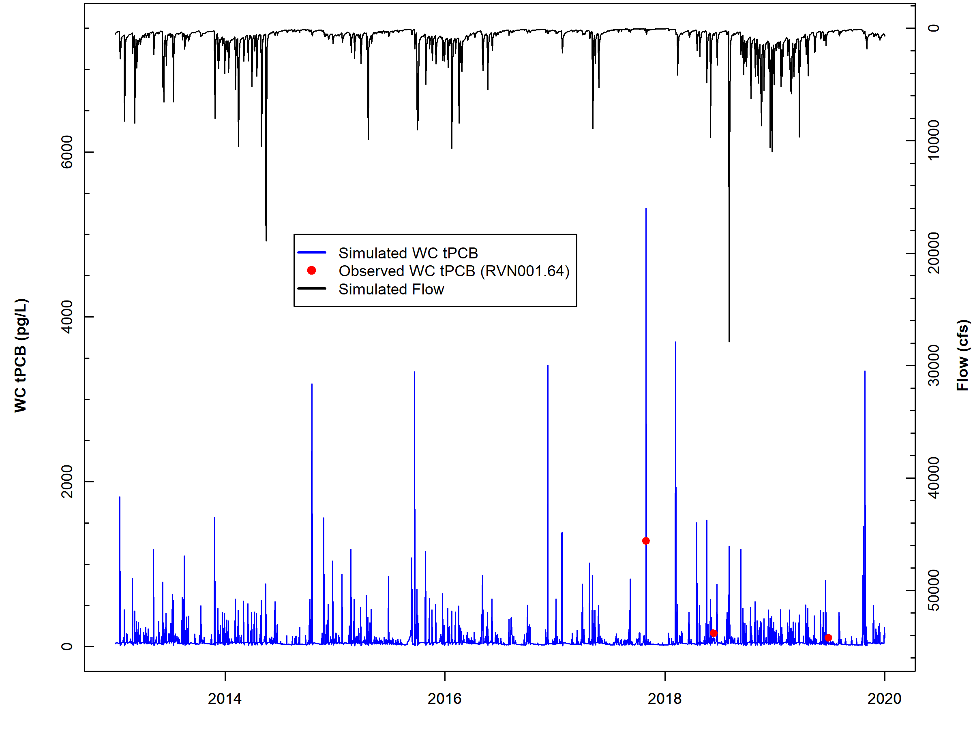
Figure F-20. Comparison of observed water column PCB concentrations, simulated water column PCB concentrations, and simulated flow for subwatershed reach 1 in Lower James River – Rivanna River.

Five-day Window Performance Assessment
Figure F-21 shows the 5-day windows and observed data for Lower James River – Rivanna River reach number one (outlet). All observed data points for reach one were within the 5-day windows except one data point indicating a good fit between the simulated and observed data. The 5-day window plots for the other Lower James River – Rivanna River water quality calibration stations can be provided upon request by referring to the contact information on page ii. Table F-27 includes the results of the 5-day window calibration analysis for all Lower James River – Rivanna River calibration reaches. Results show that across all stations, 91% of the observed data were within a 5-day window, exceeding the 50% calibration threshold goal, and also 9% of the data were above the 5-day windows respectively, indicating that the model is not exhibiting bias.

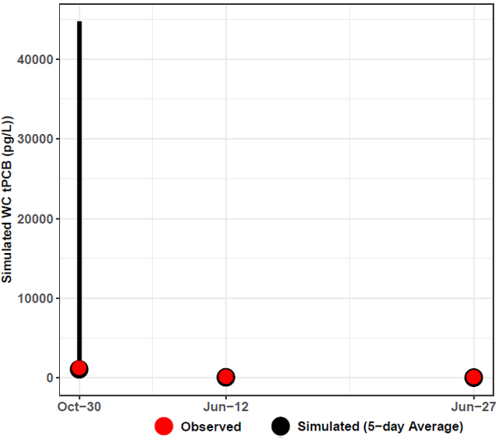
Figure F-21. Five-day window plots for water column PCB concentrations showing the 5-day average, max, and min, and observed values at station 2-RVN001.64 (Lower James River – Rivanna River sub-watershed reach 1).

Table F-21. Simulated water column PCB concentrations (pg/L), 5-day calibration windows, and observed PCB concentrations (pg/L) for Lower James River – Rivanna River
Subwatershed | Station | Date | Observed Water Column PCB | Simulated | 5-Day Max. | 5-Day Min.
 |  |  |  | 5-Day Average
1 | 2-RVN001.64 | 10/30/2017 | 1286.08 | 199.22 | 7090.90 | 14.52
1 | 2-RVN001.64 | 6/12/2018 | 163.39 | 34.91 | 122.92 | 21.25
1 | 2-RVN001.64 | 6/27/2019 | 111.36 | 29.87 | 164.50 | 19.52
9 | 2-RVN033.65 | 6/12/2018 | 144.76 | 124.08 | 229.67 | 53.37
9 | 2-RVN033.65 | 6/27/2019 | 107.33 | 156.67 | 284.15 | 58.86
11 | 2-RVN039.58 | 6/12/2018 | 100.61 | 49.75 | 249.03 | 8.44
11 | 2-RVN039.58 | 6/27/2019 | 61.47 | 51.66 | 198.34 | 10.72
13 | 2-RRN002.19 | 6/12/2018 | 120.78 | 67.46 | 559.47 | 8.13
13 | 2-RRN002.19 | 6/27/2019 | 40.33 | 49.94 | 486.25 | 17.30
19 | 2-RRS003.12 | 6/12/2018 | 151.82 | 60.27 | 184.86 | 15.64
19 | 2-RRS003.12 | 6/27/2019 | 59.41 | 74.97 | 200.93 | 17.39
 |  |  |  | Within 5-Day Range | Above 5-Day Range | Below 5-Day Range
 |  |  | PERCENT | 91% | 9% | 0%

Calibration Summary: Lower James River – Rivanna River
The “weight-of-evidence” approach used for the Lower James River – Rivanna River HSPF PCB model calibration sufficiency assessment included a qualitative, visual examination of the PCB concentration time series graphs and the 5-day calibration window assessment. Based on these analyses of instream PCB concentration response to precipitation and flow conditions, BSE concludes that the Lower James River – Rivanna River HSPF PCB TMDL model was sufficiently well calibrated to adequately simulate in-stream PCB concentrations. The PCB calibration parameters are shown in Table F-28.

Table F-22. Final calibrated parameters for the Lower James River – Rivanna River PCB Calibration.
Parameter | Definition | Units | FINAL  CALIBRATION VALUE | POSSIBLE RANGE OF VALUES^{ǂ} | CALCULATION METHOD^{ǂ}
PERLND/IMPLNDª
QUAL-INPUT (Nonseasonal Sediment-Associated Quality Constituent Parameters)
POTFW^{b} | Washoff potency factor (surface sources – regulated and unregulated¹) | pg/ton | 2.39E+09 – 3.82E+10 | 0.0 - Inf. | Calibrated
POTFW^{b} | Washoff potency factor (contaminated sites) | pg/ton | 7.02E+10 – 1.29E+12 | 0.0 - Inf. | Approximated from previous PCB TMDLs^{c}  Estimated from observed sampling data
RCHRES^{e}
GQ-KD (Adsorption Coefficients of PCB Quality Constituent)
ADPM1-ADPM3 | Adsorption coefficients for suspended sediment | L/mg | Sand: 0.01 – 0.06^{f};  Silt: 0.17 – 0.94^{f};  Clay: 0.30 – 1.59^{f} | 1.0E-10 - Inf. | Derived from observed water column samples with PCB homolog and TOC data,  Calibrated
ADPM4-ADPM6 | Adsorption coefficients for bed sediment | L/mg | Sand: 0.001 -0.036^{f},  Silt: 0.025 – 0.614^{f};  Clay: 0.174– 1.043^{f} | 1.0E-10 - Inf. | Derived from observed sediment samples with PCB homolog and TOC data,  Calibrated
GQ-ADRATE (Adsorption/Desorption Rate Parameters)
ADPM1-ADPM3 | Adsorption/desorption rates for suspended sediment | 1/day | 0.0987 | 1.0E-05 - Inf. | Derived from observed water column samples with PCB homolog data, Applied to entire calibration segment
ADPM4-ADPM6 | Adsorption/desorption rates for bed sediment | 1/day | 1.0E-05 | 1.0E-05 - Inf. | Assumed approx. zero as in previous PCB TMDLs^{c}
GQ-SEDCONC (Initial PCB Concentrations on Sediment)
SQAL1-SQAL4 | Initial PCB concentrations on suspended sediment | pg/mg | 0.00 | 0.0 - Inf. | Assumed zero as in previous PCB TMDLs^{c}
SQAL5-SQAL6 | Initial PCB concentrations on bed sediment | pg/mg | 0.46 – 9.41^{f} | 0.0 - Inf. | Estimated in observed sediment sample data
MONTH-DATA | PCB atmospheric deposition rate on water surface | pg/ac/mo-nth | 3.0E+06 | N/A | Initial value based on Chesapeake Bay Toxics Report^{g}, Calibrated
^{ǂ} Acquired from HSPF Version 12.2 User’s Manual
¹Surface load sources represent the sum of net atmospheric deposition to land surfaces, loads from small tributaries that are not specified in the model, regulated and unregulated stormwater runoff, loads from unidentified contaminated sites, and unspecified point source discharges.
ª Pervious and Impervious land segment
^{b} Includes the atmospheric deposition on the land surface
^{c} DEQ, 2009. Roanoke River PCB TMDL., 2018 New River PCB TMDL
^{d} Varies between contaminated sites
^{e} Main stem of stream in each subwatershed
^{f} Varies by calibration segment reach
^{g} CBP, 1999. Chesapeake Bay Basin Toxics Loading and Release Inventory.

PCB Calibration: Lower James River – Reedy Creek
This section presents the HSPF PCB calibration for the Lower James River – Reedy Creek watershed (the outlet of the James River study area). PCB model calibration was an iterative process in which adjustments were made to the calibration parameters. After executing the model, the results were analyzed, and the parameters were adjusted again. The results of the model were analyzed using the “weight-of-evidence” metrics discussed previously.

PCB Concentration Time Series Graphs
Figure F-22 and Figure F-23 illustrate the comparison of daily average simulated PCB concentrations and observed water column PCB concentrations for reach number one, the outlet of Lower James River – Reedy Creek. These graphs show that the simulated PCB concentration responded to fluctuations in rainfall and simulated flow. The model adequately simulated instream PCB concentrations in response to extreme rainfall and peak flow events. These plots illustrate that the simulated PCB concentrations followed a pattern of increasing and decreasing similar to the observed data. Further, the model adequately reflects the baseflow PCB concentrations and peak observed concentrations. Time series graphs for the other Lower James River – Reedy Creek water quality calibration stations and their corresponding reaches can be provided by BSE upon request by referring to the contact information on page ii.
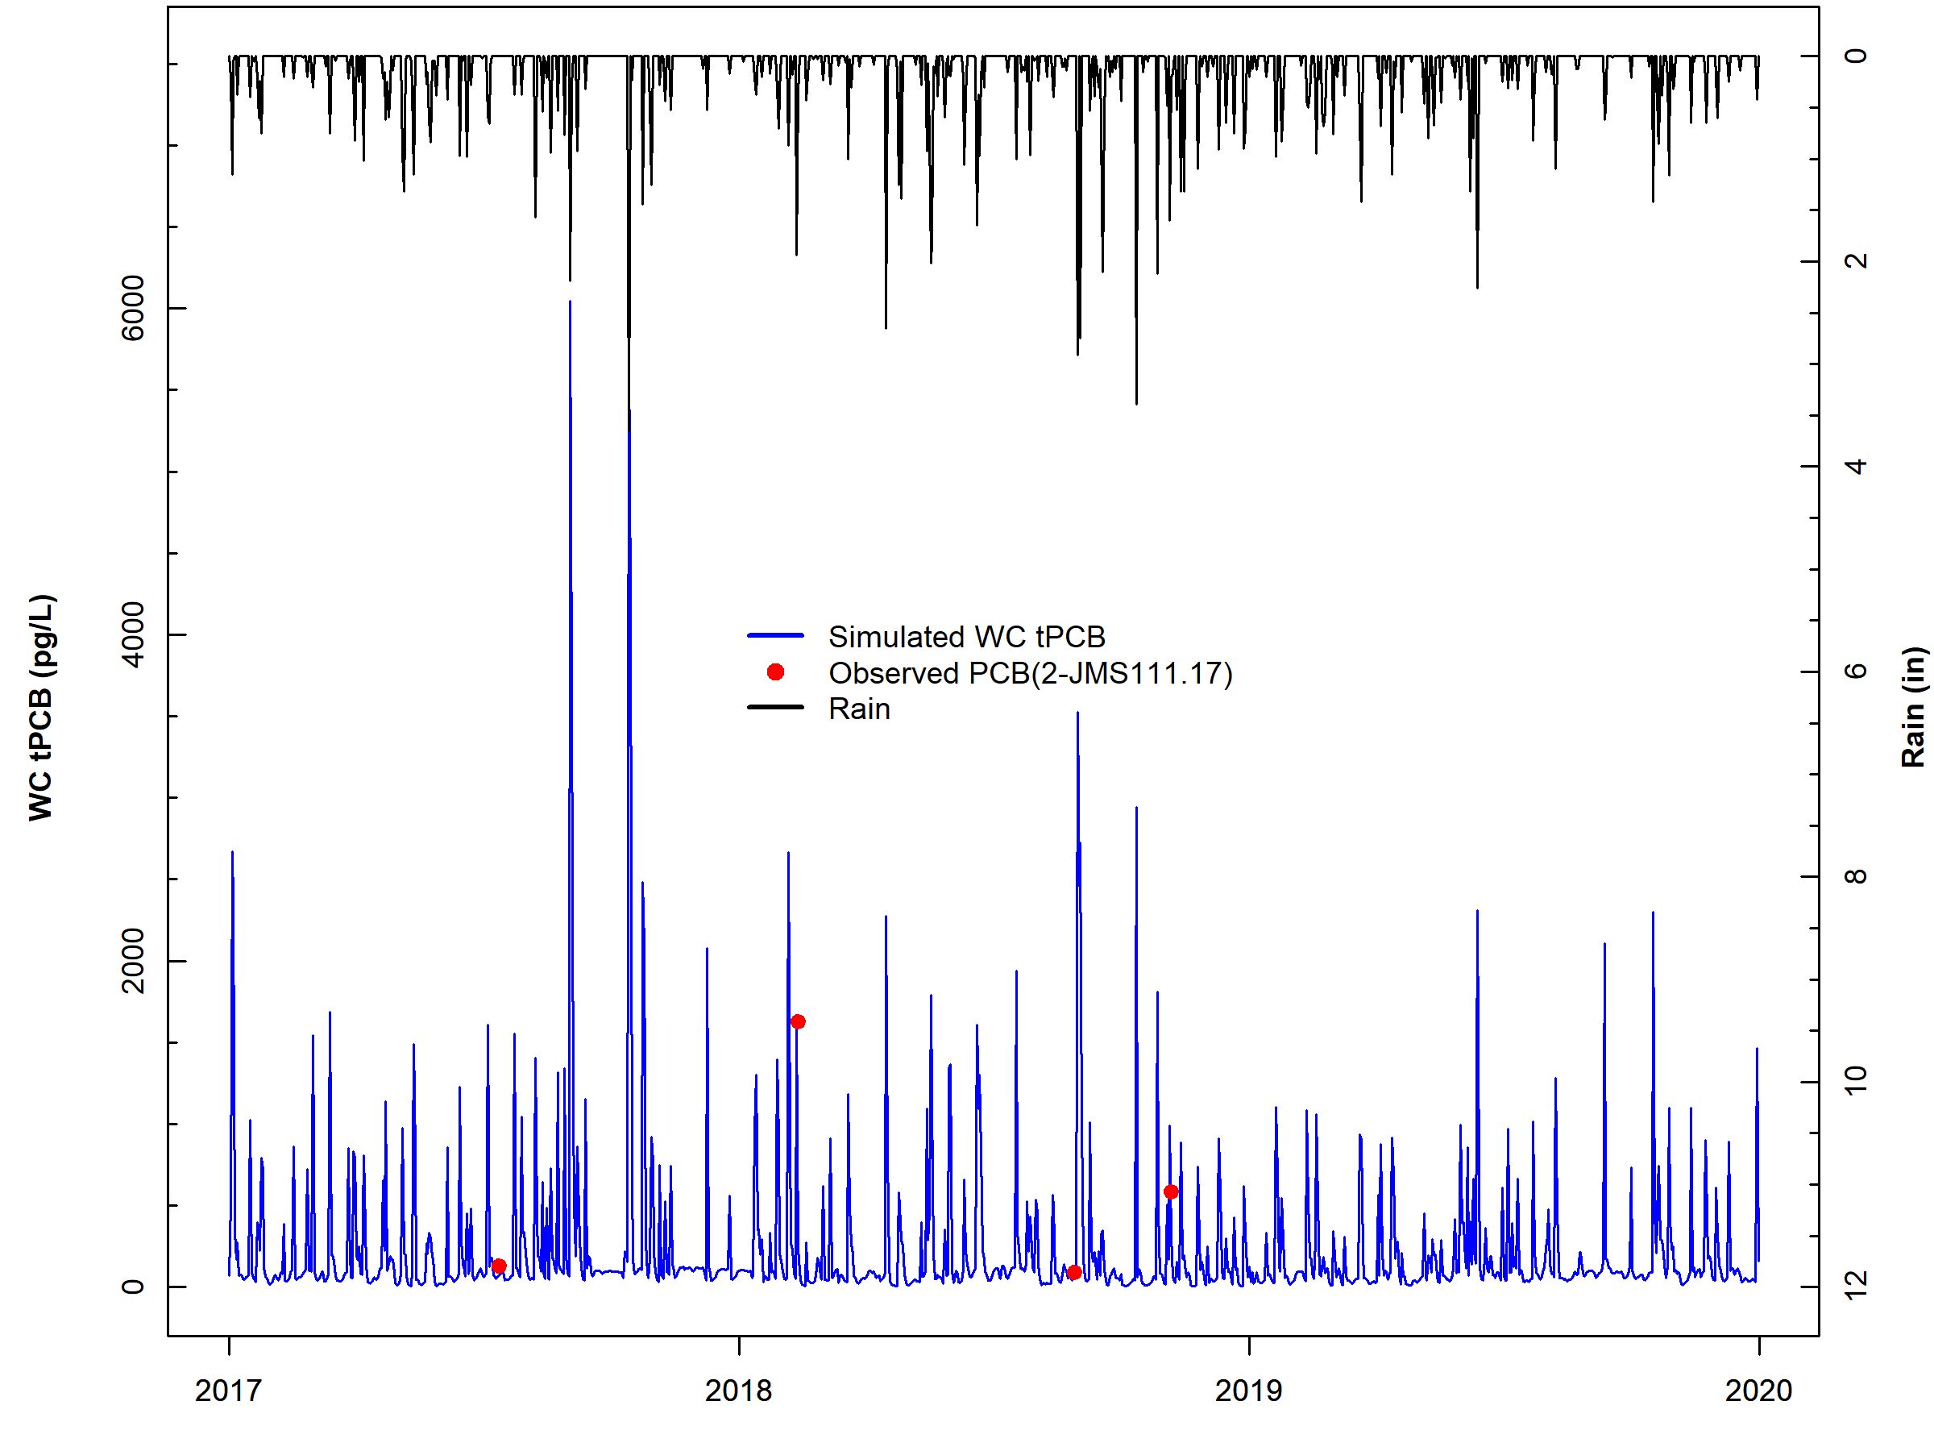
Figure F-22. Comparison of observed water column PCB concentrations, simulated water column PCB concentrations, and observed rainfall for subwatershed reach 1 in Lower James River – Reedy Creek.

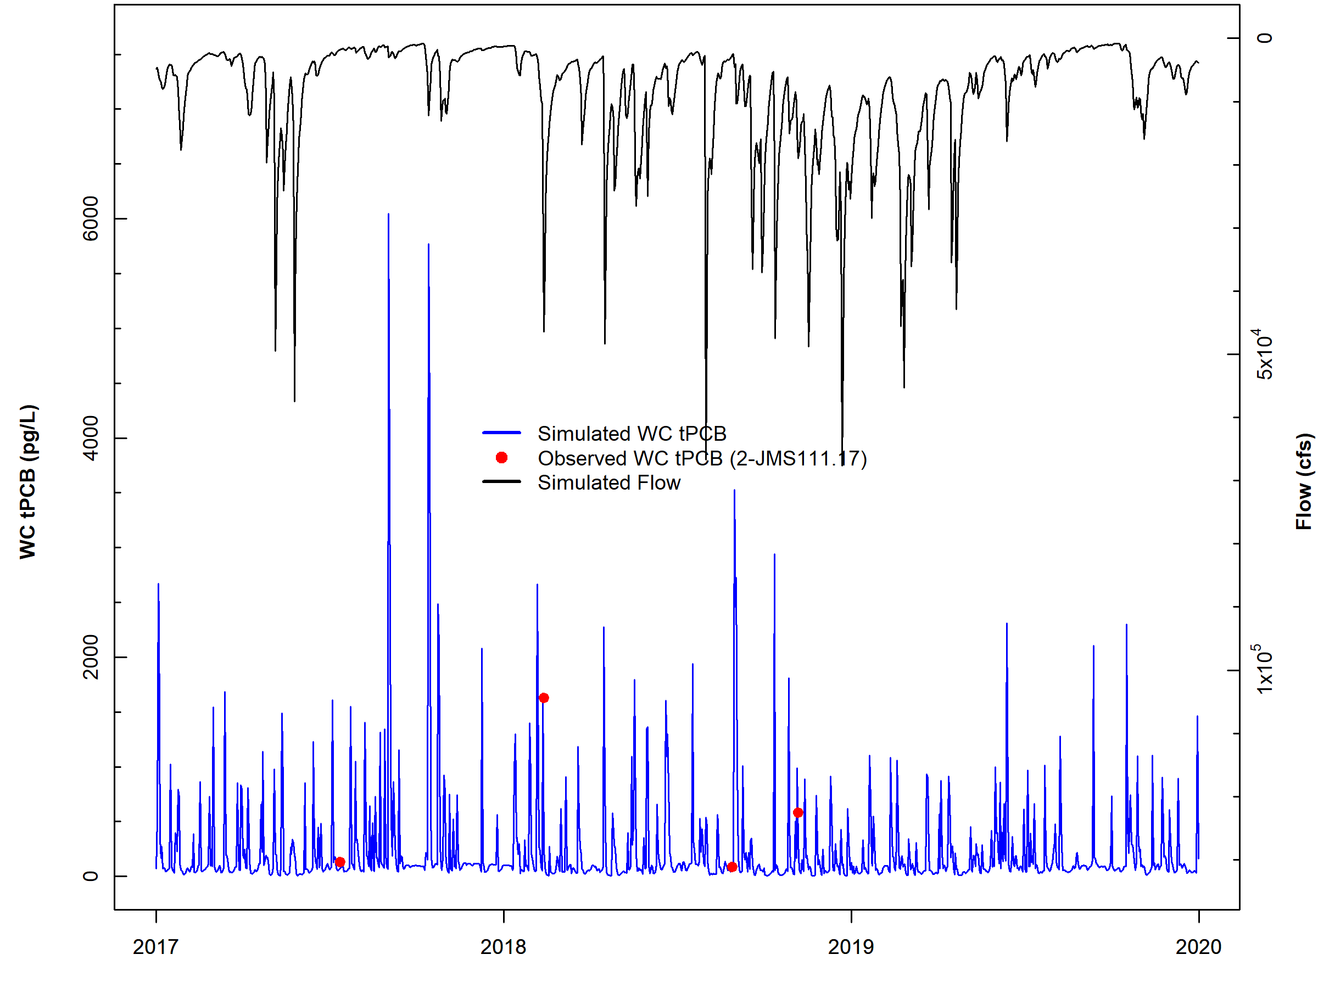
Figure F-23. Comparison of observed water column PCB concentrations, simulated water column PCB concentrations, and simulated flow for subwatershed reach 1 in Lower James River – Reedy Creek.

Five-day Window Performance Assessment
Figure F-24 shows the 5-day windows and observed data for Lower James River – Reedy Creek reach number one (outlet). All of the observed data points for reach four were within the 5-day windows. The 5-day window plots for the other Lower James River – Reedy Creek water quality calibration stations can be provided upon request by referring to the contact information on page ii. Table F-31 includes the results of the 5-day window calibration analysis for all Lower James River – Reedy Creek calibration reaches. Results show that across all stations, 88.7% of the observed data were within a 5-day window, exceeding the 50% calibration threshold goal and while the model under-predicted some of the PCB data as indicated by the high percentage of ‘Above’ values for the 5-day windows, overall the model performed well. Despite the sparsity of the observed data, the results of the calibration window analysis indicate that the model is sufficiently well-calibrated.

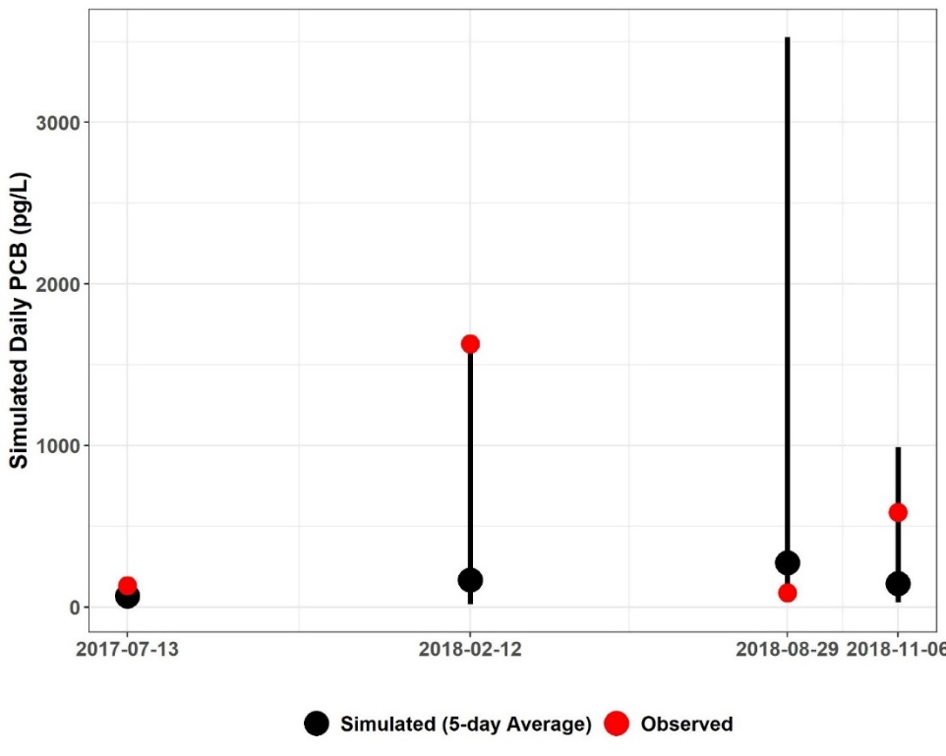
Figure F-24. Five-day window plots for water column PCB concentrations showing the 5-day average, max, and min, and observed values at station 2-JMS111.17(Lower James River – Reedy Creek subwatershed reach 1).

Table F-23. Simulated water column PCB concentrations (pg/L), 5-day calibration windows, and observed PCB concentrations (pg/L) for Lower James River – Reedy Creek
Subwatershed | Station ID | Date | Observed Water Column PCB | Simulated | 5-Day Max. | 5-Day Min.
 |  |  |  | 5-Day Average
1 | 2-JMS111.17 | 7/13/2017 | 131.72 | 68.26 | 99.16 | 48.39
1 | 2-JMS111.17 | 2/12/2018 | 1628.83 | 167.86 | 1658.19 | 17.42
1 | 2-JMS111.17 | 8/29/2018 | 89.13 | 274.67 | 3525.97 | 28.49
1 | 2-JMS111.17 | 11/6/2018 | 584.89 | 146.23 | 988.81 | 28.35
2 | 2-RDD000.19 | 6/26/2018 | 769.56 | 58.70 | 883.63 | 41.46
2 | 2-RDD000.19 | 11/15/2018 | 8529.66 | 483.18 | 8553.01 | 41.29
3 | 2-RDD001.57 | 6/26/2018 | 443.73 | 40.70 | 1195.68 | 20.78
3 | 2-RDD001.57 | 11/15/2018 | 2171.32 | 145.29 | 2890.13 | 20.43
4 | 2-JMS112.33 | 8/29/2018 | 145.83 | 108.96 | 803.97 | 18.82
4 | 2-JMS112.33 | 11/6/2018 | 336.12 | 59.41 | 391.41 | 17.33
6 | 2-PWT000.57 | 6/26/2018 | 218.52 | 16.22 | 417.11 | 7.50
6 | 2-PWT000.57 | 11/15/2018 | 1963.97 | 157.39 | 2401.19 | 7.67
7 | 2-PWT003.98 | 6/26/2018 | 117 | 12.82 | 188.13 | 9.19
7 | 2-PWT003.98 | 11/15/2018 | 2378.95 | 294.27 | 4739.21 | 9.85
8 | 2-JMS117.35 | 8/28/2017 | 112.26 | 44.71 | 167.60 | 33.56
8 | 2-JMS117.35 | 2/12/2018 | 880.93 | 88.08 | 1849.55 | 11.29
8 | 2-JMS117.35 | 8/30/2018 | 138.49 | 210.23 | 1432.54 | 27.02
8 | 2-JMS117.35 | 11/6/2018 | 62.19 | 69.38 | 828.54 | 21.35
8 | 2-JMS117.35 | 11/6/2018 | 154.58 | 69.38 | 828.54 | 21.35
9 | 2BJMS119.35 | 7/12/2017 | 109.14 | 84.59 | 222.23 | 20.08
10 | 2-JMS123.23 | 2/12/2018 | 372.83 | 25.47 | 621.36 | 4.51
12 | 2-TKO003.42 | 2/12/2018 | 360.15 | 42.70 | 727.38 | 4.73
12 | 2-TKO003.42 | 11/15/2018 | 561.53 | 50.12 | 582.80 | 3.69
12 | 2-TKO003.42 | 11/15/2018 | 250.7 | 50.12 | 582.80 | 3.69
16 | 2-LIY001.73 | 2/12/2018 | 669.37 | 54.64 | 1852.95 | 6.13
18 | 2-JMS127.50 | 7/12/2017 | 105.83 | 162.04 | 430.60 | 26.17
18 | 2-JMS127.50 | 11/6/2018 | 189.57 | 11.34 | 121.29 | 3.355
20 | 2-NWD002.27 | 6/26/2018 | 118.97 | 27.05 | 233.82 | 15.02
20 | 2-NWD002.27 | 11/15/2018 | 74.49 | 16.57 | 261.98 | 1.92
21 | 2-GEN000.51 | 11/15/2018 | 164.21 | 25.14 | 541.22 | 1.52
23 | 2-FIN000.81 | 10/11/2017 | 96.82 | 61.47 | 96.11 | 40.93
24 | 2-BDC000.79 | 11/15/2018 | 147.27 | 10.05 | 200.07 | 1.08
26 | 2-JMS140.00 | 2/12/2018 | 712.67 | 63.94 | 856.48 | 14.476
26 | 2-JMS140.00 | 7/19/2018 | 68.51 | 448.89 | 2008.89 | 244.00
 |  |  |  | Within 5-Day Range | Above 5-Day Range | Below 5-Day Range
 |  |  | PERCENT | 88.7% | 8.5% | 2.8%

Calibration Summary
The “weight-of-evidence” approach used for the Lower James River – Reedy Creek HSPF PCB model calibration sufficiency assessment included a qualitative, visual examination of the PCB concentration time series graphs and the 5-day calibration window assessment. Based on these analyses of instream PCB concentration response to precipitation and flow conditions, BSE concludes that the Lower James River – Reedy Creek HSPF PCB TMDL model was sufficiently well calibrated to adequately simulate in-stream PCB concentrations. The PCB calibration parameters are shown in Table F-32.

Table F-24. Final calibrated parameters for the Lower James River – Reedy Creek PCB Calibration
Parameter | Definition | Units | FINAL  CALIBRATION VALUE | POSSIBLE RANGE OF VALUES^{ǂ} | CALCULATION METHOD^{ǂ}
PERLND/IMPLNDª
QUAL-INPUT (Nonseasonal Sediment-Associated Quality Constituent Parameters)
POTFW^{b} | Washoff potency factor (surface sources – regulated and unregulated¹) | pg/ton | 2.39E+09 – 9.18E+13 | 0.0 - Inf. | Calibrated
POTFW^{b} | Washoff potency factor (contaminated sites) | pg/ton | 7.02E+10 – 1.29E+12 | 0.0 - Inf. | Approximated from previous PCB TMDLs^{c}  Estimated from observed sampling data
RCHRES^{e}
GQ-KD (Adsorption Coefficients of PCB Quality Constituent)
ADPM1-ADPM3 | Adsorption coefficients for suspended sediment | L/mg | Sand: 0.0004 – 0.01926^{f};  Silt: 0.0077 – 3.2653^{f};  Clay: 0.0131 – 5.5511^{f} | 1.0E-10 - Inf. | Derived from observed water column samples with PCB homolog and TOC data,  Calibrated
ADPM4-ADPM6 | Adsorption coefficients for bed sediment | L/mg | Sand: 0.02 – 1.82^{f},  Silt: 0.25 – 30.94^{f},  Clay: 0.42 – 52.59^{f} | 1.0E-10 - Inf. | Derived from observed water column samples with PCB homolog and TOC data,  Calibrated
GQ-ADRATE (Adsorption/Desorption Rate Parameters)
ADPM1-ADPM3 | Adsorption/desorption rates for suspended sediment | 1/day | 3.1121 | 1.0E-05 - Inf. | Derived from observed water column samples with PCB homolog data, Applied to entire calibration segment
ADPM4-ADPM6 | Adsorption/desorption rates for bed sediment | 1/day | 1.0E-05 | 1.0E-05 - Inf. | Assumed approx. zero as in previous PCB TMDLs^{c}
GQ-SEDCONC (Initial PCB Concentrations on Sediment)
SQAL1-SQAL4 | Initial PCB concentrations on suspended sediment | pg/mg | 0.0 | 0.0 - Inf. | Assumed zero as in previous PCB TMDLs^{c}
SQAL5-SQAL6 | Initial PCB concentrations on bed sediment | pg/mg | 0.4 – 47.0^{f} | 0.0 - Inf. | Derived from observed sediment samples
MONTH-DATA | PCB atmospheric deposition rate on water surface | pg/ac/mo-nth | 3.0E+06 | N/A | Initial value based on Chesapeake Bay Toxics Report^{g}, Calibrated
^{ǂ} Acquired from HSPF Version 12.2 User’s Manual
¹Surface load sources represent the sum of net atmospheric deposition to land surfaces, loads from small tributaries that are not specified in the model, regulated and unregulated stormwater runoff, loads from unidentified contaminated sites, and unspecified point source discharges.
ª Pervious and Impervious land segment
^{b} Includes the atmospheric deposition on the land surface
^{c} DEQ, 2009. Roanoke River PCB TMDL., 2018 New River PCB TMDL
^{d} Varies between contaminated sites
^{e} Main stem of stream in each subwatershed
^{f} Varies by calibration segment reach
^{g} CBP, 1999. Chesapeake Bay Basin Toxics Loading and Release Inventory.

Table F-33 provides an estimate of the contributions from the different source categories to the annual PCB loading (mg/yr) in the stream. These contributions include loadings to regulated land surfaces (MS4 service areas), unregulated land surface (atmospheric deposition, unregulated stormwater runoff, loads from unidentified contaminated sites, unspecified point source discharges), contaminated sites (including railyards and electric substations), direct loading to the stream (atmospheric deposition to water surfaces and permitted sources), instream contaminated streambed sediment, and spill sites. The “percent of total load” column shows the portion of the PCB load (mg) that originates from a particular PCB source; it does not describe the fate of the PCBs once they enter the stream/river reach.

Table F-25. Estimated existing annual source PCB loads for Lower James River – Reedy Creek during the allocation period (2002).
Source | Estimated Load  (mg/yr) | Percent of total load (%)
Upstream Sources | 286,864 | 59
Streambed Sediment | 1,476 | <1
Surface Load – Unregulated¹ | 19,741 | 4
Surface Load – Regulated¹ | 169,327 | 35
Atmospheric Deposition | 1,685 | <1
CSOs | <1 | <1
Spills | <1 | <1
Contaminated Sites | 777 | <1
Permitted | 9,717 | 2
Total | 489,587 | –
¹Surface load sources represent the sum of net atmospheric deposition to land surfaces, loads from small tributaries that are not specified in the model, regulated and unregulated stormwater runoff, loads from unidentified contaminated sites, and unspecified point source discharges.

Table F-34 shows the contribution (in percent) of the various PCB sources to the in-stream PCB concentration at the outlet (pg/L). The largest source of PCBs are upstream sources followed by regulated surface loads (MS4s).

Table F-26. Estimated existing relative contributions of different PCB sources to the overall tPCB concentration at the Lower James River – Reedy Creek outlet during the allocation period (2002).
Source | Mean Daily Water Column tPCB Concentrations by Source (pg/L) | Relative Contribution by Source (%)
All Sources | 157 | –
Upstream Sources | 87 | 55
Surface Load – Unregulated¹ | 8 | 5
Surface Load – Regulated¹ | 53 | 34
Atmospheric Deposition | 1 | <1
Streambed Sediment | <1 | <1
Spills | <1 | <1
Contaminated Sites | <1 | <1
Permitted | 8 | 5
CSOs | <1 | <1
¹Surface load sources represent the sum of net atmospheric deposition to land surfaces, loads from small tributaries that are not specified in the model, regulated and unregulated stormwater runoff, loads from unidentified contaminated sites, and unspecified point source discharges.

References
CBP (Chesapeake Bay Program). 1999. Chesapeake Bay Basin Toxics Loading and Release Inventory. EPA 903-R99-006. U.S. EPA Chesapeake Bay Program, Annapolis, MD.

DEQ. 2009. Roanoke River PCB TMDL Development (Virginia). Prepared for United States Environmental Protection Agency, Region 3. December 2009.

DEQ. 2011. E. coli, Phased Benthic, and Phased Total PCB TMDL Development for Levisa Fork, Slate Creek, and Garden Creek. Prepared by MapTech, Inc. February 2011.

DEQ. 2018. PCB Total Maximum Daily Load Development for Reed Creek, the Upper New River, Peak Creek, Walker Creek, Stony Creek, and the Lower New River. Prepared by Virginia Tech Biological Systems Engineering Department. July 2018.

ICPRB (Interstate Commission on the Potomac River Basin). 2007. Total Maximum Daily Loads of Polychlorinated Biphenyls (PCBs) for Tidal Portions of the Potomac and Anacostia Rivers in the District of Columbia, Maryland, and Virginia. Prepared for District of Columbia Department of the Environment, Maryland Department of the Environment, and Virginia Department of Environmental Quality. September 28, 2007.

Kim, S.M., B.L. Benham, K.M. Brannan, R.W. Zeckoski, G.R. Yagow, 2007. Water Quality Calibration Criteria for Bacteria TMDL Development. 2007 American Society of Agricultural and Biological Engineers ISSN 0883-8542 23(2) 171-176.

Li, G.L., Ping, X.M. 2014. Difference in organic carbon contents and distributions in particle-size fractions between soil and sediment on the southern Loess Plateau, China. Journal of Mountain Science 11(3) 717-726.

Schneider, R. 2005. PCB Desorption from Resuspended Hudson River Sediment. Unpublished Ph.D. thesis, University of Maryland, College Park.

Totten, L.A., M. Panangadan, S.J. Eisenreich, G.J. Cavallo, T.J. Fikslin. 2006. Direct and indirect atmospheric deposition of PCBs to the Delaware River watershed. Environmental Science and Technology 40(7) 2171-2176.

The development of these TMDLs coincided with the revision to 9 VAC-25-260-140. Consequently, the numeric WQC (640 pg/L) was revised to 580 pg/L relatively late in the TMDL development process. For the James and Maury Rivers, the site-specific TMDL endpoints selected for the allocations are more sensitive than the revised WQC. For the Jackson River, the site-specific TMDL endpoint was greater than the revised WQC (580 pg/L), therefore, the revised WQC is the TMDL endpoint for Jackson River.
PCBs are hydrophobic and do not quickly break down in water. It is assumed that “dissolved” PCBs are those PCBs freely available in the water column and not associated with sediment.

