Stressor Identification Analysis for Crooked Run, Pughs Run and Stony Creek in Shenandoah County, Virginia

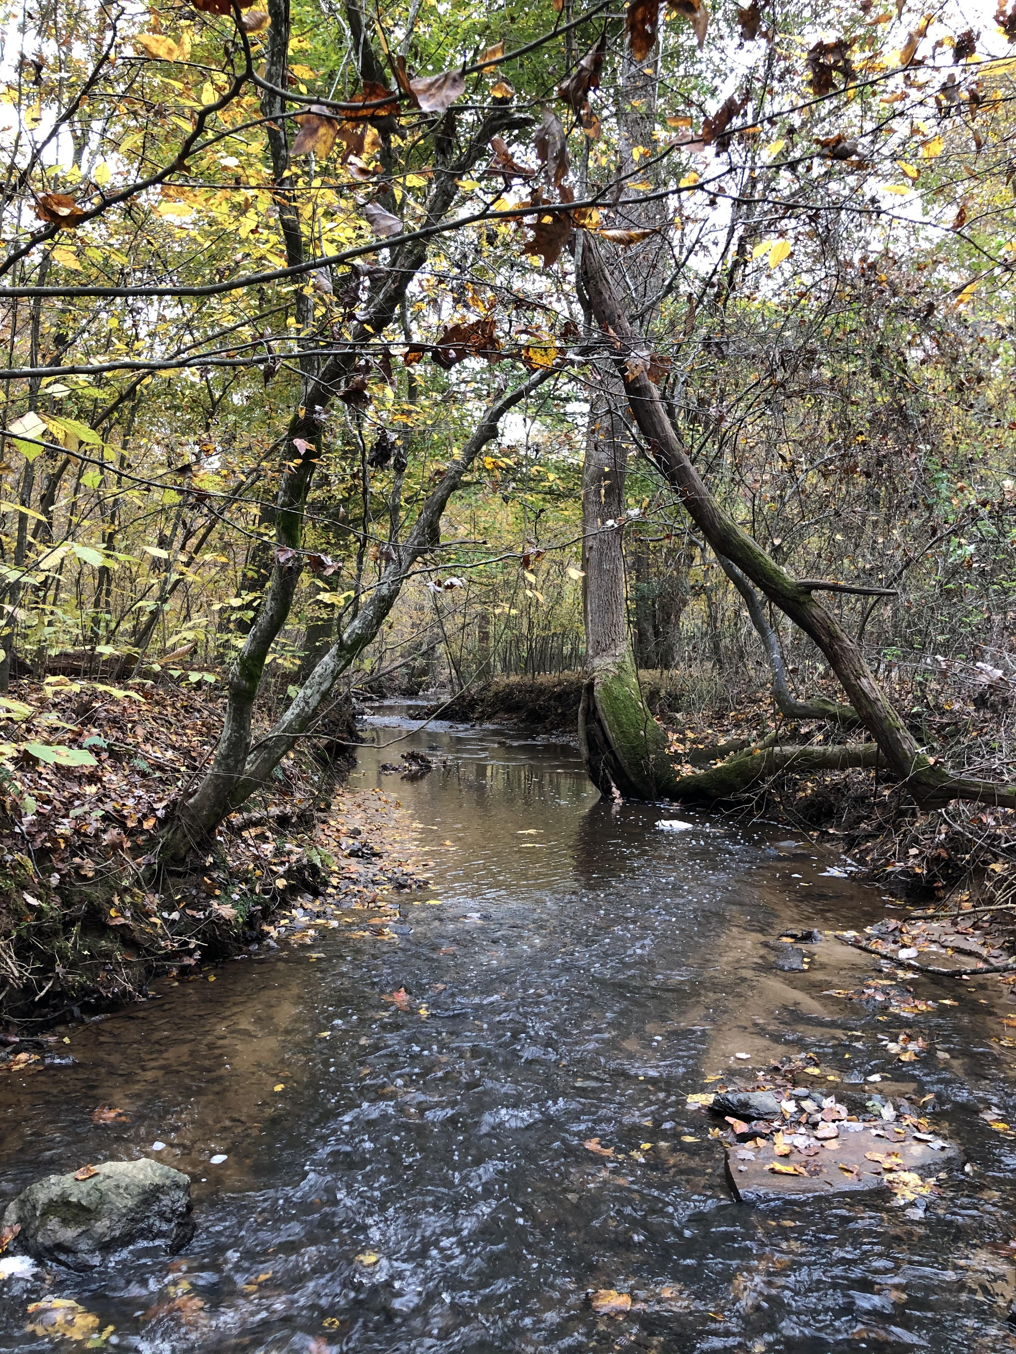
Prepared by:
Virginia Department of
Environmental Quality

August 2023

Table of Contents
Chapter 1: Stressor Identification Analysis 6
1.1. Overview 6
1.2. Biological, Physical, and Chemical Data 6
1.2.1. Benthic Assessments 9
* listing station 10
1.2.1.1. Temporal Trends in Benthic Data 10
1.2.1.2. Analysis of Benthic Metrics 14
1.2.1.3. Analysis of Community Composition 17
1.2.1.4. Biological Condition Gradient Analysis 21
1.2.1.5. Analysis of Functional Feeding Groups 24
1.2.2. Habitat Assessment 27
1.2.2.1. Relative Bed Stability 33
1.2.3. Water Quality Data 37
1.2.3.1. Temperature 37
1.2.3.2. pH 40
1.2.3.3. Dissolved Oxygen 42
1.2.3.4. Conductivity and Dissolved Solids 43
1.2.3.5. Dissolved Ions 47
1.2.3.6. Nutrients 53
1.2.3.7. Water Quality Regressions 60
1.3. Causal Analysis 61
1.3.1. Temperature 64
1.3.2. pH 64
1.3.3. Dissolved Oxygen 67
1.3.4. Conductivity and Total Dissolved Solids 68
1.3.5. Dissolved Ions – Sodium 72
1.3.6. Dissolved Ions – Sulfate 72
1.3.7. Dissolved Ions – Chloride 72
1.3.8. Dissolved Ions – Potassium 73
1.3.9. Suspended Solids and Deposited Sediment 77
1.3.10. Nitrogen 81
1.3.11. Phosphorus 82
1.4. Causal Analysis Summary 86
1.4.1. Probable Stressors 86
1.4.2. Contributing Factors 87
1.4.2.1. Historic Land Disturbance 87
1.4.2.2. Historic Dams 88
1.4.3. Causal Pathways 88
1.4.4. TMDL Target Pollutants 91
1.5. References 91

List of Figures
Figure 1-1. Ambient and biological monitoring stations in the Crooked Run, Pughs Run and Stony Creek watersheds. 7
Figure 1-2. Average stream condition index (SCI) scores between 2002 and 2022 for benthic stations in Crooked Run, Pughs Run and Stony Creek. 10
Figure 1-3. Temporal trends of benthic stream condition index (SCI) scores in the Stony Creek, Crooked and Pughs Run watersheds. 12
Figure 1-4 Crooked and Pughs Run and Stony Creek stream condition index scores (spring and fall). Whiskers indicate the range, boxes indicate the inter-quartile range, lines indicate the median, and white markers indicate the average. 13
Figure 1-5 Spatial trends in Stream Condition Index scores in Stony Creek 13
Figure 1-6. Metric scores comprising stream condition index (SCI) scores in Crooked and Pughs Runs (upper) and Stony Creek (lower). * indicates that the metric was significantly different (α = 0.05) from the benthic reference score (Gravel Springs Run and Upper North Fork Shenandoah River). 16
Figure 1-7. Benthic community structure (by order) in Crooked (upper) and Pughs Run (middle) in comparison with reference stream Gravel Springs Run (bottom). 20
Figure 1-8. Benthic community structure (by order) in Stony Creek in comparison with reference stream, NF Shenandoah River 21
Figure 1-9 Functional feeding group composition in benthic communities in Crooked and Pughs Runs and Stony Creek compared to Gravel Springs Run and North Fork Shenandoah River (reference streams). 27
Figure 1-10. Total habitat scores for Crooked and Pughs Runs and Stony Creek. Colors represent the probability that data within that range would be responsible for causing stress. Asterisks indicate scores significantly different from the reference conditions (α=0.05). 29
Figure 1-11. Comparison of total habitat scores with SCI scores in Crooked and Pughs Runs and Stony Creek 29
Figure 1-12. Habitat metric scores for Crooked and Pughs Runs (upper) and Stony Creek (lower) compared to references. Metrics with a * are statistically different from the reference site (α=0.05). 32
Figure 1-13. Crooked and Pughs Runs and Stony Creek bottom substrate comparisons with references (Gravel Springs Run and NF Shenandoah River). 36
Figure 1-14. Log relative bed stability index (LRBS) scores for Crooked and Pughs Runs and Stony Creek in comparison with reference streams (Gravel Springs Run and NF Shenandoah River). 36
Figure 1-15. Temperature measured in Crooked and Pughs Runs and Stony Creek compared to reference watersheds. Whiskers indicate the range, boxes indicate the inter-quartile range, lines indicate the median, and white markers indicate the average. 38
Figure 1-16. Diurnal temperatures in Crooked and Pughs Runs. The red line indicates the water quality standard for temperature. 39
Figure 1-17. pH measured in Crooked and Pughs Runs and Stony Creek. Whiskers indicate the range, boxes indicate the inter-quartile range, lines indicate the median, and white markers indicate the average. Streams with a * are statistically different from the reference sites. Colors represent the probability that data within that range would be responsible for causing stress. 40
Figure 1-18. Diurnal pH in Crooked and Pughs Runs. Colors represent the probability that data within that range would be responsible for causing stress. 41
Figure 1-19. Dissolved oxygen measured in Crooked and Pughs Runs and Stony Creek. Whiskers indicate the range, boxes indicate the inter-quartile range, lines indicate the median, and white markers indicate the average. Streams with a * are statistically different from the reference sites. Colors represent the probability that data within that range would be responsible for causing stress. The red line indicates the water quality standard. 43
Figure 1-20. Specific conductance measured in Crooked and Pughs Runs and Stony Creek. Whiskers indicate the range, boxes indicate the inter-quartile range, lines indicate the median, and white markers indicate the average. Streams with a * are statistically different from the reference sites. Colors represent the probability that data within that range would be responsible for causing stress. 45
Figure 1-21 Temporal patterns in specific conductance in Crooked and Pughs Runs 45
Figure 1-22. Diurnal measurements of specific conductance in Crooked and Pughs Runs. 46
Figure 1-23. Total dissolved solids measured in Crooked and Pughs Runs and Stony Creek. Whiskers indicate the range, boxes indicate the inter-quartile range, lines indicate the median, and white markers indicate the average. Colors represent the probability that data within that range would be responsible for causing stress. 47
Figure 1-24 Dissolved ions measured in Crooked and Pughs Runs and Stony Creek. Whiskers indicate the range, boxes indicate the inter-quartile range, lines indicate the median, and white markers indicate the average. Colors represent the probability that data within that range would be responsible for causing stress. 50
Figure 1-25 Temporal trends in dissolved chloride concentrations in Pughs Run (1PGH000.60). 51
Figure 1-26 Temporal trends in dissolved potassium concentrations in Stony Creek (1BSTY004.24). 52
Figure 1-27. Total nitrogen concentrations in Crooked and Pughs Runs and Stony Creek. Whiskers indicate the range, boxes indicate the inter-quartile range, lines indicate the median, and white markers indicate the average. Colors represent the probability that data within that range would be responsible for causing stress. 54
Figure 1-28. Total phosphorus concentrations in Crooked and Pughs Runs and Stony Creek. Whiskers indicate the range, boxes indicate the inter-quartile range, lines indicate the median, and white markers indicate the average. Colors represent the probability that data within that range would be responsible for causing stress. 55
Figure 1-29 Diurnal dissolved oxygen in Crooked and Pughs Runs. Colors represent the probability that data within the range would be responsible for causing stress. The dashed white line indicates the water quality standard. 58
Figure 1-30 Diurnal dissolved oxygen saturation (% saturation) in Crooked and Pughs Runs. 59
Figure 1-31. Conceptual model for the causal pathway of sediment impacts on benthic macroinvertebrates. 90

List of Tables
Table 1-1. Benthic and chemical monitoring data used in the Crooked Run, Pughs Run and Stony Creek stressor analysis. 8
Table 1-2. Benthic scores in the Crooked Run, Pughs Run and Stony Creek watersheds. 10
Table 1-3. Predominant families in Crooked and Pughs Runs and Stony Creek compared with reference streams. 19
Table 1-5. Mid-Atlantic biological condition gradient attributes and stressors evaluated. 22
Table 1-6. Weighted average biological condition gradient scores by stressor for Crooked and Pughs Runs and Stony Creek 23
Table 1-7. Biological condition gradient scores by stressor for predominant families in Crooked and Pughs Runs and Stony Creek. 24
Table 1-8. Total habitat scores for Crooked and Pughs Runs and Stony Creek. 28
Table 1-9. Relative bed stability analysis for Crooked and Pughs Runs and Stony Creek. 34
Table 1-12. Regression relationship between water quality parameters and stream condition index (SCI) scores. 61
Table 1-13. Lines of evidence used in the causal analysis approach. 62
Table 1-14. Scoring criteria used to evaluate candidate stressors. 63
Table 1-15. Scheme for classifying candidate causes based on causal analysis. 63
Table 1-16. Causal analysis results for temperature as a stressor. 65
Table 1-17. Causal analysis results for pH as a stressor. 65
Table 1-18. Causal analysis results for dissolved oxygen as a stressor. 69
Table 1-19. Causal analysis results for conductivity and total dissolved solids as a stressor. 71
Table 1-20. Causal analysis results for dissolved sodium as a stressor. 74
Table 1-21. Causal analysis results for dissolved sulfate as a stressor. 74
Table 1-22. Causal analysis results for dissolved chloride as a stressor. 75
Table 1-23 Causal analysis results for dissolved potassium as a stressor. 76
Table 1-24. Causal analysis results for sediment as a stressor. 79
Table 1-25. Causal analysis results for nitrogen as a stressor. 83
Table 1-26. Causal analysis results for phosphorus as a stressor. 84
Table 1-27. Total causal analysis scores by stream and by candidate stressor. Green indicates non-stressors, orange indicates possible stressors, and red indicates probable stressors. 87
Table 1-28. Non-stressors, possible stressors, and probable stressors in Crooked and Pughs Runs and Stony Creek. 87

Stressor Identification Analysis

Overview
Benthic impairments are based on biological assessments of the benthic community. These biological assessments are effective at determining whether a water body is impaired or not, but they do not provide information on the stressor or source causing the impairment. To determine the cause of the impairment, a stressor identification analysis must be conducted. The Virginia Department of Environmental Quality (DEQ) completed stressor identification analyses for Crooked Run, Pughs Run and Stony Creek according to the Environmental Protection Agency’s Stressor Identification Guidance Document (USEPA, 2000a). The first step in the stressor identification analysis is to list potential candidate stressors. DEQ identified these from the listing information, monitoring data, scientific literature, and historic information.
The next step is to analyze all of the available evidence to support or eliminate potential candidate stressors. In this step, the Causal Analysis/Diagnosis Decision Information System (CADDIS) was used (USEPA, 2018). The CADDIS approach provides guidance on evaluating various lines of evidence to determine the cause of biological impairments. In the case of the Crooked Run, Pughs Run and Stony Creek impairments, available physical, chemical, and biological data collected throughout the watershed, published water quality standards and threshold values, and available literature from other cases were used to investigate the potential causes of impairment in each stream. Based on the weight of evidence supporting each potential candidate, stressors were then separated into the following categories: non-stressor(s), possible stressor(s), and probable stressor(s).
Once the most probable stressor was identified, a conceptual model was developed to describe the causal pathways linking pollutant sources to the probable stressors and mechanisms of impairment. The pathways in the conceptual model were then evaluated to determine if the existing data supported those mechanisms for producing the impairment.

Biological, Physical, and Chemical Data
For the stressor identification analysis, DEQ used biological, physical, and chemical data from monitoring stations within the Crooked Run, Pughs Run and Stony Creek watersheds (Figure 1-1). DEQ operates nine (9) water quality (ambient) and eight (8) biological (benthic) monitoring stations within the watersheds. Five of these stations are co-located benthic and water quality stations.
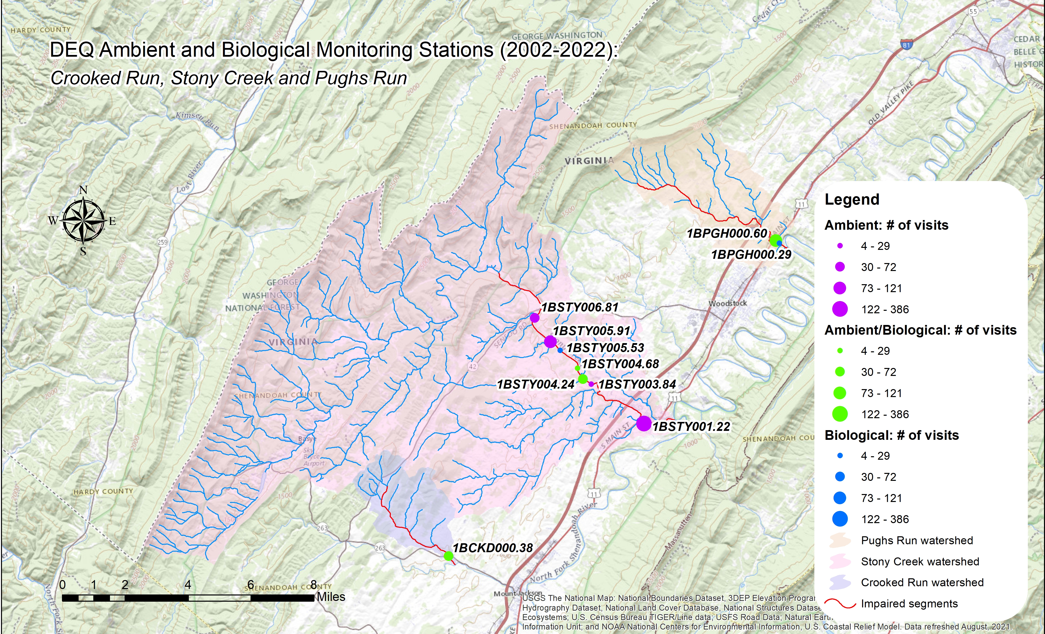
Figure 1-1. Ambient and biological monitoring stations in the Crooked Run, Pughs Run and Stony Creek watersheds.
Table 1-1 shows the number of samples and the period of time over which individual stations were monitored. For benthic monitoring stations, data include taxonomic identification (family or genus level) and counts of benthic macroinvertebrates collected, eight calculated benthic metrics, stream condition index scores (SCI), and visual habitat assessment scores. For water quality monitoring stations, data include results for various physical and chemical parameters. The data analysis window was limited to ambient and biological data collected between 2002 and 2022 in order to focus on existing conditions in the watersheds and recent changes in land use. In total, 268 water quality samples were collected from six (6) ambient monitoring stations in the Crooked Run, Pughs Run and Stony Creek watersheds between 2002 and 2022. Samples were analyzed for 44 different water quality parameters. A total of 56 benthic samples were collected from seven (7) monitoring stations within the project area between 2002 and 2022.
In addition to sampling locations within the three impaired watersheds, benthic data collected from a monitoring station in the Gravel Springs Run watershed (1BGSR000.44 and 1BGSR000.58) in Frederick County was used to establish a healthy, unimpaired reference condition for comparative purposes with Crooked and Pughs Runs. A limited extent of ambient monitoring was conducted at one of the Gravel Springs Run stations (1BGSR000.44), while field parameters (specific conductivity, dissolved oxygen, pH and temperature) were collected at the time of benthic monitoring at both stations. In cases where reference data were not available for comparison, water quality standards and established probability of stressor effects ranges were evaluated to determine whether measured constituents were stressors. In 2014, twelve (12) samples were collected from two stations in Gravel Springs Run (Table 1-1).
Benthic data collected from several monitoring stations on the North Fork Shenandoah River (1BNFS093.80, 1BNFS096.53, 1BNFS102.55 and 1BNFS107.86) in Rockingham County were used as a reference condition for comparison with Stony Creek. The North Fork Shenandoah River is significantly larger than Gravel Springs Run with a larger drainage area, making it a more suitable reference for Stony Creek. Between 2008 and 2022, a total of 16 benthic samples were collected from the North Fork Shenandoah River monitoring stations. Ambient monitoring was conducted at three of the four stations, while field parameters were collected at all the stations during benthic monitoring. A total of 27 water samples were collected from the North Fork Shenandoah River stations between 2002 and 2018. Both Gravel Springs Run and the North Fork Shenandoah River are fully supporting the aquatic life use designation and have a land use distribution similar to the impaired watersheds. Comparisons of the biological communities in these streams in conjunction with established benthic metrics and stressor thresholds allowed for the establishment of a reference condition for the impaired streams that could be used to gauge stressor effects.
Table 1-1. Benthic and chemical monitoring data used in the Crooked Run, Pughs Run and Stony Creek stressor analysis.
Stream | Station | Station Type | Benthic Sampling |  | Water Quality Sampling
 |  |  | Monitoring Period | Samples Collected | Monitoring Period | Samples Collected
Crooked Run | 1BCKD000.38 | DEQ Water Quality/Benthic | 2005-2022 | 12 | 2021-2022 | 24
Pughs Run | 1BPGH000.29 | DEQ Benthic | 2009-2020 | 3
 | 1BPGH000.60 | DEQ Water Quality/Benthic | 2013-2022 | 12 | 2004-2022 | 46
Stony Creek | 1BSTY001.22 | DEQ Water Quality |  |  | 2003-2022 | 137
 | 1BSTY003.84 | DEQ Water Quality |  |  | 2003-2009 | 25
 | 1BSTY004.24 | DEQ Water Quality/Benthic | 2002-2022 | 14 | 2021-2022 | 23
 | 1BSTY004.68 | DEQ Benthic | 2012-2022 | 5
 | 1BSTY005.53 | DEQ Benthic | 2012-2013 | 4
 | 1BSTY005.91 | DEQ Benthic | 2012-2015 | 6
 | 1BSTY006.81 | DEQ Water Quality |  |  | 2009 | 13
Reference Watershed Stations
Gravel Springs Run | 1BGSR000.44 | DEQ Water Quality |  |  | 2014 | 10
 | 1BGSR000.58 | DEQ Water Quality/Benthic | 2014 | 2 | 2014 | 2
NF Shenandoah | 1BNFS093.80 | DEQ Water Quality/Benthic | 2014 | 2 | 2014 | 6
 | 1BNFS096.53 | DEQ Water Quality/Benthic | 2018 | 1 | 2018 | 12
 | 1BNFS102.55 | DEQ Benthic | 2022 | 1
 | 1BNFS107.86 | DEQ Water Quality/Benthic | 2008-2022 | 10 | 2002-2003 | 7

Benthic Assessments
From spring 2002 to fall 2022, DEQ conducted 56 benthic assessments at seven (7) stations within the Crooked Run, Pughs Run and Stony Creek watersheds. Table 1-2 and Figure 1-2 show the average SCI scores for each station over this 20-year window. In addition, Table 1-2 includes averages for the 2022 Water Quality Assessment window (2015-2020). For a stream to be placed on Virginia’s 303(d) list of impaired waters with a benthic impairment, one sample with a score below 60 within the monitoring window is all that is required. To remove a benthic impairment listing, scores above 60 must be recorded for the most recent fall and spring samples within a given water quality assessment cycle. One of the listing stations for the impairment on Stony Creek has an average VSCI scores above 60 for the 2022 assessment cycle; however, the most recent fall and spring scores within this time frame are not both over 60, and 2021-2022 monitoring downstream indicates that the stream remains impaired.
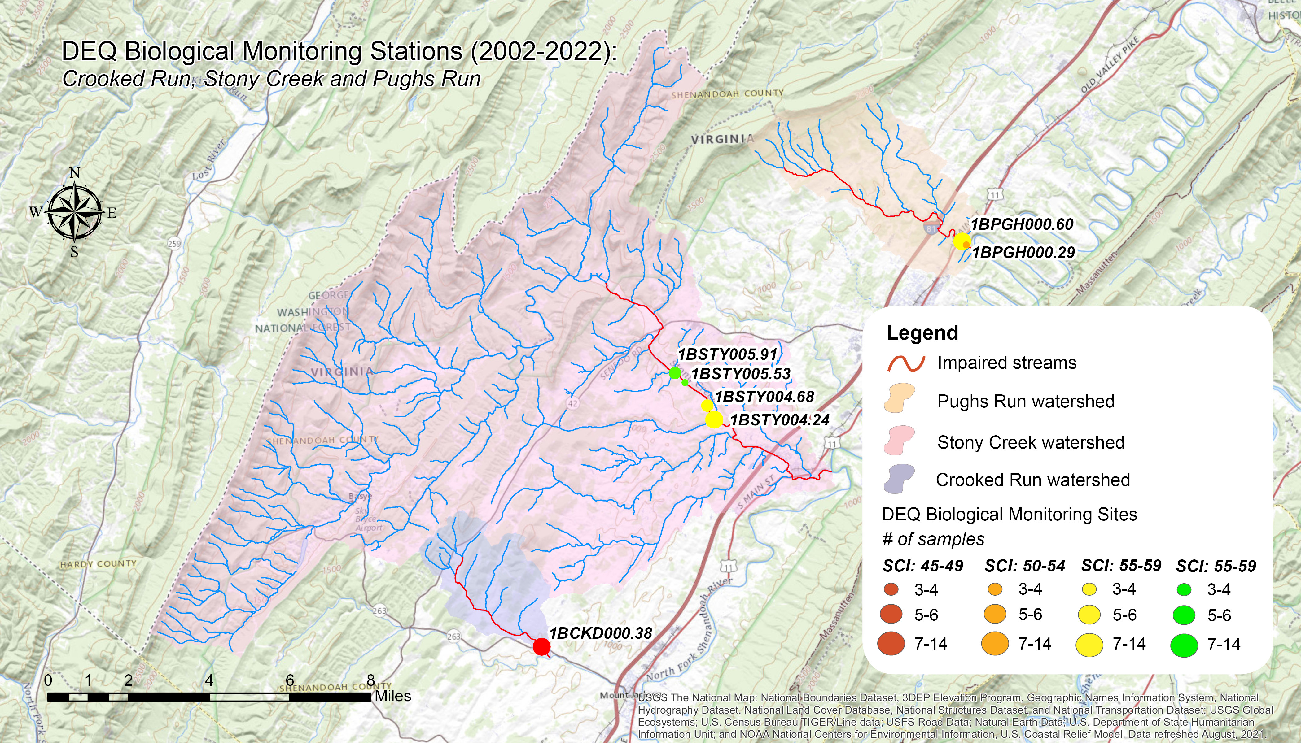
Figure 1-2. Average stream condition index (SCI) scores between 2002 and 2022 for benthic stations in Crooked Run, Pughs Run and Stony Creek.

Table 1-2. Benthic scores in the Crooked Run, Pughs Run and Stony Creek watersheds.
Stream | Station | Years Sampled | Samples Collected | SCI Average | 2022 WQA (2015-2020) SCI Avg.
Crooked Run | 1BCKD000.38* | 2005-2022 | 12 | 46.44 | 47.43
Pughs Run | 1BPGH000.29* | 2009-2020 | 3 | 50.30 | 54.04
 | 1BPGH000.60* | 2013-2022 | 12 | 57.51 | 59.62
Stony Creek | 1BSTY004.24* | 2002-2022 | 14 | 58.26 | 56.03
 | 1BSTY004.68 | 2012-2022 | 5 | 58.45 | N/A
 | 1BSTY005.53 | 2012-2013 | 4 | 59.88 | N/A
 | 1BSTY005.91* | 2012-2015 | 6 | 65.20 | 65.13

* listing station

Temporal Trends in Benthic Data
Figure 1-3 shows temporal trends in benthic data from the impaired streams. The red line shown in each figure indicates the impairment threshold (SCI Score = 60). Stony Creek had samples above and below 60 in both the spring and fall with 55% of samples falling above the impairment threshold of 60. None of the samples collected from Crooked Run (1BCKD000.38) were above 60. All of the samples collected from the lower Pughs Run monitoring station (1BPGH000.29) fell below the threshold. Fifty percent of samples from the upper Pughs Run station (1BPGH000.60) fell above the impairment threshold. Average spring benthic SCI scores were significantly lower (α=0.05) than average fall scores in Crooked Run and Stony Creek (Figure 1-4). Spring scores were slightly higher than fall scores in Pughs Run, though this difference was not significant. The seasonal trend observed in Crooked Run and Stony Creek indicates that higher spring flows may be contributing to the benthic impairments present in the two watersheds due to increased concentrations of nutrients and/or sediment in runoff to the streams.
In Stony Creek, benthic SCI scores between 2002 and 2022 averaged 59.9 and ranged from 34.7 (spring 2002) to 74.7 (fall 2021). SCI scores showed a clear trend of improvement (R²=0.89) moving upstream (Figure 1-5). The impaired segment of Stony Creek extends 9.3 miles upstream from the mouth, meaning that the uppermost station shown in Figure 1-5, 1BSTY012.47, does not fall within the impaired segment. Most samples were above the impairment threshold (51.4%), while only 20% of scores fell below 50, suggesting a relatively moderate level of impairment.
Half of SCI scores in Crooked Run (1BCKD000.38) fell between 40 and 50. SCI scores between 2005 and 2022 averaged 46.1 and ranged from 32.7 (Spring 2022) to 57.7 (Fall 2022). The fact that the highest in lowest SCI scores occurred within the same year suggests that elevated levels of runoff in the spring is a significant contributor to the impairment on Crooked Run.
SCI scores in Pughs Run averaged 55.7 between 2009 and 2022, ranging from 39.0 (Spring 2022) to 67.6 (Spring 2019). The mean score at 1BPGH000.29 (50.3) was lower than the mean score at 1BPGH000.60 (57.5). This is likely because 1BPGH000.29 is a bedrock dominated site that was sampled as part of DEQ’s Probabilistic Monitoring Program. While 1BPGH000.60 was selected as a site that was representative of the watershed, 1BPGH000.29 was randomly selected through the Probabilistic Monitoring Program. Consequently, it is likely that the benthic impairment on Pughs Run is more moderate, with most SCI scores falling closely around the impairment threshold of 60.
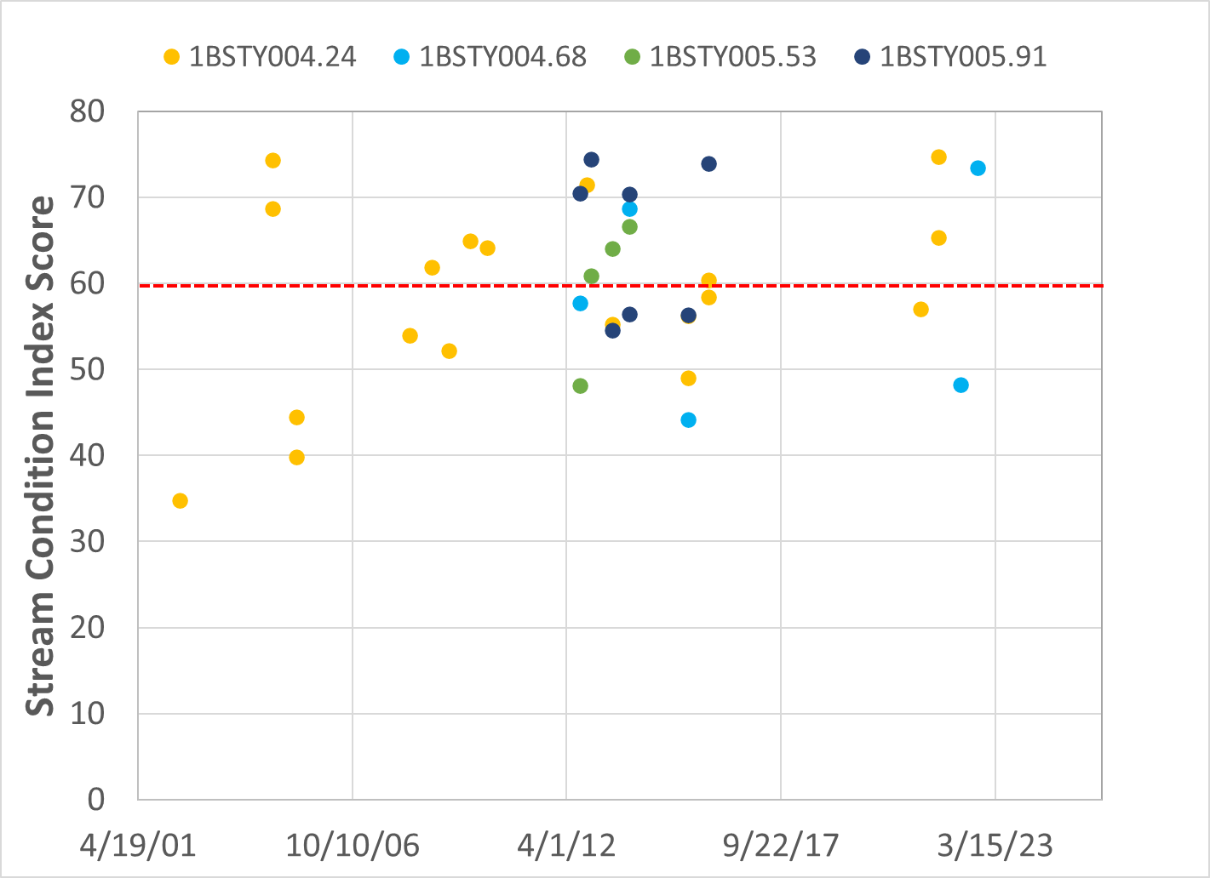
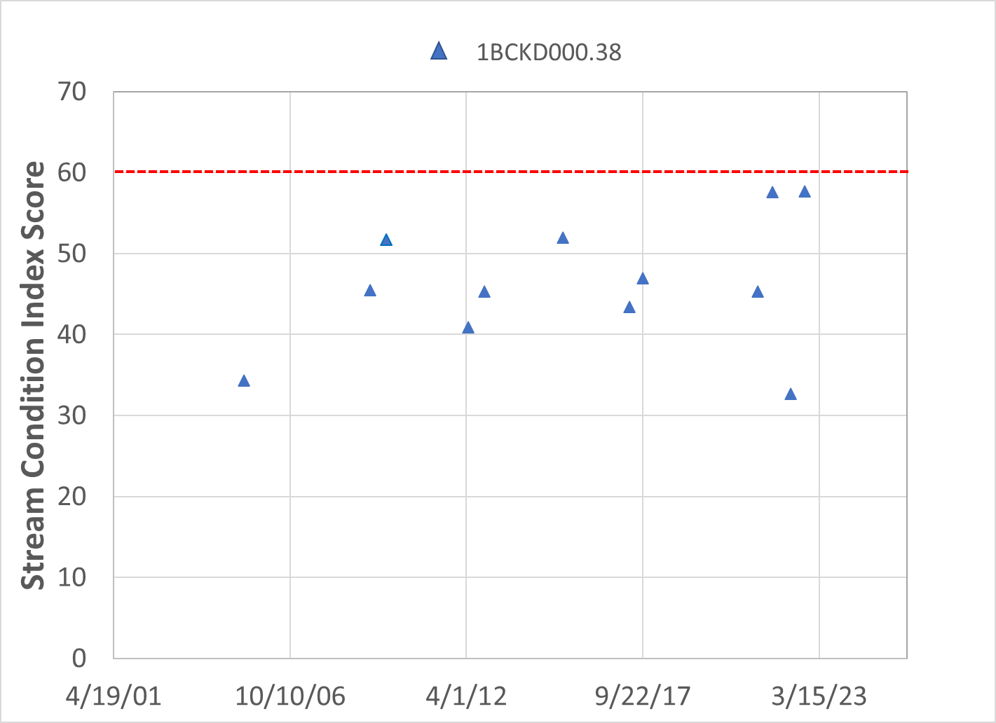
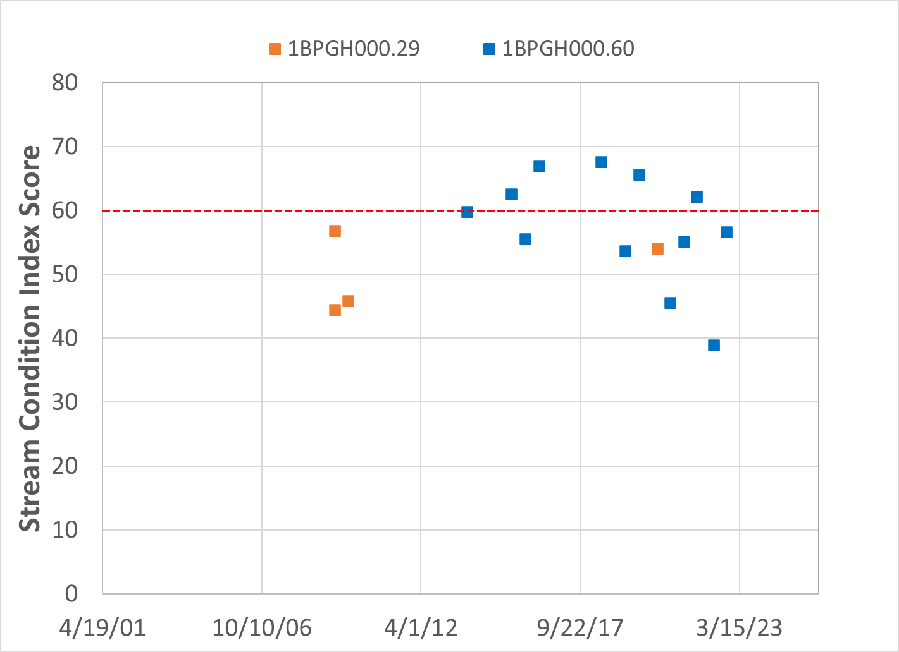
Figure 1-3. Temporal trends of benthic stream condition index (SCI) scores in the Stony Creek, Crooked and Pughs Run watersheds.
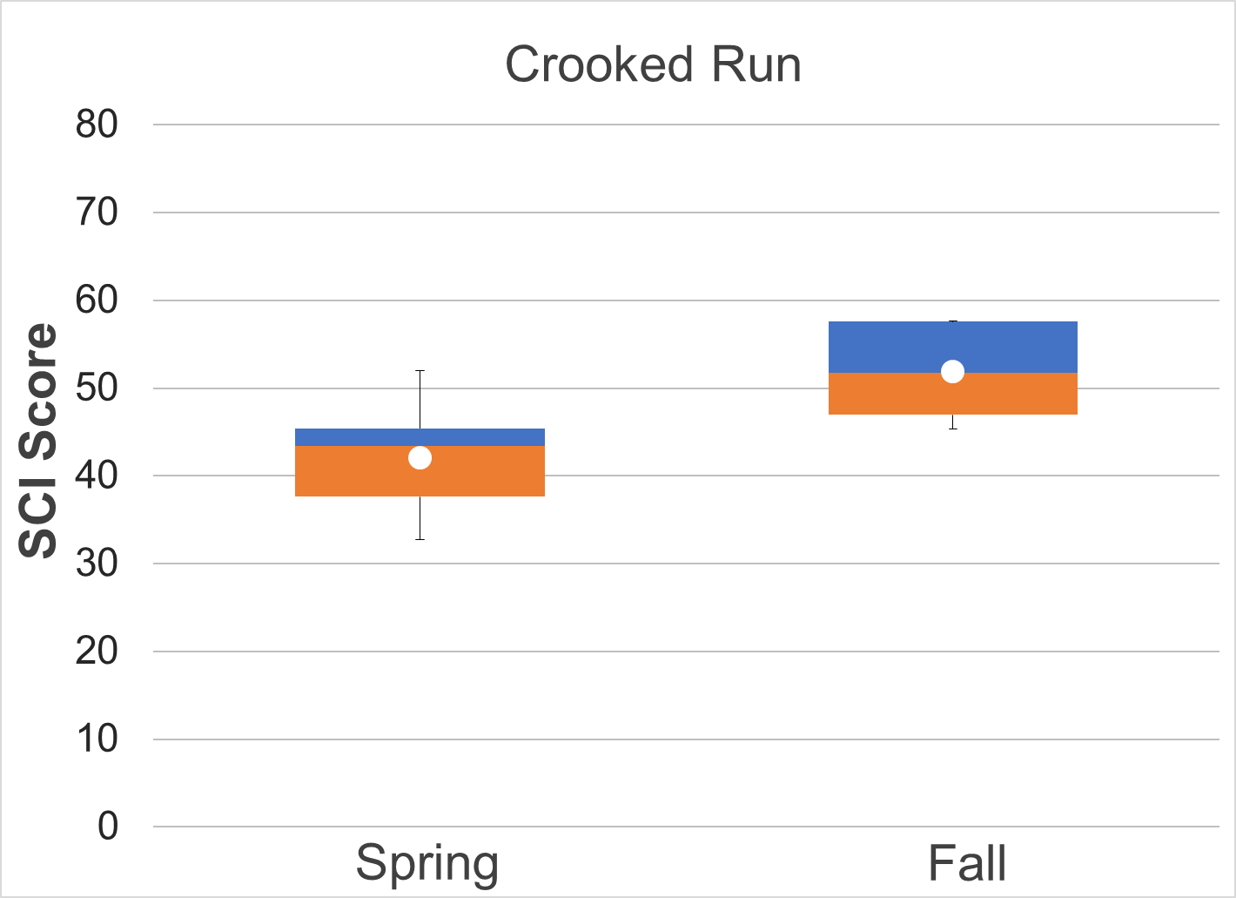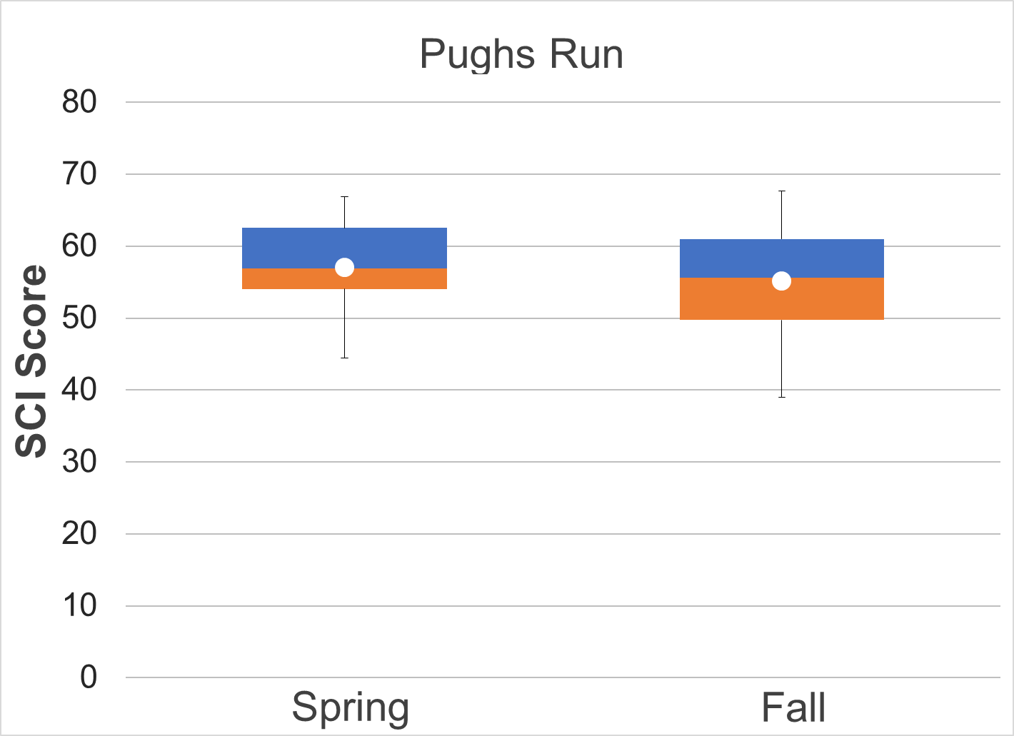
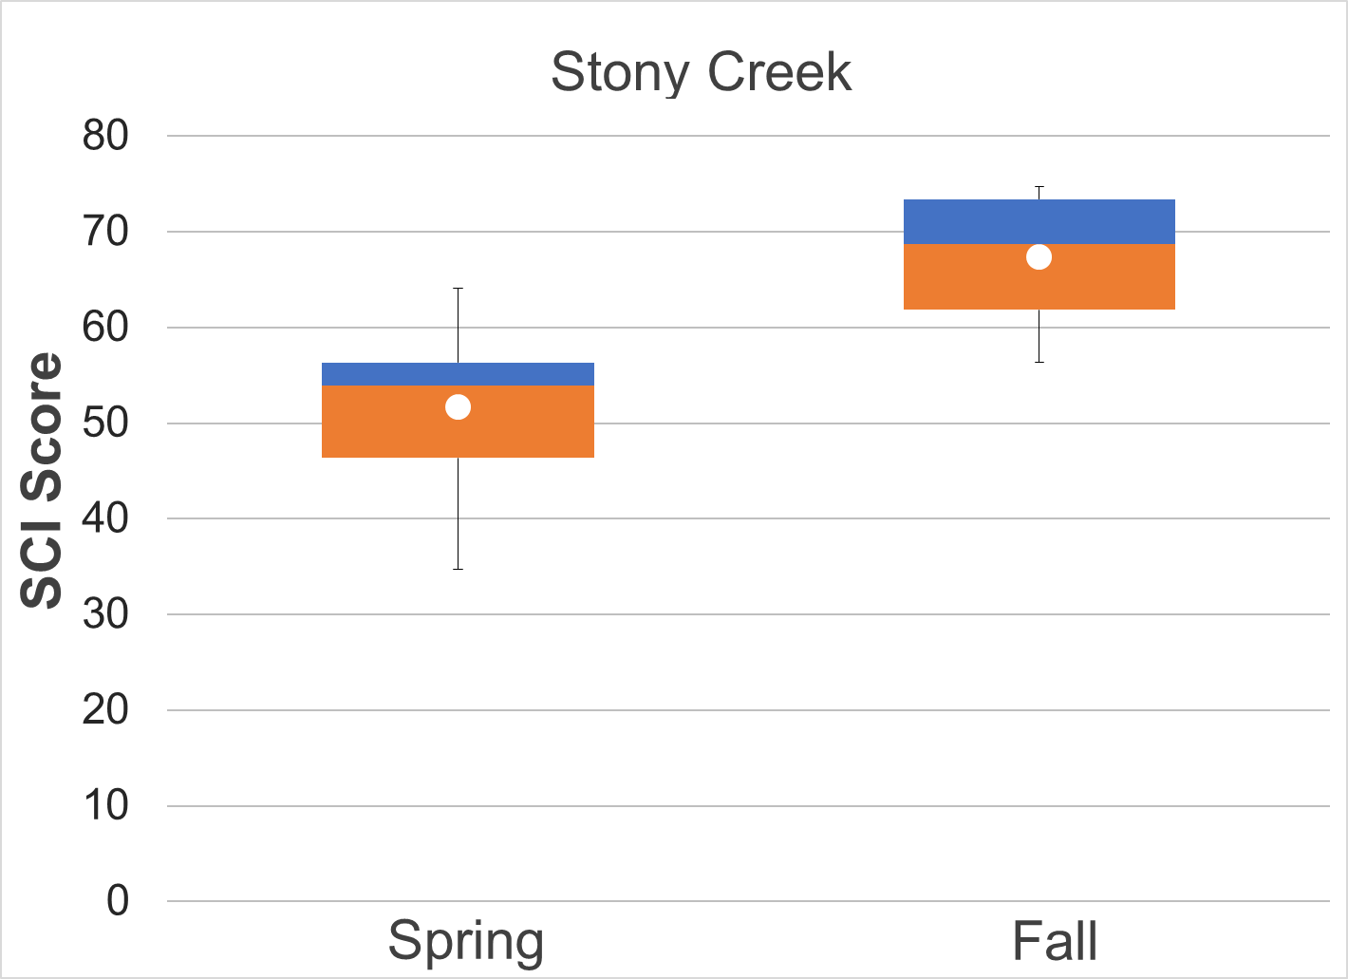

Figure 1-4 Crooked and Pughs Run and Stony Creek stream condition index scores (spring and fall). Whiskers indicate the range, boxes indicate the inter-quartile range, lines indicate the median, and white markers indicate the average.
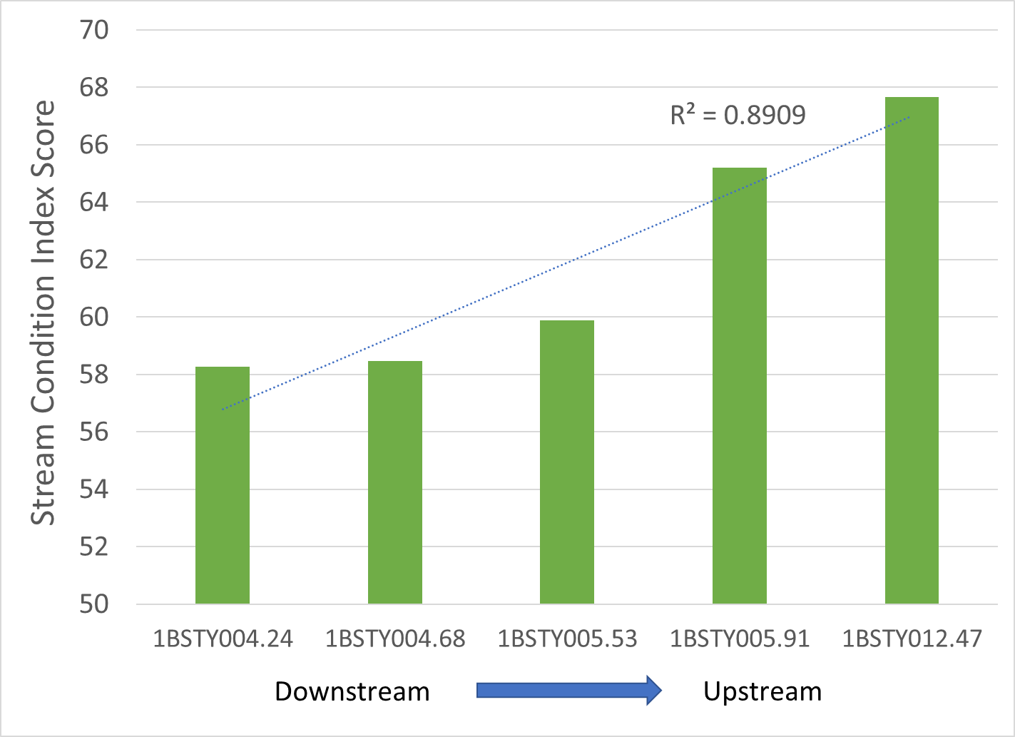
Figure 1-5 Spatial trends in Stream Condition Index scores in Stony Creek

Analysis of Benthic Metrics
Individual metrics that comprise the SCI were evaluated for the impaired streams in comparison to benthic reference streams (Figure 1-5). The benthic reference used for comparisons with Stony Creek was an upstream segment of the North Fork Shenandoah River in Rockingham County, Virginia (1BNFS107.86). Benthic metrics from Gravel Springs Run in Frederick County were used for comparisons with Crooked and Pughs Runs. Average metric scores for each stream were compared to the references using a t-test with unequal variances (α = 0.05). All the scores in Crooked Run were lower than the reference condition with the exception of %Scraper. However, only Richness and Ephemeroptera Plecoptera Trichoptera (EPT) scores were significantly lower (p<0.001 and p=0.009, respectively). This is likely due to the small sample size in Gravel Springs Run (n=2) and the variability in several scores. For example, mean values for % Ephemeroptera in Crooked Run and Gravel Springs Run were 13.44 and 48.20, respectively; however, these differences were not significant. Individual scores for %Ephemeroptera in Gravel Springs Run varied widely with values of 68.22 in Spring 2014 and 28.18 in Fall 2014. Finding a suitable reference stream for Crooked and Pughs Runs proved challenging due to a limited pool of similarly sized watersheds with similar land uses nearby. Despite its low sample size, Gravel Springs Run displays similar characteristics to the impaired watersheds and excellent stream health and was therefore the most suitable reference watershed. Differences in %Ephemeroptera, % Plecoptera and Trichoptera minus Hydropsychidae (%PT-H), Richness and EPT were most pronounced in Crooked Run. This is likely due to the low number of EPT taxa present in the stream, comprising 12% of the overall population compared to 48% in Gravel Springs Run. The %Scraper score in Crooked Run (62.48) was nearly twice as high as the reference condition (35.24) This could be indicative of nutrient enrichment. Scrapers feed on algae, periphyton and aquatic vegetation growing on the bottom substrate. Their prevalence in Crooked Run suggests that excess nutrients could be stimulating the growth of these food sources, resulting in an abundance of scrapers in the stream. However, the scraper community in Crooked Run is largely comprised of Elmidae, which are found in areas with high embeddedness and sedimentation. Therefore, the shift towards scrapers observed in Crooked Run may also signal excess sedimentation in the stream.
Differences in Pughs Run were less apparent. Similarly, only Richness and EPT showed significant differences from the reference condition. All metric scores were slightly lower than the reference condition except for %Scraper, which was only slightly higher in Pughs Run (37.99) compared to the reference condition (35.24). Richness is a measure of the diversity of taxa present in the stream. The significant difference in this metric in Pughs Run compared to the reference stream suggests that overall community composition is comprised of a smaller number of taxa. The EPT score was also significantly lower in Pughs Run. While a greater number of different EPT taxa were present in Pughs Run, they comprised a smaller portion of the overall community. Additionally, the data set for the reference stream consisted of two samples, while the Pughs Run data set consisted of 16 benthic macroinvertebrate samples. Consequently, a greater number of taxa would be expected in the overall sample for Pughs Run. In Pughs Run, benthic metric scores showed evidence of a “borderline” or minor impairment. While it is likely that the small sample size in Gravel Springs Run led to a lack of significant differences in paired t-tests with Crooked Run, this is probably not the case in Pughs Run. These results suggest a relatively minor impairment in Pughs Run, effects of which are likely limited to the most sensitive macroinvertebrate taxa.
In Stony Creek, benthic metric scores were compared with the NF Shenandoah River using paired t-tests. %Ephemeroptera, %PT-H, EPT and Modified Family Biotic Index (%MFBI) scores were significantly lower than the reference condition. Ephemeroptera taxa comprised 34% of the benthic community in Stony Creek compared to 43% in the NF Shenandoah River. Plecoptera and Trichoptera taxa were present in lower abundance in Stony Creek, 1% and 5% of the community, respectively, resulting in a significantly lower %PT-H score when compared to the reference condition. These differences were also reflected in the EPT score for Stony Creek (66.24), which was significantly lower than the NF Shenandoah (77.27). The %MFBI measures the ecological tolerance and relative abundance of aquatic macroinvertebrates present in a stream. Lower MFBI scores indicate that water quality or habitat conditions are limiting the presence of sensitive taxa in Stony Creek.
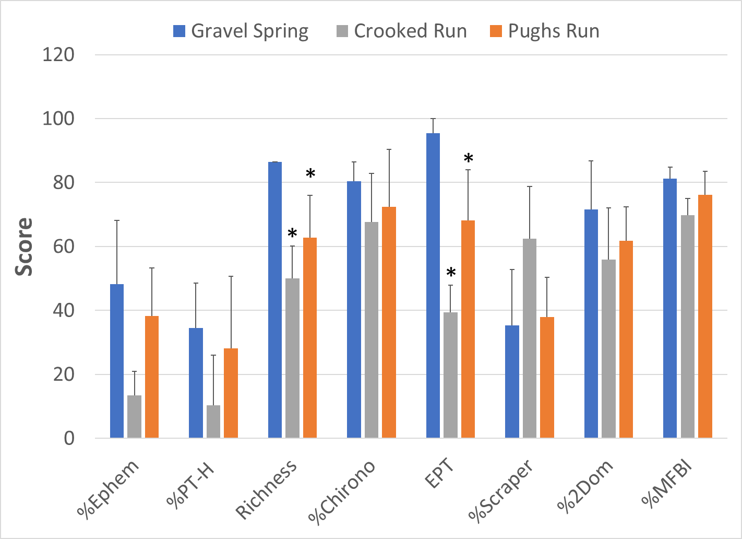
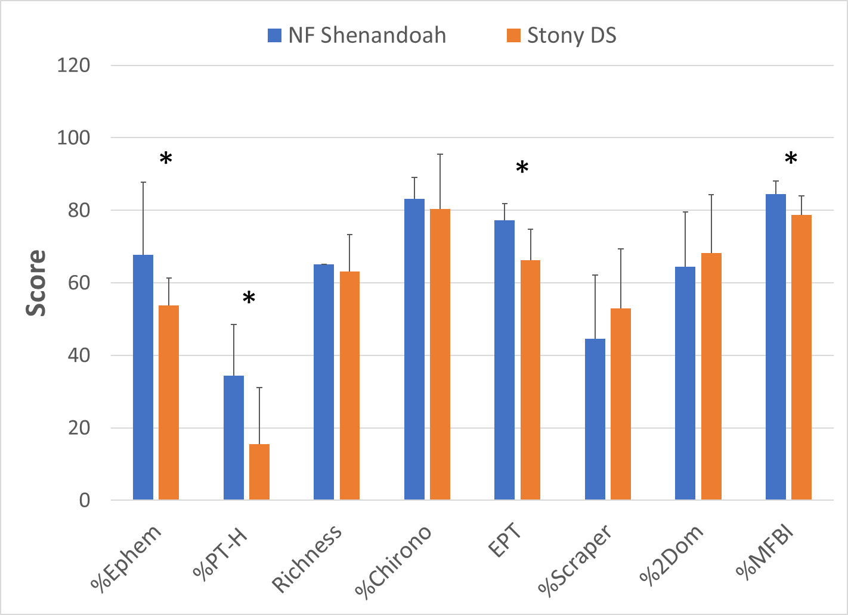
Figure 1-6. Metric scores comprising stream condition index (SCI) scores in Crooked and Pughs Runs (upper) and Stony Creek (lower). * indicates that the metric was significantly different (α = 0.05) from the benthic reference score (Gravel Springs Run and Upper North Fork Shenandoah River).

Analysis of Community Composition
The taxonomic composition of the benthic communities was analyzed to identify shifts in composition at impaired sites that might provide clues to sources or mechanisms of impairment. Figure 1-6 and Figure 1-7 compare the reference streams (Gravel Springs Run and the North Fork Shenandoah River) to the taxonomic composition in the impaired streams, Crooked and Pughs Runs and Stony Creek, respectively, and Table 1-3 shows the three predominant taxa in each stream.
In the reference streams, Gravel Springs Run and North Fork Shenandoah, taxonomic composition is relatively balanced, with Ephemeroptera, Trichoptera (excluding Hydropsychidae) and Plecoptera taxa comprising 55% and 56% of the macroinvertebrate community, respectively. Plecoptera taxa were absent in Crooked Run, while Ephemeroptera and Trichoptera (excluding Hydropsychidae) comprised 11.9% of the benthic community. Diptera were the predominant taxa in Crooked Run. Chironomidae, a family of non-biting midges, were the predominant Dipteran family in in Crooked Run (90%). Many Chironomid larvae construct silk tubes within burrows in the stream. They are well adapted to thrive in conditions where excess sediment is present in the stream bottom. Bjornn et al. (1977) demonstrated in artificial mesocosm experiments that increases in fine sediment significantly reduced EPT taxa but were tolerated by Chironomid taxa. The shift towards pollution tolerant midges could also be indicative of nutrient or sediment enrichment. Lawrence and Gressens (2011) showed that Chironomid abundance correlated with increased nutrient enrichment in urban and rural streams. Coleoptera taxa comprised 27% of the benthic community in Crooked Run, predominantly the Elmidae family, which comprised 90% of Coleoptera taxa in the stream. While some genra within the Elmidae family are sensitive to pollution, the predominant genus in Crooked Run was Stenelmis (87%), which is relatively tolerant of excess sedimentation in streams. Hydropsychidae comprised 14.6% of the benthic community in Crooked Run. Hydropsychidae are a family of net-spinning caddisflies that can implicate the presence of increased suspended organic matter in the stream, which is a food source that these caddisflies effectively trap as it moves downstream. Community composition in Crooked Run was significantly altered from the reference condition, signaling an overall shift to more pollution tolerant taxa.
Taxonomic composition in Pughs Run was slightly altered from that of the reference stream. Chironomidae and Hydropsychidae taxa comprised over 50% of macroinvertebrate samples collected from Pughs Run compared to 37% in the reference stream. Both taxa are well adapted to thrive in conditions where excess sediment is present in the stream bottom as discussed above. Ephemeroptera taxa were relatively abundant in Pughs Run, comprising 23.9% of the benthic community. Heptageniidae was the predominant Ephemeroptera family in the stream. Plecoptera and Trichoptera (excluding Hydropsychidae) taxa were less prevalent, comprising 9% of the community. However, these taxa were not abundant in the reference stream either, comprising 12% of the benthic community. This may be due to the predominance of bedrock in Gravel Springs Run, which could be limiting available habitat. The prevalence of Ephemeroptera taxa in Pughs Run signals that the impairment is relatively moderate, meaning that the stream is capable of supporting organisms that are sensitive to pollution, while comparatively pollution tolerant taxa also continue to thrive.
Taxonomic composition in Stony Creek was only slightly altered from that of the reference stream. The most significant shifts in community composition were a 9.4% decrease in Ephemeroptera taxa and an 8.0% decrease in Plecoptera taxa. Additionally, Diptera taxa increased by 8.2%. These changes reflect a general shift from the more sensitive EPT taxa to more pollution tolerant taxa. Basommatophora (primarily family Pleuroceridae) comprised 8.3% of the benthic community in Stoney Creek; however, this order/family was not found in NF Shenandoah River samples. Pleuroceridae is a family of gilled snails that are typically found in healthy streams. Other shifts in community composition were minor. This suggests that the impairment on Stony Creek is relatively moderate, meaning that the stream is capable of supporting organisms that are sensitive to pollution, while comparatively pollution tolerant taxa also continue to thrive.

Table 1-3. Predominant families in Crooked and Pughs Runs and Stony Creek compared with reference streams.
Stream | Order,  Family | % of Benthic Community | Order,  Family | % of Benthic Community | Order,  Family | % of Benthic Community
Crooked Run | Trichoptera, Hydropsychidae | 14.6% | Coleoptera,  Elmidae | 26.9% | Diptera, Chironomidae | 32.3%
Pughs Run | Ephemeroptera,  Heptageniidae | 9.2% | Trichoptera, Hydropsychidae | 20.8% | Diptera, Chironomidae | 29.5%
Stony Creek | Ephemeroptera, Ephemerellidae | 15.2% | Trichoptera, Hydropsychidae | 17.0% | Diptera, Chironomidae | 18.3%
Gravel Springs Run (Crooked and Pughs Run reference) | Ephemeroptera, Ephemerellidae | 17.7% | Trichoptera, Hydropsychidae | 17.7% | Diptera, Chironomidae | 19.5%
NF Shenandoah (Stony Creek reference) | Ephemeroptera,  Heptageniidae | 11.7% | Diptera, Chironomidae | 16.0% | Ephemeroptera, Ephemerellidae | 19.0%

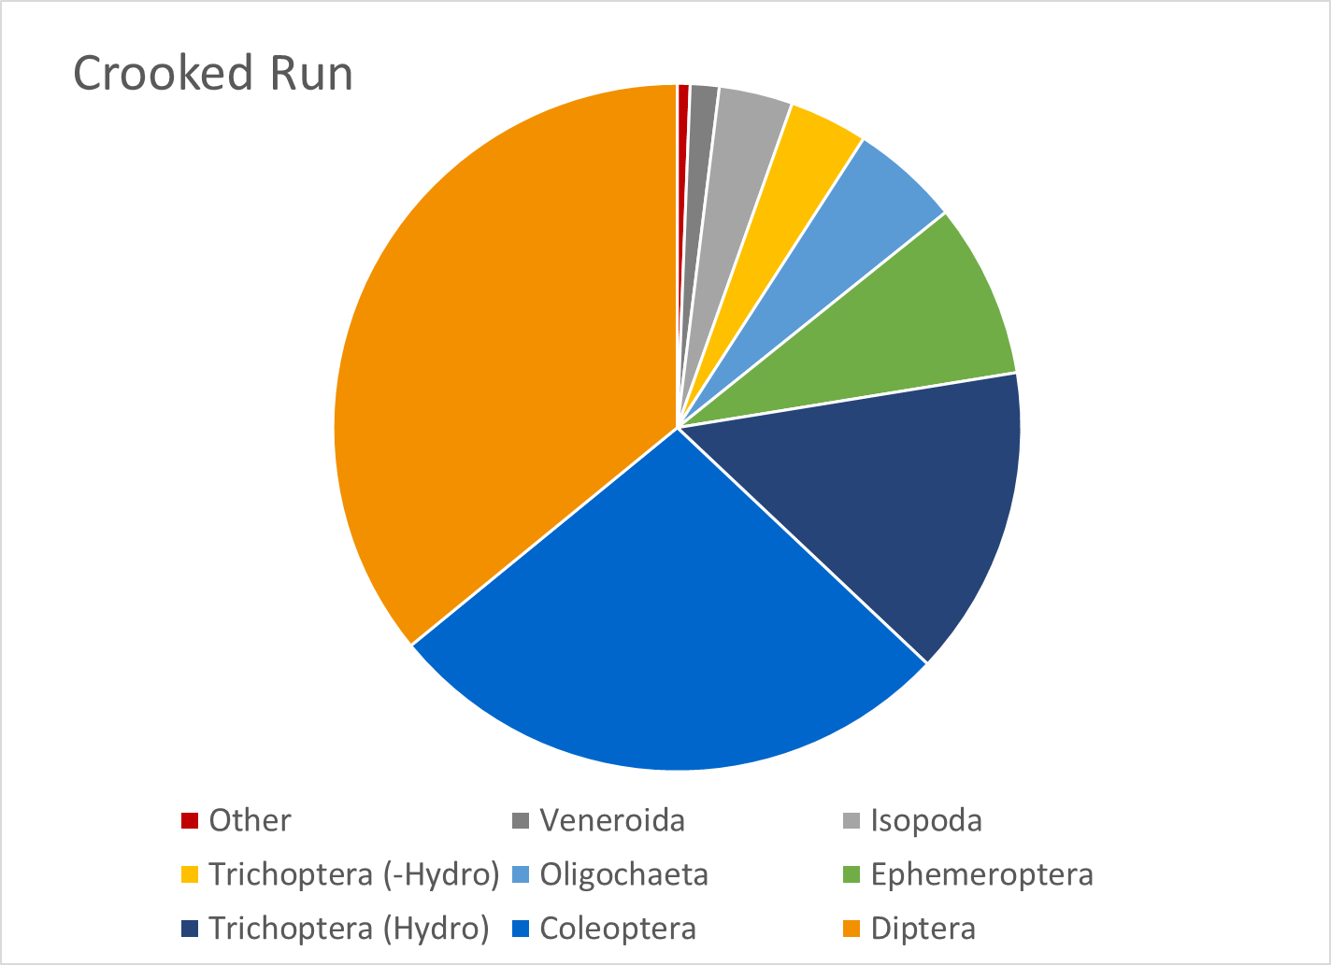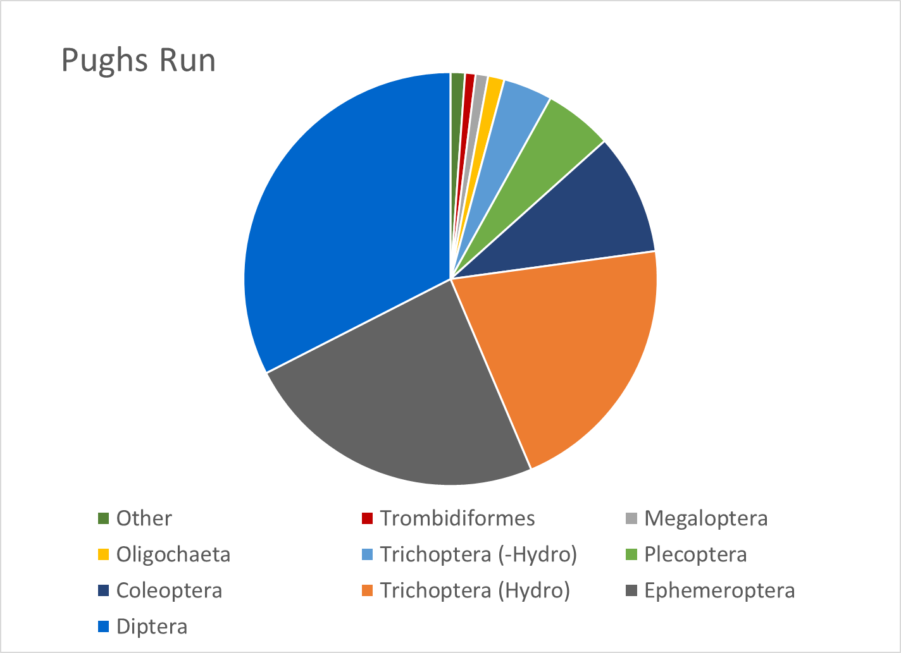
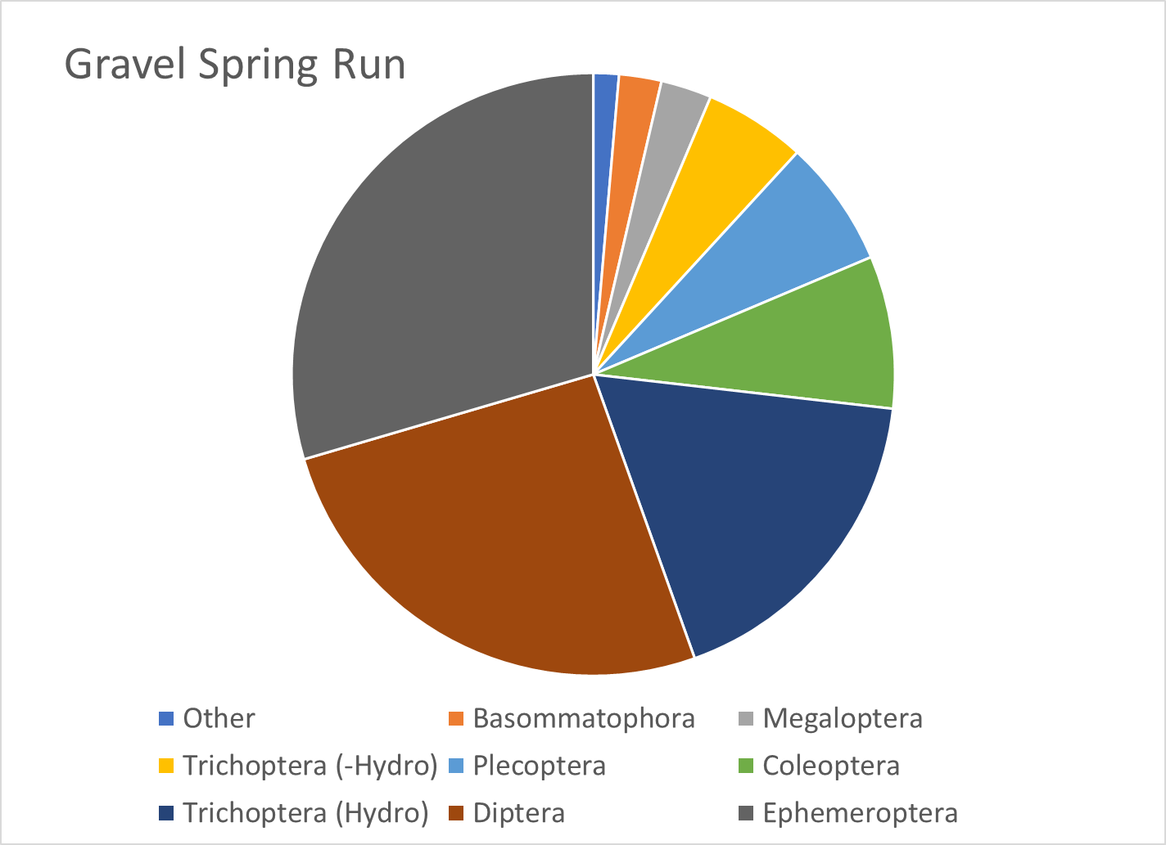
Figure 1-7. Benthic community structure (by order) in Crooked (upper) and Pughs Run (middle) in comparison with reference stream Gravel Springs Run (bottom).
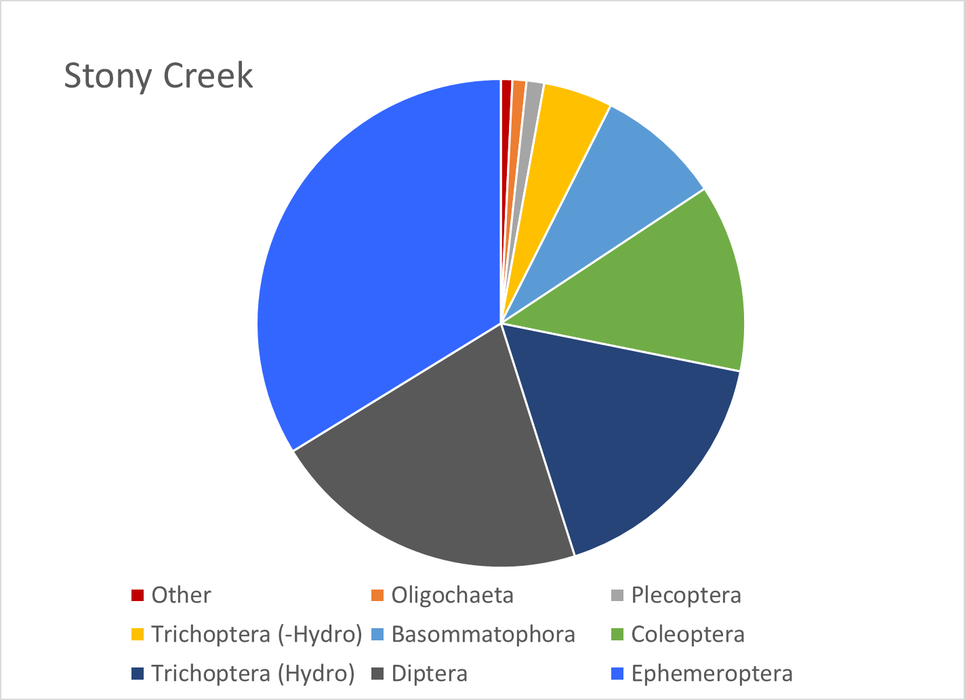
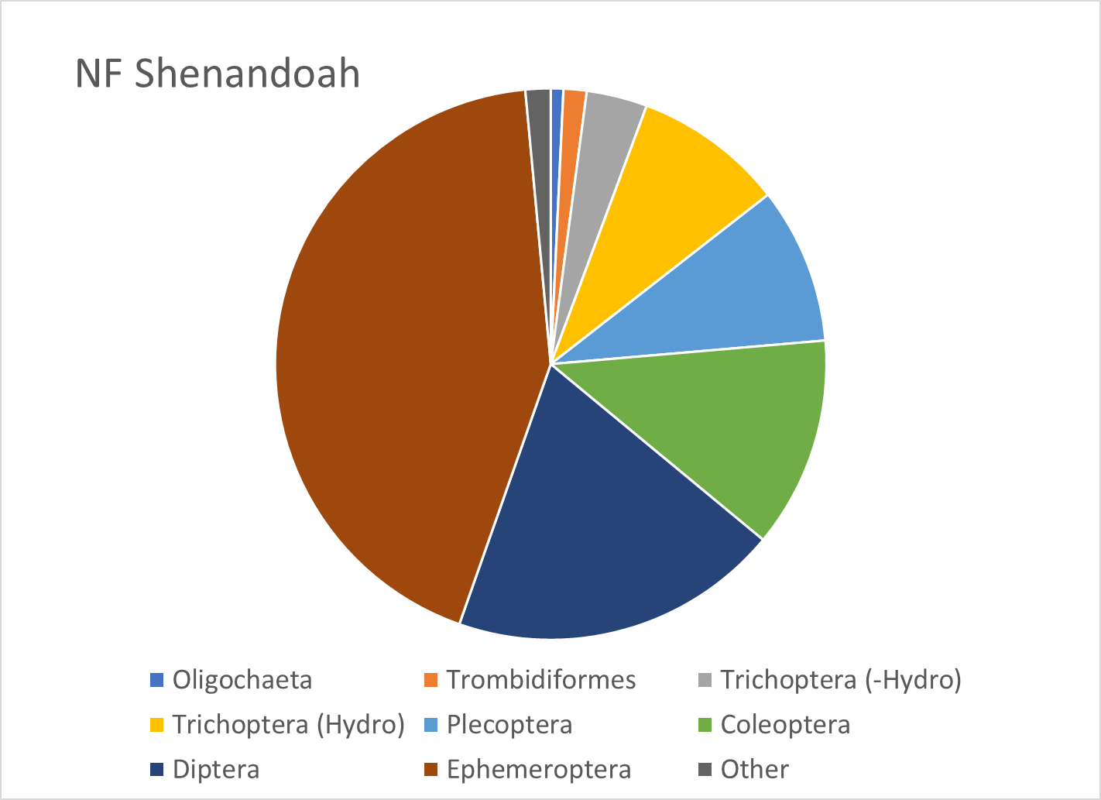
Figure 1-8. Benthic community structure (by order) in Stony Creek in comparison with reference stream, NF Shenandoah River

Biological Condition Gradient Analysis
In partnership with the US EPA and several Mid-Atlantic States (Virginia, West Virginia, and Maryland), Tetra Tech developed a Mid-Atlantic Biological Conditions Gradient (BCG) model in 2019 (Tetra Tech, 2019). A BCG is a conceptual framework that may be used to predict biological responses to increased environmental stress. The BCG model establishes a framework of measurable characteristics known as “attributes” of biological communities including properties such as richness, abundance, and structure. The model predicts how these attributes shift in response to increasing levels of environmental stress based on observed patterns of biological response to stressors for a given geographic region. The Mid-Atlantic BCG model defines six attributes related to the pollution tolerance among fish and macroinvertebrate taxa present in the region. These attributes were assigned scores for ten specific stressors for a total of 560 macroinvertebrate taxa based on data provided by multiple states through a consensus-based process with input from regional biologists (Table 1-5).
Table 1-5. Mid-Atlantic biological condition gradient attributes and stressors evaluated.
Attribute | Explanation | Stressors Evaluated
I | Historically documented, sensitive, long-lived or regionally endemic taxa | Dissolved oxygen  Acidity  Alkalinity  Specific conductivity  Total habitat  % Imperviousness | Chloride  Sulfate  Total Nitrogen  Total Phosphorus  Relative bed stability
II | Highly sensitive taxa
III | Intermediate sensitive taxa
IV | Intermediate tolerant taxa
V | Tolerant taxa
VI | Non-native taxa

Taxa receiving high attribute values for a stressor are typically more tolerant of that particular stressor. Conversely, taxa assigned low attribute values for a stressor are generally intolerant of that stressor and will not typically be abundant or present in conditions where this particular stressor is experienced. Using attribute data from Virginia’s BCG model, scores were assigned to taxa in Crooked and Pughs Runs and Stony Creek samples for each stressor listed in Table 1-5. Weighted average attribute values were calculated for each stressor across all taxa in the impaired streams (Table 1-6). In addition, attribute values for stressors were evaluated for predominant species in the streams to identify potential stressors that may be disproportionately influencing benthic community composition in the impaired streams (Table 1-7). As shown in Table 1-7, there was little variability in average BCG scores for possible stressors, with percent impervious in Crooked Run receiving the highest score (4.3), and dissolved oxygen, acidity, and chloride in Stony Creek receiving the lowest score (3.3). These data suggest that taxa present in both streams are relatively tolerant to a wide range of stressors and do not show much differentiation with respect to stressor identification. BCG scores for Crooked Run were slightly higher than those in Pughs Run, with mean values of 4.0 and 3.9, respectively. Stony Creek had the lowest mean score of 3.6. While these differences are minor, comparison of scores between the three streams with varying degrees of impairment indicates that stressor effects from pollutants in Crooked and Pughs Runs are having a greater impact on community composition in the streams compared to Stony Creek. As shown in Table 1-7, Hydropsychidae and Chironomidae were prevalent in all three of the streams; however, when BCG values were weighted by the number of individuals present samples, the abundance of more sensitive Ephemerellidae in Stony Creek lowered mean values. The predominance of Ephemerellidae in Stony Creek suggests that stressor impacts may be relatively limited, as this family of mayflies has been assigned a score of three for each of the stressors evaluated with the exception of alkalinity and RBS. This supports the conclusion that sediment may be impacting aquatic life in Stony Creek. The other predominant family of mayflies in Stony Creek, Heptageniidae, appears similarly intolerant of stressors, with only RBS and percent impervious categories receiving a score of 4. These results suggest that stressor impacts in Stony Creek have been limited enough to allow for more sensitive taxa to populate the stream; however, taxa more tolerant of stressor impacts have also been able to thrive.

BCG scores of predominant taxa in Crooked Run suggest a greater degree of impairment. Chironomidae was assigned a score of four for all stressors evaluated, suggesting that this family of blackflies is relatively tolerant of pollution. Elmidae was one of the three predominant families in Crooked Run. BCG scores for this family signal that it is relatively sensitive to stressors. However, genus level data shows that Stenelmis comprise the greatest proportion of individuals found in Crooked Run within this family. BCG scores for Stenelmis indicate that this genus is relatively tolerant of pollution, with specific conductivity, percent impervious and total habitat stressors assigned values of 5, and all other stressors assigned values of 4. Results for Crooked Run suggest stressor impacts in the stream may be significant. Total habitat and percent impervious BCG scores for Stenelmis may signal a shift towards sediment tolerant genre in the stream.

The abundance of Chironomidae and Hydropsychidae taxa in Pughs Run raised weighted averages for BCG scores. The prevalence of Ephemerellidae in the stream suggest that stressor impacts in Pughs Run have been limited enough to allow for more sensitive taxa to populate the stream; however, taxa more tolerant of stressor impacts have also been able to thrive.
Table 1-6. Weighted average biological condition gradient scores by stressor for Crooked and Pughs Runs and Stony Creek
Stream | Diss. Oxy. | Acidity | Alkalinity | Spec. Cond. | Chloride | Sulfate | TN/TP | Total Habitat | RBS | % Imp.
Crooked Run | 3.8 | 3.7 | 3.9 | 4.1 | 3.7 | 4.0 | 4.0 | 4.1 | 4.0 | 4.3
Pughs Run | 3.6 | 3.6 | 3.9 | 4.0 | 3.6 | 4.0 | 4.0 | 3.8 | 4.0 | 4.0
Stony Creek | 3.3 | 3.3 | 3.9 | 3.7 | 3.3 | 3.6 | 3.8 | 3.6 | 3.9 | 3.8

Table 1-7. Biological condition gradient scores by stressor for predominant families in Crooked and Pughs Runs and Stony Creek.
Stream | Predominant Taxa | General | Diss. Oxy. | Acidity | Alkalinity | Spec. Cond. | Chloride | Sulfate | TN/TP | Total Habitat | RBS | % Imp.
Crooked Run | Hydropsychidae | 4 | 3 | 3 | 4 | 4 | 3 | 4 | 4 | 3 | 4 | 4
 | Elmidae | 4 | 3 | 3 | 4 | 3 | 3 | 4 | 3 | 3 | 4 | 4
 | Chironomidae | 4 | 4 | 4 | 4 | 4 | 4 | 4 | 4 | 4 | 4 | 4
Pughs Run | Heptageniidae | 3 | 3 | 3 | 4 | 3 | 3 | 3 | 3 | 3 | 4 | 4
 | Hydropsychidae | 4 | 3 | 3 | 4 | 4 | 3 | 4 | 4 | 3 | 4 | 4
 | Chironomidae | 4 | 4 | 4 | 4 | 4 | 4 | 4 | 4 | 4 | 4 | 4
Stony Creek | Ephemerellidae | 3 | 3 | 3 | 4 | 3 | 3 | 3 | 3 | 3 | 4 | 3
 | Hydropsychidae | 4 | 3 | 3 | 4 | 4 | 3 | 4 | 4 | 3 | 4 | 4
 | Chironomidae | 4 | 4 | 4 | 4 | 4 | 4 | 4 | 4 | 4 | 4 | 4

Analysis of Functional Feeding Groups
The composition of functional feeding groups comprising the benthic community was also analyzed to identify shifts in composition at impaired sites that might provide clues to sources or mechanisms of impairment. Figure 1-9 shows the composition of functional feeding groups within the impaired streams in comparison to conditions in the reference streams. Shredders and predators constituted a smaller portion of the population in the impaired streams when compared to the reference streams. Shredders comprised less than 3% of the benthic community in Crooked Run, and less than 1% in Stony Creek. Conversely, shredders comprised 7.3% of the community in Gravel Springs Run and 4.1% in North Fork Shenandoah. The difference observed in the reference conditions may be explained by the size of the streams. A smaller, higher order stream like Gravel Springs Run is likely to have a greater proportion of coarse particulate organic matter (CPOM) on the stream bottom. While collectors consume fine particulate organic matter (FPOM) deposited on the stream bottom, shredders consume CPOM including leaf litter and wood. In a large, lower order stream like the North Fork Shenandoah River, a lesser amount of CPOM would be expected. The shift away from shredders in the impaired streams could be indicative of a reduction in CPOM due to a lack of riparian buffers. Alternatively, it could signal an overabundance of suspended organic matter in the water column and FPOM on the stream bottom, allowing for a predominance of filterers and collectors in the impaired streams.
The greatest shift in function feeding groups observed was in Crooked Run, where scrapers comprised 32% of the community compared to 18.3% in Gravel Spring Run. This 14% increase could signal excess algae growth in the stream due to elevated nutrient inputs. Scrapers use rasping mouthparts to scrape algae and periphyton off bottom substrates. Excess nutrients can stimulate growth of these materials, leading to a shift towards scrapers in the benthic community. However, the scraper community in Crooked Run is largely comprised of Elmidae, which are found in areas with high embeddedness and sedimentation. Therefore, this shift towards scrapers could also signal excess sedimentation in the stream.
An 11% shift in the proportion of filters in Stony Creek was observed in comparison with the reference condition. This shift towards filterers can be indicative of excess suspended organic matter in the water column, which is further supported by the prevalence of Hydropsychidae in Stony Creek.
Functional feeding group composition in Pughs Run was very similar to the reference condition. The greatest shift observed was a 4% decrease in predators. This suggests that stressor impacts are marginal. It is also possible that multiple stressors are impacting the stream in different ways, making it challenging to detect shifts in community composition.
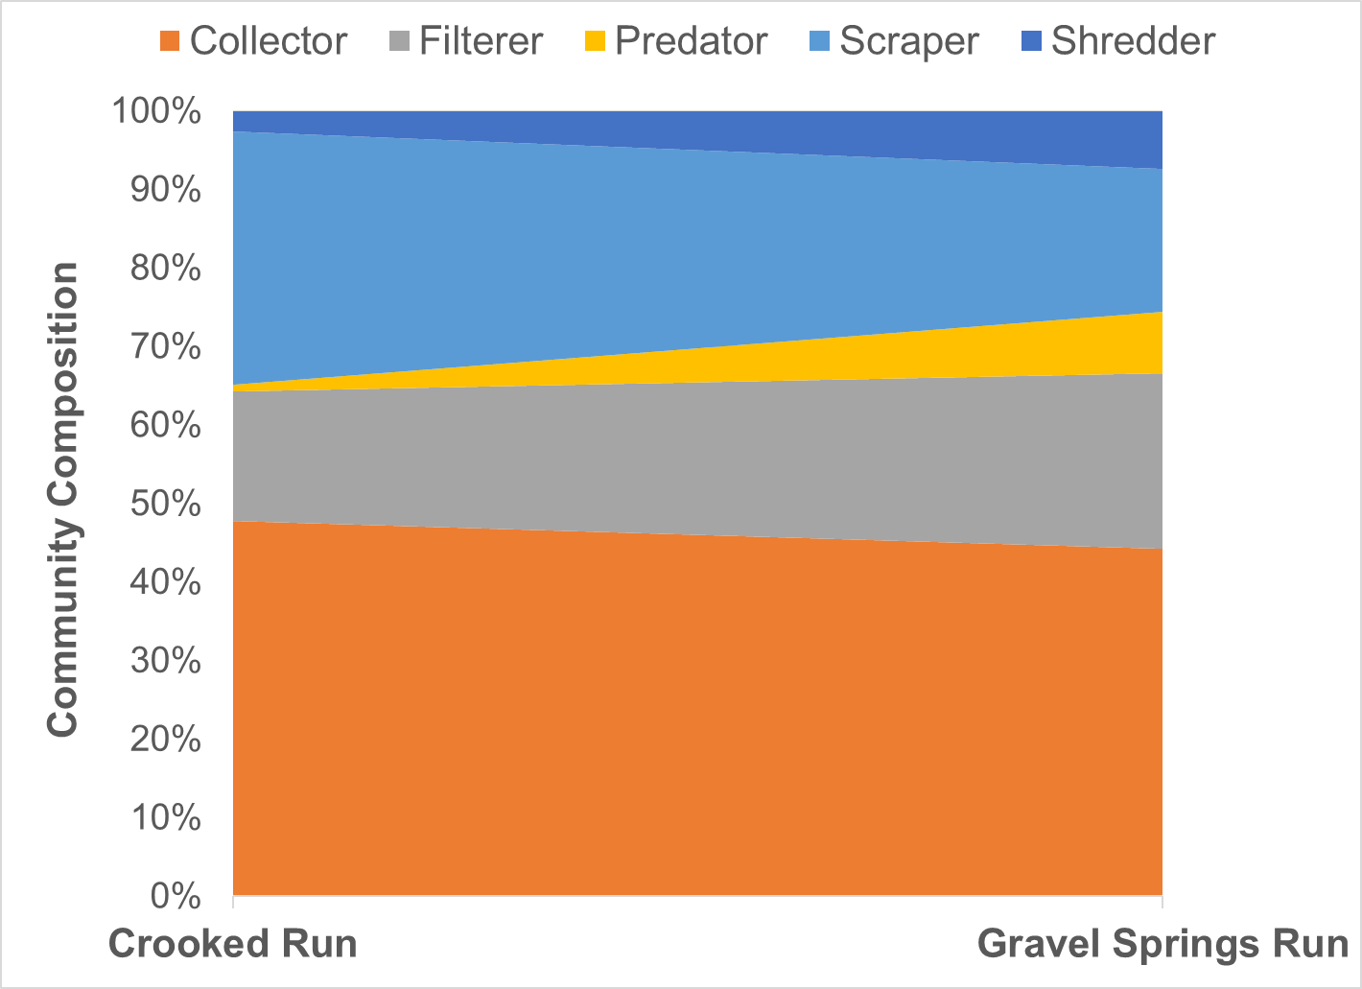
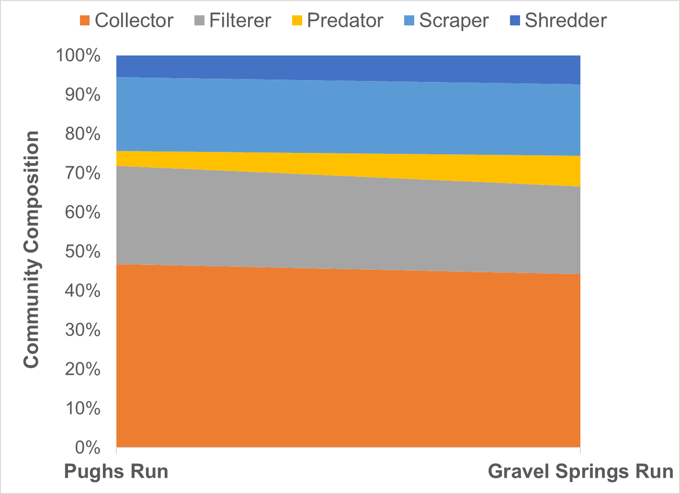
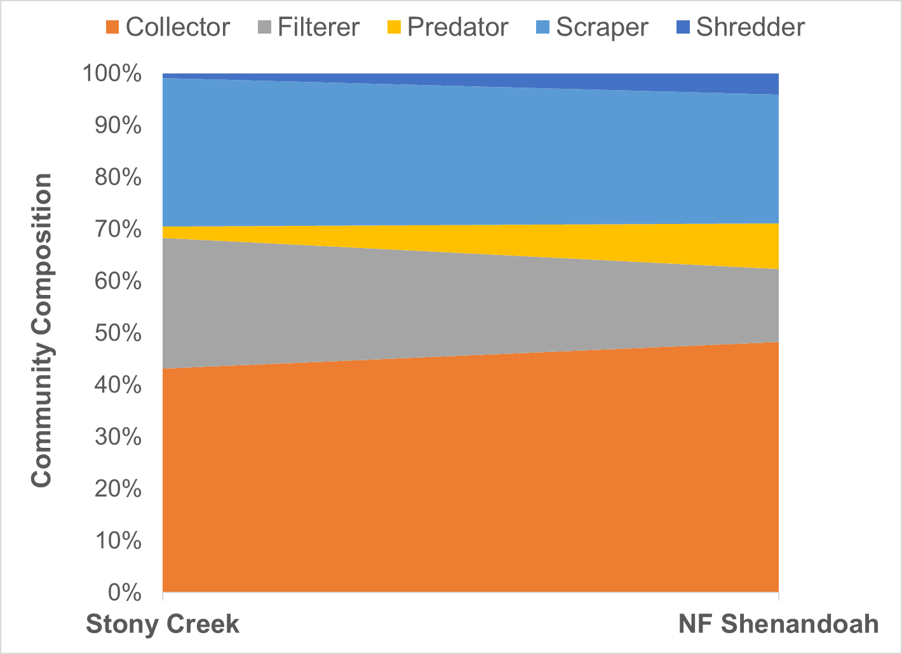
Figure 1-9 Functional feeding group composition in benthic communities in Crooked and Pughs Runs and Stony Creek compared to Gravel Springs Run and North Fork Shenandoah River (reference streams).

Habitat Assessment
As part of the Rapid Bioassessment Protocol, a visual habitat assessment is performed at the time of each benthic sample collection. This assessment entails scoring each of a series of habitat components from 0 to 20. These habitat components include channel alteration, bank stability, bank vegetation, embeddedness, flow, riffles, riparian vegetation, sediment, substrate, and velocity. The individual scores for each of these measures are summed to determine a total habitat score. Table 1-8 shows scores for the impaired streams and compares the total habitat scores to the reference streams (Gravel Spring Run and North Fork Shenandoah River) using t-tests with unequal variances (ɑ=0.05). Scores for both Crooked and Pughs Runs were significantly lower than in the reference stream. The mean total habitat score for Stony Creek was lower than the reference but this difference was not significant.
Figure 1-10 shows the probability of habitat being a stressor on the aquatic community for each stream based on DEQ’s analysis of probabilistic monitoring data (DEQ, 2017). Crooked Run fell in the medium probability category while Pughs Run and Stony Creek fell in the high probability category.
Table 1-8. Total habitat scores for Crooked and Pughs Runs and Stony Creek.

Stream | Total Habitat Score | Significantly Different from Reference | P value
Crooked Run | 128.8 | Yes | p < 0.001
Pughs Run | 153.3 | Yes | p = 0.457
Stony Creek | 162.9 | No | p = 0.192
Gravel Springs Run (reference) | 161.5
NF Shenandoah River (reference) | 166.4

Habitat scores were statistically compared to SCI scores through a regression analysis (Figure 1-11). The low R² value (0.1901) indicates considerable variability in this relationship, which was not significant (α=0.05). As indicated by the trend line in Figure 1-11, it appears that this relationship is positively correlated, meaning that as habitat improves, SCI scores go up; however, this trend is not significant.
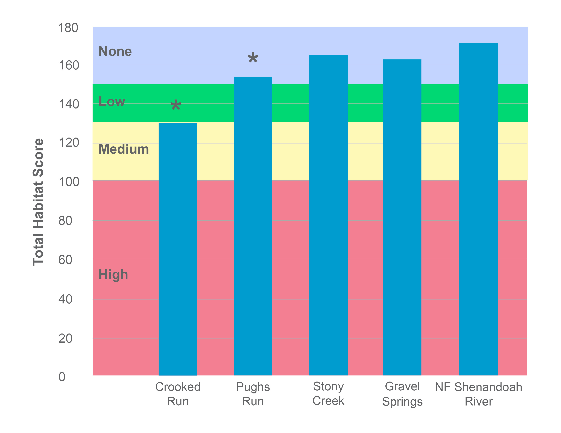
Figure 1-10. Total habitat scores for Crooked and Pughs Runs and Stony Creek. Colors represent the probability that data within that range would be responsible for causing stress. Asterisks indicate scores significantly different from the reference conditions (α=0.05).
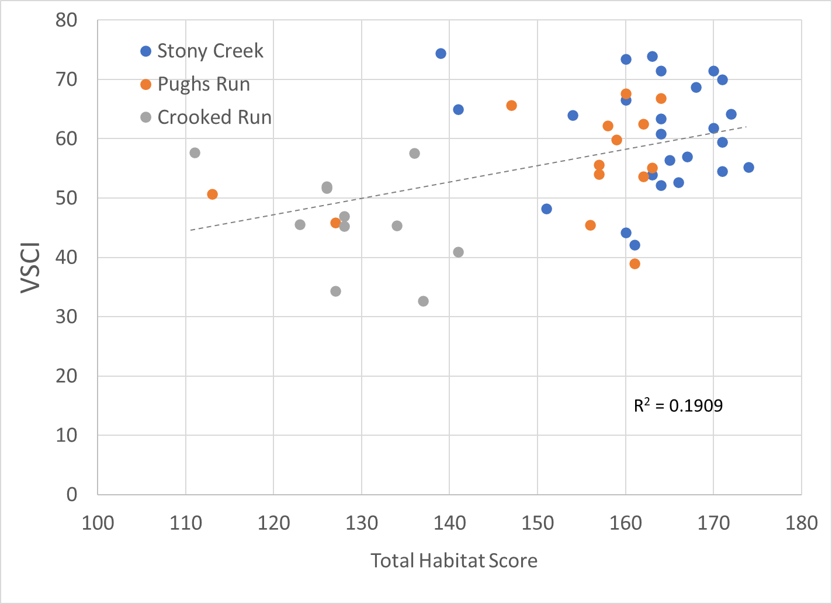
Figure 1-11. Comparison of total habitat scores with SCI scores in Crooked and Pughs Runs and Stony Creek
Individual habitat metrics are shown in Figure 1-12. A score of 16 or greater is indicative of optimal conditions for habitat metrics. Scores between 15 and 11 are considered suboptimal, values between 10 and 6 reflect marginal conditions, and values below 6 are considered poor. All values in Crooked Run fell within the suboptimal range, with the exception of sediment (SEDIMENT) and riparian vegetation (RIPVEG) which fell within the marginal range. Trends in Crooked Run habitat metrics indicated that significant alterations to in-stream and riparian habitat are impacting the benthic community. Mean values for all the habitat metrics in Crooked Run were considerably lower than those in the reference watershed. Channel (CHANNEL), riffles (RIFFLES), bank vegetation (BANKVEG) and RIPVEG metrics in Crooked Run were significantly different from the reference stream (t-test with unequal variances, ɑ = 0.05). It is likely that more of these relationships would be significant if the sample size in the reference watershed (n=2) was greater. When compared to the reference condition, the greatest difference in habitat metric scores were associated with metrics indicative of excess sediment deposition in the stream. Large differences in RIPVEG, SEDIMENT, streambanks (BANKS) and BANKVEG scores were observed, all indicating excess sediment deposition on the stream bottom is occurring as a result of streambank erosion associated with poor vegetative cover.
Metric scores in Pughs Run largely fell just above or below the optimal range except for embeddedness (EMBED), RIPVEG and SEDIMENT which were in the middle of the suboptimal range. Mean values for BANKS, bottom substrate (SUBSTRATE) and SEDIMENT metrics in Pughs Run were slightly higher than those in the reference condition, though these differences were not significant. BANKS, SUBSTRATE and SEDIMENT metrics in the reference stream were all within the suboptimal category, signaling that comparisons with the impaired stream may not be informative with respect to impacts of habitat parameters on stream health. All other metrics were slightly lower in Pughs Run compared to the reference condition. Measures of riparian vegetation, embeddedness and sediment in Pughs Run signal that poor vegetative cover in riparian areas may be contributing to increased deposition of excess sediment in the streambed.
Habitat metric scores in Stony Creek all fell within the optimal range with the exception of riparian vegetation which fell within the lower range of suboptimal and streambanks which fell in the upper range of suboptimal. CHANNEL and RIPVEG were both significantly lower than values in the reference watershed. Channel flow status reflects the degree to which the stream channel is filled with water. Channel flow is useful in determining potential impacts from low flows on stream health due to reductions in available habitat. The mean value for this metric in Stony Creek was 16.4, falling within the lower range of optimal which signals that it is not impacting stream health. Results of habitat assessments in Stony Creek indicate that in stream and riparian habitat is relatively good, and comparable to the reference watershed in most cases. Reduced vegetative cover in riparian zones may be allowing for increased runoff of pollutants into the creek, though these impacts appear limited.
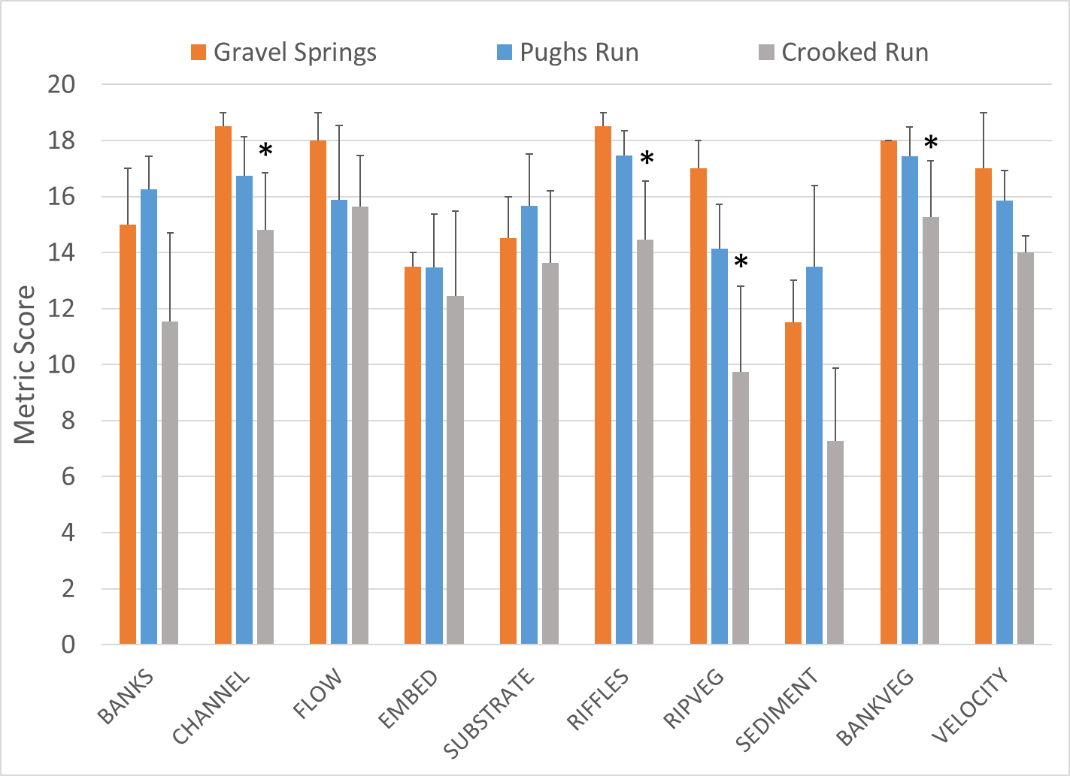
Figure 1-12. Habitat metric scores for Crooked and Pughs Runs (upper) and Stony Creek (lower) compared to references. Metrics with a * are statistically different from the reference site (α=0.05).
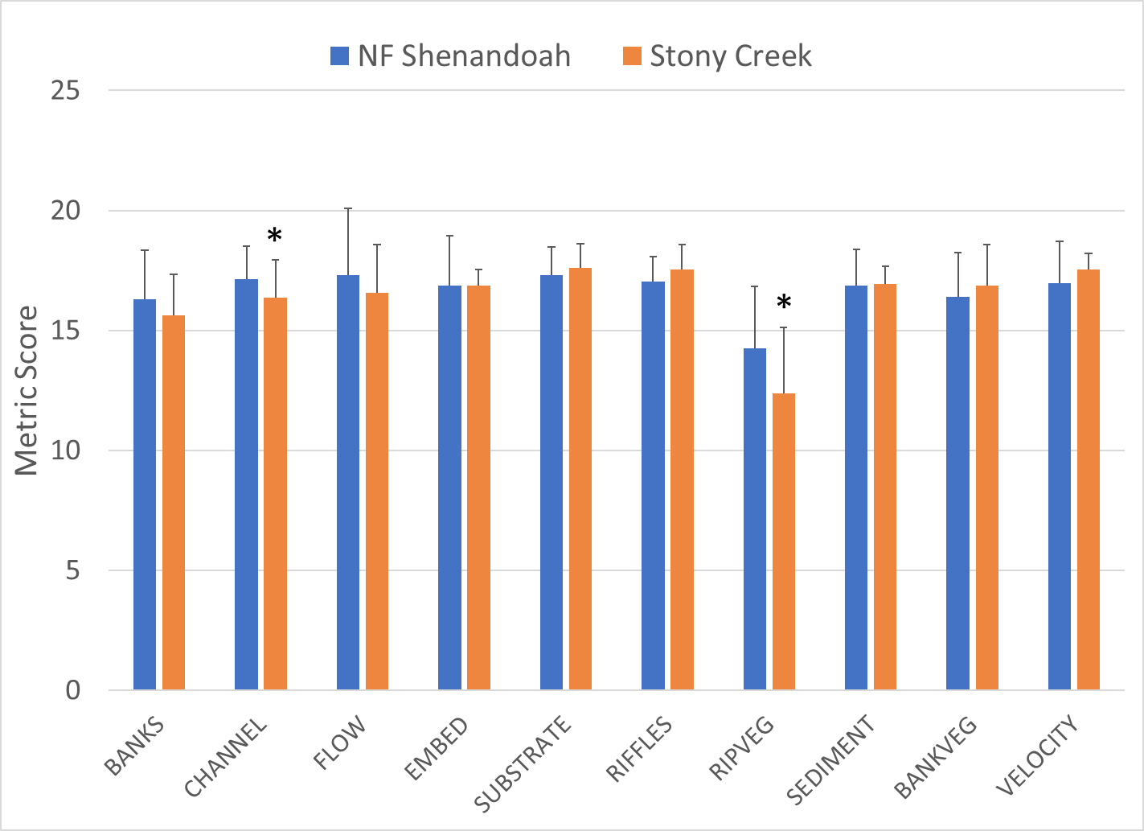
Figure 1-13. Habitat metric scores for Crooked and Pughs Runs (upper) and Stony Creek (lower) compared to references. Metrics with a * are statistically different from the reference site (α=0.05).

Relative Bed Stability
As a part of TMDL monitoring, DEQ conducted a detailed physical habitat assessment of the two impaired streams according to EPA methods for Quantifying Physical Habitat in Wadeable Streams (Kaufmann et al., 1999). This analysis involved the measurement of channel dimensions and substrate composition at numerous transects within 160, 320 and 600-m stream reaches surrounding benthic monitoring stations 1BCKD000.30 (Crooked Run), 1BPGH000.29 (Pughs Run) and 1BSTY004.24 (Stony Creek), respectively. The outcome of this analysis is the calculation of a log relative bed stability index (LRBS). The LRBS is the ratio between the observed distribution of in-stream sediments and the predicted sediment size distribution based on bankfull depth. LRBS values near zero indicate that the stream is stable. Large negative values indicate that the stream is unstable and depositing excess sediment. Large positive numbers, while less common, indicate that the stream is unstable and sediment starved. In an analysis of streams across the commonwealth, DEQ has determined that LRBS scores between -1.0 and -1.5 have a medium probability of stressing aquatic life, and LRBS scores <-1.5 have a high probability of stressing aquatic life (DEQ, 2017).
Table 1-9, Figure 1-13 and Figure 1-14 show the results of relative bed stability analysis in Crooked and Pughs Runs and Stony Creek. Figure 1-13 shows how bottom substrate composition in the impaired streams compares to a reference conditions. The bottom substrate composition in Crooked Run shows clear evidence of excess sediment deposition, with sand and fines comprising over 50% of the stream bottom. Embeddedness was high in Crooked Run (67.2%), also indicating that excessive sedimentation is limiting available habitat for colonization by aquatic macroinvertebrates. The bottom substrate composition in Pughs Run closely matches the reference stream, with bedrock comprising 37.1% and 43.8% of the stream bottom, respectively. Both Pughs Run and the reference watershed had relatively high levels of embeddedness in RBS surveys, 34.2% and 42.2%, respectively. In addition to having a higher level of embeddedness of bottom substrate, the reference watershed had a slightly higher percent of sand and fines compared to Pughs Run.
Stony Creek had a high proportion of sand and fines (18.1%) compared to the NF Shenandoah (1.9%). Embeddedness was also three times higher in Stony Creek (36.2%) compared to the reference condition (12.7%), signaling that excessive sedimentation is limiting available habitat for colonization by aquatic macroinvertebrates. Cobble and gravel comprised nearly 10% more of the bottom substrate in the reference watershed (75.2%) compared to Stony Creek (66.7%), offering a greater degree of valuable habitat for macroinvertebrates.
Figure 1-14 compares LRBS values in each of the streams to DEQ stressor thresholds. The LRBS score for Crooked Run (-1.01) fell on the boundary between a low to medium probability of stress range. Crooked Run exhibited characteristics of an unstable stream channel with significant sediment deposition throughout the streambed and a high degree of embeddedness (Table 1-9). Both Stony Creek and Pughs Run had RBS scores within the no probability of stressor effects range. This suggests that the streambeds are relatively stable, comprised of substrate that is generally larger than the biggest particle that the streams could carry during stormflow. These results signal that the impairments in Pughs Run and Stony Creek are relatively moderate.
Table 1-9. Relative bed stability analysis for Crooked and Pughs Runs and Stony Creek.
Stream | Station | Date | %Sand and Fines | % Boulder, Cobble, and Gravel | %  Embedded | Log Relative Bed Stability Index (LRBS)
Crooked Run | 1BCKD000.30 | 8/22/2022 | 56.2% | 29.5% | 67.3% | -1.01
Pughs Run | 1BPGH000.29 | 9/24/2009 | 16.2% | 43.8% | 34.2% | 0.08
Stony Creek | 1BSTY004.24 | 8/15/2022 | 18.1% | 66.7% | 36.2% | 0.12
Gravel Springs Run (reference) | 1BGSR000.58 | 9/4/2014 | 24.8% | 31.4% | 42.2% | -0.02
NF Shenandoah River (reference) | 1BNFS093.80 | 8/28/2014 | 1.9% | 75.2% | 12.7% | 0.87

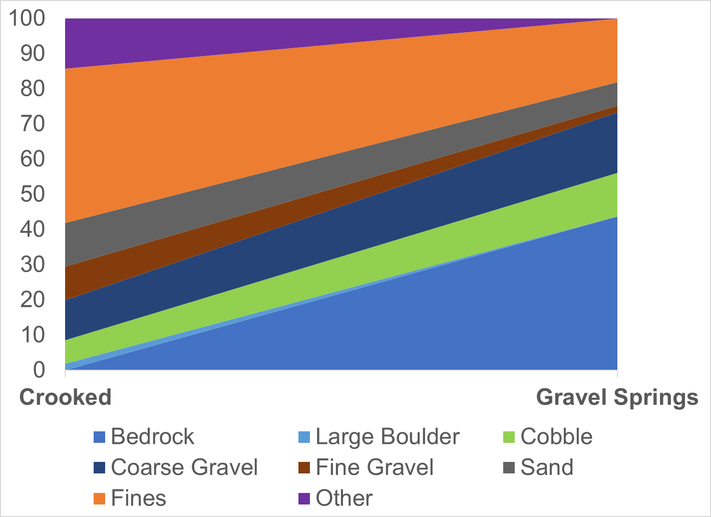
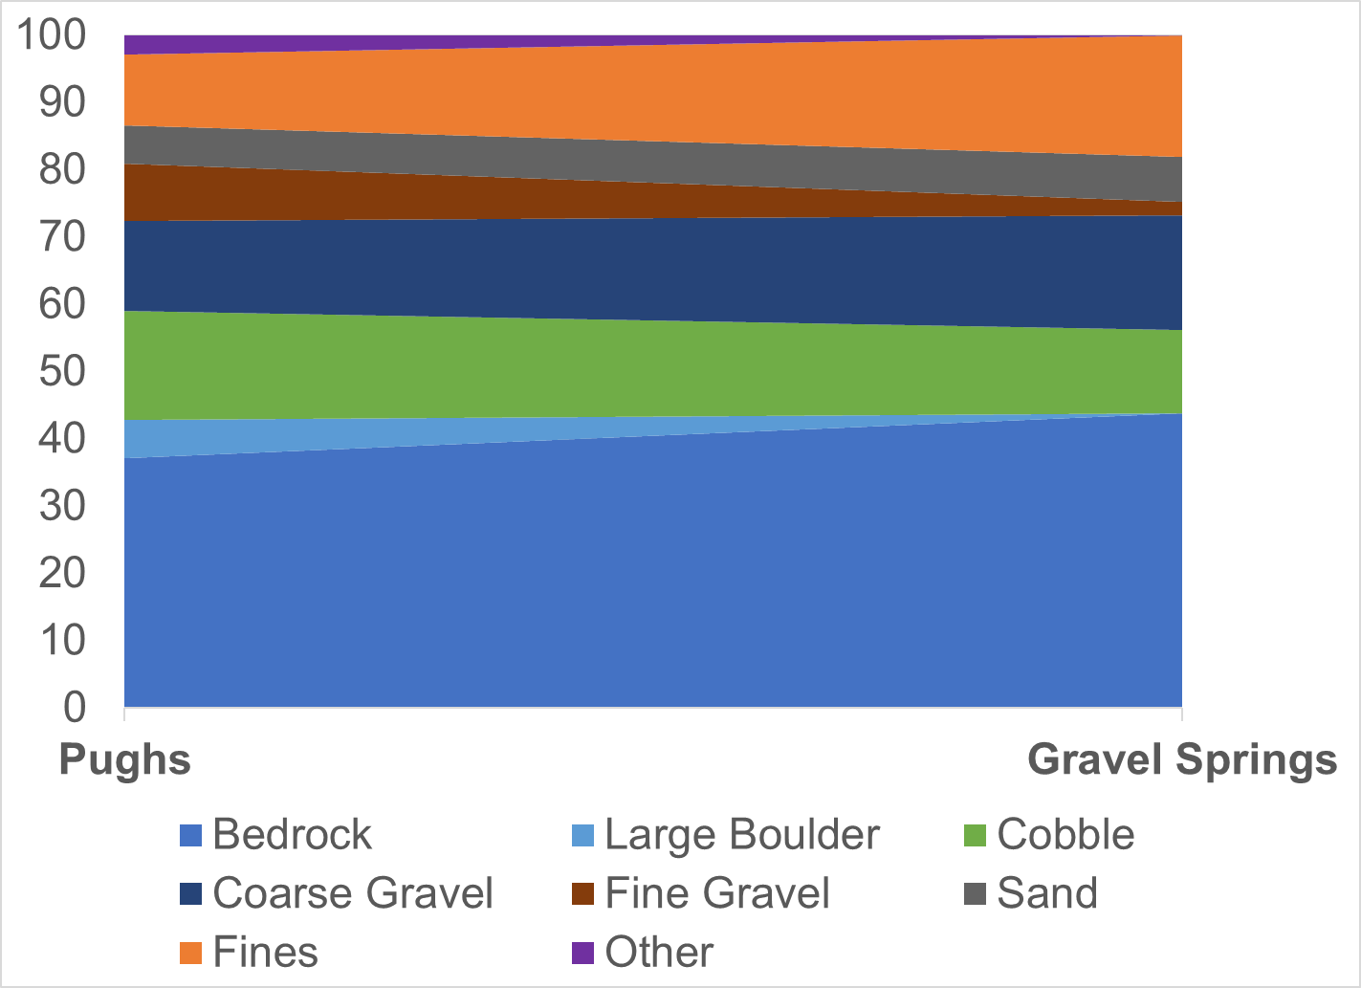
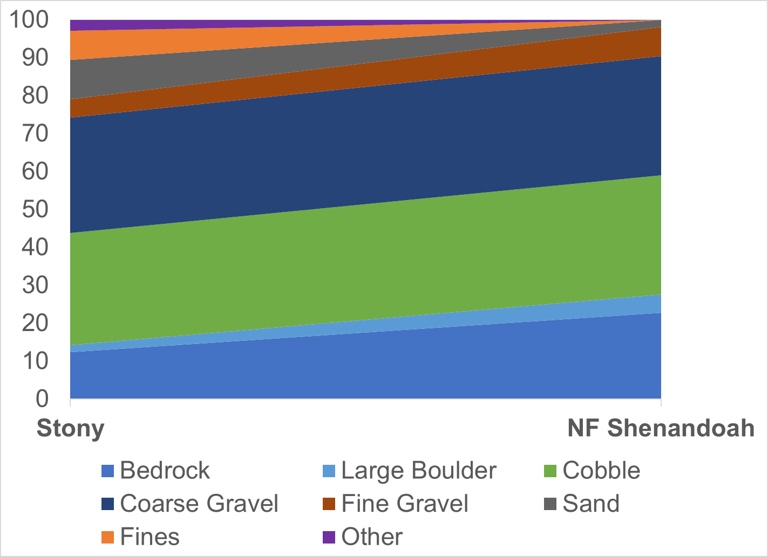
Figure 1-13. Crooked and Pughs Runs and Stony Creek bottom substrate comparisons with references (Gravel Springs Run and NF Shenandoah River).
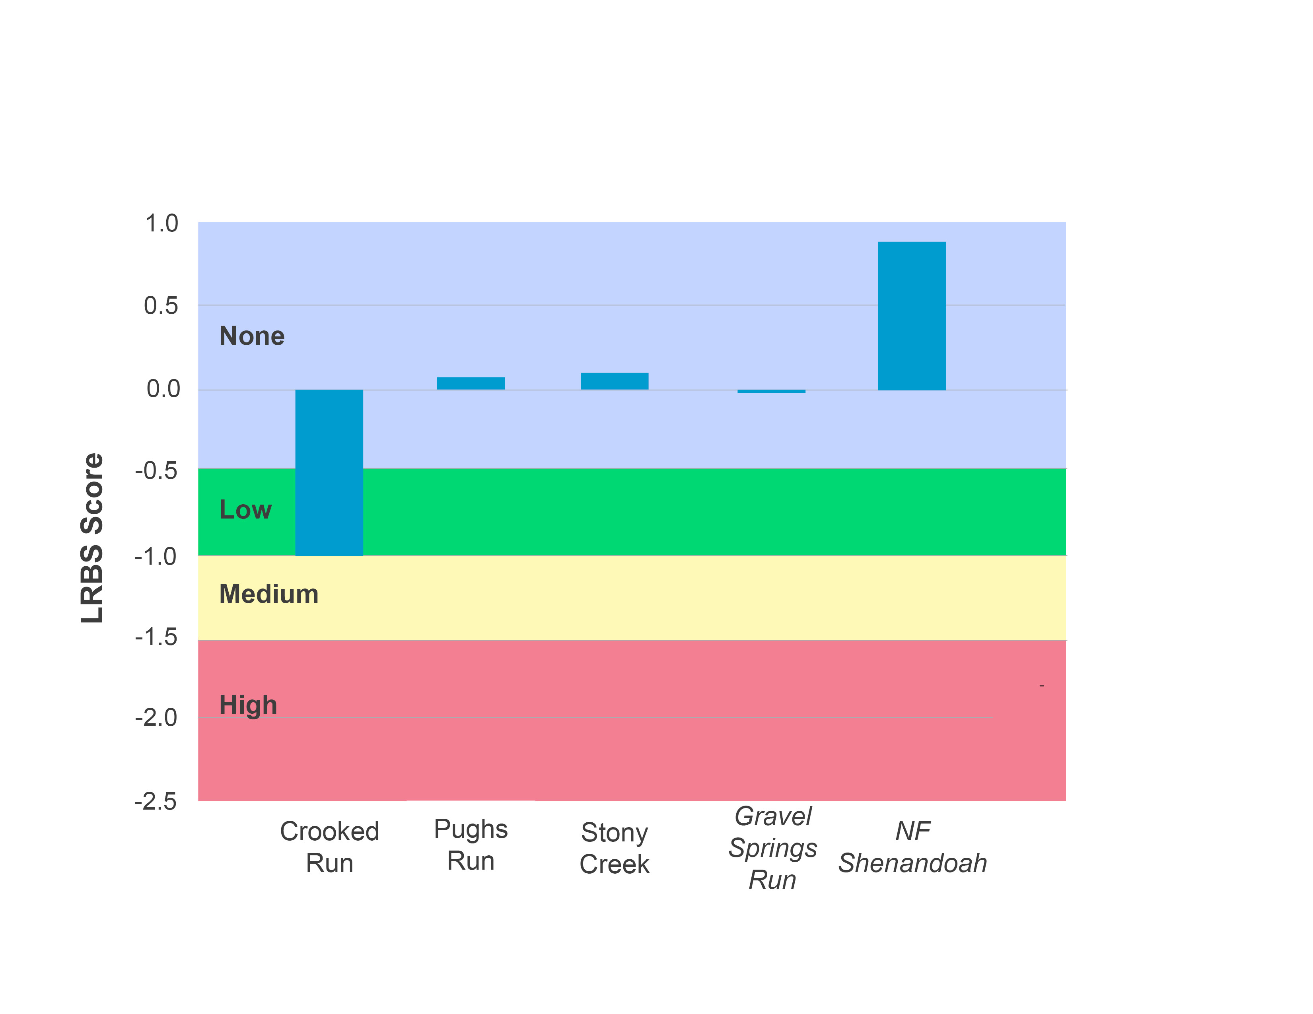
Figure 1-14. Log relative bed stability index (LRBS) scores for Crooked and Pughs Runs and Stony Creek in comparison with reference streams (Gravel Springs Run and NF Shenandoah River).

Water Quality Data
In total, 268 water quality samples were collected from six (6) ambient monitoring stations in the Crooked Run, Pughs Run and Stony Creek watersheds between 2002 and 2022. Samples were analyzed for 113 different water quality parameters. In addition, field parameters (pH, temperature, dissolved oxygen, conductivity) were measured at seven (7) benthic monitoring stations in the watersheds on 56 occasions between 2005 and 2022. Water quality parameters tested included: temperature, pH, dissolved oxygen, conductivity, total dissolved solids, turbidity, total suspended solids, total nitrogen, total phosphorus, chloride, sulfate, potassium, and sodium. These parameters were analyzed for evidence of stressor effects by comparing measured values to Virginia water quality standards, to reference conditions using paired t-tests, and to published thresholds for stressor effects.

Temperature
Temperature data for Crooked and Pughs Runs and Stony Creek are available from DEQ monthly measurements. DEQ measures temperature when collecting benthic or water quality samples, so periodic temperature data are available from 2005-2022 for Crooked Run, 2004-2022 for Pughs Run and 2003-2022 for Stony Creek (Figure 1-15). Temperatures obviously vary by season, so ranges are wide when year-round measurements are considered. Neither Crooked Run or Pughs Run had temperature measurements above the water quality standard of 31°C for Class IV Mountain Zone waters. The maximum recorded temperature was 22.7°C in Crooked Run, which was recorded in July 2021. The maximum temperature in Pughs Run (21.7°C) was recorded in July 2005. Stony Creek is designated as a Class V Stockable Trout water, and therefore has a temperature standard of 21°C. This standard was exceeded in 11 out of 159 measurements (7%). The maximum temperature in Stony Creek (23.7) was recorded in August 2009. Paired t-tests showed no significant differences (α=0.05) between temperatures in the impaired streams and the reference conditions.
DEQ also collected diurnal temperature data from Crooked and Pughs Runs over a 3-day period in August 2023, resources were not available to complete diurnal monitoring on Stony Creek. Measurements were collected in 15-minute increments. Diurnal monitoring is typically performed in the late summer months when temperatures are high and water levels are low to capture critical periods with respect to water temperature and dissolved oxygen concentrations. Temperature data during diurnal deployments are shown in Figure 1-16. Diurnal temperatures exhibited the natural cycle of increases during the day from solar heating and decreases at night. Crooked Run experienced the greatest fluctuations in temperatures throughout the 3-day period, though values remained below the temperature standard. Temperatures were slightly lower in Pughs Run during the monitoring period, with smaller shifts between daytime and nighttime temperatures. While both streams are influenced by springs located upstream of the monitoring stations, it is possible that groundwater is having a greater impact in Pughs Run compared to Crooked Run, keeping temperatures lower throughout the day. In summary, periodic field measurements in the impaired streams were below the water quality standard. Additionally, diurnal monitoring in Crooked and Pughs Runs showed that temperatures remain below the standard in the summertime when temperatures are highest.
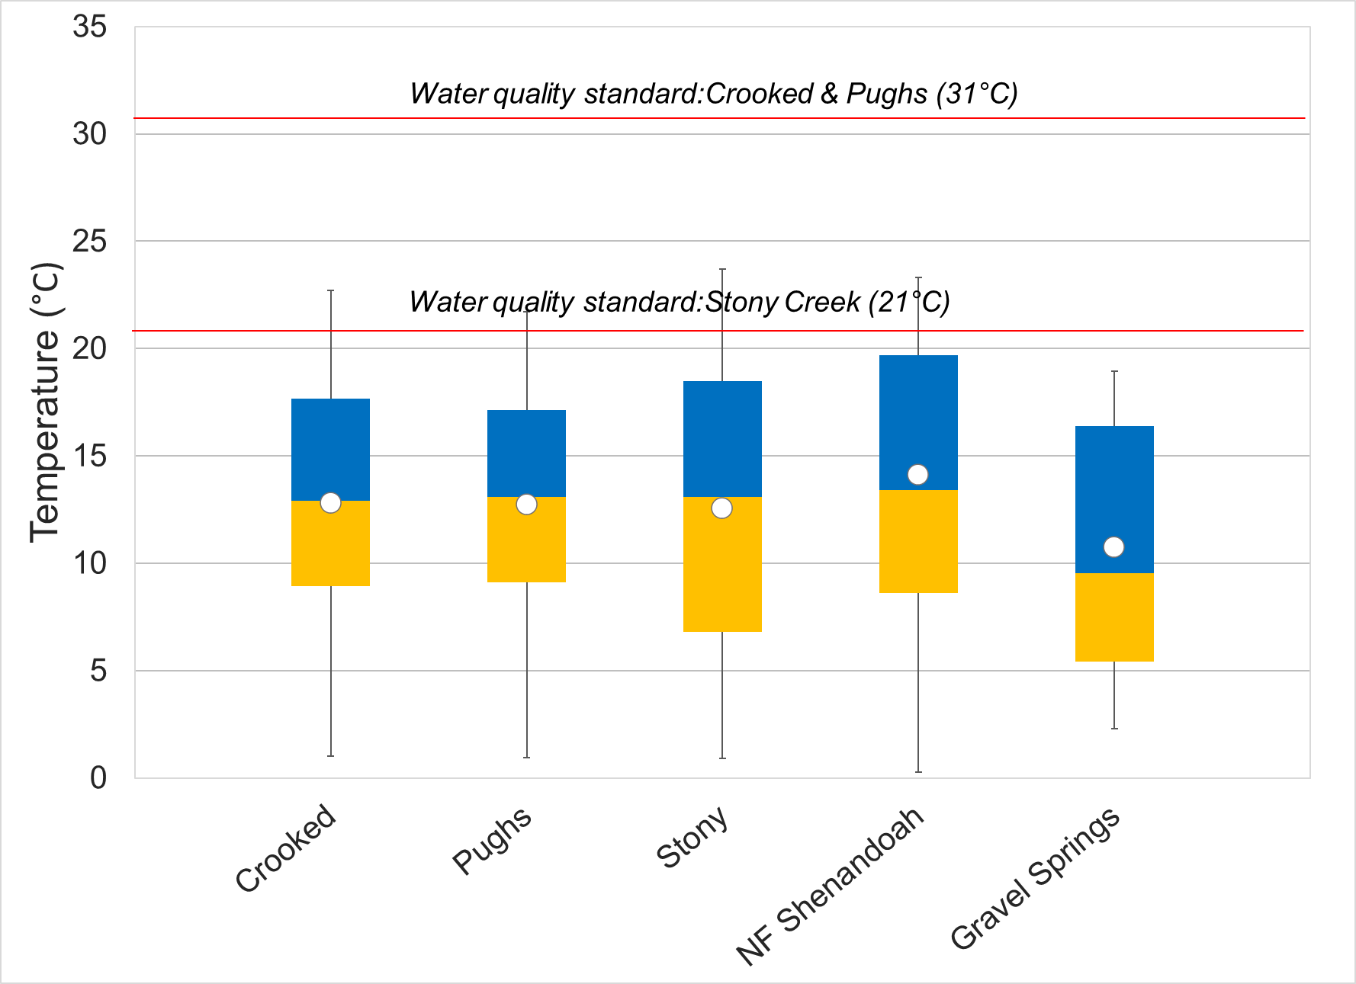
Figure 1-15. Temperature measured in Crooked and Pughs Runs and Stony Creek compared to reference watersheds. Whiskers indicate the range, boxes indicate the inter-quartile range, lines indicate the median, and white markers indicate the average.
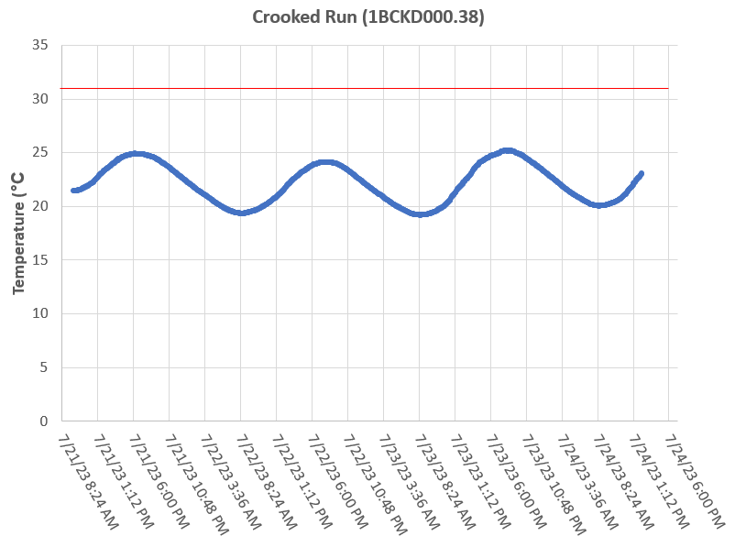
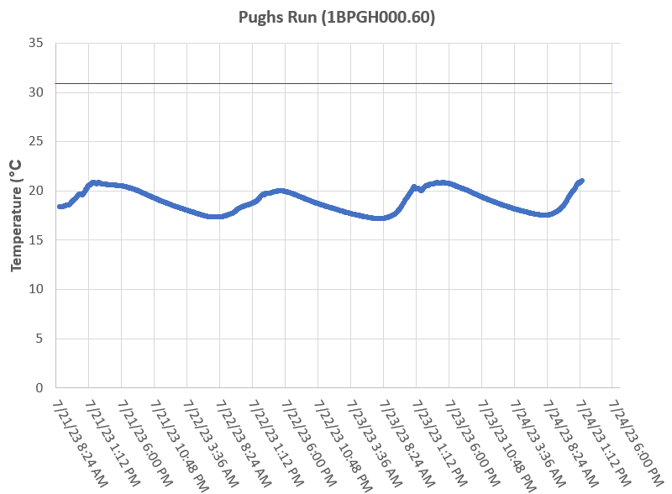
Figure 1-16. Diurnal temperatures in Crooked and Pughs Runs. The red line indicates the water quality standard for temperature.

pH
DEQ measured the pH of Crooked and Pughs Runs and Stony Creek in the field during the collection of benthic and water quality samples. Figure 1-17 shows the pH values collected from the impaired streams in comparison to the reference conditions. Measured pH values were near neutral at all sites, spanning an average of 8.4 in Crooked and Pughs Runs to 9.0 in Stony Creek. All pH values from all sites met pH water quality standards of 6-9 and were within the range identified by DEQ as low probability for producing stressor effects (DEQ, 2017). Values in Stony Creek were significantly higher than the reference condition (p < 0.001), suggesting that limestone in the valley floor may be adding carbonate and bicarbonate ions to the stream and raising the pH.
DEQ also collected diurnal pH data from Crooked and Pughs Runs in August 2023. Diurnal data were collected at 15-minute intervals over a 3-day period (Figure 1-18). Diurnal pH values exhibited minimal shifts between day and nighttime. Like field parameter measurements, diurnal pH measurements were all within water quality standards and within the range of low probability for stressor effects. This indicates that pH is not a concern or stressor in Crooked or Pughs Runs.
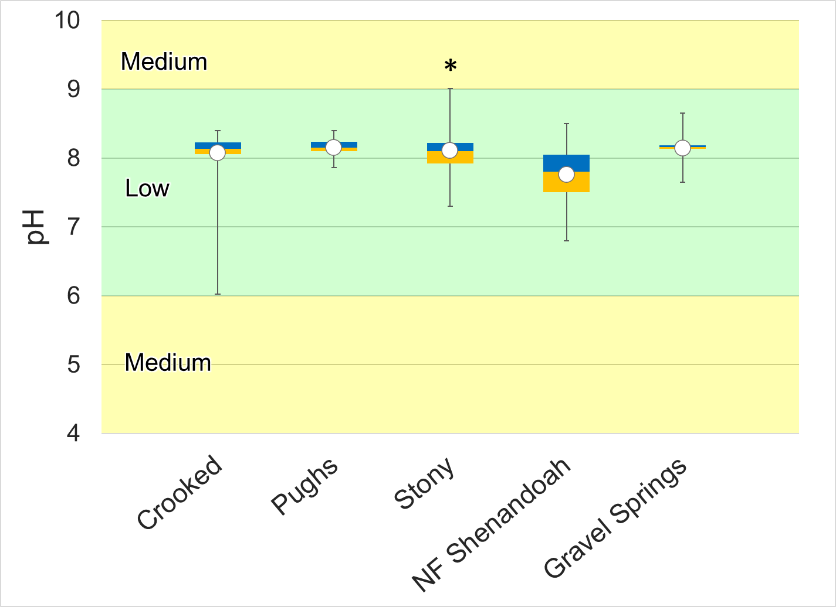
Figure 1-17. pH measured in Crooked and Pughs Runs and Stony Creek. Whiskers indicate the range, boxes indicate the inter-quartile range, lines indicate the median, and white markers indicate the average. Streams with a * are statistically different from the reference sites. Colors represent the probability that data within that range would be responsible for causing stress.
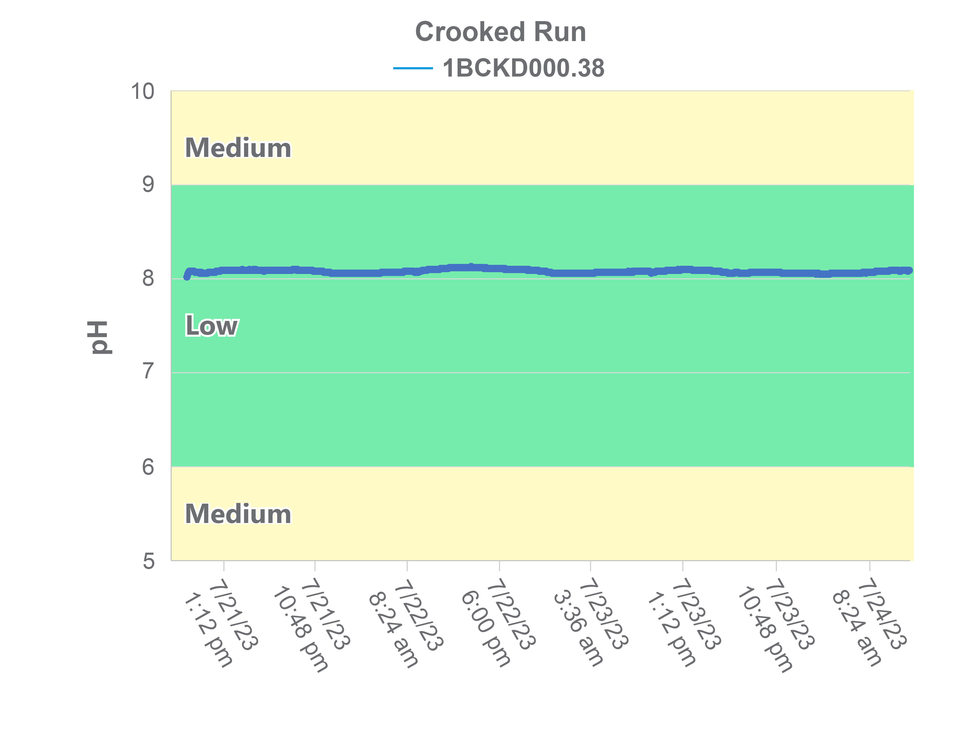
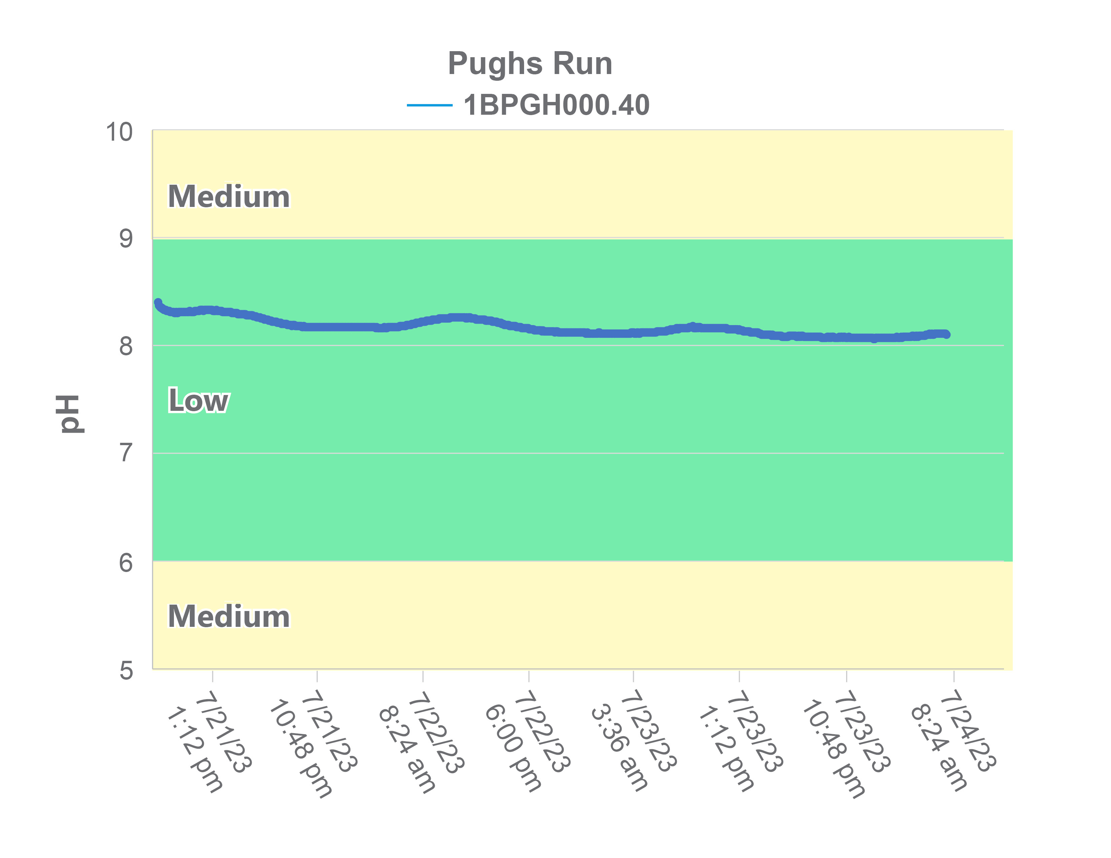
Figure 1-18. Diurnal pH in Crooked and Pughs Runs. Colors represent the probability that data within that range would be responsible for causing stress.

Dissolved Oxygen
DEQ measured the dissolved oxygen levels in Crooked and Pughs Runs and Stony Creek in the field during the collection of benthic and water quality samples. Figure 1-19 shows the dissolved oxygen values collected from the impaired streams compared with the reference watersheds. Dissolved oxygen values averaged 10.8 mg/L in Crooked Run, 11.0 mg/L in Pughs Run, and 11.5 in Stony Creek. Dissolved oxygen concentrations in Stony Creek were significantly higher than the reference watershed (p=0.009), signaling that low dissolved oxygen is not a stressor in Stony Creek. Mean and median dissolved oxygen concentrations in all three of the impaired streams fell within the no probability of stressor effects range. Four (4) of measurements in Crooked Run (11.4%) fell within the medium probability of stressor effects range. Only 1.9% of samples in Stony Creek fell within the medium probability of stressor effects range, while none of the measurements in Pughs Run fell within this range. In Stony Creek, 20% of samples were measured during the critical period (June-August) after 10:00 a.m. when the water is warmest. Approximately 16% of samples in Pughs Run and 17% of samples in Crooked Run were collected within this time frame. Ambient monitoring results indicate a low probability that a lack of dissolved oxygen is responsible for the benthic impairments in the impaired streams.
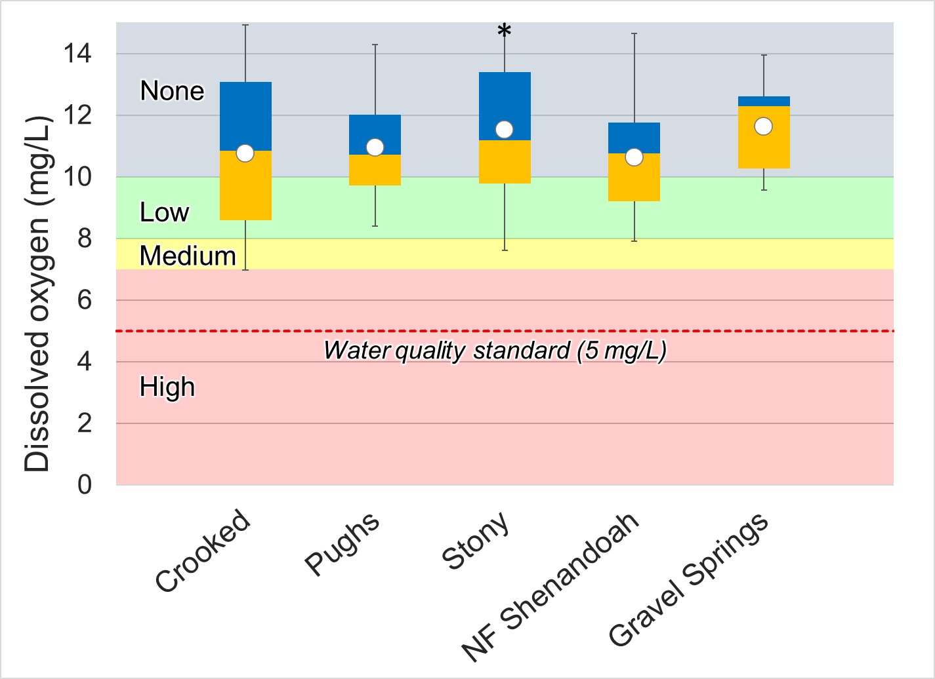
Figure 1-19. Dissolved oxygen measured in Crooked and Pughs Runs and Stony Creek. Whiskers indicate the range, boxes indicate the inter-quartile range, lines indicate the median, and white markers indicate the average. Streams with a * are statistically different from the reference sites. Colors represent the probability that data within that range would be responsible for causing stress. The red line indicates the water quality standard.

Diurnal data were collected from Crooked and Pughs Runs in August 2023. Diurnal monitoring of dissolved oxygen is important because critical dissolved oxygen levels are typically encountered just before sunrise. This is due to the combination of oxygen consumption from respiration and the absence of oxygen production from photosynthesis during the night. The results of this monitoring are discussed with nutrient monitoring results in Section 1.2.3.6

Conductivity and Dissolved Solids
Conductivity is a measure of the electrical potential of water based on the ionic charges of dissolved compounds. For this reason, the conductivity of water is closely related to the total dissolved solids present. DEQ measured specific conductance in Crooked and Pughs Runs and Stony Creek in the field during the collection of benthic and water quality samples (Figure 1-20). Specific conductance fell within the high probability range for causing stressor effects on all sampling occasions in Crooked Run. In addition, specific conductance in Crooked Run was significantly higher than the reference watershed (p<0.001) Specific conductance was also elevated in Pughs Run, with mean and median values falling in the high probability of stressor effects range. Conductivity is Pughs Run was also significantly higher than the reference stream (p<0.001). Decreases in sensitive taxa such as Ephemeroptera have been documented at conductivity levels above 500 uS/cm (Pond, 2004). However, these impacts are better explained by concentrations of dissolved metals and salts, which are a covariant of conductivity and can be toxic to aquatic macroinvertebrates at high concentrations. These constituents are commonly associated with runoff from mined sites and roadways where road salts have been applied. Measurements of dissolved ions in Crooked and Pughs Runs do not indicate that concentrations are approaching potentially toxic levels in the streams, though concentrations of several constituents are elevated. Additionally, there is no evidence of mining activities in the watersheds. The seasonal variability in conductivity typically observed with over-application of deicing agents was absent in the impaired streams (Figure 1-21). It is more likely that high conductivity levels in these streams are the result of geological processes including the weathering and dissolution of limestone and dolomite. These processes result in elevated concentrations of calcium and magnesium in the water, which are typically the dominant cations in groundwater found in karst systems.
Specific conductance was comparably lower in Stony Creek, with mean and median values falling within the low probability of stressor effects range. However, levels in Stony Creek were still significantly higher than those in the reference watershed (p<0.001).
In addition to periodic conductivity measurements, DEQ collected diurnal conductivity data from Crooked and Pughs Runs in August 2023 (Figure 1-22). Specific conductance remained within the high probability of stressor effects range in both streams throughout the 3-day monitoring period. Very little variability in conductivity was observed between day and nighttime values in either stream.
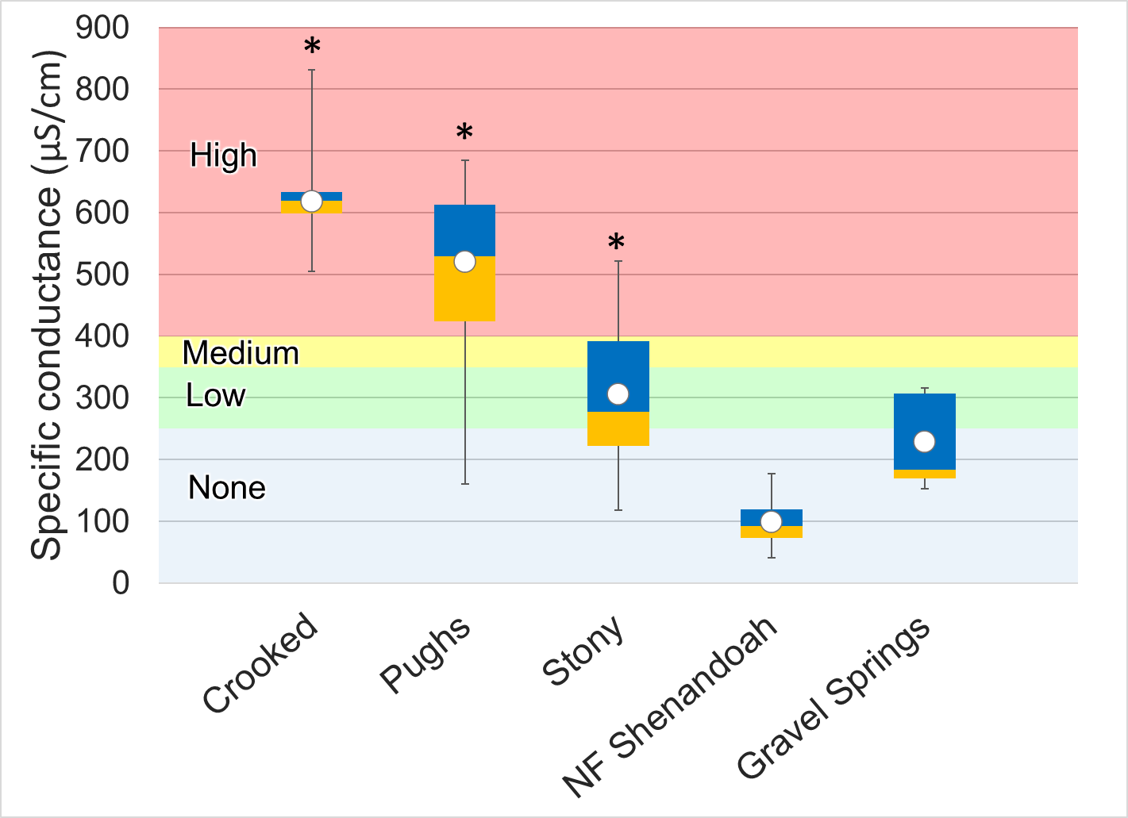
Figure 1-20. Specific conductance measured in Crooked and Pughs Runs and Stony Creek. Whiskers indicate the range, boxes indicate the inter-quartile range, lines indicate the median, and white markers indicate the average. Streams with a * are statistically different from the reference sites. Colors represent the probability that data within that range would be responsible for causing stress.
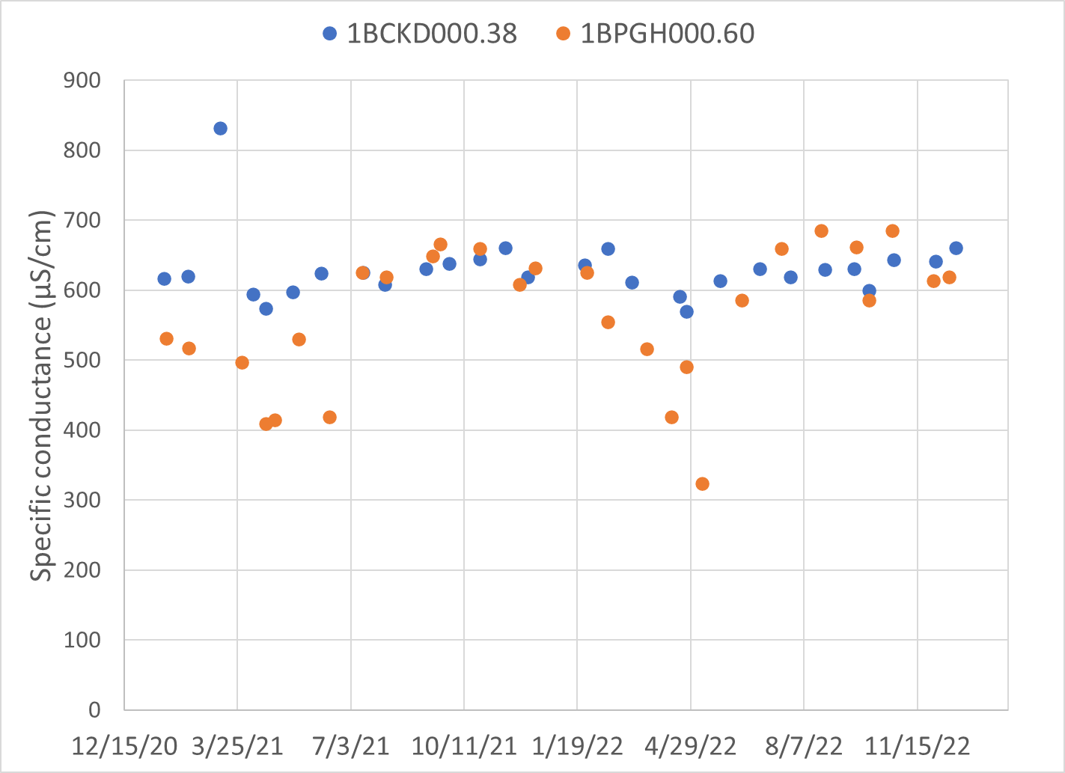
Figure 1-21 Temporal patterns in specific conductance in Crooked and Pughs Runs

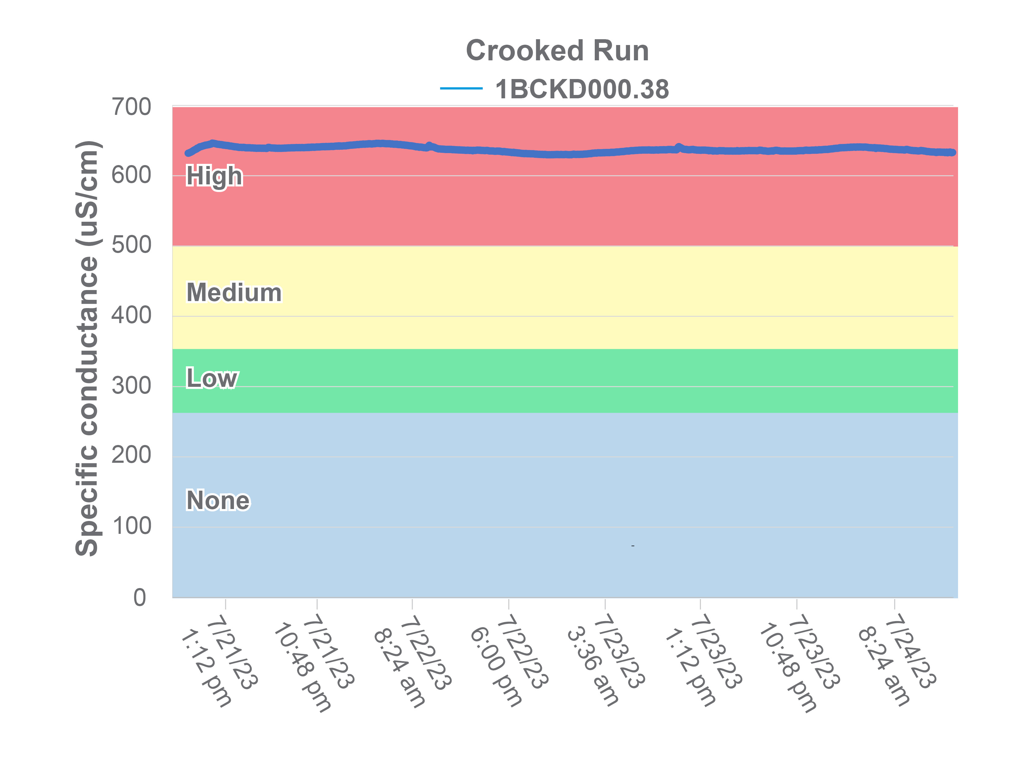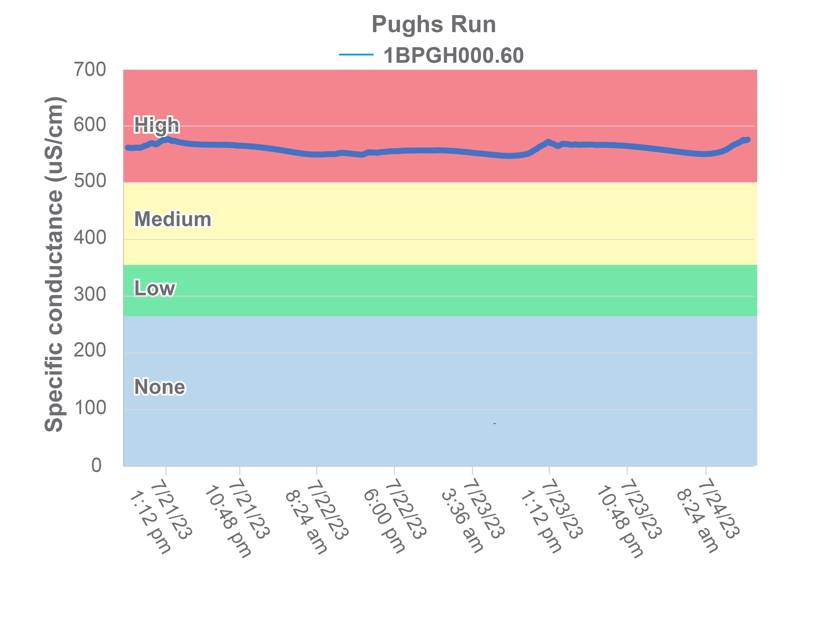
Figure 1-22. Diurnal measurements of specific conductance in Crooked and Pughs Runs.

Total dissolved solids are closely tied to conductivity since dissolved ions are responsible for transmission of electrical currents in the water. Total dissolved solids were measured monthly in Crooked and Pughs Runs and Stony Creek for a period of two years (2021-2022) (Figure 1-23). Like conductivity, mean and median total dissolved solids levels were elevated in Crooked Run, falling within the high probability of stressor effects range. Concentrations in Pughs Run generally fell within the medium probability of stressors effects range, with excursions into the high and low probability ranges. Total dissolved solids in Stony Creek were comparably lower, with mean and median values in the low probability of stressor effects range and no excursions into the medium or high probability ranges.
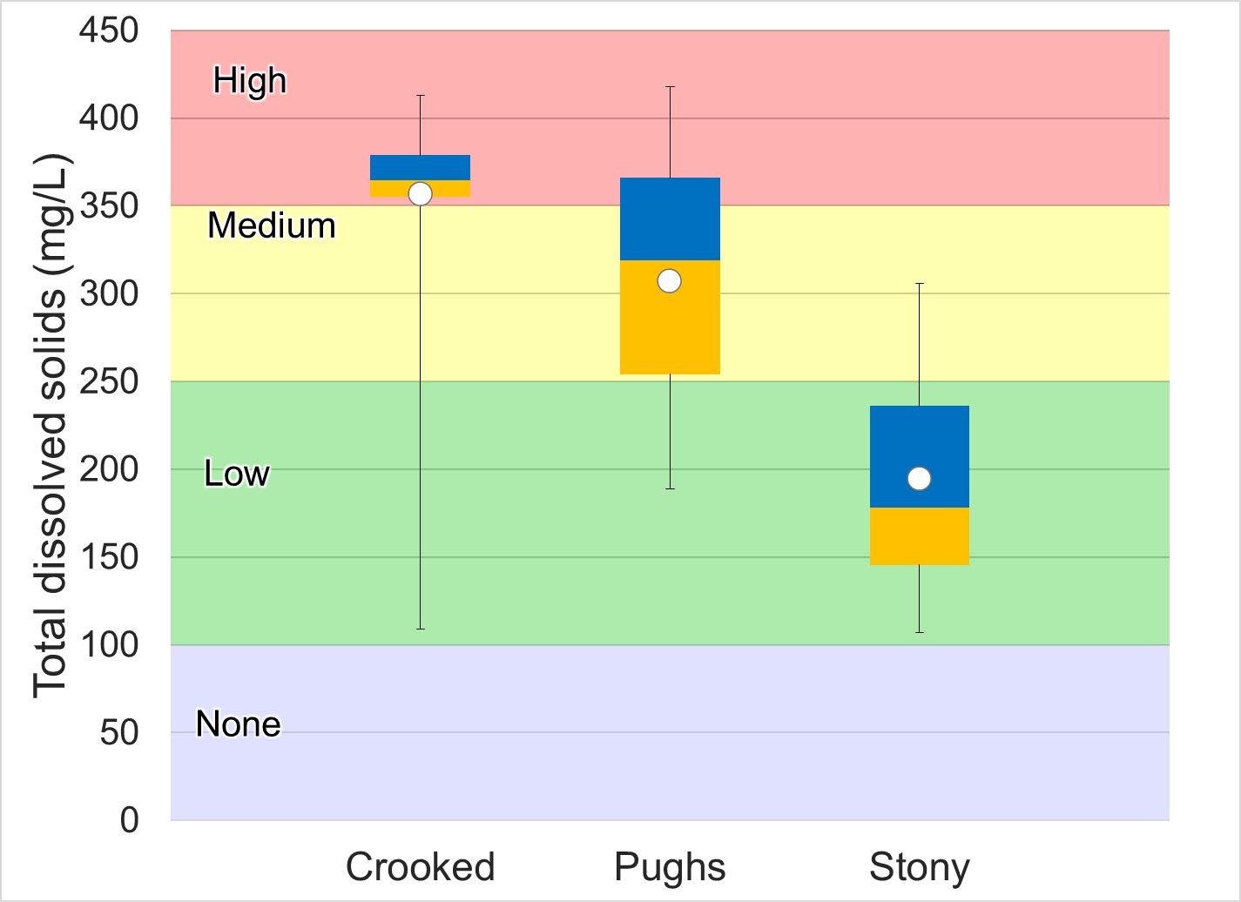
Figure 1-23. Total dissolved solids measured in Crooked and Pughs Runs and Stony Creek. Whiskers indicate the range, boxes indicate the inter-quartile range, lines indicate the median, and white markers indicate the average. Colors represent the probability that data within that range would be responsible for causing stress.

Dissolved Ions
Dissolved chloride, potassium, sodium, and sulfate were measured in Crooked and Pughs Runs and Stony Creek. Dissolved ion concentrations were compared to both DEQ’s stressor thresholds and concentrations in the reference stream (Figure 1-24).
Mean and median dissolved chloride concentrations in Crooked Run and Stony Creek fell within the low probability of stressor effects range. Maximum concentrations did not exceed water quality standards in either of the impaired streams. The median chloride concentration in Crooked Run was 12.3 mg/L, while the maximum concentration measured was 17.4 mg/L. In Stony Creek, the median concentration was 15.0 mg/L and the maximum was 30.0 mg/L. Concentrations in Pughs Run were notably higher, with a median concentration of 27.9 mg/L and a maximum concentration of 51.7 mg/L. Both the mean and median chloride concentrations in Pughs Run fell within the medium probability of stress range. Concentrations in Pughs Run did not follow a seasonal pattern, which may be observed in streams subject to runoff of deicing agents applied to roadways in the winter months. Many of the highest chloride concentrations in Pughs Run occurred in the summer and fall months (Figure 1-27). Based on the timing of the highest concentrations, it is likely that these are natural spikes in chloride occurring during low flow periods when evaporation exceeds precipitation. In these cases, groundwater supplies natural chlorides to the stream, which are weathered from geologic formations. Virginia water quality standards include an acute maximum Cl concentration criterion of 860 mg/l and a chronic maximum concentration criterion of 230 mg/l to protect aquatic life. The acute criterion is for a one-hour average not to be exceeded more than once every three years; the chronic criterion applies to a four-day average, which is also not to be exceeded more than once every three years (9VAC25-260-140).
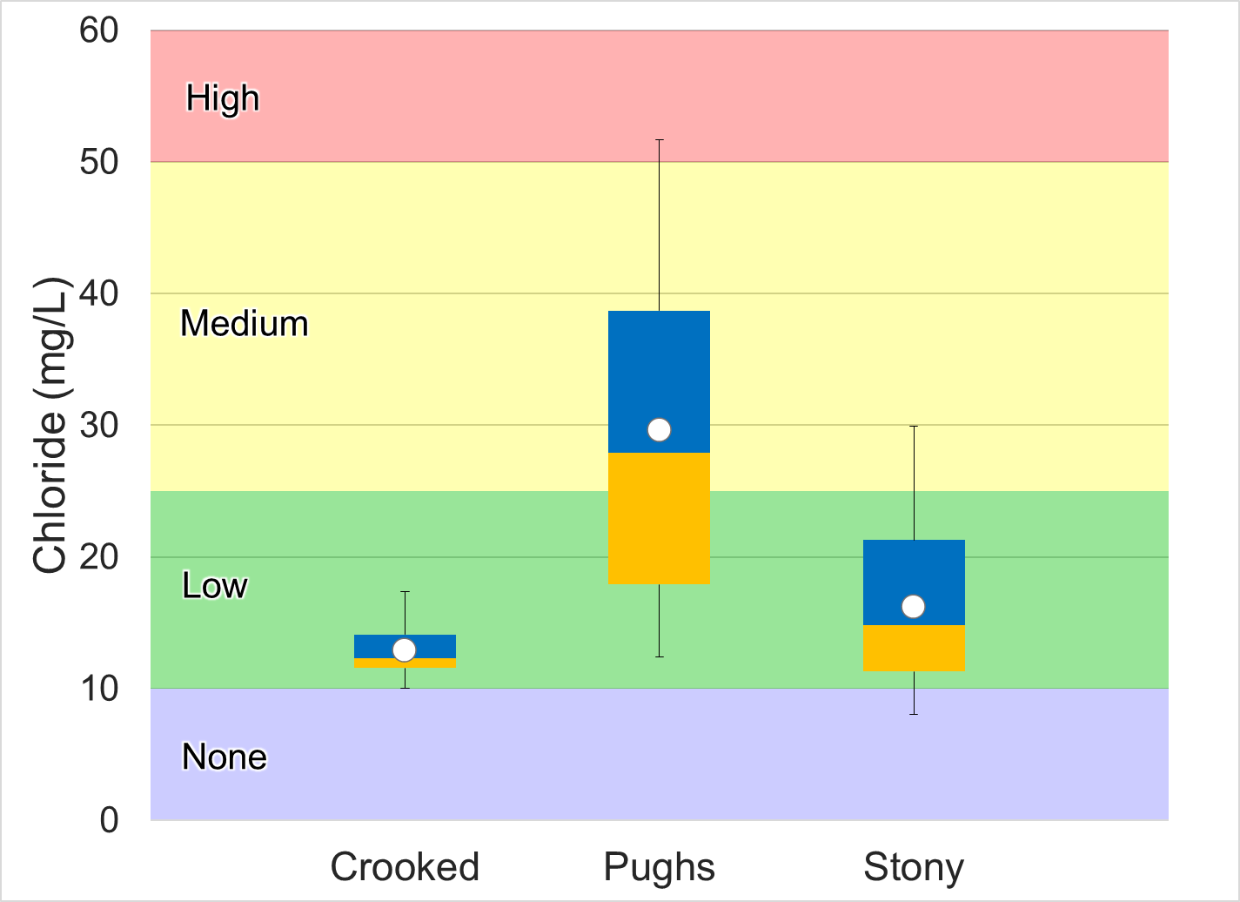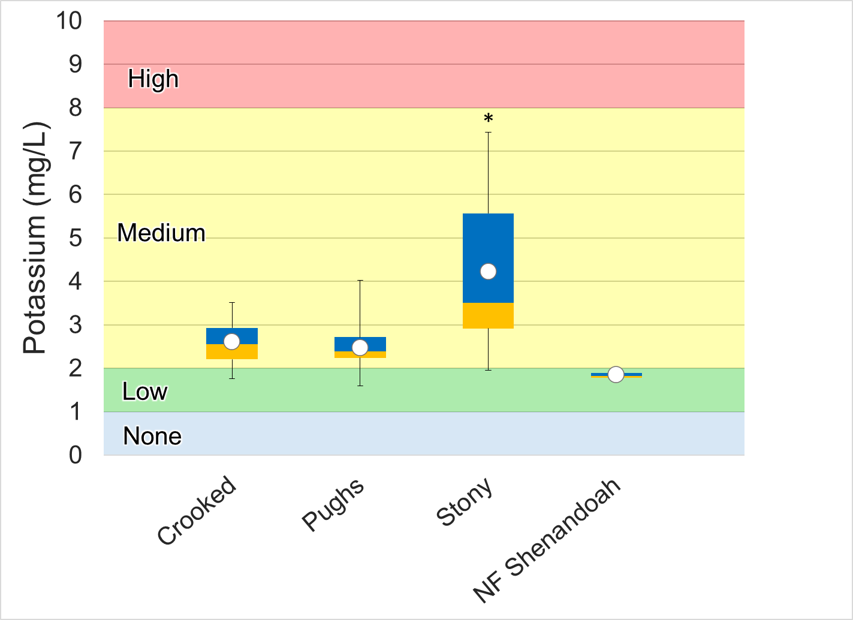
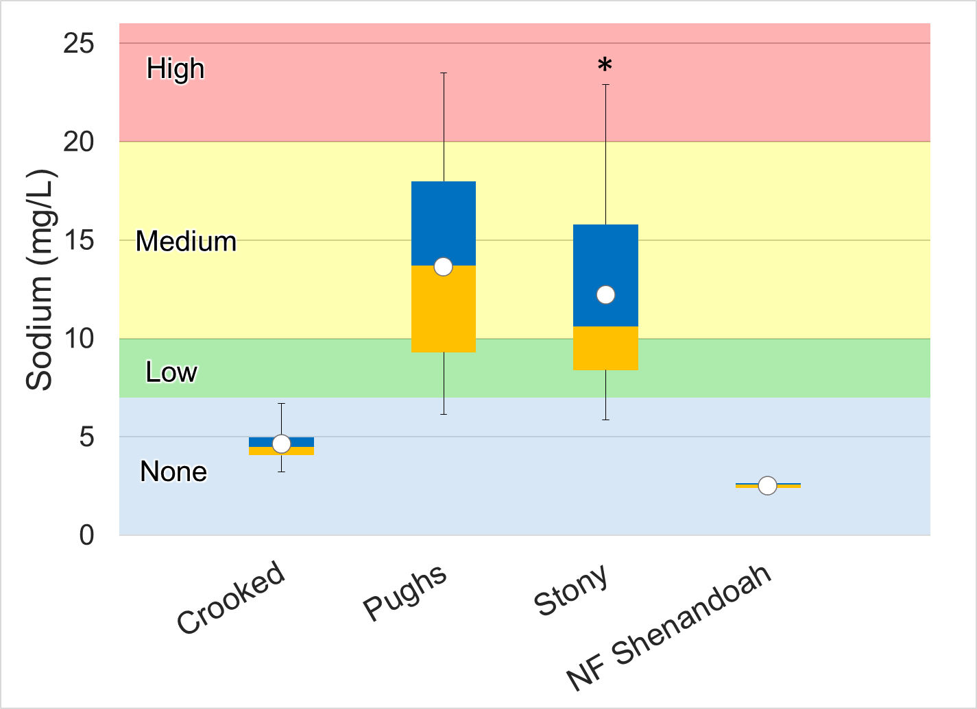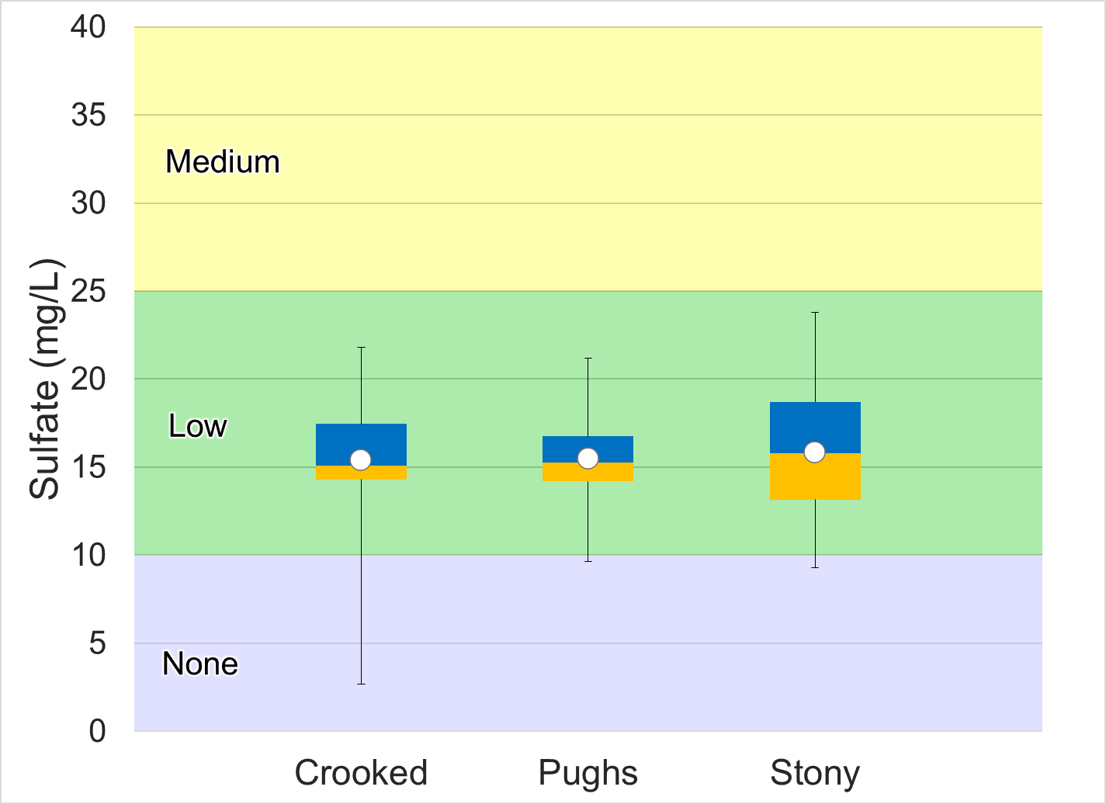

Figure 1-24 Dissolved ions measured in Crooked and Pughs Runs and Stony Creek. Whiskers indicate the range, boxes indicate the inter-quartile range, lines indicate the median, and white markers indicate the average. Colors represent the probability that data within that range would be responsible for causing stress.

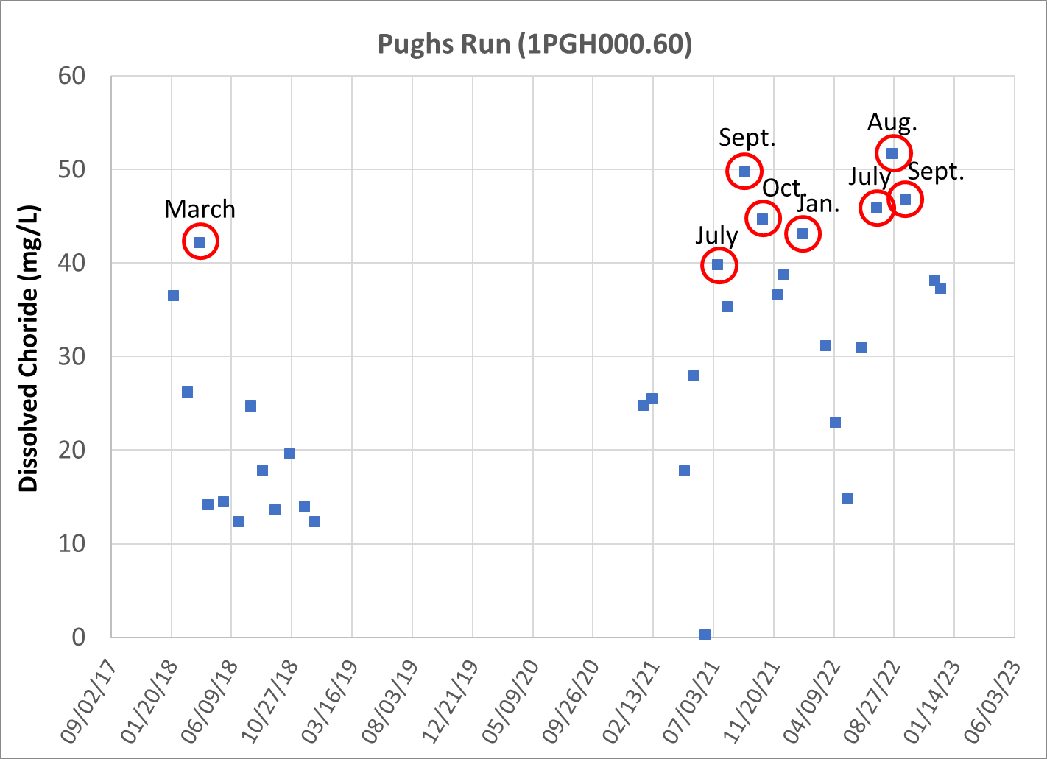
Figure 1-25 Temporal trends in dissolved chloride concentrations in Pughs Run (1PGH000.60).
Dissolved potassium concentrations were in the medium probability of stressor effects range for all the impaired streams. Mean and median concentrations fell within the lower range of the medium probability of stressor effects range in Crooked and Pughs Runs, while concentrations in Stony Creek were considerably higher (Figure 1-24). As shown in Figure 1-26, potassium concentrations in Stony Creek exhibit a clear seasonal pattern, likely driven by precipitation and streamflow. The highest concentrations occur in the summer and fall months when flows are lowest, while the lowest concentrations typically occur in the spring when flows are highest. This signals that runoff from fertilizer, a common source of elevated potassium in agricultural watersheds, is an unlikely source of potassium in Stony Creek. Elevated potassium is also associated with effluent from sewage treatment facilities. While the Edinburg STP is located in the Stony Creek watershed, the outfall for the facility is located below the Stony Creek ambient monitoring station. Based on seasonal patterns of dissolved potassium in Stony Creek, naturally occurring potassium dissolved in groundwater is the most likely source of elevated concentrations in the stream.
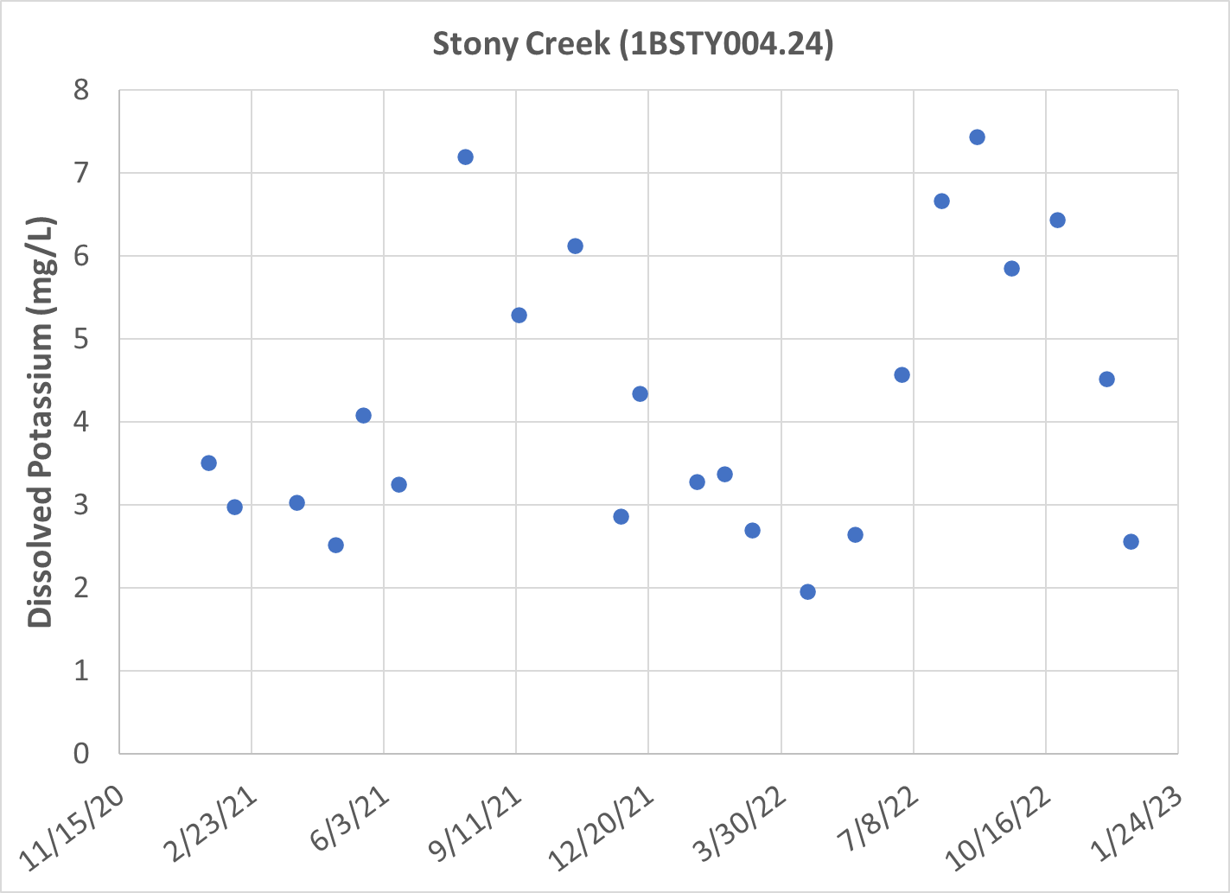
Figure 1-26 Temporal trends in dissolved potassium concentrations in Stony Creek (1BSTY004.24).
Dissolved sodium levels were relatively low in Crooked Run, with both mean and median values falling within the range of no probability of stressor effects. Concentrations were elevated in both Pughs Run and Stony Creek. Temporal patterns in both streams mirrored those of other dissolved ions found in elevated concentrations, signaling that groundwater is the most probable source of elevated sodium concentrations in the two impaired streams.
Dissolved sulfate concentrations were consistently low in all the impaired streams, with all reported values falling within the no probability of stressor effects range. Median concentrations in Crooked and Pughs Runs and Stony Creek were 15.10, 15.25 and 15.8 mg/L, respectively.
In summary, chloride, potassium, sodium and sulfate concentrations were relatively low in Crooked Run, while measurements of specific conductivity and total dissolved solids were elevated. This suggests that other dissolved ions present in elevated concentrations in the stream are responsible for high conductivity. Chloride and sodium were elevated in Pughs Run, while sodium and potassium were high in Stony Creek. Seasonal patterns in concentrations of these dissolved ions in both streams indicate that groundwater inputs are the primary source of these ions.

Nutrients
Nitrogen and phosphorus are the primary nutrients of concern in freshwater. These nutrients are necessary to support healthy ecosystems, but excess nutrients can lead to eutrophication. Excess nutrients spur algae growth and can change the benthic community composition. An overabundance of algae can reduce oxygen levels, leading to further changes in community composition and eventually hypoxic conditions. The initiation of this eutrophication process is not reliant upon the total nutrient availability, but upon the availability of the limiting nutrient. The typical ratio of nitrogen to phosphorus in algae is 7.5:1, so ratios above 7.5 indicate that phosphorus is the limiting nutrient, and ratios below 7.5 indicate that nitrogen is the limiting nutrient. In Crooked and Pughs Runs and Stony Creek, the average nitrogen to phosphorus ratios were 105.97, 83.16 and 41.22, respectively, indicating that phosphorus is the limiting nutrient in the three impaired streams.
Total nitrogen concentrations in the impaired streams were compared to DEQ’s stressor thresholds (Figure 1-27). Median nitrogen concentrations were also compared with EPA recommended nutrient criteria for the Piedmont Ecoregion, which are based upon the 25th percentile of reported values for the region (USEPA, 2000b). Median and mean total nitrogen values in Crooked Run were over six times greater than the recommended criteria of 0.65 mg/L TN. Additionally, median and mean concentrations in Crooked Run fell withing the high probability of stressor effects range, with values of 4.14 and 4.46 mg/L, respectively. Values in Crooked Run were also significantly higher than those in the reference watershed (p<0.001). Mean and median nitrogen concentrations in Pughs Run and Stony Creek both fell within the medium probability of stressor effects range. Values in both streams were over twice the EPA recommended concentration of 0.65 mg/L. While the three impaired streams repeatedly experienced elevated nitrogen concentrations, phosphorus was identified as the limiting nutrient in the streams. This suggests it is unlikely that nitrogen is responsible for stressor effects resulting from excess algal growth due to excessive nitrogen loading in the streams.
Figure 1-28 shows total phosphorus levels in Crooked and Pughs Runs and Stony Creek. Median phosphorus concentrations were compared with EPA recommended nutrient criteria for the Piedmont Ecoregion, which are based upon the 25th percentile of reported values for the region (USEPA, 2000b). The median TP concentrations in Crooked Run (0.04 mg/L) exceeded the recommended criterion of 0.03 mg/L TP, while concentrations in Pughs Runs and Stony Creek (0.02 mg/L in both streams) fell below the criterion. In Crooked Run, the mean and median concentration fell in the low probability for stressor effects range. Mean and median TP concentrations in Pughs Run both fell in the no probability of stress range. In Stony Creek, the median TP concentration fell in the no probability of stress range while the mean concentration fell in the low probability range., while the mean value fell within the high probability range. TP concentrations in the impaired streams were compared with the reference conditions using two sample t-tests with unequal variance (α=0.05). Crooked Run was the only impaired stream with concentrations that were significantly greater than the reference stream.
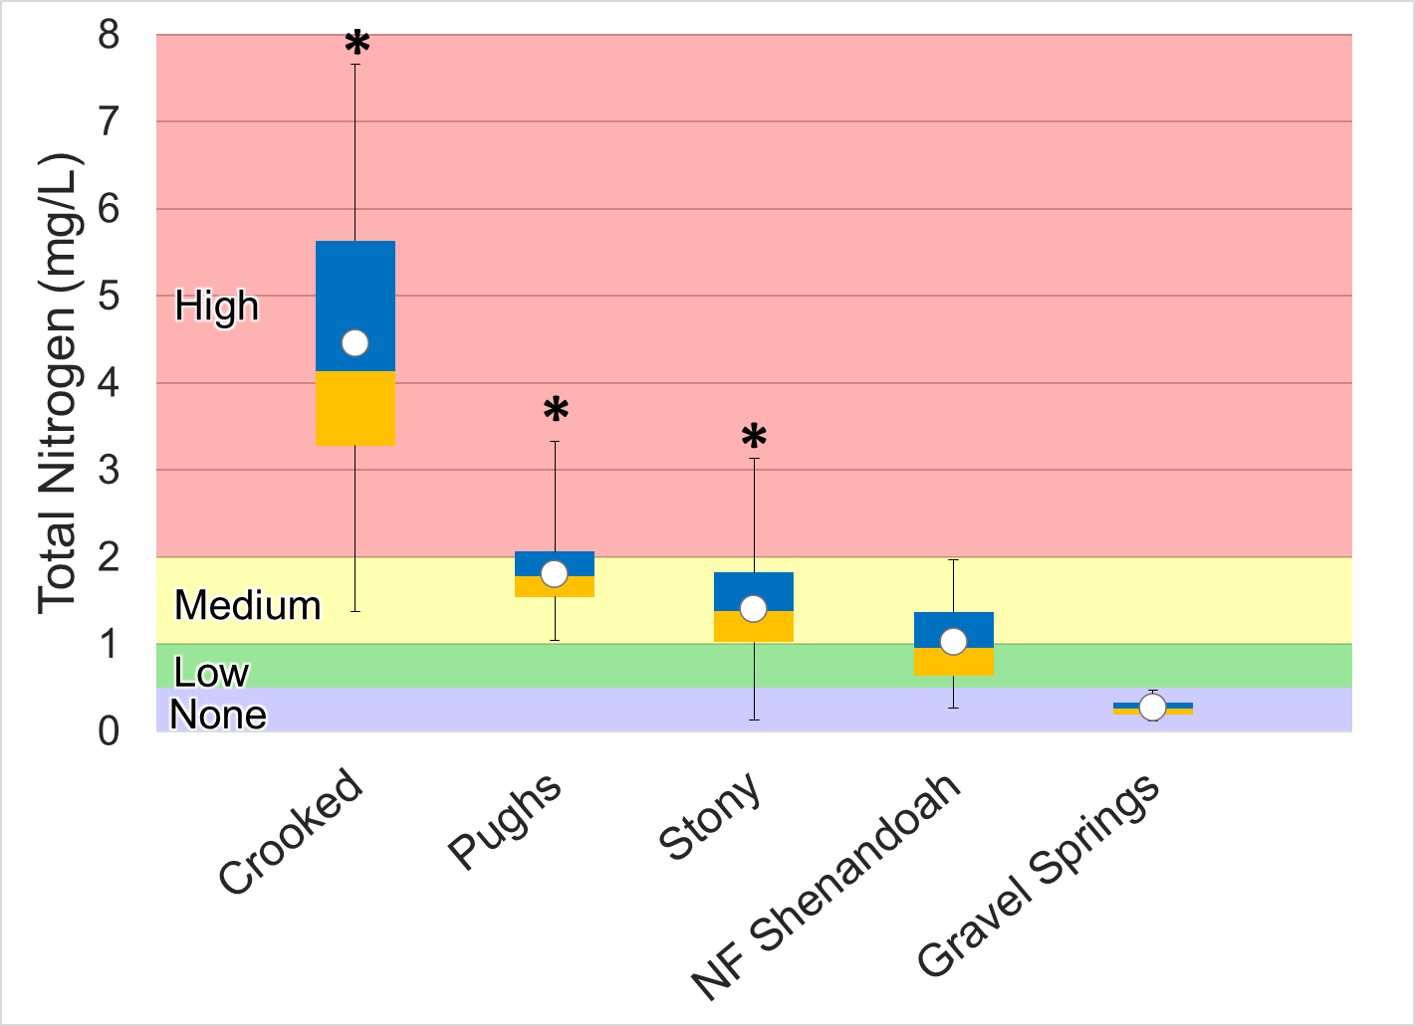
Figure 1-27. Total nitrogen concentrations in Crooked and Pughs Runs and Stony Creek. Whiskers indicate the range, boxes indicate the inter-quartile range, lines indicate the median, and white markers indicate the average. Colors represent the probability that data within that range would be responsible for causing stress.
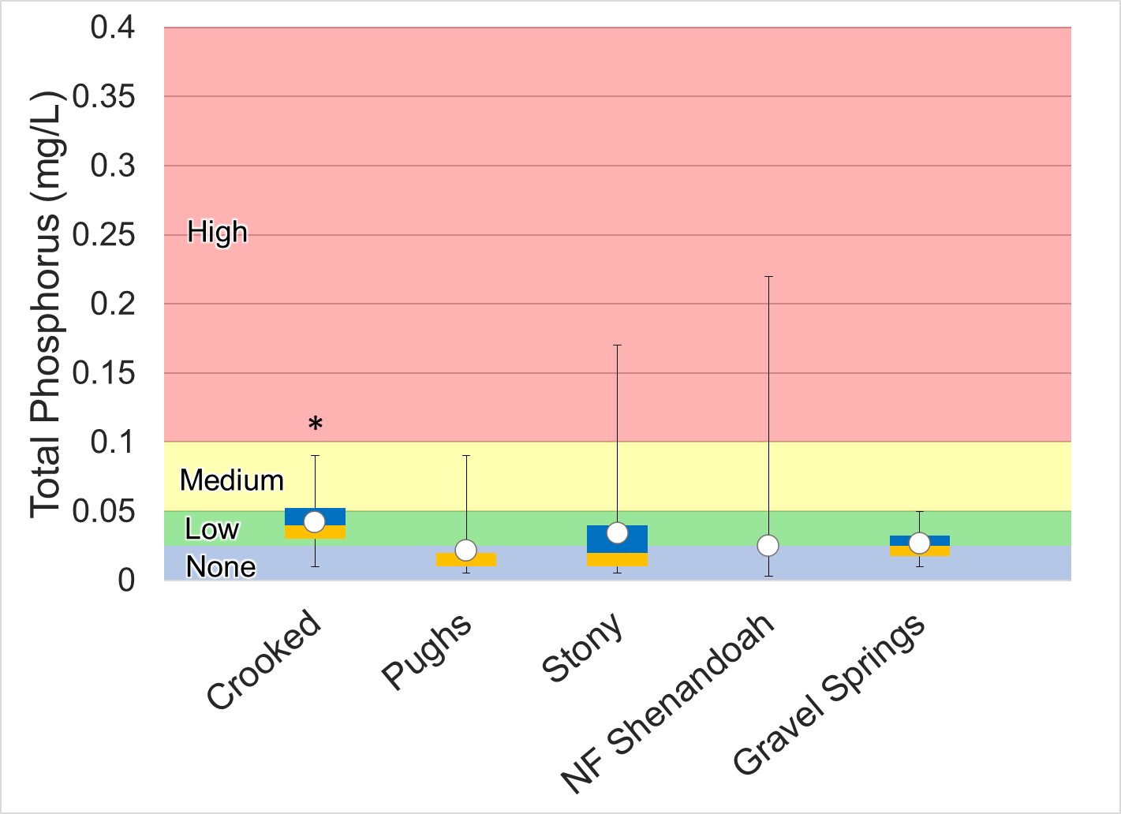
Figure 1-28. Total phosphorus concentrations in Crooked and Pughs Runs and Stony Creek. Whiskers indicate the range, boxes indicate the inter-quartile range, lines indicate the median, and white markers indicate the average. Colors represent the probability that data within that range would be responsible for causing stress.

Diurnal dissolved oxygen monitoring results must also be evaluated to determine if phosphorus or nitrogen is a likely stressor. Excess nutrient loads to a stream may accelerate algal growth, resulting in large diurnal swings in dissolved oxygen concentrations during periods of photosynthesis and respiration. Critical dissolved oxygen levels are typically encountered just before sunrise. This is due to the combination of oxygen consumption from respiration and the absence of oxygen production from photosynthesis during the night. Diurnal monitoring was conducted in Crooked and Pughs Runs for a 3-day period in August 2023. Resources were not available to conduct diurnal monitoring in Stony Creek; however, ambient dissolved oxygen and nutrient concentrations did not signal nutrient enrichment in this stream. Dissolved oxygen data during diurnal deployments are shown in Figure 1-30. Dissolved oxygen levels in Crooked Run fell within the high probability of benthic stress (below 7 mg/L) throughout the 3-day monitoring period. Concentrations approached the water quality standard of 5 mg/L on multiple occasions, with a minimum recorded value of 5.16 mg/L. Fluctuations in daytime and nighttime concentrations did not exceed 2 mg/L, typically dropping just above 5 mg/L in the early morning and rising to a maximum value of 7.0 mg/L in the evening. The amplitude of these shifts is not indicative of nutrient enrichment in Crooked Run. In such cases, greater shifts in dissolved oxygen concentration between daytime and nighttime (typically over 3 mg/L) would be expected in aquatic systems experiencing eutrophic conditions (Wetzel, 2001). This conclusion is further supported by dissolved oxygen saturation levels (% saturation) shown in Figure 1-30. Oxygen saturation is the ratio of the measured dissolved oxygen concentration to the maximum amount of oxygen that the water can hold at the given temperature and pressure. A healthy stream will typically have saturation values between 80-120%. Shifts below and above this range are indicative of elevated productivity. When productivity levels are high during the daytime, plants and algae are producing oxygen during photosynthesis leading the stream to become supersaturated with oxygen (>100%). During the evening, when respiration occurs, oxygen is consumed, concentrations are depleted, and saturation levels drop. Saturation levels in Crooked Run fluctuated between a maximum value of 77.0% and a minimum of 62.%. This maximum shift of 14.8% in Crooked Run suggests that excessive vegetative growth accelerated by increased nutrient inputs to the stream is not the likely cause of low dissolved oxygen concentrations. Groundwater inputs of poorly oxygenated water is one potential cause of low dissolved oxygen concentrations observed in Crooked Run. There is a small spring (Green Spring) located less than a mile upstream of the monitoring station on Crooked Run. Field measurements collected from this spring by DEQ in 2011 showed very low dissolved oxygen concentrations (4.61 mg/L) and high specific conductivity (602 µS/cm). While discharge from Green Spring was last measured in 1962, available data suggests that it is not a large spring with a discharge of 362 GPM. However, these monitoring results support the conclusion that poorly oxygenated groundwater inputs are influencing water chemistry in Crooked Run. This conclusion is further supported by high conductivity observed in the stream, which frequently exceeded 640 µS/cm during the 3-day monitoring period. Elevated levels of conductivity are frequently observed in karst systems where groundwater contains high levels of dissolved ions due to dissolution of limestone over time. Additionally, total nitrogen levels were elevated in Crooked Run. While nitrate concentrations were not measured, it is possible that nitrate is driving high total nitrogen concentrations observed in Crooked Run. Nitrate is the most mobile form of nitrogen due to its negative charge and high solubility. Consequently, concentrations in groundwater may be elevated as nitrate is leached from the soil and transported into groundwater. Another possible cause of low dissolved oxygen concentrations in Crooked Run is an overabundance of organic matter. As organic matter decays on the stream bottom, it consumes oxygen thereby lowering concentrations in the stream. The low dissolved oxygen concentrations observed during diurnal monitoring could also be the result of an elevated sediment oxygen demand. The degradation of organic matter in the excess sediment observed in Crooked Run may also be decaying and consuming oxygen. Each of these potential causal agents would result in continuously low dissolved oxygen concentrations and % saturation observed in Crooked Run as opposed to increased productivity which would result in far greater swings in values between day and night.

.
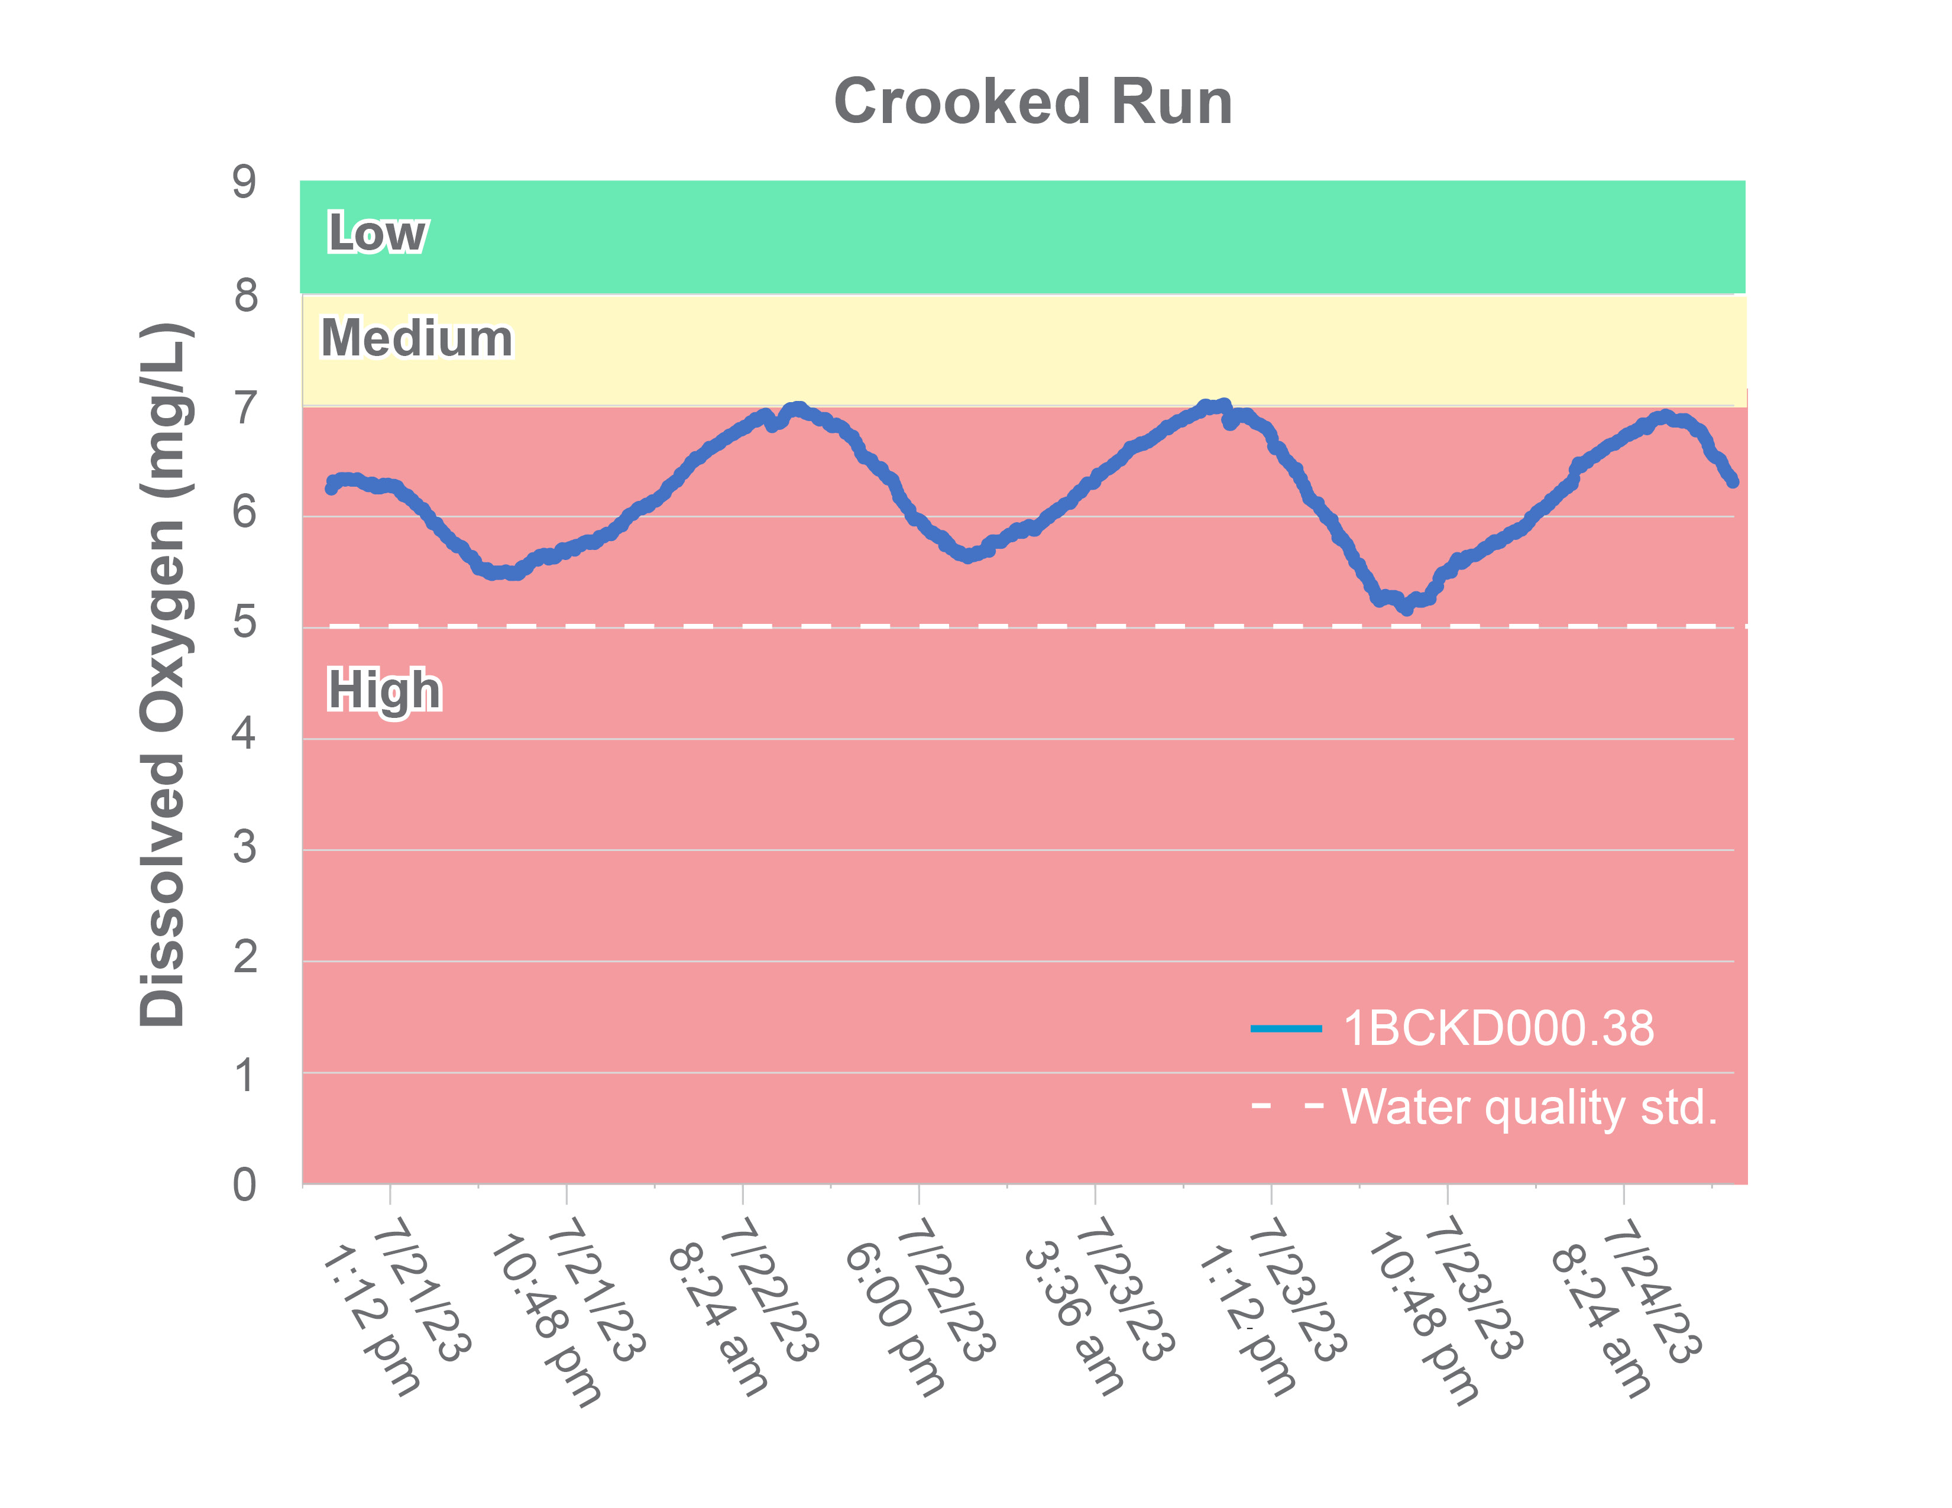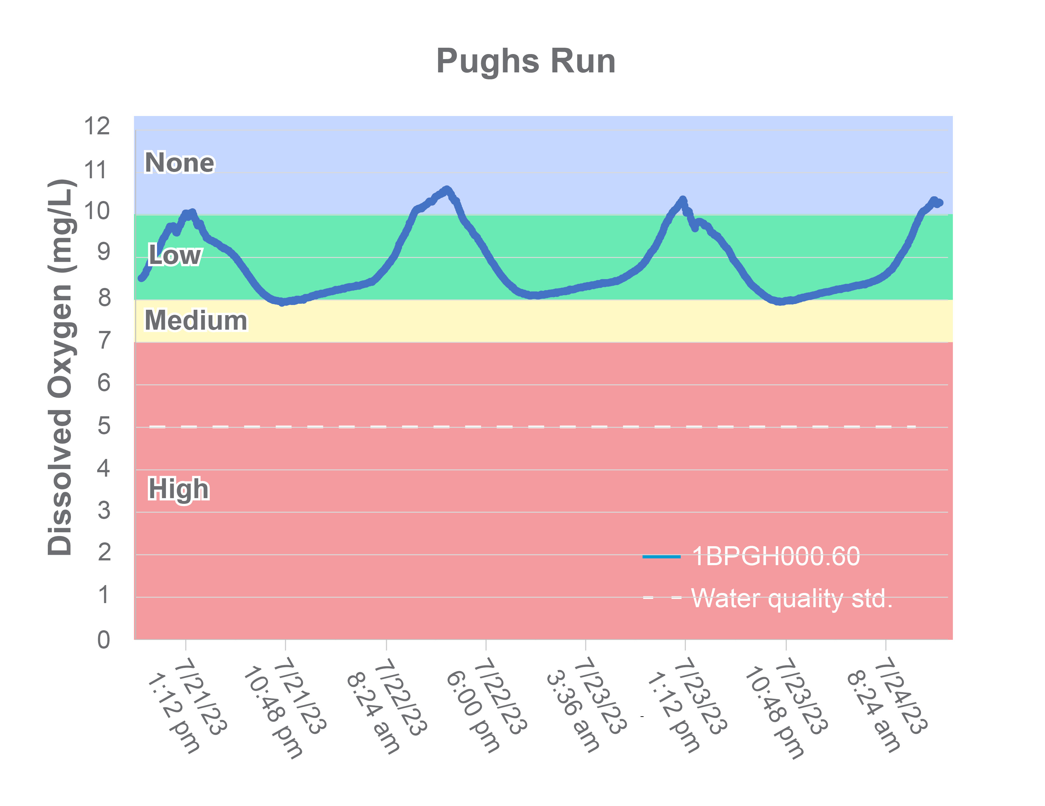
Figure 1-29 Diurnal dissolved oxygen in Crooked and Pughs Runs. Colors represent the probability that data within the range would be responsible for causing stress. The dashed white line indicates the water quality standard.
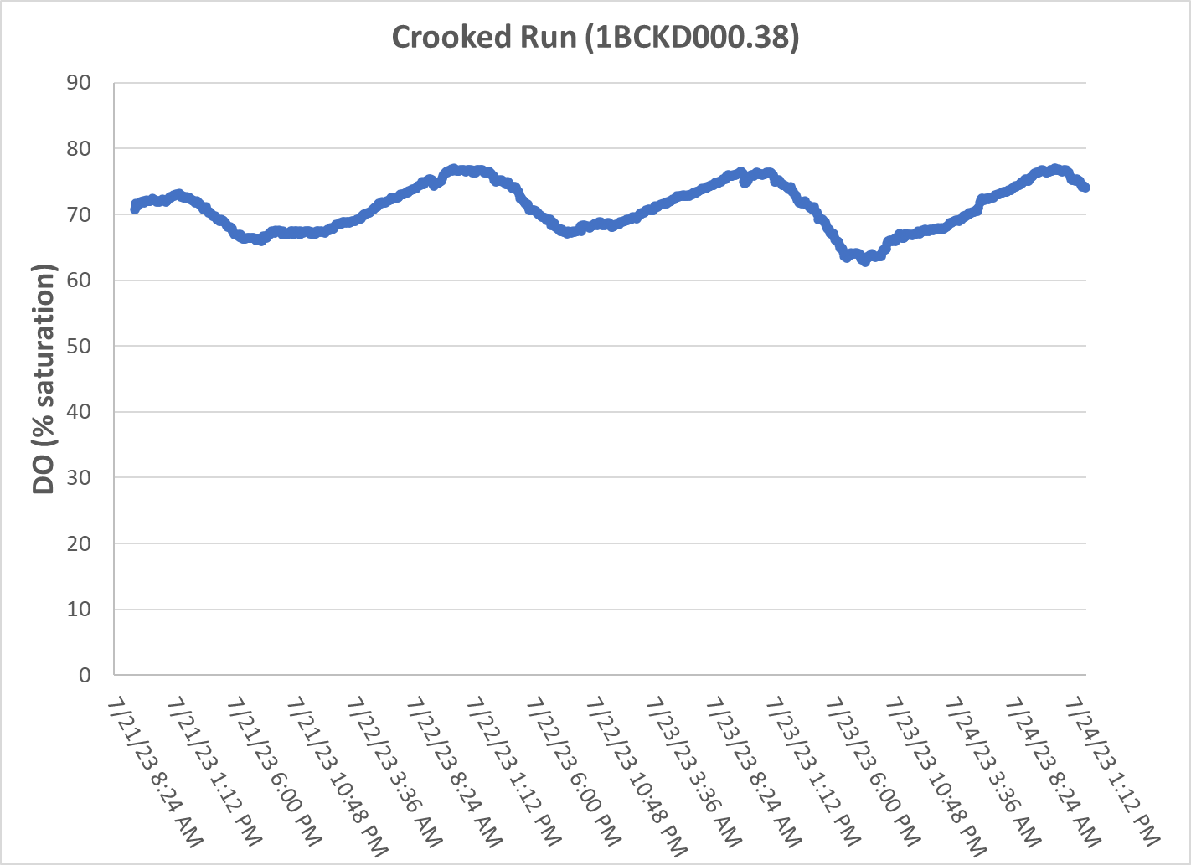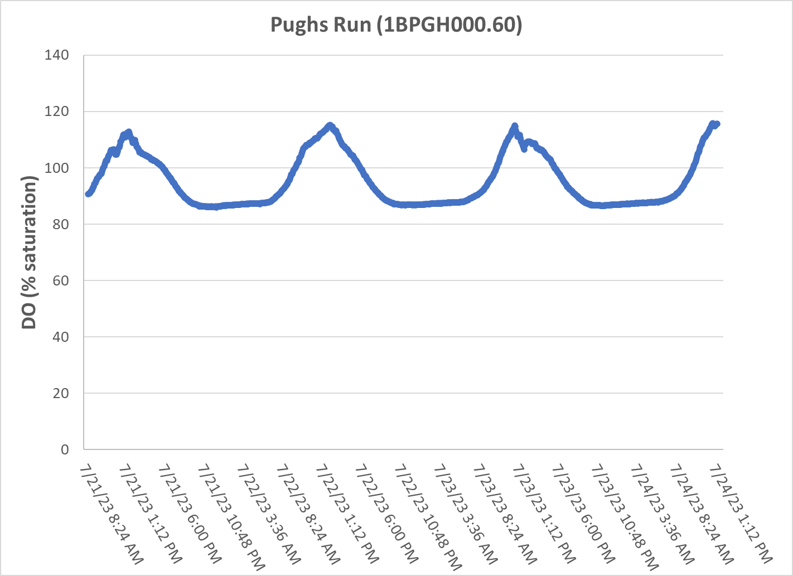
Figure 1-30 Diurnal dissolved oxygen saturation (% saturation) in Crooked and Pughs Runs.

In Pughs Run, dissolved oxygen concentrations largely fell within the low probability of stress range, dipping into the medium range during the evenings and the no probability of stress range in the morning hours. Concentrations in Pughs Run never fell below 7.9 mg/L, signaling that low dissolved oxygen is not a likely stressor in the stream. Similarly, oxygen saturation levels never fell below 80%. While greater shifts in saturation were observed during diurnal monitoring in Pughs Run compared to Crooked Run, oxygen saturation levels reflect a healthy level of productivity that is not likely accelerated by excess nutrient inputs.
In summary, monthly ambient monitoring of phosphorus did not provide evidence that phosphorus was a likely stressor in any of the impaired streams. Total nitrogen concentrations in Crooked Run and low diurnal dissolved oxygen concentrations signaled potential nutrient enrichment in the stream; however, the low amplitude of shifts in day and nighttime oxygen saturation levels suggest that nutrient enrichment is not the causal agent for low dissolved oxygen in Crooked Run. Both ambient monitoring of nutrient concentrations in Pughs Run and diurnal monitoring of dissolved oxygen do not provide clear evidence of nutrient enrichment in the stream.

Water Quality Regressions
To investigate the potential role of various water quality parameters affecting the benthic macroinvertebrate community, SCI scores for Crooked and Pughs Runs and Stony Creek were regressed against water quality parameter values collected within a 30-day window of benthic monitoring at those sites. Table 1-12 shows the results of these regressions. Sufficient ambient data were not available to complete regressions for a number of parameters in Stony Creek. Crooked Run had the greatest degree of correlation between water quality parameters and SCI scores, with specific conductance, dissolved oxygen, potassium, sodium and sulfate all significantly correlated with SCI scores. However, dissolved oxygen was negatively correlated with scores, while potassium and sulfate were positively correlated with SCI scores. This suggests that other factors not accounted for in regression analyses are impacting SCI scores in Crooked Run. Overall results of regression analyses indicate that additional data is needed to clearly demonstrate the relationship between SCI scores and water quality parameters.

Table 1-12. Regression relationship between water quality parameters and stream condition index (SCI) scores.
Parameter | No. of samples |  |  | Regression Significant  (Y/N) |  |  | R² |  |  | p-value
 | Crooked  Run | Pughs  Run | Stony Creek | Crooked  Run | Pughs  Run | Stony Creek | Crooked  Run | Pughs  Run | Stony Creek | Crooked  Run | Pughs  Run | Stony Creek
Temp Celsius | 18 | 21 | 19 | N | Y | N | 0.015 | 0.284 | 0.171 | 0.625 | 0.013 | 0.079
Field pH | 18 | 21 | 19 | N | N | N | 0.012 | 0.034 | 0.009 | 0.670 | 0.422 | 0.703
DO | 18 | 21 | 19 | Y | N | Y | 0.216 | 0.142 | 0.289 | 0.052 | 0.093 | 0.018
Spec Cond | 18 | 21 | 19 | Y | N | N | 0.337 | 0.053 | 0.134 | 0.012 | 0.316 | 0.123
Chloride | 8 | 8 | - | N | N | - | 0.011 | 0.194 | - | 0.275 | 0.802 | -
TN | 8 | 8 | - | N | N | - | 0.380 | 0.044 | - | 0.103 | 0.619 | -
TP | 8 | 8 | - | N | N | - | 0.240 | 0.112 | - | 0.218 | 0.417 | -
Potassium | 8 | 8 | - | Y | N | - | 0.698 | 0.156 | - | 0.010 | 0.333 | -
Sodium | 8 | 8 | - | Y | N | - | 0.531 | 0.007 | - | 0.040 | 0.847 | -
Sulfate | 8 | 8 | - | Y | N | - | 0.532 | 0.207 | - | 0.040 | 0.258 | -

Causal Analysis
DEQ conducted this stressor identification according to EPA’s Stressor Identification Guidance Document (USEPA, 2000a) using the Causal Analysis/Diagnosis Decision Information System (CADDIS) (USEPA, 2018). The CADDIS approach provides guidance on evaluating various lines of evidence to determine the cause of biological impairments. In the case of the Crooked and Pughs Runs and Stony Creek impairments, DEQ used the available data collected from the site, published water quality standards and threshold values, and available literature from other cases to investigate the potential causes of impairment. Table 1-13 shows the lines of evidence suggested by the CADDIS approach, an explanation of the concept, and examples of how this line of evidence was analyzed to identify probable stressors in the impaired streams. Some lines of evidence were not applicable, such as the analysis of biomarkers, field
manipulations, or laboratory experiments. The majority of the lines of evidence, however, were investigated for the three impaired streams.
Table 1-13. Lines of evidence used in the causal analysis approach.
Evidence | The Concept | Examples from Crooked and Pughs Runs and Stony Creek Data Analysis
Data from the Case
Spatial Co-occurrence | The biological effect must be observed where the cause is observed, and must not be observed where the cause is absent. | Analysis of water quality and habitat data across sites
Temporal Co-occurrence | The biological effect must be observed when the cause is observed, and must not be observed when the cause is absent. | Analysis of temporal trends in benthic data
Evidence of Exposure or Biological Mechanism | Measurements of the biota show that relevant exposure to the cause has occurred, or that other biological mechanisms linking the cause to the effect have occurred. | NA
Causal Pathway | Steps in the pathways linking sources to the cause can serve as supplementary or surrogate indicators that the cause and the biological effect are likely to have co-occurred. | Development and analysis of causal pathways for stressors
Stressor-Response Relationships from the Field | As exposure to the cause increases, intensity or frequency of the biological effect increases; as exposure to the cause decreases, intensity or frequency of the biological effect decreases. | Correlation of water quality data with benthic score
Manipulation of Exposure | Field experiments or management actions that increase or decrease exposure to a cause must increase or decrease the biological effect. | NA
Laboratory Tests of Site Media | Controlled exposure in laboratory tests to causes (usually toxic substances) present in site media should induce biological effects consistent with the effects observed in the field. | NA
Temporal Sequence | The cause must precede the biological effect. | Analysis of temporal trends in benthic data
Verified Predictions | Knowledge of a cause's mode of action permits prediction and subsequent confirmation of previously unobserved effects. | NA
Symptoms | Biological measurements (often at lower levels of biological organization than the effect) can be characteristic of one or a few specific causes. | Analysis of benthic metrics, community composition, and functional feeding groups
Data from Elsewhere
Stressor-Response Relationships from Other Field Studies | At the impaired sites, the cause must be at levels sufficient to cause similar biological effects in other field studies. | Water quality comparison with reference sites and stressor probability thresholds
Stressor-Response Relationships from Laboratory Studies | At the impaired sites, the cause must be at levels associated with related biological effects in laboratory studies. | Water quality comparison with VA water quality standards and literature threshold values
Stressor-Response Relationships from Simulation Models | At the impaired sites, the cause must be at levels associated with effects in mathematical models simulating ecological processes. | Confirmation through use of TMDL model
Mechanistically Plausible Cause | The relationship between the cause and biological effect must be consistent with known principles of biology, chemistry and physics. | Development and analysis of causal pathways for stressors
Manipulation of Exposure at Other Sites | Field experiments or management actions at other sites that increase or decrease exposure to a cause must increase or decrease the biological effect. | Confirmation through literature
Analogous Stressors | Agents similar to the causal agent at the impaired site should lead to similar effects at other sites. | Confirmation through literature
Multiple Types of Evidence
Consistency of Evidence | Confidence in the argument for or against a cause is increased when many types of evidence consistently support or weaken it. | Weight of evidence approach
Explanation of the Evidence | Confidence in the argument for a candidate cause is increased when a post hoc mechanistic, conceptual, or mathematical model reasonably explains any inconsistent evidence. | Confirmation through use of TMDL model
For each impaired stream and for each potential candidate cause, the applicable lines of evidence were evaluated. For each line of evidence, the candidate cause was scored on a 3-point positive and negative scale (Table 1-14). This scale represents the strength of the evidence for or against each candidate cause. A weight of evidence approach was then used to sum the respective scores and classify candidate causes as either non-stressors, possible stressors, or probable stressors. If the summed scores for candidate causes were ≤0, the cause was classified as a non-stressor. If scores were 1-3, the cause was classified as a possible stressor. If scores were >3, the cause was classified as a probable stressor (Table 1-15).
Table 1-14. Scoring criteria used to evaluate candidate stressors.
Score | Explanation
+3 | The line of evidence strongly supports the candidate stressor as the cause of the impairment
+2 | The line of evidence moderately supports the candidate stressor as the cause of the impairment
+1 | The line of evidence weakly supports the candidate stressor as the cause of the impairment
0 | The line of evidence does not support or refute the candidate stressor as the cause of the impairment
-1 | The line of evidence weakly refutes the candidate stressor as the cause of the impairment
-2 | The line of evidence moderately refutes the candidate stressor as the cause of the impairment
-3 | The line of evidence strongly refutes the candidate stressor as the cause of the impairment
Table 1-15. Scheme for classifying candidate causes based on causal analysis.
Total Score | Classification
<-2 | Non-Stressor
-1
0
+1 | Possible Stressor
+2
+3
+4 | Probable Stressor
+5
>+6

Temperature
Table 1-15 shows the causal analysis results for temperature in Crooked and Pughs Runs and Stony Creek. The total causal analysis score for Crooked Run was -15. Pughs Run had a score of -14, while Stony Creek had a score of -13, indicating that there is strong evidence that temperature is a non-stressor in these streams. No violations of the temperature standard were observed in Crooked Run or Pughs Run during routine monthly monitoring or during diurnal monitoring. Temperatures in Stony Creek occasionally exceeded the Class V Stockable Trout Waters standard of 21°C (11% exceedance rate); however, values still fell within an acceptable range to support a healthy and diverse population of benthic macroinvertebrates. For these reasons and others explained in Table 1-16, temperature was categorized as a non-stressor in Crooked and Pughs Runs and Stony Creek.

pH
Table 1-17 shows the causal analysis results for pH for Crooked and Pughs Runs and Stony Creek. Total causal analysis scores ranged from -16 in Crooked Run to -19 in Pughs Run, indicating that there is strong evidence that pH is a non-stressor in these streams. pH values were near neutral in the impaired streams, ranging between an average of 8.1 in Crooked Run to 8.2 in Pughs Run. No violations of the pH standard were observed, and values were within the low probability range of stressor effects for both streams. For these reasons and others explained in Table 1-17, pH was categorized as a non-stressor.

Table 1-16. Causal analysis results for temperature as a stressor.
Evidence: Temperature | Crooked Run | Pughs Run | Stony Creek | Explanation
Spatial Co-occurrence | -3 | -3 | -1 | Crooked Run and Pughs Run do not show temperature excursions. Stony Creek shows occasional excursions above the Class V standard, but never to values likely to impact benthic macroinvertebrates.
Temporal Co-occurrence | -3 | -3 | -3 | Temperature was measured at the time of benthic collections and no temperature excursions were observed
Stressor-Response Relationships from the Field | -2 | -3 | -2 | No significant regression between benthic scores and temperature in Crooked Run or Stony Creek (ɑ=0.05) while temperature was negatively correlated with SCI scores in Pughs Run
Temporal Sequence | -2 | 0 | -2 | Neither Crooked Run nor Stony Creek had lower fall benthic scores following high summer temperatures. Fall scores were slightly higher than spring scores in Pughs Run
Stressor-Response Relationships from Laboratory Studies | -3 | -3 | -3 | All temperatures were within water quality standards during routine monthly monitoring and diurnal monitoring in Crooked and Pughs Runs
Consistency of Evidence | -2 | -2 | -2 | All available sources of evidence refute temperature as the cause of impairment.
Sum | -15 | -14 | -13
Table 1-17. Causal analysis results for pH as a stressor.
Evidence: pH | Crooked Run | Pughs Run | Stony  Creek | Explanation
Spatial Co-occurrence | -2 | -3 | -2 | Sites with impaired benthic community do not show pH excursions into highly acidic or highly basic conditions. In 24 months of sampling, Crooked Run had one excursion down to a pH of 6.02, falling on the boundary of a medium probability of benthic stress range. Values in Stony Creek were significantly higher than the reference condition, however, actual differences in values were not of a magnitude likely to result in shifts in the benthic community
Temporal Co-occurrence | -2 | -2 | -2 | pH was measured at the time of benthic collections, and no pH excursions were observed.
Stressor-Response Relationships from the Field | -2 | -2 | -2 | No significant regression between benthic scores and pH
Stressor-Response Relationships from Other Field Studies | -2 | -3 | -3 | All pH values were in the range of low probability for stressor effects; Crooked Run had one excursion to the boundary of the medium probability for stressor effects range.
Stressor-Response Relationships from Laboratory Studies | -3 | -3 | -3 | All pH values were within water quality standards.
Mechanistically Plausible Cause | -3 | -3 | -3 | No biological mechanism for pH values within the range of median values measured impaired sites (8.10-8.15) to produce toxic effects across a diverse assemblage of benthic macroinvertebrates
Consistency of Evidence | -2 | -3 | -3 | All available sources of evidence refute pH as the cause of impairment
Sum | -16 | -19 | -18

Dissolved Oxygen
Table 1-18 shows the causal analysis results for dissolved oxygen in Crooked and Pughs Runs and Stony Creek. Total causal analysis scores totaled -21 in Stony Creek, -19 in Pughs Run, and +3 in Crooked Run, indicating that there is evidence that dissolved oxygen is a non-stressor in Stony Creek and Pughs Run and a possible stressor in Crooked Run. Dissolved oxygen levels did not approach the water quality standard of 5 mg/L in the impaired streams during routine monthly monitoring. However, DO concentrations frequently approached the standard when diurnal monitoring was conducted in Crooked Run in late August 2023, consistently falling within the high probability of stress range during the summertime critical period. Despite low DO concentrations, diurnal swings in dissolved oxygen and % saturation in Crooked Run did not indicate high productivity in the stream. Saturation levels in Crooked Run fluctuated between a maximum value of 77.0% and a minimum of 62.%. This maximum shift of 14.8% suggests that excessive vegetative growth accelerated by increased nutrient inputs to the stream is not the likely cause of low dissolved oxygen concentrations in Crooked Run. Groundwater inputs of poorly oxygenated water is one potential cause of low dissolved oxygen concentrations observed in Crooked Run. Another possible cause of low dissolved oxygen concentrations in Crooked Run is an overabundance of organic matter. As organic matter decays on the stream bottom, it consumes oxygen thereby lowering concentrations in the stream. The low dissolved oxygen concentrations observed during diurnal monitoring could also be the result of an elevated sediment oxygen demand. The degradation of organic matter in the excess sediment observed in Crooked Run may also be decaying and consuming oxygen. Each of these potential causal agents would result in continuously low dissolved oxygen concentrations and % saturation observed in Crooked Run as opposed to increased productivity which would result in far greater swings in values between day and night.
In Pughs Run, diurnal monitoring did not show low dissolved oxygen concentrations during the summertime critical period. While diurnal monitoring was not conducted in Stony Creek, ambient monitoring did not show dissolved oxygen as a stressor and other symptoms were not observed. For these reasons and others explained in Table 1-18, dissolved oxygen was categorized as a non-stressor for Pughs Run and Stony Creek and a possible stressor for Crooked Run.

Conductivity and Total Dissolved Solids
Table 1-19 shows the causal analysis results for conductivity and total dissolved solids in Crooked and Pughs Runs and Stony Creek. Total causal analysis scores were 0 in Crooked Run, 0 in Pughs Run and -11 in Stony Creek, indicating that there is some evidence that total dissolved solids and conductivity are non-stressors in Crooked and Pughs Runs and Stony Creek. Specific conductivity and TDS were elevated in Crooked and Pughs Runs. Mean and median conductivity values were in the range of a high probability for stressor effects for both streams, while TDS was in the high probability range in Crooked Run and the medium probability range in Pughs Run. Both parameters were in the low probability range in Stony Creek. Conductivity remained in the high probability for stressor effects range in Crooked and Pughs Runs throughout the diurnal monitoring period in August 2023. However, in the absence of concurrent increases in dissolved salts and metals known to produce toxic effects across a diverse assemblage of benthic macroinvertebrates, there is no clear evidence that the elevated conductivity and TDS concentrations observed in Crooked and Pughs Runs are capable of similar detrimental impacts to the aquatic community. The seasonal variability in conductivity typically observed with over-application of deicing agents was absent in Crooked and Pughs Runs. It is more likely that high conductivity levels in these streams are the result of geological processes including the weathering and dissolution of limestone and dolomite. These processes result in elevated concentrations of calcium and magnesium in the water, which are typically the dominant cations in groundwater found in karst systems. For these reasons and others explained in Table 1-19, conductivity and total dissolved solids were classified as non-stressors in Crooked and Pughs Runs and Stony Creek.

Table 1-18. Causal analysis results for dissolved oxygen as a stressor.
Evidence: Dissolved oxygen | Crooked Run | Pughs Run | Stony Creek | Explanation
Spatial Co-occurrence | 1 | -2 | -3 | Pughs Run does not show excursions in DO below 8 mg/L where the probability of stressor effects is greater. Diurnal monitoring in Pughs Run showed concentrations dropping to 7.9 mg/L in the early morning hours when DO is lowest. Values in Stony Creek were significantly higher than the reference condition with a median value of 11.18. Only 2% of DO samples collected during monthly ambient monitoring in Stony Creek fell below 7 mg/L, which is the threshold for a medium probability of stressor effects. Crooked Run had four excursions into the medium probability of stressor effects range during ambient monitoring, while all measurements collected diurnal dissolved oxygen monitoring in August 2023 fell within the high probability of stressor effects range.
Temporal Co-occurrence | -1 | -2 | -2 | DO was measured at the time of benthic sampling, only one excursion occurred during benthic sampling in Crooked Run with an SCI score of 47; however, some of the greatest DO concentrations were measured when SCI scores in Crooked Run were lowest. No excursions were observed in Pughs Run or Stony Creek during benthic sampling.
Causal Pathway | 1 | -2 | -2 | Causal pathway for dissolved oxygen impacts from elevated nutrient inputs is not clearly intact for the three impaired streams. N:P ratios for the streams indicate that they are P-limited and mean and median TP concentrations fell within the no-low probability of stressor effects ranges. TN concentrations were elevated in all three streams, most notably in Crooked Run where DO was lowest. Elevated nitrogen concentrations could be impacting DO concentration in spite of the N:P ratio in Crooked Run. However, daily shifts in DO saturation in Crooked Run were minimal, indicating that elevated productivity is not causing reductions in DO availability. Groundwater and decomposition of organic matter are also potential causal agents for low DO observed in Crooked Run. Runoff of fertilizer from surrounding agricultural land is another potential causal factor, which is supported by significantly lower spring SCI scores in Crooked Run (p=0.02).
Stressor-Response Relationships from the Field | 0 | -2 | 0 | No significant regression between benthic scores and DO in Pughs Run. While regressions were significant in Crooked Run and Stony Creek, these relationships were weakly negatively correlated (R²= 0.22 and 0.29, respectively). Since the relationship between sensitive macroinvertebrates and low dissolved oxygen is well established, it is likely that these results are reflecting other conditions present when DO is high that are negatively impacting aquatic life.
Symptoms | 1 | -2 | -3 | Sensitive taxa were present in far lower abundance in Crooked Run, where SCI scores were the lowest of the three impaired streams. A shift towards scrapers was observed in Crooked Run compared to the reference condition, which could be indicative of nutrient enrichment and subsequent low DO concentrations. However, the scraper community is largely comprised of Elmidae, which are found in areas with high embeddedness and sedimentation. Sensitive taxa were present in both Pughs Run and Stony Creek, with borderline impairments present in both streams. Weighted average BCG scores for DO in the impaired streams ranged from 3.3 in Stony Creek to 3.8 in Crooked Run suggesting that taxa present in the impaired streams are not particularly tolerant of low DO.
Stressor-Response Relationships from Other Field Studies | 1 | -2 | -3 | Mean and median DO values measured in the impaired streams during monthly ambient monitoring fell in the low probability of stressor effects, however, diurnal dissolved oxygen monitoring in Crooked Run during the summertime critical period showed 100% of measurements falling within the high probability for stressor effects range. In Pughs Run, diurnal concentrations were largely in the no probability for stressor effects range.
Stressor-Response Relationships from Laboratory Studies | -1 | -3 | -3 | DO levels were above water quality standards during ambient monthly monitoring at the three impaired streams. Concentrations approached the standard in Crooked Run during diurnal monitoring in the summertime critical period.
Mechanistically Plausible Cause | 1 | -2 | -2 | DO levels observed in the impaired streams were sufficient to support sensitive benthic macroinvertebrates throughout the monitoring period, though they were present in lower abundance in Crooked Run. Potential causes for low DO in Crooked Run include poorly oxygenated groundwater inputs and the presence of decaying organic matter.
Consistency of Evidence | 0 | -2 | -3 | Weight of evidence shows DO as a stressor Crooked Run during summertime critical period, while evidence from Pughs Run and Stony Creek consistently demonstrates that DO is a non-stressor
Sum | 3 | -19 | -21

Table 1-19. Causal analysis results for conductivity and total dissolved solids as a stressor.
Evidence: Dissolved solids | Crooked Run | Pughs Run | Stony Creek | Explanation
Spatial Co-occurrence | 1 | 1 | 0 | Crooked and Pughs Runs show high levels of conductivity and TDS while levels are slightly elevated in Stony Creek
Temporal Co-occurrence | 1 | 1 | 0 | Conductivity and TDS were elevated at the time of benthic collections
Stressor-Response Relationships from the Field | -2 | -2 | -2 | Benthic scores were not significantly correlated with conductivity in Pughs Run or Stony Creek. While regressions were significant in Crooked Run, this relationship displayed a weak positive correlation (R²= 0.34). Since the relationship between sensitive macroinvertebrates and high conductivity is relatively well established, it is likely that these results are reflecting other conditions present when conductivity is low that are negatively impacting aquatic life.
Stressor-Response Relationships from Other Field Studies | 1 | 1 | -1 | Mean and median conductivity values were in the range of a high probability for stressor effects in Crooked and Pughs Run, TDS was in the high probability range in Crooked Run and the medium probability range in Pughs Run. Conductivity remained in the high probability for stressor effects range in both streams throughout the diurnal monitoring period in August 2023. Conductivity and TDS were in the low probability for stressor effects range in Stony Creek. Conductivity was significantly greater in the impaired streams when compared to the reference conditions (α=0.05)
Stressor-Response Relationships from Laboratory Studies | 0 | 0 | -2 | Median conductivity values in Crooked and Pughs Runs were above the threshold of 500 uS/cm reported by Pond (2004) for loss of Ephemeroptera species, while values in Stony Creek fell below this threshold. However, this study was conducted in a watershed where surface mining had previously occurred, serving as the primary cause of elevated conductivity levels in the study area. Karst topology and resulting increases in calcium and magnesium concentrations is the likely cause of elevated conductivity in Crooked and Pughs Runs, which is not associated with similar detrimental effects to sensitive species.
Mechanistically Plausible Cause | -1 | -1 | -3 | In the absence of concurrent increases in dissolved salts and metals known to produce toxic effects across a diverse assemblage of benthic macroinvertebrates, there is no evidence that the elevated conductivity and TDS concentrations observed in Crooked and Pughs Runs are capable of similar detrimental impacts to the aquatic community
Consistency of Evidence | 0 | 0 | -3 | There is inconsistent evidence to support conductivity and TDS as non-stressors in the impaired streams
Sum | 0 | 0 | -11

Dissolved Ions – Sodium
Table 1-20 shows the causal analysis results for dissolved sodium in Crooked and Pughs Runs and Stony Creek. Total causal analysis scores were -15 in Crooked Run, -6 in Pughs Run and -3 in Stony Creek, indicating that there is clear evidence that dissolved sodium is a non-stressor in these streams. Median and average sodium values were in the range of no probability for stressor effects in Crooked Run, while falling in the medium range in Pughs Run and Stony Creek. There was no significant regression between benthic scores and sodium in Pughs Run. The regression between sodium and benthic scores in Crooked Run was significant; however, concentrations are not elevated in this stream. Conductivity was in the highest range for stressor effects in Crooked Run and is an analogous stressor to sodium; however, sodium concentrations were relatively low in Crooked Run. Conversely, conductivity was relatively low in Stony Creek, while sodium concentrations were slightly elevated in the stream. Sensitive taxa are present in the impaired streams in lower abundance than the reference conditions. This signals that dissolved ions like sodium in not present at concentrations high enough to produce toxic effects. For these reasons and others shown in Table 1-20, sodium was categorized as a non-stressor in the impaired streams.

Dissolved Ions – Sulfate
Table 1-21 shows the causal analysis results for dissolved sulfate as a stressor in Crooked and Pughs Runs and Stony Creek. Total causal analysis scores were -12 in Crooked Run, -11 in Pughs Run and -13 in Stony Creek, indicating that there is clear evidence that dissolved sulfate is a non-stressor in these streams. Average and median concentrations fell within the low probability of stress range in the impaired streams. There was no significant regression between benthic scores and sulfate in Pughs Run. While regressions were significant in Crooked Run, this relationship displayed a weak positive correlation (R²=0.53). Since the relationship between sensitive macroinvertebrates and high sulfate concentrations is relatively well established, it is likely that these results are reflecting other conditions present when sulfate concentrations are low that are negatively impacting aquatic life. For these reasons and others shown in Table 1-21, dissolved sulfate was classified as a non-stressor in Crooked and Pughs Runs and Stony Creek.

Dissolved Ions – Chloride
Table 1-22 shows the causal analysis results for dissolved chloride in Crooked and Pughs Runs and Stony Creek. Total causal analysis scores were -21 in Crooked Run, -20 in Pughs Run and -18 in Stony Creek. Chloride concentrations in the impaired streams were relatively low in the impaired streams. Average and median chloride values fell within the no probability of stressor effects range for Crooked Run and Stony Creek, values in Pughs Run fell in the medium probability range. Maximum chloride concentrations in the streams fell well below both chronic and acute concentration criteria established in Virginia water quality standards to protect aquatic life. For these reasons and others explained in Table 1-22, dissolved chloride was categorized as a non-stressor for Crooked and Pughs Runs and Stony Creek.

Dissolved Ions – Potassium
Table 1-23 shows the causal analysis results for dissolved potassium in Crooked and Pughs Runs and Stony Creek. Total causal analysis scores were -13 in both Crooked and Pughs Runs and -4 in Stony Creek. Mean and median potassium values in the impaired streams were slightly elevated, falling within the medium probability for stressor effects range. Additionally, potassium values in the impaired streams were well below the range where toxic effects would be expected. The regression between benthic scores and potassium concentrations was not significant in Pughs Run, while SCI scores were positively correlated with potassium concentrations in Crooked Run (p=0.010, R²=0.70) suggesting that potassium is not a stressor in these streams. For these reasons and others explained in Table 1-23, dissolved potassium was categorized as a non-stressor for Crooked and Pughs Runs and Stony Creek.

Table 1-20. Causal analysis results for dissolved sodium as a stressor.
Evidence: Sodium | Crooked Run | Pughs Run | Stony Creek | Explanation
Spatial Co-occurrence | -3 | 1 | 1 | Crooked Run does not show elevated sodium concentrations, concentrations in Pughs and Stony Creeks are slightly elevated.
Causal Pathway | -3 | -3 | -3 | A clear causal pathway for elevated sodium concentrations is not intact in the impaired watersheds.
Stressor-Response Relationships from the Field | 0 | -3 | 0 | No significant regression between benthic scores and sodium in Pughs Run. The regression between sodium and benthic scores in Crooked Run was significant; however, concentrations are not elevated in this stream
Stressor-Response Relationships from Other Field Studies | -3 | 1 | 1 | Median and average sodium values were in the range of no probability for stressor effects in Crooked Run, while falling in the medium range in Pughs Run and Stony Creek.
Mechanistically Plausible Cause | -3 | -1 | -1 | Sensitive taxa are present in the impaired streams in lower abundance than the reference conditions. This signals that dissolved ions like sodium in not present at concentrations high enough to produce toxic effects.
Analogous stressors | 0 | 0 | 0 | Conductivity was in the highest range for stressor effects in Crooked Run and is an analogous stressor to sodium; however, sodium concentrations were relatively low in Crooked Run. Conversely, conductivity was relatively low in Stony Creek, while sodium concentrations were slightly elevated in the stream.
Consistency of Evidence | -3 | -1 | -1 | Evidence that sodium is a stressor in Pughs Run or Stony Creek is inconsistent.
Sum | -15 | -6 | -3
Table 1-21. Causal analysis results for dissolved sulfate as a stressor.
Evidence: Sulfate | Crooked Run | Pughs Run | Stony Creek | Explanation
Spatial Co-occurrence | -3 | -3 | -3 | None of the impaired streams show elevated sulfate concentrations.
Causal Pathway | -3 | -3 | -3 | A clear causal pathway for elevated sulfate concentrations is not intact in the impaired watersheds.
Symptoms | 1 | 1 | 0 | Average BCG scores for sulfate in Crooked and Pughs Runs and Stony Creek were 4.0, 4.0 and 3.6 respectively, suggesting that there were organisms present in the impaired streams that were tolerant of elevated sulfate concentrations
Stressor-Response Relationships from the Field | -2 | -2 | 0 | No significant regression between benthic scores and sulfate in Pughs Run. While regressions were significant in Crooked Run, this relationship displayed a weak positive correlation (R²= 0.53). Since the relationship between sensitive macroinvertebrates and high sulfate concentrations is relatively well established, it is likely that these results are reflecting other conditions present when sulfate concentrations are low that are negatively impacting aquatic life.
Stressor-Response Relationships from Other Field Studies | -2 | -2 | -2 | Median and average sulfate values were in the range of a low probability for stressor effects in the impaired streams.
Mechanistically Plausible Cause | -1 | -1 | -3 | While taxa tolerant of elevated sulfate concentrations are present in the impaired streams, sensitive taxa are also present in lower abundance.
Analogous stressors | 1 | 1 | -1 | Conductivity was consistently elevated in Crooked and Pughs Runs and is an analogous stressor to sulfate
Consistency of Evidence | -3 | -3 | -3 | There is relatively little evidence that sulfate is a stressor in either of the impaired streams
Sum | -12 | -11 | -13
Table 1-22. Causal analysis results for dissolved chloride as a stressor.
Evidence: Chloride | Crooked Run | Pughs Run | Stony Creek | Explanation
Spatial Co-occurrence | -3 | -2 | 0 | Crooked Run did not show any chloride excursions while Stony Creek had one excursion during the two year ambient monitoring period. Pughs Run had slightly elevated chloride concentrations with over 50% of measurements exceeding 25 and 50 mg/L.
Causal Pathway | -3 | -3 | -3 | A clear causal pathway for elevated chloride concentrations is not intact in the impaired watersheds.
Symptoms | -2 | -2 | -3 | Average BCG scores for chloride in Crooked and Pughs Runs and Stony Creek were equal to 3.7, 3.6 and 3.3, respectively, suggesting that organisms present in both streams were relatively intolerant of elevated chloride concentrations
Stressor-Response Relationships from the Field | -2 | -2 | 0 | No correlation between benthic scores and chloride concentrations in Crooked or Pughs Runs.
Stressor-Response Relationships from Other Field Studies | -3 | -3 | -1 | Average and median chloride values fell within the no probability of stressor effects range for Crooked Run and Stony Creek, values in Pughs Run fell in the medium probability range.
Stressor-Response Relationships from Laboratory Studies | -3 | -3 | -3 | Chloride levels were well below chronic and acute water quality standards; no significant regression between benthic scores and chloride
Mechanistically Plausible Cause | -3 | -3 | -3 | No biological mechanism for average chloride concentrations measured in impaired sites to produce toxic effects across a diverse assemblage of benthic macroinvertebrates. In a literature review by Blasius and Merritt (2002), the most sensitive taxa were affected by sodium chloride concentrations of approximately 800 mg/L (240 mg/L chloride) and many were not affected until concentrations exceeded 2,000 mg/L (800 mg/L chloride).
Analogous stressors | 1 | 1 | -2 | Conductivity was in the high probability for stressor effects range in Crooked and Pughs Runs and is an analogous stressor to chloride
Consistency of Evidence | -3 | -3 | -3 | Available data sources of evidence refute chloride as the cause of impairment
Sum | -21 | -20 | -18
Table 1-23 Causal analysis results for dissolved potassium as a stressor.
Evidence: Potassium | Crooked Run | Pughs Run | Stony Creek | Explanation
Spatial Co-occurrence | 0 | 0 | 1 | Mean and median potassium values in the impaired streams were slightly elevated, falling within the medium probability for stressor effects range
Stressor-Response Relationships from the Field | -2 | -2 | 0 | No correlation between benthic scores and potassium concentrations in Pughs Run. SCI scores were positively correlated with potassium concentrations in Crooked Run (p=0.010, R²=0.70) suggesting that potassium is not a stressor
Stressor-Response Relationships from Other Field Studies | 0 | 0 | 1 | Average and median potassium values were in the low end of the range of medium probability for stressor effects in Crooked and Pughs Runs; mean and median values in Stony Creek slightly higher within this same range.
Stressor-Response Relationships from Laboratory Studies | -2 | -2 | 0 | No significant regression between benthic scores and potassium concentrations in Pughs Run. SCI scores were positively correlated with potassium concentrations in Crooked Run (p=0.010, R²=0.70) suggesting that potassium is not a stressor
Mechanistically Plausible Cause | -3 | -3 | -2 | No biological mechanism for average potassium concentrations under 3 mg/L, as measured in Crooked and Pughs Runs to produce toxic effects across a diverse assemblage of benthic macroinvertebrates. Mean and median concentrations below 5 mg/L measured in Stony Creek are similarly unlikely to cause toxic effects.
Analogous stressors | -3 | -3 | -2 | Conductivity is an analogous stressor to potassium and was in the high probability for stressor effects range in Crooked and Pughs Runs where potassium concentrations were lowest. This suggests that other dissolved ions are likely impacting aquatic life in Crooked and Pughs Runs.
Consistency of Evidence | -3 | -3 | -2 | Most available sources of evidence refute potassium as the cause of impairment
Sum | -13 | -13 | -4

Suspended Solids and Deposited Sediment
Table 1-24 shows the causal analysis results for suspended solids and deposited sediment in Crooked and Pughs Runs and Stony Creek. Total causal analysis scores were +20 in Crooked Run, +10 in Pughs Run and +4 in Stony Creek, indicating that suspended solids and deposited sediment are probable stressors in these streams. Lines of evidence supporting sediment as a probable stressor in the streams include:
- Seasonal trends in benthic health in both streams indicated poor health in the spring following high spring flows that typically bring greater sediment loads in Crooked and Pughs Run. In Stony Creek where the benthic impairment is more moderate, fall SCI scores are greater, though this difference is not significant.
- Taxonomic community structure in the impaired streams indicated shifts to Hydropsychidae and Dipteran dominated communities, which are sediment tolerant and away from Plecoptera, and Trichoptera, which generally prefer clean substrate. Ephemeroptera taxa were present in greater abundance in Pughs Run and Stony Creek, suggesting that these impairments are borderline and that these streams are capable of supporting more sensitive organisms.
- Average BCG scores for relative bed stability in Crooked and Pughs Runs and Stony Creek were equal 4.0, 4.0 and 3.9 respectively, suggesting that organisms present in the impaired streams were relatively tolerant of unstable conditions within the stream channel and excess sediment deposition.
- In the Crooked Run habitat assessment, all metrics reflecting excess streambank erosion and sediment deposition were lower than the reference stream, though not all differences were significant. The LRBS value in Crooked Run also is indicative of unstable conditions in the channel resulting in a high degree of sediment deposition. Differences were less pronounced in Pughs Run and Stony Creek comparisons. Metric scores in Pughs Run largely fell just above or below the optimal range with the exception of EMBED, RIPVEG and SEDIMENT which were in the middle of the suboptimal range. RIPVEG and BANKS measurements in Stony Creek fell within the suboptimal range.
- Comparisons of bottom substrate with reference conditions showed shifts towards sand and fines in the impaired streams, which were most pronounced in Crooked Run. Embeddedness was also greater in both Crooked Run and Stony Creek compared with the reference conditions.
- Visual evidence of incised stream channels, steep and unstable streambanks are all indicative of a sediment stressor.
For these reasons and others explained in Table 1-24, suspended solids and deposited sediment were categorized as probable stressors in the impaired streams.

Table 1-24. Causal analysis results for sediment as a stressor.
Evidence: Sediment | Crooked Run | Pughs Run | Stony Creek | Explanation
Spatial Co-occurrence | 2 | 1 | 1 | In the Crooked Run habitat assessment, all metrics reflecting excess streambank erosion and sediment deposition were lower than the reference stream, though not all differences were significant. LRBS value in Crooked Run also is indicative of unstable conditions in the channel resulting in a high degree of sediment deposition. Differences were less pronounced in Pughs Run and Stony Creek comparisons. Metric scores in Pughs Run largely fell just above or below the optimal range with the exception of EMBED, RIPVEG and SEDIMENT which were in the middle of the suboptimal range. RIPVEG and BANKS measurements in Stony Creek fell within the suboptimal range.
Temporal Co-occurrence | 2 | 1 | 1 | Habitat measurements taken at the time of biological monitoring demonstrated that streambanks were exposed during sample collection, and that sediment deposition was occurring in the stream bottoms of the impaired streams
Causal Pathway | 3 | 2 | 1 | Causal pathway from sediment sources to impaired benthic community intact for impaired streams, reflected in BANKS, and RIPVEG metrics in all impaired streams. BANKVEG also significantly lower than the reference condition in Crooked Run, signaling a causal pathway for excess sedimentation through bank erosion.
Temporal Sequence | 1 | 0 | -1 | Temporal trends in benthic data negatively correlated with high springtime sediment flows in Crooked Run; spring SCI scores were lower in both Crooked and Pughs Runs, though differences between spring and fall scores were not significant in Pughs Run. Fall scores were slightly high than spring SCI scores in Stony Creek.
Symptoms | 2 | 2 | 0 | Taxonomic community structure in the impaired streams indicated shifts to Hydropsychidae and Dipteran dominated communities, which are sediment tolerant and away from Plecoptera, and Trichoptera, which generally prefer clean substrate. Ephemeroptera taxa were present in greater abundance in Pughs Run and Stony Creek, suggesting that these impairments are borderline and that these streams are capable of supporting more sensitive organisms. Average BCG scores for relative bed stability in Crooked and Pughs Runs and Stony Creek were equal 4.0, 4.0 and 3.9 respectively, suggesting that organisms present in the impaired streams were relatively tolerant of unstable conditions within the stream channel and excess sediment deposition
Stressor-Response Relationships from Other Field Studies | 2 | 1 | 0 | Total habitat scores were in the low probability of stress range in both of the impaired streams, though the score in Pughs Run was significantly lower than the reference condition. The score in Crooked Run fell in the medium probability of stress range and was significantly lower than the reference condition. The relative bed stability score for Crooked Run fell on the boundary between a low to medium probability of stressor effects range. Scores in Pughs Run and Stony Creek fell in the no probability range. Comparisons of bottom substrate with reference conditions showed shifts towards sand and fines in the impaired streams, which were most pronounced in Crooked Run. Embeddedness was also greater in both Crooked Run and Stony Creek compared with the reference conditions.
Mechanistically Plausible Cause | 3 | 1 | 1 | Causal pathway from sediment sources to impaired benthic community intact for the impaired streams habitat analyses provided some evidence of sediment deposition due to eroding streambanks and poor riparian buffers. A high degree of embeddedness was measured in Crooked Run (67.3%) and embeddedness in Stony Creek approximately three times greater than the reference condition. This degree of embeddedness signals a loss of habitat for benthic macroinvertebrates, particularly those intolerant of excess sediment.
Manipulation of Exposure at Other Sites | 2 | 1 | 0 | Benthic community composition analysis indicated sediment impacts in Crooked and Pughs Runs and Stony Creek and were consistent with literature on sediment effects; comparisons of functional feeding groups in the impaired streams with reference conditions showed a shift towards filterers, who were best adapted to feed in systems impacted by sediment; bottom substrate and habitat analyses provided evidence of sediment deposition due to eroding streambanks and poor riparian buffers
Consistency of Evidence | 3 | 1 | 1 | Weight of evidence strongly supported sediment as a stressor in Crooked Run while sediment impacts in Pughs Run and Stony Creek are less significant.
Sum | 20 | 10 | 4

Nitrogen
Table 1-25 shows the causal analysis results for nitrogen in Crooked and Pughs Runs and Stony Creek. Total causal analysis scores were +3 in Crooked Run, -4 in Pughs Run, and -5 in Stony Creek, indicating that there is some evidence that nitrogen is a non-stressor in Pughs Run and Stony Creek, and a possible stressor in Crooked Run. Median and mean total nitrogen values in Crooked Run were over six times greater than the recommended criteria of 0.65 mg/L TN. Additionally, median and mean concentrations in Crooked Run fell withing the high probability of stressor effects range, with values of 4.14 and 4.46 mg/L, respectively. Values in Crooked Run were also significantly higher than those in the reference watershed (p<0.001). Mean and median nitrogen concentrations in Pughs Run and Stony Creek both fell within the medium probability of stressor effects range. Values in both streams were over twice the EPA recommended concentration of 0.65 mg/L. While the three impaired streams repeatedly experienced elevated nitrogen concentrations, phosphorus was identified as the limiting nutrient in the streams. This makes it less likely that nitrogen is responsible for stressor effects resulting from excess algal growth. While the classical thinking on nutrient availability has been that algae growth in freshwater systems is primarily controlled by phosphorus as the limiting nutrient, many researchers have recently questioned this paradigm. In a review of the nutrient availability literature for freshwater streams, Dodds and Smith (2016) argue that both nitrogen and phosphorus play a role in the eutrophication of streams, pointing out that more algal biomass is produced per unit phosphorus when N:P ratios are high. This could be the case in Crooked Run, where nitrogen concentrations are highest of the three impaired streams and dissolved oxygen concentrations are lowest. Dodds et al. (1998) suggested a threshold from mesotrophic to eutrophic conditions at 1.5 mg/L total nitrogen. Mean and median nitrogen concentrations in Crooked Run exceeded 4 mg/L, indicating that nitrogen levels are sufficient for eutrophication. However, diurnal dissolved oxygen monitoring results in Crooked Run signal that the stream is not overly productive as a result of excess nutrient loading. While dissolved oxygen levels in Crooked Run fell within the high probability of benthic stress (below 7 mg/L) throughout the 3-day monitoring period, saturation levels in Crooked Run fluctuated between a maximum value of 77.0% and a minimum of 62.%. This maximum shift of 14.8% suggests that excessive vegetative growth accelerated by increased nutrient inputs to the stream is not the likely cause of low dissolved oxygen concentrations in Crooked Run. Groundwater inputs of poorly oxygenated water is one potential cause of low dissolved oxygen concentrations observed in Crooked Run. Another possible cause of low dissolved oxygen concentrations in Crooked Run is an overabundance of organic matter. Each of these potential causal agents would result in continuously low dissolved oxygen concentrations and % saturation observed in Crooked Run as opposed to increased productivity which would result in far greater swings in values between day and night. For these reasons and others explained in Table 1-25, nitrogen was categorized as a non-stressor for Pughs Run and Stony Creek, and a possible stressor in Crooked Run.

Phosphorus
Table 1-26 shows the causal analysis results for phosphorus in Crooked and Pughs Runs and Stony Creek. Total causal analysis scores were -6 in Crooked Run, -13 in Pughs Run, and -15 in Stony Creek, indicating that there is clear evidence that phosphorus is a non-stressor in the three impaired streams. Median phosphorus concentrations in Crooked Run fell within the low probability of stressor effects, while concentrations in Pughs Run and Stony Creek were within the no probability range. N:P ratios in the impaired streams indicated that phosphorus is limiting productivity; however, ambient and diurnal dissolved monitoring did not clearly support nutrient enrichment as a stressor in the impaired streams. For these reasons and others explained in
Table 1-26, phosphorus was categorized as a non-stressor in Crooked and Pughs Runs and Stony Creek.

Table 1-25. Causal analysis results for nitrogen as a stressor.
Evidence: Nitrogen | Crooked Run | Pughs Run | Stony Creek | Explanation
Spatial Co-occurrence | 2 | 1 | 1 | All three of the impaired streams had nitrogen excursions with mean and median values that were significantly higher than the non impaired reference streams
Temporal Co-occurrence | 2 | 1 | 1 | Nitrogen concentrations were elevated at the time of benthic collections in the impaired streams.
Causal Pathway | 0 | -1 | -2 | DO concentrations and N:P ratios in Pughs Run and Stony Creek do not signal that the causal pathway is intact. DO concentrations in Crooked Run signal that the pathway is intact, however, phosphorus is also the limiting nutrient in Crooked Run
Stressor-Response Relationships from the Field | -1 | -1 | 0 | No significant correlation between nitrogen concentrations and benthic scores in Crooked or Pughs Runs
Temporal Sequence | 1 | 0 | -1 | SCI scores were significantly lower in the spring compared to the fall in Crooked Run indicating that elevated runoff of nitrogen during high spring flows may be impacting aquatic life. Spring scores were slightly lower than fall scores in Pughs Run, though differences were not significant. Fall scores were greater than spring scores in Stony Creek where TN concentrations were lowest.
Symptoms | -2 | -2 | -2 | The shifts in functional feeding groups observed in Pughs Run and Stony Creek are not indicative of nutrient enrichment. A shift to scrapers in Crooked Run was observed; however, the scraper community is largely comprised of Elmidae, which are found in areas with high embeddedness and sedimentation. Diurnal monitoring of DO in Crooked Run does not indicate that elevated TN concentrations are causing high levels of productivity in the stream, with small shifts in % saturation between daytime and nighttime. It is more likely that elevated TN inputs are from groundwater, which is also contributing poorly oxygenated water. This conclusion is supported by testing of Green Spring upstream of 1BCKD000.38. Average BCG scores for TN/TP in Crooked and Pughs Runs were 4.0, 4.0 and 3.8, respectively, suggesting that taxa present in the impaired streams were relatively tolerant of elevated nutrient concentrations
Stressor-Response Relationships from Other Field Studies | 2 | 1 | 1 | The median and mean nitrogen values for Crooked Run fell within the high probability for stressor effects from nitrogen, with no measured values in the low to no probability ranges. Mean and median values for Pughs Run and Stony Creek both fell within the high probability range.
Stressor-Response Relationships from Laboratory Studies | 1 | 1 | 1 | Mean and median nitrogen values in the impaired streams fell above the EPA recommended reference level of 0.65 mg/L for this ecoregion; values in Crooked Run frequently were over four times greater than this reference level.
Mechanistically Plausible Cause | -1 | -2 | -2 | Nitrogen to phosphorus ratios indicate that phosphorus is the limiting nutrient in the impaired streams. Dodds and Smith (2016) argue that both nitrogen and phosphorus play a role in the eutrophication of streams, pointing out that more algal biomass is produced per unit phosphorus when N:P ratios are high. Dodds et al. (1998) suggested a threshold from mesotrophic to eutrophic conditions at 1.5 mg/L total nitrogen. Mean and median nitrogen concentrations in Crooked Run exceeded 4 mg/L, indicating that nitrogen levels are sufficient for eutrophication.
Consistency of Evidence | -1 | -2 | -2 | Results were inconsistent, with elevated concentrations indicative of excess nitrogen in the impaired streams, though causal pathway and symptoms of nutrient enrichment are largely absent
Sum | 3 | -4 | -5

Table 1-26. Causal analysis results for phosphorus as a stressor.
Evidence: Phosphorus | Crooked Run | Pughs Run | Stony Creek | Explanation
Spatial Co-occurrence | 1 | -2 | -1 | TP concentrations in the impaired streams were relatively low. Concentrations were highest in Crooked Run, where values were significantly higher than the reference condition with 25% of measurements falling in the medium probability of stress range.
Temporal Co-occurrence | -1 | -1 | 0 | No significant regression between phosphorus concentrations and benthic scores in Crooked and Pughs Runs
Causal Pathway | -1 | -2 | -2 | DO concentrations collected during ambient monitoring in Crooked and Pughs Runs do not indicate that causal pathway for nutrient impacts is intact; diurnal DO patterns in Crooked Run are not indicative of nutrient enrichment during the summertime critical period with minimal shifts in % saturation occurring between daytime and nighttime. DO concentrations in Pughs Run remained relatively high during this critical period. DO concentrations in Stony Creek are relatively high, suggesting that the causal pathway for nutrient enrichment is not intact.
Stressor-Response Relationships from the Field | -1 | -1 | 0 | No significant regression between phosphorus concentrations and benthic scores in Crooked or Pughs Runs
Temporal Sequence | 1 | 1 | -1 | Temporal trends of lower spring benthic scores may indicate nutrient effects in Crooked and Pughs Runs, fall scores were higher in Stony Creek, suggesting that runoff of nutrients occurring during high springtime flows is not impacting stream health in Stony Creek.
Symptoms | -1 | -1 | -2 | The shifts in functional feeding groups observed in Pughs Run and Stony Creek are not indicative of nutrient enrichment. A shift to scrapers in Crooked Run was observed; however, the scraper community is largely comprised of Elmidae, which are found in areas with high embeddedness and sedimentation. Diurnal monitoring of DO in Crooked Run does not indicate that elevated TP concentrations are causing high levels of productivity in the stream, with small shifts in % saturation between daytime and nighttime. It is more likely that groundwater is contributing poorly oxygenated water. This conclusion is supported by testing of Green Spring upstream of 1BCKD000.38. Average BCG scores for TN/TP in Crooked and Pughs Runs were 4.0, 4.0 and 3.8, respectively, suggesting that taxa present in the impaired streams were relatively tolerant of elevated nutrient concentrations
Stressor-Response Relationships from Other Field Studies | -1 | -2 | -2 | In Crooked Run, median and mean TP concentrations fell within the low probability of stressor effects range and were significantly greater than the reference condition. Median values in Pughs Run and Stony Creek were not significantly different than the reference condition and fell within the no probability of stressor effects range.
Stressor-Response Relationships from Laboratory Studies | 0 | -1 | -1 | Median phosphorus concentrations in Crooked Run (0.04 mg/L) fell just above the EPA recommended criterion of 0.03 mg/L TP. Concentrations in Pughs Run and Stony Creek (0.02 mg/L) fell below the criterion.
Mechanistically Plausible Cause | -2 | -2 | -3 | Nitrogen to phosphorus ratios indicate that phosphorus is the limiting nutrient in the impaired streams, however DO concentrations and diurnal saturation patterns (Crooked Run) were not indicative of nutrient enrichment.
Consistency of Evidence | -1 | -2 | -3 | Weight of evidence demonstrated that phosphorus is not a stressor in Hat Creek, though concentrations appear elevated in the stream at times. Routinely elevated phosphorus concentrations were observed in Black Creek and summertime diurnal dissolved oxygen concentrations provide some evidence of elevated productivity. Analysis of aquatic taxa in Black Creek provides some evidence of the predominance of nutrient tolerant organisms, though analysis of functional feeding groups does not provide similar evidence.
Sum | -6 | -13 | -15

Causal Analysis Summary

Probable Stressors
The total causal analysis scores for each candidate stressor are shown in Table 1-27. Candidate stressors with causal analysis scores ≤0 were classified as non-stressors, candidate stressors with causal analysis scores of 1-3 were classified as possible stressors, and candidate stressors with scores >3 were classified as probable stressors. Table 1-28 shows the non-stressors, possible stressors, and probable stressors identified for Crooked and Pughs Runs and Stony Creek. The results indicate that sediment was identified as a probable stressor in all of the impaired streams, with causal analysis scores of +20, +10 and +4 in Crooked and Pughs Runs and Stony Creek, respectively. In addition, dissolved oxygen and total nitrogen were identified as a possible stressors in Crooked Run, both with a causal analysis score of +3. Based on patterns observed in diurnal dissolved oxygen and saturation in Crooked Run, it is unlikely that the stream is overly productive as a result of nutrient enrichment. Diurnal shifts in % saturation were minimal, while dissolved oxygen concentrations remained low throughout the monitoring period. Additionally, the N:P ratio in Crooked Run indicates that productivity is limited by phosphorus availability in the stream. Since total phosphorus concentrations are relatively low in the stream, nutrient enrichment is an unlikely. Groundwater inputs are the most likely cause of low dissolved oxygen concentrations measured in Crooked Run during the summertime critical period. This conclusion is supported by sampling of a spring upstream of 1BCKD000.38, which the dissolved oxygen concentration was below 5 mg/L. Consequently, it was determined that a TMDL was not necessary for total nitrogen or dissolved oxygen in Crooked Run.

Table 1-27. Total causal analysis scores by stream and by candidate stressor. Green indicates non-stressors, orange indicates possible stressors, and red indicates probable stressors.
Candidate Stressor | Crooked Run | Pughs Run | Stony Creek
Temperature | -15 | -14 | -13
pH | -16 | -19 | -18
Dissolved Oxygen | +3 | -19 | -21
Conductivity/Total Dissolved Solids | 0 | 0 | -11
Dissolved Sodium | -15 | -6 | -3
Dissolved Sulfate | -12 | -11 | -13
Dissolved Chloride | -21 | -20 | -18
Dissolved Potassium | -13 | -13 | -4
Sediment | +20 | +10 | +4
Nitrogen | +3 | -4 | -5
Phosphorus | -6 | -13 | -15

Table 1-28. Non-stressors, possible stressors, and probable stressors in Crooked and Pughs Runs and Stony Creek.
Stream | Non-Stressors | Possible Stressors | Probable Stressors
Crooked Run | pH, Temperature, Conductivity/Total Dissolved Solids Dissolved Sodium, Dissolved Sulfate, Dissolved Chloride, Dissolved Potassium, Phosphorus | Dissolved oxygen  Nitrogen | Sediment
Pughs Run | pH, Temperature, Conductivity/Total Dissolved Solids Dissolved Sodium, Dissolved Sulfate, Dissolved Chloride, Dissolved Potassium, Nitrogen, Phosphorus, Dissolved Oxygen | NA | Sediment
Stony Creek | pH, Temperature, Conductivity/Total Dissolved Solids Dissolved Sodium, Dissolved Sulfate, Dissolved Chloride, Dissolved Potassium, Nitrogen, Phosphorus, Dissolved Oxygen | NA | Sediment

Contributing Factors
In addition to sediment, there are other factors contributing to the impairments in Crooked and Pughs Runs and Stony Creek. The TMDL may not directly address these conditions, but they should be considered when implementing or evaluating the success of the TMDL.

Historic Land Disturbance
The widespread deforestation and intensive agriculture using poor row crop farming practices of the 1820-1930s in the valley region have produced a legacy of accumulated sediment in valley bottoms that characterize valley streams. In a piedmont stream in Georgia, Jackson et al. (2005) estimated that the volume of stored sediment in the floodplain from the agricultural era (1820-1930) exceeded current sediment export rates in the watershed by 6,000-10,000 times, meaning that it may take millennia to remove stored sediment from this era. The current geomorphology of piedmont streams is dominated by this process of slowly excavating historically deposited floodplain sediments through channel migration and streambank erosion. This process is evidenced by stream channels that are highly incised, streambanks that are steep and unstable, and streambeds composed of loose and highly mobile sands. This legacy contributes to current sediment loads and stream habitat conditions.

Historic Dams
In addition to historic forest clearing and intensive agriculture in the valley region, Walter and Merritts (2008) suggest that the presence of historic mill dams significantly contributed to the present morphology of streams in the region and resulting sediment loads. The construction of mill dams in the mid-atlantic piedmont was pervasive in the 17th to 19th century, with more than 5465 mills being recorded on the 1840 Virginia census (U.S. Department of State, 1841). According to Walter and Merritts (2008), prior to European settlement, streams throughout the mid-Atlantic were primarily small, low energy waterbodies surrounded by vegetated wetlands that served as organic carbon sinks and accumulated very little sediment. Walter and Merritts suggest that the construction of these dams following Eurpoean settlement created backwater effects throughout 1st through 3rd order streams in the region. In combination with high erosion rates from forest clearing and agriculture, the slowed water velocities behind dams produced excessive sedimentation in stream valleys. Walter and Merritts estimated as much as 1 to 5 meters of sediment was accumulated behind these dams, with deposits extending 1 to 3 km upstream. As most mill dams were breached in the mid 20th century, streams began to down-cut and erode through the deposited material, leaving the highly incised stream channels with steep, unstable streambanks that we observe today.

Causal Pathways
Based on the observed data and causal analysis, conceptual models were developed to describe the causal relationships between the sources of the impairment, the probable stressors, and the observed loss of benthic macroinvertebrates. Figure 1-30 shows the conceptual model for sediment impacts in Crooked and Pughs Runs and Stony Creek.
In the conceptual model for sediment, an increased particulate load (i.e., suspended sediment) is identified as the probable stressor. The conceptual model shows several different pathways linking this stressor to sources of sediment. These pathways include watershed soils that are eroded or washed off of the land surface during storm events, deposited instream sediments that are resuspended during higher flows, and stream bank sediments that are eroded. Multiple lines of evidence support these pathways including visual evidence, suspended sediment monitoring, habitat evaluations, relative bed stability measurements, and sediment loading calculations.
Other contributing factors, such as land disturbance, impervious cover, historical dams, and historical farming practices act to increase available sediment stores or increase watershed or streambank erosion. For instance, historical dams and farming practices have provided a reserve of easily erodible floodplain and streambank sediments. Land disturbance increases sediment sources from erosion throughout the watershed, and impervious cover increases peak flow rates and associated streambank erosion.
The increased particulate load in Crooked and Pughs Runs and Stony Creek then acts to biologically impair the stream through the filling of interstitial spaces that reduces available habitat. Benthic taxa data provide evidence of these pathways with an observed increase in sediment tolerant taxa and a decrease in overall taxa richness. Habitat assessments and relative bed stability analysis also provide evidence of interstitial filling. The combined weight of evidence documented in the causal analysis supports this conceptual model of sediment as a stressor in Crooked and Pughs Runs and Stony Creek.

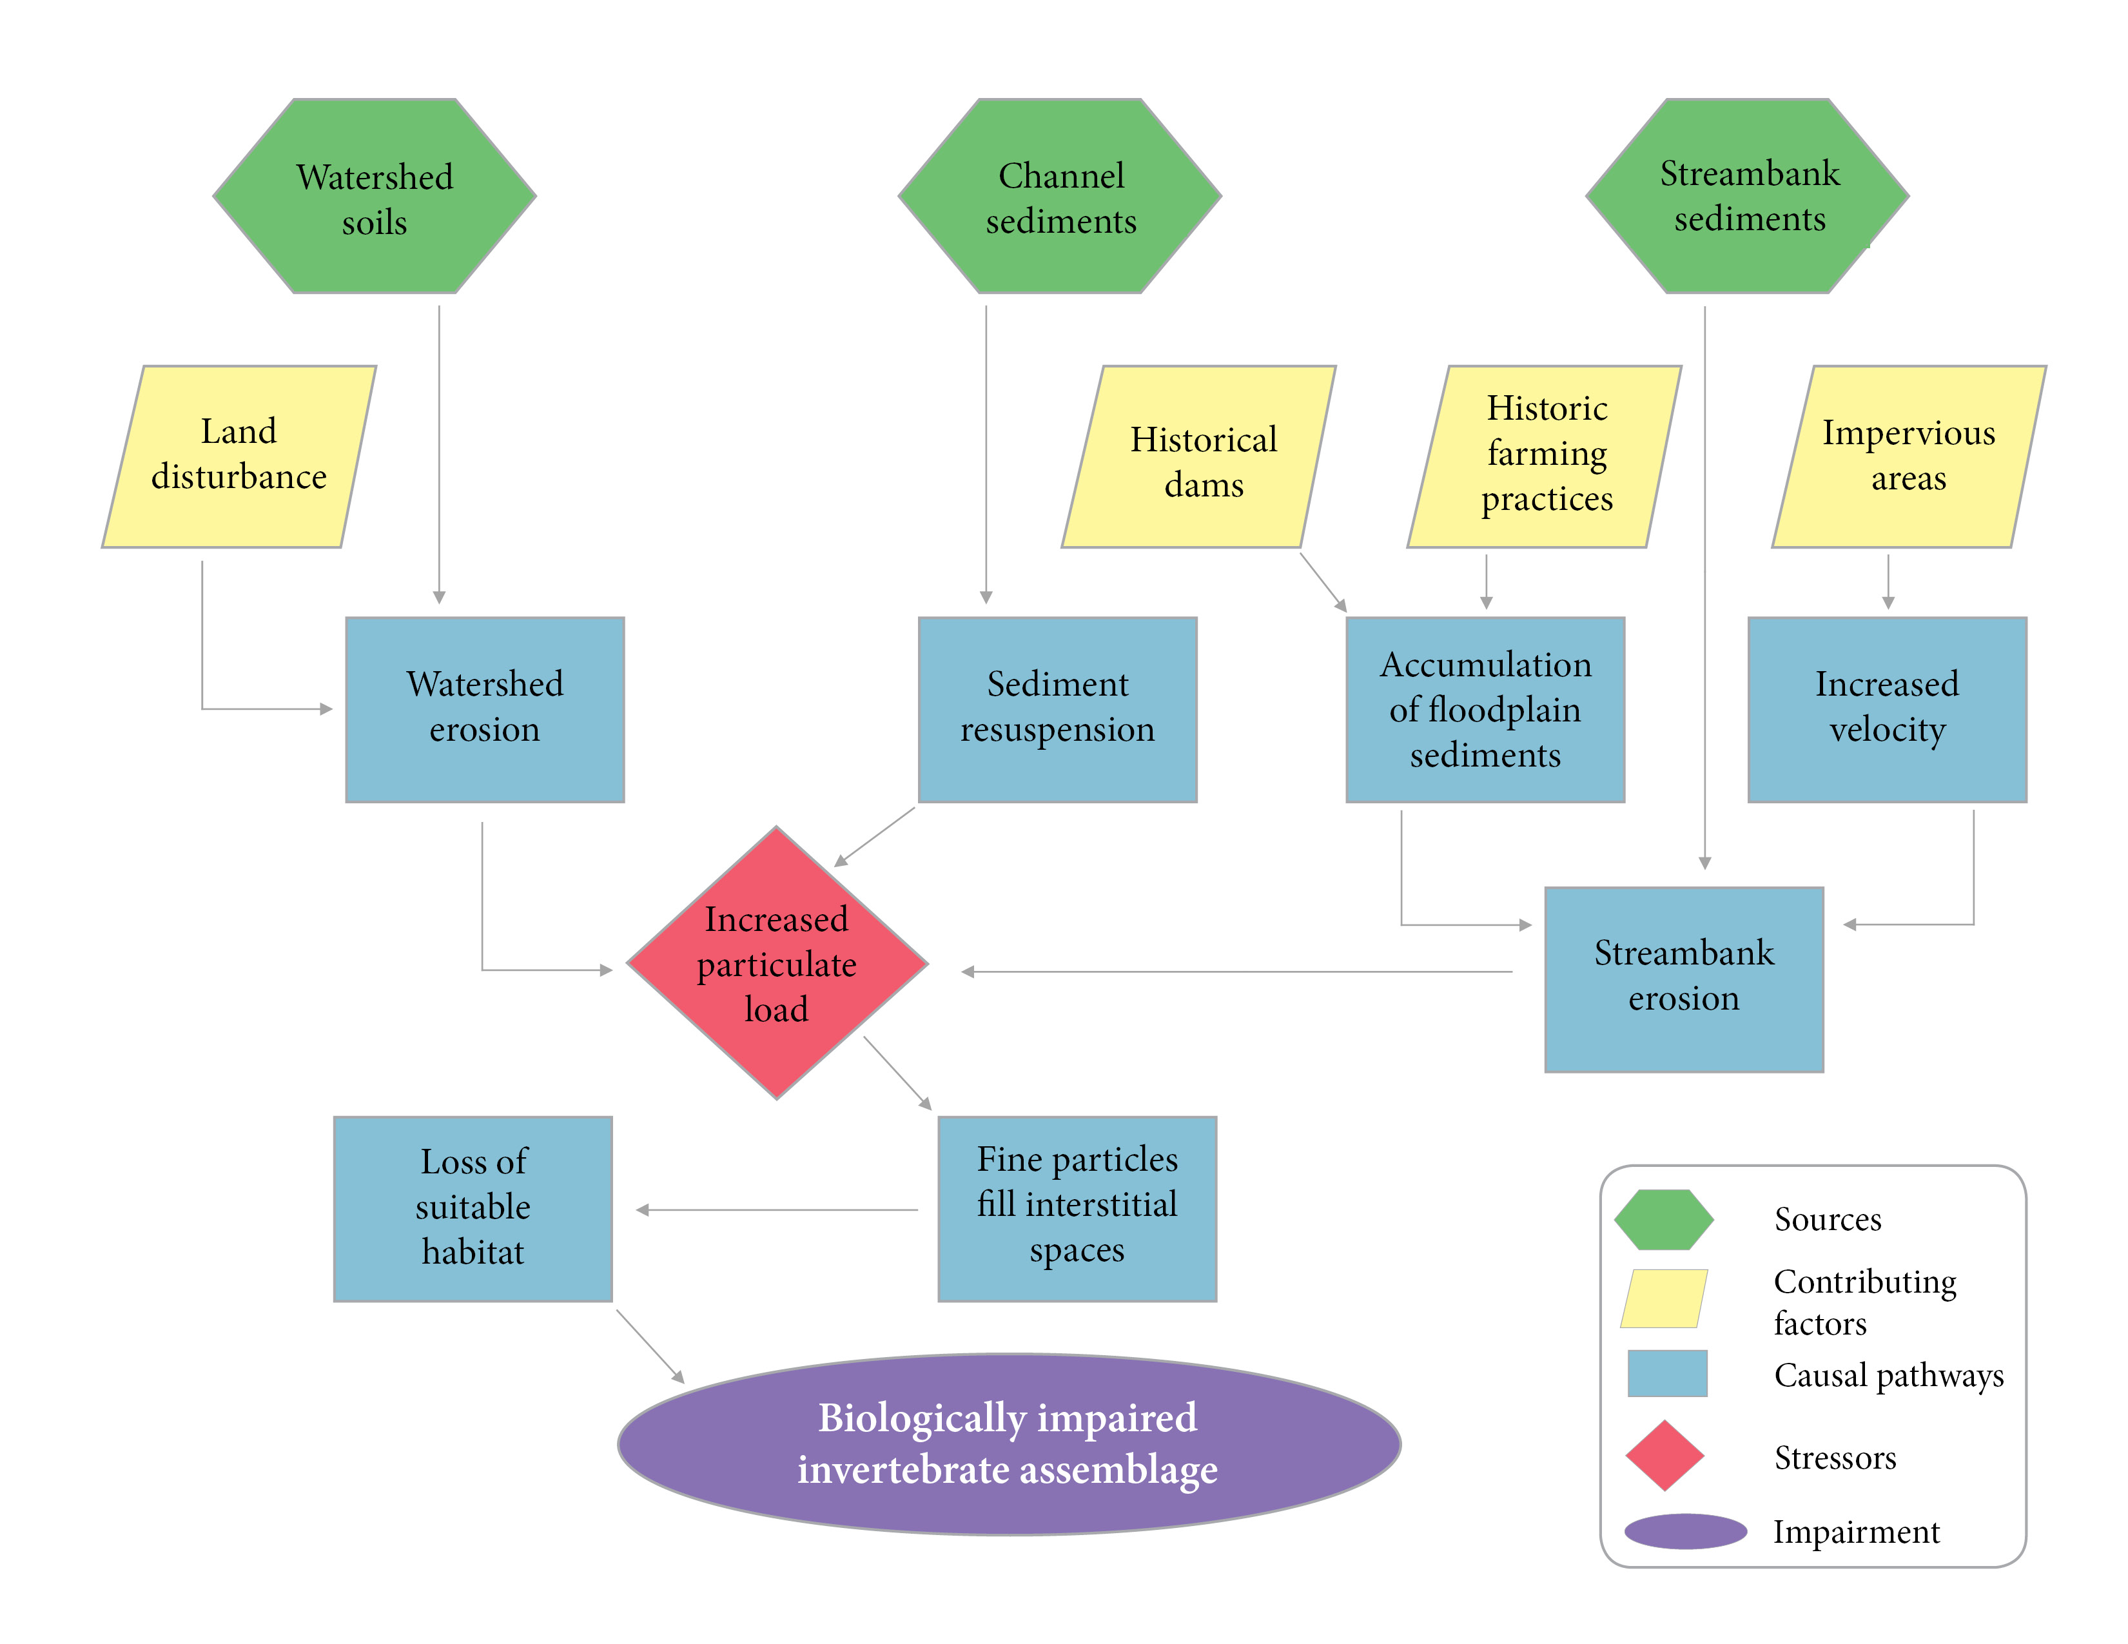
Figure 1-31. Conceptual model for the causal pathway of sediment impacts on benthic macroinvertebrates.

TMDL Target Pollutants
Following causal analysis and the determination of probable stressors, sediment was selected as the target pollutant for Crooked and Pughs Runs and Stony Creek TMDLs. TMDL target pollutants are the physical or chemical substances that will be controlled and allocated in the TMDL to result in restored aquatic life (measured by benthic macroinvertebrate health). TMDL targets must be pollutants that are controllable through source reductions, such as sediment, phosphorus, nitrogen, or other substances. Physical factors or environmental conditions, such as flow regimes, hydrologic modifications, or physical structures (like dams) cannot be TMDL target pollutants. Even though these conditions influence ecological communities and may be sources of stress, they do not represent substances that originate from point and nonpoint sources, they cannot be quantified, summed, and allocated to respective sources, and they cannot be controlled through source reductions.

References
Bjornn, T.C., M.A. Brusven, M.P. Molnau, J.H. Milligan, R.A. Klamt, E. Chacho, and C. Schaye. 1977. Transport of Granitic Sediment in Streams and its Effects on Insects and Fish. University of Idaho, Forest, Wildlife and Range Experiment Station, Moscow, ID.
Blasius, B.J. and R.W. Merritt. 2002. Field and laboratory investigations on the effects of road salt (NaCl) on stream macroinvertibrate communities. Environmental Pollution 120:219-231.
Dodds, W.K., Jones, J.R., and Welch, E.B. 1998. Suggested classification for stream trophic state: distributions of temperate stream types by chlorophyll, total N and P. Water Res. 32:1455–1462.
Dodds, Walter K. & Val H. Smith. 2016. Nitrogen, phosphorus, and eutrophication in streams, Inland Waters, 6:2, 155-164
Jackson, C.R., J.K. Martin, D.S. Leigh, and L.T. West. 2005. A southeastern piedmont watershed sediment budget: evidence for a multi-millennial agricultural legacy. Journal of Soil and Water Conservation, 60(6):298-310.
Lawrence, J.M. and S.E. Gressens. 2011. Foodweb response to nutrient enrichment in rural and urban streams. Journal of Freshwater Ecology, 19(3):375-385.
Pond, G.J. 2004. Effects of Surface Mining and Residential Land Use on Headwater Stream Biotic Integrity. Kentucky Department of Environmental Protection Division of Water. July, 2004. p.33.
Tetra Tech. 2019. Biological Condition Gradient (BCG) Attribute Assignments of Macroinvertebrates and Fish in the Mid-Atlantic Region (Virginia, West Virginia, and Maryland).
U.S. Department of State. 1841. Enumeration of the Inhabitants and Statistics of the United States. U.S. Department of State, Washington, D.C.
U.S. Environmental Protection Agency. 2000a. Stressor Identification Guidance Document. EPA-822-B-00-025. U.S. EPA Office of Water, Washington D.C.
U.S. Environmental Protection Agency. 2000b. Ambient Water Quality Criteria Recommendations: Information Supporting the Development of Station and Tribal Nutrient Criteria, Rivers and Streams in Nutrient Ecoregion IX. EPA-802-B-00-019. U.S. EPA Office of Water, Washington D.C.
U.S. Environmental Protection Agency. 2018. Causal Analysis/Diagnosis Decision Information System (CADDIS). Retrieved: January 17, 2018. Available from: www.epa.gov/caddis. Office of Research and Development, Washington, D.C.
Virginia Department of Environmental Quality. 2017. Stressor Analysis in Virginia: Data Collection and Stressor Thresholds. Virginia Department of Environmental Quality, Richmond, VA.
Walter, R.C. and D.J. Merritts. 2008. Natural streams and the legacy of water-powered mills. Science, 319:299-304.

