Contents

CHAPTER 4: VIRGINIA WATER PROTECTION GENERAL PERMITS 1

4.1 VWP General Permits 1

4.2 Reviewing Applications 2

4.3 Activities Authorized by VWP General Permits 2

4.4 Activities Not Allowable Under General Permits 3

4.5 Coverage Compensation 5

4.6 Coordination with Resource Agencies 6

4.6.1 VDWR Coordination 6

4.6.2 Coordination with Department of Conservation and Recreation (VDCR) 11

4.6.3 Processing Time Management 16

4.7 Applications that do not Result in Coverage 16

4.8 Coverage Package 17

4.8.1 Coverage Letter 17

4.8.2 Monthly Construction Inspection Form and Semi-Annual Construction Status Form 18

4.8.3 Permit Summary Sheet 18

See DISCLAIMER in INTRODUCTION.

# CHAPTER 4: VIRGINIA WATER PROTECTION GENERAL PERMITS

## 4.1 VWP General Permits

Virginia Water Protection (VWP) general permits are issued via state regulatory processes, including approval by the State Water Control Board. Each project is evaluated on a case-by-case basis to determine if it may be *covered* under a VWP general permit. Coverage under general permits (VWP general permit coverage) may be issued by DEQ’s Director or delegated staff for activities that meet all of the terms and conditions of applicable law, VWP regulations, and the coverage letter. The VWP Permit Program currently provides coverage under four general permits, each issued in regulation for certain nontidal surface water impacts: WP1, WP2, WP3, and WP4 (see Figure 1 below). The general permits have an effective date of August 2, 2016, and expire on August 1, 2026. Because general permits are contained in regulations, effective and expiration dates do not change, regardless of when coverage is issued by DEQ. Therefore, some permittees may have a longer period of time in which to complete a project than others, based on the date coverage is granted by DEQ.

The intent of this chapter is to provide staff with necessary procedures to review, process and prepare general permit coverage in accordance with the applicable law, regulations, guidance, and policies. The general permit regulations are listed below.The complete and current regulations in the Virginia Administrative Code can viewed on the [Virginia Legislative Information System-Virginia Law](https://law.lis.virginia.gov/) (LIS) website.

## 4.2 Reviewing Applications

Section 3.1 of Chapter 3 provides details for the review and processing of applications for general permit coverage.

In general, VWP permit staff will complete the steps below to process a general permit application.

* Review the application to verify eligibility for general permit coverage, for application completeness, and the need for permit application fees and compensatory mitigation.
* If needed, request additional information.
* Coordinate the application with the Virginia Department of Wildlife Resources (VDWR) and the Virginia Department of Conservation and Recreation (VDCR), and if a permit decision seems likely, copy the Virginia Marine Resources Commission (VMRC) on coordination correspondence[1]. In many cases, coordination may begin prior to a complete application, particularly when the outstanding information needed or requested by staff is not related to potential impacts to species, such as a permit application fee or owner contact information.
* Issue general permit coverage or deny the application.
* Update CEDS in accordance with the VWP CEDS manual and save all documents in the appropriate file location.
* As applicable, Complete SPGP processing in accordance with Chapter 6 of this Manual.

## 4.3 Activities Authorized by VWP General Permits

Each general permit authorizes specific types of activities, as shown in Table 1 below.

Table 1: General Permit Summary

| **General Permit** | **Type of Activity** | **Limitation of Impacts** |
| --- | --- | --- |
| [WP1](https://law.lis.virginia.gov/admincode/title9/agency25/chapter660/) (9VAC25-660)  General Permit for Impacts Less Than One-Half of an Acre | Not activity specific  Staff should review details at [9VAC25-660-30](https://law.lis.virginia.gov/admincode/title9/agency25/chapter660/section30/) | Any person granted coverage…may permanently or temporarily impact less than one-half acre of nontidal wetlands or open water and up to 300 linear feet of nontidal stream bed,… |
| [WP2](https://law.lis.virginia.gov/admincode/title9/agency25/chapter670/) (9VAC25-670)  Facilities and Activities of Utility and Public Service Companies Regulated by the Federal Energy Regulatory Commission (FERC) or the State Corporation Commission (SCC) and Other Utility Line Activities | Construction, maintenance or repair of:   * utility lines * outfalls * substation facilities * pumping stations * overhead utility line towers, poles or anchors * associated access roads   Staff should review details at [9VAC25-670-30](https://law.lis.virginia.gov/admincode/title9/agency25/chapter670/section30/).B | Any person granted coverage…may permanently or temporarily impact up to one acre of nontidal wetlands or open water and up to 1,500 linear feet of nontidal stream bed for facilities and activities of utilities and public service companies regulated by the FERC or the SCC and other utility line activities,… |
| [WP3](https://law.lis.virginia.gov/admincode/title9/agency25/chapter680/) (9VAC25-680)  Virginia Water Protection General Permit for Linear Transportation Projects | Construction, expansion, modification or improvement of:   * linear transportation projects (roads) * railways * trails, bicycle and pedestrian * airport runways and taxiways * temporary and permanent attendant features   Staff should review details at [9VAC25-680-30](https://law.lis.virginia.gov/admincode/title9/agency25/chapter680/section30/).B | Any person granted coverage…may permanently or temporarily impact up to two acres of nontidal wetlands or open water and up to 1,500 linear feet of nontidal stream bed for linear transportation projects,… |
| [WP4](https://law.lis.virginia.gov/admincode/title9/agency25/chapter690/) (9VAC25-690)  Virginia Water Protection General Permit for Impacts from Development and Certain Mining Activities | Construction, expansion or maintenance of:   * residential developments * commercial developments * institutional developments * recreational facilities * stormwater management facilities * mining facilities   Staff should review the details at [9VAC25-690-30](https://law.lis.virginia.gov/admincode/title9/agency25/chapter690/section30/).B | Any person granted coverage…maypermanently or temporarily impact up to two acres of nontidal wetlands or open water and up to 1,500 linear feet of nontidal stream bed for general development and certain mining activities,… |

## 4.4 Activities Not Allowable Under General Permits

The regulations identify specific activities that cannot be authorized under the general permits, as summarized in the Table 2 below. Review the applicable regulation sections for exact language.

Table 2: Prohibited Activities Under VWP General Permits

|  | **Can this GP be used?** | | | |
| --- | --- | --- | --- | --- |
| **Activity(ies)** | **WP1** | **WP2** | **WP3** | **WP4** |
| Construction of a stormwater management facility in perennial streams or in waters designated as oxygen-impaired or temperature-impaired (does not include wetlands). [Note: Construction or conversion of a stormwater management facility may qualify for an individual permit unless otherwise excluded from permitting.] | No | No | No | No |
| The construction of an irrigation impoundment on a perennial stream | No |  | No | No |
| Any water withdrawal activity | No | No | No | No |
| The location of animal feeding operations or waste storage facilities in state waters | No |  | No | No |
| The pouring of wet or uncured concrete in state waters, unless the area is contained within a cofferdam and the work is performed in the dry or unless approved by the Department of Environmental Quality | No | No | No | No |
| Dredging or maintenance dredging | No | No |  |  |
| Return flow discharges from dredge disposal sites | No |  | No | No |
| Overboard disposal of dredge materials |  |  | No | No |
| Dredging in marinas |  |  | No | No |
| Dredging of shellfish areas, submerged aquatic vegetation beds, or other highly productive areas |  |  | No | No |
| Federal navigation projects |  |  | No | No |
| Construction of new ski areas | No |  |  | No |
| Construction of oil and gas wells | No |  |  |  |
| Any activity in surface waters that will impact federal or state listed threatened or endangered species or designated critical habitat, or taking of threatened or endangered species | No | No | No | No |
| Any activity in wetlands composed of 10% or more, singularly or in combination, based upon either basal area or percent areal cover in the area of impact, in a vegetative stratum: Atlantic white cedar (Chamaecyparis thyoides), bald cypress (Taxodium distichum), water tupelo (Nyssa aquatica), or overcup oak (Quercus lyrata)[2] | No | No | No | No |
| Any activity in wetlands underlain by histosols | No |  |  | No |
| Any activity in tidal waters | No | No | No | No |
| Any activity in nontidal wetlands adjacent to tidal waters | No |  |  |  |
| Any activity in 100-year floodplains, as identified by the Federal Emergency Management Agency's (FEMA) flood insurance rate maps or FEMA-approved local floodplain maps | No |  |  |  |
| In accordance with [9VAC25-210-130](https://law.lis.virginia.gov/admincode/title9/agency25/chapter210/section130/).B, DEQ my require an individual permit application rather than approving granting coverage under this VWP general permit | No | No | No | No |
| This VWP general permit does not authorize activities that cause more than minimal changes to the peak hydraulic flow characteristics, that significantly increase flooding, or that cause more than minimal degradation of the water quality of a stream | No | No | No | No |
| Multiple general permits issued for a single complete project that cumulatively exceed the general permit threshold | No | No | No | No |
| Activity in a phased development which that would cause the aggregate total loss of nontidal wetlands or open water in the subdivision to exceed two acres, or to exceed 1,500 linear feet of nontidal stream bed |  |  |  | No |
| Activity prohibited by state law or regulations, nor shall it contravene applicable Water Quality Standards ([9VAC25-260](https://law.lis.virginia.gov/admincode/title9/agency25/chapter260/)) | No | No | No | No |
| This VWP general permit cannot be used for nonlinear features commonly associated with transportation projects, such as, but not limited to, vehicle maintenance or storage buildings, parking lots, train stations, or aircraft hangars |  |  | No |  |
| This VWP general permit shall not be granted for impacts to state waters for the construction of any natural gas transmission pipeline that is greater than 36 inches inside diameter pursuant to a certificate of public convenience and necessity under § 7c of the federal Natural Gas Act (15 U.S.C. § 717f(c)). *Note: while this language appears in -670 and -690 only, it is applicable to all VWP General Permits per* [9VAC25-210-130](https://law.lis.virginia.gov/admincode/title9/agency25/chapter210/section130/)*.* | No | No | No | No |

## 4.5 Coverage Compensation

Compensatory mitigation may be required for permanent surface water impacts. Typically this occurs when impacts exceed 1/10 acre of wetlands or open water or exceed 300 linear feet of stream bed.

General Permit WP1 is the least commonly used because it has an increased compensation ratio of 2:1. When the general permits were first developed in 2001, on-site permittee responsible compensation was the preferential requirement. This general permit provided the public the opportunity to buy credits without having to conduct an analysis to demonstrate that credits were ecologically preferable. However, since the 2008 Federal Mitigation Rule and 2016 VWP Regulations changes, credits are the ecologically preferred alternative and the benefits of the WP1 have been largely negated. If permittee responsible mitigation (PRM) is pursued by an applicant, any permanent impacts associated with construction or development of the PRM site are counted with other project impacts to determine permit application fees and any required compensatory mitigation.

If general permit WP1 is used for wetland or open water impacts *greater than* 1/10 acre, a condition must be in the Letter of Coverage to require the proof of credit purchase be submitted prior to impacts. In certain instances, the WP1 may be the only option for coverage, provided that the impact thresholds are not exceeded.

## 4.6 Coordination with Resource Agencies

Per VWP General Permit regulations, DEQ determines whether or not a proposed project requires coordination with VDWR and VDCR regarding the presence of federal or state listed threatened and endangered species or designated critical habitat (see subdivision 50.C of each VWP general permit regulation). Both of the agencies have authority in the protection of threatened or endangered (T-E) species. VDWR has authorities over T-E animals and VDCR, working in collaboration with the Department of Agricultural and Consumer Services (VDACS), has authority over T-E plants and insects. See specific information on the Canebrake rattlesnake and other species in the Chapter 4 References subfolder.

While the Code of Virginia allows a total of 45 days for a response from resource agencies before staff can assume the agencies have no comment (§ [62.1-44.15:20](https://law.lis.virginia.gov/vacode/title62.1/chapter3.1/section62.1-44.15:20/).C), the Code also provides that, within 45 days of receipt of a complete application, DEQ must deny, approve, or approve with conditions any application for coverage under a general permit, or the application shall be deemed approved (§ [62.1-44.15:21](https://law.lis.virginia.gov/vacode/title62.1/chapter3.1/section62.1-44.15:21/).F, referred to as 45-day coverage). This contradiction means that DEQ cannot wait the full 45 days from a complete general permit coverage application for resource agency comments.

The general basis for coordination on the shorter coordination timeframe is provided in the 2007 Memorandum of Understanding between DEQ, VDWR, and VDCR. Some parts of the memo processes have been routinely updated over time. The current procedures are provided below.

* The coordination with resources agencies should typically begin within the initial 15 calendar days of receiving the application and permit application number, unless the application is so deficient that it does not provide a general description of the project site, impacts, and mitigation site (if applicable); does not provide the information required by the Joint Permit Application (JPA), including information of potential species impacts; or does not provide adequate information or maps to identify the project location.
* While the MOU allots 14 days for agency comment, the Permitting Enhancement and Evaluation Platform (PEEP) provides VDWR and VDCR with 15 calendar days to review and respond to the coordination information provided by VWP staff. Agency comments will be accepted through 11:59 p.m. on the 15th day. The 15-day period is counted from application complete (APCP), or from the day on which DEQ requested comments, whichever occurs first.
* Staff may complete the coordination process for general permit coverages; or, applicants may certify coordination has occurred and provide documentation of the coordination and results, either with a JPA or as a separate submittal.
* It is important to be aware that it is ultimately the VWP Permit Program’s decision to determine what additional actions to require, such as surveys, and what, if any, conditions to add to the general permit coverage. With few exceptions, the VWP Permit Program cannot regulate activities in areas beyond state surface waters.

### 4.6.1 VDWR Coordination

The VDWR coordination requires screening three databases:

* Virginia Fish and Wildlife Information Service (VaFWIS) Website

(<https://services.dwr.virginia.gov/fwis/>)

* Northern Long-Eared Bat Winter Habitat & Roots Application
* Little Brown Bat and Tri-colored Winter Habitat & Roots Application

Staff will use the databases to determine if further coordination is required. For the VaFWIS database, staff should note any VaFWIS-related communications or documents as excluded from the Virginia Freedom of Information Act, per Chapter 3.2 of this manual. DEQ staff access to the VaFWIS database provides species location information at a smaller scale and thus should follow said FOIA provisions. For bat databases, the public has access to the same level of information as DEQ staff.

#### 4.6.1.1 What’s Needed to Complete this Screening

* The latitude and longitude for the project site.
* The project location map, USGS Map of the project site, or any map provided that shows the project boundaries.
* A general understanding of the impacts that are proposed.
* The types of habitat features on the site, i.e., forested hardwood, recently clear cut, pasture, perennial streams, etc.

#### 4.6.1.2 How to Complete VaFWIS Website Screening

Staff is required to obtain a species list for a 2-mile radius around the project.

1. Open VDWR’s VaFWIS website using the link provided below:

<https://services.dwr.virginia.gov/fwis/>

**\*Note:** The website works best using Google Chrome or Firefox

Log in: Username: specific to your region

Password: specific to your region

1. In the menu on the left side of the screen select “By Coordinates”

Enter the Latitude/Longitude (lat/long) of the center of the project into the “Project Site Coordinates” Box within the Step 2 box using the format from the example.

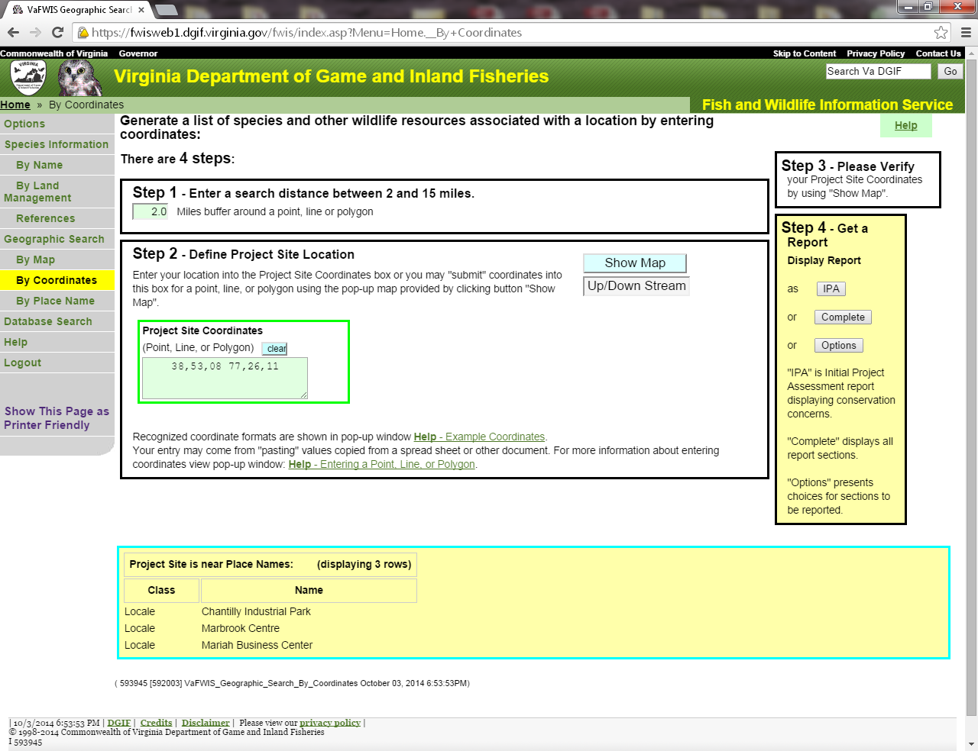

1. Click on “Show Map” button.

This will open another screen showing the location of the project on a topographic map and show the 1 and 2 mile radius from the lat/long. Use your project location map from the file to verify that the project lat/long was correct and check to see that the limits of your project fit within the inner most circle on the map generated.

**Note:** If your lat/long is incorrect you can use the tools on the map to pan to the project location or figure out the correct lat/long for the center of the project and try again.

**Note:** If your project is a linear project that does not fit within the 2-mile radius you can do multiple searches using multiple latitudes and longitudes across the project, or you can contact the VDWR review coordinator for direction on submitting an electronic request for review.

1. Back on the main page, click on the “IPA” button located in the Step 4 box on the right side of the screen. This will generate the abbreviated VaFWIS Species Report for the area within the two mile radius on your map.

At the bottom of the menu on the left-hand side of the screen click on “Show This Page as Printer Friendly”.

Right click, select print, print to pdf, and save this document to the VDWR folder within the project file.

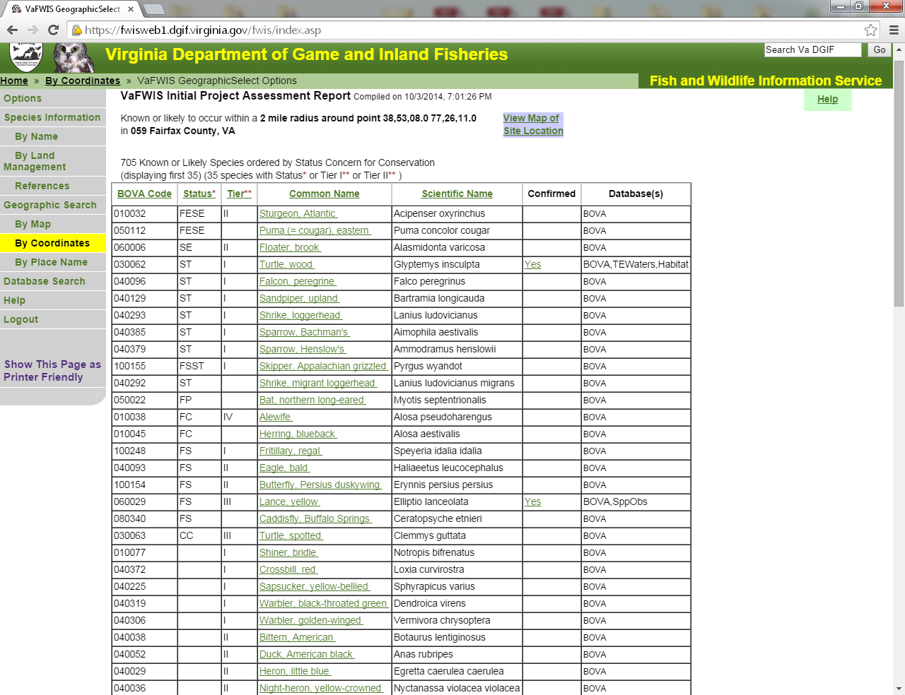

#### 4.6.1.3 How to Review the Initial Project Assessment Report

Staff must review the Initial Project Assessment Report (Report) to determine if additional coordination with VDWR is required as a result of this database screening. The following results dictate additional coordination with VDWR:

* When the following three criteria apply to a species on the table:
  + the “status” column indicates state or federal threatened or endangered species ( FE, FT, SE, ST);
  + the “confirmed” column is Yes; and,
  + one of the following databases is listed under the “database(s)” column:
    - Species Observations (SppObs)
    - Colonial Waterbird (CWB)
    - Threatened and Endangered Species Waters (TEWaters)
* Presence of a Threatened and Endangered Species Waters (TEWaters), even if not associated with a specific species.
* Presence of Anadromous Fish Use Areas
* Presence of Cold Water Streams
* Presence Stocked Trout Waters
* Presence of Colonial Waterbird (CWB)
* Presence of VDWR Lands (boat ramps, WMA’s, Fish Hatcheries)

If you have determined that coordination **IS** required then move on to the coordinating your project with VDWR section below.

If coordination is **NOT** required from either the VaFWIS screening or the bat screening, then the VDWR coordination process is complete. The Report is to be saved in the permit file.

#### 4.6.1.4 Northern Long-Eared Bat, Tri-Colored Bat, and Little Brown Bat (Bats) **[PENDING CHANGES DUE TO USFWS ACTION and/or GUIDELINES]**

Refer to the .pdf document called “1Latest NLEB DWR Coord [Date].pdf” in the References subfolder of Chapter 4. [Note: At this time, the release of USFWS interim NLEB guidance and tools on April 1, 2024 inform but do not change the process below.]

Staff will use the two links below to determine if the project area is within 2-mile radius of habitat feature (Hibernacula, Roost Tree, or Human Structures) identified on either of these applications. These searched can be completed by entering the property address or navigating to the project location.

[Northern Long-Eared Bat Winter Habitat & Roost Trees Application](http://dgif-virginia.maps.arcgis.com/apps/webappviewer/index.html?id=32ea4ee4935942c092e41ddcd19e5ec5)

[Little Brown Bat and Tri-colored Bat Winter Habitat & Roosts Application](http://dgif-virginia.maps.arcgis.com/apps/webappviewer/index.html?id=15cf32b9c82b426fb6be47b6c8d5b624)

* If the project is located within a 2-mile radius of a habitat feature, then coordination is required. See Coordinating your project with VDWR Section.
* If the project is not located within a 2-mile radius of a habitat feature, then no coordination is required for the bats. If no coordination was required from the VaFWIS screening, no further coordination is required. Save the screen shots of the project location on the two maps above in the permit file. The VDWR coordination is complete.

Staff is required to save screen shots documenting that the search resulted in no habitat features because the Bats Applications will be continually updated and documenting the information that lead to staff’s permit decision is important.

#### 4.6.1.5 Coordinating a Project with VDWR

If the results of VaFWIS or the bat applications require coordination, staff will need the following information:

* VaFWIS Report[3]
* Project Location/USGS Map
* T-E information provided in the application.
  + Please do not send VDWR the entire application. Extract the applicable sections relating to T-E and/or habitat.[4]
* A completed VDWR coordination form (see Chapter 4 Templates subfolder). Fill out the VDWR coordination form.
  + Provide as much relevant information as you have for the species or habitat for which you are coordinating.[5] For example, it is more important that you identify the characteristics of on-site stream channels when you are coordinating for threatened or endangered mussels vs. the types of trees on-site. Similarly, if the receiving stream at the project site is physically isolated (i.e., dam or other structure downstream) it would be good to mention, as it could affect some listed aquatic species’ ability to access the project area. Also, if there are old structures like barns on the project site, it would be good to mention if bats are listed.
* Once you have all the above information together, VWP staff may share links to these documents with other Virginia state agencies only via emailing links to the OneDrive-Commonwealth of Virginia SharePoint system, assuming that the state resource agency also has SharePoint capabilities. If there is limited information to share, sending via email may be adequate. If these methods are not feasible, staff can use the VitaShare system to send the coordination request. VitaShare has a pre-file size limitation of 50 MB.
* If using email, the subject line of the email should provide the project name and application number.[6]
* In the body of either your email or your VitaShare link, be sure to request a review and response within the 15 calendar days.
* Send the coordination email or VitaShare link to [ESSProjects@dwr.virginia.gov](mailto:ESSProjects@dwr.virginia.gov).
* Save your coordination email in the permit file.

### 4.6.2 Coordination with Department of Conservation and Recreation (VDCR)

Through a Memorandum of Agreement between VDCR and VDACS, VDCR assists with determining impacts to state-listed plants and insects. Title 10.1 of the Code of Virginia (Law) governs VDCR. VDCR provides comments on behalf of VDACS during the initial review of the project and will let staff know if direct coordination with VDACS is necessary. Comments may also include recommendations on using native species and not using invasive species. Staff should consider these comments as applicable to the proposed project’s restoration of temporary impacts and any required permittee-responsible mitigation plan(s) – see example in 4.3.2.2. Reference tools for staff include VDCR’s [Native Plant Finder](https://www.dcr.virginia.gov/natural-heritage/native-plants-finder) tool and the most recent Virginia [Invasive Plant Species List](https://www.dcr.virginia.gov/natural-heritage/invsppdflist).

What staff will need to conduct the review:

* The latitude and longitude for the project site. Usually found in Section 1 on page 7 of the Standard JPA Document.
* The project location map or USGS Map with the project outline of the project site. (Or any map provided that shows the project boundaries).
* An understanding of the impacts and compensation that are proposed (Ex. Are stream impacts proposed? If PRM applies, are there any associated impacts?)
* Any information provided in the JPA or observed during a site visit regarding the current site conditions that may be helpful in their review (ex. The site has been completely cleared within the last 5 years or is a previous forestry site).

#### 4.6.2.1 Obtaining the Initial Project Report

1. Open and log into the VDCR’s Natural Heritage Data Explorer (NHDE) Website using the below link. (Works best using Chrome or Firefox)

<https://vanhde.org/home>

**\*Note:** If this is your first time you will have to create a new account and be added by the administrator to the subscription (See [NHDE User Guide](http://vdcr.maps.arcgis.com/sharing/rest/content/items/36ba504aa8044ab48f655b89197bc989/data)). A confirmation email will be automatically sent to the administrator when you create an account.

1. Select “Map” in the menu at the top of the page.
2. Select the 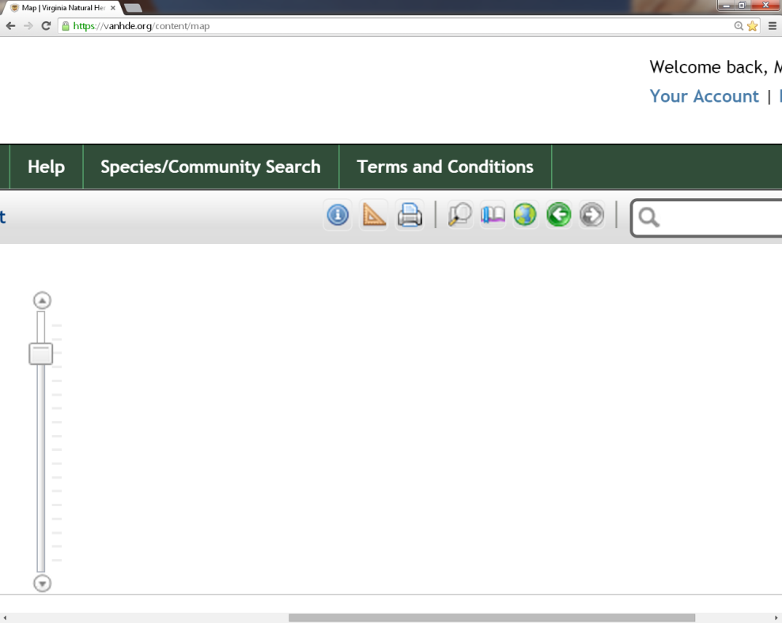 in the menu on the right side of the screen at the top of the map. For scale select anything smaller than 18,056 and enter your lat/long (which should be the center of the project). Finally select “Zoom.” A red box will show up on your map around that point.

**\*Note:** you must be zoomed into the map closer than 1:72,244 to draw your project area.

1. Once you have made sure that your point is in the right location close the lat/long box.
2. Click on “Create Project” at the top of the map to the left, and from the Draw/Edit tool, select 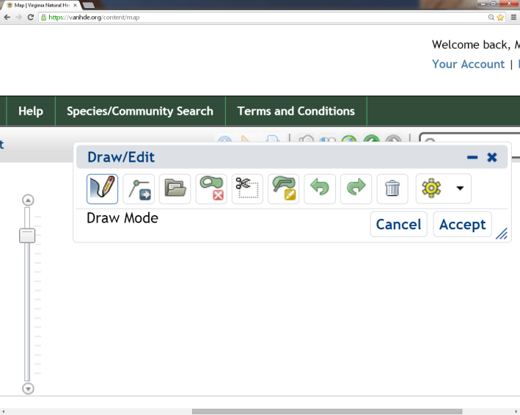. Now you can start drawing your project boundaries on the map. Try and stay as close to the limits of the project as possible. After you drop your first point on the map every next click will draw a line between those two points. On your last point double click to set your polygon. As in any GIS based system, try not to cross your boundary lines over one another. Also, you have the ability to edit your lines locations and move your polygon as a whole using the various tools in the Draw/Edit toolbar.

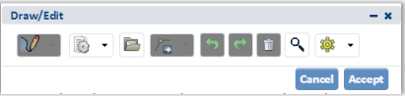

1. Please note, if there is a shapefile available for the project you can upload the zipped shapefile in lieu of drawing the project boundary. Upload a shapefile at any scale by clicking on the ‘Upload Shapes’ buttonFolder icon on the Draw/Edit menu. In the upload shapefile window, click on the ‘Select File to Upload’ button and browse to select a zipped shapefile in a standard ESRI projection with all the parts of an ESRI shapefile, a KML file or a GML file.
2. From the “Draw/Edit” menu select “Accept.” A window will pop up where you will enter the requested project information.

**\*Note:** VDCR tracks the project using the “Project Title” so make sure that the facility name that you use is the correct one for the project and the one that you use to further coordinate if needed in the future.

1. Make sure to provide as much information as is available regarding the proposed project, including a detailed project description and existing site conditions. At the bottom of the pop up window, there is an option to upload attachments. At the minimum, attach the impacts map as well as any relevant T-E info from the JPA[7]. Photos of the project area are also helpful. You can also copy a VITASAHRE link into the comments section, so then are able to provide any large attachments such as T-E reports, ext.
2. Click “Save”.

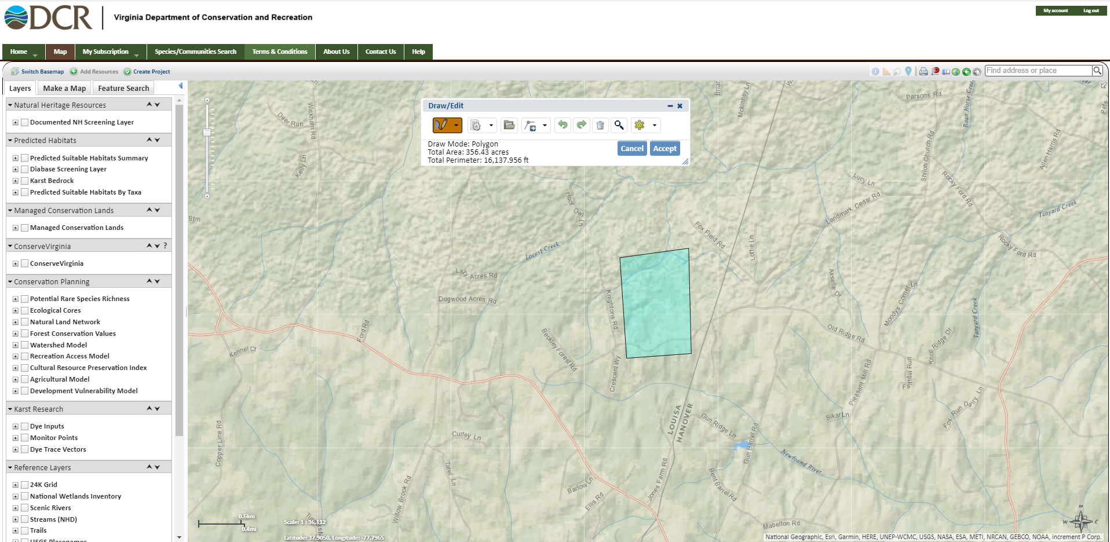

* The system will typically send an email notifying the user when the report is ready. VDCR’s initial report will be a link in this email. Save the .pdf instead of the email because others will not be able to view the report by clicking the provided link[8].
* On the main page hover over “My Subscription” and select “My Projects” when it pops up. Here you can see a list of and retrieve a report for every project that you have submitted into the system. Select your project and at the bottom of the report under “Attachment”, there should be a “project review” file. This is your initial report for the project. Open the document and right click on the page outside of the USGS map area and select print from the drop down. Print the file to PDF and save it to the VDCR Folder in your project folder on the network drive, naming it using the appropriate naming convention (See ECM Naming Convention Document)[9] and close the page. If you don’t receive the notification within an hour of submitting the review request, first make sure that you logged out of the system and then go ahead and log back in. If you still have not received the initial report after logging back into the website, please send an email to [nhreview@dcr.virginia.gov](mailto:nhreview@dcr.virginia.gov) including the title of the project, when it was submitted and that you did not receive an initial report.

The last page of your automatically generated report is a generic letter that indicates if there are any natural heritage resources within the project vicinity.

VDCR will automatically review and send you comments based on the project information that you submitted to the website for VWP general permit coverage. Thus, after submitting the online project review request and receiving VDCR’s initial report, wait for the final project comments from VDCR sent via email.[10] [Note: For VWP individual permits, please submit the project directly to Allison Tillett, VDCR Environmental Review Coordinator at [allison.tillett@dcr.virginia.gov](mailto:allison.tillett@dcr.virginia.gov) for coordination with all the VDCR divisions. An agency comment letter will be provided via email.]

#### 4.6.2.2 Reviewing and Responding to VDWR and/or VDCR Comments

The coordination processes for VDWR and VDCR are separate and distinct; however, the response to their comments is the same. This section summarizes the various ways that the coordination process is concluded.

If no response is received within 15 days of DEQ’s request for comments, and staff *is aware of the presence of a T-E species*, send an email reminder to the agency(ies) and ask if their review can be expedited. Discuss the situation with your manager before issuing coverage.

Common responses received from VDWR or VDCR and how staff should respond:

* VDWR/VDCR request additional information.
  + Staff must determine if there is conflict with the 45-day issuance clock which is discussed in the Processing Time Management Section below.
  + If staff has the information, provide it to VDWR, and allow an additional 15 calendar days for a response.[11]
  + If staff does not have the information, forward the request to the applicant/agent, and send it to VDWR once it is received.
* Request for T-E Surveys. Forward to the applicant so that they may complete the survey.[12]
  + Sometimes the applicant will submit additional information supporting why a survey should not be required. Generally, this information is provided to the requesting agency for their consideration.
* Comments or recommendations related to the protection of Threatened or Endangered Species.[13]
  + Should be included as conditions of coverage. Examples of Coverage Conditions commonly included are provided in the Coverage Letter template. If this occurs staff should notify the applicant as soon as the comments are received so that they applicant is aware of the limitation to be placed in their permit. The applicant may choose to submit additional information to change a recommendation for a particular species, such as providing more details to support that habitat for that species is not present. In these cases, DEQ forwards the additional information to VDWR/VDCR as appropriate and waits for their updated recommendations.
  + Sometimes a staff may question the validity of recommended restrictions placed on the project. Ideally the coverage would include conditions that both the requesting agency and DEQ believes is sufficient to the protect T-E species; however, it ultimately the responsibility of the VWP Permit Program to determine what is appropriate as a condition of coverage. Staff should always discuss these unique situations with their supervisor.
* Comments or recommendations made that do not pertain to the protection of a T-E species.
  + These are not included in the permit authorization. However, these comments are provided to the applicant for their information. DEQ does not require a response from the applicant.
    - If there is a situation that staff believes may be an exception to this, they should discuss this with their supervisor. Examples of commonly received comments that are not included in the authorization are:
    - Recommendation for a TOYR for tree removal and ground clearing to protect resident and migratory song bird nesting. This recommendation would not be included in the permit as it does not specifically pertain to a T-E species.
* Comments that are already addressed by permit conditions.
  + These are not included in the permit because they would be duplicative.
    - A recommendation that in-stream activities are conducted during low- or no-flow conditions, using non-erodible cofferdams, or that any culverts are countersunk.
    - This is an example of a recommendation that is addressed by the permit process and conditions. “VDCR recommends *strict adherence to applicable state and local erosion and sediment control/storm water management laws and regulations, establishment/enhancement of riparian buffers and native plant species and maintaining natural stream flow as efforts that can be undertaken to protect the significant Aquatic Natural Communities and the surrounding watershed.*”
* VDCR or VDWR recommends coordination with USFWS or NOAA.
* If the project is receiving an SPGP verification, then the USFWS process will already be underway or completed by USACE staff, and no additional action would be required by DEQ. However, if the project is not receiving an SPGP verification, and USFWS coordination is recommended, then staff should coordinate with USFWS using the USFWS coordination procedures in the SPGP section of this manual. If staff feels there are relevant T-E aquatic species that are in NOAA’s purview, then staff should coordinate with NOAA as necessary.[14][15] When applicable, staff should send the JPA materials including project description, project location and relevant T-E sections to [NMFS.GAR.ESA.Section7@noaa.gov](mailto:NMFS.GAR.ESA.Section7@noaa.gov) and in the subject line include “Technical Assistance Request”. The coordination processes are concluded for each agency when following occurs:
  + The agency provides comments within 15 days.
  + The agency fails to provide comments prior to DEQ having to move forward with coverage issuance in order to avoid the 45-day coverage issuance.
  + Within 15 days, the agency recommends specific limitations be placed on the project to protect threatened or endangered species, even after additional information may have been provided to refute the recommendation.
  + The agency provides comments that are not related to T-E species and these are provided to the applicant for their information.
  + The agency provides comments that are already addressed by the permit.

### 4.6.3 Processing Time Management

Staff is required to complete all required application processing steps and is responsible for managing potential conflicts as necessary to meet the *15-day application review* and *45–day general permit coverage processing* timeframes set by the regulation and statute, respectively. Challenges in meeting these deadlines may include:

* A survey to establish the presence or absence of T-E species is required, but it cannot be completed by the applicant and approved by the appropriate resource agency within these time frames.
* Threatened or endangered species are on site and negotiations to prevent a take of this species are ongoing with VDWR, VDCR or USFWS.
* The applicant intends to submit a minor change to the site plan and they ask that you wait to issue coverage until they submit the updated plan.

When these situations arise, it is necessary to stop the processing clock; otherwise, the permit coverage will be automatically issued on day 45. Typically, one of the following will stop the processing time clock: 1) applicant requests a suspension; 2) applicant voluntarily withdraws an application; 3) DEQ administratively withdraws an incomplete application for failure to provide the required information after 60 days from the date of the latest written information request made; or 4) the application is moved from a general permit coverage pathway to an individual permit pathway, possibly because the applicant refuses to suspend processing while they resolve VDWR, VDCR or USFWS concerns about T-E species, or when DEQ has concerns about other impacts to the aquatic environment (see Chapter 3). DEQ can only require that the project be processed as an individual permit in accordance [9VAC25-210-130](https://law.lis.virginia.gov/admincode/title9/agency25/chapter210/section130/).B.

If the SPGP application process has stalled because the USACE tasks have not been completed, staff may continue with issuing general permit coverage without the SPGP verification being issued in conjunction.

Staff should always notify the applicant as soon as possible when these situations arise and explain the options.

## 4.7 Applications that do not Result in Coverage

Applications may not result in coverage under the general permit when:

* The applicant withdraws their application.
* The applicant does not respond at all, or does not provide all of the requested additional information within 60 days of the last DEQ request that is required to complete the application or make a permit decision. Accordingly, staff will administratively withdraw the application (Subsection 60 D or E of each VWP general permit regulation).
* Staff, after getting approval from their supervisor, will notify the applicant that an individual permit is required for reasons consistent with [925VAC-210-130](https://law.lis.virginia.gov/admincode/title9/agency25/chapter210/section130/).B.

In any of these situations, staff must be sure to include all correspondence in the file and update the record in accordance with the CEDS manual. Also notify the USACE and VMRC of this outcome.

## 4.8 Coverage Package

The VWP Coverage Package consists of the following documents:

* Coverage Letter
* Copy of the applicable General Permit
* Construction Status Update Form
* Monthly VWP Permit Inspection Form
* SPGP Verification Letter, If applicable
* SPGP, if applicable
* Summary Sheet (case-by-case, see Section 4.5.3)

This package must be reviewed and signed in accordance with the most recent DEQ Policy on Delegation of Authority. The VWP General Permit Coverage Letter is signed by the Regional VWP Program Manager. The VWP General Permit Coverage package is typically emailed to the permittee and/or agent. If sending a paper copy via postal mail, ensure a copy is also sent via email. Also email an electronic copy to staff counterparts at the USACE and VMRC, or upload to an agency-designated site for their access and download.

### 4.8.1 Coverage Letter

The Coverage Letter, on DEQ letterhead, includes the expiration date of the general permit, the date on which the coverage letter was signed, and other pertinent information as shown in the applicable Chapter 4 GP Coverage Letter template.

Conditions of Coverage

In accordance with [9VAC25-660-60](https://law.lis.virginia.gov/admincode/title9/agency25/chapter660/section60/).C.2, [9VAC25-670-60](https://law.lis.virginia.gov/admincode/title9/agency25/chapter670/section60/).D.2, [9VAC25-680-60](https://law.lis.virginia.gov/admincode/title9/agency25/chapter680/section60/).D.2, and [9VAC25-690-60](https://law.lis.virginia.gov/admincode/title9/agency25/chapter690/section60/).D.2 coverage may be granted with conditions/requirements consistent with the general permit regulations, including applicable agency recommendations.

Staff must add conditions to the coverage letter specifically identifying the authorized impacts and compensation, including any associated with the construction or development of a permittee responsible mitigation (PRM) site. *If permanent nontidal wetland or open water impacts are greater than one-tenth acre or permanent nontidal stream bed impacts are greater than 300 linear feet, a condition must be in the WP1 Coverage Letter to require the permittee to submit proof of credit purchase prior to impacts.*

Conditions to avoid any affect or potential effect on T-E species are often conditions of coverage. Examples of these conditions are provided in the template.

All conditions of coverage must be enforceable, using words such as “shall”, “shall not” or “must” to convey actions that are required or prohibited. In legal matters, the use of the term “will” causes a condition to be less easily enforced. (For example: “The project will impact no more than 0.35 acre of forested wetlands.”)

Prior to issuance of coverage, staff must ensure that DEQ has received an accurate and complete Property Access Agreement (See Chapter 3).

**Permit Conditions**

The general permit itself is in regulation (Section 100 of each VWP general permit regulation), and the conditions in regulation cannot be changed outside of an agency regulatory action approved by the State Water Control Board. Provide a copy of the applicable VWP General Permit to the permittee with the coverage letter.

### 4.8.2 Monthly Inspection Form and Semi-Annual Construction Status Form

The requirements to complete project inspections and status updates are in each VWP General Permit and/or coverage. The templates called *Monthly VWP Permit Inspection Form* and *Construction Status Update Form* (CSU) should be updated to include the project specific information. Staff may provide the permittee a word version of these forms if requested.

The *Monthly VWP Permit Inspection Form* is intended to be used by the permittee during the inspections required by [9VAC25-660-100](https://law.lis.virginia.gov/admincode/title9/agency25/chapter660/section100/) Part II.B.1; [9VAC25-670-100](https://law.lis.virginia.gov/admincode/title9/agency25/chapter670/section100/) Part II.B.1; [9VAC25-680-100](https://law.lis.virginia.gov/admincode/title9/agency25/chapter680/section100/) Part II.B.1; and [9VAC25-690-100](https://law.lis.virginia.gov/admincode/title9/agency25/chapter690/section100/) Part II.B.1. Monthly inspections shall be conducted in the following areas: all authorized permanent and temporary impact areas; all avoided surface waters, including wetlands, stream channels, and open water; surface water areas within 50 feet of any land disturbing activity and within the project or right-of-way limits; and all on-site permanent preservation areas required under this permit. Observations shall be recorded on the inspection form provided by the Department of Environmental Quality. The form shall be completed in its entirety for each monthly inspection and shall be kept on site and made available for review by the Department of Environmental Quality staff upon request during normal business hours. Inspections are not required during periods of no activity within impact areas.

The CSU is to be completed by the permittee and submitted twice per year, always by July 10th and January 10th, in accordance with 9VAC25-660-100 Part I.C.3; 9VAC25-670-100 Part II.E.3; 9VAC25-680-100 Part II.E.3; and 9VAC25-690-100 Part II.E.3.

### 4.8.3 Permit Summary Sheet

The VWP General Permit Project Summary Sheet is similar to the individual permit fact sheet, providing support for the agency’s decision to provide coverage under a general permit, and is to be used on a case-by-case basis as warranted by the nature and/or complexity of the proposed activities. When used, the summary sheet should be provided to the permittee as part of the VWP Coverage package.[16]

1. See the [DEQ-VMRC Memorandum of Agreement, Amended August 16, 2023](https://covgov.sharepoint.com/:b:/r/sites/deqnet/Shared%20Documents/Water%20Division/Water%20Permitting/Wetlands%20%26%20Stream%20Protection%20-%20VWP/1DRAFT-VWP%20Permit%20%26%20Compliance%20Manual/MOA-DEQVMRCPermittingInNontidalWatersAmd8-16-2023.pdf?csf=1&web=1&e=W2b8aQ).
2. Proposed impacts, whether directly to the plant or the area in which it is found, are more stringently regulated due to the significance of these particular wetland types. Project proponents should carefully key out such species.
3. See Section 3.2 of this manual for note about communications and FOIA.
4. Ibid.
5. Ibid.
6. See Section 3.2 of this manual for note about communications and FOIA.
7. See Section 3.2 of this manual for note about communications and FOIA.
8. See Section 3.2 of this manual for note about communications and FOIA.
9. Ibid.
10. Ibid.
11. See Section 3.2 of this manual for note about communications and FOIA.
12. Ibid.
13. Ibid.
14.
15.
16. See Section 3.2 of this manual for note about communications and FOIA.