SPGP Section 7 Procedures
Step 1: Official Species List
- Obtain vicinity map of the project site and conduct DCR and DGIF database searches (see procedures for each).
- Utilize the FWS Information, Planning, and Consultation System (IPaC) by clicking on the following link: http://ecos.fws.gov/ipac/
- “Click on initial Project Scoping” along the left side of the page. This will take you to a map where you will locate your project site.
- Finding your project site: You can do so by zooming in or by clicking on “Find a place” along the top portion of the map.
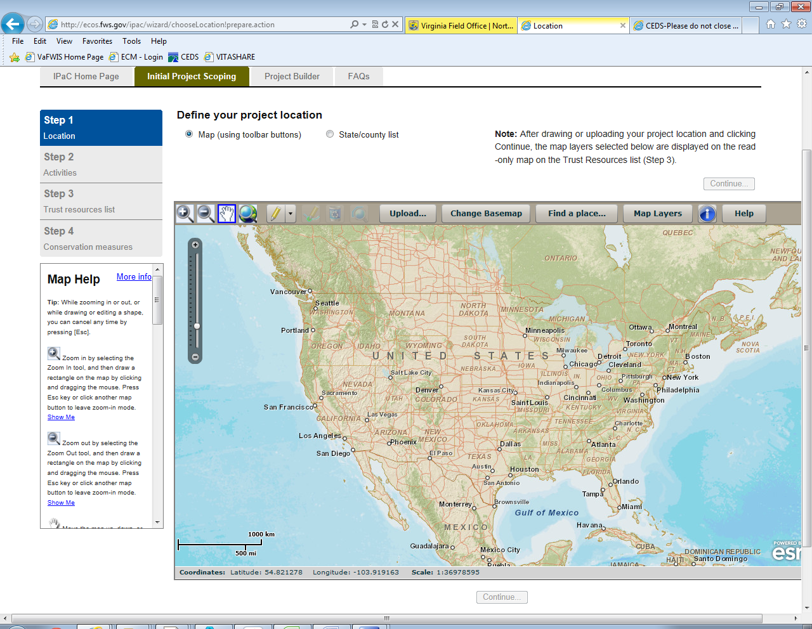
- Draw your project boundary polygon. Once you have found your project site, click the dropdown menu with the pencil at the top of the map. Begin drawing your project boundary polygon by clicking on the map and continue until the entire boundary is drawn.
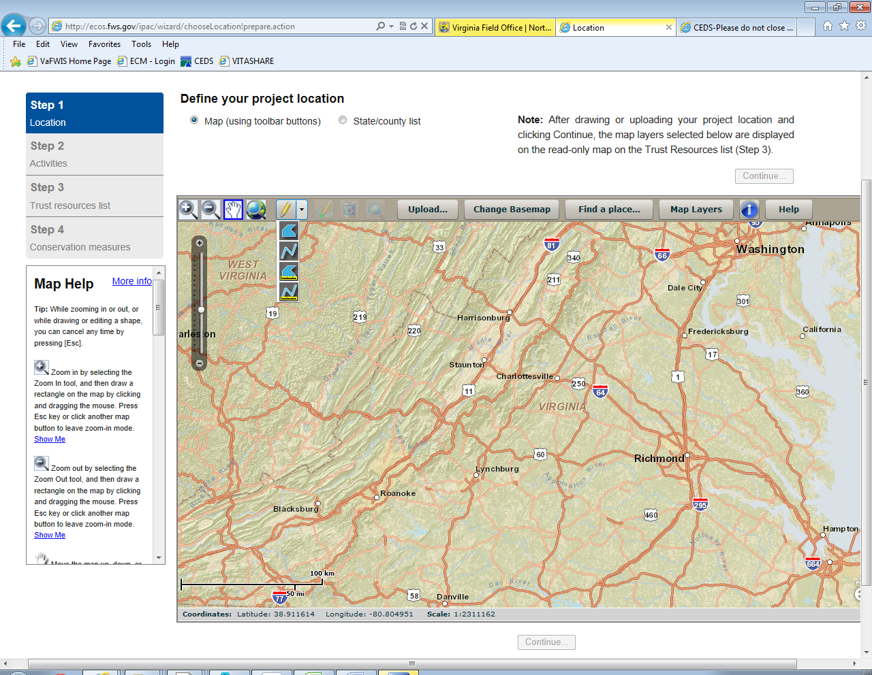
- Double click on last point to set polygon. Do not cross the line of the polygon. You can also edit polygon by moving the aqua squares and green dots. Click the “Continue” button below the map.
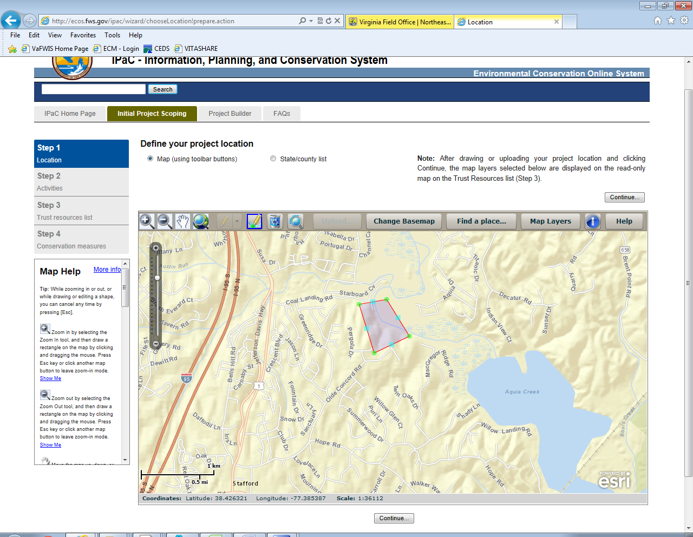
- Once you hit the “Continue” button from the map page, the below page appears. Select “Development” from the dropdown menu and hit the “Continue” button.
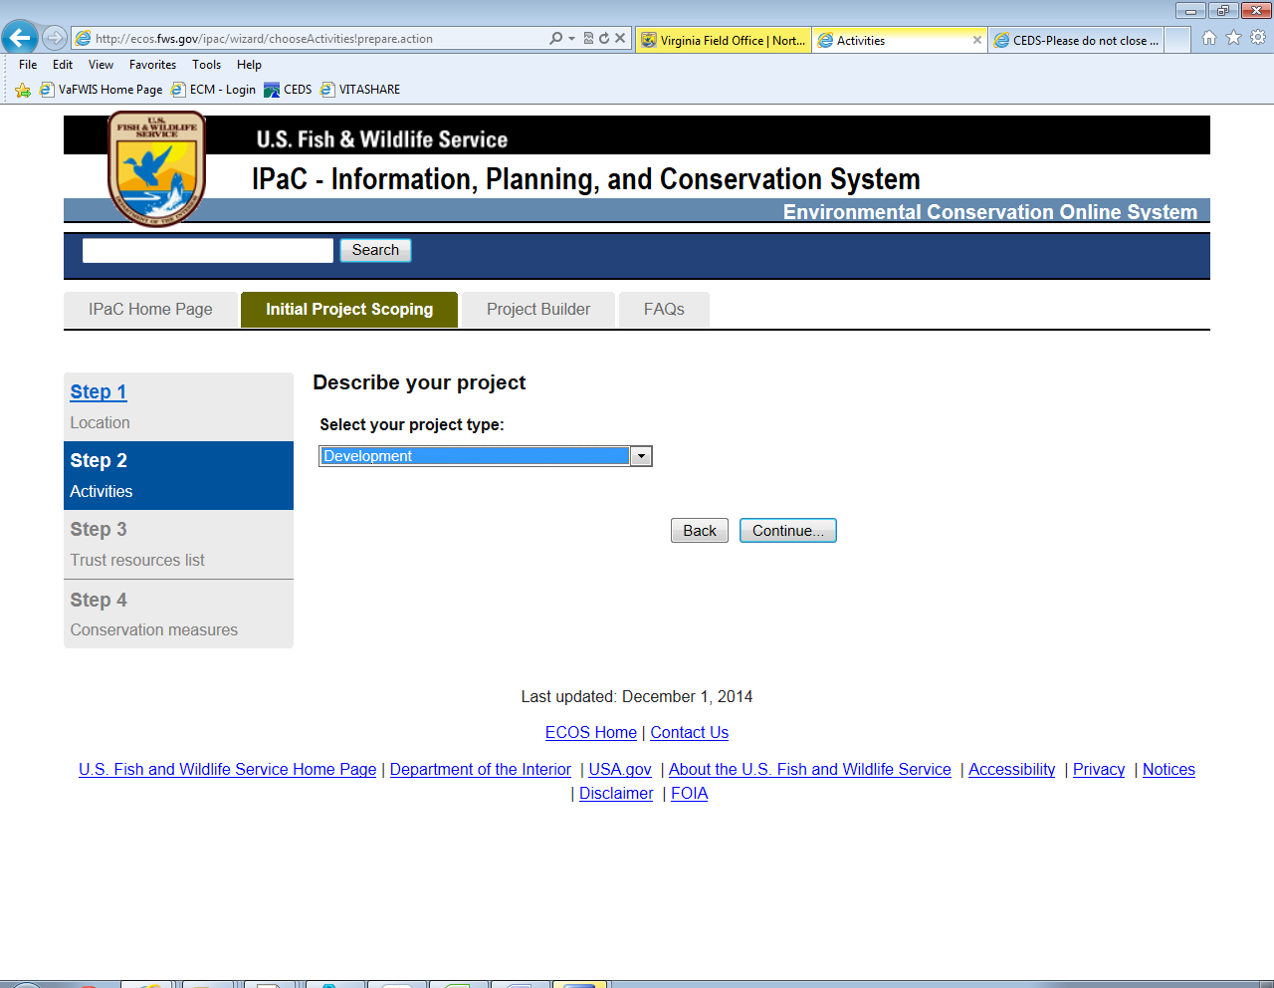
- The page that appears after hitting the “Continue” button will have your informal information regarding your project site. However, an Official Species List must be obtained for Section 7. Click on the “Request Official Species List” and fill out the Project Name and Description information and click “Request Official Species List.”
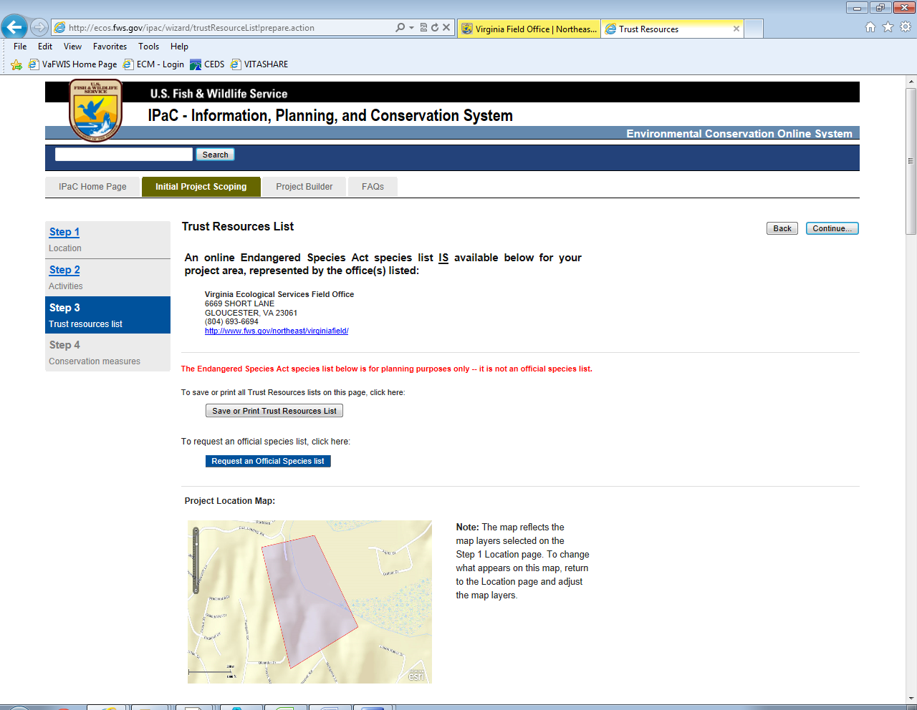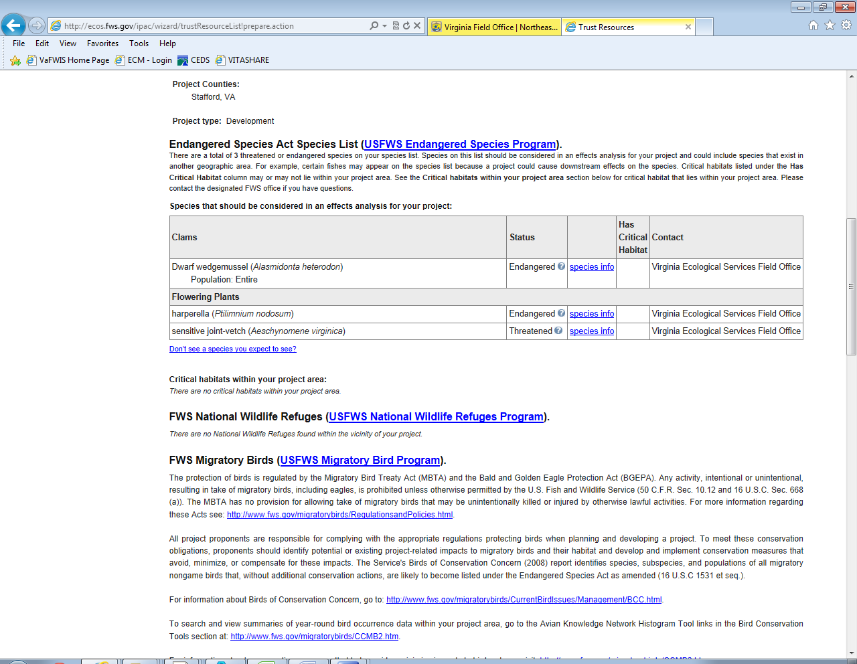
- Fill out required (*) information in the pop up window. The agency would be at the bottom of the drop down menu under “State of Virginia, Department of Environmental Quality.” Click “No” for the “Are you a consultant” and click the check box and hit “Continue” button. The button will not become available until all the required information is completed.
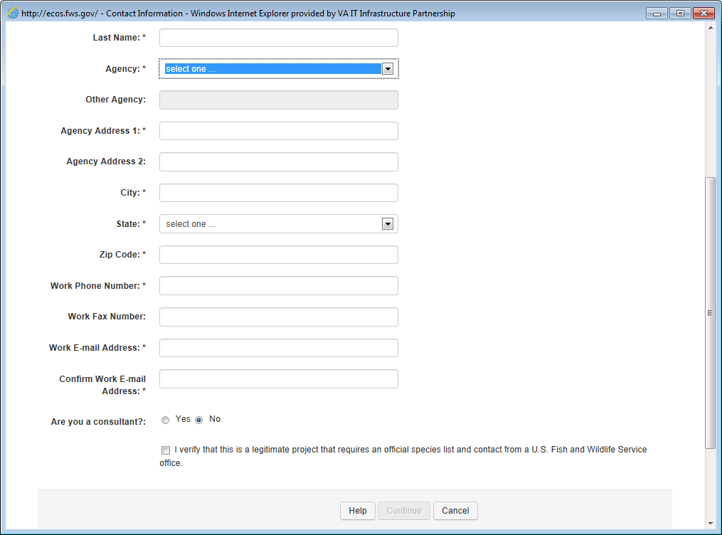
- Once you hit “Continue” an email with a link will be sent to the email provided in the pop-up. Clicking that link will prompt the system to send an email with your official species list. Save email to the permit folder on the U drive.
Step 2: Eagle Nest and Concentration.
- Find your project site on The Center for Conservation Biology Eagle Nest Locator Portal: http://www.ccbbirds.org/what-we-do/research/species-of-concern/virginia-eagles/nest-locator/. The mapping portal is located half way down the page.
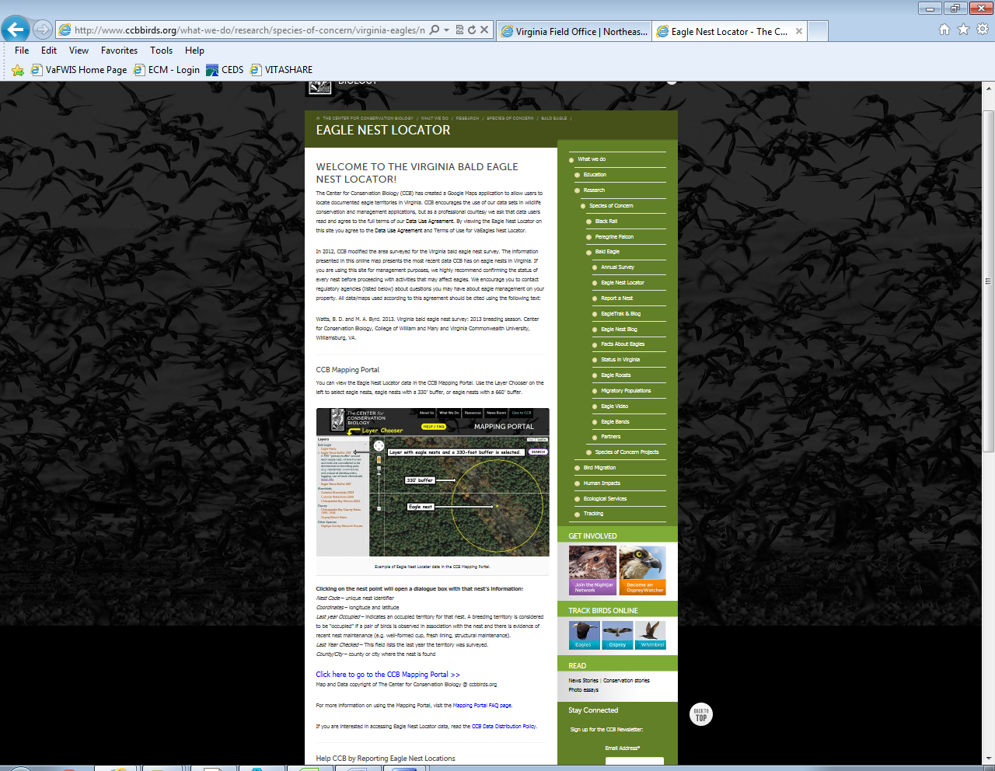
- After locating your project site, determine if there are any nests located within 660 feet. The yellow dots on the map indicate eagle nests. Zoom down to 200m resolution and print screen to PDF or take a screen shot (push control, alternate, shift, and print screen keys all at the same time) and paste into a Word document. Save a PDF of the document to the permit folder on the U drive.
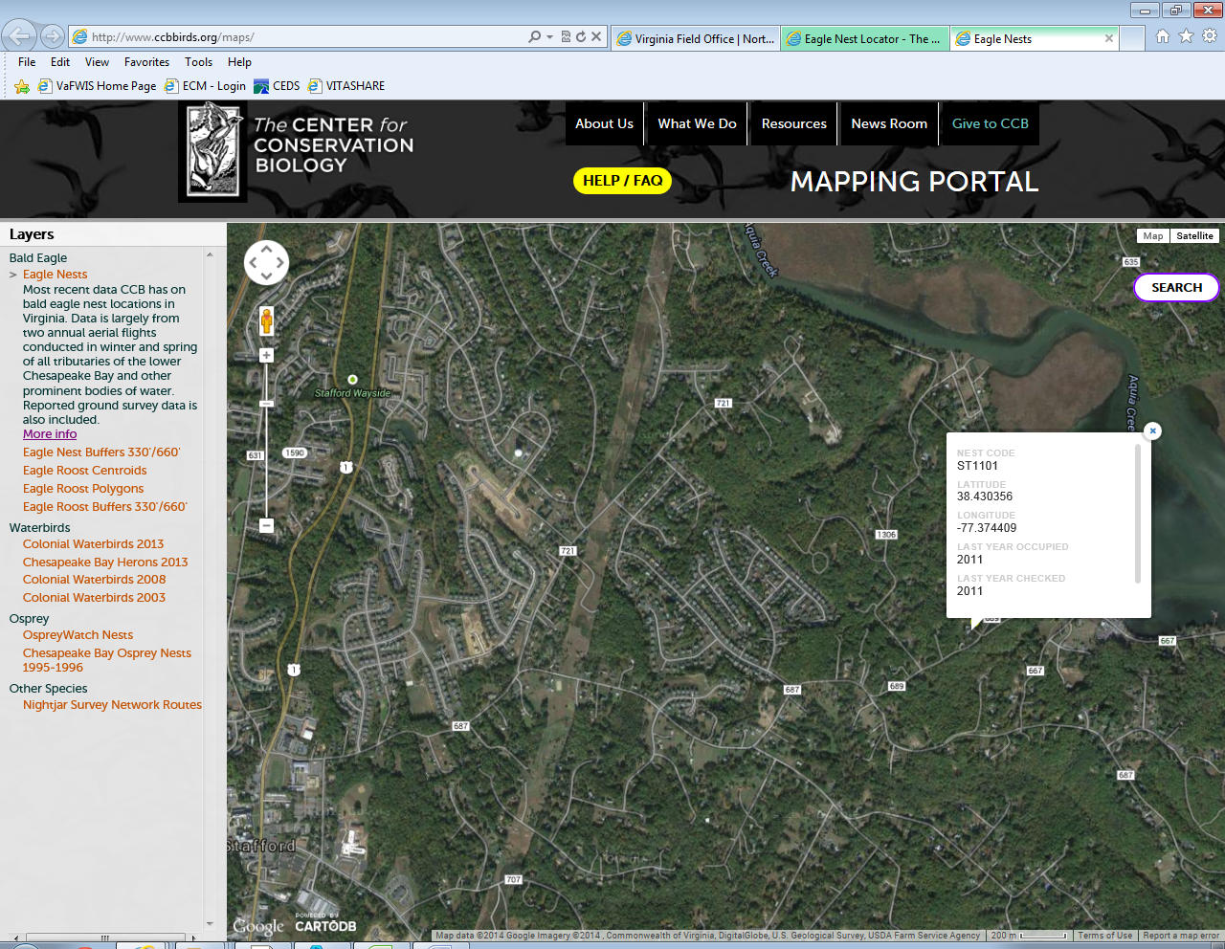
- Eagle Concentration Areas Determination: Use the following link to determine if your project site is within an Eagle Concentration Area: http://www.fws.gov/northeast/virginiafield/endangered/projectreviews_step6b.html
- Follow the steps located on the page. You will be utilizing the ArcGIS map to find your project and to determine if the site is within an established concentration area.
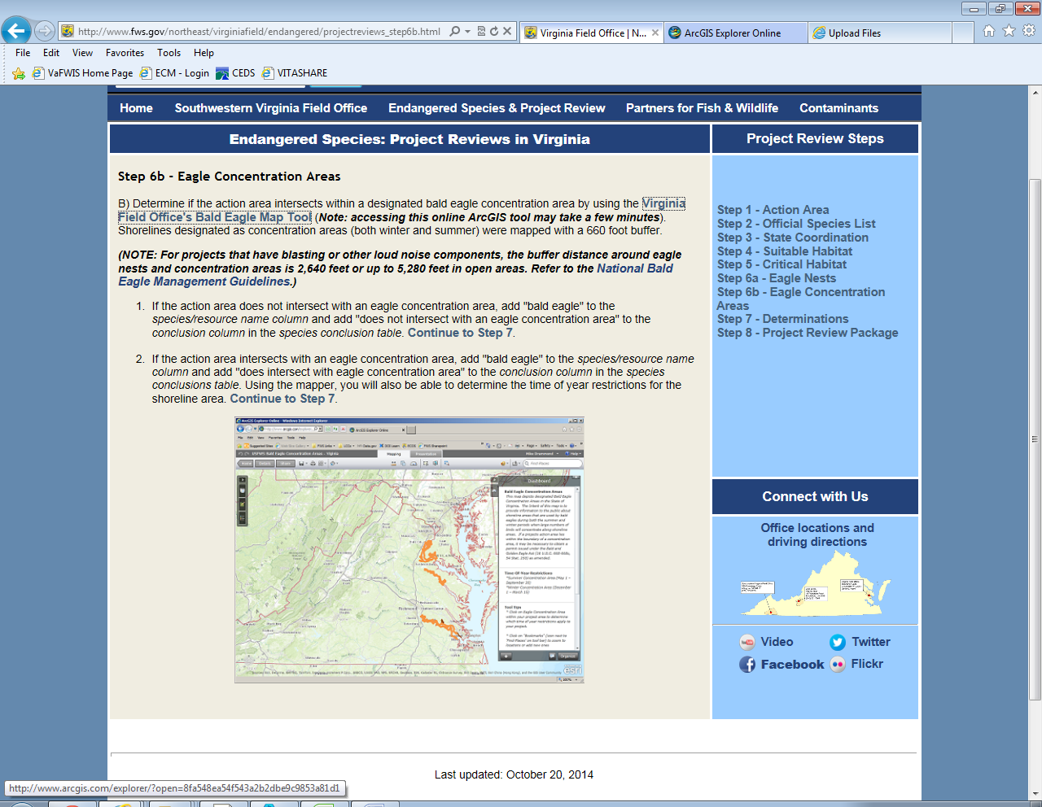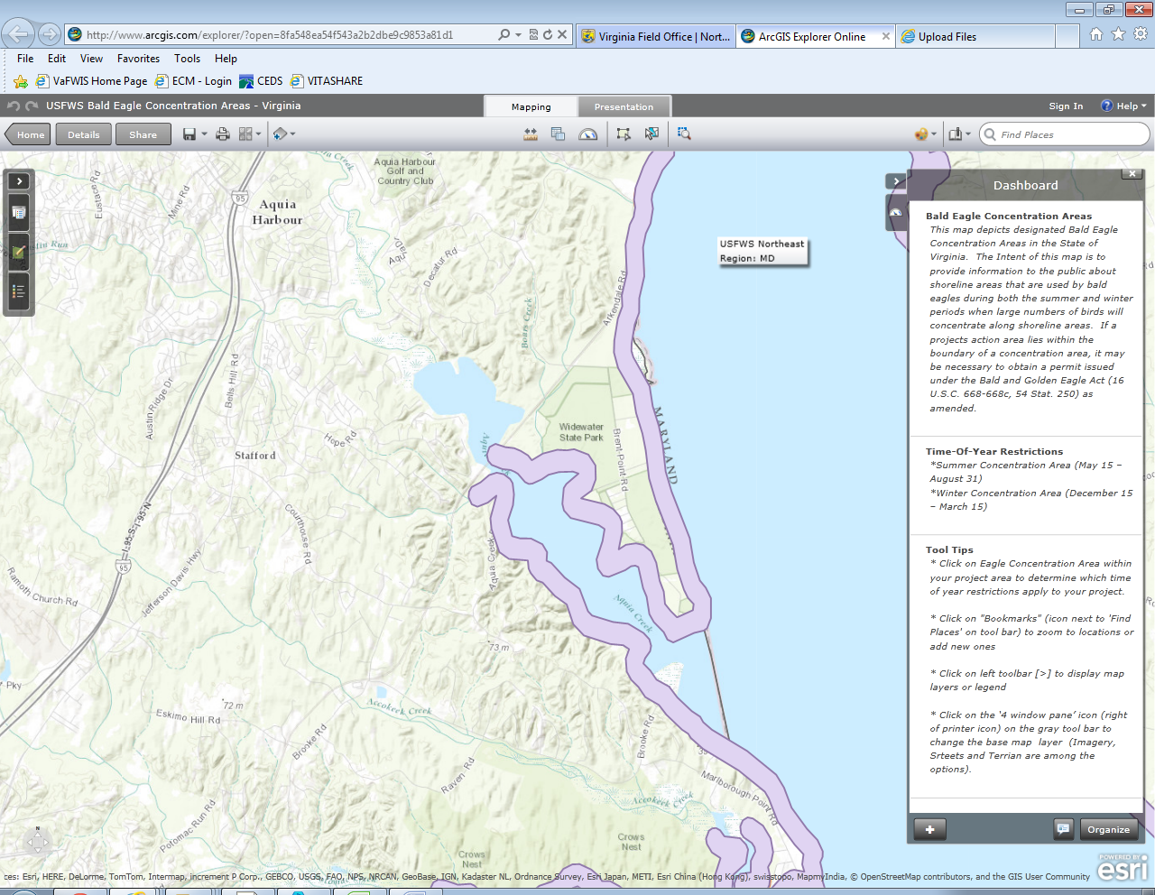
Eagle Concentration Area
Project site

- Print screen to PDF or take a screen shot (push control, alternate, shift, and print screen keys all at the same time) and paste into a Word document. Save a PDF of the document to the permit folder on the U drive.
Step 3: Species Conclusion Table.
  - Gather the DCR and DGIF reports and FWS Species List and any threatened and endangered species information in the JPA.
  - Open Species Conclusion Table. Find the species located on the Official Species List in the drop down menu of the Species Conclusion Table.
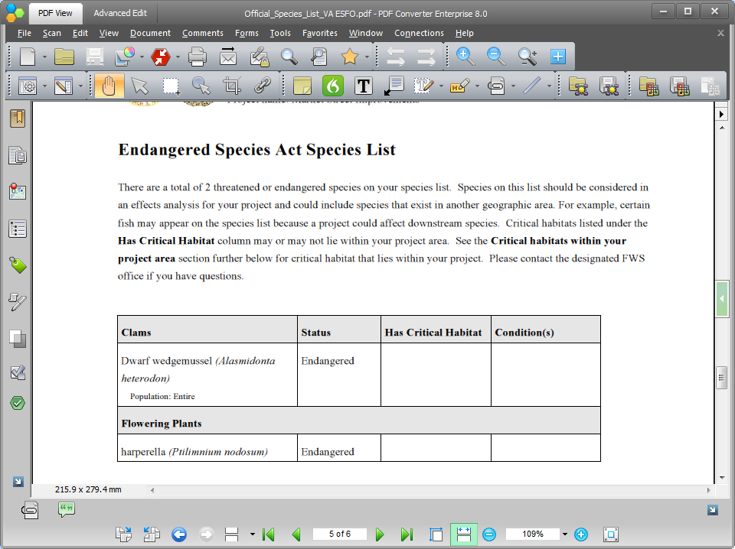

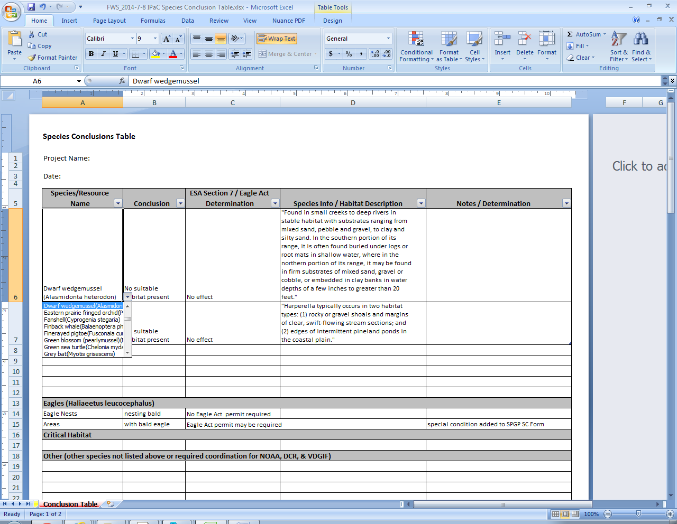
Auto populated once conclusion is selected
Auto populated once conclusion is selected
Auto populated once species is selected

  - Once the species is selected, the Species info/Habitat Description column will auto populate. Use this information and information located in the JPA to determine if habitat is present. Use the dropdown menu in the Conclusion column to select your determination. Appendix C, NAO ESA Project Review Procedure can be used to conclude your determination. The ESA Section 7/Eagle Act Determination column will auto populate once a conclusion is selected in the Conclusion column. Insert any supportive information for your determination in the Notes/Determination column.
  - Determine if the site will disturb an eagle nest or if in an eagle concentration area. The ESA Section 7/Eagle Act Determination column will auto populate once a conclusion is selected in the Conclusion column.
  - Add any federally listed and proposed species listed in the DCR and DGIF searches in the Other section of the form and determine conclusion and determination. This section will not auto populate and must be manually entered.
  - See Appendix C, ESA Agency Coordination Procedures and NAO Fish and Wildlife Coordination Act Project Review Process of the SPGP SOP to determine if further coordination is needed.
- If further coordination is required, include the following in the coordination package:
    - Action area on USGS
    - Official Species List from IPaC
    - DCR and DGIF database search results
    - Habitat Assessment or Species surveys (if applicable)
    - Eagle nest area map
    - Species Conclusion Table
    - Completed Project Review Request Letter (see GP startup templates)
    - Any other information that supports conclusions

