Section 1 – General Information

Inspection Information
Inspector: | Inspection Date | Report Date |  | Arrived On Site: AM / PM
 | / / | / /
Weather Conditions: (Indicate conditions that may have a bearing on the site visit. Example: 10 in. of rain fell within the 3 days prior to the site visit or the project site is located within a declared drought area.) |  |  |  |  | SPGP  Reporting Only
On-site Reps: (Or note if sign-in sheet is attached)
Project Information
Applicant Name:
Project Physical Location:
City: |  |  | County:
Impacts Map or Documents Used
(Indicate impacts map name used for site visit and the Joint Permit Application or other documents). (Please Include dates for documents.)
(Expand this area as necessary)

Section 2 – Site Observations and Narrative

Inspection Observations
The site appears consistent with information denoted in the JPA and any additional submittals that were provided. (Delete Section 3 then sign/date inspection report unless additional observations were made.) -OR-
The site did not appear as denoted in the JPA. (Please continue to Section 3 of Inspection Report.)
Photo(s) Attached? |  | Yes |  | No | How many photos? |  | Graphics Attached? |  | Yes |  | No
Narrative: (Insert detailed factual observations denoted on site visit. Make as few assumptions as possible.)
Narrative Example: The JPA and wetland delineation provided with the JPA indicated a PFO located at impact Location 1. However, during the site visit, it was observed that the PFO also had a stream channel (outlined in the graphic section below) flowing through it. See photo section below.
(Expand or delete this area as necessary)

Section 3 –Photos and Graphics

PHOTO #1 Expand & Insert Photo Here
ORIENTATION: Example: Southwest of impact 1
NOTES: Example: Appears to have stream channel flowing through PFO. Stream channel is approx. 1 ft. wide and 200 ft. long prior to connecting to channel downstream of impact 1.
(Copy information for photo above and expand in this area as necessary or delete if no photos)

Expand This Section & Insert Graphics here) NOTE: to see what type of graphics should be displayed in this section please click on sample below and enlarge to see the details – then delete the sample and insert your own graphic.
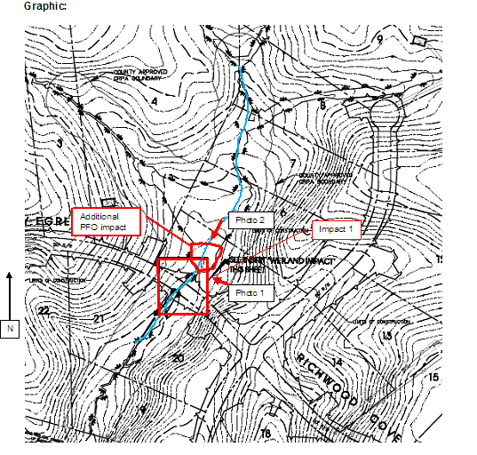- Sample Graphics
Comments:

Inspector’s Signature:_________________________________________________ Date:____________________

NOTE:
- Please make sure all RED instructional notations are removed before signing the inspection report.
- Expand narrative sections as needed.
- Expand Section 3 as needed for photos or graphics or delete Section 3 to bring up the signature box to conserve paper.
- Remove “template” watermark from your report.

