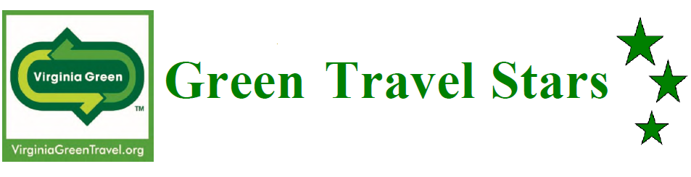

Innovative Green Project Application

| **Name of Innovative Green Project** | |
| --- | --- |
| **Name of Project:** |  |

| **Contact Information for Person Submitting Application:** | |
| --- | --- |
| **Contact Name:** |  |
| **Contact Email:** |  |
| **Contact Phone Number:** |  |

| **Virginia Green Member Information** | |
| --- | --- |
| **Facility Name & Project Title:**  (This will be used, as written, for potential award wording.) |  |
| **Facility Address:**  (Street, City, State & Zip): |  |
| **Virginia Green Category:** | Click here to access the drop-down list. |

| **Virginia Green Membership** | | | |
| --- | --- | --- | --- |
| Your facility must be a current Virginia Green Member to be eligible for the Virginia Green Travel Awards. Re-certification of your facility’s Virginia Green commitments is required every 2 years. This means that your facility must have re-certified or joined the program in 2023 or 2024 in order to qualify. If your certification has expired, submit your renewal to be eligible to apply for the awards program. To apply or re-certify for Virginia Green, visit the Virginia Green Travel Alliance website: <https://www.virginiagreen.net/get-certified/> | | | |
| **Are you a current Virginia Green Member?** | | | |
|  | Yes |  | Going to apply/re-certify now and submit ASAP! |

# Tell us about your Innovative Project!

Judges want to hear about your innovative project. Use this space to brag about what you are doing. The maximum potential point value for each category is in parenthesis to help applicants understand how applications are scored.

| **Summary** |
| --- |
| **Include a brief description of your innovative project.** What's the goal of the project? How is the project accomplishing that goal? What makes it innovative? Also, if you were recognized with an award last year, please make sure to tell us what is new this year. (30 points) |
|  |

| **Quantifiable Environmental Results** | |
| --- | --- |
| **Show us the numbers!** Please provide any available data on water usage, air emissions, waste, material use, energy use, natural resources and/or transportation, including applicable units. It is understandable if your project results in reduced environmental impacts for only one of these categories, but please provide information about as many categories as you can with data and tell us more in the text field below.  Ideally, we are hoping for a minimum of 12 months of data, but please share any information you have.  This information could be provided with copies of utility bills. If you do not have exact data, please attempt to provide reasonable estimates of your progress. Please note that quantifiable results must be included in order for judges to award any points. If you know you've done something great, but are having trouble figuring out how to quantify it, let us know and we are happy to help. Ask Virginia Green by emailing [VirginiaGreen@DEQ.Virginia.gov](mailto:VirginiaGreen@DEQ.Virginia.gov). (40 points) | |
| **What was reduced:** |  |
| **Quantity used in 2024:**  *Include units* |  |
| **Quantity used in prior year:**  *Include units* |  |
| What year: |  |
| **Change in quantity:**  *(Prior year usage – use in 2024*) |  |
| **Change in quantity as a percentage: $$\frac{Prior year-2024}{Prior year} ×100$$** |  |
| **Do you have data on more than one metric?** Include another below: | |
| **What was reduced:** |  |
| **Quantity used in 2024:**  *Include units* |  |
| **Quantity used in prior year:**  *Include units* |  |
| What year: |  |
| **Change in quantity:**  *(Prior year usage – use in 2024)* |  |
| **Change in quantity as a percentage: $$\frac{Prior year-2024}{Prior year} ×100$$** |  |
| **Please use this box to tell us more about the environmental benefits of your innovative green project.**  If you did estimate data above, please explain how these estimates were derived. | |
|  | |

| **Cost Effectiveness** |
| --- |
| Describe the cost effectiveness of your innovative project. (15 points) |
|  |

| **Customer Outreach** |
| --- |
| How do you get your customers involved? Do you communicate what you're doing and why? How do you encourage your customers to participate? (10 points) |
|  |

| **Website** |
| --- |
| Do you tell potential customers about your green efforts on your website? Bonus points if your website includes the Virginia Green logo! Paste the link below. (5 points) |
|  |

| **Pictures & Logo** | |
| --- | --- |
| **Please email a copy of your logo and a picture of your innovative project to VirginiaGreen@DEQ.Virginia.gov.**  You can include up to 5 pictures. | |
|  | Yes! I’m going to include a copy of my logo and pictures showing off what I’m doing. |

| **Virginia Green People's Choice Award** | |
| --- | --- |
| **Are you interested in participating in the Virginia Green People's Choice Award?** In the weeks leading up to the Virginia Green Travel Conference, a contest will be run through social media to determine the 2025 People's Choice Awards. It's an opportunity to engage loyal customers and supporters through a fun social media campaign. More information will be available in the weeks leading up to the conference, scheduled for March 20-21, 2025. | |
|  | Yes! Send me more details by email. |
|  | No thanks, I don't want extra publicity. |

| **Are you ready to submit?** | |
| --- | --- |
| Once you have completed the sections above, send your application to [VirginiaGreen@deq.virginia.gov](mailto:VirginiaGreen@deq.virginia.gov). Applications are due by Tuesday, January 21, 2025.  Do not forget to include the following attachments: | |
|  | Completed application, with wording as you would want it on an award plaque. |
|  | Company logo |
|  | Pictures that show off your innovative green project |