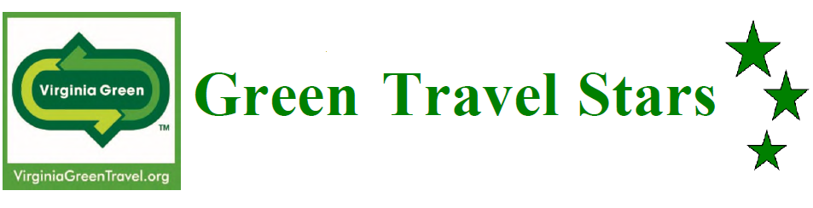

Green Products & Services Application

| **Contact Information for Person Submitting Application:** | |
| --- | --- |
| **Contact Name:** |  |
| **Contact Email:** |  |
| **Contact Phone Number:** |  |

| **Virginia Green Member Information** | |
| --- | --- |
| **Facility Name:**  (This will be used, as written, for potential award wording.) |  |
| **Facility Address**  (Street, City, State & Zip): |  |
| **Virginia Green Category:** | Click here to access the drop-down list. |

| **Virginia Green Membership** | | | |
| --- | --- | --- | --- |
| Your facility must be a current Virginia Green Member to be eligible for the Virginia Green Travel Awards. Re-certification of your facility’s Virginia Green commitments is required every 2 years. This means that your facility must have re-certified or joined the program in 2023 or 2024 in order to qualify. If your certification has expired, submit your renewal to be eligible to apply for the awards program. To apply or re-certify for Virginia Green, visit the Virginia Green Travel Alliance website: <https://www.virginiagreen.net/get-certified/> | | | |
| **Are you a current Virginia Green Member?** | | | |
|  | Yes |  | Going to apply/re-certify now and submit ASAP! |

# Tell us about your Green Products & Services. Include information about how you are helping tourism operators reduce the environmental impacts of their operations.

Judges want to hear about your green products & services. Use this space to brag about what you are doing. The maximum potential point value for each category is in parenthesis to help applicants understand how applications are scored.

| **Product or Service** |
| --- |
| **Include a brief written description of your product or service**. If you were recognized last year, please describe how this effort is different. (20 points) |
|  |

| **Company Summary** |
| --- |
| **In addition to your green products and/or services, tell us about how your company is committed to reducing its environmental impacts.** Do you have a companywide environmental commitment? Have you taken steps to increase recycling, reduce waste, conserve energy, or conserve water? (10 points) |
|  |

| **Quantifiable Environmental Results** | |
| --- | --- |
| **Show us the numbers!** Please provide any available information on water usage, air emissions, waste, material use, energy use, natural resources and/or transportation, greenhouse gases, etc., including applicable units. It is understood that your customers are the ones reducing their environmental impacts, so numbers can be based upon estimates according to product specifications and use. Additionally, your specific product may reduce environmental impacts in only of the categories listed, but please provide data about as many metrics as you can, and tell us more in the text field below.  Again, we are ideally looking for data/results from your work with Virginia Green participants or at least from efforts with tourism-related facilities. Please note that some level of quantifiable results must be included in order for judges to award any points in this category.  If you know you've done something great, but are having trouble figuring out how to quantify it, let us know and we are happy to help. Ask Virginia Green by emailing [VirginiaGreen@DEQ.Virginia.gov](mailto:VirginiaGreen@DEQ.Virginia.gov). (30 points) | |
| **What was reduced:** |  |
| **Quantity used in 2024**  *Include units* |  |
| **Quantity used in prior year:**  *Include units* |  |
| What year: |  |
| **Change in quantity:**  *(Prior year usage – use in 2024)* |  |
| **Change in quantity as a percentage: $$\frac{Prior year-2024}{Prior year} ×100$$** |  |
| **Do you have data on more than one metric?** Include another below: | |
| **What was reduced:** |  |
| **Quantity used in 2024:**  *Include units* |  |
| **Quantity used in prior year:**  *Include units* |  |
| What year: |  |
| **Change in quantity:**  *(Prior year usage – use in 2024)* |  |
| **Change in quantity as a percentage: $$\frac{Prior year-2024}{Prior year} ×100$$** |  |
| **Please use this box to tell us more about the actual environmental benefits of your green products or services:** | |
|  | |

| **Cost Effectiveness** |
| --- |
| Describe the cost effectiveness of your green product or service. (10 points) |
|  |

| **Customer Outreach & Engagement** |
| --- |
| How do you get your customers involved? Do you help train staff on the environmental benefits of your products and services? Do you encourage your customers to promote their own efforts related to your green products and services? (20 points) |
|  |

| **Website** |
| --- |
| Do you tell potential customers about your green efforts on your website? Bonus points if your website includes the Virginia Green logo! Paste the link below. (10 points) |
|  |

| **Pictures & Logo** | |
| --- | --- |
| **Please email a copy of your logo and a picture of your green products/services in action to VirginiaGreen@DEQ.Virginia.gov.** You can include up to 5 pictures. | |
|  | Yes! I’m going to include a copy of my logo and pictures showing off what I’m doing. |

| **Virginia Green People's Choice Award** | |
| --- | --- |
| **Are you interested in participating in the Virginia Green People's Choice Award?** In the weeks leading up to the Virginia Green Travel Conference, a contest will be run through social media to determine the 2025 People's Choice Awards. It's an opportunity to engage loyal customers and supporters through a fun social media campaign. More information will be available in the weeks leading up to the conference, scheduled for March 20-21, 2025. | |
|  | Yes! Send me more details by email. |
|  | No thanks, I don't want extra publicity. |

| **Are you ready to submit?** | |
| --- | --- |
| Once you have completed the sections above, send your application to [VirginiaGreen@deq.virginia.gov](mailto:VirginiaGreen@deq.virginia.gov). Applications are due by Tuesday, January 21, 2025.  Do not forget to include the following attachments: | |
|  | Completed application, with wording as you would want it on an award plaque. |
|  | Company logo |
|  | Pictures that show off your green products/services |