**Universal Waste Mercury-Containing Lamp Crushing Guidance**



[www.deq.virginia.gov](http://www.deq.virginia.gov/)

revised October 5, 2017

TABLE OF CONTENTS

Executive Summary 1

Chapter One – Universal Waste Lamp Handlers 2

Part One – Small Quantity and Large Quantity UW Lamp Handlers 2

Part Two – Facilities which are Under the Control of the Generator 2

Part Three – Notification of UW Lamp Crushing Operations 3

Part Four – Training Requirements 3

Part Five – Mechanical Crusher Requirements 4

Part Six – Secondary Filtration Requirements 5

Part Seven – Emissions Sampling, Testing and Monitoring Requirements 5

Part Eight – Closure Requirements 7

Part Nine –Recordkeeping Requirements 7

Part 10 –Compliance Dates 8

Appendix A: Notification Form for Facilities with Crushing Operations 9

Appendix B: DEQ Regional Office Notification Mailing Addresses 10

Appendix C: VDOT Culpeper Facility Secondary Filtration System 12

Appendix D: Lamp Crushing Implementation Checklist 14

# Executive Summary

While crushing of mercury containing Universal Waste (UW) lamps has been allowed under the Virginia Hazardous Waste Management Regulations (VHWMR) by 9 VAC 20-60 since March, 2002. Virginia had not received authorization from the Environmental Protection Agency (EPA) for these regulations. In order to receive authorization, the DEQ must demonstrate equivalency with the federal standards which do not allow crushing. Specifically, Virginia must demonstrate that crushing can be done in a protective and safe manner and that the risk of exposure from crushing is no greater than that which would be experienced at a facility that does not crush lamps. The regulatory amendment which will support the equivalency determination that UW lamp crushing meets the federal standards is now effective and there are new compliance requirements for UW lamp generators who crush at their facility and for UW lamp recyclers in Virginia.

For generators, the amended regulations are in 9 VAC 20-60-273 and 9 VAC 20-60-1505. In general, the new requirements for generators include:

* Initial notification of intent to crush lamps and for existing crushing operations;
* Annual training plan for operators;
* Secondary filtration with a separate HVAC system;
* Initial and annual emissions monitoring;
* Recordkeeping; and
* Financial assurance for closure (if applicable).

This guidance was developed to assist UW lamp generators who wish to crush their UW lamps in complying with the revised regulatory requirements. Please note that the amended regulations are in addition to the regulations in 9VAC 20-60-273 for UW handlers.

# Chapter One – Universal Waste Lamp Handlers

## Part One – Small Quantity and Large Quantity UW Lamp Handlers

The regulations establish different regulatory requirements for small quantity and large quantity UW handlers. Small quantity handlers may only accumulate less than 5,000 kg (11,000 lbs.) at their facility at any one time. Large quantity handlers are those facilities which accumulate 5,000 kg (11,000 lbs.) or more on-site at any one time.

Most of the revised requirements for lamp crushing are applicable to all UW lamp handlers but there are some which are dependent on the quantity of UW lamps accumulated at the facility. Large quantity UW handlers, of UW lamps only (i.e. not including other UW types), are required to maintain a financial assurance mechanism and develop a closure plan. These requirements are in place to ensure a facility will be cleaned according to the regulatory standards once it closes, and that Virginia taxpayers will not be responsible for the clean-up cost. In addition certain handlers (large or small) may not be required to conduct mercury emissions monitoring if they fall under certain time and quantity thresholds.

## Part Two – Facilities which are Under the Control of the Generator

Generally, UW lamps are crushed on-site at the same facility which generates the UW lamps. However, 9 VAC 20-60-1505.B allows for facilities which are “under the control of the generator” to crush the UW lamps at a facility which may, or may not be, contiguous to the original generating facility but is owned, leased or otherwise controlled by the generator. Under these requirements, the crushed lamps must be sent off-site for recycling only and not for disposal.

A generating facility which is not contiguous to the facility where the UW lamps will be crushed may still crush lamps at the non-contiguous facility if the non-contiguous facility meets the following conditions for being under the control of the generator:

* + 1. Both the generating facility and the crushing facility are controlled by the same person as defined in 40 CFR § 260.1;
    2. The generator provides one of the following certifications:
       1. “On behalf of [insert generator facility name], I certify that this facility will send the indicated UW lamps to [insert crushing facility name], which is controlled by [insert generator facility name] and that [insert the name of either facility] has acknowledged full responsibility for the safe management of the UW lamps”; or
       2. “On behalf of [insert generator facility name] I certify that this facility will send the indicated UW lamps to [insert crushing facility name], that both facilities are under common control, and that [insert name of either facility] has acknowledged full responsibility for the safe management of the UW lamps.”

For purposes of this certification, "control" means the power to direct the policies of the facility, whether by the ownership of stock, voting rights, or otherwise.

For example, a chain of retail stores generates waste lamps in multiple locations in an area but only has one location equipped with a UW lamp crusher. These facilities are all owned by the same corporate entity. As long as the certification requirements in 9VAC20-60-1505.B.4.b are met and maintained, the stores would be able to send the UW lamps generated at all of their Virginia locations to the one Virginia location equipped with the crusher.

If a facility with UW lamp crushing capabilities cannot certify that it shares common control with the generator, the facility must then comply with the requirements in 40 CFR § 273, Subpart E for UW lamp destination facilities in order to be able to crush the UW lamps received from off-site.

## Part Three – Notification of UW Lamp Crushing Operations

All handlers of UW lamps which have a crushing operation at their facility, regardless of size, must notify the applicable Virginia Department of Environmental Quality (DEQ) regional office within 30 days of commencing the crushing operation. Facilities with existing crushing operations must notify the applicable DEQ regional office within 30 days of the regulation’s effective date. A notification form for facilities is included as Appendix A as an example and may be used to supply the required information. A list of the addresses for the DEQ regional offices and the areas overseen by each area is included in Appendix B. The written notification must include the following information:

* + The name of the company or individual which owns the crusher;
  + EPA ID Number (if one has been issued);
  + Physical location of the crushing operation; and
  + Name, business address and phone number of the operators and principal contact persons for the generator.

Additionally if the crushing facility is under the same control as a generator, the crushing facility must include a copy of the generator’s certification statement required in 9VAC20-60-1505.B.4.b with the notification. If any of the information made in the notification to DEQ changes, the facility must provide an updated notification within 15 days of the change occurring.

## Part Four – Training Requirements

All UW lamp handlers with crusher operations are required to develop training plans for their crusher operations. The training plans must include, at a minimum, training in the following elements:

* Procedures to safely crush, handle, and store mercury-containing lamps. The procedures should address the following topics:
* The type of equipment to be used to crush mercury-containing lamps safely;
* Instructions for proper equipment operation;
* Implementation of proper waste management practices during all aspects of the crushing operation (handling, loading, drum changing, etc.); and
* The use of personal protective equipment which should include, at a minimum, safety glasses or full face shield and cut-proof gloves.
* Procedures to minimize the release of mercury, including during drum changes and malfunctions.
* Procedures for dealing with emergencies. Specifically, the training should include language which outlines the procedure for cleaning up broken UW lamps in accordance with 40 CFR Part 273.13(d)(2) or 40 CFR Part 273.33(d)(2).
* The maintenance schedule for the crushing unit which incorporates the manufacturer’s specifications and which identifies all maintenance operations and the specified frequency, including replacement of particle filters and the activated carbon media.

Each crusher unit operator must receive an initial and recurring annual training in the crushing procedures, waste handling, safety, use of personal protective equipment, and emergency procedures contained in the training plan. Operators must complete the initial training before being allowed to operate the crusher units.

## Part Five – Mechanical Crusher Requirements

For all UW lamp handlers with a lamp crushing operation, the mechanical lamp crusher being used must comply with the following requirements in 9VAC 20-60-1505.B.7:

* The crusher must be specifically designed to crush mercury-containing lamps;
* The crusher must be equipped with air pollution controls that capture both particulate and vapor phase mercury emissions. At a minimum, these controls must include:
* A HEPA filter which achieves a particle retention rate of 99.97% with negative pressure maintained throughout the unit; or
* A sorption column of sulfur-impregnated activated carbon media (or equivalent impregnated activated carbon media) with negative pressure maintained throughout the unit.
* The crusher must be hermetically sealed, except for air intakes, and kept under negative pressure;
* Air intake points on the crusher must be closed when the unit is not operating;
* The crusher cannot be mobile and the location of the crusher is to be included in the notification provided to DEQ; and
* The crusher may only be operated indoors.

Along with the design criteria for the UW lamp crushers, there are requirements which apply to the storage of crushed UW lamps once the drum or container is removed from the crusher:

* Crushed UW lamps may not be transferred to another drum or container;
* Mercury-containing residues, filters, equipment, and other solid waste cannot be placed in the same drum or container which is being used for storing the crushed UW lamps. These materials must be handled as solid or hazardous waste;
* Crushed UW lamps must be stored in a closed and hermetically sealed, non-leaking drum or container which are in good condition with no severe rusting, apparent structural defects, and which are not leaking; and
* The drum or container storing the crushed UW lamps must be properly sealed and labeled with the label stating either "universal waste-lamps," "waste lamps," or "used lamps".

## Part Six – Secondary Filtration Requirements

UW lamp crushing operations are required to be performed in a space where the ambient air is isolated from other parts of the facility where other workers could be exposed to mercury emissions. This may involve installing additional ductwork to isolate the space where UW lamp crushing is being performed from the rest of the facility’s Heating, Ventilation and Air Conditioning (HVAC) system. An example of the cost and scope of work performed to modify an existing HVAC system is included as Appendix C.

Additionally, the ambient air from room(s) where the UW lamp crushing operations are being performed must be filtered before being discharged directly to an area outside the building where people are unlikely to be directly exposed. Requirements for the secondary filtration system mirror the filter system for the crusher units and include a HEPA filter or sorption column of sulfur impregnated activated carbon (or equivalent impregnated activated carbon media) and for negative pressure to be maintained.

However, if a situation exists where a facility has determined the discharge of ambient air from a room containing a UW lamp crushing operation to the outside is technically or financially impracticable, DEQ may approve an alternate design to be used in place of the secondary filtration. The alternate design would allow for ambient air from a room containing a crushing operation to another internal building space or centralized HVAC system if the following requirements are met:

* The filtration system is capable of capturing both particulate and mercury vapor emissions;
* The filtration system is maintained according to manufacturer recommendations; and
* Maintenance records for the filtration system are maintained at the facility.

Approval of alternate designs to satisfy the secondary filtration requirement will be made on a case-by-case basis by DEQ. Facilities which wish to pursue approval of an alternate design must notify the DEQ and submit detailed information which supports the equivalency of the alternate design to the required secondary filtration prior to commencement of crushing activities. As this approval is granted on a case-by-case basis, DEQ cannot provide a standard list of required information at this time. However, this guidance will be updated when alternate designs are approved by DEQ for other facilities to follow as an example.

## Part Seven – Emissions Sampling, Testing and Monitoring Requirements

Both small and large UW lamp generators with crushing operations are required to perform mercury emissions sampling within the first month after beginning the crushing operation and annually thereafter. Each time the crusher is modified or replaced at a facility, emissions sampling must be performed within the first month of operation of the new or modified unit. Please note that regular maintenance and repair of the crusher does not require additional sampling beyond the annual mercury sampling requirement. Handlers who crush UW lamps less than two hours a month and crush no more than 100 kg (220 lbs.) per month of UW lamps are exempt from the sampling requirements. The following amount of lamps weighs 220 lbs. or 100 kg:

• 360 4’ T12 lamps

• 540 4’ T8 lamps

• 910 4’ T5 lamps

The number of hours UW lamps are crushed per month dictates the chronic exposure air limit and is documented in the table below. The risk based acute exposure limit of 300 µg/m3is the same for all facilities.

Mercury vapor analyzers used for sampling and recording of data must be a U.S Occupational Safety and Health Administration (OSHA) or Virginia Department of Labor and Industry (VDLI) approved unit. The analyzer must be able to detect mercury vapor at or below the following concentrations depending on the number of hours bulbs are crushed per month:

|  |  |  |  |
| --- | --- | --- | --- |
|  | Monthly Bulb Crushing Duration (X Hours/Month)* | Chronic Exposure Air Emission Limit (µg/m3) | Acute Exposure Air Emission Limit (µg/m3) |
|  | X ≥ 32 | 1.314skin µg/m3 | 300 µg/m3 |
|  | 8 < X < 32 | 6.317 skin µg/m3 | 300 µg/m3 |
|  | X ≤ 8 | 27.375 skin µg/m3 | 300µg/m3 |
|  | X ≤ 2  and no more than 220 lbs./month or 100 kg/month of bulbs crushed | Monitoring not required | Monitoring not required |
|  | *Monthly crushing duration is determined based on the maximum number of hours that bulb crushing occurred in any one month over the last 12-month period. | | |

The initial and annual ambient air sampling for mercury must be conducted within five feet of the UW lamp crusher. Emissions sampling is also required to be performed within two inches of all connection points for hoses circulating air from within the unit, the seal between the unit and the drum, and openings in the crushing unit which will include, but may not be limited to, the lamp feed tube for the crusher. All sampling events must occur while the crusher is operating and actively crushing lamps.

If a crusher fails to meet either the chronic or acute emissions standards listed in the table above then the crusher will have to be taken out of operation immediately. The unit will then have to be repaired and retested to ensure excess mercury emissions are not occurring. A facility does have the option of demonstrating compliance with the acute exposure standards by comparing the 95% confidence interval of the mean. EPA’s ProUCL tool can be used for this calculation. The latest version can be found at the following address: <https://www.epa.gov/land-research/proucl-software>. Alternatively, if a facility wishes to calculate the 95% upper confidence limit without using the ProUCL software, the procedure from the [August 2002 EPA guidance document for RCRA Waste Sampling](https://www.epa.gov/sites/production/files/2015-10/documents/rwsdtg_0.pdf) may be used. The relevant language detailing the procedure to calculate the 95% upper confidence limit is found in Appendix F in the August 2002 EPA guidance document.

## Part Eight – Closure Requirements

Financial assurance and closure plans are required for Large Quantity UW handlers who handle 5000 kg or more of UW lamps at any time. The typical mechanisms which are used for demonstrating financial assurance include the following:

* **Trust Fund**
* **Surety Bond**
* **Letter of Credit**
* **Insurance**
* **Financial Test**

Closure plans for Large Quantity UW lamp handler facilities will be specific to each facility but all closure plans must include the following elements:

* A description of how each crusher unit and the area the crusher was operated in will be closed;
* A description of how final closure of the facility will be achieved;
* An estimate of the maximum amount of UW lamps accumulated on site during the facility’s operating life;
* A detailed description of closure methods, including specific waste removal and site decontamination;
* A description of any other required steps, such as groundwater monitoring; and
* A schedule of closure dates, including closure dates for each unit and the entire facility.

Large quantity UW lamp handling facilities should work with DEQ staff to develop a closure plan that will be specific to the facility operations and waste handling activity.

## Part Nine –Recordkeeping Requirements

Generator facilities of all sizes with crushing operations must maintain records of the following:

* Mercury emissions monitoring (date, place, time of measurement);
* The methodology used and the analytical results;
* The amount of time per month spent crushing lamps;
* The quantities of lamps handled (for sampling threshold requirements);
* Training records for lamp crushing workers;
* Vapor sampler calibration
* Maintenance records for the emissions monitor;
* Secondary filtration system maintenance;
* Procedure to safely crush UW lamps; and
* Copies of the initial notification and certification.

Additionally, large quantity handlers of UW lamps must keep records of each shipment of UW lamps shipped from or received at the facility. The record may take the form of a log, invoice, manifest, bill of lading, or other shipping document. The record for each shipment of universal waste received by or shipped from the large quantity handler must include the following information:

* The name and address of the originating universal waste handler or foreign shipper from whom the universal waste was sent;
* The quantity of each type of universal waste received by or shipped from the large quantity UW handler; and
* The date of receipt or shipping of the UW lamps to or from the large quantity UW handler.

The records must be maintained on-site for a minimum of 3 years and available for inspection by DEQ compliance staff.

## Part 10 –Compliance Dates

New facilities must comply with the requirements in the UW lamp crushing regulations once crushing operation is performed at the facility. Existing facilities with crusher operations have until April 1, 2017 to demonstrate compliance. A checklist for facilities with UW lamp crushing operations is included in Appendix D to assist facilities with complying with the regulations. Use of this checklist is optional by facilities.

# Appendix A: Notification Form for Facilities with Crushing Operations

**Universal Waste Lamp Crushing Notification Form (rev. 10/2017)**

**Form Type (Check All Applicable):** **Notification of Intent to Crush ____**

**Notification of Existing Crusher Operations ____**

**Notification of Intent to Discontinue Crusher Operations ­­­­____**

**Notification of Shipment Off-site for Crushing ____**

**Notification of Crusher Operation Updates _____**

**Facility Name: _____________________________________________________________________**

**Facility Address: ___________________________________________________________________**

**EPA Identification Number (if applicable): ____________________________**

**Physical location of Bulb Crusher – please include address, building number, and location within the building: ___________________________________________________________________________________**

**___________________________________________________________________________________**

**Bulb Crusher Operator Name: _________________________________________________________**

**Bulb Crusher Operator Address: _____________________________________________________**

**Bulb Crusher Operator E-mail: _______________________________________________________**

**Bulb Crusher Operator Phone Number: _______________________________________________**

**a. Does your facility receive bulbs from off site for crushing? Yes ____ No ____**

**If you answered Yes to “a”, please identify the names and addresses of off-site locations from which you are receiving bulbs for crushing:**

**_____________________________________________________________________________________________**

**_____________________________________________________________________________________________**

**_____________________________________________________________________________________________**

**b. Does your facility send bulbs off site to be crushed**

**by another company location in Virginia? YES ____ No ____**

**If you answered Yes to “b”, please identify the name and address of the Virginia location to which you are sending bulbs to be crushed:**

**____________________________________________________________________________________________**

**If you answered YES to “a” or “b” above, please complete one of the following certifications:**

**1. On behalf of ________________________(insert generator facility name), I certify that this facility will send the indicated UW lamps to ______________________ (insert crushing facility name), which is controlled by _____________________ (insert generator facility name), and that _______________ (insert the name of either facility) has acknowledged full responsibility for the safe management of the UW lamps.**

**2. On behalf of _____________ [insert generator facility name] I certify that this facility will send the indicated UW lamps to ________________ [insert crushing facility name], that both facilities are under common control, and that __________________ [insert name of either facility] has acknowledged full responsibility for the safe management of the UW lamps.**

**(continued on next page)**

**Certifier Name: ______________________________________________________________________**

**Certifier Signature: ___________________________________________________________________**

**Certifier Title: _______________________________________________________________________**

**Certifier E-mail: ______________________________________________________________________**

**Certifier Phone Number: _______________________________________________________________**

**Submission Date: ______________________________________**

**Comments:**

# Appendix B: DEQ Regional Office Notification Mailing Addresses

Virginia Department of Environmental Quality

Blue Ridge Regional Office

Attn: Land Protection Program Manager

3019 Peters Creek Road

Roanoke, VA  24019

The Blue Ridge Regional Office serves the counties of Alleghany, Amherst, Appomattox, Bedford, Botetourt, Buckingham, Campbell, Charlotte, Craig, Cumberland, Floyd, Franklin, Giles, Halifax, Henry, Lunenburg, Mecklenburg, Montgomery, Nottaway, Patrick, Pittsylvania, Prince Edward, Pulaski and Roanoke; and the cities of Bedford, Clifton Forge, Covington, Danville, Lynchburg, Martinsville, Radford, Roanoke and Salem. If your facility is located within one of these areas please send your notification to them.

Virginia Department of Environmental Quality

Northern Virginia Regional Office

Attn: Land Protection Program Manager

13901 Crown Court

Woodbridge, Virginia 22193

The Northern Virginia Regional Office serves the counties of Arlington, Caroline, Culpeper, Fairfax, Fauquier, King George, Loudoun, Louisa, Madison, Orange, Prince Williams, Rappahannock, Spotsylvania and Stafford; and the cities of Alexandria, Fairfax, Falls Church, Fredericksburg, Manassas and Manassas Park. If your facility is located within one of these areas please send your notification to them.

Virginia Department of Environmental Quality

Piedmont Regional Office

Attn: Land Protection Program Manager

4949-A Cox Road

Glen Allen, VA  23060

The Piedmont Regional Office serves the counties of Amelia, Brunswick, Charles City, Chesterfield, Dinwiddie, Essex, Gloucester, Goochland, Greensville, Hanover, Henrico, King and Queen, King William, Lancaster, Mathews, Middlesex, New Kent, Northumberland, Powhatan, Prince George, Richmond, Surry, Sussex and Westmoreland; and the cities of Colonial Heights, Emporia, Hopewell, Petersburg and Richmond. If your facility is located within one of these areas please send your notification to them.

Virginia Department of Environmental Quality

Southwest Regional Office

Attn: Land Protection Program Manager

355-A Deadmore Street

Abingdon, Virginia 24210

The Southwest Regional Office serves the counties of Bland, Buchanan, Carroll, Dickenson, Grayson, Lee, Russell, Scott, Smyth, Tazewell, Washington, Wise and Wythe; and the cities of Bristol, Galax and Norton. If your facility is located within one of these areas please send your notification to them.

Virginia Department of Environmental Quality

Tidewater Regional Office

Attn: Land Protection Program Manager

5636 Southern Blvd.

Virginia Beach, VA 23462

The Tidewater Regional Office serves the counties of Accomack, Isle of Wight, James City, Northampton, Southampton and York; and the cities of Chesapeake, Franklin, Hampton, Newport News, Norfolk, Poquoson, Portsmouth, Suffolk, Virginia Beach and Williamsburg. If your facility is located within one of these areas please send your notification to them.

Virginia Department of Environmental Quality

Valley Regional Office

Attn: Land Protection Program Manager

P.O. Box 3000

Harrisonburg, VA 22801

The Valley Regional Office serves the counties of Albemarle, Augusta, Bath, Clarke, Fluvanna, Frederick, Greene, Highland, Nelson, Page, Rockbridge, Rockingham, Shenandoah and Warren; and the cities of Buena Vista, Charlottesville, Harrisonburg, Lexington, Staunton, Waynesboro and Winchester. If your facility is located within one of these areas please send your notification to them.

# Appendix C: VDOT Culpeper Facility Secondary Filtration System

The VDOT Culpeper facility has installed a box which contains a HEPA filter over an existing fan which exhausts to the ambient air outside of the room where the crushing operation is performed. The system has been hardwired into the crusher so that the crusher cannot operate without the fan operating as well. The secondary filtrations system is shown in the following images: 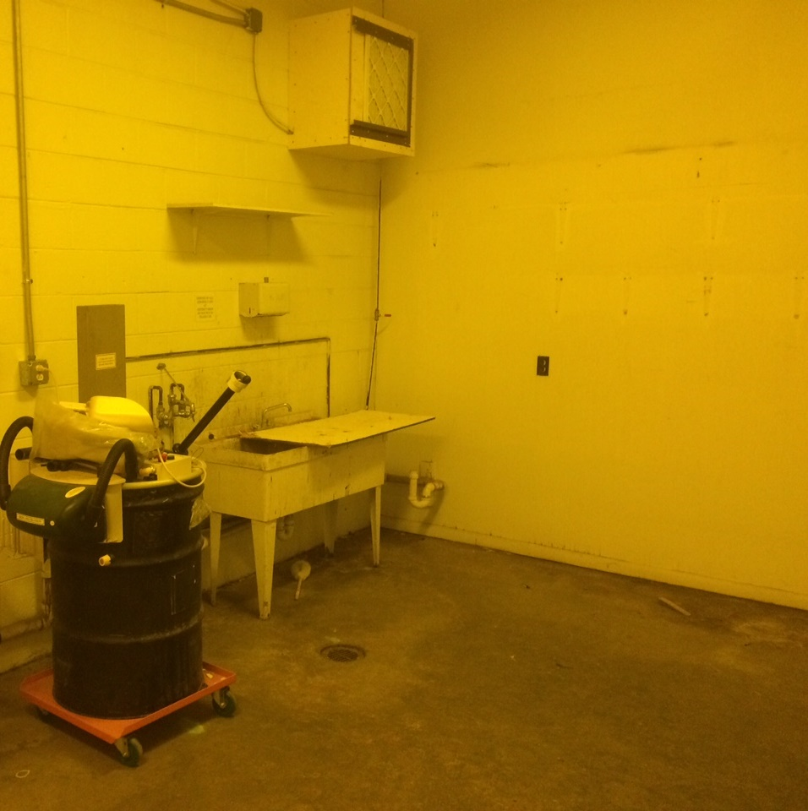

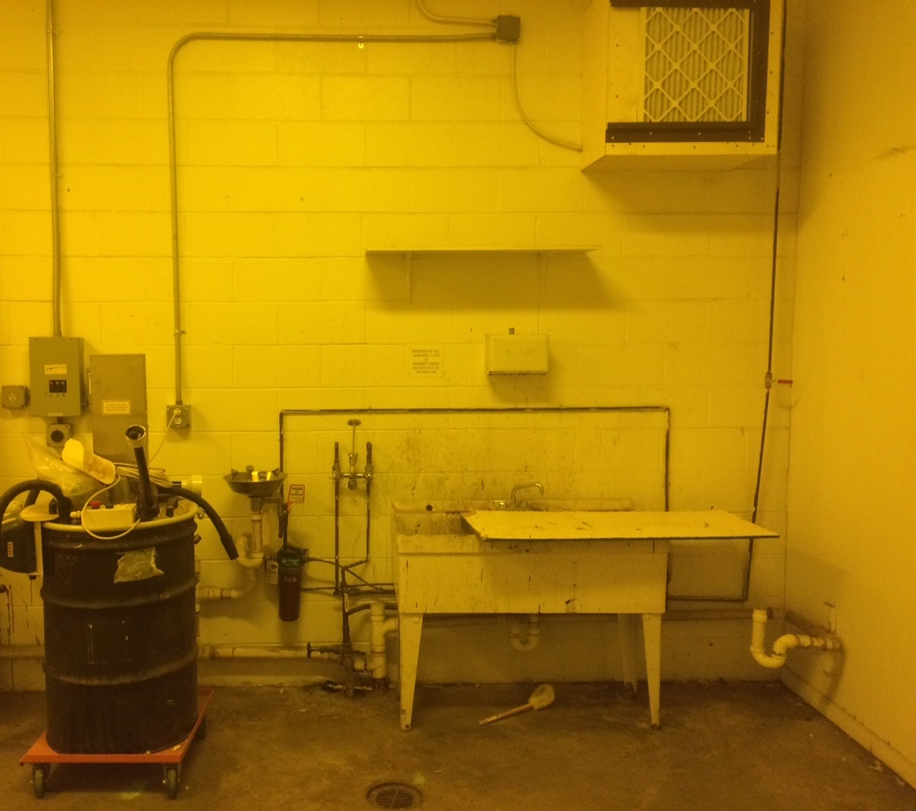

# Appendix D: Lamp Crushing Implementation Checklist

|  |  |  |  |  |  |  |  |  |  |
| --- | --- | --- | --- | --- | --- | --- | --- | --- | --- |
| Facility Name |  | EPA ID Number | | |  | | | | |
| Physical Address |  | City |  | | | State |  | Zip |  |
| Mailing Address |  | City |  | | | State |  | Zip |  |
|  | | Tel. | |  | | | | | |
| E-mail | |  | | | | | |

|  |  |  |  |  |  |
| --- | --- | --- | --- | --- | --- |
| **UWH Category (SQH or LQH)**  SQH < 5,000 kg (11,000 lbs) at facility at one time. LQH > 5,000 kg | |  |  | |  |
|  |  |  |  |  | |
|  | **YES** | **NO** | **N/A** |  | |
| Did the facility’s crushing operation exist on the date of the lamp crushing regulation’s effective date? |  |  |  |  | |
| a) If yes, did the facility notify DEQ within 30 days of the effective date of the regulations that it had an existing crushing operation? [9 VAC 20-60-1505.B.7(h)] |  |  |  | Date of notification: | |
| b) If no, did the facility submit an initial notification to VDEQ of its intent to crush lamps within 30 days of commencing the crushing operation? [9 VAC 20-60-1505.B.7(h)] |  |  |  | Date of notification: | |
| Did the notification include the following: [9 VAC 20-60-1505.B.7(h)]   * The name of the company or individual who owns the crusher; * EPA ID Number; (if applicable) * Physical location of the crushing operation; and * Name, business address and phone number of the operators and principal contact persons for the generator(s) |  |  |  |  | |

|  |  |  |  |  |  |
| --- | --- | --- | --- | --- | --- |
| **Lamp generation information** | | | | | |
| (a) Does the facility crush lamps generated: | On site | | | Off site | Both |
| The following questions are **for lamps received from off-site**. If no lamps are received from off-site, skip to question 6. | | |  |  |  |
| 1. **For lamps received from off site**, is the crushing facility under the control of the generator(s) associated with the lamp crushing facility? [9VAC20-60-1505.B.4] | | Yes | | No | NA |
| 1. If yes, describe the relationship between the generator and the crushing facility: | | | | | |
| 1. Has the generator provided a certification to VDEQ that reads as follows: [9 VAC 20-60-1505.B.4.b]   “On behalf of [insert generator facility name], I certify that this facility will send the indicated UW lamps to [insert crushing facility name], which is controlled by [insert generator facility name] and that [insert the name of either facility] has acknowledged full responsibility for the safe management of the UW lamps“; **OR**  “On behalf of [insert generator facility name] I certify that this facility will send the indicated UW lamps to [insert crushing facility name], that both facilities are under common control, and that [insert name of either facility] has acknowledged full responsibility for the safe management of the UW lamps. “  **(circle one)** | | | | | |
| 1. If the facility could not certify that it shares common control with the generator, has the facility complied with the requirements of 40 CFR§273, Subpart E for UW destination facilities? | | | | | |
| * For **lamps received from off site**, how often are lamps received at the crushing facility? | | | | | |
| * For **lamps received from off site**, list all the UW transporters that are bringing these lamps to the crushing facility (if self-transported, indicate the source and the fact that they are self-transporting): | | | | | |

|  |  |  |
| --- | --- | --- |
| **Types and Numbers of Lamps received from off site for crushing:** | | |
| **Check** | **Type** | **Approximate volume or number / month** |
|  | Fluorescent –standard mercury |  |
|  | Fluorescent – low mercury |  |
|  | UV |  |
|  | HID |  |
|  | Other (specify) |  |
|  |  |  |
| **Types and Numbers of Lamps generated on site that are crushed:** | | |
| **Check** | **Type** | **Approximate volume or number / month** |
|  | Fluorescent –standard mercury |  |
|  | Fluorescent – low mercury |  |
|  | UV |  |
|  | HID |  |
|  | Other (specify) |  |

|  |  |  |  |  |  |
| --- | --- | --- | --- | --- | --- |
| **Storage prior to processing** | | **Yes** | **No** | **NA** | **Comments** |
| Are lamps that are received from off site stored in the packing in which they were received at the crushing facility? If no, describe. | |  |  |  |  |
| Where are lamps received from off site being stored prior to crushing? | |  |  |  |  |
| * Are the containers labeled? If yes, describe. | |  |  |  |  |
| * Are containers kept closed? | |  |  |  |  |
| * Were the containers dated by the generator? | |  |  |  |  |
| (b) Are lamps generated on site stored in containers that are labeled? | |  |  |  |  |
| (c) Are lamps generated on site stored in containers that are kept closed? | |  |  |  |  |
| (d) Are lamps generated on site stored in containers that are dated? | |  |  |  |  |
| * If no, can the facility document how long the lamps have been at the facility? | |  |  |  |  |
|  | | | | | |
| **Frequency of crushing (processing) for lamps received from OFF SITE** | | | | | |
| **Check** | **Frequency** | | | | |
|  | As received | | | | |
|  | Monthly | | | | |
|  | Volume dependent (minimum required to process?) | | | | |
|  | Other frequency (describe) | | | | |

|  |  |  |
| --- | --- | --- |
| **Frequency of crushing (processing) for lamps generated ON SITE** | | |
| **Check** | **Frequency** | |
|  | As generated | |
|  | Monthly | |
|  | Volume dependent (minimum required to process?) | |
|  | Other frequency (describe) | |
|  | | |
| **UW Lamp Management** | | |
| **Check** | **Recycled:** | **Specify facility type, i.e., UWH, UWH destination facility, TSD.\*** |
|  | In Virginia |  |
|  | Outside of Virginia |  |

|  |  |  |
| --- | --- | --- |
|  | | |
| **Residue Management** | | |
| **Check** | **Recycled:** | **Specify facility type, i.e., UWH, UWH destination facility, TSD.\*** |
|  | In Virginia |  |
|  | Outside of Virginia |  |
| **Check** | **Disposed as:** | **Provide details on handling methods when disposal is occurring.^** |
|  | Hazardous waste |  |
|  | Non-hazardous waste |  |

|  |  |  |  |  |  |  |  |  |  |
| --- | --- | --- | --- | --- | --- | --- | --- | --- | --- |
|  | **Waste characterization** | | | | | | | | |
|  | **(Check)** | | | **Lamps** | |  | **(Check)** | **Crushing residues** | |
|  |  | | | TCLP | |  |  | TCLP | |
|  |  | | | Knowledge based declaration | |  |  | Knowledge based declaration | |
|  |  | | | | | |
|  | **Description of lamp crushing device:** | | | | | | | |
|  | (a) Manufacturer | | | |  | | | |
|  | (b) Model Name / Type | | | |  | | | |
|  | (c) Date of installation of crushing device? | | | |  | | | |
|  | (d) General comments | | | |  | | | |

|  |  |  |  |  |
| --- | --- | --- | --- | --- |
| **Written Procedures [9 VAC 20-60-1505.B.7(i)]** | **Yes** | **No** | **NA** | **NC** |
| Has the facility developed a written procedure specifying how to safely crush, handle and store mercury-containing lamps, including during drum changes and malfunctions? [9 VAC 20-60-1505.B.7(i)] |  |  |  |  |
| Does this written procedure include the following: |  |  |  |  |
| 1. The type of equipment to be used to crush mercury-containing lamps safely; |  |  |  |  |
| 1. Instructions for proper equipment operation; |  |  |  |  |
| 1. A schedule for maintenance of the unit in accordance with manufacturer’s specifications; |  |  |  |  |
| 1. Proper waste management practices; and |  |  |  |  |
| 1. The use of personal protective equipment including, at a minimum, safety glasses or full-face shield and cut-proof gloves. |  |  |  |  |
| Has the facility documented maintenance activities conducted in accordance with the written maintenance schedule? [9 VAC 20-60-1505.B.7(j)] |  |  |  |  |
| Is the crusher operated indoors? [9 VAC 20-60-1505.B.7(d)] |  |  |  |  |

|  |  |  |  |  |  |
| --- | --- | --- | --- | --- | --- |
|  | **Training [9 VAC 20-60-1505.B.7(k)]** | **Yes** | **No** | **NA** | **NC** |
|  | Does the facility have an annual training plan for lamp crusher operators? |  |  |  |  |
|  | Does the training plan include the following: |  |  |  |  |
|  | a) Procedures to safely crush, handle and store mercury-containing lamps? |  |  |  |  |
|  | b) Procedures to minimize the release of mercury, including during drum changes and malfunctions? |  |  |  |  |
|  | c) Procedures for dealing with emergencies, including cleaning up broken UW lamps? |  |  |  |  |
|  | d) The maintenance schedule for the crushing unit? |  |  |  |  |
|  | Did each crusher unit operator receive initial training before being allowed to operate the crusher units? |  |  |  |  |
|  | Has each operator received annual refresher training on how to operate the crusher units? |  |  |  |  |
|  | Does the facility maintain lamp crusher workers’ training records for at least three years? |  |  |  |  |

|  |  |  |  |  |
| --- | --- | --- | --- | --- |
| **Mechanical Crusher Requirements [9 VAC 20-60-1505.B.7]** | **Yes** | **No** | **NA** | **NC** |
| Is the crusher specifically designed to crush mercury-containing lamps? [9 VAC 20-60-1505.B.7(a)] |  |  |  |  |
| Is the crusher equipped with air pollution controls that capture both particulate and vapor phase mercury emissions including: [9 VAC 20-60-1505.B.7(c )] |  |  |  |  |
| 1. A HEPA filter which achieves 99.97% particle retention; |  |  |  |  |
| 1. A sorption column of sulfur-impregnated activated carbon media; |  |  |  |  |
| 1. Negative pressure maintained throughout the unit. |  |  |  |  |
| Is the crusher hermetically sealed except for air intakes and kept under negative pressure? [9 VAC 20-60-1505.B.7(b)] |  |  |  |  |
| Are air intake points on the crusher closed when the unit is not operating? [9 VAC 20-60-1505.B.7(b)] |  |  |  |  |
| Is the crusher mobile? [9 VAC 20-60-1505.B.2] |  |  |  |  |
| Is the crusher operated indoors? [9 VAC 20-60-1505.B.7(d)] |  |  |  |  |
|  |  |  |  |  |
| **Secondary Filtration Requirements [9 VAC 20-60-1505.B(7)(b)]** | **YES** | **NO** | **NA** | **NC** |
| Are UW lamp crushing operations performed in a space where the ambient air is isolated from other parts of the facility? |  |  |  |  |
| Is ambient air from the lamp crushing area filtered prior to discharging to an area outside the building? |  |  |  |  |
| Does the secondary filtration system include a HEPA filter, a sorption column, and negative pressure maintained? |  |  |  |  |
| * If **NO**, has DEQ approved an alternate design to be used in place of secondary filtration? |  |  |  |  |
| Is there a separate HVAC system in the crushing facility? Describe: |  |  |  |  |

|  |  |  |  |  |
| --- | --- | --- | --- | --- |
| **Storage of crushed UW lamps** | **Yes** | **No** | **NA** | **NC** |
| Are crushed UW lamps transferred to another drum or container after crushing? [9 VAC 20-60-1505.B.7(e )] |  |  |  |  |
| Are mercury-containing residues, filters, equipment and other solid waste placed into the same drum as the crushed UW lamps? [9 VAC 20-60-1505.B.7(l) |  |  |  |  |
| Is the drum or container storing crushed UW lamps properly sealed? [9 VAC 20-60-1505.B.7(f)] |  |  |  |  |
| Is the drum or container storing crushed UW lamps labeled as either “universal waste lamps”, “waste lamps” or “used lamps”? [9 VAC 20-60-1505.B.7(g)] |  |  |  |  |
|  |  |  |  |  |
| **Emissions Sampling, Testing and Monitoring Requirements [9 VAC 20-60-1505.B.7(n)]** | **Yes** | **No** | **NA** | **NC** |
| Did the facility performed emissions monitoring within the first month of crushing operation? [9 VAC 20-60-1505.B.7(n)(1) |  |  |  |  |
| Has the facility performed annual emissions monitoring? [(9 VAC 20-60-1505.B.7(n)(1)] |  |  |  |  |
| **Note: Handlers who crush < 2 hours/month and no more than 220 pounds/month are exempt from emissions sampling requirements.** |  |  |  |  |
| Has the facility modified or replaced the crusher since the last annual emissions monitoring? |  |  |  |  |
| * If **YES,** was emissions sampling performed within the first month of operation of the new or modified unit? |  |  |  |  |
| Type of Mercury Vapor Analyzer Used: |  |  |  |  |
| Is this unit VDOLI and OSHA approved? [9 VAC 20-60-1505.B.7(n)(2)] |  |  |  |  |
| Did the unit meet the risk-based protectiveness standards specified below:   |  |  |  | | --- | --- | --- | | Monthly Bulb Crushing Duration  (x hours/month)* | Chronic Exposure Air Emission Limit (µg/m3) | Acute Exposure Air Emission Limit (µg/m3) | | X ≥ 32 | 1.34skin µg/m3 | 300 µg/m3 | | 8 < X < 32 | 6.317skinµg/m3 | 300 µg/m3 | | X ≤ 8 | 27.375skinµg/m3 | 300 µg/m3 | | X ≤ 2  And no more than 220 lbs/month or 100 kg/month of bulbs crushed | Monitoring not required | Monitoring not required |   *Monthly crushing duration is determined based on the maximum number of hours that bulb crushing occurred in any one month over the last 12 month period. |  |  |  |  |
| For lamp crushing devices that cannot meet the criteria specified in #18, has the unit been immediately removed from service? |  |  |  |  |
| Does the facility maintain records of vapor sampler calibration and maintenance of the monitor for at least three years? |  |  |  |  |
| Does the facility keep all lamp crushing monitoring records (date, place, time of measurement) for at least three years? |  |  |  |  |
| Does the facility maintain records of the amount of time per month spent crushing lamps and quantities for at least three years? |  |  |  |  |
| **For LQG of UW**, is a financial assurance mechanism in place for final closure of the facility?[9 VAC 20-60-273.B.3(d)] |  |  |  |  |
| **For LQH of UW**, does the facility have a closure plan for closure of the lamp handling/crushing area? [9 VAC 20-60-273.B.3(d)] |  |  |  |  |

|  |  |
| --- | --- |
| **25** | **General Comments** |
|  |  |