# Hat and Black Creek Stakeholder Meeting

## Nelson Memorial Library, Lovingston

## March 1, 2023

**Figure 1.** Location map of Hat Creek and Black Creek impairment watersheds

## A Brief Re-Cap

* Hat and Black Creeks placed on Virginia’s impaired waters list in 2012 and 2014, respectively
* Both streams have impaired benthic macroinvertebrate communities (bugs that live on the bottom of the stream)
* Benthic stressor analysis study indicated that sediment is the cause of impairment in both streams, while phosphorus is an additional stressor in Black Creek
* The VA Department of Environmental Quality (DEQ) and its contractor, Wetland Studies and Solutions Inc. (WSSI) are working to complete a Total Maximum Daily Load (TMDL) study for the streams. The study will identify sources of sediment in both watersheds and phosphorus in Black Creek. We will develop estimates of how much sediment and phosphorus these sources are contributing, and the pollutant reductions needed from those sources to restore the benthic macroinvertebrate community.
* The role of the local community in this process is to review data from the study and provide feedback on pollutant sources and reduction scenarios. You can also share information about the watersheds including:
  + Historic and current land use
  + Future development
  + Previous and planned restoration projects
  + Local monitoring efforts
  + Key stakeholder groups and contacts

## Review of Hat and Black Creek Benthic Stressor Analysis

## *Evidence for sediment as a stressor*

* Seasonal trends in benthic health in both streams indicated poor health in the spring following high spring flows that typically bring greater sediment loads.
* The aquatic insect community in both streams is dominated by insects that prefer sediment while those that generally prefer clean substrate are present in far lower numbers.
* Insects that feed by filtering suspended material from the water column were dominant in both streams.
* Habitat metric scores in both impaired streams were indicative of excess sediment deposition, though these differences were more pronounced in Black Creek. Large differences in SEDIMENT, BANKS, EMBED, and RIPVEG scores were observed in Black Creek in comparison to the reference condition, all indicating excess sediment deposition on the stream bottom is occurring. While SEDIMENT and RIPVEG scores in Hat Creek were considerably lower than the reference condition, these differences were not significant. These results suggest that streambank erosion and subsequent sediment deposition are likely impacting the benthic community in both of the impaired streams.
* Streambed substrate in both impaired streams consisted of a greater proportion of sand compared to the reference condition. Black Creek also showed a large shift towards fines. Additionally, both streams had greater embeddedness values than the reference condition.
* Visual evidence of incised stream channels, steep and unstable streambanks are all indicative of a sediment stressor.

## *Evidence for phosphorus as a stressor*

* Continuous monitoring of dissolved oxygen concentrations in Black Creek in summer 2022 provided some evidence of excess nutrient loading; with over 70% of dissolved oxygen concentrations falling within Virginia’s “medium” to “high probability for stressor effects” range during the 9-day monitoring period.
* Average phosphorus concentration in Black Creek over a two year monitoring period fell within Virginia’s “high probability for stressor effects” category.
* A discharge of untreated sewage from the Nelson County STP to Black Creek was documented at the beginning of May 2021. The median TP concentration between January 2020 and April 2021 (prior to the discharge) was 0.085 mg/L, while the median concentration between May 2021 and December 2021 was 0.20 mg/L. This discharge could be a source of the increase in TP concentrations measured in the last 7 months of sampling.
* While biological community composition is not indicative of nutrient enrichment (e.g. an overabundance of scrapers), this may be due to the fact that much of the bottom substrate is unavailable for colonization and algal growth due to excess sediment deposition.

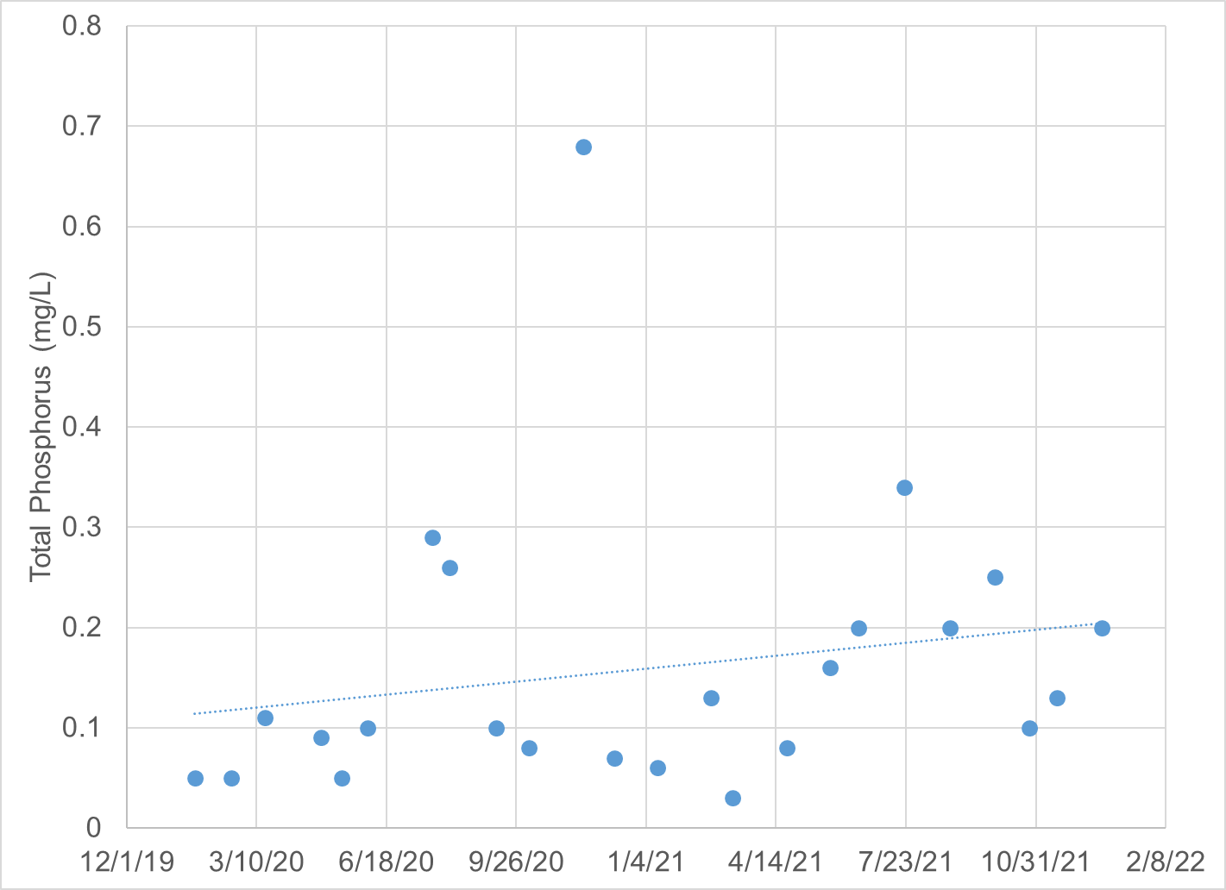

**Figure 2.** Total phosphorus concentrations in Black Creek (2-BKC000.08) measured between 2020 and 2021

## Accounting for sediment and phosphorus sources in the watersheds

In order to take advantage of monitoring data within the watersheds and develop more refined estimates of sediment loads from sources in Hat and Black Creeks and phosphorus in Black Creek, the watersheds were divided into a series of smaller subwatersheds (one in Hat Creek and three in Black Creek). Land cover data from the Virginia Geographic Information Network (VGIN, 2016) was then used to estimate acres of the various land cover categories in each subwatershed (**Table 1, Figures 3 through 5**). Estimated sediment and phosphorus loading rates could then be applied to each land cover category to estimate the amount of sediment originating from that land cover category in each subwatershed (**Tables 2 through 4, Figures 6 through 8**).

**Figure 3.** Hat Creek Watershed Land Cover Distribution Map

**Figure 4.** Black Creek WatershedLand Cover Distribution Map

**Table 1.** Hat and Black Creek WatershedLand Cover Distributions

|  |  |  |  |  |
| --- | --- | --- | --- | --- |
| ***Land Use*** | **Hat Creek** | | **Black Creek** | |
| *Acres* | *Percentage* | *Acres* | *Percentage* |
| Cropland | 278 | 2% | 25 | 1% |
| Hay | 1,130 | 9% | 483 | 15% |
| Pasture | 1,055 | 8% | 232 | 7% |
| Forest | 8,499 | 68% | 1,764 | 56% |
| Trees | 887 | 7% | 334 | 11% |
| Shrub | 22 | 0% | 8 | 0% |
| Harvested/Disturbed | 26 | 0% | 16 | 1% |
| Water | 19 | 0% | 10 | 0% |
| Wetland | 2 | 0% | 1 | 0% |
| Barren | 0 | 0% | 0 | 0% |
| Turfgrass | 366 | 3% | 163 | 5% |
| Developed, pervious | 10 | 0% | 10 | 0% |
| Developed, impervious | 147 | 1% | 104 | 3% |
| *Total* | 12,441 | 100% | 3,152 | 100% |

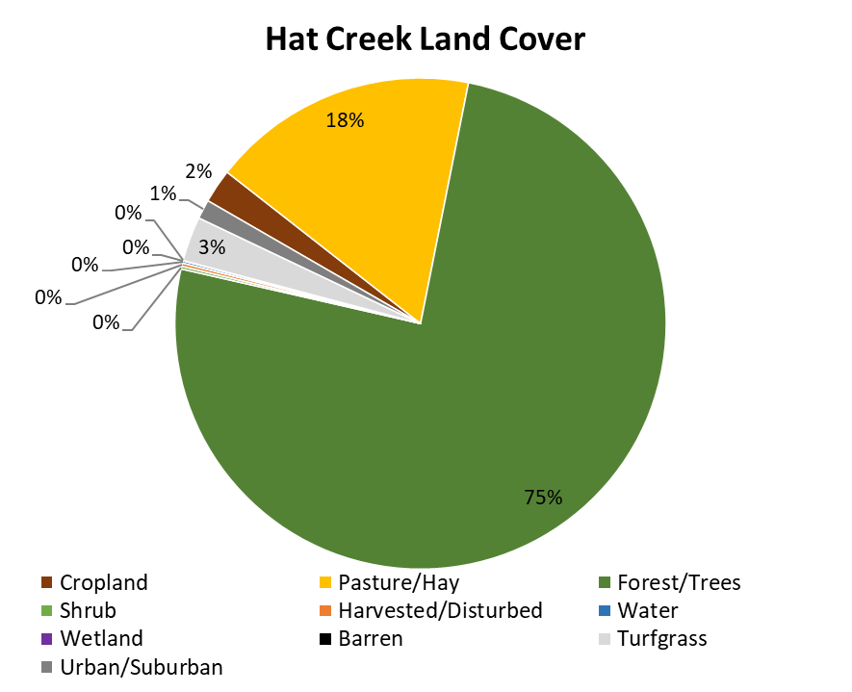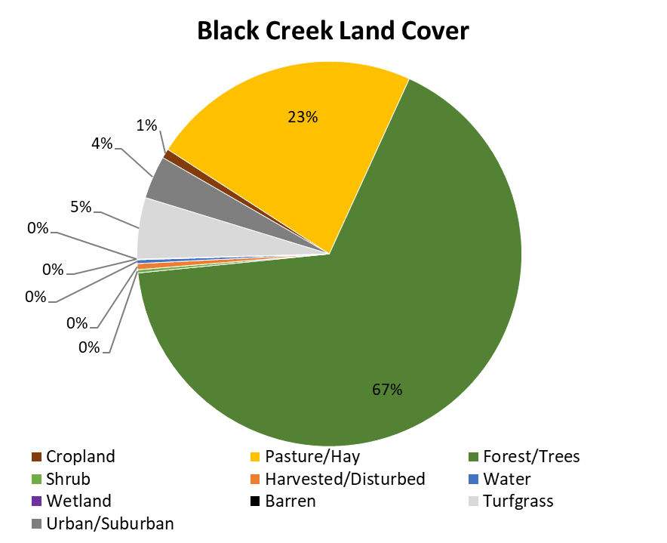

**Figure 5.** Hat and Black Creek WatershedsLand Cover Distributions

**Table 2.** Hat Creek Existing Sediment Loadings

|  |  |  |  |
| --- | --- | --- | --- |
| **Hat Creek Existing Sediment Loadings** | | | |
| **Land Cover Category** | ***Area or Length (ac or m)*** | ***TSS (lb/ac/yr or lb/m/yr)*** | ***TSS (lb/yr)*** |
| Cropland | 278 | 1,272 | 353,700 |
| Hay | 1,130 | 87 | 98,530 |
| Pasture | 1,055 | 1,082 | 1,142,000 |
| Forest | 8,499 | 43 | 364,300 |
| Trees | 887 | 65 | 57,450 |
| Shrub | 22 | 231 | 5,071 |
| Harvested/Disturbed | 26 | 677 | 17,610 |
| Water | 19 | - | - |
| Wetland | 2 | 88 | 176 |
| Barren | 0 | - | - |
| Turfgrass | 366 | 77 | 28,360 |
| Developed, pervious | 10 | 218 | 2,182 |
| Developed, impervious | 147 | 620 | 91,180 |
| Streambank | 37,516 | 7 | 275,000 |
| *Total* | *-* | *-* | *2,436,000* |

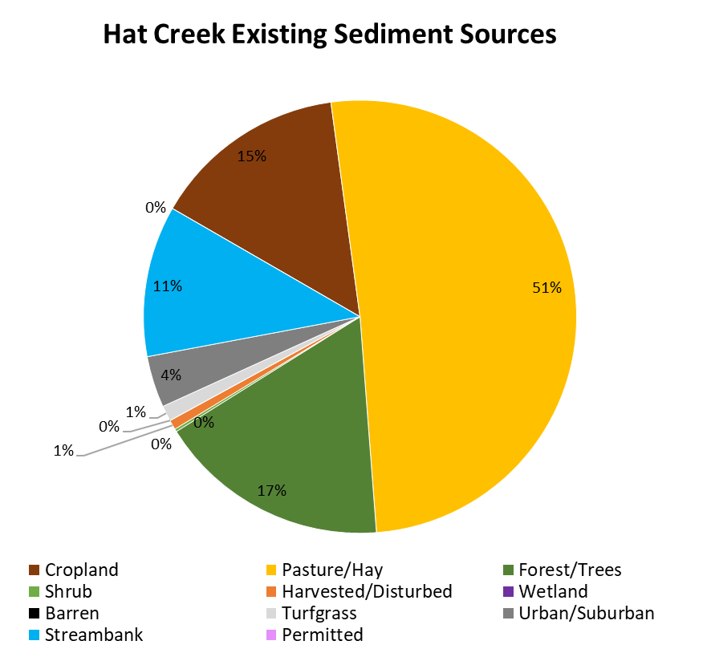

**Figure 6.** Hat Creek Existing Sediment Sources

**Table 3.** Black Creek Existing Sediment Loadings

|  |  |  |  |
| --- | --- | --- | --- |
| **Black Creek Existing Sediment Loadings** | | | |
| **Land Cover Category** | ***Area or Length (ac or m)*** | ***TSS***  ***(lb/ac/yr or lb/m/yr)*** | ***TSS (lb/yr)*** |
| Cropland | 25 | 1,327 | 33,170 |
| Hay | 483 | 123 | 59,440 |
| Pasture | 232 | 1,523 | 353,300 |
| Forest | 1,764 | 49 | 87,140 |
| Trees | 334 | 97 | 32,370 |
| Shrub | 8 | 333 | 2,661 |
| Harvested/Disturbed | 16 | 874 | 13,980 |
| Water | 10 | - | - |
| Wetland | 1 | 453 | 453 |
| Barren | 0 | - | 4,946 |
| Turfgrass | 163 | 93 | 15,230 |
| Developed, pervious | 10 | 178 | 1,782 |
| Developed, impervious | 104 | 677 | 70,410 |
| Streambank | 8,830 | 2 | 21,450 |
| *Total* | *-* | *-* | *696,300* |

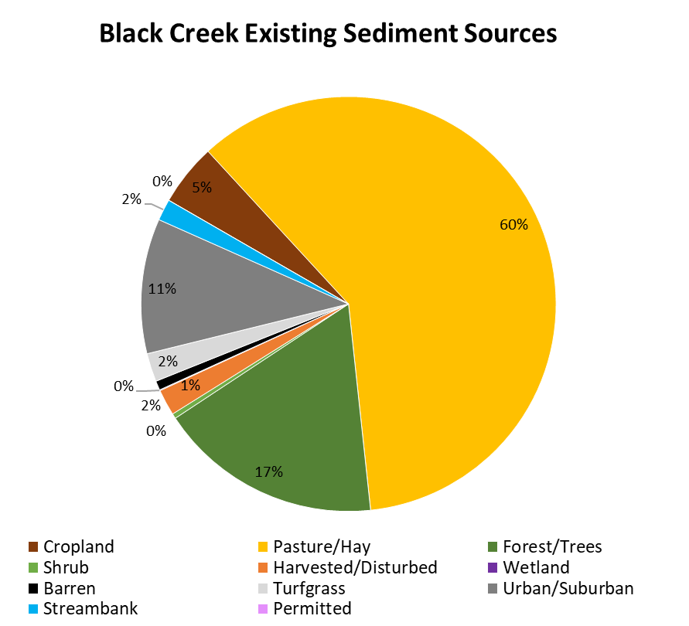

**Figure 7.** Black Creek Existing Sediment Sources

**Table 4.** Black Creek Existing Phosphorus Loadings

|  |  |  |  |
| --- | --- | --- | --- |
| **Black Creek Existing Phosphorus Loadings** | | | |
| **Land Cover Category** | ***Area or Length (ac or m)*** | ***TP (lb/ac/yr or lb/m/yr)*** | ***TP (lb/yr)*** |
| Cropland | 25 | 1.07 | 27 |
| Hay | 483 | 0.39 | 189 |
| Pasture | 232 | 0.58 | 135 |
| Forest | 1764 | 0.01 | 18 |
| Trees | 334 | 0.03 | 9 |
| Shrub | 8 | 0.05 | 0 |
| Harvested/Disturbed | 16 | 0.16 | 3 |
| Water | 10 | - | - |
| Wetland | 1 | 0.07 | 0 |
| Barren | 0 | - | 1 |
| Turfgrass | 163 | 0.17 | 27 |
| Developed, pervious | 10 | 0.12 | 1 |
| Developed, impervious | 104 | 1.49 | 155 |
| Groundwater | - | - | 169 |
| Septic | - | - | 2 |
| Streambank | 8,830 | 0.001 | 8 |
| *Total* | *-* | *-* | *742* |

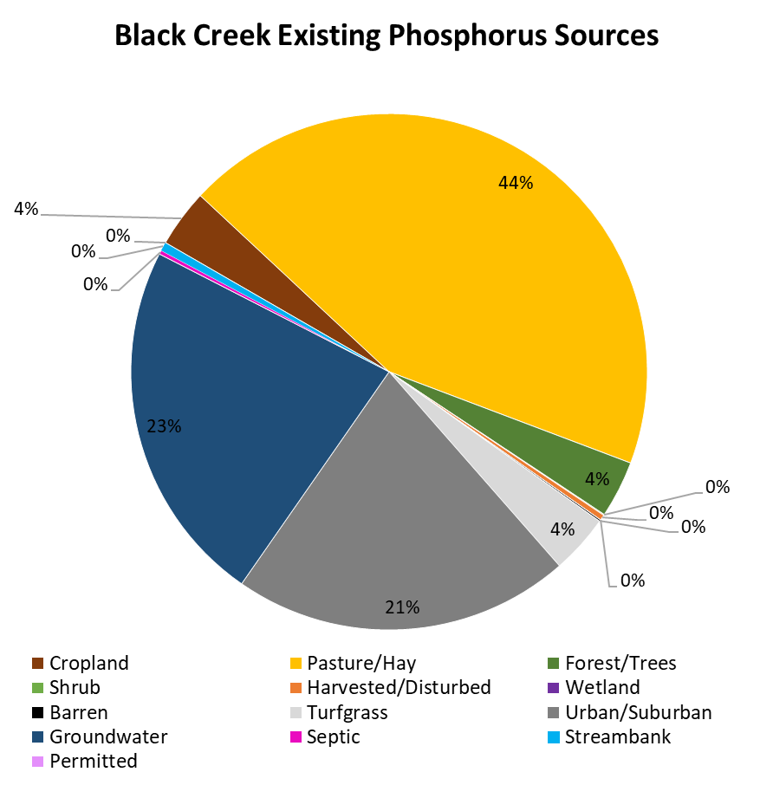

**Figure 8.** Black Creek Existing Sediment Sources

## Permitted sediment and phosphorus sources

**Construction Permits**

Permitted (point) sources of sediment and phosphorus were also accounted for in the TMDL study. Typically, we account for sediment and phosphorus inputs from development by reviewing construction sites covered under a Virginia Stormwater Management Program (VSMP) permit over a 10 year window of time. This allows us to develop an annual average acreage that under construction. However, there have been no permits issued for construction in the project area through this program within the past 10 years. Therefore, we need to develop an estimate for average annual acres to be disturbed within the watersheds and allocate the expected sediment and phosphorus load to this permitted source so that permits may be issued for construction in the future.

Factors to consider:

* Known plans for future development?
* County comprehensive plan
* Extent of smaller construction projects
* Local enforcement of erosion and sediment control standards

**Other permitted sources**

Additionally, there is one Individual VA Pollution Discharge Elimination System (VPDES) permit in the Black Creek watershed and one Domestic Sewage Discharge general permit in the Hat Creek watershed (**Table 5**).

**Table 5.** Permitted phosphorus and sediment sources in the Hat and Black Creek watersheds.

| **Watershed** | **Permit no.** | **Facility Name** | **Existing sediment load (lbs/yr)** | **Existing phosphorus load (lbs/yr)** |
| --- | --- | --- | --- | --- |
| Hat Creek | VAG408483 | Private Residence | 91.44 | - |
| Black Creek | VA0089729 | Nelson County STP | 1,626.5 | 1,283.5 |

## Setting sediment and phosphorus reduction targets

A key component of the TMDL study for Hat and Black Creeks is the establishment of pollutant reduction goals. While Virginia has water quality criteria that regulate the concentration of some pollutants in our waterways, there are no such criteria for sediment or phosphorus. Therefore, an alternative method must be used to determine the water quality targets for sediment and phosphorus in the TMDL study.

## *The All Forest Load Multiplier (AllForX) Endpoint Approach*

The AllForX approach has been used to establish sediment and nutrient reduction targets in many TMDLs studies completed in Virginia since 2014. AllForX is the ratio of the simulated pollutant load under existing conditions to the pollutant load from an all-forest simulated condition for the same watershed (see illustration in **Figure 9**). In other words, AllForX is an indication of how much higher current sediment or phosphorus loads are above an undeveloped condition.

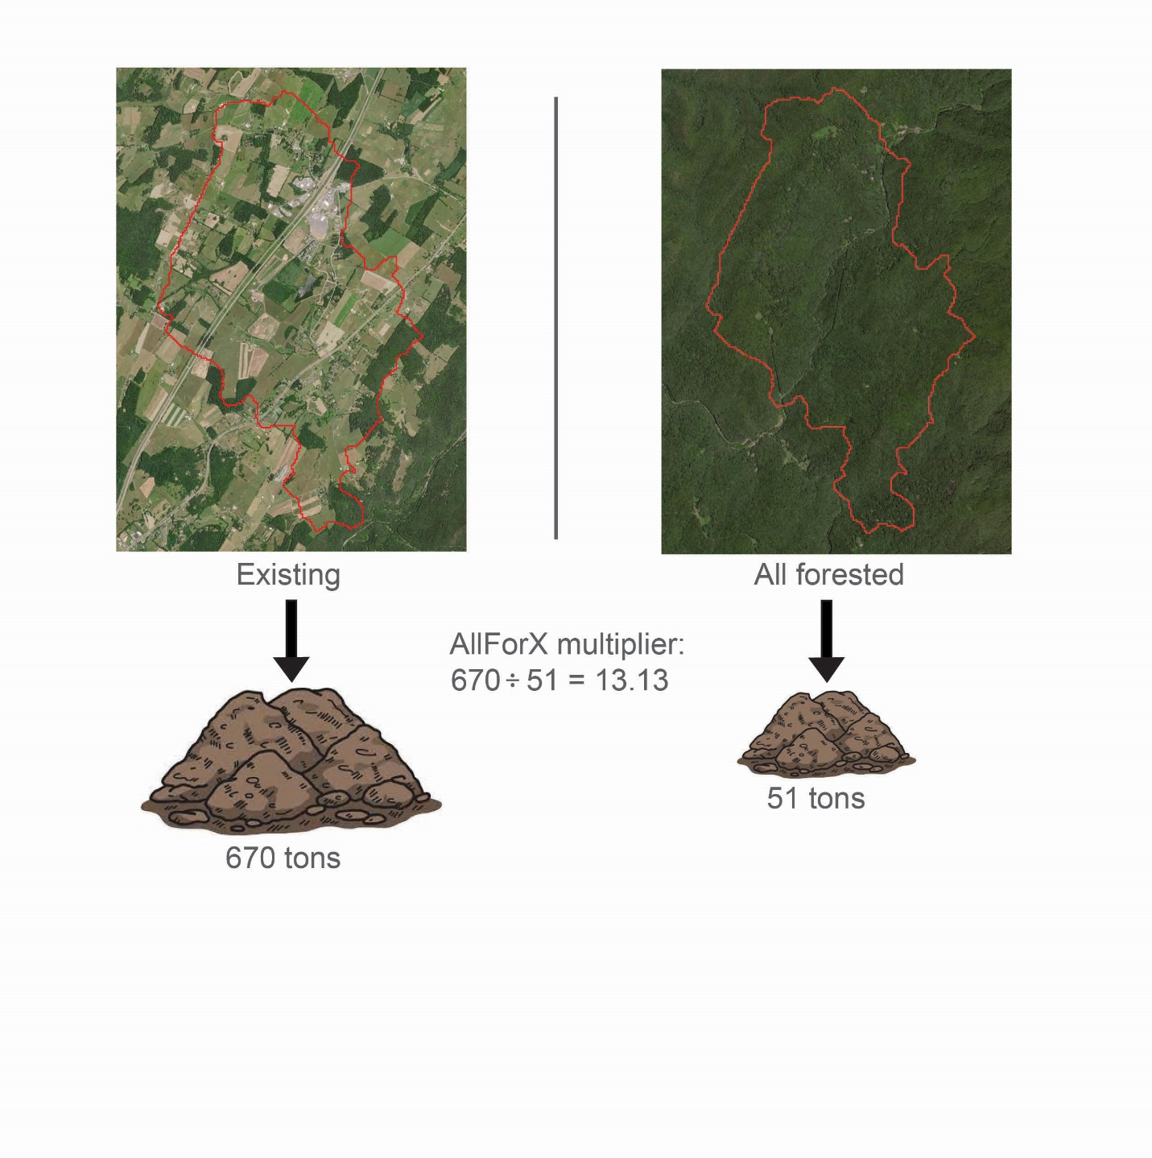

**Figure 9.** Illustration of Establishment of AllForX Multiplier for a watershed

These multipliers are calculated for the TMDL watersheds as well as a group of unimpaired and impaired comparison watersheds. A regression is then developed between the average Virginia Stream Condition Index (VSCI) scores at each TMDL or comparison monitoring station and the corresponding AllForX ratio for the watersheds contributing to that monitoring site. This regression can be used to quantify the value of AllForX threshold that corresponds to the benthic health threshold (VSCI < 60) as shown in the preliminary regression in **Figure 10**. The pollutant TMDL load can then be calculated by applying the AllForX threshold ratio to the all-forest simulated pollutant load of the TMDL study watershed.

**Figure 10.** Preliminary TSS AllForX Regression Developed, Resulting in a TSS AllForX Target Ratio of 3.3.

## *So what does this figure tell us?*

If we can reduce the sediment load to Black Creek by 18.6%, we will hit the AllForX target ratio of 3.3, which is the point at which average stream health scores typically fall above 60 (the threshold for impairment).

A separate regression was developed for Hat Creek to account for unique characteristics of the watershed. Rather than using average VSCI scores for monitoring stations included in the regression, *the 33rd percentile of scores for the past 10 years was used.*

The results of the benthic stressor analysis for Hat Creek indicate a borderline impairment, with VSCI scores repeatedly falling above and below the threshold of 60. As a result, using average VSCI scores from other streams to develop the regression indicated that no reduction in sediment was necessary in Hat Creek. Given the findings of the benthic stressor analysis, this is not the case.

In addition to the borderline nature of the impairment, the soils and topography of the Hat Creek watershed, and its past history of landslides must also be considered. An ongoing study by the VA Department of Energy includes mapping of historic landslides in Nelson and Albemarle Counties. Mapping of the western portion of the counties has been completed and includes a portion of the Hat Creek watershed. The study has shown that Hat Creek experienced a large number of landslides during Hurricane Camille. As a result of these landslides, a large amount of unconsolidated material, including sediment, was deposited in Hat Creek’s floodplain. As the stream meanders through its floodplain, this material is susceptible to erosion, adding sediment to the stream. While we must consider the current potential for erosion resulting from these historic sediment deposits, we must also consider the possibility of future landslides in the area and additional movement of material into the floodplain. Consequently, a conservative approach to setting sediment reduction goals in Hat Creek is necessary.

With VSCI scores in Hat Creek falling both above and below the impairment listing threshold, using the 33rd percentile also accounts for the fact that DEQ recommends two consecutive years of benthic monitoring above the VSCI threshold of 60 before delisting the stream as unimpaired. Based on a 6-yr assessment window and typical DEQ monitoring every 2 years, no more than a third (33%) of benthic scores could be below the threshold of 60 and meet the qualifications for delisting. Based on the 33rd percentile of results achieving a VSCI score of 60, the target AllForX ratio for Hat Creek was determined to be 3.1. This AllForX target of 3.1 can then be used to determine an acceptable sediment load for Hat Creek.

A separate regression was developed for phosphorus loads, using the same methodology as the initial TSS regression, using the average VSCI scores while substituting the AllForX ratios of existing to all-forested phosphorus estimates. The target TP AllForX ratio was determined to be 2.9. The values for the TMDL watershed monitoring stations used in these efforts are presented in **Table 6**. Preliminary reductions for each TMDL are presented in **Tables 7 and 8**.

**Table 6**. Summary of VSCI data and Model Data Used in AllForX Regression Development.

|  |  |  |  |  |  |  |  |  |
| --- | --- | --- | --- | --- | --- | --- | --- | --- |
| **Station ID** | **Average VSCI** | **33rd % VSCI** | **TSS (t/yr)** | **TSS All-Forested (t/yr)** | **TSS AllForX Ratio** | **TP (kg/yr)** | **TP All-Forested (kg/yr)** | **TP AllForX Ratio** |
| 2-BKC000.08 | 54.36 | 53.98 | 311.30 | 75.99 | 4.10 | 335.09 | 97.67 | 3.43 |
| 2-HAT000.14 | 58.67 | 52.26 | 1,104.71 | 365.69 | 3.02 | 1,078.84 | 397.80 | 2.71 |

**Table 7**. Preliminary Target Sediment Reductions

|  |  |  |  |  |
| --- | --- | --- | --- | --- |
| **Impaired Stream** | **TSS Existing** (lb/yr) | **TSS AllForest** (lb/yr) | **TSS Target** (lb/yr) | **Estimated % Reduction** |
| Black Creek | 686,283 | 167,529 | 558,778 | 18.6% |
| Hat Creek | 2,435,465 | 806,207 | 2,495,973 | -2.5% |

**Table 8**. Preliminary Target Phosphorus Reductions

|  |  |  |  |  |
| --- | --- | --- | --- | --- |
| **Impaired Stream** | **TP Existing** (lb/yr) | **TP AllForest** (lb/yr) | **TP Target** (lb/yr) | **Estimated % Reduction** |
| Black Creek | 742 | 219 | 635 | 14.4% |

## What’s next?

## *Developing Allocation Scenarios*

We will develop a series of allocation scenarios for sediment and phosphorus in the watersheds. The scenarios will identify reductions in sediment and phosphorus needed from different sources (e.g. pasture, turfgrass, urban/suburban land). Stakeholders will be offered an opportunity to review these scenarios and select an option that makes sense for the community.

## Contact Information

Nesha McRae, VA DEQ  
[Nesha.mcrae@deq.virginia.gov](mailto:Nesha.mcrae@deq.virginia.gov)  
540-574-7850

Katie Shoemaker, Wetland Studies and Solutions  
[kshoemaker@wetlands.com](mailto:kshoemaker@wetlands.com)  
540-953-0170 ext. 4318

Stephen Dombroski, Wetland Studies and Solutions

[sdombroski@wetlands.com](mailto:sdombroski@wetlands.com)

804-442-3330