Stressor Identification Analysis for Hat and Black Creeks in Nelson County, Virginia

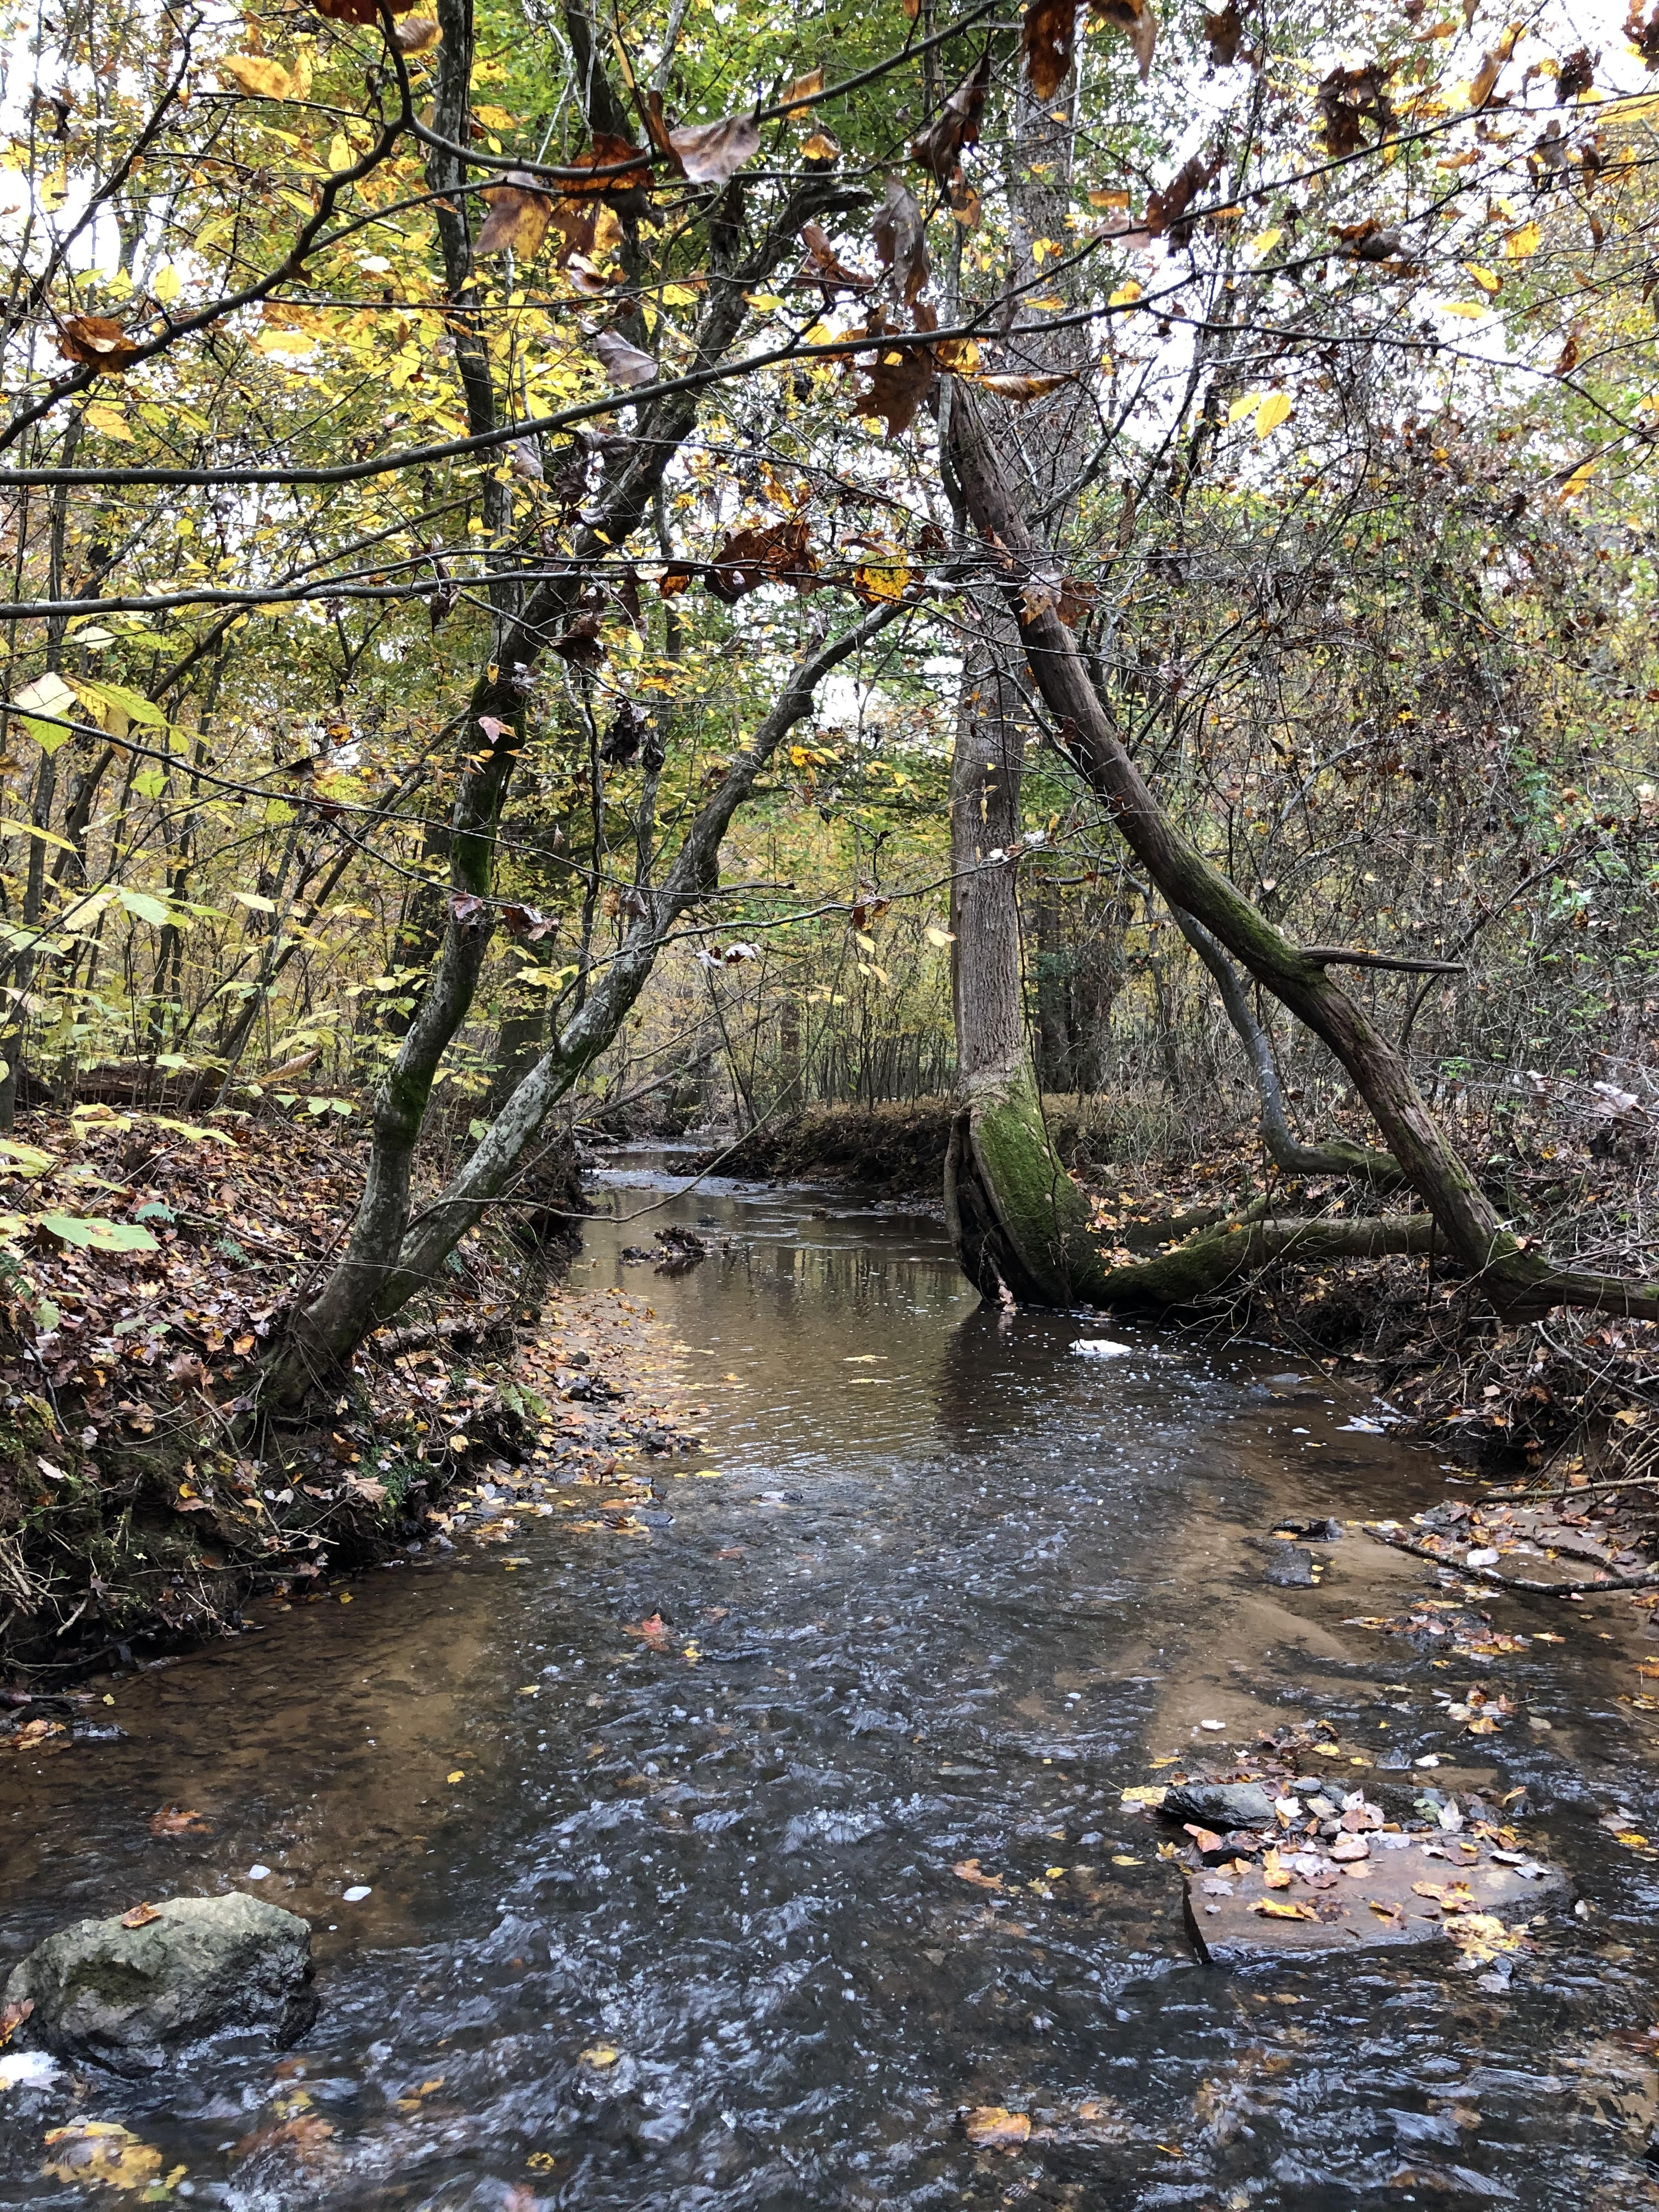
Prepared by:
Virginia Department of
Environmental Quality

August 30, 2022



Table of Contents
Chapter 1: Stressor Identification Analysis 6
1.1. Overview 6
1.2. Biological, Physical, and Chemical Data 6
1.2.1. Benthic Assessments 8
1.2.1.1. Temporal Trends in Benthic Data 10
1.2.1.2. Analysis of Benthic Metrics 12
1.2.1.3. Analysis of Community Composition 15
1.2.1.4. Biological Condition Gradient Analysis 18
1.2.1.5. Analysis of Functional Feeding Groups 21
1.2.2. Habitat Assessment 22
1.2.2.1. Relative Bed Stability 27
1.2.3. Land Use Assessment 30
1.2.4. Water Quality Data 33
1.2.4.1. Temperature 33
1.2.4.2. pH 35
1.2.4.3. Dissolved Oxygen 36
1.2.4.4. Conductivity and Dissolved Solids 40
1.2.4.5. Dissolved Ions 42
1.2.4.6. Nutrients 45
1.2.4.7. Water Quality Regressions 51
1.3. Causal Analysis 51
1.3.1. Temperature 55
1.3.2. pH 55
1.3.3. Dissolved Oxygen 57
1.3.4. Conductivity and Total Dissolved Solids 57
1.3.5. Dissolved Ions – Sodium 60
1.3.6. Dissolved Ions – Sulfate 60
1.3.7. Dissolved Ions – Chloride 60
1.3.8. Dissolved Ions – Potassium 61
1.3.9. Suspended Solids and Deposited Sediment 64
1.3.10. Nitrogen 68
1.3.11. Phosphorus 68
1.4. Causal Analysis Summary 73
1.4.1. Probable Stressors 73
1.4.2. Contributing Factors 74
1.4.2.1. Historic Land Disturbance 74
1.4.2.2. Historic Dams 75
1.4.2.3. Existing Impoundments 75
1.4.3. Causal Pathways 76
1.4.4. TMDL Target Pollutants 80
1.5. References 80

List of Figures
Figure 1-1. Ambient and biological monitoring stations in the Hat and Black Creek watersheds. 7
Figure 1-2. Average stream condition index (SCI) scores through 2021 for benthic stations in Hat and Black Creeks. 9
Figure 1-3. Temporal trends of benthic stream condition index (SCI) scores in the Hat (upper graph) and Black Creek (lower graph) watersheds. 11
Figure 1-4 Hat and Black Creek stream condition index scores (spring and fall). Whiskers indicate the range, boxes indicate the inter-quartile range, lines indicate the median, and white markers indicate the average. 12
Figure 1-5. Metric scores comprising stream condition index (SCI) scores in Hat and Black Creeks. * indicates that the metric was significantly different (alpha = 0.05) from the benthic reference score (Roach River and Long Island Creek). 14
Figure 1-6. Benthic community structure (by order) in Black Creek in comparison with reference stream Long Island Creek. 17
Figure 1-7. Benthic community structure (by order) in Hat Creek in comparison with reference stream and Roach River. 18
Figure 1-8. Functional feeding group composition in benthic communities in Hat and Black Creeks compared to Roach River and Long Island Creek (reference streams). 22
Figure 1-9. Total habitat scores for Hat and Black Creeks. Colors represent the probability that data within that range would be responsible for causing stress. Asterisks indicate scores significantly different from the reference conditions (α=0.05). 24
Figure 1-10. Comparison of total habitat scores with SCI scores in Hat and Black Creeks. Red line indicates impairment threshold (SCI = 60). 24
Figure 1-11. Habitat metric scores for Hat and Black Creeks. Metrics with a * are statistically different from the reference site (α=0.05). 26
Figure 1-12. Hat and Black Creek bottom substrate comparisons with references (Spruce and Long Island Creeks, respectively). 29
Figure 1-13. Log relative bed stability index (LRBS) scores for Hat and Black Creeks in comparison with reference conditions (Spruce and Long Island Creeks, respectively). 30
Figure 1-14. Temperature measured in Hat and Black Creeks. Whiskers indicate the range, boxes indicate the inter-quartile range, lines indicate the median, and white markers indicate the average. Streams with a * are statistically different from the reference sites. 34
Figure 1-15. Diurnal temperatures in Black Creek (2-BCK000.08). The red line indicates the water quality standard for temperature. 34
Figure 1-16. pH measured in Hat and Black Creeks. Whiskers indicate the range, boxes indicate the inter-quartile range, lines indicate the median, and white markers indicate the average. Streams with a * are statistically different from the reference sites. Colors represent the probability that data within that range would be responsible for causing stress. 35
Figure 1-17. Diurnal pH in Black Creek in spring 2022. Colors represent the probability that data within that range would be responsible for causing stress. 36
Figure 1-18. Dissolved oxygen measured in Hat and Black Creeks. Whiskers indicate the range, boxes indicate the inter-quartile range, lines indicate the median, and white markers indicate the average. Streams with a * are statistically different from the reference sites. Colors represent the probability that data within that range would be responsible for causing stress. The red line indicates the water quality standard. 37
Figure 1-19. Diurnal dissolved oxygen and corresponding water temperatures collected from Black Creek (2-BCK000.08) in 2022. Colors represent the probability that dissolved oxygen data within that range would be responsible for causing stress (temperature probability thresholds are not shown). 39
Figure 1-20. Diurnal oxygen saturation in Black Creek. 40
Figure 1-21. Specific conductance measured in Hat and Black Creeks. Whiskers indicate the range, boxes indicate the inter-quartile range, lines indicate the median, and white markers indicate the average. Streams with a * are statistically different from the reference sites. Colors represent the probability that data within that range would be responsible for causing stress. 41
Figure 1-22. Diurnal measurements of specific conductance in Black Creek in 2022. 41
Figure 1-23. Total dissolved solids measured in Hat and Black Creeks. Whiskers indicate the range, boxes indicate the inter-quartile range, lines indicate the median, and white markers indicate the average. Colors represent the probability that data within that range would be responsible for causing stress. 42
Figure 1-24. Dissolved ions measured in Hat and Black. Whiskers indicate the range, boxes indicate the inter-quartile range, lines indicate the median, and white markers indicate the average. Colors represent the probability that data within that range would be responsible for causing stress. 44
Figure 1-25. Dissolved potassium concentrations in Black Creek (2-BKC000.08) measured between 2020 and 2021. 45
Figure 1-26. Total nitrogen concentrations in Hat and Black Creeks. Whiskers indicate the range, boxes indicate the inter-quartile range, lines indicate the median, and white markers indicate the average. Colors represent the probability that data within that range would be responsible for causing stress. 48
Figure 1-27. Total phosphorus concentrations in Hat and Black Creeks. Whiskers indicate the range, boxes indicate the inter-quartile range, lines indicate the median, and white markers indicate the average. Colors represent the probability that data within that range would be responsible for causing stress. 48
Figure 1-28 Total phosphorus concentrations in Black Creek (2-BKC000.08) measured between 2020 and 2021. 49
Figure 1-29 Discharge at USGS gage on Tye River near Lovingston, VA in 2020 and 2021 versus total phosphorus concentrations in Black Creek (2-BKC000.08). 49
Figure 1-30. Reported monthly average discharge rates for the Nelson County STP and total phosphorus concentrations in Black Creek (2020-2021). 50
Figure 1-31. Conceptual model for the causal pathway of sediment impacts on benthic macroinvertebrates. 78
Figure 1-32 Conceptual model for causal pathway for phosphorus impacts to benthic macroinvertebrates. 79

List of Tables
Table 1-1. Benthic and chemical monitoring data used in the Hat and Black Creek stressor analysis. 8
Table 1-2. Benthic scores in the Hat and Black Creek watersheds. 9
Table 1-3. Predominant taxa in Hat and Black Creeks compared with reference streams. 16
Table 1-4. Mid-Atlantic biological condition gradient attributes and stressors evaluated 19
Table 1-5. Weighted average biological condition gradient scores by stressor for Hat and Black Creeks. 20
Table 1-6. Biological condition gradient scores by stressor for predominant taxa in Hat and Black Creeks. 20
Table 1-7. Total habitat scores for Hat and Black Creeks. 23
Table 1-8. Relative bed stability analysis for Hat and Black Creeks. 28
Table 1-9. Land use upstream from each benthic monitoring station in the Black and Hat Creek watersheds. 32
Table 1-10. Regression relationship between stream condition index scores and watershed land uses. 32
Table 1-11. Regression relationship between water quality parameters and stream condition index (SCI) scores. 51
Table 1-12. Lines of evidence used in the causal analysis approach. 53
Table 1-13. Scoring criteria used to evaluate candidate stressors. 54
Table 1-14. Scheme for classifying candidate causes based on causal analysis. 54
Table 1-15. Causal analysis results for temperature as a stressor. 56
Table 1-16. Causal analysis results for pH as a stressor. 56
Table 1-17. Causal analysis results for dissolved oxygen as a stressor. 58
Table 1-18. Causal analysis results for conductivity and total dissolved solids as a stressor. 59
Table 1-19. Causal analysis results for dissolved sodium as a stressor. 62
Table 1-20. Causal analysis results for dissolved sulfate as a stressor. 62
Table 1-21. Causal analysis results for dissolved chloride as a stressor. 63
Table 1-22 Causal analysis results for dissolved potassium as a stressor. 63
Table 1-23. Causal analysis results for sediment as a stressor. 66
Table 1-24. Causal analysis results for nitrogen as a stressor. 70
Table 1-25. Causal analysis results for phosphorus as a stressor. 71
Table 1-26. Total causal analysis scores by stream and by candidate stressor. Green indicates non-stressors, orange indicates possible stressors, and red indicates probable stressors. 74
Table 1-27. Non-stressors, possible stressors, and probable stressors in Hat and Black Creeks. 74

Stressor Identification Analysis

Overview
Benthic impairments are based on biological assessments of the benthic community. These biological assessments are effective at determining whether a water body is impaired or not, but they do not provide information on the stressor or source causing the impairment. To determine the cause of the impairment, a stressor identification analysis must be conducted. The Virginia Department of Environmental Quality (DEQ) completed stressor identification analyses for Hat and Black Creeks according to the Environmental Protection Agency’s Stressor Identification Guidance Document (USEPA, 2000a). The first step in the stressor identification analysis is to list potential candidate stressors. DEQ identified these from the listing information, monitoring data, scientific literature, and historic information.
The next step is to analyze all of the available evidence to support or eliminate potential candidate stressors. In this step, the Causal Analysis/Diagnosis Decision Information System (CADDIS) was used (USEPA, 2018). The CADDIS approach provides guidance on evaluating various lines of evidence to determine the cause of biological impairments. In the case of the Hat and Black Creek impairments, available physical, chemical, and biological data collected throughout the watershed, published water quality standards and threshold values, and available literature from other cases were used to investigate the potential causes of impairment in each stream. Based on the weight of evidence supporting each potential candidate, stressors were then separated into the following categories: non-stressor(s), possible stressor(s), and probable stressor(s).
Once the most probable stressor was identified, a conceptual model was developed to describe the causal pathways linking pollutant sources to the probable stressors and mechanisms of impairment. The pathways in the conceptual model were then evaluated to determine if the existing data supported those mechanisms for producing the impairment.

Biological, Physical, and Chemical Data
For the stressor identification analysis, DEQ used biological, physical, and chemical data from monitoring stations within the Hat and Black Creek watersheds (Figure 1-1). DEQ operates four (4) benthic (biological) and two (2) water quality (ambient) monitoring stations within the watersheds. Two of these stations are co-located benthic and water quality stations.
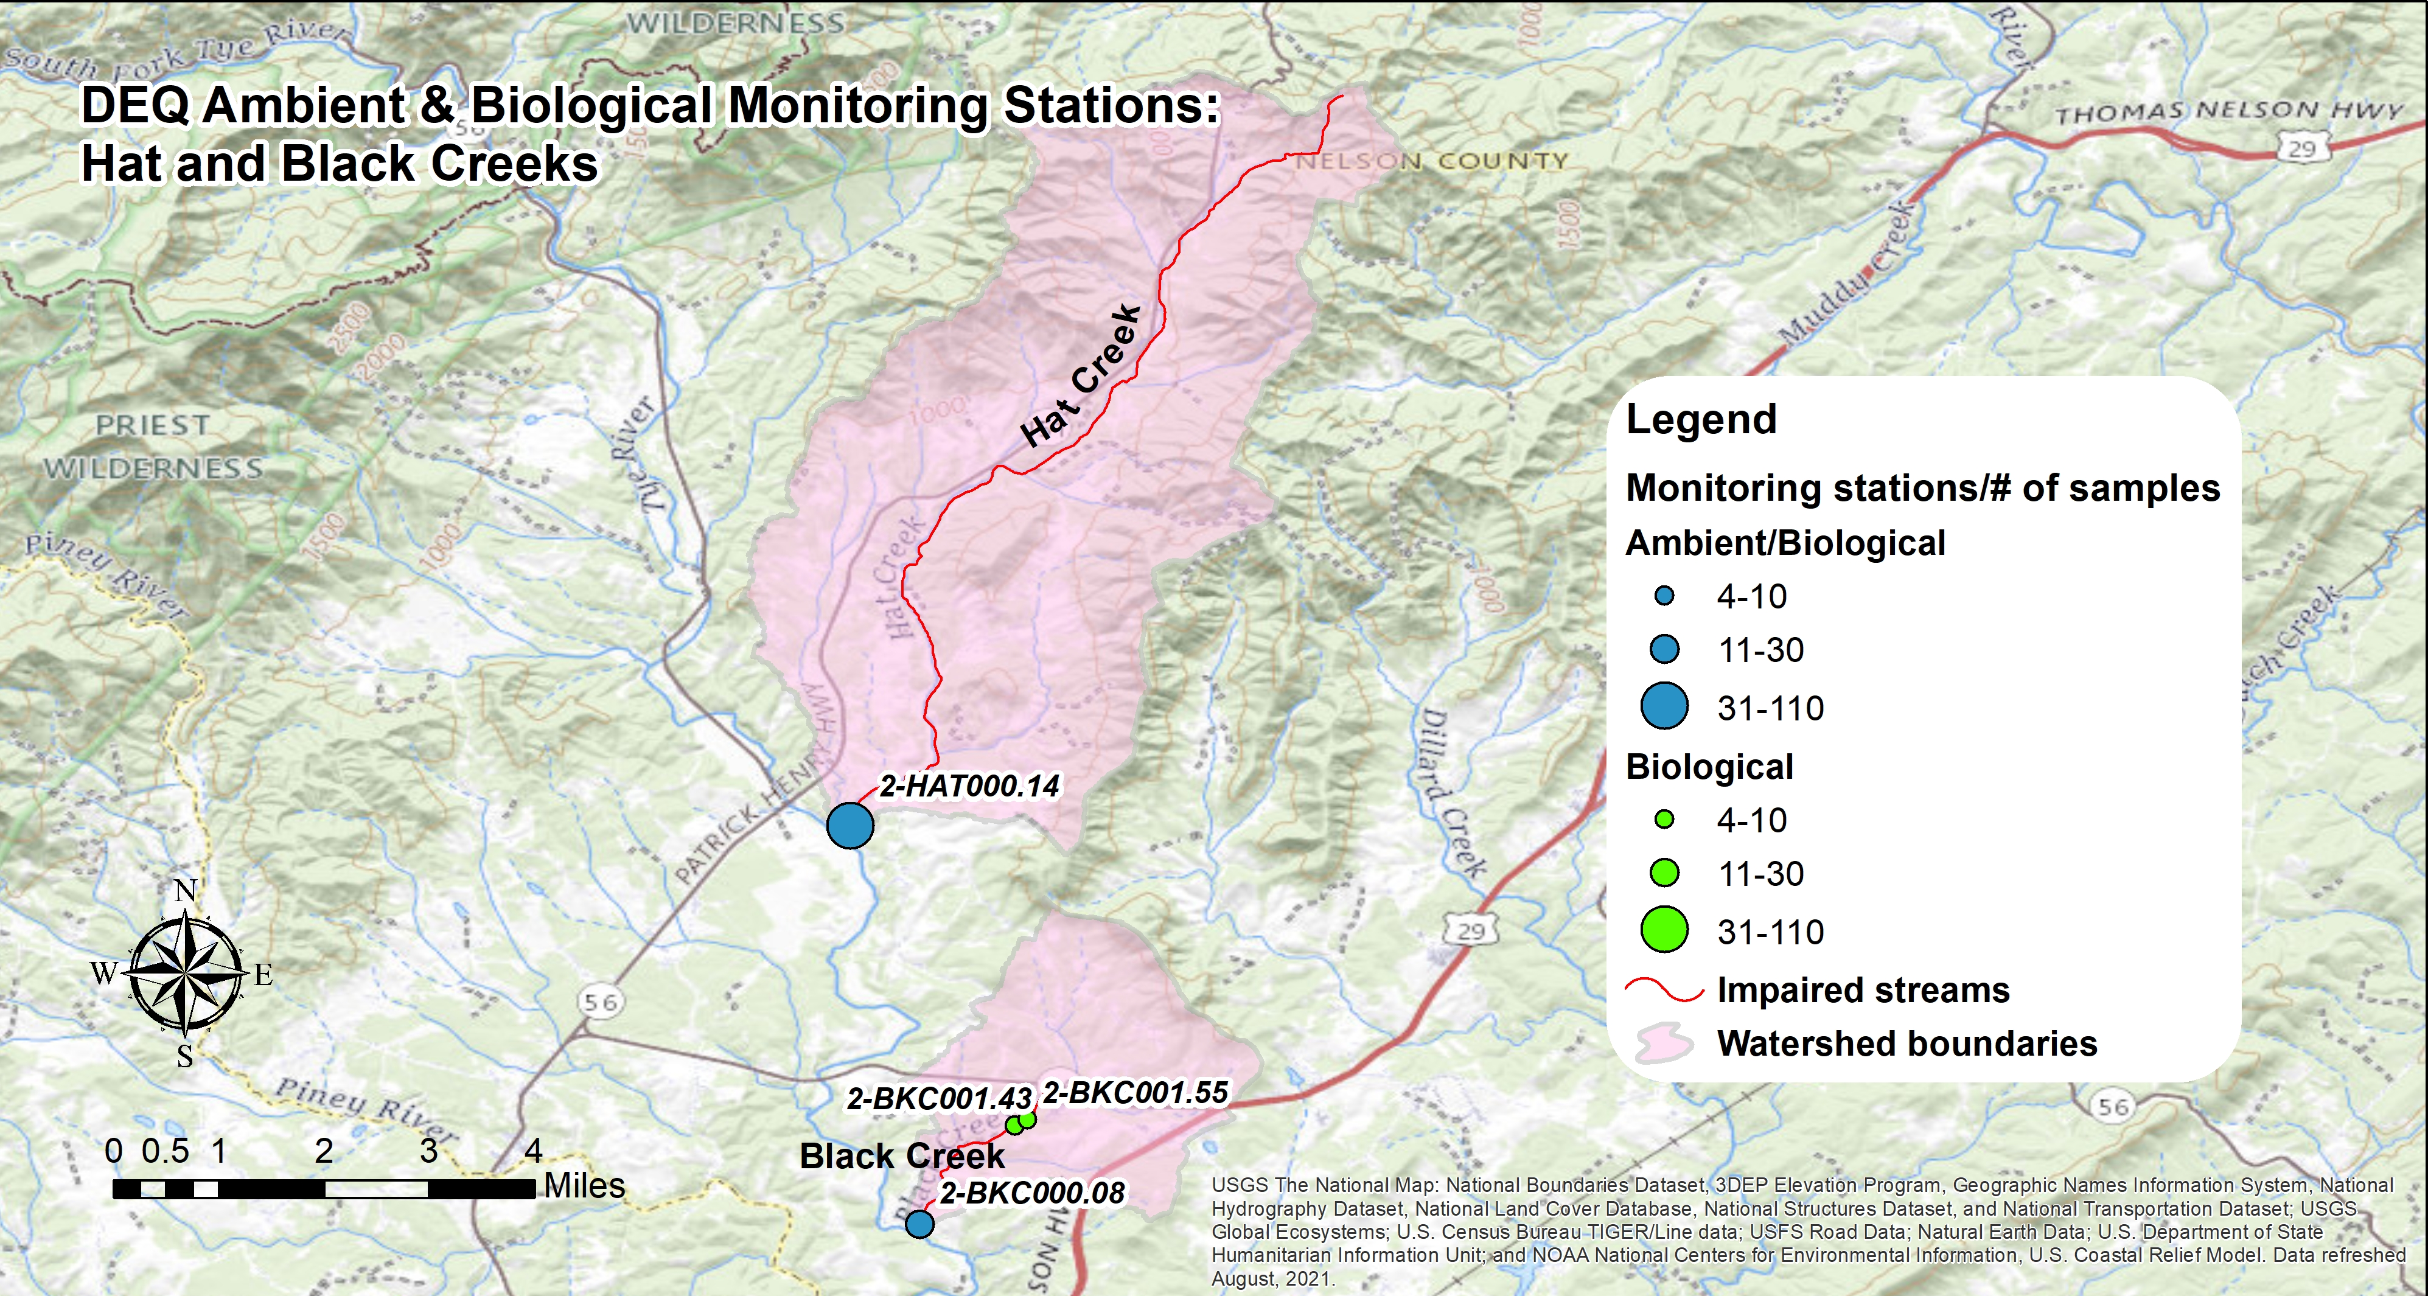
Figure 1-1. Ambient and biological monitoring stations in the Hat and Black Creek watersheds.
Table 1-1 shows the number of samples and the period of time over which individual stations were monitored. For benthic monitoring stations, data include taxonomic identification (family or genus level) and counts of benthic macroinvertebrates collected, eight calculated benthic metrics, stream condition index scores (SCI), and visual habitat assessment scores. For water quality monitoring stations, data include results for various physical and chemical parameters. The data analysis window was limited to ambient and biological data collected between 2005 and 2021 in order to focus on existing conditions in the watersheds and recent changes in land use. In total, 110 water quality samples were collected from two ambient monitoring stations in the Hat and Black Creek watersheds between 2005 and 2021. Samples were analyzed for 22 different water quality parameters. A total of 24 benthic samples were collected from four monitoring stations within the project area between 2005 and 2021.
In addition to sampling locations within the two impaired watersheds, benthic data collected from a monitoring station in the Long Island Creek (2-LSD001.23) in Fluvanna County was used to establish a healthy, unimpaired reference condition for comparative purposes with Black Creek. Routine ambient monitoring was not conducted at this station, though field parameters (specific conductivity, dissolved oxygen, pH and temperature) were collected at the time of benthic monitoring. In cases where reference data were not available for comparison, water quality standards and established probability of stressor effects ranges were evaluated to determine whether measured constituents were stressors. Between 1999 and 2011, 17 samples were collected from Long Island Creek (Table 1-1).
Benthic data collected from a monitoring station on the Roach River (2-RCH001.25) in Albemarle County were used as a reference condition for comparison with Hat Creek. The Roach River is a larger, lower gradient creek than Long Island Creek with a larger drainage area, making it a more suitable reference for Hat Creek. Between 2008 and 2017, a total of six benthic samples were collected from Roach River. Limited ambient monitoring was conducted at the site beyond measurements of field parameters during biological monitoring events. A total of 16 samples were collected from the Roach River between 2001 and 2011, which were analyzed for 33 different water quality parameters. Analyses largely focused on suspended and deposited sediment in the stream in addition to chlorophyll. Both Long Island Creek and Roach River are fully supporting the aquatic life use designation and have a land use distribution similar to Black and Hat Creeks. Comparisons of the biological communities in these streams in conjunction with established benthic metrics and stressor thresholds allowed for the establishment of a reference condition for the impaired streams that could be used to gauge stressor effects.
Table 1-1. Benthic and chemical monitoring data used in the Hat and Black Creek stressor analysis.
Stream | Station | Station Type | Benthic Sampling |  | Water Quality Sampling
 |  |  | Monitoring Period | Samples Collected | Monitoring Period | Samples Collected
Black Creek | 2-BKC000.08 | DEQ Water Quality |  |  | 2020-2021 | 24
 |  | DEQ Benthic | 2020-2021 | 4
 | 2-BKC001.43 | DEQ Benthic | 2011-2013 | 4
 | 2-BKC001.55 | DEQ Benthic | 2011-2013 | 4
Hat Creek | 2-HAT000.14 | DEQ Water Quality |  |  | 2007-2021 | 86
 |  | DEQ Benthic | 2008-2021 | 11
Reference Watershed Stations
Long Island Creek | 2-LSD001.24 | DEQ Benthic | 1999-2011 | 17
Roach River | 2-RCH001.25 | DEQ Water Quality |  |  | 2001-2011 | 16
 |  | DEQ Benthic | 2008-2017 | 6

Benthic Assessments
From fall 2008 to fall 2021, DEQ conducted 23 benthic assessments at four stations within the Hat and Black Creek watersheds. Table 1-2 and Figure 1-2 show the average SCI scores for each station over this 13-year window In addition, Table 1-2 includes averages for the 2022 Water Quality Assessment window (2015-2020). In order for a stream to be placed on Virginia’s 303(d) list of impaired waters with a benthic impairment, one sample with a score below 60 within the monitoring window is all that is required. In order to remove a benthic impairment listing, scores above 60 must be recorded for the most recent fall and spring samples within a given water quality assessment cycle. Both Black and Hat Creeks have average VSCI scores above 60 for the 2022 assessment cycle; however, the most recent fall and spring scores for both streams within this time frame are not both over 60, and 2021 monitoring indicates that the streams remain impaired.
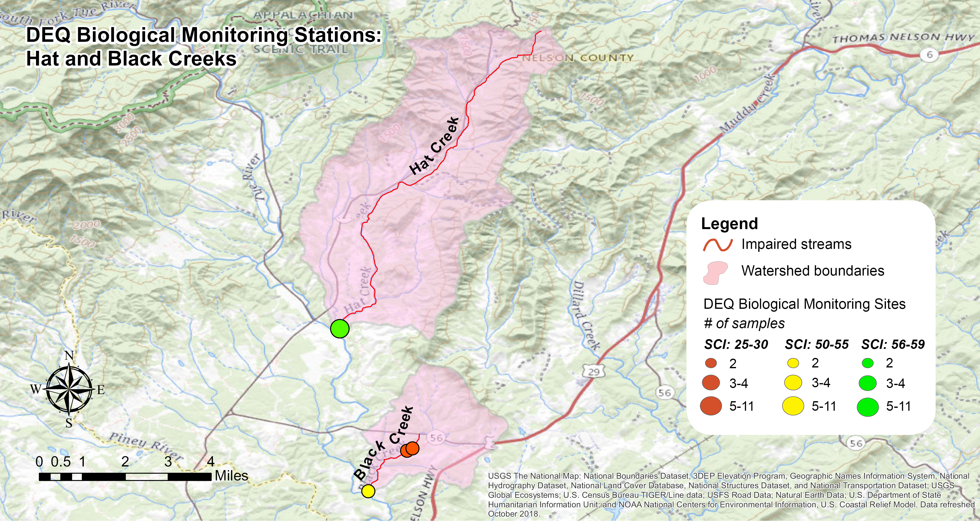
Figure 1-2. Average stream condition index (SCI) scores through 2021 for benthic stations in Hat and Black Creeks.

Table 1-2. Benthic scores in the Hat and Black Creek watersheds.
Stream | Station | Years Sampled | Samples Collected | SCI Average | 2022 WQA (2015-2020) SCI Avg. | 2020 WQA Listing Status
Black Creek | 2-BKC000.08 | 2020-2021 | 4 | 54.2 | 63.3 | Impaired
 | 2-BKC001.43 | 2011-2013 | 4 | 29.3 | N/A | Impaired
 | 2-BKC001.55 | 2011-2013 | 4 | 25.1 | N/A | Impaired
Hat Creek | 2-HAT000.14 | 2008-2021 | 10 | 58.7 | 62.3 | Impaired

Temporal Trends in Benthic Data
Figure 1-3 shows temporal trends in benthic data from the impaired streams. The red line shown in each figure indicates the impairment threshold (SCI Score = 60). Hat Creek (2-HAT000.14) had samples above and below 60 in both the spring and fall. One sample collected from Black Creek at 2-BKC000.08 in fall 2020 was above 60. Average spring benthic SCI scores were below average fall scores for both of the streams (Figure 1-4), though differences were not significant in either. This seasonal trend indicates that higher spring flows may be responsible for the benthic impairments present in the project area due to increased concentrations of nutrients and/or sediment in runoff to the streams. Monthly average discharge data was available from USGS for the Tye River in Lovingston, approximately 3.5 miles downstream of its confluence with Hat Creek and approximately 2.2 miles upstream of its confluence with Black Creek. Regression analyses of Hat and Black Creek SCI scores with discharge rates did not show a significant correlation between high or low flows and benthic scores (ɑ=0.05).
In Hat Creek, benthic SCI scores between 2005 and 2021 averaged 58.7 and ranged from 44.4 (spring 2009) to 75.5 (fall 2020). The majority of samples were below the impairment threshold (63.6%), though only 27% of scores fell below 50, suggesting a relatively moderate level of impairment. Overall, spring benthic scores in Hat Creek (averaging 55.6) were lower than fall benthic scores (averaging 61.3); however, this difference was not significant. SCI scores have remained relatively constant over time at 2-HAT000.14, fluctuating around the threshold value of 60.
Overall, spring benthic scores in Black Creek (averaging 33.2) were lower than fall benthic scores (averaging 39.3); however, this difference was not significant. SCI scores have shown a gradual increase over time, with conditions improving significantly during sampling in 2020 and 2021 at 2-BKC000.08 (R²=0.631, p value = 0.004). However, this is likely due to the relocation of the biological monitoring site further downstream. Conditions at 2-BKC001.55 are influenced by the site’s proximity to an impoundment approximately 250 feet upstream. Similarly, 2-BKC001.43 is impacted by the presence of the impoundment in addition to the Nelson County Regional STP discharge directly upstream of the monitoring station.
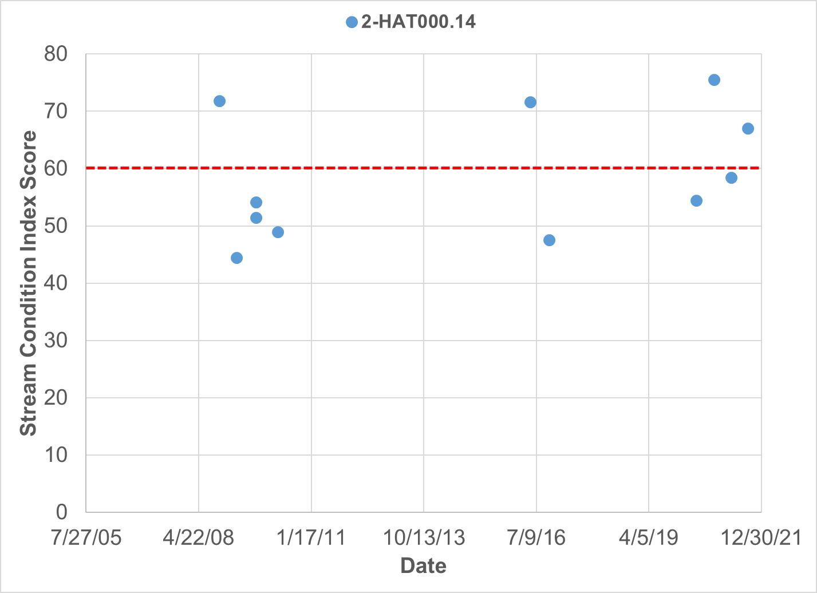
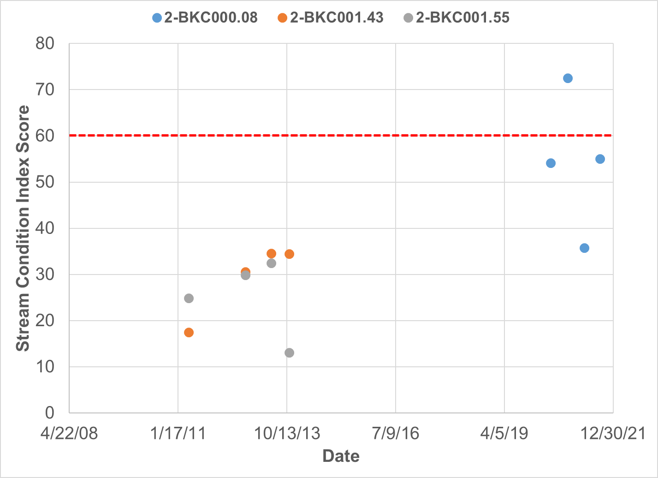
Figure 1-3. Temporal trends of benthic stream condition index (SCI) scores in the Hat (upper graph) and Black Creek (lower graph) watersheds.
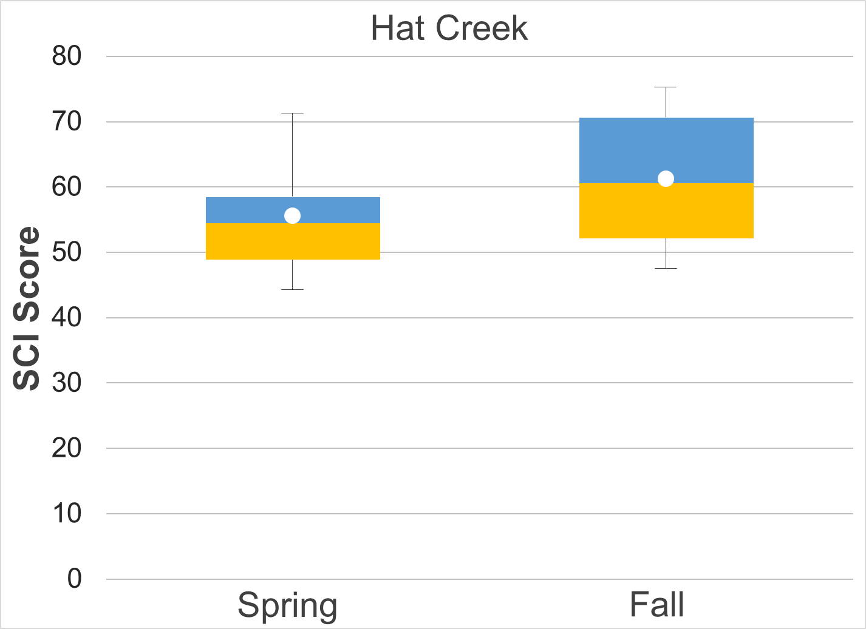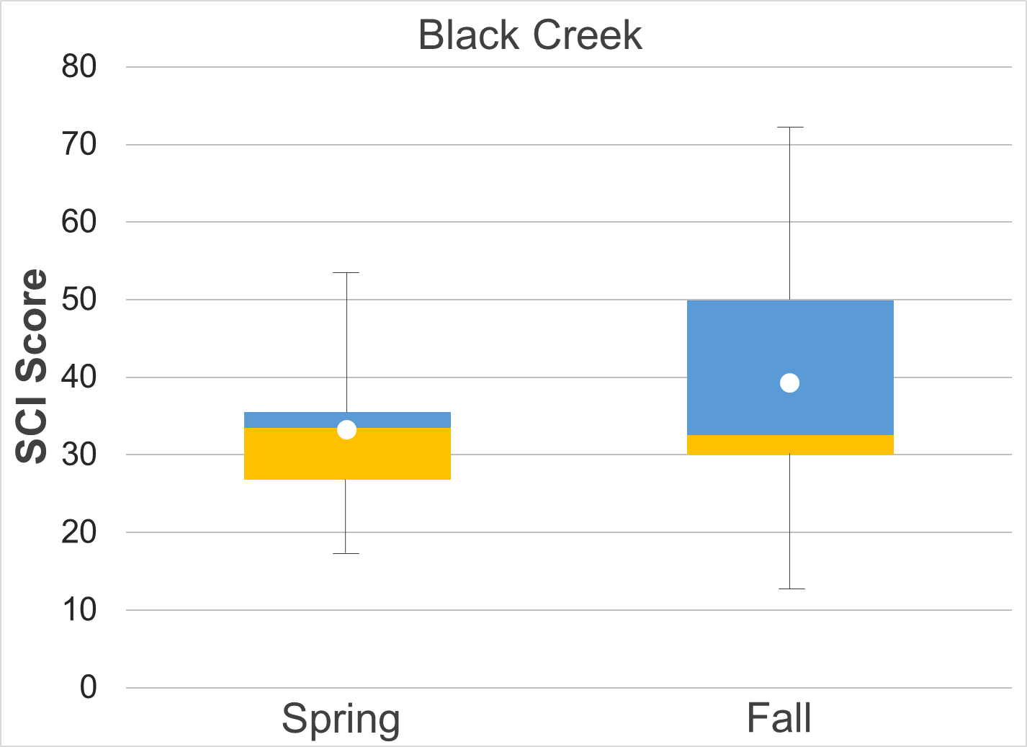
Figure 1-4 Hat and Black Creek stream condition index scores (spring and fall). Whiskers indicate the range, boxes indicate the inter-quartile range, lines indicate the median, and white markers indicate the average.

Analysis of Benthic Metrics
Individual metrics that comprise the SCI were evaluated for the impaired streams, Hat and Black Creeks, in comparison to benthic reference streams (Figure 1-5). The benthic reference used for comparisons with Hat Creek was the Roach River in Albemarle County, Virginia. Benthic metrics from Long Island Creek in Fluvanna County were used for comparisons with Black Creek. Average metric scores for each stream were compared to the references using a t-test with unequal variances (alpha = 0.05). All of the scores in Black Creek were significantly different from the reference condition with the exception of %Chironomidae (p=0.06). Differences in Hat Creek were less apparent, with only % Plecoptera and Trichoptera minus Hydropsychidae (%PT-H) and Modified Family Biological Index (%MFBI) showing significant differences from the reference condition. Both streams had lower scores for % Ephemeroptera, % Plecoptera and Trichoptera minus Hydropsychidae (%PT-H), Ephemeroptera, Plecoptera, Trichoptera (EPT), %2Dominant (%2Dom) and %MFBI when compared to the reference condition.
In Hat Creek, benthic metric scores showed evidence of a “borderline” or minor impairment. Richness, %Chironomidae (%Chiro), and % Scraper scores were slightly higher in Hat Creek when compared to the reference stream, though these differences were not significant. Only two benthic metrics observed in Hat Creek were significantly lower than the reference condition, %PT-H and %MFBI. The high EPT score observed in Hat Creek is largely due to the abundance of Ephemeroptera taxa in the stream, notably Ephemerellidae, which comprises 54% of Ephemeroptera taxa. Plecoptera and Trichoptera taxa are present in comparatively lower abundance in Hat Creek, resulting in the significantly lower (p=0.02) %PT-H score of 16.1 compared to 46.7 in the reference stream, Roach River. The MFBI score in Hat Creek (77.2) may also reflect the lower abundance of sensitive Trichoptera and Plecoptera taxa compared to the reference stream (86.9). The MFBI measures the ecological tolerance and relative abundance of aquatic macroinvertebrates present in a stream. Lower MFBI scores indicate that water quality or habitat conditions are limiting the presence of sensitive taxa. While richness is higher in Hat Creek (66.5) than in the reference stream (63.6), MFBI is not. This indicates while the benthic community in Hat Creek is relatively diverse, the number of sensitive taxa present in the creek is comparatively limited. These results suggest a relatively minor impairment in Hat Creek, effects of which are likely limited to the most sensitive macroinvertebrate taxa.
In Black Creek, scores for all benthic metrics were significantly lower (ɑ=0.05) than the reference condition with the exception of the %Chironomidae score, which was still considerably lower in Black Creek (p=0.06). Diptera and Trichoptera (Hydropsychidae) were the predominant orders present in Black Creek samples, comprising an average of 42% and 27% of the community, respectively, compared to 21% and 15% in Long Island. Consequently, Black Creek had a significantly lower %2 Dominant score (p=0.0001) when compared to Long Island Creek. Ephemeroptera, Plecoptera and Trichoptera (minus Hydropsychidae) taxa were present in low abundance in samples, comprising 15% of the benthic community in Black Creek. Notably, Trichoptera (minus Hydropsychidae) comprised less than 1% of the benthic community in Black Creek. Similarly, Plecoptera taxa was nearly absent, comprising 1.5% of benthic samples. This resulted in the low %PT-H score of 7.66, compared to 70.3 in the reference stream (p<0.001). Similarly, the EPT and % Ephemeroptera scores in Black Creek were significantly lower (p<0.001 and p=0.001, respectively) than in Long Island Creek. The average EPT score in Black Creek was 37.1 compared to 84.0 in Long Island Creek, while % Ephemeroptera scores followed a similar trend with values of 16.7 and 41.3 in Black Creek and Long Island Creek, respectively. Sensitive taxa were present in relatively low abundance in Black Creek, resulting in a significantly lower (p<0.001) Modified Family Biological Index (MFBI) score (65.8) compared to Long Island Creek (87.0). This suggests that water quality or habitat conditions are limiting the presence of sensitive taxa in Black Creek.
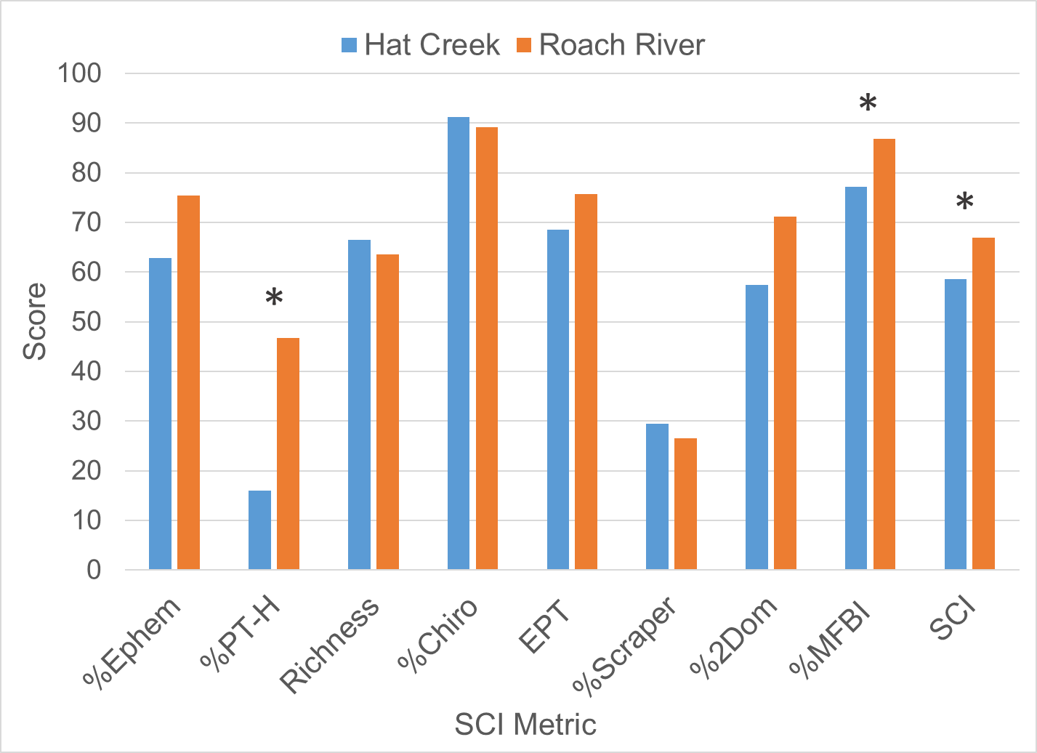
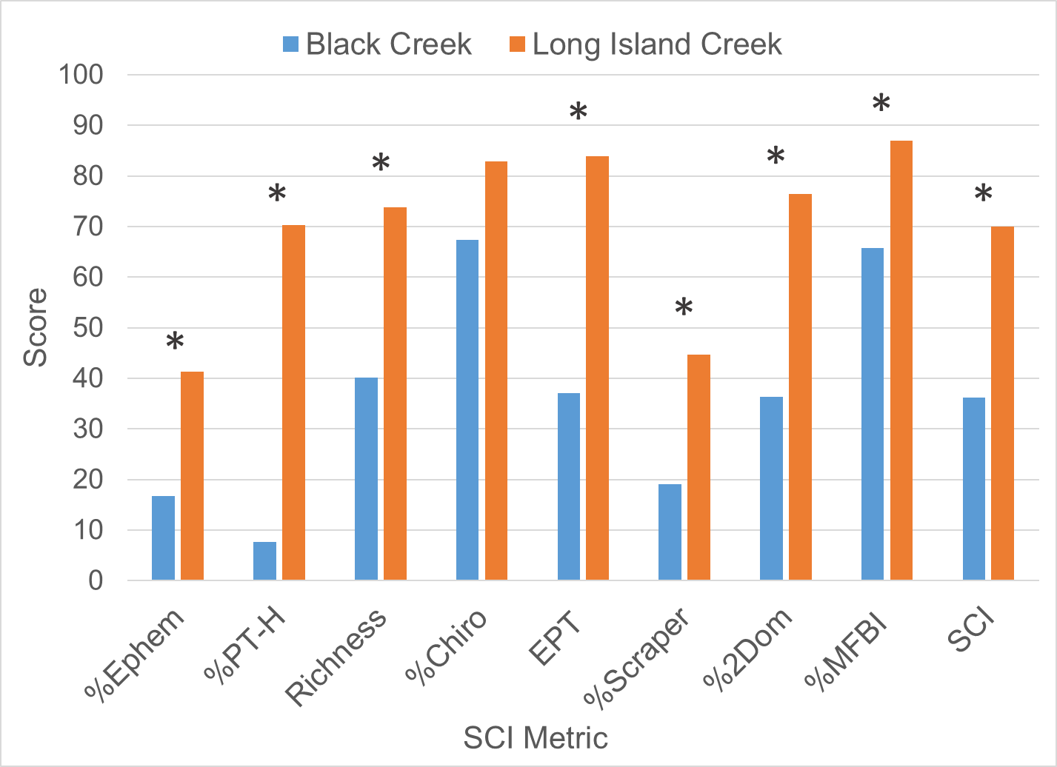
Figure 1-5. Metric scores comprising stream condition index (SCI) scores in Hat and Black Creeks. * indicates that the metric was significantly different (alpha = 0.05) from the benthic reference score (Roach River and Long Island Creek).

Analysis of Community Composition
The taxonomic composition of the benthic communities was analyzed to identify shifts in composition at impaired sites that might provide clues to sources or mechanisms of impairment. Figure 1-6 and Figure 1-7 compare the reference streams (Long Island Creek and Roach River) to the taxonomic composition in the impaired streams, Black and Hat Creeks, respectively, and Table 1-3 shows the three predominant taxa in each stream.
In the reference streams, Roach River and Long Island Creek, taxonomic composition is relatively balanced, with Ephemeroptera, Trichoptera (excluding Hydropsychidae) and Plecoptera taxa comprising 67% and 50% of the macroinvertebrate community, respectively. Hydropsychidae comprised a greater proportion of the benthic community in the impaired streams, Hat Creek (29.5%) and Black Creek (27.4%). Hydropsychidae are a family of net-spinning caddisflies that can implicate the presence of increased suspended organic matter in the stream. Diptera and Ephemeroptera taxa comprised over 50% of macroinvertebrate samples collected from the impaired streams, while Plecoptera and Trichoptera (excluding Hydropsychidae) taxa were less abundant. Baetidae and Ephemerellidae were the predominant Ephemeroptera families in Black and Hat Creeks, respectively. Baetidae and Ephemerellidae are both collectors, and are relatively sensitive to pollution. Chironomidae, a family of non-biting midges, were the predominant Diptera family in both of the impaired streams. Many Chironomid larvae construct silk tubes within burrows in the stream. They are well adapted to thrive in conditions where excess sediment is present in the stream bottom.
Taxonomic composition in Black Creek was significantly altered from that of the reference stream. The most significant changes were a 12.9% decrease in Ephemeroptera taxa and a 17.4% decrease in Plecoptera taxa. Additionally, Diptera and Trichoptera (Hydropsychidae) taxa increased by 21.1% and 12.4%, respectively. These changes reflect a general shift from the more sensitive EPT taxa to more pollution tolerant taxa. Blackfly larvae including Chironomidae, Simuliidae, and Simulium comprised 41.7% of the overall benthic community in Black Creek. The shift towards pollution tolerant blackfly taxon could be indicative of nutrient or sediment enrichment. Lawrence and Gressens (2011) showed that Chironomid abundance correlated with increased nutrient enrichment in urban and rural streams. Bjornn et al. (1977) demonstrated in artificial mesocosm experiments that increases in fine sediment significantly reduced EPT taxa but were tolerated by Chironomid taxa. The predominance of Hydropsychidae in Black Creek signals the presence of increased suspended organic matter in the stream, which is a food source that these net spinning caddisflies effectively trap as it moves downstream. Plecoptera and Trichoptera (excluding Hydropsychidae) taxon were rarely observed in Black Creek. A sample collected in fall 2020 contained 22 individuals belonging to the order Plecoptera, comprising 88% of the total count of stoneflies found in the creek during the sampling period. This suggests that the stream does not typically support an established population of stoneflies.
Taxonomic composition in Hat Creek was slightly altered from that of the reference stream. The most significant changes were an 18.3% increase in Hydropsychidae and 8.6% and 10.7% decreases in Plecoptera and Ephemeroptera taxa, respectively. Other shifts in community composition were minor. This suggests that the impairment on Hat Creek is relatively moderate, meaning that the stream is capable of supporting organisms that are sensitive to pollution, while comparatively pollution tolerant taxa also continue to thrive. The shift to Hydropsychidae is indicative of excess suspended organic matter in the stream, suggesting that streambank erosion and runoff of sediment during precipitation events is a likely source of impairment in Hat Creek.
Table 1-3. Predominant taxa in Hat and Black Creeks compared with reference streams.
Stream | Order,  Family | % of Benthic Community | Order,  Family | % of Benthic Community | Order,  Family | % of Benthic Community
Hat Creek | Trichoptera, Hydropsychidae | 25.9% | Ephemeroptera, Ephemerellidae | 21.2% | Ephemeroptera, Baetidae | 9.6%
Black Creek | Trichoptera, Hydropsychidae | 27.4% | Diptera, Chironomidae A | 26.6% | Diptera, Simulium & Simuliidae* | 7.0%
Roach River (Hat Creek reference) | Ephemeroptera, Ephemerellidae | 26.0% | Diptera, Chironomidae A | 10.8% | Diptera, Simuliidae | 9.0%
Long Island Creek (Black Creek reference) | Diptera, Chironomidae A | 17.2% | Trichoptera, Hydropsychidae | 15.0% | Ephemeroptera,  Heptageniidae | 13.8%
* Present in equal abundance

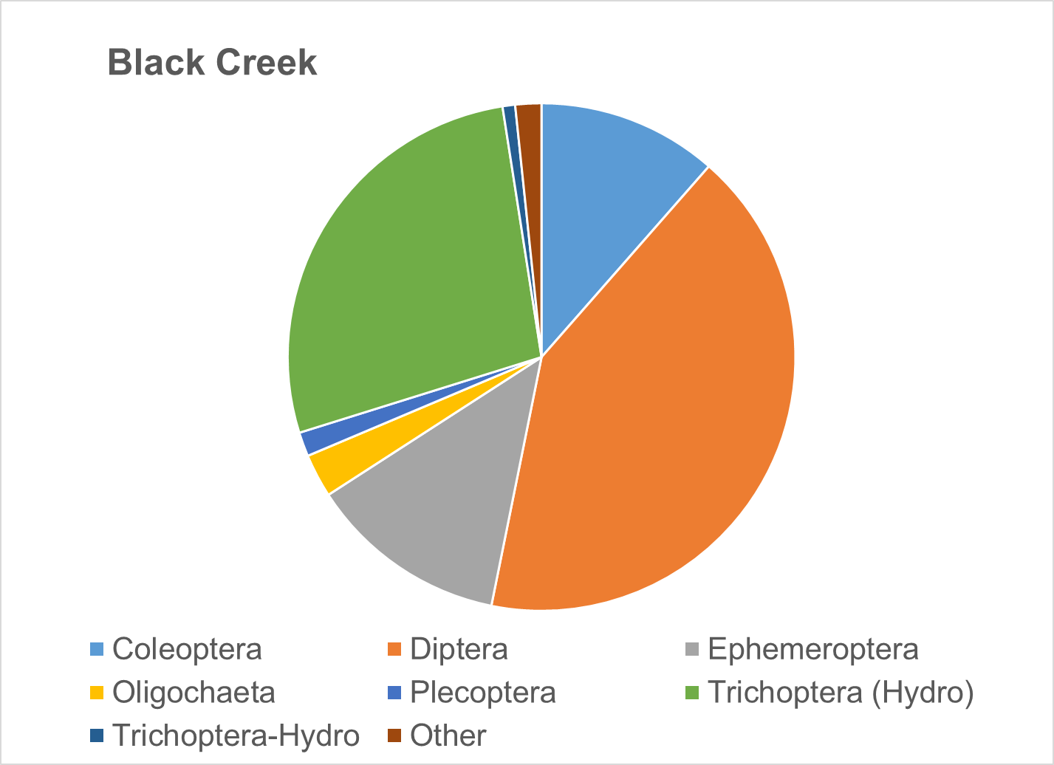
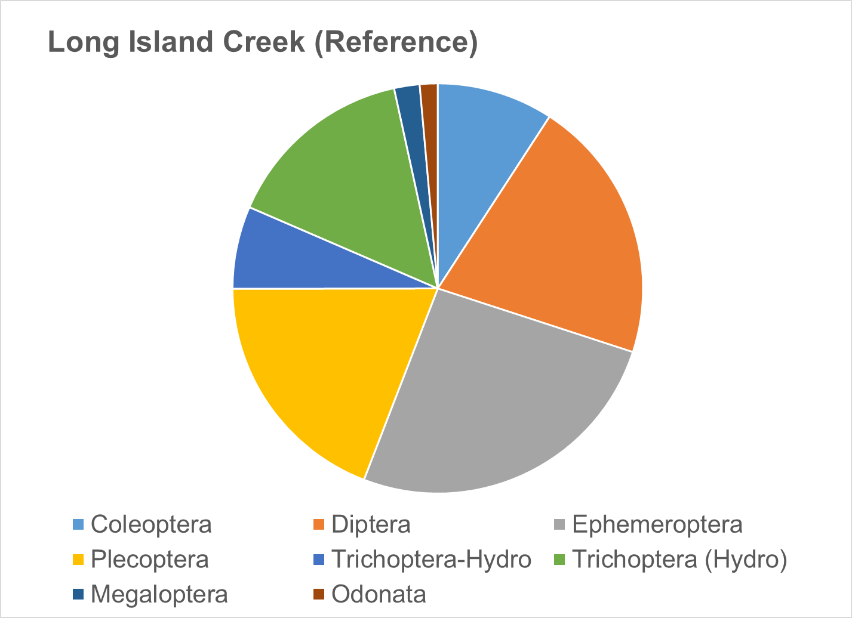
Figure 1-6. Benthic community structure (by order) in Black Creek in comparison with reference stream Long Island Creek.

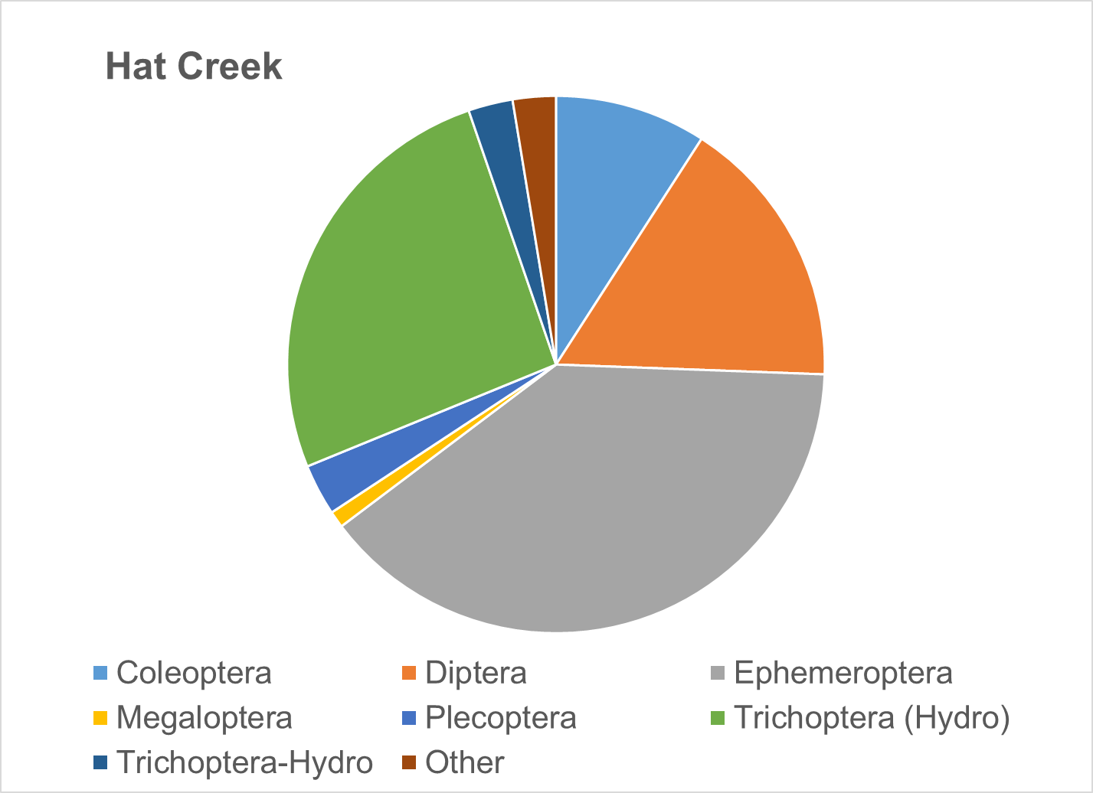
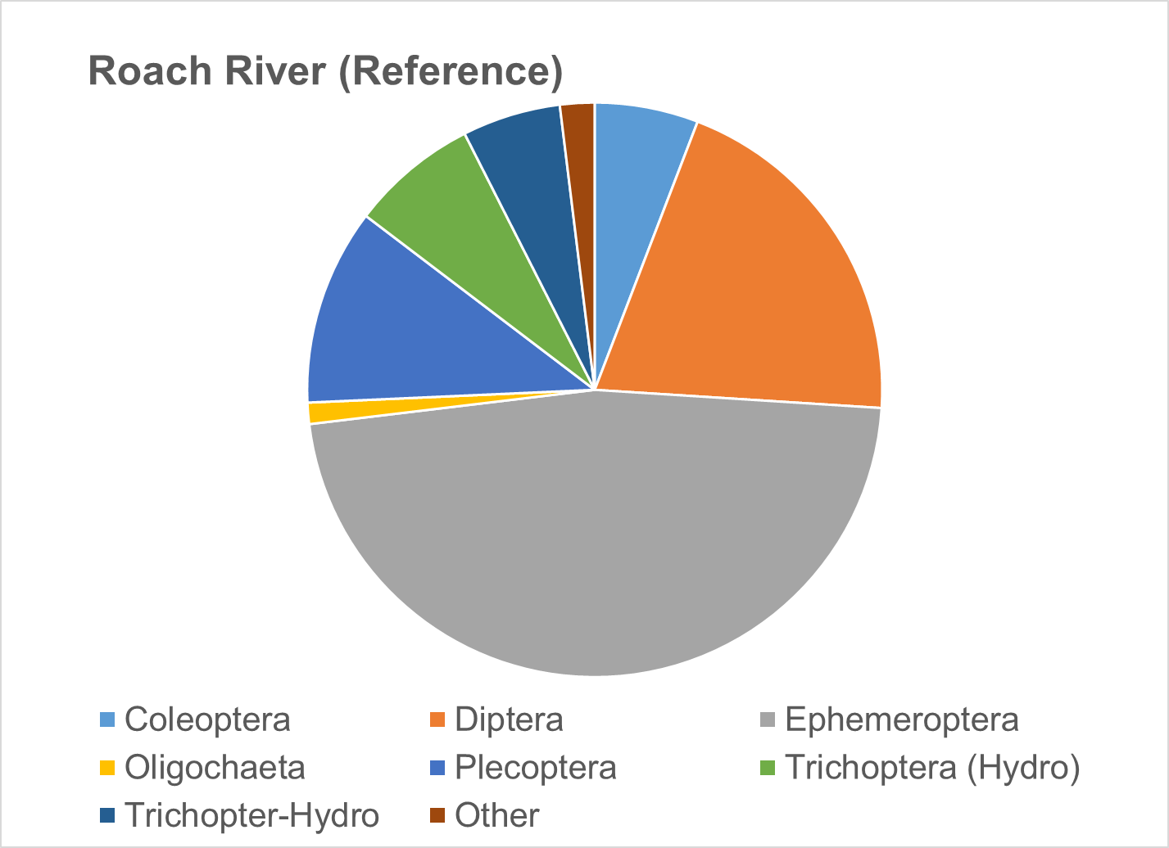
Figure 1-7. Benthic community structure (by order) in Hat Creek in comparison with reference stream and Roach River.

Biological Condition Gradient Analysis
In partnership with the US EPA and several Mid-Atlantic States (Virginia, West Virginia, and Maryland), Tetra Tech developed a Mid-Atlantic Biological Conditions Gradient (BCG) model in 2019 (Tetra Tech, 2019). A BCG is a conceptual framework that may be used to predict biological responses to increased environmental stress. The BCG model establishes a framework of measurable characteristics known as “attributes” of biological communities including properties such as richness, abundance and structure. The model predicts how these attributes shift in response to increasing levels of environmental stress based on observed patterns of biological response to stressors for a given geographic region. The Mid-Atlantic BCG model defines six attributes related to the pollution tolerance among fish and macroinvertebrate taxa present in the region. These attributes were assigned scores for ten specific stressors for a total of 560 macroinvertebrate taxa based on data provided by multiple states through a consensus-based process with input from regional biologists (Table 1-4).
Table 1-4. Mid-Atlantic biological condition gradient attributes and stressors evaluated
Attribute | Explanation | Stressors Evaluated
I | Historically documented, sensitive, long-lived or regionally endemic taxa | Dissolved oxygen  Acidity  Alkalinity  Specific conductivity  Total habitat  % Imperviousness | Chloride  Sulfate  Total Nitrogen  Total Phosphorus  Relative bed stability
II | Highly sensitive taxa
III | Intermediate sensitive taxa
IV | Intermediate tolerant taxa
V | Tolerant taxa
VI | Non-native taxa

Taxa receiving high attribute values for a stressor are typically more tolerant of that particular stressor. Conversely, taxa assigned low attribute values for a stressor are generally intolerant of that stressor and will not typically be abundant or present in conditions where this particular stressor is experienced. Using attribute data from Virginia’s BCG model, scores were assigned to taxa in Hat and Black Creek samples for each stressor listed in Table 1-4. Weighted average attribute values were calculated for each stressor across all taxa in Hat and Black Creeks (Table 1-5). In addition, attribute values for stressors were evaluated for predominant species in the streams in order to identify potential stressors that may be disproportionately influencing benthic community composition in the impaired streams (Table 1-6). As shown in Table 1-6, there was little variability in average BCG scores for possible stressors, with TN/TP in Black Creek receiving the highest score (4.1), and dissolved oxygen and chloride in Hat Creek receiving the lowest score (3.2). These data suggest that taxa present in both streams are relatively tolerant to a wide range of stressors and do not show much differentiation with respect to stressor identification. BCG scores for Black Creek were slightly higher than those in Hat Creek, with median values of 3.9 and 3.7, respectively. While this difference is minor, comparison of scores between the two streams with varying degrees of impairment indicates that stressor effects from pollutants in Black Creek are having a greater impact on community composition in the stream. As shown in Table 1-6, the predominance of Hydropsychidae in both Hat and Black Creeks resulted in BCG scores with a median value of four. The prevalence of Ephemerellidae in Hat Creek suggests that stressor impacts may be relatively limited, as this family of mayflies has been assigned a score of three for each of the stressors evaluated with the exception of alkalinity and RBS. This supports the conclusion that sediment may be impacting aquatic life in Hat Creek. The other predominant family of mayflies in Hat Creek, Baetidae, appears slightly more tolerant of high dissolved ion concentrations, poor habitat conditions, and excess sediment in the stream. These results suggest that stressor impacts in Hat Creek have been limited enough to allow for more sensitive taxa to populate the stream; however, taxa more tolerant of stressor impacts have also been able to thrive. BCG scores of predominant taxa in Black Creek suggest a greater degree of impairment. Chironomidae was assigned a score of four for all stressors evaluated, suggesting that this family of blackflies is relatively tolerant of pollution. Scores were even higher for Simulium, which was assigned a value of five for chloride and sulfate. Scores for all other stressors with the exception of specific conductance were fours. Results for Black Creek suggest stressor impacts in the stream may be significant, though BCG scores do not point to a particular stressor that is responsible for the impairment.
Table 1-5. Weighted average biological condition gradient scores by stressor for Hat and Black Creeks.
Stream | Diss. Oxy. | Acidity | Alkalinity | Spec. Cond. | Chloride | Sulfate | TN/TP | Total Habitat | RBS | % Imp.
Hat Creek | 3.2 | 3.3 | 3.8 | 3.8 | 3.2 | 3.9 | 3.8 | 3.5 | 3.9 | 3.6
Black Creek | 3.4 | 3.4 | 3.8 | 4.0 | 3.5 | 4.0 | 4.1 | 3.8 | 4.0 | 3.9

Table 1-6. Biological condition gradient scores by stressor for predominant taxa in Hat and Black Creeks.
Stream | Predominant Taxa | General | Diss. Oxy. | Acidity | Alkalinity | Spec. Cond. | Chloride | Sulfate | TN/TP | Total Habitat | RBS | % Imp.
Hat Creek | Hydropsychidae | 4 | 3 | 3 | 4 | 4 | 3 | 4 | 4 | 3 | 4 | 4
 | Ephemerellidae | 3 | 3 | 3 | 4 | 3 | 3 | 3 | 3 | 3 | 4 | 3
 | Baetidae | 4 | 3 | 3 | 4 | 4 | 4 | 4 | 4 | 4 | 4 | 3
Black Creek | Hydropsychidae | 4 | 3 | 3 | 4 | 4 | 3 | 4 | 4 | 3 | 4 | 4
 | Chironomidae | 4 | 4 | 4 | 4 | 4 | 4 | 4 | 4 | 4 | 4 | 4
 | Simulium | 4 | 4 | 4 | 4 | 3 | 5 | 5 | 4 | 4 | 4 | 4

Analysis of Functional Feeding Groups
The composition of functional feeding groups comprising the benthic community was also analyzed to identify shifts in composition at impaired sites that might provide clues to sources or mechanisms of impairment. Figure 1-8 shows the composition of functional feeding groups within the impaired streams in comparison to conditions in the reference streams. Shredders constituted a smaller portion of the population in the impaired streams when compared to the reference streams. Conversely, the proportion of filterers was greater in the impaired streams compared to the reference conditions. This shift towards filterers can be indicative of excess suspended organic matter in the water column, which is further supported by the prevalence of Hydropsychidae in Hat and Black Creeks. Collectors comprised over 40% of the benthic community in Hat and Black Creeks, which was similar to community composition in the reference streams.
The percentage of shredders was lower in both of the impaired streams when compared to the reference conditions. Shredders comprised less than 3% of the benthic community in Hat and Black Creeks. Conversely, shredders comprised 16.7% of the community in Long Island Creek and 6.7% in Roach River. The difference observed in the reference conditions may be explained by the size of the streams. A smaller, higher order stream like Long Island Creek is likely to have a greater proportion of coarse particulate organic matter (CPOM) on the stream bottom. While collectors consume fine particulate organic matter (FPOM) deposited on the stream bottom, shredders consume CPOM including leaf litter and wood. The shift away from shredders in the impaired streams could be indicative of a reduction in CPOM due to a lack of riparian buffers. Alternatively, it could signal an overabundance suspended organic matter in the water column and FPOM on the stream bottom, allowing for a predominance of filterers and collectors in the impaired streams.
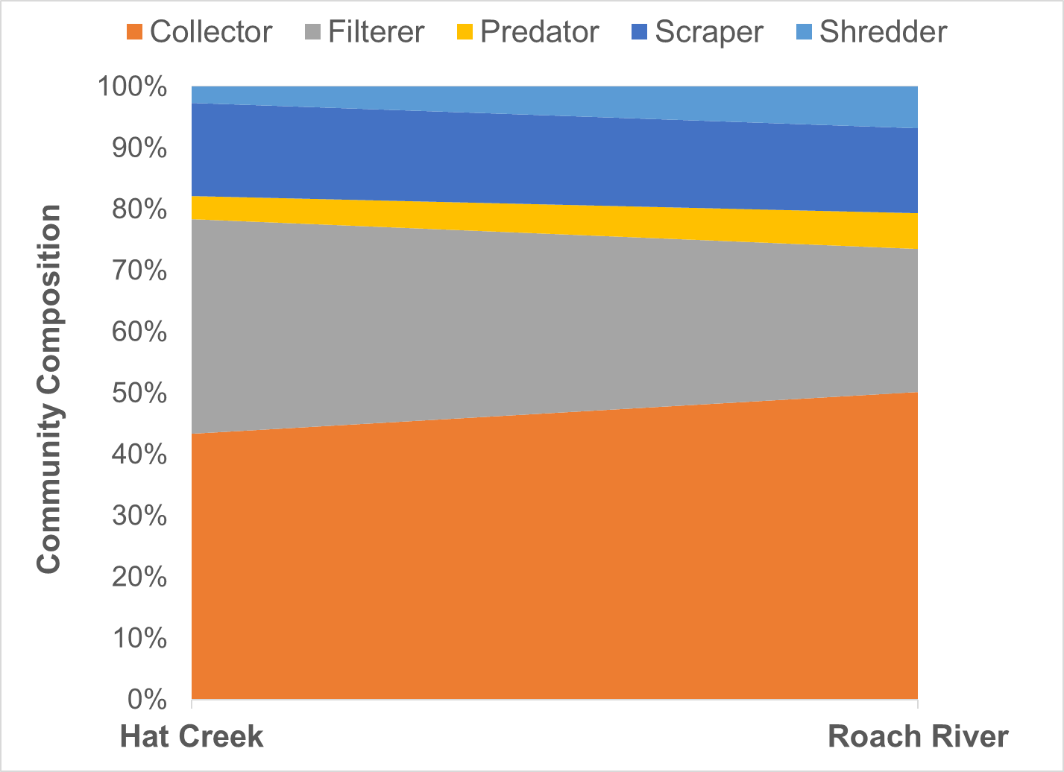
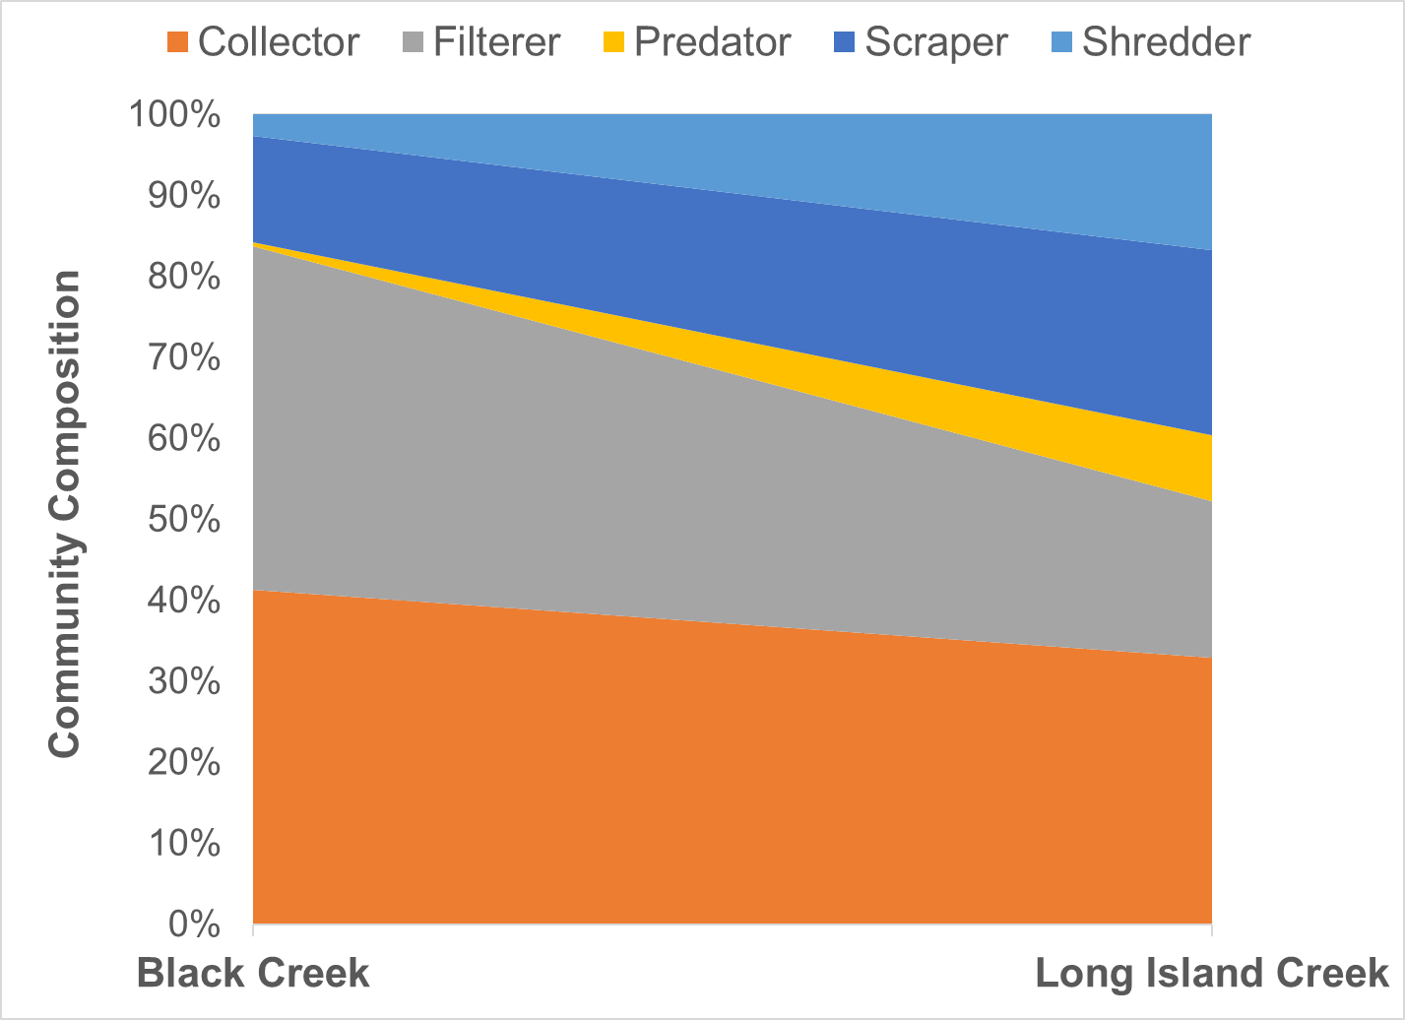
Figure 1-8. Functional feeding group composition in benthic communities in Hat and Black Creeks compared to Roach River and Long Island Creek (reference streams).

Habitat Assessment
As part of the Rapid Bioassessment Protocol, a visual habitat assessment is performed at the time of each benthic sample collection. This assessment entails scoring each of a series of habitat components from 0 to 20. These habitat components include channel alteration, bank stability, bank vegetation, embeddedness, flow, riffles, riparian vegetation, sediment, substrate, and velocity. The individual scores for each of these measures are summed to determine a total habitat score. Table 1-7 shows scores for the impaired streams, and compares the total habitat scores to the reference streams (Roach River and Long Island Creek) using t-tests with unequal variances (ɑ=0.05). Scores for both Hat and Black Creeks were significantly lower than in the reference streams.
Figure 1-9 shows the probability of habitat being a stressor on the aquatic community for each stream based on DEQ’s analysis of probabilistic monitoring data (DEQ, 2017). Both Black and Hat Creeks fell in the low probability category.
Table 1-7. Total habitat scores for Hat and Black Creeks.

Stream | Total Habitat Score | Significantly Different from Reference | P value
Hat Creek | 141.8 | Yes | p =0.026
Black Creek | 136.2 | Yes | p < 0.001
Roach River (reference) | 154.8
Long Island Creek (reference) | 166.5

Habitat scores were statistically compared to SCI scores through a regression analysis (Figure 1-9). The low R² value (0.138) indicates considerable variability in this relationship, which was not significant (α=0.05). As indicated by the trend line in Figure 1-9, it appears that this relationship is negatively correlated, meaning that as habitat improves, SCI scores go down. Given the low R² value, the trend line does not accurately describe the relationship between these measures.
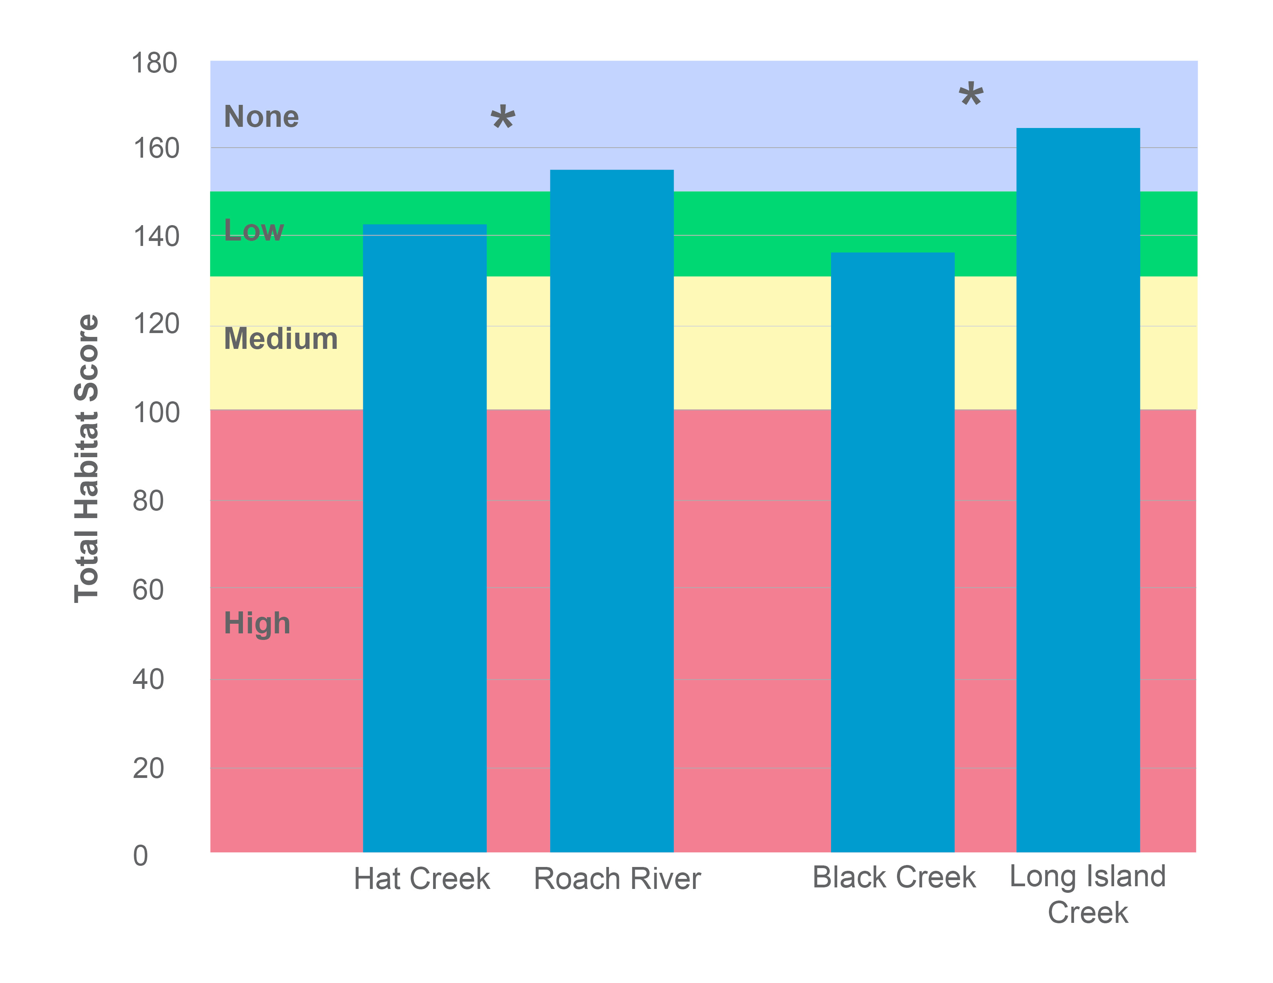
Figure 1-9. Total habitat scores for Hat and Black Creeks. Colors represent the probability that data within that range would be responsible for causing stress. Asterisks indicate scores significantly different from the reference conditions (α=0.05).
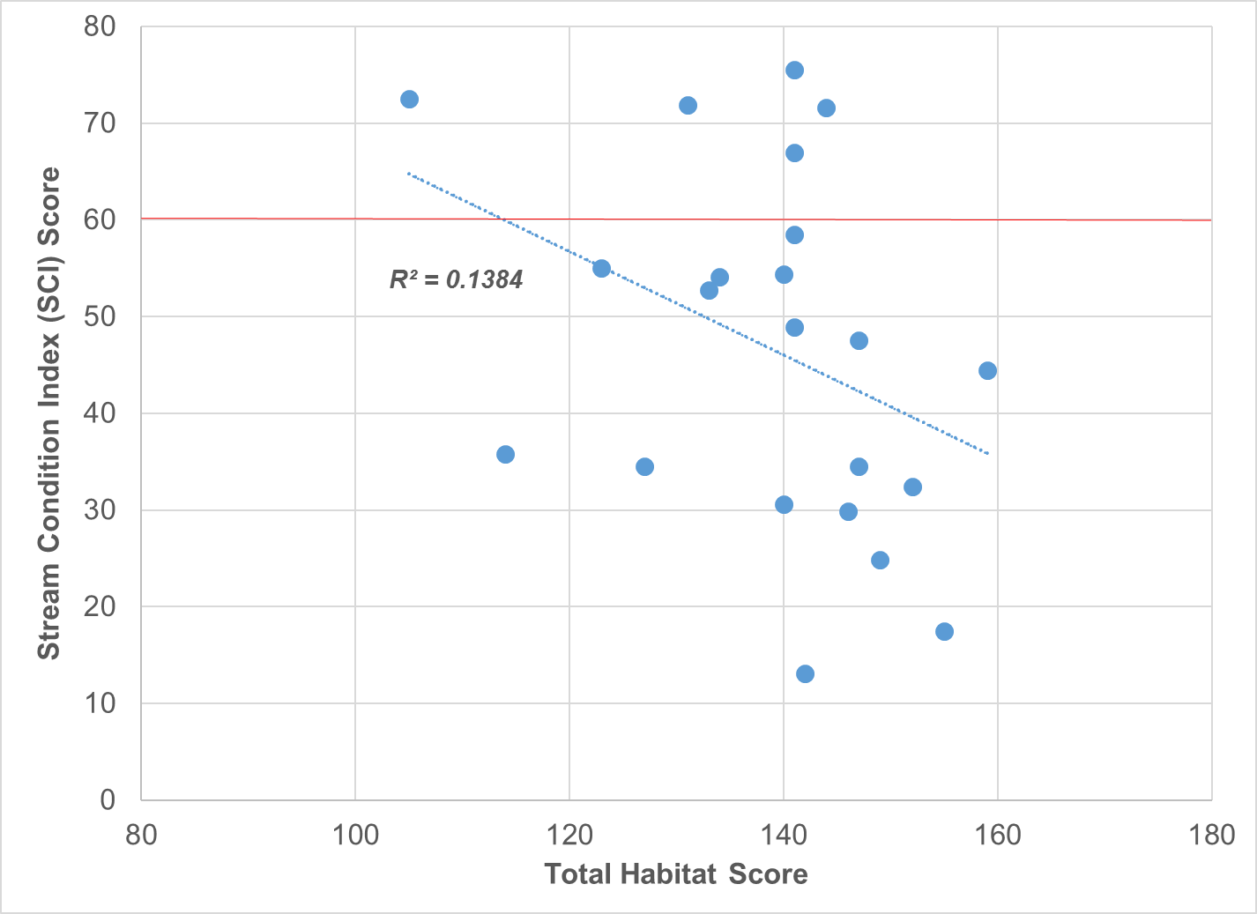
Figure 1-10. Comparison of total habitat scores with SCI scores in Hat and Black Creeks. Red line indicates impairment threshold (SCI = 60).
Individual habitat metrics are shown in Figure 1-11. Trends in Black Creek habitat metrics indicated that significant alterations to in-stream and riparian habitat are impacting the benthic community. All metrics in Black Creek were significantly different from the reference stream (t-test with unequal variances, ɑ = 0.05). When compared to the reference condition, the greatest difference in habitat metric scores were associated with metrics indicative of excess sediment deposition in the stream. Large differences in RIPVEG, SEDIMENT, and BANKVEG scores were observed, all indicating excess sediment deposition on the stream bottom is occurring as a result of streambank erosion associated with poor vegetative cover. Epifaunal substrate scores (SUBSTRATE) in Black Creek were also significantly lower than the reference condition, suggesting that the stream is lacking adequate natural habitat structures such as fallen trees, large rocks and cobble to support a healthy aquatic macrofauna community.
Although scores for nearly all of the metrics in Hat Creek were lower than the reference condition, only the channel alteration (ALTER) and riffles (RIFFLE) metrics were significantly lower. Despite the fact that these metrics were significantly lower than the reference condition, mean values were relatively high and did not signal likely impacts to the benthic community. Measures of riparian vegetation (RIPVEG) and sediment (SEDIMENT) in Hat Creek were notably lower than the reference condition, suggesting that poor vegetative cover in riparian areas may be contributing to streambank erosion and deposition of excess sediment in the streambed.
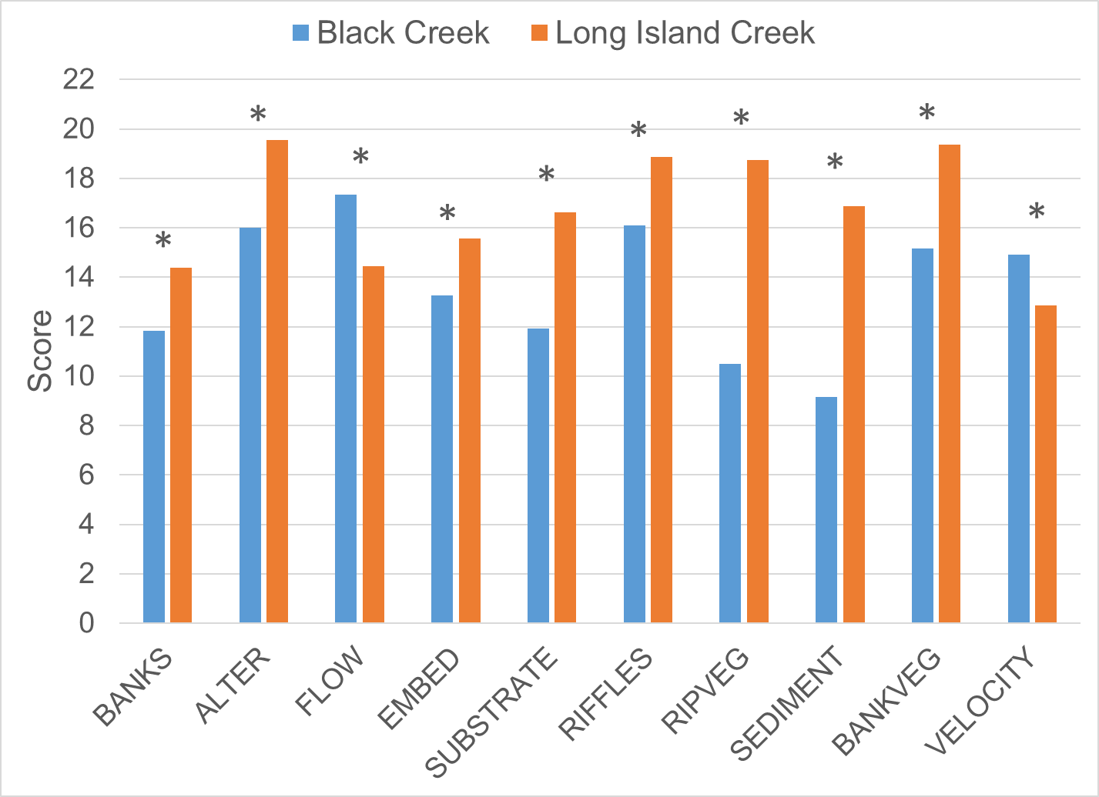
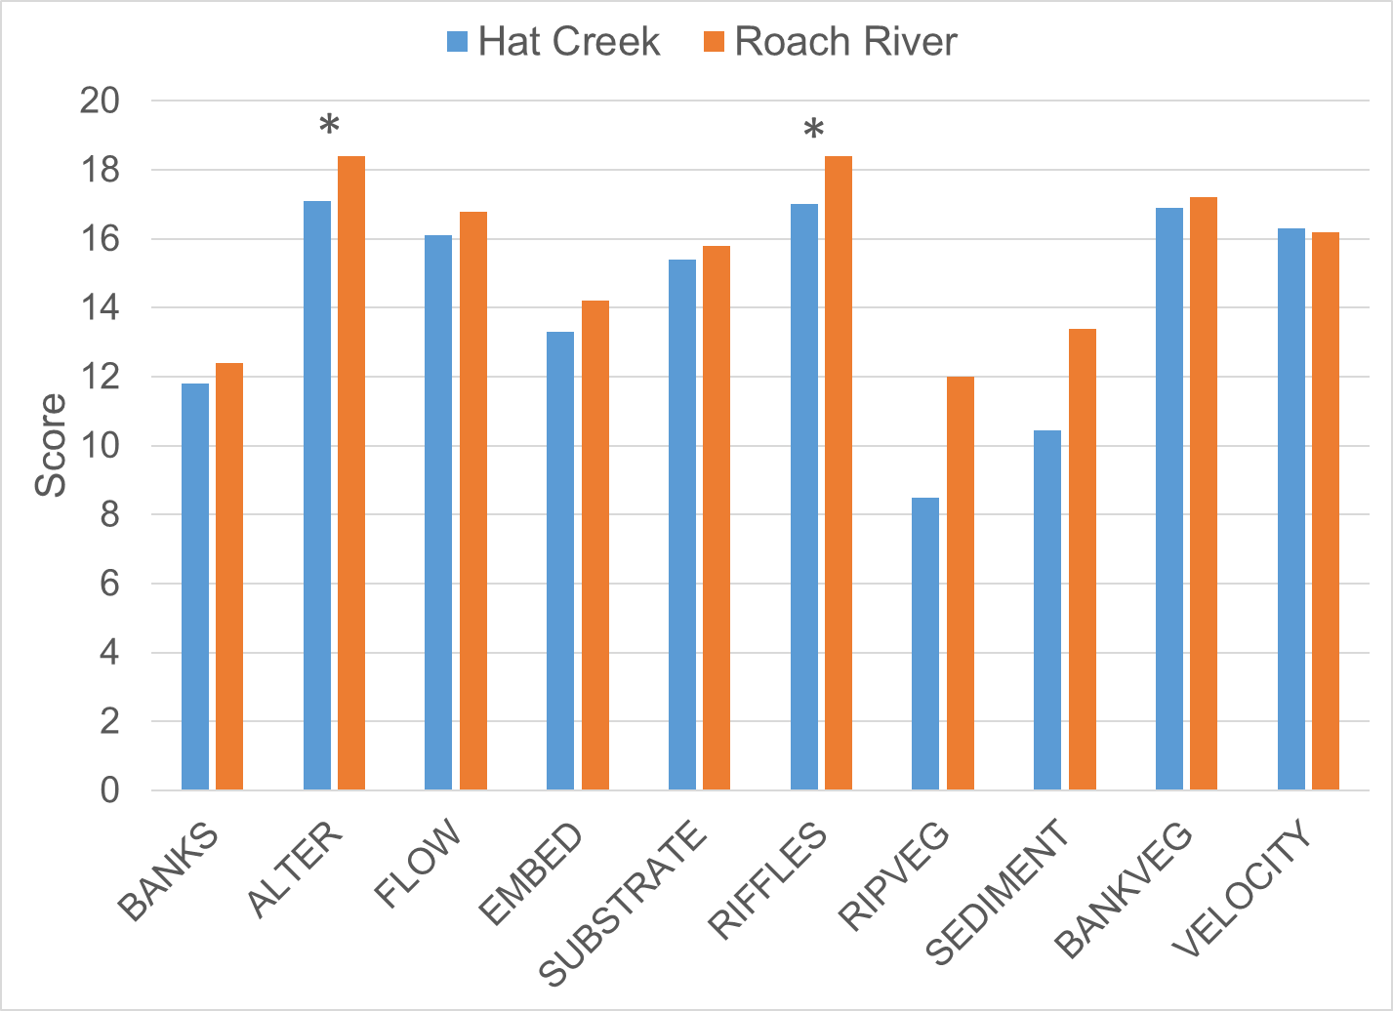
Figure 1-11. Habitat metric scores for Hat and Black Creeks. Metrics with a * are statistically different from the reference site (α=0.05).

Relative Bed Stability
As a part of TMDL monitoring, DEQ conducted a detailed physical habitat assessment of the two impaired streams according to EPA methods for Quantifying Physical Habitat in Wadeable Streams (Kaufmann et al., 1999). This analysis involved the measurement of channel dimensions and substrate composition at numerous transects within a 150 to 240-m stream reach surrounding benthic monitoring stations 2-BKC000.08 in Black Creek and 2-HAT000.14 in Hat Creek, respectively. The outcome of this analysis is the calculation of a log relative bed stability index (LRBS). The LRBS is the ratio between the observed distribution of in-stream sediments and the predicted sediment size distribution based on bankfull depth. LRBS values near zero indicate that the stream is stable. Large negative values indicate that the stream is unstable and depositing excess sediment. Large positive numbers, while less common, indicate that the stream is unstable and sediment starved. In an analysis of streams across the commonwealth, DEQ has determined that LRBS scores between -1.0 and -1.5 have a medium probability of stressing aquatic life, and LRBS scores <-1.5 have a high probability of stressing aquatic life (DEQ, 2017).
Table 1-8, Figure 1-12 and Figure 1-13 show the results of relative bed stability analysis in Hat and Black Creeks. Figure 1-12 shows how bottom substrate composition in the impaired streams compares to a reference condition. While Roach River served as the reference condition for Hat Creek in benthic data analyses, RBS monitoring was not conducted in the watershed so an additional reference had to be identified. Spruce Creek, a tributary of the South Fork of the Rockfish River located in Nelson County, was selected as a reference for RBS data analyses for Hat Creek. The Spruce Creek watershed is similar in size and gradient to Hat Creek, has minimal impacts from urbanization, and similar soils and geology. Additionally, Spruce Creek supports a healthy community of benthic macroinvertebrates. The RBS score and bottom substrate composition in Spruce Creek reflect the naturally sandy bottom of the stream. Abundant cobble and gravel in the stream bottom likely provide sufficient substrate for colonization by benthic macroinvertebrates. Impacts from a power line cut were also observed during collection of RBS data from Spruce Creek. Despite these impacts, Spruce Creek supports a healthy benthic community. The use of Spruce Creek as a reference condition for Hat Creek accounts for some degree of naturally occurring sediment deposition, which is also likely in Hat Creek. Differences in bottom substrate composition may still be observed between Hat Creek and Spruce Creek, all of which are indicative of excess sediment as a likely stressor to the benthic community in Hat Creek.
Figure 1-13 compares LRBS values in each of the streams to DEQ stressor thresholds. The LRBS score for Black Creek fell within the medium probability of stress range, while the score for Hat Creek feel within the low probability range for stressor effects. Black Creek exhibited characteristics of an unstable stream channel with significant sediment deposition throughout the streambed and a high degree of embeddedness (Table 1-8). Sand and fines comprised the greatest proportion of bottom substrates in Black Creek (31.4% and 28.6%, respectively), while cobble and gravel were far less abundant (1.0% and 29.5%, respectively). The LRBS value for Black Creek (-1.2) is indicative of a moderate probability of stress to the benthic community (Figure 1-12). LRBS monitoring results for Hat Creek indicated a similar degree of sand in the stream bottom (41.9%) but far less fines (8.6%) compared to Black Creek (Table 1-8). Cobble comprised a significant portion of bottom substrate (21.0%) while coarse and fine gravel comprised only 10.5% of the stream bottom. In comparison, coarse and fine gravel comprised nearly three times this amount (30.0%) in Spruce Creek (Figure 1-12). Sand and fines comprised approximately half of the stream bottom in Hat Creek, compared to 25% in the reference condition. In Hat Creek, bedrock comprised 16.2% of the stream bottom, while it was absent in Spruce Creek. It is likely that the absence of bedrock in the reference stream resulted in a slightly lower LRBS score compared to the impaired stream.
Table 1-8. Relative bed stability analysis for Hat and Black Creeks.
Stream | Station | Date | %Sand and Fines | % Boulder, Cobble, and Gravel | %  Embedded | Log Relative Bed Stability Index (LRBS)
Hat Creek | 2-HAT000.14 | 8/30/21 | 50.48% | 30.91% | 60.18% | -0.62
Black Creek | 2-BKC000.08 | 8/30/21 | 60.00% | 29.10% | 70.00% | -1.20
Spruce Creek (Hat Creek reference) | 2-SPC001.07 | 8/21/18 | 24.76% | 72.73% | 49.18% | -0.87
Long Island Creek (Black Creek reference) | 2-LSD001.23 | 9/27/04 | 13.47% | 55.56% | 32.36% | 0.80

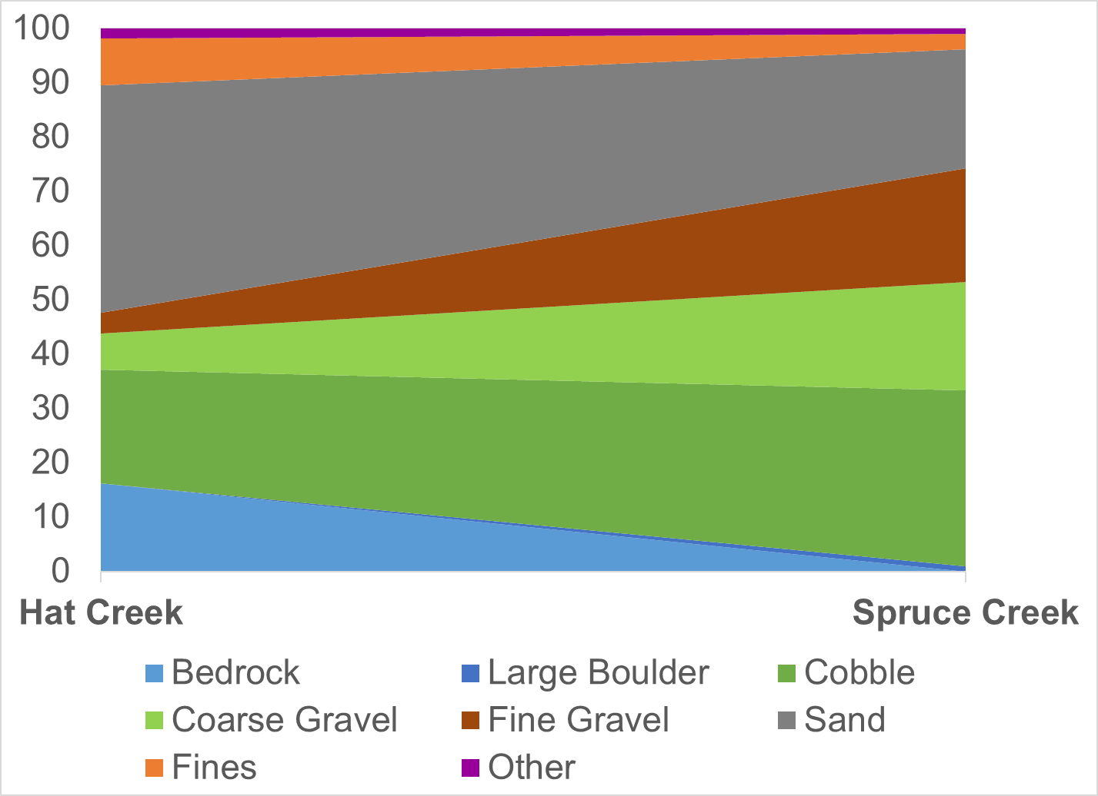
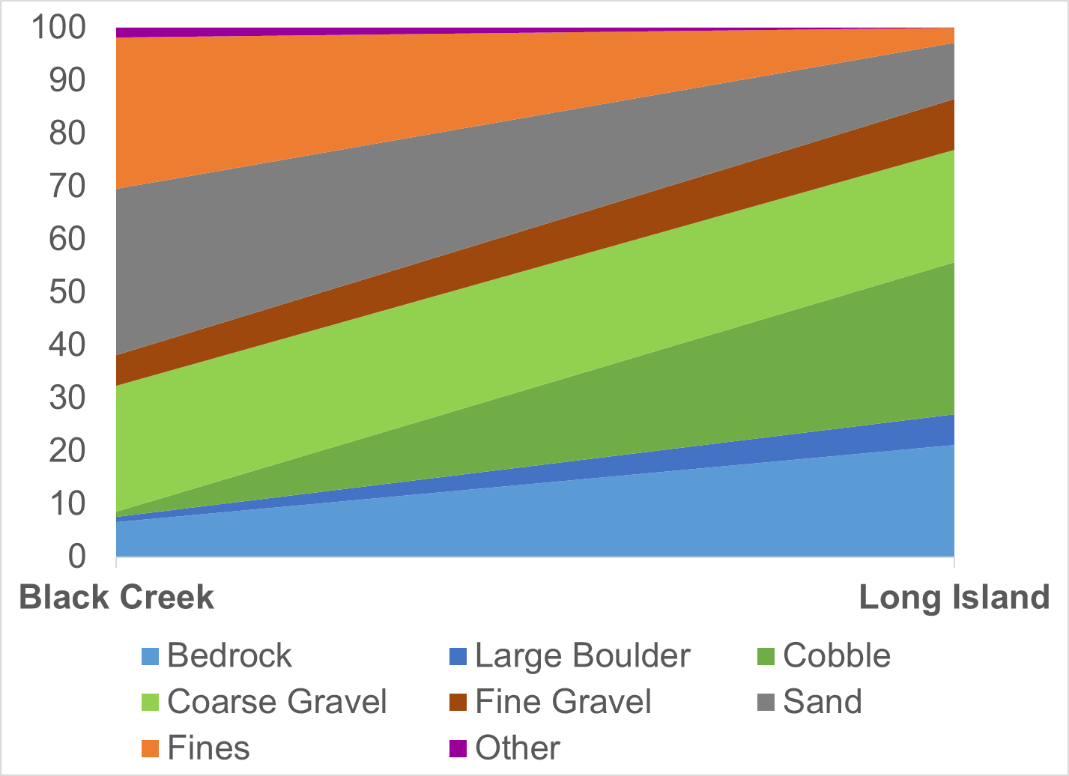
Figure 1-12. Hat and Black Creek bottom substrate comparisons with references (Spruce and Long Island Creeks, respectively).
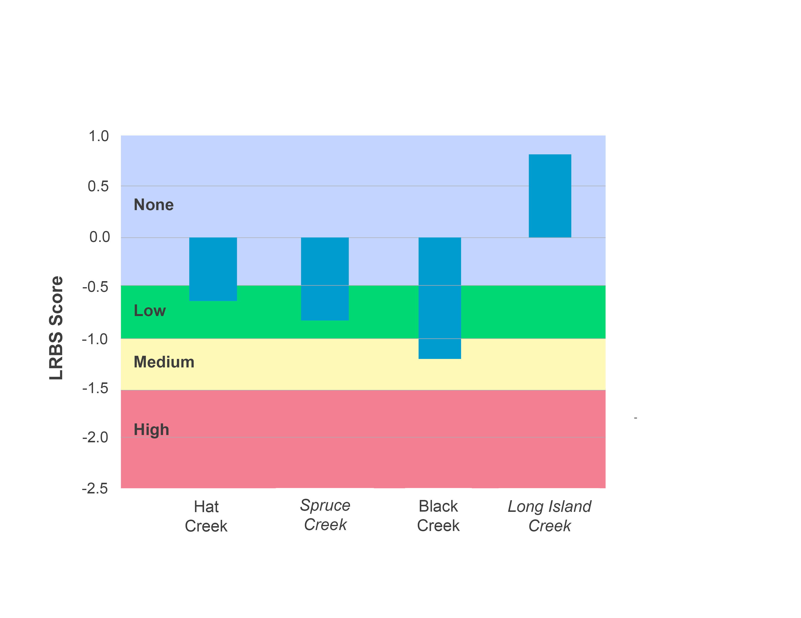
Figure 1-13. Log relative bed stability index (LRBS) scores for Hat and Black Creeks in comparison with reference conditions (Spruce and Long Island Creeks, respectively).

Land Use Assessment
While a more detailed land use assessment will be part of the Hat and Black Creek TMDL Report, the stressor analysis evaluated the potential connections between land use patterns within the watersheds and impaired benthic stations. Table 1-9 shows the land uses contributing to each of the benthic monitoring stations in the two watersheds.
Regression analysis was used to compare land use trends to benthic SCI scores at the respective stations. Water and scrub shrub land cover variables had significant regressions with SCI scores in the impaired streams (Table 1-10). SCI scores were negatively correlated with both water (r² = 0.91) and scrub shrub variables (r²=0.92). The presence of the impoundment directly above 2-BKC001.43 and 2-BKC001.55 is likely to be responsible for the strong correlation between water and SCI scores in the project area. These two sites also have a slightly higher scrub shrub acreage, which is also responsible for the negative correlation observed between SCI scores and this land cover classification. It is unlikely that scrub shrub acreage is impacting stream health in the watersheds given that it comprises less than one percent of land cover in the impaired watersheds, and variability in acreage is minimal between the monitoring station drainage areas (Table 1-9).
In summary, excluding the presence of the impoundment upstream of 2-BKC001.43 and 2-BKC001.55, there was minimal variability in land cover variables between the monitoring station drainage areas in Hat and Black Creeks. Therefore, land cover was not a good predictor of stream health in the impaired watersheds.

Table 1-9. Land use upstream from each benthic monitoring station in the Black and Hat Creek watersheds.
Stream | Station | Water | Impervious | Forest | Urban/ Res. Trees | Scrub/ Shrub | Harvested/Disturbed | Urban/ Res. Grass | Pasture | Cropland | Wetlands
Black Creek | 2-BKC000.08 | 0.32% | 3.63% | 55.80% | 10.68% | 0.27% | 0.51% | 5.19% | 22.75% | 0.81% | 0.05%
Black Creek | 2-BKC001.43 | 0.51% | 3.33% | 63.75% | 10.03% | 0.37% | 0.62% | 5.74% | 15.57% | 0.00% | 0.08%
Black Creek | 2-BKC001.55 | 0.52% | 3.39% | 64.19% | 10.04% | 0.38% | 0.63% | 5.81% | 14.96% | 0.00% | 0.08%
Hat Creek | 2-HAT000.14 | 0.15% | 1.26% | 68.21% | 7.15% | 0.18% | 0.21% | 2.95% | 17.60% | 2.26% | 0.02%

Table 1-10. Regression relationship between stream condition index scores and watershed land uses.
Land Use Variable | Significant Regression (Y/N) | p-value | Direction of Relationship (+/-) | R²
Water | Y | 0.05 | - | 0.91
Impervious | N | 0.43 | NA | 0.32
Forest | N | 0.88 | NA | 0.01
Urban/Residential Trees | N | 0.50 | NA | 0.25
Scrub/Shrub | Y | 0.04 | - | 0.92
Harvested/Disturbed | N | 0.16 | NA | 0.04
Urban/Residential Grasses | N | 0.20 | NA | 0.64
Pasture | N | 0.26 | NA | 0.55
Cropland | N | 0.12 | NA | 0.77
Wetlands | N | 0.06 | NA | 0.89

Water Quality Data
Water quality data collected by DEQ from 2007 to 2021 in the Hat and Black Creek watersheds were used in the benthic stressor analysis. One hundred and ten (110) samples were collected from two ambient monitoring stations in the project area (2-BKC000.08 and 2-HAT000.14). In addition, field parameters (pH, temperature, dissolved oxygen, conductivity) were measured at four benthic monitoring stations in the watersheds on 23 occasions between 2008 and 2021. Water quality parameters tested included: temperature, pH, dissolved oxygen, conductivity, total dissolved solids, turbidity, total suspended solids, ammonia, total nitrogen, total phosphorus, chloride, sulfate, potassium, and sodium. These parameters were analyzed for evidence of stressor effects by comparing measured values to Virginia water quality standards, to reference conditions, and to published thresholds for stressor effects.

Temperature
Temperature data for Hat and Black Creek are available from DEQ monthly measurements. DEQ measures temperature when collecting benthic or water quality samples, so periodic temperature data are available from 2007 to present at both Hat and Black Creek monitoring sites (Figure 1-14). Temperatures obviously vary by season, so ranges are wide when year-round measurements are considered. Neither of the impaired streams had temperature measurements above the water quality standard of 31°C for Class IV Mountain Zone waters. The maximum recorded temperature was 24.6°C in Hat Creek, which was recorded in June 2008. The maximum temperature in Black Creek (26.3°C) was recorded in August 2021.
DEQ also collected diurnal temperature data above the mouth of Black Creek (2-BKC000.08) in late June/early July 2022. Diurnal monitoring is typically performed in the late summer months when temperatures are high and water levels are low in order to capture critical periods with respect to water temperature and dissolved oxygen concentrations. Diurnal monitoring was limited to Black Creek where phosphorus concentrations were relatively high, which could result in depletion of dissolved oxygen concentrations during critical periods. Similar conditions were not observed in Hat Creek. Temperature data during diurnal deployments are shown in Figure 1-15. Diurnal temperatures exhibited the natural cycle of increases during the day from solar heating and decreases at night. Black Creek exhibited temperatures below the standard throughout the 9-day period, suggesting that water temperatures have a low probability of stress to the benthic community. In summary, periodic field measurements at both stations were below the water quality standard. Additionally, diurnal monitoring in Black Creek showed that temperatures remain below the standard in the summertime when temperatures are highest.
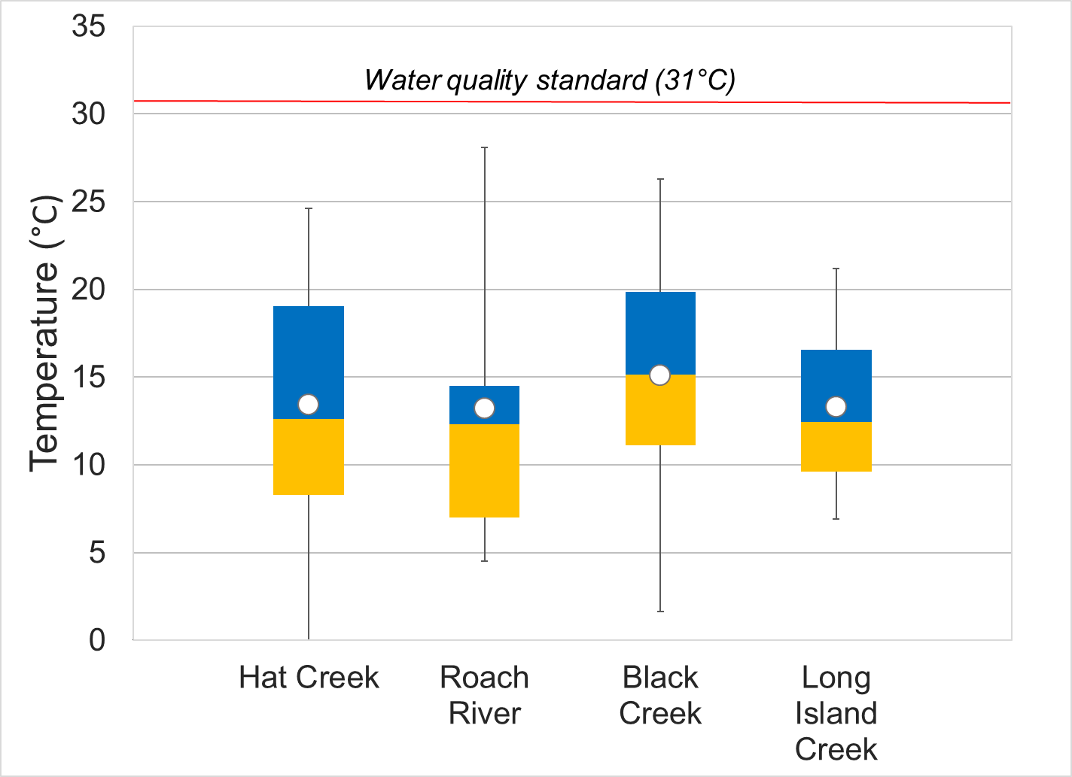
Figure 1-14. Temperature measured in Hat and Black Creeks. Whiskers indicate the range, boxes indicate the inter-quartile range, lines indicate the median, and white markers indicate the average. Streams with a * are statistically different from the reference sites.
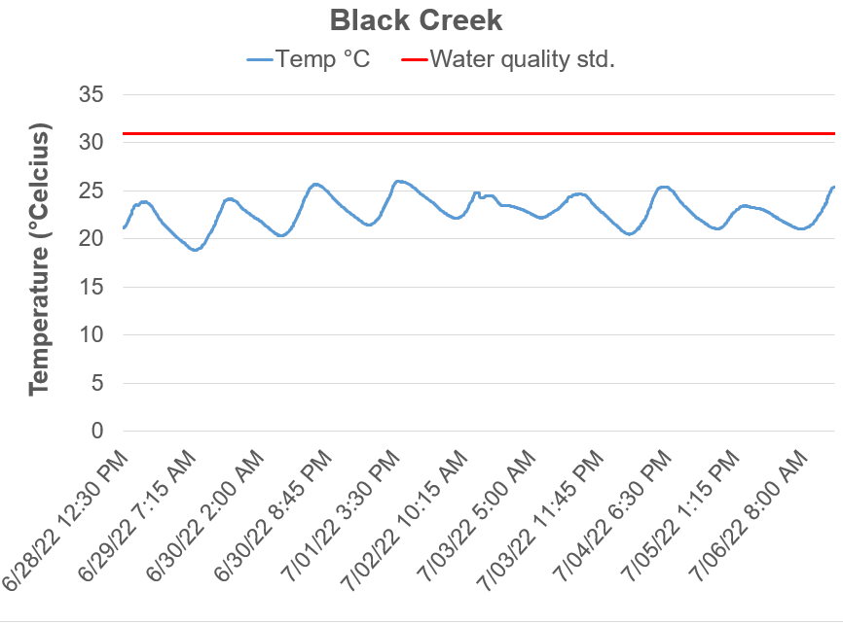
Figure 1-15. Diurnal temperatures in Black Creek (2-BCK000.08). The red line indicates the water quality standard for temperature.

pH
DEQ measured the pH of Hat and Black Creeks in the field during the collection of benthic and water quality samples. Figure 1-16 shows the pH values collected from the impaired streams in comparison to the reference conditions. Measured pH values were near neutral at all sites, spanning an average of 7.5 in Hat Creek to 7.1 in Black Creek. All pH values from all sites met pH water quality standards of 6-9 and were within the range identified by DEQ as low probability for producing stressor effects (DEQ, 2017). Values in Black Creek were significantly lower than the reference condition (p=0.005).
DEQ also collected diurnal pH data from Black Creek in late June/early July 2022. Diurnal data were collected at 15-minute intervals over a 9-day period. pH data collected during this diurnal deployment is shown in Figure 1-16. Diurnal pH values exhibited the natural cycle of increases during the day while plants are photosynthesizing and decreases at night while respiration dominates. Like field parameter measurements, diurnal pH measurements were all within water quality standards and within the range of low probability for stressor effects. This indicates that pH is not a concern or stressor in Black Creek.
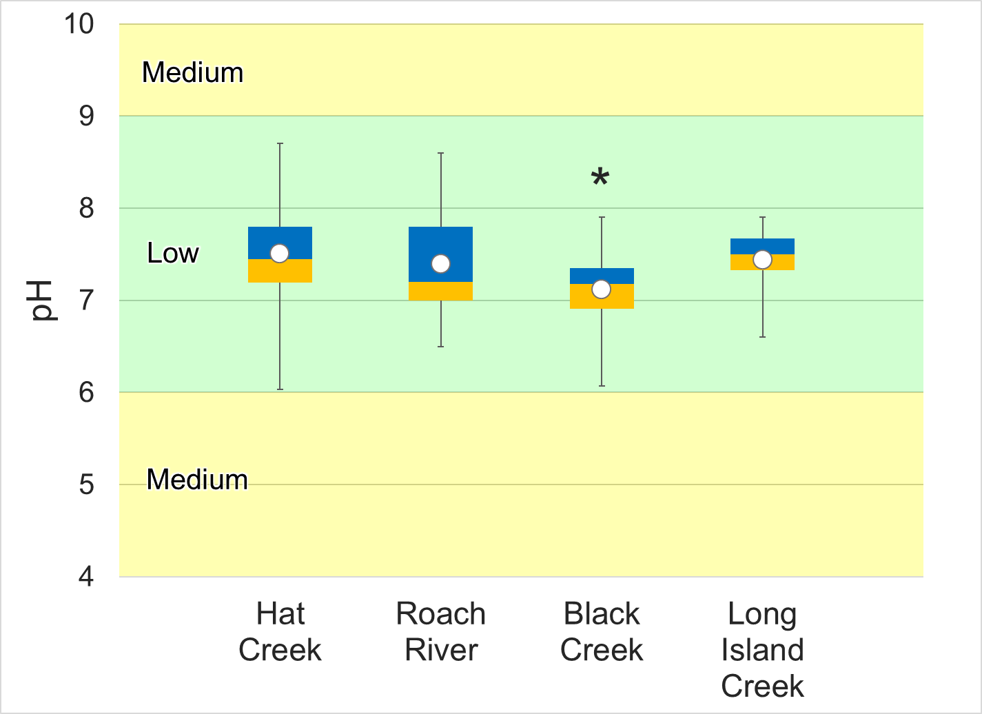
Figure 1-16. pH measured in Hat and Black Creeks. Whiskers indicate the range, boxes indicate the inter-quartile range, lines indicate the median, and white markers indicate the average. Streams with a * are statistically different from the reference sites. Colors represent the probability that data within that range would be responsible for causing stress.

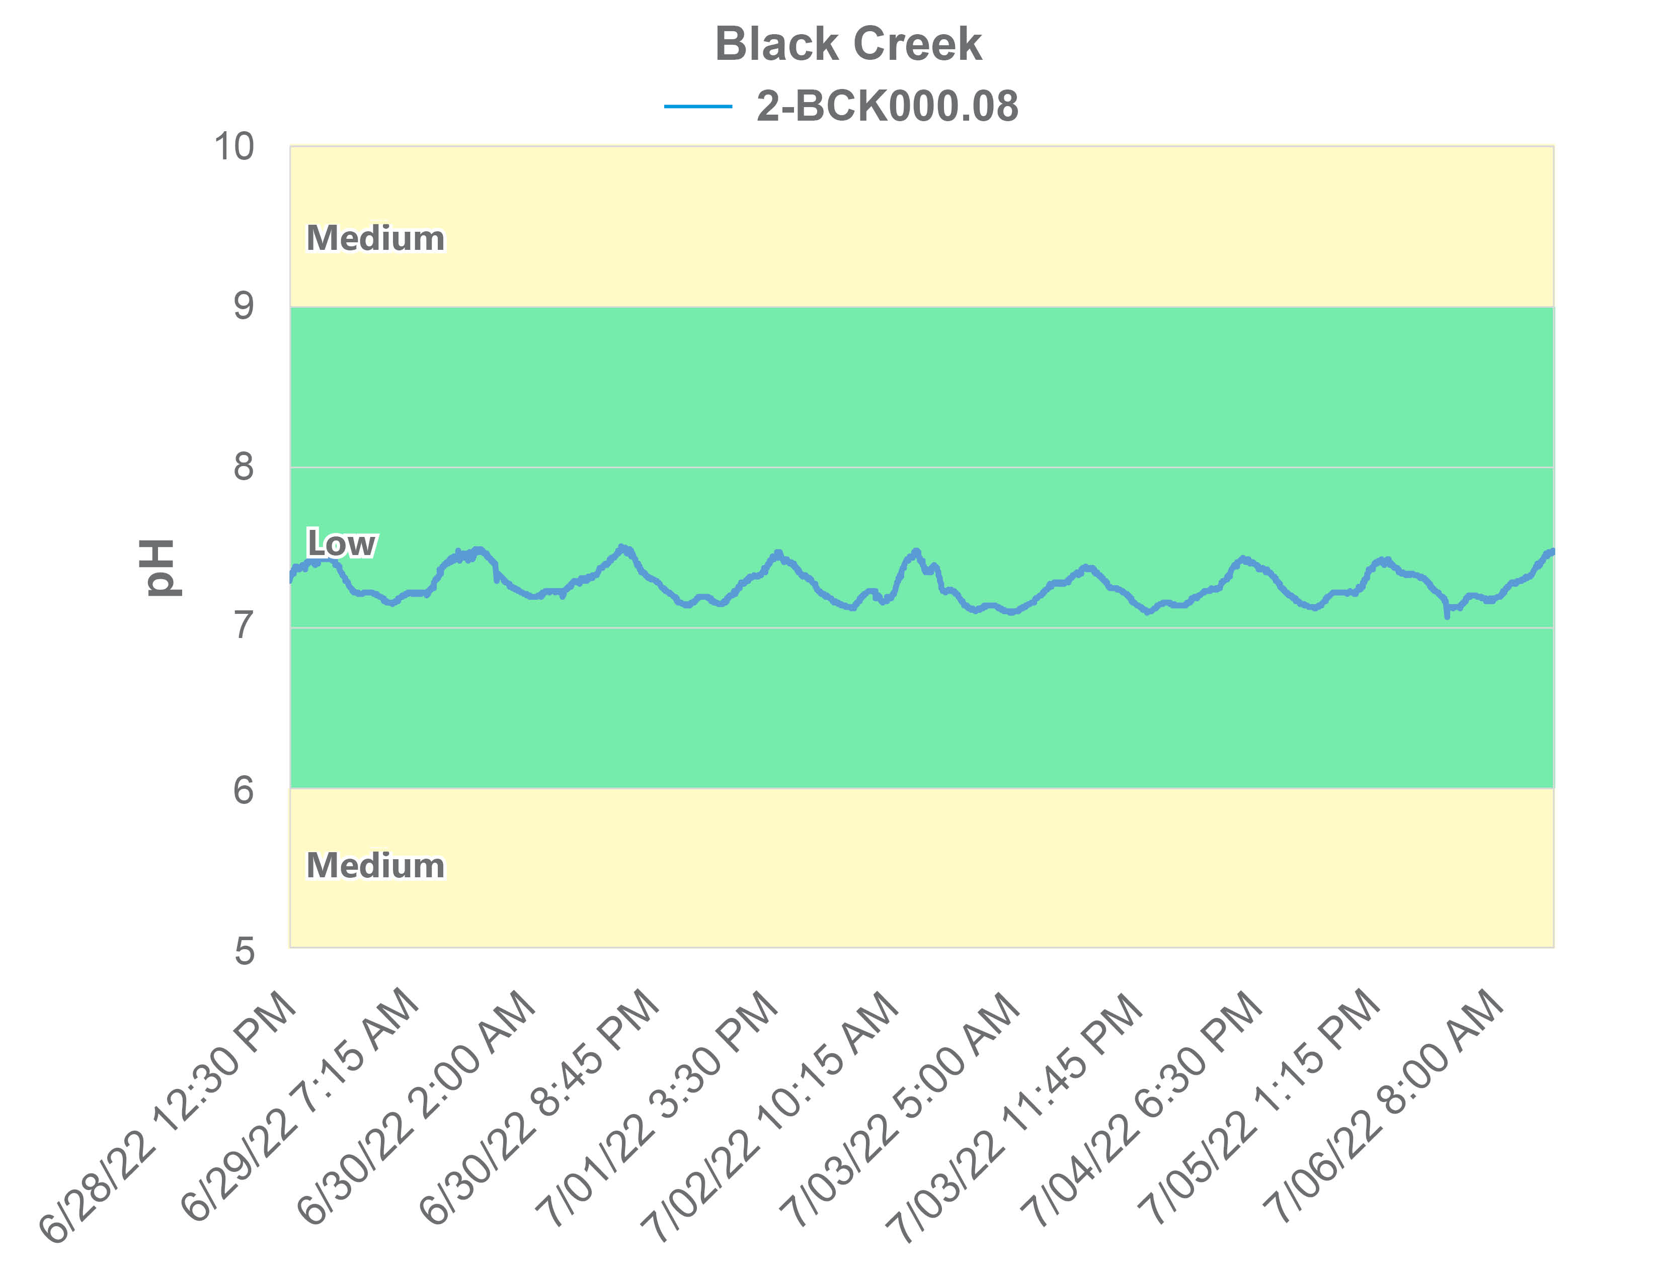
Figure 1-17. Diurnal pH in Black Creek in spring 2022. Colors represent the probability that data within that range would be responsible for causing stress.

Dissolved Oxygen
DEQ measured the dissolved oxygen levels in Hat and Black Creeks in the field during the collection of benthic and water quality samples. Figure 1-18 shows the dissolved oxygen values collected from the impaired streams compared with the reference watersheds. Dissolved oxygen values averaged 10.9 mg/L in Hat Creek and 10.5 mg/L in Black Creek. Neither of the impaired streams were significantly different from their respective reference conditions (ɑ=0.05). All dissolved oxygen values measured in Hat Creek fell above the medium probability for stressor effects threshold, while Black Creek had one excursion into this range. Ambient monitoring results indicate a low probability that a lack of dissolved oxygen is responsible for the benthic impairments. However, only five (5) of the 35 ambient monitoring samples collected from Black Creek were measured during the critical period (June-August) after 10:00 a.m. when the water is warmest. In Hat Creek, 15 of 94 samples were collected within this critical time frame.
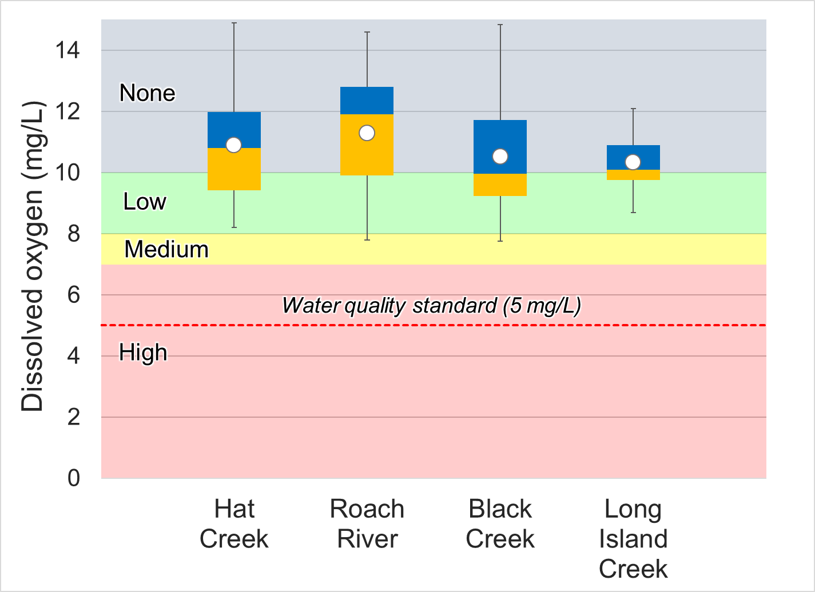
Figure 1-18. Dissolved oxygen measured in Hat and Black Creeks. Whiskers indicate the range, boxes indicate the inter-quartile range, lines indicate the median, and white markers indicate the average. Streams with a * are statistically different from the reference sites. Colors represent the probability that data within that range would be responsible for causing stress. The red line indicates the water quality standard.

Diurnal data were collected from Black Creek at 15-minute intervals over a 9-day period beginning on June 28, 2022. Diurnal monitoring of dissolved oxygen is important, because critical dissolved oxygen levels are typically encountered just before sunrise. This is due to the combination of oxygen consumption from respiration and the absence of oxygen production from photosynthesis during the night.
Dissolved oxygen data and water temperatures collected during this diurnal deployment are shown in Figure 1-19. Dissolved oxygen values at Black Creek exhibited the natural cycle of increases during the day while plants are photosynthesizing and decreases at night when respiration dominates. Daily fluctuations averaged 2.4 mg/L, with the largest daily shift of 3.1 mg/L occurring on 7/06/22. Large daily fluctuations in dissolved oxygen concentrations (typically over 3 mg/L) can be indicative of eutrophic conditions in aquatic systems (Wetzel, 2001). Temperatures ranged from 18.8 °C to 26.1°C. Dissolved oxygen concentrations were lowest on the morning of 7/02/22 (5.66 mg/L) after water temperatures reached their maximum value the previous afternoon. Twenty four percent of diurnal measurements in Black Creek fell within the high probability of stressor effects range, while 48% fell in the medium probability range. While dissolved oxygen concentrations never dropped below the water quality standard of 5 mg/L, they remained low enough the cause stress to sensitive aquatic organisms for over 70% of the 9-day monitoring period.
Diurnal oxygen saturation (% saturation) in Black Creek is shown in Figure 1-20. The largest diurnal shift in % saturation occurred between 7/1/2022 and 7/2/2022, with values dropping from a high of 105.3% the afternoon of the 1st to a low of 65.2% the morning of the 2nd. Oxygen saturation is the ratio of the measured dissolved oxygen concentration to the maximum amount of oxygen that the water can hold at the given temperature and pressure. A healthy stream will typically have saturation values between 80-120%. Shifts below and above this range are indicative of elevated productivity. When productivity levels are high during the daytime, plants and algae are producing oxygen during photosynthesis leading the stream to become supersaturated with oxygen (>100%). During the evening, when respiration occurs, oxygen is consumed, concentrations are depleted, and saturation levels drop. In Black Creek, 14.6% of dissolved oxygen saturation measurements collected during the diurnal monitoring period fell below 80%.
In summary, dissolved oxygen concentrations in Black Creek fell within the low probability for stressor effects range during the 2-year monthly monitoring period. However, diurnal monitoring indicates a moderate to high probability of benthic stress due to depleted oxygen concentrations during the summertime critical period. Daily shifts in dissolved oxygen concentrations did not typically exceed 3 mg/L, averaging 2.4 mg/L during the diurnal monitoring period. This suggests elevated productivity is occurring in the stream, but does not provide clear evidence of eutrophication. Oxygen saturation levels fell below 80% over 10% of the time during the 9-day diurnal monitoring period, though never exceeding 106%. These results do not provide clear evidence of excessive productivity in the stream. However, elevated phosphorus concentrations in Black Creek provide a causal pathway for excess enrichment and productivity, which could be followed by a reduction in dissolved oxygen in Black Creek. Additionally, diurnal monitoring was conducted in June which is typically prior to the summertime critical period when water temperatures are at their highest in late July/early August. It is possible that dissolved oxygen concentrations dropped further following the diurnal monitoring period. In Hat Creek, concentrations observed during monthly monitoring did not indicate likely stressor effects as a result of low dissolved oxygen concentrations.

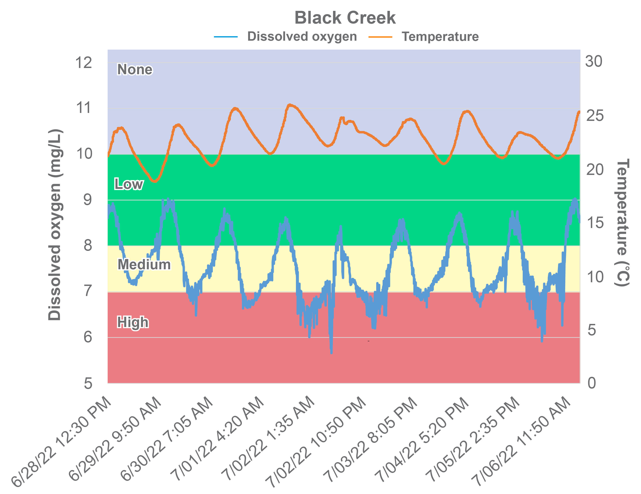
Figure 1-19. Diurnal dissolved oxygen and corresponding water temperatures collected from Black Creek (2-BCK000.08) in 2022. Colors represent the probability that dissolved oxygen data within that range would be responsible for causing stress (temperature probability thresholds are not shown).
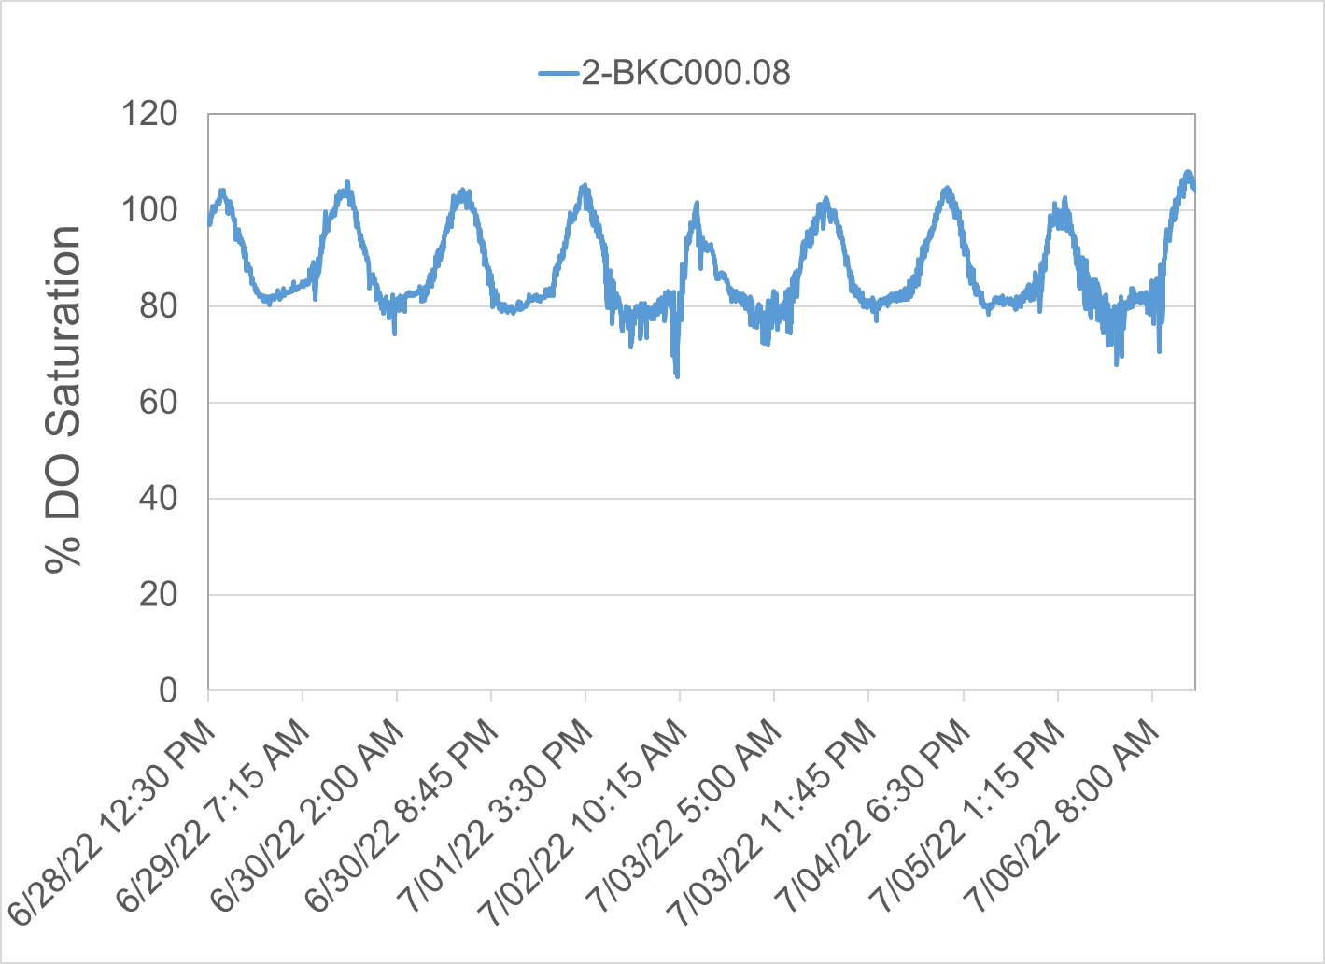
Figure 1-20. Diurnal oxygen saturation in Black Creek.

Conductivity and Dissolved Solids
Conductivity is a measure of the electrical potential of water based on the ionic charges of dissolved compounds. For this reason, the conductivity of water is closely related to the total dissolved solids present. DEQ measured specific conductance in Hat and Black Creeks in the field during the collection of benthic and water quality samples (Figure 1-21). Specific conductance fell within the no probability range for causing stressor effects on all sampling occasions with the exception of one event in Black Creek in September 2012 when specific conductance measured 258 µS/cm. In addition, neither of the streams had concentrations that were significantly higher than their reference conditions.
In addition to periodic conductivity measurements, DEQ collected diurnal conductivity data from Black Creek during the summer of 2022. Diurnal data were collected at 15-minute intervals for a period of 13 days (Figure 1-22). Specific conductance remained low and within the low probability of stressor effects range for the majority of the 9-day monitoring period, with only 2% of samples exceeding 150 µS/cm.
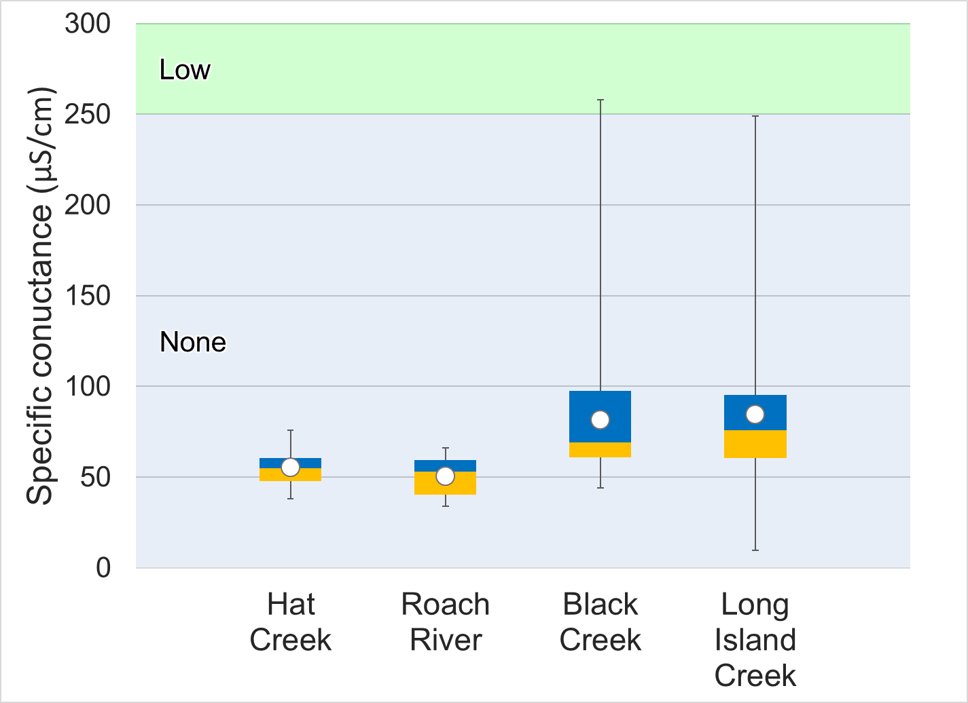
Figure 1-21. Specific conductance measured in Hat and Black Creeks. Whiskers indicate the range, boxes indicate the inter-quartile range, lines indicate the median, and white markers indicate the average. Streams with a * are statistically different from the reference sites. Colors represent the probability that data within that range would be responsible for causing stress.
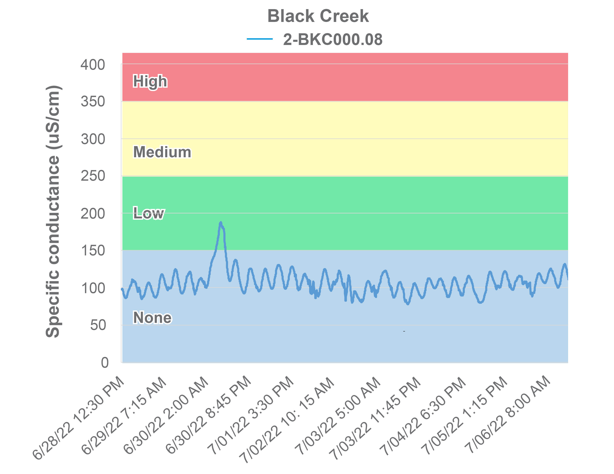
Figure 1-22. Diurnal measurements of specific conductance in Black Creek in 2022.
Total dissolved solids are closely tied to conductivity, since dissolved ions are responsible for transmission of electrical currents in the water. Total dissolved solids were measured monthly in Hat and Black Creeks for a period of two years (2020-2021) (Figure 1-23). Like conductivity, total dissolved solids levels were well within the no probability of stress range.
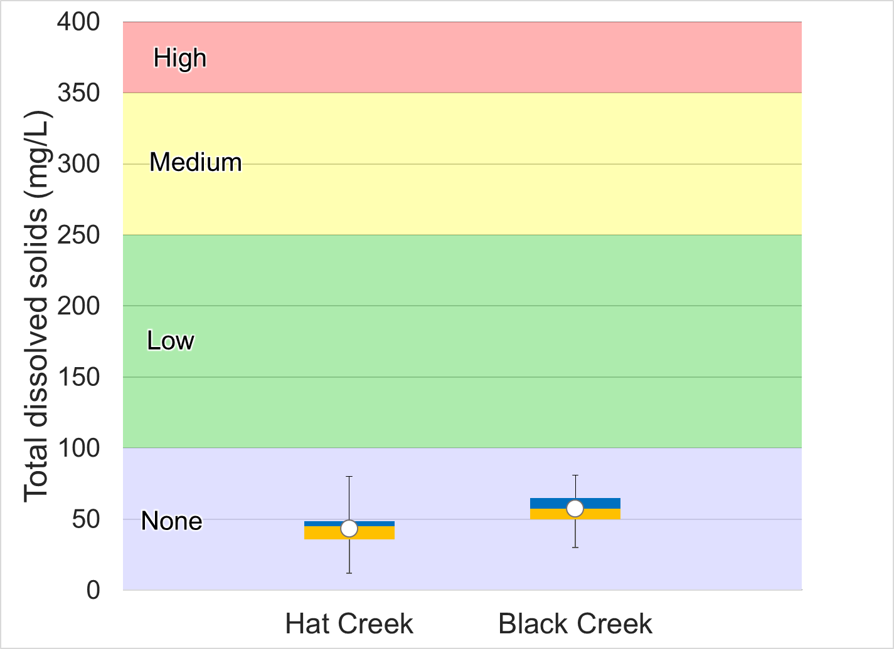
Figure 1-23. Total dissolved solids measured in Hat and Black Creeks. Whiskers indicate the range, boxes indicate the inter-quartile range, lines indicate the median, and white markers indicate the average. Colors represent the probability that data within that range would be responsible for causing stress.

Dissolved Ions
Dissolved chloride, potassium, sodium, and sulfate were measured in Hat and Black Creeks. Dissolved ion concentrations were compared to both DEQ’s stressor thresholds and concentrations in the reference stream (Figure 1-24).
Dissolved chloride concentrations in Hat and Black Creeks fell within the no to low probability of stressor effects range. Maximum concentrations did not exceed water quality standards in either of the impaired streams. The median chloride concentration in Hat Creek was 3.59 mg/L, while the maximum concentration measured was 12.4 mg/L. In Black Creek, the median concentration was 8.47 mg/L and the maximum was 13.0 mg/L. Virginia water quality standards include an acute maximum Cl concentration criterion of 860 mg/l and a chronic maximum concentration criterion of 230 mg/l to protect aquatic life. The acute criterion is for a one-hour average not to be exceeded more than once every three years; the chronic criterion applies to a four-day average, which is also not to be exceeded more than once every three years (9VAC25-260-140).
Dissolved potassium concentrations were slightly elevated in Black Creek, with median and maximum values of 2.11 and 3.41 mg/L, respectively. Both mean and median concentrations fell within the lower range of the medium probability of stressor effects range (Figure 1-24). As shown in Figure 1-25, concentrations appear to increase after April 2021 and remain slightly elevated throughout the remainder of the monitoring period. The lack of seasonality makes runoff of fertilizer an unlikely source of elevated potassium concentrations in the stream. The Nelson County Sewage Treatment Plant, located upstream of the monitoring station (2-BKC000.08) documented a sewage overflow of 23,000 gallons of effluent on May 5, 2021, noting that the untreated effluent reached Black Creek. It is possible that the dry conditions that persisted throughout the remainder of 2021 allowed for continued impacts from the overflow. Values were slightly lower in Hat Creek, with mean and median concentrations of 1.36 and 1.27 mg/L, respectively. Hat Creek had one excursion into the medium probability for stressor effects range (2.44 mg/L on October 2021), with all remaining values falling within the low to no probability range.
Dissolved sodium levels were relatively low in Hat and Black Creeks, with median values of 3.48 and 5.28 mg/L, respectively. Mean and median values in both impaired streams fell within the range of no probability of stressor effects.
Dissolved sulfate concentrations were consistently low in both of the impaired streams, with all reported values falling within the no probability of stressor effects range. Median concentrations in Hat and Black Creek were 2.75 and 3.06 mg/L, respectively.
In summary, dissolved ion concentrations were relatively low in Hat and Black Creeks, as were measurements of specific conductivity and total dissolved solids. There was little evidence supporting the conclusion that any of the dissolved ions measured in the impaired streams were potential stressors. Potassium concentrations in Black Creek were slightly elevated, particularly in the latter half of 2021. It is possible that a sewage overflow in May 2021 upstream of the monitoring station resulted in elevated concentrations observed during this period. However, potassium levels still remained within the lower range of a medium probability of stressor effects during this period.

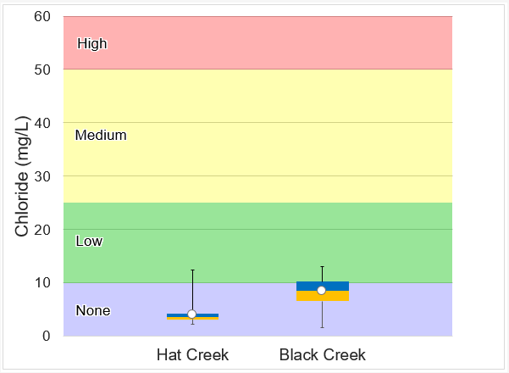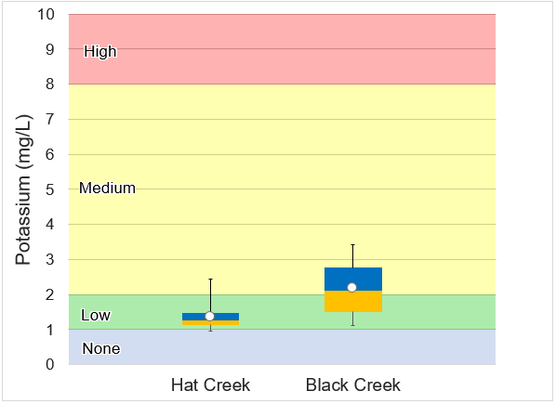

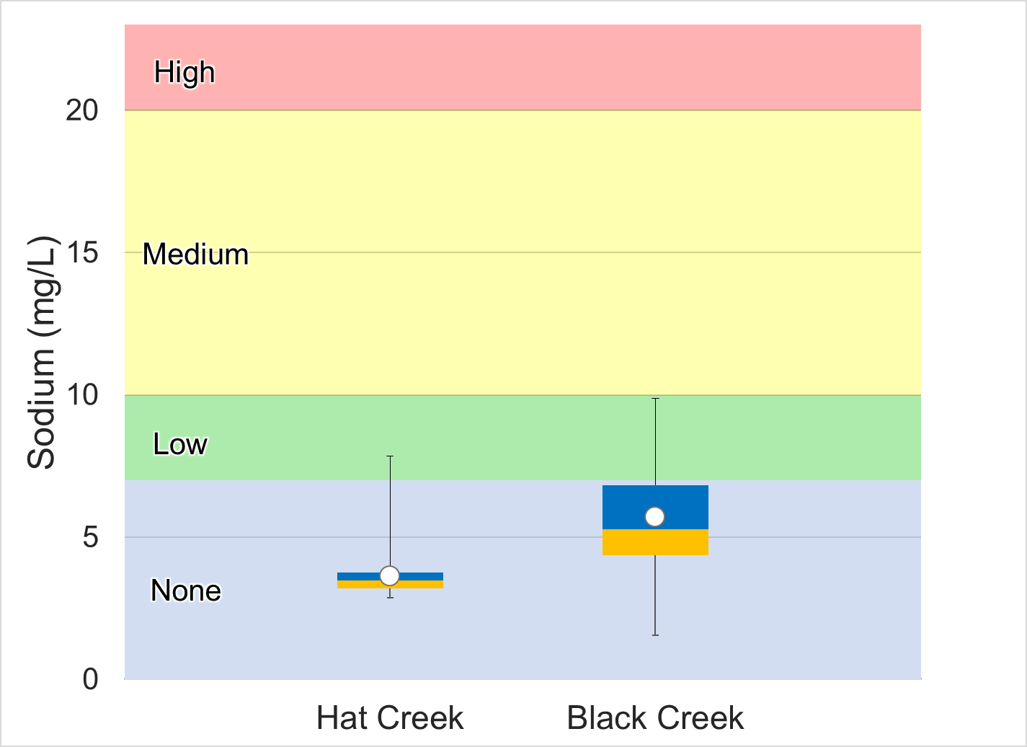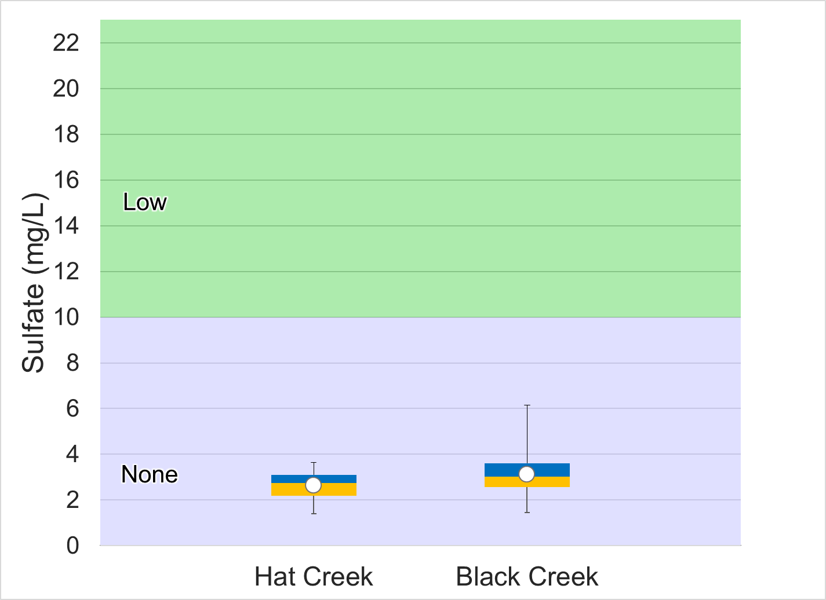

Figure 1-24. Dissolved ions measured in Hat and Black. Whiskers indicate the range, boxes indicate the inter-quartile range, lines indicate the median, and white markers indicate the average. Colors represent the probability that data within that range would be responsible for causing stress.
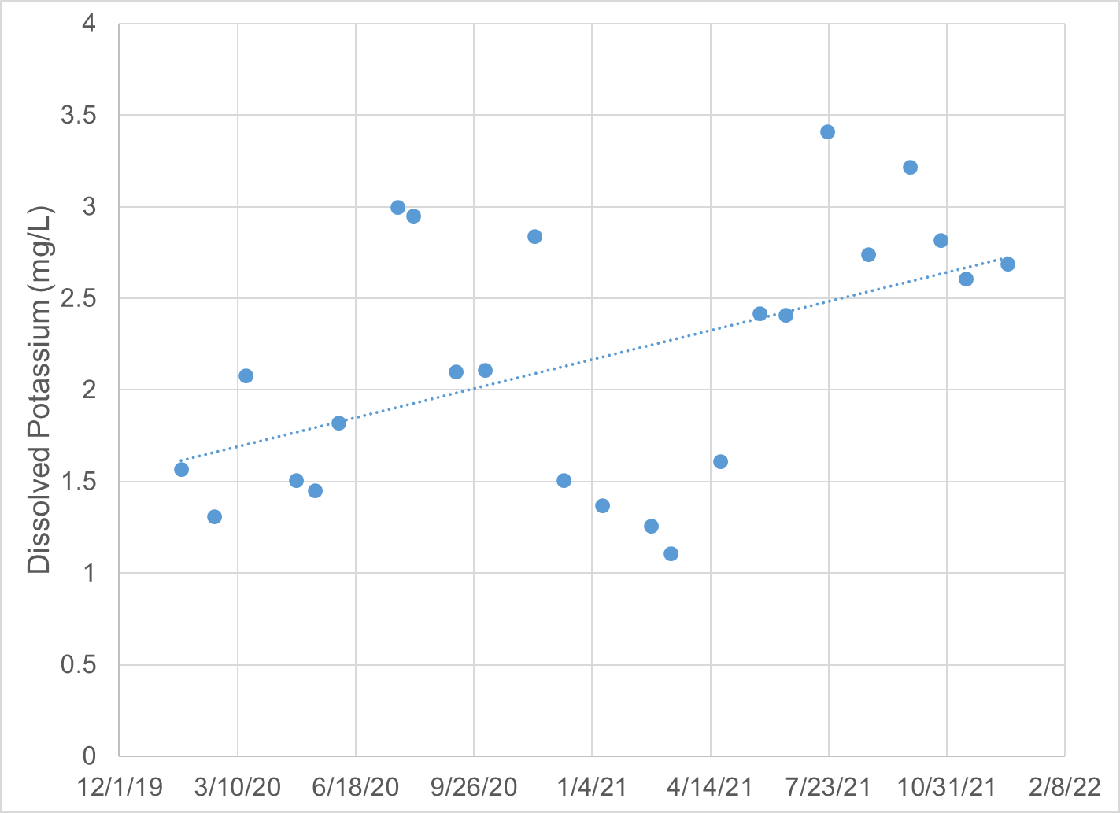
Figure 1-25. Dissolved potassium concentrations in Black Creek (2-BKC000.08) measured between 2020 and 2021.

Nutrients
Nitrogen and phosphorus are the primary nutrients of concern in freshwater. These nutrients are necessary to support healthy ecosystems, but excess nutrients can lead to eutrophication. Excess nutrients spur algae growth and can change the benthic community composition. An overabundance of algae can reduce oxygen levels, leading to further changes in community composition and eventually hypoxic conditions. The initiation of this eutrophication process is not reliant upon the total nutrient availability, but upon the availability of the limiting nutrient. The typical ratio of nitrogen to phosphorus in algae is 7.5:1, so ratios above 7.5 indicate that phosphorus is the limiting nutrient, and ratios below 7.5 indicate that nitrogen is the limiting nutrient. In Hat and Black Creeks, the average nitrogen to phosphorus ratios were 5.64 and 8.71, respectively, indicating that phosphorus is the limiting nutrient in Black Creek while nitrogen is limiting in Hat Creek.
Total nitrogen concentrations in the impaired streams were compared to DEQ’s stressor thresholds (Figure 1-26). Median nitrogen concentrations were also compared with EPA recommended nutrient criteria for the Piedmont Ecoregion, which are based upon the 25th percentile of reported values for the region (USEPA, 2000b). While a portion of Hat Creek extends into the Blue Ridge Ecoregion, the majority of the watershed, including the monitoring station, falls within the Piedmont Ecoregion. Median and mean total nitrogen values in Hat Creek fell well below the recommended criteria of 0.65 mg/L TN. Concentrations in Black Creek frequently exceeded this threshold, with a median concentration of 0.925 mg/L. Both median and average values for Black Creek fell just below the threshold for a medium probability of stressor effects due to excess nitrogen (1 mg/L), with one excursion into the high probability of stressor effects range. Mean and median nitrogen concentrations in Hat Creek both fell within the no probability of stressor effects range. There were two excursions into the medium probability of stressor effects range between 2007 and 2021. While Black Creek had elevated nitrogen concentrations on several occasions, phosphorus was identified as the limiting nutrient in the stream. This suggests it is unlikely that nitrogen is responsible for stressor effects resulting from excess algal growth due to excessive nitrogen loading in Black Creek. While nitrogen was the limiting nutrient in Hat Creek, monthly monitoring data suggests that nitrogen is not a stressor in the stream.
Figure 1-27 shows total phosphorus levels in Hat and Black Creeks. Median phosphorus concentrations were compared with EPA recommended nutrient criteria for the Piedmont Ecoregion, which are based upon the 25th percentile of reported values for the region (USEPA, 2000b). The median TP concentrations in Hat and Black Creeks (0.06 and 0.105 mg/L, respectively) exceeded the recommended criterion of 0.03 mg/L TP. In Black Creek, the median concentration fell along the boundary between a medium and high probability for stressor effects range, while the mean value fell within the high probability range. Median and mean concentrations in Hat Creek fell within the medium probability of stressor effects range for TP. Since nitrogen is the limiting nutrient in Hat Creek, it is unlikely that phosphorus is a stressor in the stream as it is not the primary factor controlling nutrient growth. TP concentrations in Black Creek were elevated through the two year monitoring period, but began to increase further between April and May 2021. Concentrations remained elevated through the remainder of the monitoring period (Figure 1-28). As noted previously, a discharge of untreated sewage from the Nelson County STP to Black Creek was documented at the beginning of May 2021. The median TP concentration between January 2020 and April 2021 (prior to the discharge) was 0.085 mg/L, while the median concentration between May 2021 and December 2021 was 0.20 mg/L. This discharge could be a source of the increase in TP concentrations measured in the last 7 months of sampling. While there is not a stream gage on Black Creek, DEQ/USGS operates a gage on the Tye River in Lovington. Discharge rates at this gage provide an indication of conditions upstream in Black Creek. As shown in Figure 1-29, the increase in TP occurred during a relatively dry period, and low flow conditions persisted through the end of July. The dry conditions could allow for continued impacts from the documented discharge of untreated sewage for several months. TP concentrations in Black Creek would be expected to increase during periods of high flow if non point source runoff from surrounding agricultural and residential land and streambank erosion were responsible for elevated concentrations. Comparisons of TP concentrations and mean daily discharge at the Tye River gage indicate that some of the highest concentrations were documented during periods of low flow, occurring both before and after the documented overflow at the STP (Figure 1-29). TP concentrations were also compared with monthly average discharge data from the Nelson County STP (Figure 1-30). The relationship between average monthly discharge and phosphorus is variable during the two year monitoring period. During some months, it appears that the facility may be diluting phosphorus concentrations in the creek, with low TP concentrations occurring when the average discharge rate is high, and high TP concentrations occurring when the discharge rate is lower (e.g. January 2020 and July 2020, respectively). On other occasions, phosphorus concentrations are elevated when discharge rates are elevated (November 2020, July 2021). Without paired discharge and phosphorus data from the outfall at the STP, it is difficult to determine how the STP is affecting phosphorus concentrations in Black Creek.
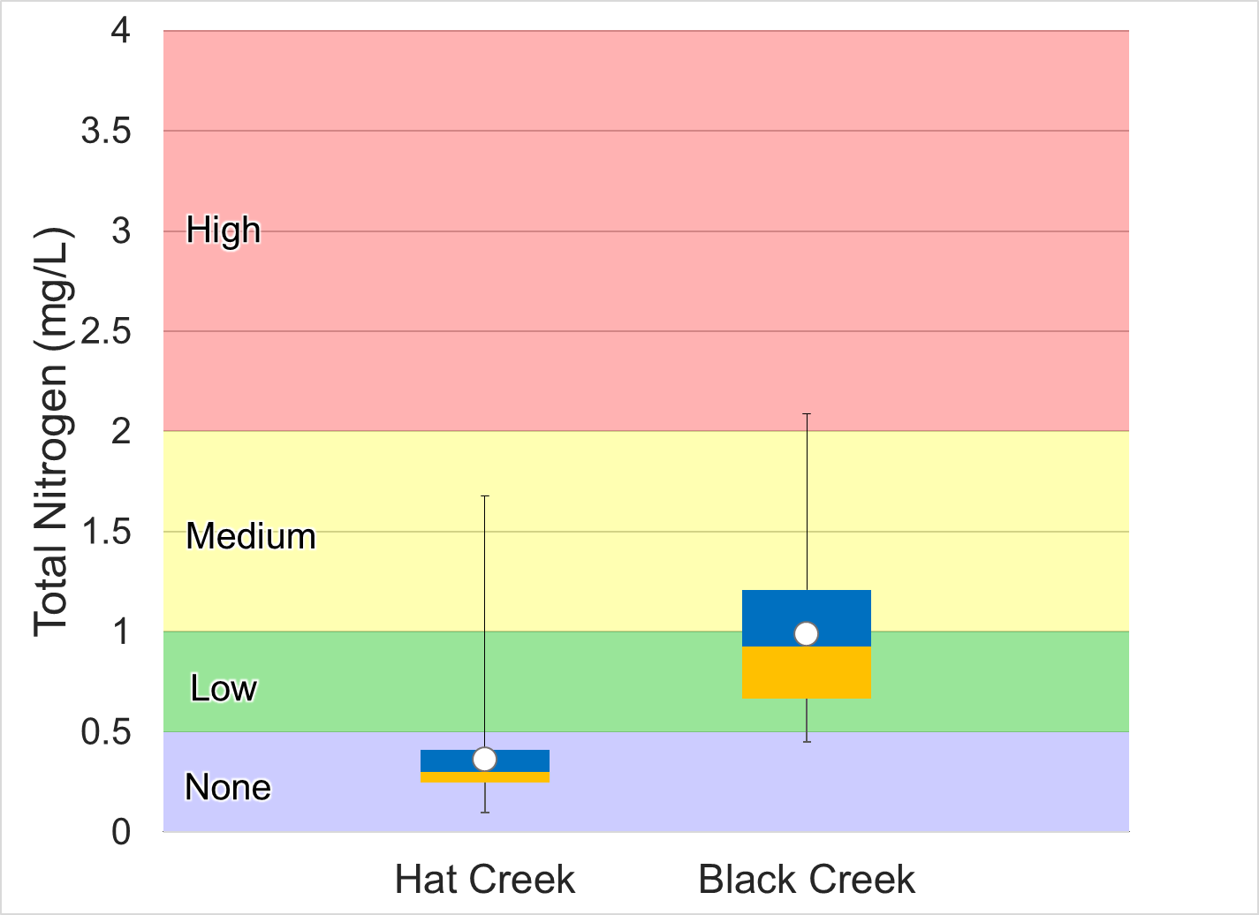
Figure 1-26. Total nitrogen concentrations in Hat and Black Creeks. Whiskers indicate the range, boxes indicate the inter-quartile range, lines indicate the median, and white markers indicate the average. Colors represent the probability that data within that range would be responsible for causing stress.
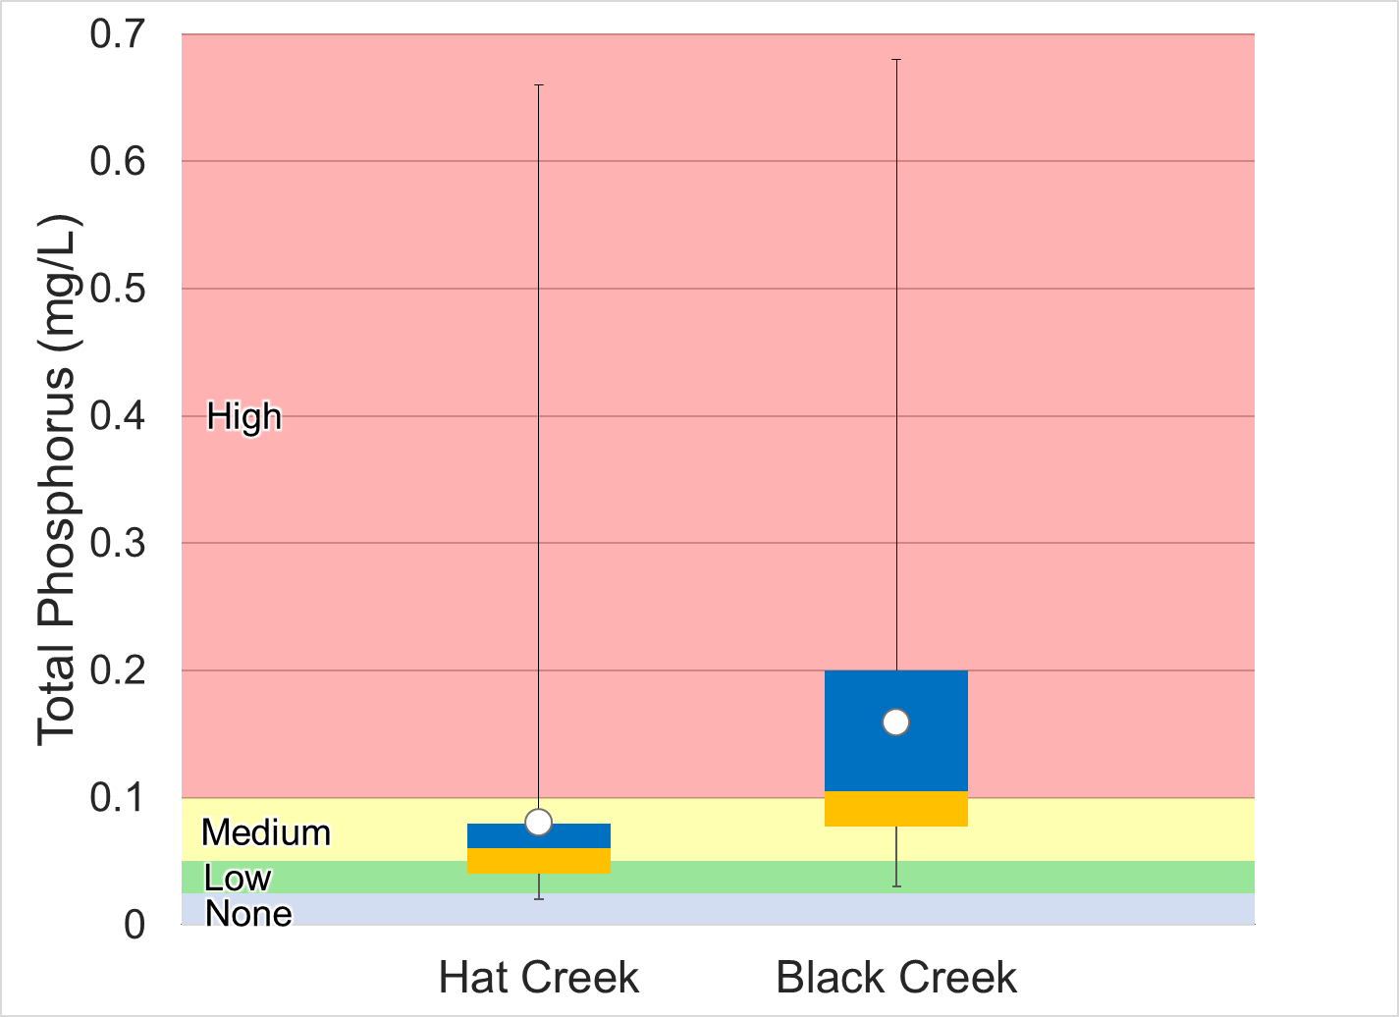
Figure 1-27. Total phosphorus concentrations in Hat and Black Creeks. Whiskers indicate the range, boxes indicate the inter-quartile range, lines indicate the median, and white markers indicate the average. Colors represent the probability that data within that range would be responsible for causing stress.

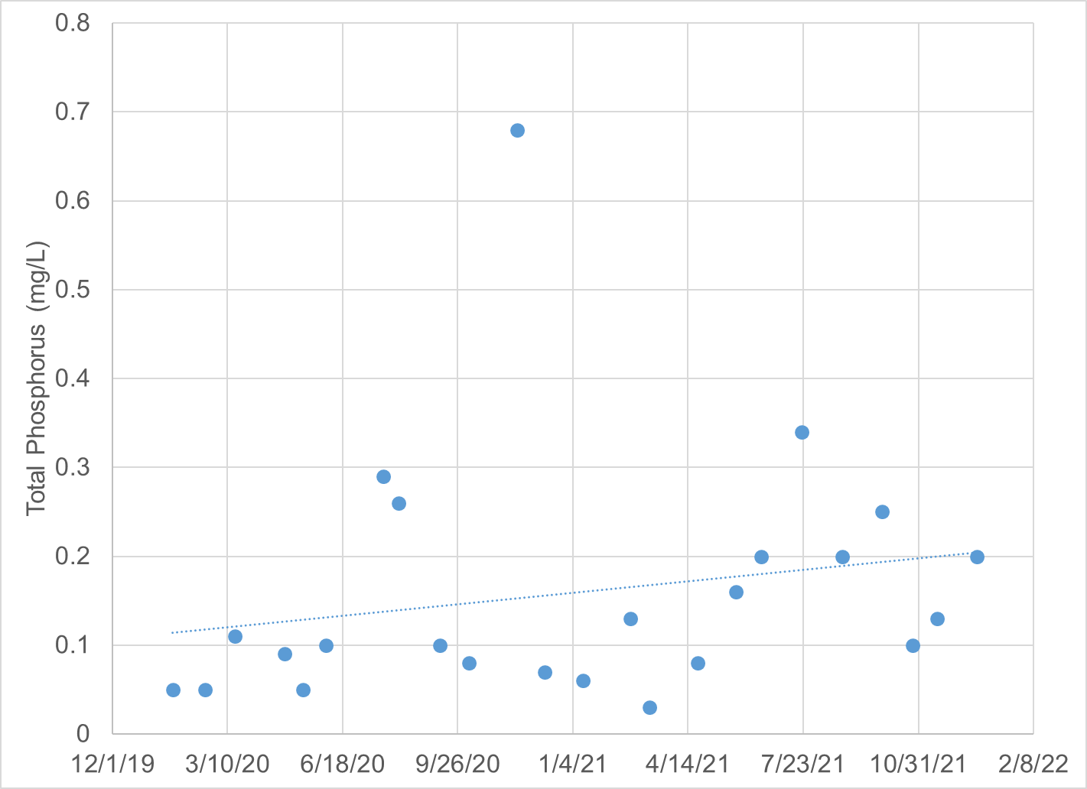
Figure 1-28 Total phosphorus concentrations in Black Creek (2-BKC000.08) measured between 2020 and 2021.

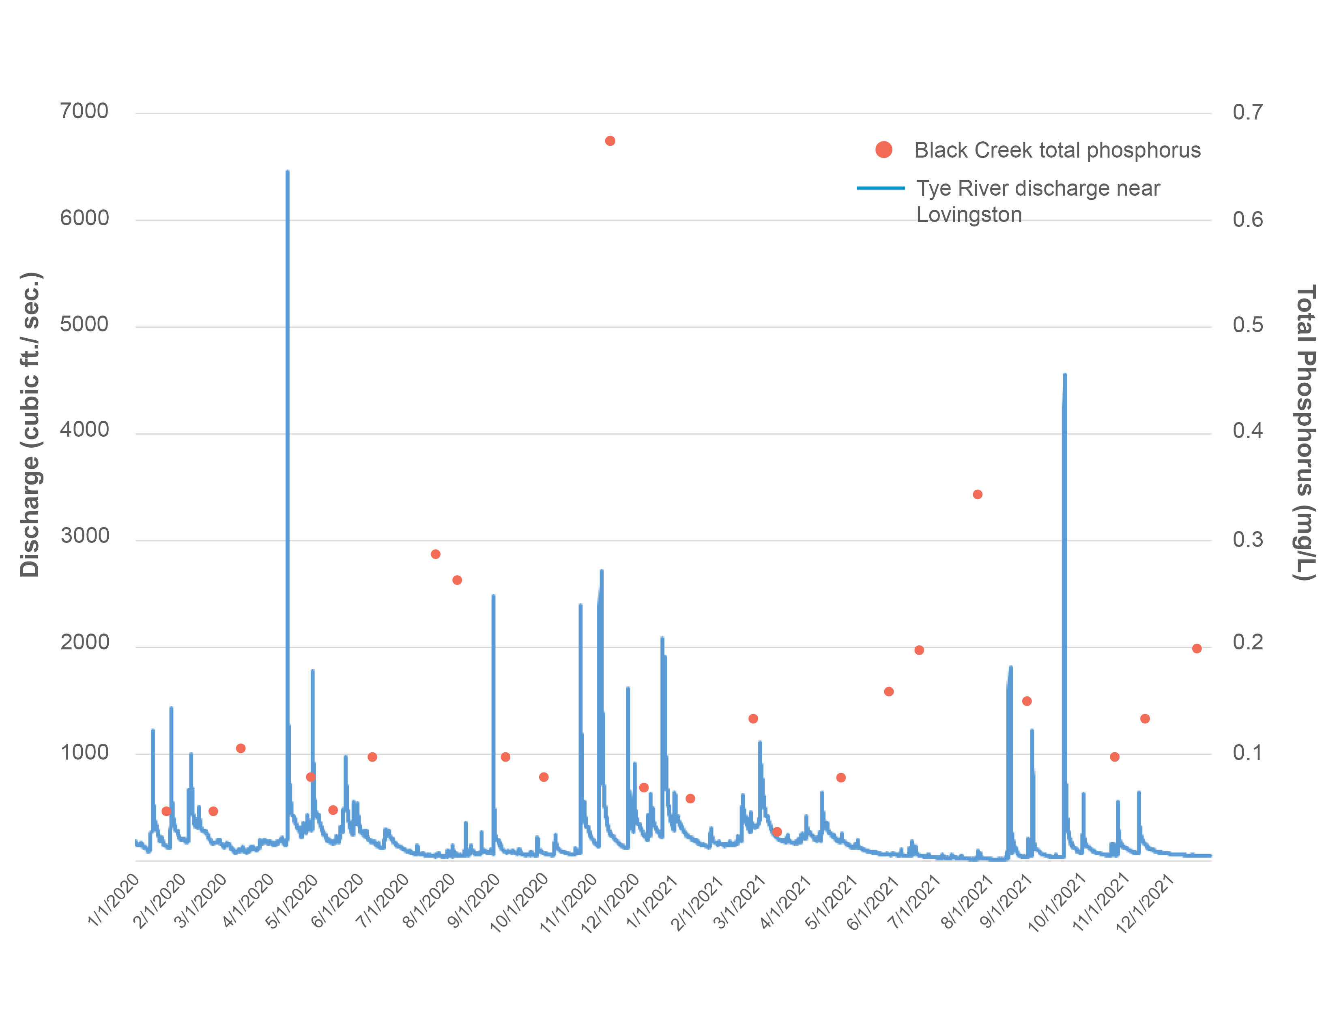
Figure 1-29 Discharge at USGS gage on Tye River near Lovingston, VA in 2020 and 2021 versus total phosphorus concentrations in Black Creek (2-BKC000.08).
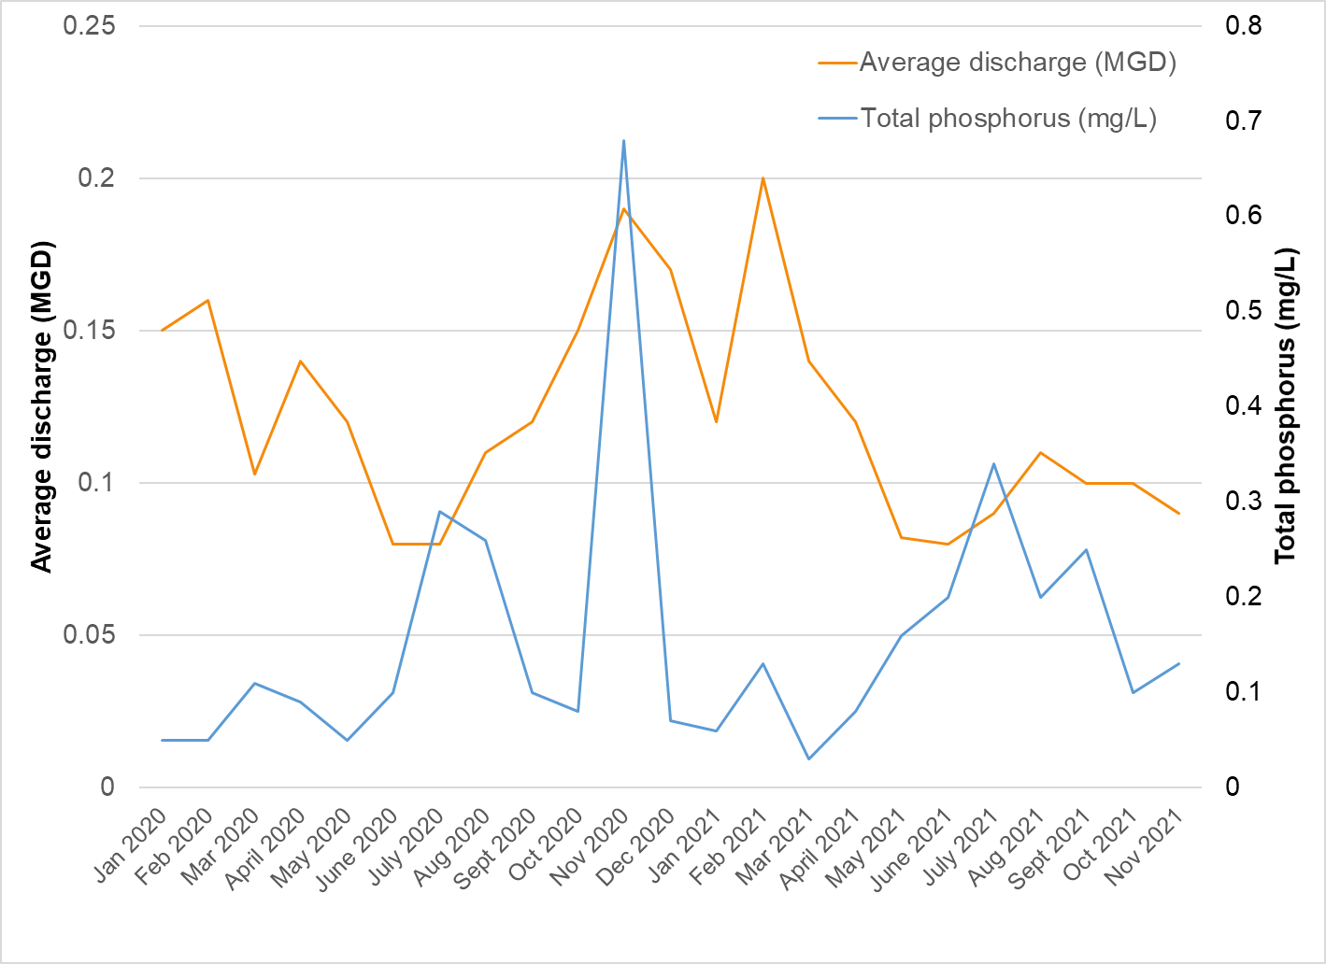
Figure 1-30. Reported monthly average discharge rates for the Nelson County STP and total phosphorus concentrations in Black Creek (2020-2021).
Diurnal dissolved oxygen monitoring results must also be evaluated to determine if phosphorus is a likely stressor. Excess nutrient loads to a stream may accelerate algal growth, resulting in large diurnal swings in dissolved oxygen concentrations during periods of photosynthesis and respiration. Diurnal monitoring was conducted in Black Creek for a 9-day period in late June/early July 2022. Dissolved oxygen levels in Black Creek fell within the high probability of benthic stress (below 7 mg/L) during the daytime throughout the 9-day period of diurnal monitoring. However, concentrations did not approach the water quality standard of 5 mg/L, and the shift in both concentration and % saturation between daytime and nighttime was typically not indicative of eutrophic conditions. This suggests that plant growth, photosynthesis and respiration are affecting dissolved oxygen levels in Black Creek, but that growth rates are moderate as a result of elevated phosphorus inputs.
In summary, monthly ambient monitoring of phosphorus provided some evidence that phosphorus was a likely stressor in Black Creek, but not in Hat Creek. Additionally, diurnal monitoring in Black Creek provided evidence of depleted dissolved oxygen concentrations in the summertime, which may be the result of elevated productivity in the stream stimulated by excess phosphorus loading. Consequently, phosphorus was considered to be a possible stressor in Black Creek.

Water Quality Regressions
To investigate the potential role of various water quality parameters affecting the benthic macroinvertebrate community, SCI scores for both Hat and Black Creeks were regressed against water quality parameter values collected within a 30-day window of benthic monitoring at those sites. Table 1-11 shows the results of these regressions. None of the water quality parameters were significantly correlated with SCI scores for either of the impaired streams. This may be partially attributed to the small sample size. Additionally, several of the parameters showed little variation between samples. Total phosphorus in Black Creek had the greatest R² value and the smallest p-value of any of the regressions performed. Overall results of regression analyses indicate that additional data is needed to clearly demonstrate the relationship between SCI scores and water quality parameters.
Table 1-11. Regression relationship between water quality parameters and stream condition index (SCI) scores.
Parameter | No. of samples |  | Regression Significant  (Y/N) |  | R² |  | p-value
 | Hat Creek | Black Creek | Hat Creek | Black Creek | Hat Creek | Black Creek | Hat Creek | Black Creek
Temp Celsius | 10 | 12 | N | N | 0.07 | 0.00 | 0.96 | 0.96
Field pH | 10 | 12 | N | N | 0.04 | 0.05 | 0.55 | 0.54
DO | 9 | 12 | N | N | 0.00 | 0.11 | 0.89 | 0.38
Spec Cond | 10 | 12 | N | N | 0.00 | 0.01 | 0.90 | 0.82
Chloride | 4 | 4 | N | N | 0.06 | 0.65 | 0.76 | 0.20
TN | 5 | 4 | N | N | 0.09 | 0.48 | 0.63 | 0.31
TP | 5 | 4 | N | N | 0.01 | 0.75 | 0.87 | 0.14
Potassium | 4 | 4 | N | N | 0.20 | 0.66 | 0.55 | 0.19
Sodium | 4 | 4 | N | N | 0.01 | 0.61 | 0.90 | 0.22
Sulfate | 4 | 4 | N | N | 0.08 | 0.06 | 0.71 | 0.75
TDS | 4 | 4 | N | N | 0.24 | 0.15 | 0.51 | 0.61

Causal Analysis
DEQ conducted this stressor identification according to EPA’s Stressor Identification Guidance Document (USEPA, 2000a) using the Causal Analysis/Diagnosis Decision Information System (CADDIS) (USEPA, 2018). The CADDIS approach provides guidance on evaluating various lines of evidence to determine the cause of biological impairments. In the case of the Hat and Black Creek impairments, DEQ used the available data collected from the site, published water quality standards and threshold values, and available literature from other cases to investigate the potential causes of impairment. Table 1-12 shows the lines of evidence suggested by the CADDIS approach, an explanation of the concept, and examples of how this line of evidence was analyzed to identify probable stressors in the impaired streams. Some lines of evidence were not applicable, such as the analysis of biomarkers, field manipulations, or laboratory experiments. The majority of the lines of evidence, however, were investigated for the two impaired streams.

Table 1-12. Lines of evidence used in the causal analysis approach.
Evidence | The Concept | Examples from Hat and Black Creek Data Analysis
Data from the Case
Spatial Co-occurrence | The biological effect must be observed where the cause is observed, and must not be observed where the cause is absent. | Analysis of water quality and habitat data across sites
Temporal Co-occurrence | The biological effect must be observed when the cause is observed, and must not be observed when the cause is absent. | Analysis of temporal trends in benthic data
Evidence of Exposure or Biological Mechanism | Measurements of the biota show that relevant exposure to the cause has occurred, or that other biological mechanisms linking the cause to the effect have occurred. | NA
Causal Pathway | Steps in the pathways linking sources to the cause can serve as supplementary or surrogate indicators that the cause and the biological effect are likely to have co-occurred. | Development and analysis of causal pathways for stressors
Stressor-Response Relationships from the Field | As exposure to the cause increases, intensity or frequency of the biological effect increases; as exposure to the cause decreases, intensity or frequency of the biological effect decreases. | Correlation of water quality data with benthic score
Manipulation of Exposure | Field experiments or management actions that increase or decrease exposure to a cause must increase or decrease the biological effect. | NA
Laboratory Tests of Site Media | Controlled exposure in laboratory tests to causes (usually toxic substances) present in site media should induce biological effects consistent with the effects observed in the field. | NA
Temporal Sequence | The cause must precede the biological effect. | Analysis of temporal trends in benthic data
Verified Predictions | Knowledge of a cause's mode of action permits prediction and subsequent confirmation of previously unobserved effects. | NA
Symptoms | Biological measurements (often at lower levels of biological organization than the effect) can be characteristic of one or a few specific causes. | Analysis of benthic metrics, community composition, and functional feeding groups
Data from Elsewhere
Stressor-Response Relationships from Other Field Studies | At the impaired sites, the cause must be at levels sufficient to cause similar biological effects in other field studies. | Water quality comparison with reference sites and stressor probability thresholds
Stressor-Response Relationships from Laboratory Studies | At the impaired sites, the cause must be at levels associated with related biological effects in laboratory studies. | Water quality comparison with VA water quality standards and literature threshold values
Stressor-Response Relationships from Simulation Models | At the impaired sites, the cause must be at levels associated with effects in mathematical models simulating ecological processes. | Confirmation through use of TMDL model
Mechanistically Plausible Cause | The relationship between the cause and biological effect must be consistent with known principles of biology, chemistry and physics. | Development and analysis of causal pathways for stressors
Manipulation of Exposure at Other Sites | Field experiments or management actions at other sites that increase or decrease exposure to a cause must increase or decrease the biological effect. | Confirmation through literature
Analogous Stressors | Agents similar to the causal agent at the impaired site should lead to similar effects at other sites. | Confirmation through literature
Multiple Types of Evidence
Consistency of Evidence | Confidence in the argument for or against a cause is increased when many types of evidence consistently support or weaken it. | Weight of evidence approach
Explanation of the Evidence | Confidence in the argument for a candidate cause is increased when a post hoc mechanistic, conceptual, or mathematical model reasonably explains any inconsistent evidence. | Confirmation through use of TMDL model
For both impaired streams and for each potential candidate cause, the applicable lines of evidence were evaluated. For each line of evidence, the candidate cause was scored on a 3-point positive and negative scale (Table 1-13). This scale represents the strength of the evidence for or against each candidate cause. A weight of evidence approach was then used to sum the respective scores and classify candidate causes as either non-stressors, possible stressors, or probable stressors. If the summed scores for candidate causes were ≤0, the cause was classified as a non-stressor. If scores were 1-3, the cause was classified as a possible stressor. If scores were >3, the cause was classified as a probable stressor (Table 1-14).

Table 1-13. Scoring criteria used to evaluate candidate stressors.
Score | Explanation
+3 | The line of evidence strongly supports the candidate stressor as the cause of the impairment
+2 | The line of evidence moderately supports the candidate stressor as the cause of the impairment
+1 | The line of evidence weakly supports the candidate stressor as the cause of the impairment
0 | The line of evidence does not support or refute the candidate stressor as the cause of the impairment
-1 | The line of evidence weakly refutes the candidate stressor as the cause of the impairment
-2 | The line of evidence moderately refutes the candidate stressor as the cause of the impairment
-3 | The line of evidence strongly refutes the candidate stressor as the cause of the impairment

Table 1-14. Scheme for classifying candidate causes based on causal analysis.
Total Score | Classification
<-2 | Non-Stressor
-1
0
+1 | Possible Stressor
+2
+3
+4 | Probable Stressor
+5
>+6

Temperature
Table 1-15 shows the causal analysis results for temperature in Hat and Black Creeks. The total causal analysis score for both streams was -15, indicating that there is strong evidence that temperature is a non-stressor in these streams. No violations of the temperature standard were observed in either of the streams including during routine monthly monitoring. Temperatures were fell within an acceptable range to support a healthy and diverse population of aquatic life. For these reasons and others explained in Table 1-15, temperature was categorized as a non-stressor in Hat and Black Creeks.

pH
Table 1-16 shows the causal analysis results for pH for Hat and Black Creeks. Total causal analysis scores ranged from -18 in Hat Creek to -16 in Black Creek, indicating that there is strong evidence that pH is a non-stressor in these streams. pH values were near neutral in both streams, generally ranging between 7.1 in Black Creek to 7.5 in Hat Creek. No violations of the pH standard were observed, and values were within the low probability range of stressor effects for both streams. Values in Black Creek were significantly lower than the reference condition (α=0.05), though still within an acceptable range. For these reasons and others explained in Table 1-16, pH was categorized as a non-stressor.

Table 1-15. Causal analysis results for temperature as a stressor.
Evidence: Temperature | Hat Creek | Black Creek | Explanation
Spatial Co-occurrence | -3 | -3 | Both impaired streams do not show temperature excursions
Temporal Co-occurrence | -3 | -3 | Temperature was measured at the time of benthic collections and no temperature excursions were observed
Stressor-Response Relationships from the Field | -2 | -2 | No significant regression between benthic scores and temperature (ɑ=0.05)
Temporal Sequence | -2 | -2 | Neither of the impaired sites had lower fall benthic scores following high summer temperatures
Stressor-Response Relationships from Laboratory Studies | -3 | -3 | All temperatures were within water quality standards during routine monthly monitoring
Consistency of Evidence | -2 | -2 | All available sources of evidence refute temperature as the cause of impairment.
Sum | -15 | -15
Table 1-16. Causal analysis results for pH as a stressor.
Evidence: pH | Hat Creek | Black Creek | Explanation
Spatial Co-occurrence | -3 | -3 | Sites with impaired benthic community do not show pH excursions, while reference condition shows greater variability with excursions to levels within the medium probably of stress range
Temporal Co-occurrence | -2 | -2 | pH was measured at the time of benthic collections, and no pH excursions were observed.
Stressor-Response Relationships from the Field | -2 | -2 | No significant regression between benthic scores and pH
Stressor-Response Relationships from Other Field Studies | -3 | -1 | All pH values were in the range of low probability for stressor effects; Black Creek had pH values significantly lower than the reference
Stressor-Response Relationships from Laboratory Studies | -3 | -3 | All pH values were within water quality standards.
Mechanistically Plausible Cause | -2 | -2 | No biological mechanism for pH values within the range of 7.1-7.5, as measured in impaired sites, to produce toxic effects across a diverse assemblage of benthic macroinvertebrates
Consistency of Evidence | -3 | -3 | All available sources of evidence refute pH as the cause of impairment
Sum | -18 | -16

Dissolved Oxygen
Table 1-17 shows the causal analysis results for dissolved oxygen in Hat and Black Creeks. Total causal analysis scores ranged from -20 in Hat Creek to 3 in Black Creek, indicating that there is significant evidence that dissolved oxygen is a non-stressor in Hat Creek and a possible stressor in Black Creek. Dissolved oxygen levels did not approach the water quality standard of 5 mg/L in either stream during routine monthly monitoring. However, diurnal monitoring conducted in Black Creek in late June/early July 2022 indicated that concentrations routinely fell within the high to medium probability of stress range during the summertime critical period. Diurnal swings in dissolved oxygen averaged 2.4 mg/L, occasionally exceeding 3 mg/L. While this does not provide clear evidence of eutrophic conditions in Black Creek, it is indicative of elevated productivity. Average and median values in Black Creek during monthly ambient monitoring fell above and below the boundary of no and low probability of stressor effects. In Hat Creek, median and mean concentrations were in the no probability for stressor effects range. For these reasons and others explained in Table 1-17, dissolved oxygen was categorized as a non-stressor for Hat Creek and a possible stressor for Black Creek.

Conductivity and Total Dissolved Solids
Table 1-18 shows the causal analysis results for conductivity and total dissolved solids in Hat and Black Creeks. Total causal analysis scores for both streams had a value of -20, indicating that there is no evidence that total dissolved solids and conductivity are stressors in these streams. Specific conductance fell within the no probability range for causing stressor effects on all sampling occasions with the exception of one event in Black. In addition, neither of the streams had concentrations that were significantly higher than their reference conditions. For these reasons and others explained in Table 1-18, conductivity and total dissolved solids were not probable stressors in Hat and Black Creek.

Table 1-17. Causal analysis results for dissolved oxygen as a stressor.
Evidence: Dissolved oxygen | Hat Creek | Black Creek | Explanation
Spatial Co-occurrence | -3 | 2 | Hat Creek does not show excursions in DO below 8 mg/L where the probability of stressor effects is greater. Black Creek had one excursion into the medium probability of stressor effects range during ambient monitoring in June 2020, though concentrations never fell below 7 mg/L during monthly monitoring. However, diurnal dissolved oxygen monitoring in Black Creek showed over 70% of measurements falling below 7 mg/L and 24% below 6 mg/L.
Temporal Co-occurrence | -1 | 0 | DO was measured at the time of benthic sampling, and both Hat and Black Creeks did not show routine excursions; DO concentrations in Black Creek fell within the medium probability of stress on one occasion in June 2020.
Causal Pathway | -3 | 2 | Causal pathway for nutrient impacts was intact during the monitoring period in Black Creek, following a discharge of untreated sewage from the Nelson County STP that reached the stream. This pathway is no longer intact as the untreated effluent is no longer present in the stream, and repeated discharges have not been documented at this facility. An impoundment located upstream of Black Creek monitoring stations has the potential to impact DO concentrations downstream, which is supported by the negative correlation between SCI scores at Black Creek monitoring stations and water land cover comprising their associated drainage areas α=0.05). The causal pathway is not clearly intact in Hat Creek, where nitrogen is the limiting nutrient and total nitrogen concentrations are relatively low.
Stressor-Response Relationships from the Field | -2 | -2 | No significant regression between benthic scores and DO
Symptoms | -2 | -2 | No symptoms of low DO observed in Hat or Black Creeks, sensitive taxa were present in both streams suggesting DO concentrations were sufficient to support taxa intolerant of low DO. Average BCG scores for oxygen in Hat and Black Creek were 3.2 and 3.4, respectively. This indicates that taxa relatively intolerant of low dissolved oxygen were present in the stream, while those tolerant taxa were not abundant. Two of the three predominant taxa in Black Creek were slightly more tolerant of low DO concentrations compared to Hat Creek.
Stressor-Response Relationships from Other Field Studies | -2 | 2 | Mean and median values in Black Creek during monthly ambient monitoring fell above and below the boundary of no and low probability of stressor effects, however, diurnal dissolved oxygen monitoring showed over 70% of measurements falling within the medium to high probability for stressor effects range during the summertime critical period. In Hat Creek, median and mean concentrations were in the no probability for stressor effects range.
Stressor-Response Relationships from Laboratory Studies | -2 | -2 | DO levels were above water quality standards during ambient monthly monitoring at both sites
Mechanistically Plausible Cause | -2 | 2 | DO levels observed in Hat Creek were sufficient to support even sensitive benthic macroinvertebrates throughout the monitoring period, while predominant taxa present in Black Creek were more tolerant of low DO concentrations. The presence of the impoundment upstream of Black Creek monitoring stations coupled with the documented sewage discharge from the Nelson County STP upstream of the sites are plausible causes for low DO concentrations and associated benthic stress due to elevated phosphorus concentrations in the stream
Consistency of Evidence | -3 | 1 | Weight of evidence shows DO as a stressor Black Creek during summertime critical period, while evidence from Hat Creek consistently demonstrates that DO is a non-stressor
Sum | -20 | 3

Table 1-18. Causal analysis results for conductivity and total dissolved solids as a stressor.
Evidence: Dissolved solids | Hat Creek | Black Creek | Explanation
Spatial Co-occurrence | -3 | -3 | Sites with impaired benthic community do not show high conductivity or dissolved solids concentrations excursions.
Temporal Co-occurrence | -3 | -3 | Conductivity and TDS were not elevated at the time of benthic collections
Stressor-Response Relationships from the Field | -2 | -2 | Benthic scores were not significantly correlated with conductivity
Stressor-Response Relationships from Other Field Studies | -3 | -3 | Mean and median conductivity and TDS values were in the range of no probability for stressor effects in both streams. Conductivity and TDS was not significantly different in the impaired streams when compared to the reference conditions (α=0.05)
Stressor-Response Relationships from Laboratory Studies | -3 | -3 | Median conductivity values in Hat and Black Creeks were well below the threshold of 500 uS/cm reported by Pond (2004) for loss of Ephemeroptera species.
Mechanistically Plausible Cause | -3 | -3 | There are is no known biological mechanism for conductivity values within the range of 55-69 uS/cm (the median values at the impaired sites), to produce toxic effects across a diverse assemblage of benthic macroinvertebrates
Consistency of Evidence | -3 | -3 | There is consistent evidence to support conductivity and TDS as non-stressors in the impaired streams
Sum | -20 | -20

Dissolved Ions – Sodium
Table 1-19 shows the causal analysis results for dissolved sodium in Hat and Black Creeks. Total causal analysis scores were -20 in both of the impaired streams, indicating that there is clear evidence that dissolved sodium is a non-stressor in these streams. Average and median concentrations fell within the no probability of stress range in both streams. Additionally sodium concentrations were still well below documented toxicity levels and do not appear to exhibit spikes to concentrations capable of causing acute toxicity in the streams. There was no correlation between sodium and SCI scores in either of the impaired streams. Conductivity, an analogous stressor for sodium, was also low in both streams. For these reasons and others shown in Table 1-19, sodium was categorized as a non-stressor in Hat and Black Creeks.

Dissolved Ions – Sulfate
Table 1-20 shows the causal analysis results for dissolved sulfate as a stressor in Hat and Black Creeks. Total causal analysis scores were -20 in both of the impaired streams, indicating that there is clear evidence that dissolved sulfate is a non-stressor in these streams. Average and median concentrations fell within the no probability of stress range in both streams. There was no correlation between sulfate and SCI scores in either of the impaired streams. Conductivity, an analogous stressor for sulfate, was also low in both streams. For these reasons and others shown in Table 1-20, dissolved sulfate was classified as a non-stressor in Hat and Black Creeks.

Dissolved Ions – Chloride
Table 1-21Table 1-23 shows the causal analysis results for dissolved chloride in Hat and Black Creeks. Total causal analysis scores were equal to -25 in both streams. Both of the impaired streams had mean and median values that fell within the no probability for stressor effects range. With median chloride concentrations ranging from 3.6 mg/L in Hat Creek to 8.5 mg/L in Black Creek, chloride concentrations were well below the range where toxic effects would be expected. Maximum chloride concentrations in both streams fell well below both chronic and acute concentration criteria established in Virginia water quality standards to protect aquatic life. For these reasons and others explained in Table 1-21, dissolved chloride was categorized as a non-stressor for Hat and Black Creeks.

Dissolved Ions – Potassium
Table 1-23 shows the causal analysis results for dissolved potassium in Hat and Black Creeks. Total causal analysis scores ranged from -17 in Hat Creek to -9 in Black Creek. Mean and median potassium values in Black Creek fell just above the boundary between a low and medium probability for stressor effects. Mean and median potassium concentrations in Hat Creek fell within the low probability of stressor effects range. Additionally, potassium values in the impaired streams were well below the range where toxic effects would be expected. For these reasons and others explained in Table 1-22, dissolved potassium was categorized as a non-stressor for Hat and Black Creeks.

Table 1-19. Causal analysis results for dissolved sodium as a stressor.
Evidence: Sodium | Hat Creek | Black Creek | Explanation
Spatial Co-occurrence | -3 | -3 | Neither Hat nor Black Creeks show elevated sodium concentrations.
Causal Pathway | -3 | -3 | A clear causal pathway for elevated sodium concentrations is not intact in the impaired watersheds.
Stressor-Response Relationships from the Field | -2 | -2 | No significant regression between benthic scores and sodium
Stressor-Response Relationships from Other Field Studies | -3 | -3 | Median and average sodium values were in the range of no probability for stressor effects in both streams.
Mechanistically Plausible Cause | -3 | -3 | No biological mechanism for sodium concentrations under 10 mg/L, as measured in impaired sites, to produce toxic effects across a diverse assemblage of benthic macroinvertebrates
Analogous stressors | -3 | -3 | Conductivity was in the lowest range for stressor effects in both streams and is an analogous stressor to sodium
Consistency of Evidence | -3 | -3 | There is no evidence that sodium is a stressor in either of the impaired streams
Sum | -20 | -20
Table 1-20. Causal analysis results for dissolved sulfate as a stressor.
Evidence: Sulfate | Hat Creek | Black Creek | Explanation
Spatial Co-occurrence | -3 | -3 | Neither Hat nor Black Creeks show elevated sulfate concentrations.
Causal Pathway | -3 | -3 | A clear causal pathway for elevated sulfate concentrations is not intact in the impaired watersheds.
Symptoms | 0 | 0 | Average BCG scores for sulfate in Hat and Black Creek were equal to 3.9 and 4.0, respectively, suggesting that there were organisms present in both streams that were tolerant of elevated sulfate concentrations
Stressor-Response Relationships from the Field | -2 | -2 | No significant regression between benthic scores and sulfate
Stressor-Response Relationships from Other Field Studies | -3 | -3 | Median and average sulfate values were in the range of no probability for stressor effects in both streams.
Mechanistically Plausible Cause | -3 | -3 | No biological mechanism for sulfate concentrations under 3 mg/L, as measured in impaired sites, to produce toxic effects across a diverse assemblage of benthic macroinvertebrates
Analogous stressors | -3 | -3 | Conductivity was in the lowest range for stressor effects in both streams and is an analogous stressor to sulfate
Consistency of Evidence | -3 | -3 | There is no evidence that sulfate is a stressor in either of the impaired streams
Sum | -20 | -20
Table 1-21. Causal analysis results for dissolved chloride as a stressor.
Evidence: Chloride | Hat Creek | Black Creek | Explanation
Spatial Co-occurrence | -3 | -3 | Both Hat and Black Creeks did not show any chloride excursions
Causal Pathway | -3 | -3 | A clear causal pathway for elevated chloride concentrations is not intact in the impaired watersheds.
Symptoms | -2 | -2 | Average BCG scores for chloride in Hat and Black Creek were equal to 3.2 and 3.5, respectively, suggesting that organisms present in both streams were relatively intolerant of elevated chloride concentrations
Stressor-Response Relationships from the Field | -2 | -2 | No correlation between benthic scores and chloride concentrations
Stressor-Response Relationships from Other Field Studies | -3 | -3 | Average and median chloride values fell within the no probability of stressor effects range for Hat and Black Creeks.
Stressor-Response Relationships from Laboratory Studies | -3 | -3 | Chloride levels were well below chronic and acute water quality standards; no significant regression between benthic scores and chloride
Mechanistically Plausible Cause | -3 | -3 | No biological mechanism for average chloride concentrations under 9 mg/L as measured in impaired sites, to produce toxic effects across a diverse assemblage of benthic macroinvertebrates
Analogous stressors | -3 | -3 | Conductivity was in the no probability for stressor effects range in both streams and is an analogous stressor to chloride
Consistency of Evidence | -3 | -3 | Available data sources of evidence refute chloride as the cause of impairment
Sum | -25 | -25
Table 1-22 Causal analysis results for dissolved potassium as a stressor.
Evidence: Potassium | Hat Creek | Black Creek | Explanation
Spatial Co-occurrence | -2 | 1 | Potassium values in Hat Creek were consistently low, with one excursion over 2 mg/L; mean and median values in Black Creek were slightly elevated, falling within the medium probability for stressor effects range
Stressor-Response Relationships from the Field | -2 | -2 | No correlation between benthic scores and potassium concentrations
Stressor-Response Relationships from Other Field Studies | -2 | 2 | Average and median potassium values were in the low end of the range of medium probability for stressor effects in Black Creek; mean and median values in Hat Creek were in the low probability range.
Stressor-Response Relationships from Laboratory Studies | -2 | -2 | No significant regression between benthic scores and potassium concentrations
Mechanistically Plausible Cause | -3 | -3 | No biological mechanism for average potassium concentrations under 2.2 mg/L, as measured in the impaired sites, to produce toxic effects across a diverse assemblage of benthic macroinvertebrates
Analogous stressors | -3 | -3 | Conductivity was in the no probability for stressor effects range in both streams and is an analogous stressor to potassium
Consistency of Evidence | -3 | -2 | Most available sources of evidence refute potassium as the cause of impairment
Sum | -17 | -9

Suspended Solids and Deposited Sediment
Table 1-23 shows the causal analysis results for suspended solids and deposited sediment in Hat and Black Creeks. Total causal analysis scores ranged from +9 in Hat Creek to +20 in Black Creek, indicating that suspended solids and deposited sediment are probable stressors in these streams. Lines of evidence supporting sediment as a probable stressor in Hat and Black Creeks include:
- Seasonal trends in benthic health in both streams indicated poor health in the spring following high spring flows that typically bring greater sediment loads.
- Taxonomic community structure indicated shifts to Hydropsychidae and Dipteran dominated communities that prefer sediment and away from Ephemeroptera, Plecoptera, and Trichoptera, which generally prefer clean substrate. Shifts away from sensitive taxa were more pronounced in Black Creek, where a 12.9% decrease in Ephemeroptera taxa and a 17.4% decrease in Plecoptera taxa was observed. Reductions in sensitive taxa were less significant in Hat Creek, with 10.7% and 8.6% decreases in Ephemeroptera and Plecoptera taxa, respectively, compared to the reference stream.
- Functional feeding group analysis indicated shifts to filterers in both streams, and collectors in Black Creek. Shredders exhibited a 14.1% and 4.1% reduction from the reference condition in Black and Hat Creeks, respectively. Filterers increased 23.1 and 11.7% in Black and Hat Creek, respectively, when compared with the reference condition.
- Habitat metric scores in both impaired streams were indicative of excess sediment deposition, though most differences were not significant in Hat Creek. Large differences in SEDIMENT, BANKS, EMBED, and RIPVEG scores were observed in Black Creek in comparison to the reference condition, all indicating excess sediment deposition on the stream bottom is occurring. While SEDIMENT and RIPVEG scores in Hat Creek were considerably lower than the reference condition, these differences were not significant. These results suggest that streambank erosion and subsequent sediment deposition are likely impacting the benthic community in both of the impaired streams.
- Relative bed stability analysis showed that the bed substrate in both impaired streams consisted of a greater proportion of sand compared to the reference condition. Black Creek also showed a large shift towards fines. Additionally, both streams had greater embeddedness values than the reference condition.
- Visual evidence of incised stream channels, steep and unstable streambanks are all indicative of a sediment stressor.
For these reasons and others explained in Table 1-23, suspended solids and deposited sediment were categorized as probable stressors.

Table 1-23. Causal analysis results for sediment as a stressor.
Evidence: Sediment | Hat Creek | Black Creek | Explanation
Spatial Co-occurrence | 1 | 3 | In the Black Creek habitat assessment, all metrics reflecting excess streambank erosion and sediment deposition were significantly lower than the reference stream (ɑ=0.05). Other habitat measurements indicative of excess sediment (embeddedness, substrate) were also lower at the impaired sites when compared to the reference condition. Differences were less pronounced in Hat Creek comparisons. While metrics indicative of excess sedimentation were reduced in Hat Creek, these differences were not significant when compared to the reference condition. Total habitat scores in both impaired streams were significantly lower than the reference conditions
Temporal Co-occurrence | 1 | 2 | Habitat measurements taken at the time of biological monitoring demonstrated that streambanks were exposed during sample collection, and that sediment deposition was occurring in the stream bottoms
Causal Pathway | 1 | 3 | Causal pathway from sediment sources to impaired benthic community intact for both streams, relative bed stability scores reflect unstable conditions in the impaired streams, BANKS, and RIPVEG metrics were lower than the reference condition in both streams, these differences were significant in Black Creek
Temporal Sequence | 1 | 1 | Temporal trends in benthic data negatively correlated with high springtime sediment flows; spring SCI scores were lower in both Hat and Black Creeks, though differences between spring and fall scores were not significant
Symptoms | 2 | 3 | Taxonomic community structure in Black indicated shifts to Hydropsychidae and Dipteran dominated communities, which are sediment tolerant and away from Ephemeroptera, Plecoptera, and Trichoptera, which generally prefer clean substrate. Shifts towards Hydropsychidae were also observed in Hat Creek. Functional feeding group analysis revealed increases in filterers at the impaired sites when compared to the reference conditions. Average BCG scores for relative bed stability in Hat and Black Creek were equal to 3.9 and 4.0, respectively, suggesting that organisms present in both streams were relatively tolerant of unstable conditions within the stream channel and excess sediment deposition
Stressor-Response Relationships from Other Field Studies | 1 | 2 | Total habitat scores were in the low probability of stress range in both of the impaired streams. Relative bed stability scores were in the medium probability of stressor effects range in Black Creek and the low probability range in Hat Creek. Comparisons of bottom substrate with reference conditions showed shifts towards sand and fines in the impaired streams, which were most pronounced in Black Creek; measurements of embeddedness also show greater sediment deposition in the impaired streams compared to the reference conditions
Stressor-Response Relationships from Simulation Models |  |  | TMDL model using AllForX approach indicated excess sediment at all sites
Mechanistically Plausible Cause | 0 | 1 | Causal pathway from sediment sources to impaired benthic community intact for Black Creek, presence of impoundment upstream of the monitoring stations may be contributing to the impairment which is supported by negative correlation between SCI scores and water. Causal pathway is less clear in Hat Creek, which supports the conclusion that the impairment is marginal; habitat analyses provided some evidence of sediment deposition due to eroding streambanks and poor riparian buffers
Manipulation of Exposure at Other Sites | 1 | 2 | Benthic community composition analysis indicated sediment impacts in Hat and Black Creeks and were consistent with literature on sediment effects; comparisons of functional feeding groups in the impaired streams with reference conditions showed a shift towards filterers, who were best adapted to feed in systems impacted by sediment; bottom substrate and habitat analyses provided evidence of sediment deposition due to eroding streambanks and poor riparian buffers
Analogous Stressors | 1 | 1 | Total habitat scores strongly correlated with benthic scores reflecting sediment buffering capacity of healthy riparian habitat
Consistency of Evidence | 0 | 2 | Weight of evidence strongly supported sediment as a stressor in Black Creek while sediment impacts in Hat Creek are less significant.
Explanation of the Evidence |  |  | TMDL model using AllForX approach explained the benthic impairment evidence using modeled sediment loads in all streams
Sum | 9 | 20

Nitrogen
Table 1-24 shows the causal analysis results for nitrogen in Hat and Black Creeks. Total causal analysis scores ranged from -8 in Hat Creek to -3 in Black Creek, indicating that there is some evidence that nitrogen is a non-stressor in these streams. N:P ratios indicate that phosphorus is the limiting nutrient in Black Creek, making nitrogen an unlikely source of impairment despite somewhat elevated concentrations. While nitrogen is the limiting nutrient in Hat Creek, concentrations remained relatively low throughout the sampling period, falling well below the EPA recommended criteria of 0.65 mg/L TN for this region. For these reasons and others explained in Table 1-24, nitrogen was categorized as a non-stressor for Hat and Black Creeks.

Phosphorus
Table 1-25 shows the causal analysis results for phosphorus in Hat and Black Creeks. Total causal analysis scores ranged from -8 in Hat Creek to +8 in Black Creek, indicating that there is some evidence that phosphorus is a non-stressor in Hat Creek, and a probable stressor in Black Creek. Median phosphorus levels Black Creek fell along the boundary between a medium and high probability for stressor effects, while concentrations in Hat Creek were within the medium probability range. N:P ratios in the impaired streams indicated that nitrogen is the limiting nutrient in Hat Creek, while phosphorus is limiting productivity in Black Creek. Dissolved oxygen levels during routine ambient monitoring did not clearly support nutrient enrichment as a stressor in either of the impaired streams. Follow up diurnal monitoring of dissolved oxygen concentrations in Black Creek in summer 2022 provided some evidence of excess nutrient loading; with over 70% of dissolved oxygen concentrations falling within the medium to high probability for stressor effects range during the 9-day monitoring period. Temporal patterns in phosphorus in Black Creek showed an increase in concentration between April and May 2021 samples. This increase coincides with a discharge of untreated sewage from the Nelson County STP at the beginning of May. It is possible that this discharge was responsible for the elevated concentrations measured for the remaining monitoring period. However, TP concentrations were also elevated prior to the discharge in Black Creek, with median and mean concentrations of 0.085 mg/L and 0.139 mg/L, respectively. This is indicative of a consistent problem of excess nutrient loading rather than an isolated incident that does not represent typical conditions in the stream. While biological community composition is not indicative of nutrient enrichment (e.g. an overabundance of scrapers), this may be due to the fact that much of the bottom substrate is unavailable for colonization and algal growth due to excess sediment deposition. For these reasons and others explained in Table 1-25, phosphorus was categorized as a non-stressor in Hat Creek and a probable stressor in Black Creek.

Table 1-24. Causal analysis results for nitrogen as a stressor.
Evidence: Nitrogen | Hat Creek | Black Creek | Explanation
Spatial Co-occurrence | -1 | 1 | Both on the impaired streams showed some nitrogen excursions; however, mean and median concentrations in Hat Creek remained relatively low; concentrations in Black Creek fell just below the threshold for a medium probability of stressor effects due to excess nitrogen (1 mg/L)
Temporal Co-occurrence | -1 | -1 | No significant correlation between nitrogen concentrations and benthic scores
Causal Pathway | -2 | -1 | DO concentrations in Hat and Black do not indicate that causal pathway for nutrient impacts is intact
Stressor-Response Relationships from the Field | -1 | -1 | No significant correlation between nitrogen concentrations and benthic scores
Temporal Sequence | 1 | 1 | Temporal trends of lower spring benthic scores may indicate nutrient effects in both Hat and Black Creeks
Symptoms | 0 | 0 | The shifts in functional feeding groups observed in Hat and Black Creeks are not indicative of nutrient enrichment, with a decrease in scrapers in Black Creek (where nitrogen is highest) compared to the reference condition. Average BCG scores for TN/TP in Hat and Black Creek were 3.8 and 4.1, respectively, suggesting that taxa present in the impaired streams were relatively tolerant of elevated nutrient concentrations
Stressor-Response Relationships from Other Field Studies | -2 | 1 | The median and mean nitrogen values for Black Creek fell along the boundary of a low to medium probability for stressor effects from nitrogen, while values in Hat Creek were in the no probability range. Black Creek had one excursion into the high probability range
Stressor-Response Relationships from Laboratory Studies | -2 | 1 | Mean and median nitrogen values in Hat Creek fell well below the EPA recommended reference level of 0.65 mg/L for this ecoregion; values in Black Creek frequently exceeded this reference level with a median concentration of 0.925 mg/L.
Mechanistically Plausible Cause | 1 | -3 | Nitrogen to phosphorus ratios indicate that phosphorus is the limiting nutrient in Black Creek, while nitrogen is the limiting nutrient in Hat Creek
Consistency of Evidence | -1 | -1 | Results were inconsistent, with elevated concentrations indicative of excess nitrogen in both streams, though causal pathway and symptoms of nutrient enrichment are largely absent
Sum | -8 | -3

Table 1-25. Causal analysis results for phosphorus as a stressor.
Evidence: Phosphorus | Hat Creek | Black Creek | Explanation
Spatial Co-occurrence | -1 | 1 | In Hat Creek, 10% of samples fell within the high probability of stressor effects range for total phosphorus while 63% of samples in Black Creek fell in the high probability range
Temporal Co-occurrence | -1 | 0 | No significant regression between phosphorus concentrations and benthic scores, though phosphorus had the greatest R² value (0.75) and lowest p-value (0.14) of any parameter included in regression analyses for Black Creek SCI scores.
Causal Pathway | -3 | 1 | DO concentrations collected during ambient monitoring in both Hat and Black Creeks do not indicate that causal pathway for nutrient impacts is intact; diurnal DO patterns are evidence of causal pathway for nutrient impacts in Black Creek during the summertime critical period. Mean and median TP concentrations were elevated both before and after STP discharge in May 2021, suggesting excess TP loading is a persistent problem in the stream
Stressor-Response Relationships from the Field | -1 | 0 | No significant regression between phosphorus concentrations and benthic scores, though phosphorus had the greatest R² value (0.75) and lowest p-value (0.14) of any parameter included in regression analyses for Black Creek SCI scores.
Temporal Sequence | 1 | 1 | Temporal trends of lower spring benthic scores may indicate nutrient effects in Hat and Black Creeks
Symptoms | -1 | 0 | The shifts in functional feeding groups observed in Hat and Black Creeks are not indicative of nutrient enrichment, with a decrease in scrapers in Black Creek (where phosphorus is highest and is the limiting nutrient) when compared to the reference condition. Average BCG scores for TN/TP in Hat and Black Creek were 3.8 and 4.1, respectively, suggesting that taxa present in the impaired streams were relatively tolerant of elevated nutrient concentrations.
Stressor-Response Relationships from Other Field Studies | 1 | 2 | In Black Creek, the median concentration fell along the boundary between a medium and high probability for stressor effects range, while the mean value fell within the high probability range. Prior to the STP discharge in May 2021, the median concentration fell within the medium probability range while the mean value fell within the high probability range. Median and mean concentrations in Hat Creek fell within the medium probability of stressor effects range.
Stressor-Response Relationships from Laboratory Studies | 1 | 1 | Median phosphorus concentrations in Hat and Black Creeks (0.06 and 0.105 mg/L, respectively) exceeded the recommended criterion of 0.03 mg/L TP.
Mechanistically Plausible Cause | -3 | 1 | Nitrogen to phosphorus ratios indicate that phosphorus is the limiting nutrient in Black Creek, while nitrogen is the limiting nutrient in Hat Creek
Consistency of Evidence | -1 | 1 | Weight of evidence demonstrated that phosphorus is not a stressor in Hat Creek, though concentrations appear elevated in the stream at times. Routinely elevated phosphorus concentrations were observed in Black Creek and summertime diurnal dissolved oxygen concentrations provide some evidence of elevated productivity. Analysis of aquatic taxa in Black Creek provides some evidence of the predominance of nutrient tolerant organisms, though analysis of functional feeding groups does not provide similar evidence.
Sum | -8 | 8

Causal Analysis Summary

Probable Stressors
The total causal analysis scores for each candidate stressor are shown in Table 1-26. Candidate stressors with causal analysis scores ≤0 were classified as non-stressors, candidate stressors with causal analysis scores of 1-3 were classified as possible stressors, and candidate stressors with scores >3 were classified as probable stressors. Table 1-27 shows the non-stressors, possible stressors, and probable stressors identified for Hat and Black Creeks. The results indicate that sediment was identified as a probable stressor in both of the impaired streams, with causal analysis scores ranging from +9 to +20 in Hat and Black Creeks, respectively. In addition, total phosphorus was identified as a probable stressor in Black Creek, with a score of +8. Dissolved oxygen was identified as a possible stressor in Black Creek, with a causal analysis score of +3. Addressing phosphorus in Black Creek will also address low dissolved oxygen concentrations in the stream; consequently, it was determined that a TMDL was not necessary to address this parameter.

Table 1-26. Total causal analysis scores by stream and by candidate stressor. Green indicates non-stressors, orange indicates possible stressors, and red indicates probable stressors.
Candidate Stressor | Hat Creek | Black Creek
Temperature | -15 | -15
pH | -18 | -16
Dissolved Oxygen | -20 | +3
Conductivity/Total Dissolved Solids | -20 | -20
Dissolved Sodium | -20 | -20
Dissolved Sulfate | -20 | -20
Dissolved Chloride | -25 | -25
Dissolved Potassium | -17 | -9
Sediment | +9 | +20
Nitrogen | -8 | -3
Phosphorus | -8 | +8

Table 1-27. Non-stressors, possible stressors, and probable stressors in Hat and Black Creeks.
Stream | Non-Stressors | Possible Stressors | Probable Stressors
Hat Creek | pH, Temperature, Conductivity/Total Dissolved Solids Dissolved Sodium, Dissolved Sulfate, Dissolved Chloride, Dissolved Potassium, Nitrogen, Phosphorus, Dissolved Oxygen | NA | Sediment
Black Creek | pH, Temperature, Conductivity/Total Dissolved Solids Dissolved Sodium, Dissolved Sulfate, Dissolved Chloride, Dissolved Potassium, Nitrogen | Dissolved oxygen | Sediment  Phosphorus

Contributing Factors
In addition to sediment, there are other factors contributing to the impairments in Hat and Black Creeks. The TMDL may not directly address these conditions, but they should be considered when implementing or evaluating the success of the TMDL.

Historic Land Disturbance
The widespread deforestation and intensive agriculture using poor row crop farming practices of the 1820-1930s in the valley region have produced a legacy of accumulated sediment in valley bottoms that characterize valley streams. In a piedmont stream in Georgia, Jackson et al. (2005) estimated that the volume of stored sediment in the floodplain from the agricultural era (1820-1930) exceeded current sediment export rates in the watershed by 6,000-10,000 times, meaning that it may take millennia to remove stored sediment from this era. The current geomorphology of piedmont streams is dominated by this process of slowly excavating historically deposited floodplain sediments through channel migration and streambank erosion. This process is evidenced by stream channels that are highly incised, streambanks that are steep and unstable, and streambeds composed of loose and highly mobile sands. This legacy contributes to current sediment loads and stream habitat conditions.

Historic Dams
In addition to historic forest clearing and intensive agriculture in the valley region, Walter and Merritts (2008) suggest that the presence of historic mill dams significantly contributed to the present morphology of streams in the region and resulting sediment loads. The construction of mill dams in the mid-atlantic piedmont was pervasive in the 17th to 19th century, with more than 5465 mills being recorded on the 1840 Virginia census (U.S. Department of State, 1841). According to Walter and Merritts (2008), prior to European settlement, streams throughout the mid-Atlantic were primarily small, low energy waterbodies surrounded by vegetated wetlands that served as organic carbon sinks and accumulated very little sediment. Walter and Merritts suggest that the construction of these dams following Eurpoean settlement created backwater effects throughout 1st through 3rd order streams in the region. In combination with high erosion rates from forest clearing and agriculture, the slowed water velocities behind dams produced excessive sedimentation in stream valleys. Walter and Merritts estimated as much as 1 to 5 meters of sediment was accumulated behind these dams, with deposits extending 1 to 3 km upstream. As most mill dams were breached in the mid 20th century, streams began to down-cut and erode through the deposited material, leaving the highly incised stream channels with steep, unstable streambanks that we observe today.

Existing Impoundments
There is a 6-acre impoundment located at the Nelson County STP, approximately 130 meters upstream DEQ monitoring station 2-BKC001.55 in the Black Creek watershed. The process of damming a stream and creating a lake inherently alters the ecology of the stream by changing flow regimes, temperature regimes, and nutrient and organic matter dynamics. This shifts the benthic macroinvertebrate community downstream from a shredder and scraper dominated community that relies on riparian leaf input and periphyton growth to a filterer and collector community that relies on suspended and deposited organic matter and nutrients. Additionally, the presence of an impoundment may result in lower dissolved oxygen concentrations. Water temperature and nutrient dynamics both play a role in this process. Impoundments can often trap nutrients from upstream drainage areas, resulting in increased algal growth and lower dissolved oxygen concentrations. Water temperatures are often higher in the upper reaches of impoundments due to increased surface area available for warming. Since warmer water holds less oxygen than cooler water, this may exacerbate dissolved oxygen deficiencies in impoundments. This is particularly problematic when water is discharged from the top of an impoundment rather than an outlet several feet below the surface where temperatures are lower.

Causal Pathways
Based on the observed data and causal analysis, conceptual models were developed to describe the causal relationships between the sources of the impairment, the probable stressors, and the observed loss of benthic macroinvertebrates. Figure 1-30 shows the conceptual model for sediment impacts in Hat and Black Creeks, and Figure 1-31 shows the conceptual model for phosphorus impacts in Black Creek.
In the conceptual model for sediment, an increased particulate load (i.e., suspended sediment) is identified as the probable stressor. The conceptual model shows several different pathways linking this stressor to sources of sediment. These pathways include watershed soils that are eroded or washed off of the land surface during storm events, deposited instream sediments that are resuspended during higher flows, and stream bank sediments that are eroded. Multiple lines of evidence support these pathways including visual evidence, suspended sediment monitoring, habitat evaluations, relative bed stability measurements, and sediment loading calculations.
Other contributing factors, such as land disturbance, impervious cover, historical dams, historical farming practices, and existing impoundments act to increase available sediment stores or increase watershed or streambank erosion. For instance, historical dams and farming practices have provided a reserve of easily erodible floodplain and streambank sediments. Land disturbance increases sediment sources from erosion throughout the watershed, and impervious cover increases peak flow rates and associated streambank erosion.
The increased particulate load in Hat and Black Creeks then acts to biologically impair the stream through the filling of interstitial spaces that reduces available habitat. Benthic taxa data provide evidence of these pathways with an observed increase in sediment tolerant taxa and a decrease in overall taxa richness. Habitat assessments and relative bed stability analysis also provide evidence of interstitial filling. The combined weight of evidence documented in the causal analysis supports this conceptual model of sediment as a stressor in Hat and Black Creeks.
Figure 1-31 describes the causal pathways linking sources of phosphorus to biological impacts in Black Creek. Nutrients originate from agricultural or residential sources of manure and fertilizers applied to the land surface. In urban areas, nutrients can accumulate on impervious surfaces from diffuse sources such as atmospheric deposition, and pet or wildlife defecation. These nutrients can run off of the land surface during precipitation events. Nutrients from direct sources, such as livestock with stream access, point sources, or even failing septic systems can also contribute to instream nutrient loads. This increase in nutrient loads to the stream results in a decrease in dissolved oxygen concentrations as algal growth in accelerated. The presence of impoundments also contributes to reductions in dissolved oxygen with increased depth and water temperatures and decreased aeration. These reductions in dissolved oxygen limit diversity and abundance of benthic macroinvertebrates as sensitive taxa that require higher dissolved oxygen concentrations are eliminated.

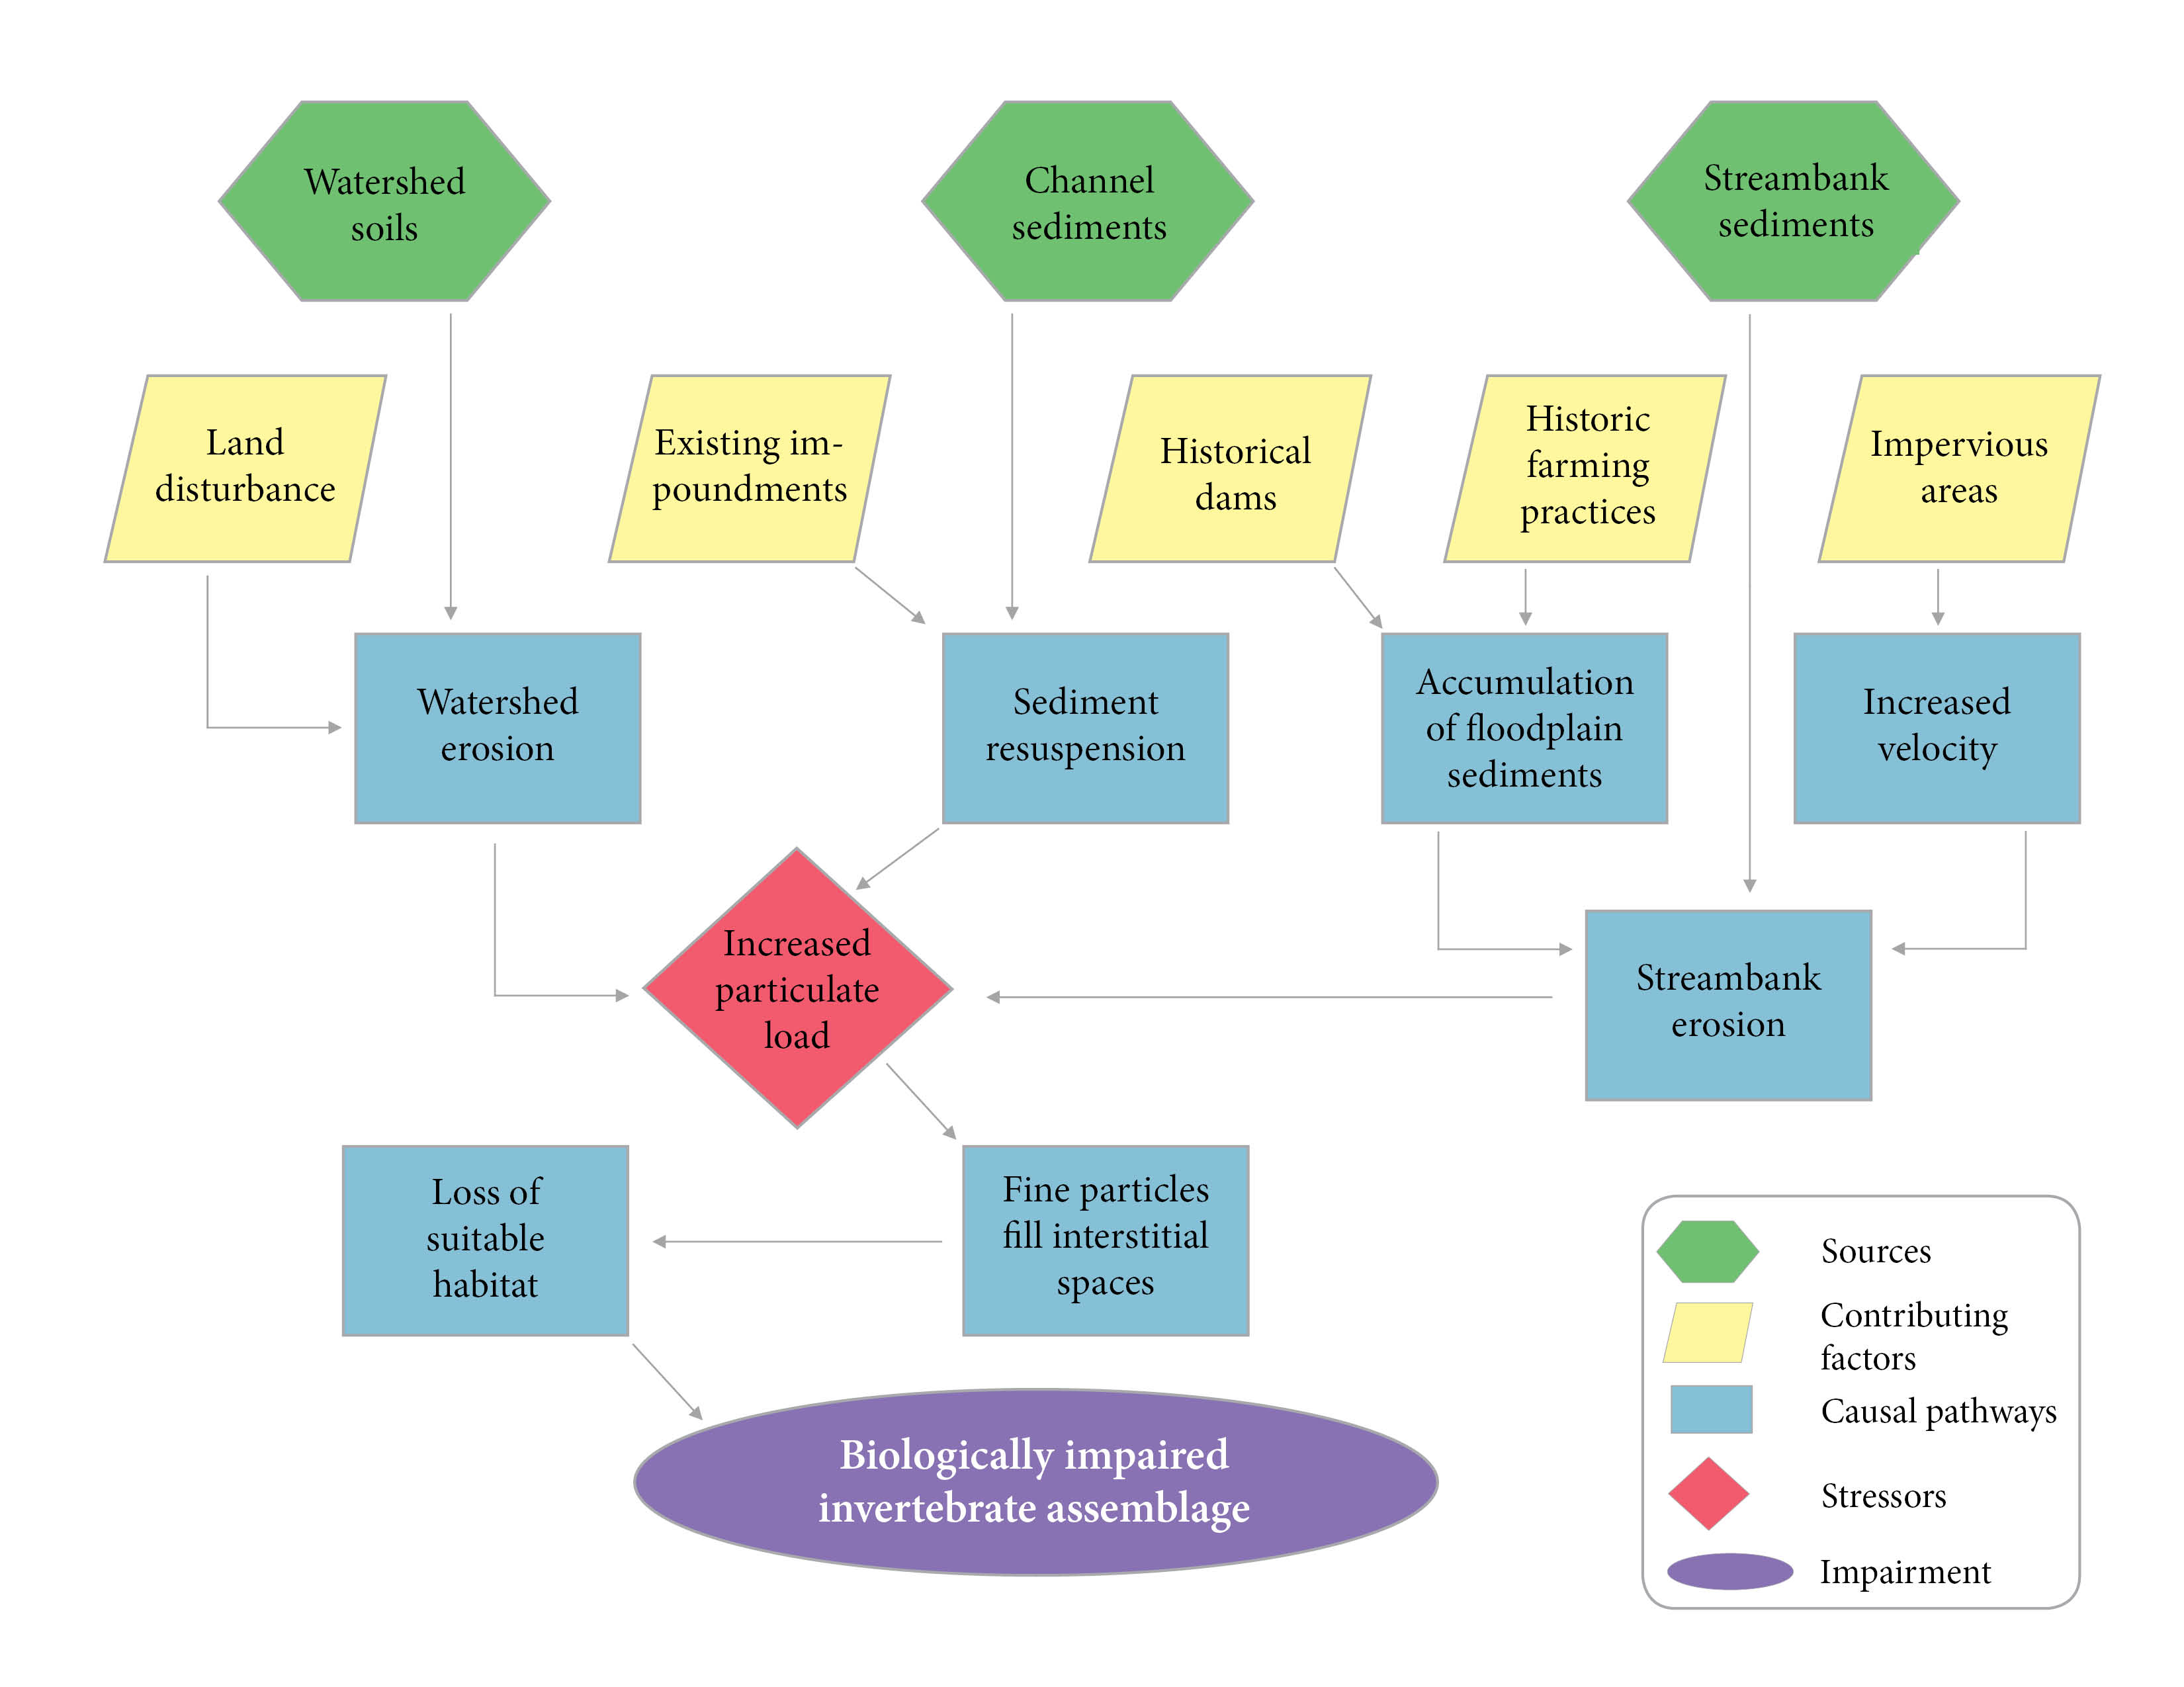
Figure 1-31. Conceptual model for the causal pathway of sediment impacts on benthic macroinvertebrates.
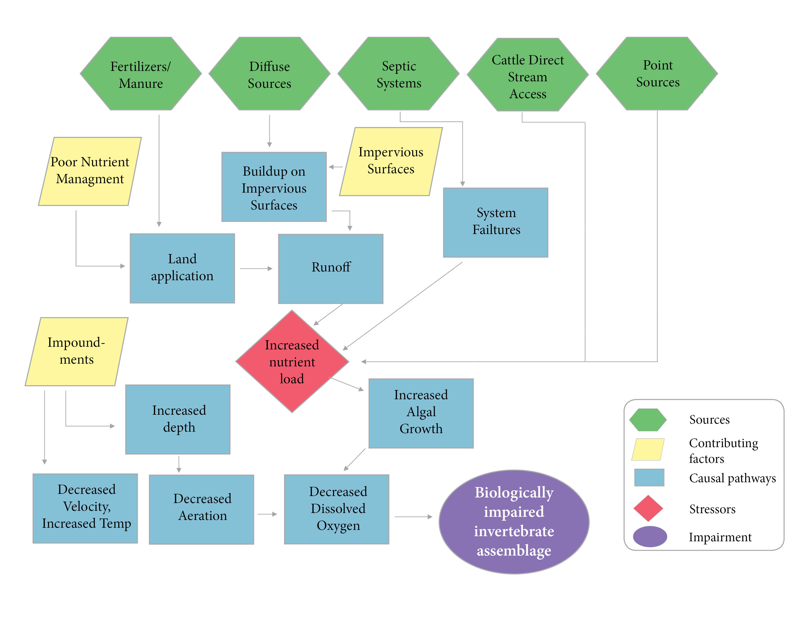

Figure 1-32 Conceptual model for causal pathway for phosphorus impacts to benthic macroinvertebrates.

TMDL Target Pollutants
Following causal analysis and the determination of probable stressors, sediment was selected as the target pollutant for the Hat and Black Creek TMDLs, and total phosphorus was selected as a target pollutant for Black Creek. TMDL target pollutants are the physical or chemical substances that will be controlled and allocated in the TMDL to result in restored aquatic life (measured by benthic macroinvertebrate health). TMDL targets must be pollutants that are controllable through source reductions, such as sediment, phosphorus, nitrogen, or other substances. Physical factors or environmental conditions, such as flow regimes, hydrologic modifications, or physical structures (like dams) cannot be TMDL target pollutants. Even though these conditions influence ecological communities and may be sources of stress, they do not represent substances that originate from point and nonpoint sources, they cannot be quantified, summed, and allocated to respective sources, and they cannot be controlled through source reductions.

References
Aston, R.J. 1973. Tubificids and water quality: A review. Envr. Poll., 5(1): 1-10.
Bjornn, T.C., M.A. Brusven, M.P. Molnau, J.H. Milligan, R.A. Klamt, E. Chacho, and C. Schaye. 1977. Transport of Granitic Sediment in Streams and its Effects on Insects and Fish. University of Idaho, Forest, Wildlife and Range Experiment Station, Moscow, ID.
Brabec, E., S. Schulte, and P.L. Richards. 2002. Impervious surfaces and water quality: a review of current literature and its implications for watershed planning. Journal of Planning Literature, 16(4):499-514.
Hayashi, M., T. Vogt, L. Machler, M. Schurmer. 2012. Diurnal fluctuations of electrical conductivity in a pre-alpine river: Effects of photosynthesis and groundwater exchange. Journal of Hydrology, 450-451: 93-104.
Jackson, C.R., J.K. Martin, D.S. Leigh, and L.T. West. 2005. A southeastern piedmont watershed sediment budget: evidence for a multi-millennial agricultural legacy. Journal of Soil and Water Conservation, 60(6):298-310.
Kaufmann. P.R., P. Levine, E.G. Robison, C. Seeliger, and D.V. Peck. 1999. Quantifying Physical Habitat in Wadeable Streams. EPA/620/R-99/003. U.S. Environmental Protection Agency, Washington, D.C.
Lawrence, J.M. and S.E. Gressens. 2011. Foodweb response to nutrient enrichment in rural and urban streams. Journal of Freshwater Ecology, 19(3):375-385.
Liu, Z., X. Liu, C. Liao. 2008. Daytime deposition and nighttime dissolution of calcium carbonate controlled by submerged plants in a karst spring-fed pool: insights from high time resolution monitoring of physico-chemistry of water. Environmental Geology, 55(6):1159-1168.
Mount, D.R., R.J. Erickson, T.L. Highland, J.R. Hockett, D.J. Hoff, C.T. Jenson, T.J. Norberg-King, K.N., Peterson, Z.M. Polaske, and S. Wisniewski. 2016. The acute toxicity of major ion salts to Ceriodaphnia dubia: I. Influence of background water chemistry. Environmental Toxicology and Chemistry, 35(12): 3039-3057.
Pond, G.J. 2004. Effects of Surface Mining and Residential Land Use on Headwater Stream Biotic Integrity. Kentucky Department of Environmental Protection Division of Water. July, 2004. p.33.
Tetra Tech. 2019. Biological Condition Gradient (BCG) Attribute Assignments of Macroinvertebrates and Fish in the Mid-Atlantic Region (Virginia, West Virginia, and Maryland).
U.S. Department of State. 1841. Enumeration of the Inhabitants and Statistics of the United States. U.S. Department of State, Washington, D.C.
U.S. Environmental Protection Agency. 2000a. Stressor Identification Guidance Document. EPA-822-B-00-025. U.S. EPA Office of Water, Washington D.C.
U.S. Environmental Protection Agency. 2000b. Ambient Water Quality Criteria Recommendations: Information Supporting the Development of Station and Tribal Nutrient Criteria, Rivers and Streams in Nutrient Ecoregion IX. EPA-802-B-00-019. U.S. EPA Office of Water, Washington D.C.
U.S. Environmental Protection Agency. 2018. Causal Analysis/Diagnosis Decision Information System (CADDIS). Retrieved: January 17, 2018. Available from: www.epa.gov/caddis. Office of Research and Development, Washington, D.C.
Virginia Department of Environmental Quality. 2017. Stressor Analysis in Virginia: Data Collection and Stressor Thresholds. Virginia Department of Environmental Quality, Richmond, VA.
Walsh, C. J., A.H. Roy, J.W. Feminella, P.D. Cottingham, P.M. Groffman, and R.P. Morgan. 2005. The urban stream syndrome: current knowledge and the search for a cure. Journal of the North American Benthological Society, 24(3):706-723.
Walter, R.C. and D.J. Merritts. 2008. Natural streams and the legacy of water-powered mills. Science, 319:299-304.
Wetzl, R.G. 2001. Limnology: Lake and River Ecosystems. San Diego: Academic Press.

