## **I. Create a Green Team**

One way to improve environmental performance and meet goals is to establish a Green Team, which is a cross-functional group of staff focused on the environmental goals of the larger entity, whether it be a business, college, university or other. Ideally, a Green Team starts as a small group that sets achievable goals. Accomplishing these goals helps to build momentum. As with all long-term or ongoing projects, the team should meet regularly (quarterly meetings are recommended). As mentioned previously, a cross-functional team helps to bring together a diverse knowledge base, encourages collaboration and helps to distribute the workload. If possible, include staff from building services as they can be instrumental in project approval/support, data collection and monitoring.

Environmental improvement often hinges on cultural and behavioral change, so communication is imperative. Create a newsletter, blog, Facebook page, etc., to get the word out about events, resources and how people can get involved. This can be coupled with a 12-month campaign schedule to focus on different environmental topics each month. Use your communication infrastructure to recognize internal environmental leaders. Engage staff through competition. The competition could be about conserving resources on-site like energy and water or competition can also come in the form of soliciting feedback from staff and rewarding innovative ideas.

The Green Team should encourage universal staff buy-in and promote project ownership. The handful of staff on the Green Team can be a catalyst for change, but all staff will need to be engaged and committed to environmental change.

If you have questions about establishing a Green Team or similar entity, please contact [DEQ’s Office of Pollution Prevention](mailto:veep@deq.virginia.gov).

## **II. Signage and Collection Best Practices**

## Good signage on collection bins for waste, recycling, and compost is an important tool in reducing contamination in the collection process. Here are some tips:

## **Uniform Signage:** Signage should be consistent across your facility. It can be helpful when the receptacle color remains consistent as well. Receptacles should have labels identifying the materials what is and is not collected. If possible, include pictures of items.

## **Close the Lid:** Containers ideally have lids that close with information on the material collected on the lid.

## **Co-locate:** Containers should be co-located. Always place recycling and composting receptacles next to trash cans. This will help reduce contamination. A recycling or composting container alone can end up being used as a trash can.

## **III. Waste Audit**

Five Steps to a Waste Audit:

1. Select your team and plan a date for the waste audit.
   1. Include staff from across the organization (a Green Team is an excellent resource for auditors).
   2. Waste audits often identify wasteful practices that translate into soft dollar losses, so make sure to include the custodial team in the planning process as they can advise on your waste collection program and identify areas for improvement.
   3. Select an uneventful week at your facility, and collect all waste over a 3-day period and place the waste in a secure container.
   4. Collect waste and recycling on Tuesdays, Wednesdays and Thursdays (do not include Mondays and Fridays as there is typically a higher incidence of absences on those days).
   5. Provide labels for the audit team so they can label each bag with the date, location and stream.
2. Gather your equipment.
   1. Clear garbage bags for use in all waste and recycling bins during the 3-day period
   2. Large secure container to store the collected bags
   3. Labels to identify date, location and stream for each bag
   4. Protective clothing for the waste audit team, including overalls, gloves, eye protectors and safety shoes (if required)
   5. Camera
   6. Weighing scales
   7. Printed checklist or tablet/laptop to record the data
3. Go through the garbage
   1. On audit day, remove the bags from the secure container and start to group the bags together by collection location.
   2. Weigh each bag and record the weight, location and stream.
   3. Perform a visual assessment of the contents and determine the percentage and type of contamination. (It is helpful to note the actual items causing contamination so that you can communicate this to everyone afterwards.)
4. Calculate the diversion rate.
   1. 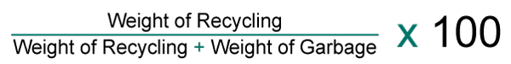A diversion rate is an easy way to measure how an organization’s recycling program is doing. The simple formula is:
   2. The weight of recycling includes any organic waste that is collected for compost and any recyclable waste that is diverted from landfill.
5. Communicate your results.
   1. Distribute the results of the audit.
   2. Highlight any areas for improvement by posting images of key contaminants by the bins for awareness.
   3. Share the waste audit with staff to reinforce recycling goals, and to raise awareness of the bin locations and recyclables in your facility.

## **IV. Food Recovery Strategies**

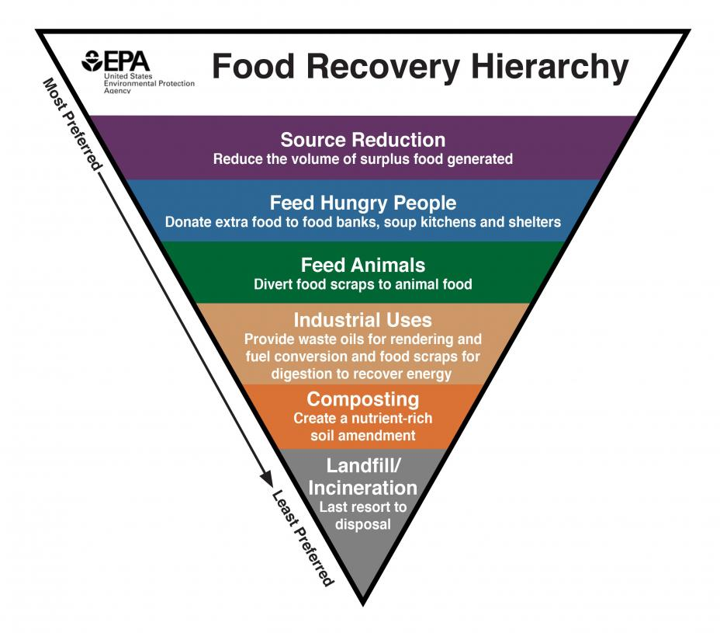The Food Recovery Hierarchy prioritizes actions organizations can take to prevent and divert food waste. Each tier of the Food Recovery Hierarchy focuses on different management strategy for waste food:

The top levels of the hierarchy are the most effective ways to prevent and divert wasted food because they create the most benefits for the environment, society and the economy. Click on the links below to learn more about the tiers of the hierarchy.

* [Source Reduction](https://www.epa.gov/sustainable-management-food/how-prevent-wasted-food-through-source-reduction)
* [Feed Hungry People](https://www.epa.gov/sustainable-management-food/reduce-wasted-food-feeding-hungry-people)
* [Feed Animals](https://www.epa.gov/sustainable-management-food/reduce-wasted-food-feeding-animals)
* [Industrial Uses](https://www.epa.gov/sustainable-management-food/industrial-uses-wasted-food)
* [Composting](https://www.epa.gov/sustainable-management-food/reducing-impact-wasted-food-feeding-soil-and-composting)

**Composting resources**

Below are resources that could be helpful in establishing a composting collection system:

1. The [Virginia Green Sustainable Event Guide](https://www.deq.virginia.gov/home/showdocument?id=5260) has a section on food waste and composting collection.
2. [FindAComposter.com](https://www.findacomposter.com/) is a tool sponsored by the Biodegradable Products Institute, the Foodservice Packaging Institute, the Closed Loop Foundation and the Institute for Local Self-Reliance to make it easier to find compost facilities.
3. The Virginia Cooperative Extension put together a [Mid-Atlantic Composting Directory](https://resources.ext.vt.edu/contentdetail?contentid=1459&contentname=Mid-Atlantic%20Composting%20Directory) to provide contact information.

## **V.** [**Environmentally Responsible Purchasing Practices**](https://www.deq.virginia.gov/get-involved/pollution-prevention/environmental-preferable-purchasing)

Environmental preferable purchasing is a cost-effective way to reduce an agencies’ impact on the environment. When purchasing reusable plastic items, agencies should seek items that are better for the environment, such as those with higher recycled content, biodegradability, and/or durability. Visit the [Environmentally Preferable Purchasing](https://www.deq.virginia.gov/get-involved/pollution-prevention/environmental-preferable-purchasing) page for more information.

**Life Cycle Assessment**

Life-cycle assessment (LCA) is a tool for assessing a product, building or service’s lifetime environmental impact. LCA takes into consideration all of the steps, from raw material to manufacture, to distribution and usage, to final disposal. It is a cradle-to-grave or cradle-to-cradle analysis. While a full LCA may be beyond the capability of an individual agency or institution, agencies and institutions should consider end-of-life options in the purchasing process (i.e., can the item be reused, recycled or composted; will it require special disposal handling, etc.).

Calculating greenhouse gas emissions (or a carbon footprint) is just one dimension of an LCA, which can also assess impacts such as ozone depletion, eutrophication, impact on human health and more.

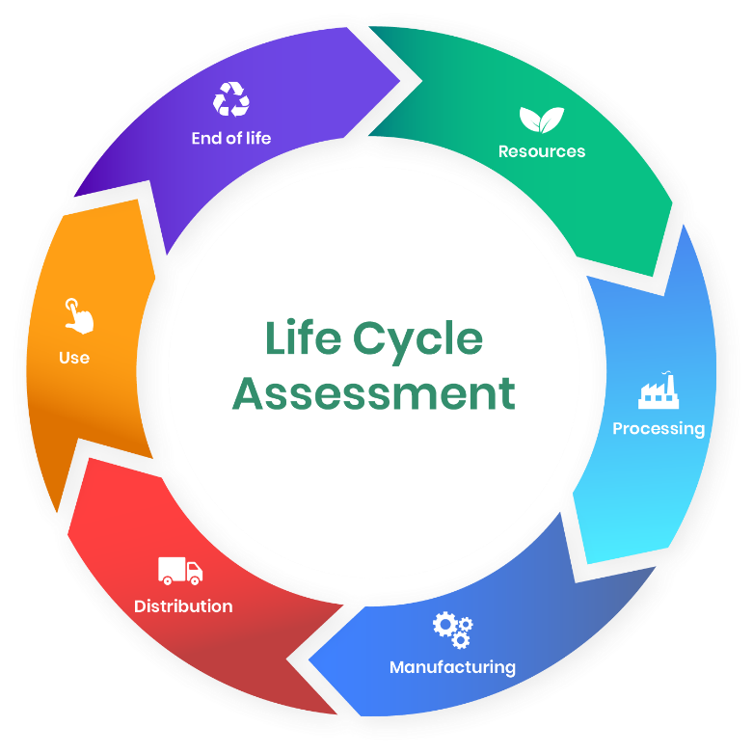

Life-cycle assessment stages

LCA began in the 1960s, but became a more recognized scientific process in the 1990s after the food and beverage industry needed to gain a more detailed understanding of the impacts of product packaging. This process resulted in the development of the International Standard (ISO) 14040, which governs LCA practice.

LCA in the construction sector provides a number of tangible benefits:

* Evaluating building site options to select the lowest impact choice.
* Comparing the environmental impacts of renovating rather than demolishing and building anew.
* Comparing design alternatives to choose those with the lowest impact.
* Identifying a building’s environmental hotspots and taking action to reduce them.
* Calculating the lifetime impact of building materials and products to help find the most sustainable options.

Of course, construction is just one example. There are many sectors and products that can benefit from LCA. If you lack the resources to do a full assessment, remember that that there are several phases in the life cycle when purchasing decisions are made, such as material extraction, manufacturing, packaging and transportation, use and end of life. Consider these phases when making choices that will minimize environmental impacts.