## Chapter 7.4. COST/BENEFIT ASSOCIATED WITH THE CLEAN WATER STATE REVOLVING LOAN FUND

**Construction Assistance Grants**

The Federal construction grants program was initiated in 1958 to provide financial assistance to municipalities for the planning, design, and construction of publicly owned treatment works. Until 1988, the program was an essential element in pollution control efforts, without which many localities would have been unable to provide wastewater treatment systems.

Through 1988, Virginia received approximately $1.2 billion in federal appropriations for construction grants. These federal funds financed up to 75 percent of the total eligible cost of approximately 183 projects. The state contributed another $52.3 million toward project costs, with the remainder coming from local sources. Total local investment in these projects is estimated at $500 million.

**Virginia Clean Water Revolving Loan Fund**

In 1988, a grant program was converted to a low-interest loan program to provide financial assistance for the planning, design and construction of POTW's. The 1986 General Assembly created the Virginia Water Facilities Loan Fund, through which loans could be made to local governments at or below current market interest rates for wastewater treatment improvements. Principal and interest repaid into the fund could then be loaned again for additional projects. The Federal Water Quality Act of 1987 established a State Revolving Loan Fund Capitalization Grant Program that provided an avenue for states to convert federal grant monies into a State Revolving Loan Fund.

On June 10, 1988, Virginia became the first state in EPA Region III and the fifth state in the nation to receive authorization to administer a State Revolving Loan Program. As of June 30, 2021, Virginia has received federal capitalization grants totaling $1,060,669,207. In addition, Virginia has provided the required matching funds of $196,092,383 to the program.

These funds, along with accrued interest earnings, repayments by loan recipients, and the implementation of a leveraging program in each of FY’s 1999, 2000, 2004, 2007 through 2013 (when demand exceeded available resources), and 2021 have enabled the VRLF to provide loan assistance to 1,094 projects totaling over $3.64 billion.

**AgBMP Loan Program**

The 1999 General Assembly amended Chapter 22 of the Code of Virginia, expanded the activities of Virginia’s Water Facilities (Clean Water) Revolving Fund, to allow low interest loan financing of specific agricultural best management practices (AgBMP). This legislation was amended to encourage the commonwealth’s farm communities to implement best management practices that reduce or eliminate agricultural non-point source pollution of Virginia’s waters. This funding initiative went into effect July 1, 1999. Agreements were reached with the Virginia Resources Authority and the State’s three Farm Credit Associations to allow them to perform necessary loan underwriting and execute and disburse loan proceeds to the recipients.

Virginia received its first request for low-interest loan assistance from its AgBMP program on January 14, 2000. Since then, DEQ has authorized more than $46 million in low-interest loan assistance to Virginia farmers for over 614 eligible BMP projects that would improve water quality in the commonwealth. In July 2016, this program was suspended for lack of interest and then updated, expanded and reinstituted in July 2019. Since restarting, the AgBMP program has authorized more than $17.9 million in interest-free loan assistance for 179 eligible BMP projects.

**Brownfield Program**

The 2001 General Assembly amended the VRLF legislation to make loan assistance available for remediation of contaminated brownfield properties across the commonwealth. This funding initiative provides assistance to eligible entities for activities that result from an approved site characterization and remediation plan and where the remediation effort results in an improvement to or protection of surface or groundwater. As of June 30, 2021, eight loans for brownfield projects have been closed totaling $6.12 million.

**Land Conservation Loan Program**

The 2003 General Assembly enacted legislation that expanded the activities of the fund by allowing Virginia to authorize low-interest loans for acquisition of title or other rights to real property when the Board was satisfied that the acquisition would protect or improve water quality and prevent pollution of state waters. The legislation provided that financing for land acquisition would be available only in those fiscal years when all other eligible loan requests from local governments had been satisfied. This program was includedin each of the FY 04 through FY 21 loan solicitations and 12 loans have been closed totaling $54.79 million.

**Stormwater Loan Program**

During their 2010 session, the Virginia General Assembly further expanded the activities of the Virginia Water Facilities Revolving Fund by allowing the State Water Control Board to authorize low interest loans from the Fund for construction of facilities or structures or implementation of best management practices that reduce or prevent pollution of state waters caused by stormwater runoff from impervious surfaces. According to the enabling legislation, VCWRLF financing for stormwater projects can only be available in fiscal years when loan requests for eligible wastewater treatment facilities designed to meet the state’s water quality standards have first been satisfied, unless otherwise required by law. This program was includedin each of the FY 12 through FY 21 loan solicitations and four loans have been closed totaling $6.38 million.

**Living Shorelines Loan Program**

During their 2015 session, the Virginia General Assembly further expanded the activities of the Virginia Water Facilities Revolving Fund by allowing the State Water Control Board to authorize low interest loans from the Fund to a local government for establishing living shorelines or to a local government that has developed a funding program to individual citizens for the purpose of establishing living shorelines to protect or improve water quality. In the 2019 session, the code section was expanded to include small businesses as eligible applicants for funds from a local government that has developed a funding program. This program was includedin each of the FY 17 through FY 21 loan solicitations and two loans have been closed totaling $500,000.

As of June 30, 2016, the Department of Environmental Quality’s Ag BMP Loan Program had provided 491 low interest loans to Virginia farmers to assist them with implementation expenses related to the following 614 agricultural best management practices (see Figure 7.4-1). The Legacy AgBMP Loan Program was suspended on June 30, 2016

A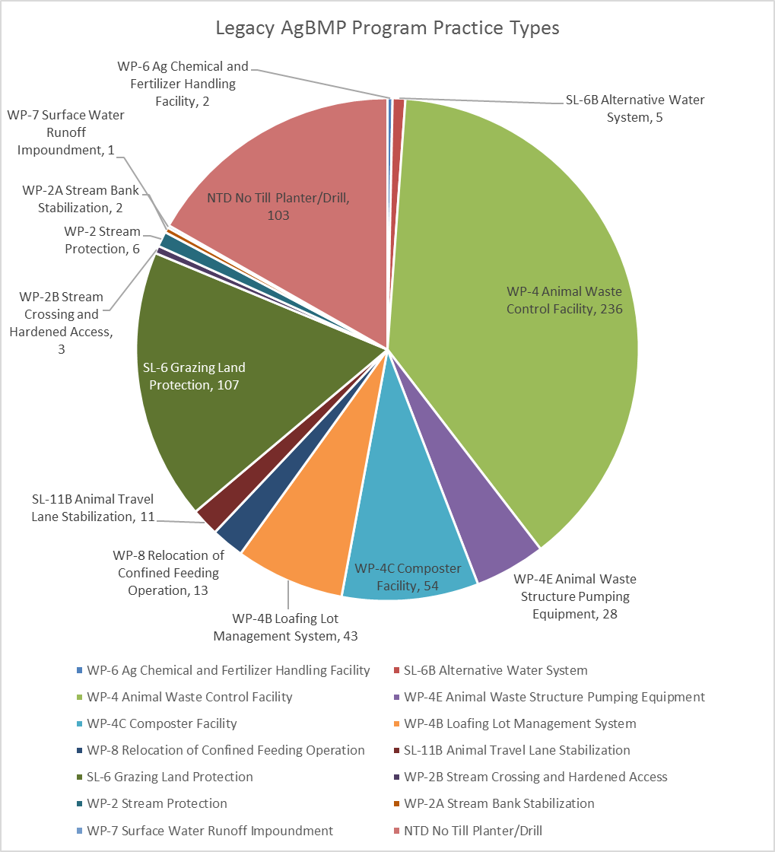

Figure 7.4-1 Number of BMPs funded by the Legacy AgBMP Loan Program (prior to June 30, 2016)

Legislative changes were passed in early 2019 and updates to the program guidelines were adopted by the State Water Control Board (SWCB) on June 27, 2019 in preparation to restart the program July 1, 2019. Since restarting in FY 2020, the Ag BMP loan program has received approximately 160 applications for assistance and has closed 50 loans. Figure 7.4-2 shows the numbers and types of agricultural BMPs funded by loans closed since the beginning of FY 2020.

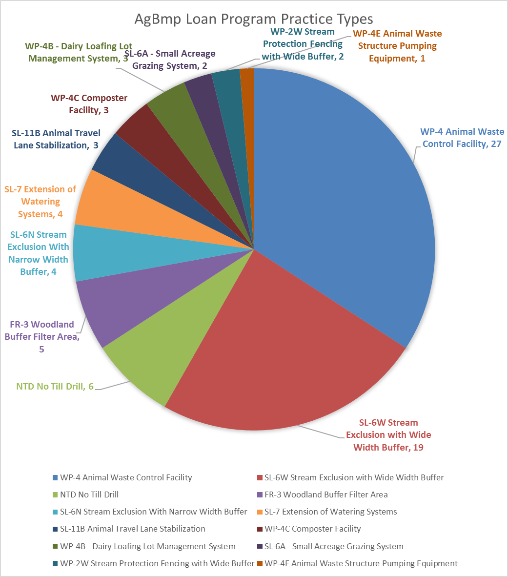Figure 7.4-2 Number of BMPs funded by the restarted AgBMP Loan Program (restarted July 1, 2019)