Stressor Identification Analysis for Moores and Mill Creeks in Rockbridge County, Virginia

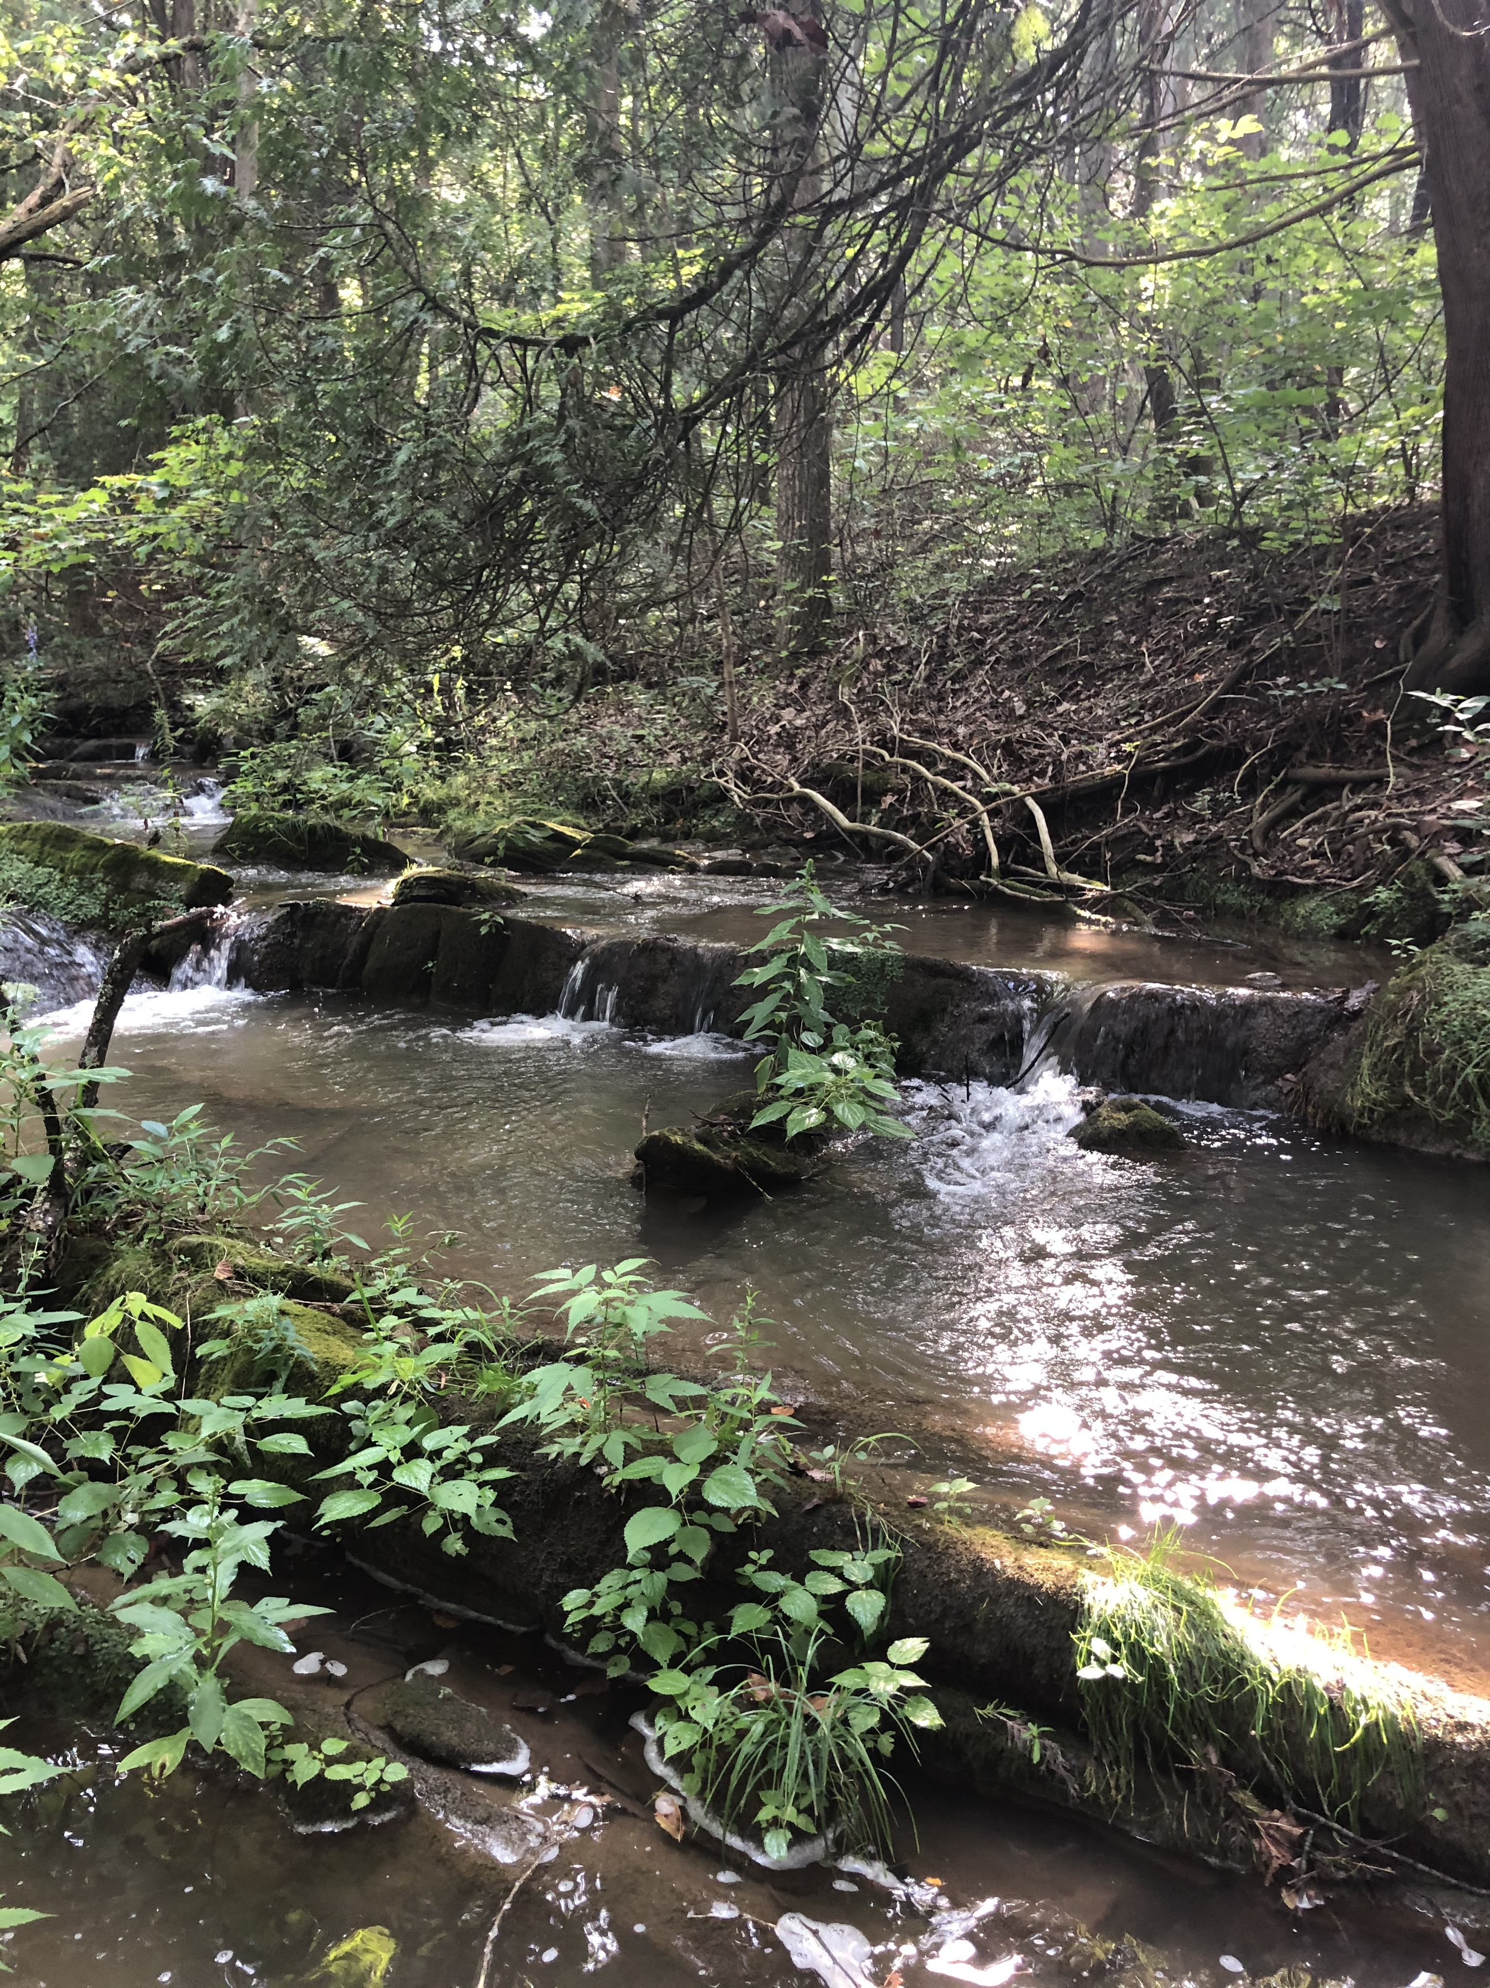


Prepared by:
Virginia Department of
Environmental Quality

July 28, 2021
Table of Contents
Chapter 1: Stressor Identification Analysis 7
1.1. Overview 7
1.2. Biological, Physical, and Chemical Data 7
1.2.1. Benthic Assessments 10
1.2.1.1. Temporal Trends in Benthic Data 11
1.2.1.2. Analysis of Benthic Metrics 14
1.2.1.3. Analysis of Community Composition 17
1.2.1.4. Biological Condition Gradient Analysis 20
1.2.1.5. Analysis of Functional Feeding Groups 22
1.2.2. Habitat Assessment 24
1.2.2.1. Relative Bed Stability 27
1.2.3. Land Use Assessment 31
1.2.4. Water Quality Data 35
1.2.4.1. Temperature 35
1.2.4.2. pH 37
1.2.4.3. Dissolved Oxygen 39
1.2.4.4. Conductivity and Dissolved Solids 43
1.2.4.5. Dissolved Ions 50
1.2.4.6. Solids 54
1.2.4.7. Nutrients 54
1.2.4.8. Ammonia 57
1.2.4.9. Water Quality Regressions 58
1.2.5. Other Studies 59
1.3. Causal Analysis 59
1.3.1. Temperature 62
1.3.1. pH 62
1.3.2. Dissolved Oxygen 64
1.3.1. Conductivity and Total Dissolved Solids 64
1.3.1. Dissolved Ions – Sodium 69
1.3.1. Dissolved Ions – Sulfate 69
1.3.2. Dissolved Ions – Chloride and Potassium 69
1.3.3. Suspended Solids and Deposited Sediment 74
1.3.4. Nitrogen 78
1.3.5. Phosphorus 78
1.3.1. Ammonia 81
1.4. Causal Analysis Summary 83
1.4.1. Probable Stressors 83
1.4.2. Contributing Factors 84
1.4.2.1. Historic Land Disturbance 84
1.4.2.2. Historic Dams 85
1.4.2.3. Imperviousness 85
1.4.2.4. Existing Impoundments 86
1.4.3. Causal Pathways 86
1.4.4. TMDL Target Pollutants 89
1.5. References 89

List of Figures
Figure 1-1. Ambient and biological monitoring stations in the Moores and Mill Creek watersheds. 8
Figure 1-2. Average stream condition index (SCI) scores through 2020 for benthic stations in Moores and Mill Creeks. 10
Figure 1-3. Temporal trends of benthic stream condition index (SCI) scores in the Moores and Mill Creek watersheds. 13
Figure 1-4. Metric scores comprising stream condition index (SCI) scores in the Moores and Mill Creek watersheds. * indicates that the metric was significantly different (alpha = 0.05) from the benthic reference score (Strait Creek). 16
Figure 1-5. Benthic community structure (by order) in the Moores and Mill Creek watersheds in comparison with a reference watershed, Strait Creek. 20
Figure 1-6. Functional feeding group composition in benthic communities in Moores and Mill Creeks compared to Strait Creek (reference stream). 24
Figure 1-7. Total habitat scores for Moores and Mill Creeks. Colors represent the probability that data within that range would be responsible for causing stress. 25
Figure 1-8. Comparison of total habitat scores with SCI scores Moores and Mill Creeks. 26
Figure 1-9. Habitat metric scores for Moores and Mill Creeks. Metrics with a * are statistically different from the reference site (α=0.05). 27
Figure 1-10. Moores and Mill Creek bottom substrate comparisons with reference (Walker Creek). 30
Figure 1-11. Log relative bed stability index (LRBS) scores for Moores and Mill Creeks in comparison with reference condition (Walker Creek). 31
Figure 1-12 . Relationship between impervious land cover and stream condition index scores (SCI) in Moores and Mill Creeks. 33
Figure 1-13. Relationship between cropland cover and stream condition index scores (SCI) in Moores and Mill Creeks. 33
Figure 1-14. Temperature measured in Moores and Mill Creeks. Whiskers indicate the range, boxes indicate the inter-quartile range, lines indicate the median, and white markers indicate the average. Streams with a * are statistically different from the reference site. 36
Figure 1-15. Diurnal temperatures in Moores and Mill Creeks. The red line indicates the water quality standard for temperature. 37
Figure 1-16. pH measured in Moores and Mill Creeks. Whiskers indicate the range, boxes indicate the inter-quartile range, lines indicate the median, and white markers indicate the average. Streams with a * are statistically different from the reference site. Colors represent the probability that data within that range would be responsible for causing stress. 38
Figure 1-17. Diurnal pH in Moores and Mill Creeks. Colors represent the probability that data within that range would be responsible for causing stress. Red line indicates the water quality standard for pH. 39
Figure 1-18. Dissolved oxygen measured in Moores and Mill Creeks. Whiskers indicate the range, boxes indicate the inter-quartile range, lines indicate the median, and white markers indicate the average. Streams with a * are statistically different from the reference site. Colors represent the probability that data within that range would be responsible for causing stress. The red line indicates the water quality standard. 40
Figure 1-19. Diurnal dissolved oxygen in Moores and Mill Creeks. Colors represent the probability that data within that range would be responsible for causing stress. The dashed white line indicates the water quality standard. 42
Figure 1-20. Diurnal oxygen saturation in Moores and Mill Creeks. 43
Figure 1-21. Specific conductance measured in Moores and Mill Creeks. Whiskers indicate the range, boxes indicate the inter-quartile range, lines indicate the median, and white markers indicate the average. Streams with a * are statistically different from the reference site. Colors represent the probability that data within that range would be responsible for causing stress. 45
Figure 1-22. Temporal variability in specific conductivity in Moores and Mill Creeks. 46
Figure 1-23. Specific conductance in Moores and Mill Creeks and daily discharge rates at USGS gage 2024000 on the Maury River near Buena Vista. 46
Figure 1-24. Diurnal conductivity in Moores and Mill Creeks. Colors represent the probability that data within that range would be responsible for causing stress. 48
Figure 1-25 Diurnal shifts in pH and specific conductance in Mill Creek. 49
Figure 1-26. Total dissolved solids measured in Moores and Mill Creeks. Whiskers indicate the range, boxes indicate the inter-quartile range, lines indicate the median, and white/blue markers indicate the average. Colors represent the probability that data within that range would be responsible for causing stress. 50
Figure 1-27. Dissolved ions measured in Moores and Mill Creeks and the reference stream (Strait Creek). Whiskers indicate the range, boxes indicate the inter-quartile range, lines indicate the median, and white/blue markers indicate the average. Streams with a * are statistically different from the reference site. Colors represent the probability that data within that range would be responsible for causing stress. 53
Figure 1-28. Total nitrogen concentrations in Moores and Mill Creeks compared to the reference stream, Strait Creek. Whiskers indicate the range, boxes indicate the inter-quartile range, lines indicate the median, and blue/white markers indicate the average. Colors represent the probability that data within that range would be responsible for causing stress. 56
Figure 1-29. Total phosphorus concentrations in Moores and Mill Creeks compared to the reference stream, Strait Creek. Whiskers indicate the range, boxes indicate the inter-quartile range, lines indicate the median, and blue/white markers indicate the average. Colors represent the probability that data within that range would be responsible for causing stress. 56
Figure 1-30. Conceptual model for the causal pathway of sediment impacts on benthic macroinvertebrates. 88

List of Tables
Table 1-1. Benthic and chemical monitoring data used in the Moores and Mill Creek stressor analysis. 9
Table 1-2. Benthic scores in the Moores and Mill Creek watersheds. 10
Table 1-3. Predominant taxa in the Moores and Mill Creek TMDL project area. 20
Table 1-4. Mid-Atlantic biological condition gradient attributes and stressors evaluated 21
Table 1-5 Average biological condition gradient scores by stressor for Moores and Mill Creeks. 22
Table 1-6 Biological condition gradient scores by stressor for predominant taxa in Moores and Mill Creeks. 22
Table 1-7. Total habitat scores for Moores and Mill Creeks. 24
Table 1-8. Relative bed stability analysis in Moores and Mill Creeks. 29
Table 1-9. Land use upstream from each benthic monitoring station in the Moores and Mill Creek watersheds. 34
Table 1-10. Regression relationship between stream condition index scores and watershed land uses. 34
Table 1-11. Regression relationship between water quality parameters and stream condition index (SCI) scores. 58
Table 1-12. Lines of evidence used in the causal analysis approach. 60
Table 1-13. Scoring criteria used to evaluate candidate stressors. 61
Table 1-14. Scheme for classifying candidate causes based on causal analysis. 61
Table 1-15. Causal analysis results for temperature as a stressor. 63
Table 1-16. Causal analysis results for pH as a stressor. 63
Table 1-17. Causal analysis results for dissolved oxygen as a stressor. 67
Table 1-18. Causal analysis results for conductivity and total dissolved solids as a stressor. 68
Table 1-19. Causal analysis results for dissolved sodium as a stressor. 71
Table 1-20. Causal analysis results for dissolved sulfate as a stressor. 71
Table 1-21. Causal analysis results for dissolved chloride and potassium as stressors. 72
Table 1-22. Causal analysis results for sediment as a stressor. 76
Table 1-23. Causal analysis results for nitrogen as a stressor. 79
Table 1-24. Causal analysis results for phosphorus as a stressor. 79
Table 1-25. Causal analysis results for ammonia as a stressor. 82
Table 1-26. Total causal analysis scores by stream and by candidate stressor. Green indicates non-stressors, orange indicates possible stressors, and red indicates probable stressors. 84
Table 1-27. Non-stressors, possible stressors, and probable stressors in Moores and Mill Creeks. 84

Stressor Identification Analysis

Overview
Benthic impairments are based on biological assessments of the benthic community. These biological assessments are effective at determining whether a water body is impaired or not, but they do not provide information on the stressor or source causing the impairment. To determine the cause of the impairment, a stressor identification analysis must be conducted. The Virginia Department of Environmental Quality (DEQ) completed stressor identification analyses for Moores and Mill Creeks according to the Environmental Protection Agency’s Stressor Identification Guidance Document (USEPA, 2000a). The first step in the stressor identification analysis is to list potential candidate stressors. DEQ identified these from the listing information, monitoring data, scientific literature, and historic information.
The next step is to analyze all of the available evidence to support or eliminate potential candidate stressors. In this step, the Causal Analysis/Diagnosis Decision Information System (CADDIS) was used (USEPA, 2018). The CADDIS approach provides guidance on evaluating various lines of evidence to determine the cause of biological impairments. In the case of the Moores and Mill Creek impairments, available physical, chemical, and biological data collected throughout the watershed, published water quality standards and threshold values, and available literature from other cases were used to investigate the potential causes of impairment in each stream. Based on the weight of evidence supporting each potential candidate, stressors were then separated into the following categories: non-stressor(s), possible stressor(s), and probable stressor(s).
Once the most probable stressor was identified, a conceptual model was developed to describe the causal pathways linking pollutant sources to the probable stressors and mechanisms of impairment. The pathways in the conceptual model were then evaluated to determine if the existing data supported those mechanisms for producing the impairment.

Biological, Physical, and Chemical Data
For the stressor identification analysis, DEQ used biological, physical, and chemical data from monitoring stations within the Moores and Mill Creek watersheds (Figure 1-1). DEQ operates 6 benthic and 9 water quality monitoring stations within the watershed. Two of these stations are co-located benthic and water quality stations.
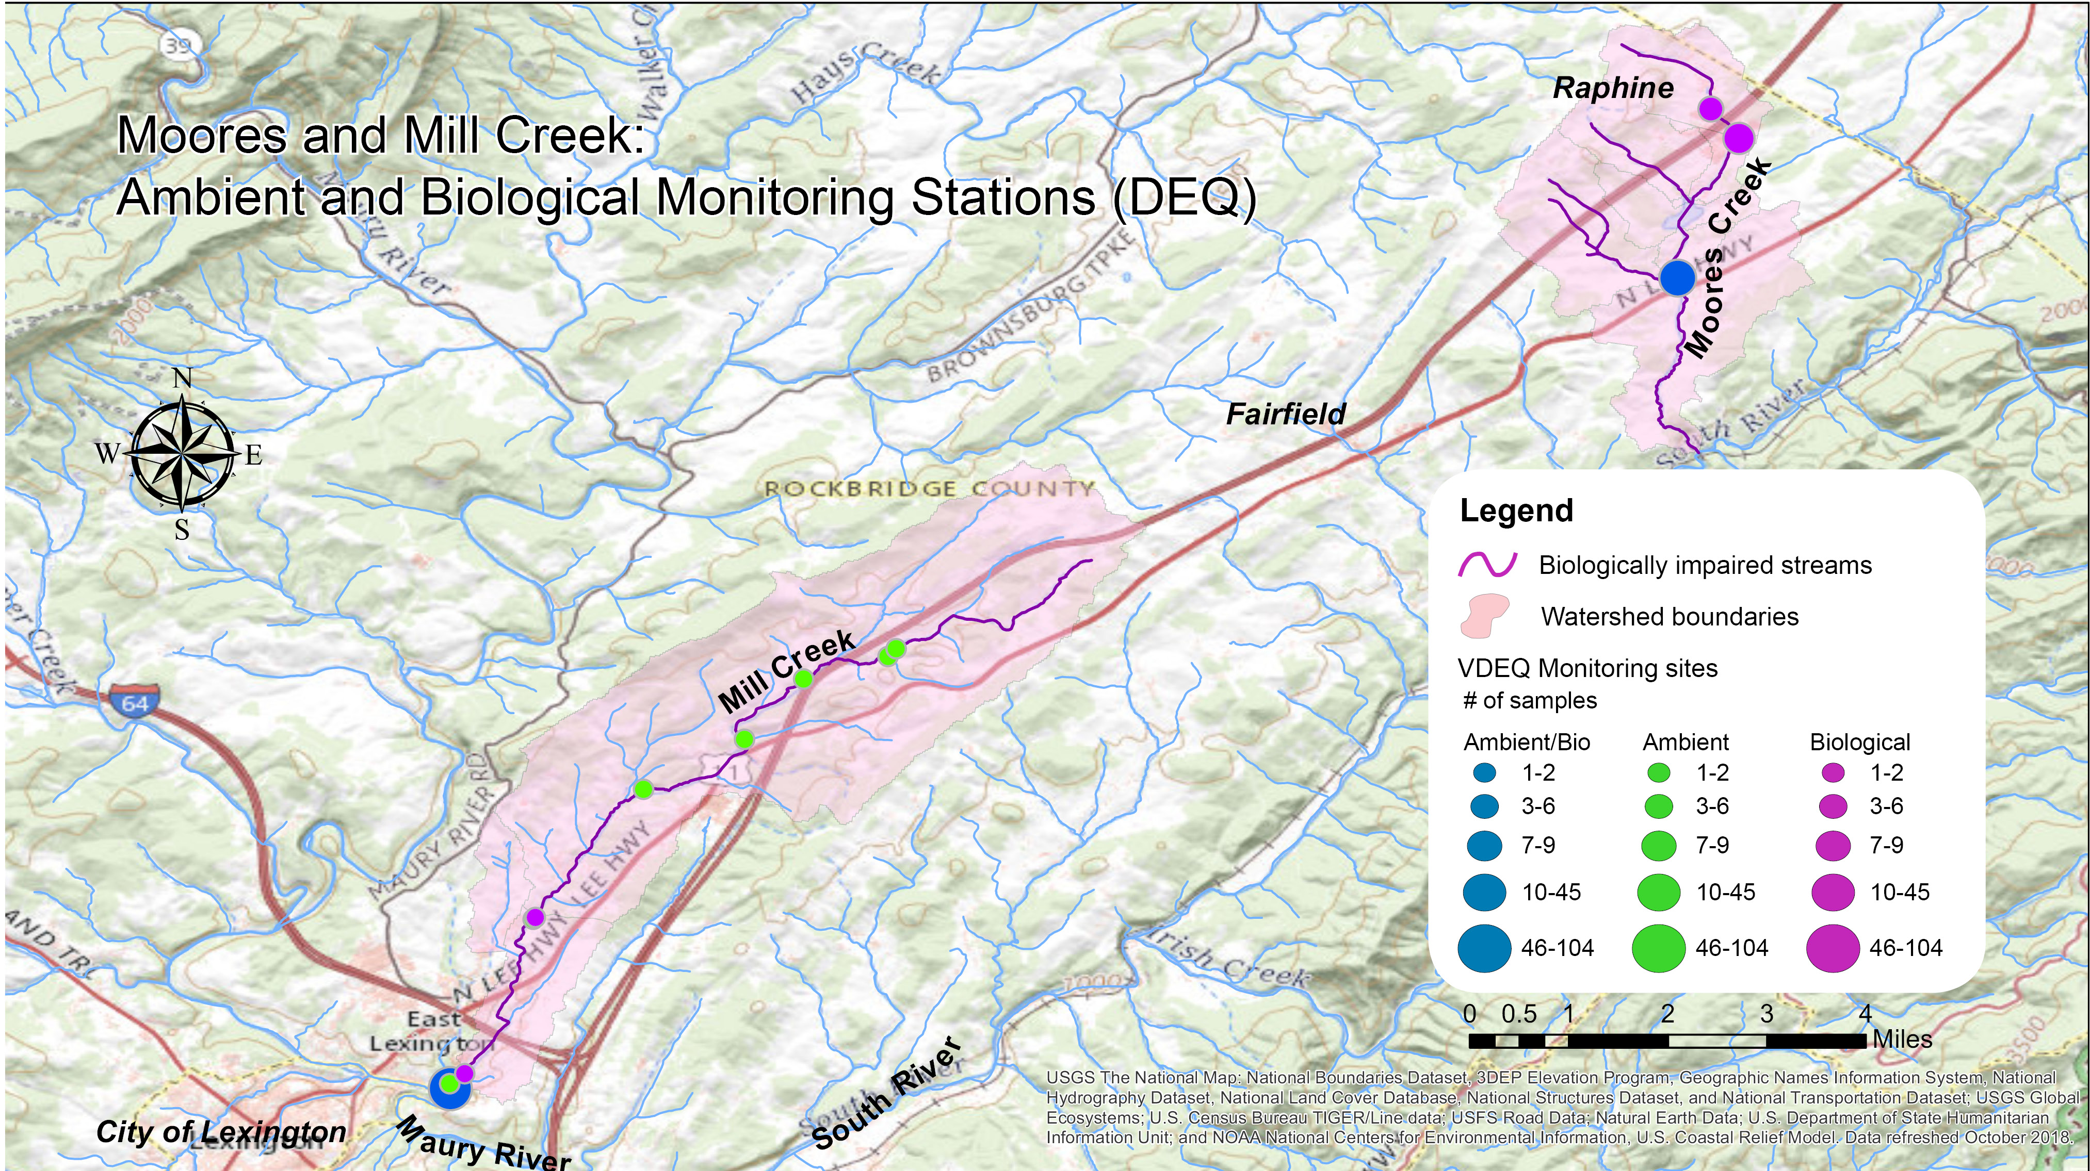Figure 1-1. Ambient and biological monitoring stations in the Moores and Mill Creek watersheds.
Table 1-1 shows the number of samples and the period of time over which individual stations were monitored. For benthic monitoring stations, data include taxonomic identification (family or genus level) and counts of benthic macroinvertebrates collected, eight calculated benthic metrics, stream condition index scores (SCI), and visual habitat assessment scores. For water quality monitoring stations, data include results for various physical and chemical parameters. The data analysis window was limited to ambient and biological data collected between 2005 and 2020 in order to focus on existing conditions in the watersheds and recent changes in land use. In total, 74 water quality samples were collected from nine ambient monitoring stations in the Moores and Mill Creek watersheds between 2005 and 2020. Samples were analyzed for 25 different water quality parameters. A total of 26 benthic samples were collected from seven monitoring stations within the project area between 2005 and 2020.
In addition to sampling locations within the two impaired watersheds, benthic and chemical monitoring data collected from benthic and water quality monitoring stations in the Strait Creek watershed were used for comparison. Between 2005 and 2020, 35 samples were collected from Strait Creek, and were analyzed for 46 different water quality parameters. A total of 19 benthic samples were collected from two monitoring stations on Strait Creek during the same period of time. Strait Creek is located in Highland County, Virginia. DEQ has established an extensive benthic monitoring dataset for the creek, which demonstrates a fully supporting benthic community. Similar to Moores and Mill Creeks, Strait Creek is a small/medium limestone influenced stream, where predominant land uses include forest and agriculture.
Table 1-1. Benthic and chemical monitoring data used in the Moores and Mill Creek stressor analysis.
Stream | Station | Station Type | Benthic Sampling |  | Water Quality Sampling
 |  |  | Monitoring Period | Samples Collected | Monitoring Period | Samples Collected
Moores Creek | 2-MRC002.14 | DEQ Water Quality |  |  | 2018-2019 | 35
 |  | DEQ Benthic | 2003-2020 | 10
 | 2-MRC003.82 | DEQ Benthic | 2003-2014 | 8
 | 2-MRC004.21 | DEQ Benthic | 2003-2005 | 4
Mill Creek | 2-MIS000.04 | DEQ Water Quality |  |  | 1991-2020 | 96
 |  | DEQ Benthic | 2008-2019 | 8
 | 2-MIS000.09 | DEQ Water Quality |  |  | 2005 | 2
 | 2-MIS000.30 | DEQ Benthic | 2020 | 2
 | 2-MIS002.21* | DEQ Benthic | 2018 | 1
 | 2-MIS002.23* | DEQ Benthic | 2018 | 1
 | 2-MIS003.90 | DEQ Water Quality |  |  | 2005 | 2
 | 2-MIS005.00 | DEQ Water Quality |  |  | 2005 | 2
 | 2-MIS005.94 | DEQ Water Quality |  |  | 2005 | 2
 | 2-MIS006.76 | DEQ Water Quality |  |  | 2005 | 2
 | 2-MIS006.88 | DEQ Water Quality |  |  | 2005 | 2
Reference Watershed Stations
Strait Creek | 1AST000.02 | DEQ Water Quality |  |  | 1991-2020 | 72
 | 1AST000.62 | DEQ Benthic | 2002 | 1
 | 1AST000.72 | DEQ Water Quality |  |  | 2006 | 2
 |  | DEQ Benthic | 1998-2020 | 16
 | 1ASTC000.92 | DEQ Benthic | 1996-1997 | 2
 | 1ASTC001.54 | DEQ Water Quality |  |  | 2006-2007 | 7
 | 1ASTC004.27 | DEQ Water Quality |  |  | 1997-2007 | 22
 |  | DEQ Benthic | 1994-2017 | 28
*Pollution complaint response site

Benthic Assessments
From spring 2005 to fall 2020, DEQ conducted 26 benthic assessments at seven stations within the Moores and Mill Creek watersheds. Table 1-2 and Figure 1-2 show the average SCI scores for each station over this 15-year window In addition, Table 1-2 includes averages for the 2022 Water Quality Assessment window (2015-2020). In order for a stream to be placed on Virginia’s 303(d) list of impaired waters with a benthic impairment, one sample with a score below 60 is all that is required. In order to remove a benthic impairment listing, scores above 60 must be recorded for the most recent fall and spring samples within a given water quality assessment cycle. Thus, Table 1-2 shows several streams with average scores above 60 that remain listed as impaired due to either fall or spring scores that were below 60.
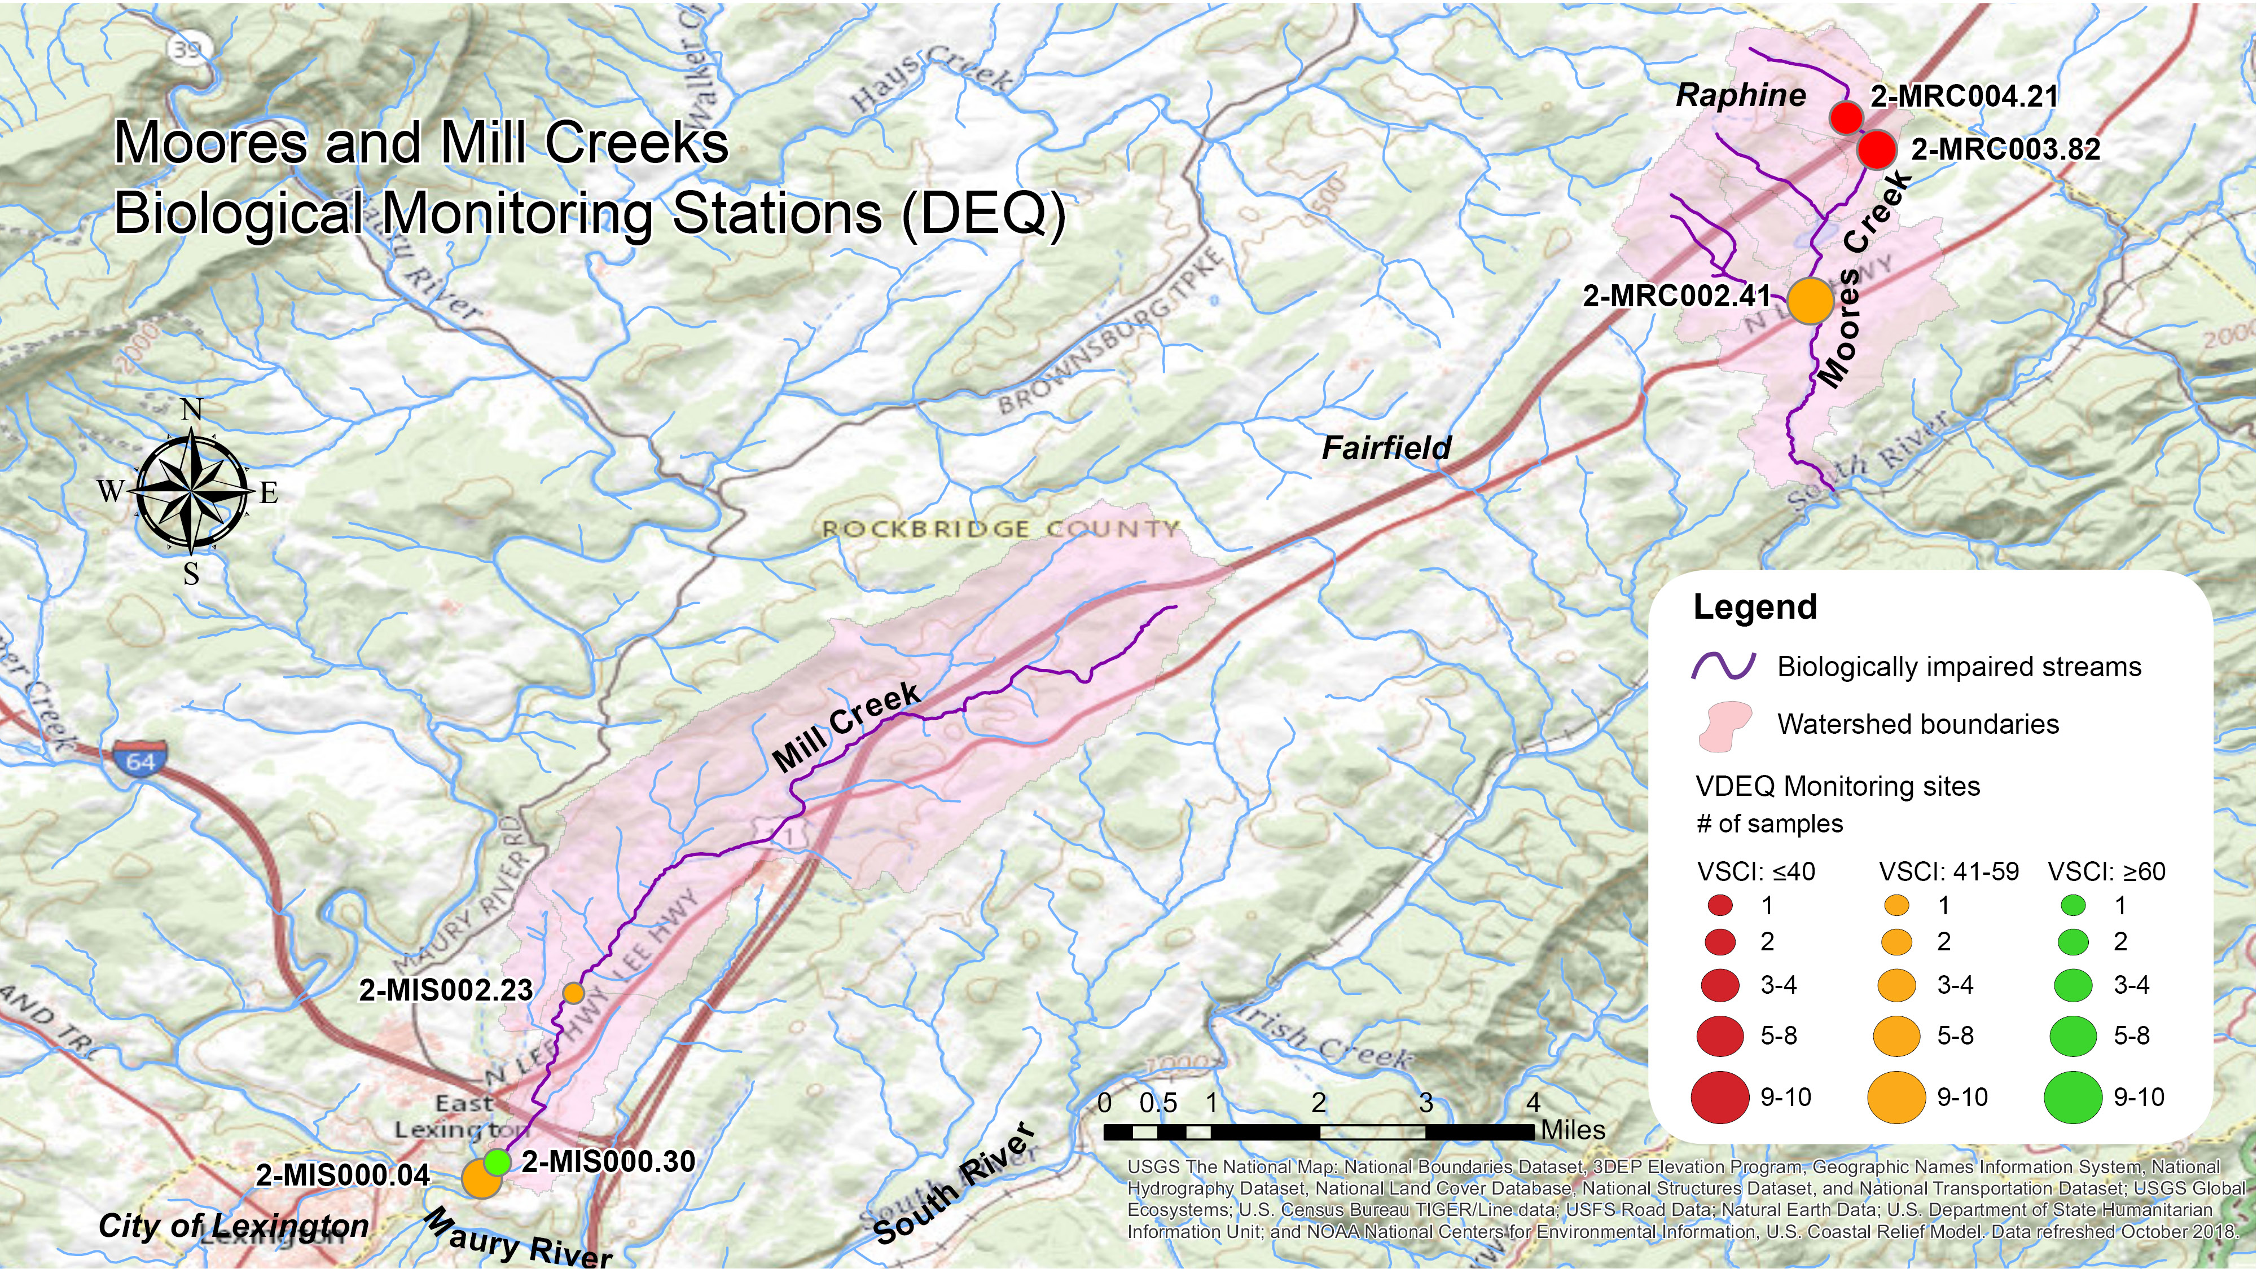
Figure 1-2. Average stream condition index (SCI) scores through 2020 for benthic stations in Moores and Mill Creeks.

Table 1-2. Benthic scores in the Moores and Mill Creek watersheds.
Stream | Station | Years Sampled | Samples Collected | SCI Average | 2020 WQA (2015-2020) SCI Avg. | 2020 WQA Listing Status
Moores Creek | 2-MRC002.14 | 2005-2020 | 8 | 50.0 | 56.5 | Impaired
 | 2-MRC003.82 | 2005-2014 | 5 | 30.6 | N/A | Impaired
 | 2-MRC004.21 | 2005 | 2 | 37.9 | N/A | Impaired
Mill Creek | 2-MIS000.04 | 2008-2019 | 8 | 59.4 | 63.7 | Impaired
 | 2-MIS000.30 | 2020 | 2 | 65.7 | 65.7 | Impaired
 | 2-MIS002.23 | 2018 | 1 | 54.0 | 54.0 | Impaired

Temporal Trends in Benthic Data
Figure 1-3 shows the temporal trends in benthic data from the watersheds. The red line shown in each figure indicates the impairment threshold (SCI Score = 60). All of the sites had samples above and below 60 in both the spring and fall. Average spring benthic SCI scores were below average fall scores for both of the streams (Figure 1-4), though differences were only significant in Mill Creek (p = 0.017). This seasonal trend indicates that higher spring flows may be responsible for the benthic impairments present in the project area due to increased concentrations of nutrients and/or sediment in runoff to the streams. Monthly average discharge data was available from USGS for the Maury River near Buena Vista, approximately four miles downstream of its confluence with Mill Creek. Moores Creek discharges to South River over 13 miles upstream of the Maury River confluence, so discharge rates at the gage may be a less accurate measure of flows in Moores Creek. Regression analyses of Mill and Moores Creek SCI scores with discharge rates did not show a significant correlation between high or low flows and benthic scores (ɑ=0.05).
In Moores Creek, benthic SCI scores between 2005 and 2020 averaged 41.9 and ranged from 14.2 (station 2-MRC003.82, 2012) to 62.2 (station 2-MRC002.14, 2020). Notably, the highest and lowest scoring samples for Moores Creek were collected on the same day in April 2012. The difference in the scores may be explained by construction activities underway adjacent to the 2-MRC003.82 monitoring site at the time of sampling. These activities included the removal of riparian vegetation and clearing of land without appropriate erosion and sediment control measures in place. The result, as observed by DEQ biologists, was the transport of a large volume of sediment to the streambed. The majority of samples were below the impairment threshold (87%), but on 2 occasions (spring 2012 and fall 2020) benthic scores were above the impairment threshold. Overall, spring benthic scores in Moores Creek (averaging 39.5) were lower than fall benthic scores (averaging 45.4); however, this difference was not significant. SCI scores have shown a gradual increase over time, with conditions improving significantly during sampling in 2020 at 2-MRC002.14 (R²=0.314, p value = 0.029). This may be partially due to the fact that DEQ stopped sampling at 2-MRC003.82 in 2014 when the stream channel was modified by a riparian property owner.
Benthic SCI scores in Mill Creek averaged 60.1 between 2005 and 2020, and ranged from 36.8 (station 2-MIS000.04, spring 2011) to 78.3 (station 2-MIS000.04, fall 2019). SCI scores in this stream indicate a moderate impairment with 54.6% falling below the impairment threshold of 60 and 81.9% of values falling over a score of 50 . Overall, spring SCI values were significantly lower than fall scores, with average values of 52.9 and 68.7, respectively (p=0.017). This seasonal trend indicates that stressors impacting Mill Creek may be related to higher flows in the spring (such as nutrients or sediment). Benthic SCI scores have remained relatively consistent in Mill Creek during the overall monitoring period with no significant changes in scores over time.
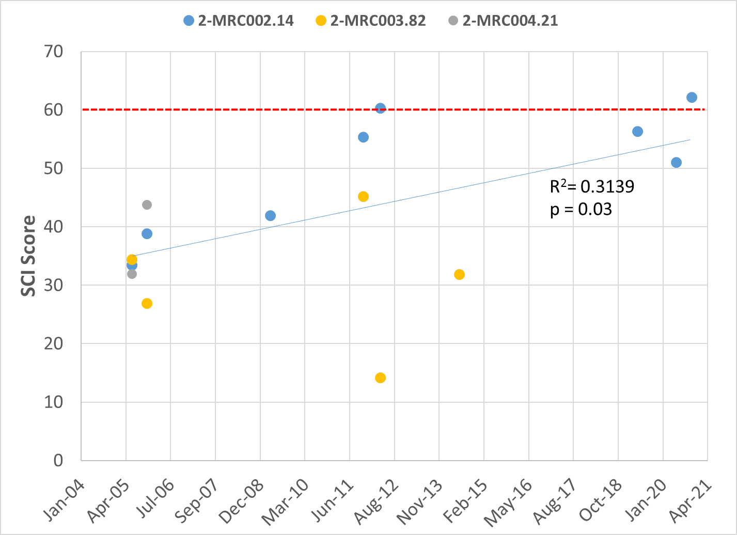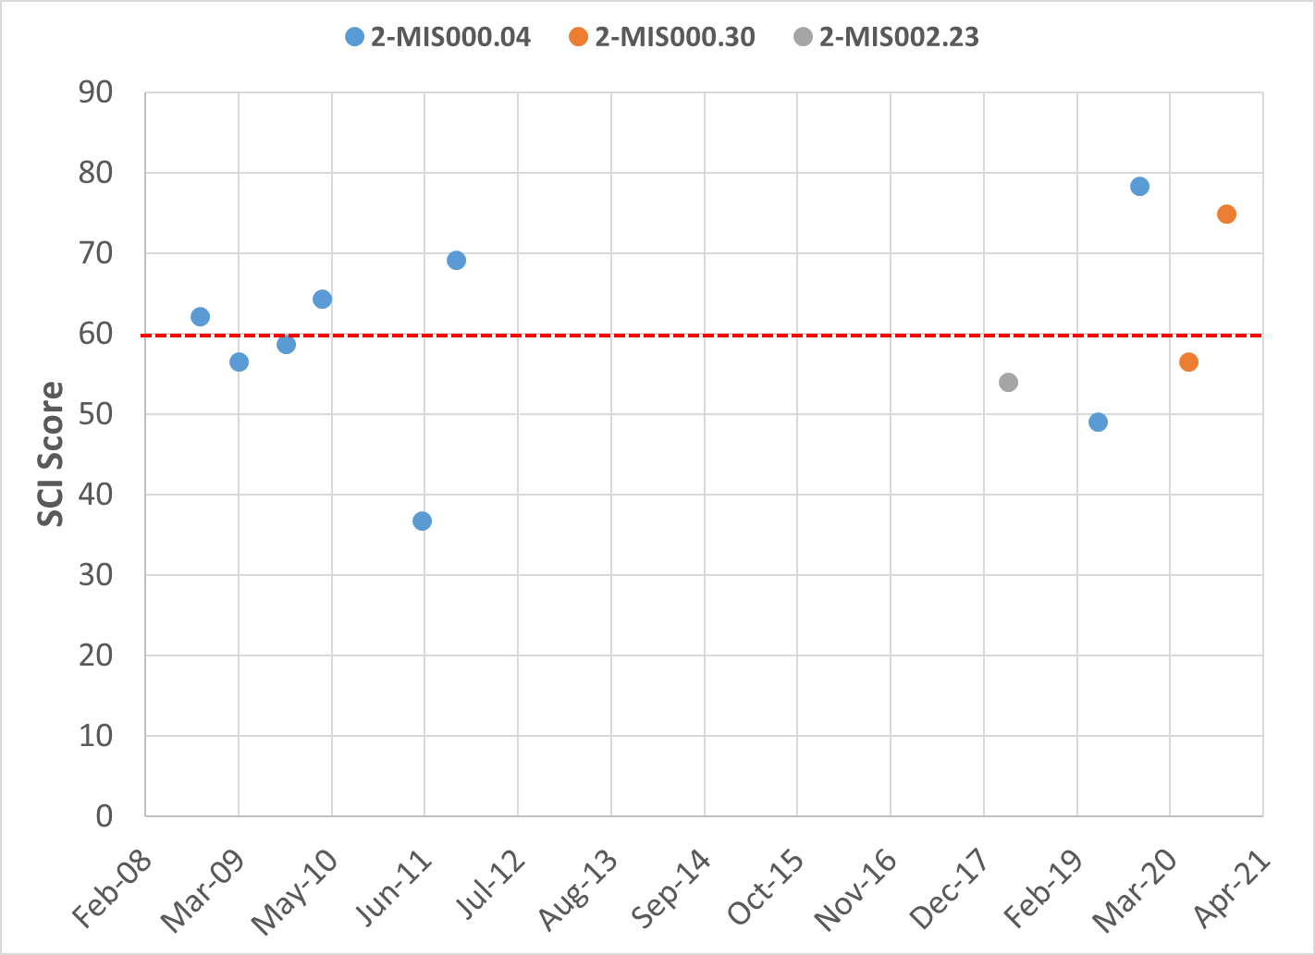
Figure 1-3. Temporal trends of benthic stream condition index (SCI) scores in the Moores and Mill Creek watersheds.
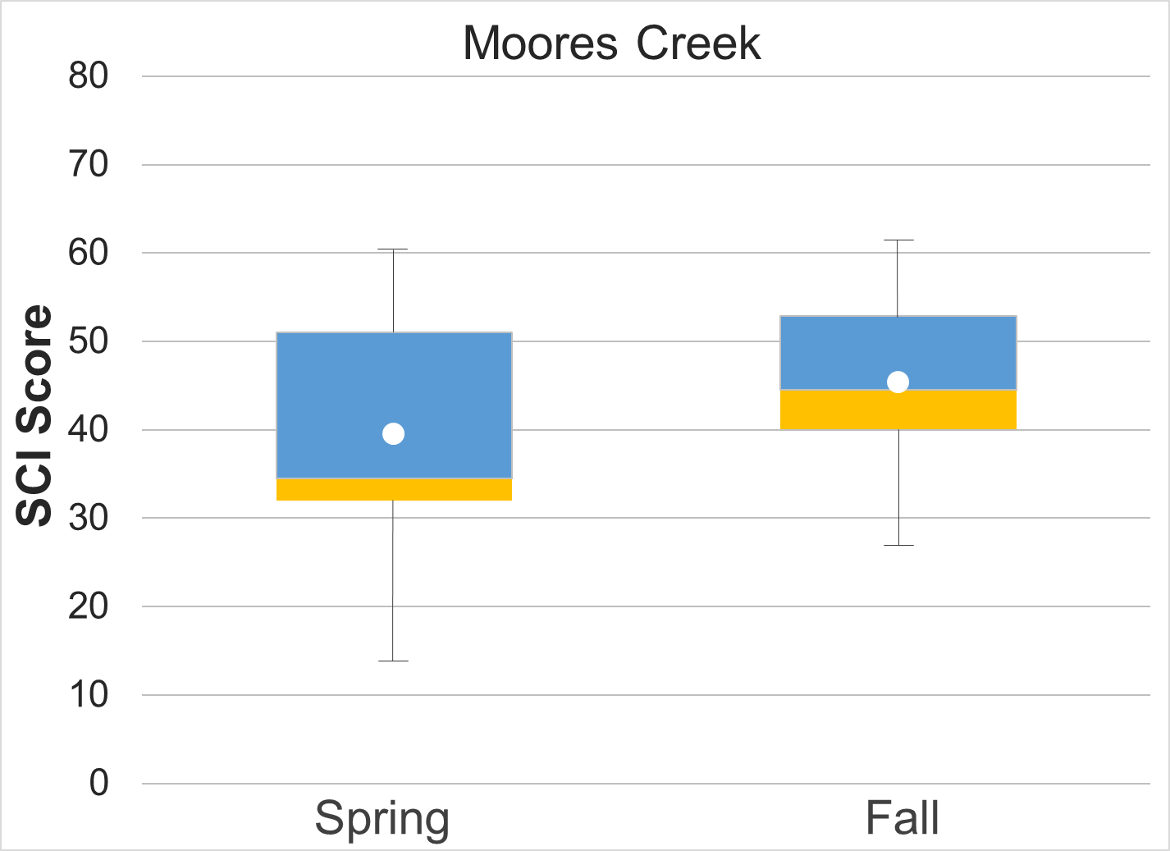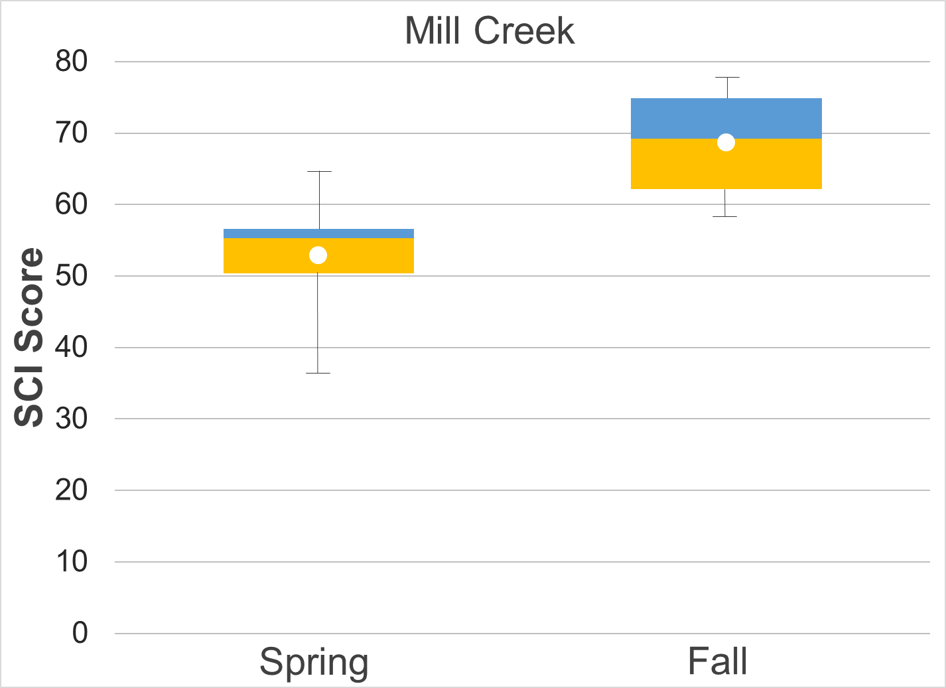
Figure 1-4 Moores and Mill Creek stream condition index scores (spring and fall). Whiskers indicate the range, boxes indicate the inter-quartile range, lines indicate the median, and white markers indicate the average.

Analysis of Benthic Metrics
Individual metrics that comprise the SCI were evaluated for the impaired streams in the Moores and Mill Creek in comparison to a benthic reference stream (Figure 1-4). The benthic reference used for these comparisons was Strait Creek in Highland County, Virginia. Average metric scores for each station were compared to the reference using a t-test with unequal variances (alpha = 0.05). All of the scores in Moores Creek were significantly different from the reference condition, while differences in Mill Creek were less apparent. Both streams had lower scores for % Ephemeroptera, % Plecoptera and Trichoptera minus Hydropsychidae (%PT-H), Richness, %Chironomidae, and Ephemeroptera, Plecoptera, Trichoptera (EPT) when compared to the reference condition. Scores for % Scraper were higher in both of the impaired streams. While none of these differences was significant in Mill Creek, comparisons suggest a lower abundance of pollution sensitive taxa in the impaired streams. In Mill Creek, differences from the reference condition indicate a marginal impairment, while conditions in Moores Creek suggest a more significant biological impairment.
In Moores Creek, scores for all benthic metrics were significantly lower (ɑ=0.05) than the reference condition with the exception of the %Scraper score, which was significantly higher in Moores Creek (p=0.02). An abundance of scrapers can be indicative of nutrient enrichment in streams. When the supply of dissolved nutrients is in excess, algae growth may be accelerated and the available food source for scrapers increases. Coleoptera and Diptera were the predominant orders present in Moores Creek samples, comprising an average of 20% and 33% of the community, respectively, compared to 17% and 9% in Strait Creek. Consequently, Moores Creek had a significantly lower %2 dominant score (p=0.007) when compared to Strait Creek. Ephemeroptera and Trichoptera taxa were present in low abundance in samples, comprising 10.3% of the benthic community in Moores Creek. Similarly, Plecoptera taxa was nearly absent, comprising 0.10% of benthic samples. This resulted in the low %PT-H score of 3.75, compared to 53.51 in the reference stream (p<0.001). Similarly, the EPT and % Ephemeroptera scores in Moores Creek were significantly lower (p<0.001) than in Strait Creek, with averages of 28.48 and 16.73, respectively, compared to 84.85 and 49.71 in Strait Creek. Sensitive taxa were present in relatively low abundance in Moores Creek, resulting in a significantly lower (p<0.001) Modified Family Biological Index (MFBI) score (66.17) compared to Strait Creek (84.94). The MFBI measures the ecological tolerance and relative abundance of aquatic macroinvertebrates present in a stream. Lower MFBI scores indicate that water quality or habitat conditions are limiting the presence of sensitive taxa.
In Mill Creek, benthic scores were evidence of a moderate impairment. Only the % MFBI metric was significantly lower (ɑ=0.05) than the reference condition, indicating that water quality or habitat conditions could be limiting the overall abundance of sensitive taxa. The % Scraper score was higher in Mill Creek (48.47) when compared to Strait Creek (30.94), though this difference was not significant. This shift towards scrapers could be indicative of nutrient enrichment. While the % MFBI metric was significantly lower in Mill Creek, richness was nearly equal (67.77 in Mill Creek) when compared to the reference (67.17). This suggests that while the benthic community in Mill Creek is relatively diverse, more sensitive taxa are present in lower abundance. This is reflected in lower EPT and %PT-Hydro scores in Mill Creek when compared to the reference condition. While Ephemeroptera were relatively abundant in Mill Creek, comprising 26.5% of the community, Plecoptera and Trichoptera (minus Hydropsychidae) comprised just over 10% of the community in Mill Creek compared to 20% in Strait Creek. Heptageniidae were the predominant Ephemeroptera family present in the stream, comprising 57% of Ephemeroptera taxa. This suggests that a low abundance of Plecoptera and sensitive Trichoptera taxa may be responsible for the significantly lower number of EPT taxa in Mill Creek when compared to the reference condition.
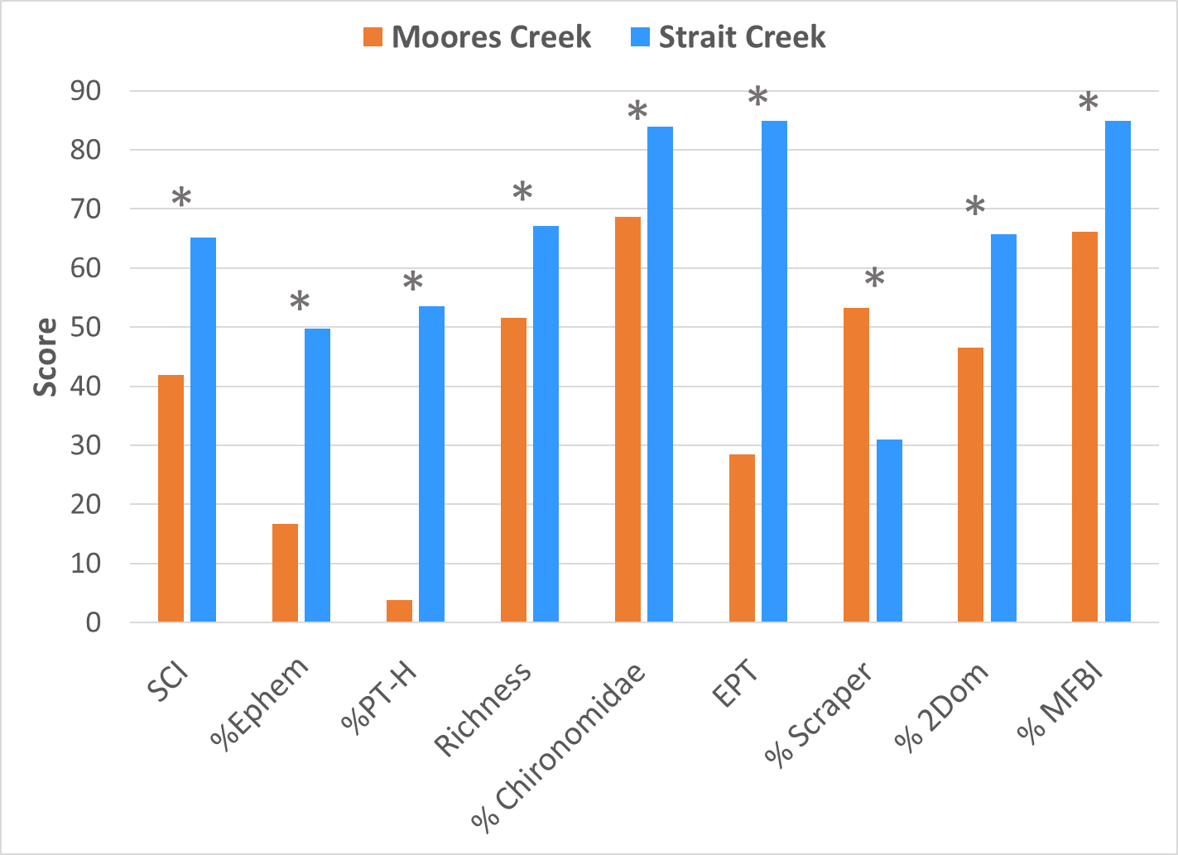
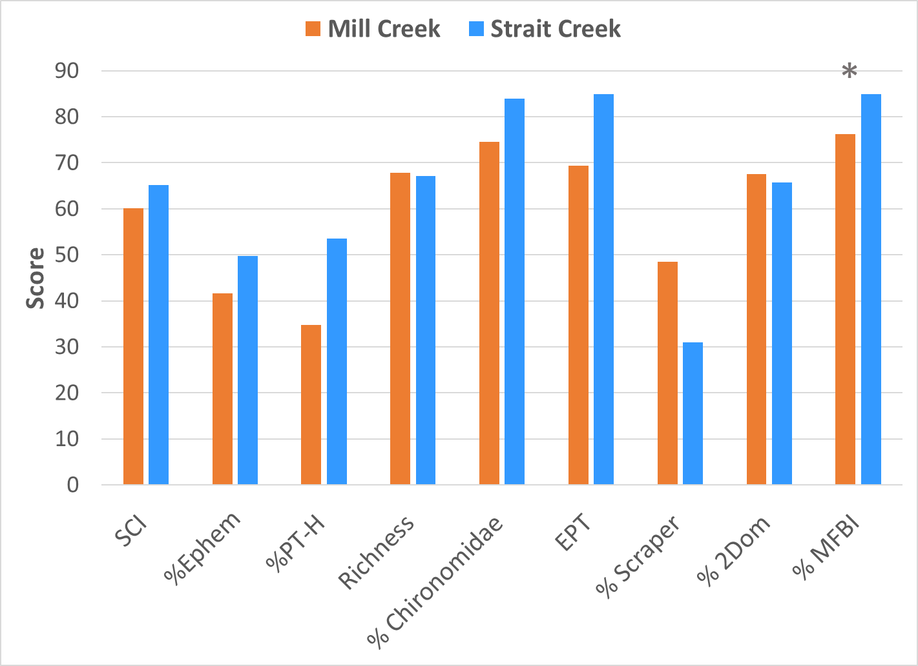
Figure 1-5. Metric scores comprising stream condition index (SCI) scores in the Moores and Mill Creek watersheds. * indicates that the metric was significantly different (alpha = 0.05) from the benthic reference score (Strait Creek).

Analysis of Community Composition
The taxonomic composition of the benthic communities was analyzed to identify shifts in composition at impaired sites that might provide clues to sources or mechanisms of impairment. Figure 1-5 compares the reference stream (Strait Creek) to the taxonomic composition in the impaired streams, Moores and Mill Creeks, and Table 1-3 shows the three most dominant taxa in each stream.
In the reference stream, taxonomic composition is relatively balanced. Ephemeroptera, Trichoptera (excluding Hydropsychidae) and Plecoptera make up 51% of the community in Strait Creek. Dipteran taxa (primarily Chironomidae) comprised 33% of the benthic community in both Moores and Mill Creeks. In the reference stream, Dipteran taxa comprised 17% of macroinvertebrate samples, just over half of the proportion observed in the impaired communities. Other predominant taxa in the impaired streams include Heptageniidae, Elmidae, and Hydropsychidae. Elmidae comprised a greater portion of the benthic community compared to the reference condition in both Moores and Mill Creeks. This difference was most pronounced in Moores Creek where Elmidae comprised 20% of samples compared to 7% in the reference stream. Heptageniidae were the predominant Ephemeroptera family in Mill Creek, while Baetidae and Ephemerellidae were the predominant families in Moores Creek and the reference stream, respectively. Baetidae and Ephemerellidae are both collectors, and are relatively sensitive to pollution, while Heptageniidae are scrapers and similarly sensitive to pollution.
Taxonomic composition in Moores Creek was significantly altered from that of the reference stream. The most significant changes were a 21.6% decrease in Ephemeroptera taxa and a 13% decrease in Plecoptera taxa. Additionally, Coleoptera and Diptera taxa increased by 11.2% and 15.7%, respectively. These changes reflect a general shift from the more sensitive EPT taxa to more pollution tolerant taxa. Chironomidae comprised 82.7% of Diptera taxa in Moores Creek, and 27.3% of the overall benthic community. The shift towards Chironomidae could be indicative of nutrient or sediment enrichment. Lawrence and Gressens (2011) showed that Chironomid abundance correlated with increased nutrient enrichment in urban and rural streams. Bjornn et al. (1977) demonstrated in artificial mesocosm experiments that increases in fine sediment significantly reduced EPT taxa but were tolerated by Chironomid taxa. Elmidae comprised 96.4% of Coleoptera taxa in Moores Creek, and 19.6% of the aquatic community as a whole. Elmidae, or riffle beetles, are moderately intolerant of pollution, with most species found in gravel and rocky bottom areas of swift currents in streams. Elmidae have anal gills covered by a moveable operculum that can protect the gills from suspended solids (Voshell, 2002). This characteristic could give the Elmidae a competitive advantage in higher suspended solids environments, so their abundance could indicate an early community response to suspended solids as a stressor. Further analysis of genus level data indicated that Optioservus and Stenelmis were the predominant Elmidae taxa in Moores Creek, comprising 50.8% and 30.7% of Elmidae samples, respectively. As noted in Section 1.2.1.4, Biological Conditions Gradient attribution for these taxa indicate a greater tolerance to elevated specific conductivity and poor habitat conditions. Additionally, Optioservus and Stenelmis have been commonly observed in Valley streams where agriculture is the predominant land use and evidence of excess sediment and nutrient inputs is present (W. VanWart, DEQ Regional Biologist, personal communication, August 13, 2021). Oligochaetes comprise 11.8% of the aquatic community in Moores Creek, compared to 1.28% in Strait Creek. This shift may be indicative of excess nutrients and reduced dissolved oxygen concentrations in Moores Creek. Tubificidae comprised 50% of Oligochaeta taxa in Moores Creek. These aquatic worms are adapted to survive in very low oxygen conditions based on their respiratory physiology (Aston, 1973). Tubificidae populations were greatest at 2-MRC003.82, where the number of sensitive taxa present were greatly reduced compared to the other Moores Creek stations. No Plecoptera taxa were present at this site, and only two insects in the order Trichoptera (Philopotamidae) were found on seven sampling events between 2005 and 2014. This suggests that results from 2-MRC003.82 may have a significant impact on overall averages with respect to the identification of predominant taxa in the Moores Creek watershed and the presence of sensitive taxa.
Taxonomic composition in Mill Creek was moderately altered from that of the reference stream. The most significant changes were a 16.04% increase in Diptera taxa and an 8.6% decrease in Plecoptera. These changes reflect a general shift from the more sensitive EPT taxa to more pollution tolerant taxa. Chironomidae comprised 78.5% of Diptera taxa in Mill Creek, and 26.2% of the overall benthic community. The shift towards Chironomidae could be indicative of nutrient or sediment enrichment. EPT taxa (minus Hydropsychidae) comprised 37.7% of the macroinvertebrate community in Mill Creek, representing a moderate shift from the reference condition (-13.1%). Moderately pollution intolerant Ephemeroptera taxa comprise the greatest portion of EPT taxa in Mill Creek, with Heptageniidae constituting over 40% of EPT taxa present in Mill Creek. More sensitive Plecoptera taxa were present in far smaller numbers. This suggests that the impairment on Mill Creek is relatively moderate, meaning that the stream is capable of supporting organisms that are sensitive to pollution, while comparatively pollution tolerant taxa continue to thrive.
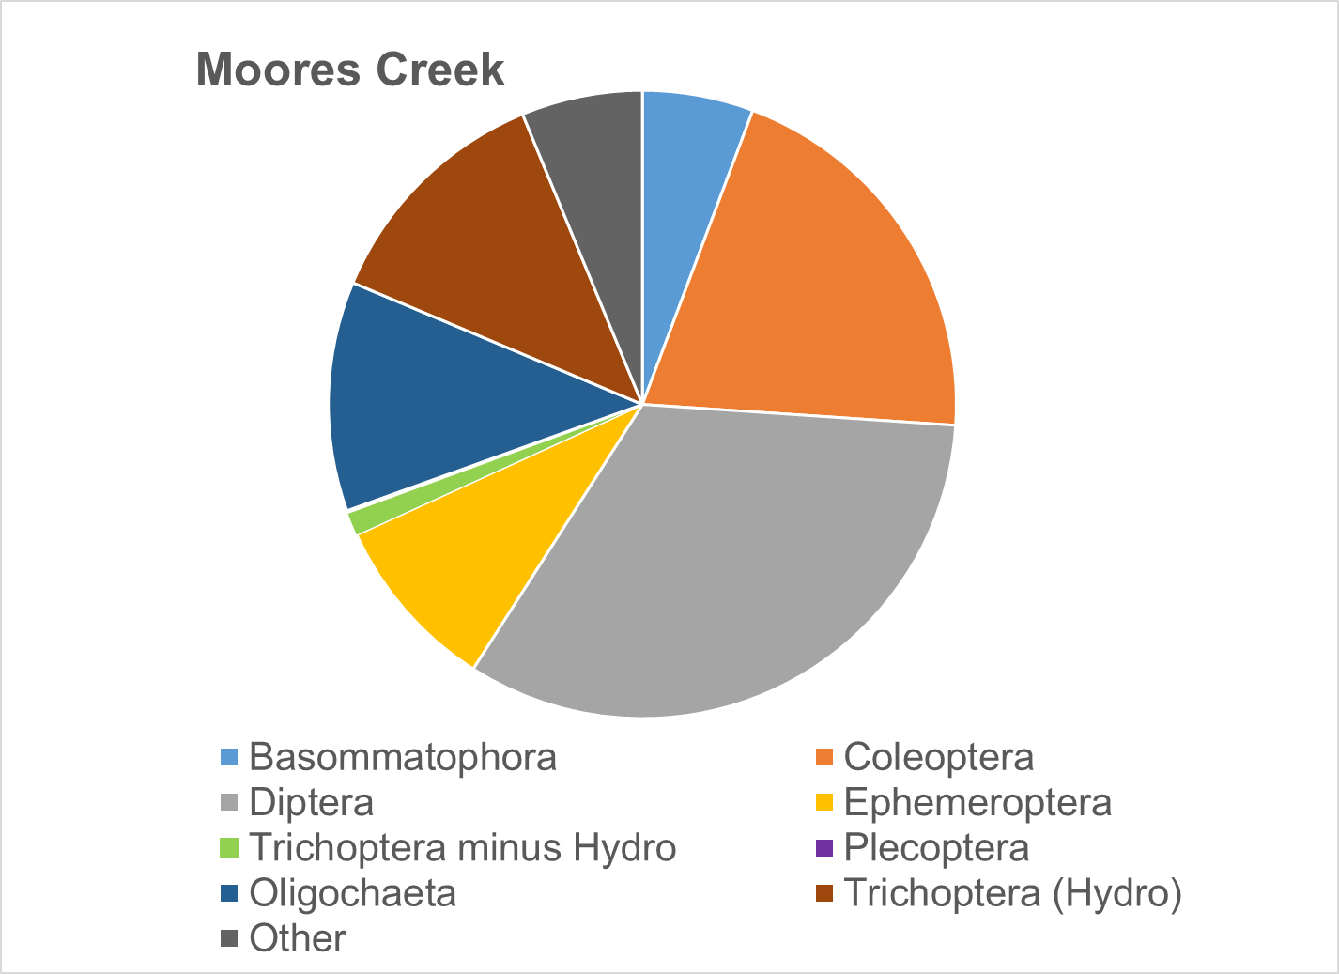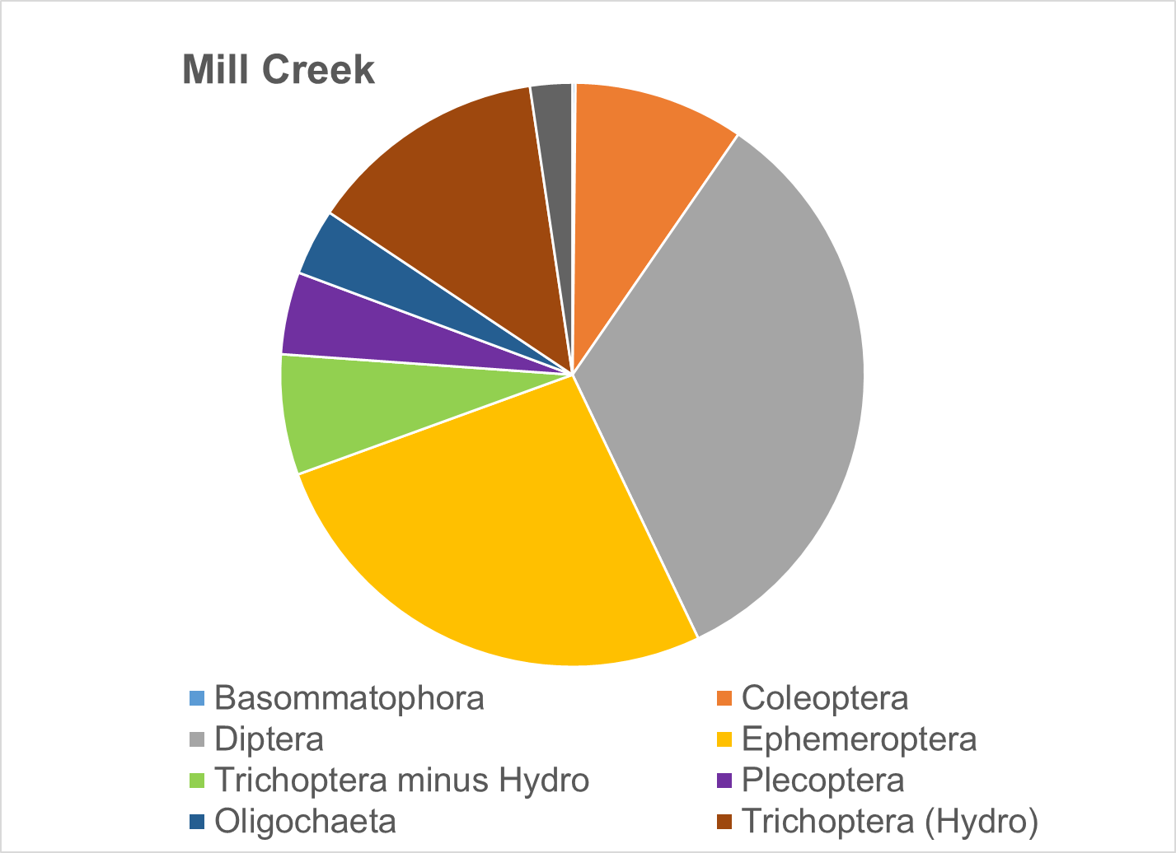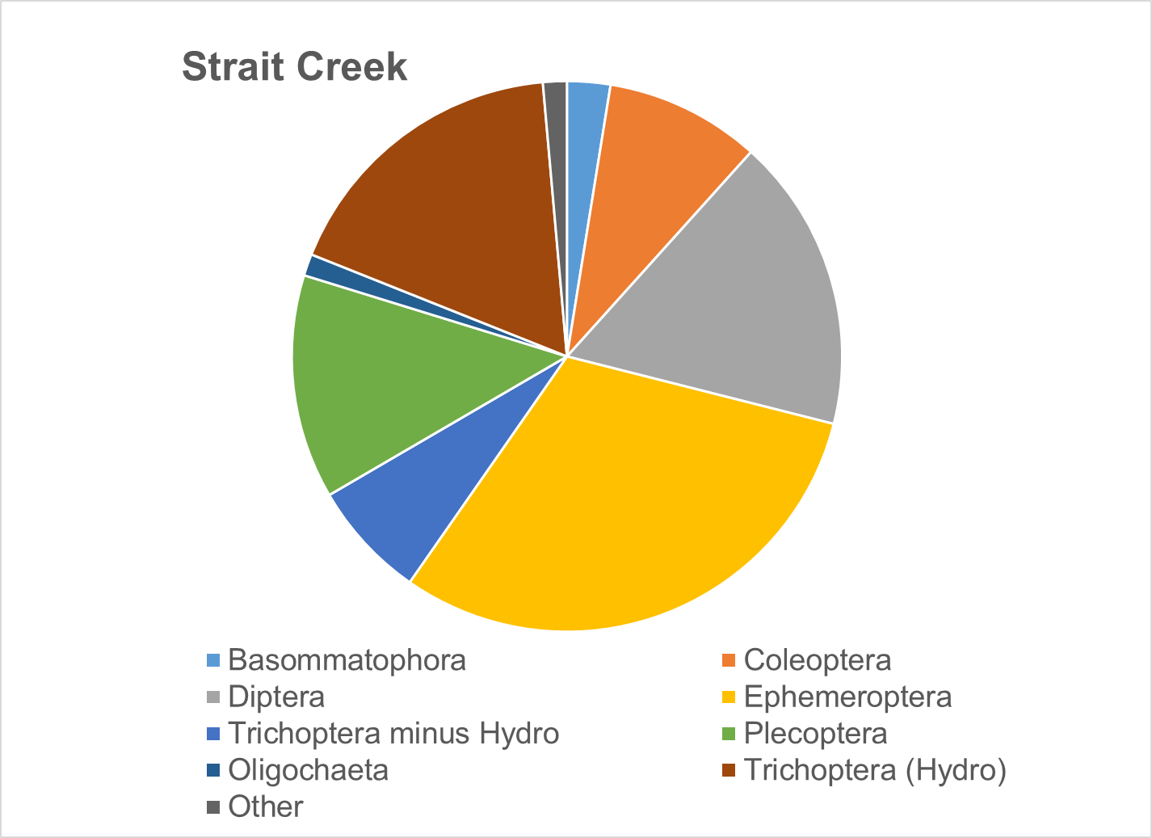
Figure 1-6. Benthic community structure (by order) in the Moores and Mill Creek watersheds in comparison with a reference watershed, Strait Creek.

Table 1-3. Predominant taxa in the Moores and Mill Creek TMDL project area.
Stream | Order,  Family | % of Benthic Community | Order,  Family | % of Benthic Community | Order,  Family | % of Benthic Community
Moores Creek | Trichoptera, Hydropsychidae | 12.4% | Coleoptera, Elmidae | 19.6% | Diptera, Chironomidae A | 27.3%
Mill Creek | Trichoptera, Hydropsychidae | 13.3% | Ephemeroptera  Heptageniidae | 15.2% | Diptera, Chironomidae A | 26.2%
Strait Creek (reference) | Ephemeroptera, Ephemerellidae | 9.2% | Diptera, Chironomidae A | 14.1% | Trichoptera, Hydropsychidae | 17.6%

Biological Condition Gradient Analysis
In partnership with the US EPA and several Mid-Atlantic States (Virginia, West Virginia, and Maryland), Tetra Tech developed a Mid-Atlantic Biological Conditions Gradient (BCG) model in 2019 (Tetra Tech, 2019). A BCG is a conceptual framework that may be used to predict biological responses to increased environmental stress. The BCG model establishes a framework of measurable characteristics known as “attributes” of biological communities including properties such as richness, abundance and structure. The model predicts how these attributes shift in response to increasing levels of environmental stress based on observed patterns of biological response to stressors for a given geographic region. The Mid-Atlantic BCG model defines six attributes related to the pollution tolerance among fish and macroinvertebrate taxa present in the region. These attributes were assigned scores for ten specific stressors for a total of 560 macroinvertebrate taxa based on data provided by multiple states through a consensus-based process with input from regional biologists (Table 1-4).
Table 1-4. Mid-Atlantic biological condition gradient attributes and stressors evaluated
Attribute | Explanation | Stressors Evaluated
I | Historically documented, sensitive, long-lived or regionally endemic taxa | Dissolved oxygen  Acidity  Alkalinity  Specific conductivity  Total habitat  % Imperviousness | Chloride  Sulfate  Total Nitrogen  Total Phosphorus  Relative bed stability
II | Highly sensitive taxa
III | Intermediate sensitive taxa
IV | Intermediate tolerant taxa
V | Tolerant taxa
VI | Non-native taxa

Taxa receiving high attribute values for a stressor are typically more tolerant of that particular stressor. Conversely, taxa assigned low attribute values for a stressor are generally intolerant of that stressor and will not typically be abundant or present in conditions where this particular stressor is experienced. Using attribute data from Virginia’s BCG model, scores were assigned to taxa in Moores and Mill Creek samples for each stressor listed in Table 1-4. Weighted average attribute values were calculated for each stressor across all taxa in Moores and Mill Creeks (Table 1-5). In addition, attribute values for stressors were evaluated for predominant species in Moores and Mill Creeks in order to identify potential stressors that may be disproportionately influencing benthic community composition in the impaired streams (Table 1-6). As shown in Table 1-5, there was little variability in average BCG scores for possible stressors, with dissolved oxygen in Mill Creek receiving the highest score (3.9), and dissolved oxygen and acidity in Moores Creek receiving the lowest score (3.1). These data suggest that taxa present in both streams are relatively tolerant to a wide range of stressors and do not show much differentiation with respect to stressor identification. As shown in Table 1-6, the predominance of Chironomidae and Hydropsychidae in both Moores and Mill Creeks resulted in a relatively narrow range of BCG scores for potential stressors, with no clear indication that a particular stressor is responsible for shifts in the aquatic community. These results suggest that it is more likely that a combination of multiple stressors are interacting together to make conditions less favorable for relatively sensitive taxa.
Table 1-5 Average biological condition gradient scores by stressor for Moores and Mill Creeks.
Stream | Diss. Oxy. | Acidity | Alkalinity | Spec. Cond. | Chloride | Sulfate | TN/TP | Total Habitat | RBS | % Imp.
Moores Creek | 3.1 | 3.1 | 3.4 | 3.4 | 3.2 | 3.5 | 3.4 | 3.3 | 3.4 | 3.4
Mill Creek | 3.9 | 3.4 | 3.6 | 3.5 | 3.3 | 3.6 | 3.7 | 3.6 | 3.7 | 3.8

Table 1-6 Biological condition gradient scores by stressor for predominant taxa in Moores and Mill Creeks.
Stream | Predominant Taxa | General | Diss. Oxy. | Acidity | Alkalinity | Spec. Cond. | Chloride | Sulfate | TN/TP | Total Habitat | RBS | % Imp.
Moores Creek | Chironomidae | 4 | 4 | 4 | 4 | 4 | 4 | 4 | 4 | 4 | 4 | 4
 | Elmidae | 4 | 4 | 3 | 4 | 4 | 3 | 4 | 3 | 4 | 4 | 4
 | Hydropsychidae | 4 | 4 | 3 | 4 | 4 | 3 | 4 | 4 | 4 | 4 | 4
Mill Creek | Chironomidae | 4 | 4 | 4 | 4 | 4 | 4 | 4 | 4 | 4 | 4 | 4
 | Hydropsychidae | 4 | 3 | 3 | 4 | 4 | 3 | 4 | 4 | 3 | 4 | 4
 | Maccaffertium | 4 | 4 | 4 | 4 | 3 | 3 | 3 | 4 | 4 | 4 | 4

Analysis of Functional Feeding Groups
The composition of functional feeding groups comprising the benthic community was also analyzed to identify shifts in composition at impaired sites that might provide clues to sources or mechanisms of impairment. Figure 1-6 shows the composition of functional feeding groups within the impaired streams in comparison to reference conditions in Strait Creek. Shredders constituted a smaller portion of the population in the impaired streams when compared to the reference stream. In the impaired streams, communities shifted to a higher percentage of collectors and scrapers when compared to Strait Creek. This shift towards scrapers can be indicative of nutrient enrichment in a stream. When the supply of dissolved nutrients is in excess, algae growth may be accelerated and the available food source for scrapers increases. Collectors comprised over 40% of the benthic community in Moores and Mill Creeks. The shift towards collectors in the impaired streams may be explained by an abundance of deposited organic matter in these streams. When organic matter increases, the niche of macroinvertebrates that collect their food from bottom deposits (collectors) expands.
The percentage of shredders was lower in all of the impaired streams when compared to the reference condition. Shredders comprised less than 1% of the benthic community in Moores Creek, and 3.7% in Mill Creek. Conversely, shredders comprised 12.8% of the community in Strait Creek. While collectors consume fine particulate organic matter (FPOM) deposited on the stream bottom, shredders consume coarse particulate matter (CPOM) including leaf litter and wood. The shift away from shredders in the impaired streams could be indicative of a reduction in CPOM in the impaired streams due to a lack of riparian buffers. Alternatively, it could signal an overabundance of FPOM, allowing for a predominance of collectors in the impaired streams.
Surprisingly, there was a greater proportion of filterers in Strait Creek compared to the impaired streams. Analyses of habitat parameters discussed in Section 1.2.2 indicated that both impaired streams show evidence of excess streambank erosion and sediment deposition. A shift towards filterers such as Hydropsychidae (net spinning caddisflies) is typically observed under these conditions, as they are well adapted to filter suspended materials in their nets. This shift was not observed in either of the impaired streams when compared to the reference condition. It is common for filter feeders to comprise 40-50% of the macroinvertebrate community in streams with excessive sediment loading.
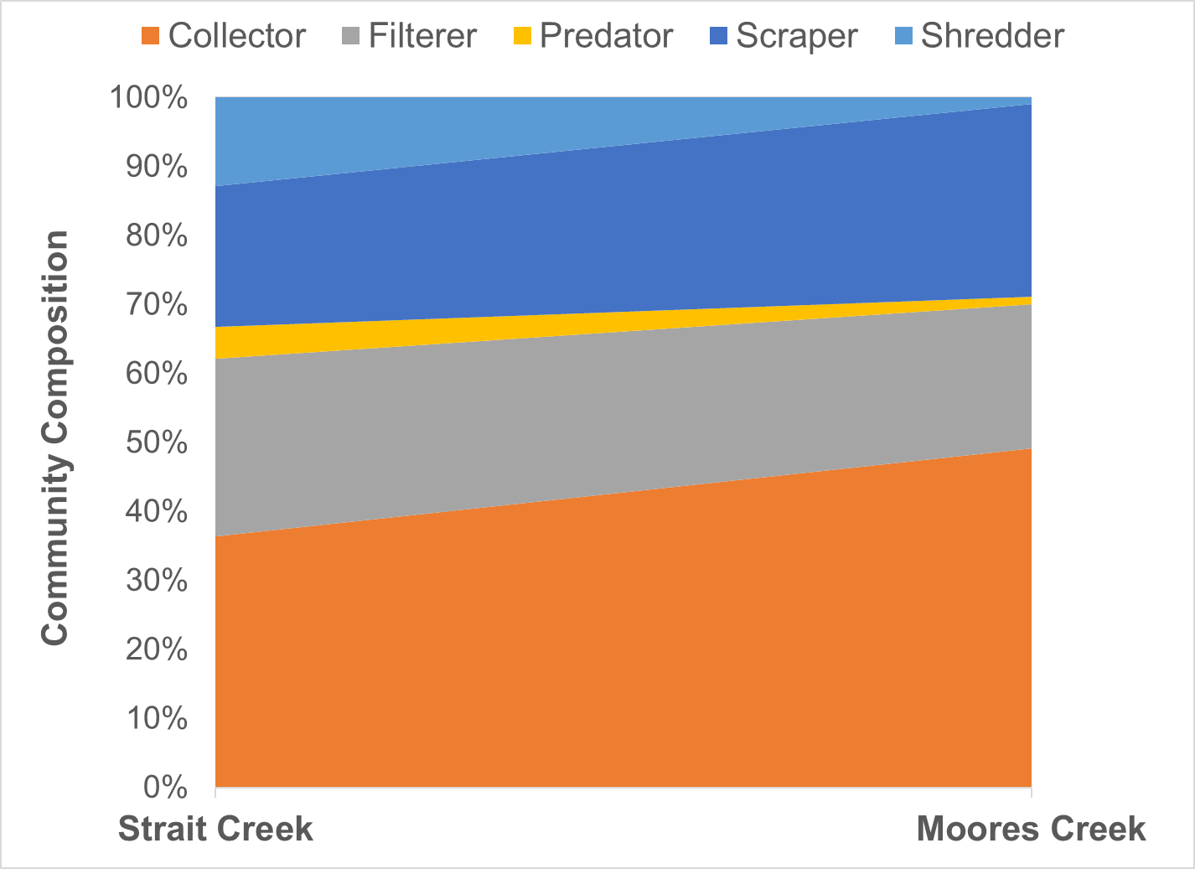
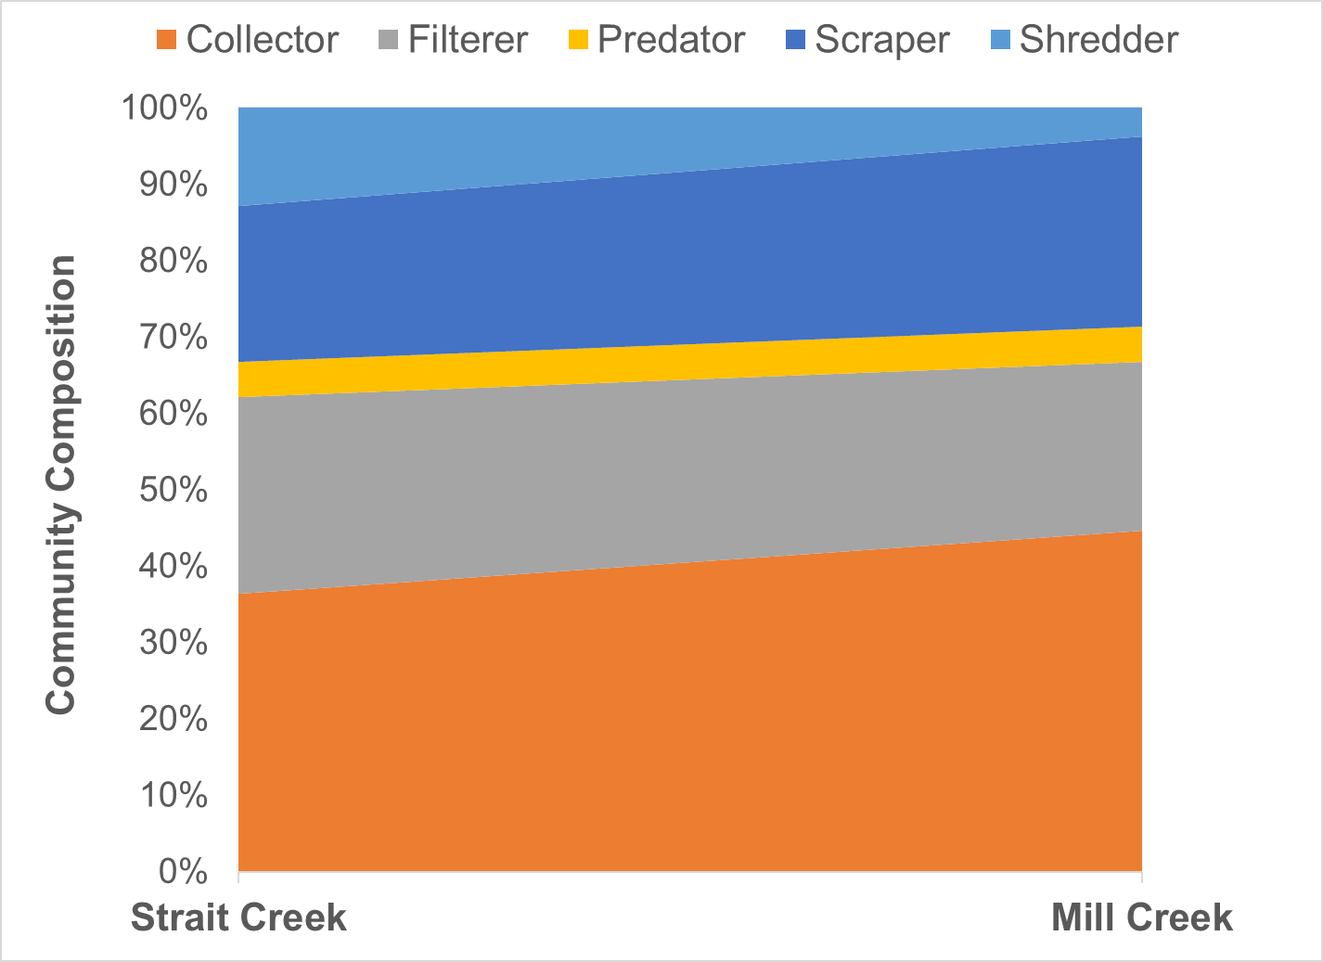
Figure 1-7. Functional feeding group composition in benthic communities in Moores and Mill Creeks compared to Strait Creek (reference stream).

Habitat Assessment
As part of the Rapid Bioassessment Protocol, a visual habitat assessment is performed at the time of each benthic sample collection. This assessment entails scoring each of a series of habitat components from 0 to 20. These habitat components include channel alteration, bank stability, bank vegetation, embeddedness, flow, riffles, riparian vegetation, sediment, substrate, and velocity. The individual scores for each of these measures are summed to determine a total habitat score. Table 1-7 shows scores for the impaired streams, and compares the total habitat scores to the reference stream (Strait Creek) using t-tests with unequal variances (ɑ=0.05). Scores for both Moores and Mill Creeks were significantly lower than the reference condition.
Figure 1-7 shows the probability of habitat being a stressor on the aquatic community for each stream based on DEQ’s analysis of probabilistic monitoring data (DEQ, 2017). Moores Creek fell in the medium probability of stress category, and Mill Creek fell in the low probability category.
Table 1-7. Total habitat scores for Moores and Mill Creeks.

Stream | Total Habitat Score | Significantly Different from Reference | P value
Moores Creek | 124.5 | Yes | p <0.001
Mill Creek | 141.8 | Yes | p =0.005
Strait Creek (reference) | 158.5

Habitat scores were statistically compared to SCI scores through a regression analysis (Figure 1-8). While the low R² value (0.365) indicates considerable variability in this relationship, the p value (p<0.001) demonstrates that habitat scores are a strong predictor of SCI scores. Consequently, poor habitat should be considered as a stressor to the benthic community where low SCI scores are documented.
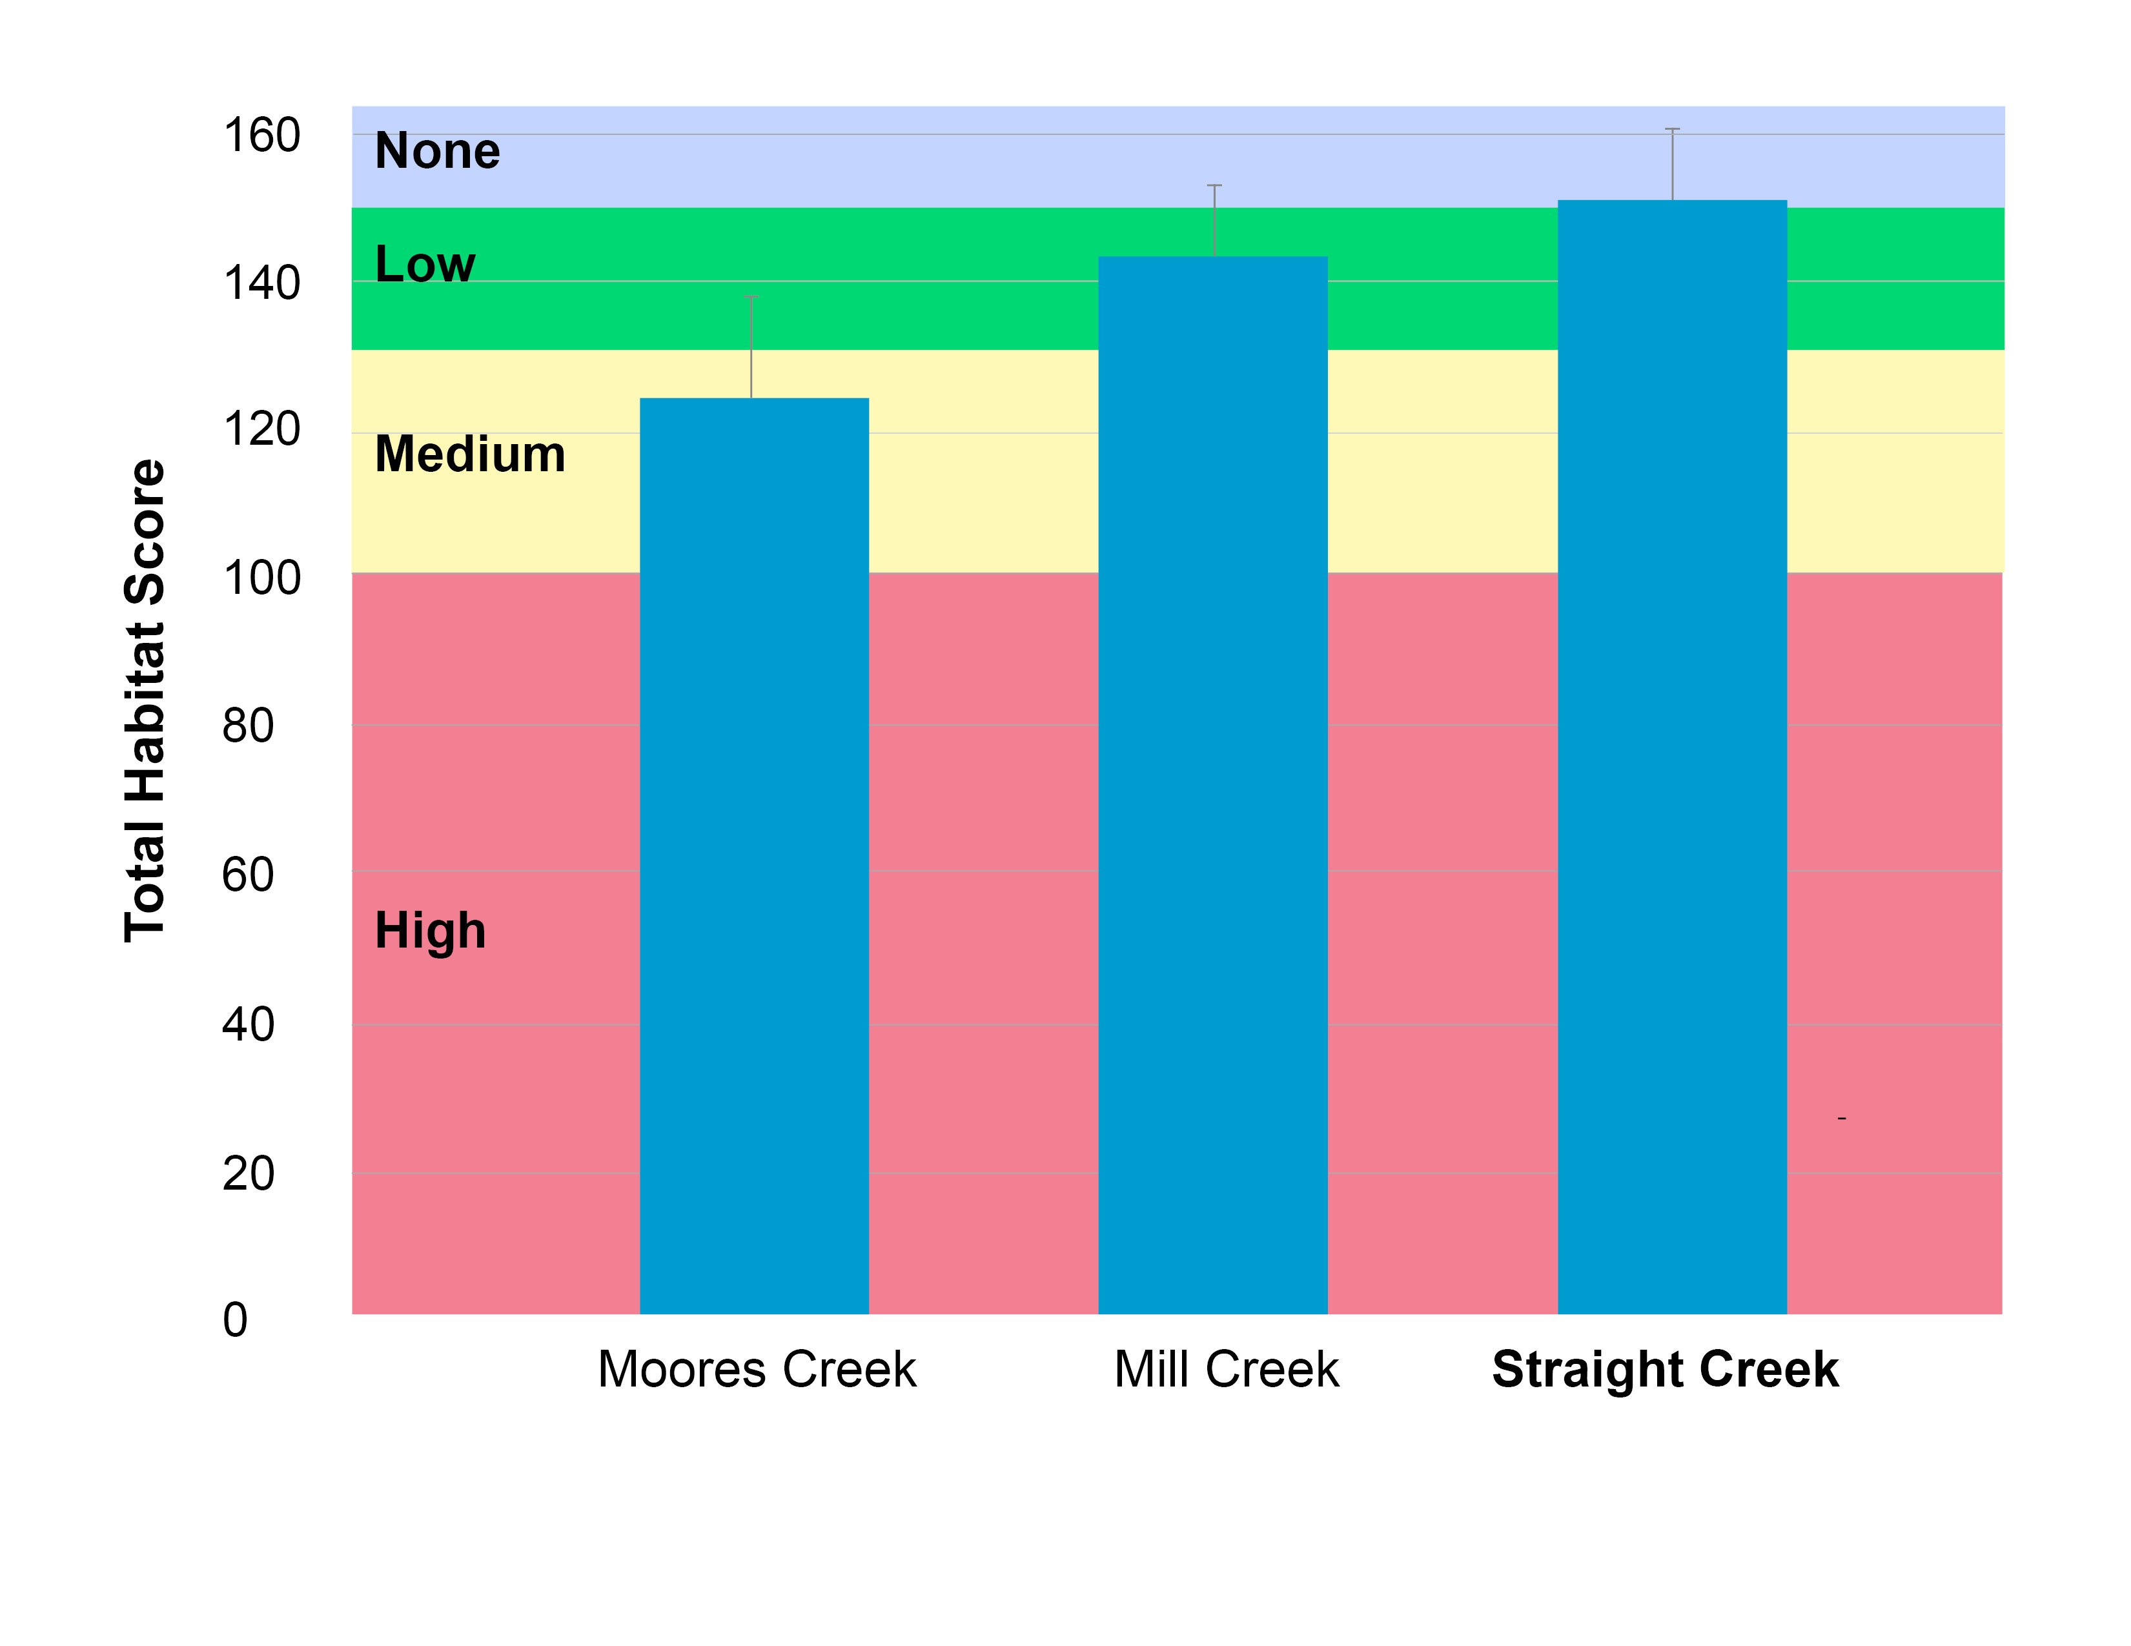
Figure 1-8. Total habitat scores for Moores and Mill Creeks. Colors represent the probability that data within that range would be responsible for causing stress.

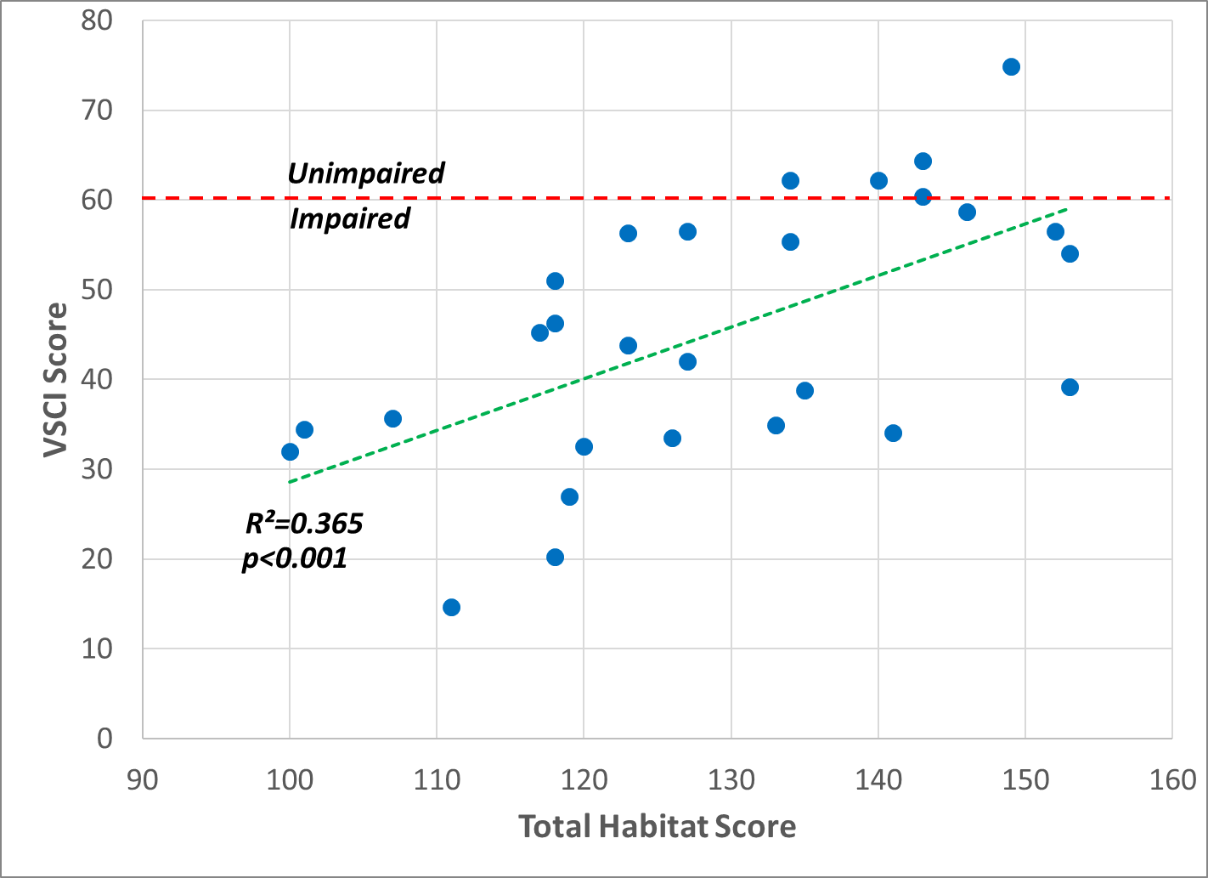
Figure 1-9. Comparison of total habitat scores with SCI scores Moores and Mill Creeks.
Individual habitat metrics are shown in Figure 1-9. Trends in Moores Creek habitat metrics indicated that significant alterations to in-stream and riparian habitat are impacting the benthic community. All metrics in Moores Creek with the exception of stream channel alteration (ALTER) and FLOW were significantly different from the reference stream (t-test with unequal variances, ɑ = 0.05). When compared to the reference condition, the greatest difference in habitat metric scores were associated with metrics indicative of excess sediment deposition in the stream. Large differences in SEDIMENT, BANKS, EMBED, and RIPVEG scores were observed, all indicating excess sediment deposition on the stream bottom is occurring as a result of streambank erosion associated with poor vegetative cover. Epifaunal substrate scores (SUBSTRATE) in Moores Creek were also significantly lower than the reference condition, suggesting that the stream is lacking adequate natural habitat structures such as fallen trees, large rocks and cobble to support a healthy aquatic macrofauna community.
Although scores for nearly all of the metrics in Mill Creek were lower than the reference condition, only the bank stability (BANKS) and sediment (SEDIMENT) metrics were significantly lower. Measures of embeddedness (EMBED) and riparian vegetation (RIPVEG) in Mill Creek were notably lower than the reference condition, suggesting that poor vegetative cover in riparian areas may be contributing to streambank erosion and deposition of excess sediment in the streambed.
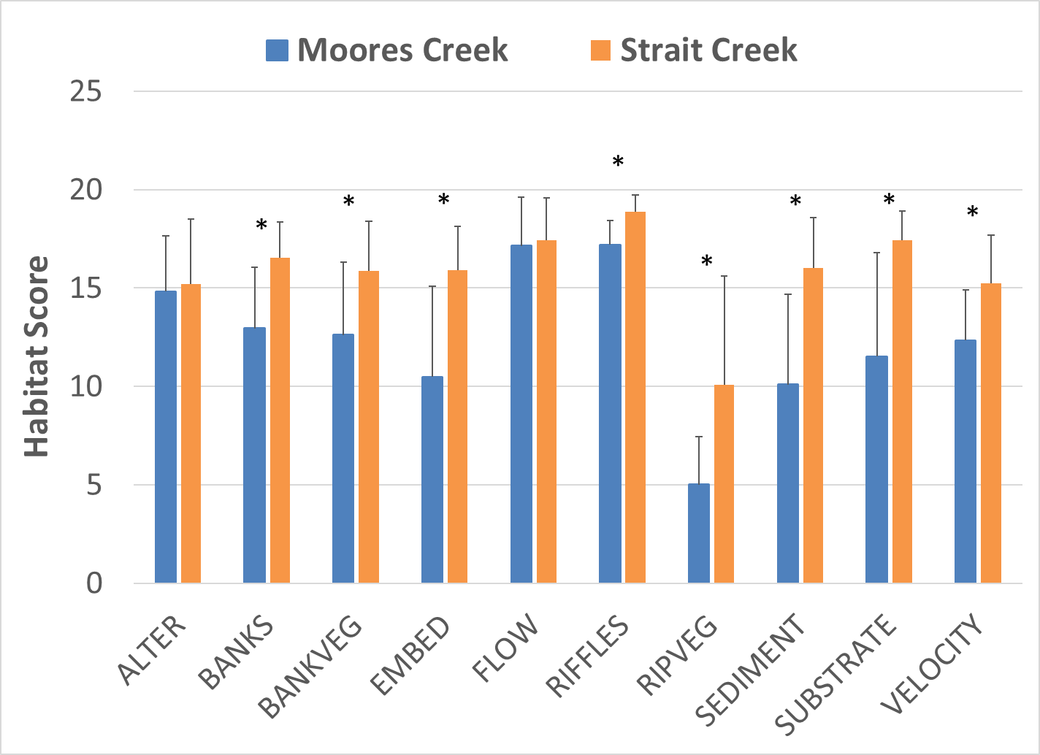
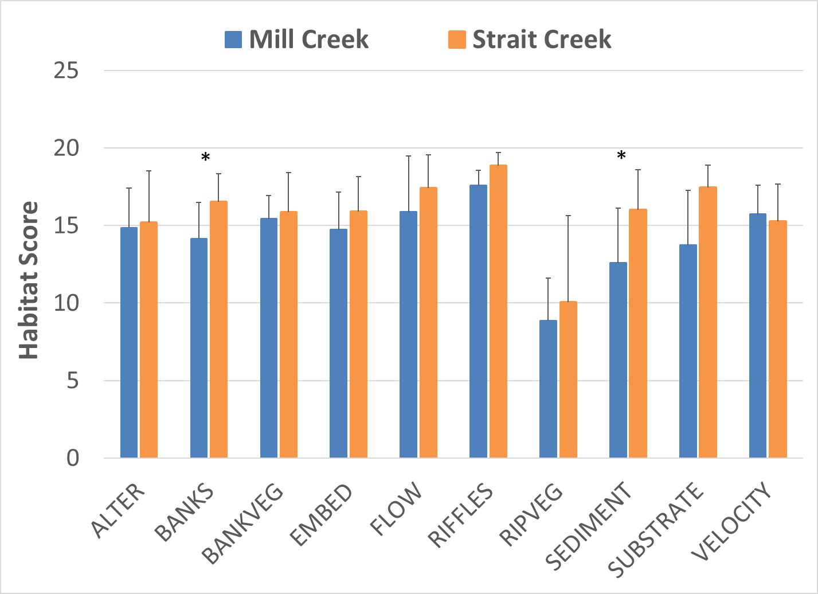
Figure 1-10. Habitat metric scores for Moores and Mill Creeks. Metrics with a * are statistically different from the reference site (α=0.05).

Relative Bed Stability
As a part of TMDL monitoring, DEQ conducted a detailed physical habitat assessment of the two impaired streams according to EPA methods for Quantifying Physical Habitat in Wadeable Streams (Kaufmann et al., 1999). This analysis involved the measurement of channel dimensions and substrate composition at numerous transects within a 150 to 240-m stream reach surrounding benthic monitoring stations 2-MRC002.14 in Moores Creek and 2-MIS000.30 in Mill Creek, respectively. The outcome of this analysis is the calculation of a log relative bed stability index (LRBS). The LRBS is the ratio between the observed distribution of in-stream sediments and the predicted sediment size distribution based on bankfull depth. LRBS values near zero indicate that the stream is stable. Large negative values indicate that the stream is unstable and depositing excess sediment. Large positive numbers, while less common, indicate that the stream is unstable and sediment starved. In an analysis of streams across the commonwealth, DEQ has determined that LRBS scores between -1.0 and -1.5 have a medium probability of stressing aquatic life, and LRBS scores <-1.5 have a high probability of stressing aquatic life (DEQ, 2017).
Table 1-8, Figure 1-10 and Figure 1-11 show the results of relative bed stability analysis in Moores, and Mill Creeks. Figure 1-10 shows how bottom substrate composition in the impaired streams compares to the reference condition in Walker Creek. While Strait Creek served as the reference condition for the two impaired streams for benthic and chemical data analyses, RBS monitoring was not conducted in the watershed, so an additional reference had to be identified. Walker Creek, a tributary of the Maury River located in Rockbridge County, was selected as a reference for RBS data analyses for the two impaired streams. Walker Creek is a limestone dominated stream with a predominantly agricultural watershed in the Ridge and Valley Ecoregion. One of the primary reasons Walker Creek was selected as an RBS reference was due to the proportion of bedrock comprising the stream bottom. Due to the predominance of bedrock in RBS analyses for Mill Creek, this established a better framework for comparisons between other substrate types and potential impacts to the benthic macroinvertebrate community. Additionally, the Walker Creek watershed is similar in size to those of the three impaired streams, has minimal impacts from urbanization, and similar soils and geology.
Figure 1-11 compares LRBS values in each of the streams to DEQ stressor thresholds. Individual LRBS scores in Moores Creek were in the high probability range for stressor effects, while scores in Mill Creek were in the no probability range for stressor effects. Moores Creek exhibited characteristics of an unstable stream channel with significant sediment deposition throughout the streambed and a high degree of embeddedness (Table 1-5). Fines comprised the greatest proportion of bottom substrates (44.8%) in Moores Creek, while cobble and gravel were far less abundant (25.7%). The LRBS value for Moores Creek (-2.0) is indicative of a high probability of stress to the benthic community (Figure 1-11). In contrast, RBS monitoring results for Mill Creek indicated far more stable conditions present in the stream channel and a much lower probability of stress to the benthic community due to excessive sediment deposition, with an LRBS value of 0.4 (Table 1-5). In Mill Creek, % embeddedness was lower than the reference condition with values of 24.5% and 39.3%, respectively. Sand comprised a larger percentage of bottom substrate in Mill Creek compared to the reference condition while the % fines was lower in Mill Creek when compared to the reference (Figure 1-10). Bedrock was the predominant substrate found in Mill Creek (43.8%), compared to 18.1% in Walker Creek. Conversely, cobble and gravel were less abundant in Mill Creek, comprising 36.2% of the bottom substrate. The proportion of cobble and gravel in Mill Creek compared to the reference condition (68.6%) suggests that the lack of these substrates could be the primary factor limiting benthic macroinvertebrate colonization in this stream. While evidence of sediment deposition is lacking in Mill Creek, the stream bottom is dominated by bedrock, which offers limited habitat for benthic macroinvertebrates when compared to gravel and cobble.
Table 1-8. Relative bed stability analysis in Moores and Mill Creeks.
Stream | Station | Date | %Sand and Fines | %  Embedded | % Bedrock | Log Relative Bed Stability Index (LRBS)
Moores Creek | 2-MRC002.14 | 8/20/2020 | 62.9% | 68.8% | 8.6% | -2.0
Mill Creek | 2-MIS000.30 | 8/27/2020 | 20.0% | 24.5% | 43.8% | 0.4
Walker Creek (reference) | 2AWKS003.34 | 9/8/2016 | 8.6% | 39.3% | 18.1% | 0.3

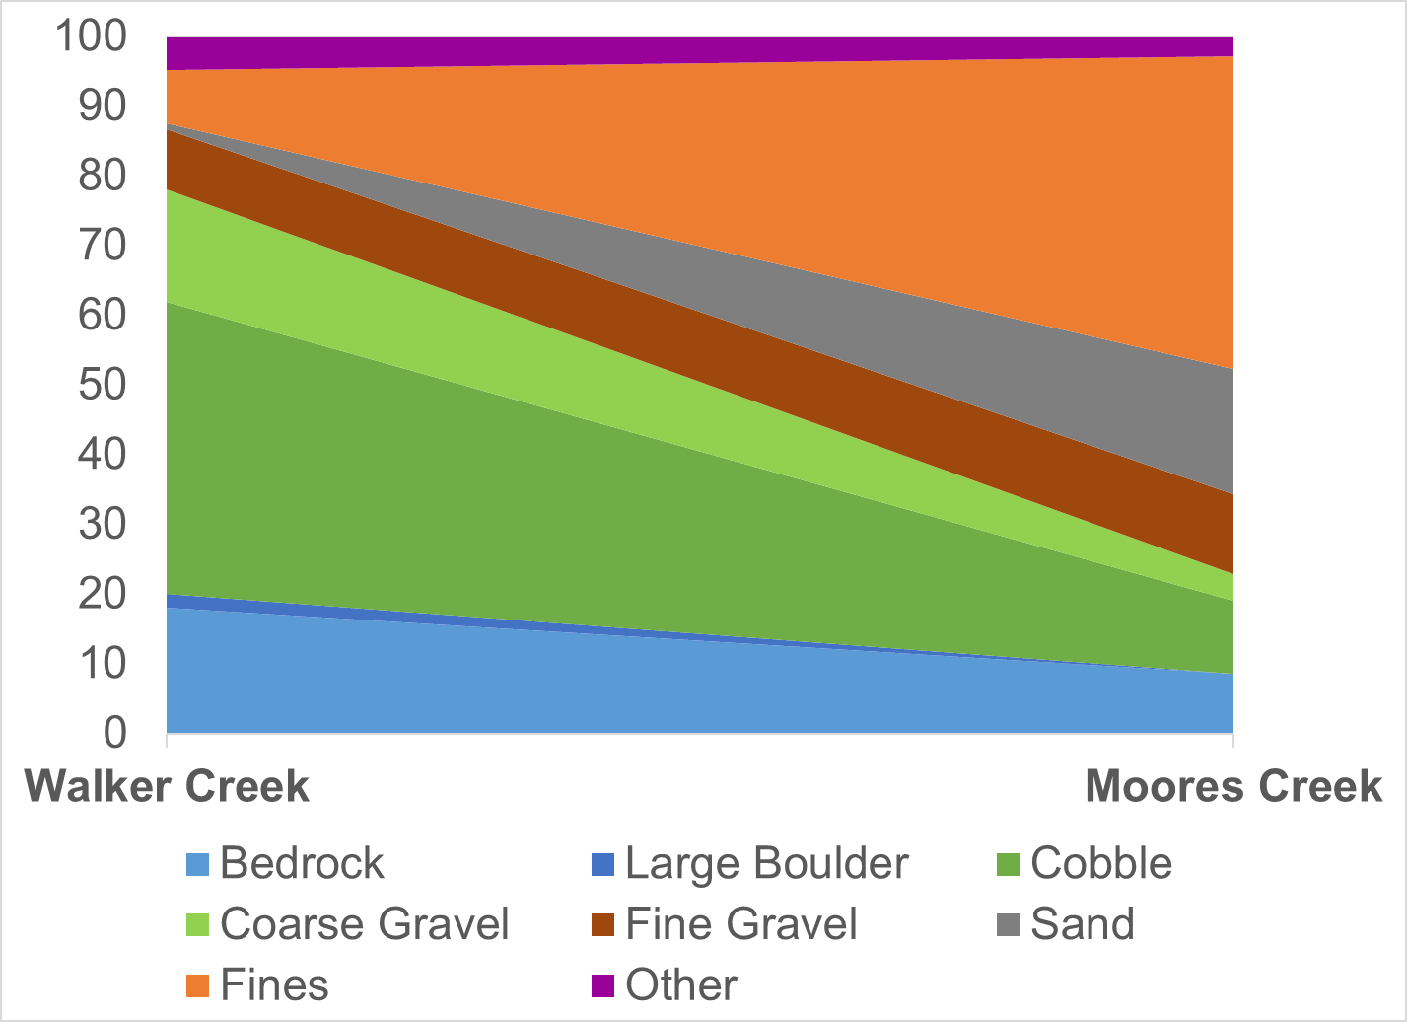

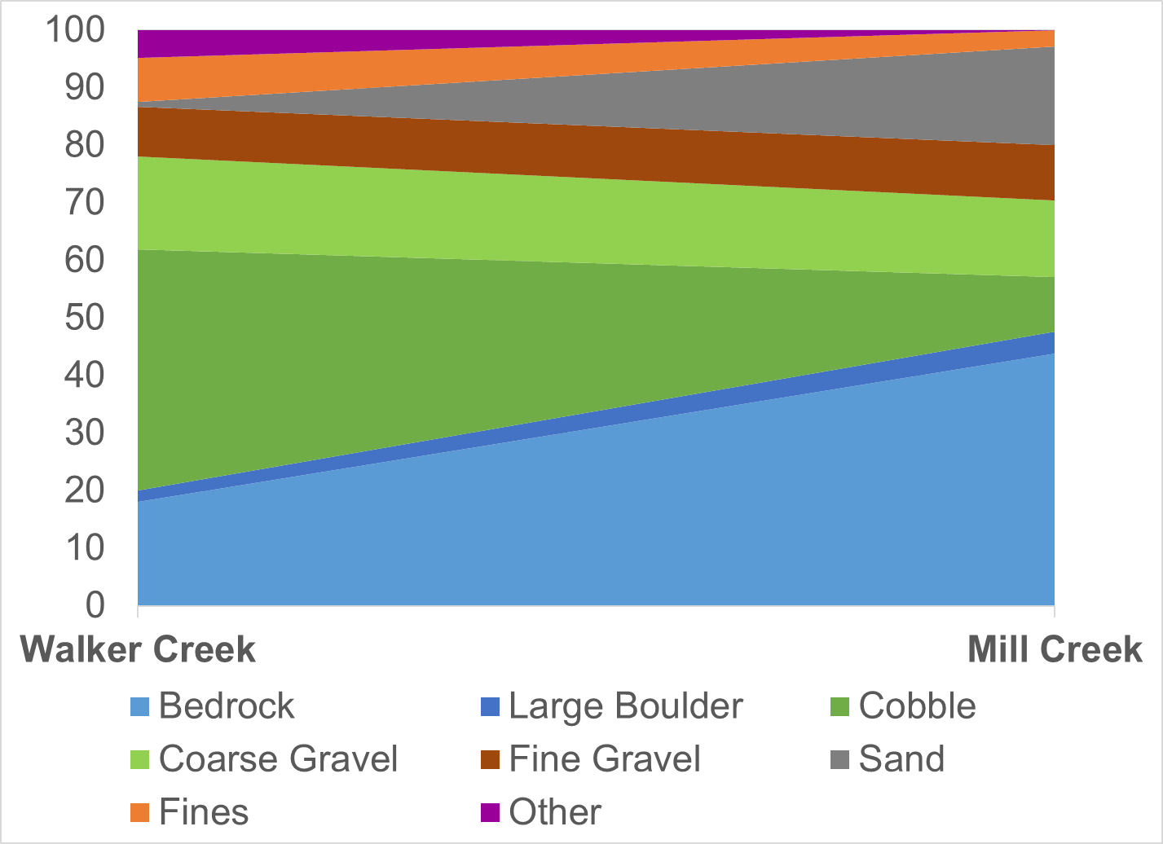
Figure 1-11. Moores and Mill Creek bottom substrate comparisons with reference (Walker Creek).
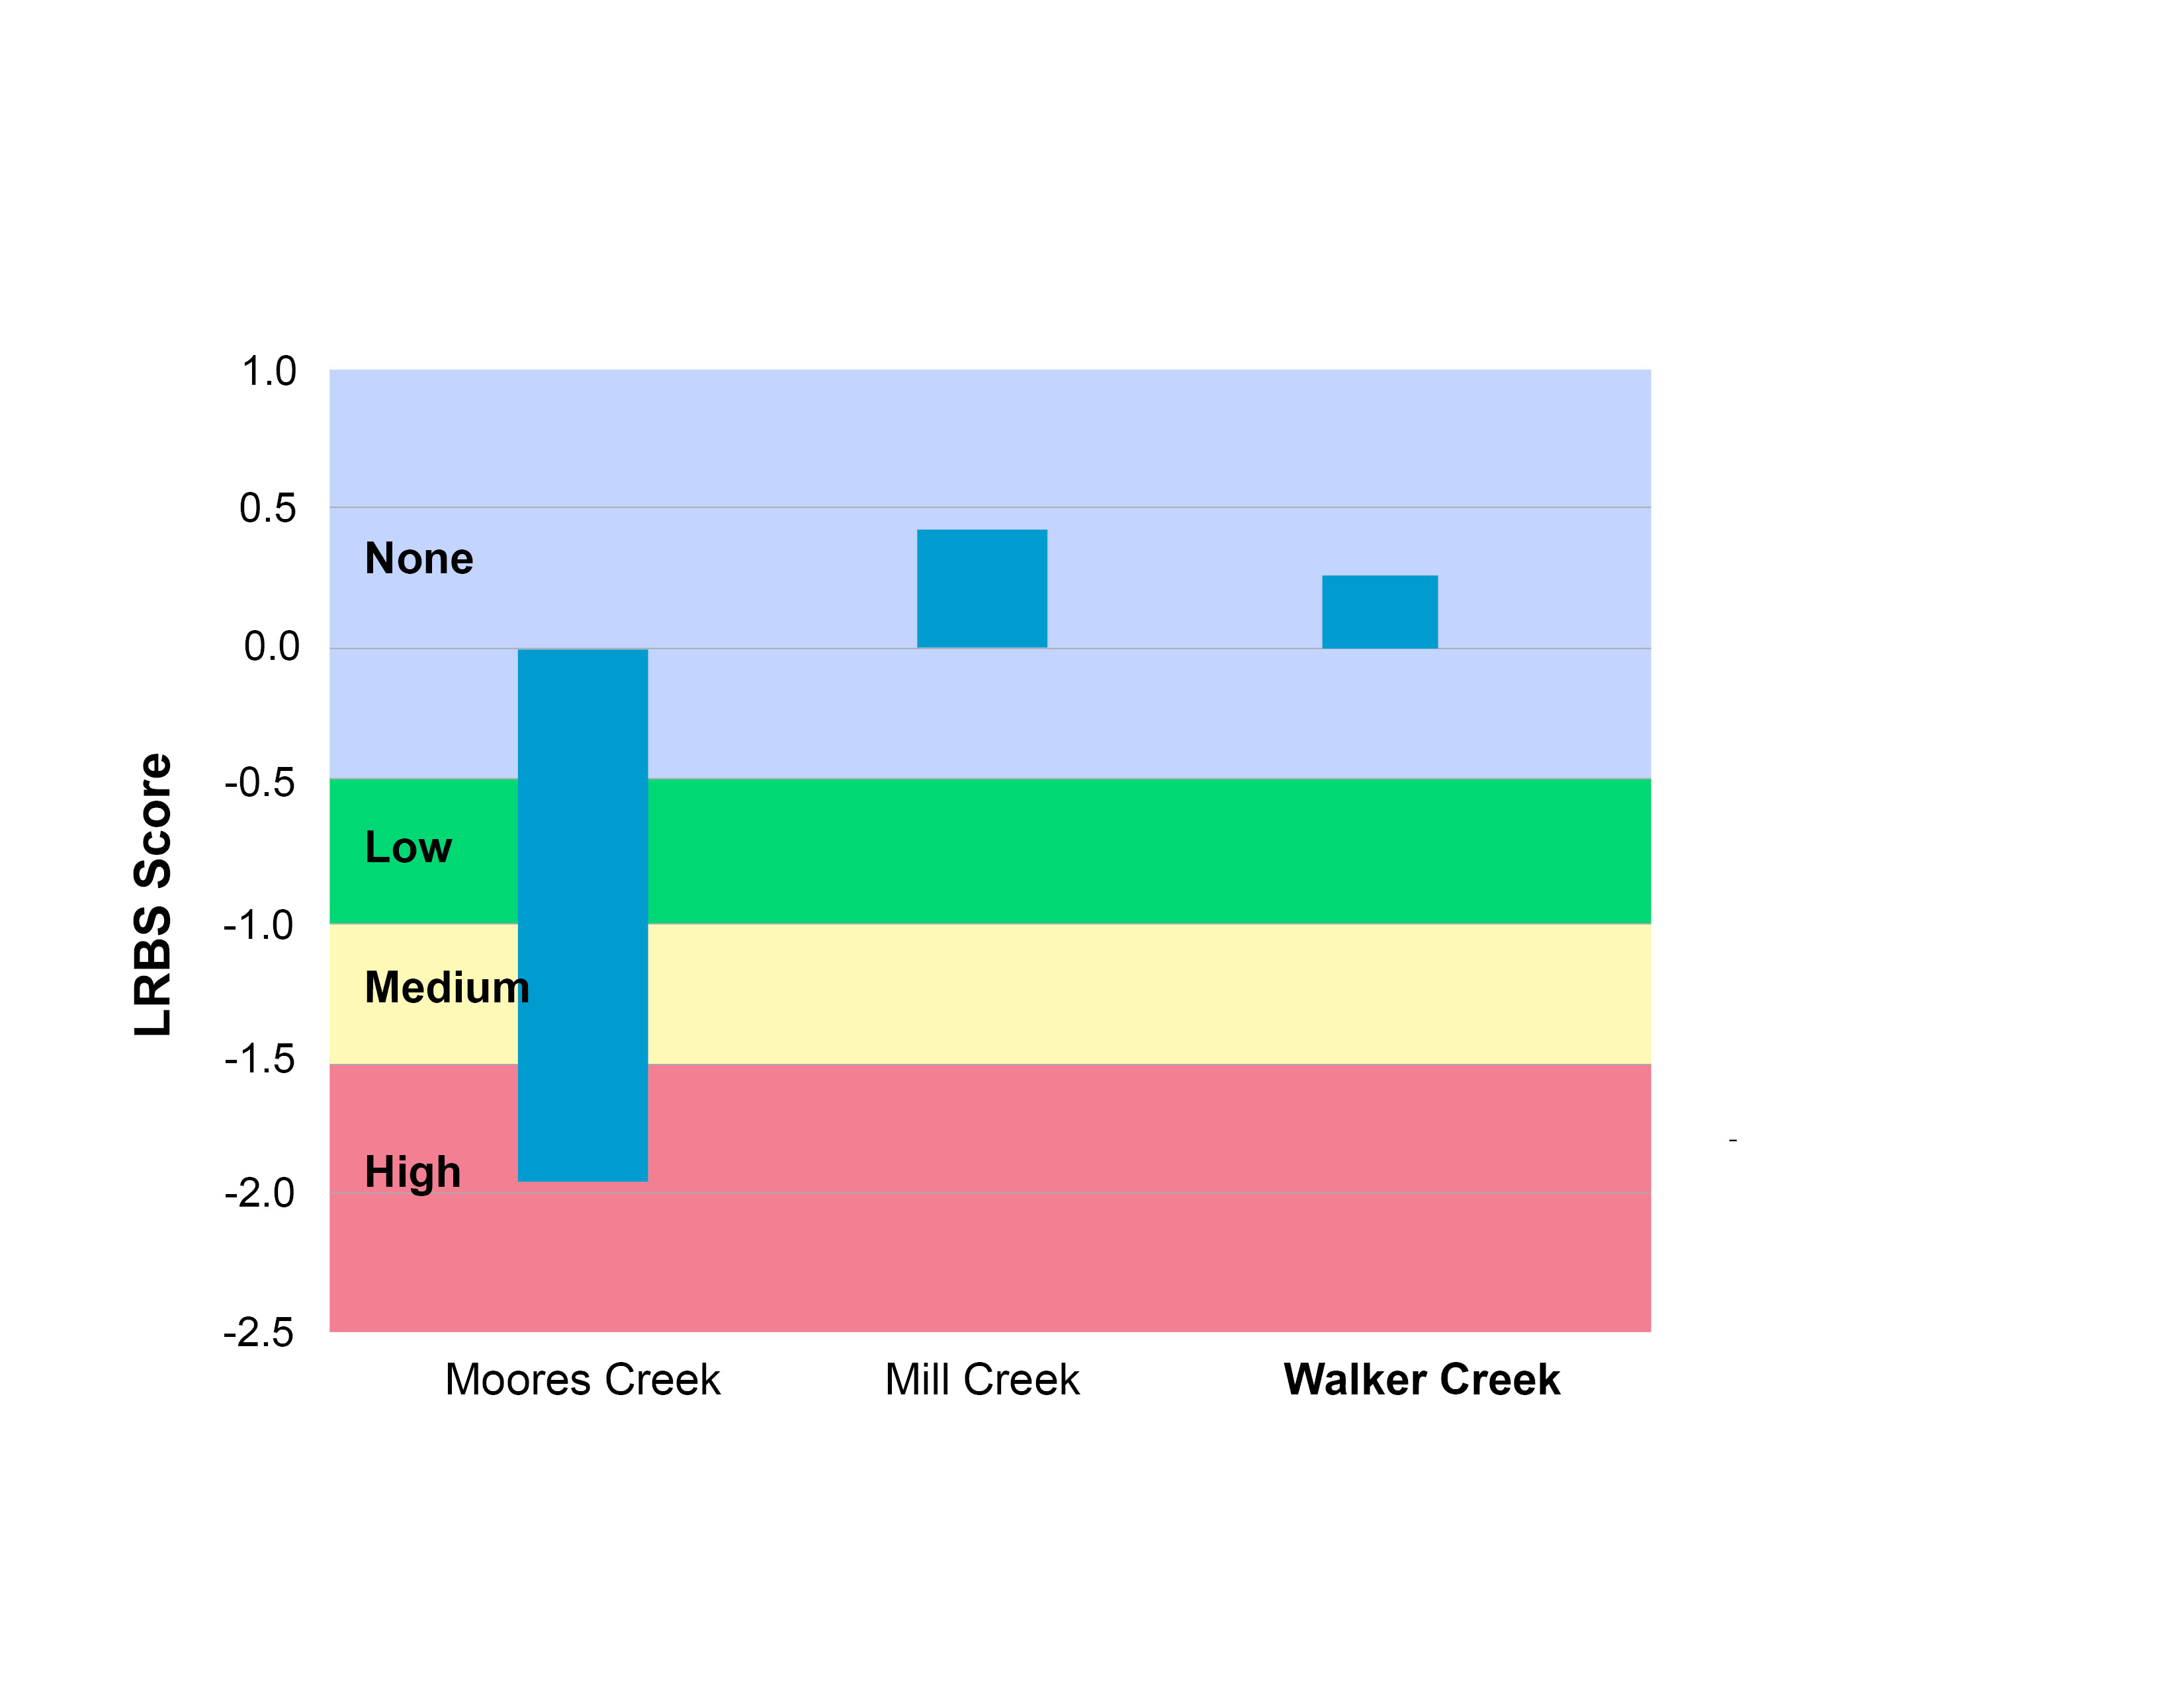
Figure 1-12. Log relative bed stability index (LRBS) scores for Moores and Mill Creeks in comparison with reference condition (Walker Creek).

Land Use Assessment
While a more detailed land use assessment will be part of the Moores and Mill Creek TMDL Report, the stressor analysis evaluated the potential connections between land use patterns within the watersheds and impaired benthic stations. Table 1-9 shows the land uses contributing to each of the benthic monitoring stations in the two watersheds. In Moores Creek, development has been concentrated in the upper portion of the watershed including a large lakeside subdivision, a Pilot Travel Center, and a truck and trailer repair center adjacent to the stream. SCI scores in the upper watershed are significantly lower than those in the lower watershed (p=0.004) where agriculture and forest are the predominant land uses. In Mill Creek, development has historically been concentrated in the lower portion of the watershed where significant commercial/retail development has taken place within the past 15 years. Sufficient data were not available to compare SCI scores above and below areas of concentrated development in the Mill Creek watershed.
Regression analysis was used to compare land use trends to benthic SCI scores at the respective stations. Impervious cover and urban/residential trees land use variables had significant regressions with SCI scores in the impaired streams (Table 1-10). SCI scores were negatively correlated with impervious cover (r² = 0.86), while they were positively correlated with urban/residential trees (r²=0.80). As the percentage of impervious surfaces in a watershed increased, stream health (as measured by the SCI) decreased (Figure 1-12). Using this regression relationship, impaired stream conditions with SCI scores <60 are predicted at levels of watershed imperviousness above 5.2%. This is consistent with Brabec et al. (2002), who reviewed the biological impacts of watershed imperviousness and found that the threshold for fish and macroinvertebrate diversity was from 3.6 to 15% imperviousness. As a watershed develops and the percentage of impervious surfaces increases, runoff during precipitation events increases. As the amount of runoff increases, peak flows in local streams increase causing streambank erosion and stream bed scouring. Tree cover in developed areas plays an important role in maintaining stream health by filtering polluted urban runoff, and allowing for greater infiltration and reducing peak flows. Tree cover in urbanized portions of the impaired watersheds may help to reduce impacts from urban stormwater. In addition, urban/residential tree cover was inversely related to impervious cover in the watersheds. This inverse relationship with impervious cover may help to explain the significance of the regression with SCI scores as well. Cropland was negatively correlated with SCI scores in the streams (p=0.05, r²=0.75, Figure 1-13). In the drainage areas for the two monitoring stations in upper Moores Creek (2-MRC003.82 and 2-MRC004.21), cropland comprised over 10% of the watershed while average SCI scores were below 40. This suggests that runoff from cropland could contribute pollution in the stream. Cropland runoff can carry large sediment loads to a stream depending on the degree of tillage, vegetative cover and riparian buffers in place on a property. The significant relationship between cropland cover and SCI scores coupled with additional supporting evidence for sediment as a stressor in Moores Creek suggests that sediment runoff from cropland in the upper watershed is a likely stressor to the aquatic community.
In summary, stream health in the Moores and Mill Creek watersheds is strongly correlated with impervious land use. As imperviousness increases in the watersheds (specifically above 5.2%), stream health decreases. This very strong association points to a mechanism of impairment whereby increased imperviousness increases runoff, bank erosion, scouring, and ultimately sediment load. Preserving and enhancing tree cover in urban areas can help to reduce impacts of urbanization on stream health, as indicated by the positive correlation between urban forest cover and SCI scores in the watersheds. Additionally, cropland cover in the watersheds was negatively correlated with stream health. SCI scores were lowest at two stations in the upper Moores Creek where cropland comprised over 10% of the drainage area.
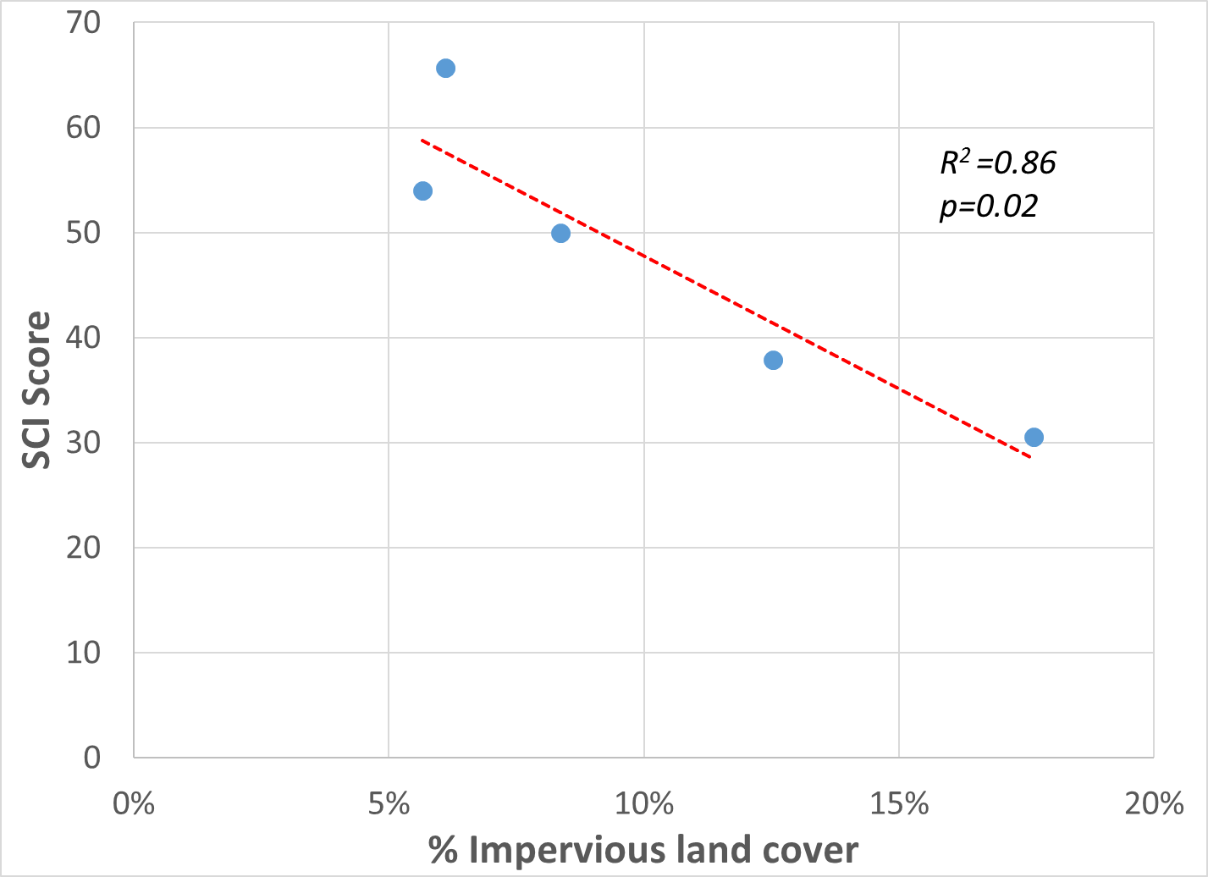
Figure 1-13 . Relationship between impervious land cover and stream condition index scores (SCI) in Moores and Mill Creeks.

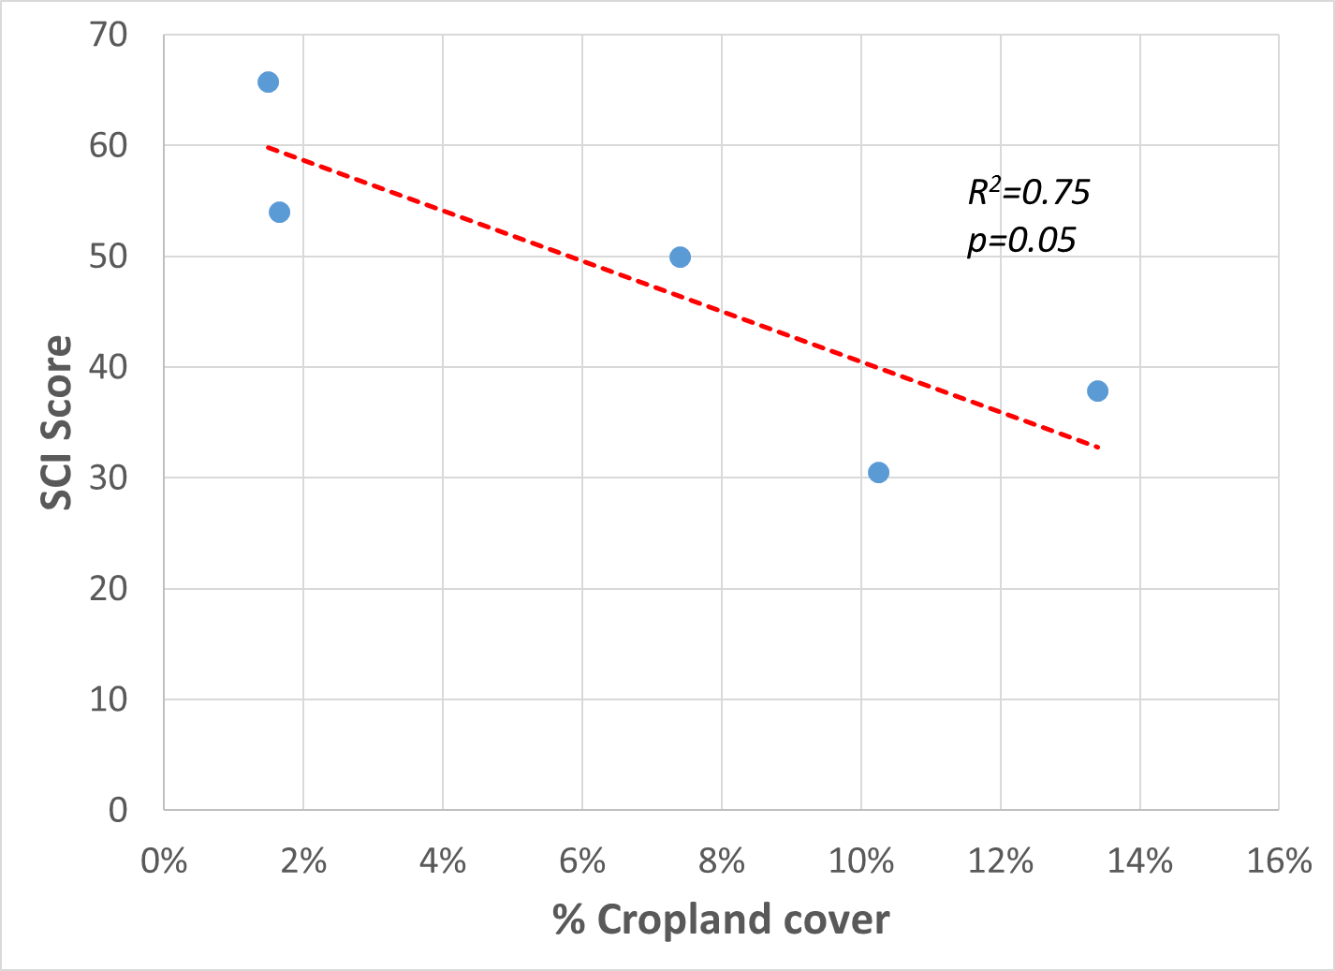

Figure 1-14. Relationship between cropland cover and stream condition index scores (SCI) in Moores and Mill Creeks.
Table 1-9. Land use upstream from each benthic monitoring station in the Moores and Mill Creek watersheds.
Stream | Station | Water | Impervious | Barren | Forest | Urban/ Res. Trees | Scrub/ Shrub | Harvested/Disturbed | Urban/ Res. Grass | Pasture | Cropland | Other
Mill Creek | 2-MIS000.30 | 0.09% | 6.10% | 0.10% | 37.35% | 13.67% | 0.37% | 0.00% | 9.84% | 30.97% | 1.49% | 0.01%
Mill Creek | 2-MIS002.23 | 0.02% | 5.66% | 0.06% | 40.37% | 13.39% | 0.00% | 0.00% | 8.60% | 30.24% | 1.65% | 0.01%
Moores Creek | 2-MRC002.14 | 1.06% | 8.36% | 0.60% | 11.40% | 7.98% | 0.00 % | 0.62% | 14.94% | 47.50% | 7.40% | 0.13%
Moores Creek | 2-MRC003.82 | 0.13% | 17.63% | 0.02% | 12.40% | 5.94% | 0.00% | 0.00% | 16.45% | 37.18% | 10.25% | 0.00%
Moores Creek | 2-MRC004.21 | 0.17% | 12.52% | 0.00% | 13.44% | 5.22% | 0.00% | 0.00% | 9.35% | 45.90% | 13.39% | 0.00%

Table 1-10. Regression relationship between stream condition index scores and watershed land uses.
Land Use Variable | Significant Regression (Y/N) | p-value | Direction of Relationship (+/-) | R²
Water | N | NA | NA | NA
Impervious | Y | 0.02 | - | 0.86
Barren | N | NA | NA | NA
Forest | N | NA | NA | NA
Urban/Residential Trees | Y | 0.80 | + | 0.04
Scrub/Shrub | N | NA | NA | NA
Harvested/Disturbed | N | NA | NA | NA
Urban/Residential Grasses | N | NA | NA | NA
Pasture | N | NA | NA | NA
Cropland | Y | 0.05 | - | 0.75
Other | N | NA | NA | NA

Water Quality Data
Water quality data collected by DEQ from 2005 to 2020 in the Moores and Mill Creek watersheds were used in the benthic stressor analysis. Seventy-one (71) samples were collected from two ambient monitoring stations in the project area (2-MRC002.14 and 2-MIS000.04). In addition, field parameters (pH, temperature, dissolved oxygen, conductivity) were measured at four benthic monitoring stations in the watersheds on 19 occasions between 2005 and 2020. Water quality parameters tested included: temperature, pH, dissolved oxygen, conductivity, total dissolved solids, turbidity, total suspended solids, ammonia, total nitrogen, total phosphorus, chloride, sulfate, potassium, and sodium. These parameters were analyzed for evidence of stressor effects by comparing measured values to Virginia water quality standards, to reference conditions, and to published thresholds for stressor effects.

Temperature
Temperature data for Moores and Mill Creek are available from DEQ monthly measurements, and from diurnal deployments conducted in June 2021. DEQ measures temperature when collecting benthic or water quality samples, so periodic temperature data are available from 2005 to present at both Moores and Mill Creek monitoring sites (Figure 1-14). Temperatures obviously vary by season, so ranges are wide when year-round measurements are considered. Neither of the impaired streams had temperature measurements above the water quality standard of 31°C for Class IV Mountain Zone waters. The maximum recorded temperature was 24.3°C in Moores Creek, which was recorded in August 2020. The maximum temperature in Mill Creek (25.6°C) was recorded during diurnal monitoring at the end of June 2021.
Diurnal water quality parameters were collected in Moores and Mill Creeks in June 2021. Diurnal data were collected at 15-minute intervals over a 3-day period. Temperature data during diurnal deployments are shown in Figure 1-15. Diurnal temperatures generally exhibited the natural cycle of increases during the day from solar heating and decreases at night. Moores and Mill Creeks both exhibited temperatures below the standard throughout the 3-day period, suggesting that water temperatures have a low probability of stress to the benthic community. In summary, periodic field measurements at both stations were below the maximum water quality standard. Diurnal monitoring showed that temperatures remain below the water quality standard throughout the day in the summertime when temperatures are typically highest.
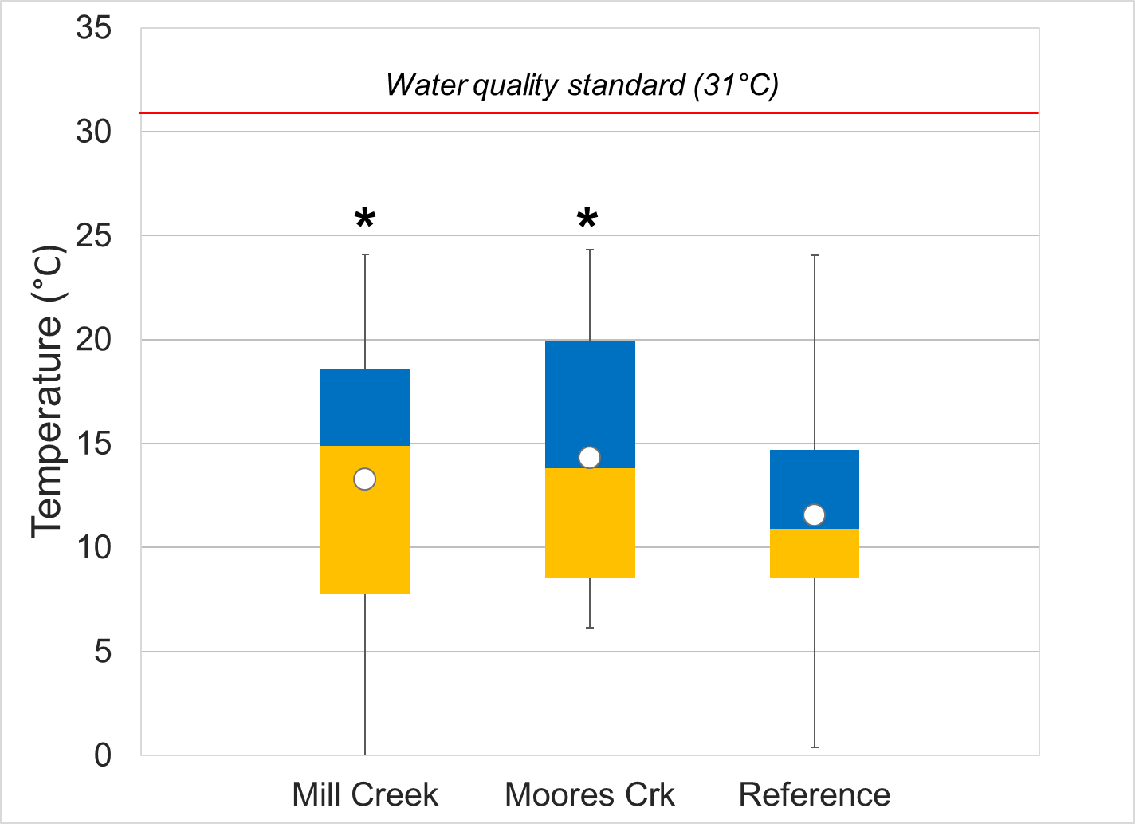
Figure 1-15. Temperature measured in Moores and Mill Creeks. Whiskers indicate the range, boxes indicate the inter-quartile range, lines indicate the median, and white markers indicate the average. Streams with a * are statistically different from the reference site.

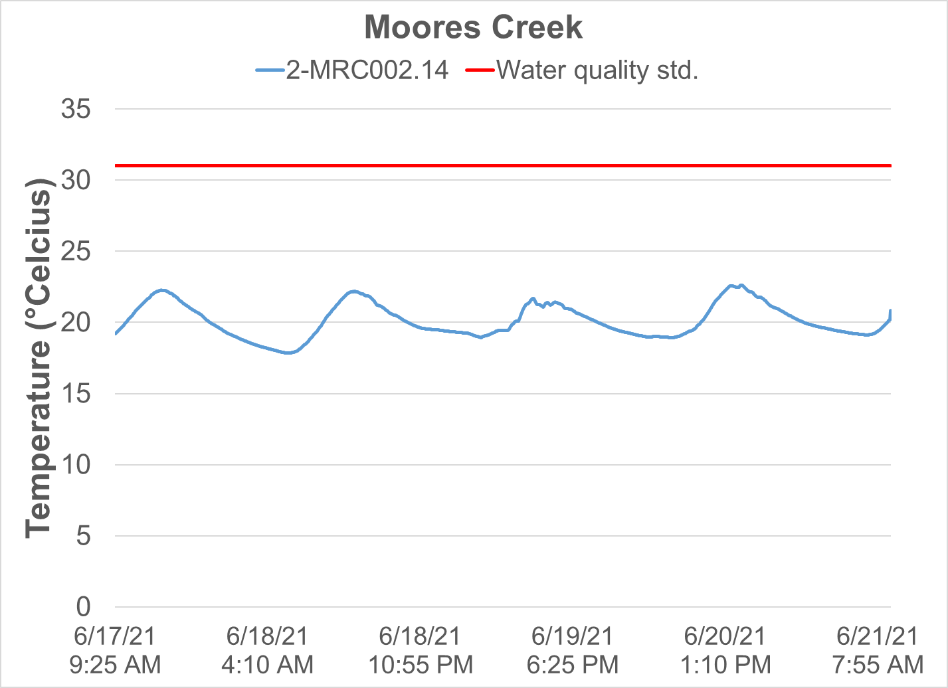
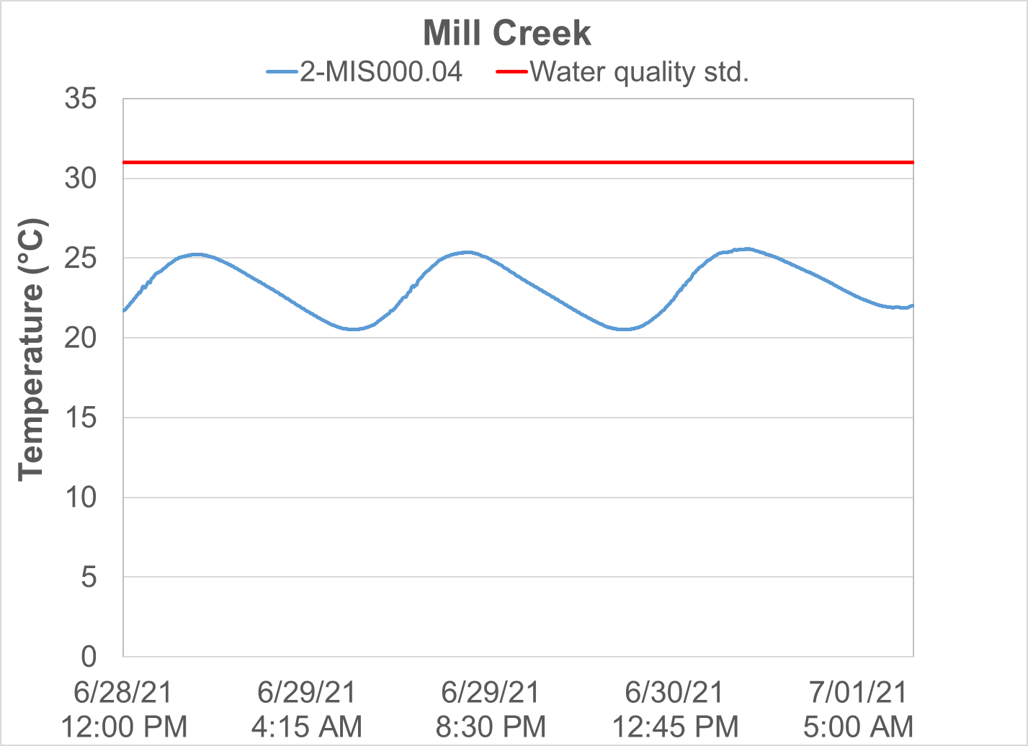
Figure 1-16. Diurnal temperatures in Moores and Mill Creeks. The red line indicates the water quality standard for temperature.

pH
DEQ measured the pH of Moores and Mill Creeks in the field during the collection of benthic and water quality samples. Figure 1-16 shows the pH values collected from the impaired streams in comparison to the reference condition. Measured pH values were near neutral at all sites, spanning an average of 8.0 in Moores Creek to 8.5 in Strait Creek. All pH values from all sites met pH water quality standards of 6-9 and were within the range identified by DEQ as low probability for producing stressor effects (DEQ, 2017).
DEQ also collected diurnal pH data at the two impaired streams in summer of 2021. Diurnal data were collected at 15-minute intervals over a 3-day period in June. pH data collected during diurnal deployments are shown in Figure 1-17. Diurnal pH values exhibited the natural cycle of increases during the day while plants are photosynthesizing and decreases at night while respiration dominates. Like field parameter measurements, diurnal pH measurements were all within water quality standards and within the range of low probability for stressor effects. This indicates that pH is not a concern or stressor in Moores or Mill Creeks.
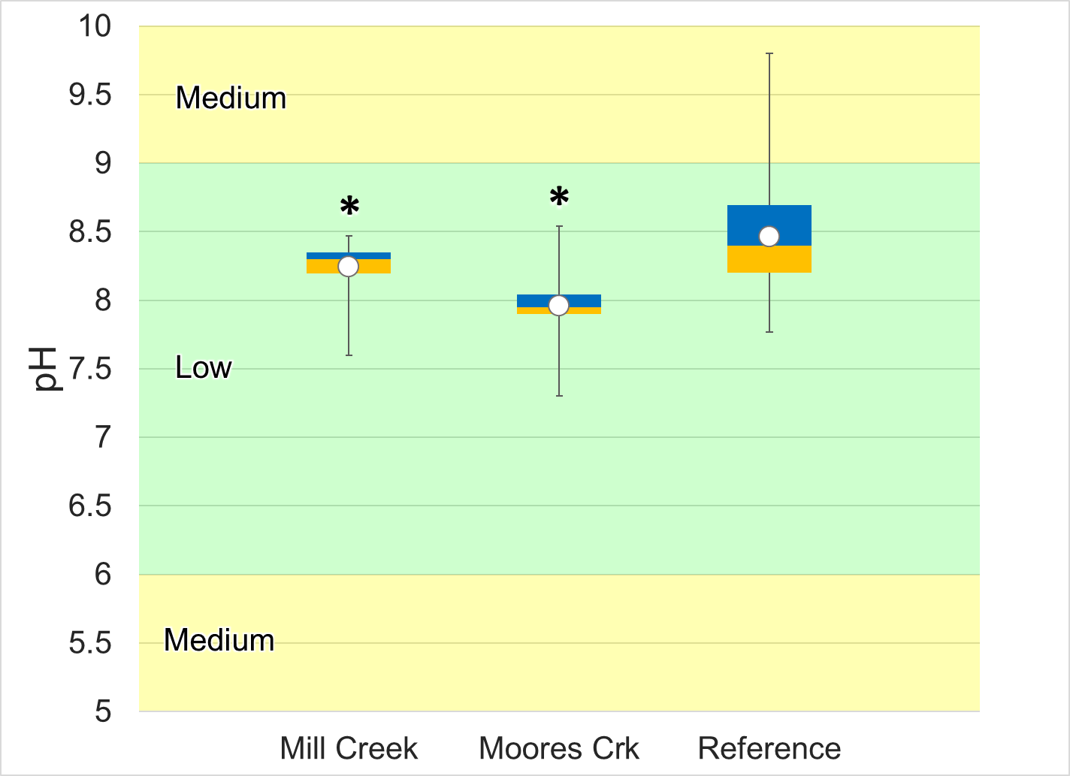
Figure 1-17. pH measured in Moores and Mill Creeks. Whiskers indicate the range, boxes indicate the inter-quartile range, lines indicate the median, and white markers indicate the average. Streams with a * are statistically different from the reference site. Colors represent the probability that data within that range would be responsible for causing stress.
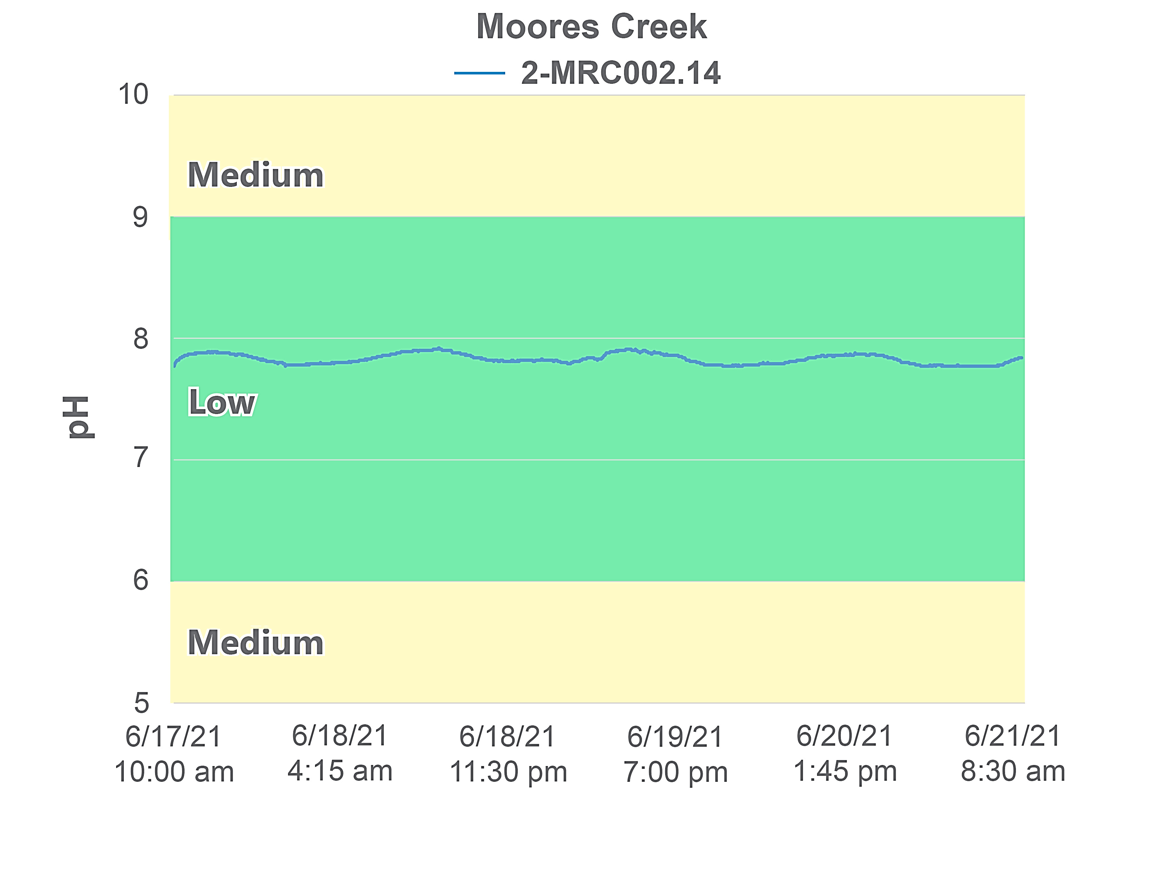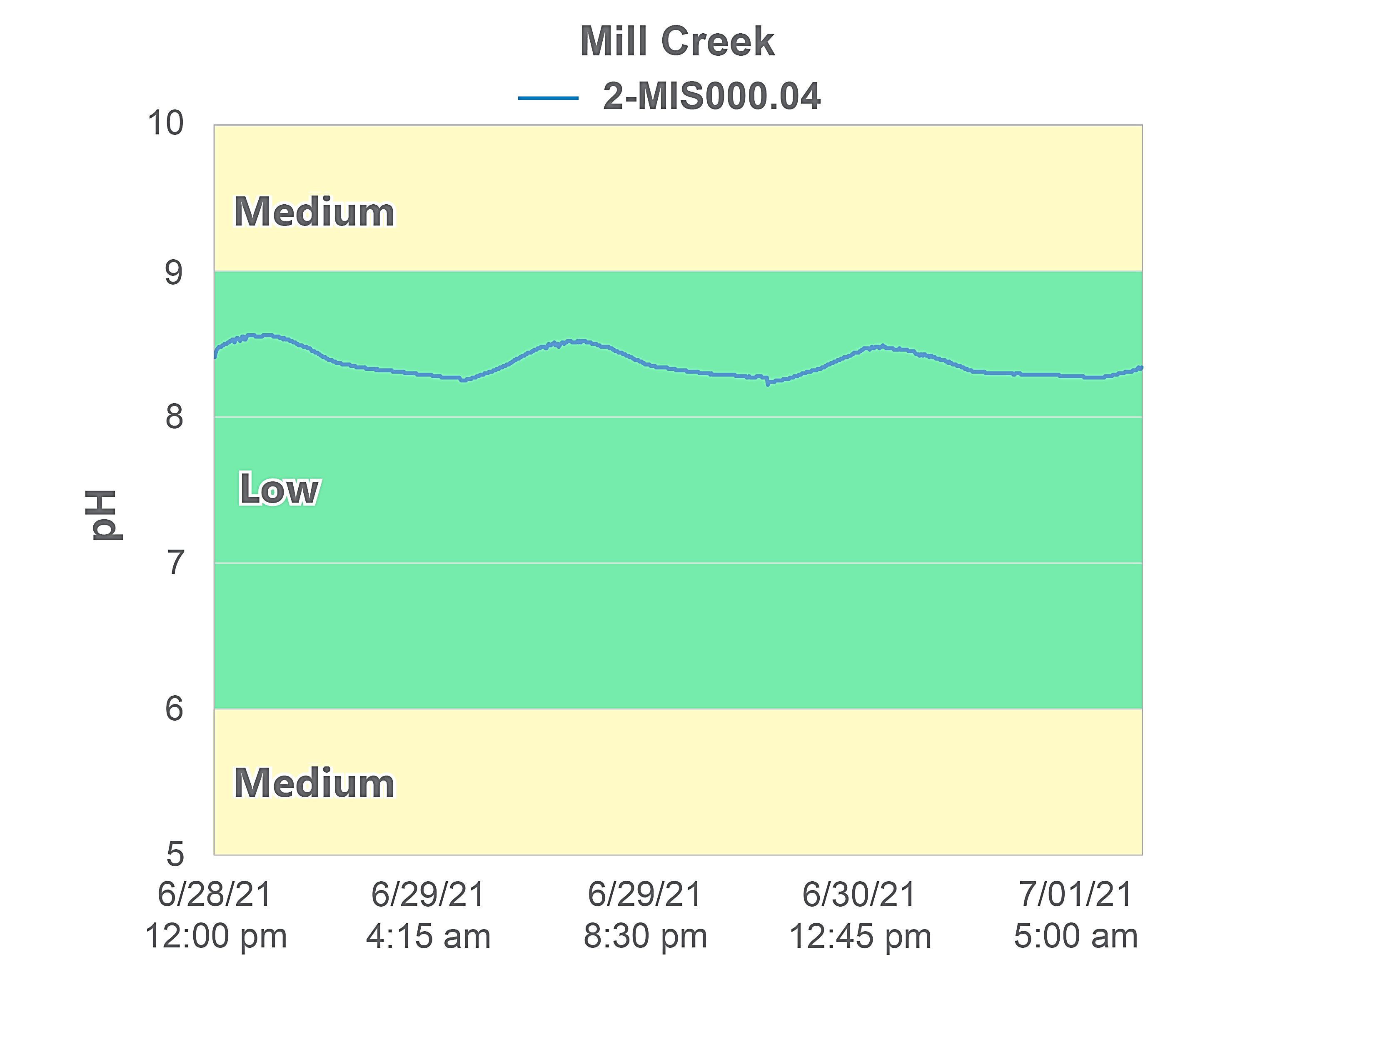
Figure 1-18. Diurnal pH in Moores and Mill Creeks. Colors represent the probability that data within that range would be responsible for causing stress.

Dissolved Oxygen
DEQ measured the dissolved oxygen levels in Moores and Mill Creeks in the field during the collection of benthic and water quality samples. Figure 1-18 shows the dissolved oxygen values collected from the impaired streams compared with the reference watershed. Dissolved oxygen values averaged 9.7 mg/L in Moores Creek and 11.0 mg/L in Mill Creek. While both streams had lower average concentrations than the reference site (11.1), only concentrations in Moores Creek were significantly lower (ɑ=0.05). The bulk of the data (from 25 – 75th percentiles) collected from both of the impaired streams fell within the category of no to low probability of dissolved oxygen causing stressor effects.
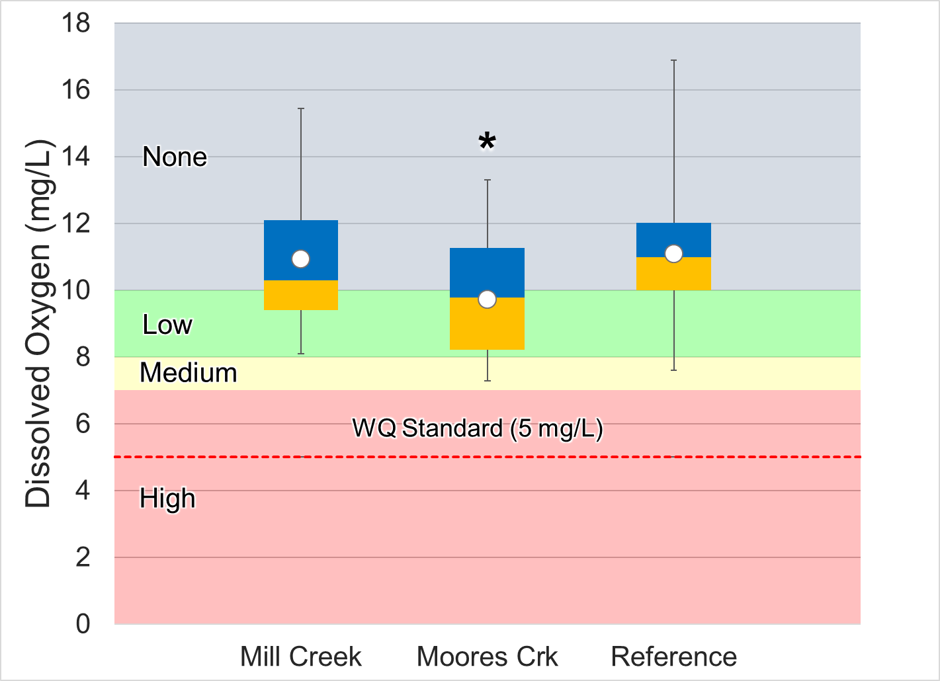
Figure 1-19. Dissolved oxygen measured in Moores and Mill Creeks. Whiskers indicate the range, boxes indicate the inter-quartile range, lines indicate the median, and white markers indicate the average. Streams with a * are statistically different from the reference site. Colors represent the probability that data within that range would be responsible for causing stress. The red line indicates the water quality standard.
In addition to periodic dissolved oxygen measurements, DEQ collected diurnal dissolved oxygen data from Moores and Mill Creeks during the summer of 2021. Diurnal data were collected at 15-minute intervals over a period of 3 days. Diurnal monitoring of dissolved oxygen is important, because critical dissolved oxygen levels are typically encountered just before sunrise. This is due to the combination of oxygen consumption from respiration and the absence of oxygen production from photosynthesis during the night. Diurnal monitoring was conducted in June because critical dissolved oxygen levels are also more common during the hot and dry summer months.
Dissolved oxygen data during diurnal deployments are shown in Figure 1-19. Values at both sites exhibited the natural cycle of increases during the day while plants are photosynthesizing and decreases at night when respiration dominates. This pattern was not particularly pronounced in Moores Creek, where dissolved oxygen concentrations typically swung from 7 mg/L during the day to 6 mg/L in the evening. Dissolved oxygen saturation (% saturation) in Moores Creek is shown in Figure 1-20. Similarly, small diurnal shifts can be observed in saturation levels, commonly shifting between 80% during the day to 70% in the evening. Nighttime dissolved oxygen concentrations routinely dropped below 7 mg/L, falling within the high probability of benthic stress range. However, concentrations never approached the water quality standard of 5 mg/L. Based on results of diurnal monitoring, dissolved oxygen levels in Moores Creek have some probability for stressor effects.
Diurnal shifts in dissolved oxygen concentrations were more pronounced in Mill Creek, ranging from 9.5 mg/L in the midafternoon to a nighttime low of 7.5 mg/L, typically occurring around 9:00 p.m. While dissolved oxygen saturation levels exhibited similar patterns in Mill Creek, dropping in the evenings and increasing during the day, values never fell below 90% saturation, and commonly exceeded 100% in the mid-afternoon (Figure 1-20). This suggests that plant growth, photosynthesis, and respiration are affecting dissolved oxygen levels in Mill Creek, but that growth rates are relatively moderate. Consequently, accelerated productivity spurred by excess nutrients is an unlikely stressor to the benthic community in Mill Creek.
In summary, dissolved oxygen concentrations in Moores Creek fell within the low probability for stressor effects range during the 2-year monthly monitoring period; however, diurnal monitoring during the critical period indicates some probability of benthic stress due to low dissolved oxygen concentrations in the evenings. In Mill Creek, concentrations observed during both monthly and diurnal monitoring periods did not indicate likely stressor effects as a result of low dissolved oxygen concentrations.

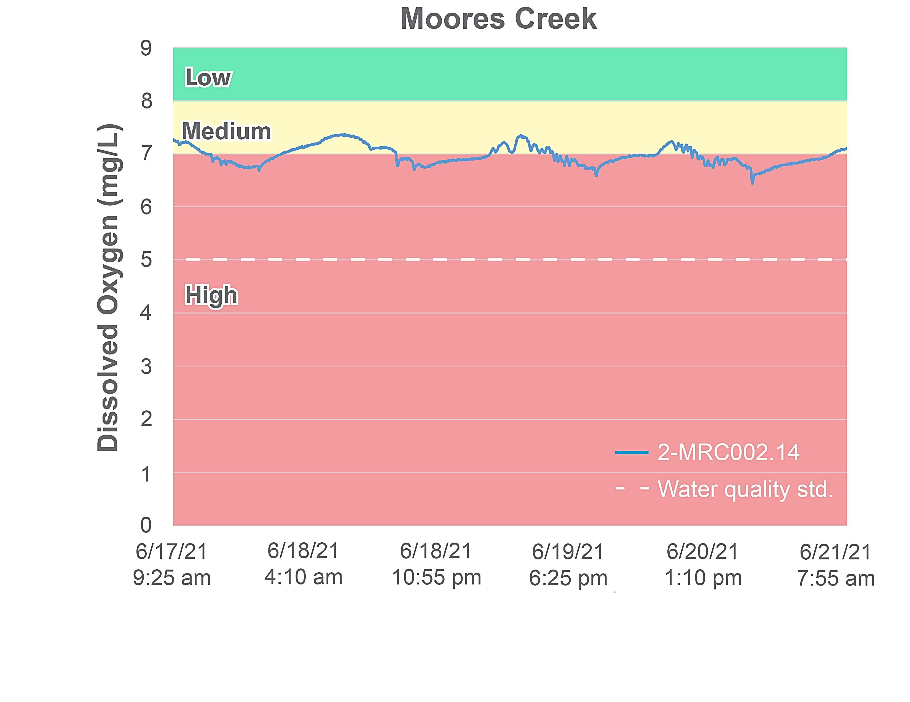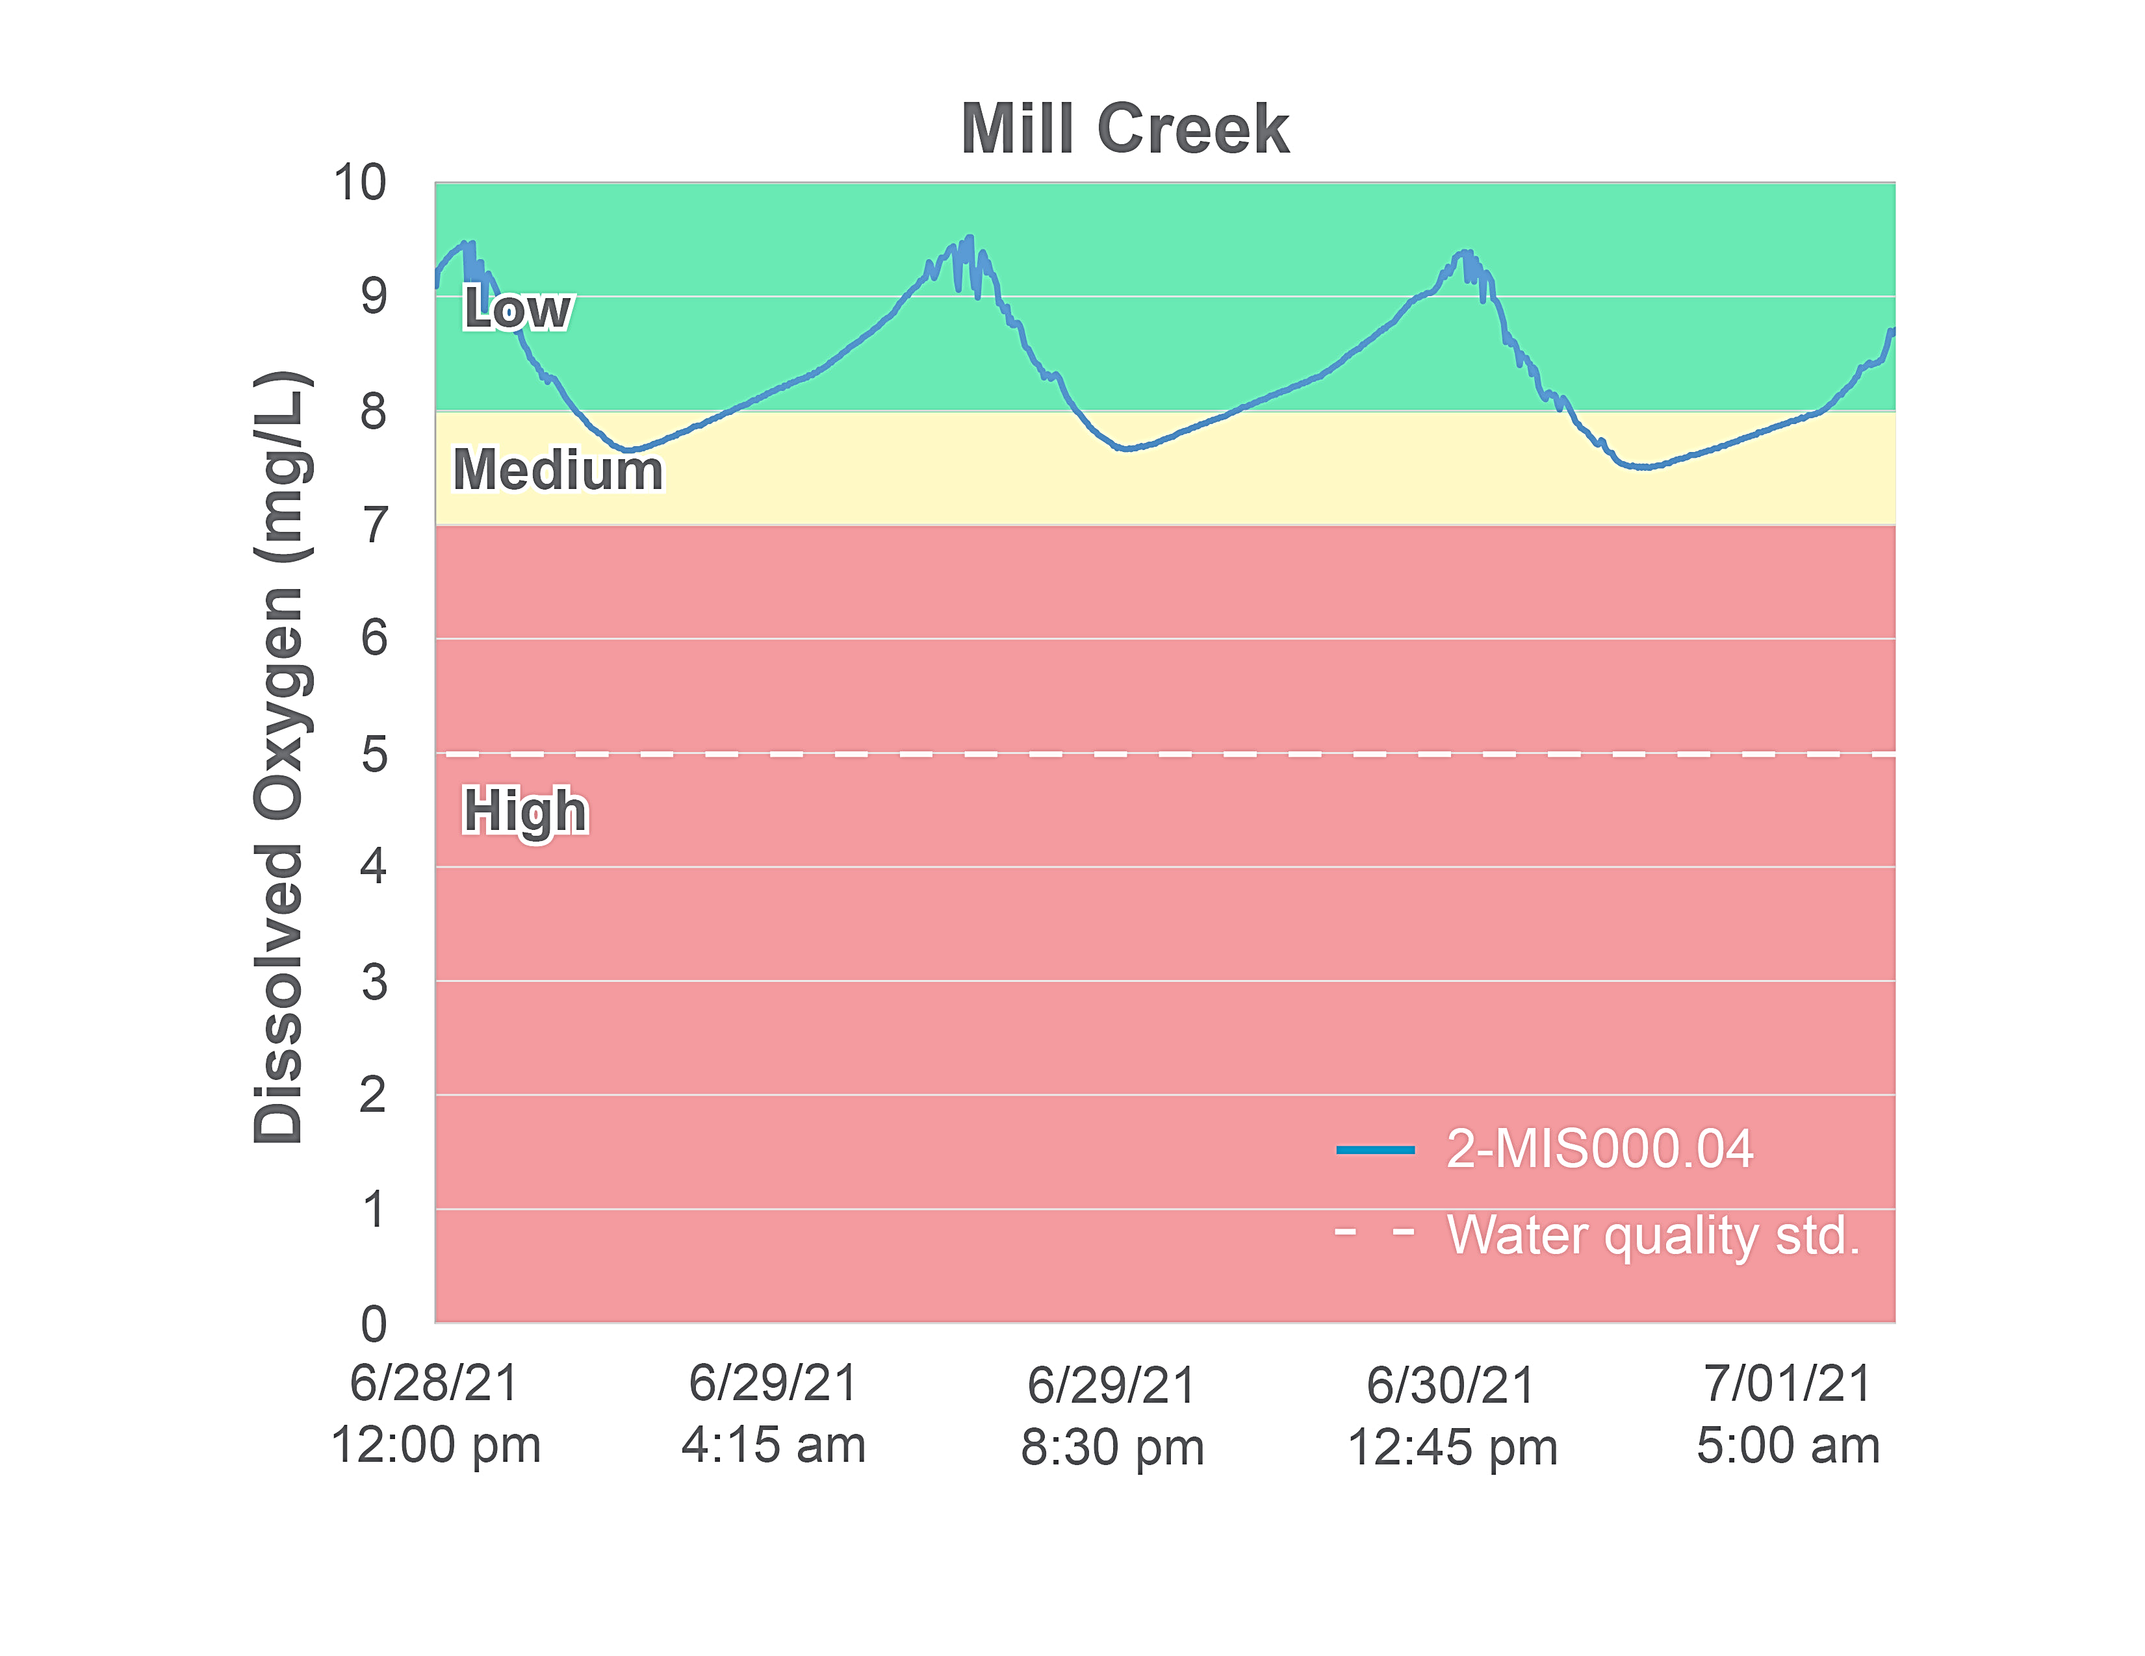
Figure 1-20. Diurnal dissolved oxygen in Moores and Mill Creeks. Colors represent the probability that data within that range would be responsible for causing stress. The dashed white line indicates the water quality standard.
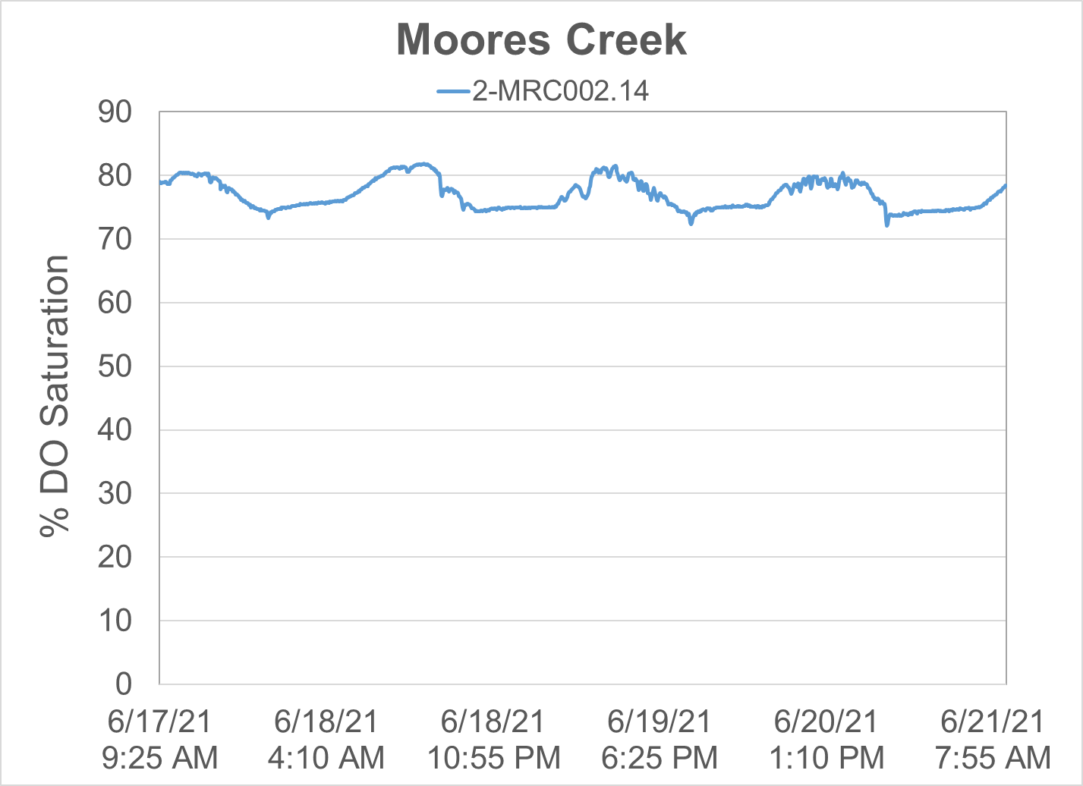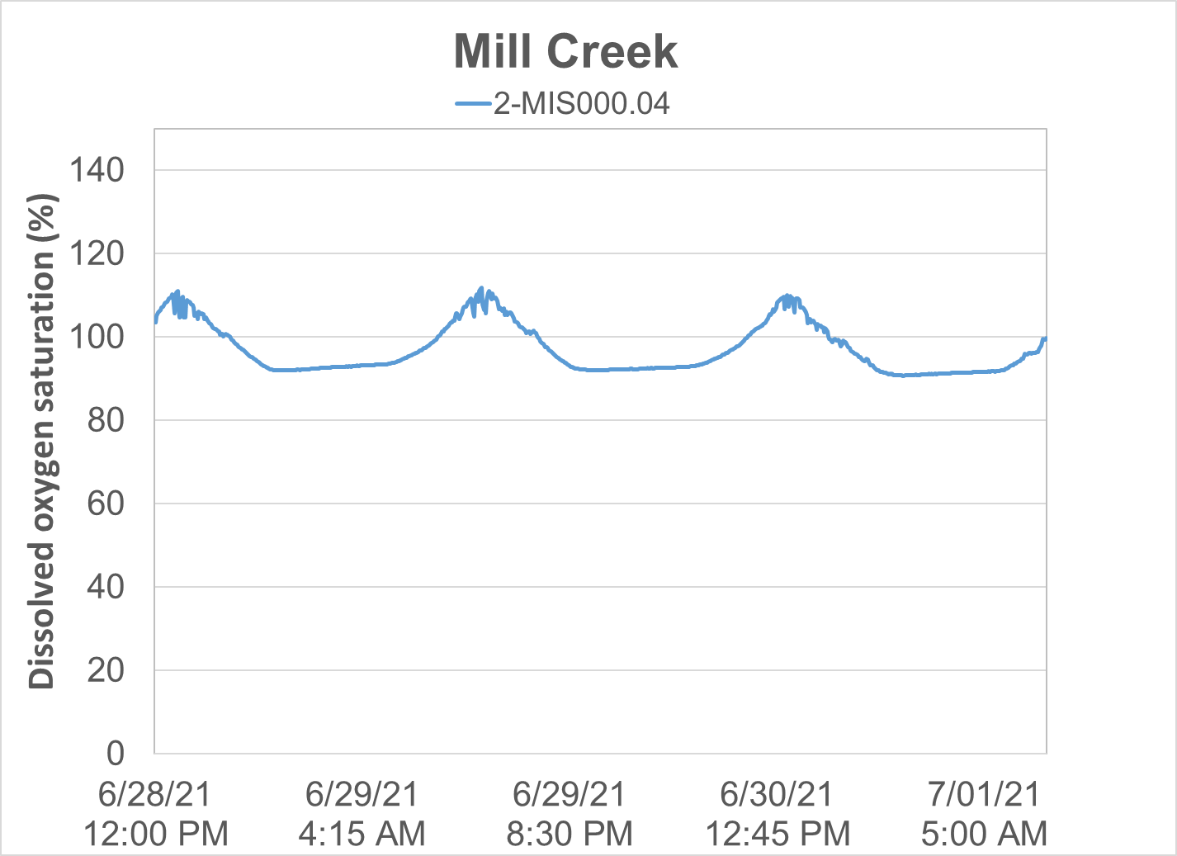
Figure 1-21. Diurnal oxygen saturation in Moores and Mill Creeks.

Conductivity and Dissolved Solids
Conductivity is a measure of the electrical potential of water based on the ionic charges of dissolved compounds. For this reason, the conductivity of water is closely related to the total dissolved solids present. DEQ measured specific conductance in Moores and Mill Creeks in the field during the collection of benthic and water quality samples (Figure 1-21). Specific conductance was elevated in both Moores and Mill Creek, with over 90% of recorded concentrations falling within the high probability range for causing stressor effects. In addition, concentrations in both streams were significantly higher than the reference condition. Decreases in sensitive taxa such as Ephemeroptera have been documented at conductivity levels above 500 uS/cm (Pond, 2004). However, these impacts are better explained by concentrations of dissolved metals and salts, which are a covariant of conductivity and can be toxic to aquatic macroinvertebrates at high concentrations. These constituents are commonly associated with runoff from mined sites and roadways where road salts have been applied. Measurements of dissolved ions in Moores and Mill Creeks do not indicate that concentrations are approaching potentially toxic levels in the streams, though concentrations of several constituents are elevated. Additionally, there is no evidence of mining activities in the watersheds. Mill Creek runs underneath Interstate 64 approximately 1,200 meters upstream of the routine ambient monitoring station, suggesting wintertime application of deicing salts could be a source of elevated conductivity in the stream. In addition, a 4.4-mile stretch of Interstate 81 bisects the upper half of the watershed, providing an opportunity for runoff of chemicals from the roadway. The Moores Creek ambient monitoring station is also located within close proximity to the stream’s intersection with Interstate 81, and is downstream of a 74-acre tractor-trailer travel center located adjacent to the stream. Consequently, the causal pathway for elevated conductivity in both streams is intact. However, the seasonal variability in conductivity typically observed with over-application of deicing agents was absent in the impaired streams (Figure 1-22). Spikes in conductivity were not observed during winter months when application of deicing agents is more common.
A regression analysis of conductivity and stream flow was completed for Moores and Mill Creeks using daily discharge data from the USGS gage on the Maury River. As shown in Figure 1-23, conductivity was not positively correlated with streamflow (α=0.05). This suggests that runoff from impervious surfaces occurring during high flows is not responsible for elevated conductivity in the impaired streams. It is more likely that high conductivity levels in these streams are the result of geological processes including the weathering and dissolution of limestone and dolomite. These processes result in elevated concentrations of calcium and magnesium in the water, which are typically the dominant cations in groundwater found in karst systems. Analysis of conductivity in surrounding watersheds supports this conclusion. Hays Creek, Cedar Grove Branch and Marl Creek are all tributaries of the Maury River, located within five miles of both Mill and Moores Creeks. These streams are not biologically impaired and impacts from impervious surfaces including interstates are very limited. All three streams have average specific conductance values above 400 µS/cm. The close proximity of these streams to Mill and Moores Creeks and the predominance of karst topography in the region suggest that underlying geology and groundwater interactions are the primary cause of observed elevated specific conductance levels in the impaired streams.
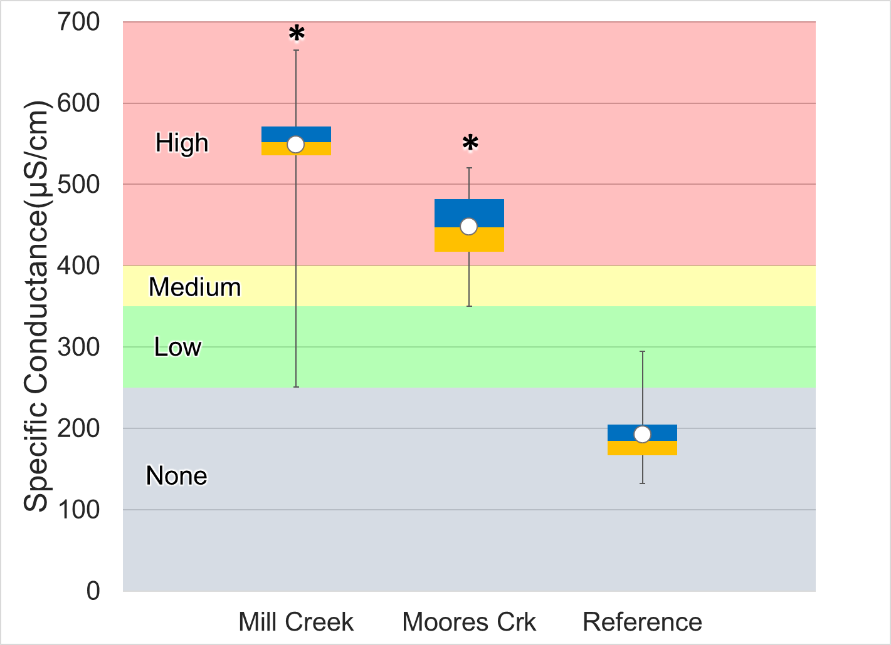
Figure 1-22. Specific conductance measured in Moores and Mill Creeks. Whiskers indicate the range, boxes indicate the inter-quartile range, lines indicate the median, and white markers indicate the average. Streams with a * are statistically different from the reference site. Colors represent the probability that data within that range would be responsible for causing stress.

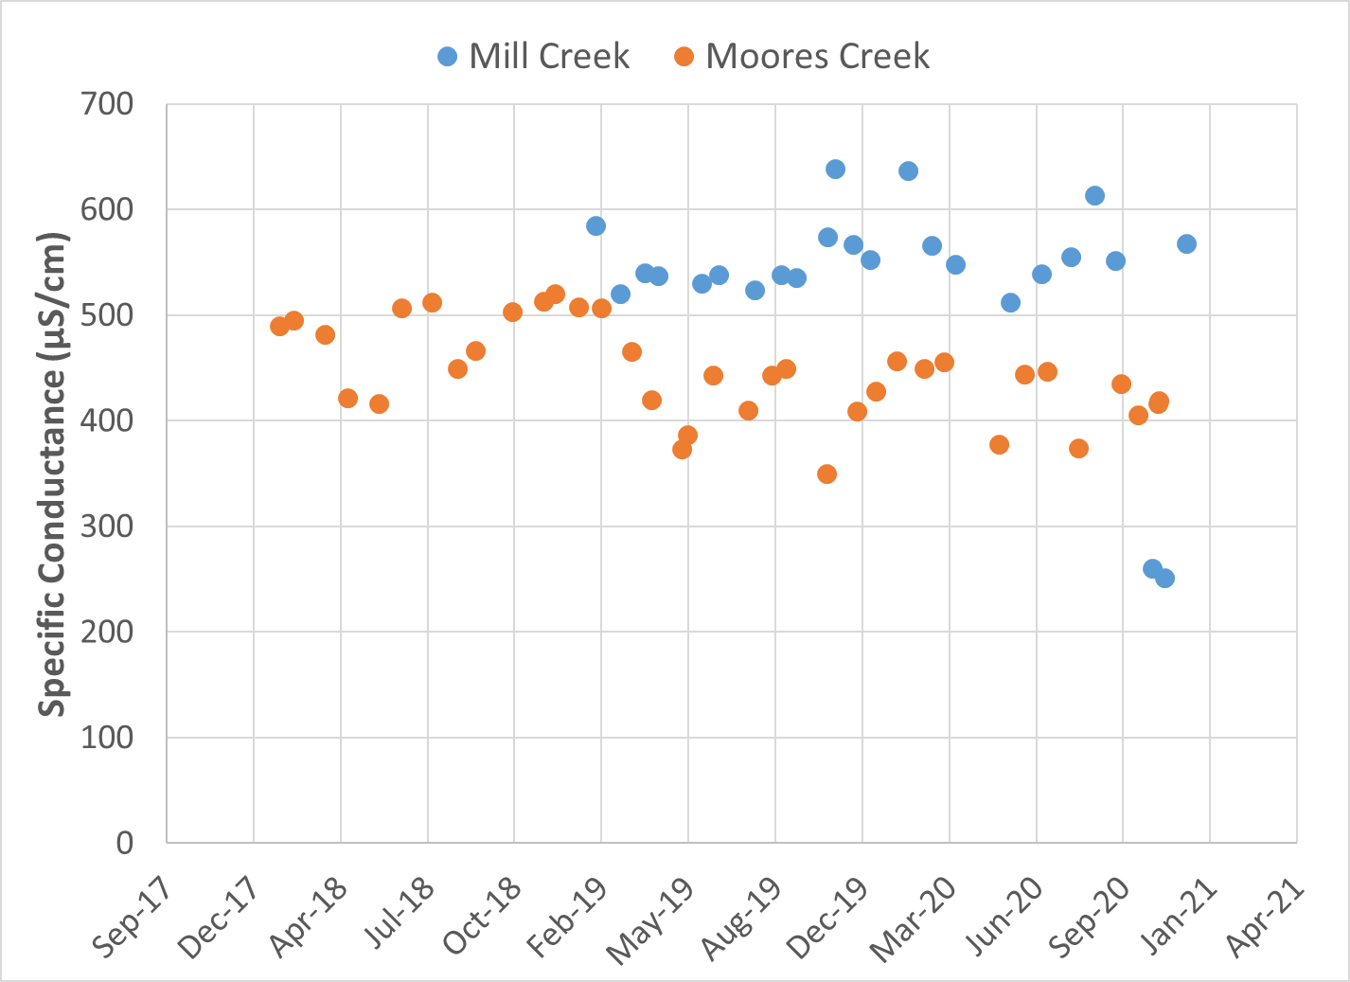
Figure 1-23. Temporal variability in specific conductivity in Moores and Mill Creeks.
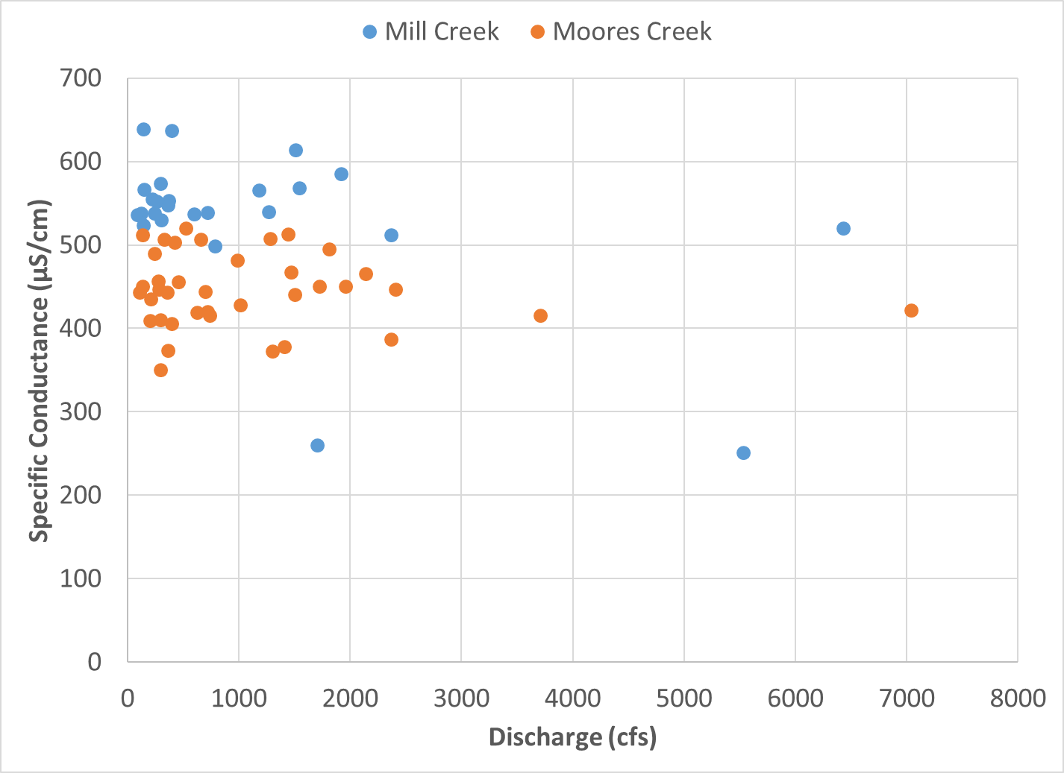
Figure 1-24. Specific conductance in Moores and Mill Creeks and daily discharge rates at USGS gage 2024000 on the Maury River near Buena Vista.

In addition to periodic conductivity measurements, DEQ collected diurnal conductivity data from Moores and Mill Creeks during the summer of 2021. Diurnal data were collected at 15-minute intervals for a period of three days (Figure 1-24). In Moores Creek, specific conductance remained elevated and within the medium probability of stressor effects range throughout the 3-day monitoring period. Very little variability was observed between daytime and nighttime concentrations in Moores Creek. Conductivity in Mill Creek remained largely within the high probability of stress throughout the 3-day diurnal monitoring period, with occasional departures into the medium probability range. A distinct diurnal pattern in specific conductance was present throughout the monitoring period in Mill Creek, with levels reaching a high of 540 µS/cm in the mid-morning (between 8:00 a.m. and 9:00 a.m.), and dropping to a low of 489 µS/cm in the late afternoon. Since temperature affects the mobility of dissolved ions in the water, measurements of specific conductance are adjusted to 25°C. Consequently, the diurnal shifts in specific conductance observed in Mill Creek are not a factor of stream temperature. Similar shifts in specific conductance have been observed in other small karst-influenced streams (Liu et. al, 2008). These fluctuations may be caused by periphyton growth during the daytime, with photosynthesis releasing O₂ and consuming CO_{2,} thereby increasing pH during the day. In karst streams, calcium and magnesium concentrations are often elevated as a result of limestone and dolomite dissolution by groundwater. The increase in pH resulting from photosynthesis during the day can cause calcium to precipitate out of the water column, resulting in a drop in conductivity (Hayashi et. al, 2012). As respiration occurs in the evening and the pH drops, conductivity increases with the dissolution of precipitated calcium. Diurnal shifts in pH in Mill Creek suggest that periphyton growth and daytime photosynthesis are increasing pH in the mid-late afternoon with a maximum value of 8.6 reached between 2:30 p.m. and 4:30 p.m. each day. This increase in pH is followed by a drop in specific conductance in the early evening (Figure 1-25).

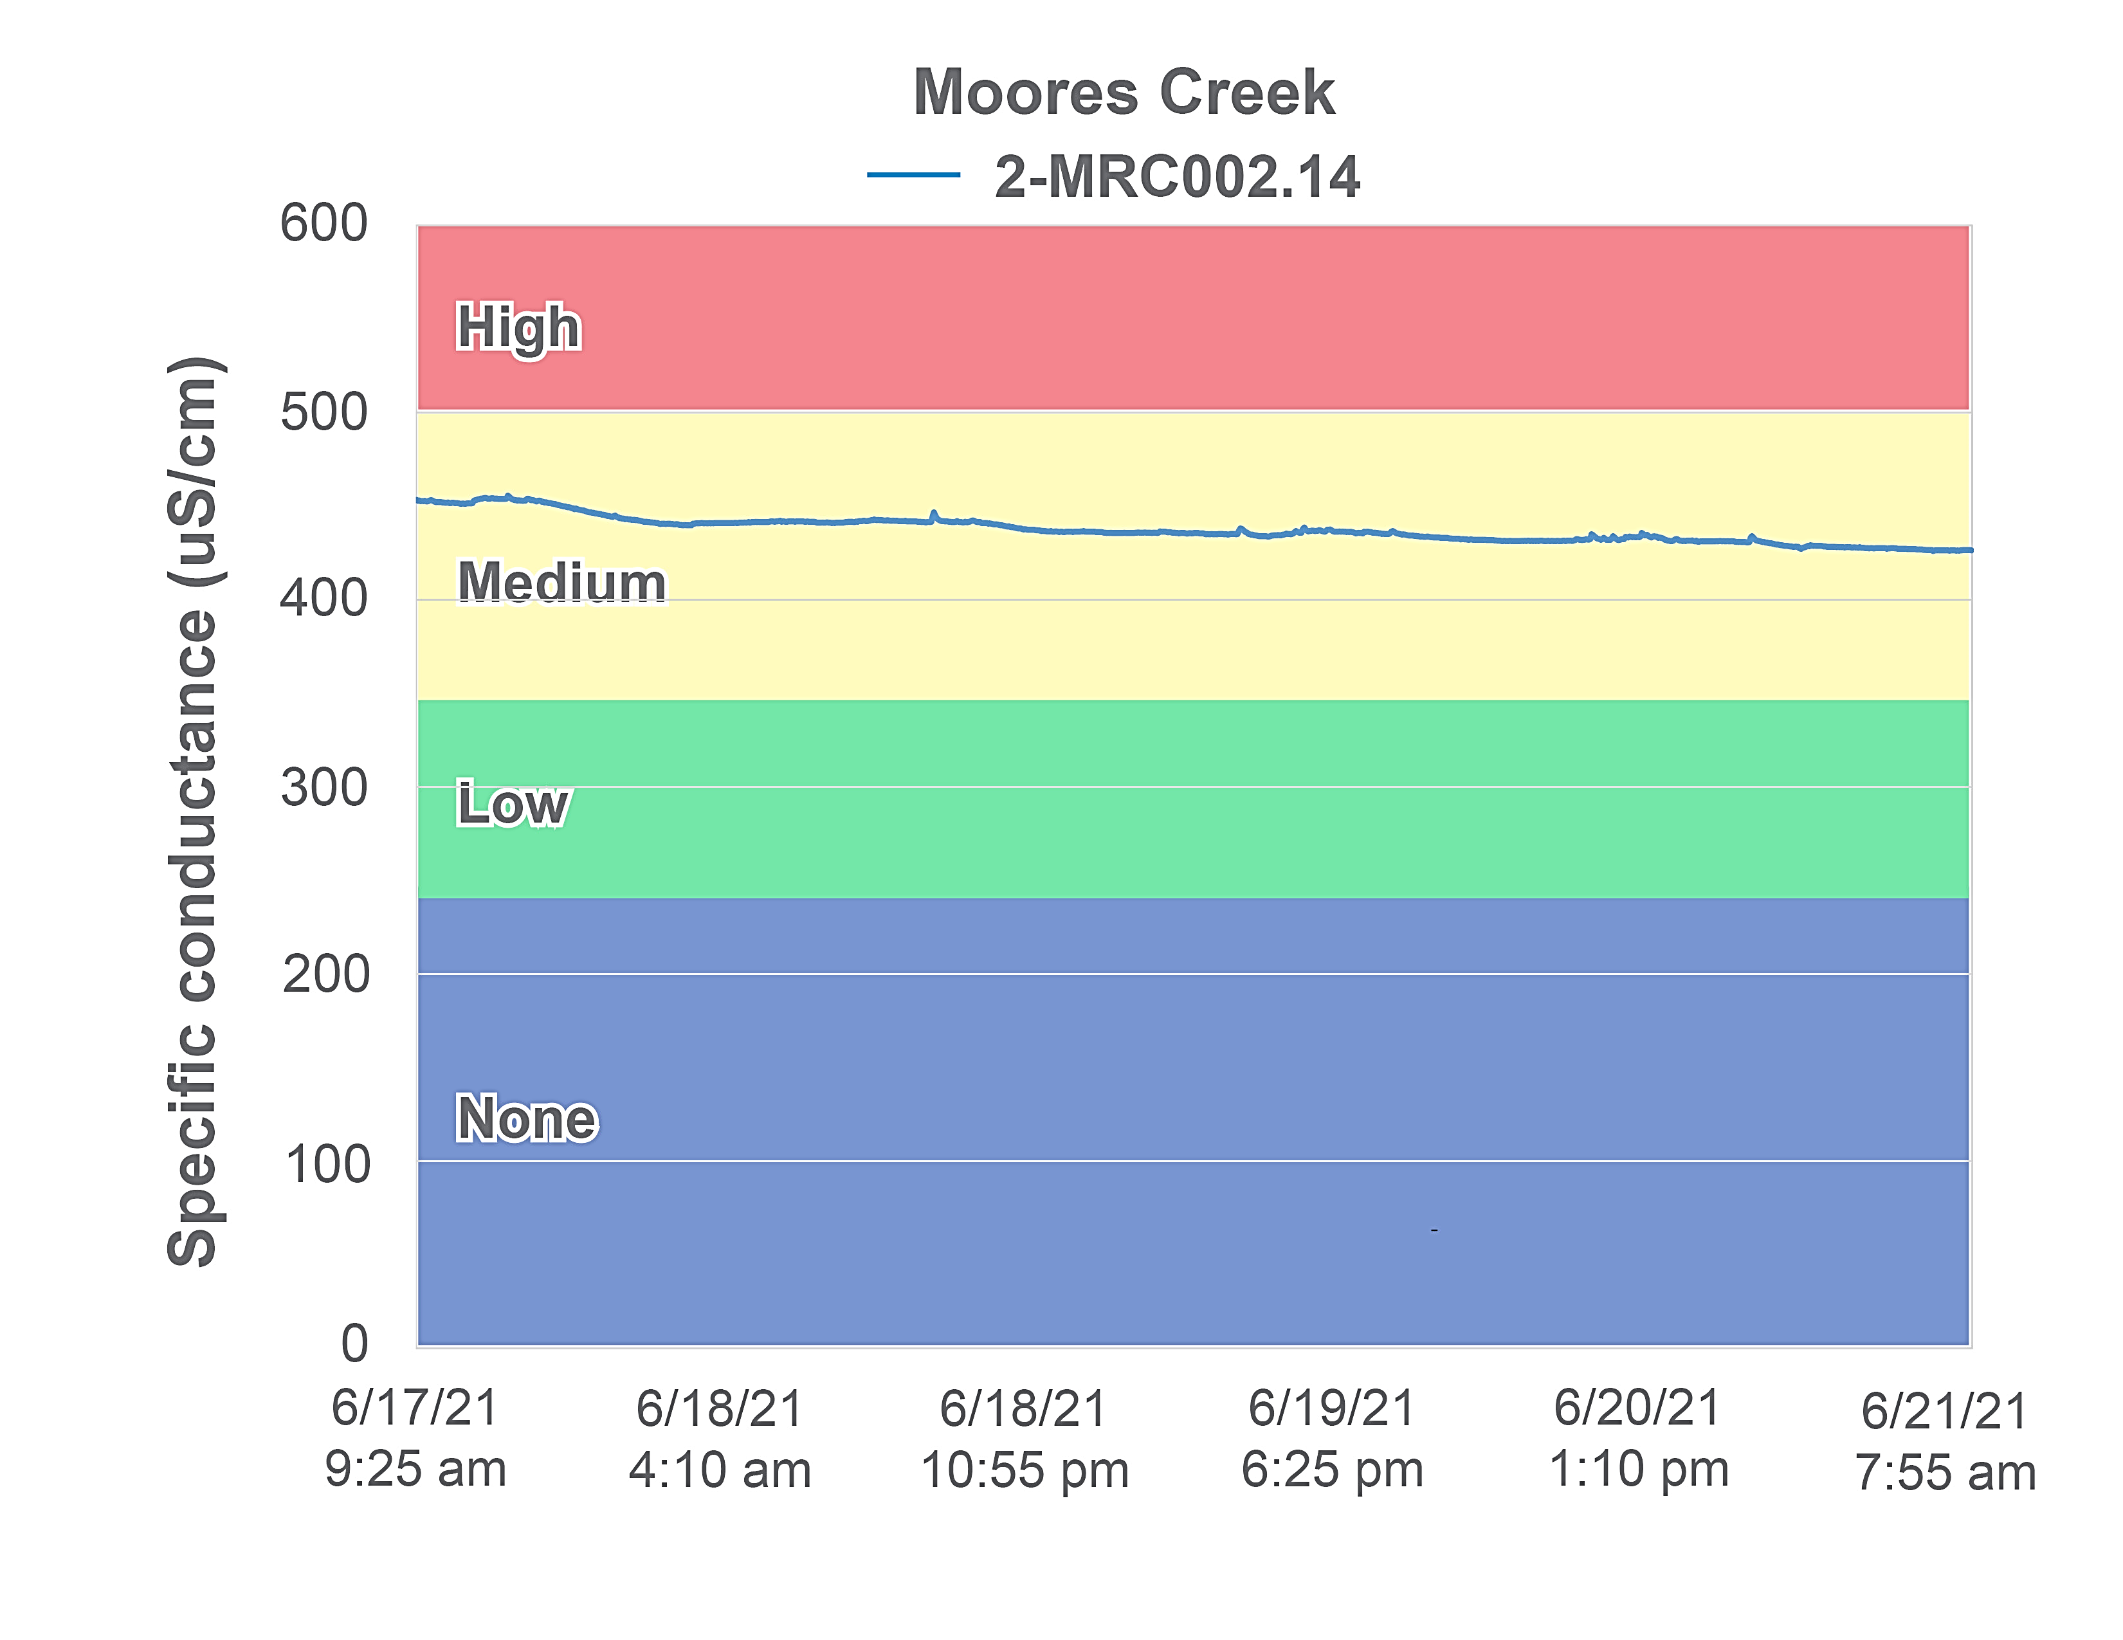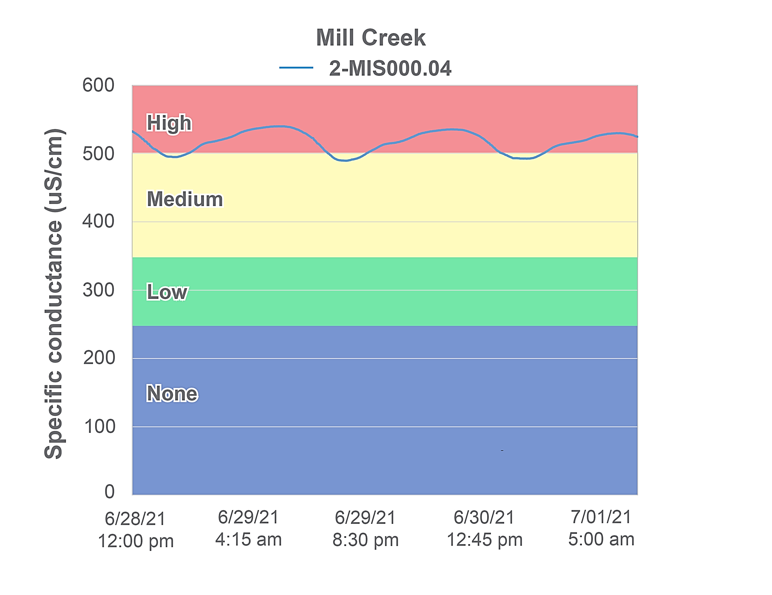
Figure 1-25. Diurnal conductivity in Moores and Mill Creeks. Colors represent the probability that data within that range would be responsible for causing stress.
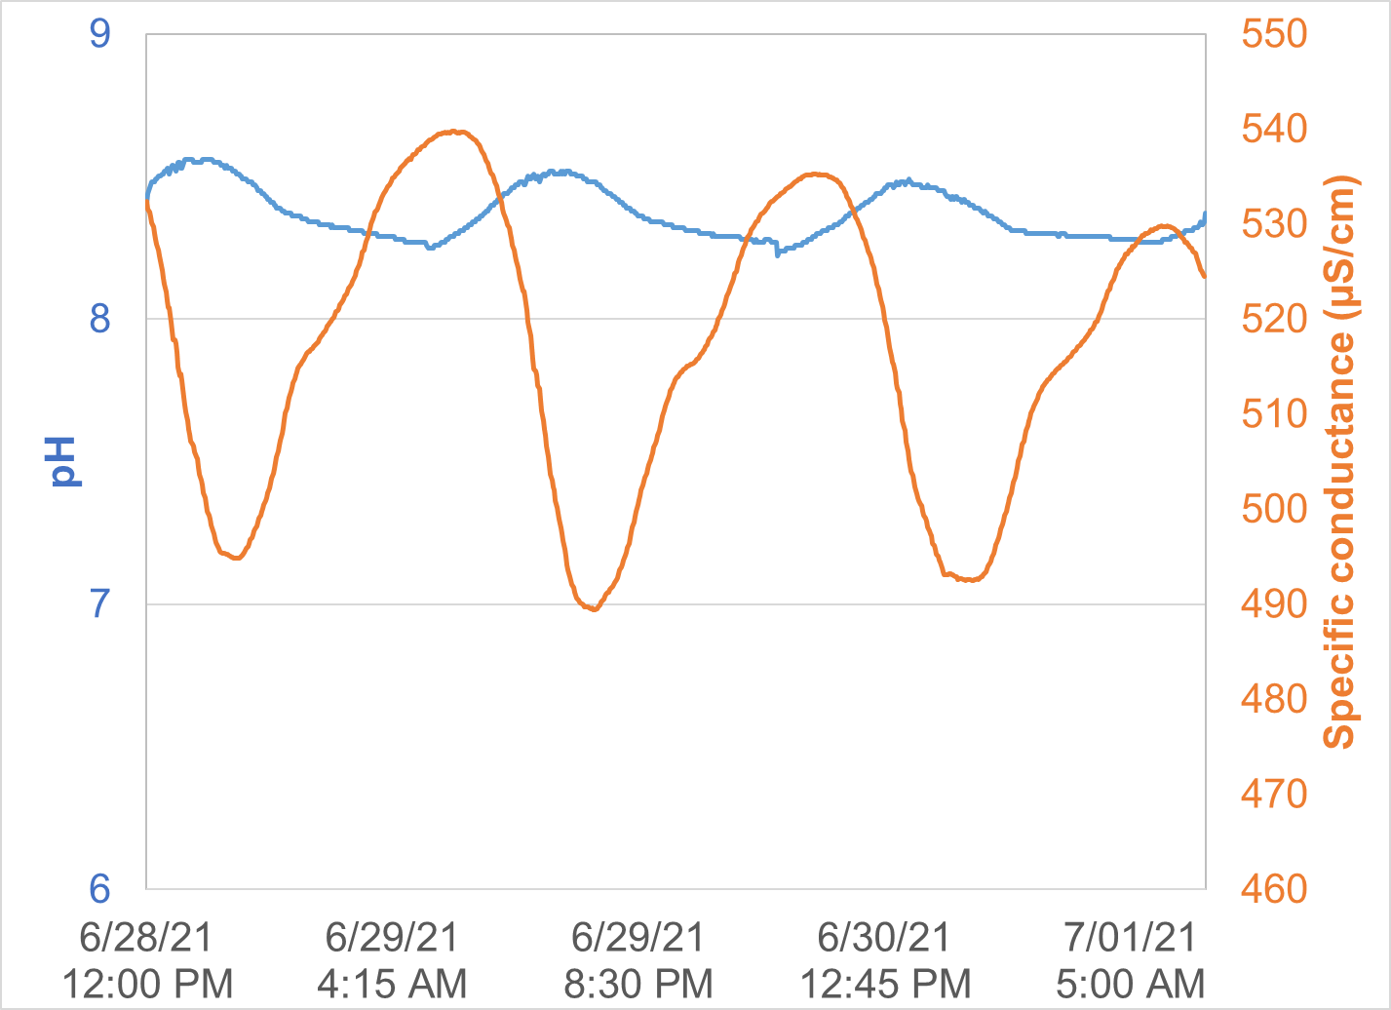
Figure 1-26 Diurnal shifts in pH and specific conductance in Mill Creek.

Total dissolved solids are closely tied to conductivity, since dissolved ions are responsible for transmission of electrical currents in the water. Total dissolved solids were measured monthly in Moores and Mill Creeks for a period of two years (Figure 1-26). Like conductivity, total dissolved solids levels were elevated in the impaired streams when compared to the reference condition, particularly in Mill Creek, where the average value was 311 mg/L. Both streams had values significantly higher than the reference stream (ɑ=0.05). The bulk of the data (from 25 – 75th percentiles) collected from Mill Creek fell within the medium probability of stressor effects range, while in Moores Creek, most data fell within the upper range of a low probability of stressor effects from total dissolved solids.
In summary, results from analyses of conductivity and total dissolved solids data are mixed. Concentrations are routinely elevated to levels where stress to the macroinvertebrate community has been observed. While the causal pathway for elevated dissolved ion concentrations through runoff from impervious surfaces is intact in both watersheds, temporal patterns in specific conductance do not indicate that wintertime application of deicing salts is a likely source. The lack of a positive correlation between specific conductance and discharge suggests that concentrations remain elevated in the streams during low flow conditions, making karst topography a more likely cause.
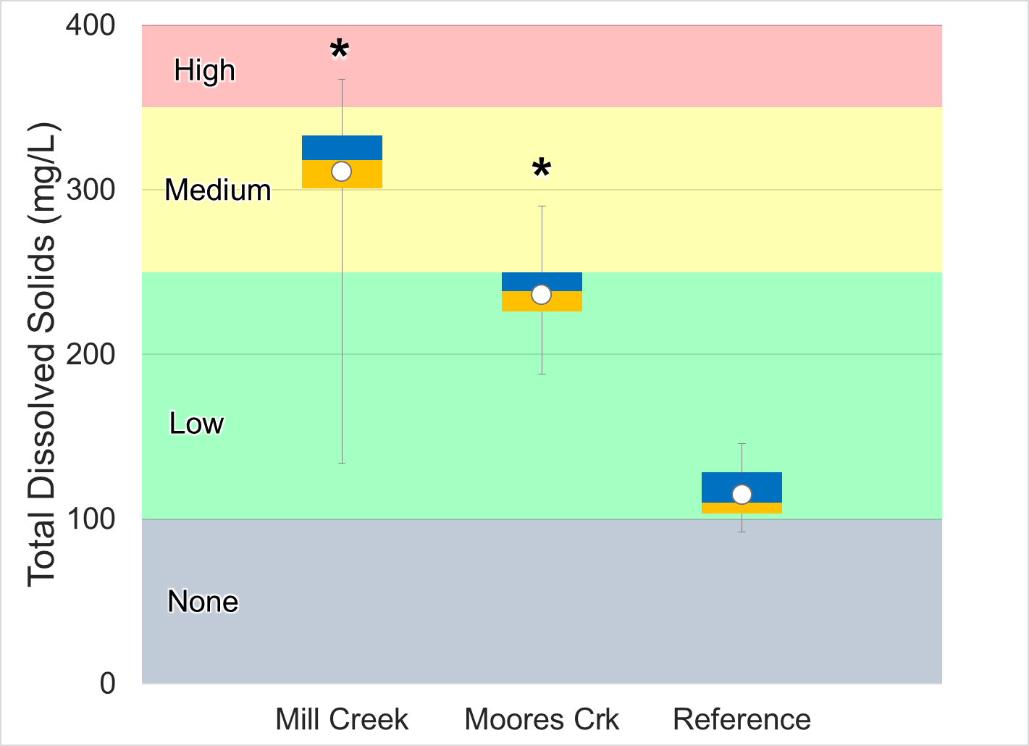
Figure 1-27. Total dissolved solids measured in Moores and Mill Creeks. Whiskers indicate the range, boxes indicate the inter-quartile range, lines indicate the median, and white/blue markers indicate the average. Colors represent the probability that data within that range would be responsible for causing stress.

Dissolved Ions
Dissolved chloride, potassium, sodium, and sulfate were measured in Mill and Moores Creeks. Dissolved ion concentrations were compared to both DEQ’s stressor thresholds and concentrations in the reference stream (Figure 1-27).
Dissolved chloride concentrations in Moores and Mill Creeks were statistically higher than in the reference stream (ɑ=0.05), with average and median values falling along the boundary of low to medium probabilities of stressor effects. Maximum concentrations did not exceed water quality standards in either of the impaired streams. Virginia water quality standards include an acute maximum CL concentration criterion of 860 mg/l and a chronic maximum concentration criterion of 230 mg/l to protect aquatic life. The acute criterion is for a one-hour average not to be exceeded more than once every three years; the chronic criterion applies to a four-day average, which is also not to be exceeded more than once every three years (9VAC25-260-140). Dissolved potassium concentrations followed a similar trend in Mill and Moores Creek, where they were statistically higher than in the reference (ɑ=0.05), averaging 2.6 and 2.5 mg/L, respectively. These values fell within the lower range of a medium probability of stressor effects in both streams.
Dissolved sodium levels were also elevated in both Moores and Mill Creeks, averaging 13.4 and 14.1 mg/L, respectively. Values in both impaired streams were significantly higher than the reference stream (ɑ=0.05), with the majority of data points (from 25 – 75th percentiles) collected falling within the range of a medium probability of stressor effects.
Dissolved sulfate concentrations were comparatively low in both of the impaired streams, particularly Moores Creek where all values fell within the low probability of stressor effects range. In Mill Creek, sulfate concentrations were significantly higher than the reference condition (ɑ=0.05) with a median value of 21 mg/L. The majority of data collected from Mill Creek fell within the low probability of stressor effects range, with just over 20% of values falling within the medium probability range.
In summary, while conductivity and total dissolved solids are elevated in both Moores and Mill Creeks, there is insufficient evidence to conclude that the potentially toxic ions chloride, potassium, and sulfate are likely to be stressors in the impaired streams. Sodium concentrations consistently fall within the medium probability for stressors effects range, and could therefore be considered as a possible stressor.

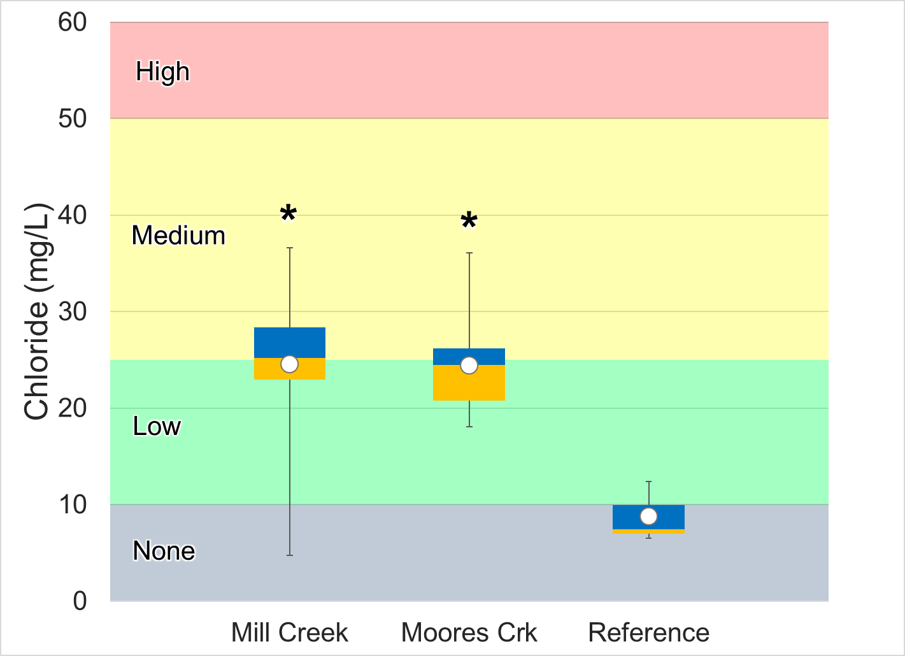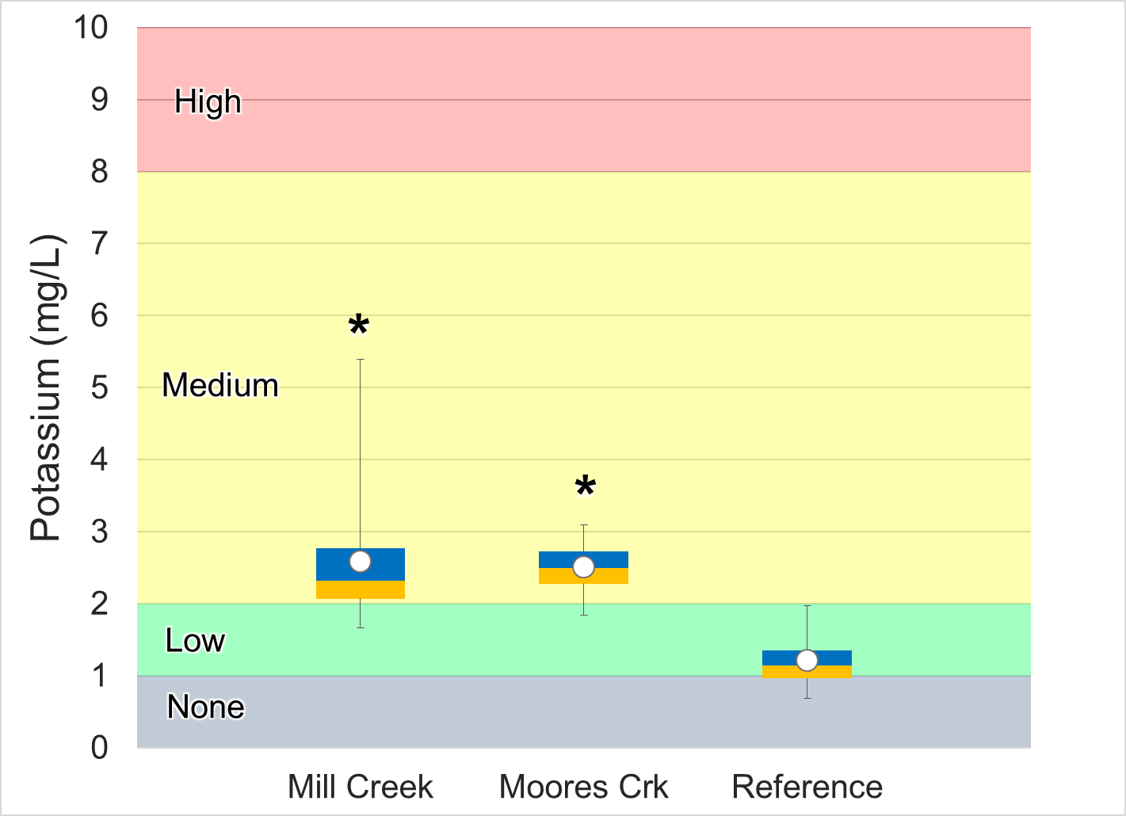

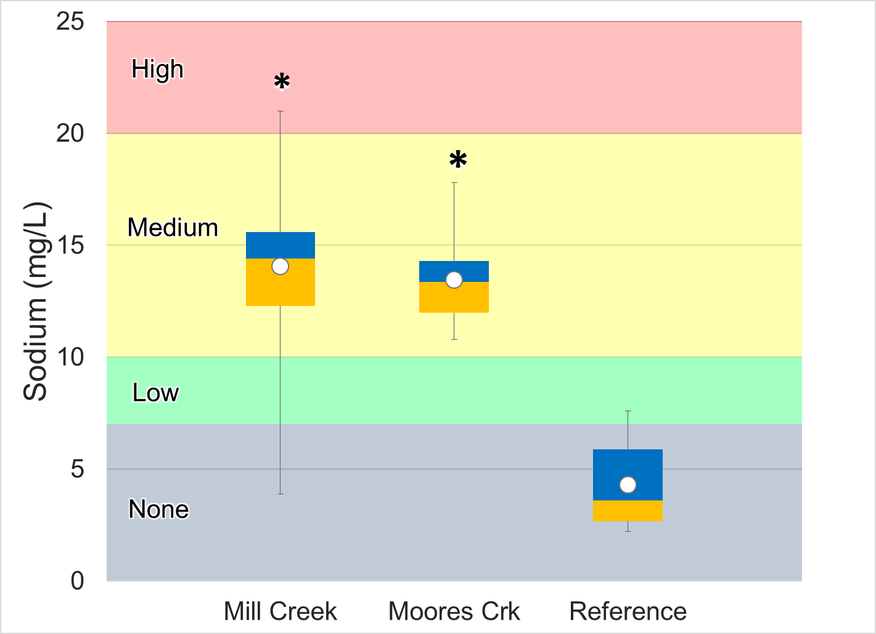
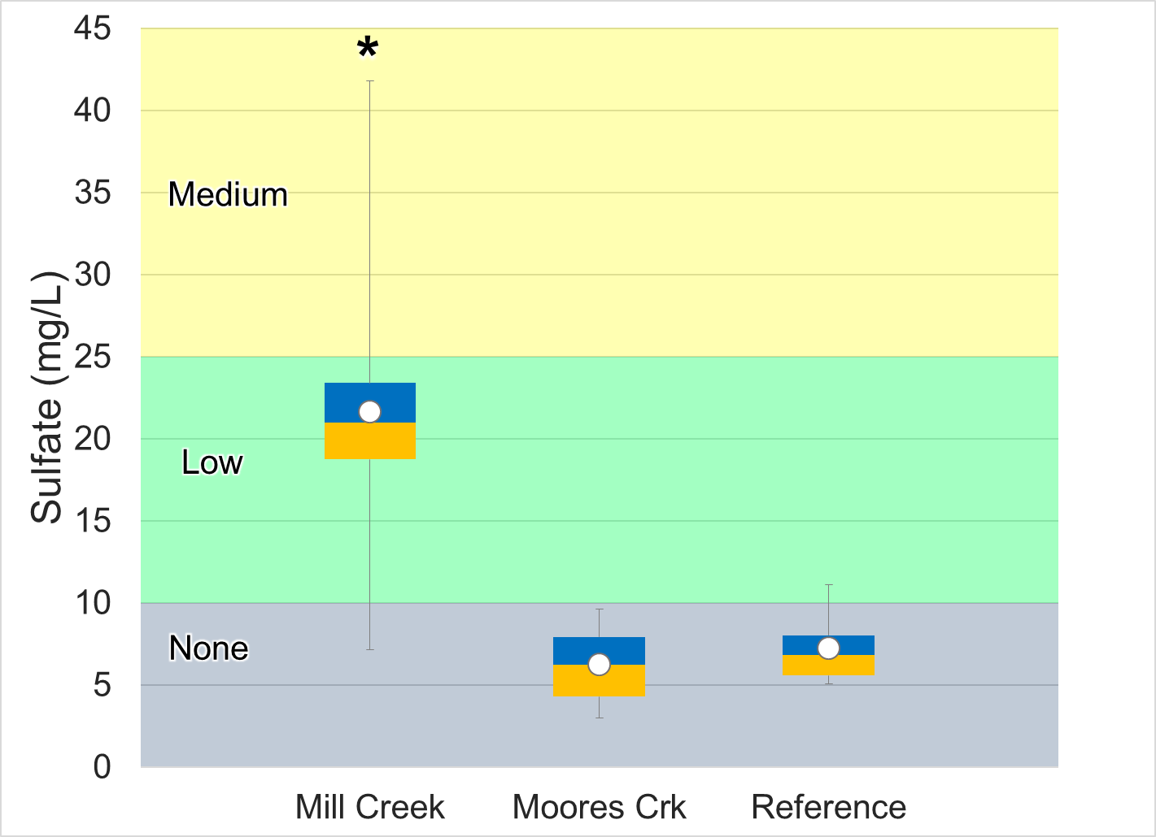
Figure 1-28. Dissolved ions measured in Moores and Mill Creeks and the reference stream (Strait Creek). Whiskers indicate the range, boxes indicate the inter-quartile range, lines indicate the median, and white/blue markers indicate the average. Streams with a * are statistically different from the reference site. Colors represent the probability that data within that range would be responsible for causing stress.

Solids
Total suspended solids (TSS) were measured bimonthly in 2007 in Mill Creek, and once in 2008. No measurements were collected in Moores Creek. TSS concentrations in Mill Creek all fell at the detection limit of 3 mg/L, suggesting that TSS levels remain consistently low in the stream during normal streamflow conditions. Turbidity measurements were also taken in Mill Creek in 2007/2008. While differences from the reference condition in Strait Creek were not significant, mean and median values in Mill Creek (2.69 NTU and 2.20 NTU, respectively) were higher than mean and median values in Strait Creek (2.02 NTU and 1.67 NTU, respectively).

Nutrients
Nitrogen and phosphorus are the primary nutrients of concern in freshwater. These nutrients are necessary to support healthy ecosystems, but excess nutrients can lead to eutrophication. Excess nutrients spur algae growth and can change the benthic community composition. An overabundance of algae can reduce oxygen levels, leading to further changes in community composition and eventually hypoxic conditions. The initiation of this eutrophication process is not reliant upon the total nutrient availability, but upon the availability of the limiting nutrient. The typical ratio of nitrogen to phosphorus in algae is 7.5:1, so ratios above 7.5 indicate that phosphorus is the limiting nutrient, and ratios below 7.5 indicate that nitrogen is the limiting nutrient. In Moores and Mill Creeks, the average nitrogen to phosphorus ratios were 89.9 and 89.6, respectively, indicating that phosphorus is the limiting nutrient in both streams.
Over time, DEQ has measured various forms of nitrogen (total nitrite, total nitrate, total ammonia, and total nitrogen) and total phosphorus in Moores and Mill Creeks. While these various forms signal the availability of nutrients for biological uptake, total nitrogen and total phosphorus are used in the stressor analysis to identify the potential for nutrient enrichment. Total nitrogen was measured in the impaired streams in addition to the reference stream (Strait Creek). Total nitrogen concentrations in the impaired streams were compared to both DEQ’s stressor thresholds and the reference condition (Figure 1-28). Median nitrogen concentrations were also compared with EPA recommended nutrient criteria for the Ridge and Valley Ecoregion, which are based upon the 25th percentile of reported values for the region (USEPA, 2000b). Values in Moores and Mill Creeks exceeded the recommended criteria of 0.214 mg/L TN, with median concentrations of 1.1 mg/L and 1.25 mg/L, respectively. Using a t-test with unequal variances (ɑ = 0.05), total nitrogen concentrations in the impaired streams were compared to those in Strait Creek. Concentrations in both streams were significantly higher than the reference condition (Figure 1-28). Both median and average values for Moores and Mill Creeks fell within the range of a medium probability of stressor effects due to excess nitrogen, while both streams had multiple excursions into the high probability of stressor effects when compared with DEQ’s stressor thresholds (DEQ, 2017). While both Moores and Mill Creeks had elevated nitrogen concentrations, phosphorus was identified as the limiting nutrient in both streams. This suggests it is unlikely that nitrogen is responsible for stressor effects resulting from excess algal growth due to excessive nutrient loading.
Figure 1-29 shows total phosphorus levels in Moores and Mill Creeks. Median phosphorus concentrations were compared with EPA recommended nutrient criteria for the Ridge and Valley Ecoregion, which are based upon the 25th percentile of reported values for the region (USEPA, 2000b). The median and mean TP concentration in Moores Creek (0.02 mg/L) exceeded the recommended criterion of 0.01 mg/L TP, while Mill Creek had multiple excursions in exceedance of this criterion. The mean TP concentration in Mill Creek (0.06 mg/L) exceeded the recommended concentration. Using a t-test with unequal variances (ɑ=0.05), phosphorus concentrations in the impaired streams were compared with the reference condition. Neither Moores nor Mill Creeks had concentrations that were significantly different from the reference site. Median concentrations in both streams fell within the no probability of stressor effects range for TP. Two spikes in concentrations in Mill Creek (1.62 mg/L and 0.77 mg/L TP) increased the mean concentration, placing it within the medium probability of stressor effects range. Periodic excursions in phosphorus levels are expected during storm events when sediment is deposited in streams through runoff and streambank erosion. Similar spikes may be observed in healthy streams. Since total phosphorus levels in Moores and Mill Creeks rarely exceed the threshold of the low probability range for stressor effects, ambient monthly monitoring of phosphorus suggests that is not likely a stressor in these streams.
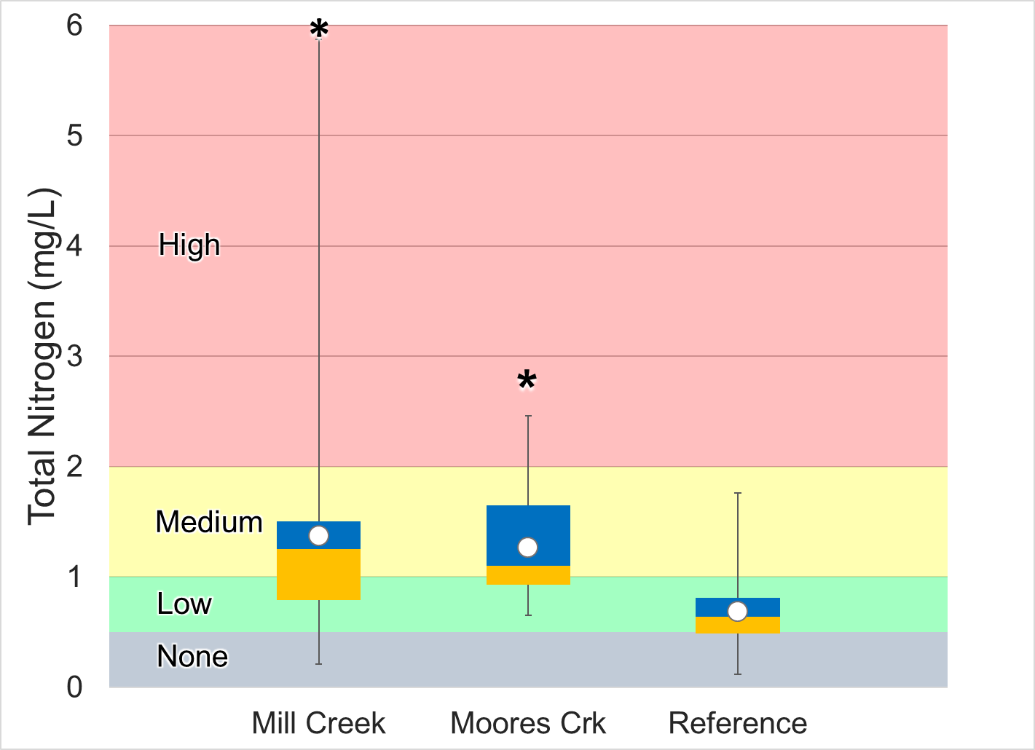
Figure 1-29. Total nitrogen concentrations in Moores and Mill Creeks compared to the reference stream, Strait Creek. Whiskers indicate the range, boxes indicate the inter-quartile range, lines indicate the median, and blue/white markers indicate the average. Colors represent the probability that data within that range would be responsible for causing stress.
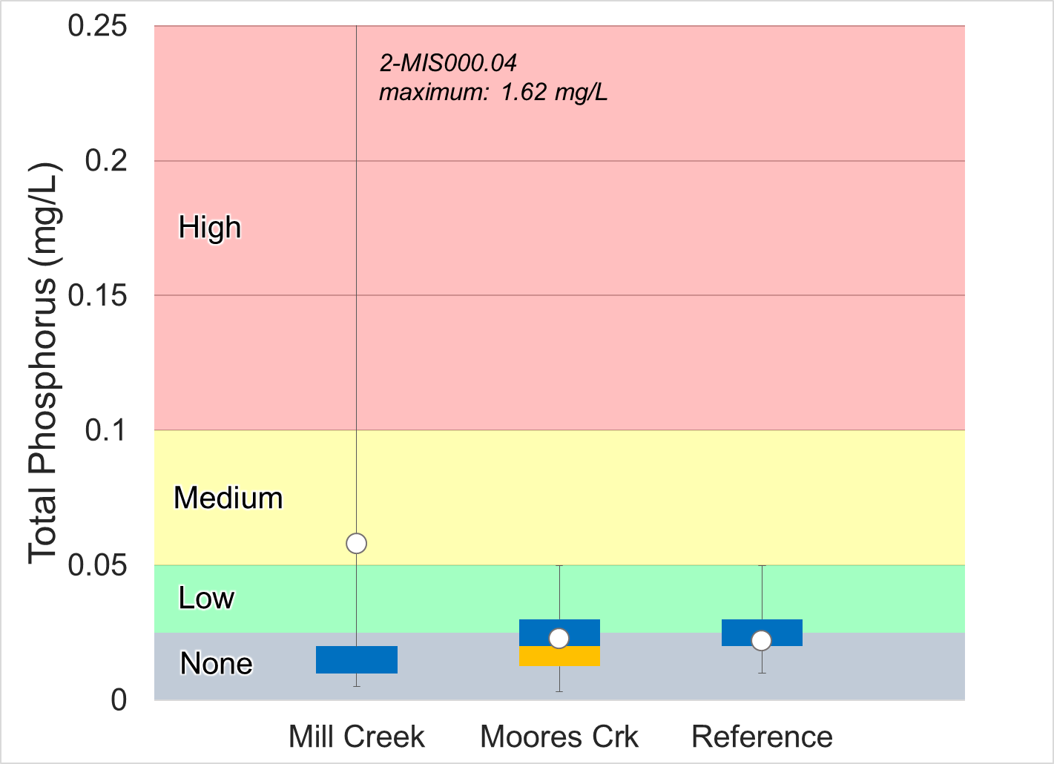
Figure 1-30. Total phosphorus concentrations in Moores and Mill Creeks compared to the reference stream, Strait Creek. Whiskers indicate the range, boxes indicate the inter-quartile range, lines indicate the median, and blue/white markers indicate the average. Colors represent the probability that data within that range would be responsible for causing stress.

Diurnal dissolved oxygen monitoring results must also be evaluated to determine if phosphorus is a likely stressor. Excess nutrient loads to a stream may accelerate algal growth, resulting in large diurnal swings in dissolved oxygen concentrations during periods of photosynthesis and respiration. Dissolved oxygen levels in Moores Creek fell within the high probability of benthic stress (below 7 mg/L) during the daytime throughout the 3-day period of diurnal monitoring. However, concentrations did not approach the water quality standard of 5 mg/L, and the shift in both concentration and % saturation between daytime and nighttime was minimal. This suggests that plant growth, photosynthesis and respiration are affecting dissolved oxygen levels in Moores Creek, but that growth rates are moderate as a result of elevated phosphorus inputs. In Mill Creek, diurnal dissolved oxygen levels experienced similar shifts between the daytime and the evening; however, concentrations remained largely in the low probability of stress effects range. In addition, saturation values never fell below 90% in the evenings. This suggests a lack of significant nutrient enrichment and associated increases in photosynthesis during the day and respiration at night.
In summary, monthly ambient monitoring of phosphorus did not indicate that phosphorus was a likely stressor in Moores or Mill Creeks. However, diurnal monitoring of dissolved oxygen in Moores Creek is indicative of slightly elevated nutrient inputs. Consequently, phosphorus was considered to be a possible stressor in Moores Creek.

Ammonia
Ammonia is a reduced form of nitrogen that can be toxic at certain temperatures and pH values. Ammonia levels were measured in Mill Creek between 2007 and 2008 (n=7). All concentrations were equal to the minimum detection level of 0.04 mg/L, indicating that ammonia is not a stressor to benthic macroinvertebrates in Mill Creek. In addition, all samples fell below the freshwater chronic criterion for ammonia where early life stages of fish are present. Using pH and temperature values measured at the time of sample collection, the chronic criterion for ammonia was calculated for each sample. Even at the highest recorded temperature at the time of sampling (22°C) and the highest pH (8.4), ammonia concentrations still fell well below the chronic criterion. For this reason, ammonia is not likely a stressor in Mill Creek. Ammonia data were not available for Moores Creek, but given total nitrogen concentrations, temperature and pH data collected for the stream, it is unlikely that ammonia is a significant stressor in Moores Creek.

Water Quality Regressions
To investigate the potential role of various water quality parameters affecting the benthic macroinvertebrate community, SCI scores for both Moores and Mill Creeks were regressed against water quality parameter values collected within a 30-day window of benthic monitoring at those sites. Table 1-11 shows the results of these regressions. Conductivity was negatively correlated with SCI scores in Moores Creek (p=0.04), while it was positively correlated with scores in Mill Creek (p=0.03). Conductivity levels in Mill Creek remain relatively elevated, with over 90% of samples exceeding 500 µS/cm. The general lack of variability in conductivity may not allow it to be effectively evaluated as an independent variable in Mill Creek. Differences in SCI scores may be better explained when considering streamflow, which is a covariant of conductivity. As shown in Figure 1-23, as streamflow increases, conductivity in Mill Creek typically decreases. During periods of high flows, streams typically experience higher levels of turbidity and elevated pollutant concentrations due to increased runoff. These variables may have a more significant influence on SCI scores when compared to conductivity. The negative correlation between conductivity and SCI scores observed in Moores Creek may be due to elevated concentrations of dissolved ions in the stream, which can negatively affect aquatic life. This conclusion is supported by the significant correlation with sodium in Moores Creek. Overall results of regression analyses indicate that additional data is needed to clearly demonstrate the relationship between SCI scores and water quality parameters.
Table 1-11. Regression relationship between water quality parameters and stream condition index (SCI) scores.
Parameter | Regression Significant  (Y/N) |  | R² |  | p-value
 | Moores Creek | Mill Creek | Moores Creek | Mill Creek | Moores Creek | Mill Creek
Temperature | N | N | 0.01 | 0.12 | 0.68 | 0.28
Sodium | Y | N | 0.54 | 0.00 | 0.05 | 0.92
Potassium | N | N | 0.44 | 0.45 | 0.10 | 0.07
Chloride | N | N | 0.47 | 0.01 | 0.08 | 0.84
Conductivity | Y | N | 0.28 | 0.52 | 0.04 | 0.03
Dissolved Oxygen | N | N | 0.01 | 0.02 | 0.7 | 0.65
pH | N | N | 0.08 | 0.13 | 0.32 | 0.27
Total Dissolved Solids | N | N | 0.52 | 0.13 | 0.06 | 0.38
Sulfate | N | N | 0.00 | 0.06 | 0.98 | 0.56
Total Nitrogen | N | N | 0.00 | 0.14 | 0.90 | 0.31
Total Phosphorus | N | N | 0.01 | 0.20 | 0.85 | 0.22

Other Studies

Causal Analysis
DEQ conducted this stressor identification according to EPA’s Stressor Identification Guidance Document (USEPA, 2000a) using the Causal Analysis/Diagnosis Decision Information System (CADDIS) (USEPA, 2018). The CADDIS approach provides guidance on evaluating various lines of evidence to determine the cause of biological impairments. In the case of the Mill and Moores Creek impairments, DEQ used the available data collected from the site, published water quality standards and threshold values, and available literature from other cases to investigate the potential causes of impairment. Table 1-12 shows the lines of evidence suggested by the CADDIS approach, an explanation of the concept, and examples of how this line of evidence was analyzed to identify probable stressors in the impaired streams. Some lines of evidence were not applicable, such as the analysis of biomarkers, field manipulations, or laboratory experiments. The majority of the lines of evidence, however, were investigated for the two impaired streams.

Table 1-12. Lines of evidence used in the causal analysis approach.
Evidence | The Concept | Examples from Moores and Mill Creek Data Analysis
Data from the Case
Spatial Co-occurrence | The biological effect must be observed where the cause is observed, and must not be observed where the cause is absent. | Analysis of water quality and habitat data across sites
Temporal Co-occurrence | The biological effect must be observed when the cause is observed, and must not be observed when the cause is absent. | Analysis of temporal trends in benthic data
Evidence of Exposure or Biological Mechanism | Measurements of the biota show that relevant exposure to the cause has occurred, or that other biological mechanisms linking the cause to the effect have occurred. | NA
Causal Pathway | Steps in the pathways linking sources to the cause can serve as supplementary or surrogate indicators that the cause and the biological effect are likely to have co-occurred. | Development and analysis of causal pathways for stressors
Stressor-Response Relationships from the Field | As exposure to the cause increases, intensity or frequency of the biological effect increases; as exposure to the cause decreases, intensity or frequency of the biological effect decreases. | Correlation of water quality data with benthic score
Manipulation of Exposure | Field experiments or management actions that increase or decrease exposure to a cause must increase or decrease the biological effect. | NA
Laboratory Tests of Site Media | Controlled exposure in laboratory tests to causes (usually toxic substances) present in site media should induce biological effects consistent with the effects observed in the field. | NA
Temporal Sequence | The cause must precede the biological effect. | Analysis of temporal trends in benthic data
Verified Predictions | Knowledge of a cause's mode of action permits prediction and subsequent confirmation of previously unobserved effects. | NA
Symptoms | Biological measurements (often at lower levels of biological organization than the effect) can be characteristic of one or a few specific causes. | Analysis of benthic metrics, community composition, and functional feeding groups
Data from Elsewhere
Stressor-Response Relationships from Other Field Studies | At the impaired sites, the cause must be at levels sufficient to cause similar biological effects in other field studies. | Water quality comparison with reference sites and stressor probability thresholds
Stressor-Response Relationships from Laboratory Studies | At the impaired sites, the cause must be at levels associated with related biological effects in laboratory studies. | Water quality comparison with VA water quality standards and literature threshold values
Stressor-Response Relationships from Simulation Models | At the impaired sites, the cause must be at levels associated with effects in mathematical models simulating ecological processes. | Confirmation through use of TMDL model
Mechanistically Plausible Cause | The relationship between the cause and biological effect must be consistent with known principles of biology, chemistry and physics. | Development and analysis of causal pathways for stressors
Manipulation of Exposure at Other Sites | Field experiments or management actions at other sites that increase or decrease exposure to a cause must increase or decrease the biological effect. | Confirmation through literature
Analogous Stressors | Agents similar to the causal agent at the impaired site should lead to similar effects at other sites. | Confirmation through literature
Multiple Types of Evidence
Consistency of Evidence | Confidence in the argument for or against a cause is increased when many types of evidence consistently support or weaken it. | Weight of evidence approach
Explanation of the Evidence | Confidence in the argument for a candidate cause is increased when a post hoc mechanistic, conceptual, or mathematical model reasonably explains any inconsistent evidence. | Confirmation through use of TMDL model
For each impairment and for each potential candidate cause, the applicable lines of evidence were evaluated. For each line of evidence, the candidate cause was scored on a 3-point positive and negative scale (Table 1-13). This scale represents the strength of the evidence for or against each candidate cause. A weight of evidence approach was then used to sum the respective scores and classify candidate causes as either non-stressors, possible stressors, or probable stressors. If the summed scores for candidate causes were ≤0, the cause was classified as a non-stressor. If scores were 1-3, the cause was classified as a possible stressor. If scores were >3, the cause was classified as a probable stressor (Table 1-14).

Table 1-13. Scoring criteria used to evaluate candidate stressors.
Score | Explanation
+3 | The line of evidence strongly supports the candidate stressor as the cause of the impairment
+2 | The line of evidence moderately supports the candidate stressor as the cause of the impairment
+1 | The line of evidence weakly supports the candidate stressor as the cause of the impairment
0 | The line of evidence does not support or refute the candidate stressor as the cause of the impairment
-1 | The line of evidence weakly refutes the candidate stressor as the cause of the impairment
-2 | The line of evidence moderately refutes the candidate stressor as the cause of the impairment
-3 | The line of evidence strongly refutes the candidate stressor as the cause of the impairment

Table 1-14. Scheme for classifying candidate causes based on causal analysis.
Total Score | Classification
<-2 | Non-Stressor
-1
0
+1 | Possible Stressor
+2
+3
+4 | Probable Stressor
+5
>+6

Temperature
Table 1-15 shows the causal analysis results for temperature in Moores and Mill Creeks. Total causal analysis scores ranged from -13 in Moores Creek to -14 in Mill Creek, indicating that there is strong evidence that temperature is a non-stressor in these streams. No violations of the temperature standard were observed in either of the streams including during summertime diurnal monitoring. While temperatures were significantly higher than the reference condition in both streams, they still fell within an acceptable range, unlikely to impact aquatic life in the streams. For these reasons and others explained in Table 1-15, temperature was categorized as a non-stressor in Moores and Mill Creeks.

pH
Table 1-16 shows the causal analysis results for pH for Moores and Mill Creeks. Total causal analysis scores ranged from -14 in Mill Creek to -13 in Moores Creek, indicating that there is strong evidence that pH is a non-stressor in these streams. pH values were near neutral in both streams, generally ranging between 7.3 and 8.5. No violations of the pH standard were observed, and values were within the low probability range of stressor effects. In addition, the reference stream experienced larger pH variations than either of the impaired streams. For these reasons and others explained in Table 1-16, pH was categorized as a non-stressor.

Table 1-15. Causal analysis results for temperature as a stressor.
Evidence: Temperature | Mill Creek | Moores Creek | Explanation
Spatial Co-occurrence | -1 | -1 | Both impaired streams do not show temperature excursions; however, both sites had values significantly higher than the reference condition (ɑ=0.05)
Temporal Co-occurrence | -3 | -3 | Temperature was measured at the time of benthic collections and no temperature excursions were observed
Stressor-Response Relationships from the Field | -2 | -2 | No significant regression between benthic scores and temperature (ɑ=0.05)
Temporal Sequence | -3 | -2 | None of the impaired sites had lower fall benthic scores following high summer temperatures. In Mill Creek, fall scores were significantly higher than in the spring.
Stressor-Response Relationships from Laboratory Studies | -3 | -3 | All temperatures were within water quality standards during routine monthly and summertime diurnal monitoring
Consistency of Evidence | -2 | -2 | All available sources of evidence refute temperature as the cause of impairment.
Sum | -14 | -13
Table 1-16. Causal analysis results for pH as a stressor.
Evidence: pH | Mill Creek | Moores Creek | Explanation
Spatial Co-occurrence | -3 | -3 | Sites with impaired benthic community do not show pH excursions, while reference condition shows greater variability with excursions to levels within the medium probably of stress range
Temporal Co-occurrence | -2 | -2 | pH was measured at the time of benthic collections, and no pH excursions were observed.
Stressor-Response Relationships from the Field | -2 | -2 | No significant regression between benthic scores and pH
Stressor-Response Relationships from Other Field Studies | -3 | -3 | All pH values were in the range of low probability for stressor effects; and reference site showed greater pH variation; both sites had pH values significantly lower than the reference
Stressor-Response Relationships from Laboratory Studies | -3 | -3 | All pH values were within water quality standards.
Mechanistically Plausible Cause | -2 | -2 | No biological mechanism for pH values within the range of 7.3-8.5, as measured in impaired sites, to produce toxic effects across a diverse assemblage of benthic macroinvertebrates
Consistency of Evidence | -3 | -3 | All available sources of evidence refute pH as the cause of impairment
Sum | -18 | -18

Dissolved Oxygen
Table 1-17 shows the causal analysis results for dissolved oxygen in Moores and Mill Creeks. Total causal analysis scores ranged from -16 in Mill Creek to -1 in Moores Creek, indicating that there is significant evidence that dissolved oxygen is a non-stressor in Mill Creek. Evidence is more varied in Moores Creek, but still within the range of unlikely stressors in the impaired stream. Dissolved oxygen levels did not approach the water quality standard of 5 mg/L in either stream during routine monthly monitoring. Diurnal monitoring during critical summertime conditions indicated that concentrations generally remained in the low probability for stressor effects range in Mill Creek, while concentrations consistently fell within the medium to high probability range in Moores Creek. Average and median values were in the no to low probability for stressor effects in both Mill and Moores Creeks, respectively. Moores Creek had several excursions into the medium probability of stressor effects range during the summer months (June, July and August) when water temperatures are higher and therefore have a lower capacity to retain oxygen. However, concentrations never dropped below 6 mg/L, remaining well above the water quality standard. For these reasons and others explained in Table 1-17, dissolved oxygen was categorized as a non-stressor for both Mill and Moores Creeks.

Conductivity and Total Dissolved Solids
Table 1-18 shows the causal analysis results for conductivity and total dissolved solids in Moores and Mill Creeks. Total causal analysis scores for both streams had a value of +1, indicating that there is some evidence that total dissolved solids and conductivity are possible stressors in these streams. Conductivity was consistently elevated in Moores and Mill Creeks, with median values of 447 and 552 µS/cm, respectively. Mean and median values for both streams fell within the high probability of stressor effects range. Conductivity levels were also above concentrations at which benthic impairment has been reported in the literature (Pond, 2004). Total dissolved solids (TDS) fell within the medium probability of stressor effects range in Mill Creek, with excursions into the high probability range. TDS concentrations were lower in Moores Creek, with mean and median values in the low probability of stressor effects range. High conductivity and TDS are covariants of multiple dissolved ions that may be toxic to aquatic macroinvertebrates at high concentrations. Measurements of these ions in Moores and Mill Creeks indicated that concentrations are well below thresholds where toxic effects may be observed. It is likely that the high TDS and conductivity levels observed in these streams are naturally occurring, resulting from underlying karst geology in the watersheds. Similar conditions have been observed in other karst, limestone dominated streams in the Shenandoah Valley, wherein healthy benthic communities are supported. Regression analyses of conductivity and discharge at the USGS gage on the Maury River in Buena Vista indicated that conductivity levels are higher during low flow conditions in the streams, particularly in Mill Creek where levels are highest. This supports the conclusion that natural geology and weathering processes are responsible for elevated conductivity and TDS levels in the stream. Calcium (Ca⁺²) and magnesium (Mg⁺²) are typically the dominant cations in karst groundwater. It is likely that these ions are responsible for elevated conductivity and TDS concentrations observed during low flow conditions in Moores and Mill Creeks. Relative bed stability analyses in the Mill Creek watershed provide further support for this conclusion. Bedrock comprised over 40% of bottom substrate in Mill Creek compared to 8.5% in Moores Creek. This suggests that weathering and other geological processes may have a more significant effect on dissolved ion concentrations in the stream. Diurnal shifts in specific conductance observed in Mill Creek provide additional evidence that natural conditions resulting from karst topography in the watershed are driving elevated conductivity in the stream. Throughout the 3-day diurnal monitoring period in Mill Creek, specific conductance was elevated in the late afternoon, and then dropped overnight. Similar shifts in specific conductance have been observed in small karst-influenced streams (Liu et. al, 2008). These fluctuations may be caused by periphyton growth during the daytime, with photosynthesis releasing O₂ and consuming CO_{2,} thereby increasing pH during the day. This increase in pH causes calcite to precipitate out of the water column, resulting in a drop in conductivity (Hayashi et. al, 2012). As respiration occurs in the evening and the pH drops, conductivity increases as precipitated calcite re-dissolves. Conductivity in Mill Creek remained largely within the high probability of stress throughout the 3-day diurnal monitoring period, with occasional departures into the medium probability range. It is likely that these decreases in conductivity were the result of calcium precipitation following increases in pH during the daytime.
Notably, SCI scores are consistently higher in Mill Creek as compared to Moores Creek, despite higher conductivity and TDS levels in the stream. In addition, concentrations do not exhibit temporal patterns indicative of impacts from winter applications of deicing agents to roadways, which is a common cause of elevated conductivity levels in streams. Levels remain consistently elevated over time, with little variation. There are also no documented mining operations in either the Moores or Mill Creek watersheds, which are another common cause of elevated conductivity and potentially toxic dissolved ions. For these reasons and others explained in Table 1-18, conductivity and total dissolved solids were categorized as possible stressors.

Table 1-17. Causal analysis results for dissolved oxygen as a stressor.
Evidence: Dissolved oxygen | Mill Creek | Moores Creek | Explanation
Spatial Co-occurrence | -2 | 2 | Mill Creek does not show dissolved oxygen excursions into the medium-high probability range during routine monthly ambient monitoring; Moores Creek shows multiple excursions into the medium probability range in June-August and into the high probability range during the evenings throughout the 3-day diurnal monitoring period
Temporal Co-occurrence | -1 | 0 | DO was measured at the time of benthic sampling, and both Moores and Mill Creeks did not show routine excursions; DO concentrations in Moores Creek fell within the medium probability of stress (6.8 mg/L) on one occasion in June 2005.
Causal Pathway | -1 | -1 | Causal pathway for nutrient impacts is partially intact in Mill and Moores Creek due to surrounding agricultural land uses; however, median phosphorus concentrations were in the no probability of stress range in both impaired streams, and were not significantly greater than the reference condition. This suggests that it is unlikely that phosphorus (the limiting nutrient in both streams) is present in sufficient concentrations to result in significantly reduced DO concentrations
Stressor-Response Relationships from the Field | -2 | -2 | No significant regression between benthic scores and DO
Symptoms | -2 | -2 | No symptoms of low DO observed in Mill or Moores Creeks, sensitive taxa were present in both streams suggesting DO concentrations were sufficient to support taxa intolerant of low DO
Stressor-Response Relationships from Other Field Studies | -2 | 2 | Mean and median DO values fell within the no and low probability for stressor effects range in Mill and Moores Creeks, respectively; Moores Creek had multiple excursions below 8 mg/L during June-August when water temperatures are elevated. No significant difference between Mill Creek and the reference condition, while concentrations in Moores Creek were significantly lower (ɑ=0.05). Moores Creek had diurnal DO values that fell within the high probability range
Stressor-Response Relationships from Laboratory Studies | -2 | -1 | DO levels were above water quality standards during ambient monthly monitoring at both sites
Mechanistically Plausible Cause | -2 | 1 | DO levels observed in Mill Creek were sufficient to support even sensitive benthic macroinvertebrates throughout the monitoring period; diurnal measurements in Moores Creek indicated that concentrations drop below levels tolerated by more sensitive taxa during the summertime
Consistency of Evidence | -2 | 1 | Weight of evidence slightly refutes DO as a stressor Moores Creek, while evidence from Mill Creek consistently demonstrates that DO is a non-stressor
Sum | -16 | -1

Table 1-18. Causal analysis results for conductivity and total dissolved solids as a stressor.
Evidence: Dissolved solids | Mill Creek | Moores Creek | Explanation
Spatial Co-occurrence | 1 | 1 | Sites with impaired benthic community show consistently high conductivity and dissolved solids concentrations. The reference stream does not exhibit similar elevated concentrations. However, conductivity in Mill Creek is typically higher than Moores Creek, where SCI scores are considerably lower.
Temporal Co-occurrence | 2 | 2 | Conductivity was consistently high when measured at the time of benthic collections
Causal Pathway | 1 | 1 | Multiple causal pathways are intact in the watersheds. A 4.4-mile segment of Interstate 81 bisects the Mill Creek watershed, while Moores Creek runs adjacent to a 74-acre tractor-trailer complex above the monitoring station. Another likely causal pathway for Moores and Mill Creeks is naturally occurring karst topography present in both watersheds. While the causal pathway (weathering of underlying limestone and dolomite) is intact for both streams, the resulting elevated conductivity and TDS are unlikely to cause stress to the aquatic community in the absence of covariant ions that prove toxic to aquatic life at high concentrations.
Stressor-Response Relationships from the Field | -2 | -2 | Benthic scores were not significantly correlated with conductivity
Stressor-Response Relationships from Other Field Studies | 2 | 1 | Mean and median conductivity values were in the range of high probability for stressor effects in both streams. TDS was in the medium probability range in Mill Creek and low probability range in Moores Creek. Both streams had significantly higher conductivity and dissolved solids compared to the reference.
Stressor-Response Relationships from Laboratory Studies | -1 | 0 | Median conductivity values in Mill Creek (552 uS/cm) were higher than the threshold of 500 uS/cm reported by Pond (2004) for loss of Ephemeroptera species. The median value in Moores Creek (447 µS/cm) fell below this threshold. However, this study was conducted in a watershed where surface mining had previously occurred, serving as the primary cause of elevated conductivity levels in the study area. Karst topology and resulting increases in calcium and magnesium concentrations is the likely cause of elevated conductivity in Moores and Mill Creeks, which is not associated with similar detrimental effects to sensitive species. Hayashi et al (2012) and Hui et al (2008) demonstrated impacts of groundwater inputs in karst-dominated streams with respect to periphyton production, associated shifts in pH and calcium precipitation. Similar processes were observed in Mill Creek, providing further evidence that natural conditions are largely responsible for elevated conductivity in the stream.
Mechanistically Plausible Cause | -1 | -1 | In the absence of concurrent increases in dissolved salts and metals known to produce toxic effects across a diverse assemblage of benthic macroinvertebrates, there is no evidence that the elevated conductivity and TDS concentrations observed in Moores and Mill Creeks are capable of similar detrimental impacts to the aquatic community
Consistency of Evidence | -1 | -1 | There is considerable variability in evidence to support conductivity as the cause of impairment
Sum | 1 | 1

Dissolved Ions – Sodium
Table 1-19 shows the causal analysis results for dissolved sodium in Moores and Mill Creeks. Total causal analysis scores ranged from -2 in Moores Creek to 0 in Mill Creek, indicating that there is some evidence that dissolved sodium is a non-stressor in these streams. Average and median concentrations fell within the medium probability of stress in both streams and were significantly higher than the reference condition (ɑ=0.05). However, sodium concentrations were still well below documented toxicity levels and do not appear to exhibit spikes to concentrations capable of causing acute toxicity in the streams. In addition, the relationship between sodium concentrations and SCI scores was unclear, with higher SCI scores at monitoring stations with higher sodium concentrations. For these reasons and others shown in Table 1-19, sodium was categorized as a non-stressor in Moores and Mill Creeks.

Dissolved Ions – Sulfate
Table 1-20 shows the causal analysis results for dissolved sulfate as a stressor in Moores and Mill Creeks. Total causal analysis scores ranged from -12 in Moores Creek to -2 in Mill Creek, indicating that there is significant evidence that dissolved sulfate is a non-stressor in both streams. Average and median concentrations fell within the low probability of stress range in Mill Creek, and in the no probability of stress range in Moores Creek. Sulfate concentrations in Mill Creek were significantly higher than the reference condition (ɑ=0.05), with several excursions into the medium probability of stress range. The predominance of bedrock in the Mill Creek watershed may be a significant source of elevated sulfate concentrations in the stream. High sulfate concentrations are commonly associated with karst-dominated streams, and are a result of weathering and other geological processes. For these reasons and others shown in Table 1-20, dissolved sulfate was classified as a non-stressor in Moores and Mill Creeks.

Dissolved Ions – Chloride
Table 1-21 shows the causal analysis results for dissolved chloride in Moores and Mill Creeks. Total causal analysis scores were equal to -5 in both streams. Both Moores and Mill Creeks had chloride values that were significantly higher than the reference site. Mean and median values for both streams fell along the boundary between a low and medium probability for stressor effects, with median chloride concentrations ranging from 26.2 mg/L in Mill Creek to 28.35 mg/L in Moores Creek. However, chloride values in the impaired streams were well below the range where toxic effects would be expected. Maximum chloride concentrations in both streams fell well below both chronic and acute concentration criteria established in Virginia water quality standards to protect aquatic life. For these reasons and others explained in Table 1-21, dissolved chloride was categorized as a non-stressor for Moores and Mill Creeks.

Dissolved Ions – Potassium
Table 1-22 shows the causal analysis results for dissolved potassium in Moores and Mill Creeks. Total causal analysis scores were equal to -3 in both streams. Both Moores and Mill Creeks had potassium values that were significantly higher than the reference site. Mean and median potassium values for both streams fell along the boundary between a low and medium probability for stressor effects, with median concentrations ranging from 2.32 mg/L in Mill Creek to 2.49 mg/L in Moores Creek. However, potassium values in the impaired streams were well below the range where toxic effects would be expected. For these reasons and others explained in Table 1-22, dissolved potassium was categorized as a non-stressor for Moores and Mill Creeks.

Table 1-19. Causal analysis results for dissolved sodium as a stressor.
Evidence: Sodium | Mill Creek | Moores Creek | Explanation
Spatial Co-occurrence | 1 | 0 | Both Moores and Mill Creeks show elevated sodium concentrations, while similar conditions are not observed in the reference stream. However, SCI scores are considerably higher in Mill Creek compared to Moores Creek and conversely, sodium concentrations are higher in Mill Creek.
Causal Pathway | -1 | -1 | A clear causal pathway for elevated sodium concentrations is not intact in the impaired watersheds. While Mill Creek is located in close proximity to I-64, the lack of seasonal variability in concentrations does not support a clear connection with high sodium concentrations and the application of de-icing agents; additionally, impervious cover appeared to be inversely related to sodium concentrations in Mill and Moores Creek, with impervious cover comprising 6.1% of the Mill Creek monitoring station drainage area and 8.4% of the Moores Creek monitoring station drainage area
Stressor-Response Relationships from the Field | -1 | -1 | No significant regression between benthic scores and sodium
Stressor-Response Relationships from Other Field Studies | 2 | 1 | Median and average sodium values were in the range of a medium probability for stressor effects in both streams and were significantly higher than the reference condition
Mechanistically Plausible Cause | -2 | -2 | No biological mechanism for sodium concentrations under 20 mg/L, as measured in impaired sites, to produce toxic effects across a diverse assemblage of benthic macroinvertebrates
Analogous stressors | 1 | 1 | Conductivity was in the high range for stressor effects in both streams and is an analogous stressor to sulfate
Consistency of Evidence | -1 | -1 | There is some evidence that sodium is elevated in the creeks, but clear causal pathways and evidence of stressor effects is lacking; an inverse relationship between sodium concentrations and stream health is not established in these streams, with higher SCI scores at sites with higher sodium concentrations
Sum | 0 | -2
Table 1-20. Causal analysis results for dissolved sulfate as a stressor.
Evidence: Sulfate | Mill Creek | Moores Creek | Explanation
Spatial Co-occurrence | 0 | -2 | Mill Creek shows slightly elevated sodium concentrations, while similar conditions are not present in Moores Creek or the reference stream. However, SCI scores are considerably higher in Mill Creek compared to Moores Creek and conversely, sulfate concentrations are higher in Mill Creek.
Causal Pathway | 0 | -1 | The likely causal pathway for elevated sulfate concentrations in Mill Creek is naturally occurring karst topography, which is particularly abundant in the Mill Creek watershed. While the causal pathway (weathering of underlying limestone and dolomite) is intact for both streams, the resulting elevated sulfate concentrations in Mill Creek are unlikely to cause stress to the aquatic community.
Symptoms | 0 | -1 | Average BCG scores for sulfate in Moores and Mill Creek equal to 3.5 and 3.6, respectively. Scores for all predominant taxa in both streams equal to 4, with the exception of Maccaffertium in Mill Creek with a score of 4. Sulfate concentrations in Mill Creek extended into the high probability of stress range while those in Moores Creek did not.
Stressor-Response Relationships from the Field | -1 | -1 | No significant regression between benthic scores and sulfate
Stressor-Response Relationships from Other Field Studies | -1 | -3 | All median and average sulfate values were in the range of no probability for stressor effects in Moores Creek. Concentrations fell in the low probability for stressor effects range in Mill Creek. Comparisons with the reference stream indicated that concentrations in Mill Creek were significantly higher (ɑ=0.05)
Mechanistically Plausible Cause | -1 | -3 | No biological mechanism for sulfate concentrations under 40 mg/L (maximum measure value at the impaired sites), to produce toxic effects across a diverse assemblage of benthic macroinvertebrates
Analogous stressors | 1 | 1 | Conductivity was in the high range for stressor effects in both streams and is an analogous stressor to sulfate
Consistency of Evidence | 0 | -3 | Most evidence refutes the conclusion that sulfate is the cause of impairment in Mill Creek, whereas evidence in Moores Creek consistently refutes this conclusion.
Sum | -2 | -12
Table 1-21. Causal analysis results for dissolved chloride as a stressor.
Evidence: Chloride | Mill Creek | Moores Creek | Explanation
Spatial Co-occurrence | 1 | 1 | Both Mill and Moores Creek show several chloride excursions into the medium probability of stress range; average chloride values are significantly higher than the reference condition in both streams (ɑ=0.05)
Causal Pathway | 0 | 0 | A clear causal pathway for elevated chloride concentrations is not intact in the impaired watersheds. While Mill Creek is located in close proximity to I-64, the lack of seasonal variability in concentrations does not support a clear connection with high chloride concentrations and the application of de-icing agents.
Symptoms | -1 | -1 | Average BCG scores for chloride in Moores and Mill Creek were equal to 3.2 and 3.3, respectively, suggesting that organisms present in both streams were not tolerant of elevated chloride concentrations
Stressor-Response Relationships from the Field | -2 | -2 | No correlation between benthic scores and chloride concentrations
Stressor-Response Relationships from Other Field Studies | 1 | 1 | Average and median chloride values fell along the border of a low to medium probability of stress range; both Moores and Mill Creeks had concentrations significantly higher than those of the reference site
Stressor-Response Relationships from Laboratory Studies | -2 | -2 | Chloride levels were well below chronic and acute water quality standards; no significant regression between benthic scores and chloride
Mechanistically Plausible Cause | -2 | -2 | No biological mechanism for average chloride concentrations under 40 mg/L as measured in most impaired sites, to produce toxic effects across a diverse assemblage of benthic macroinvertebrates
Analogous stressors | 1 | 1 | Conductivity was in the high range for stressor effects in both streams and is an analogous stressor to chloride
Consistency of Evidence | -1 | -1 | Most available sources of evidence refute chloride and potassium as the cause of impairment
Sum | -5 | -5

Table 1-22 Causal analysis results for dissolved potassium as a stressor.
Evidence: Potassium | Mill Creek | Moores Creek | Explanation
Spatial Co-occurrence | 1 | 1 | Both impaired streams have mean and median potassium concentrations in the medium probability of stress range; average potassium values are significantly higher than the reference condition in both streams (ɑ=0.05)
Stressor-Response Relationships from the Field | -2 | -2 | No correlation between benthic scores and potassium concentrations
Stressor-Response Relationships from Other Field Studies | 2 | 2 | Average and median potassium values were in the low end of the range of medium probability for stressor effects in both streams average; both Moores and Mill Creeks had concentrations significantly higher than those of the reference site
Stressor-Response Relationships from Laboratory Studies | -3 | -3 | In an analysis of toxicity to major ions (Mount et al., 2016), all LC50s for Ceriodaphnia exposed to KCl were well above the potassium levels in Moores and Mills Creeks. No significant regression between benthic scores and potassium concentrations
Mechanistically Plausible Cause | -2 | -2 | No biological mechanism for average potassium concentrations under 6 mg/L, as measured in most impaired sites, to produce toxic effects across a diverse assemblage of benthic macroinvertebrates
Analogous stressors | 1 | 1 | Conductivity was in the high range for stressor effects in both streams and is an analogous stressor to potassium
Consistency of Evidence | -1 | -1 | Most available sources of evidence refute potassium as the cause of impairment
Sum | -3 | -3

Suspended Solids and Deposited Sediment
Table 1-22 shows the causal analysis results for suspended solids and deposited sediment in Mill and Moores Creeks. Total causal analysis scores ranged from +7 in Mill Creek to +22 in Moores Creek, indicating that suspended solids and deposited sediment are probable stressors in these streams. Lines of evidence supporting sediment as a probable stressor in Mill and Moores Creeks include:
- Seasonal trends in benthic health in both streams indicated poor health in the spring following high spring flows that typically bring greater sediment loads.
- Taxonomic community structure indicated shifts to Dipteran dominated communities that prefer sediment and away from Ephemeroptera, Plecoptera, and Trichoptera, which generally prefer clean substrate. Shifts away from sensitive taxa were more pronounced in Moores Creek, where a 21.6% decrease in Ephemeroptera taxa and a 13% decrease in Plecoptera taxa was observed. Reductions in sensitive taxa were less significant in Mill Creek, with 8.6% and 4.2% decreases in Plecoptera and Ephemeroptera, respectively, compared to the reference stream.
- Functional feeding group analysis indicated shifts to collectors and scrapers in both streams. Shredders exhibited an 11.9% and 9.1% reduction from the reference condition in Mill and Moores Creeks, respectively. In Mill Creek, shifts in functional feeding groups may be driven by both excess sediment deposition in the stream and the bottom substrate, comprised of over 40% bedrock. With a reduction in cobble and gravel on the stream bottom, it is likely that food sources for collectors and scrapers are subsequently reduced.
- Habitat metric scores in Moores Creek were indicative of excess sediment deposition in the stream. Large differences in SEDIMENT, BANKS, EMBED, and RIPVEG scores were observed in comparison to the reference condition, all indicating excess sediment deposition on the stream bottom is occurring. BANKS and SEDIMENT metrics were significantly lower in Mill Creek when compared to the reference condition. These results suggest that streambank erosion and subsequent sediment deposition may be impacting the benthic community in Mill Creek, while other factors are collectively contributing to the impairment.
- Relative bed stability analysis showed that the bed substrate in Moores Creek was unstable and consisted of a majority of sands and fines. Results in Mill Creek are less indicative of sediment deposition. The predominance of bedrock and reduced extent of cobble and gravel in the stream bottom may play a more significant role in observed shifts in the benthic community.
- Visual evidence of incised stream channels, steep and unstable streambanks are all indicative of a sediment stressor.
- Strong negative correlation between both cropland and imperviousness and benthic scores.
For these reasons and others explained in Table 1-22, suspended solids and deposited sediment were categorized as probable stressors.

Table 1-23. Causal analysis results for sediment as a stressor.
Evidence: Sediment | Mill Creek | Moores Creek | Explanation
Spatial Co-occurrence | 1 | 3 | In the habitat assessment, the sediment metric was significantly reduced at both of the impaired sites in comparison to the reference stream (ɑ=0.05). Other habitat measurements indicative of excess sediment (embeddedness, substrate) were also lower at the impaired sites when compared to the reference condition. Differences were more pronounced in Moores Creek comparisons
Temporal Co-occurrence | 1 | 2 | Habitat measurements taken at the time of biological monitoring demonstrated that total habitat scores were directly correlated with SCI scores
Causal Pathway | 2 | 3 | Causal pathway from sediment sources to impaired benthic community intact for both streams, measure of streambank stability (BANKS) significantly lower than the reference condition in both watersheds (ɑ=0.05)
Stressor-Response Relationships from the Field | 0 | 0 | Total suspended solids were below detection limits in Mill Creek while mean and median turbidity measurements were higher than the reference condition. Data were not available for Moores Creek
Temporal Sequence | 1 | 3 | Temporal trends in benthic data correlated with high springtime sediment flows; spring SCI scores were lower in both Mill and Moores Creeks
Symptoms | 1 | 2 | Taxonomic community structure indicated shifts to Dipteran dominated communities that prefer sediment and away from Ephemeroptera, Plecoptera, and Trichoptera, which generally prefer clean substrate. Functional feeding group analysis revealed increases in collectors and scrapers at the impaired sites, with a greater number of filterers present at the reference site.
Stressor-Response Relationships from Other Field Studies | -2 | 3 | Relative bed stability measurements were in the high probability for stressor effects range for Moores Creek, while Mill Creek fell within the no probability range. Based on RBS surveys, evidence of sediment deposition is lacking in Mill Creek, the stream bottom is dominated by bedrock, which offers limited habitat for benthic macroinvertebrates when compared to coarse gravel and cobble.
Stressor-Response Relationships from Simulation Models |  |  | TMDL model using AllForX approach indicated excess sediment at all sites
Mechanistically Plausible Cause | 1 | 1 | Causal pathway from sediment sources to impaired benthic community intact for Moores and Mill Creeks; negative correlation between imperviousness and benthic score
Manipulation of Exposure at Other Sites | 1 | 2 | Benthic community composition analysis indicated sediment impacts in Moores and Mill Creeks and were consistent with literature on sediment effects; functional feeding group analysis did not provide clear evidence of shifts towards groups best adapted to feed in systems impacted by sediment (e.g. proportion of filterers was greater in the reference stream)
Analogous Stressors | 1 | 1 | Total habitat scores strongly correlated with benthic scores reflecting sediment buffering capacity of healthy riparian habitat
Consistency of Evidence | 0 | 2 | Weight of evidence strongly supported sediment as a stressor in Moores Creek while sediment impacts in Mill Creek are less significant.
Explanation of the Evidence |  |  | TMDL model using AllForX approach explained the benthic impairment evidence using modeled sediment loads in all streams
Sum | 7 | 22

Nitrogen
Table 1-23 shows the causal analysis results for nitrogen in Moores and Mill Creeks. Total causal analysis scores were equal to -2 in both Mill and Moores Creeks, indicating that there is some evidence that nitrogen is a non-stressor in these streams. Nitrogen levels in both streams were in the medium probability range for stressor effects; however, N:P ratios indicate that phosphorus is the limiting nutrient in both streams. For these reasons and others explained in Table 1-23, nitrogen was categorized as a non-stressor for Moores and Mill Creeks.

Phosphorus
Table 1-24 shows the causal analysis results for phosphorus in Moores and Mill Creeks. Total causal analysis scores ranged from -2 in Moores Creek to -3 in Mill Creek, indicating that there is some evidence that phosphorus is a non-stressor in these streams. Median phosphorus levels in both streams were in the no probability range for stressor effects. Dissolved oxygen levels did not clearly support nutrient enrichment as a stressor in Mill Creek. Diurnal monitoring of dissolved oxygen concentrations in Moores Creek provided some evidence of excess nutrient loading; however, concentrations never fell below the water quality standard. For these reasons and others explained in Table 1-24, phosphorus was categorized as a non-stressor in both Mill and Moores Creeks.

Table 1-24. Causal analysis results for nitrogen as a stressor.
Evidence: Nitrogen | Mill Creek | Moores Creek | Explanation
Spatial Co-occurrence | 1 | 1 | Both Moores and Mill Creeks showed some nitrogen excursions while the reference stream did not; however, Mill Creek had higher mean and median nitrogen concentrations than Moores Creek, while SCI scores were also considerably higher in Mill Creek
Temporal Co-occurrence | -1 | -1 | No significant correlation between nitrogen concentrations and benthic scores
Causal Pathway | -2 | -2 | DO concentrations in Moores and Mill Creeks do not indicate that causal pathway for nutrient impacts is intact; diurnal DO patterns do not indicate evidence of causal pathway for nutrient impacts in either of the impaired streams
Stressor-Response Relationships from the Field | -1 | -1 | No significant correlation between nitrogen concentrations and benthic scores
Temporal Sequence | 1 | 1 | Temporal trends of significantly (ɑ=0.05) lower spring benthic scores may indicate nutrient effects in both Moores and Mill Creeks
Symptoms | 1 | 1 | The shifts in functional feeding groups observed in Moores and Mill Creeks are indicative of nutrient enrichment, with an increase in scrapers in both streams when compared to the reference condition
Stressor-Response Relationships from Other Field Studies | 2 | 2 | The median and mean nitrogen values for Moores and Mill Creeks were in the range of a medium probability for stressor effects from nitrogen; both streams had excursions into the high probability range
Stressor-Response Relationships from Laboratory Studies | 1 | 1 | Mean nitrogen values at both Moores and Mill Creeks were over twice the EPA recommended reference level of 0.214 mg/L for this ecoregion
Mechanistically Plausible Cause | -3 | -3 | Nitrogen to phosphorus ratios indicate that phosphorus (not nitrogen) is the limiting nutrient in the impaired streams
Consistency of Evidence | -1 | -1 | Results were inconsistent, with elevated concentrations indicative of excess nitrogen in both streams, though causal pathway and symptoms of nutrient enrichment are largely absent
Sum | -2 | -2
Table 1-25. Causal analysis results for phosphorus as a stressor.
Evidence: Phosphorus | Mill Creek | Moores Creek | Explanation
Spatial Co-occurrence | 1 | -2 | Mill Creek had two excursions of phosphorus concentrations in the high probability of stressor effects; Moores Creek did not have any excursions though SCI scores were considerably lower in Moores Creek
Temporal Co-occurrence | -1 | -1 | No significant regression between phosphorus concentrations and benthic scores
Causal Pathway | -2 | -2 | DO concentrations in both Mill and Moores Creeks do not indicate that causal pathway for nutrient impacts is intact; diurnal DO patterns do not indicate evidence of causal pathway for nutrient impacts in Mill and Moores Creeks
Stressor-Response Relationships from the Field | -1 | -1 | No significant regression between phosphorus concentrations and benthic scores
Temporal Sequence | 1 | 1 | Temporal trends of significantly (ɑ=0.05) lower spring benthic scores may indicate nutrient effects in Mill and Moores Creeks
Symptoms | 1 | 1 | The shifts in functional feeding groups observed in Moores and Mill Creeks are indicative of nutrient enrichment, with an increase in scrapers in both streams when compared to the reference condition
Stressor-Response Relationships from Other Field Studies | -1 | -3 | Median phosphorus levels were in the no probability for stressor effects range for both streams, while mean concentrations in Mill Creek fell in the medium probability range due to two spikes that occurred during the monitoring period. Values in both impaired streams were not significantly different from the reference condition
Stressor-Response Relationships from Laboratory Studies | -1 | 1 | The median phosphorus concentration in Mill Creek was below the EPA recommended reference level of 0.01 mg/L for this ecoregion while the mean concentration exceeded the reference concentration. Both mean and median concentrations for Moores Creek exceeded the reference concentration for the ecoregion
Mechanistically Plausible Cause | 1 | 1 | Nitrogen to phosphorus ratios indicate that phosphorus is the limiting nutrient in Moores and Mill Creeks
Consistency of Evidence | 0 | 2 | Weight of evidence consistently demonstrated that phosphorus is not a stressor in Moores Creek, results in Mill Creek largely consistent though several spikes in phosphorus concentrations were observed in the stream
Sum | -2 | -3

Ammonia
Table 1-25 shows the causal analysis results for ammonia in Mill and Moores Creeks. Ammonia data was only available for Mill Creek. Total causal analysis scores ranged from -16 in Mill Creek to -3 in Moores Creek indicating that there is some to strong evidence that ammonia is a non-stressor in either stream. The score for Moores Creek was greater than Mill Creek due to the lack of data, rather than additional supporting evidence of ammonia as a stressor. Ammonia levels in Mill Creek were below water quality standards, and consistently fell below the limit of detection. In addition, comparisons with the reference stream showed no significant difference in ammonia concentrations in Mill Creek. For these reasons and others explained in Table 1-25, ammonia was categorized as a non-stressor.

Table 1-26. Causal analysis results for ammonia as a stressor.
Evidence: Ammonia | Mill Creek | Moores Creek | Explanation
Spatial Co-occurrence | -3 | - | Mill Creek does not show ammonia excursions; all data below the limit of detection, data not available for Moores Creek
Causal Pathway | -1 | -1 | Causal pathway from enriched organic matter decomposition to high ammonia is not present at Moores or Mill Creeks
Stressor-Response Relationships from the Field | -2 | - | No significant regression between ammonia and benthic scores in Mill Creek
Stressor-Response Relationships from Other Field Studies | -3 | - | Ammonia levels in Mill Creek were all below the water quality standard, falling below the limit of detection, and comparisons with the reference stream showed no significant difference in concentrations
Stressor-Response Relationships from Laboratory Studies | -3 | - | Maximum ammonia levels were below water quality standards in Mill Creek
Mechanistically Plausible Cause | -1 | -1 | Mill Creek and Moores Creek did not show evidence of enrichment with organic matter
Consistency of Evidence | -3 | -1 | Weight of evidence consistently refuted ammonia as a stressor
Sum | -16 | -3

Causal Analysis Summary

Probable Stressors
The total causal analysis scores for each candidate stressor are shown in Table 1-26. Candidate stressors with causal analysis scores ≤0 were classified as non-stressors, candidate stressors with causal analysis scores of 1-3 were classified as possible stressors, and candidate stressors with scores >3 were classified as probable stressors. Table 1-27 shows the non-stressors, possible stressors, and probable stressors identified for Moores and Mill Creeks. The results indicate that sediment was identified as a probable stressor in both of the impaired streams, with causal analysis scores ranging from +7 to +22 in Mill and Moores Creeks, respectively. Total dissolved solids and conductivity were identified as possible stressors in Moores and Mill Creeks, where causal analysis scores were equal to +1 in both streams. With symptoms of elevated conductivity and dissolved solids concentrations largely lacking in both streams, and with an intact causal pathway for effects from karst topology, it was determined that a TMDL was not necessary to address these parameters.

Table 1-27. Total causal analysis scores by stream and by candidate stressor. Green indicates non-stressors, orange indicates possible stressors, and red indicates probable stressors.
Candidate Stressor | Mill Creek | Moores Creek
Temperature | -14 | -13
pH | -18 | -18
Dissolved Oxygen | -16 | -1
Conductivity/Total Dissolved Solids | +1 | +1
Dissolved Sodium | 0 | -2
Dissolved Sulfate | -2 | -12
Dissolved Chloride | -5 | -5
Dissolved Potassium | -3 | -3
Sediment | +7 | +22
Nitrogen | -2 | -2
Phosphorus | -2 | -3
Ammonia | -16 | -3

Table 1-28. Non-stressors, possible stressors, and probable stressors in Moores and Mill Creeks.
Stream | Non-Stressors | Possible Stressors | Probable Stressors
Moores Creek | pH, Temperature, Dissolved Sodium, Dissolved Sulfate, Dissolved Chloride, Dissolved Potassium, Nitrogen, Phosphorus, Dissolved Oxygen, Ammonia | Conductivity/Total Dissolved Solids | Sediment
Mill Creek | pH, Temperature, Dissolved Sodium, Dissolved Sulfate, Dissolved Chloride, Dissolved Potassium, Nitrogen, Phosphorus, Dissolved Oxygen, Ammonia | Conductivity/Total Dissolved Solids | Sediment

Contributing Factors
In addition to sediment, there are other factors contributing to the impairments in Moores and Mill Creeks. The TMDL may not directly address these conditions, but they should be considered when implementing or evaluating the success of the TMDL.

Historic Land Disturbance
The widespread deforestation and intensive agriculture using poor row crop farming practices of the 1820-1930s in the valley region have produced a legacy of accumulated sediment in valley bottoms that characterize valley streams. In a piedmont stream in Georgia, Jackson et al. (2005) estimated that the volume of stored sediment in the floodplain from the agricultural era (1820-1930) exceeded current sediment export rates in the watershed by 6,000-10,000 times, meaning that it may take millennia to remove stored sediment from this era. The current geomorphology of piedmont streams is dominated by this process of slowly excavating historically deposited floodplain sediments through channel migration and streambank erosion. This process is evidenced by stream channels that are highly incised, streambanks that are steep and unstable, and streambeds composed of loose and highly mobile sands. This legacy contributes to current sediment loads and stream habitat conditions.

Historic Dams
In addition to historic forest clearing and intensive agriculture in the valley region, Walter and Merritts (2008) suggest that the presence of historic mill dams significantly contributed to the present morphology of streams in the region and resulting sediment loads. The construction of mill dams in the mid-atlantic piedmont was pervasive in the 17th to 19th century, with more than 5465 mills being recorded on the 1840 Virginia census (U.S. Department of State, 1841). In Rockbridge County alone, where Moores and Mill Creeks are located, more than 71 flour, grist, and saw mills were recorded in 1840. According to Walter and Merritts (2008), prior to European settlement, streams throughout the mid-Atlantic were primarily small, low energy waterbodies surrounded by vegetated wetlands that served as organic carbon sinks and accumulated very little sediment. Walter and Merritts suggest that the construction of these dams following Eurpoean settlement created backwater effects throughout 1st through 3rd order streams in the region. In combination with high erosion rates from forest clearing and agriculture, the slowed water velocities behind dams produced excessive sedimentation in stream valleys. Walter and Merritts estimated as much as 1 to 5 meters of sediment was accumulated behind these dams, with deposits extending 1 to 3 km upstream. As most mill dams were breached in the mid 20th century, streams began to down-cut and erode through the deposited material, leaving the highly incised stream channels with steep unstable streambanks that we observe today.

Imperviousness
In the Mill and Moores Creek watersheds, there was a significant regression (r² = 0.86, p=0.02) between imperviousness and benthic scores. As the imperviousness of the watershed increased, benthic scores decreased. As a watershed develops and the percentage of impervious surfaces increases, runoff during precipitation events increases. In turn, as the amount of runoff increases, peak flows in local streams increase, causing streambank erosion and stream bed scouring. The resulting impact of increased watershed imperviousness on stream water quality and benthic macroinvertebrate community health have been widely documented (Walsh et al., 2005). Based on the regression relationship developed for the Mill and Moores Creek watersheds, impaired stream conditions with SCI scores <60 are predicted at levels of watershed imperviousness above 5.2%. In Moores Creek, impacts of development in the upper watershed appear substantial. The proximity of the stream to a series of truck travel and repair stations is a likely source of biological impairment. Impervious cover around these operations has grown significantly over the past 15 years, leaving the stream with less of an opportunity for recovery. Development and associated impervious cover in the Mill Creek watershed has been concentrated in the lower portion of the basin. The growth of retail/commercial space above the biological monitoring station at the watershed outlet (2-MIS000.30) has accelerated over the past 15 years. However, it appears that established forest cover between areas of concentrated urban development and the monitoring station is acting as a buffer for polluted runoff from impervious surfaces. Based on SCI scores for Mill Creek, the macroinvertebrate community has the opportunity to recover below these areas, with marginal impacts to the abundance of particularly sensitive taxa persisting. In summary, the growing impact of development in the watersheds and increasing imperviousness should be considered in the development and implementation of the Mill and Moores Creek TMDLs.

Existing Impoundments
There are a number of existing impoundments in the upper portion of the Moores Creek watershed. There is one large 25-acre lake in the watershed (Willow Lake), while the remaining four impoundments are small ponds averaging just over one acre. The Mill Creek watershed has one 5.5 acre impoundment and nine small ponds all under one acre. The process of damming a stream and creating a lake inherently alters the ecology of the stream by changing flow regimes, temperature regimes, and nutrient and organic matter dynamics. This shifts the benthic macroinvertebrate community downstream from a shredder and scraper dominated community that relies on riparian leaf input and periphyton growth to a filterer and collector community that relies on suspended and deposited organic matter and nutrients.

Bedrock Dominated Substrate
Bedrock was the predominant substrate found in Mill Creek (43.8%), compared to 18.1% in in the reference stream (Walker Creek). Conversely, cobble and gravel were less abundant in Mill Creek, comprising 36.2% of the bottom substrate. The proportion of cobble and gravel in Mill Creek compared to the reference condition (68.6%) suggests that the lack of these substrates could be one of the primary factors limiting benthic macroinvertebrate colonization in this stream. Bedrock offers limited habitat for benthic macroinvertebrates when compared to gravel and cobble. Analyses of habitat metrics and aquatic macroinvertebrate taxa present in Mill Creek provides some evidence of excess sediment impacts in the stream; however, these impacts are relatively limited. When coupled with low availability of cobble and gravel habitat due to a predominance of bedrock, deposition of excess sediment on the stream bottom may be further limit suitable habitat for more sensitive aquatic macroinvertebrates.

Causal Pathways
Based on the observed data and causal analysis, a conceptual model was developed to describe the causal relationships between the sources of the impairment, the probable stressor, and the observed loss of benthic macroinvertebrates. Figure 1-30 shows the conceptual model for sediment impacts in Moores and Mill Creeks. In this conceptual model, an increased particulate load (i.e., suspended sediment) is identified as the probable stressor. The conceptual model shows several different pathways linking this stressor to sources of sediment. These pathways include watershed soils that are eroded or washed off of the land surface during storm events, deposited instream sediments that are resuspended during higher flows, and stream bank sediments that are eroded. Multiple lines of evidence support these pathways including visual evidence, suspended sediment monitoring, habitat evaluations, relative bed stability measurements, and sediment loading calculations.
Other contributing factors, such as land disturbance, impervious cover, historical dams, and historical farming practices, and existing impoundments act to increase available sediment stores or increase watershed or streambank erosion. For instance, historical dams and farming practices have provided a reserve of easily erodible floodplain and streambank sediments. Land disturbance increases sediment sources from erosion throughout the watershed, and impervious cover increases peak flow rates and associated streambank erosion.
The increased particulate load in Moores and Mill Creeks then acts to biologically impair the stream through the filling of interstitial spaces that reduces available habitat. Additionally, the predominance of bedrock in Mill Creek acts to further limit available habitat. Benthic taxa data provide evidence of these pathways with an observed increase in sediment tolerant taxa and a decrease in overall taxa richness. Habitat assessments and relative bed stability analysis also provide evidence of interstitial filling. The combined weight of evidence documented in the causal analysis supports this conceptual model of sediment as a stressor in Moores and Mill Creeks.

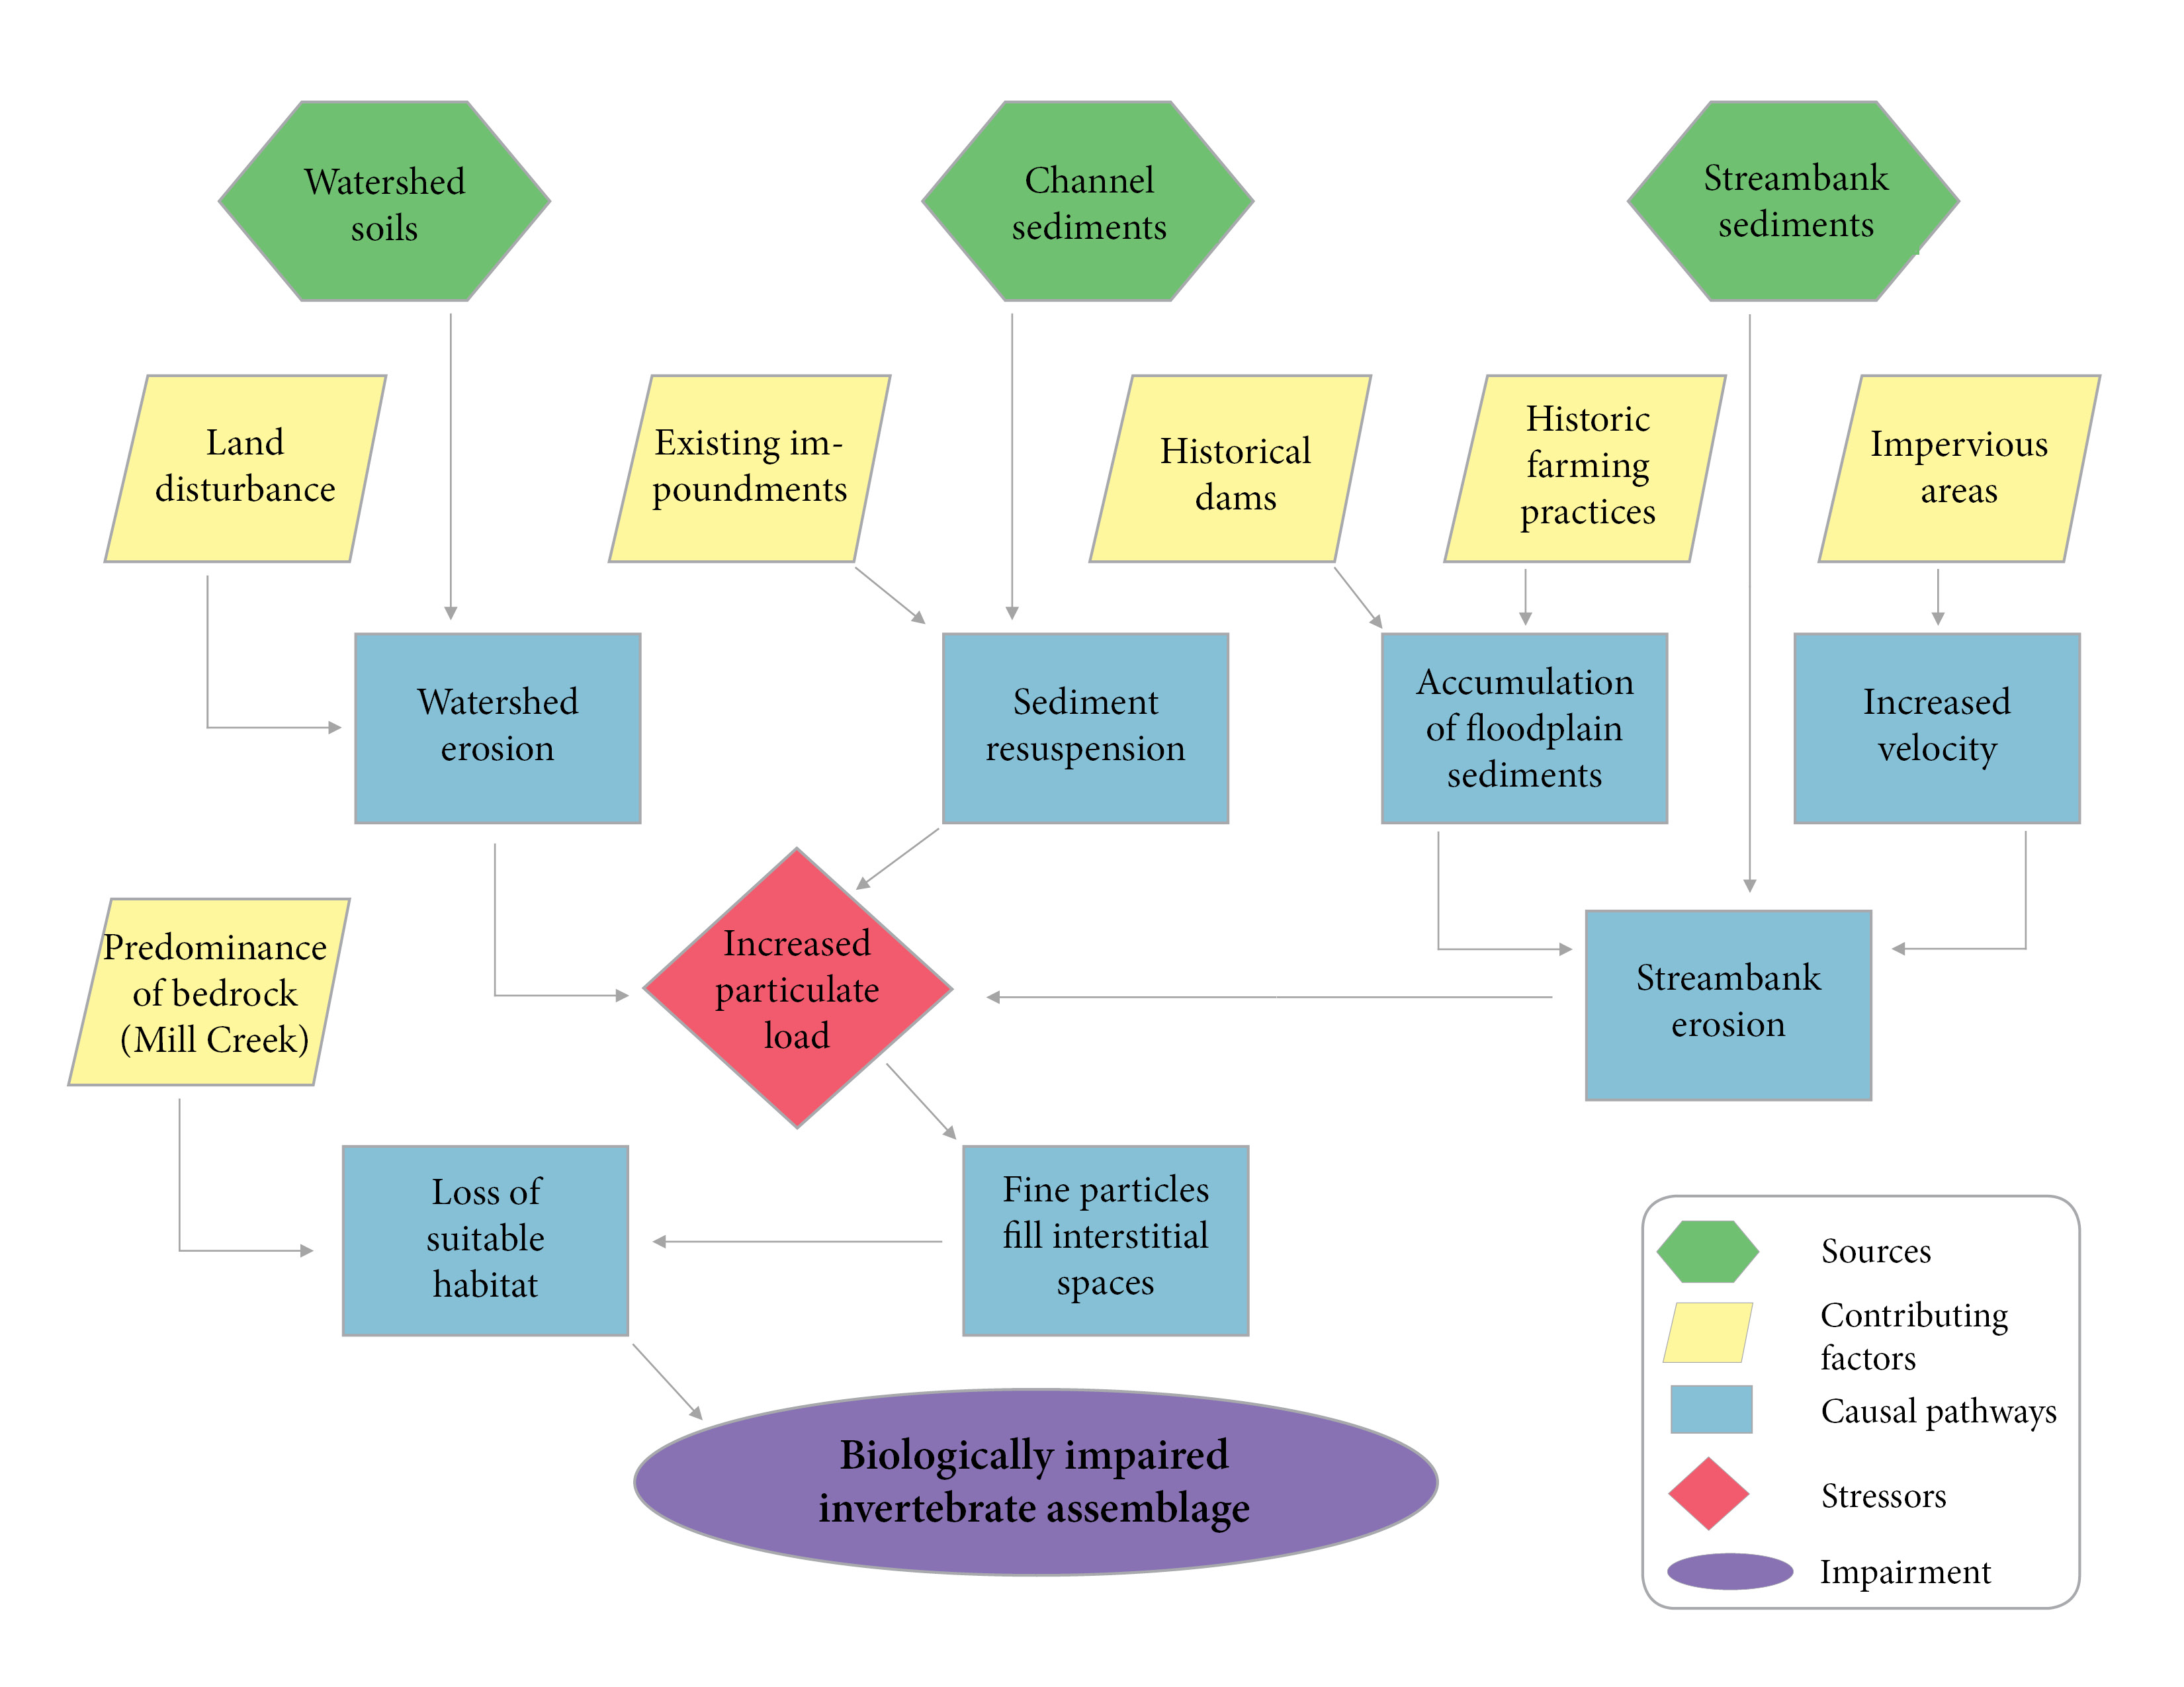
Figure 1-31. Conceptual model for the causal pathway of sediment impacts on benthic macroinvertebrates.

TMDL Target Pollutants
Following causal analysis and the determination of probable stressors, sediment was selected as the target pollutant for the Moores and Mill Creek TMDLs. TMDL target pollutants are the physical or chemical substances that will be controlled and allocated in the TMDL to result in restored aquatic life (measured by benthic macroinvertebrate health). TMDL targets must be pollutants that are controllable through source reductions, such as sediment, phosphorus, nitrogen, or other substances. Physical factors or environmental conditions, such as flow regimes, hydrologic modifications, or physical structures (like dams) cannot be TMDL target pollutants. Even though these conditions influence ecological communities and may be sources of stress, they do not represent substances that originate from point and nonpoint sources, they cannot be quantified, summed, and allocated to respective sources, and they cannot be controlled through source reductions.

References
Aston, R.J. 1973. Tubificids and water quality: A review. Envr. Poll., 5(1): 1-10.
Bjornn, T.C., M.A. Brusven, M.P. Molnau, J.H. Milligan, R.A. Klamt, E. Chacho, and C. Schaye. 1977. Transport of Granitic Sediment in Streams and its Effects on Insects and Fish. University of Idaho, Forest, Wildlife and Range Experiment Station, Moscow, ID.
Brabec, E., S. Schulte, and P.L. Richards. 2002. Impervious surfaces and water quality: a review of current literature and its implications for watershed planning. Journal of Planning Literature, 16(4):499-514.
Hayashi, M., T. Vogt, L. Machler, M. Schurmer. 2012. Diurnal fluctuations of electrical conductivity in a pre-alpine river: Effects of photosynthesis and groundwater exchange. Journal of Hydrology, 450-451: 93-104.
Jackson, C.R., J.K. Martin, D.S. Leigh, and L.T. West. 2005. A southeastern piedmont watershed sediment budget: evidence for a multi-millennial agricultural legacy. Journal of Soil and Water Conservation, 60(6):298-310.
Kaufmann. P.R., P. Levine, E.G. Robison, C. Seeliger, and D.V. Peck. 1999. Quantifying Physical Habitat in Wadeable Streams. EPA/620/R-99/003. U.S. Environmental Protection Agency, Washington, D.C.
Lawrence, J.M. and S.E. Gressens. 2011. Foodweb response to nutrient enrichment in rural and urban streams. Journal of Freshwater Ecology, 19(3):375-385.
Liu, Z., X. Liu, C. Liao. 2008. Daytime deposition and nighttime dissolution of calcium carbonate controlled by submerged plants in a karst spring-fed pool: insights from high time resolution monitoring of physico-chemistry of water. Environmental Geology, 55(6):1159-1168.
Mount, D.R., R.J. Erickson, T.L. Highland, J.R. Hockett, D.J. Hoff, C.T. Jenson, T.J. Norberg-King, K.N., Peterson, Z.M. Polaske, and S. Wisniewski. 2016. The acute toxicity of major ion salts to Ceriodaphnia dubia: I. Influence of background water chemistry. Environmental Toxicology and Chemistry, 35(12): 3039-3057.
Pond, G.J. 2004. Effects of Surface Mining and Residential Land Use on Headwater Stream Biotic Integrity. Kentucky Department of Environmental Protection Division of Water. July, 2004. p.33.
Tetra Tech. 2019. Biological Condition Gradient (BCG) Attribute Assignments of Macroinvertebrates and Fish in the Mid-Atlantic Region (Virginia, West Virginia, and Maryland).
U.S. Department of State. 1841. Enumeration of the Inhabitants and Statistics of the United States. U.S. Department of State, Washington, D.C.
U.S. Environmental Protection Agency. 2000a. Stressor Identification Guidance Document. EPA-822-B-00-025. U.S. EPA Office of Water, Washington D.C.
U.S. Environmental Protection Agency. 2000b. Ambient Water Quality Criteria Recommendations: Information Supporting the Development of Station and Tribal Nutrient Criteria, Rivers and Streams in Nutrient Ecoregion IX. EPA-802-B-00-019. U.S. EPA Office of Water, Washington D.C.
U.S. Environmental Protection Agency. 2018. Causal Analysis/Diagnosis Decision Information System (CADDIS). Retrieved: January 17, 2018. Available from: www.epa.gov/caddis. Office of Research and Development, Washington, D.C.
Virginia Department of Environmental Quality. 2017. Stressor Analysis in Virginia: Data Collection and Stressor Thresholds. Virginia Department of Environmental Quality, Richmond, VA.
Walsh, C. J., A.H. Roy, J.W. Feminella, P.D. Cottingham, P.M. Groffman, and R.P. Morgan. 2005. The urban stream syndrome: current knowledge and the search for a cure. Journal of the North American Benthological Society, 24(3):706-723.
Walter, R.C. and D.J. Merritts. 2008. Natural streams and the legacy of water-powered mills. Science, 319:299-304.

